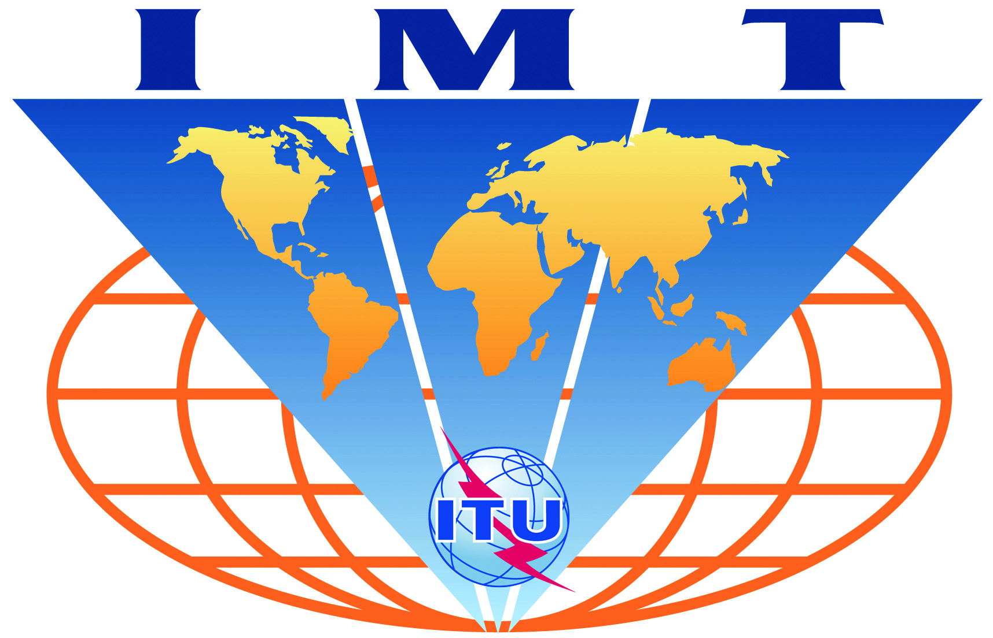

Satellite IMT-2020
Evaluation Group Registration Form

Name of the Evaluation Group:

SatComForum

Organizations participating in the Group's evaluation activities:

Member of SatComForum: ETRI, KTsat, LIG Nex1, Korea Aerospace Industry, Ltd, RFHIC, Hanwa Systems Co,. Ltd, Intellian Technologies, SK Telink, Soletop, Asia Pacipic Satellite Inc., CoreNet Global, SOLiD Technologies, FRTek, XMW, LGElectronics, Korea University, Ajou University, Chungnam National University, Hankyong National University, University of Seoul, Jeonbuk National University, etc

Contact person(s):

- name: Joon Gyu RYU, Chairman of SatComForum Technical Committee
- telephone: +82-42-860-1650
- email: jgryurt@etri.re.kr

- name: Hee Wook KIM, Person in charge
- telephone: +82-42-860-5422
- email: prince304@etri.re.kr

Related web site (if available):

http://satcomforum.org/en/sub/forum/committee_activity.asp

