Radiocommunication Study Groups | 
Source: Documents 3J/TEMP/100, 3J/162(Annex 24), 3J/116(Annex 18)  Subject: Technical information to support studies under WRC-27 agenda item 1.15 | Document 3J/FAS/12-E
 | 3 July 2026
 | English only
Working Party 3J
FASCICLE 3J/FAS/12
Fascicle on predicting lunar RF propagation environment
(Question ITU-R 273/3)
Scope
This fascicle treats the lunar propagation environment as a three-region medium: lunar exosphere, lunar regolith, and lunar bedrocks. Then it provides models for predicting the complex relative permittivity for each region, and model for predicting the complex relative permeability for the lunar regolith.
TABLE OF CONTENTS
1 Introduction 2
2 Lunar radio-wave propagation environment model 2
3 The exosphere’s complex relative permittivity 3
3.1 Inputs of the exospheric complex relative permittivity model 3
3.2 Exospheric complex relative permittivity prediction model 4
3.3 Exospheric refractive index 6
3.4 Exosphere phase velocity and group velocity 8
3.5 The Exospheric propagation parameters 11
4 The regolith complex relative permittivity prediction model 12
4.1 The inputs of regolith complex relative permittivity model 12
4.2 Regolith complex relative permittivity model at frequencies below 1 MHz 15
4.3 Model at frequencies between 1 MHz and 37 GHz 17
5 Lunar rock complex relative permittivity 19
6 Lunar regolith complex relative permeability 20

1 Introduction
The radio-wave propagation environment and the electromagnetic characteristics are crucial factors in assessing electromagnetic wave interaction. The radio-wave propagation environment is represented by the geometric structures of the object and the dimensions and the locations of those structures. The electromagnetic characteristics are represented by the complex relative permittivity and the complex relative permeability of its constituents. On the other hand, electromagnetic interaction could be associated with different radio-wave propagation mechanisms such as reflection, diffraction, scattering, and ducting depending on the geometric structure of the subject. Those radio- wave propagation mechanisms could lead to interference between RF systems, signal fade, or to multi-path, etc.
This fascicle provides two types of models:
One is a Model type for lunar radio-wave propagation environment, and
the other is a Model type for predicting electromagnetic characteristics of the lunar radio-wave propagation environment
The lunar radio-wave propagation environment model, which is provided in Section 2, encompasses three regions:
one is the Lunar exosphere,
another is the Lunar regolith/soil, and
the final is the Lunar bedrocks.
The lunar exosphere is a non-magnetic ionized medium containing charged dust (Manning, 2008; Stubles et al., 2011; and Rao et al., 2022a). It could have magnetic characteristics depending on its mineral contents (Rochette et al., 2010; Barmatz 2012, Garman et al., 2023), and the operating RF frequency.
The models for predicting the electrical constituent parameters (complex relative permittivity) of lunar exosphere, lunar regolith, and lunar bedrocks are provided in Sections 3, 4, and 5 respectively. There are two models for predicting the complex relative permittivity of regolith:
– A model applicable at frequencies below 1 MHz. Such a model is based on either collected regolith samples, or penetrating radar data (Section 3), and
– A model applicable at frequencies between 1 MHz and 37 GHz. Such a model is based on lunar measured brightness temperature data.
Moreover, the model for predicting the complex relative permeability of regolith is provided in Section 6.
Furthermore, Addendum A is provided to shed more lights on the real part of the complex relative permittivity of either regolith or bedrock. Addendum B provides a mixing complex relative permittivity formula that can be used in case of a mixture of regolith particles and bedrock particles. Addendum C provides a technique for calculating the regolith penetration depth. Addendum D provides a model for predicting regolith vertical and horizontal reflection coefficients.

2 Lunar radio-wave propagation environment model
The lunar radio-wave propagation environment model includes the exosphere, and the regolith. The exosphere is a layer of electrons that is apparently formed by the liberation of photoelectrons from the lunar surface by the solar wind. This photoelectron layer, which is not a thermal ionospheric plasma like that of the Earth, is located over the lunar regolith. As shown in Figure 1, the lunar regolith has two regions: upper lunar regolith lunar soil, and the bedrock. From now on the upper regolith is called the lunar regolith, and the bedrock is called lunar rocks (French, 1991).
FIGURE 1
Lunar regolith regions
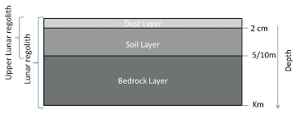
Accordingly, the lunar environment can be divided into three regions:
– Exosphere,
– Lunar regolith, and
– Bedrock.
Models for predicting the complex relative permittivity of each lunar region are provided in the following sections.

3 The exosphere’s complex relative permittivity
This section provides the exosphere’s complex relative permittivity prediction model (sub-section 3.2), and the model inputs (sub-section 3.1). It also provides the mathematical formulations of the exosphere propagation parameters directly derived from the exosphere’s complex relative permittivity. Those parameters include the refractive index, the phase constant, the attenuation constant (sub-section 3.3), the phase velocity, and the group velocity (sub-section 3.4). This section also provides numerical simulations aiming at investigating trends of those propagation parameters with the frequency (sub-sections 3.3 and 3.4).

3.1 Inputs of the exospheric complex relative permittivity model
For a frequency of $f$ (Hz) and a height $h$ above the regolith surface, the complex relative permittivity $ε_{ep}(h)$ of the exospheric plasma prediction model includes the dust density profile $N_{d}\left(h\right)$, and electron density profile $N_{e}(h)$ of the exosphere as its input (Rao et al., 2021).
If the dust density profile is not given, it can be written as (Stubbs et al., 2011, Eq. 1)
$N_{d}\left(h\right)=N_{d}\left(0\right)\exp\left(-\frac{h}{H_{d}}\right) { m}^{-3}$ (1)
$N_{d}(0)$ is the dust density on the surface, and $H_{d}$ is the scale height of the exospheric dust. The default values of $N_{d}(0)$, and $H_{d}$ are given in Table 1.
If the electron density profile is not given, it can be written as (Stubbs et al., 2011, Eq. 6)
$N_{e}\left(h\right)=N_{e}\left(0\right)\exp\left(-{\left(\frac{h}{H_{e}}\right)}^{v}\right) { m}^{-3}$ (2)
$N_{e}(0)$ is the electron density on the surface, and $H_{e}$ is the scale height of the exosphere electron. The default values of $N_{e}(0)$, and $H_{e}$ are given in Table 1. Moreover, $v$ is a dimensionless parameter that can be equated to 3.
Table 1
The default values of exospheric dust and electron density profiles (Stubbs et al., 2011)
Parameter | $$N_{d}\left(0\right), m^{-3}$$ | $H_{d}$  (km) | $$N_{e}\left(0\right), m^{-3}$$ | $$H_{e}$$(km)
Value | $${10}^{5}$$ | 15 | $$9.5×{10}^{8}$$ | 25

3.2 Exospheric complex relative permittivity prediction model
The complex relative permittivity $ε_{ep}(h)$ of the exosphere at the altitude $h$can be written as (Rao et al., 2021a, b, c):
$ε_{ep}\left(h\right)=ε_{ep}^{'}\left(h\right)-j ε_{ep}^{''}\left(h\right)$ (3)
with
$ε_{ep}^{'}\left(h\right)= 1- \frac{ω_{p}^{2}(h)}{ω^{2}+ v_{en}^{2}}+ \frac{cη_{ed}(h)}{ε_{0}} \frac{\left(v_{en}+ v_{ch}\right)}{\left(ω^{2}+ v_{en}^{2}\right)\left(ω^{2}+v_{ch}^{2}\right)}$ (4)
and $ε_{ep}^{''}\left(h\right)= \frac{v_{en}}{ω} \frac{ω_{p}^{2}(h)}{ω^{2}+ v_{en}^{2}} + \frac{cη_{ed}(h)}{ε_{0}ω} \frac{\left(ω^{2}-v_{en} v_{ch}\right)}{\left(ω^{2}+ v_{en}^{2}\right)\left(ω^{2}+v_{ch}^{2}\right)}$ (5)
With $ω=2πf$ ($f$ is the RF frequency in Hz), $v_{en}$ is the effective collision frequency for the electrons. Moreover, $ω_{p}\left(h\right)=2πf_{p}(h)$ with $f_{p}\left(h\right)$ is the plasma frequency at the altitude $h$ (Manning, 2008)
$f_{p}\left(h\right)= \frac{e}{2π} \sqrt{\frac{N_{e}(h)}{ε_{0}m}}, Hz$ (6)
In the above expression, $e$ is the electron charge ($e=1.6217662 ×{10}^{-19}$ Coulombs), $m$ ($m=9.10938356×{10}^{-31}$ kg) is the electron mass, and $ε_{0}$ ($ε_{0}=8.85×{10}^{-12}$ F/m) is the free space permittivity. Substituting for the values of $e$, $m$, and $ε_{0}$ into (6) reduces the plasma frequency formulation to:
$f_{p}\left(h\right)= 9.091 \sqrt{N_{e}(h)}, Hz$ (7)
The above plasma frequency is analogous to the ionosphere ordinary wave critical frequency (Rec. ITU-R P.531-14). The trend of the plasma frequency with altitude is depicted in Figure 2. Figure 2 is calculated by combining Eqns. (2) and (7) with the default values given in Table 1.
FIGURE 2
Trend of the exospheric plasma frequency with the exosphere altitude
Furthermore, $v_{ch}$ in (4) and (5) is the dusty particle charging frequency, $c$ ($c=299 792 458$ m/s) is the speed of light in vacuum, and $η_{ed}(h)$ is the charging response factor of the charged dust at the altitude $h$.
$η_{ed}(h)= e^{2} π r_{d}^{2}N_{e}\left(h\right)N_{d}(h)/m$ (8)
In the above equation, $r_{d}$ is the radius of the charged dust in the exosphere. The default value of $r_{d}$ is given in Table 2 along with the default values of electron collision frequency $v_{en}$, and dusty particle charging frequency $v_{ch}$.
TABLE 2
Default values of the parameters $r_{d}$, $v_{en}$, and $v_{ch}$ (Rao et al 2021a)
Parameter | Dust radius $r_{d}$  (m) | Electron collision frequency $v_{en}$(Hz) | Dust charging frequency $v_{ch}$  (GHz)
Value | $$8 × {10}^{-6}$$ | 0 | 0.3

For the default zero value of $v_{en}$, Eqns. (4) and (5) reduce to:
$ε_{ep}^{'}\left(h\right)= 1- {\left(\frac{ω_{p}\left(h\right)}{ω}\right)}^{2}+ \frac{cη_{ed}(h)}{ε_{0} ω^{2}} \frac{v_{ch}}{\left(ω^{2}+v_{ch}^{2}\right)}$ (9)
and $ε_{ep}^{''}\left(h\right)= \frac{cη_{ed}(h)}{ε_{0}ω} \frac{1}{\left(ω^{2}+v_{ch}^{2}\right)}$ (10)

3.3 Exospheric refractive index
The wavenumber $k(h)$determining the phase delay and the propagation attenuation within the exosphere is related to the complex relative permittivity through the refractive index$n_{r}(h)$ by
$k\left(h\right)= k_{0}\sqrt{ε_{ep(h)}}=k_{0} n_{r}(h)$=$k_{0}\left\{n_{r}^{'}\left(h\right)-j n_{r}^{''}(h)\right\}$ (11)
with $k_{0}$ is the free space wavenumber,
$n_{r}^{'}\left(h\right)= \frac{1}{\sqrt{2}}\sqrt{\sqrt{{\left(ε_{ep}^{'}(h)\right)}^{2}+ {\left(ε_{ep}^{''}(h)\right)}^{2}}+\left(ε_{ep}^{'}(h)\right)} ,$ (12a)
and $n_{r}^{''}\left(h\right)= \frac{1}{\sqrt{2}}\sqrt{\sqrt{{\left(ε_{ep}^{'}\left(h\right)\right)}^{2}+ {\left(ε_{ep}^{''}\left(h\right)\right)}^{2}}-\left(ε_{ep}^{'}\left(h\right)\right)}.$ (12b)
Equations (12a) and (12b) giving the real and the imaginary parts of the exosphere refractive index are calculated in Figures 3 and 4, respectively. The equations are calculated at the lunar regolith surface as a function of frequency. Moreover, (12a) and (12b) can be multiplied by the free space wavenumber giving the propagation phase constant $β(h)$ and the attenuation constant $κ(h)$ such that:
$β\left(h\right)= k_{0} n_{r}^{'}\left(h\right) ,$ (13a)
and $κ\left(h\right)= k_{0} n_{r}^{''}\left(h\right) .$ (13b)
Plots of equations (13a) and (13b) are shown in Figures 5 and 6, at the lunar regolith surface, as a function of frequency.
FIGURE 3
Real part of the exospheric refractive index at the lunar regolith surface as a function of frequency
FIGURE 4
Imaginary part of the exospheric refractive index at the lunar regolith surface as a function of frequency
FIGURE 5
The exospheric phase constant at the lunar regolith surface as a function of frequency
FIGURE 6
The exospheric attenuation constant at the lunar regolith surface as a function of frequency

3.4 Exosphere phase velocity and group velocity
The exosphere phase velocity $v_{p}(h)$, and group velocity $v_{g}\left(h\right)$are two propagation parameters that are of interest for communication channels. The phase velocity is the velocity at which the phase of any frequency component of the wave travels and it can be obtained from the phase constant $β$ (13a) as:
$v_{p}(h)= ω/β\left(h\right) .$ (14)
Introducing (12a) into (13a) and introducing the resultant into (14) gives the explicit expression of phase velocity in terms of the real and imaginary parts of the exospheric complex relative permittivity,
$v_{p}(h)= \frac{\sqrt{2} c}{\sqrt{\sqrt{{\left(ε_{ph}^{'}(h)\right)}^{2}+ {\left(ε_{ph}^{''}(h)\right)}^{2}}+ ε_{ph}^{'}(h)}} , m/s$ (15)
In getting (15), the free space wavenumber $k_{0}$ is equated to $ω/c$, where $c$ is the free space phase velocity which is equal to speed of light in free space.
The group velocity is the velocity at which a wave packet (or wave envelope) travels. The group velocity $v_{g}\left(h\right)$at an altitude $h$ is given by:
$v_{g}(h)=\frac{∂ω}{∂β(h)} , m/s$ (16)
To infer the relationship between the group velocity and the phase velocity, Eqn. (14) is differentiated, and Eqn. (16) is used to get:
$v_{g}\left(h\right)=v_{p}\left(h\right){\left(1- \frac{ω}{v_{p}\left(h\right)} \frac{∂v_{p\left(h\right)}}{∂ω}\right)}^{-1}. m/s$ (17)
A further reduction for (17) yields:
$v_{g}(h)=v_{p}(h) {\left(1+ \frac{ω}{2\sqrt{{(ε_{ph}^{'}\left(h\right))}^{2}+ {(ε_{ph}^{''}\left(h\right))}^{2}}}\left\{\frac{∂ε_{ph}^{'}(h)}{∂ω}+ \frac{ε_{ph}^{''}∂ε_{ph}^{''}(h)/∂ω}{\sqrt{{\left(ε_{ph}^{'}(h)\right)}^{2}+{(ε_{ph}^{''}\left(h\right))}^{2}} +ε_{ph}^{'}(h)}\right\}\right)}^{-1}m/s$ (18)
The first order derivatives $∂ε_{ph}^{'}(h)/∂ω$ and $∂ε_{ph}^{''}(h)/∂ω$ in (18) can be obtained through differentiating (4) and (5) yielding:
$\frac{∂ε_{ph}^{'}(h)}{∂ω}=2ω\left\{\frac{ω_{p}^{2}\left(h\right)-B}{{\left(ω^{2}+ v_{en}^{2}\right)}^{2}}+ \frac{B}{{\left(ω^{2}+v_{ch}^{2}\right)}^{2}}\right\} ,$ (19)
$\frac{∂ε_{ph}^{''}(h)}{∂ω}=-\frac{ε_{ph}^{''}\left(h\right)}{ω} - \frac{{2 v_{en}ω}_{p}^{2}\left(h\right)}{{\left(ω^{2}+ v_{en}^{2}\right)}^{2}} + 2D\left\{\frac{1}{\left(ω^{2}+ v_{en}^{2}\right)}- \frac{1}{\left(ω^{2}+v_{ch}^{2}\right)}\right\} + g\left(ω\right),$ (20)
and $g\left(ω\right)=-2D\left(ω^{2}- v_{en}v_{ch}\right)\left\{\frac{1}{{\left(ω^{2}+ v_{en}^{2}\right)}^{2}}- \frac{1}{{\left(ω^{2}+v_{ch}^{2}\right)}^{2}}\right\}$ (21)
with:
$B= \frac{c η_{ed}(h)}{ε_{0}\left(v_{ch}-v_{en}\right)}$ (22)
and $D= \frac{c η_{ed}(h)}{ε_{0}\left({v_{ch}^{2}-v}_{en}^{2}\right)} .$ (23)
Figures 7 and 8 depict trends of the exosphere normalized phase velocity and the normalized group velocity with frequency at the regolith surface. In Figure 7, the phase velocity is normalized over the free space phase velocity, and in Figure 8, the group velocity is normalized over the free space group velocity. One should keep in mind that in free space, the phase velocity and the group velocity have an equal value which is the speed of light in free space. Moreover, as an illustration for the use of the group velocity depicted in Figure 8, it is used in Figure 9 to calculate group delay within a communication channel. The group delay $G_{d}(h)$ is calculated as follows:
$G_{d}\left(h\right)= \frac{∂β\left(h\right)}{∂ω}= \frac{1}{v_{g}\left(h\right)} s/m$ (24)
The group delay has a negative sign which is understood and removed.
FIGURE 7
The exospheric phase velocity at the lunar regolith surface as a function of frequency
FIGURE 8
The exospheric group velocity at the lunar regolith surface as a function of frequency
FIGURE 9
The exospheric group delay at the lunar regolith surface as a function of frequency

3.5 The exospheric propagation parameters
Based on the numerical results depicted in Figures 2-9, values of propagation parameters directly derived from exosphere complex relative permittivity can be classified into:
– Parameters values at frequencies below the plasma frequency, and
– Parameters values at frequencies above the plasma frequency.
At frequencies below the plasma frequency, the propagation attenuation within the exosphere is very high as shown in Figure 6. At those frequencies if a wave is excited within the exosphere it will propagate only along very short distance and it will be totally attenuated. Accordingly, at frequencies below plasma frequency (Figure 2), the exosphere cannot support wave propagation, and all propagation parameters values (refractive index, phase velocity, group velocity, and phase constant) at those frequencies are of no use.
At frequencies above the plasma frequency, as shown in Figures 3-8, the exosphere can be treated as free space. This means that at those frequencies, the exosphere propagation parameters can be replaced by the corresponding parameters of free space. Those parameters include the refractive index (Figures 3 – 4), the phase constant (Figure 5), the attenuation constant (Figure 6), the phase velocity (Figure 7), and the group velocity.

4 The regolith complex relative permittivity prediction model

4.1 The inputs of regolith complex relative permittivity model
Lunar regolith physical properties required as inputs for the regolith complex relative permittivity prediction model are as follows:
– Regolith depth
– Regolith mineral contents
– Regolith bulk density (specific gravity, porosity, void ratio)
– Regolith temperature
Also the RF frequency is required as an input for the model.
Regolith depth
The regolith depth $d$ can be obtained from long wave radar maps (Campbell et al., 1997; Ishiyama, et al., 2013). Also, it can be inferred from lunar surface altitude $H$, with $H$ in meters, as follows (Fa and Jin, 2007):
$d= 9.5 +8.5 tanh\left(\frac{H+1200}{1632.5}\right), m$ (25)
Figure 10 depicts lunar surface digital elevation model (DEM) that can be used in getting the altitude’s $H$ values.
FIGURE 10
Lunar surface digital mapping (km):(a) nearside, (b) far side (Fa and Jin 2007)
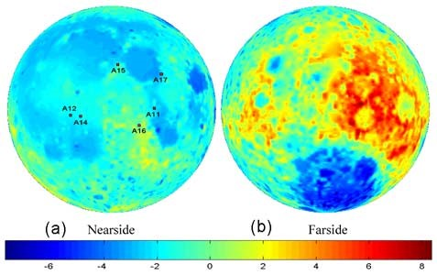
Mineral contents
The mineral contents impacting the lunar regolith permittivity are titanium dioxide (TiO₂) and dioxide ferrite (FeO). There are global maps for the weight percentage of TiO₂ and FeO derived from five-band multispectral optical data (Lucey et al., 1995, 1998, 2000; Liu et al., 2019). Figure 11 shows histograms of FeO and TiO₂ contents (Liu et al., 2019).
FIGURE 11
Histograms for FeO and TiO₂ percentage weight contents (Liu et al., 2019)
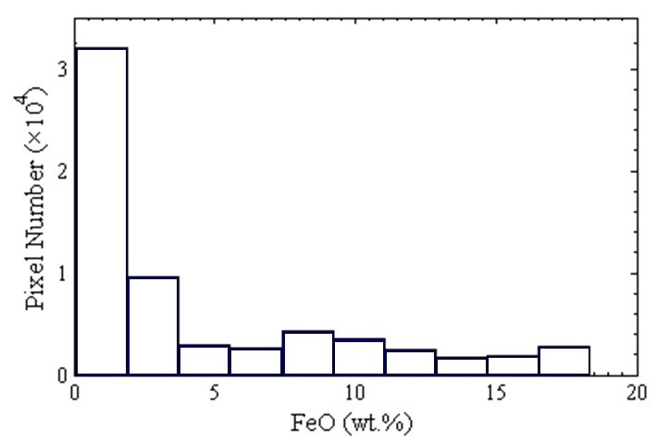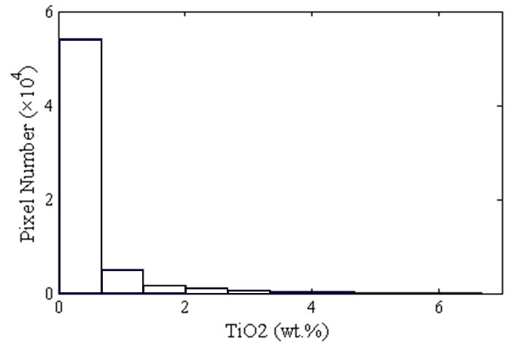
Figure 12 provides mapping for volume of FeO and TiO₂ abundance derived from microwave sounder (CLEMS) data from Chang’ E-2 satellite using back propagation neural networks (BPNN).
FIGURE 12
Mapping of the volume (a) FeO and (b) TiO₂ abundances with CELMS data
using the BPNN method (Liu et al., 2019)
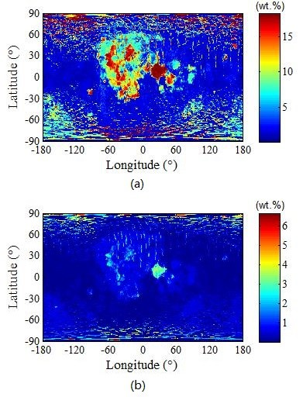
Bulk density
The bulk density, ρ, of a material is defined as the mass of the material contained within a given volume, usually expressed in units of grams per cubic centimetre (g/cm³). The porosity, and specific gravity are other parameters related to the bulk density. The porosity, ϕ, is defined as the volume of void space between the particles divided by the total volume. The specific gravity, $G$, of a soil particle is defined as the ratio of its mass to the mass of an equal volume of water at 4°C. Many terrestrial soils have a specific gravity of 2.7; that is, the density of the individual particles is 2.7 g/cm³, or 2.7 times that of water $ρ_{w}$ (1 g/cm³). The volume fraction $V$ is ratio of the volume soil particles over the total volume. Bulk density, porosity, specific gravity, and volume fraction are interrelated as:
$ρ= Gρ_{w}\left(1- ϕ\right)$ (26)
and $V= 1- ϕ$ . (27)
The bulk density varies with regolith depth$z$, with $z$ in meters as follows (Hyane et al., 2017):
$ρ\left(z\right)= 1.890\frac{0.0169-z}{0.0290-z}, g/{cm}^{3}$ (28)
It should be noted that $z$ may represent negative values. Figure 13 depicts the trend of bulk density with depth.
FIGURE 13
The trend of bulk density with regolith depth
Temperature
The complex relative permittivity of lunar regolith has no explicit dependence on temperature at frequencies above 1 MHz (Olhoeft, et al., 1974a; Carrier et al., 1991). On the other hand, temperature of the lunar regolith layer varies with selenographic latitude and longitude at specific lunar time. The temperature of the lunar regolith layer is determined by considering the balance between the incident solar flux, conduction of heat through the subsurface, the reradiation outward and internal energy flux (Hyane et al., 2017). Table 3 presents the averaged lunar surface temperature given by the Lunar Colony Study Group (Fa and Jin, 2007).
Table 3
Lunar surface temperature (Fa and Jin, 2007)
 | Shadowed polar crater | Other polar areas | Front equatorial | Back equatorial | Limb equatorial | Typical mid-latitudes
Average temperature | 40K | 220K | 254K | 256K | 255K | 220 < T < 255K
Monthly range |  | $±$10K | $±$140K | $±$140K | $±$140K | $±$110K

4.2 Regolith complex relative permittivity model at frequencies below 1 MHz
At frequencies below 1 MHz, the lunar regolith complex relative permittivity can be described by a Cole-Cole frequency distribution with a Boltzmann temperature distribution as follows (Olhoeft, et al., 1974a; Carrier et al., 1991):
$ε_{rg}= ε_{rg}^{'}-j ε_{rg}^{''}$ (29)
where:
$ε_{rg}^{'}=ε_{∞}+ \frac{\left(ε_{s}-ε_{∞}\right)\left\{1+ {\left(2πfτ\right)}^{1-α}\sin\left(απ/2\right)\right\}}{1+2{\left(2πfτ\right)}^{1-α}\sin\left(απ/2\right)+ {\left(2πfτ\right)}^{2(1-α)}}$ (30)
$ε_{rg}^{''}= \frac{\left(ε_{s}-ε_{∞}\right){\left(2πfτ\right)}^{1-α}\cos\left(απ/2\right)}{1+2{\left(2πfτ\right)}^{1-α}\sin\left(απ/2\right)+ {\left(2πfτ\right)}^{2(1-α)}}+\frac{1.7984×{10}^{10}σ}{f}+ε_{rg}^{'}\tan{δ^{'}}$ (31)
In the above, $ε_{∞}$ and $ε_{s}$ are the high frequency limit, and the static dielectric constants, respectively. They are given by (Carrier et al., 1991, Campbell et al., 1997, Fa and Jin, 2007, Zhang 2019).
$ε_{∞}= {1.919}^{ρ}$, $ε_{s}= 6700$ (32)
Additionally, $τ$, $σ$, and $α$ are the relaxation time (time factor), the static conductivity, and the frequency distribution parameter (sometimes it is called activation energy distribution parameter), respectively. They are related to the temperature $T$in Kelvin as follows:
$τ= 2.56 ×{10}^{-12}e^{29010/T}, s$ (33a)
$σ=0.6 ×{10}^{-17}e^{0.0237T}, mho/s$ (33b)
and $1-α= {\left[e^{0.0018\left(1000-T\right)}+1\right]}^{-1}.$ (33c)
Furthermore, $\tan{δ^{'}}$ which was introduced by Olhoeft et al. (1974a) into (15) to fit the measured data, is given by:
$\tan{δ^{'}}= \frac{ξ{\left(2πfτ'\right)}^{β}\sin\left(βπ/2\right)}{1+ ξ\left(2+ ξ\right){\left(2πfτ'\right)}^{β}\cos\left(βπ/2\right)+ {\left(2πfτ'\right)}^{2β}}$ . (34)
In Eqn. (34), $β=0.33$, while 𝛏 and $τ^{'}$ are not uniquely defined. In this study, they are taken as follows 𝛏=1 and $τ^{'}=406.9 s$ (Olhoeft et al., 1974a).
FIGURE 14
Real part of the regolith complex relative permittivity as a function of frequency at different temperatures (reproduction of Figure 1 of Olhoeft et al., 1974a and Figure 9.62 of Carrier et al., 1991)
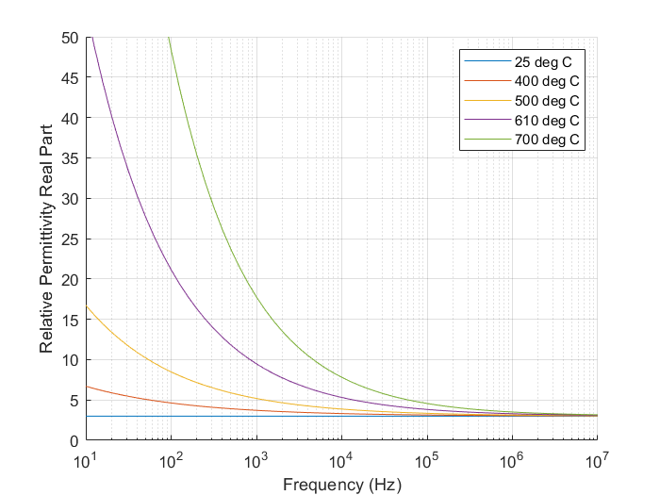
Figures 14 and 15, which are reproduction of Figures 1 and 3 of Olhoeft et al. (1974a); as well as Figures 9.62, and Figure 9.63 of Carrier et al (1991) are presented to illustrate the trend of both the real part of complex relative permittivity and dielectric loss tangent with frequency and temperature dependence. In Figures 1 and 3 of Olhoeft et al. (1974a); and in Figures 9.62, and Figure 9.63 of Carrier et al., 1991, the predictions of the complex relative permittivity model (30) – (31) showed a good agreement with the corresponding measured data.
FIGURE 15
The regolith loss tangent as a function of frequency at different temperatures (reproduction of Figure 3
of Olhoeft et al., 1974a, and Figure 9.63 of Carrier et al., 1991)
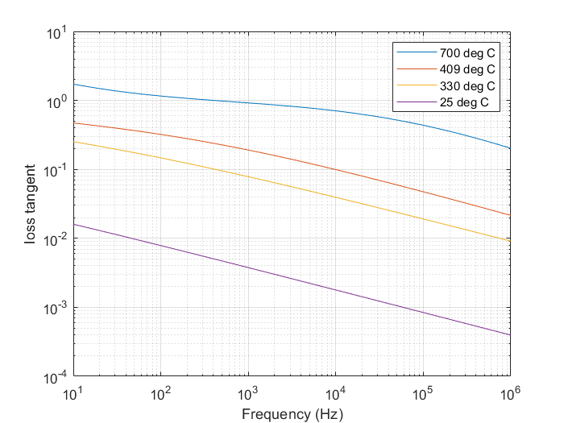

4.3 Model at frequencies between 1 MHz and 37 GHz
At frequencies between 1 MHz and 37 GHz, the regolith complex relative permittivity $ε_{reg}$ can be written as (Carrier et al., 1991, Campbell et al., 1997, Fa and Jin, 2007, Zhang 2019, Montopoli et al., 2011, Siegler et al., 2019, Bussey Howard E., 1978):
$ε_{reg}= ε_{reg}^{'}-j ε_{reg}^{'}\tan{δ}$ . (35)
The real part $ε_{reg}^{'}$ has neither frequency nor temperature dependence, and it depends only on the bulk density $ρ$:
$ε_{reg}^{'}= {1.919}^{ρ}$ . (36)
The loss tangent depends on bulk density, frequency, and ${TiO}_{2}$ and $FeO$ percentage weight content $S$ (Montopoli et al., 2011, Siegler et al., 2019):
$\tan{δ}= {10}^{\left\{\left(a_{1}f_{GHz}+ a_{2}\right)ρ+ b_{1}S-b_{2})\right\}}$ (37)
In the above expression, $f_{GHz}$ is the frequency in GHz; and the coefficients $a_{1}, a_{2}, b_{1}, b_{2}, and S$ are given as (Montopoli et al., 2011, Siegler et al., 2019):
$a_{1}$= 0.0272, ${GHz}^{-1}$,$a_{2}$= 0.2967,
$b_{1}$ = 0.027,$b_{2}$ = 3.058,
and $S=\%{TiO}_{2}+\%FeO$ .
Since the density $ρ$ varies along the regolith depth as given in (12), the regolith complex relative permittivity also varies along the regolith depth. Figures 16 and 17 depict the trend of the complex relative permittivity real part and the loss tangent along the regolith depth. The figures are calculated for regolith thickness of 2 m.
FIGURE 16
Real part of regolith permittivity for frequencies above 1 MHz as a function of regolith depth
FIGURE 17
The regolith dielectric loss tangent at 1.5 GHz as a function regolith depth ($\%{TiO}_{2}$ = 4, and $\%FeO$=15)

5 Lunar rock complex relative permittivity
Lunar rock complex relative permittivity $ε_{rock}$ can be written as:
$ε_{rock}= ε_{rock}^{'}-j ε_{rock}^{'}\tan{δ_{rock}}$ (38)
With $ε_{rock}^{'}$ can be obtained from (39) through replacing the regolith bulk density $ρ$ by the rock bulk density $ρ_{rock}$ (Campbell and Ulrichs, 1969, Ulaby et al., 1990, Montopoli et al., 2011):
$ε_{rock}^{'}= {1.919}^{ρ_{rock}}$ (39)
For lunar rock material there is no empirical or theoretical model available, but it is quite well established that typical rock density variations lie between 2 and 3.3 $g cm^{-3}$ (Montopoli et al., 2011). Accordingly, from (28) the values of $ε_{rock}^{'}$ varies between 3.6826 and 8.5931. Figure 2 of Ulaby et al. (1990) shows measured values of different rocks between 4 and 7. Moreover, in the caption of Table 1 of Campbell et al. (1997) values between 5 and 7 are reported.
On the other hand, the loss tangent $\tan{δ_{rock}}$ in (38) can be written as:
$\tan{δ_{rock}}= {10}^{\left\{\left(a_{1}f_{GHz}+ a_{2}\right)ρ_{rock}+ b_{1}S-b_{2})\right\}} + \frac{17.984σ_{rock}}{ε_{rock}^{'}f_{GHz}}$ (40)
In the above expression, $σ_{rock}$ is the rock dc conductivity and has the following dependence on temperature (Olhoeft et al., 1974b, Carrier et al., 1991):
$σ_{rock}= 3×{10}^{-14} e^{0.0230T} . mho/m$ (41)
Moreover, the coefficients $a_{1}, a_{2}, b_{1},b_{2}, and c$ are given by (Montopoli et al., 2011):
$a_{1}$= 0.0086 ${GHz}^{-1}$,$a_{2}$= 0.1833,
$b_{1}= 0.038$, $b_{2}=3.26$,
and $S=\%{TiO}_{2}+\%FeO$ .
Figure 18 depicts trend of lunar rock loss tangent with frequency at different temperatures.
FIGURE 18
Lunar rock loss tangent as a function of frequency at different temperature ($ρ_{rock}=2.5 gm/{cm}^{3}$)
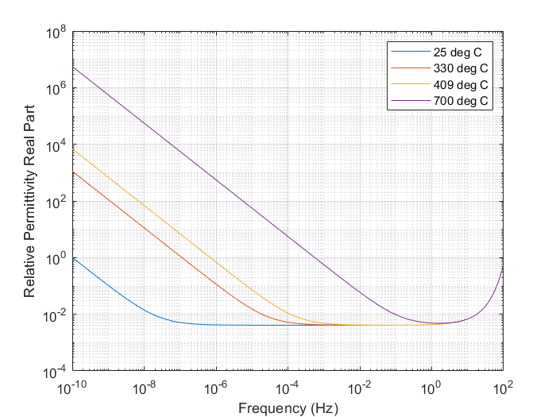

6 Lunar regolith complex relative permeability
The prediction model of regolith complex relative permeability, presented in this section is based on the data provided by the following authors: Rochette et al (2010), Barmatz et al (2012), and Garman et al (2021).
Table 1 of Rochette et al (2010) provides values for the magnetic susceptibility 𝒳 which can be used to obtain the complex relative permeability $μ_{r}$ as follows:
$μ_{r}= 1+ 4πX$ (42)
With $μ_{r}$ is written as:
$μ_{r}= μ_{r}^{'}-j μ_{r}^{''}$ (43)
The values of complex relative permeability reported in Rochette et al (2010) are static values with no frequency dependence.
Figures 1 and 3 of Barmatz et al (2012) depict trends of $μ_{r}^{'}$ and $μ_{r}^{''}$ with frequency in the range between 2 GHz and 3.5 GHz for regolith simulant samples and regolith soil samples. The data parts of those figures containing the complex relative permeability of regolith soil are recalled as Figures 19 and 20.
Comparing Figure 19 against Figure 20 indicates that the data reported in both figures cannot be fitted by dispersion model based on molecular vibration such as Cole-Cole dispersion model or Debye dispersion model. This is because the trend of the permeability’s imaginary part $μ_{r}^{''}$ with frequency dependence depicted in Figure 20 implies that there is a relaxation frequency around 3.5 GHz. In approaching such a relaxation frequency, the imaginary part increases until it reaches its maximum value at the relaxation frequency. Moreover, the imaginary part has even symmetry around the relaxation frequency. On the other hand, the real part has an odd symmetry around the relaxation frequencies with higher values at frequencies below the relaxation frequency. So in approaching the relaxation frequency, the permeability real part should decrease as the frequency increases. However, Figure 18 indicates that the real part $μ_{r}^{'}$ increases as the frequency increases. Accordingly, the data of Barmatz et al (2012) should be revisited.
FIGURE 19
Real part of regolith soil complex relative permeability as a function of frequency
(Figure 3 of Barmatz et al., 2012)
FIGURE 20
Imaginary part of regolith soil complex relative permeability as a function of frequency
(Figure 1 of Barmatz et al., 2012)
Moreover, Table 2 of Garman et al. (2021) provides data values for $μ_{r}^{'}$ and $μ_{r}^{''}$at frequencies of 0.06 GHz, 2 GHz, and 3.5 GHz. At the frequency of 0.06 GHz, Garman et al. reported values of zero for the imaginary part of the permeability in references Lai et al. (2019), (2022); and Wang et al. (2022). However, Lai et al. (2019), (2022); and Wang et al. (2022) are focused on the permittivity and mention nothing about the permeability. Moreover, the permeability values at 2, and 3.5 GHz are based the data of Barmatz et al. (2012), which are depicted in Figures 19 and 20. As mentioned above, the data of Figures 19 and 20 should be revisited. Accordingly, values reported in Table 2 of Garman et al. (2021) for the permeability imaginary part cannot be used because they either wrong or need to be revisited.
To summarize this section, within the frequency bands reported in Resolution 680 (WRC-23) the real and imaginary parts of lunar regolith magnetic permeability can be estimated as follows:
$μ_{r}^{'}= 1$ (44)
and $μ_{r}^{''}=0$ (45)
The values reported in (43) and (44) are based on the following:
– Magnetic permeability values given in Table 3 of Stillman, and Olhoeft (2008).
– Relaxation frequency values reported in Olhoeft, and Capron (1993).
– Lunar penetration radar studies (Lai, et al., 2019, Wang, et al., 2021).
As a conclusion to this section, it is worth mentioning that the above regolith magnetic characteristics differ from the magnetic characteristics of lunar crust which is known as lunar magnetic anomalies (Hood et al., 2001; Wieczorek et al., 2012; Carley et al., 2012).

Addendum A
Dependence of $ε^{'}$ on bulk density
Equations (26) and (29) give the dependence of $ε_{r}^{'}$ on bulk density for regolith soil and rock, respectively. To derive those equations, consider a two-phase medium consisting of a host (gas) and an inclusion (solid). The solid stands for either a rock or a regolith particle. Using the geometric mean formula (Ulaby et al., 1990), $ε_{r}^{'}$ of the medium can be written as:
$\log{ε_{r}^{'} }= \sum{V_{i}}\log{ε_{i}^{'}}$ (1A)
where $V_{i}$ is the volume fraction of the $i^{th}$ component of the medium. The medium may contain volume fractions of solids $V_{s}$, and gasses $V_{g}$; by definition, $V_{s}+V_{g}=V_{t}=1$. Since $ε_{g}^{'}=1$, (1A) becomes:
$\log{ε_{r}^{'} }= V_{s}\log{ε_{s}^{'}}$ (2A)
where $ε_{s}^{'}$ is the real part of relative permittivity of the solid material (in the absence of air). The volume fraction $V_{s}$ of solid is given by:
$V_{s}= \frac{v_{s}}{v_{t}}= \frac{m_{s}/ρ_{s}}{v_{t}}=ρ_{b}/ρ_{s}$ (3A)
In the above expression, $m_{s}$ is the mass of solid, $ρ_{s}$ is the ratio solid mass over solid volume $v_{s}$, and $ρ_{b}$ is the bulk density. Inserting (3A) into (2A) and solving for $ε_{r}^{'}$ yields:
$ε_{r}^{'} = {\left(ε_{s}^{'}\right)}^{ρ_{b}/ρ_{s}} .$ (4A)
Campbell, and Ulrichs (1996) conducted measurements for a large number of powdered rocks all at density $ρ_{b}=1 gm/{cm}^{3}$, and found that $ε^{'}$ varied over the narrow range between 1.9 and 2.1 for most of the 25 different types of powdered rocks measured, and that the mean value is around 1.919. Ulaby et al. (1990) approximated the mean value by 2.
Upon setting $ρ_{b}=1 gm/{cm}^{3}$ and $ε_{r}^{'}$ = 1.919 in (4A), we find that:
$ε_{s}^{'}={1.919}^{ρ_{s}} .$ (5A)
Inserting (5A) into (4A) yields:
$ε_{r}^{'} ={1.919}^{ρ_{b}}$, (6A)
which describes the dependence of$ε_{r}^{'}$ on bulk density $ρ_{b}$.

Addendum B
Complex relative permittivity of regolith and rock mixture
When there is a mixture of rocks and regolith soil, by treating the rock particles as spherical particles, the complex relative permittivity $ε_{mixed}$ of the mixture can be obtained through applying the following mixing formula (Wei et al., 2020):
$\left(1-V_{rock}\right)\frac{ε_{reg}-ε_{mixed}}{ε_{reg}+2ε_{mixed}}+V_{rock} \frac{ε_{rock}-ε_{mixed}}{ε_{rock}+2ε_{mixed}}=0 ,$ (1B)
which can be reduced into a quadratic algebraic equation:
$Aε_{mixed}^{2}+Bε_{mixed}+C=0$ (2B)
with:
$A=2 ,$ (3B)
$B=-2\left(1-V_{rock}\right)ε_{reg}+ \left(1-3V_{rock}\right)ε_{rock} ,$ (4B)
and $C=-ε_{reg}ε_{rock} .$ (5B)
Solving (2B) gives $ε_{mixed}$:
$ε_{mixed}=\frac{-B+\sqrt{B^{2}-4AC}}{2A}$ (6B)

Addendum C
Lunar regolith penetration depth
The extent to which the lower strata of lunar regolith influences the effective electrical characteristics of the lunar surface depends upon the penetration depth of the radio energy, $δ$, which is defined as the depth at which the amplitude of the field strength of electromagnetic radiation inside a material falls to 1/e (about 37%) of its original value at (or more properly, just beneath) the lunar regolith surface. To obtain the amplitude of the field inside the lunar regolith the Wentzel-Kramers-Brillouin (WKB) approximation can be applied (Ugwu et al., 2011; Light, 2017; Prokopovich et al., 2018). This approximation is appropriate, because of the smooth variations of the complex relative permittivity along the regolith depth as shown in Figures 16 and 17. Only the relative amplitude of the field is considered. As for the polarization of the field, it is not required, and it can be treated as in earlier studies (Ferencz, 2004; Light, 2017; Moiseeva, 2019).
In applying the WKB approximation, the wave equation governing the electric or magnetic fields $F\left(z\right)$within the lunar regolith can be written as:
$\left[\frac{∂^{2}}{{∂z}^{2}}+ k^{2}(z)\right]F\left(z\right)=0$ (1C)
where $k$is the RF wavenumber such that
$k= ω\sqrt{ε(z)μ(z)}= β\left(z\right)-jκ(z)$ (2C)
In Eqn. (2C), $β\left(z\right)$, and $κ(z)$ are the phase constant and the attenuation constant at the depth $z$, respectively. The solution of (1C) can be assumed as:
$F\left(z\right)=e^{ju(z)} .$ (3C)
Inserting (3C) into (1C) yields the governing differential equation for finding $u(z)$:
$j\frac{∂^{2}u(z)}{{∂z}^{2}}- {\left(\frac{∂u\left(z\right)}{∂z}\right)}^{2}+ k^{2}\left(z\right)=0 .$ (4C)
Equation (4C) can be solved with the following successive approximation:
$u_{m}\left(z\right)=±\int_{0}^{z}{\sqrt{k^{2}\left(z'\right)+\frac{∂^{2}u_{m-1}(z')}{{∂z'}^{2}} }dz'}, m=1,2$ (5C)
with: $u_{0}\left(z\right)=±\int_{0}^{z}{k\left(z'\right)dz'} .$ (6C)
In this way, the first successive approximation can be written from (4B) as:
$u_{1}\left(z\right)=±\int_{0}^{z}{k(t)\sqrt{1+ j\frac{1}{k^{2}\left(z^{'}\right)}\frac{∂k\left(z^{'}\right)}{∂z^{'}}}dz'} .$ (7C)
The second term beneath the square root operator is obtained through differentiating (5B) twice. Assuming that $\frac{1}{{kn}^{2}(z')}\frac{∂n(z')}{∂z'}≪1$, the square root operator in (7C) can be approximated by the first two terms in its binomial expansion yielding:
$u_{1}\left(z\right)=±\int_{0}^{z}{\left(k\left(z'\right)+\frac{j}{2k(z')}\frac{∂k(z')}{∂z'}\right) dz'} .$ (8C)
Performing the integration in (8C) yields:
$u_{1}\left(z\right)=±\int_{0}^{z}{k\left(z'\right) dz'}+ \frac{j}{2} log\left\{k\left(z\right)\right\}+C .$ (9C)
In the above equation, $C$ is an integration constant. Based on (3C) and (9C), the forward propagating electromagnetic field within the regolith layer can be written as:
$F\left(z\right)=A\frac{e^{-j\int_{0}^{z}{k\left(z'\right) dz'}}}{\sqrt{k(z)}} .$ (10C)
In the above equation, $A$ is a constant that can be determined from the boundary conditions. Moreover, Equation (10C) is the result of WKB approximation. Based on Eqns. (2C) and (10C), the penetration depth, $l$, can be obtained through solving the following equation:
$\left\lceil \frac{F\left(l\right)}{F(0)}\right\rceil =\left\lceil \sqrt{\frac{k(0)}{k(l)}}\right\rceil e^{-\int_{0}^{l}{κ(z) dz}}= e^{-1}$ (11C)
Taking the logarithm of (11C) yields:
$\frac{1}{2}\log\left\lceil \frac{k(l)}{k(0)}\right\rceil +\int_{0}^{l}{κ(z) dz}= 1$ (12C)
Figure 21 depicts the trend of lunar regolith penetration depth as a function of frequency.
FIGURE 21
Lunar regolith penetration depth as a function of frequency ($\%{TiO}_{2}$ = 4, and $\%FeO$=15)

Addendum D
Lunar regolith reflection coefficients
The lunar regolith is an inhomogeneous medium with a complex relative permittivity varying with depth, as shown in Figures 16 and 17, where the real part of lunar regolith relative permittivity and dielectric loss tangent are depicted as a function of regolith depth at a frequency of 1.5 GHz.
FIGRUE 22
The geometry of discretized regolith
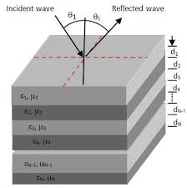
To calculate the regolith reflection coefficient at an incident angle $θ_{i}$, the regolith layer is discretized into $N$sub-layers of equal thickness which is taken to be 0.005 m as shown in Figure 22. The thickness value of 0.005 m is selected because, as proven through numerical calculations, it is the minimum thickness value below which thickness value has no effect on the calculated reflection coefficient. Discretizing the regolith layer converts the geometry of the inhomogeneous lunar regolith into a geometry of $N$ sub-layers subtended between two half spaces: an upper half space, the $0^{th}$ layer, which is represented by the exosphere, and a lower half space, the ${(N+1)}^{th}$ layer, which is represented by the half space of lunar bedrock. An arbitrary sub-layer $n$ ($n=1,2,…,N$) is subtended by the two planes:$z={-d}_{n-1}$ and $z={-d}_{n}$. The sub-layer has a thickness $∆_{n}$ ($∆_{n}=d_{m}-d_{n-1}$, $∆_{0}=0$), and a complex relative permittivity $ε_{n}$, which is equated to the complex relative permittivity at the upper interface of the sub-layer. The complex relative permittivity prediction model of Equations (35)-(37) is used to obtain $ε_{n}$ in terms of the bulk density $ρ$ which is obtained from (28).
The regolith reflection coefficient $R_{0}^{p}\left(θ_{i}\right)$ for $p$ ($p=v,h$) polarization is the reflection coefficient at the regolith upper interface ($n=0$). This reflection coefficient can be obtained from the recurrence relation (1D) through varying $n$ from $n=N-1$ to $n=0$ (Equation (39) of Recommendation ITU-R P.2040-2)
$$\begin{aligned}R_{n}^{p}\left(θ_{i}\right)=\frac{r_{n}^{p}\left(θ_{i}\right)+R_{n+1}^{p}\left(θ_{i}\right)\exp\left(-2jγ_{n+1}∆_{n+1}\right)}{1+r_{n}^{p}\left(θ_{i}\right)R_{n+1}^{p}\left(θ_{i}\right)\exp\left(-2jγ_{n+1}∆_{n+1}\right)} , p=v or h\#\left(1D\right)\end{aligned}$$
In (1D),${ r}_{n}^{v}\left(θ_{i}\right)$ and $r_{n}^{h}\left(θ_{i}\right)$ are the vertical and horizontal Fresnel reflection coefficients at the $n^{th}$ interface into the $n^{th}$ sub-layer:
$$\begin{aligned}r_{n}^{v}\left(θ_{i}\right)=\frac{ε_{n+1}\sqrt{ε_{n}-\sin^{2}{θ_{i}}}-ε_{n}\sqrt{ε_{n+1}-\sin^{2}{θ_{i}}} }{ε_{n+1}\sqrt{ε_{n}-\sin^{2}{θ_{i}}}+ε_{n}\sqrt{ε_{n+1}-\sin^{2}{θ_{i}}}}\#\left(2D\right)\end{aligned}$$
$$\begin{aligned}r_{n}^{h}\left(θ_{i}\right)=\frac{\sqrt{ε_{n}-\sin^{2}{θ_{i}}}-\sqrt{ε_{n+1}-\sin^{2}{θ_{i}}}}{\sqrt{ε_{n}-\sin^{2}{θ_{i}}}+\sqrt{ε_{n+1}-\sin^{2}{θ_{i}}}}\#\left(3D\right)\end{aligned}$$
and
$γ_{n}=k\sqrt{ε_{n}-\sin^{2}{θ_{i}}}$ (4D)
Figure 23 and Figure 24 depict trends of the magnitude of the regolith vertical and horizontal reflection coefficients with incident angle at two different frequencies:
– 450 MHz (Figure 22), and
– 2.4 GHz (Figure 23).
In plotting Figure 23 and Figure 24, based on prior methods (39), the complex relative permittivity of bedrock is taken to be $ε_{rock}=4 \left(1-j0.08\right)$. Moreover, all other parameters required for calculating the figures are given in figure captions.
To investigate how the regolith inhomogeneity could impact the magnitude of reflection coefficients, for each polarization, two types of reflection coefficient values are calculated in each figure:
– Regolith reflection coefficient values based on (1D), and
– Reflection coefficient values based on Fresnel reflection coefficient
Reflection coefficient values based on Fresnel reflection coefficients are obtained by replacing the regolith and bedrock by a uniform medium having the complex relative permittivity of the upper sub-layer of the regolith. In this case, the reflection coefficient values based on Fresnel reflection coefficient can be obtained from (2D) and (3D) through setting $n=0$ yielding
$$\begin{aligned}r_{0}^{v}\left(θ_{i}\right)=\frac{ε_{1}\cos{θ_{i}-\sqrt{ε_{1}-\sin^{2}{θ_{i}}}}}{ ε_{1}\cos{θ_{i}}+\sqrt{ε_{1}-\sin^{2}{θ_{i}}}}\#\left(5D\right)\end{aligned}$$
$$\begin{aligned}r_{0}^{h}\left(θ_{i}\right)=\frac{\cos{θ_{i}}-\sqrt{ε_{1}-\sin^{2}{θ_{i}}}}{\cos{θ_{i}}+\sqrt{ε_{1}-\sin^{2}{θ_{i}}}}\#\left(6D\right)\end{aligned}$$
In deriving (5D) and (6D) from (2D) and (3D), the complex relative permittivity of the lunar exosphere is equated to unity ($ε_{0}=1$). Moreover, Fresnel reflection coefficients in (5D) and (6D) are like the Fresnel reflection coefficients $R_{eTE}$ and $R_{eTM}$ given in Equations (37b) and (37a) of Recommendation ITU-R P.2040-3 respectively. TE, which stands for transverse electric, is equivalent to horizontal polarization, TM, which stands for transverse magnetic, is equivalent to vertical polarization. The reflection coefficients $r_{0}^{p}\left(θ_{i}\right)$ in (5D)-(6D) above, and hence in (37a)-(37b) in Recommendation ITU-R P.2040-3 are the ratio of reflected $E_{r}^{p}$and incident $E_{i}^{p}$electric field components as given in (31a)-(31b) of Recommendation ITU-R P.2040-3. The electric field components $E_{r}^{p}$ and $E_{i}^{p}$ are the electric field component tangential to the surface for polarization $\hat{p}$ ($p=v,h$).
Note: This fascicle and other ITU-R P-series recommendations define the reflected electric field vector in the same direction as the incident field’s polarization; i.e., with the same coordinate basis.
FIGURE 23
The geometry of reflection from regolith surface
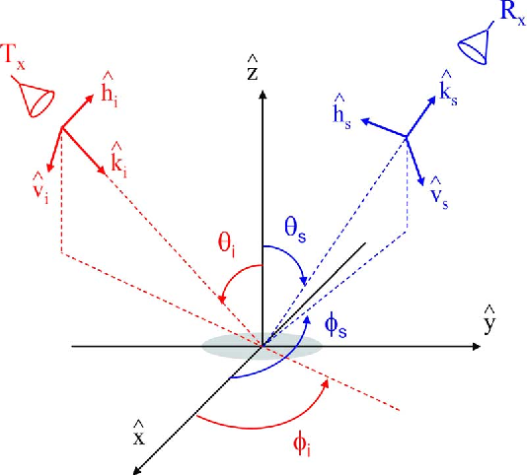
In the incident direction ${\hat{k}}_{i}$ the polarization vectors are ${\hat{h}}_{i}$ and ${\hat{v}}_{i}$ with:
$$\begin{aligned}{\hat{h}}_{i}=\frac{\hat{z}×{\hat{k}}_{i}}{\left|\hat{z}×{\hat{k}}_{i}\right|}=-\sin{φ_{i}}\hat{x}+ \cos{φ_{i}}\hat{y}\#\left(7D\right)\end{aligned}$$
$$\begin{aligned}{\hat{v}}_{i}=\frac{{\hat{h}}_{i}×{\hat{k}}_{i}}{\left|{\hat{h}}_{i}×{\hat{k}}_{i}\right|}=-\cos{θ_{i}\left(\cos{φ_{i}\hat{x}+ \sin{φ_{i}\hat{y}}}\right)}-\sin{θ_{i}\hat{z}}\#\left(8D\right)\end{aligned}$$
In the above, $\hat{z}$ is the normal on the regolith surface. For any arbitrary scattering direction ${\hat{k}}_{s}$ ($θ_{s}, φ_{s}$) as shown in Figure 23, the polarization vectors can be written as:
$$\begin{aligned}{\hat{h}}_{s}=\frac{\hat{z}×{\hat{k}}_{s}}{\left|\hat{z}×{\hat{k}}_{i}\right|}=-\sin{φ_{s}}\hat{x}+ \cos{φ_{s}}\hat{y}\#\left(9D\right)\end{aligned}$$
$$\begin{aligned}{\hat{v}}_{s}=\frac{{\hat{h}}_{s}×{\hat{k}}_{s}}{\left|{\hat{h}}_{s}×{\hat{k}}_{s}\right|}=\cos{θ_{s}\left(\cos{φ_{s}\hat{x}+ \sin{φ_{s}\hat{y}}}\right)}-\sin{θ_{s}\hat{z}}\#\left(10D\right)\end{aligned}$$
Based on Figure 23, at the reflection specular direction $θ_{s}=θ_{i}$ and $φ_{s}=φ_{i}$. Accordingly, the polarization vectors in the specular reflection direction can be written from (9D) and (10D) as follows
$$\begin{aligned}{\hat{h}}_{r}=-\sin{φ_{i}}\hat{x}+ \cos{φ_{i}}\hat{y}\#\left(11D\right)\end{aligned}$$
$$\begin{aligned}{\hat{v}}_{sr}=-\cos{θ_{i}\left(\cos{φ_{i}\hat{x}+ \sin{φ_{i}\hat{y}}}\right)}-\sin{θ_{i}\hat{z}}\#\left(12D\right)\end{aligned}$$
Comparing (11D) and (12D) against (9D) and (10D) indicates that the reflection from the surface does not change the direction of horizontally polarized field, and changes the direction of the vertically polarized field component tangential to the regolith interface. The vertically polarized tangential component defines the reflection coefficient, and it is given by:$E_{vt}=\cos{θ_{s}\left(\cos{φ_{s}\hat{x}+ \sin{φ_{s}\hat{y}}}\right)}$.
Examining Figures 24 and 25 indicates that:
‒ At frequencies of 450 MHz and below, the reflection coefficient magnitude values having an oscillating trend with the incident angle. Such a trend is attributed to the presence of bedrock layer, and the variation of the regolith complex relative permittivity with regolith depth.
‒ The vertically polarized reflection coefficient is more sensitive to regolith structure than the horizontally polarized reflection coefficient.
‒ At frequencies of 2.5 GHz, values of reflection coefficients magnitudes reduce to the corresponding values based on Fresnel reflection coefficients of (5D) and (6D). This implies that at those frequencies, the lunar regolith can be replaced by a uniform medium with complex relative permittivity equal to the corresponding permittivity at the regolith surface.
FIGURE 24
Comparison between values of lunar regolith reflection coefficient at 450 MHz (solid curves) and the corresponding values based on Fresnel reflection coefficients (dashed curves) {$\%{TiO}_{2}$ = 4, $\%FeO$=15, $d=5m\}$

FIGURE 25
Comparison between values of lunar regolith reflection coefficient at 2.4 GHz (solid curves) and the corresponding values based on Fresnel reflection coefficients (dashed curves) {$\%{TiO}_{2}$ = 4, $\%FeO$=15, $d=2m\}$

References
Barmatz, M., et al, “Microwave permittivity and permeability measurements on lunar simulants,” 43rd Lunar and Planetary Science Conference, 2012.
Bussey, Howard E. "Dielectric measurements of lunar soil." Lunar and Planetary Science Conference. vol. 9. (1978).
Campbell, M. J., and J. Ulrichs, “Electrical properties of rocks and their significance for lunar radar observations,” Journal of Geophysical Research, Vol. 74, No. 25, PP.5867 – 5881, 1969.
Campbell, B. A., B. Ray Hawke, T. W. Thompson, “Regolith composition and structure in the lunar Maria: Results of long-wavelength radar studies,” Journal of Geophysical Research, Vol. 102, No. E8, PP.19,307-19,320, 1997.
Carley, R. A., et al, “Magnetization of the lunar crust,” Journal of Geophysical Research, VOL. 117, E08001, doi:10.1029/2011JE003944, 2012.
Carrier, W. D., G. R. Olhoeft, and W. Mendell, Physical properties of the lunar surface. In G. H. Heiken, D. T. Vaniman, & B. M. French (Eds.), Lunar source book: A user's guide to the Moon (pp. 530–552). New York: Cambridge University Press, 1991.
Fa, W., and Y. Jin,” Simulation of brightness temperature from lunar surface and inversion of regolith-layer thickness,” Journal of Geophysical Research, Vol. 112, E05003, doi:10.1029/2006JE002751, 2007.
Fa, W., M. A. Wieczorek, and E. Heggy, “Modeling polarimetric radar scattering from the lunar surface: Study on the effect of physical properties of the regolith layer,” Journal of Geophysical Research, Vol. 116, E03005, doi:10.1029/2010JE003649, 2011.
Ferencz, C., “Real solution of monochromatic wave propagation in inhomogeneous media,” Paramana- J. Phys., Vol. 62, No. 4, PP.943 – 955, 2004.
French, Bevan M., Grant Heiken, and David Vaniman. Lunar sourcebook: A user's guide to the Moon. CUP Archive, pg. 93 (1991).
Garman, S. M. et al, “Magnetic field coupling with lunar soil simulants,” Scientific Reports, 2023, www.nature.com/scienticreports/.
Hongo, K., H. Toh, and A. Kumamoto,” Estimation of bulk permittivity of the moon’s surface using lunar radar sounder on-board Selenological and Engineering Explorer,” Earth, Planets and Space, 72:137, 2020.
Hyane, P.O., et al., “Global regolith thermophysical properties of the moon from the diviner lunar radiometer Experiments,” Journal of Geophysical Research: Planet”, Vol. 10, No. 1002, PP.2371 – 2400, 2017.
Hood, L. L. et al, “Initial mapping and interpretation of lunar crustal magnetic anomalies using Lunar Prospector magnetometer data,” Journal of Geophysical Research, VOL. 106, NO. Ell, PP. 27,825-27,839, November 25, 2001.
Ishiyama, et al., “Estimation of permittivity and porosity of lunar upper most basalt layer based on observations of impact craters by SELENE,” Journal of Geophysical Research, Vol. 118, PP.1453 - 1467, 2013.
Lai, J., Cui, F., Xu, Y., Liu, C. & Zhang, L. Dielectric properties of lunar materials at the Chang’e-4 landing site. Remote Sens. 13(20), 4056. https://doi.org/10.3390/rs13204056 (2021).
Lai, J. et al. Comparison of dielectric properties and structure of lunar regolith at Chang’e-3 and Chang’e-4 landing sites revealed by ground-penetrating radar. Geophys. Res. Lett. 46(22), 12783-12793. https://doi.org/10.1029/2019GL084458 (2019).
Light, M. E., “Geometric optics and WKB method for electromagnetic wave propagation in an inhomogeneous plasma near cutoff,” Los Alamos National Laboratory, Report LA-UR-17-23030, 2017.
Liu, C., et al., “Retrieving volume FeO and TiO2 abundances of lunar regolith with CE-2 CELMS data using BPNN method,” Research in Astronomy and Astrophysics, Vol. 19, No. 5, 66(12PP), 2019.
Lucey, P.G., G. J. Taylor, and E. Malaret, “Abundance and distribution of iron on the Moon,” Science, Vol. 268, PP.1855 – 1858, 1995.
Lucey, P.G., D. T. Blewett, and B. R. Hawke (1998), “Mapping the FeO and TiO2 content of the lunar surface with multispectral imagery,” J. Geophys. Res., Vol. 103, PP.3679 – 3699, 1998.
Lucey, P.G., D. T. Blewett, and B. L. Jolliff, “Lunar iron and titanium abundance algorithms based on final processing of Clementine ultraviolet-visible images,” J. Geophys. Res., 105, 20,297 – 20,305, 2000.
Manning, R. M., “Long-range transhorizon lunar surface radio wave propagation in the presence of a regolith and a sparse exospheric plasma,” NASA/TM—2008-215463; 2008.
Montopoli, M., et al., “Remote sensing of the Moon’s subsurface with multifrequency microwave radiometers: A numerical study,” Radio Science, VOL. 46, RS1012, 2011.
Moiseeva, N. “Cross-polarization of electromagnetic waves reflected by anisotropic gradient planar structures,” ITM Web of Conferences 30, 2019.
Olhoeft, D. W., A. L. Frisillo, and D. W. Strangway, “Electrical properties of lunar soil sample 15301,38, “ Journal of Geophysical Research, Vol. 79, No. 11, PP.1599 – 1604, 1974a.
Olhoeft, D. W, et al., “Temperature dependence of electrical conductivity and lunar temperature,” The Moon 9 (1974b) 79-87.
Olhoeft, G. R., and D. E. Capron, “Laboratory measurements of the radio frequency electrical and magnetic properties of soils from Yuma, Arizona,” Open File Rep. 93–701, 214 pp., U. S. G. S., Denver, Colo, 1993.
Prokopovich, I., et al., “Application of coupled-wave Wentzel-Kramers-Brillouin approximation to ground penetrating radar,” Remote Sensing. 2018, 10, 22; doi:10.3390/rs10010022.
Rao, Q., G. Xu, and W. Mao, “Detection of the lunar surface soil permittivity with megahertz electromagnetic Wave,“ Sensors 2021a, 21, 2466.
Rao, Q.; G. Xu, P. Wang, and Z. Zheng, “ Study of propagation characteristics of terahertz waves in a collisional and inhomogeneous dusty plasma with a ceramic substrate and oblique angle of incidence,” International Journal of Antennas and Propagation, 2021b, Article ID 6625530, 9 pages.
Rao, Q., G. Xu, P. Wang, and Z. Zheng,” Study on the propagation characteristics of terahertz waves in dusty plasma with a ceramic substrate by the scattering matrix method,” Sensors, 2021c, 21, 263.
Rochette, P., et al, “Magnetic properties of lunar materials: Meteorites, Luna and Apollo returned samples,” Earth and Planetary Science Letter, 292, PP. 383 – 391, 2010.
Siegler, M. A., et al., “Deriving lunar loss tangent and subsurface temperature from Chang’E-2 MRM and LRO Diviner,” 50th Lunar and Planetary Science Conference 2019 (LPI Contrib. No. 2132).
Stillman, D.; and G. Olhoeft,” Frequency and temperature dependence in electromagnetic properties of Martian analog minerals,” Journal of Geophysical Research, Vol. 113, E09005, doi:10.1029/2007JE002977, 2008.
Stubbs, T. J., et al,” On the role of dust in the lunar ionosphere,” Planetary and Space Science, 59, PP. 1659 – 1664, 2011.
Ugwu, E.. I., et al.,” Computational study of wave propagation through a dielectric thin film medium using WKB approximation,” American Journal of Scientific and Industrial Research, 2(4): 547-551, 2011.
Ulaby, F. T., et al., “Microwave dielectric properties of dry rocks,” IEEE Tran. Geoscience and Remote Sensing, VOL. 28. NO. 3, PP.325 – 336, 1990.
Viitanen, A. J.,” Generalized WKB Approximation for Stratified Bi-isotropic Media,” Journal of Electromagnetic Waves and Applications, Vol. 6, No. 1, PP.71 – 83, 1998.
Wang, R. et al. A novel approach for permittivity estimation of lunar regolith using the lunar penetrating radar on-board Chang’E-4 rover. Remote Sens. 13(18), 3679. https://doi.org/10.3390/rs13183679 (2021).
Wei, G., et al., “Lunar surface and buried rock abundance retrieved from Chang’E-2 Microwave and Diviner Data,” The Planetary Science Journal, 1:56 (16pp), 2020.
Wieczorek, M. A., et al, “An Impactor Origin for Lunar Magnetic Anomalies,” Science 335, 1212, 2012, DOI: 10.1126/science.1214773.
Zhang, W., “Lunar subsurface temperature profile modelling based on CE-1 and CE-2,” Bollettino di Geofisica Teorica ed Applicata, Vol. 60, n. 3, pp. 489-516; 2019.
Zheng, Y., et al., “Measurement of the complex permittivity of dry rocks and minerals: application of polythene dilution method and Lichtenecker’s mixture formula,” Geophys. J. Int. Vol. 163, PP.1195–1202, 2005.

_______________

Around the plasma frequency there is a transition region. At frequencies above the upper frequency of the transition region, the exosphere can be treated as free space. Based on Figures 3-8, at regolith surface the upper frequency of the transition region is about 1 MHz.
To ensure even symmetry around the relaxation frequency${ f}_{0}$, for a frequency deviation $∆f$, the following identity should be satisfied $μ_{r}^{''}\left(f_{0}+∆f\right)=μ_{r}^{''}\left(f_{0}-∆f\right)$. The frequency within the parentheses ( ), is the frequency at which $μ_{r}^{''}$ is calculated.
The odd symmetry around the relaxation frequency is satisfied if the following identity is satisfied satisfied $μ_{r}^{'}\left(f_{0}+∆f\right)-μ_{r}^{'}\left(f_{0}\right)=-\left\{μ_{r}^{'}\left(f_{0}-∆f\right)-μ_{r}^{'}\left(f_{0}\right)\right\}$. The frequency within the parentheses ( ), is the frequency at which $μ_{r}^{'}$ is calculated.

