Radiocommunication Study Groups | 
Source: Document 3K/TEMP/64  Subject: Clutter loss measurement | Revision 1 to  Document 3K/FAS/1-E
 | 3 July 2026
 | English only
Working Party 3K
FASCICLE 3K/FAS/1-1
Concerning Recommendation ITU-R P.2108 on clutter loss
in the frequency range 30 MHz to 100 GHz
Description of the method for clutter loss measurement
Scope
This Fascicle provides guidance on measuring clutter loss for Earth-space, aeronautical and terrestrial paths to support further development of Recommendation ITU-R P.2108 and the associated Report, ITU-R P.2402.

1 Clutter loss
“Clutter loss” is defined, in Recommendation ITU-R P.2108, as the difference in the transmission loss or basic transmission loss with and without the presence of terminal clutter at either end of the path with all other path details being the same.
When measuring clutter loss, L_{c} (dB), it is obtained as the difference between the theoretically predicted free space basic transmission loss (Rec. ITU-R P.525) and the measured basic transmission loss.

2 Measurement scenario
The uncluttered terminal should be positioned at sufficient distance from the first obstacle and/or at sufficient height that the wave front is essentially plane and clear of local obstructions.
Measurements made with directional and omnidirectional antennas may be expected to give different results; antenna characteristics should, in any case, be carefully described.
The measurements need to include paths on street canyons of different widths, open squares, parking places etc. to have representative statistics of all environments.

3 Measurement equipment
If measurements are performed using continuous wave (CW) transmissions the measured data should be spatially averaged to eliminate multipath fading. An alternative to spatial averaging would be frequency averaging using a wide band signal.
Estimation of the path loss requires calibration of the system from back-to-back tests where the transmitter output is connected to the input of the receiver via attenuators and all the gain settings in the receiver’s RF chain and signal conditioning are tabulated.
If mobile measurements are made, care should be taken to avoid distorting spatial statistics by repeated sampling when the vehicle is stationary. Measurements will, ideally, be triggered by the vehicle odometer although post-processing may also be applied.

4 Antennas
The antenna at the T_{c} can be omnidirectional or scanned in azimuth.
In the case where a directional antenna is used at the T_{u}, the pointing of the antenna should ensure that the main beam passes over the roof of the buildings and the T_{c} is inside the main beam. The pointing of the antenna needs to be known to apply the antenna gain corrections at the T_{u}.

5 Analysis of clutter loss with respect to elevation angle
Elevation angle is an input parameter only for the Earth-space and aeronautical statistical clutter loss model of Section 3.3 of the Recommendation.
While elevation angle could be defined in a variety of ways (see Figure 2), the distinction between them will generally be irrelevant for the long paths to which the Section 3.3 model would be applied. It should also be noted that where elevation is defined with respect to local clutter height, the use of spatial averaging of multipath may make it impossible to determine an unambiguous geometry for each measurement point.
Measurement data submitted to the Study Group should not include elevation angle. The post-processing of such data can derive such angles using assumptions appropriate to the particular analysis (e.g. plane-Earth geometry, detailed terrain data, high-resolution building data).

Figure 1
Illustration of elevation angles
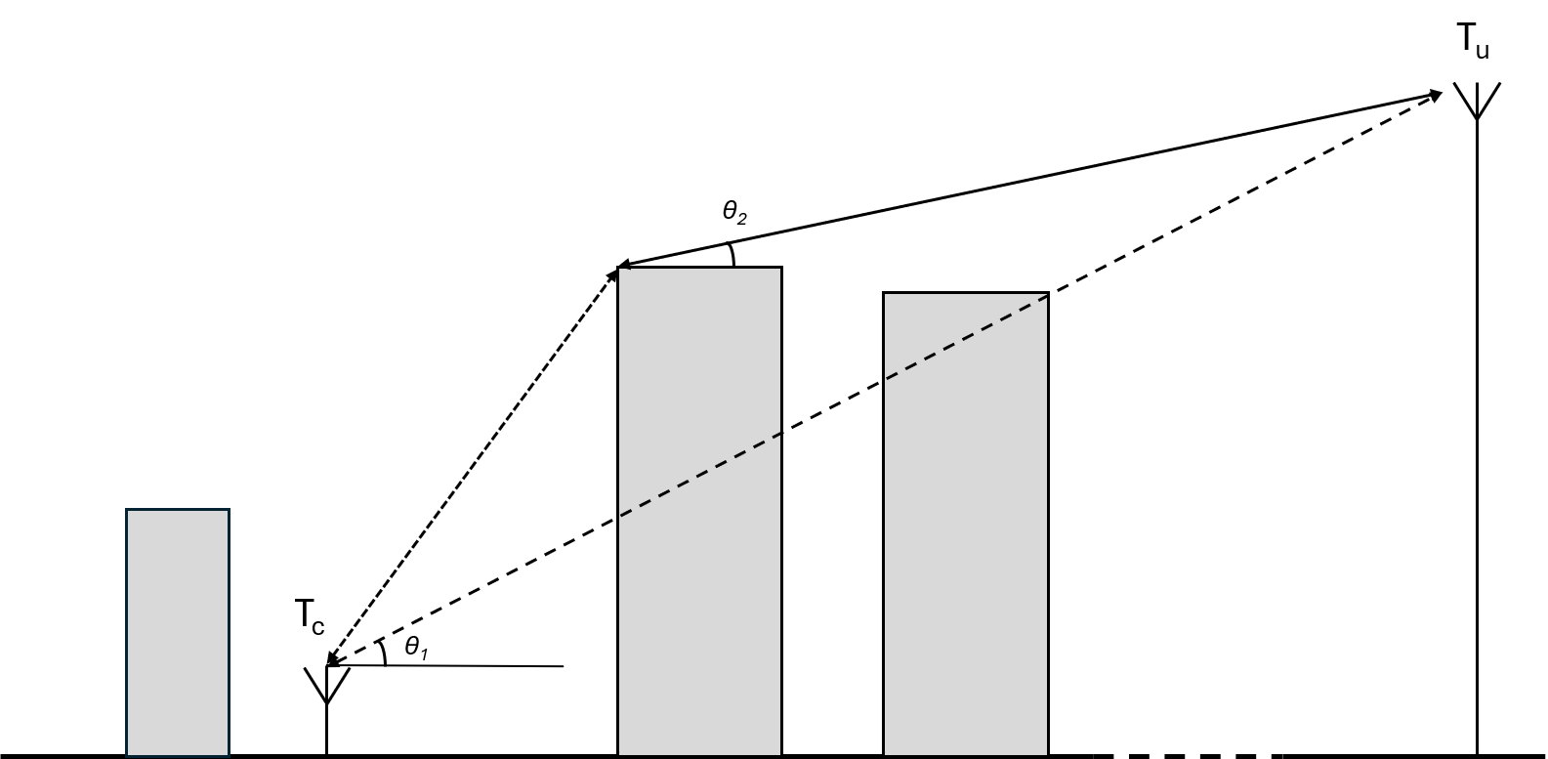

6 Parameters to be recorded
Each measurement set will ideally consist of a number of measurement samples in JSON format, following the schema embedded in this fascicle; if this is not possible a tabulated cumulative distribution function of loss could also be provided.
Researchers are asked to provide as much additional detail as possible; in particular, the geometry of the scenario. Photographs of the environment and measurement locations should be supplied.
When using directional antennas, antenna pointing information should be provided. Self-documenting information on antenna patterns should be provided as additional JSON metadata
The following parameters should be recorded when performing measurements of clutter loss, and submitted as a JSON data file. A schema for the submission of data is provided on the SG3 website.
TABLE 1
Measurement parameters
Datum | JSON element | Type | Note
Metadata
Number of measurement points | datapoint_count | Integer
Dataset name | dataset_name | string | Free text
Location | location | string | Free text
Coordinate reference system | EPSG | Integer | 4 or 5 digit ID
Start/stop date/time | date.start_time  date.stop_time | Structure (string) | ISO 8601 format
Noise floor | relative_noise_floor__dB | float | In terms of basic transmission loss
Transmitted waveform | waveform | string | CW, PRBS. Chirp, etc
Bandwidth | bandwidth__MHz | float | 0.0 if CW
Source | data_source | string | ‘measurements’, ‘raytracing’, ‘simulated’
Notes | notes | String array | Free text
Measurement area | bounding_box.lat_min__deg  bounding_box.lat_max__deg  bounding_box.lon_min__deg  bounding_box.lon_max__deg | Structure (float) | Decimal degrees, in WGS84 (EPSG 4326)
Terminal identification | uncluttered_terminal_is | string | ‘tx’ or ‘rx’
Environment type | environment | string | Free text
Multipath averaging | averaging | string | ‘spatial’, ‘frequency’
Uncluttered antenna data | uncluttered_antenna.type  uncluttered_antenna.pol  uncluttered_antenna.gain__dBi  uncluttered_antenna.azimuth__deg  uncluttered_antenna.elevation__deg | Structure (string, string, float, float, float) | type = ‘omnidirectional’ or ‘directional’  pol=’v’, ‘h’, ‘rhc’,’lhc’
Cluttered antenna data | cluttered_antenna.type  cluttered_antenna.pol  cluttered_antenna.gain__dBi | Structure (string, float) | type = ‘omnidirectional’ or ‘directional’  If ‘directional’ assumed aligned with other terminal  pol=’v’, ‘h’, ‘rhc’,’lhc’
datapoints
Reference ID | id | int | sequential
RX latitude | rx_lat__deg | float | Decimal degrees WGS84 (EPSG 4326)
RX longitude | rx_lon__deg | float | Decimal degrees WGS84 (EPSG 4326)
TX latitude | tx_lat__deg | float | Decimal degrees WGS84 (EPSG 4326)
TX longitude | tx_lon__deg | float | Decimal degrees WGS84 (EPSG 4326)
Frequency | f__MHz | float
Tx antenna height above ground | h_tx__m | float
Rx antenna height above ground | h_rx__m | float
Cluttered antenna data | uncluttered_antenna.azimuth__deg  uncluttered_antenna.elevation__deg | float  float | Only required if antenna is directional and not aligned with uncluttered antenna
Basic transmission loss | L_btl__dB | float | Including all calibration
Elapsed time | time_offset__s | float | seconds

_________________

Definitions of “transmission loss” and “basic transmission loss” are given in Recommendation ITU-R P.341.
JavaScript Object Notation (JSON)

