(Questions ITU-R 204-3/3, ITU-R 206-3/3)

|  |  |
| --- | --- |
| **Radiocommunication Study Groups** |  |
|  |  |
|  |  |
| Source: Annex 1 to Document 3M/50  Subject: Time series synthesis | **Document 3J/FAS/10-E** |
| **3 June 2013** |
| **English only** |
| Working Party 3J | |
| Fascicle  (Replaces Fascicle 3M/FAS/5) | |
| Background information on TROPOSPHERIC attenuation time series synthesiZer in recommendation ITu-R P.1853 | |
|  | |

# 1 Introduction

The document in Appendix 1 contains background information used to adopt Recommendation ITU-R P.1853 which may be useful in developing Handbook material. In its current version, it presents validation elements of the rain attenuation time series synthesizer adopted in the Recommendation.

Appendix 1

# 1 Introduction

This document presents validation elements of the rain attenuation time series synthesizer adopted in Recommendation ITU-R P.1853. It consists of a compilation of publicly available documents dealing with the proposed model. For any mentioned reference in this document, the elements which can be found in are listed.

While developing the time series synthesis method for Earth space links, an exhaustive comparison analysis with other existing models has been carried out with respect to European experimental data. For this testing analysis, the metrics recommended in Recommendation ITU-R P.311-12 have been used. Others metrics willing to assess the physical soundness of isolated events have also been defined and used.

The proposed model having been judged satisfying, its validation and parameterization has been extended to other areas and other climates making use of Canadian CRC data and Brazilian tropical and equatorial data.

References dealing with these issues are listed in section 2 of this document. Section 3 is concerned with terrestrial links, as not many references were available, validation elements have been annexed to this document.

The proposed time series synthesis method has not been compared to other models for terrestrial links, but a testing analysis has been carried out with respect to experimental data from Norway, Brazil and Hungary.

# 2 Validation for Earth-space links: published works

* F. Lacoste, M. Bousquet, L. Castanet, F. Cornet, J. Lemorton: “Improvement of the ONERA-CNES rain attenuation time series synthesiser and validation of the dynamic characteristics of the generated fade events”, Space Communication Journal, Vol. 20, n°1‑2, 2005.
* Version of the model without the Aoffset parameter
* Improved methodology to infer Beta value from experimental data
* Sensitivity of 2nd order statistics to Beta Value
* Introduction of Event-Based testing analysis
* F. Lacoste, M. Bousquet, L. Castanet, F. Cornet, J. Lemorton: “Event-based testing analysis of rain attenuation time series synthesizers for the ka-band satellite propagation channel”, Proceedings of CLIMDIFF conference, Cleveland, OH, USA, September 2005.
* Detailed description of Event-Based testing analysis
* Comparison of existing models with event-based method, including Maseng‑Bakken model with and without Aoffset
* F. Lacoste: “Modélisation de la dynamique du canal de propagation Terre-Espace en Bandes Ka Et EHF,” Ph. D. dissertation, Supaero, Toulouse, France, 2005.
* Exhaustive development of new models and comparison with existing ones with respect to Olympus and Italsat experimental data
* Elements concerning gaseous synthesis of scintillation time series
* J. Lemorton, L. Castanet, F. Lacoste, C. Riva, E. Matricciani, U-C. Fiebig, M.M.J.L. Van de Kamp, A. Martellucci: “Development and validation of time series synthesizers of rain attenuation for Ka-band and Q/V-band satellite communication systems”, *International Journal of Satellite Communications and Networking*, Volume 25, October 2007, pp 575‑601.
* Exhaustive testing of existing models using 1st and 2nd order statistics testing variables from Rec. ITU-R P.311-12, with respect to Olympus and Italsat data (Output of ESA contract n°16865/03/NL/EC)
* G. Carrie, F. Lacoste, L. Castanet: “A Robust Estimator of the Dynamic Characteristics of Rain Attenuation Events”, *Proceedings of 2nd JA2310 SatNEx Workshop*, Oberpfaffenhofen, Germany, April 2008.
* Current version of Beta estimator used to infer all the Beta values presented in ITU‑R input Document 3J/94
* Justification of the Aoffset parameter with respect to spectral characteristics using Italsat data
* G. Carrie, F. Lacoste, L. Castanet: “Validation of Rain Attenuation Time Series Synthesizers for Temperate Area - On the Enhanced Maseng-Bakken Model”, *Proc. IWSSC’08*, Toulouse, France, Oct. 2008 (IEEE).
* Introduction of CRC data in the 1st and 2nd order testing analysis
* M. Rodrigues, G. Carrie, L. Castanet, L. Silva Mello: “Study and test of Rain Attenuation Time Series Synthesizers for Tropical and Equatorial Areas”,   
  *Proc. ESA Workshop on Radiowave Propagation Models, Tools and Data for Space Systems*, Noordwijk, Netherlands, Dec. 2008.
* Introduction of Brazilian tropical and equatorial data in the 1st and 2nd order testing analysis
* Boulanger X.: " Modelling of the Earth-Space propagation channel in Ka and Q/V bands: Time series synthesis, statistical variability and risk estimation", University of Toulouse Ph’D, March 2013.
* Introduction of new time series synthesizers of rain attenuation
* Test of several time series synthesizers of rain attenuation
* Introduction of new methods to synthesize cloud, water vapour and oxygen attenuation and simultaneous rain and cloud attenuation
* Boulanger X., Féral L., Castanet L., Jeannin N., Carrie G., Lacoste F.: "A Rain Attenuation Time Series Synthesizer Based on a Dirac and Lognormal Distribution", IEEE Trans. on Antennas and Propagation, Vol 61, No 3, March 2013, pp1396-1406.
* Introduction of new time series synthesizers of rain attenuation
* Comparisons of several time series synthesizers of rain attenuation
* Boulanger X., Carrie G., Castanet L., Feral L.: "*Overview of a more simplified new channel model to synthesize total attenuation time series for satellite communication systems at Ka and Q/V band*", Space Communications Journal, 2013.
* Introduction of new methods to synthesize cloud, water vapour and oxygen attenuation, as well as scintillation in clear air and during rain
* Introduction of a new method to synthesize simultaneously rain and cloud attenuation
* Boulanger X., Castanet L., (Ed.) et al.: "A Rain Attenuation Time Series Synthesizer Based on a Dirac and Lognormal Distribution", COST-IC0802 Working Group 2 Final Report, Chapter 3, 2013.
* Comparisons of several time series synthesizers of rain attenuation
* Introduction of new methods to synthesize cloud, water vapour and oxygen attenuation and simultaneous rain and cloud attenuation
* Document 3J/49 – 3M/48 (June 2008).
* Aoffset justification for Earth-Space links
* Sensitivity of 2nd order statistics to Beta Value.

# 3 Terrestrial links

## 3.1 Published works

* Document 3J/49 – 3M/48 (June 2008).
* 2nd order conditional moment validation and Beta value assessment for Terrestrial links in Norway
* M. Cheffena, L.E. Bråten, T. Ekman: “On the Space-Time Variations of Rain Attenuation”, IEEE Transactions on Antennas and Propagation, vol. 57, no. 6, June 2009, pp 1771-1782.
* Table III (Lines 1 to 3): Experimental Beta values for 3 Terrestrial links at 43 GHz in Norway (consistent of doc. 3J/94)
* Figure 8: Comparison of experimental and synthetic 1st order statistics at 43 GHz for 3 Terrestrial links in Norway
* Figure 12: Comparison of experimental and synthetic rain attenuation autocorrelation at 43 GHz for 3 Terrestrial links in Norway.

## 3.2 Unpublished work annexed to this document

– Annex 1: Testing analysis of the model in terms of 1st and 2nd order statistics with respect to Terrestrial experimental data in Brazil at 15 and 18 GHz.

– Annex 2: 2nd order conditional moment validation and Beta value assessment for Terrestrial links in Hungary.

– Annex 3: Testing analysis of the model in terms of 1st and 2nd order statistics with respect to Terrestrial experimental data in Hungary at 38 GHz (Broadwan results).

# 4 Conclusion

For Earth-space paths, the time series synthesis method has been shown to be valid for frequencies between 4 GHz and 55 GHz and elevation angles between 5 deg and 90 deg.

For terrestrial paths, the time series synthesis method has been tested for frequencies between 14 GHz and 44 GHz and path lengths between 2 km and 28 km. As the assessment of input parameters is based on the prediction procedure outlined in Recommendation ITU-R P.530-12 which is considered to be valid in all parts of the world at least for frequencies up to 40 GHz and path lengths up to 60 km, it is proposed to extend the validity range of the time series synthesis method to frequencies between 4 GHz and 40 GHz and path lengths between 2 km and 60 km.

Annex 1

# 1 Experimental links in Brazil

FigURE 1

Yearly first order statistics



TABLE 1

Experimental links characteristics

|  |  |  |  |
| --- | --- | --- | --- |
| Location | Frequency (GHz) | Polarization | Rx-Tx length (km) |
| Bradesco | 14.55 | H | 12.8 |
| Cenesp | 14.55 | H | 12.78 |
| Cenesp | 18.61 | V | 12.78 |
| Scania | 14.50 | V | 18.38 |
| Barueri | 14.53 | V | 21.69 |
| Shell | 18.59 | V | 7.48 |

# 2 Input parameters assessment using Recommendation ITU-R P. 530-12

Figure 2

Barueli

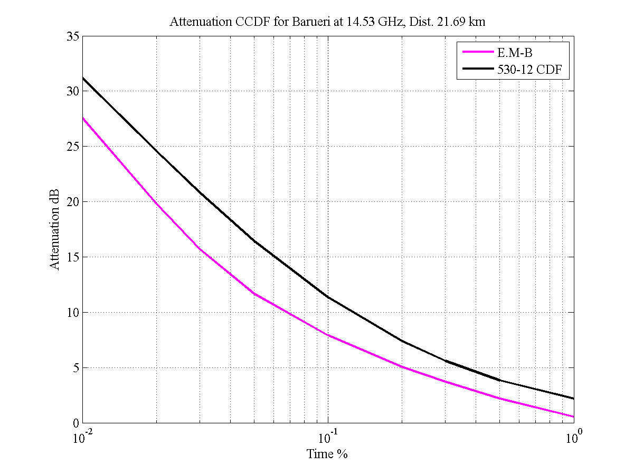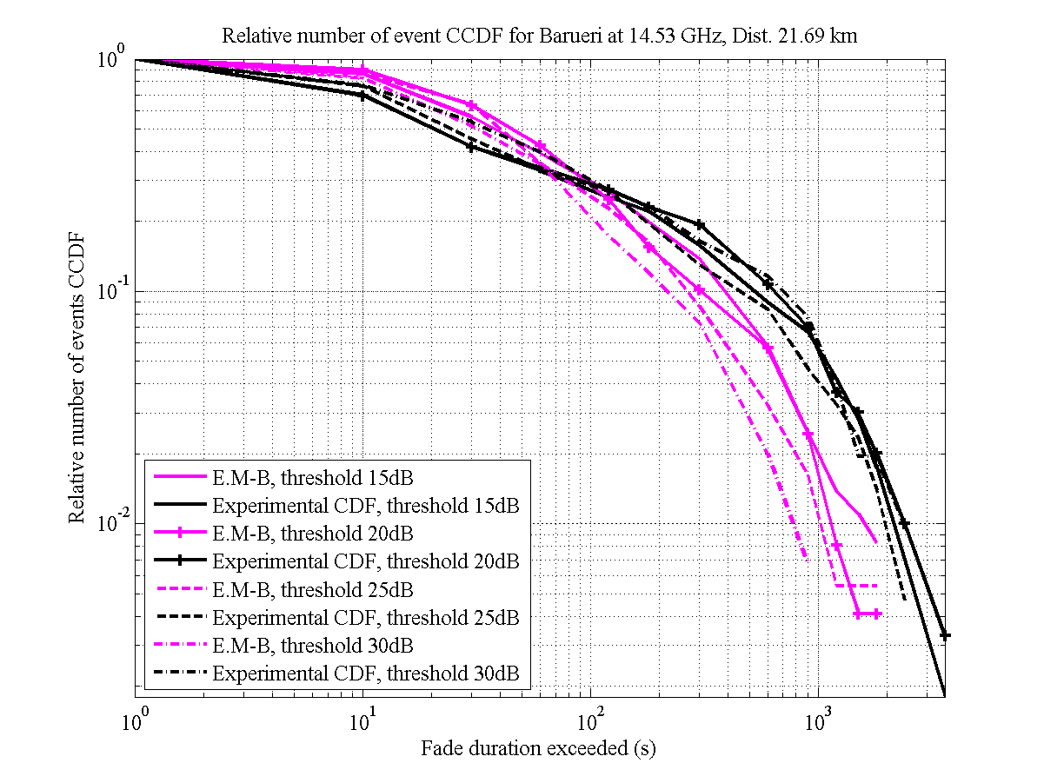

Figure 3

Bradesco

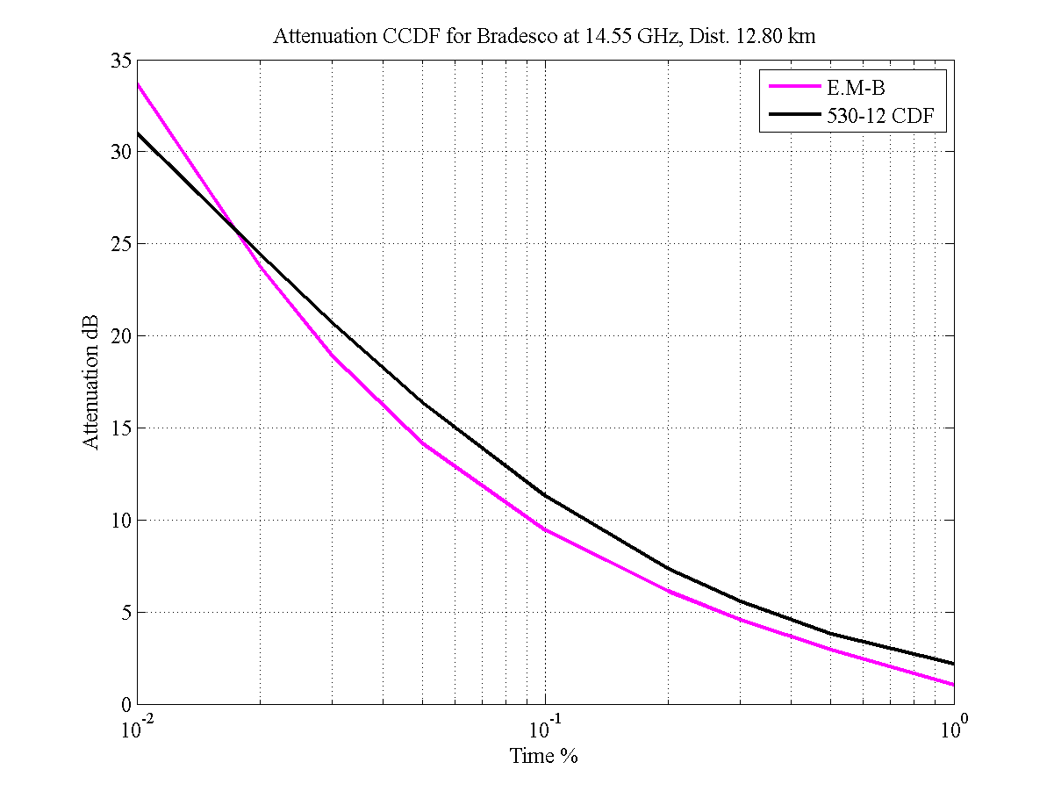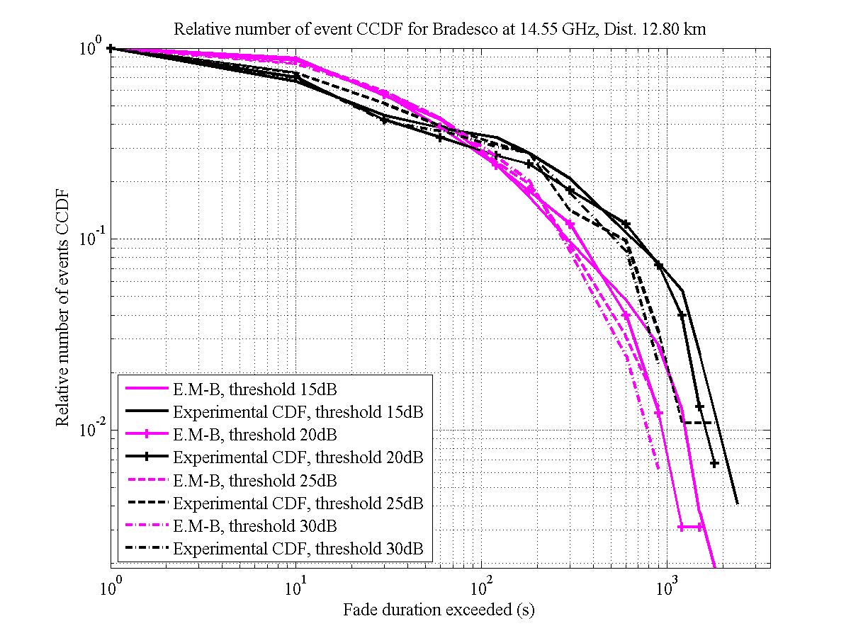

Figure 4

Cenesp 15

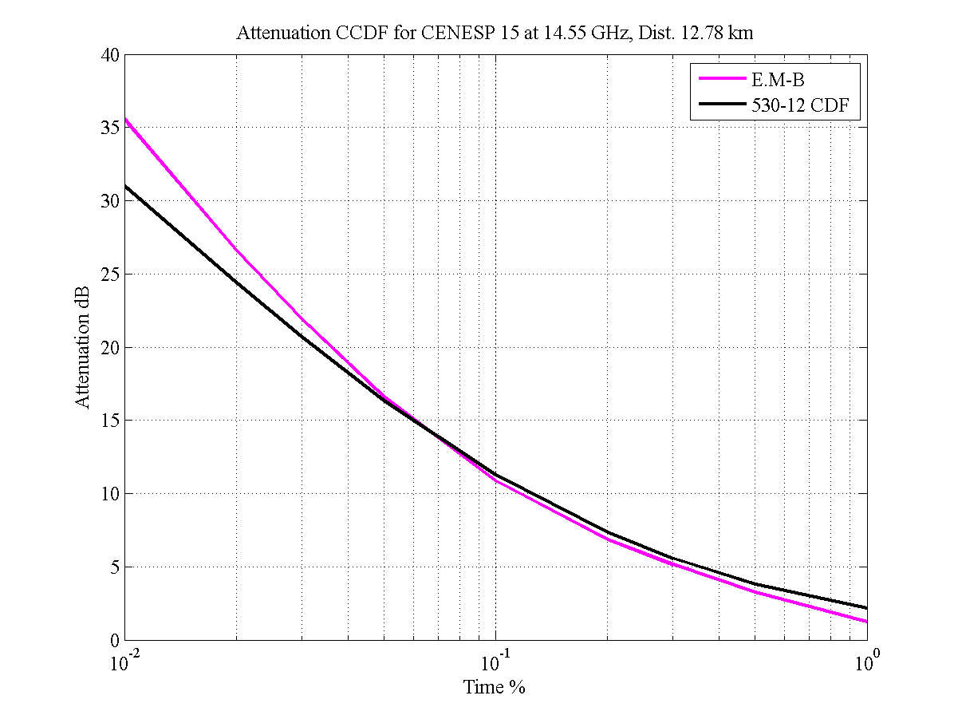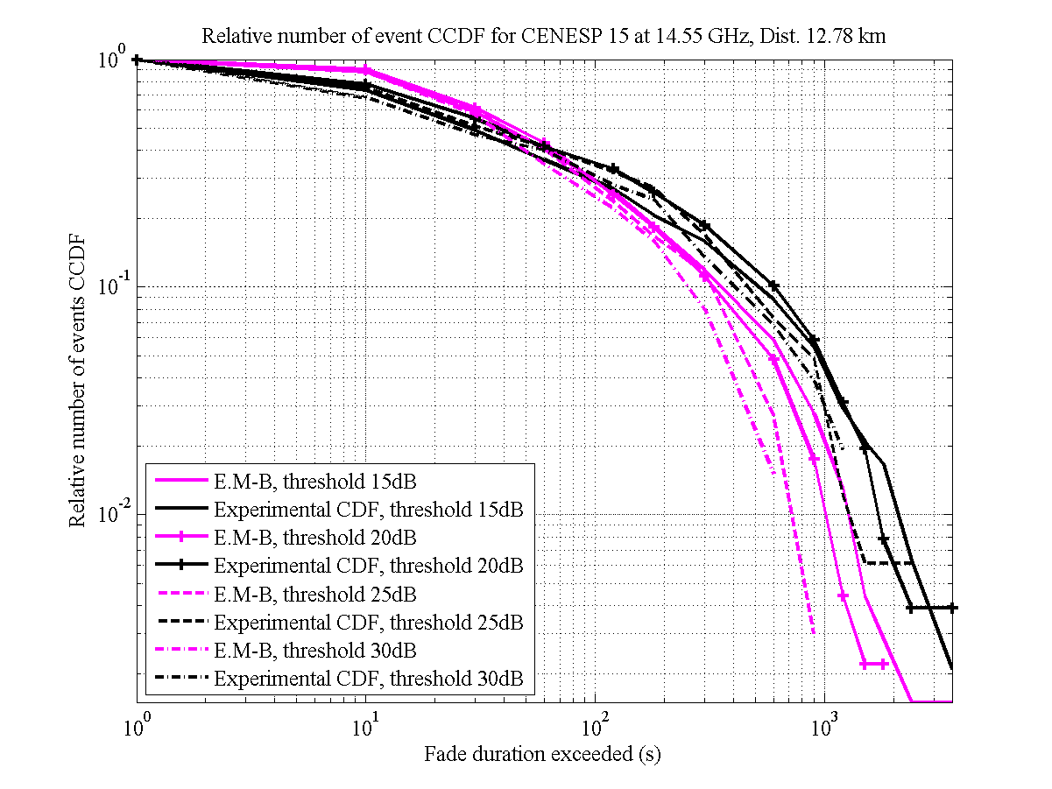

Figure 5

Cenesp 18

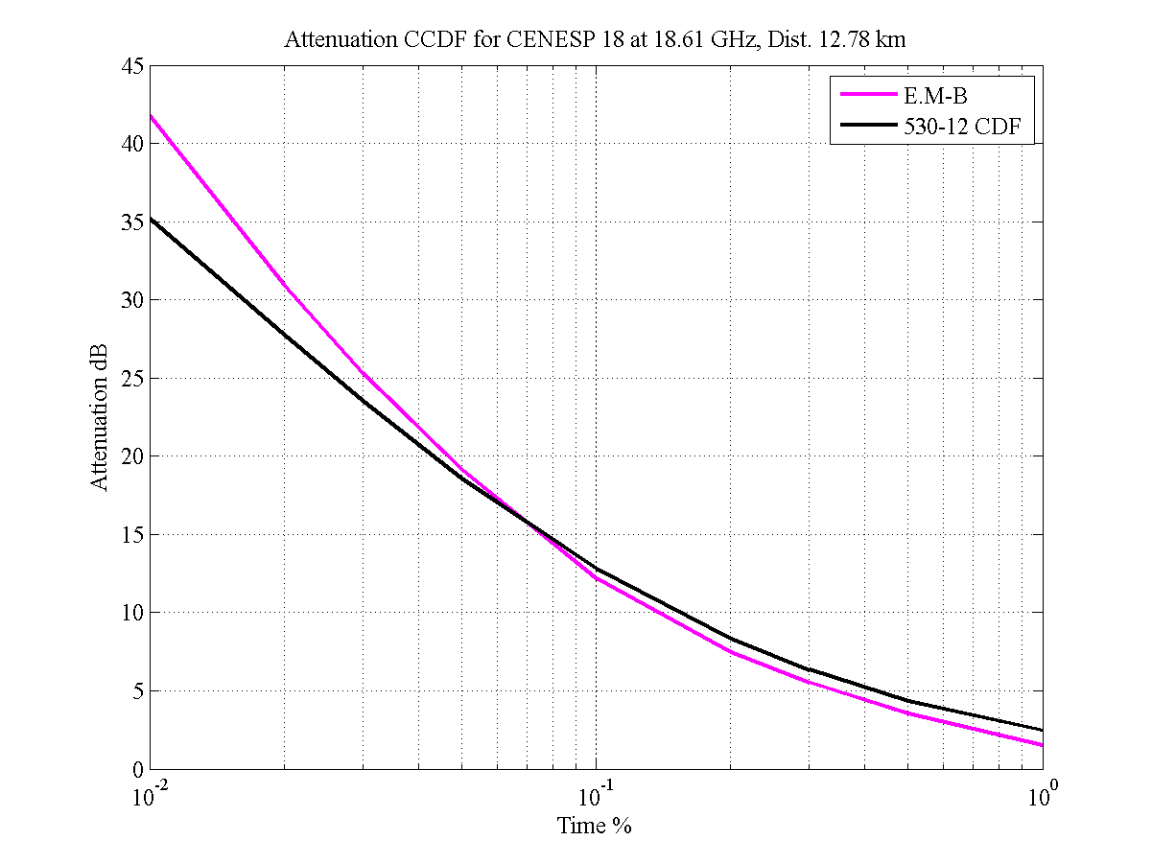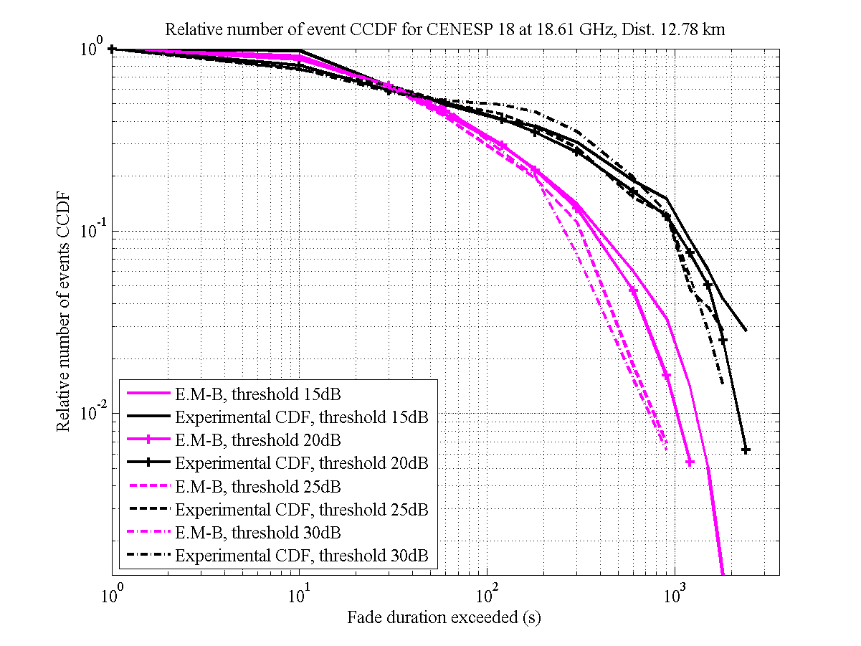

Figure 6

Scania

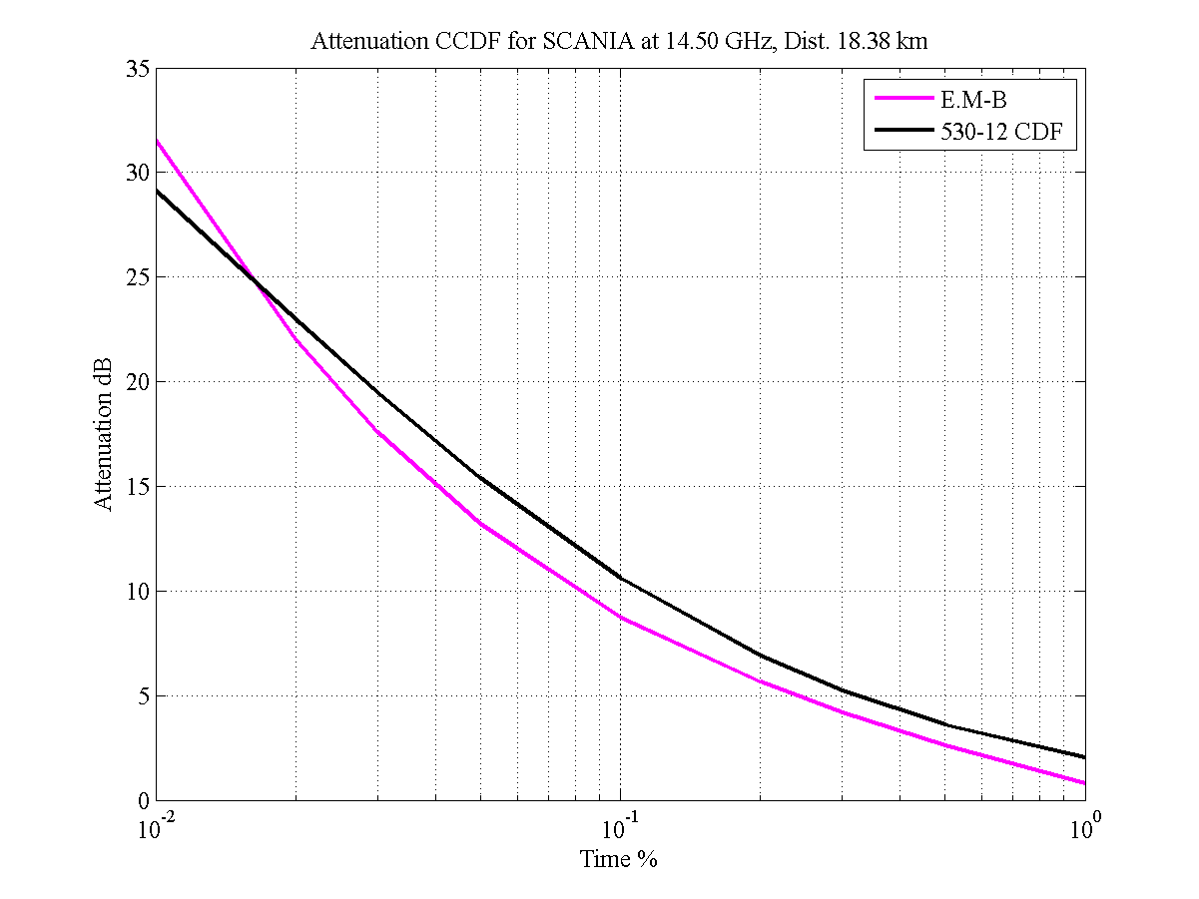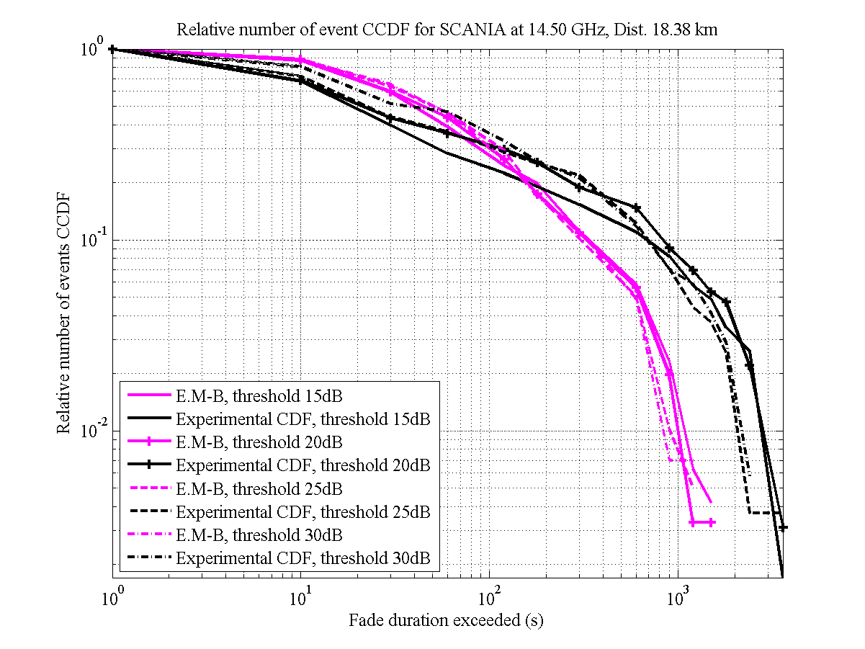

Figure 7

Shell

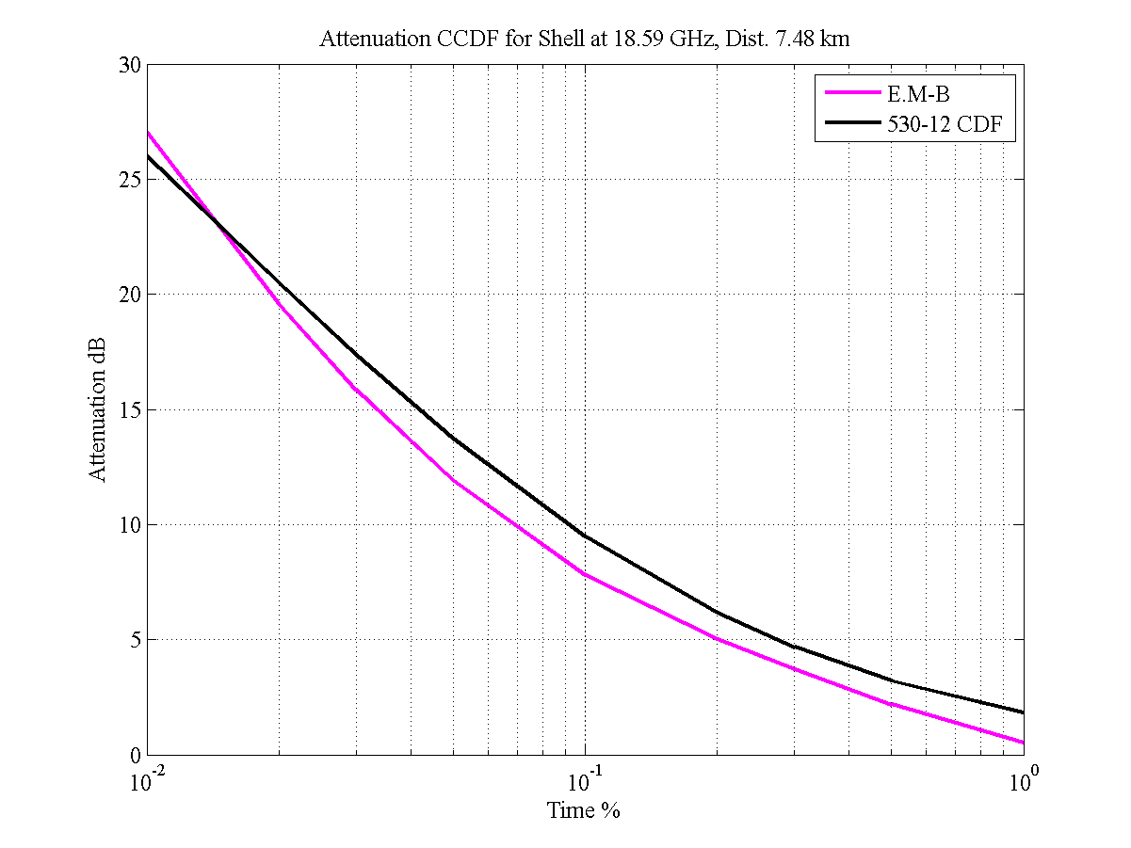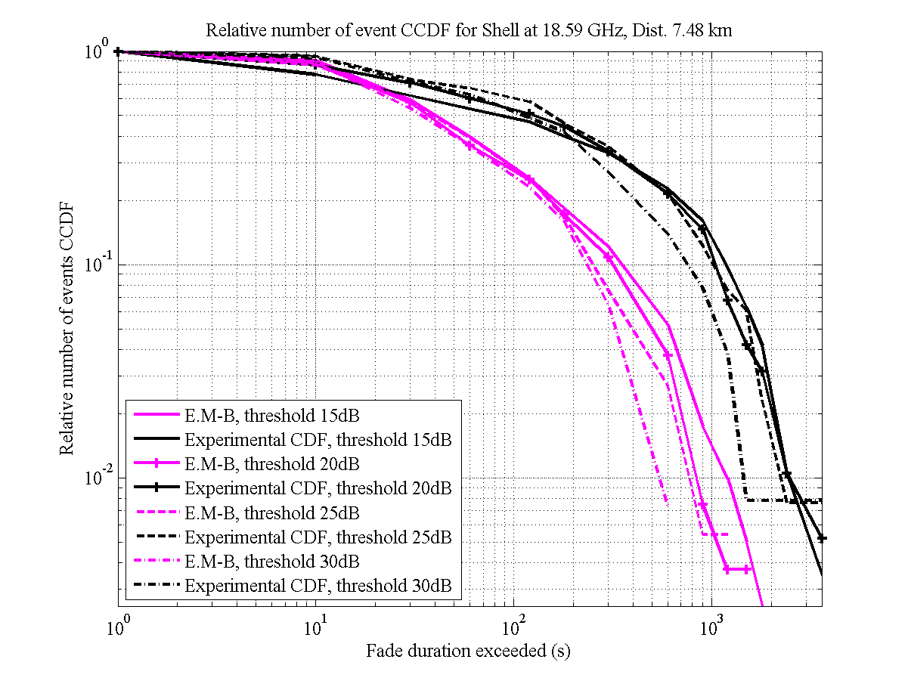

The model is tested using the test variables given in Recommendation ITU-R P.311-12.

Experimental reference in Earth-space links for first order statistics:

Italsat link in Spino d’Adda at 18.7 GHz : RMS,CPA = 0.18

table 2

RMS Error for CPA

| Model /  RMS CPA | Experimental Data | | | | | |
| --- | --- | --- | --- | --- | --- | --- |
| BARU | BRAD | CE15 | CE18 | SCAN | SHEL |
| Enhanced M-B | 0.47 | 0.23 | 0.16 | 0.16 | 0.28 | 0.34 |

All copolar attenuation (CPA) results but maybe BARU ones are satisfying.

table 3

RMS Error for Relative Number of Events

| Model /  RMS FDN | Experimental Data | | | | | |
| --- | --- | --- | --- | --- | --- | --- |
| BARU | BRAD | CE15 | CE18 | SCAN | SHEL |
| Enhanced M-B | 0.87 | 0.87 | 0.85 | 1.36 | 1.08 | 1.39 |

The figure hereafter shows reference relative fade number (FDn) errors (blue curve) for the Italsat link in Spino d’Adda at 18.7 GHz. Errors obtained with non optimal Beta values can give a reference to state if the model proposed for Terrestrial paths is satisfying. It can be concluded that at least BARU, BRAD and CE 15 results are satisfying. SCAN is a little bit worse but still acceptable. CE 18 and SHEL results may be explained by a significant number of attenuation measurements close to the dynamic range limit (see first order statistics).

Figure 8

Sensitivity of the 2nd order statistics with respect to β (Spino d’Adda link at 18.7 GHz)

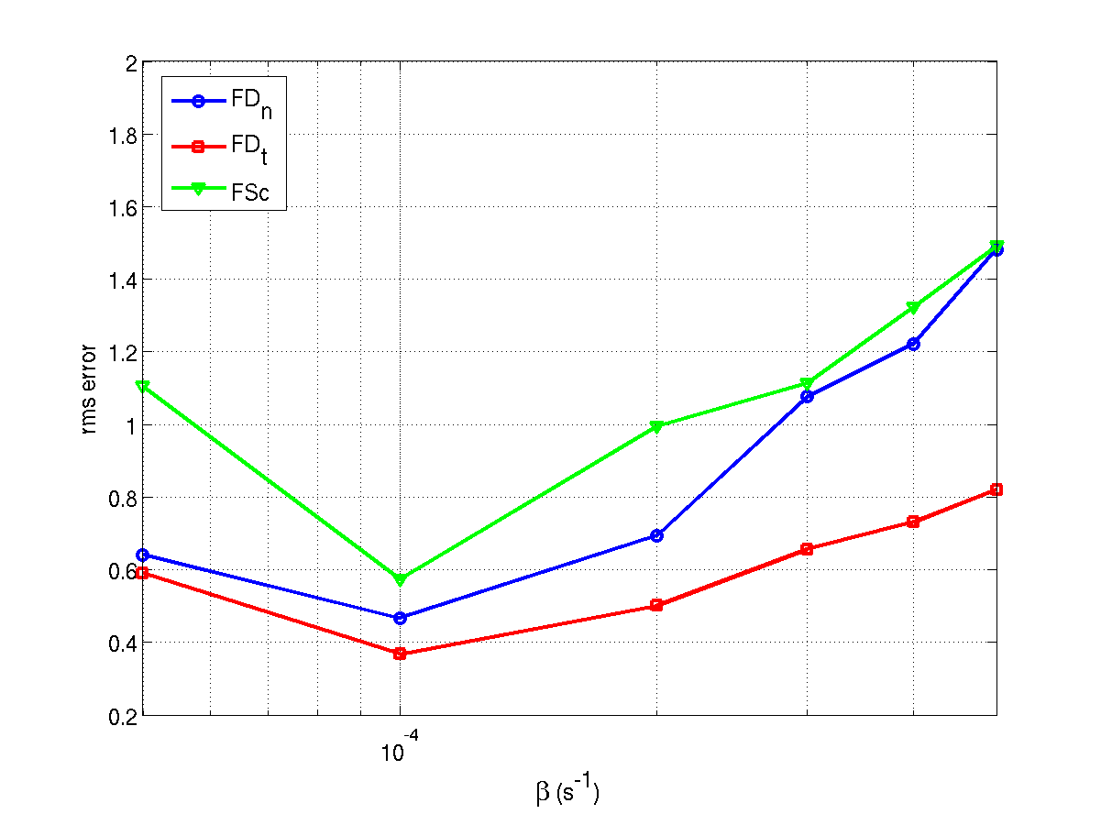

# 3 Input parameters assessment using experimental attenuation CCDF

Figure 9

Bradesco

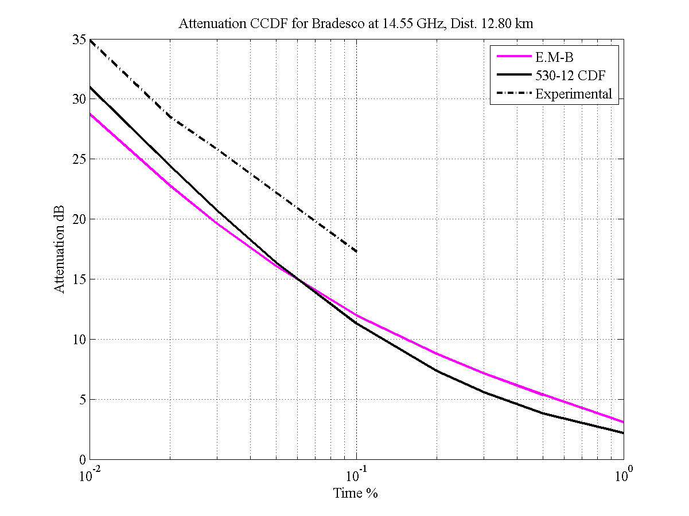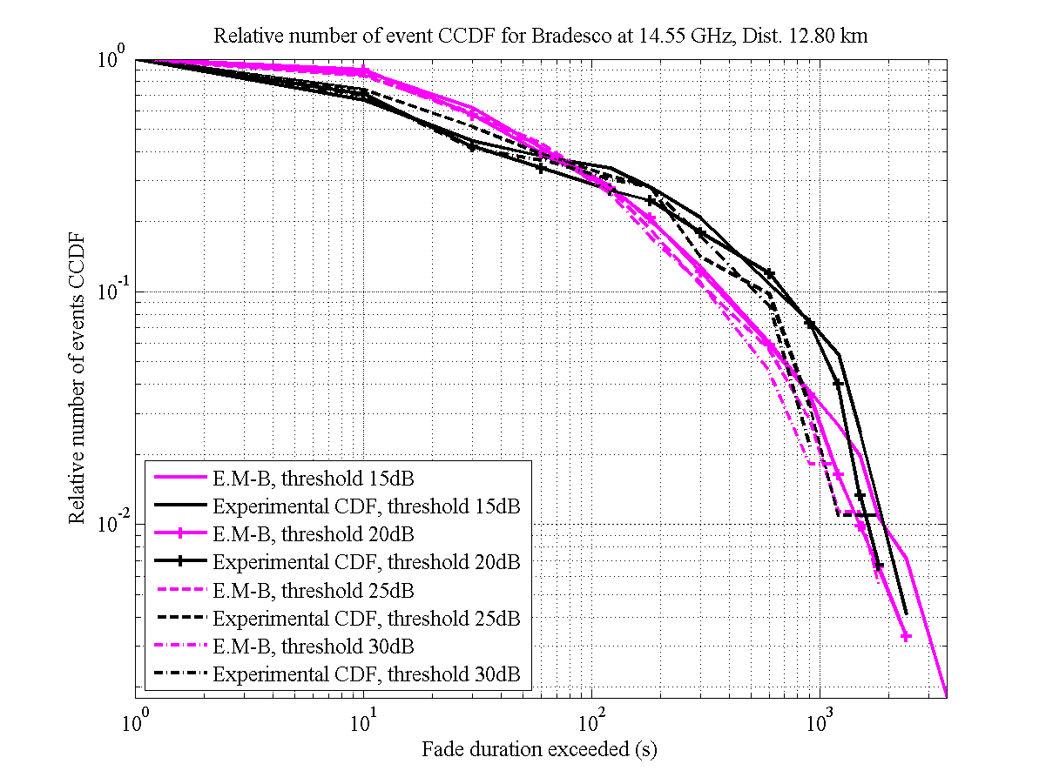

Figure 10

Cenesp 15

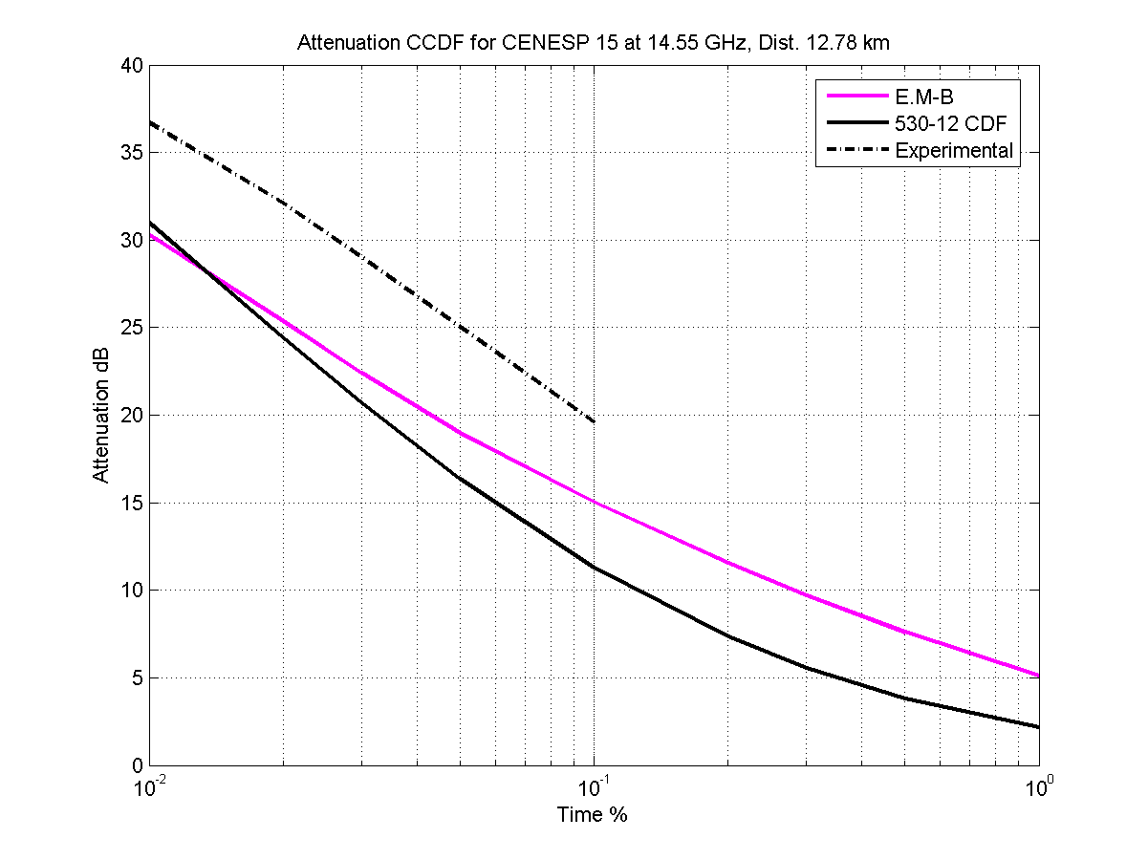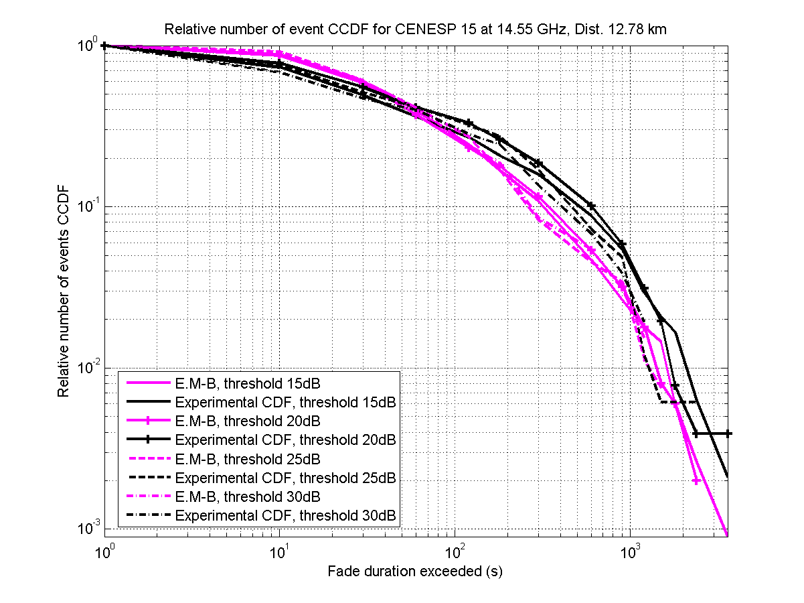

table 4

RMS Error for CPA

| Model /  RMS CPA | Experimental Data | | | | | |
| --- | --- | --- | --- | --- | --- | --- |
| BARU | BRAD | CE15 | CE18 | SCAN | SHEL |
| Enhanced M-B  Experim. | - | 0.27 | 0.24 | - | - | - |

Results in term of CPA are slightly worse than when using Recommendation ITU-R P.530-12. It may be due to the Aoffset value that is significantly higher in this case. Since experimental P0 value concurrent with experimental measurements was not available, the ITU-R P0 map (Rec. ITU‑R P.837-5) was used. This can explain the probable underestimation of P0 value corresponding to the experimental measurements and then causing an overestimation of the Aoffset parameter. Another possible explanation comes from the available percentages of time (less than 0.1%), whereas the proposed method uses percentages between 0.01 % and P0 %.

TABLE 5

RMS Error for relative number of events

| Model /  RMS FDN | Experimental Data | | | | | |
| --- | --- | --- | --- | --- | --- | --- |
| BARU | BRAD | CE15 | CE18 | SCAN | SHEL |
| Enhanced M-B.  530-12 | 0.87 | 0.87 | 0.85 | 1.36 | 1.08 | 1.39 |
| Enhanced M-B  Experim. | - | 0.39 | 0.47 | - | - | - |

The FDn error values obtained in this case are significantly lower than the ones obtained using Recommendation ITU-R P.530-12. Moreover, these values are very close to optimal ones obtained for Italsat link in Spino d’Adda at18.7 GHz (see Figure 8).

# 4 Conclusion

This preliminary testing analysis of the proposed model with respect to links at 15 and 18 GHz in Brazil seems to show that it can be used for terrestrial links at least for Rx-Tx distance between 7 km and 22 km in tropical areas.

Annex 2

The parameters of the investigated links in Hungary are listed in Table 1, while the schematic representation of the star topology are depicted in Figure 1 – Figure 2, where EOV-X and EOV-Y means the axis of the uniform Hungarian geographical frame of reference. In Table 1 the determined β and σ parameters of Enhanced Maseng-Bakken model are also listed, determination is described in details in the following.

Table 1

Link parameters and calculated β and σ values

|  |  |  |  |
| --- | --- | --- | --- |
| Name | HU32 | HU61 | HU66 |
| Site | Pécs | Szeged | Szeged |
| Frequency | 23 GHz | 38 GHz | 38 GHz |
| Polarization | V | V | V |
| Length | 10.03 km | 3.27 km | 2.86 km |
| β [1/s] | 1.45e-4 | 1.5339e-4 | 2.54e-4 |
| σ | 1.3395 | 1.3833 | 1.4462 |

Figure 1

Star topology of links in Pécs

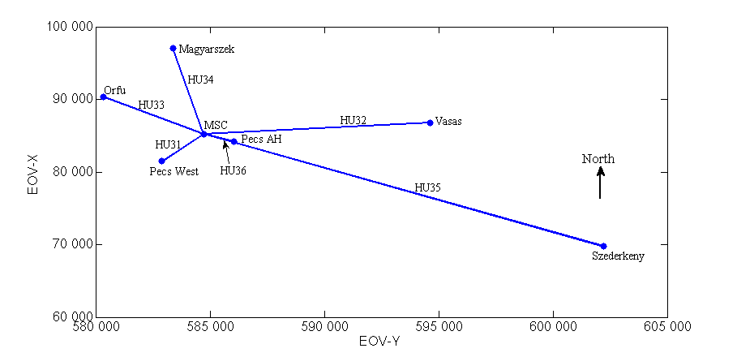

Figure 2

Star topology of links in Szeged

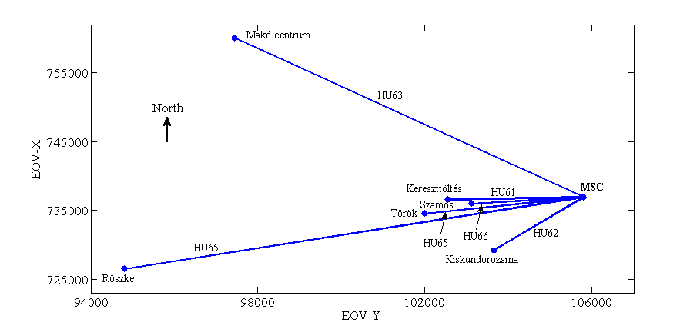

The β parameter of Enhanced Maseng-Bakken model has been calculated for several Hungarian terrestrial links. The regression curves for different links are depicted in Figure 3 – Figure 5. The obtained β and σ deviation parameters are summarised in Table 1 as well. Taking a look at the obtained values and link parameters the suspicion about the relationship between link length and β seems verified: the higher the link length is the smaller the β is.

Figure 3

β extraction for link HU32

|  |  |
| --- | --- |
|  |  |

Figure 4

β extraction for link HU61

|  |  |
| --- | --- |
|  |  |

Figure 5

β extraction for link HU66

|  |  |
| --- | --- |
|  |  |

Annex 3

Table 1

Parameters of the investigated link

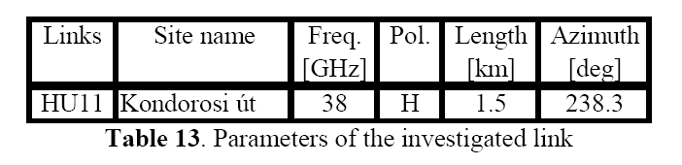

Figure 1

CDF of fade duration calculated from measured data  
for different threshold values

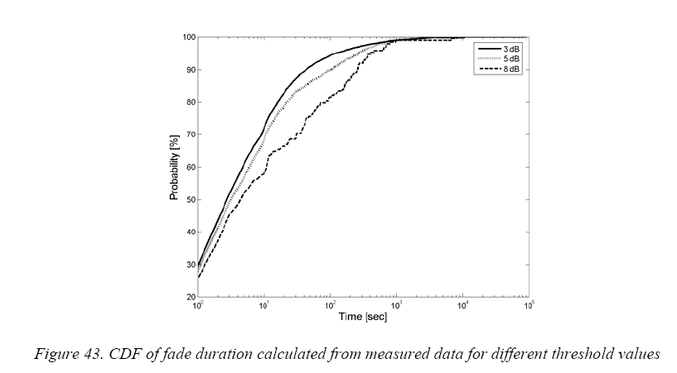

Figure 2

CDF of fade duration calculated from synthetic data (Rec. ITU-R P.530-12)  
for different threshold

Image1

***values (3, 5 and 8 dB)***

Figure 3

CDF of CPA calculated from measured data

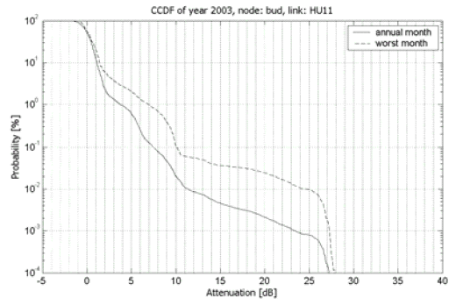

Figure 4

CDF of CPA calculated from Rec. ITU-R P.530 + Lognormal fitting



