|  |  |
| --- | --- |
| **Radiocommunication Study Groups** |  |
|  |  |
|  |  |
| Source: Documents 3J/TEMP/157, Fascicle [3J/FAS/9](https://www.itu.int/oth/R0A0400008C/en), and [3J/255](https://www.itu.int/md/R19-WP3J-C-0255/en)  Subject: Fascicle on Recommendation ITU-R P.838 | **Revision 1 of Document 3J/FAS/9-E** |
| **13 June 2023** |
| **English only** |
| Working Party 3J | |
| FASCICLE | |
| Rain specific attenuation formulation | |

Introduction

Recommendation ITU-R P.838 provides a model of rain specific attenuation that is relevant for various recommendations and is extensively used in SG 3 studies.

This fascicle provides information on the development of the current version of this recommendation, as described in the documents by ITU-R WP 3J and ITU-R SG 3 in the Study period 2003-2007.

This information is evaluated as needed for the validation and improvement of the methods contained in Rec. ITU-R P.838.

**Table of Contents**

1 Summary 3

2 Scattering Calculations 3

3 Rain Drop Size Distributions 2

3.1 Negative exponential distributions 5

3.2 Gamma Function Distributions 6

3.3 Lognormal and Shifted Lognormal Distributions 7

3.4 Weibull Distributions 7

3.5 Comparison of Drop Size Distributions 8

4 Raindrop Terminal Velocity 9

5 Derivation of Rain regression Coefficients 9

6 Path length Reduction Factors 9

7 Propagation Databanks available in 2003 11

8 Testing Parameters 11

9 Results of Testing on Terrestrial Paths in 2003 11

9.1 Variation with Drop Shape 11

9.2 Variation with Drop Terminal Velocity 12

9.3 Variation with Drop Size Distribution 13

9.4 Development of a Model Based on the Full Rainrate Distribution 13

9.5 Derivation of a New Path length Adjustment Factor 14

9.6 Temperature Dependence 19

9.7 Comparisons with the Terrestrial Databank 20

10 Algorithms for the Regression Coefficients 21

11 Comparison with Recommendation P.838-2 in 2003 24

12 Results of Testing on Slant Paths in 2003 25

12.1 Development of a New Model for Slant-Path Rain Attenuation 26

12.2 Determination of the Vertical Adjustment Factor 27

12.3 Comparisons with the Slant-Path Databank 30

13 Summary and Conclusions 33

14 Annex 1: The derivation of the equations in Rec ITU-R P.838 36

# 1 Summary

The model for the specific attenuation by rain contained in Rec. ITU-R P.838-3 has been originally developed by UK. This model derives from new calculations of the forward scattering amplitudes for scattering from oblate spheroidal raindrops which have been integrated with a number of different rain drop size distributions, to provide the best fits to the available experimental rain attenuation data.

The model was based on new calculations of the scattering amplitudes of raindrops, using the T‑matrix (or extended boundary condition) method, for frequencies from 1 GHz to 1 000 GHz. A large number of rain drop size distributions (DSDs) and path length reduction factors (which describe the inhomogeneity of rain, and which should ideally depend solely on the path length and rainfall rate) have been examined, in order to derive a model which best fits the experimental data available in 2003, both for terrestrial paths and for earth-space paths.

A complete description of the model development and testing was given by Gibbins and Walden [2003].

# 2 Scattering calculations

The key element to the theoretical prediction of specific attenuation by rain is a set of extinction cross-sections for each rain drop size, shape and orientation with respect to the incident wave. This requires an accurate solution of the electromagnetic wave equation, to determine the forward scattering amplitude for a plane wave incident on a single raindrop.

The influence of drop shape on propagation characteristics is widely documented in the literature, and although the effect is most important at lower frequencies, where the larger raindrops can exhibit resonant behaviour, it can still play a significant role at the frequencies of most interest here. For example, recent calculations by Kim *et al.* [2001] suggest that, even at 40 GHz, there may be a difference in specific attenuation between horizontal and vertical polarizations of around 20% for oriented raindrops. This study supports this finding.

In practice, drop shape and size are linked, and it is customary to assume a one-to-one relationship between the two, with the selected shape corresponding, for example, to the hydrodynamic equilibrium shape. The other customary assumption is to neglect fluctuations in orientation and consider a single orientation as representative, although there may be variations in canting angle along a link path induced by the effects of wind. Given the approximate way in which spatial variations in rainfall rate are taken into account, though, this effect is perhaps of secondary importance, and hence is not considered here.

Keenan *et al.* [2001] have recently reviewed raindrop-size relationships. Past studies have suggested that, as far as scattering of microwaves and millimetre waves is concerned, the important parameter characterizing raindrops is the way in which the aspect ratio *α*(*D*), i.e. the ratio of minor to major axes, rather than the precise drop shape. Hence, raindrops are commonly modelled as oblate spheroids with various expressions proposed for the functional form of *α*(*D*), and the drop shapes which have been evaluated in this study are:

* Pruppacher and Beard [1970] (PB)
* Pruppacher and Pitter [1971] (PP)
* Green [1975] (G)
* Beard and Chuang [1987] (BC)
* RAL / Beard-Chuang (RBC)
* Chuang and Beard [1990] (CB)
* Olympus [Poiares Baptista, 1992] (OL)
* Keenan-AB [2001] (KA)
* Keenan-NR [2001] (KN)

Figure 1 illustrates graphically the aspect ratios for these models, which have been used in this study.

FIGURE 1

Raindrop aspect ratio – size relationships for the nine models selected in this study

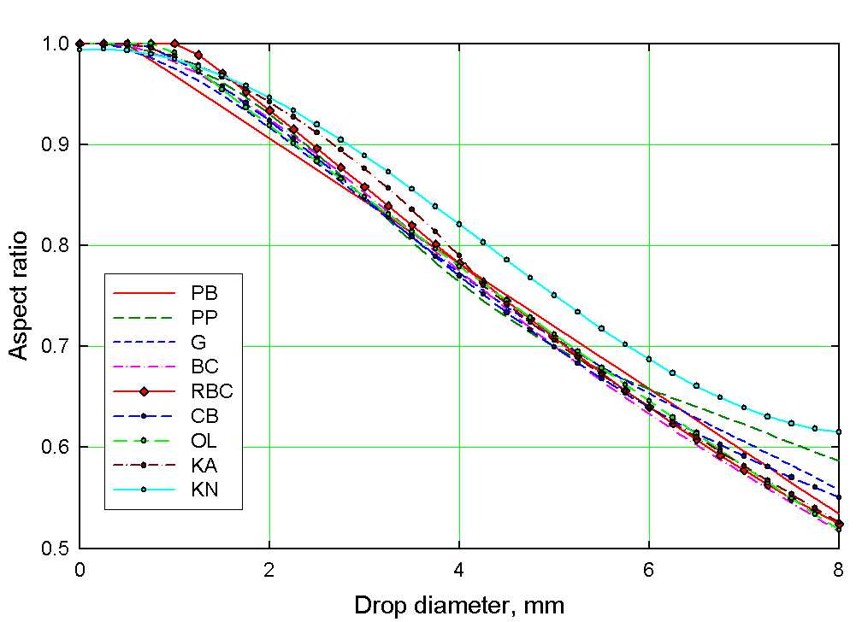

Forward scattering amplitudes versus equi-volume diameter *D* of spheroidal particles have been calculated for each selected frequency and temperature, assuming an orientation in which the symmetry axis is vertical. The temperature dependence of the extinction coefficients derives from the variation in the refractive index of water, and in common with the majority of other treatments, the refractive index model of Ray [1972] has been used.

There are a variety of computational methods available for determining the scattering properties of non-spherical dielectric particles; these may be classified into two broad categories: (a) differential equation methods which compute the scattered field by solving the vector wave equation in the frequency and time domain, and (b) integral equation methods based on the volume or surface integral counterpart of Maxwell’s equations. Exceptions are hybrid methods such as the extended boundary condition (EBC) or T-matrix method, which can be derived using different approaches. Mishchenko *et al.* [2000] have recently reviewed comprehensively these methods, the applicability of which depends on the value of the size parameter , where *λ* is the wavelength. For rain attenuation in the frequency range up to 1 000 GHz, size parameters of about 100 are involved, and Mishchenko *et al.* report that current implementations of the EBCM method are applicable to size parameters in excess of 100.

Thus, the EBC method has been used in this study. It is based on expanding the incident field in vector spherical wave functions (VSWFs) regular at the origin, and expanding the scattered field outside a circumscribing sphere of the scatterer in VSWFs regular at infinity. Imposing boundary conditions on the surface of this sphere allows determination of the elements of a T-matrix which transforms the expansion coefficients of the incident field into those of the scattered field.

Scattering amplitudes were calculated at frequencies from 1 to 100 GHz, at 1 GHz intervals, and at 120, 150, 200, 300, 400, 500, 600, 700, 800, 900 and 1 000 GHz. At each frequency, calculations were carried out at temperatures from 0° to 30°C at 5°C intervals.

The results of these calculations have been extensively compared with previous results derived using the Fredholm integral equation method (FIM) [Holt *et al.*, 1978], with which there was very good agreement. Further comparisons were also made with other results for both lossy and non-lossy dielectric ellipsoids, also with good agreement.

# 3 Rain drop size distributions

The specific attenuation due to rain, *γ*, is calculated by integrating the imaginary part of the forward scattering amplitudes over the rain drop size distribution:

$γ=4.343×{10}^{-3}\int_{D_{min}}^{D_{max}}{N\left(D\right)Q_{ext}(D)}dD$ (1)

where *N*(*D*) is the distribution (in m-3mm-1) of raindrop sizes of diameter *D* (mm) and *Qext*(*D*) is the extinction cross-section (in m2) of a raindrop (Ishimaru, 1978; Karam and Fung, 1982; Karam, 1998, Okamura and Oguchi, 2010).

$Q_{ext}\left(D\right)=\frac{4π}{k} Im\left\{f(D;\hat{i},\hat{i})\right\}$ (1a)

In (1a), $f\left(D;\hat{i},\hat{i}\right)$ is the scattering amplitude in the forward direction (m) of a raindrop with diameter $D$, $Im\{ \}$ is the imaginary part operator, and $k$ ($m^{-1}$) is the wavenumber, $k=2π/λ$. Moreover, the integration in (1) is carried out over all raindrop sizes. It is thus necessary to know the rain drop size distribution, and a large number of models for this have appeared in the literature. These are generally expressed in algorithmic form which may be categorized into the following four groups of model:

1. Negative exponential distributions
2. Gamma function distributions
3. Lognormal and shifted lognormal distributions; and
4. Weibull distributions

## 3.1 Negative exponential distributions

The negative exponential function is probably the most extensively-used distribution for rain drop sizes, and can be written in the form

 (2)

where the coefficients *N*0 and Λ may be constants or functions of rainfall rate *R*. Quite a number of variants of the negative exponential distribution have appeared in the literature, of which perhaps the most widely used is that derived by Marshall and Palmer in 1948 from an analysis of the stains made by raindrops falling on died filter paper. Table 1 lists some of the values for the coefficients which have been used by various authors.

TABLE 1

Coefficients in the negative exponential distribution

| Reference | Code | *N*0 | Λ |
| --- | --- | --- | --- |
| Marshall and Palmer [1948] | MP | 8 000 |  |
| Joss *et al.* – drizzle [1968] | JD | 30 000 | 5.7*R*-0.21 |
| Joss *et al.* – widespread [1968] | JW | 7 000 | 4.1*R*-0.21 |
| Joss *et al.* – thunderstorm [1968] | JT | 1 400 | 3.0*R*-0.21 |
| Manabe, Ihara and Furuhama [1984] | MIF |  |  |
| Ihara, Furuhama and Manabe [1984] | IFM |  |  |
| Ulbrich (Laws & Parsons) [1983] | ULP |  |  |
| Yang-Su *et al*. (ETRI) [2001] | ET |  |  |
| Uijlenhoet [2001] | U1 | 8000 | 4.23*R*-0.214 |
| U2 | 6910*R*0.019 | 4.1*R*-0.21 |
| U3 | 11300*R*-0.203 | 4.55*R*-0.258 |
| U4 | 8000 | 4.34*R*-0.229 |
| U5 | 5410*R*0.13 | 4.1*R*-0.21 |

In this Table, as in the following, the “Code” is used to identify the DSDs in the Sections on testing in this document. Note also that *R* is the rainfall rate in mm/h.

## 3.2 Gamma function distributions

A generalized function of which the negative exponential is a special case, the gamma function was first proposed as a rain drop size distribution by Deirmendjian [1963], in the form:

 (3)

This function has been employed by a number of authors, and those which have been tested in this study are listed in Table 2.

TABLE 2

Coefficients in Gamma function distributions

|  |  |  |  |  |  |  |
| --- | --- | --- | --- | --- | --- | --- |
| Reference | Code | *N*0 | | *p* | Λ | *q* |
| Maitra and Gibbins | MGG1 |  | | 2 |  | 1 |
| MGG2 |  | | 2 |  | 1 |
| Ajayi and Olsen | AO | *R* ≤ 15 | 260 | 1.43 |  | 2.6 |
| *R* > 15 | 210 | 1.43 |  | 3.1 |
| Gloaguen | GL |  | | *n* |  | 1 |

## 3.3 Lognormal and shifted lognormal distributions

Two variants of the lognormal distribution have been investigated for application to drop size distributions. These are the conventional lognormal distribution, generally expressed as:

 (4)

and the so-called “shifted” lognormal distribution, in which the dependent variable, here the diameter of the raindrop, is given an offset, *s*:

 (5)

Parameters in some lognormal and shifted lognormal distributions are given in Tables 3 and 4.

It is pertinent to note that, because of the shifting value s, the number of drops in the shifted lognormal distribution does not become zero when *D* → 0. For this reason it can only be used from a lower limit of about 0.1 mm. In applying the shifted lognormal in the present studies, the number of drops was thus constrained to zero at drop diameters below 0.1 mm.

TABLE 3

Coefficient in lognormal distributions

|  |  |  |  |  |
| --- | --- | --- | --- | --- |
| Reference | Code | *N*0 | *σ* | *μ* |
| Maitra and Gibbins | MGL |  |  |  |
| Veyrunes | Ve |  |  |  |

TABLE 4

Coefficients in shifted lognormal distributions

|  |  |  |  |  |  |
| --- | --- | --- | --- | --- | --- |
| Reference | Code | *N*0 | *s* | *σ* | *μ* |
| Park | PK |  | 1 |  |  |
| Åsen and Gibbins | AGL1 |  | 1 | 0.29 |  |
| AGL2 |  | 1 | 0.23 |  |

## 3.4 Weibull Distributions

The Weibull distribution was presented by Assouline and Mualem [1989], who derived an expression theoretically, based on the mechanisms of drop coalescence and break-up. The Weibull distribution can be expressed as

 (6)

Brussaard and Watson[1995] have applied this to a variety of climates, while Åsen and Gibbins have further investigated the Weibull distribution for temperate and tropical climates.

TABLE 5

Coefficients in Weibull distributions

|  |  |  |  |  |  |
| --- | --- | --- | --- | --- | --- |
| Reference | Code | *N*0 | *η* | *a* | *σ* |
| Brussaard and Watson [1995] | W1 |  | 3 | 0.71 |  |
| W2 |  | 3 | 0.71 |  |
| W3 |  | 3 | 0.71 |  |
| W4 |  | 3 | 0.71 |  |
| Åsen and Gibbins [2002] | AGW1 |  |  | 1.0 |  |
| AGW2 |  |  | 1.0 |  |

## 3.5 Comparison of drop size distributions

For comparison, Figure 2 illustrates these rain drop size distributions, calculated for a rainfall rate of 30 mm/h.

FIGURE 2

Examples of rain drop size distributions for a rainfall rate of 30 mm/h



|  |  |  |  |  |  |
| --- | --- | --- | --- | --- | --- |
| **1** | Negative exponential: | Marshall-Palmer | **7** | Shifted lognormal: | Åsen-Gibbins Chilbolton |
| **2** | Gamma function: | Ajayi-Olsen | **8** | Shifted lognormal: | Åsen-Gibbins Singapore |
| **3** | Gamma function: | Gloaguen | **9** | Weibull: | Washington, DC |
| **4** | Gamma function: | Maitra-Gibbins | **10** | Weibull: | Hadera, Israel |
| **5** | Lognormal: | Maitra-Gibbins | **11** | Weibull: | Åsen-Gibbins Chilbolton |
| **6** | Shifted lognormal: | Park *et al.* | **12** | Weibull: | Åsen-Gibbins Singapore |

# 4 Raindrop terminal velocity

It has been pointed out [see Olsen *et al.*, 1978] that the parameters in various negative exponential distributions do not satisfy the rain rate integral equation:

 (7)

where  is the raindrop terminal velocity. It is thus necessary to normalize the rainfall rates when fitting to calculated attenuations, using this equation and seven different expressions for the terminal velocity have been evaluated, listed in Table 6.

TABLE 6

Raindrop terminal velocity

|  |  |  |
| --- | --- | --- |
| Gunn and Kinzer [1948] | GK | (8) |
| Maitra and Gibbins [1995] | GKmod | (9) |
| Brussaard and Watson [1994] | BW | (10) |
| Uijlenhoet  [2001] | U1 | (11) |
| U2 | (12) |
| U3 | (13) |
| U4 | (14) |

# 5 Derivation of rain regression coefficients

Equation (8) has been integrated numerically using the forward scattering amplitudes for each rain drop size distribution, and the results fitted to the power-law equation:

 dB/km (8)

Attenuations were calculated for rainfall rates between 1 and 150 mm/h in steps of 1 mm/h and values for the power-law coefficients derived by a non-linear least-squares fitting procedure using a finite difference Levenberg-Marquardt algorithm.

# 6 Path length reduction factors

Rain, particularly intense convective rain, is generally not distributed homogeneously along paths through the Earth’s atmosphere, and this non-homogeneity is customarily taken into account through the use of empirical “path reduction” factors. A number of path reduction factors have been employed in the literature, and those examined in the present study are listed in Table 7.

Other path length reduction factors have been proposed, for example by Moupfouma [1984], Crane [1980] and Dissanayake *et al.* [1997] (these being used in Recommendation ITU-R P.618 for slant paths). However, these all make use of additional parameters, including frequency and specific attenuation or related variables. Path length reduction factors are generally derived empirically, through a process of fitting to the experimental path attenuation data, and the fact that such expressions include frequency and/or attenuation-related parameters arises from inadequacies in the values of specific attenuation which have been employed.

TABLE 7

Path length reduction factors

|  |  |  |
| --- | --- | --- |
| ITU-R [Rec.P.530, 2003] | ITU | (16) |
| ITU (Australia)  [Doc. 3M/38] | ITU-Au | (17) |
| Lin [1977] | Lin | (18) |
| Morgensen & Stephansen  [COST, 1996] | MS | (19) |
| Garcia-Lopez & Peiro  [COST, 1996] | GP | (20) |
| Garcia-Lopez and Casares-Giner [COST, 1996] | GC | (21) |
| Goddard & Thurai [1997] | RAL | (22) |

# 7 Propagation databanks available in 2003

Data for the development and testing were taken from the ITU-R Study Group 3 databank DBSG5, available in 2003 although not all the links in these databanks were included in the analysis. Only those links which covered multiples of 12 month periods were included, with rainfall rates measured with 1 minute integration times. A further test was applied, for terrestrial paths, in an attempt to identify outliers, in which estimates of rain specific attenuation were derived from the measured path attenuation, by inverting the procedure in Recommendation ITU-R P.530, and these fitted to the rain attenuation power law, to yield values for the coefficients *k* and *α*. Comparison of these with the model in Recommendation ITU-R P.838 identified some further links which did not fall within the main groupings, and were hence excluded from the analysis.

The databank for terrestrial paths included 63 links with 477 individual measurements, while that for the slant path analyses included 271 links with 2 753 individual measurements.

# 8 Testing parameters

The test variable defined in Recommendation ITU-R P.311-11 was used for all tests, to assess the goodness of fit between the models and data. For each time percentage in the databanks, the mean value, standard deviation and r.m.s values of the test variable have been examined, in order to assess the performance of each of the model variants.

Additionally, the skewness in the distribution of errors was also examined, in order to test the hypothesis that the errors, as determined with this test variable, were distributed normally.

# 9 Results of testing on terrestrial paths in 2003

With 9 drop shapes, 7 temperatures, 28 drop size distributions, 7 terminal velocities and 7 path length reduction factors, the task of examining all possible permutations and combinations could assume Herculean proportions. Consequently, it was decided to start with the more basic elements and apply some selection in what has been tested, in order to reduce the range of variables. Perhaps the most basic is the shape of the raindrops, and these were examined first, to select the best with which to proceed to the next stage, i.e. the drop size distribution.

Some decisions were necessary on all other parameters, of course, in order to make comparisons with the available experimental data, and after some preliminary tests, the Marshall-Palmer DSD was used initially, applying the resultant *k* and *α* coefficients to the current model in Recommendation ITU-R P.530-10.

For each test in the entire process, the results were examined for each of the temperatures at which the scattering amplitudes were calculated. Only the best results for the temperature range are reported here. In general, the best results were obtained at the upper end of the temperature range, and this is discussed more fully in Section 9.6.

## 9.1 Variation with drop shape

There was very little variation with drop shape, all variants yielding comparable results. Figure 3 shows the ratio of the r.m.s values for each drop shape, compared with the r.m.s value for the current model in Recommendation ITU-R P.530.

FIGURE 3

Ratio of r.m.s values for different drop shapes

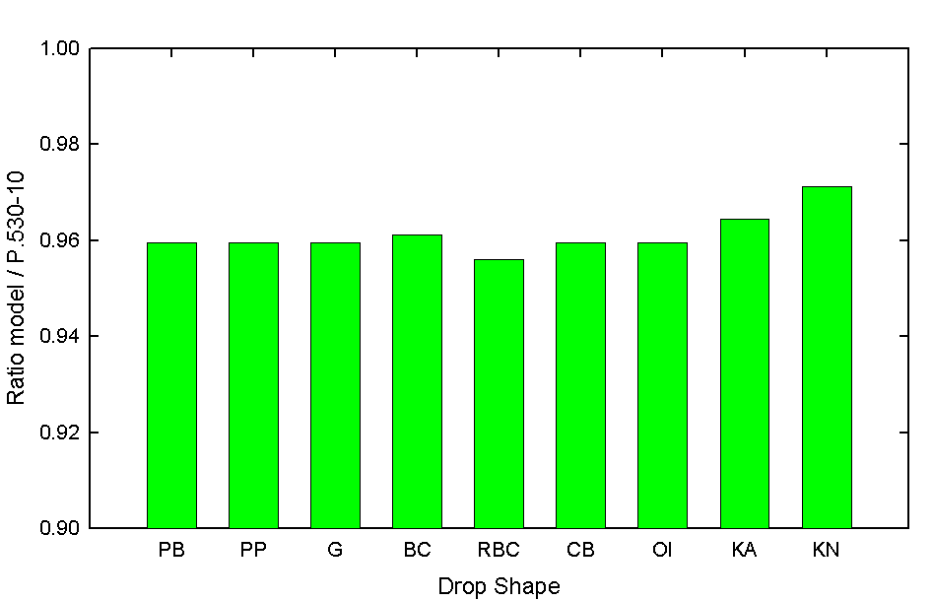

Overall, the Beard-Chuang drop shape, modified by RAL (RBC) yielded slightly better results, and this drop shape has been used for all subsequent investigations.

## 9.2 Variation with Drop Terminal Velocity

The variation with terminal velocity is shown in Figure 4, again in terms of the ratio of r.m.s values to those from Recommendation ITU-R P.530. There is again very little difference between any of the formalisms, and since it has widespread acceptance, the terminal velocity of Gunn and Kinzer has been used for all the remaining tests.

FIGURE 4

Ratio of r.m.s values for different terminal velocity

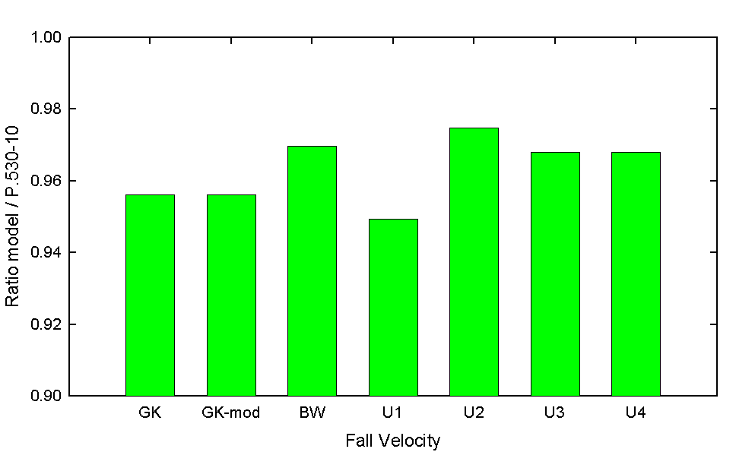

## 9.3 Variation with drop size distribution

Twenty-eight different rain drop shapes have been investigated using the RAL / Beard-Chuang drop shape with the Gunn and Kinzer terminal velocity, applying the resultant *k* and *α* coefficients to Recommendation ITU-R P.530. The results are summarized in Figure 5.

A number of drop size distributions yield predictions which are superior to those from the current model in Recommendation ITU-R P.530. These include:

|  |  |
| --- | --- |
| * Marshall-Palmer * Manabe, Ihara and Furuhama * ETRI * Maitra-Gibbins Gamma 2 | * Joss widespread * Ulbrich (Laws and Parsons) * Uijlenhoet 1,2,3,4 & 5 * Brussaard and Watson Weibull 2 |

These DSDs have been selected for the detailed investigation of path length reduction factors, basing the model on the full rainfall rate distribution, rather than solely the rain rate exceeded for 0.01% of time, as in the current model in Recommendation ITU-R P.530-10.

FIGURE 5

Ratio of r.m.s values for different rain drop size distributions

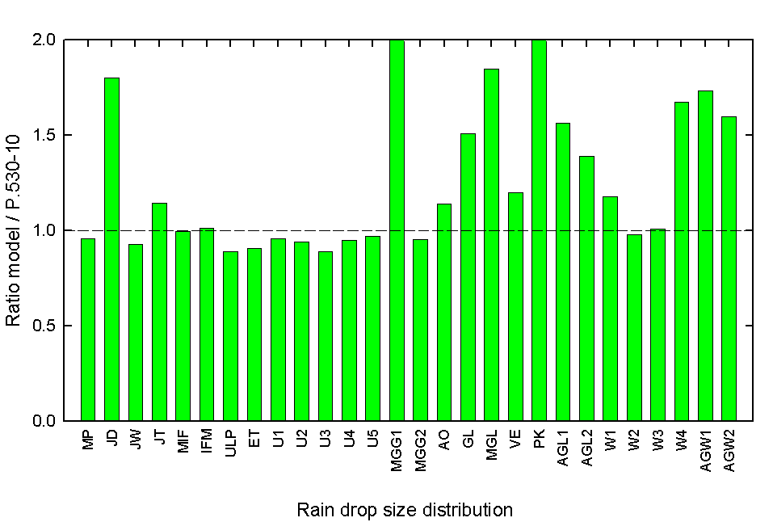

## 9.4 Development of a model based on the full rain rate distribution

The primary aim in this work is to develop a model for rainfall attenuation which is based on the full rainfall rate distribution, rather than one based on the rain rate exceeded at one particular time percentage, with a global (or near-global) extrapolation to other time percentages, as in the current model. This latter method, which has been in use for many years, has the disadvantage of imbuing all attenuation distributions with the same shape, merely shifting this in one direction, despite the fact that rainfall rate distributions from disparate climatic regions clearly exhibit characteristically different shapes. Attempts to take this into account have been applied to both Recommendations ITU-R P.530 and ITU-R P.618, through extrapolation formulae which depend on latitude; this method results in non-physical discontinuities in the attenuation distributions at the boundaries between the latitude regions.

It is hence considered more appropriate to develop a new model which exploits the full rainfall rate distribution, obviating the need to apply such universal extrapolations.

The seven path length reduction factors have been used with each of the 12 raindrop size distributions listed above, applied to each point in the rainfall rate distribution. The results are summarized in Figure 6.

Using the current values for the coefficients in the various path length reduction factors, only the RAL and Morgensen-Stephansen formulations yield results which are comparable with the current procedure in P.530-10. These expressions were, of course, derived from comparisons between experimental data and the extant calculated specific attenuation coefficients. In this analysis, however, new values are being employed for the specific attenuation coefficients, and it is therefore appropriate to re-examine the values of the coefficients in the path length reduction factors.

FIGURE 6

Ratio of r.m.s values for 12 DSDs and 7 path length reduction factors

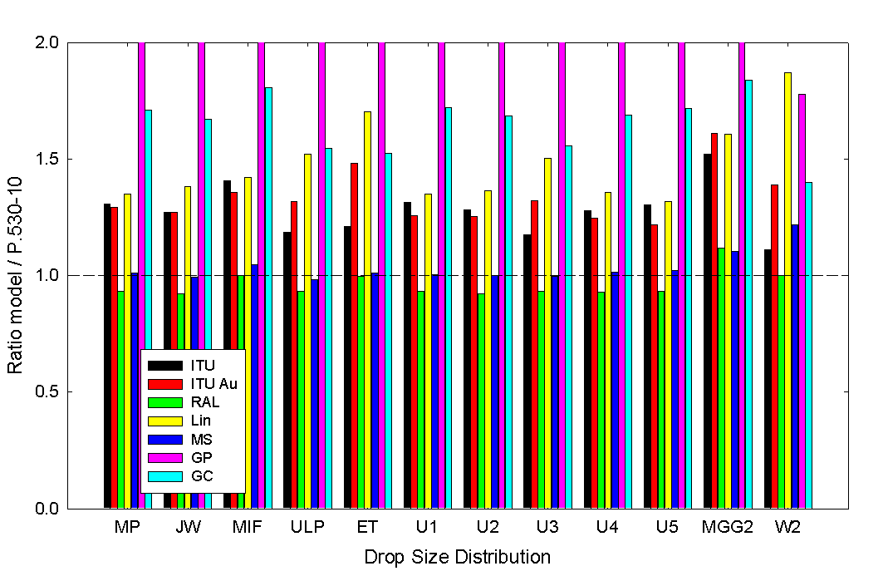

## 9.5 Derivation of a new path length adjustment factor

The four functional forms of the path length reduction factors – ITU-R, RAL, Lin and Garcia-Lopez – have been generalized to provide the highest degree of freedom, and the algorithms fitted to the experimental data using a non-linear Levernberg-Marquardt method, to derive the best fits, using the Recommendation ITU-R P.311 test variable as the residual to be minimized. The resultant model for terrestrial path attenuation is then expressed as:

 dB (9)

where *d* is the path length, in km, and  is the path length reduction factor, a function of rainfall rate, *R* and path length.

The four path length reduction factors were examined for two cases: (a) constraining the value to a maximum of unity, and (b) allowing the value to exceed unity, for short paths and low rainfall rates. In every case, better fits were obtained allowing the path length reduction factor to exceed unity. That this should be the case is clearly demonstrated by examining the experimental data, dividing the measured attenuations by the specific attenuation multiplied by the true path length, i.e. inverting Equation (9) to obtain experimental values for *r*. These are shown in Figure 7, as functions separately of rainfall rate and path length.

It is relevant to note that very similar results are obtained using the current model for rain specific attenuation in Recommendation ITU-R P.838-2.

FIGURE 7

Experimental values for the path length reduction factor

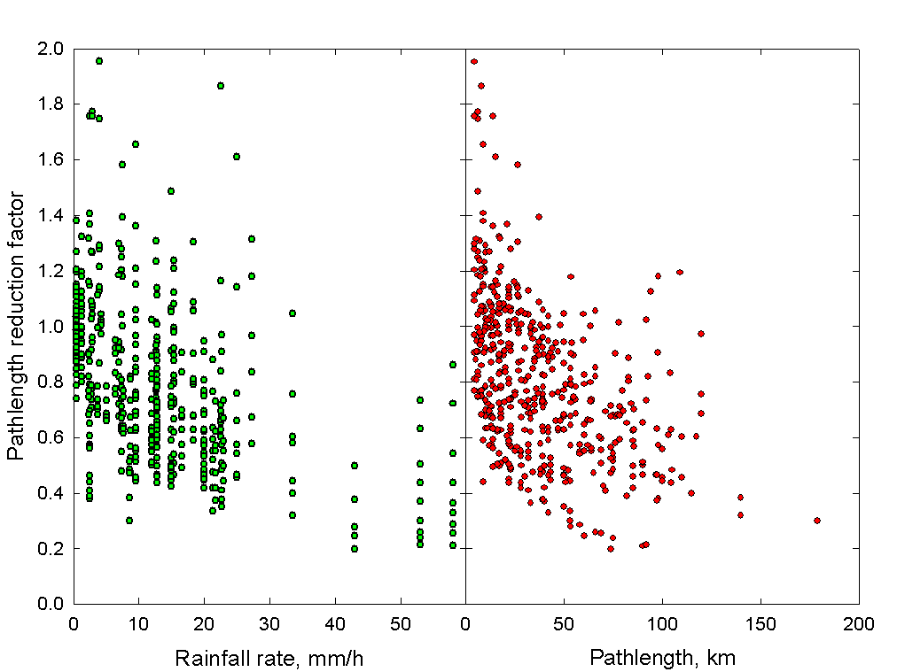

Further justification for allowing the path length reduction factor to exceed unity may be found from the likelihood that, in general, rain gauges may not be as effective in measuring low rainfall rates as they are for higher rainfall rates, either through delays in response times due to wetting effects or through entrainment of light rain in prevailing winds, thus reducing the rain deposit at ground level. It is also worth noting that the reduction/adjustment factors currently used in Recommendation ITU-R P.618 can exceed unity.

In view of this, it is more appropriate now to denote this term as a “path length adjustment factor”.

The results of fitting each path length adjustment factor to the data are summarized in Figure 8.

FIGURE 8

Ratio of r.m.s values for 12 DSDs and 4 path length adjustment factors

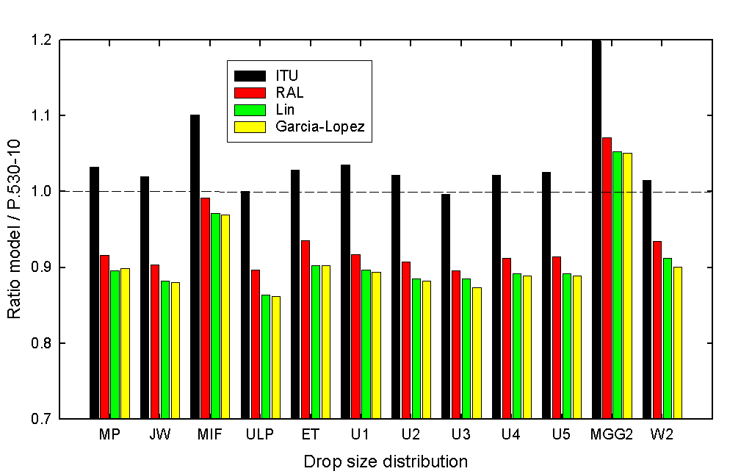

The best overall performance is obtained using the Ulbrich (Laws and Parsons) rain drop size distribution with path length adjustment factors based on the Lin and the Garcia-Lopez functions.

It is appropriate to examine the performance of these two models in different frequency ranges, and the terrestrial databank has been divided into five frequency ranges, each group representing, as far as possible, the major frequency bands used for terrestrial services, while maintaining approximately equal numbers of samples. The frequency bands, and the number of data points in each band, are listed in Table 8.

TABLE 8

Division of DBSG5 Databank into Frequency Bands

|  |  |  |  |  |  |  |
| --- | --- | --- | --- | --- | --- | --- |
| Frequency band, GHz | < 13 | 13-15 | 15-19 | 19-25 | 25-40 | > 40 |
| No. of data points | 90 | 86 | 76 | 74 | 88 | 63 |

Figures 9 shows respectively the mean value, the standard deviation and the r.m.s values of the test variable for the two models together with reference values from Recommendation ITU-R P.530-10. In the frequency bands < 13 GHz, 13-15 GHz, 19-25 GHz and > 40 GHz, both new models yield predictions better than ITU-R P.530. However, in the 15-19 and 25-40 GHz bands, the new models yield slightly less effective predictions than does ITU-R P.530-10.

FIGURE 9

Mean, standard deviation and r.m.s values for Rec. ITU-R P.311 test variable

|  |  |  |
| --- | --- | --- |
| ..\..\..\..\KnAlpha\Data Plots\Mean value.gif | ..\..\..\..\KnAlpha\Data Plots\Standard deviation.gif | ..\..\..\..\KnAlpha\Data Plots\Rms value.gif |

It is worth examining this in a little more detail, in particular with reference to the *relative* differences in attenuation, rather than the Recommendation ITU-R P.311 test variable, i.e. using the following test variable:



Figure 10 shows the mean, standard deviation and r.m.s values for this test variable. With this alternative test variable, the new models yield predictions which are, in fact, superior to those from Recommendation ITU-R P.530 in the 25-40 GHz band.

FIGURE 10

Mean, standard deviation and r.m.s values for the *relative* difference in attenuation

|  |  |  |
| --- | --- | --- |
| ..\..\..\..\KnAlpha\Data Plots\Mean value - relative differences.gif | ..\..\..\..\KnAlpha\Data Plots\Standard deviation - relative difference.gif | ..\..\..\..\KnAlpha\Data Plots\Rms value - relative difference.gif |

There is little to choose between the two models, however. Overall, the Lin function yields marginally better predictions, especially at the higher frequencies, and has the added benefit of simplicity. Thus, the proposed new model for terrestrial path attenuation is based on the following path length adjustment factor:

 (10)

Figure 11 illustrates some examples of this function, in comparison with the current model in Recommendation ITU-R P.530-10.

FIGURE 11

Path length adjustment factor vs. path length and rainfall rate

|  |  |
| --- | --- |
| ..\..\..\..\Project Files\KnAlpha\Data Plots\prf vs distance.gif | ..\..\..\..\Project Files\KnAlpha\Data Plots\prf vs rainrate.gif |

The final comparisons between the new model and Recommendation ITU-R P.530-10 are summarized in Tables 9 and 10, and in Figure 12.

TABLE 9

Summary of r.m.s. values for different time percentages

|  |  |  |  |  |  |  |  |  |  |  |  |
| --- | --- | --- | --- | --- | --- | --- | --- | --- | --- | --- | --- |
| Model | Percentage of time | | | | | | | | | Overall | |
| 0.001 | 0.002 | 0.003 | 0.006 | 0.010 | 0.020 | 0.030 | 0.060 | 0.100 |  | % |
| P.530-10 | 0.73 | 0.61 | 0.60 | 0.59 | 0.57 | 0.53 | 0.54 | 0.60 | 0.66 | **0.593** | **81.0** |
| New | 0.66 | 0.63 | 0.57 | 0.47 | 0.46 | 0.46 | 0.46 | 0.50 | 0.52 | **0.513** | **66.9** |

TABLE 10

Summary of r.m.s. values for different frequency ranges

|  |  |  |  |  |  |  |  |  |  |  |  |  |
| --- | --- | --- | --- | --- | --- | --- | --- | --- | --- | --- | --- | --- |
| Freq. | < 13 GHz | | 13-15 GHz | | 15-19 GHz | | 19-25 GHz | | 25-40 GHz | | > 40 GHz | |
| Model |  | % |  | % |  | % |  | % |  | % |  | % |
| P.530 | 0.92 | 150.5 | 0.57 | 76.1 | 0.42 | 51.4 | 0.75 | 112.0 | 0.33 | 39.7 | 0.25 | 28.6 |
| New | 0.72 | 104.8 | 0.38 | 45.7 | 0.45 | 57.2 | 0.69 | 99.5 | 0.43 | 54.2 | 0.13 | 14.0 |

FIGURE 12

R.m.s values for the new model and Rec. ITU-R P.530-10, at different time percentages

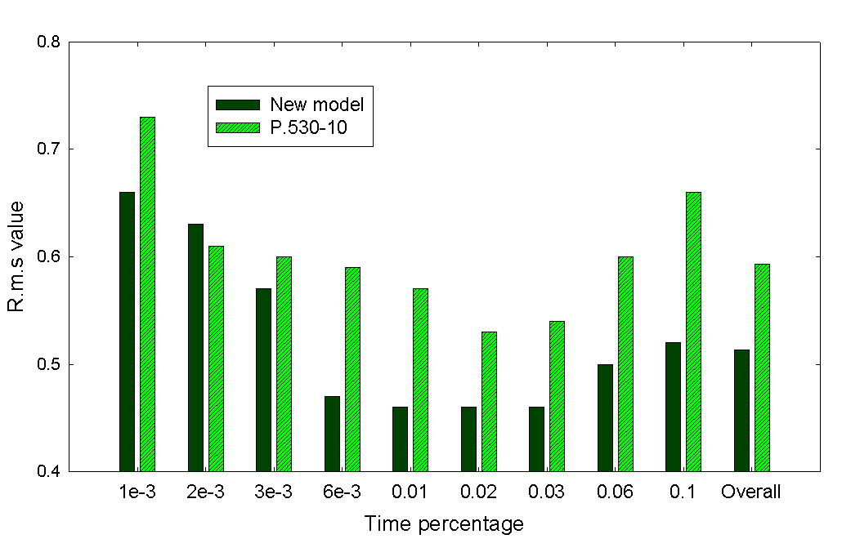

## 9.6 Temperature Dependence

In all the tests described above, evaluations were performed for each set of *k* and *α* coefficients for all the seven different temperatures at which the scattering amplitudes were calculated. The results reported are those at the temperature which yielded the best fits. In most cases, the temperature which gave the best fit was either 25° or 30° C, apart from the Weibull DSDs, which yielded the best fits with the 0° coefficients. The reason for this bias towards the extremes of the temperature range is not understood. There are small changes in the shape of the *k* and *α* curves as the temperature changes, which give rise to differences in the fitting to experimental data, which is variable in quality. That the best fits occur at temperatures which may be regarded as somewhat unrealistic is considered to be evidence that, of all the DSDs included in the calculations, perhaps none describe accurately the actual path-integrated distribution of rain drop sizes which ultimately determines the path attenuation. Additionally, it may be over-simplistic to assume that a single DSD can adequately describe the whole range of different types of rain, from widespread drizzle in temperate regions to tropical monsoons.

It is suggested, therefore, that little heed be paid to the fact that the best fits derive from calculations carried out at temperatures which could be regarded as unrealistically high, and the model should therefore be considered on its merits as an empirical procedure. It is, after all, derived from many successive approximations and subsequent curve fits. The assumption of a power-law relationship between attenuation and rainfall rate is itself a generalization requiring a curve-fitting process to derive simple coefficients which can readily be used for calculation. The inclusion of factors to describe the inhomogeneity of rain is a wholly empirical concept, while the development of algorithms for analytical functions for the *k* and *α* coefficients is again based on pure curve fitting. It is hence not altogether surprizing (nor indeed should it be unacceptable) that some aspects of the model may be perhaps less than physical in their origin, since there are so many elements in the model which are empirical. Indeed, the very foundation of the method, the complex refractive index of water (developed by Ray in 1972) is itself an empirical model.

This being the case, it is considered that there would be little benefit to be gained from including temperature as a parameter. There is some evidence to corroborate this, from tests which have been carried out during the development of the new models. An attempt was made to include temperature as a parameter, this being obtained from Recommendation ITU-R P.1510 for each of the links in the databank. The average annual surface temperature for the terrestrial links was about 10° C, with a range from 0° to 20°C. The attenuations for each data point were calculated using the *k* and *α* coefficients at the temperature closest to that for each link, and the results compared with those using a single temperature for all links. There was no improvement discernible, indeed the procedure yielded results generally inferior to those with a global value for temperature. It is thus considered that temperature is not a parameter which should be incorporated into the model.

## 9.7 Comparisons with the Terrestrial Databank

Figure 13 shows the comparison between predicted and measured attenuations for the current model in Recommendation ITU-R P.530-10 and for the new model. The continuous lines represent the contour of equal attenuation, and it is clearly apparent that ITU-R P.530-10 underestimates attenuations, and that this underestimation is removed with the new model.

FIGURE 13

Comparisons between predicted and measured attenuations

|  |  |
| --- | --- |
| Comparison with P.530.gif | Comparison with new model.gif |

It is worth examining the performance of the model in different frequency bands, and Figure 14 shows the same comparisons for each of the 6 frequency bands noted above. In general, the new model provides a closer approximation to experiment in the majority of these bands, although there is evidence of an increase in scatter in the 25-40 GHz band in particular. This higher level of scatter arises from the use of the full rainfall rate, and the fact that, for some of the links in the databank, the rainfall rate distributions appear to deviate, at times significantly, from those that might be expected from Recommendation ITU-R P.837-3. While some differences might be expected between annual and long-term statistics, due to the inherent year-to-year variability in meteorological processes, there are marked differences in the *shape* of the distributions which remain unexplained, and which contribute to the increase in scatter in this band.

Nevertheless, these comparisons show the general improvement achieved by the new model, when compared with the current model in Recommendation ITU-R P.530-10.

FIGURE 14

Comparisons of predicted and measured attenuations from Rec. ITU-R P.530-10 and the new model

|  |  |
| --- | --- |
| Comparison lt 13 GHz.gif | Comparison 13-15 GHz.gif |
| Comparison 15-19 GHz.gif | Comparison 19-25 GHz.gif |
| Comparison 25-40 GHz.gif | Comparison gt 40 GHz.gif |

# 10 Algorithms for the regression coefficients

Following the current method in Recommendation ITU-R P.838-2, algorithms based on sums of Gaussian functions have been used to develop a model for the rain regression coefficients. Because of the more detailed structure in the coefficients, it was necessary to increase the number of Gaussian functions, to four for the *k* coefficient (fitting to *η*, the base-10 logarithm of *k*) and five for the *α* coefficient. The resulting expression for *k* is then given by:

 (11)

and the numerical values for the coefficients are listed in Table 11, for horizontal polarization, and Table 12 for vertical polarization.

TABLE 11

**Coefficients for **

|  |  |  |  |  |  |
| --- | --- | --- | --- | --- | --- |
| j | aj | bj | cj | d | e |
| 1 | -5.339 80 | -0.100 08 | 1.130 98 | 0.711 47 | -0.189 61 |
| 2 | -0.353 51 | 1.269 70 | 0.454 00 |
| 3 | -0.237 89 | 0.860 36 | 0.153 54 |
| 4 | -0.941 58 | 0.645 52 | 0.168 17 |

TABLE 12

**Coefficients for **

|  |  |  |  |  |  |
| --- | --- | --- | --- | --- | --- |
| j | aj | bj | cj | d | e |
| 1 | -3.805 95 | 0.569 34 | 0.810 61 | 0.632 97 | -0.163 98 |
| 2 | -3.449 65 | -0.229 11 | 0.510 59 |
| 3 | -0.399 02 | 0.730 42 | 0.118 99 |
| 4 | 0.501 67 | 1.073 19 | 0.271 95 |

The coefficients for horizontal and vertical polarizations are shown in Figure 15, together with their individual components.

FIGURE 15

*η* coefficients for horizontal and vertical polarizations, and their components

|  |  |
| --- | --- |
| ..\KnAFits\Plots\k_h components.gif | ..\KnAFits\Plots\k_v components.gif |

The absolute errors in the derived values for *η* are shown in Figure 16 for horizontal and vertical polarizations.

For the *α* coefficients, it was found necessary to fit with 5 Gaussian functions, together with the linear component:

 (12)

and the numerical values for the coefficients are given in Tables 13 and 14, for horizontal and vertical polarizations, respectively.

FIGURE 16

Absolute differences in *η* for horizontal and vertical polarizations

|  |  |
| --- | --- |
| ..\KnAFits\Plots\diff in eta-h.gif | ..\KnAFits\Plots\diff in eta-v.gif |

TABLE 13

Coefficients for *αh*

|  |  |  |  |  |  |
| --- | --- | --- | --- | --- | --- |
| j | aj | bj | cj | d | e |
| 1 | -0.143 18 | 1.824 42 | -0.551 87 | -1.955 37 | 0.678 49 |
| 2 | 0.295 91 | 0.775 64 | 0.198 22 |
| 3 | 0.321 77 | 0.637 73 | 0.131 64 |
| 4 | -5.376 10 | -0.962 30 | 1.478 28 |
| 5 | 16.17 21 | -3.299 80 | 3.439 90 |

TABLE 14

Coefficients for *αv*

|  |  |  |  |  |  |
| --- | --- | --- | --- | --- | --- |
| j | aj | bj | cj | d | e |
| 1 | -0.077 71 | 2.338 40 | -0.762 84 | 0.834 33 | -0.0537 39 |
| 2 | 0.567 27 | 0.955 45 | 0.540 39 |
| 3 | -0.202 38 | 1.145 20 | 0.268 09 |
| 4 | -48.29 91 | 0.7916 69 | 0.1162 26 |
| 5 | 48.58 33 | 0.7914 59 | 0.1164 79 |

The *α* coefficients, and their individual components, and shown graphically in Figure 17 for horizontal and vertical polarizations, respectively, while the absolute errors are illustrated in Figure 18.

FIGURE 17

*α* coefficient for horizontal and vertical polarizations, and their components

|  |  |
| --- | --- |
| ..\KnAFits\Plots\alpha_h components.gif | ..\KnAFits\Plots\alpha_v components.gif |

FIGURE 18

Absolute errors in the *α* coefficients for vertical polarization

|  |  |
| --- | --- |
| ..\KnAFits\Plots\diff in alpha-h.gif | ..\KnAFits\Plots\diff in alpha-v.gif |

It is relevant to note that there was virtually no difference in the test results, comparing the model with experimental data, when changing from the use of tabulated values for the coefficients, with interpolation, to the use of these algorithms. The errors given above are therefore considered to be well within acceptable limits.

# 11 Comparison with Recommendation ITU-R P.838-2 in 2003

The following figure show the predicted rain specific attenuations from the new model, in comparison with those from the current model in Recommendation ITU-R P.838-2, to where the most significant differences occur. These are mainly at the lower rainfall rates, where the new model generally predicts higher attenuations, while at the higher rainfall rates, the new model predicts lower attenuations, especially at frequencies above 100 GHz.

FIGURE 19

Comparison of specific attenuations between Rec. ITU-R P.838-3 and ITU-R P.838-2, for some rainfall rates

|  |  |
| --- | --- |
| ..\Data Plots\10 mm-h.gif | ..\Data Plots\20 mm-h.gif |
| ..\Data Plots\30 mm-h.gif | ..\Data Plots\50 mm-h.gif |
| ..\Data Plots\75 mm-h.gif | ..\Data Plots\100 mm-h.gif |

# 12 Results of testing on slant paths in 2003

The new model for rain attenuation must also be applied to the slant-path prediction procedure in Recommendation ITU-R P.618. This method is slightly more complicated than that for terrestrial paths, in that the path length through the rain is not determined precisely and solely by the link geometry. Instead, the path through the rain is considered to extend from the terminal (earth station) up to the rain height. Information on the rain height can be derived from Recommendation ITU-R P.839 for the appropriate latitude and longitude, if this is not known locally. There are then two path length adjustment factors to be applied to this slant path length, one for the horizontal component, which takes account of the non-homogeneity of rain near ground level (as in the case for terrestrial paths), and one for the vertical component. Both of these factors in the current model in Recommendation ITU-R P.618-8 are empirically derived and depend on frequency and attenuation, in addition to the expected parameters. As such, they attempt to account for deficiencies in the model for specific attenuation, and are hence unsuitable for use in the new model.

In principal, and ideally, the method for slant-path attenuation should be an extension of the terrestrial model, with one of the terminals elevated to an altitude above the rain height. This, the path length adjustment factor for the horizontal component of the slant path should ideally be the same as that employed in the terrestrial model. With this assumption, it becomes necessary only to determine a new “vertical adjustment” factor, to take account of inhomogeneities in the vertical distribution of rainfall.

A new model has thus been developed, based on the terrestrial model, with the addition of a vertical adjustment factor. The model derives from curve fitting for this adjustment factor, to the slant-path rain attenuation data in Table II-1 of the Study Group 3 Databank DBSG5 in 2003. There were 271 links used in the analysis, comprising 2 753 individual measurements.

## 12.1 Development of a new model for slant-path rain attenuation

The model can be defined as follows, using the same terminology as in Recommendation ITU-R P.618-8, with the rain assumed to extend from the ground, at a height *hS* above mean sea level, up to the rain height, *hR*. These heights may be obtained from Recommendations ITU-R P.1511 and ITU-R P.839-3, respectively.

The slant path length, *LS*, from the earth station to the rain height is determined from:

 (13)

The horizontal projection of the slant path length along the ground is given by:

 (14)

The specific attenuation due to rain is obtained from

 (15)

where *R* is the rainfall rate at the required time percentage.

The horizontal path length adjustment factor is then given by the expression developed for terrestrial paths, for this horizontal path length:

 (16)

The effective path length along the slant path can then be defined as:

 (17)

where *ν* is a vertical adjustment factor, to be determined, and the slant-path attenuation is then given by:

 (18)

## 12.2 Determination of the vertical adjustment factor

Using the terrestrial path model described in Sections 9 and 10, each of the four functional forms for the path length adjustment factor have been examined. These are:

• the ITU-R function;

• the RAL function;

• the Lin / Morgensen-Stephansen function; and

• the Garcia-Lopez function.

The distance in these functional forms for the vertical adjustment factor is assumed to be the vertical distance from the ground to the height of the rain, i.e. to , where *hR* is the rain height, obtained from Recommendation ITU-R P.839-3 and *hS* is the height of the ground above sea level, which can be obtained from Recommendation ITU-R P.1510, at the latitude and longitude of interest.

The model has been fitted to the slant-path databank, comprising 2753 individual measurements, to derive values for the various coefficients, using the non-linear Levernberg-Marquardt technique described earlier. The overall results are summarized in Figure 20 for three ranges of time percentages, from 0.001 – 0.1 %, from 0.001 – 1 % and over the full range in the databank from 0.001 – 50 %.

Figure 21 illustrates the variation with time percentage in more detail, giving the r.m.s values individually for each time percentage in the databank. The marked increase in r.m.s values from the Recommendation ITU-R P.618-8 model at long time percentages originated primarily from the mean value, with the Recommendation ITU-R P.618-8 model seriously underestimating the attenuations at these long time percentages.

FIGURE 20

R.m.s values for the vertical adjustment factor models, compared with Rec. ITU-R P.618-8

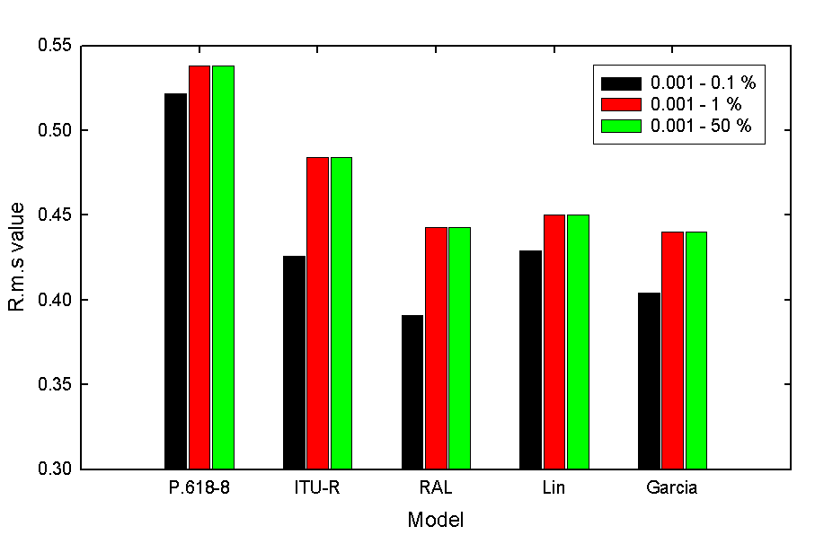

FIGURE 21

R.m.s values for all time percentages

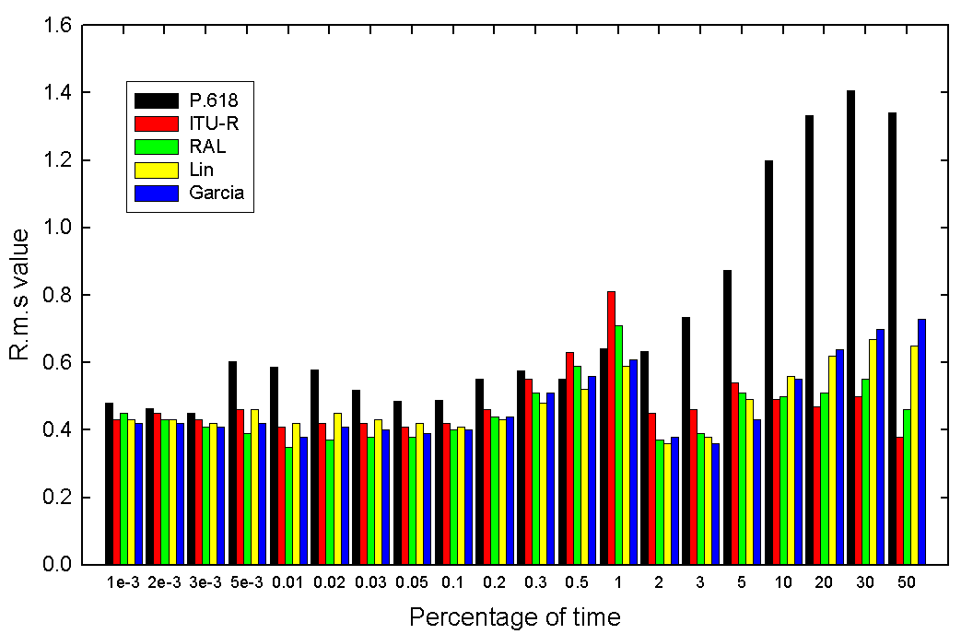

The model was also fitted to data extending only over the time percentage range from 0.001% to 1%. This produced in small changes to the values of the coefficients in the vertical adjustment factor, but resulted in a marginally inferior performance, in fact.

The results have been further analysed in terms of frequency bands. The databank was divided into four groups, each representing, as far as possible, the major satellite frequency bands; these are specified in Table 15, which gives also the number of samples in each group.

TABLE 15

Frequency bands used in the analysis

|  |  |  |  |  |
| --- | --- | --- | --- | --- |
| Frequency band | < 13 GHz | 13-17 GHz | 17-20 GHz | > 20 GHz |
| No. of samples | 1630 | 146 | 692 | 285 |

Figures 22 and 23 show the mean and r.m.s values of the test variable for each of the four models, together with Recommendation ITU-R P.618-8, for the four frequency bands.

FIGURE 22

Mean values in the four frequency bands

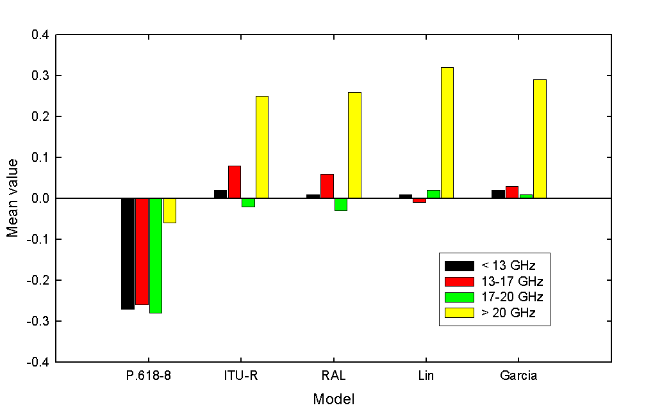

FIGURE 23

R.m.s values in the four frequency bands

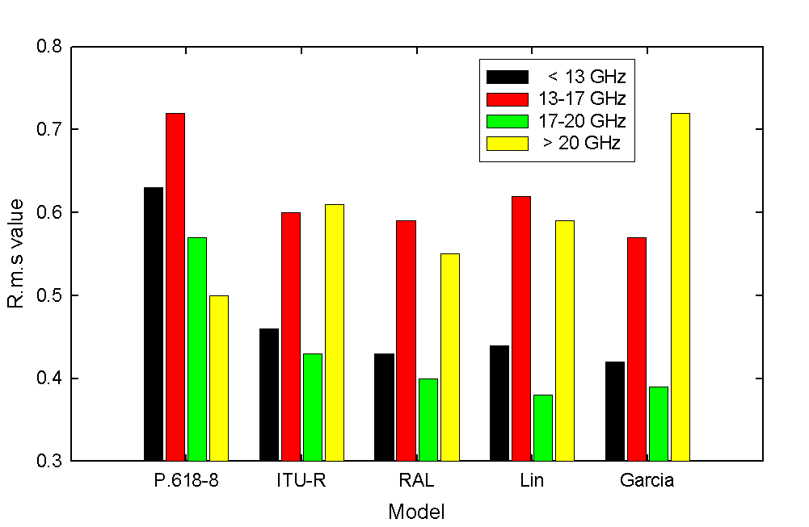

The best overall performance is obtained using the RAL function for the vertical adjustment factor. However, with the coefficients deriving from the fitting procedure, it was found that this function could attain very large values for very short vertical paths – paths shorter than any in the databank, in fact. Nevertheless, it was felt expedient to place an upper limit on this function, and a value of 2 was found to give the best results. Furthermore, it was also found that, for very low rainfall rates, less than 1 mm/h, the function could become negative, so it is necessary to place an additional constraint that, for rainrates less than 1 mm/h, a value of 1 mm/h should be used.

With these constraints, the vertical adjustment factor has the form:

 (19)

with the constraint that *R* ≥ 1 mm/h.

Figure 24 shows some example values for this factor, in comparison with the current vertical adjustment factor from Recommendation ITU-R P.618-8, for a frequency of 11 GHz, elevation angle of 30° and latitude of 30°. Under these conditions, there are, in fact, only quite small differences between the two factor for rain heights of 2 km or more above the ground. Only for lower rain heights do differences begin to appear.

FIGURE 24

Vertical adjustment factor for different rain heights above the ground

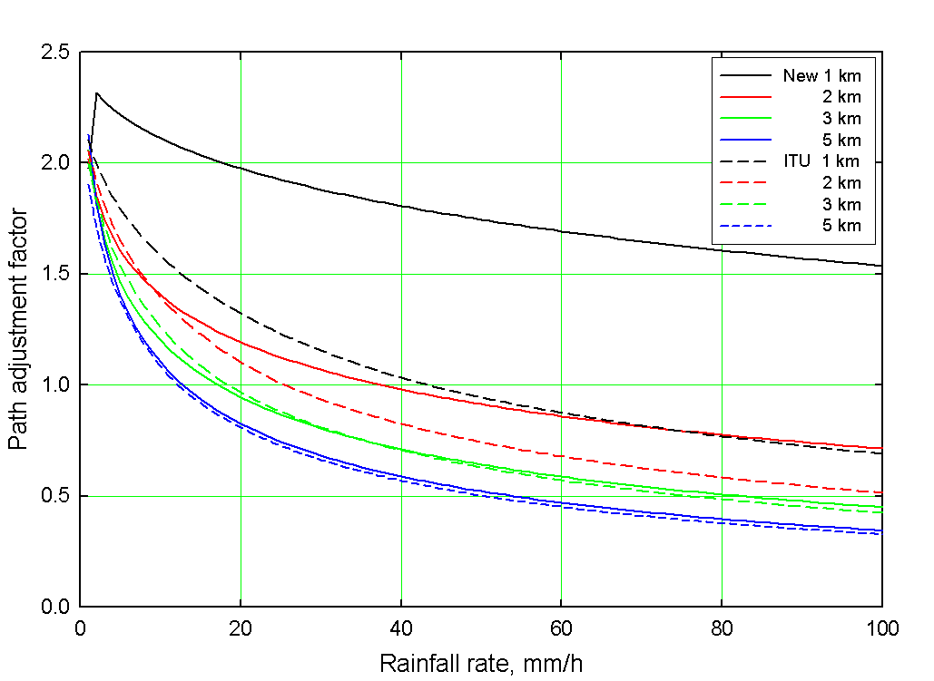

## 12.3 Comparisons with the slant-path databank

Figure 25 gives comparisons between the predicted and measured data for the current model in Recommendation ITU-R P.618-8 and for the new model. The high degree of scatter is clearly evident, especially in predictions from the current model in Recommendation ITU-R P.618-8, while the new model reduces the underestimation in attenuation and, to a smaller extent, the scatter.

FIGURE 25

Comparison of Rec. ITU-R P.618-8 and new model with DBSG5 databank

|  |  |
| --- | --- |
| ..\Data Plots\Slant path\comparison with P618.gif | ..\Data Plots\Slant path\comparison with new model.gif |

The comparisons between prediction and measurement are further illustrated in Figure 26, for each of the four frequency bands into which the databank was subdivided, showing the general reduction in underestimation, especially in the lower frequency bands.

FIGURE 26

Comparison of Rec. ITU-R P.618-8 and new model in different frequency bands

|  |  |
| --- | --- |
| ..\..\..\..\KnAlpha\Data Plots\Slant path\comparison lt 13 GHz.gif | ..\..\..\..\KnAlpha\Data Plots\Slant path\comparison 13-17 GHz.gif |
| ..\..\..\..\KnAlpha\Data Plots\Slant path\comparison 17-20 GHz.gif | ..\..\..\..\KnAlpha\Data Plots\Slant path\comparison gt 20 GHz.gif |

It is interesting to note that, while there is some evidence of an overestimation in predicted attenuations in the frequency band above 20 GHz, this does not appear, subjectively at least, to be quite as severe as the test results, as shown in Figure 22, might suggest. It is worth investigating this in more detail, particularly in terms of the time percentage ranges used in the analysis. The results shown in Figure 22 are for the complete database, i.e. over the range from 0.001 to 50% of time. Comparisons between the models and data at long time percentages are not especially meaningful, though, since there are other propagation effects which start to play increasingly important roles at longer time percentages, especially at higher frequencies. These include attenuation due to atmospheric molecules and clouds, for example, and these are not taken into account in the current analysis, which considers only attenuation due to rain. Indeed, to be strictly accurate in the overall prediction procedure, it is necessary to include these effects in a combined model. There are some difficulties in this, however. Firstly, there is still some debate as to how the different effects should be combined. Secondly, it will be necessary, when comparing predictions from a combined model with experimental measurements, to have knowledge of whether the measurements are of total attenuation, which will include gaseous absorption and cloud effects, or are of excess attenuation, i.e. that induced by rain alone. Even here, it will not be possible to separate out cloud attenuation in the presence of rain. Furthermore, there is not enough information in the DBSG5 databank to facilitate such distinctions. For these reasons, no attempt has been made here to examine a combined model.

It is, however, relevant to examine the performance of the model over restricted ranges of time percentage, and confining the analysis to time percentages up to 1 % and even to 0.1 % will help to reduce the influence of these other propagation phenomena in the data, especially at the higher frequencies, where clouds, in particular, are expected to play a more significant role. Figure 27 shows the mean values and r.m.s values for the new model in comparison with Recommendation ITU-R P.618-8 for the four frequency bands, for three different ranges of the time percentage: the full range from 0.001 to 50%, and ranges from 0.001 to 1 % and from 0.001 to 0.1%.

At the most restricted range, from 0.001 to 0.1 %, which will be dominated almost entirely by rain effects only, the new model performs consistently better than does Recommendation ITU-R P.618‑8. Only as data from longer time percentages, where other propagation phenomena start to become of importance, does the model perform less effectively. These discrepancies arise from the prediction of small attenuations and the application of the test variable in Recommendation ITU-R P.311. At time percentages above 1%, all the measured attenuations are less than about 7 dB, and close inspection of Figure 26 suggests that the new model may, perhaps, tend to overestimate the attenuations for low rainfall rates at frequencies above about 20 GHz. Because of the nature of the test variable, these overestimates of attenuation, while small in absolute magnitude, can have an undue influence on the overall test result, despite the weighting factor included to reduce the impact of errors in attenuations less than 10 dB. This is clearly apparent from the fact that the r.m.s. value reduces from 74%, for the full range of time percentages, down to 32% when the test is restricted to time percentages less than 0.1%, thus removing from the analysis all the small attenuations. For high levels of attenuation, the new model offers a significant improvement over the current model in Recommendation ITU-R P.618-8.

FIGURE 27

Mean value and r.m.s value in 4 frequency bands for different time ranges

|  |
| --- |
| ..\..\..\..\KnAlpha\Data Plots\Slant path\mean value vs time range.gif |
| ..\..\..\..\KnAlpha\Data Plots\Slant path\rms vs time range.gif |

# 13 Summary and conclusions

A new model was developed in 2003 for the specific attenuation due to rain at frequencies from 1 to 1 000 GHz. This has been applied to the rain attenuation prediction procedures for terrestrial paths, in Recommendation ITU-R P.530, and for Earth-space paths, in Recommendation ITU-RP.618.

Tables 16 and 17 highlight the performance of the new models for terrestrial paths and slant paths, respectively, in comparison with the current model in Recommendation ITU-R P.530, in terms of the percentage mean, standard deviation and r.m.s values of the Recommendation ITU-R P.311 test variable. Also included is the skewness divided by the standard deviation, as a measure of how well the errors in prediction are distributed normally. Note that a normal distribution is defined as one having a skewness of ~ 2*σ* or less.

The new models both provide a substantial improvement in the accuracy of prediction, while at the same time being based on the full distribution of rainfall rates, thus removing the reliance on a single statistic at a single time percentage and obviating the need to apply empirical global (or near-global) extrapolations to a range of time percentages.

TABLE 16

Summary of performance of models for terrestrial paths

|  |  |  |  |  |
| --- | --- | --- | --- | --- |
| Model | Mean % | Standard deviation % | R.m.s value % | Skewness / SD |
| New model | -0.2 | 66.9 | 66.9 | -0.4 |
| P.530-10 | -21.6 | 71.8 | 81.0 | -1.9 |

TABLE 17

Summary of performance of models for slant paths

|  |  |  |  |  |
| --- | --- | --- | --- | --- |
| Model | Mean % | Standard deviation % | R.m.s value % | Skewness / SD |
| New model | 2.1 | 56.4 | 56.6 | -1.4 |
| P.618-8 | -22.2 | 73.9 | 83.6 | -3.2 |

Separate proposals are made in companion documents for the consequent revision of Recommendations ITU-R P.838, ITU-R P.530 and ITU-R P.618.

References

Ajayi, G. O. and Olsen, R. L. (1985), “Modelling of a tropical raindrop size distribution for microwave and millimeter wave applications”, *Radio Sci.*, **20**, pp 193 – 202

Åsen, W. and Gibbins C. J. (2002), “A comparison of rain attenuation and drop size distributions measured in Chilbolton and Singapore”, *Radio Sci*.

Assouline, S. and Mualem, Y. (1989), “The similarity of regional rainfall: a dimensionless model of drop size distribution”, *Trans. ASAE*, **32**, pp 1216 – 1222

Beard, K. V. and Chuang, C. (1987), “A new model for the equilibrium shape of raindrops”, *J. Atmos. Sci.*, **44**, pp 1509 – 1524

Brussaard, G. and Watson, P. A. (1995), “Atmospheric Modelling and Millimetre Wave Propagation”, Chapman and Hall, London, ISBN 0 412 56230 8

Chuang, C. and Beard, K. V. (1990), “A numerical model for the equilibrium shape of electrified raindrops”, *J. Atmos. Sci.*47, pp 1374 – 1389

COST 235 (1996), “Radiowave Propagation Effects on Next Generation Fixed-Services Terrestrial Telecommunications Systems”, Final Report, EUR 16992, Luxembourg

Crane, R. K. (1980), “Prediction of attenuation by rain”, *IEEE Trans. Comm.*, **COM-28**, pp 1717 – 1773

Diermendjian, D. (1963), “Complete microwave scattering and extinction properties of poly dispersed cloud and rain elements”, The Rand Corporation Report, R-422-PR

Dissanayake, A., Allnutt, J. and Haidara, F. (1997), “A prediction model that combines rain attenuation and other propagation impairments along Earth-satellite paths”, *IEEE Trans. Ant. Prop.*, **45**, pp 1546 – 1558

Gibbins, C. J. and Walden, C. J. (2003), “A study into the derivation of improved rain attenuation regression coefficients”, Radicommunications Agency Report No. AY4359, available from [http://www.radio.gov.uk/topics/research/research-index.htm](http://www.radio.gov.uk/)

Gloaguen, C. (1994), “Influence de la pluie sur la propagation des ondes électromagnétiques dans le domaine millimétrique: approches théoretique et expérimentale”, Thèse de doctorat d’Etat, Paris VII

Goddard, J. W. F. and Thurai, M. (1997), “Radar-derived path reduction factors for terrestrial paths”, *Proc. 10th Int. Conf. Ant. Prop.*, ICAP97, Heriot-Watt University, Edinburgh, 1997, IEE Conf. Publ. 436, pp 2.218 – 2.221

Green, A. W. (1975), “An approximation for the shape of large raindrops”, *J. Appl. Meteor*., **14**, 1578‑1583

Holt, A. R. (1978), Uzunoglu, N. and Evans, B. G. (1978), “An integral equation approach to the scattering of electromagnetic radiation by dielectric spheroids and ellipsoids”, *IEEE Trans. Ant. Prop*., **AP-26**, pp 706‑712

Ihara, T, Furuhama, Y. and Manabe, T. (1984), Inference of raindrop size distribution from rain attenuation statistics at 12, 35 and 82 GHz”, *Trans. IECE Japan*, **E67**, pp 211 – 217

Ishimaru, A. (1978), Wave Propagation and Scattering in Random Media, pp. 10-12, 30-32, 287-294, Academic, New York.

Joss, J., Thams, J. C. and Waldvogel, A. (1968), “The variation of raindrop size distribution at Locarno”, Proc. Int. Conf. on Cloud Physics, Toronto, Canada, pp 369 – 377

Karam, M. A., and A. K. Fung, (1982) “Vector forward scattering theorem, “Radio Science, 17(4), pp. 752 – 756.

Karam, M. A., (1998) ” Polarimetric optical theorem, “ Journal of Optical Society of America A, vol. 15, no. 1, pp. 196 - 201, 1998.

Keenan, T. D., Carey, L. D., Zrnic, D. S. and May, P. T. (2001), “Sensitivity of 5-cm wavelength polarimetric radar variables to raindrop axial ratio and drop size distribution”, *J. Appl. Meteorol.*, **40**, pp 526‑545

Kim, Y.-S., Lee, J.-H., Kim, J-H. and Choi, Y.-S. (2001), “The effects of drop shape and size distribution on the specific rain attenuation”, *Proc. CLIMPARA 2001*, Budapest, Hungary

Lin, S. H. (1977), “Nationwide long-term rainrate statistics and empirical calculation of 11 GHz microwave rain attenuation”, *Bell Syst. Tech. J.*, **56**, pp 1581 – 1604

Maitra, A and Gibbins, C. J. (1995), “Inference of raindrop size distributions from measurements of rainfall rate and attenuation at infrared wavelengths”, *Radio Sci*., **30**, pp 931 – 941

Maitra, A and Gibbins, C. J. (1999), “Modeling of raindrop size distributions from multiwavelength rain attenuation measurements”, *Radio Sci*., **34**, pp 657 – 666

Manabe, T. Ihara, T. and Furuhama, Y. (1984), “Inference of raindrop size distribution from attenuation and rain rate measurements”, *IEEE Trans. Ant. Prop.*, **AP-32**, pp 474 – 478

Marshall, J. S. and Palmer, W. McK. (1948), “The distribution of raindrops with size”, *J. Meteorol*., **5**, pp 165 – 166

Mishchenko, M. I., Hovenier, J. W. and Travis, L. D. (2000), “Light Scattering by Non-Spherical Particles. Theory, Measurements and Applications”, Academic Press, San Diego, Ca., USA, 690 pp

Mishchenko, M. I., Travis, L. D. and Macke, A. (2000), “T-matrix method and its applications”, in “Light Scattering by Nonspherical Particles”, eds. Mishchenko, Hovenier and Travis, Academic Press, San Diego, Ca., USA

Moupfouma, F. (1984), “Improvement of a rain attenuation prediction method for terrestrial microwave links”, *IEEE Trans. Ant. Prop.*, **AP-32**, pp 1368 – 1372

Okamura, S., and Oguchi, T. (2010),” Electromagnetic wave propagation in rain and polarization effects,” Proc. Jpn. Acad. Ser B, Vol. 86, PP. 539 – 562,

# Annex 1

# The derivation of the equations in Rec ITU-R P.838

Recommendation ITU-R P.838-3 provides a method to predict the specific rain attenuation vs. frequency, polarization tilt angle, and elevation angle.

The specific rain attenuation, $γ_{R},$ is given by Equation (1) of Recommendation ITU-R P.838-3:

$γ_{R}=kR^{α}$ (1)

Recommendation ITU-R P.838-3 and the accompanying Equations (4) and (5) state:

For linear and circular polarization, and for all path geometries, the coefficients in Equation (1) can be calculated from the values given by Equations (2) and (3) using the following equations:

$k=\left[k_{H}+k_{V}+\left(k_{H}-k_{V}\right)\cos^{2}{θ\cos{2τ}}\right]$ (2)

 $α=\left[k_{H}α_{H}+k_{V}α_{V}+\left(k_{H}α_{H}-k_{V}α_{V}\right)\cos^{2}{θ\cos{2τ}}\right]$ (3)

where  is the path elevation angle, and  is the polarization tilt angle relative to the horizontal (  45 for circular polarization).

These equations were published in Nowland, *et al*.[[1]](#footnote-1); however, the derivation is not documented in a readily available reference.

Derivation of exact equation

Consider a right-hand coordinate system, where the x and y axes are in the horizontal plane and z is up, with the two rotation matrices:

$R_{y}=\left(\begin{matrix}\cos{θ} & 0 & \sin{θ} \\ 0 & 1 & 0 \\ -\sin{θ} & 0 & \cos{θ}\end{matrix}\right)$ (4)

$R_{z}=\left(\begin{matrix}\cos{τ} & -\sin{τ} & 0 \\ \sin{τ} & \cos{τ} & 0 \\ 0 & 0 & 1\end{matrix}\right)$ (5)

The elevation angle, $θ$, is a CCW rotation around y, and the polarization tilt angle, $τ$, is a CW rotation around *z*. Then, assuming a linearly polarized signal, where the x-axis is the reference, the resultant vector is:

$R_{z}{\left(τ\right)R}_{y}\left(-θ\right)\left(\begin{matrix}1 \\ 0 \\ 0\end{matrix}\right)=\left(\begin{matrix}\cos{θ\cos{τ}} \\ \cos{θ\sin{τ}} \\ -sin{θ}\end{matrix}\right)$ (6)

The specific attenuation in the x-direction is $γ_{x}$, the specific attenuation in the y-direction is $γ_{y}$, and the specific attenuation in the z-direction is $γ_{z}.$ Then the net specific attenuation, $γ_{R}$, assuming an elevation angle of $θ$ and polarization tilt angle of $τ$ is:

$γ_{R}=γ_{x}(\cos^{2}{θ\cos^{2}{τ)+γ_{y} (\cos^{2}{θ\sin^{2}{τ)+γ_{z}}\sin^{2}{θ}}}}$ (7)

Based on the coefficients $k_{H}$, $α_{H}$, $k_{V}$, and $α_{V}$, where $R$ is the rainfall rate (mm/hr), Recommendation ITU-R P.838 predicts $γ_{x}$ and $γ_{y}$ as:

$γ_{x}=γ_{H}=k_{H}R^{α_{H}}$ (8)

$γ_{y}=γ_{V}=k_{V}R^{α_{V}}$ (9)

and implicitly assumes that $γ_{z}=\frac{γ_{x}+γ_{y}}{2}=\frac{γ_{H}+γ_{V}}{2}$.

Consequently,

$γ_{R}=γ_{H}(\cos^{2}{θ\cos^{2}{τ)+γ_{V} (\cos^{2}{θ\sin^{2}{τ)+\frac{γ_{H}+γ_{V}}{2}}\sin^{2}{θ}}}}$ (10a) $= \frac{\left(γ_{H}+γ_{V}\right)+\left(γ_{H}-γ_{V}\right)\cos^{2}{θ\cos{2τ}}}{2}$ (10b) $=\frac{γ_{H}\left(1+\cos^{2}{θ\cos{2τ}}\right)+γ_{V}(1-\cos^{2}{θ\cos{2τ}})}{2}$ (10c)

However, Recommendation ITU-R P.838-3 consolidates $k_{H}$, $k_{V}$, $α_{H}$, and $α_{V}$ into approximate net $k$ and $α$ per Equations (1), (2), and (3) above.

Note that at $θ=0^{o}$, $γ_{R}=γ_{H}\cos^{2}{τ+}γ_{V}\sin^{2}{τ}$. In this case, $γ_{R}=γ_{H}$ for $τ=0^{o}$, and $γ_{R}=γ_{V}$ for $τ=90^{o}$, which are exact.

General sum of exponentials

In order to derive the approximation in Equations (1), (2), and (3) of Recommendation ITU-R P.838-3, consider the general problem of determining $a$ and $b$, where:

$a_{x}R^{b_{x}}+a_{y}R^{b_{y}}≈aR^{b}$ (11)

Let $R=e^{r}$, then:

$a_{x}R^{b_{x}}+a_{y}R^{b_{y}}=a_{x}e^{rb_{x}}+a_{y}e^{rb_{y}}$ (12a)

$=a_{x}\left[1+rb_{x}+\frac{{\left(rb_{x}\right)}^{2}}{2}+\frac{{\left(rb_{x}\right)}^{3}}{6}+\frac{{\left(rb_{x}\right)}^{4}}{24}+…\right]+a_{y}\left[1+rb_{y}+\frac{{\left(rb_{y}\right)}^{2}}{2}+\frac{{\left(rb_{y}\right)}^{4}}{24}+…\right]$ (12b)

$=\left(a_{x}+a_{y}\right)+\left(a_{x}b_{x}+a_{y}b_{y}\right)r+\left(\frac{a_{x}b_{x}^{2}}{2}+\frac{a_{y}b_{y}^{2}}{2}\right)r^{2}+\left(\frac{a_{x}b_{x}^{3}}{6}+\frac{a_{y}b_{y}^{3}}{6}\right)r^{3}$ $+\left(\frac{a_{x}b_{x}^{4}}{24}+\frac{a_{y}b_{y}^{4}}{24}\right)r^{4}…$ (12c)

$=\left(a_{x}+a_{y}\right)\left[1+\frac{a_{x}b_{x}+a_{y}b_{y}}{a_{x}+a_{y}}r+\frac{a_{x}b_{x}^{2}+a_{y}b_{y}^{2}}{2\left(a_{x}+a_{y}\right)}r^{2}+\frac{a_{x}b_{x}^{3}+a_{y}b_{y}^{3}}{6\left(a_{x}+a_{y}\right)}r^{3}+\frac{a_{x}b_{x}^{4}+a_{y}b_{y}^{4}}{24\left(a_{x}+a_{y}\right)}r^{4}+…\right]$ (12d)

Assuming the series represents an exponential function defined by the first-order term:

$≈\left(a_{x}+a_{y}\right)e^{\frac{a_{x}b_{x}+a_{y}b_{y}}{a_{x}+a_{y}}r}$ (13a)

$=\left(a_{x}+a_{y}\right)R^{\frac{a_{x}b_{x}+a_{y}b_{y}}{a_{x}+a_{y}}}$ (13b)

Hence, $a=a_{x}+a_{y}$, and $b=\frac{a_{x}b_{x}+a_{y}b_{y}}{a_{x}+a_{y}}$.

Since the higher-order terms are not the higher-order terms of an exponential function defined by the first-order term, the error in the second-order term is:

$\frac{1}{2!}\left(a_{x}+a_{y}\right){ r}^{2}\left[\frac{a_{x}b_{x}^{2}+a_{y}b_{y}^{2}}{\left(a_{x}+a_{y}\right)}-{\left(\frac{a_{x}b_{x}+a_{y}b_{y}}{a_{x}+a_{y}}\right)}^{2}\right]$ (14a)

the error in the third-order term is:

$\frac{1}{3!}\left(a_{x}+a_{y}\right) r^{3}\left[\frac{a_{x}b_{x}^{3}+a_{y}b_{y}^{3}}{\left(a_{x}+a_{y}\right)}-{\left(\frac{a_{x}b_{x}+a_{y}b_{y}}{a_{x}+a_{y}}\right)}^{3}\right]$ (14b)

and the error in the ith-order term (i>2) is:

$\frac{1}{i!}\left(a_{x}+a_{y}\right) r^{i}\left[\frac{a_{x}b_{x}^{i}+a_{y}b_{y}^{i}}{\left(a_{x}+a_{y}\right)}-{\left(\frac{a_{x}b_{x}+a_{y}b_{y}}{a_{x}+a_{y}}\right)}^{i}\right]$ (14c)

Derivation of approximate equation consolidating $k$ and $α$

Based on Equations (10c) and (13b),

$γ_{R}≈kR^{α}$ (15)

where

$k=\frac{k_{H}\left(1+\cos^{2}{θ\cos{2τ}}\right)+k_{V}\left(1-\cos^{2}{θ\cos{2τ}}\right)}{2}$ (16a)

$=\frac{\left(k_{H}+k_{V}\right)+\left(k_{H}-k_{V}\right)\cos^{2}{θ\cos{2τ}}}{2}$ (16b)

and

$α=\frac{k_{H}\left(1+\cos^{2}{θ\cos{2τ}}\right){α_{H}+k}_{V}\left(1-\cos^{2}{θ\cos{2τ}}\right)α_{Y}}{k_{x}\left(1+\cos^{2}{θ\cos{2τ}}\right){+k}_{y}\left(1-\cos^{2}{θ\cos{2τ}}\right)}$ (17a)

$=\frac{\left(k_{H}α_{H}{+k}_{V}α_{Y}\right)+\left(k_{H}α_{H}{-k}_{V}α_{Y}\right)\cos^{2}{θ\cos{2τ}}}{2k}$ (17b)

Raindrop shape

The raindrop shape is assumed to be an oblate spheroid obtained by rotating an ellipse around its minor axis; i.e. a "squashed" [spheroid](http://mathworld.wolfram.com/Spheroid.html) for which the equatorial radius is greater than the polar radius. For a terrestrial link and an elevation of 0º, the raindrop looks like a squashed ellipse, and the horizontally polarized wave will experience more attenuation than a vertically polarized wave. For an Earth-space link at an elevation of 90º, the raindrop looks like a circle, and the attenuation is independent of the polarization.

\_\_\_\_\_\_\_\_\_\_\_\_\_\_

1. Nowland, W.L., Olsen, R.L., and Shkarofsky, *Theoretical relationship between rain depolarisation and attenuation*, Electronics Letters, 27 October 1977, Vol. 13 No. 22, pp. 676-678. [↑](#footnote-ref-1)