|  |  |
| --- | --- |
| **Radiocommunication Study Groups** |  |
|  |  |
|  |  |
| Source: Document 3J/TEMP/91  References: Rec. ITU-R [P.1511-1](https://www.itu.int/rec/R-REC-P.1511/en)  Annex 6 to Document [3J/209](https://www.itu.int/md/R15-WP3J-C-0209/en) | **Document 3J/FAS/8-E** |
| **20 May 2019** |
| **English only** |
| Working Party 3J | |
| FASCICLE | |
| Topography for Earth-space paths in  Recommendation ITU-R P.1511-2 | |

# 1 Introduction

The purpose of this document is to document several candidate digital elevation models (to be precise, land surface models) that were considered in revising the topographic altitude digital map in Recommendation ITU-R P.1511-1, which is over 16 years old, pre-dates the Shuttle Radar Topography Mission (SRTM), and is on a 0.5° x 0.5° grid. Specifically, this document:

1 Augments Document [3J/142](https://www.itu.int/md/R15-WP3J-C-0142/en), Review of Higher Resolution Altitude Data and Comparison with Recommendation ITU-R P.1511, submitted by Luxembourg to the August 2017 meeting of Working Party-3J;

2 Provides a set of criteria to evaluate candidate digital elevation models;

3 Discusses the Shuttle Radar Topography Mission (SRTM) data, which is the basis for all except one of the digital elevation models that were evaluated;

4 Selects a spatial resolution of approximately 0.1° x 0.1°;

5 Selects the Google API as the elevation truth used to assess the accuracy of the candidate digital elevation models;

6 Compares the characteristics of the following candidate digital elevation models: 1) GLOBE, 2) ETOPO1, 3) GMTED2010, 4) VFP, and 5) EARTH2014;

7 Compares the accuracy of these digital elevation models relative to the Google API using: 1) a set of 91 809 worldwide GHCN locations, 2) a set of 25 bodies of water (i.e. lakes and inland seas), and 3) a set of 1 663 mountain peaks;

8 Selects the VFP and EARTH2014 digital elevation models as the “best” candidate updated digital elevation models for further study.

Recommendation ITU-R P.1511 provides a worldwide digital elevation model (DEM) of elevation above mean sea level on a 0.5° x 0.5° grid. This digital map, from the United Nations Environment Programme (UNEP), was published by ITU-R Study Group 3 in 2001, and there have been significant improvements in the resolution and accuracy of publicly available digital elevation data since 2001. Improving both the resolution and accuracy of the digital elevation model in Recommendation ITU-R P.1511-1 will improve the accuracy of various propagation prediction methods (e.g. the rain attenuation prediction method in Recommendation ITU-R P.618 and the gaseous attenuation prediction method in Recommendation ITU-R P.676). Recent digital elevation models include the Shuttle Radar Topography Mission (SRTM), the Advanced Spaceborne Thermal Emission and Reflection Radiometer (ASTER), ETOPO1, GLOBE, merged products including extensive work by Jonathan de Ferranti at [viewfinderspanoramas.org](http://www.viewfinderspanoramas.org) (VFP), and EARTH2014.These various sources of digital elevation model data were evaluated using the following criteria:

• Worldwide pole-to-pole coverage

• Horizontal datum: WGS84; Vertical datum: elevation above mean sea level

• Elevation of oceans, lakes, and inland seas are at the water level

• “Best” all around accuracy (land, lakes and inland seas, and mountains)

• Data is publicly available at no charge

• Derived data is freely redistributable by the ITU-R.

## 1.1 Definitions

The following definitions are provided for reference:

• Height: vertical distance between a point and the local surface of the Earth

• Altitude: vertical distance between a point and mean sea level

• Elevation: vertical distance between the local surface of the Earth and mean sea level.

# 2 Shuttle Radar Topography Mission

All candidate digital elevation models, except GLOBE, are based on Shuttle Radar Topography Mission (SRTM) data. The SRTM was a joint venture of NASA’s Jet Propulsion Laboratory (JPL), National Imaging & Mapping Agency (NIMA), which has since been renamed the National Geospatial-Intelligence Agency (NGA) and the German and Italian Space Agencies. The mission collected 12 terabytes of data over 80% of the earth’s landmass between 60°N and 56°S in February 2000. 99.96% of the targeted landmass was imaged at least once, 94.60% twice and 50% three times. The original SRTM elevations were calculated relative to the WGS84 ellipsoid and then converted to elevations relative to mean sea level using the EGM96 geoid. Since the radar did not see through thick vegetation canopies or buildings, it approximately mapped the surface of the Earth.

The original SRTM data had 3 339 913 voids encompassing ~836 000 km2. Various organizations and researchers have filled these data voids using either interpolation from surrounding non-void data or data from other sources. As a result, there are several reprocessed versions (e.g. SRTM V2, SRTM30, SRTM+, SRTM4). Currently, void-filled SRTM V4 data from the Consultative Group on International Agricultural Research - Consortium for Spatial Information (CGIAR-CSI) provides the best global coverage full resolution SRTM data, and the void-filled data derived from SRTM and other products from Viewfinder Panoramas are high quality at full SRTM resolution.

# 3 Candidate digital elevation models

A summary of the characteristics of the candidate GLOBE, ETOPO1, GMTED2010, VFP, and EARTH2014 DEMs is shown in Tables 1a and 1b. Subsequent paragraphs will assess the accuracy of these DEMs using a database of GHCN locations, bodies of water, and mountain peaks.

Elevation maps of GLOBE, GMTED2010, VFP, and EARTH2014 are shown in Figures 1, 2, 3 and 4, respectively. An elevation map of ETOPO1 is not included since ETOPO1 maps the ocean floor rather than the water level.

## 3.1 GLOBE

The GLOBE model was published by the National Environmental Satellite, Data, and Information Service/National Oceanic and Atmospheric Administration (NESDIS/NOAA) of the U.S. Department of Commerce in 1999 and pre-dates the availability of SRTM data. The GLOBE model is based on the following data sets:

• Digital Terrain Elevation Data

• Digital Chart of the World

• Australian DEM

• Antarctic Digital

• Brazil 1:1 000 000-scale maps

• DEM for Greenland

• AMS 1:1 000 000-scale maps

• DEM for Japan

• DEM for Italy

• DEM for New Zealand

• Peru 1:1 000 000-scale map.

GLOBE elevations were adjusted by setting all pixels with a value of -500 to 0.

## 3.2 ETOPO1

The ETOPO1 ice surface model was published by the National Geophysical Data Center/National Oceanic and Atmospheric Administration (NGDC/NOAA) of the U.S. Department of Commerce in 2009. ETOPO1 is a 1 arc-minute global relief model of the Earth's surface that integrates land topography and ocean bathymetry. The ice surface model is based on the following data sets:

• SRTM30 Topography

• U.S. Coastal Relief Model

• GLOBE Topography

• Antarctica RAMP Topography

• Various Bathymetry Models.

Luxembourg submitted an input document[1] to the August 2017 meeting of WP 3J suggesting the ETOPO1 digital elevation model.

Unlike the other DEMs, the ETOPO1 DEM is a bathymetric (i.e. the elevation of the floor of the oceans, lakes, and inland seas) rather than a surface model of the oceans, lakes, and inland seas. Since the GLOBE DEM marks the oceans with a level of -500, the GLOBE DEM could be used to correct the ETOPO1 ocean elevations to sea level; however, this is not straightforward since the ETOPO1 and GLOBE resolutions are different, and the ETOPO1 and GLOBE grid points are not coincident. However, this correction could be difficult to apply to some lakes (e.g. the Great Lakes) and inland seas (e.g. the Caspian Sea), and these further adjustments could be problematic. Subsequent analysis will show that even if this correction could be performed, other DEMs provide better accuracy.

## 3.3 GMTED2010

The GMTED2010 model was published by the U.S. Geological Survey, U.S. Department of Interior in 2010. The model is based on the following data sets:

• SRTM Digital Terrain Elevation Data (DTED®2)

• Non-SRTM DTED

• Canadian Digital Elevation Data (CDED)

• Satellite Probatoire d'Observation de la Terre (SPOT 5) Reference3D

• National Elevation Dataset (NED) for the continental United States and Alaska

• GEODATA digital elevation model (DEM) for Australia

• Antarctica satellite radar and laser altimeter DEM

• Greenland satellite radar altimeter DEM.

GMTED2010 has no data for latitudes above 83.99569444°N, and 720 rows were added corresponding to 0 m elevation. This is consistent with the other DEMs where all elevation data above 84°N is 0 m.

## 3.4 VFP

The VFP model was developed by Jonathan de Ferranti and last updated in 2014. An extensive list of VFP data sources is available at: <http://viewfinderpanoramas.org/dem3.html>.

## 3.5 EARTH2014

The EARTH2014 model was developed by the Western Australian Centre for Geodesy, Curtin University, Perth and Technische Universität München. The Earth’s surface model is based on the following data sets:

• Bedmap2 (Antarctica)

• GBT v3 (Greenland)

• SRTM V4.1.

The EARTH2014 model is provided in several representations and two resolutions: 1’ and 5’. The 1’ data was subsampled with bicubic interpolation to a 0.1° x 0.1° grid, and the 5’ data was used directly without subsampling and interpolation. In this case, the 5’ data point are at integer multiples of 0.083333° (i.e. a 0.083333° x 0.83333° grid) rather than multiples of 0.1°.

# 4 Target spatial resolution, subsampling, and interpolation method

## 4.1 Selection of target spatial resolution

GLOBE provides 30” x 30” data, GMTED2010 provides 7.5” x 7.5”, 15” x 15”, and 30” x 30” data, VFP provides 1” x 1”, 3” x 3”, and 15” x 15” data, and EARTH2014 provides 1’ x 1’ and 5’ x 5’ data. Recommendation ITU-R P.1511-1 provides two associated latitude and longitude files in addition to the elevation data file; however, since the data points of all DEMs are on a uniformly spaced grid, these additional files are not required. If the data product distributed by the ITU-R is an ASCII file with elevation data rounded to tenths of a meter, the spatial resolutions and approximate files sizes are shown in Table 2. The ASCII file would be reduced by ~14% if the elevation data were rounded to the nearest meter.

TABLE 1a

Characteristics of GLOBE, ETOPO1, and GMTED2010 digital elevation models

|  |  |  |  |
| --- | --- | --- | --- |
|  | GLOBE | ETOPO1 | GMTED2010 |
| Grid | 1/120° x 1/120° | 1/60° x 1/60° | 1/120° x 1/120° |
| Latitude Pixels | 21 600 | 10 801 | 20 880🡪21 600 |
| Longitude Pixels | 43 200 | 21 601 | 43 200 |
| Latitude Range (deg) | +89.9958333... to  -89.9958333… | +90 to -90 | 89.9956944 to -89.99597222 |
| Longitude Range (deg) | -179.9958333... to +179.9958333… | -180 to +180 | -179. to 179.9998611 |
| Horizontal Datum | WGS-84 | WGS-84 | WGS-84 |
| Vertical Datum | Mean Sea Level (EGM-96) | Mean Sea Level (EGM-96) | Mean Sea Level (EGM-96) |
| Subsampling Factor | 12:1 | 6:1 | 12:1 |
| Interpolation | Bicubic (48x48) | Bicubic (23x23) | Bicubic (48x48) |
| Ocean Elevation | Mean Sea Level | Bathymetry | Mean Sea Level |
| Inland Lake Elevations | Correct | Some Incorrect | Correct |
| Published by | NOAA/NESDIS | NGDC/NOAA | U.S. Geological Survey |
| Date | 1999 | 2009 | 2010 |
| Data Source(s) | Multiple (pre-SRTM) | SRTM+ | SRTM+Multiple Others |
| Required Permissions | Acknowledgement | Acknowledgement | Acknowledgement |

Websites

GLOBE: <https://www.ngdc.noaa.gov/mgg/topo/globe.html>

ETOPO1: <https://www.ngdc.noaa.gov/mgg/global/>

GMTED2010: <https://lta.cr.usgs.gov/GMTED2010>

TABLE 1b

Characteristics of VFP, and EARTH2014 digital elevation models

|  |  |  |  |
| --- | --- | --- | --- |
|  | VFP | EARTH2014 | EARTH2014 |
| Grid | 1/240° x 1/240° | 1/60° x 1/60° | 1/12° x 1/12° |
| Latitude Pixels | 43 201 | 10 800 | 2 160 |
| Longitude Pixels | 86 401 | 21 600 | 4 320 |
| Latitude Range (deg) | +90 to -90 | 89.991666 to -89.991666 | 89.958333 to -89.958333 |
| Longitude Range (deg) | -180 to +180 | -179.991666 to 179.991666 | -179.958333 to 179.958333 |
| Horizontal Datum | WGS-84 | GRS-80 | GRS-80 |
| Vertical Datum | Mean Sea Level (EGM-96) | Mean Sea Level (EGM-96) | Mean Sea Level (EGM-96) |
| Subsampling Factor | 24:1 | 5:1 | None |
| Interpolation | Bicubic (47x47) after subsampling by 2 | Bicubic (20x20) | None |
| Ocean Elevation | Mean Sea Level | Mean Sea Level | Mean Sea Level |
| Inland Lake Elevations | Correct | Correct | Correct |
| Published by | Jonathan de Ferranti | Curtin University, Perth &  TU München | Curtin University, Perth |
| Date | 2014 | 2014 | 2014 |
| Data Source(s) | SRTM+Multiple Others | SRTM+Multiple Others | SRTM+Multiple Others |
| Required Permissions | Acknowledgement | None | None |

Websites

VFP: <http://viewfinderpanoramas.org/dem3.html>

Earth2014: <http://www.iapg.bgu.tum.de/9321785-bD1lbg-~iapg~forschung~Topographie~Earth2014.html>

FIGURE 1

GLOBE Elevation (km)

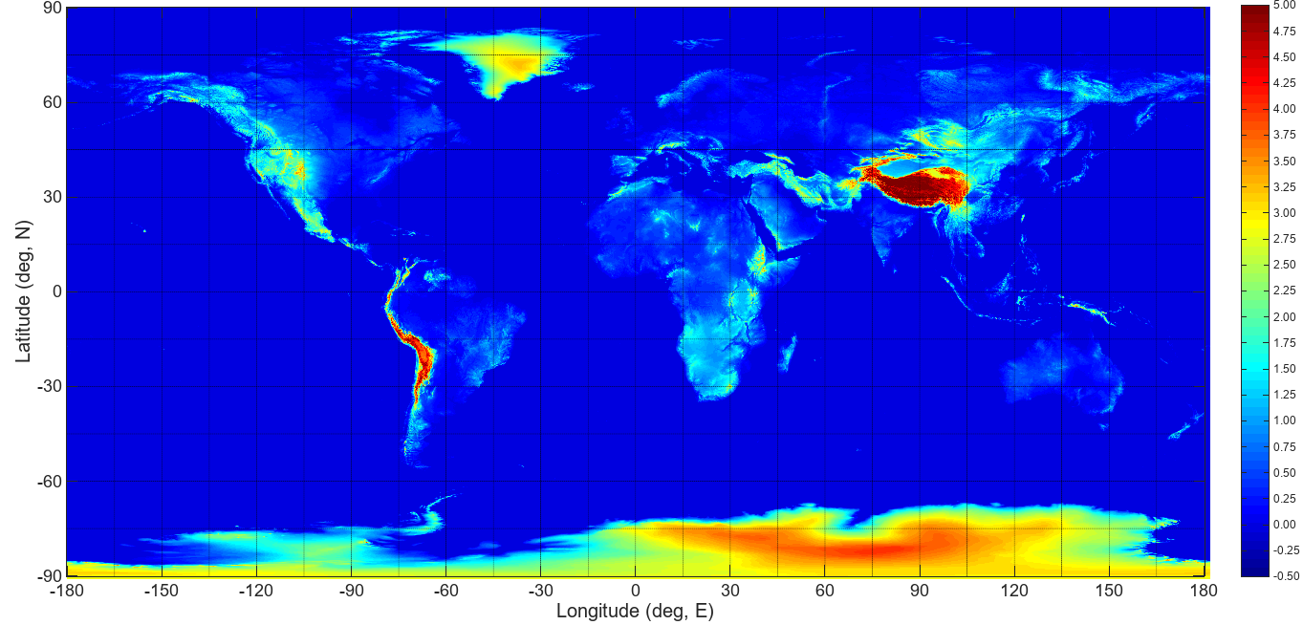

FIGURE 2

GMTED2010 Elevation (km)

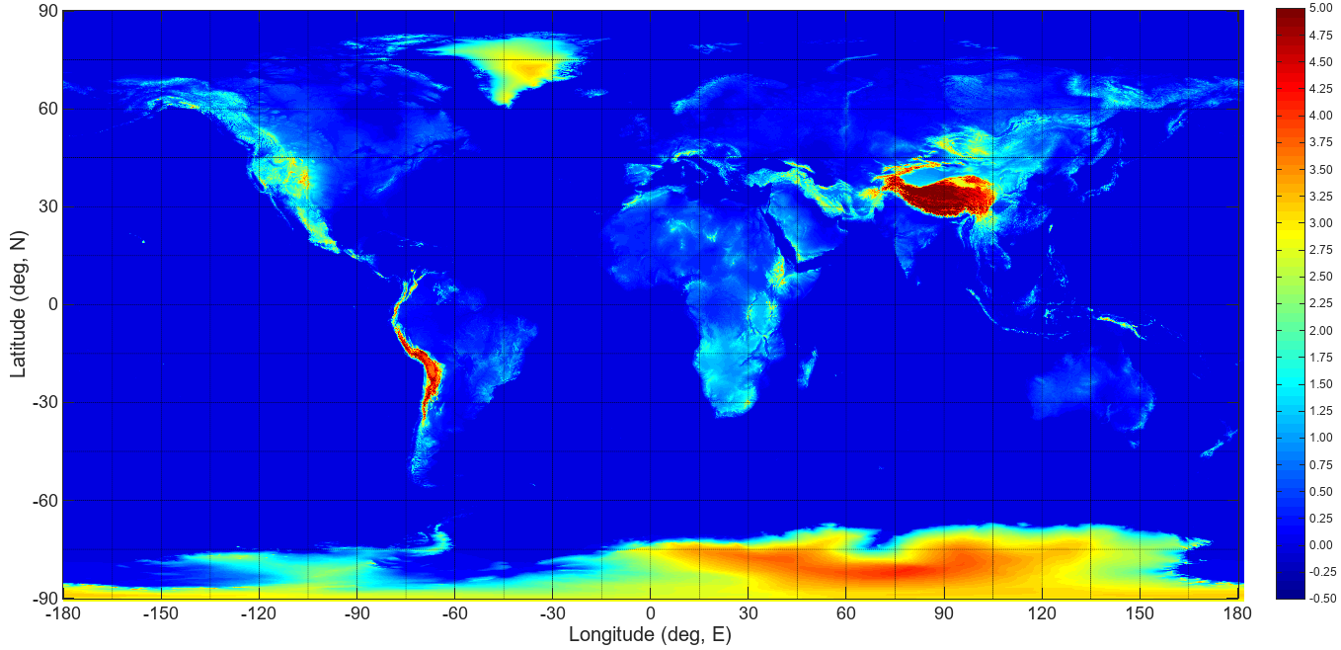

FIGURE 3

VFP Elevation (km)

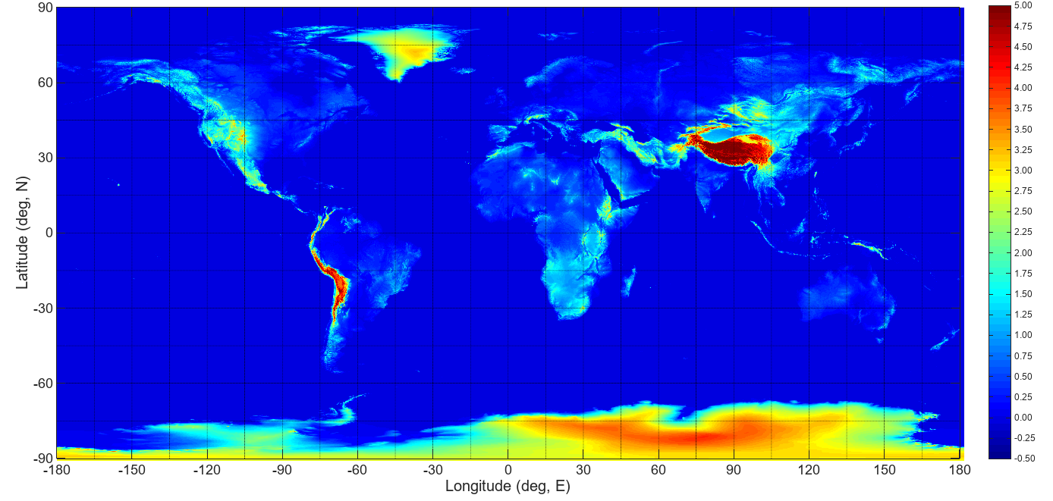

FIGURE 4

EARTH2014 Elevation (km)

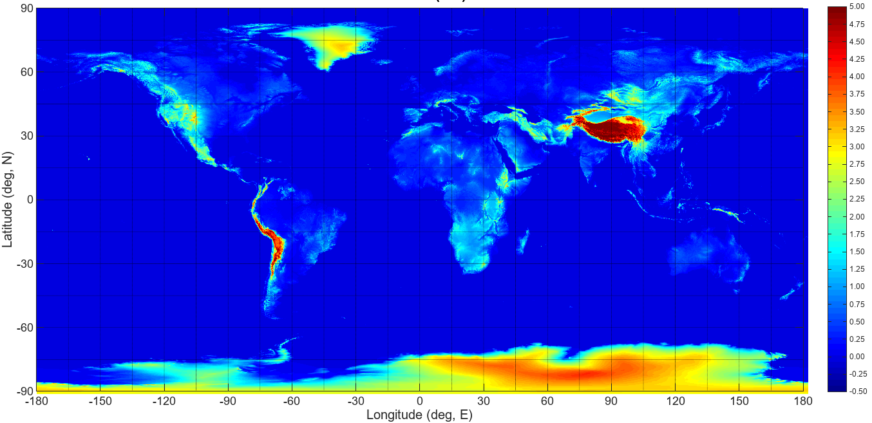

TABLE 2

Pixel dimensions and approximate ASCII file size vs. spatial resolution

|  |  |  |  |  |
| --- | --- | --- | --- | --- |
| Spatial Resolution (deg) | ASCII File Size (MB) | Latitude (deg) | Latitude Pixel (km) | Longitude Pixel (km) |
| 0.5000 | 2 | 45 | 55.7 | 39.4 |
| 0.2500 | 7 | 45 | 27.8 | 19.7 |
| 0.1000 | 44 | 45 | 11.1 | 7.9 |
| 0.0833 | 64 | 45 | 9.3 | 6.6 |
| 0.0500 | 178 | 45 | 5.6 | 3.9 |
| 0.0200 | 711 | 45 | 2.8 | 2.0 |
| 0.0100 | 4 441 | 45 | 1.1 | 0.8 |

Based on the desire to keep the ASCII file size under a manageable size of 100 MB, a resolution of 0.1° (i.e. a 0.1° x 0.1° grid) or 0.08333° (i.e. a 0.08333° x 0.08333° grid) is proposed. This results in a significant improvement in the elevation accuracy in terrains with moderate rates of change in elevation vs. distance. However, in mountainous regions with large rates of change in elevation vs. distance, prediction errors can be as large as several kilometres. In this case, the revised recommendation should suggest that local data or higher resolution data sources should be used if precise elevation data is required in mountainous regions.

## 4.2 Subsampling and interpolation

Since the GLOBE, ETOPO1, GMTED2010, VFP, and the 1’ x 1’ EARTH2014 digital elevation models have higher resolution data than the target 0.1° x 0.1° they must be subsampled. The ETOPO1 data provides elevation data at exact integer multiples of 0.1°, so the ETOPO1 1’ x 1’ data can simply be subsampled by a factor of 6. The VFP data provides elevation data at exact integer multiples of 0.1°, so the VFP 15” x 15” data can simply be subsampled by a factor of 24. The GLOBE and GMTED2010 data are not at exact multiples of 0.1°, so the GLOBE and GMTED2010 data can either be simply subsampled by a factor of 12 and retain the original data points or interpolated to a 0.1° x 0.1° grid. The GMTED2010 data is provided in several aggregation methods: minimum elevation, maximum elevation, mean elevation, median elevation, standard deviation of elevation, systematic subsample, and breakline emphasis. The systematic subsample product uses the elevation of the nearest neighbour resampling over a grid square, and the mean elevation uses an average elevation of over a grid square.

The choice between simply subsampling or subsampling with interpolation depends on the intended interpretation of a data point in the target data; i.e. a) a data point in the target data can represent the elevation at the exact location, or b) a data point in the target data can represent a weighted average of the elevations in the area surrounding the target location. The Geospatial Data Abstraction Library (GDAL) open-source image processing software considers the subsampling factor in its cubic interpolation algorithm. The basic cubic interpolation method is the well-known Catmull-Rom method documented in Recommendation ITU-R P.1144 that approximates the elevation at a point as the weighted average of the two surrounding points in each direction in latitude and longitude; i.e. a weighted average of 4x4 points. GDAL adjusts the number of surrounding points by the subsampling factor; e.g. GDAL calculates a weighted average of 48x48 (±24x±24) points for a subsampling factor of 12. In this case, the $K(δ)$ factor in Recommendation ITU-R P.1144 becomes $K(\frac{δ}{12})$, and the sum of all 48x48 points is divided by 144.

An example single-axis $K(δ)$ for the GLOBE subsampled data is shown in Figure 5. The target subsampled points at integer multiples of 0.1° are half-way between two points in the original data set, and the target subsampled data points are separated by 12 points in the original data set.

Independent from the subsampling and interpolation method used to calculate the 0.1° x 0.1° data set, Recommendation ITU-R P.1511 uses the 4x4 Catmull-Rom bicubic interpolation method to interpolate the elevation from the 0.1° x 0.1° data to the elevation at a desired location.

FIGURE 5

Example $K(δ)$ for GLOBE resampling with cubic interpolation



To determine which subsampling and interpolation method provides the best estimate, the following models were evaluated:

GLOBE

• GLOBE No Interp: Subsampling the 30” x 30” data by factor of 12 at the original data points (grid at non-integer multiples of 0.1°)

• GLOBE 48x48: Bicubic interpolating using 48x48 points to a grid at integer multiples of 0.1°

ETOPO1

• ETOPO1 No Interp: Subsampling the 1’ x 1’ data by factor of 6 at the original data points (grid at non-integer multiples of 0.1°)

• ETOPO1 23x23: Bicubic interpolating the 1’ x 1’ data using 23x23 points to a grid at integer multiples of 0.1°

GMTED2010

• GMTED2010 Sample: Systematic subsampling the 30” x 30” data with bicubic interpolating using 48x48 points to a grid at integer multiples of 0.1°

• GMTED2010 Average: Average subsampling the 30” x30” data with bicubic interpolating using 48x48 points to a grid at integer multiples of 0.1°

VFP

• VFP No Interp: Subsampling the 15” x15” data by factor of 24 at the original data points (grid at integer multiples of 0.1°)

• VFP 47x47: Subsampling the 15” x 15” data by a factor of 2, followed by bicubic interpolating using 47x47 points to a grid at integer multiples of 0.1° (Due to the size of the original data, the 15” x 15” VFP data was first subsampled by a factor of 2 to a 30” x 30” grid, and the 30” x 30” grid was bicubic interpolated to 0.1° x 0.1°)

Since the target data points on a 0.1° x 0.1° grid exactly match the VFP data points on the 30” x 30” grid, an odd number of data points (23 data points below, the target data point, and 23 data points above for a total of 47x47 data points) were selected for interpolation.

EARTH 2014

• EARTH2014 5’: 5’ x 5’ (i.e. 0.083333° x 0.083333° grid) data without subsequent subsampling or interpolation

• EARTH2014 20x20: Bicubic interpolating the 1’ x 1’ data using 20x20 data points to a 0.1° x 0.1° grid at integer multiples of 0.1°

Latitudes are based on the GRS80 rather than the WGS-84 ellipsoid; however, for all practical applications the WGS84 ellipsoid and GRS80 ellipsoid are identical. The height above mean sea level was obtained from the GRS80 ellipsoid and the EGM96 undulations.

# 5 Geodetic reference points

The document submitted to ITU-R WP 3J at the August 2017 meeting used a subset of NOAA’s Global Historical Climatology Network (GHCN) locations and the associated elevations as elevation “truth”; however, it is unknown whether the associated GHCN elevations are relative to WGS-84 or mean sea level.

Other potential sources of elevation “truth” are:

• Google Maps API (<https://developers.google.com/maps/documentation/elevation/intro>)

• Bing Maps API (<https://msdn.microsoft.com/en-us/library/jj158959.aspx>)

• ITRF Reference Stations

• SRTM V4.1

The Google Maps API and Bing Maps API provide the elevation relative to mean sea level except for the oceans where both APIs return the bathymetric elevation. Only 522 of the 91 809 GHCN locations are below sea level from the Google API.

The International Terrestrial Reference System (ITRS) maintains a set of International Terrestrial Reference Frame (ITRF) reference stations with the locations as WGS-84 (X, Y, Z). These locations were converted from WGS-84 (X, Y, Z) to WGS-84 geodetic (Latitude, Longitude, Elevation), and the elevation relative to the WGS-84 ellipsoid was converted to elevation relative to the EGM-2008 geoid (i.e. altitude above mean sea level). The set of reference stations was then parsed to eliminate multiple entries for the same location. The elevations above mean level of the resulting 977 ITRF reference stations were then compared with the elevations from the Google API, where the ITRF reference stations with elevations below sea level were ignored. The absolute value of the difference in elevations between the ITRF reference stations and the Google API was less than 20 m for 90% of the locations and less than 55 m for 99% of the locations.

SRTM V4.1 provides elevation data relative to mean sea level for latitudes between 60°N and 60°S on a 30” x 30” grid; however, the SRTM V4.1 data set does not provide 100% complete coverage. GHCN sites where a) elevations from the Google API were negative, and b) there were voids in SRTM V4.1 coverage that were removed from consideration. The elevations from the Google API and the SRTM V4.1 were compared for the remaining 83 492 GHCNs. The absolute value of the difference in elevation between the Google API and SRTM V4.1 is less than 24.6 m for 90% of the locations and less than 45 m for 99% of the locations.

These two comparisons imply that the elevations provided by the Google API are sufficiently accurate to be used as the “gold standard” to evaluate the accuracy of the various candidate digital elevation models.

## 5.1 Comparison for GHCN locations

The average, standard deviation, maximum, and elevation corresponding to 95% of the absolute difference between the elevations from each digital elevation model and the elevation from the Google Maps API is shown in Table 3, where the comparison has been restricted to the locations where the elevations from the Google API are non-negative. This restriction was imposed because the Google API returns the elevation of the bedrock rather than the elevation of the water level.

TABLE 3

Error statistics of each digital elevation model for GHCN sites and  
the Google API as the reference

|  |  |  |  |  |  |  |
| --- | --- | --- | --- | --- | --- | --- |
|  | Average (m) | Std Dev (m) | RMS (m) | Max Diff(m) | Elevation (m) | CDF |
| ITU-R | 145.95 | 226.80 | 269.7 | 4 088.0 | 630.0 | 0.95 |
| GLOBE 48x48 | 50.30 | 84.88 | 98.7 | 1 244.6 | 218.3 | 0.95 |
| GLOBE No Interp | 51.27 | 91.93 | 105.3 | 1 475.1 | 215.8 | 0.95 |
| ETOPO1 23x23 | 49.73 | 88.64 | 101.6 | 1 739.8 | 218.3 | 0.95 |
| ETOPO1 No Interp | 46.15 | 89.01 | 100.3 | 1 832.3 | 204.5 | 0.95 |
| GMTED2010 Average | 46.01 | 82.98 | 94.9 | 1 849.4 | 215.8 | 0.95 |
| GMTED2010 Sample | 46.00 | 82.96 | 94.9 | 1 849.4 | 216.8 | 0.95 |
| VFP 47x47 | 46.09 | 82.97 | 94.9 | 1 238.9 | 218.3 | 0.95 |
| VFP No Interp | 46.11 | 89.52 | 100.7 | 1 699.6 | 204.7 | 0.95 |
| Earth2014 5’ | 41.61 | 76.27 | 86.9 | 1 281.6 | 215.9 | 0.95 |
| Earth2014 20x20 | 44.31 | 80.42 | 91.8 | 1 198.2 | 216.4 | 0.95 |

GLOBE, ETOPO1, GMTED2010, VFP and EARTH2014 are significantly better than the current ITU-R topographic model. GLOBE 48x48, VFP 47x47, and both EARTH2014 models are approximately equivalent, and EARTH2014 5’ would be an excellent selection based on RMS and maximum error.

## 5.2 Comparison for bodies of water

For an example list of 25 bodies of water including lakes and inland seas, the absolute difference between the elevations from each digital elevation model and the true elevation is shown in Table 4. ETOPO1 has the highest error since it provides the elevation at the bottom of several bodies of water rather than at the surface. EARTH2014 20x20 has the best performance. It is difficult to predict the elevation of Lake Nakuru since the lake is surrounded by mountains, and interpolation weighting the elevations of the lake with the surrounding mountains distorts the predicted elevation of the lake.

## 5.3 Comparison for mountain peaks

For an example list of 1 663 mountain peaks, the average, standard deviation, and maximum absolute difference is shown in Table 5. These comparatively large errors can be anticipated due to the 0.1° x 0.1° grid spacing which corresponds to a pixel area of 87.7 km2 at a latitude of 45°. Users who want accurate elevations in mountainous areas should refer to local data or higher resolution data sources (e.g. Google Earth, Google API, topographic maps). Note, however, that Google Earth’s elevation data is typically derived from SRTM data which has a 3” x 3” resolution, corresponding to 92 m x 92 m at the equator.

## 5.4 Comparison summary

Based on the comparison for GHCN locations, bodies of water and mountain peaks, EARTH2014 original 5’ x 5’ data was selected as the best approach. However, in mountainous regions where the elevation rate of change can be large, a method which uses the subsampled data point without interpolation is a better approximation to the true elevation. It may be possible to provide a hybrid of the two approaches; however, a hybrid approach was not investigated since the elevation prediction error in mountainous regions can be several kilometres, and there is very limited benefit of the hybrid approach.

# 6 Miscellaneous notes

## 6.1 Data wrapping

It is important to ensure the data is correctly mapped at the edges and the subsampled data augmented with additional columns at each edge to facilitate subsequent bicubic interpolation using Recommendation ITU-R P.1144. All of the original data is from approximately -180° E to +180°E and +90°N to -90°N. It is straightforward to replicate adjacent columns on the left and right edges. Additional adjacent rows at the top and bottom edges must be mapped to longitudes on the other side of the Earth; i.e. a longitude of X° on one side of the Earth is adjacent to a longitude of X+180° on the other side of the Earth.

## 6.2 Matlab/Octave bi-linear interpolation

The Matlab/Octave function interp2() is sometimes used to perform bi-cubic interpolation; however, interp2() is computationally inefficient. Since the proposed data sets are on a regular uniformly spaced grid, it is more computationally efficient to perform the bi-cubic interpolation by directly implementing the method documented in Recommendation ITU-R P.1144.

Note that the Matlab and Octave interp2() bicubic interpolation functions are different. Matlab implements the 4x4 Catmull-Rom bicubic interpolation documented in Recommendation ITU-R P.1144; however, Octave appears to implement bi-cubic Hermite spline interpolation which is less accurate than the 4x4 Catmull-Rom method.

TABLE 4

Error statistics of each digital elevation model for bodies of water true elevation as the reference



TABLE 5

Error statistics of each digital elevation model for mountain peaks and true elevation as the reference

|  |  |  |  |  |
| --- | --- | --- | --- | --- |
|  | Average (m) | Std Dev (m) | RMS (m) | Max Diff (m) |
| ITU-R | 1 921.5 | 695.8 | 2 043.6 | 5 045.4 |
| GLOBE 48x48 | 1 193.0 | 411.2 | 1 261.9 | 3 267.3 |
| GLOBE No Interp | 1 082.3 | 515.3 | 1 198.7 | 3 907.6 |
| ETOPO1 23x23 | 1 220.2 | 421.1 | 1 290.8 | 3 392.2 |
| ETOPO1 No Interp | 1 092.3 | 503.5 | 1 202.8 | 3 899.5 |
| VFP 47x47 | 1 187.9 | 428.1 | 1 262.7 | 3 488.3 |
| VFP No Interp | 1 087.9 | 529.1 | 1 209.7 | 3 853.3 |
| EARTH2014 No Interp | 1 111.6 | 397.6 | 1 180.6 | 3 046.4 |
| EARTH2014 20x20 | 1 158.6 | 415.0 | 1 230.6 | 3 170.7 |

References

**GLOBE**: Hastings, David A. and Paula K. Dunbar, Paula K., Editors, Global Land One-kilometer Base Elevation (GLOBE), Digital Elevation Model, Version 1.0, Documentation Version 1.0, NCDC Key to Geophysical Records Documentation No. 34, United States Department of Commerce, National Oceanic and Atmospheric Administration National Environmental Satellite, Data, and Information Service National Geophysical Data Center Boulder, Colorado, May 1999.

**ETOPO1**: Amante, C., and Eakins, B.W., ETOPO1 1 Arc-Minute Global Relief Mode: Procedures, Data Sources, and Analysis, National Geophysical Data Center, Marine Geology and Geophysics Division, Boulder, Colorado, March 1999.

**GMTED2010**: Danielson, J.J., and Gesch, D.B., Global multi-resolution terrain elevation data 2010 (GMTED2010): U.S. Geological Survey Open-File Report 2011–1073, 2011.

**VFP**: <http://viewfinderpanoramas.org/dem3.html>

**EARTH2014**: Hirt, C. and Rexer, M., Earth2014: 1 arc‐min shape, topography, bedrock and ice‐sheet models – available as gridded data and degree‐10,800 spherical harmonics, International Journal of Applied Earth Observation and Geoinformation 39, 103‐112.

______________

1. Review of Higher Resolution Altitude Data and Comparison with Recommendation ITU-R P.1511, Document [3J/142](https://www.itu.int/md/R15-WP3J-C-0142/en)-E, 15 August 2017.