|  |  |
| --- | --- |
| **Radiocommunication Study Groups** |  |
| **Meetings of Working Parties 3J, 3K, 3L and 3M Montreal, Canada - 19-28 June 2018** |  |
|  |  |
| Source: Documents 3J/TEMP/77  Subject: Fascicle on drop size distribution data processing | **Revision 1 to Document 3J/FAS/7-E** |
| **3 July 2018** |
| **English only** |
| Working Party 3J | |
| FASCICLE | |
| The processing of drop size distribution data  for Study Group 3 Experimental Database | |

Table of Contents

1 Scope 2

2 Introduction 2

3 General description of disdrometer data pre-processing 3

4 Discussion on specific instruments 3

4.1 2D-Video-Disdrometer 3

4.1.1 Technical description 3

4.1.2 Data pre-processing 5

4.2 Thies disdrometer 7

4.2.1 Technical description 7

4.2.2 Measurement errors 9

4.2.3 Data pre-processing 9

4.2.4 Pre-processing procedure 11

5 Conclusion 11

6 References 12

# 1 Scope

This document describes the recommended methods to be used when processing disdrometer measurements for submission of data to the SG 3 experimental [Table IV-12: “Statistics of rain drop size distribution”](https://www.itu.int/oth/R0A04000079/en).

# 2 Introduction

The impact of rain on a propagating wave depends on the frequency, polarization, elevation angle of the slant path and characteristics of the rain event [1]. The specific rain attenuation is influenced not only by the rain rate, but also by the shape of the drop size distribution (DSD), which can cause significant differences [2].

This fascicle focuses on ground disdrometer measurements. A disdrometer is an instrument used to measure the DSD and velocity of falling hydrometeors, among other parameters. There are three main types: Video, acoustic and impact disdrometers. Not all disdrometers of a certain type rely on the same measurement process (e.g. some video disdrometers measure drops passing through the sampling area from the scattered light, whereas others do it from the occluded light). Different models are available including: 2D-Video-Disdrometer (2DVD), 1D-Video-Disdrometer (1DVD), THIES Laser precipitation monitor, Joss-Waldvogel Disdrometer (JWD), Vaisala RAINCAP Sensor… etc. Some disdrometers can distinguish between rain, graupel, and hail. 2D video disdrometers can be used to analyse individual particles.

The statistical characterisation of the rain drop size distribution can be applied to improve the accuracy of rain attenuation prediction models [3, 4, 5]. Measurement campaigns around the world put in evidence that the DSD shapes are influenced by the geographic and climatic characteristics, with the largest differences observed between maritime and continental climates [6]. Figure 1 presents an exemplary selection of locations with long-term DSD measurements. Although this figure shows a preliminary list of currently available measurement datasets, a good coverage of various climates and geographic regions is already achieved.

Figure 1

Some locations of long-term 2DVD measurements

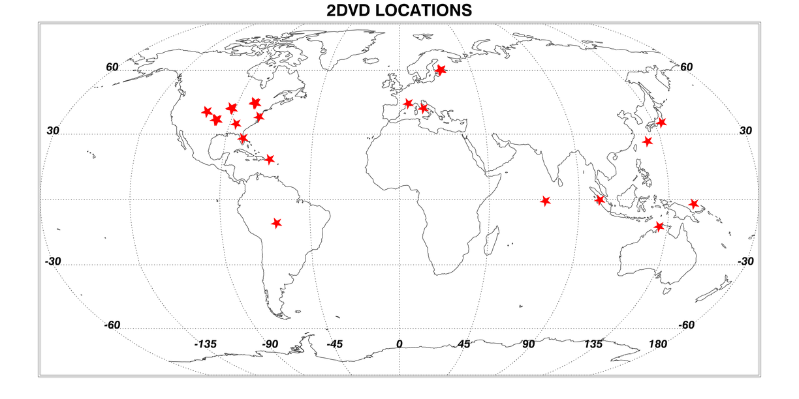

A table containing annual mean values of local DSD measurements conditioned to rain rate was added to the SG 3 experimental databank in Part IV (Radiometeorological data): [Table IV-12: “Statistics of rain drop size distribution”](https://www.itu.int/oth/R0A0400007A/en). This table refers explicitly to rain drops, so it is thus necessary to exclude all other particles from the analysis. This fascicle describes how to pre-process raw disdrometer data to filter out spurious data and non-rain particles.

# 3 General description of disdrometer data pre-processing

The objective of the disdrometer data pre-processing is to remove false rain detections such as:

– Any non-rain particles (e.g. snow particles with large diameter and low velocity)

– Splashed drops after hitting instrument surfaces

– Particles falling through the edges of the sample area

– Eventual system artefacts

Observations of particles with anomalous fall velocities and diameters could be attributed to wind effects and should also be identified and analysed in a specific way.

The preferred approach when using video disdrometers is to compare the relationship between the fall velocity of the particles and their diameter against widely accepted models in the literature such as Atlas *et al.* [7] and Gunn, R. and G. Kinzer [8].

The model by Atlas *et al.* [7] represents an analytically closed form for the computation of the fall velocity as a function of the rain drop size.

$v\left(D\right)=9.65-10.3∙\exp\left(-0.6∙D\right)$          (m/s) (1)

More precise models for the fall velocity of raindrops could be used to take into account also the effects of location height above mean sea level, atmospheric pressure and climatic variability.

# 4 Discussion on specific instruments

## 4.1 2D-Video-Disdrometer

### 4.1.1 Technical description

The 2D-Video-Disdrometer measures single particle parameters and derives drop size distribution and other parameters with an adjustable integration time.

The operational principle is depicted in a schematic fashion in Figure 2. The device contains two optical paths: two CCD line scan cameras are directed towards two illumination units. Objects passing through the measurement area – determined by the cross-section of the two optical paths as seen from above – obstruct the light and are detected as shadows by the cameras. Individual precipitation particles are identified matching their views from camera A and B.

In order to reconstruct observables like falling velocity, oblateness, etc., the two optical paths are displaced vertically by a distance of about 6 mm. Measuring this distance and adjusting the background illumination are the two major calibration and maintenance tasks necessary for the correct operation of the device.

Figure 2

Measurement principle of the 2D-Video-Distrometer

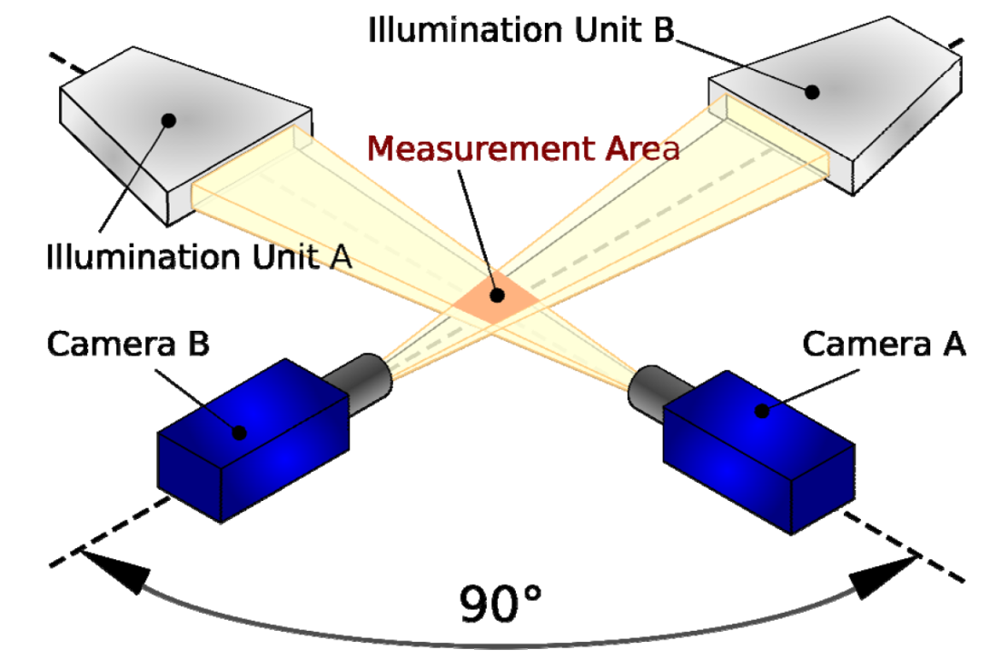

The instrument software is used to analyse the raw data and obtain the characteristics of each detected drop. The parameters of interest for the pre-processing are: diameter, fall velocity, volume and effective measuring area.

Fall velocity of each drop is measured by the time the particle takes for proceeding from camera A (upper system) to camera B (lower system), as sketched in Figure 3. To minimize quantization effects, the mean of (t2-t0) and (t3-t1) is considered. The height distance between the two optical planes is calibrated using high precision steel spheres.

Figure 3

Fall velocity calculation

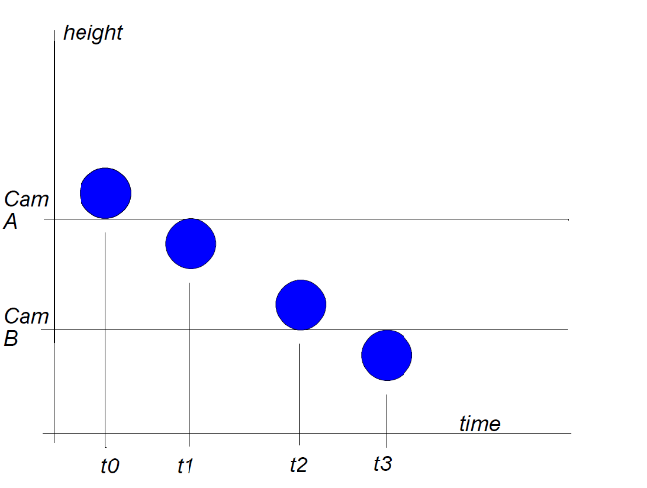

When determining the drop size distribution, the 2D-Video-Distrometer considers only particles that are totally within the common field of view of the two cameras. The effective sensing area therefore depends on the size of the recorded particles (Figure 4). For a particle diameter D (mm) the effective sensing area is:

${(L-D)}^{2}$                (mm²)

with *L* being the side length of the quadrate sensing area.

Figure 4

Effective sensing area of the 2DVD for precipitation particles with diameter *D*

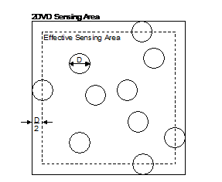

### 4.1.2 Data pre-processing

For the pre-processing and filtering of the data, the histogram of fall velocity vs. diameter is generated using observations of each particle. The procedure is explained in the following and Figure 5 is given for illustration.

Each particle is compared against the model given by Atlas *et al.* [7]. The selected metric is the orthogonal distance to the model in the v(D) graph (i.e. the length of the normal vector in the velocity vs. diameter grid), which allows keeping the most significant amount of measured particles, especially when considering the lower diameters and velocities. The threshold for this comparison is chosen for each experimental site analysing a statistically significant set of samples. It stems from local characteristics of precipitation; e.g., if strong winds are common, the v(D) distribution widens up and the threshold has to be accordingly set to slightly higher values.

In the example in Figure 5, a length of the normal vector of 1.2 was chosen as threshold. This resulted in filtering out 3.5% of the total rain fall, corresponding to drops outside of the marked area. It is worth noting that the steel spheres of 4 mm diameter used for the calibration of the 2D-Video-Disdrometer are present in the raw distribution and are of course filtered out from the dataset during the pre-processing.

Figure 5

Cumulative count of particles (in logarithmic scale) in a velocity vs. diameter grid, recorded in Graz (Austria) during the year 2014. Red line: Model by Atlas *et al.* [7]. Green lines: thresholds for non-rain decision. Using a vector normal to the model of length 1.2, 3.5 % of the total rain fall is filtered out

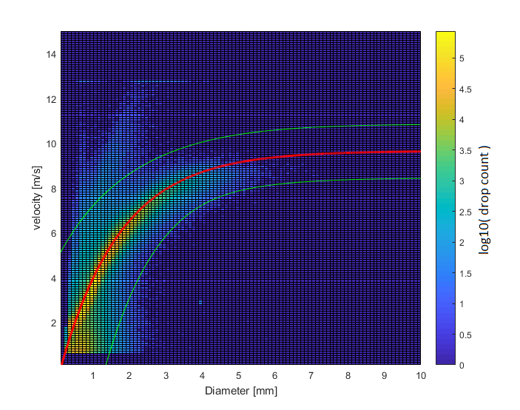

The establishment of annual DSDs from individual drop information follows the classic approach:

1 The year is divided in intervals of duration integration time $Δ$*t*

2 The DSDs are computed for these intervals using equation (1), which gives the drop number density:

       (1/m3mm) (1)

where:

*i* denotes a particular drop size class;

$Δ$*Di* width of drop size class *i* (mm);

$Δ$*t* time interval (s);

*j* denotes a particular drop within size class *i* and time interval $Δ$*t*;

*mi* number of drops within size class *i* and time interval $Δ$*t*;

*Di* mean diameter of drop size class *i* (mm);

*Aj* effective measuring area for drop *j* (m²);

*vj* fall velocity of drop *j* (m/s).

1 The resulting DSDs are categorized according to the rain rate computed with equation (2):

$R= 3600*\frac{1}{Δt}*\sum_{i=1}^{n}{\frac{V_{i}}{A_{i}}}$      (mm/h) (2)

where

$Δ$*t* time interval (s);

*i* denotes a drop;

*n* total number of fully visible drops measured during the time interval $Δ$*t*;

*Vi* volume of drop *i* (mm³);

*Ai* effective measuring area for drop *i* (mm²).

2 Finally, the yearly mean DSDs conditioned to rain rate are computed to fill Table IV-12.

## 4.2 Thies disdrometer

### 4.2.1 Technical description

A laser diode and some optical elements produce a parallel infrared light sheet of 785 nm thickness providing a detection area of 20 × 228 mm2 [9], as shown in Figures 6 and 7. A photo diode with a lens on the receiver side transforms the optical intensity into an electrical signal. When the precipitation particles fall through this beam, the received signal is reduced. The amplitude of the reduction is related to the size of the particles, and the fall velocity is determined from the duration of the reduction. From these measurements the instrument calculates a set of parameters, such as precipitation intensity and amount or reflectivity, and particle size and velocity distributions in the form of particle spectra. Precipitation type is then determined from known statistics of particle size and velocity for the different precipitation types that may include rain, hail, snow, etc. The manufacturer provides a version of this disdrometer with temperature, humidity and wind sensors connected to the instrument. Temperature measurements are also used for solid particle identification.

Figure 6

Thies laser disdrometer

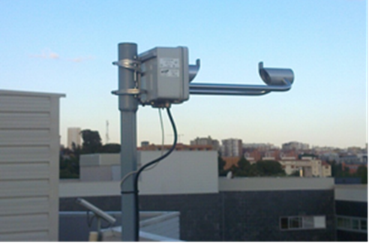

Figure 7

Operating principle of the Thies laser disdrometer



Although the instrument can provide a data sample for each detected particle with equi-volumetric drop diameter and velocity information, the format generally used to acquire the data consists of one –minute accumulations, which provide the number of particles that have been detected in each diameter and velocity class, being distributed in 20 and 22 classes, between 0.125 mm and 8 mm and 0.2 m/s and 10 m/s, respectively, as shown in Table 1. Particles are allocated in a diameter-fall velocity grid so that each bin of the grid corresponds to a specific combination of diameter and velocity classes, with a total of 440 bins. Such grids are represented by the software provided with the instrument as diameter-velocity spectra where the colour of each bin indicates the number of particles detected during that minute. Some examples are shown in Figure 8.

In order to adapt the data to the format of Table IV-12, the diameter classes 2 and 3 of the disdrometer must be merged into a single class, which corresponds to the second column of the Table (diameters between 0.25 and 0.5 mm). The class 22 includes all the particles whose diameter exceeds 8 mm, which may fall in three different classes of Table IV-12, or even beyond its upper limit. Since it is not possible to accurately distribute these particles into these classes, it could be safer to discard this class.

Figure 8

Spectra provided by the Thies disdrometer

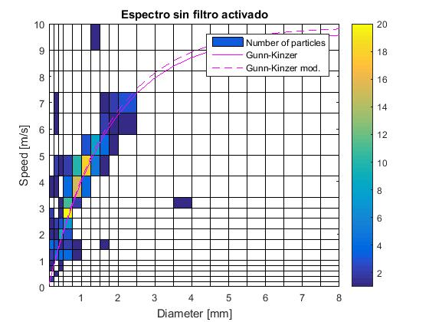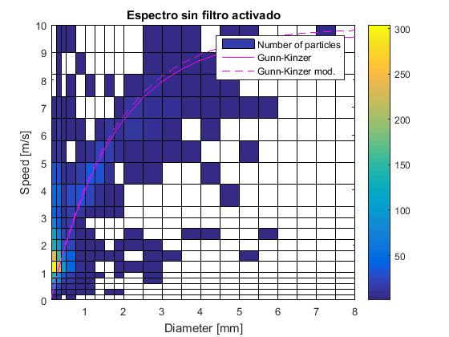

TABLE 1

Diameter and velocity classes of the Thies disdrometer

|  |  |  |  |  |  |  |
| --- | --- | --- | --- | --- | --- | --- |
| Diameter classes | | |  | Fall velocity classes | | |
| Class | **Diameter (mm)** | **Class width (mm)** |  | **Class** | **Velocity (m/s)** | **Class width (m/s)** |
| 1 | ≥ 0,125 | 0,125 |  | **1** | ≥ 0,000 | 0,200 |
| 2 | ≥ 0,250 | 0,125 |  | **2** | ≥ 0,200 | 0,200 |
| 3 | ≥ 0,375 | 0,125 |  | **3** | ≥ 0,400 | 0,200 |
| 4 | ≥ 0,500 | 0,250 |  | **4** | ≥ 0,600 | 0,200 |
| 5 | ≥ 0,750 | 0,250 |  | **5** | ≥ 0,800 | 0,200 |
| 6 | ≥ 1,000 | 0,250 |  | **6** | ≥ 1,000 | 0,400 |
| 7 | ≥ 1,250 | 0,250 |  | **7** | ≥ 1,400 | 0,400 |
| 8 | ≥ 1,500 | 0,250 |  | **8** | ≥ 1,800 | 0,400 |
| 9 | ≥ 1,750 | 0,250 |  | **9** | ≥ 2,200 | 0,400 |
| 10 | ≥ 2,000 | 0,500 |  | **10** | ≥ 2,600 | 0,400 |
| 11 | ≥ 2,500 | 0,500 |  | **11** | ≥ 3,000 | 0,400 |
| 12 | ≥ 3,000 | 0,500 |  | **12** | ≥ 3,400 | 0,800 |
| 13 | ≥ 3,500 | 0,500 |  | **13** | ≥ 4,200 | 0,800 |
| 14 | ≥ 4,000 | 0,500 |  | **14** | ≥ 5,000 | 0,800 |
| 15 | ≥ 4,500 | 0,500 |  | **15** | ≥ 5,800 | 0,800 |
| 16 | ≥ 5,000 | 0,500 |  | **16** | ≥ 6,600 | 0,800 |
| 17 | ≥ 5,500 | 0,500 |  | **17** | ≥ 7,400 | 0,800 |
| 18 | ≥ 6,000 | 0,500 |  | **18** | ≥ 8,200 | 0,800 |
| 19 | ≥ 6,500 | 0,500 |  | **19** | ≥ 9,000 | 1,000 |
| 20 | ≥ 7,000 | 0,500 |  | **20** | ≥ 10,000 | 10,000 |
| 21 | ≥ 7,500 | 0,500 |  |  |  |  |
| 22 | ≥ 8,000 | ∞ |  |  |  |  |

### 4.2.2 Measurement errors

Disdrometers should provide information on falling hydrometeors. However, these instruments may produce erroneous detections that are not originated by free falling hydrometeors or that are distorted by some system artefacts.

The comparisons with reference rain gauges performed in [10] revealed that the Thies disdrometer generally measures larger rainfall amounts than the reference rain gauges and has a tendency to yield higher intensity peaks in the presence of relatively high rain rates. Such errors may be due to multiple simultaneous drops being detected as a single large drop [11]. On the other hand, particles hitting the rim of the light beam could be interpreted as too small particles. In this respect, in the study performed in [12], the bias between disdrometers and other gauges was attributed, not only to the uncertainty in the evaluation of the diameter or to wind effects, but also to inaccuracies in the determination of the sensing area.

### 4.2.3 Data pre-processing

Data measured with this disdrometer should be pre-processed both to compensate for the instrument errors, such as those indicated in the previous paragraph, and also to adapt the data to the requirements for Table IV-12, which should include only DSDs derived from liquid rain measurements.

Several studies on data pre-processing for the Parsivel optical disdrometer are available in the literature. No similar studies have been found for the Thies disdrometer. Since they both share a similar operating principle and, therefore, some instrument errors, a data pre-processing procedure for the Parsivel instrument is summarized here.

A set of criteria on pre-processing, or quality control procedure, for the Parsivel disdrometer is provided in [13]. It is based on typical particle sizes and fall velocity–diameter relationships for specific particles such as rain, graupel or hail. A time step is removed if particles are observed within some specific margins associated with particles that are not considered to be real precipitation, but caused by effects such as wind, splashing, etc. Several criteria are proposed to discriminate among different particle types (rain, graupel, hail). The Gunn-Kinzer (GK) expression [14], which yields the velocity of rain drops as a function of their diameter, is considered as a reference for rain. Particle identification is performed considering various diameter thresholds and velocities with respect to the GK curve. For example, particles with velocities 60% above or below the GK curve are considered as erroneous particles (due to splashing, wind or particles falling through the edges of the sensing area) [13].

Recently, several studies dealing with size and velocity of rain drops have been published [15, 16, 17]. Using optical array spectrometer probes, the presence of drops with higher than expected fall velocities was observed [15]. These ‘‘super-terminal drops’’ of different sizes were produced by the break-up of a large drop and kept moving with the speed of the parent drop. An increase in the fraction of super-terminal drops with rain rate was observed for drops with diameters of less than 0.5 mm, which moved at velocities of 6 to 8 m/s.

The Meteorological Particle Spectrometer (MPS), used in [16], allows for characterizing the concentration of very small drops with very high resolution. The study based on these data, and on data detected with a 2-D video disdrometer, concluded that the DSD spectra present a drizzle mode for D below 0.7 mm and a precipitation mode for larger diameters. The presence of the drizzle mode was observed throughout the duration of the analysed events. Fall speed distributions for very small drops measured with the MPS were investigated in [17] by plotting velocity histograms for specific diameters. It was found that drops of 0.5 mm may present super-terminal velocities exceeding 2.34 m/s, 1.8 m/s being the mean value, so that occasional occurrences of sub and super‑terminal fall speeds could not be ruled out. In a turbulent event, considering drops of 1.3, 2 and 3 mm, the mean fall velocities were found to decrease reaching sub-terminal velocities, that is, values about 25–30% less than the terminal velocity of Gunn–Kinzer.

According to [18], about 25% of particles were removed when a filter similar to the one described above (as proposed in [13, 18]) was applied to data measured in light-to-moderate rainfall with a Parsivel disdrometer, being 71% of the filtered drops below 0.5 mm and about 28% between 0.5 and 1 mm.

Given the large amount of small particles that are removed with pre-processing procedures that can be found in the literature for the Parsivel disdrometer, and considering the recent discoveries on the existence and velocity of small particles, a different, lighter procedure is proposed here. However, various measured spectra should be inspected visually before and after applying such filters to ascertain that spurious particles have been removed and also, as far as possible, that only rain drops are left in the filtered spectra (no solid particles).

Since solid particles must not be included in Table IV-12, hail should be removed. A procedure to eliminate hail based on a set of known fall velocity–diameter relationships is proposed in [13]. However, misclassifications can occur. According to [21] hail is defined as ice particles of diameter larger than 5 mm that are observed as showers during heavy thunderstorms. They usually fall at velocities higher than rain drops [13]. In [21] small hail is defined as ice particles between 2 and 5 mm, also originated during thunderstorms. Such particles are more difficult to separate from rain drops. An additional difficulty is the limited accuracy of hail records, which are usually made by observers that must be present on the ground to measure the hailstones. Simultaneous records of electric meteors (lightning), usually observed during hail showers, can also be considered.

### 4.2.4 Pre-processing procedure

1. Time steps (one-minute spectra) with less than 10 particles when the rain rate is below 0.1 mm/h should be removed [19]. These spectra are considered as “noise”.
2. Particles with relatively large diameters and low velocities should be removed. Such particles can be spurious particles or snowflakes. For this, the Locatelli-Hobbs empirical diameter–fall speed relationship can be applied [20]:

V(D) = 0.8D0.16 (1)

1. Isolated particles should be removed if they are located at a given distance from the main cluster of bins containing particles. A distance between 2 and 4 empty bins has been used in [3] to eliminate unrealistic particles.
2. Very small particles (up to 1 mm) with very high fall velocities should be removed. Here, to select a velocity threshold, a compromise between fall velocities of real and spurious particles, which may depend on the specific instrument and on the precipitation characteristics, taking into account the above discussion, is recommended.
3. Hail particles can be identified as suggested in [13], using a known fall velocity–diameter relationships for hail particles, although misclassifications can occur. Alternatively, several characteristics associated to hail particles may be considered simultaneously to discriminate between hail and rain. As discussed above, diameters should be larger than 5 mm, particles should present high fall velocities and the simultaneous occurrence of thunderstorms must be observed (records of high rainfall rates and lightning). The specific climatic characteristics of the site must also be taken into account in the discrimination procedure to reduce the probability of identifying large rain drops as hail and vice versa.

# 5 Conclusion

This document describes the recommended methods to be used when processing disdrometer measurements for submission of data to the SG 3 experimental [Table IV-12: “Statistics of rain drop size distribution”](https://www.itu.int/oth/R0A04000079/en).

Table IV-12 refers explicitly to rain drops, so it is thus necessary to exclude all other particles from the analysis. This fascicle presents the objectives and methodology to pre-process raw disdrometer data filtering out spurious and non-rain particles.

The discussion on specific instruments is presented in Section 4. The operational principle, and parameters of interest for both the 2D-Video-Disdrometer and the Thies laser disdrometer are introduced. The approach for the analysis of the 2DVD data is discussed in Section 4.1, and it is based on the comparison between measured fall velocity and diameter of the particles with a model, with the support of some examples. The procedures for data processing proposed for the Thies laser disdrometer are discussed in Section 4.2.

# 6 References

[1] ITU-R P.838-3 “Specific attenuation model for rain for use in prediction methods” (2005). International Telecommunication Union, Geneva, Switzerland, 2005.

[2] M. Thurai, V.N. Bringi, and A. Rocha, “Specific attenuation and depolarisation in rain from 2-dimensional video disdrometer data”, IET Microwaves, Antennas & Propagation, Vol. 1, No. 2, 373-380, 2007. doi:10.1049/iet-map:20060023.

[3] J. M. Garcia-Rubia, J. M. Riera, A. Benarroch, and P. Garcia-del-Pino, "Estimation of Rain Attenuation from Experimental Drop Size Distributions," *Antennas and Wireless Propagation Letters, IEEE,* vol. 10, pp. 839-842, 2011.

[4] J. M. Garcia-Rubia, J. M. Riera, P. Garcia-del-Pino, and A. Benarroch, "Attenuation Measurements and Propagation Modeling in the W-Band," *Antennas and Propagation, IEEE Transactions On,* vol. 61, *(4),* pp. 1860-1867, 2013.

[5] J. M. Garcia-Rubia, A. Benarroch, P. Garcia-del-Pino, J. M. Riera, “A Five-year Study of Experimental Drop Size Distributions for Rain Attenuation in Madrid”, 10th European Conference on Antennas and Propagation, Davos, Switzerland, 10-15 April 2016.

[6] V.N. Bringi, V. Chandrasekar, J. Hubbert, W.L. Randeu and M. Schoenhuber, “Raindrop size distribution in different climatic regimes from disdrometer and dual-polarized radar analysis”, Journal of the atmospheric sciences, vol. 60, pp. 354-365, 2003.

[7] Atlas, D., R.C. Shrivastava and R.S. Sekhon “Doppler radar characteristics of precipitation at vertical incidence”. Rev. Geophys. Space Phys., pp. 1-35, 1973

[8] Gunn, R. and G. Kinzer, “The terminal velocity of fall for water droplets in stagnant air.” J. Meteor., 6, 248-248, 1949.

[9] [www.thiesclima.com/en/Products/Precipitation-Electrical-devices/?art=774](http://www.thiesclima.com/en/Products/Precipitation-Electrical-devices/?art=774)[10] Lanza, L.G., Vuerich, E., 2009. The WMO field intercomparison of rain intensity gauges. Atmospheric Research 94, 534–543.

[11] Lanzinger, E., Theel, M. and Windolph, H., 2006. Rainfall amount and intensity measured by the Thies laser precipitation monitor, TECO-2006, Geneva, Switzerland.

[12] Frasson, R.P.d.M., L.K. da Cunha, and W.F. Krajewski, Assessment of the Thies optical disdrometer performance. Atmospheric Research, 2011. 101(1-2): p. 237-255.

[13] Friedrich, K., S. Higgins, F. J. Masters, and C. R. Lopez, 2013: Articulating and stationary PARSIVEL disdrometer measurements in conditions with strong winds and heavy rainfall. J. Atmos. Oceanic Technol., 30, 2063–2080, doi:10.1175/JTECH-D-12-00254.1.

[14] Gunn, R. and G. Kinzer, “The terminal velocity of fall for water droplets in stagnant air.” J.Meteor., 6, 248-248., 1949.

[15] Montero-Martínez, G., A. B. Kostinski, R. A. Shaw, and F. García-García (2009), Do all raindrops fall at terminal speed?, Geophys. Res. Lett., 36, L11818, doi:10.1029/2008GL037111.

[16] Thurai, M., Gatlin, P., Bringi, V. N., Petersen, W., Kennedy, P., Notaroš, B., and Carey, L.: Toward completing the raindrops size spectrum: case studies involving 2-D-video disdrometer, droplet spectrometer, and polarimetric radar measurements, J. Appl. Meteorol. Clim., 56, 877–896, [https://doi.org/10.1175/JAMC-D-16- 0304](https://doi.org/10.1175/JAMC-D-16-%200304).1, 2017

[17] Bringi, V., Thurai, M., and Baumgardner, D.: Raindrop fall velocities from an optical array probe and 2-D video disdrometer, Atmos. Meas. Tech., 11, 1377-1384, https://doi.org/10.5194/amt-11-1377-2018, 2018.

[18] Jaffrain, J. and Berne, A.: Experimental quantification of the sampling uncertainty associated with measurements from Parsivel disdrometers, J. Hydrometeor., 12, 352 370, doi:10.1175/2010JHM1244.1, 2011.

[19] A. Tokay, W. A. Petersen, P. Gatlin, and M. Wingo, 2013: Comparison of raindrop size distribution measurements by collocated disdrometers. J. Atmos. Oceanic Technol., 30, 1672–1690, doi:10.1175/JTECH-D-12-00163.1

[20] Locatelli, J. D., and P. V. Hobbs, 1974: Fall speeds and masses of solid precipitation particles. J. Geophys. Res., 79, 2185–2197.

[21] cloudatlas.wmo.int

______________