|  |  |
| --- | --- |
| **Radiocommunication Study Groups** |  |
|  |  |
|  |  |
| Source: Document 3J/TEMP/52  Subject: Fascicle on drop size distribution data processing | **Document 3J/FAS/7-E** |
| **12 September 2017** |
| **English only** |
| Working Party 3J | |
| FASCICLE | |
| The processing of drop size distribution data  for Study Group 3 Experimental Database | |

Table of Contents

1 Scope 2

2 Introduction 2

3 General description of disdrometer data pre-processing 3

4 Discussion on specific instruments 3

4.1 2D-Video-Disdrometer data processing description 3

6 Conclusion 7

7 References 7

# 1 Scope

This document describes the recommended methods to be used when processing disdrometer measurements for submission of data to the SG 3 experimental [Table IV-12: “Statistics of rain drop size distribution”](https://www.itu.int/oth/R0A04000079/en).

# 2 Introduction

The impact of rain on a propagating wave depends on the frequency, polarization, elevation angle of the slant path and characteristics of the rain event [1]. The specific rain attenuation is influenced not only by the rain rate, but also by the shape of the drop size distribution (DSD), which can cause significant differences [2].

This fascicle focuses on ground disdrometer measurements. A disdrometer is an instrument used to measure the DSD and velocity of falling hydrometeors, among other parameters. There are three main types: Video, acoustic and impact disdrometers. Not all disdrometers of a certain type rely on the same measurement process (e.g. some video disdrometers measure drops passing through the sampling area from the scattered light, whereas others do it from the occluded light). Different models are available including: 2D-Video-Disdrometer (2DVD), 1D-Video-Disdrometer (1DVD), THIES Laser precipitation monitor, Joss-Waldvogel Disdrometer (JWD), Vaisala RAINCAP Sensor… etc. Some disdrometers can distinguish between rain, graupel, and hail. 2D video disdrometers can be used to analyse individual particles.

The statistical characterisation of the rain drop size distribution can be applied to improve the accuracy of rain attenuation prediction models [3, 4, 5]. Measurement campaigns around the world put in evidence that the DSD shapes are influenced by the geographic and climatic characteristics, with the largest differences observed between maritime and continental climates [6]. Figure 1 presents an exemplary selection of locations with long-term DSD measurements. Although this figure shows a preliminary list of currently available measurement datasets, a good coverage of various climates and geographic regions is already achieved.

Figure 1

Some locations of long-term 2DVD measurements

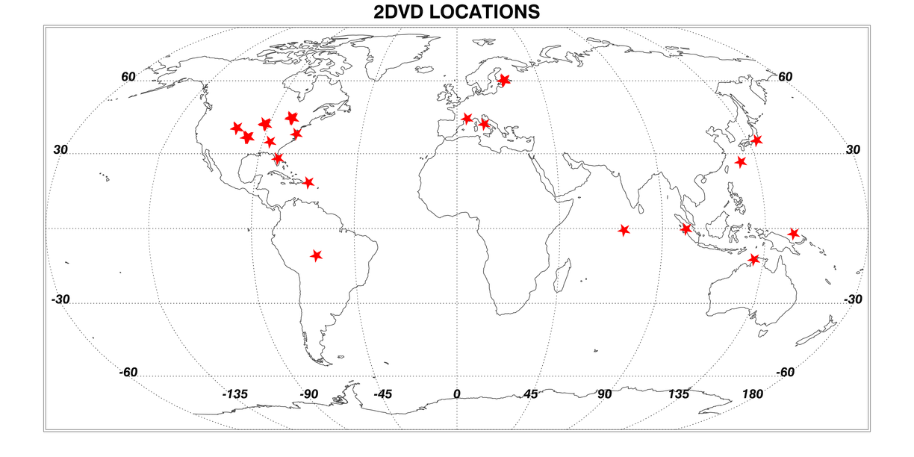

A table containing annual mean values of local DSD measurements conditioned to rain rate was added to the SG 3 experimental databank in Part IV (Radiometeorological data): [Table IV-12: “Statistics of rain drop size distribution”](https://www.itu.int/oth/R0A0400007A/en). This table refers explicitly to rain drops, so it is thus necessary to exclude all other particles from the analysis. This fascicle describes how to pre-process raw disdrometer data to filter out spurious data and non-rain particles.

# 3 General description of disdrometer data pre-processing

The objective of the disdrometer data pre-processing is to remove false rain detections such as:

– Any non-rain particles (e.g. snow particles with large diameter and low velocity)

– Splashed drops after hitting instrument surfaces

– Particles falling through the edges of the sample area

– Eventual system artefacts.

Observations of particles with anomalous fall velocities and diameters could be attributed to wind effects should also be identified and analysed in a specific way.

The preferred approach when using video disdrometers is to compare the relationship between the fall velocity of the particles and their diameter against widely accepted models in the literature such as Atlas *et al.* [7] and Gunn, R. and G. Kinzer [8].

The model by Atlas *et al.* [7] represents an analytically closed form for the computation of the fall velocity as a function of the rain drop size.

$v\left(D\right)=9.65-10.3∙\exp\left(-0.6∙D\right)$          (m/s) (1)

More precise models for the fall velocity of raindrops could be used to take into account also the effects of location height above mean sea level, atmospheric pressure and climatic variability.

# 4 Discussion on specific instruments

## 4.1 2D-Video-Disdrometer data processing description

The 2D-Video-Disdrometer measures single particle parameters and derives drop size distribution and other parameters with an adjustable integration time.

The operational principle is depicted in a schematic fashion in Figure 2. The device contains two optical paths: two CCD line scan cameras are directed towards two illumination units. Objects passing through the measurement area – determined by the cross-section of the two optical paths as seen from above – obstruct the light and are detected as shadows by the cameras. Individual precipitation particles are identified matching their views from camera A and B.

In order to reconstruct observables like falling velocity, oblateness, etc., the two optical paths are displaced vertically by a distance of about 6 mm. Measuring this distance and adjusting the background illumination are the two major calibration and maintenance tasks necessary for the correct operation of the device

Figure 2

Measurement principle of the 2D-Video-Distrometer

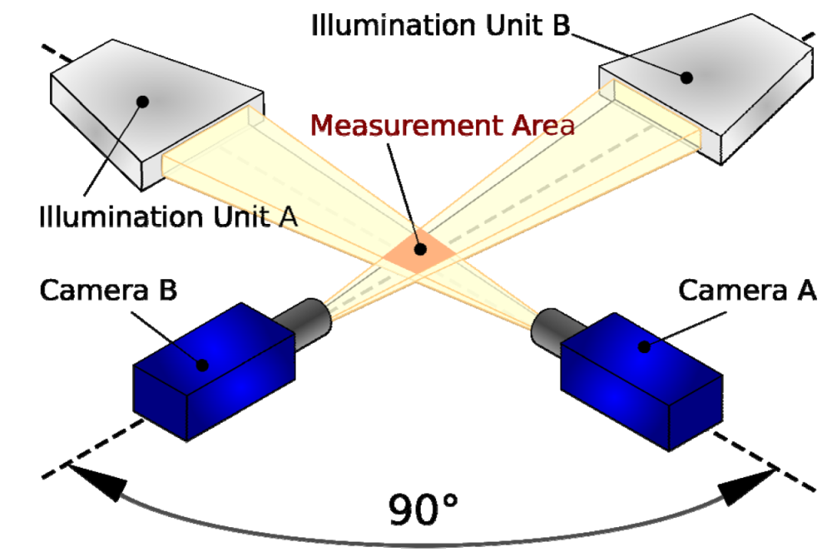

The instrument software is used to analyse the raw data and obtain the characteristics of each detected drop. The parameters of interest for the pre-processing are: diameter, fall velocity, volume and effective measuring area.

Fall velocity of each drop is measured by the time the particle takes for proceeding from camera A (upper system) to camera B (lower system), as sketched in Figure 3. To minimize quantization effects, the mean of (t2-t0) and (t3-t1) is considered. The height distance between the two optical planes is calibrated using high precision steel spheres.

Figure 3

Fall velocity calculation

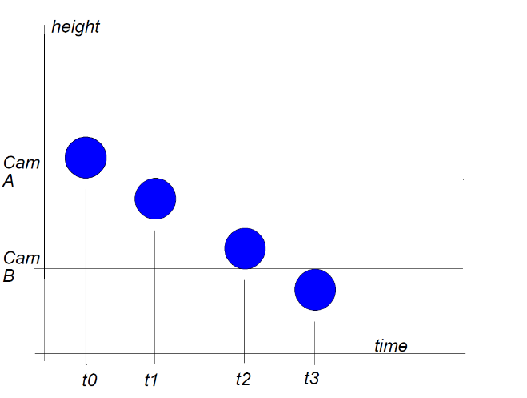

When determining the drop size distribution, the 2D-Video-Distrometer considers only particles that are totally within the common field of view seen of the two cameras. The effective sensing area therefore depends on the size of the recorded particles (Figure 4). For a particle diameter D (mm) the effective sensing area is:

${(L-D)}^{2}$                (mm²)

with *L* being the side length of the quadrate sensing area.

Figure 4

Effective sensing area of the 2DVD for precipitation particles with diameter *D*

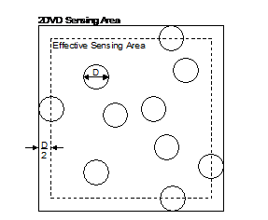

For the pre-processing and filtering of the data, the histogram of fall velocity vs. diameter is generated using observation of each particle. The procedure is explained in the following and Figure 5 is given for illustration.

Each particle is compared against the model given by Atlas *et al.* [7]. The selected metric is the orthogonal distance to the model in the v(D) graph (length of the normal vector in the velocity vs. diameter grid), which allows keeping the most significant amount of measured particles, especially when considering the lower diameters and velocities. The threshold for this comparison is chosen for each experimental site analysing a statistically significant set of samples. It stems from local characteristics of precipitation, e.g., if strong winds are common, the v(D) distribution widens up and the threshold has to be set accordingly to slightly higher values.

In the example in Figure 5, a length of the normal vector of 1.2 was chosen as threshold. This resulted in filtering out 3.5% of the total rain fall, corresponding to by drops outside of the marked area. It is worth noting that the steel spheres of 4 mm diameter used for the calibration of the 2D-Video-Disdrometer are present in the raw distribution and are of course filtered out from the dataset during the pre-processing.

Figure 5

Cumulative count of particles (in logarithmic scale) in a velocity vs. diameter grid, recorded in Graz (Austria) during the year 2014. Red line: Model by Atlas *et al.* [7]. Green lines: thresholds for non-rain decision. Using a vector normal to the model of length 1.2, 3.5 % of the total rain fall is filtered out.

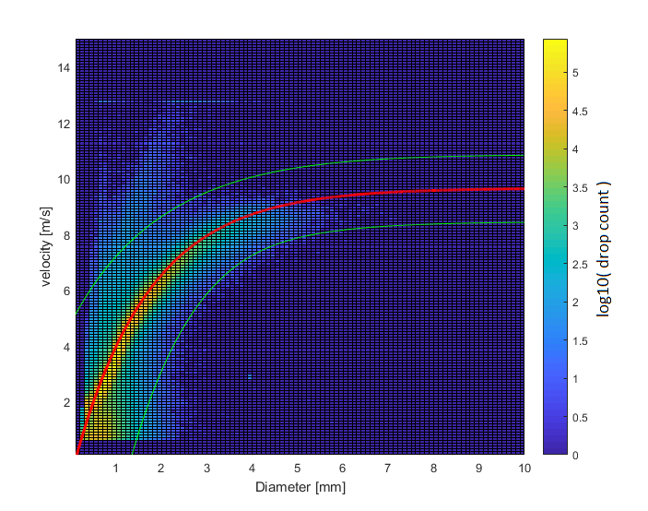

The establishment of annual DSDs from individual drop information follows the classic approach:

1 The year is divided in intervals of duration integration time $Δ$*t*

2 The DSDs are computed for these intervals using equation (1), which gives the drop number density:

       (1/m3mm) (1)

where:

*i* denotes a particular drop size class;

$Δ$*Di* width of drop size class (mm);

$Δ$*t* time interval (s);

*j* denotes a particular drop within size class *Di* and time interval $Δ$*t*;

*mi* number of drops within size class i and time interval $Δ$*t*;

*Di* mean diameter of drop size class *i*;

*Aj* effective measuring area for drop j (m²);

*vj* fall velocity of drop j (m/s).

1 The resulting DSDs are categorized according to the rain rate computed with equation (2):

$R= 3600*\frac{1}{Δt}*\sum_{i=1}^{n}{\frac{V_{i}}{A_{i}}}$      (mm/h) (2)

where

$Δ$*t* time interval (s);

*i* denotes a drop;

*n* total number of fully visible drops measured during the time interval $Δ$*t*;

*Vi* volume of drop i (mm³);

*Ai* effective measuring area for drop *i* (mm²).

2 Finally, the yearly mean DSDs conditioned to rain rate are computed to fill Table IV-12.

# 6 Conclusion

This document describes the recommended methods to be used when processing disdrometer measurements for submission of data to the SG 3 experimental [Table IV-12: “Statistics of rain drop size distribution”](https://www.itu.int/oth/R0A04000079/en).

Table IV-12 refers explicitly to rain drops, so it is thus necessary to exclude all other particles from the analysis. This fascicle presents the objectives and methodology to pre-process raw disdrometer data filtering out spurious and non-rain particles.

The operational principle, calibration methodology and parameters of interest for one type of video disdrometer (2D-Video-Disdrometer) are introduced. The preferred approach when using video disdrometers, comparing the relationship between the fall velocity of the particles and their diameter against a model, is described with examples.

# 7 References

[1] ITU-R P.838-3 “Specific attenuation model for rain for use in prediction methods” (2005). International Telecommunication Union, Geneva, Switzerland, 2005.

[2] M. Thurai, V.N. Bringi, and A. Rocha, “Specific attenuation and depolarisation in rain from 2-dimensional video disdrometer data”, IET Microwaves, Antennas & Propagation, Vol. 1, No. 2, 373-380, 2007. doi:10.1049/iet-map:20060023.

[3] J. M. Garcia-Rubia, J. M. Riera, A. Benarroch, and P. Garcia-del-Pino, "Estimation of Rain Attenuation from Experimental Drop Size Distributions," *Antennas and Wireless Propagation Letters, IEEE,* vol. 10, pp. 839-842, 2011.

[4] J. M. Garcia-Rubia, J. M. Riera, P. Garcia-del-Pino, and A. Benarroch, "Attenuation Measurements and Propagation Modeling in the W-Band," *Antennas and Propagation, IEEE Transactions On,* vol. 61, *(4),* pp. 1860-1867, 2013.

[5] J. M. Garcia-Rubia, A. Benarroch, P. Garcia-del-Pino, J. M. Riera, “A Five-year Study of Experimental Drop Size Distributions for Rain Attenuation in Madrid”, 10th European Conference on Antennas and Propagation, Davos, Switzerland, 10-15 April 2016.

[6] V.N. Bringi, V. Chandrasekar, J. Hubbert, W.L. Randeu and M. Schoenhuber, “Raindrop size distribution in different climatic regimes from disdrometer and dual-polarized radar analysis”, Journal of the atmospheric sciences, vol. 60, pp. 354-365, 2003.

[7] Atlas, D., R.C. Shrivastava and R.S. Sekhon “Doppler radar characteristics of precipitation at vertical incidence”. Rev. Geophys. Space Phys., pp. 1-35, 1973

[8] Gunn, R. and G. Kinzer, “The terminal velocity of fall for water droplets in stagnant air.” J. Meteor., 6, 248-248, 1949.

______________