|  |  |  |  |
| --- | --- | --- | --- |
|  | **Radiocommunication Study Groups** | |  |
| **INTERNATIONAL TELECOMMUNICATION UNION** | |  | |
|  | |  | |
| Source: Document 3M/TEMP/14  Subject: Fascicle on rain cell characteristics | | **Document 3M/FAS/9-E** | |
| **4 July 2016** | |
| **English only** | |
| Working Party 3M | | | |
| fascicle | | | |
| on the derivation of rain cell characteristics from Weather Radar data for Table IV-11 | | | |

**Table of Contents**

Pages

1. Scope 1

2. Introduction 1

3. Weather radar data characteristics 2

4. Rain cell definition and identification 4

5. Rain Cell Statistics 5

6. Conclusions 7

7. References 7

# 1 Scope

This document describes the recommended methods to be used for submission of weather radar measurement data to SG3 experimental Table IV-11 containing rain cell characteristics.

# 2 Introduction

For reliable modelling of radiowave propagation through the atmosphere, a clear understanding of tropospheric phenomena is essential. Rain may cause severe signal degradation, thus a detailed knowledge on rain characteristics is of utmost importance.

Whereas rain cell models are widely used for predictions of radiowave propagation, there is still need for enhanced validations of these models by measurements.

Weather radar data seem to be the perfect means for empirical determination of rain cell parameters, since they provide a three-dimensional image of the rain cells’ structures. However, certain limitations that are implicitly included in weather radar data products have to be well understood.

Thus, in the next paragraph the characteristics of weather radar data are discussed followed by a description of raincell identification methods. Finally, instructions on the production of rain cell statistics are given.

# 3 Weather radar data characteristics

When using weather radar data to derive rain cell statistics a variety of potential sources of error should be considered. These error sources mainly originate from the working principle of radars. Weather radar measurements rely on assumptions on the atmosphere and on radar targets that are not always fulfilled. As a consequence, the measurements can be biased. Below plausibility checks for weather radar data are proposed before statistics according to SG3DB Table IV-11 are produced.

Calibration

First and foremost the radar needs to be adequately calibrated what is normally done regularly for operational weather radars. A miss-calibration would affect the statistics immediately since the measured reflectivity is directly converted into rain rate.

Clutter

Radar measurements at low altitudes are often contaminated by clutter. Clutter can result from buildings, vegetation and ocean waves. In recent years, the rapidly growing number of wind turbines in many countries has a negative influence on the quality of weather radar measurements. Due to the rotation of the turbines, clutter removal algorithms using the Doppler information to discriminate between moving and static echoes are also compromised.

A visual inspection of selected radar measurements is proposed to verity if clutter contamination is an issue. If low altitudes show contamination of clutter the height levels in questions should be excluded from the statistics and this should be mentioned in the data description

Beam shielding and blockage

In mountainous terrain, some areas are generally less visible to the radar. Therefore it could occur that rain cells are not detected to their full extend. It is advised to exclude rain cell measurements from such areas up to the height that is blocked from the statistics.

Figure 1

Shielding effects due to mountains illustrated by plotting a two day rain sum  
(radar on Mt. Patscherkofel, Austria)

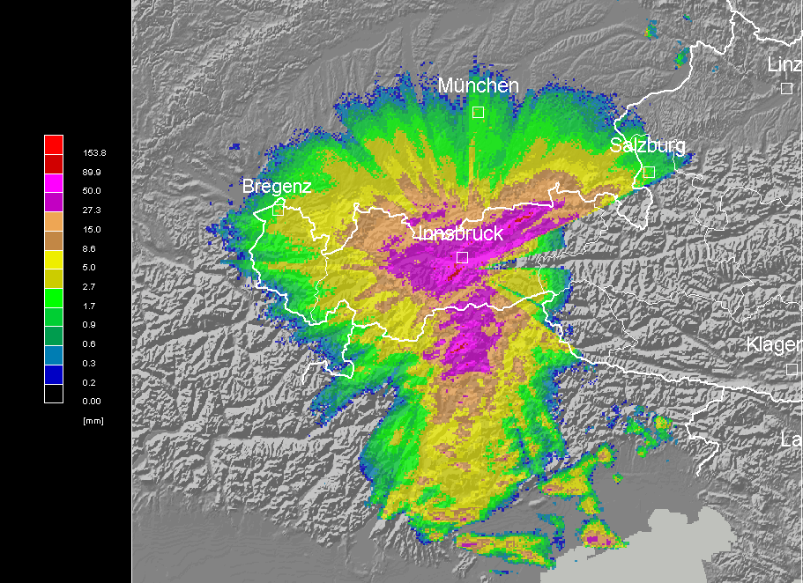

The identification can be done via coverage maps of the radar, or by calculating blocked areas via orographic information together with the radar location. A plausibility check for beam shielding and blockage is the calculation of the rain sum for several days over an area. Sudden changes in the rain amount could give an indication that beam blockage is an issue. Figure 1 exemplary shows the rain sum over a period of two days, derived from a weather radar in mountainous terrain where shielding effects to the east of the radar are clearly visible.

RLAN interference

Some wireless systems including Radio Local Area Networks (RLAN) operate in the 5 GHz band which is also used by many weather radar systems. In several countries RLAN interference with weather radar products was observed [1]. Figure 2 shows extreme examples of interference. It is advised to check if RLAN interference is an issue in the radar measurements. When indicated, segments with RLAN interference should be excluded from the study area since it would bias the statistics.

Figure 2

Extreme examples of RLAN interference to meteorological radars [1]

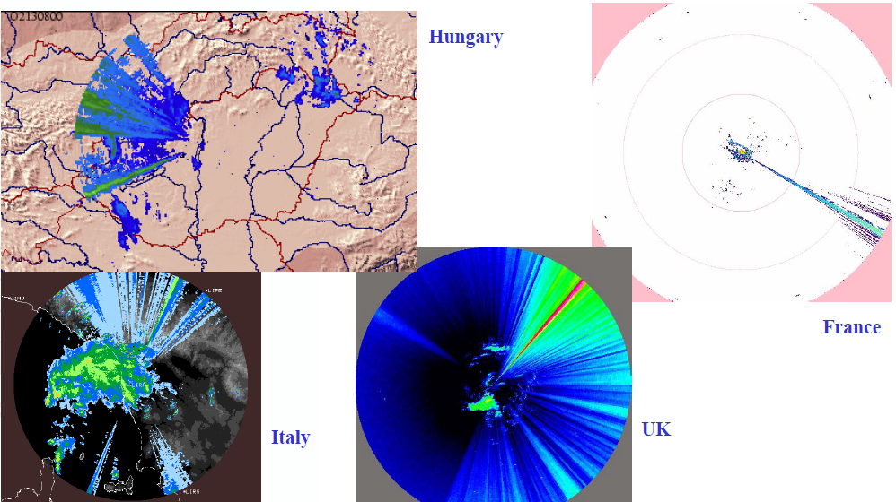

Attenuation

The microwaves used for weather radars are attenuated by rain. While for S-band radars this attenuation is negligible, in radars working in C-band the attenuation in heavy rain leads to underestimation of echoes in the detected cell and cells behind them. Therefore, the used radar frequency as well as possible attenuation correction methods should be specified. Contributions to Table IV-11 derived from S-band radars as well as from attenuation corrected dual-polarization radars are highly appreciated.

# 4 Rain cell definition and identification

The definition of rain in this context assumes that the raw radar measurements typically given in spherical coordinates are already concerted into a Cartesian grid where the measurement readings are represented by voxels (volume elements).

In the scientific literature different definitions of rain cells exist [2]. However, prevalently they are defined as contours or areas inside which the rain rate or radar reflectivity is equal to or higher than a specified threshold (cf. [3, 4]). Usually the area where the rain rate or reflectivity is lower than the threshold is factored out.

Figure 3 illustrates this definition using the example of a vertical profile of radar reflectivity measurements (RHI-plot). The contours for 34.2 dBZ and 46.0 dBZ thresholds are shown.

Figure 3

Illustration of rain cell intensity contours

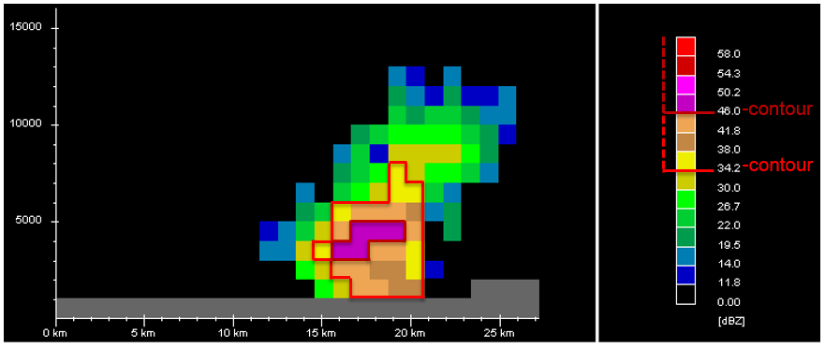

For the Table IV4-11 in the SG3DB the rain cell definition is extended to the three dimensional space. Thus, a rain cell is seen as a contiguous volume in which the radar reflectivity is throughout equal to or higher than a specified threshold [5]. Rain cells are therefore identified by connected voxels that exceeds certain thresholds. Voxels should be regarded as connected if they share a plane, an edge, or a corner point.

Only rain cells that are entirely located within the study area or the radar coverage should be included in the statistics, since otherwise the true rain cell diameter would be underestimated.  
For this purpose rain cells that are connected with the boundaries of the studied volume must be discarded.

In the ideal case rain cells should be detected with radars featuring hydrometeor classification.   
Thus e.g. effects of the bright band in the statistics can be understood. Such contributions to Table IV-11 would be highly appreciated.

# 5 Rain Cell Statistics

Production of rain cell statistics shall first of all provide the parameters requested in the presently valid format of [Table IV – 11](http://www.itu.int/dms_pub/itu-r/oth/0a/04/R0A040000790001MSWE.docx):

**Measurement country(1)** _ _

Coverage region(2)

Coverage region (latitude) From _ _ _ (deg) to _ _ _ (deg)

(longitude): From _ _ _ (deg) to _ _ _ (deg)

Coverage area (km2) _ _ _ _

Meteorological radar

Maximum height (km) _ _

Spatial Horizontal Resolution (km) __

Measurement

Start date (yyyy.mm.dd) _ _ _ _ ._ _ ._ _

End date (yyyy.mm.dd) _ _ _ _ ._ _ ._ _

Measurement interval (min) _ _

Parameters for rain cell analysis

Conversion equation _ _ _ _

Definition of rain cell:

Number of representative rain cells averaged for given rain rate at each rain event _ _

Beyond these, the parameters characterizing the radar configuration shall be given, as mentioned in the input Document [3M/78](http://www.itu.int/md/R15-WP3M-C-0078/en):

|  |
| --- |
| * Radar location |
| * Radar altitude |
| * Frequency band |
| * Frequency |
| * Polarization |
| * Beam width (3 dB) |
| * Range gate length |
| * Volume scan update time |
| * Maximum height |
| * Spatial horizontal resolution |
| * Number of intensities (operational) |
| * Conversion equation |
| * Clutter suppression (Y/N) |
| * Attenuation correction (Y/N) |
| Regarding the actual table, the guidelines as given in in the Template for Rain cell statistics DB_Rev1 (<https://extranet.itu.int/rsg-meetings/sg3/wp3m/Archive/2015%20April%20(Geneva)/SWG%203M-4%20Digital%20products/Template%20for%20Rain%20cell%20statistics%20DB_Rev1.docx)> products shall apply:  Radar Reflectivity (dBZ): The interval of dBZ data must be small enough to provide sufficient information on rain cell shape.  Rain Rate (mm/h): Rain rate data converted from the dBZ data in the same column, using the equation described in the document.  Height (km): it is required to provide data at each height for which radar reflectivity data are available.  Rain cell radius for given radar reflectivity and rain rate at each height (km) |

The reliability of statistical significance should be addressed. Thus when Table IV – 11 is produced as requested in [format definition](http://www.itu.int/dms_pub/itu-r/oth/0a/04/R0A040000790001MSWE.docx), for each entry the number of underlying CAPPI images shall be established and shall be provided to the Tablekeeper as well.

Rain cell sizes and rain cells’ vertical structure may vary with geographical location, and may vary with seasons at a given geographical location. In a first approach it may be desirable to obtain annual rain cell statistics for a given site, as much as possible. Thus preferably rain cell statistics should be established using a full year’s data, as much as possible.

Wherever an annual statistics is not available, the reader of such table may rely on the specified start and end period(s), such considering the basis of the given rain cell statistics.

In a second stage the increase of granularity to monthly statistics may be done, using the same table format.

# 6 Conclusions

This document described the recommended methods to be used for submission of weather radar measurement data to the Study Group 3 experimental Table IV-11 containing rain cell characteristics.

The document discusses the effects that can reduce accuracy of radar measurements (like clutter, blocking and interference).

The method how to define rain cells from radar data is provided and it is recommended for adoption by administrations that intend to submit their measurements for inclusion in Table IV-11.

# 7 References

[1] Philippe TRISTANT: RLAN 5 GHz interference to weather radars in Europe, ITU/WMO Seminar on use of radio spectrum for meteorology: Weather, Water and Climate monitoring and prediction, 16-18 September 2009.

[2] Begum, S., and I. E. Otung (2009): Rain cell size distribution inferred from rain gauge and radar data in the UK, Radio Sci., 44, RS2015, doi:10.1029/2008RS003984.

[3] Ashish K. Shukla, Bijoy Roy, Saurabh Das, A. R. Charania, K. S. Kavaiya, Kalyan Bandyopadhyay, K. S. Dasgupta (2010): Micro rain cell measurements in tropical India for site diversity fade mitigation estimation. Radio Science Vol: 45, Article Number: RS1002DOI: 10.1029/2008RS004093

[4] Henri Sauvageot, Frédéric Mesnard, and Ricardo S. Tenório, 1999: The Relation between the Area-Average Rain Rate and the Rain Cell Size Distribution Parameters. J. Atmos. Sci., 56, 57-70. doi: [http://dx.doi.org/10.1175/1520-0469(1999)056<0057:TRBTAA>2.0.CO;2](http://dx.doi.org/10.1175/1520-0469(1999)056%3c0057:TRBTAA%3e2.0.CO;2)

[5] R. Teschl and F. Teschl, “Rain cell size statistics for different altitudes derived from weather radar measurements”, 2016 10th European Conference on Antennas and Propagation (EuCAP), 2016, pp 1 - 5, DOI: 10.1109/EuCAP.2016.7481247.

______________