|  |  |
| --- | --- |
| **Radiocommunication Study Groups** |  |
|  |  |
|  |  |
| Subject: Processing of tipping bucket rain gauge data  Source: Document 3M/TEMP/86 | **Revision 1 to Document 3M/FAS/8-E** |
| **5 October 2017** |
| **English only** |
| Working Party 3M | |
| FASCICLE | |
| on the Processing of tipping bucket Rain Gauge data for STudy Group 3 Experimental Database | |

Table of Contents

Page

1 Scope 2

2 Introduction 2

3 Data processing of rain gauge measurements 3

3.1 Method 1: Data processing description when tips time stamps are available 3

3.2 Method 2: Data processing description when the number of tips per clock   
minutes is available 4

4 Assessment of rainfall rate CCDF interpolation error and guidelines 7

5 Conclusion 9

6 References 9

# 1 Scope

This document describes the recommended methods to be used when processing tipping bucket rain gauge measurements for submission of data to SG 3 experimental tables containing rain rate statistics (e.g. Tables I-1, II-1 and IV-1 etc.). The error that might be made if the rainfall rate statistics is wrongly interpolated is assessed. So, guidelines for the interpolation of rainfall rate statistics are also given.

# 2 Introduction

Statistical analysis of rain gauge data requires data pre-processing to estimate rain rate (mm/h) with an integration time of 1 minute generally needed for propagation application. The most used instrument in propagation experiment is a tipping-bucket rain gauge for which the sensor is composed by a collecting area and a tipping bucket connected to a sensor that generates at each commutation an electrical pulse. When a bucked is full, the weight of the water causes the tilting, the bucket gets empty and consequently the second bucket goes in the collecting position, to continue the measurement. An example of such an instrument is shown in Figure 1.

Figure 1

Example of tipping bucket rain gauge

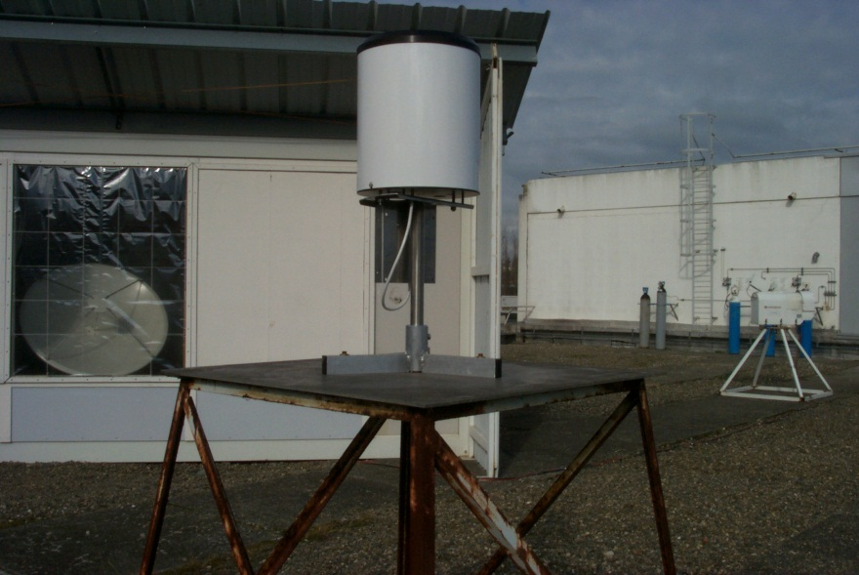 

In the past, the most common output of tipping bucket rain gauge was the time stamps of the tips while the most recent measurements provides the number of tips per clock minute or an estimate of rain rate starting from such number (in most cases the algorithm used is not known). Different data pre-processing can be used. The aim of this fascicle is to give guidelines for processing tipping bucket data when:

− the time of the stamps are available (Section 2),

− the number of tips per clock minutes are available (Section 3).

# 3 Data processing of rain gauge measurements

## 3.1 Method 1: Data processing description when tips time stamps are available

Basically, the collected data is converted into rain rate time series based on the approach proposed in Section 3.2.2.2 of [1] according to the Novel IAP methodology derived by [2] and mainly consists in computing the time derivative over 1‑minute sliding windows of the accumulated rain amount.

For any time period (year, month or so) the one minute rain amount increment can be determined for each calendar second using the flowing window (at the sampling rate of the tips which is generally 1 second) over the stepwise linearized rain amount – time of tip dependence. The length of the flowing window is one minute. Then the 1-minute rain intensity is computed (see Figure 2).

Figure 2

Novel IAP methodology - novel rain rate evaluation from Tipping-bucket rain gauge data. For better resolution, the time shift of 1s of the moving window is not in scale



An example of concurrent rainfall rate time series and tropospheric attenuation is shown in Figure 3.

Figure 3

Example of concurrent rainfall rate and tropospheric attenuation

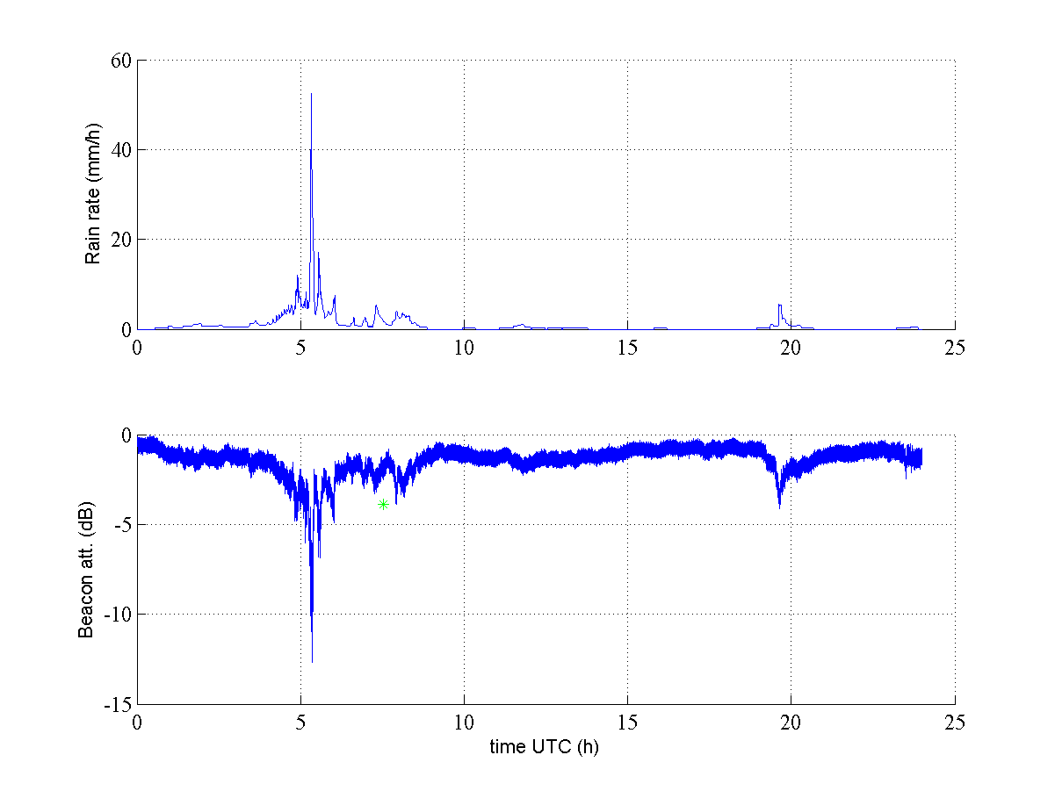

With this approach, high rain intensities that could be lost randomly with the choice of a random starting point cannot be omitted. However, if the time between tips is too long, it will result into a very low rainfall rate value over this period. This is why, it is proposed to add a fictitious tips between two rain events and before the first tip of the second rain event. Two rain events are considered to be separated events when two consecutive tips are separated by an interval T which should depend on the resolution of the bucket. The following formula could be used:

*T* = *Res*\*60/0.25 (1)

With Res being the resolution of the bucket.

This formula enables to match a minimum value of 0.25 mm/h. For instance, *T* = 24 minutes for *Res* = 0.1 mm, *T* = 48 minutes for *Res* = 0.2 mm, etc.

## 3.2 Method 2: Data processing description when the number of tips per clock minutes is available

When data are collected as number of tips per clock minute there are only discrete values available for mm/min or mm/h, such as 12, 24, 36, …, mm/h for a 0.2 mm bucket size for gauges where no water is lost between each tip. An algorithm should ideally reproduce the full distribution within the discrete numbers and down to a smaller resolution say to 1 mm/h. Then, when the number of tips per minute, *N*(*tm*), is only available from the rain-gauge, the time series (1 sample per minute) of rain rate in (mm/h), *R*(*tm*), can be calculated by simply multiplying *N*(*tm*) by the product of 60 (minutes per hour) times the capacity of the bucket, *Res* (mm), except 1-tip cases. In 1-tip cases, the amount of water *Res* is firstly distributed on the number of minutes, *nNR*, with no rain before the observations, up to *T* minutes (*nNR* ≤ *T*). This gives *nNR* times *Res*/*nNR* (mm) observations which can be converted in (mm/h) multiplying *Res*/*nNR* by 60 (minutes in one hour). At the end the full discrete series of rain rate (mm/h) includes values obtained multiplying the bucket size *Res* (mm) times 60 (minutes in one hour) times 1/60, 1/59, …1, 2, ..., 30, until the maximum observed defined by the 2 s discarded period.

The algorithm is fully described in [3].

It is suggested to fix values of *T* according to the rain gauge capacity *Res* as in Section 2: *T*= 24 minutes is suggested for *Res* = 0.1 mm and *T*= 48 minutes is suggested for *Res* = 0.2 mm.

**3.3 Example of Analysis of tipping bucket data from Spino d’Adda**

The Italian Space Agency has provided 8 years of data from Spino d’Adda, for the period 1993‑2000, for the analysis presented in this document. These data are measured with time between tips with a resolution of 1/10 s. The bucket size is 0.2 mm and no water is lost when the bucket is emptied due to a mechanism closing the hole in the bottom of the collecting funnel.

The time series data are available as a table with time between tips in 1/0 s resolution as shown in the example in Table 1.

Table 1

Example of the measured tipping bucket data from 26 June 1994

1994 6 26 19 16 22 1

1994 6 26 19 16 53 5

1994 6 26 19 17 11 9

1994 6 26 19 17 49 2

1994 6 26 19 19 2 2

1994 6 26 19 19 53 8

1994 6 26 19 20 29 7

1994 6 26 19 20 45 9

1994 6 26 19 21 3 1

1994 6 26 19 21 23 1

1994 6 26 19 21 38 0

1994 6 26 19 21 51 0

1994 6 26 19 22 6 2

1994 6 26 19 22 28 7

1994 6 26 19 22 56 5

1994 6 26 19 24 18 6

1994 6 26 19 29 0 6

1994 6 26 19 40 38 4

1994 6 26 23 2 26 8

1994 6 26 23 40 39 1

1994 6 26 23 41 57 0

1994 6 26 23 42 44 7

1994 6 26 23 43 33 7

1994 6 26 23 45 5 5

1994 6 26 23 54 10 8

Clock minute data have been derived for the time series data discarding the second observation if the time to the previous observation is 2 s or less, believed to be caused by buckets “bouncing back” under heavy rainfall. The derived clock minute representation with mm/min is presented in Figure 4 showing good all year availability.

figure 4

Time series data transferred to clock minute data.



The two representations of the data have then been analysed.

In the analyses using time between tips the time series data is divided into events where 1 hour and longer with no observation is used to separate events. For each event the first observation is discarded, i.e., the first rain rate derived is the time between the first and second times. Then an average for clock minutes is calculated. If the time between two samples is less than 2 s, the second time is deleted from the series.

The analyses of the clock minute series has been carried out as described in Section 3.

The result from the two algorithms is shown in Fig. Within the 150 mm/h rain rate the two methods follows each other closely for large parts of the distribution. In the lower end the algorithm using the clock minute data shows and overestimate of rates in the range of 1-4 tips per minute, largest around 2 tips per minute. At the lowest rates the clock minutes shows an under estimation. Both distributions respect to total rainfall observed by integrating the fine scale probability density function derived from the complementary cumulative density function shown in Figure 5.

FigURE 5

Measured rain rate distribution for Spino d’Adda 1993-2000 using time between tips and clock minute tips



In [3] a similar finding was shown using the method described in Section 2. There was a small deviation for 0.2 mm bucket sizes, but for 0.1 mm bucket sizes no visible deviation between the numbers of tips per clock minute compared to the rain rate distribution derived from the direct measured rain per minute by method described in Section 2.

# 4 Assessment of rainfall rate CCDF interpolation error and guidelines

In order to assess the impact of the interpolation methodology on the final CCDF of rainfall rate, three years of measurements (tips time stamps) collected in Toulouse between 2014 and 2016 have been used. The resolution of the tipping bucket rain gauge (TBR) is 0.1 mm.

Method 1 described in Section 3.1 (based on tip time stamps) has been applied to derive time series of rainfall rate. Then, clock minute data have been derived from the original tips time stamps data and method 2 described in Section 3.2 (based on number of tips per clock minute) has been applied as well.

In both cases, the “raw” rainfall rate CCDFs have been computed using rainfall rate thresholds ranging from 0 mm/h to 300 mm/h with 0.25 mm/h step. The results are shown in Figure 6. When tips per clock minute data are used according to method 2, it can be observed that the “raw” CCDF exhibits a “stair effect”, due to the lack of the exact time stamp for the tips, which, in turn, limits the resolution of measured rainfall rate values to multiples of 60\**TBR* mm/h (6 mm/h in this case).

figure 6

CCDF of rainfall rate from tips time stamps data and number of tips per clock minute data

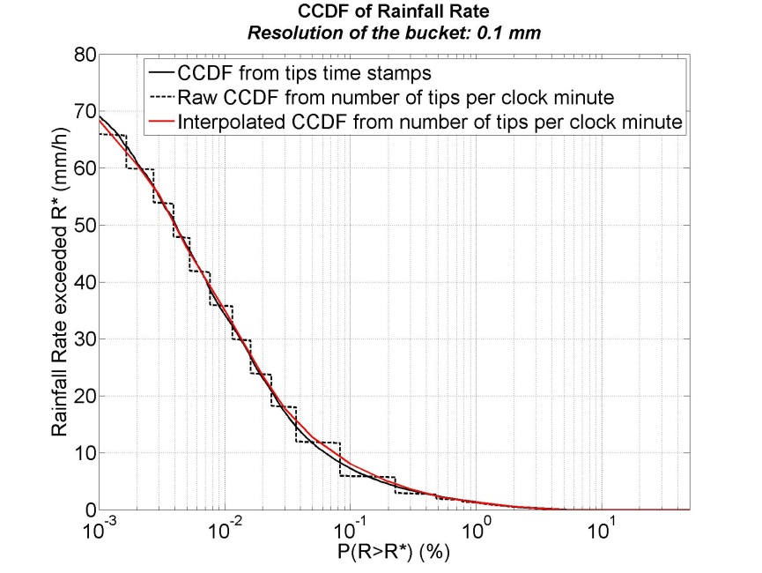

ITU-R DBSG3 tables require values of rainfall rate for specific exceedance probabilities (0.001%, 0.01%, 0.1% …), resulting in the need to interpolate the “raw” rainfall rate CCDF for these different probability values.

Figure 6 clearly points out that the best agreement between the CCDF obtained from the tips time stamps data and the one obtained from the tips per clock minute data is achieved when the centre of the rainfall rate bins (used to compute the “raw” CCDF) are selected.

The same analysis has been conducted using the same database but now assuming that the values of the resolutions of the tipping bucket rain gauge are 0.2 mm and 0.01 in (0.254 mm) (instead of 0.1 mm), which are common resolutions for tipping bucket rain gauges used in propagation experiments. The results are shown is Figure 7: as expected, the lower the resolution of the bucket (i.e corresponding to a larger bucket capacity), the higher the bias between the appropriate interpolated rainfall rate CCDF and the higher and lower part of the “raw” CCDF.

In conclusion for the interpolation in probability of the CCDF derived from rain gauge data derived using number of tips per minute (method 2 section 3.2), it is recommended to select the centre of the rainfall rate bins used to compute the “raw” CCDF.

figure 7

CCDF of rainfall rate from tips time stamps data and number of tips per clock minute data. Resolution of the bucket:   
0.2 mm (left) and 0.1 in (0.254 mm) (right)

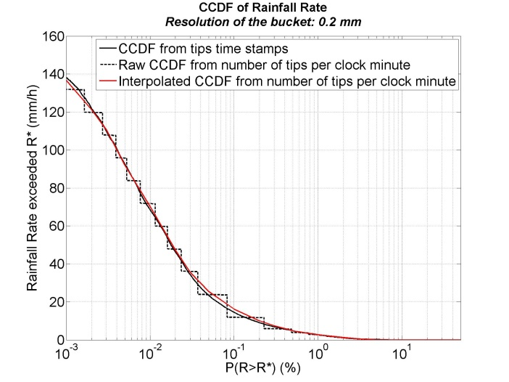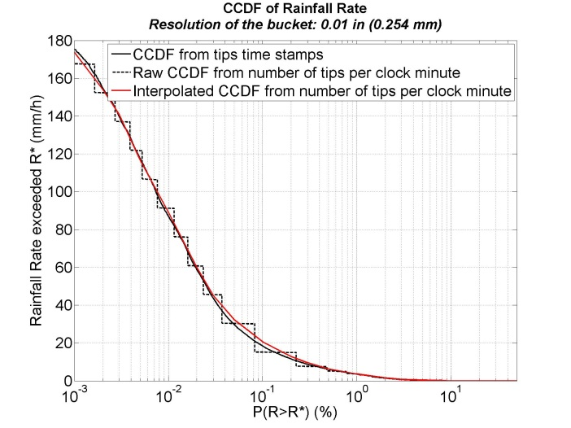

# 5 Conclusion

This document describes the recommended methods to be used when processing tipping bucket rain gauge measurements for submission of data to Study Group 3 experimental tables containing rain rate statistics (e.g. Tables I-1, II-1 and IV-1 et al.).

Method 1 (described in Section 3.1) should be used when time between tips is available from the rain gauge and provides the most accurate rain rate with 1-min integration time.

Method 2 (described in Section 3.2) should be used when only clock minute data is available and allows a good approximation of rain rate data to be obtained when compared with Method 1: for rates around 50 mm/h and higher there is little difference between the two methods.

For new measurement set-up for radio propagation purposes it is advisable to measure the time between tips. However, for data only available as rain height or number of tips per clock minute the Method 2 described in this document is recommended.

Guidelines for the interpolation of rainfall rate statistics for probability values have also been given in Section 4.

# 6 References

[1] C. Riva, M. Willis, “COST IC0802 Handbook on measurements and products” (to be published).

[2] Fiser O., O. Wilfert, 2009, “Novel processing of tipping-bucket rain gauge records”, Atmospheric Research, Vol. 92(3), pp. 283-288.

[3] J. Mamen and T. Tjelta, "New Norwegian hydrometeor precipitation rate maps derived from long term measurements," Antennas and Propagation (EuCAP), 2013 7th European Conference on, Gothenburg, 2013, pp. 975-979.

______________