|  |  |
| --- | --- |
| **Radiocommunication Study Groups** |  |
|  |  |
|  |  |
| Source: Documents 3M/TEMP/61, 3M/TEMP/22, [3M/51](https://www.itu.int/md/R23-WP3M-C-0051/en)(Annex 1), [3M/106](https://www.itu.int/md/R23-WP3M-C-0106/en) (Annex 9), [3M/157](https://www.itu.int/md/R23-WP3M-C-0157/en) (Annex 7)  Subject: Attenuation models in Rec. [ITU-R P.618](https://www.itu.int/rec/R-REC-P.618/en) | Revision 6 to Document 3M/FAS/3-E |
| 17 June 2025 |
| English only |
| Working Party 3M | |
| FASCICLE 3M/FAS/3 | |
| Guidelines for testing Earth-space attenuation prediction methods with respect to DBSG3 Table II-1 | |

TABLE OF CONTENTS

Page

1 Introduction 2

2 DBSG3 Table II-1 description 2

3 Dataset selection using DBSG3 flags 3

3.1 Testing excess attenuation 3

3.1.1 Testing excess attenuation using concurrent rainfall rate data 4

[3.1.2 Testing excess attenuation using rainfall rate maps in   
Recommendation ITU-R P.837 4](#_Toc168430271)

3.2 Testing total attenuation 4

3.2.1 Testing total attenuation using concurrent rainfall rate data 5

[3.2.2 Testing total attenuation using rainfall rate maps in   
Recommendation ITU-R P.837 5](#_Toc168430274)

4 Test cases 8

4.1 Basic test cases 8

4.2 Additional test cases 9

5 Testing results 9

6 Contact information 10

# 1 Introduction

Study Group 3 publishes recommended methods that predict: a) gaseous attenuation due to oxygen and water vapour (Annex 2 of Recommendation [ITU-R P.676](http://www.itu.int/rec/R-REC-P.676/en)), b) cloud loss (§ 3 of Recommendation [ITU-R P.840](http://www.itu.int/rec/R-REC-P.840/en)), c) rain loss (§ 2.2.1.1 of Recommendation [ITU-R P.618](http://www.itu.int/rec/R-REC-P.618/en)), d) scintillation fading (§ 2.4.1 of Recommendation ITU-R P.618), and e) total attenuation (§2.5 of Recommendation ITU-R P.618) on Earth-space paths. This fascicle describes the procedures to evaluate the accuracy of excess rain attenuation and total attenuation prediction methods using measured data in Table II-1 of DBSG3 and the testing variable specified in § 4 of Fascicle [3M/FAS/1](https://www.itu.int/oth/R0A04000007/en). Information for experimenters who submit measured rainfall rate and attenuation data is provided in Recommendation [ITU-R P.311](http://www.itu.int/rec/R-REC-P.311/en), and the testing variables for comparing Earth-space propagation prediction methods is provided in Fascicle 3M/FAS/1.

There are four classes of tests that Study Group 3 performs to evaluate the accuracy of Earth-space prediction methods:

1) excess attenuation using concurrent excess attenuation and rainfall rate statistical data in Table II-1 of DBSG3;

2) excess attenuation using excess attenuation data in Table II-1 of DBSG3 with the rainfall rate digital maps in Recommendation [ITU-R P.837](http://www.itu.int/rec/R-REC-P.837/en);

3) total attenuation using concurrent total attenuation and rainfall rate statistical data in Table II-1 of DBSG3;

4) total attenuation using total attenuation statistical data in Table II-1 of DBSG3 with the rainfall rate digital maps in Recommendation ITU-R P.837.

# 2 DBSG3 Table II-1 description

Table II-1 of DBSG3 is a database of excess and total rain attenuation and concurrent rainfall rate statistical data from beacon, radiometer, and radar measurements that spans more than 45 years. The full description of Table II-1 (header and data) is provided in the table format definition file accessible in CG 3M-2 “ITU-R SG 3 DBSG3 databank on measurements for all tables except Table VI-1 (Terrestrial Point-to-area data)” share folder.

All tests should be performed using the latest version of Table II-1 of DBSG3. Table II-1 of DBSG3 is a comma-separated file available in the [SharePoint folder](https://extranet.itu.int/rsg-meetings/sg3/wp3m/cg3m2/Shared%20Documents/Forms/AllItems.aspx?RootFolder=%2Frsg%2Dmeetings%2Fsg3%2Fwp3m%2Fcg3m2%2FShared%20Documents%2FDBSG3%20Repository%2FPart%20II%20Earth%2Dspace%20path%20data%2FII%2D01&FolderCTID=&View=%7BEDEA0D66%2D8105%2D4012%2D8540%2D52270BD3F6B3%7D) of WP 3M Correspondence Group CG 3M-2. All published test results should include the version of DBSG3 used for testing.

Several flags are used to select the datasets and the data within a dataset are to be used for testing excess rain attenuation and total attenuation prediction methods. The flags are assigned by the table keepers of Table II-1 and submitted to WP 3M for approval.

The flags are defined as follows:

Table 1

Description of flags

| **Flag** | **Description** |
| --- | --- |
| FLAG1 | Minimum validity range for the rainfall rate CCDF dataset: exponential format in 4 characters, e.g. 3E-3. |
| FLAG2 | Maximum validity range for the rainfall rate CCDF dataset: exponential format in 4 characters, e.g. 3E+0. |
| FLAG3 | Minimum validity range for excess or total attenuation CCDF dataset: exponential format in 4 characters, e.g. 1E-2. |
| FLAG4 | Maximum validity range for excess or total attenuation CCDF dataset: exponential format in 4 characters, e.g. 5E+0. |
| FLAG5 | Identifies single year, multiple year and twin year statistics (“E” or “T”):  1 The identification of Single-Year (“S” in the first character of FLAG5) or Multiple-Year statistics (“M” in the first character of FLAG5) are applied only to statistics referring to the same link (i.e. same site, satellite, frequency, elevation, polarization) and to a common observation period.  a. An “S” in the first character of FLAG5 indicates a single-year statistic where at least one multiple year statistic is also present in the database (e.g. statistics from 1994/01/01 to 1994/12/31 when the statistic from 1993/01/01 to 1997/12/31 is also available).  b. An “M” in the first character of FLAG5 indicates a multiple-year statistic where single-year statistics (or part of them) are also present.  c. A “0” (zero) in the first character of FLAG5 indicates single-year statistic where no multiple year statistics are present.  d. An “N” in the first character of FLAG5 indicates multiple year statistics when no single year statistics are available.  e. A “T” in the first character of FLAG5 indicates this statistic is similar to an already flagged statistic not flagged with “T” (e.g., a statistic referring to the same frequency, elevation angle, observation period, but a different polarization angle). Therefore the tests could be run with respect to 1 of these 2 statistics only.  2 The second character of this flag denotes if the statistics are to be included in the test of Excess (“E”) or Total (“T”) attenuation. |
| FLAG6 | “2” (high quality dataset as described in Annex 1), “1” (dataset with sufficient quality to be used for testing), or “0” (dataset with not sufficient quality to be used for testing). This flag is not currently populated and is reserved for future use. |
| FLAG7 | Reserved for future use. |
| FLAG8 | Reserved for future use. |

# 3 Dataset selection using DBSG3 flags

The next subsections specify the procedure to be followed to run the tests of Earth-space excess and total attenuation prediction methods with respect to Table II-1 of DBSG3.

## 3.1 Testing excess attenuation

Excess attenuation prediction methods predict rain attenuation using either: a) rainfall rate at a specified exceedance probability (e.g. the current rain attenuation prediction method in Recommendation ITU-R P.618 that requires $R_{0.01}$) as shown in Figure 3 or b) the full rainfall rate distribution as shown in Figure 4.

All of the parameters required for testing excess attenuation are obtained from Table II-1 of DBSG3, except that for testing excess attenuation using rainfall rate maps in Recommendation ITU‑R P.837, the rainfall rates $R_{p}$ or $R_{0.01}$ are obtained from the rainfall rate maps in Recommendation ITU-R P.837.

## 3.1.1 Testing excess attenuation using concurrent rainfall rate data

Step 1: Include the data set if and only if FLAG5 = 0E or FLAG5 = SE.

Step 2a: For a rain attenuation prediction method that requires the rainfall rate at a specific exceedance probability (e.g. the current rain attenuation prediction method in Recommendation ITU-R P.618 that requires $R_{0.01}$), and each included data set, include the value of excess attenuation if and only if:

a) the specific exceedance probability, $p,$ (e.g. $p=$ 0.01%) is within the inclusive range from FLAG1 to FLAG2 (i.e. FLAG1 $≤p≤$ FLAG2),

b) the exceedance probability corresponding to the excess attenuation is within the inclusive range from FLAG3 to FLAG4 (i.e. FLAG3 $≤p≤$ FLAG4), and

c) the value of excess attenuation, $A_{excess},$ is greater than or equal to 0.5 dB   
(i.e. $A_{excess}≥0.5$ dB).

Step 2b: For a rain attenuation prediction method that requires the full rainfall rate distribution, include the value of excess attenuation if and only if:

a) the exceedance probability is within the inclusive range from FLAG1 to FLAG2   
(i.e. FLAG1 $≤p≤$ FLAG2),

b) the exceedance probability corresponding to the excess attenuation is within the inclusive range from FLAG3 to FLAG4 (i.e. FLAG3 $≤p≤$ FLAG4), and

c) the value of excess attenuation, $A_{excess},$ is greater than or equal to 0.5 dB   
(i.e. $A_{excess}≥0.5$ dB).

Step 3: Weight the test variable (see § 4 of Fascicle 3M/FAS/1) by the minimum of: a) the duration in years, or b) 10 years.

## 3.1.2 Testing excess attenuation using rainfall rate maps in Recommendation ITU-R P.837

Step 1: Include the data set if and only if: a) FLAG5 = 0E or FLAG5 = SE.

Step 2: For each included data set, include the value of excess attenuation if and only if:

a) the exceedance probability corresponding to the excess attenuation is within the inclusive range from FLAG3 to FLAG4 (i.e. FLAG3 $≤p≤$ FLAG4), and

b) the value of excess attenuation, $A_{excess},$ is greater than or equal to 0.5 dB   
(i.e. $A_{excess}≥0.5$ dB).

Step 3: Weight the test variable (see § 4 of Fascicle 3M/FAS/1) by the minimum of: a) the duration in years, or b) 10 years.

## 3.2 Testing total attenuation

Total attenuation prediction methods predict total attenuation as the combination of gaseous attenuation due to oxygen and water vapour as shown in Figure 1, cloud loss as shown in Figure 2, rain loss, and scintillation fading as shown in Figure 5, where these effects are combined using the method in § 2.5 of Recommendation ITU-R P.618. Rain attenuation is predicted using either:

a) rainfall rate at a specified exceedance probability (e.g. the current rain attenuation prediction method in Recommendation ITU-R P.618 that requires $R_{0.01}$) as shown in Figure 3 or

b) the full rainfall rate distribution as shown in Figure 4.

All the parameters required for testing total attenuation are obtained from Table II-1 of DBSG3, except that for testing total attenuation using the rainfall rate maps in Recommendation ITU‑R P.837, the rainfall rates $R_{p}$ or $R_{0.01}$ are obtained from the rainfall rate maps in Recommendation ITU-R P.837.

## 3.2.1 Testing total attenuation using concurrent rainfall rate data

Step 1: Include the data set if and only if: a) FLAG5 = 0T or FLAG5 = ST.

Step 2a: For a rain attenuation prediction method that requires the rainfall rate at a specific exceedance probability (e.g. the current rain attenuation prediction method in Recommendation ITU-R P.618 that requires $R_{0.01}$), and for each included data set, include the value of total attenuation if and only if:

a) the specific exceedance probability, $p,$ (e.g. $p=$ 0.01%) is within the inclusive range from FLAG1 to FLAG2 (i.e. FLAG1 $≤p≤$ FLAG2),

b) the exceedance probability corresponding the total attenuation is within the inclusive range from FLAG3 to FLAG4 (i.e. FLAG3 $≤p≤$ FLAG4), an

c) the value of excess attenuation, $A_{total},$ is greater than or equal to 0.5 dB   
(i.e. $A_{total}≥0.5$ dB).

Step 2b: For a rain attenuation prediction method that requires the full rainfall rate distribution, and for each included data set, include the value of total attenuation if and only if:

a) the exceedance probability is within the inclusive range from FLAG1 to FLAG2   
(i.e. FLAG1 $≤p≤$ FLAG2),

b) the exceedance probability corresponding to the value of total attenuation is within the inclusive range from FLAG3 to FLAG4 (i.e. FLAG3 $≤p≤$ FLAG4), and

c) the value of total attenuation, $A_{total},$ is greater than or equal to 0.5 dB   
(i.e. $A_{total}≥0.5$ dB).

Step 3: Weight the test variable (see § 4 of Fascicle 3M/FAS/1) by the minimum of: a) the duration in years, or b) 10 years.

## 3.2.2 Testing total attenuation using rainfall rate maps in Recommendation ITU-R P.837

Step 1: Include the data set if and only if FLAG5 = 0T or FLAG5 = ST.

Step 2: For each included data set, include the value of total attenuation if and only if:

a) the exceedance probability corresponding to the total attenuation is within the inclusive range from FLAG3 to FLAG4 (i.e. FLAG3 $≤p≤$ FLAG4), and

b) the value of total attenuation, $A_{total},$ is greater than or equal to 0.5 dB   
(i.e. $A_{total}≥0.5$ dB).

Step 3: Weight the test variable (see § 4 of Fascicle 3M/FAS/1) by the minimum of: a) the duration in years, or b) 10 years.

Figure 1

Gaseous attenuation due to oxygen and water vapour

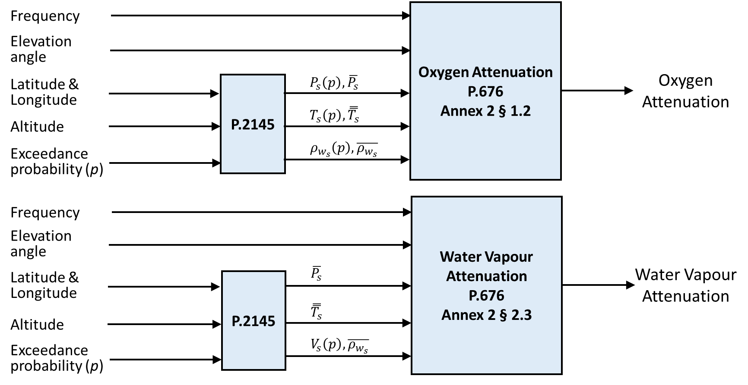

This prediction method is applicable for frequencies up to 350 GHz.

Figure 2

Cloud loss

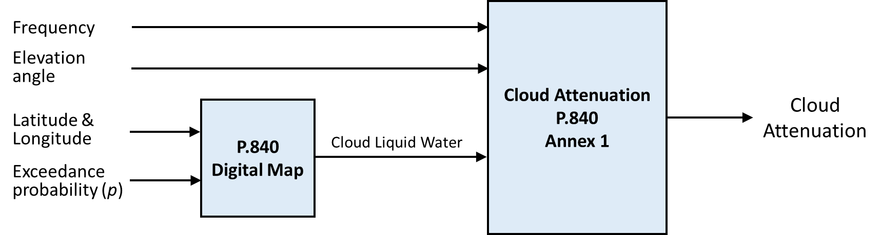

This prediction method is applicable for frequencies up to 100 GHz.

Figure 3

Rain attenuation (rain rate at 0.01% level)



Figure 4

Rain attenuation (full rain rate distribution)



Figure 5

Scintillation fading



Concerning scintillation, while the prediction method has been tested at frequencies between 7 and 50 GHz, it is recommended for frequencies between 4 and 55 GHz.

Figure 6

Total attenuation



# 4 Test cases

## 4.1 Basic test cases

The mean, standard deviation, and r.m.s. values of the testing variable specified in § 4 of Fascicle 3M/FAS/1 can be calculated for a set of exceedance probabilities in Table II-1 of DBSG3 for the following six cases. The results for cases 1, 2, and 5 are shown in § 5.

1) Excess rain attenuation data in Table II-1 of DBSG3 vs. rain attenuation using the prediction method in § 2.2.1.1 of Recommendation ITU-R P.618 with the concurrent rainfall rate data in Table II-1 of DBSG3 (see § 3.1.1);

2) Excess rain attenuation data in Table II-1 of DBSG3 vs. the sum of a) rain attenuation using the prediction method in § 2.2.1.1 of Recommendation ITU-R P.618 with concurrent rainfall rate data in Table II-1 of DBSG3 plus b) cloud attenuation using the prediction method in § 3.2 of Recommendation ITU-R P.840 (see § 3.1.1);

3) Excess rain attenuation data in Table II-1 of DBSG3 vs. rain attenuation using the prediction method in § 2.2.1.1 of Recommendation ITU-R P.618 with the rainfall rate maps in Recommendation ITU-R P.837 (see § 3.1.2);

4) Excess rain attenuation data in Table II-1 of DBSG3 vs. the sum of a) rain attenuation using the prediction method in § 2.2.1.1 of Recommendation ITU-R P.618 with the rainfall rate maps in Recommendation ITU-R P.837, plus b) cloud attenuation using the prediction method in § 3.2 of Recommendation ITU-R P.840 (see § 3.1.2);

5) Total attenuation data in Table II-1 of DBSG3 vs. the combination of a) rain attenuation using the prediction method in § 2.2.1.1 of Recommendation ITU-R P.618 with concurrent rainfall rate data in Table II-1 of DBSG3, b) cloud attenuation using the prediction method in § 3.2 of Recommendation ITU-R P.840, c) gaseous attenuation using the prediction method Annex 2 of Recommendation ITU-R P.676, and d) scintillation fading using the prediction method in § 2.4.1 of Recommendation ITU-R P.618 as specified in §2.5 of Recommendation ITU-R P.618 (see § 3.2.1); and

6) Total attenuation data in Table II-1 of DBSG3 vs. the combination of a) rain attenuation using the prediction method in § 2.2.1.1 of Recommendation ITU-R P.618 with the rainfall rate maps in Recommendation ITU-R P.837, b) cloud attenuation using the prediction method in § 3.2 of Recommendation ITU-R P.840, c) gaseous attenuation using the prediction method Annex 2 of Recommendation ITU-R P.676, and d) scintillation fading using the prediction method in § 2.4.1 of Recommendation ITU-R P.618 as specified in §2.5 of Recommendation ITU-R P.618 (see § 3.2.2).

## 4.2 Additional test cases

In addition to the cases listed in § 4.1, the mean, standard deviation, and r.m.s. values of the testing variable specified in § 4 of Fascicle 3M/FAS/1 can be calculated for a set of exceedance probabilities in Table II-1 of DBSG3 for case 1 of § 4.1 and the following ranges:

• frequency ranges: 1 ≤ *f* ≤ 17 GHz, 17 < *f* ≤ 35 GHz and *f* > 35 GHz;

• or elevation angle ranges: 0° ≤  ≤ 15°, 15° <  ≤ 60°, and 60° <  ≤ 90°;

• or latitude ranges (in absolute values): 0° ≤ *Lat* ≤ 38°, 38° < *Lat* ≤ 55° and   
*Lat* > 55°.

# 5 Testing results

The excess and total attenuation prediction methods in Recommendations ITU-R P.676-13, ITU-R P.840-9, and ITU-R P.618-14 have been calculated using the test variable documented in § 4 of Fascicle 3M/FAS/1 and DBSG3 file C2_1_v10.csv with the following results:

Excess attenuation (Rain attenuation only)

|  |  |  |  |  |  |  |  |  |  |  |  |  |  |
| --- | --- | --- | --- | --- | --- | --- | --- | --- | --- | --- | --- | --- | --- |
|  | 0.001 | 0.002 | 0.003 | 0.005 | 0.01 | 0.02 | 0.03 | 0.05 | 0.1 | 0.2 | 0.3 | 0.5 | 1 |
| Years | 8.0 | 19.6 | 36.6 | 53.2 | 101.7 | 110.8 | 116.6 | 115.6 | 108.7 | 88.9 | 77.9 | 67.2 | 60.5 |
| Mean | −0.032 | −0.097 | −0.160 | −0.137 | −0.108 | −0.085 | −0.068 | −0.044 | −0.034 | −0.095 | −0.130 | −0.142 | −0.205 |
| RMS | 0.180 | 0.282 | 0.293 | 0.265 | 0.229 | 0.233 | 0.225 | 0.226 | 0.254 | 0.292 | 0.338 | 0.381 | 0.461 |
| Sigma | 0.177 | 0.265 | 0.246 | 0.226 | 0.202 | 0.217 | 0.215 | 0.222 | 0.251 | 0.276 | 0.312 | 0.354 | 0.413 |

Excess attenuation (Rain + Cloud attenuation)

|  |  |  |  |  |  |  |  |  |  |  |  |  |  |
| --- | --- | --- | --- | --- | --- | --- | --- | --- | --- | --- | --- | --- | --- |
|  | **0.001** | **0.002** | **0.003** | **0.005** | **0.01** | **0.02** | **0.03** | **0.05** | **0.1** | **0.2** | **0.3** | **0.5** | **1** |
| **Years** | 8.0 | 19.6 | 36.6 | 53.2 | 101.7 | 110.8 | 116.6 | 115.6 | 108.7 | 88.9 | 77.9 | 67.2 | 60.5 |
| **Mean** | −0.022 | −0.088 | −0.149 | −0.125 | −0.095 | −0.069 | −0.049 | −0.020 | −0.002 | −0.053 | −0.080 | −0.084 | −0.120 |
| **RMS** | 0.181 | 0.281 | 0.289 | 0.259 | 0.224 | 0.227 | 0.219 | 0.220 | 0.245 | 0.269 | 0.306 | 0.351 | 0.411 |
| **Sigma** | 0.180 | 0.267 | 0.247 | 0.227 | 0.202 | 0.217 | 0.214 | 0.219 | 0.245 | 0.264 | 0.295 | 0.341 | 0.393 |

Total attenuation

|  |  |  |  |  |  |  |  |  |  |  |  |  |  |
| --- | --- | --- | --- | --- | --- | --- | --- | --- | --- | --- | --- | --- | --- |
|  | 0.01 | 0.02 | 0.03 | 0.05 | 0.1 | 0.2 | 0.3 | 0.5 | 1 | 2 | 3 | 5 | 10 |
| Years | 29.3 | 39.9 | 46.5 | 55.5 | 63.5 | 63.5 | 64.5 | 64.5 | 64.5 | 63.6 | 61.8 | 59.9 | 55.6 |
| Mean | −0.062 | 0.016 | 0.039 | 0.062 | 0.015 | 0.002 | 0.000 | 0.001 | 0.021 | 0.083 | 0.132 | 0.198 | −0.033 |
| RMS | 0.297 | 0.232 | 0.209 | 0.206 | 0.247 | 0.232 | 0.215 | 0.210 | 0.211 | 0.220 | 0.236 | 0.268 | 0.133 |
| Sigma | 0.291 | 0.232 | 0.206 | 0.197 | 0.246 | 0.232 | 0.215 | 0.210 | 0.210 | 0.203 | 0.196 | 0.180 | 0.129 |

# 6 Contact information

Administrations with questions about these guidelines can contact Mr Carlo Riva at [carlo.riva@polimi.it](mailto:carlo.riva@polimi.it) or Mr Harvey Berger at [Harvey.Berger@att.net](mailto:Harvey.Berger@att.net).

______________