|  |  |
| --- | --- |
| **Radiocommunication Study Groups** |  |
|  |  |
|  |  |
| Source: Documents 3M/TEMP/131, [3M/401](https://www.itu.int/md/R19-WP3M-C-0401/en), [3M/424](https://www.itu.int/md/R19-WP3M-C-0424/en)  Subject: Fascicle [3M/FAS/3](https://www.itu.int/oth/R0A04000006/en) | **Revision 5 of Document 3M/FAS/3-E** |
| **29 August 2023** |
| **English only** |
| Working Party 3M | |
| FASCICLE 3M/FAS/3 | |
| Guidelines for testing earth-space prediction methods | |

Table of contents

1 Introduction 2

2 DBSG3 Version 2

3 DBSG3 Pre-processing 2

4 Prediction of excess attenuation 4

5 Prediction of total attenuation 4

6 Testing method 8

7 Testing results 8

8 Contact Information 9

9 References 9

Annex 1 - [Selection of reference stations for slant-path propagation modelling   
(high quality data set) 10](#_Toc144218240)

A Background 10

B Scope 10

C Use of criteria 11

D Criteria 11

E Template for the selected stations 12

# 1 Introduction

In its Recommendations, Study Group 3 publishes recommended methods for the prediction of oxygen, water vapour, cloud, rain, scintillation, and total attenuation on Earth-space paths. From time to time, Study Group 3 would like to test these existing prediction methods as well as candidate revisions that are submitted by various administrations and sector members. While the testing procedure is documented in Recommendation ITU-R P.311 and in WP 3M Fascicle [3M/FAS/1](http://www.itu.int/oth/R0A04000007/en) “Testing criteria to be used for comparing propagation prediction methods”, it is not well-defined, which can result in the ambiguous and inaccurate assessment of the prediction accuracy. The purpose of this fascicle is to document the testing procedure in sufficient detail so it is standardized and well-known to all administrations and sector members.

This document is divided into two sections:

1) a description of the pre-processing that must be performed on Table II_1 of DBSG3

2) a description of testing procedure. It is important to note that this document does not address the testing variable that is used to compare the measured and predicted attenuations. A description of the testing variable for comparing excess and total rain attenuation predictions is provided in Section 4 of the fascicle “Testing criteria to be used for comparing propagation prediction methods”.

# 2 DBSG3 Version

Testing should be performed using the latest version of DBSG3 Table II_1 available on the sharefolder of the WP 3M Correspondence Group CG 3M-2 and the version should be specified in the test results. A copy of this table can be obtained from the SG 3 Counsellor.

# 3 DBSG3 Pre-processing

Table II-1 of DBSG3 is an aggregate of various excess and total rain attenuation data from beacon, radiometer, and radar measurements over more than 30 years. This data has been reviewed by propagation experts in Study Group 3, and several flags are used to indicate the appropriateness for comparison with the recommended prediction methods. There are currently eight flags defined as follows:

Table 1

**Description of flags**

| **Flag** | **Description** |
| --- | --- |
| FLAG1 | Validity range for rain rate CCDF: start time percentage, exponential format in 4 characters, e.g. 3E-3. |
| FLAG2 | Validity range for rain rate CCDF: end time percentage, exponential format in 4 characters, e.g. 3E+0. |
| FLAG3 | Validity range for **excess attenuation** CCDF: start time percentage, exponential format in 4 characters, e.g. 1E-2. |
| FLAG4 | Validity range for **excess attenuation** CCDF: end time percentage, exponential format in 4 characters, e.g. 5E+0. |
| FLAG5 | Validity range for **total attenuation** CCDF: start time percentage, exponential format in 4 characters, e.g. 1E-2. |
| FLAG6 | Validity range for **total attenuation** CCDF: end time percentage, exponential format in 4 characters, e.g. 5E+1. |
| FLAG7 | Used for single year, multiple years and twin years identification and for type of statistics (‘E’ or ‘T’) to be used for testing.  1 The identification of Single-Year (‘S’ in the first character of FLAG7) or Multiple-Year statistics (‘M’ in the first character of FLAG7) are applied only to statistics referring to the same link (i.e. same site, satellite, frequency, elevation, polarization) and to a common observation period.  a. An ‘S’ in the first character of FLAG7 indicates a single-year statistic where at least one multiple year statistic is also present in the database (e.g. statistics from 1994/01/01 to 1994/12/31 when the statistic from 1993/01/01 to 1997/12/31 is also available).  b. An ‘M’ in the first character of FLAG7 indicates a multiple-year statistic where single-year statistics (or part of them) are also present.  c. A ‘0’ (zero) in the first character of FLAG7 indicates single-year statistic where no multiple year statistics are present.  d. An “N” in the first character of FLAG7 indicates multiple year statistics when no single year statistics are available.  e. A “P” in the first character of FLAG7 indicates this statistic is similar to an already flagged statistic not flagged with “P” (e.g., a statistic referring to the same frequency, elevation angle, observation period, but a different polarization angle). Therefore the tests could be run with respect to 1 of these 2 statistics only.  2 The second character of this flag denotes if the statistics are to be included in the test of Excess (‘E’) or Total (‘T’) attenuation or Both (‘B’). |
| FLAG8 | 2 (high quality dataset*) / 1 (dataset with sufficient quality to be used for testing purposes) / 0 (dataset with not sufficient quality to be used for testing purposes). |

(*) Definition and selection criteria for these high quality datasets are described in Annex 1: “Selection of reference stations for slant-path propagation modelling (high quality data set)”.

The table-keeper will maintain a table on CG-3M-2 share folder indicating the status of flag 8 on the experiments in Table II-1, in particular for data submitted at the previous meeting.

Step 1: Ignore (or delete) all rain rate entries that are not within the inclusive range between FLAG1 and FLAG2. If either FLAG1 or FLAG2 are blank or 0, ignore (or delete) the whole rain rate curve.

Step 2: Ignore (or delete) all excess attenuation entries less than 0.5 dB or not within the inclusive range between FLAG3 and FLAG4. If either FLAG3 or FLAG4 are blank or 0, ignore (or delete) the entire attenuation dataset.

Step 3: Ignore (or delete) all total attenuation entries less than 0.5 dB or not within the inclusive range between FLAG5 and FLAG6. If either FLAG5 or FLAG6 are blank or 0, ignore (or delete) the entire attenuation dataset.

Step 4: For excess attenuation, select the rows whose FLAG7 = 0E or SE. For total attenuation, select the rows whose FLAG7 = 0T or ST.

Step 5: Limit the weight of any single dataset to a maximum of 10 years.

The in-force version of Table II-1 is provided at:  
<https://www.itu.int/en/ITU-R/study-groups/rsg3/Pages/dtbank-form-tables.aspx>.

An EXCEL file template is provided to help experimenters for data submission in being compliant with the word file (e.g. when a lot of statistics - annual, monthly, … - are submitted). Then the Table Keeper generates a single file for the whole Table II-1 with an appropriate version number. The format of this single Table II-1 file is defined by the Table Keeper.

A SW code is available on the CG 3M-2 share point (<https://extranet.itu.int/rsg-meetings/sg3/wp3m/cg3m2/default.aspx>) to import submitted EXCEL files into the single Table II‑1 file format.

Note for the generation of the overall table by the Table Keeper: there will be an additional dedicated column to indicate the Statistics period is equal to 0 if the statistics on the line refers to single year (or fraction of several months) or multiple years statistics, equal to 1, 2, …, 12 if the statistics on the line refers to single month statistics (also when they are calculated from multiple years of the same month), and equal to 13 for Worst Month statistics.

# 4 Prediction of excess attenuation

Compute the excess (i.e., rain only) attenuation for the selected rain attenuation prediction method using the strictly concurrent rain rate data required by the prediction method. If this strictly concurrent rain rate data is not present for the case of interest, then ignore that outage probability or row. When testing the current ITU-R model, ignore any specified applicability limits (in terms of frequency, elevation angle, time percentage, etc.) stated in the Recommendations (e.g., ignore the following specified applicability limit stated in Recommendation ITU-R P.618: “The following procedure provides estimates of the long-term statistics of the slant-path rain attenuation at a given location for frequencies up to 55 GHz”).

As an example, for the current ITU-R rain attenuation prediction method that only uses R0.01, the rain rate at the 0.01% outage probability, compute the excess attenuation using the procedure shown in Figure 3, and ignore all rows where R_001 is blank.

As an additional example, for rain attenuation prediction methods that use the whole probability distribution, *Rp*, compute the excess attenuation using the procedure shown in Figure 4, and ignore all outage probabilities or rows where the prediction method cannot predict the excess attenuation.

Except where noted, all of the parameters shown in Figures 3 and 4 are obtained from the data in DBSG3.

# 5 Prediction of total attenuation

Compute the total (i.e., oxygen, water vapour, cloud, and rain) attenuation using the procedure shown in Figure 6, referring to Figures 1, 2, 3 or 4, and 5. When testing ITU‑R models, ignore any specified applicability limits (in terms of frequency, elevation angle, time percentage, etc.) stated in the Recommendations (e.g., ignore the following specified applicability limit stated in Recommendation ITU-R P.618: “The following procedure provides estimates of the long-term statistics of the slant-path rain attenuation at a given location for frequencies up to 55 GHz”).

Except where noted, all of the parameters shown in Figures 1, 2, 3 or 4, and 5 are obtained from the data in DBSG3. Refer to Section 5 for the prediction of the rain attenuation portion of total attenuation.

It would be preferable not to include scintillation data in this testing of the total attenuation, and therefore to use filtered data. Scintillation models would be tested separately.

Figure 1

Oxygen and water vapour attenuation

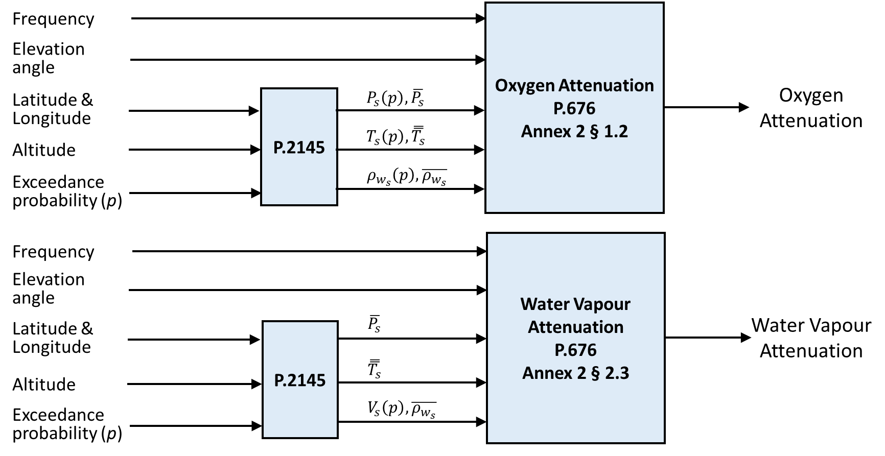

This prediction method is applicable for frequencies up to 350 GHz.

Figure 2

Cloud attenuation

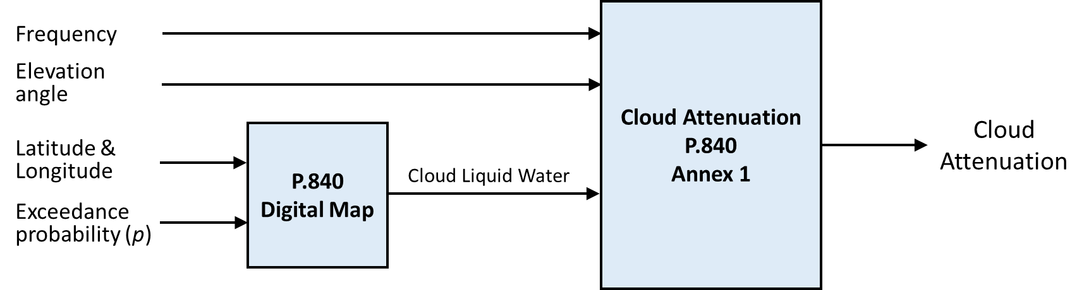

This prediction method is applicable for frequencies up to 100 GHz.

Figure 3

Rain attenuation (rain rate at 0.01% level)



Figure 4

Rain attenuation (full rain rate distribution)



This prediction method is applicable for frequencies up to 55 GHz and time percentages less than 5%.

Figure 5

Scintillation depth



Concerning scintillation, while the prediction method has been tested at frequencies between 7 and 50 GHz, it is recommended for frequencies between 4 and 55 GHz.

Figure 6

Total attenuation



Equations (62) and (63) of Recommendation ITU-R P.618-14 truncate the attenuation due to clouds and gaseous attenuation for probabilities less than 5% since a large part of the cloud attenuation and gaseous attenuation is already included in the rain attenuation prediction for time percentages less than 5%.

# 6 Testing method

Compliance with the specified test methodology must be verified with the appropriate table keeper. The various prediction methods must be tested as follows for the full range of frequencies, elevation angle, and latitudes available in the databank:

– Excess attenuation will be tested, in the probability range between FLAG3 and FLAG4 if attenuation is higher than 0.5 dB, using both the measured concurrent rainfall rate and the rainfall maps defined in Recommendation ITU-R P.837, and will be compared to (a) the predicted rain attenuation and (b) the sum of the predicted rain attenuation and the cloud attenuation predicted by Recommendation ITU-R P.840.

– Total attenuation will be tested, in the probability range between FLAG5 and FLAG6 when attenuation is higher than 0.5 dB, using both the measured concurrent rainfall rate and the rainfall maps defined in Recommendation ITU-R P.837.

In addition to these tests, excess attenuation must be tested using the measured concurrent rainfall rate for the following subsets of the DBSG3 databank:

– Frequency ranges: 1 – 17 GHz, 17 – 35 GHz and 35 – 50 GHz;

– Elevation angle ranges: 0° – 15°, 15° – 60°, and 60° – 90°;

– Latitude ranges (in absolute values): 0 – 38o, 38 – 55o and ≥55°.

# 7 Testing results

The in-force excess and total attenuation prediction methods have been tested in April 2023 using the test variable documented in Section 4 of the fascicle “Testing criteria to be used for comparing propagation prediction methods” and Table II-1_v10, file name C2_1_CR_180511_v22.csv, with the following results:

Excess attenuation (Rain attenuation only)

|  |  |  |  |  |  |  |  |  |  |  |  |  |  |
| --- | --- | --- | --- | --- | --- | --- | --- | --- | --- | --- | --- | --- | --- |
|  | 0.001 | 0.002 | 0.003 | 0.005 | 0.01 | 0.02 | 0.03 | 0.05 | 0.1 | 0.2 | 0.3 | 0.5 | 1 |
| Years | 8.0 | 19.6 | 36.6 | 53.2 | 101.7 | 110.8 | 116.6 | 115.6 | 108.7 | 88.9 | 77.9 | 67.2 | 60.5 |
| Mean | -0.032 | -0.097 | -0.160 | -0.137 | -0.108 | -0.085 | -0.068 | -0.044 | -0.034 | -0.095 | -0.130 | -0.142 | -0.205 |
| RMS | 0.180 | 0.282 | 0.293 | 0.265 | 0.229 | 0.233 | 0.225 | 0.226 | 0.254 | 0.292 | 0.338 | 0.381 | 0.461 |
| Sigma | 0.177 | 0.265 | 0.246 | 0.226 | 0.202 | 0.217 | 0.215 | 0.222 | 0.251 | 0.276 | 0.312 | 0.354 | 0.413 |

Excess attenuation (Rain + Cloud attenuation)

|  |  |  |  |  |  |  |  |  |  |  |  |  |  |
| --- | --- | --- | --- | --- | --- | --- | --- | --- | --- | --- | --- | --- | --- |
|  | 0.001 | 0.002 | 0.003 | 0.005 | 0.01 | 0.02 | 0.03 | 0.05 | 0.1 | 0.2 | 0.3 | 0.5 | 1 |
| Years | 8.0 | 19.6 | 36.6 | 53.2 | 101.7 | 110.8 | 116.6 | 115.6 | 108.7 | 88.9 | 77.9 | 67.2 | 60.5 |
| Mean | -0.010 | -0.077 | -0.138 | -0.112 | -0.076 | -0.045 | -0.022 | 0.013 | 0.042 | 0.004 | -0.010 | 0.005 | 0.010 |
| RMS | 0.185 | 0.280 | 0.284 | 0.254 | 0.217 | 0.222 | 0.215 | 0.217 | 0.244 | 0.255 | 0.283 | 0.326 | 0.369 |
| Sigma | 0.185 | 0.269 | 0.248 | 0.228 | 0.203 | 0.217 | 0.214 | 0.217 | 0.240 | 0.255 | 0.283 | 0.326 | 0.369 |

Total attenuation

|  |  |  |  |  |  |  |  |  |  |  |  |  |  |
| --- | --- | --- | --- | --- | --- | --- | --- | --- | --- | --- | --- | --- | --- |
|  | 0.01 | 0.02 | 0.03 | 0.05 | 0.1 | 0.2 | 0.3 | 0.5 | 1 | 2 | 3 | 5 | 10 |
| Years | 29.3 | 39.9 | 46.5 | 55.5 | 63.5 | 63.5 | 64.5 | 64.5 | 64.5 | 63.6 | 61.8 | 59.9 | 55.6 |
| Mean | -0.062 | 0.016 | 0.039 | 0.062 | 0.015 | 0.002 | 0.000 | 0.001 | 0.021 | 0.083 | 0.132 | 0.198 | -0.033 |
| RMS | 0.297 | 0.232 | 0.209 | 0.206 | 0.247 | 0.232 | 0.215 | 0.210 | 0.211 | 0.220 | 0.236 | 0.268 | 0.133 |
| Sigma | 0.291 | 0.232 | 0.206 | 0.197 | 0.246 | 0.232 | 0.215 | 0.210 | 0.210 | 0.203 | 0.196 | 0.180 | 0.129 |

# 8 Contact Information

Administrations with questions about these guidelines can contact Professor Carlo Riva at [carlo.riva@polimi.it](mailto:carlo.riva@polimi.it) or Mr Harvey Berger at [Harvey.Berger@att.net](mailto:Harvey.Berger@att.net).

# 9 References

“Use of flags”, Section 4 of Status of Databanks, *Annex 8 of WP 3M Chairman’s Report*, Document [3M/224](http://www.itu.int/md/R03-WP3M-C-0224/en), 24 August 2007.

ANNEx 1

Selection of reference stations for slant-path propagation modelling  
(high quality data set)

# A Background

All the experimental data, including those contained in the SG 3 experimental database (DBSG3), include a measurement error that can be minimized but it cannot be completely eliminated.

This overall measurement error results from the combination of the following contributions:

– Instrumental noise and accuracy

– Data processing

– Statistical stability and accuracy of analysis procedures.

These contributions can change over time and can vary between different experiments as a result of experimental conditions and measurement methods. As a result, the aggregated error of the overall experimental database can be dominated by older or less accurate experiments.

This represents an inherent limitation to the determination of the accuracy of models and is a common metrological problem that can be addressed by using reference data. An example of this approach is the definition of reference geodetic stations for navigation satellite systems (ref. to IGS or EUREF stations) or in the field of meteorology (ref. to meteorological reference stations in USA or Europe) for validation campaigns.

Therefore, in order to improve the accuracy of the characterization of the prediction error of propagation models for slant paths (with particular reference to Recommendation ITU-R P.618) there is the need to identify within DBSG3, those stations that can be used as a reference in testing to complement the actual procedures used by WP 3M for testing Earth-space prediction methods (ref. to Fascicle [3M/FAS/3](https://www.itu.int/oth/R0A04000006/en)).

# B Scope

The goal of this work is to identify a subset from Table II-1 of DBSG3 of particular reliable data (quality of the ground station, longer observation period duration, regularity of the statistics, completeness of probability range of the distribution, etc...) to be used for additional validation tests and in particular to select experiments that have a minimal and controlled measurement error. These stations are intended be used for detailed analysis of the error budget of propagation models and to estimate the maximum attainable accuracy of the prediction model in controlled conditions.

At the moment, the results of the tests could be affected by missing data whose impact on statistical accuracy is difficult to evaluate. On the other hand, for most of the experiments in DBSG3, it is not clear if rain rate and (excess) rain attenuation are really strictly concurrent, or if they simply refer to the same observation period. Therefore, data with really high availability (theoretically data with no missing events) and with strictly concurrent statistics are needed to be sure that model predictions accuracy is well assessed.

For these reasons, high quality data must be characterized by very high availability and possibly high dynamic range. There is no need to have a large number of sites, at least at the beginning. The need is to start to accumulate high quality data even if only a few of them are available today. Their number could be increased in the future to include data with different rain rate CCDF (higher and lower probability of rain, higher and lower maximum rain rate), different CCDF slopes, different latitudes and continents and different climatic regions.

# C Use of criteria

Criteria have to be applied mostly based on SG 3 documents. Reference to scientific publications can also be considered but this information shall be used to update the relevant SG 3 documents. The following documents shall be considered:

1) SG 3 documents, input documents, archives, chairman reports,

2) Experimental tables (DBSG3),

3) Fascicles.

# D Criteria

A list of potential criteria to be used in the determination of reference experiment is provided below:

1 Background information (score, 1 = general, 2 = detailed, 3 = complete)

Completeness and clarity of information on:

– Experimental equipment, including calibration procedures

– Data processing methods

2 Amount of valid data

– duration longer than 3 years with strictly concurrent[1] rain rate and attenuation statistics,

– availability (dc, see Table 2.1) higher than 95% (with a target of availability higher than 99%),

– information regarding missing data, such as: log-book, distribution of rain rate or radiometric attenuation during outage periods.

3 Number of frequency channels measured in the same period (beacon, radiometric)

4 Availability of key parameters in

– Excess attenuation (Table II-1) from beacon measurements

– Total attenuation (Table II-1) from radiometric observations and/or combination of radiometric and beacon data.

– Site diversity (Table II-4)

– Atmospheric XPD (table II-6a and/or Table II-6b)

– Rain rate statistics (Table IV-1)

– Sky noise Temperature (Table IV-3)

– Mean surface refractivity (Table IV-4)

– Columnar water vapour content (Table IV-9)

– Columnar cloud liquid content (Table IV-10)

– Radar data (Table IV-11)

– Rain DSD (Table IV-12).

# E Template for the selected stations

Summary table for the selected locations

|  |  |  |  |  |
| --- | --- | --- | --- | --- |
| **Parameter** | **Site1** | **Site2** | **Site3** | **Site4** |
| Background Information |  |  |  |  |
| Number of years > 95% |  |  |  |  |
| Number of frequencies |  |  |  |  |
| Excess attenuation |  |  |  |  |
| Total attenuation |  |  |  |  |
| Site diversity |  |  |  |  |
| XPD |  |  |  |  |
| Sky noise |  |  |  |  |
| Refractivity |  |  |  |  |
| Vtot |  |  |  |  |
| Lcloud |  |  |  |  |
| Radar |  |  |  |  |
| DSD |  |  |  |  |

______________

1. Strictly concurrent data means that the statistical analysis of rainfall rate and attenuation data only include measurements collected during identical time periods. In addition, if periods of rain attenuation or of total attenuation data are missing or are marked as invalid due to a system failure or malfunction, then these periods of rainfall rate data are excluded from the statistical analysis for Table II-1.