How to use ITU-R SG 1 electronic facilities
(June 2021)

1. Introduction
To make full use of the ITU-R electronic facilities you need an ITU User Account with a user-id and a password and also you need a TIES access.
If you do not have an ITU User Account and/or a TIES access, please read the information on the ITU TIES services and follow the relevant instructions given at:
www.itu.int/en/ties-services/Pages/default.aspx
The electronic facilities used by ITU-R SG 1 are as follows:
– Mailing lists: Used to send messages to all those that have subscribed to the list.
Large file attachments are discouraged.
– Share Point Site: For file exchange and other purposes (see Annexes to this document).

2. Mailing lists
Mailing lists are used by the various working parties and their subordinate groups to facilitate work by correspondence between meetings. The following SG 1 mailing lists have now been set up. As there is no automatic subscription to the lists, you will need to request subscription to the lists yourself.

2.1 General Working Party mailing lists
Used for general announcements to members of a Working Party (WP)
(e.g. announcement of the creation of a new correspondence group):
WP 1A: rwp1a@lists.itu.int | WP 1B: rwp1b@lists.itu.int | WP 1C: rwp1c@lists.itu.int

2.2 Other mailing lists for the SG 1 or Working Party sub-groups
Sub-groups (e.g. Rapporteur/Correspondence Groups) can be established by SG 1 or each WP.
Information about the groups currently established in each WP is available by following the link to “Mailing lists” on the SG 1 web page, WP 1A web page, WP 1B web page or WP 1C web page.
Additional information on the established Rapporteur and/or Correspondence Groups can be found on the following links for SG 1, WP 1A, WP 1B and WP 1C.

2.3 How to use, subscribe to and unsubscribe from a mailing list
A user guide on the new ML system is available on each new MLs Web page.

3. Share Point sites (see Annexes to this document)
It is preferable that large files (>1-2 Mbytes) be placed on the Share Point sites, rather than including them as attachments to messages sent to the mailing lists. Many subscribers' mailboxes apply file size limits, which prevent emails with large attachments being received. A better approach is to include a link to the file on the Share Point site in the message that you send to the mailing list. To be able to access the SG 1 Share Point site, you need to have a TIES ID and password. The webpage of the main SG 1 Share Point site can be accessed at:
https://extranet.itu.int/rsg-meetings/sg1/default.aspx
The webpages of the Share Point sites of the SG 1 Working Parties can be accessed directly at:
– For WP 1A: https://extranet.itu.int/rsg-meetings/sg1/wp1a/default.aspx
– For WP 1B: https://extranet.itu.int/rsg-meetings/sg1/wp1b/default.aspx
– For WP 1C: https://extranet.itu.int/rsg-meetings/sg1/wp1c/default.aspx
The Share Point sites of the relevant sub-groups (e.g. Rapporteur/Correspondence Groups) are available from the quick links on the left-hand side of the above-mentioned webpages, as shown with the red square boxes in the annexes to this document.
For further information about the ITU-R electronic facilities, please consult:
https://www.itu.int/en/ITU-R/study-groups/Pages/itu-r-e-facilities.aspx

Annex 1 – ITU-R Study Group 1 Share Point Site
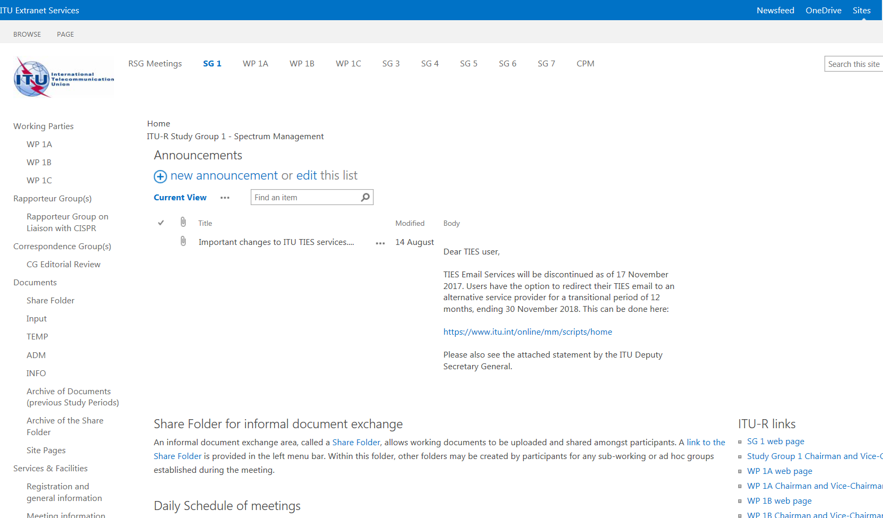

Annex 2 – ITU-R Working Party 1A Share Point Site

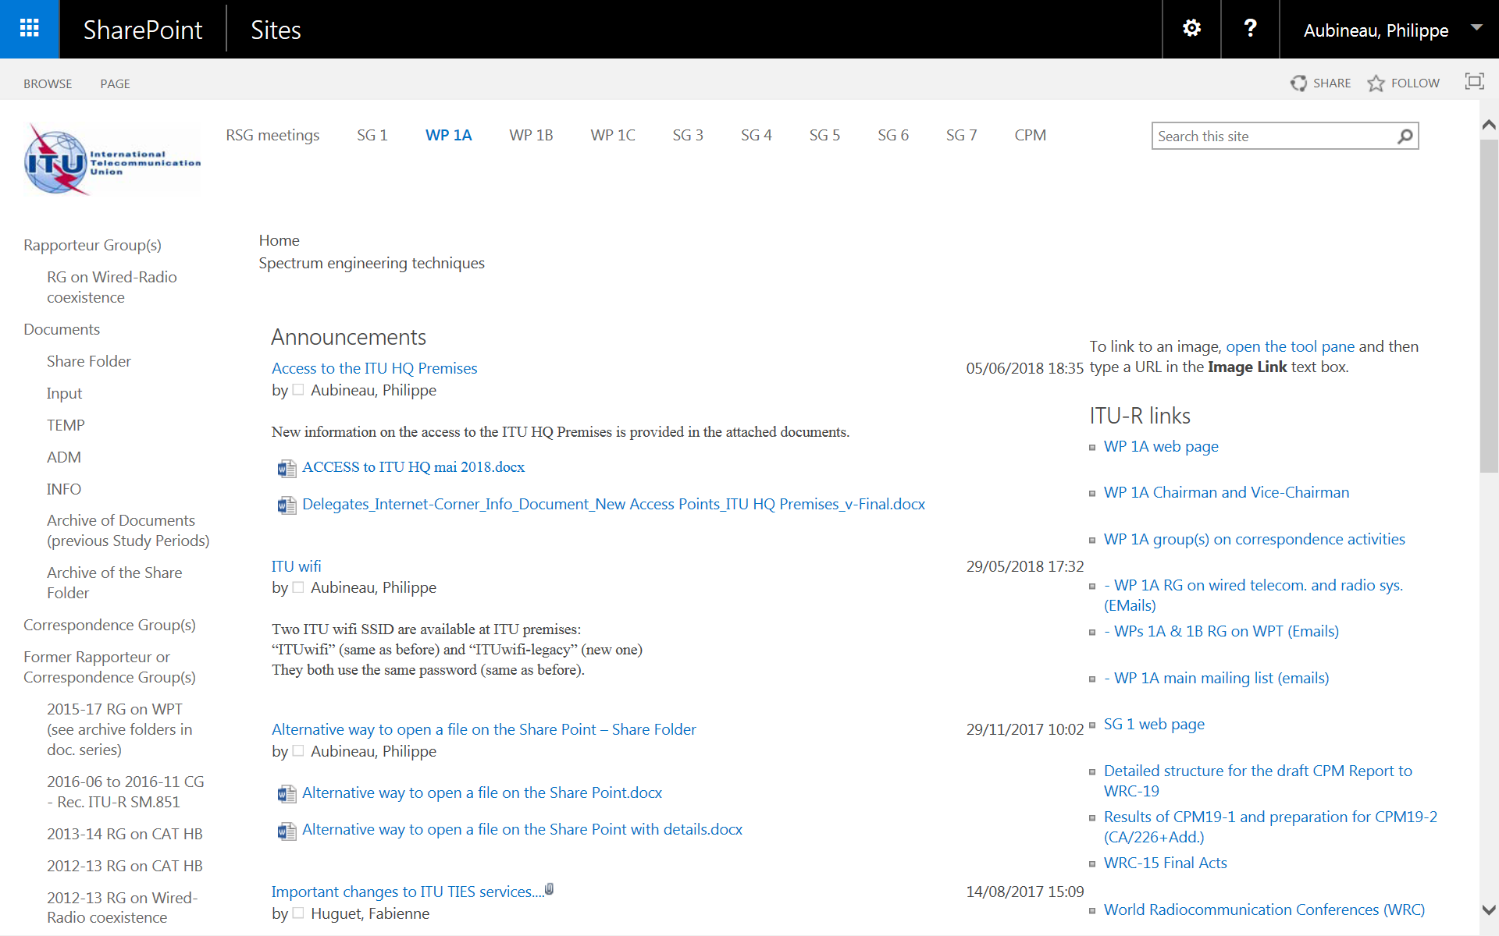

Annex 3 – ITU-R Working Party 1B Share Point Site
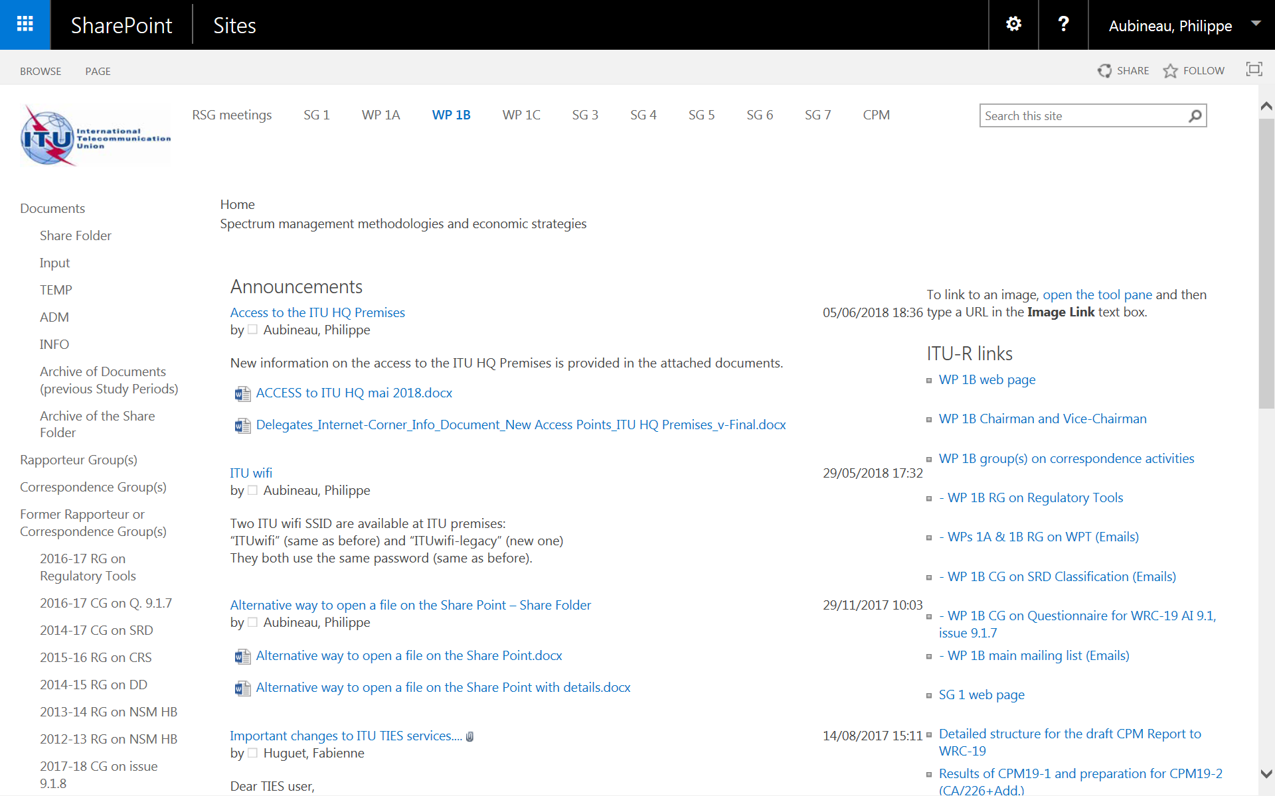

Annex 4 – ITU-R Working Party 1C Share Point Site



