ICGSF (00) 31
11 April 00

Source: BR

DESCRIPTION OF THE SPACE NETWORK SYSTEM (SNS)

1. FUNCTIONAL SUMMARY

The Space Network System (SNS) is the basic tool for the computer-assisted processing by the BR of notices and data relating to the space radiocommunications and radio astronomy services. Its design objectives are to provide for:

a) the processing of space and radio-astronomy notices:

- data capture, validation and review;

- capture of proposed or BR Findings;

- publication in the BR International Frequency Information Circular (IFIC);

- update of the magnetic reference file (MRF);

- publication in the International Frequency List (IFL);

- publication of the SRS on CD-ROM;

- publication of the Special Sections;

b) engineering applications by the Space Services Department (SSD):

- to carry out the technical examination of satellite networks as specified in Articles 28 (S21) and 29 (S22);

- to carry out comparisons of a station notified to the BR under different provisions of the Radio Regulations, for eg. RR1488 (S11.2) and RR1060 (S9.6);

- to identify cases and to carry out calculations of harmful interference;

- to carry out the examination required under Appendix 28 (S7);

- to carry out examinations required under Appendix 29 (S8) using information on the strapping of the receiving and transmitting assignments of a space station for each beam and the overall satellite link characteristics;

- to carry out the analysis and technical examinations required for updates to the plans under Appendices 30, 30A and 30B (S30 / S30A / S30B);

c) extract, inquiry and data transfer functions, needed by the specialized secretariat of the BR or by the administrations and other customers either internally or via the Internet.

The SNS is presently implemented in a client - server environment using the Ingres relational database management system as the database server and the IBM-PC workstation (running MS-Windows NT) as the client. A notice is represented in the system by a set of logically connected rows of data stored in the various tables in the SNS database. The database comprises various conceptual files such as the Notifications under RR1488 (S11.2) file, Requests for Coordination RR1060 (S9.6) file, Advance Publication RR1042 (S9.1) file, etc. These conceptual files are actually represented on the SNS database as collections of rows (records) with a particular value indicating their data-category (Notification-Reason). These records also have associated with them a status code, which indicates the particular stage of regulatory or technical processing which they are undergoing at a given point in time. The status codes can be considered as being logically divided into two groups; one is the Space Transactions in Process (STIP) consisting of all those which are in a given stage of regulatory or technical processing and the other is the Space Magnetic Reference File (SMRF) consisting of all those which have finished all required processing and are now in their final state.

2. NOTICE FLOW

2.1 Processing of notices received under RR1060 (S9.6)

The notice flow for Requests for Coordination under RR1060 (S9.6) can be summarized as follows:

- Data Capture and Verification.

Before capture a pre-validation is carried out on the notice form to ensure that it is complete and correct. This includes acknowledgement of receipt, checking that the notice is covered by the corresponding API (including the requirements of Resolution 51), checking and validation of graphical data, as well as an examination of the notice with respect to the requirements of Appendix S4 and other relevant provisions of the Radio Regulations and Rules of Procedure. In the case of a modification, the notice is marked up appropriately to ensure that the merged transaction correctly represents the modification(s) to be examined.

Notices received on Appendix S4 notice forms are captured on PCs via the SpaceCapture component which stores the data locally in an MS-Access database. The notice is additionally captured by a second operator at another PC into a different local MS-Access database. The verification of the captured notice is done by a program which compares the two versions of the notice and produces a report. Any differences between the two notices will be examined so as to obtain eventually a correctly captured notice; following verification, the notice is exported to the Ingres database via the SpaceCapture component.

Graphical data submitted with the notice is validated before being captured by the GIMS operator via the GIMS component into the GIMS database. They are identified by the same notice-id that is allocated by the Registry section to the notice.

Electronic notices are submitted in MS-Access database containers in the SNS database format. They are loaded at a PC into an MS-Access database so that they can be examined via the SpaceCapture component. A pre-validation is carried out and any necessary corrections are made, following which they are transferred into the Ingres database. Graphical data submitted electronically in the GXT format are imported via the GIMS component into the GIMS database.

2.1.2 Check for Existing (CFEX).

Transactions that have been correctly verified are designated for 'Check for Existing', to match each incoming transaction against any existing (recorded) data in the same category. This function is carried out in an automatic process and transactions that cannot be correctly processed are sent for correction; a printout indicates the errors found. If any transaction is found to match with another transaction that is already in process or if its (recorded) target in the MIFR already has a transaction-in-process (i.e. an earlier mod is already in the system), then the transaction that is being checked is moved to a "hold" status. When the other preceeding transaction has moved to the SMRF, the transaction in the "hold" status is moved back to resume the 'Check for Existing'.

In the case of Mod transactions, the CFEX process carries out a comparison of the incoming transaction and its target, identifying the records in which changes are indicated. When the CFEX process has terminated correctly, it invokes a module that created a fully merged version of the transaction in addition to the incoming transaction and its unmodified target. This merged transaction will be available to all processes which require to view or process it but will not be available for data-correction. However, if the incoming transaction is subsequently modified following completion of the CFEX, the data-correction component will clear the CFEX and other flags, delete the merged version and restart the process. The modified incoming transaction passing through the CFEX again and a new merged file created.

2.1.3 Validation (VAL).

After 'Check for Existing', 'Validation' carries out various checks on the fields of each transaction to ensure that the transaction is complete and correct. Checks are also carried out between notified and coordinated versions and between earth station transactions and the associated space station. All transactions that pass 'Validation' (both manual and automated) are designated as ‘Complete’.

The transactions that have failed 'Validation' are examined using the interactive component 'Validation Correction' (actually implemented in SpaceCapture). The operator is provided with the facility of viewing all errors and incompatibilities and to decide on a course of action to follow. The transactions may be corrected and routed back to 'Check for Existing', passed on as being correct or held pending correspondence with the responsible administration.

2.1.4 Process Complete Transactions (PCOM).

Each transaction is now considered to be complete and correct. The ‘Process Complete Transaction’ component routes the transaction to the next phase of processing after carrying out some checks. It checks that the GIMS database contains all the relevant diagrams (like antenna gain contours and service area). It also checks each transaction to determine the types of technical examination that it should undergo and stores this information (as a list of status codes) in the transaction for later use. Transactions under RR1060 are then sent for technical examination.

2.1.5 Technical Examination (TEX).

The transactions now undergo technical examination. Various examinations are required such as:

- regulatory, like PFD calculations, Article 28 (S21), 29 (S22), Article 14 (S9.21);

- technical examination under Appendix 29 (S8) (need to coordinate);

- other examinations concerning the need to coordinate (eg. Resolution 46);

The batch PFD and AP29 programs produce results that can be used by the batch findings component. This allows automatic entry of the findings into the database. The findings can also be reviewed or captured by the online findings component. When the findings have been verified, the transaction is ready for publication in the AR11/C Special Section.

2.1.6 Publication in the Special Section.

The PC-based publication component produces a MS-Word document for each satellite network awaiting publication. The special section reference and number are stored in the notice during findings capture; the current IFIC number and date are taken from the database. The corresponding graphical data are extracted from GIMS or other sources and added to the publication. The entire special section is thus produced largely automatically.

Confirmation of publication sends the transactions to the next stage of processing - update.

2.1.7 Update of the Space Master Register.

The Update component moves the transactions to status ‘50’, after carrying out some cleaning up activities. Archives are created of the transaction and the target station, if the notice is a Mod or Sup.

2.2 Processing of notices received under RR1488 (S11.2)

A brief description of the notice flow for Notifications under RR1488 (S11.2) is provided below:

2.2.1 Data Capture, Verification, CFEX and VAL.

The capture, verification and validation of notices received under RR1488 (S11.2) is the same as that of notices received under RR1060 (S9.6) and is as described in paragraphs 2.1.1 to 2.1.3 above.

2.2.2 Process Complete Transactions (PCOM).

The ‘Process Complete Transactions’ component sends the complete and validated notices for publication in Part 1 of the IFIC. The PC-based publication component creates a “frequency-list” file containing a record for each frequency assignment belonging to each space network/earth station that is being published in the IFIC. This “frequency-list” file is merged with a similar one produced from the Terrestrial system TerRaSys, so that a complete frequency list for terrestrial and space notices can be produced. These transactions are held pending a confirmation of the successful creation of the file which becomes the IFIC and which then releases them to the next stage of processing.

2.2.3 Technical Examination (TEX).

After the publication in Part 1 of the IFIC, the transactions undergo technical examination. Various examinations are carried out, depending on the type (space or earth) of the transaction, such as :

- comparison of stations that exist in the SNS in more than one data category
(RR1488 against RR1060);
- regulatory, like PFD calculations, Article 28 (S21), 29 (S22), Article 14 (S9.21);

- technical examination under Appendix 28 (S7);

- technical examination under Appendix 29 (S8);

2.2.4 Publication and Update of the Space Master Register.

Following the completion of Technical Examination, the provisional findings are captured for the respective groups of assignments, at which point the transaction is ready for publication in IFIC Parts II/III. The findings document is also printed at the same time and submitted for the approval of the weekly BR Findings meeting. After the publication has been confirmed, the transactions are sent for updating the Space Master Register File (SMRF). Archives are created of the transaction and the target station, if the notice is a Mod or Sup.

2.3 Utilities and Reporting tools

The SNS provides facilities (SpaceQry) to carry out inquiries against the notices in the various categories and statuses. Various reports tailored to specific requirements (like TSUM) can be obtained. A data correction component (based on the SpaceCapture component) provides Validation Correction and Data Amendment functionality. A group correction component is available to modify one or more data items in all group records of the notice. There are processes to carry out the publication of the SRS on CD-ROM and to provide extracts from the database to other systems. There is also Internet (WWW) access to the SNS database.

3. SYSTEM FLOW DIAGRAMS

Table 1 lists the various types of notices that are processed in the SNS, identified by their data-categories (notification-reason value). Table 2 provides a list of valid status codes that are used in controlling the flow of a notice through the system; it associates the status code with the notification-reason, indicating the various stages of processing valid for a particular notice type.

Figure 1 shows the flow of a notice through the SNS and the flow and interface relationships of all major components. In the flow diagram, the following conventions have been used:

represents a computer process, which could be batch or a terminal disconnect process
represents a conversational component where the operation interacts directly with the system data

represents a manual process
represents a file forming an interface with activities outside the SNS

If a manual or computer process is drawn with dotted lines, then that process is external to the SNS.
Table 1 Notification-Reason (Data Category)

EXTERNAL CODE | DESCRIPTION
A | Advance publication RR1042 (S9.1)
C | Request for Coordination RR1060 (S9.6)  or Resolution 46
D | Coordination under RR1107 (S9.17)
E | Article 14 (S9.21) Procedure
N | Notified under RR1488 (S11.2)
U | Notice submitted under Resolution 49

Table 2 Transaction Status Codes

Category | MNEM. | Number | Description
A C,D N | RVER | 1 | Ready for Verification
 |  | 2
A C,D N | RDCS | 3 | Ready for Data Capture Supervisor
 |  | 4
A C,D N | RCFE | 5 | Ready for Check for Existing
A C,D N | UMOD | 6 | Unmerged MOD transaction
A C,D N | RVAL | 7 | Ready for Validation
A C,D N | RDER | 8 | Ready for Data Entry Review
A C,D N | IINC | 9 | Incomplete
A C,D N | ICOM | 10 | Complete
N | HDER | 11 | Hold for Data Entry Review
 |  | 12
C N | RTEX | 13 | Pending Technical Examination
 |  | 14
A C N | RBRD | 15 | Ready for BR IFIC Approval
 |  | 16
 |  | 17
 |  | 18
N | IRNF | 19 | Returned Notice Awaiting Resubmission
C,D N | ITEX | 20 | In Technical Examination
 |  | 21
 |  | 22
A C,D N | IREG | 23 | In Regulatory Examination
 |  | 24
 |  | 25
A C,D N | IBRD | 26 | Ready for IFIC Parts 2/3/Sp.Sect. publication
A C,D N | RDEL | 27 | Ready for Deletion
 |  | 28
 |  | 29
A C N | HCAP | 30 | Hold for Data Capture Completion
A C N | RCOR | 31 | Ready for Correction
 | RFRV | 32 | Ready for Findings Review
A C,D N | HCFE | 33 | Hold for Check for Existing
 |  | 34
N | RPUB | 35 | Ready for IFIC Part 1 Publication
N | ACPB | 36 | Awaiting Confirmation of IFIC 1 Publication
C,D N | ACPF | 37 | Awaiting Confirmation of IFIC 2/3/S Publication
 |  | 38
N | AP28 | 39 | Ready for TEX: AP28
C N | AP29 | 40 | Ready for TEX: AP29
 | RTBS | 41 | Ready for TEX: AP30/30A (BSS)
 | RTAP | 42 | Ready for TEX: AP30B (Allotment Plan)
C N | PFDG | 43 | Ready for TEX: PFD (geo)
C N | PFDN | 44 | Ready for TEX: PFD (non-geo)
C | RS46 | 45 | Ready for TEX: RS46 (section II)
 |  | 46
 |  | 47
 |  | 48
A C,D N | RSMR | 49 | Ready for SMRF Update
A C,D N | SMRF | 50 | In SMRF

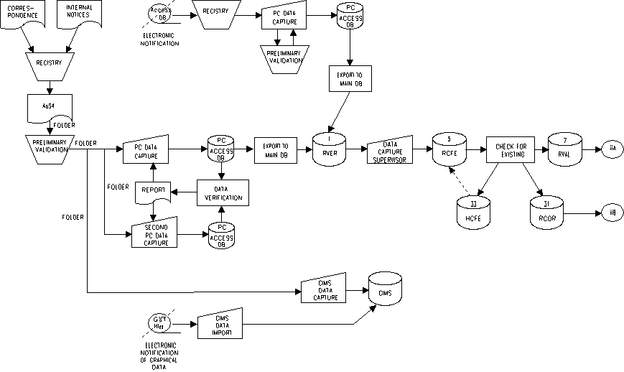

Figure 1 Notice Flow Diagram (Page 1 of 5)

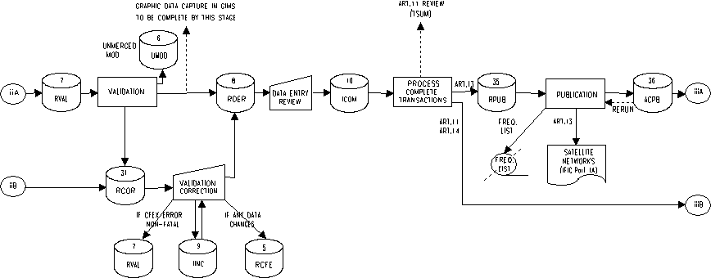

Figure 1 Notice Flow Diagram (Page 2 of 5)

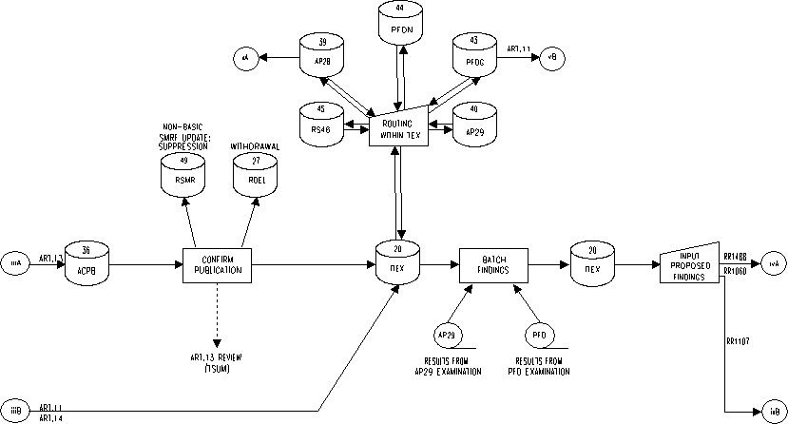

Figure 1 Notice Flow Diagram (Page 3 of 5)

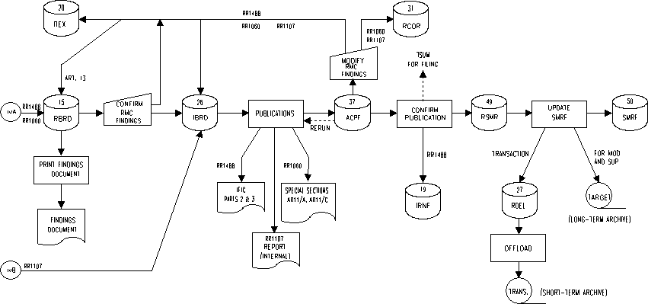

Figure 1 Notice Flow Diagram (Page 4 of 5)

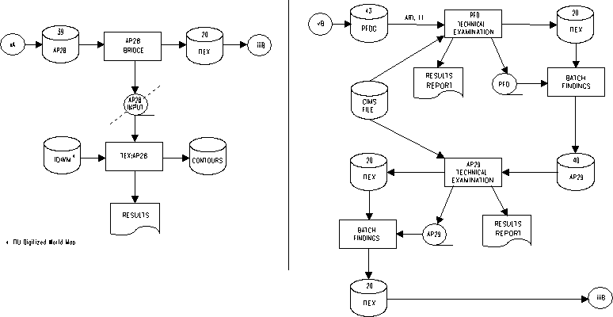

Figure 1 Notice Flow Diagram (Page 5 of 5)

The SNS as conceived and implemented allows only one active transaction under examination at a time.
Necessary to for data integrity as it ensures only the input data is modified.

