Coordination Groups in Sub CNG 1-2
Document CNG 1/Sub 2/1

Cordination Group | Member States,  Observers | Chairman
Central Europe Group | AUT, CZE, D, HNG, POL, SVK,  HRV | Peter Reindl (AUT)  Peter.reindl@rtr.at
Nordic Group | DNK, FIN, NOR, S | Alternating chairman
Baltic Group I | D, DNK, POL, S
Baltic Group II | BLR, EST, FIN, LAT, LIT, RUS, S | Alternating chairman
Central South East European Group | AUT, BIH, CZE, HNG, HRV, ROU, SCG, SVK, SVN, UKR | Maria KISSNE-AKLI (HNG)  kissne@nhh.hu

Central Europe Group

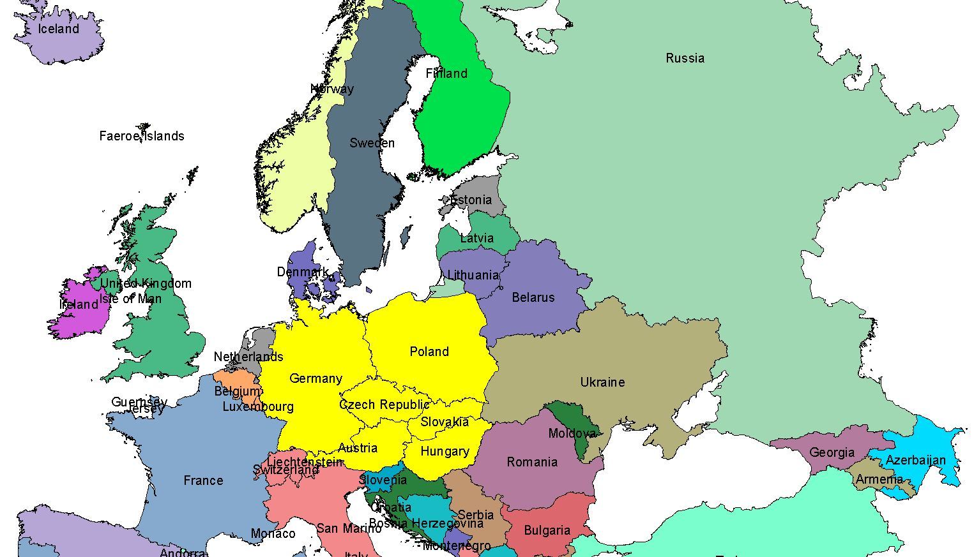

Nordic Group

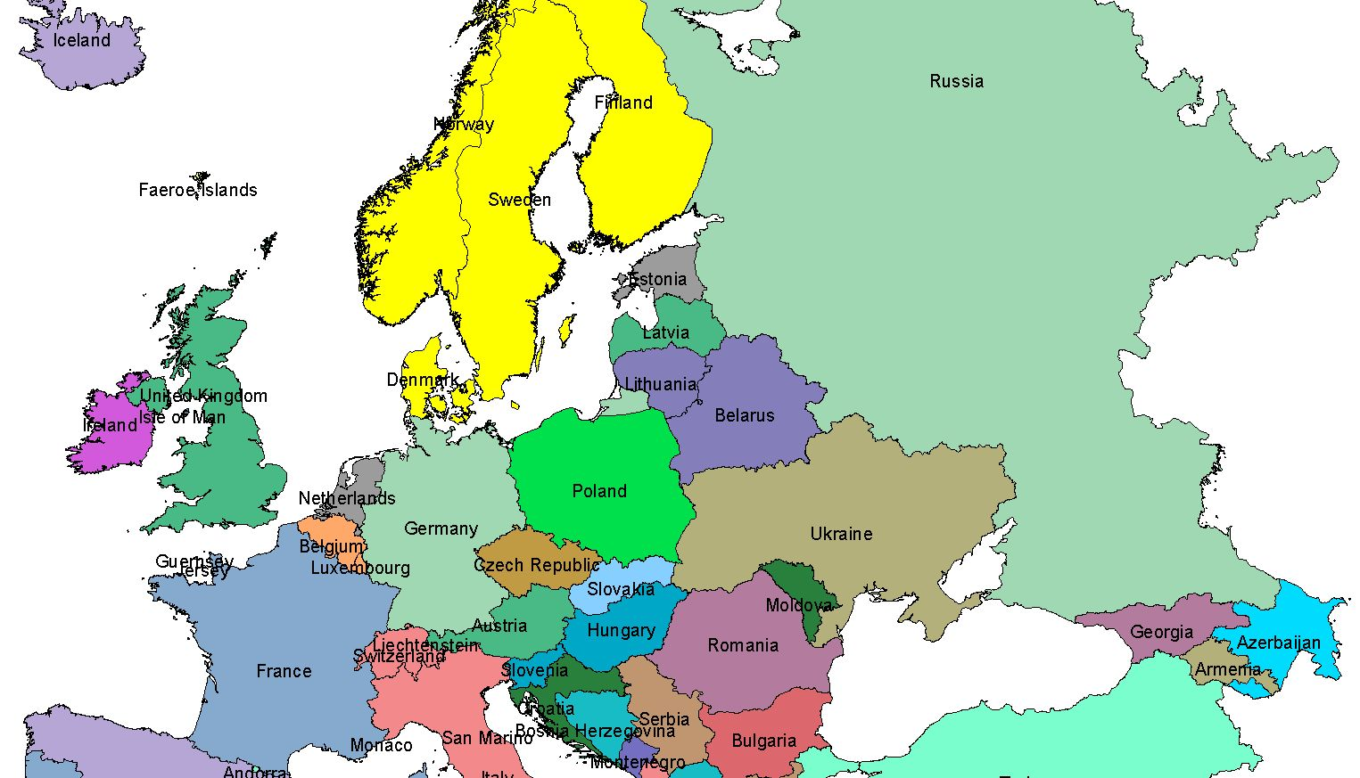

Baltic Group I

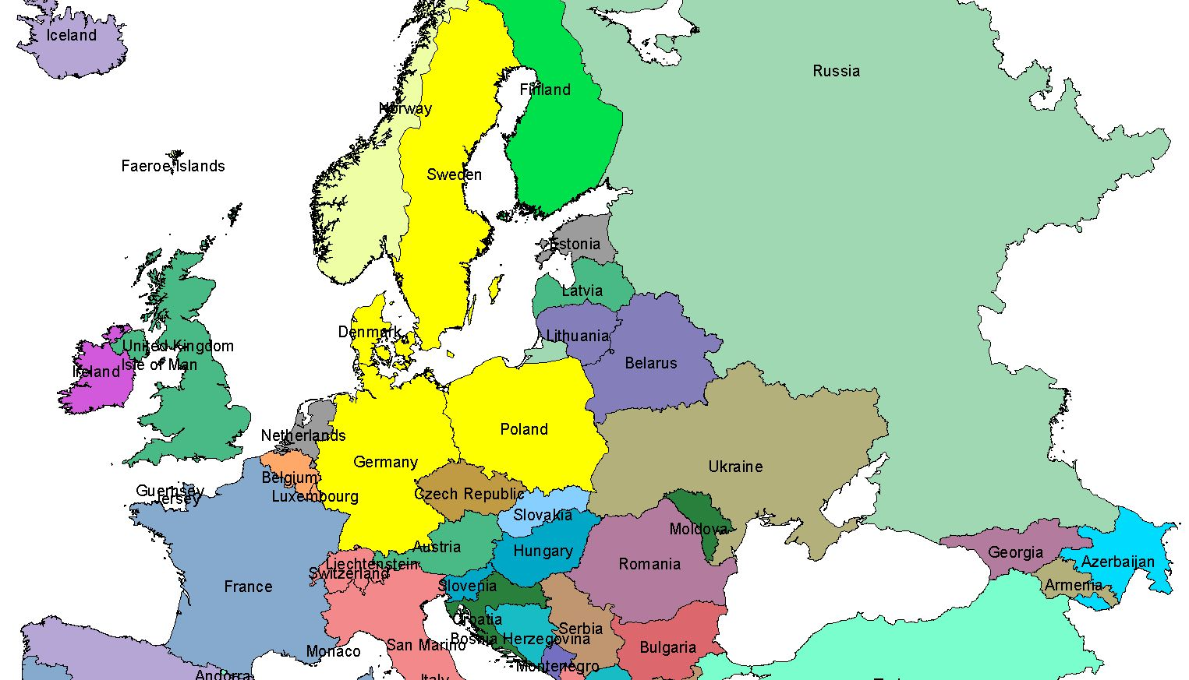

Baltic Group II

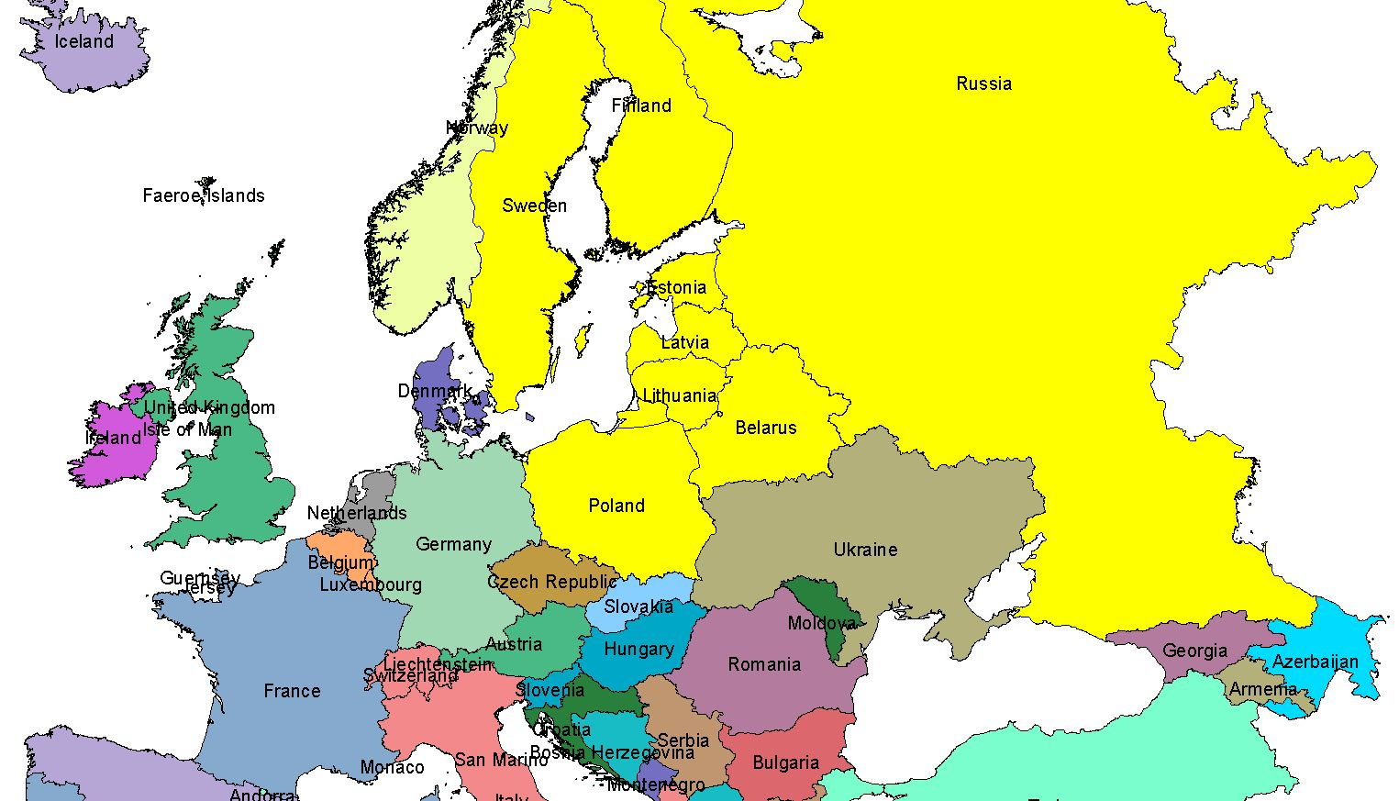

Central South East European Group

