Doc. CNG 1-1 002

CONSIDERATIONS ON WORKING ARRANGEMENTS IN sub-CNG 1_1

Source: Chairman/ vice chairman sub-CNG 1-1
Date: 17 May 2005

1. General

- Sub-CNGs are to be established for the purpose of organizing and managing the work within the CNG1. Administrations are free to engage in coordination and negotiations across the boundaries of sub-CNGs, as necessary. It is noted that the administrations know best how to organise their CNG work.
- The responsibility for making the submissions of requirements and administrative declarations shall remain the task of the appointed (authorised) member of each administration. On-line facilities will be available for administrations to make their inputs.
- There will be a need for keeping track of all calculation runs/results relevant for CNG1 and have them available throughout the conference. For that purpose an electronic archive will be created and a list of all planning iteration shall be maintained, including a brief description of each calculation run (e.g. date, scope, location of the results).

2. Meetings

2.2. The first kick off meeting of sub-CNG 1_1:
is scheduled on Friday 19 May at 9.00 hours to discuss the workings arrangement in sub CNG1-1.

2.3. Sub CNG1-1 meetings will be scheduled:
3 times per week ([Tuesday (morning), Wednesday (afternoon), and Friday (morning)]) at [9:00 or otherwise indicated] hours to be held in room: [B1?].

2.4. On request of one or more Administrations:
the chairman will call for a of sub CNG1-1 ad hoc meeting.

2.5. Coordination and negotiations meetings:
between Administrations will be arranged on ad-hoc basis, as appropriate.

2.6. Meeting facilities
The meeting room B in the ITU tower, level -2, will be available for CNG1 for the whole duration of the Conference. The meeting room can be divided into two smaller rooms which is suitable for the work of the sub-CNGs. Ad-hoc coordination meetings can also be arranged in public areas in the ITU and CICG buildings.

3. Analysis of results
- It can be expected that administrations will carry out analyses of the results for themselves.
- sub CNG1-1 chairman will be briefed by Administrations on the progress made.
- sub CNG1-1 will asses the planning results from the sub CNG1-1 perspective and identify hot spots.

4. Planning calculations for sub CNG1-1
- CNG1 will be requested to carry out additional calculations in the sub CNG1-1 area if required.

5. Role of Chairman and Vice-Chairmen of sub CNG1-1
In general, chairman and vice chairman will work as a team to assist the Administrations in sub-CNG 1_1 on all the coordination and negotiation issues they are dealing with. Where relevant the separate responsibilities are:
  - chairman:
    - intermediate to the chairman of CNG 1,
      - member of the CNG 1 steering committee;
      - daily report (e-mail) to the CNG 1 chairman
    - intermediate to the chairmen of the sub-CNGs;
    - give guidance to the overall process;
    - chairman of the sub-CNG 1_1 coordination meetings;
    - available as mediator/advisor on request;
  - vice chairman:
    - member of the CNG 1 steering committee;
    - by absence of the chairman:
      - chairman of the sub-CNG 1_1 coordination meetings;
      - intermediate to the chairman of CNG 1;
      - daily report (e-mail) to the CNG 1 chairman
      - intermediate to the chairmen of the sub CNGs
    - on request of the chairman:
      - replacing the chairman in those situations where the chairman has to take responsibility as member of his delegation;
      - give guidance to the overall process;
    - available as mediator/advisor on request;
    - responsible for the collection of all the technical data and coordinating the representation of it in overviews/files;
Annexes:

- draft agenda (topics which could be discussed)
- time tables
- Appointed contact persons for each administration
- draft overviews of the results of planning iterations

ANNEX 1

1. draft agenda:
topics which could be discussed:
  - progress reports
    - band III:
      - status of the negotiation process;
      - indication of bottlenecks;
      - proposals for solutions/assistance;
    - band IV/V:
      - status of the negotiation process;
      - indication of bottlenecks;
      - proposals for solutions/ assistance;
  - results of the other sub-CNGs 1 meetings
(where necessary: actions to be taken);
  - results of the other CNG meetings
(where necessary: actions to be taken);
  - results of the calculation runs: overviews (Annex C)
(where necessary: actions to be taken);
  - (optional) input documents:
    - summary reports of the bi- and multilateral meetings
    - report of the chairman of CNG 1 reflecting:
      - positions in the other sub-CNGs (inter group issues to be solved included);
      - status report of the progress made in other CNGs;
    - technical data for the calculation runs;
    - technical data resulting from the calculation runs;
    - weekly time tables, where necessary indicating issues to be solved and or action to be taken;

  - any other business

Annex 2

Time tables

    - sub-CNG 1_1 coordination meeting;
    - bi- and/or multilateral meetings;
    - presentation of results

Annex 3

Appointed contact persons for each administration

Administration | Name | Mobile | E-mail | Contact for
SUI | Antonio RULLO | +41 79 459 77 50 | antonio.rullo@bakom.admin.ch | F
SUI | Gerd KOEHLER | +41 79 651 35 92 | gerd.koehler@bakom.admin.ch | D
D |  |  |  | SUI
D |  |  |  | F
D |  |  |  | BEL
D |  |  |  | LUX
D |  |  |  | HOL
D |  |  |  | DNK
…
Annex 4

Proposed overviews of the results of planning iterations
1. Channel/block maps

Overviews for all input requirements on a channel-by-channel / block-by-block basis, including coverage areas as well as indications if this particular channel/block has been assigned. Figure 1 gives an example of such a map for the whole area of sub-CNG 1_1 whereas Figure 2 shows a specific planning region concerned by BEL, D, F, G, HOL, LUX.
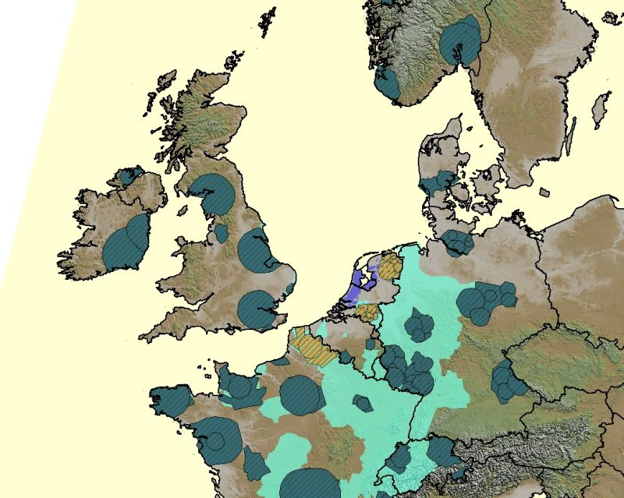
Figure 1. Allocation map of channel 30 across the planning area of sub-CNG 1_1.

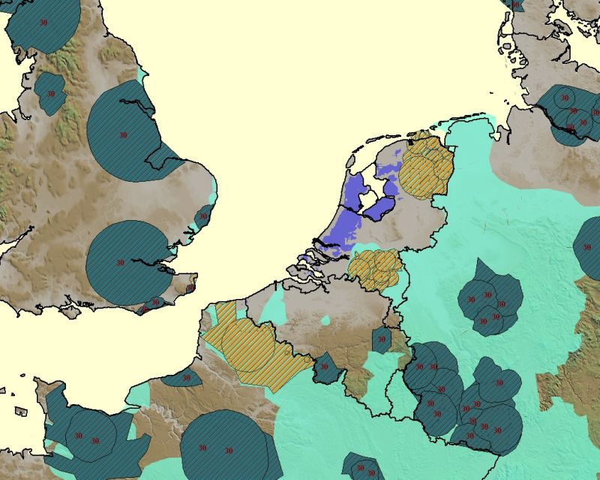
Figure 2. Allocation map of channel 30 in the region concerned by BEL, D, F, G, HOL, LUX.

Diagonally dashed background indicates those requirements, for which only a specific channel is acceptable. Light blue background indicates the requirements, for which a range of channels (e.g. 21-69) is acceptable. Dark blue colouring marks the requirements that were assigned the specific channel.

2. Digital affected and interferes

Overviews of incompatibility for all input requirements that were not assigned a specific channel in the course of a planning iteration. An incompatibility map for each not-satisfied requirement shows digital requirements that are affected by this requirement, as well as digital requirements that are considered as interferes to this requirement. Figure 3 gives an example of such incompatibility maps for a Belgian input requirement that did not get a channel in the 2nd planning exercise. Incompatibility maps may be created for all input requirements of each administration of sub-CNG 1_1 in order to facilitate discussions in bi- and multilateral groups.

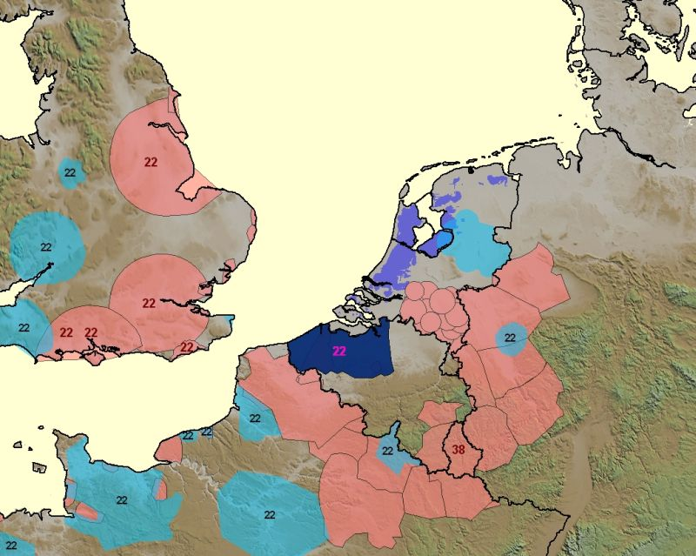 | 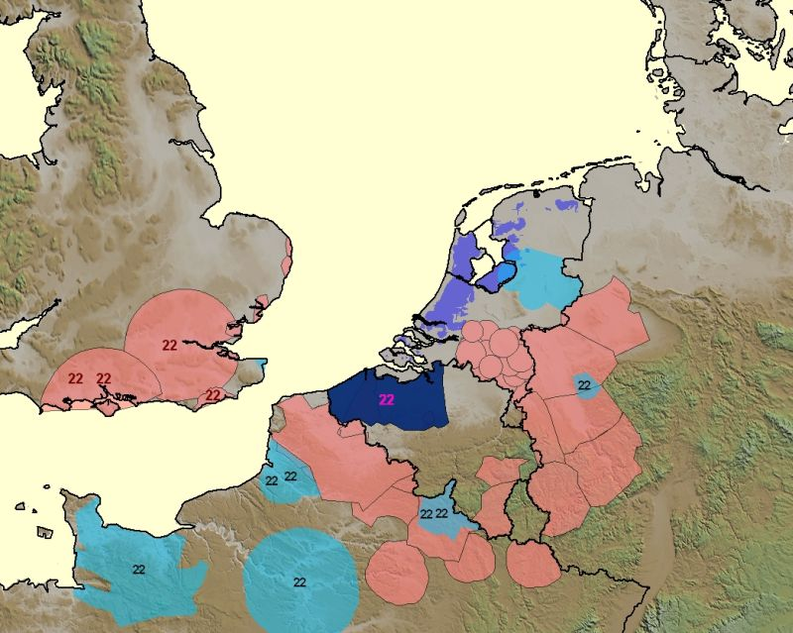
Affected | Interferes
Figure 3. Incompatibility maps of the requirement BELDVBVG002 (Belgium).

Dark blue background indicates the not-satisfied (wanted) requirement. Light blue colouring indicates those affected/interfering requirements that have an administrative declaration with the wanted requirement. Light red colouring serve to indicate the affected/interfering requirements that do not have an administrative declaration with the wanted requirements. The label with the channel/block number is assigned to those affected/interfering requirements that got a channel/block within the planning iteration.

3. Administrative declarations

Overviews of existing pair-wise administrative declarations submitted for planning iterations. Figure 4 shows an example of such an overview for SUI-F and SUI-D administrative declarations.

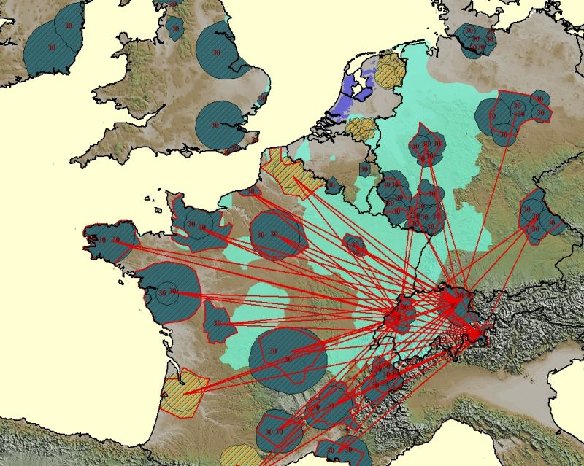
Figure 4. Administrative declarations SUI-F and SUI-D between DT2 requirements on channel 30.

