Guidelines for the preparation of Conference Documents

If, during the preparation of documents, an extract of text is taken from (a) document(s) that has (have) already been translated, the source(s) should be clearly indicated in the margin. Already existing and translated text should be revision-marked (turn on track changes). When quoting text from the Radio Regulations, text from the 2004 Edition should be used. When text from an existing document is being amended, please cut and paste and do not retype. This will facilitate translation and text processing. Long unchanged extracts from existing documents (one page or more) should not be reproduced.

If you must revise, electronically, text that already contains revision marks, please shade new revisions as follows:

Shade text at 55% and please use the following instructions:
1) Click on View/Toolbars/Tables and Borders

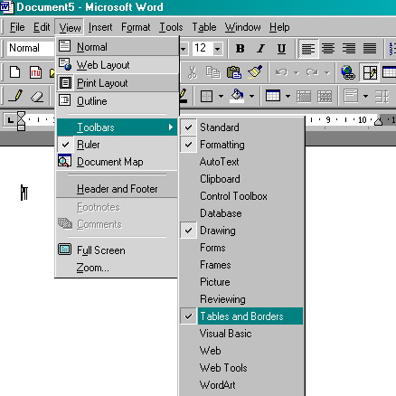

2) This will bring up the following toolbar - then click on the button highlighted in red

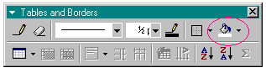

3) Then choose Gray-55%

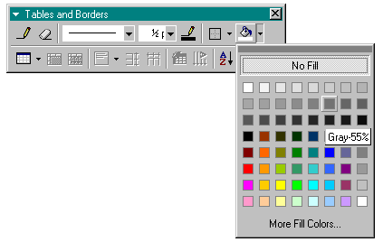

This may either be done before you type your text or, alternatively, you may highlight the text to be shaded and use the above-mentioned method. This will greatly help in tracking all changes and, subsequently ease the referencing, translation, typing and timely production of conference documents. This shading will not appear in the published version of the document.
Conference documents should begin with a reference to a particular agenda item to which the subject of the document relates, for example, “AGENDA ITEM 1.27: MODIFICATIONS TO APPENDICES 30 AND 30A”. This procedure will assist participants in identifying the agenda item under which the subject matter in the document is to be treated. When more than one agenda item is involved, please add the numbers accordingly. There will be instances where this step is not possible or appropriate, e.g. “DRAFT ORGANIZATION OF THE WORK OF COMMITTEE 5”.
As it is often necessary to photocopy manuscripts, participants are requested to write in black ink, as satisfactory results cannot be obtained from manuscripts written or revised in coloured ink. Handwritten manuscripts should be legible and presented in as concise a manner as possible in order to avoid delays in translation and typing.

______________________

