ANNEX

INTERNATIONAL TELECOMMUNICATION UNION

Regional Radiocommunication Seminar

Buenos Aires (Argentina): 14 to 18 April 2008

INFORMATION NOTE

THE MEETING

- Venue

HOTEL NH CITY & TOWER
Bolivar 120
Buenos Aires

- Local contact person

Mr Luis Carranza
Tel: +(54) (11) 4347-9454
Fax: +(54) (11) 4347-9546

E-mail: lcarranza@cnc.gov.ar

- Accommodation and hotel reservations

The Argentine Administration has secured special rates with a number of city centre hotels, details of which are given in the table on the next page, where there is also a map showing the location of each hotel in relation to the meeting venue (indicated by an arrow).

Delegates are kindly requested to inform us of the reservations made, by fax to +(54) (11) 4327-9546, or by e-mail to lcarranza@cnc.gov.ar, using the forms provided for the purpose.

It is important that reservations be made as early as possible. All reservations must include a credit card number. You will receive a confirmation message once your reservation has been accepted by the hotel. Should you subsequently find that you will be unable to attend the meeting, the reservation must be cancelled sufficiently in advance.

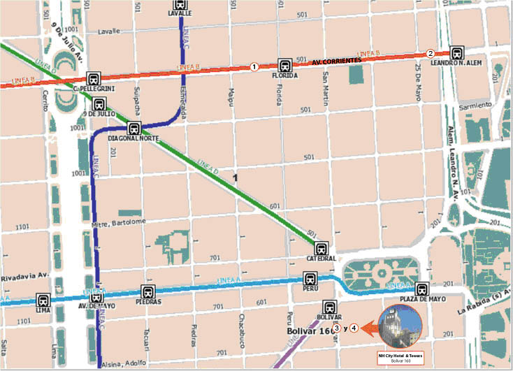

HOTEL | CATEG | TYPE OF ROOM | RATE | REMARKS
(1) Liberty  Corrientes 632  Tel/Fax: +54. 11-4325-0261  Check-in from 1200 hours  Check-out by 1000 hours  reservas@liberty-hotel.com.ar | * * * | Single  Double | USD 65  USD 77 | Includes VAT and buffet breakfast
(2) NH Jousten  Corrientes 240  Tel: +54. 11-4321-6750  Fax: +54. 11-4321-6775  Check-in from 1400 hours  Check-out by 1200 hours  www-nh-hoteles.es | * * * * | Double or Standard Single | USD 145 | Includes VAT and buffet breakfast
(3) NH City  Bolivar 160  Tel: +54. 11-4121-6464  Fax: +54-11-4121-6450  Check-in from 1400 hours  Check-out by 1200 hours  www-nh-hoteles.es | * * * * * | Double or Standard Single | USD 134 | Includes VAT and buffet breakfast
(4) NH City Tower  Bolivar 160  Tel: +54. 11-4121-6464  Fax: +54-11-4121-6450  Check-in from 1400 hours  Check-out by 1200 hours  www-nh-hoteles.es | * * * * *  superior | Double or Standard Single | USD 165 | Includes VAT and buffet breakfast

4. Flights and ground transportation

Ezeiza International Airport is located 40 minutes from the city centre. Delegates have the following options for travelling from the airport to their hotel:

Chauffeured cars (remises) and private taxis: The airport is served by a large number of taxis and remises, which can be found outside the arrivals hall.

Minibuses: These are a more economical alternative. They leave the airport every half an hour, with transfer services to the main city centre hotels.

Further information may be found on the following website: Aeropuertos Argentina 2000 - Aeropuerto de Ezeiza Ministro Pistarini (http://www.aa2000.com.ar).

GENERAL INFORMATION

- Entry formalities

While the majority of delegates will not require a visa to enter Argentina, it is nevertheless recommended that you check in advance with an Argentine embassy or consulate.

No vaccination certificate is required for entering the country, except in the case of cholera and yellow fever for passengers arriving from countries in which those diseases are endemic.

- Language

Spanish is the official language. However, most people in the central area have a working knowledge of English.

- Electric current

Alternating current is used throughout Argentina. The voltage is 220 V. Most hotels provide 110-volt adaptors.

- Climate

Buenos Aires has a mild and humid climate throughout the year, and very hot or very cold days are rare.
The normal temperature range is 18.4 to 26º C. The average temperature at this time of year is 20ºC.

- Currency

The peso ($) is the official currency of Argentina. While the dollar is generally accepted, foreign currency can be exchanged into pesos in banks and other authorized establishments. The most commonly accepted credit cards are American Express, VISA, Diners Club and MasterCard.

Exchange rates are liable to fluctuate. At 29 February 2008, the dollar exchange rate was:
USD 1 = $ 3.20.

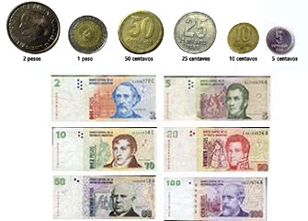

- Shopping – VAT refunds

At the airport you can receive a refund of the value added tax (21 per cent) levied on domestic products purchased from outlets belonging to the “Global Refund” system, provided the amount paid (per invoice) is over $ 70.

- Business hours

Banks and exchange offices: Monday to Friday from 1000 to 1500 hours.
Company offices: Generally from 0900 to 1200 and 1400 to 1900 hours.
Shops and businesses: In the major cities, Monday to Friday from 0900 to 1200 hours (in the country’s interior there is normally a midday break), and Saturday from 0900 to 1300 hours.
Cafes, patisseries and pizzerias: Almost always open, with a break from 0200 to 0600 hours.
Restaurants: Lunch is served from 1230 hours and dinner from 2030 hours. Many fast-food establishments are open round the clock.

- Tipping

It is customary to leave a 10 per cent gratuity in coffee bars and restaurants and to tip porters, doormen and cinema/theatre ushers.

- Other useful information

You can find further information on the city of Buenos Aires on the following Web page: http://www.gcba.gov.ar/areas/turismo/home/

