Composition of the Radio Regulations Board

The Radio Regulations Board (RRB), comprised initially of nine part-time members, was established in 1994 following revisions to the Constitution and Convention and elections conducted at the Plenipotentiary Conference (Kyoto, 1994). The part-time Board replaced the previously full time International Frequency Registration Board (IFRB).
In accordance with CV 144, the Chairman and Vice-Chairman are elected by the members of the RRB for a period of one year.

RRB Members elected at PP-10

 | Name | Country
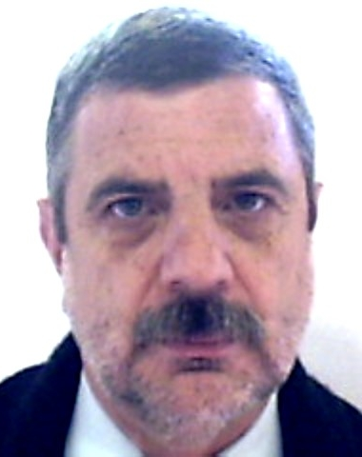 | Mr. Ricardo Luis TERÁN | Argentina
 | Mrs. Julie NAPIER ZOLLER | United States
 | Mr. Alfredo MAGENTA | Italy
 | Mr. Midaugas ZILINSKAS | Lithuania
 | Mr. Victor STRELETS | Russia
 | Mr. Baiysh NURMATOV | Kyrgyz Republic
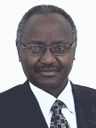 | Mr. Stanley Kaige KIBE | Kenya
 | Mr. Mustapha BESSI | Morocco
 | Mr. Simon KOFFI | Côte d’Ivoire
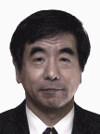 | Mr. Yasuhiko ITO | Japan
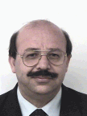 | Mr. Ali R. EBADI | Malaysia
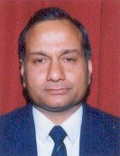 | Mr. P.K. GARG | India

