The 25th Anniversary of the Introduction of HDTV in Europe
ITU, 16 October 2007

Remarks by Mr. Lieven Vermaele, Director, Technical Department,
European Broadcasting Union (EBU)

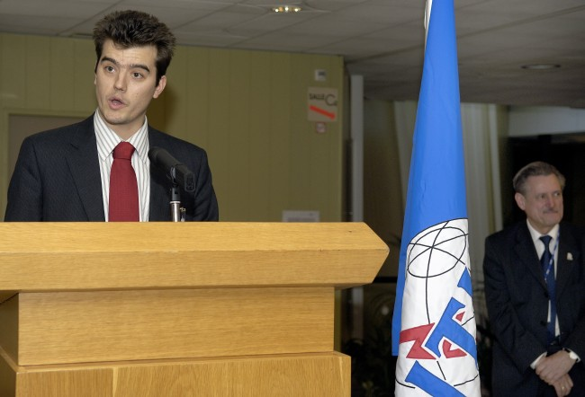
Photo source: ITU / J.M. Ferré (Compulsory)

Related photos:
http://www.itu.int/newsroom/wrc/2007/photos/detail.asp?y=2007&n=603
http://www.itu.int/newsroom/wrc/2007/photos/detail.asp?y=2007&n=604
http://www.itu.int/newsroom/wrc/2007/photos/detail.asp?y=2007&n=620

Thank you very much for inviting me this evening.

I am the 'new kid on the block' at the EBU, but I too am very excited by High Definition television.

It is the shape of television to come, and it is coming soon. In fact it has already arrived in many parts of the world.

The first HDTV broadcast service in Switzerland begins in December this year, joining over 30 HDTV channels now available from the satellites pointing at Europe.

You may know that for us in the EBU, HDTV history began in 1982, when we had the first demonstration of HDTV in Europe at our EBU General Assembly at Killarney in Ireland.

We celebrated this at our EBU General Assembly this year, and we gave a well-deserved award to NHK for everything they did for us all those years ago.

In September this year, at the IBC, I was delighted to make the HDTV inventor, Dr Fujio, a lifetime member of the EBU Technical Assembly, in recognition of his work.

That Killarney milestone event was organized by one of my predecessors, George Waters, who was the Directory General of the Irish national broadcaster RTE at the time. He hoped to be with you tonight, but could not do so, and send his warm regards.

George worked on the demonstrations with others of course, and one of the most important was Joe Flaherty, who is with us tonight.

After Killarney, many years were spent on the search for worldwide agreement on a High Definition format. It was very difficult period for the ITU from the mid 1980s to the mid 1990s. Essentially, both the '50Hz' frame rate world and the '60Hz' frame rate world wanted a single worldwide system, but only as long as it was their own frame rate.

Throughout this trying time, the ITU-R (or CCIR as it was then) was steered by the great Chairman, Prof. Mark Krivocheev. All my colleagues in the EBU have the greatest respect for Mark, and regard him as the example for how Chairmen should act and work.

My colleague David Wood worked with him during this time, and in the early 1990s, Mark entrusted David with the Chair of the Working Party, Working Party 11A, which was asked to take on the thorny issue of HDTV.

You may know that the breakthrough came in 1997 when David was able to lead his Working Group to agreement on a meaningful HDTV Recommendation at long last, called Recommendation 709-3.

This Recommendation had a number of features which meant, at last, there was a 'win-win' solution for everyone - it combined the 'common image format' combined with 'common data rate' and it included a format which used progressive scanning - though if you want to know more about these, I am not the one to ask.

David asked me to tell you that he had the greatest help from his old friend at NHK, Junji Kumada. He also apologized for not being able to be here with you himself, because of another engagement.

The EBU Technical Committee is happy and proud to have helped make Recommendation 709-3, and to have helped the progress of high definition television over the last 25 years. Recommendation 709-3 (and successors) is one of the most important achievements of the ITU, possibly it will be the most important.

We believe that, like '709', the basic idea of finding a 'win-win' formula is the only way to reach international agreement on technical standards like HDTV, and we hope that many more will lie ahead.

Once again, may I thank you on behalf of all the members of the EBU Technical Committee for inviting me tonight, on this the dawn of the golden age of high definition television.
---

