The 25th Anniversary of the Introduction of HDTV in Europe
ITU, 16 October 2007

Remarks by Mr Yukihiro NISHIDA, Senior Research Engineer, Human and Information Science, Science and Technical Research Laboratories, NHK (Japan Broadcasting Corporation)
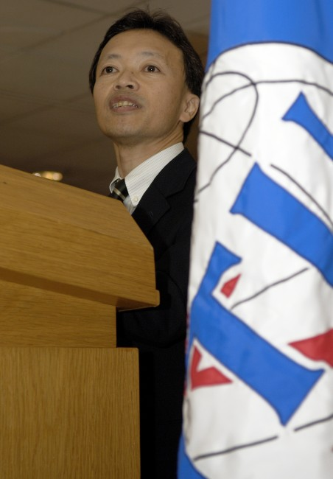
Photo source: ITU / J.M. Ferré (Compulsory)

Dr. Touré,
Mr. Timofeev,
Distinguished Delegates,
Ladies and Gentlemen,
It is a great pleasure to be here today to celebrate the 25th anniversary of HDTV in Europe, and to be given this opportunity to speak on behalf of NHK, the Japanese public broadcaster.

I am also delighted to see some familiar faces, such as Prof. Krivocheev and Dr. Flaherty, with whom we worked hard to establish the single worldwide HDTV standard, that is, Recommendation ITU-R BT.709. I would first like to look back on the history of HDTV. Back in 1964, forty-three years ago, just after the Olympic Games were held in Tokyo and color television was being introduced in Japan, we at the NHK Science & Technical Research Laboratories began conducting research into future television systems. This led to the concept of High Definition Television. It involved a new generation of electronic video media that would inspire viewers with its realistic images and sound. This idea of creating a maximum sense of reality for viewers was our goal.

High definition television does not just mean high-resolution television. The system parameters were completely based on human characteristics determined from the results of a number of psychophysical experiments. One of the experiments was to measure the relationship between visual angle and the induced sensation of reality. Our results indicated that we needed a visual angle of at least 30 degrees to obtain a strong sensation of reality. Another experiment was to determine the appropriate picture aspect ratio, and we found that a wide aspect ratio of somewhere between 5 by 3 and 6 by 3 was required to maximize the sensation of reality.

We aimed to establish a unified worldwide HDTV standard right from the start of our project. This is why in 1972 Japan proposed a new study program on High Definition Television to the CCIR. With the adoption of the new study program in 1974, the CCIR began the HDTV study.
We also intended to introduce HDTV technology across various industries other than broadcasting, such as electronic cinematography, medicine, education, and printing. As I am sure you are all aware, use of HDTV in these industries has now become normal practice.

During the 70s, fundamental technologies and equipment, from cameras to displays, were developed with the aim of creating end-to-end broadcasting systems.
In 1982, we produced our first HDTV program. This was made possible by the development of HDTV VTR.

At the beginning of the 80s, we demonstrated our HDTV equipment and pictures outside Japan. We went to North America in 1981, followed by the first demonstration in Europe in 1982, the 25th anniversary of which we are celebrating today. These demonstrations accelerated work on HDTV by the CCIR, as well as around the world.

In the mid 80s, NHK developed a fully operational HDTV transmission system, and we started experimental broadcasting via satellite to homes towards the end of the decade. This was followed by daily HDTV broadcasts, which started in the mid 90s. And now, as you know, digital HDTV broadcasting is being introduced around the world.

All of us have come a long way together, culminating in the standardization of HDTV. We reached the first version of Recommendation 709, as approved by the 17th Plenary Assembly of the CCIR, in 1990 in Düsseldorf. This recommendation created a first single worldwide television standard. This was a great achievement for the CCIR, and a lot of credit must be given to the Chairman of Study Group 11, Prof. Krivocheev, for his strong leadership.

The main characteristics of the Recommendation included a 16:9 aspect ratio, 1920 samples per active line, and unified colorimetry. And now, several improvements later, we have the current version. I would like to express my deepest gratitude to all who devoted their tireless efforts to achieving this.

The unified HDTV standard established by the ITU has accelerated the spread of HDTV around the world. HDTV broadcasting has already been introduced or is planned in many countries. People enjoy watching HDTV in their homes on large, wide-screen, high-resolution, flat panel displays, and there is no question that HDTV is becoming the norm in many countries. I think I can safely say that our dream is becoming reality.

I would like to conclude by sharing my conviction with you that broadcasting continues to play an important role in bridging and sharing cultures, bringing about mutual understanding, and in enriching the lives of us all. We must continue with our research and development into broadcasting technologies that will take us into a better future.

NHK is now working hard on next-generation television systems, such as ultra high definition television. I see a similarity now with the position we were in during the 70s when the ball was just beginning to roll with HDTV.

We, at NHK, wish to reaffirm our strong commitment to the ITU as it tackles the various problems associated with broadcasting, and we shall continue to work together with you all around the world toward a better life through broadcasting.

Thank you very much for your attention.
---

