The 25th Anniversary of the Introduction of HDTV in Europe
ITU, 16 October 2007

Plaque presented to Mr Valery Timofeev, Director, Radiocommunication Bureau, ITU

Presented by:
BBC, CBS, NHK, EBU, IAB, DTV, Rebe Globo and Sony
to the Radiocommunications Sector of the International Telecommunication Union, ITU-R, (formerly CCIR), on the occasion of the 25th Anniversary of the introduction of High-Definition Television in Europe, in grateful recognition of the work of ITU-R in securing the unique worldwide Recommendation ITU-R BT.709 for High Definition television production and international program exchange.
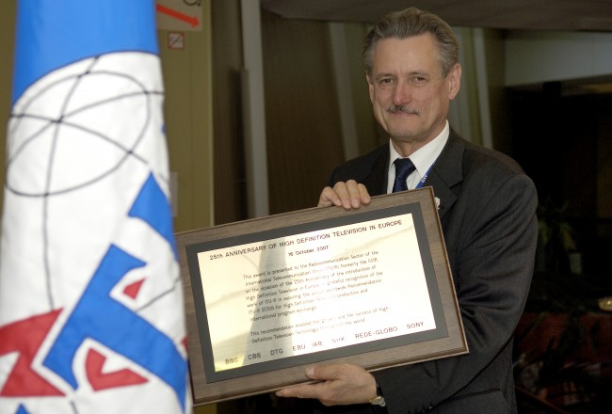
Photo source: ITU / J.M. Ferré (Compulsory)
BR Director Mr. Valery Timofeev shows honorary plaque for ITU during the 25th Anniversary of the introduction of HDTV in Europe (ITU, Geneva, Switzerland).
Remarks by Mr Joseph A. Flaherty, Senior Vice President, Technology,
CBS Broadcasting Inc.
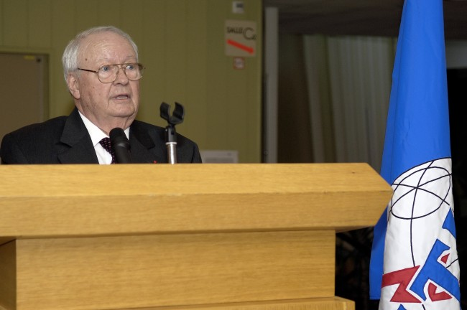
Photo source: ITU / J.M. Ferré (Compulsory)

Vision is the art of seeing that which is yet to be, and the ITU-R had such a vision through NHK’s HDTV development. The ITU-R then turned its vision into a reality, doing so in the traditional ITU-R manner through study, hard work, compromise, and final consensus.

Today, HDTV has escalated television technical quality to a plateau never before imagined, and HDTV is rapidly becoming a “must-have” technology in viewers’ homes as we move to an all-HDTV world.

Thus, as we mark this 25thAnniversary of the Introduction of High Definition television in Europe at the 1982 EBU General Assembly, it is wholly appropriate that we congratulate the ITU-R on its foresight and courage in setting the HDTV standard that is now replacing conventional television in a worldwide transition to HDTV.

The inexorable march of television technology continues to benefit the people of the World in further narrowing the “digital divide” with higher quality international programme exchange.

To mark this event, the organizers of this celebration would like to present this plaque to the ITU-R.

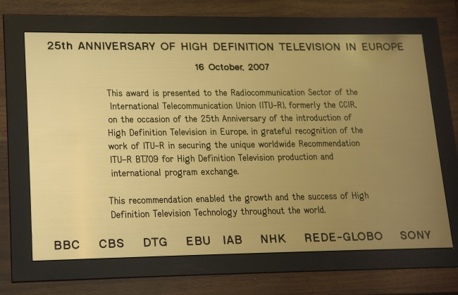
Photo source: ITU / J.M. Ferré (Compulsory)
http://www.itu.int/newsroom/wrc/2007/photos/detail.asp?y=2007&n=589

Dear Dr. Timofeev, would you be kind enough to accept this plaque on behalf of the ITU-R?

The Plaque reads:

“Presented to the Radiocommunication Sector of the International
Telecommunication Union, ITU-R, (formerly CCIR), on the occasion of the 25th
Anniversary of the introduction of High-Definition Television in Europe, in grateful
recognition of the work of ITU-R in securing the unique worldwide
Recommendation ITU-R BT.709 for High Definition television production and
international program exchange.”

“This recommendation enabled the growth and the success of High Definition Television technology throughout the World.”
---

