Nortel and the ITU Radio Regulations

Scott Wickware
Vice-President, Marketing and Strategy
Mobility and Converged Core Networks
Nortel

Since its 1895 founding as Northern Electric and Manufacturing, supplying telecommunications equipment for Canada's fledgling telephone system, Nortel has grown to become a global leader in delivering communications capabilities that enhance the human experience, power global commerce, and secure and protect the world's most critical information. Paradoxically, what started on wires has eventually become a wireless world, and Nortel has been a part of that transition all along, producing military radios, consumer radios, long-haul high-capacity microwave radios and more recently the all pervasive mobile broadband.

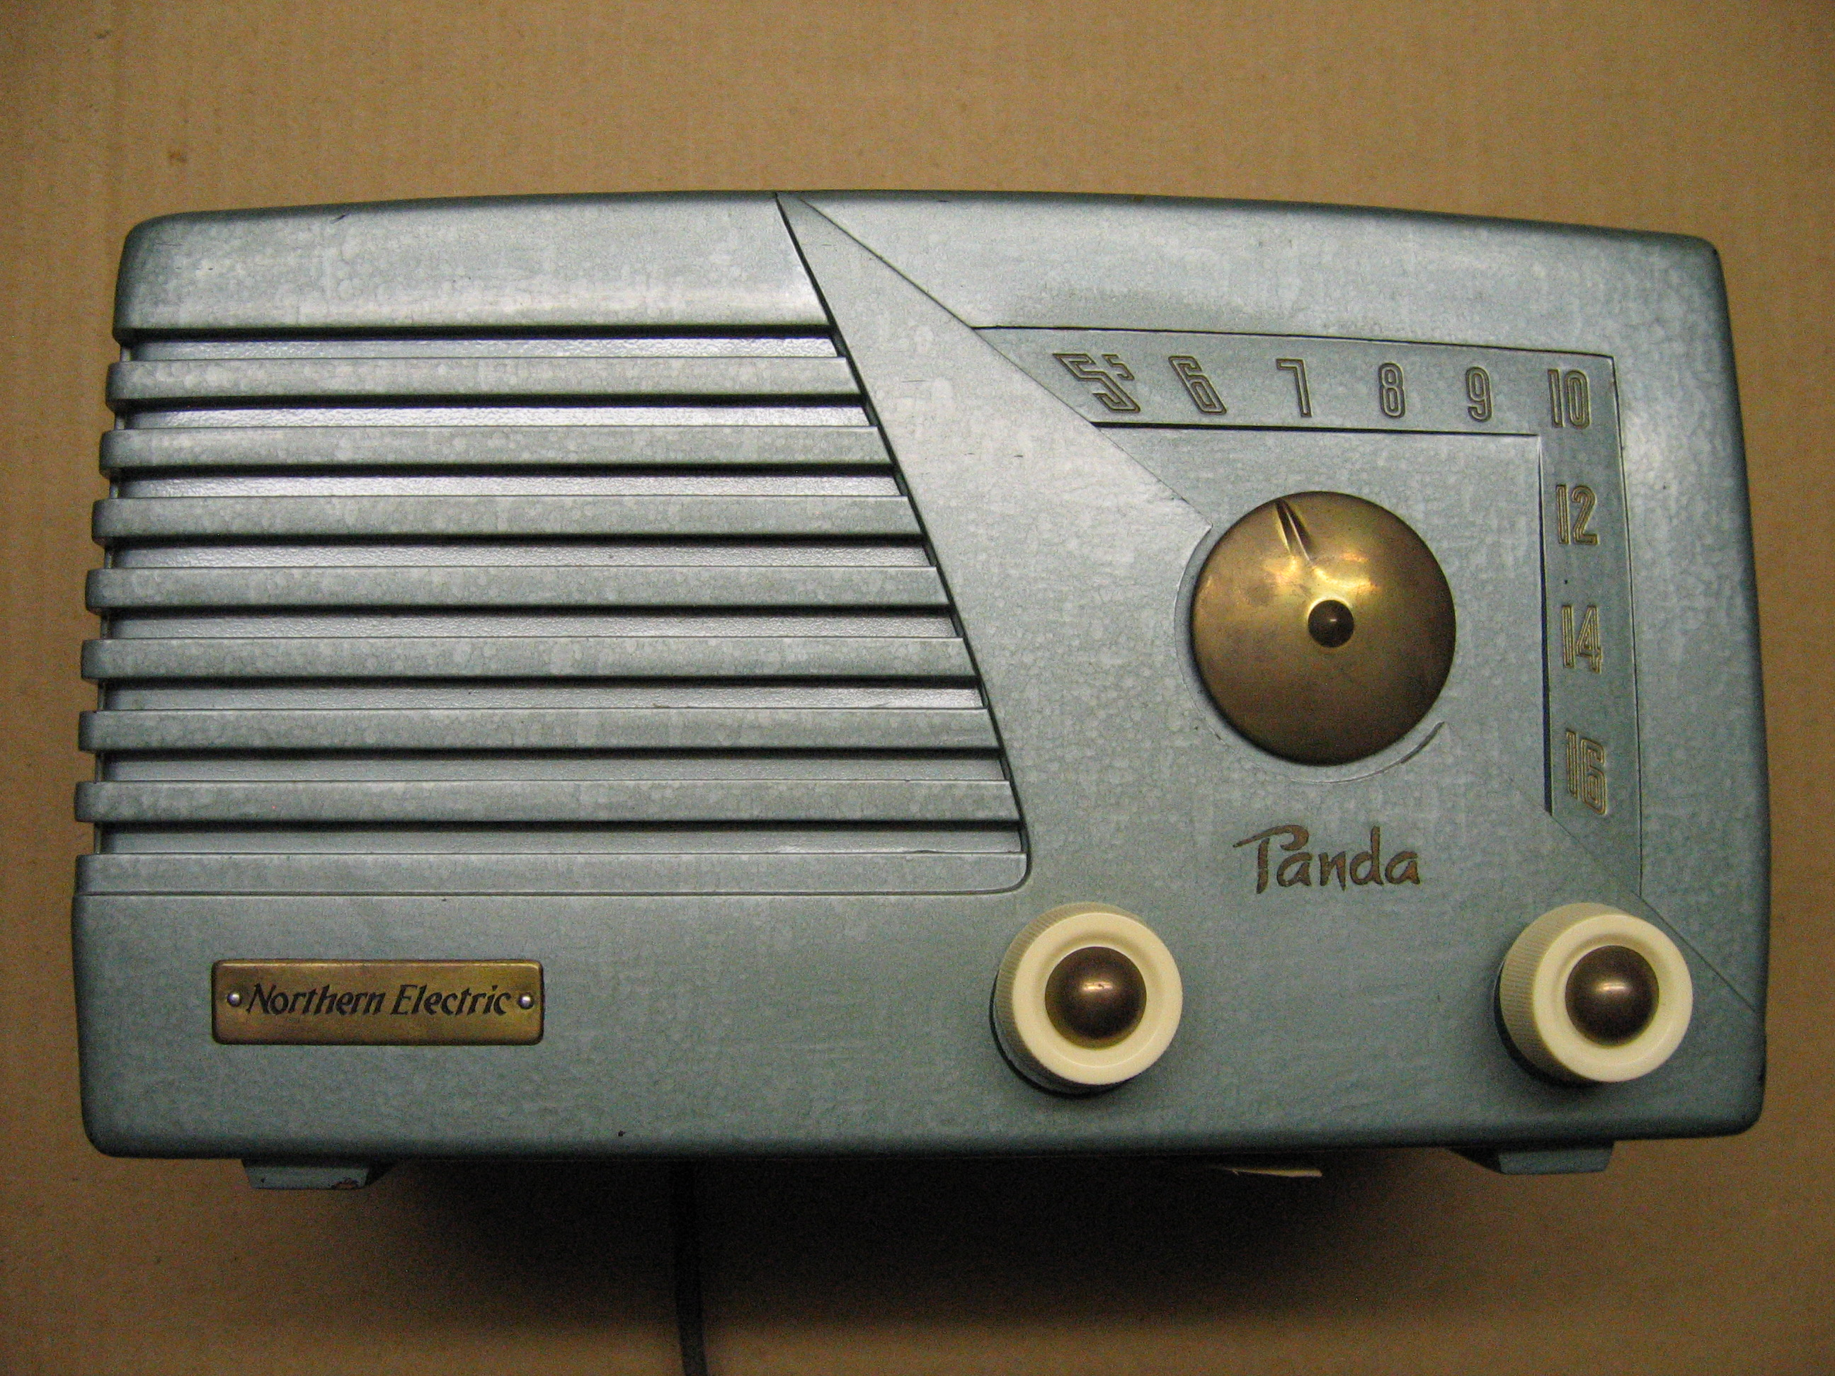

The Radio Regulations have been at every step of that evolution, either directly for international agreements or as a model for establishing national regulations (see for example the label on a typical consumer radio produced by Nortel in the 1930s (Photo Exhibit 1).

Eventually, Nortel became a Sector Member of ITU-R (then CCIR) in 1971 because of the potential impact of the Radio Regulations on its product designs as well as on its customers operations. Since then, Nortel has been very active through Administrations and Regional Organizations in the development of the Radio Regulations at each World Radiocommunication Conference. In addition to the original intent of the Radio Regulations of avoiding radio interference and increasing interconnectivity among stations, the Radio Regulations have served to develop the wireless telecommunications infrastructure by enabling global spectrum allocations, which, together with recommended interoperability standards in ITU-R, have led to economies of scale and the orderly growth of wireless telecommunication services.

Perhaps the most visible case is that of International Mobile Telecommunications (IMT), which though identification of specific global bands in the Radio Regulations within spectrum allocated to the mobile service, have promoted the rapid growth of the wireless infrastructure to serve 2.5 billion mobile phone users worldwide in 2006 or about 40% of world population. By any measure, mobile technology has fundamentally changed the way people interact and conduct business. Ongoing work will enable further economies of scale and more advanced capabilities, including mobile broadband, for the benefit of both developing and developed economies alike.

But we are now at the crossroads in terms of the development of the Radio Regulations. Indeed, up to now their development has been generally smooth and conservative, partly because they have an inherent flexibility in supporting new applications and services, but ongoing tremendous advances in radio technologies will serve to meet the increasing demands for spectrum in new and much more spectrally-efficient ways, that may need a revamping of regulatory approaches. These could include, for example, more use of computerized information in the Radio Regulations to facilitate their use, greater flexibility in the use of unused spectrum through the application of cognitive radio techniques, downloadable regulations that could be imbedded into designs, and so on.

The next 100 years will be very exciting indeed; yes, the Radio Regulations will continue to exist because of the necessities and benefits described above, but the 2106 edition may very well be quite different from what we know today. They could become a self-executable code that would enable new global applications even in between World Radiocommunication Conferences.

Nortel expects to contribute to these exciting developments for the benefit of its customers and the industry in general.

Nortel. Marketing and Strategy, Mobility and Converged Core Networks
www.nortel.com

