 | Wireless Communications Association International  1333 H St., NW Suite 700-W  Washington, D.C. 20005  ph. +1 202-452-7823 fx. +1 202-452-0041  Website: www.wcai.com

March 2, 2007

Dear Colin,
The Wireless Communications Association International (WCA) has been following with great interest the activities of the ITU-R Working Party 8F related to IMT-2000 and systems beyond IMT-2000. In particular, it has been brought to our attention that at the last ITU-R Working Party 8F (ITU-R WP-8F) meeting held in Yaoundé (Cameroon), IEEE 802.16 submitted the OFDMA air interface, named IP-OFDMA, for inclusion as the sixth IMT-2000 terrestrial radio interface in Recommendation ITU-R M.1457. The WiMAX Forum also contributed supporting information that is considered part of the proposal.
We understand that ITU-R WP-8F is now reviewing the proposal and defined a process on how to do so, covered in the 8/LCCE/153 circular letter (http://www.itu.int/md/R00-SG08-CIR-0153/en).
The ITU-R membership and relevant other organizations under the auspices of Resolution ITU-R 9-2 are encouraged to participate in the activities related to the candidacy of this technology for
inclusion in Recommendation ITU-R M.1457. This participation could take the form of reports evaluating IP-OFDMA in reference to the IMT-2000 requirements.
WCA hereby informs the ITU-R that it has decided to start a WCA Evaluation Group (WCA EG) under its engineering committee (WCAec). A link will be provided on the WCA web site and announced later where WCA will post the results of the evaluations and share information with all interested parties including other evaluation groups. WCA EG also welcomes cooperation and exchange of information with other evaluation groups.
Below is some background information on WCA, its membership, and its activities.
Regards,
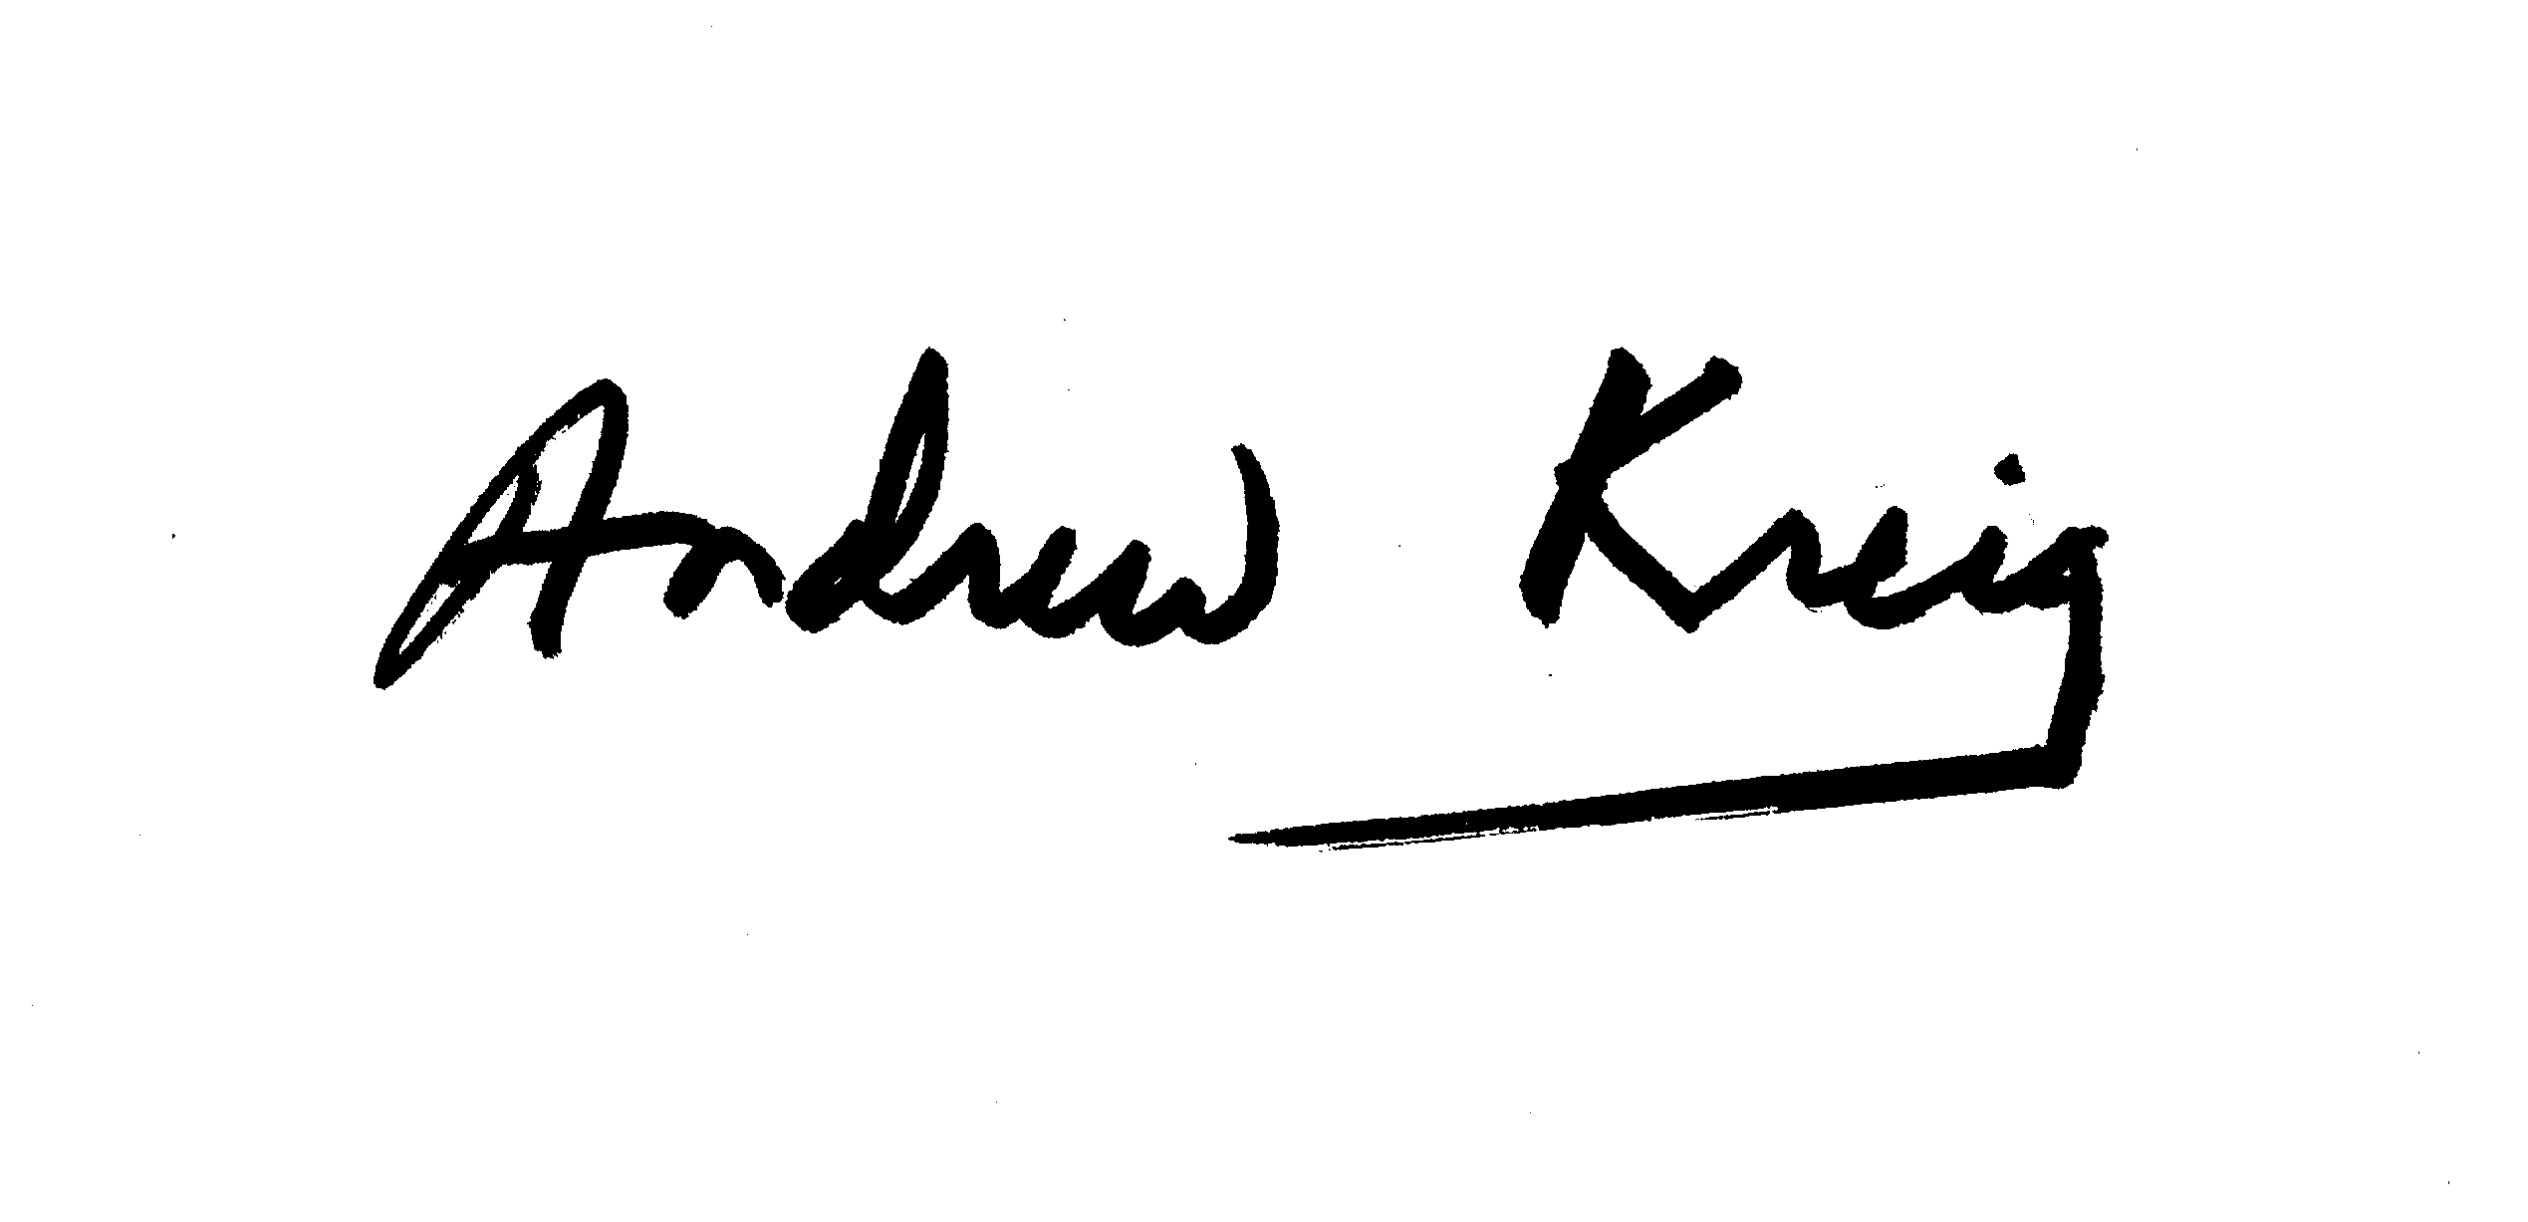
Andrew Kreig
WCA President

Background
Founded in 1988, the Wireless Communications Association International (WCA) www.wcai.com is the non-profit trade and professional association for the Wireless Broadband industry. Its member companies on six continents represent the bulk of the sector's leading carriers, vendors and consultants. WCA volunteer leaders from industry carry great stature as major carriers and suppliers: http://www.wcai.com/board_directors.htm. The WCA's mission is to advance the interests of the wireless carriers that provide high-speed data, Internet, voice and video services on broadband spectrum through land-based systems using reception/transmit devices in all broadband spectrum bands.

Contacts:
Andrew Kreig, President
Wireless Communications Association International
1333 H St, NW, Suite 700 West
Washington, DC 20005
tel: +1 202-452-7823
Email: president@wcai.com
website: www.wcai.com

Paul Sinderbrand, Counsel
Wilkinson Barker Knauer, LLP
2300 N Street, NW
Suite 700
Washington, DC 20037-1128
psinderbrand@wbklaw.com
202.783.4141 (phone)
202.783.5851 (fax)
www.wbklaw.com

Harry W. Perlow, Chairman
WCA engineering committee
Distinguished Member of the Technical Staff
Sprint Broadband Wireless Technology Development Group (BWTD)
Tel: +1 727-642-7000
Email: harry.w.perlow@sprint.com

Reza Arefi, Chairman
WCA Evaluation Group for IP-OFDMA
Wireless Technology Standards & Spectrum Policy Manager
Intel Corporation
Tel: +1 503 830 5485
Email: reza.arefi@intel.com

