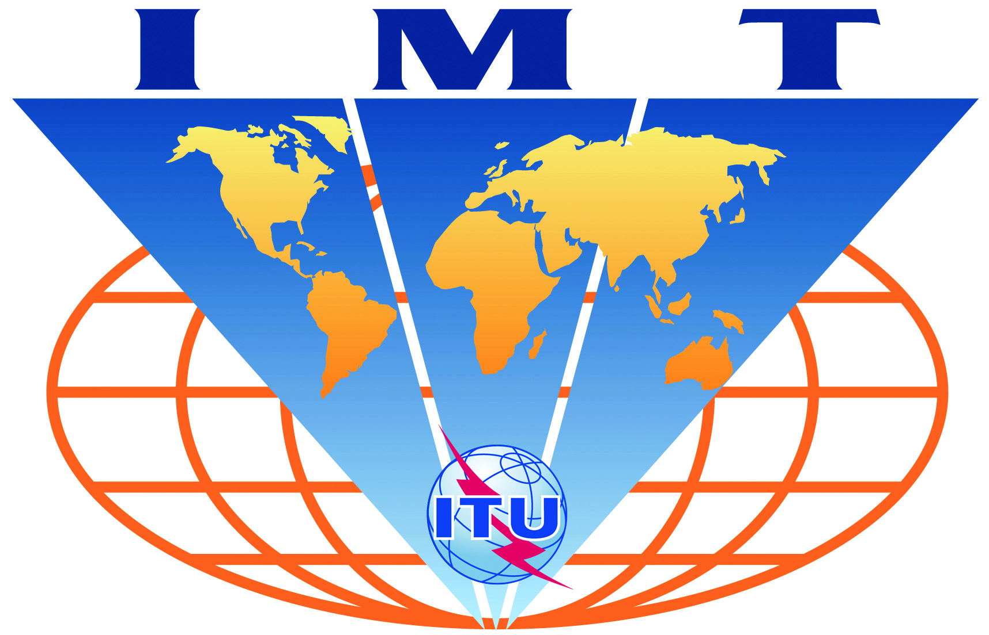

IMT-Advanced
Evaluation Group Registration Form

Name of the Evaluation Group:
Russian Evaluation Group (REG)

Organizations participating in the Group's evaluation activities:
N.I. Lobachevsky State University of Nizhny Novgorod, Russia

Contact person(s):
- name: Alexander Maltsev
- telephone: +7-831-462-3-277
- email: maltsev@rf.unn.ru
- related web site (if available): www.unn.ru

- name: Roman Maslennikov
- telephone: +7-831-462-3-277
- email: roman.maslennikov@wcc.unn.ru
- related web site (if available): www.unn.ru

- name: Alexey Khoryaev
- telephone: +7-831-462-3-277
- email: alexey.khoryaev@wcc.unn.ru
- related web site (if available): www.unn.ru

