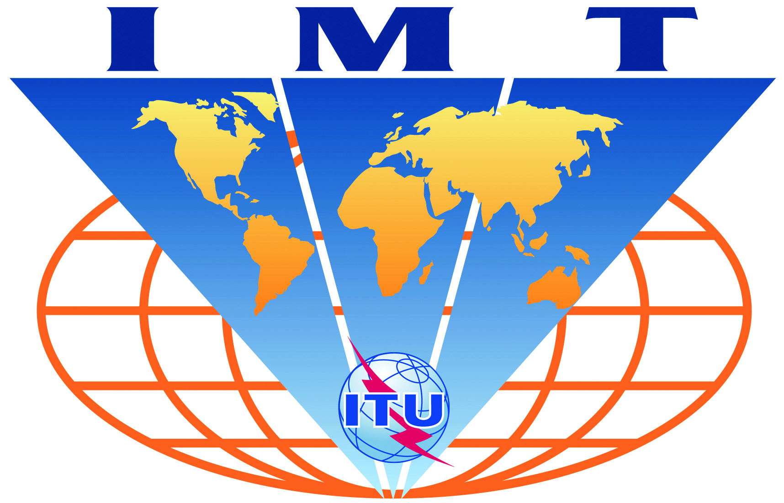

IMT-Advanced
Evaluation Group Registration Form

Name of the Evaluation Group:

Wireless Communications Association International (WCAI) Evaluation Group

Organizations participating in the Group's evaluation activities:
Members of WCAI

Contact person(s):
- name: Harry Perlow
- telephone: +1 727 642 7000
- email: harry.perlow@clearwire.com
- related web site (if available): http://www.wcai.com

- name: Reza Arefi
- telephone: +1 503 830 5485
- email: reza.arefi@intel.com
- related web site (if available): http://www.wcai.com

