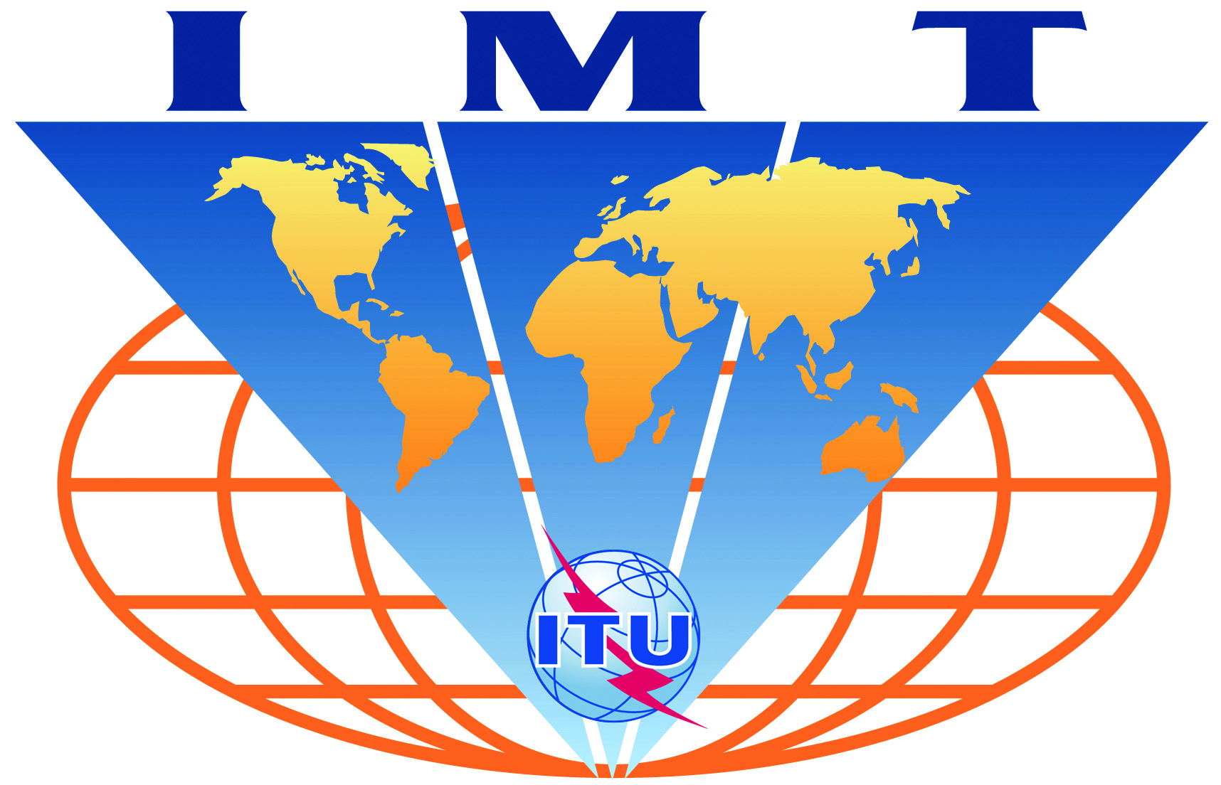

IMT-Advanced
Evaluation Group Registration Form

Name of the Evaluation Group:

Israeli Evaluation Group (IEG)

Organizations participating in the Group's evaluation activities:

The IEG, operating under the coordination of the Israeli Minister for Communications, is open to all Israeli industry. The membership at the moment of registration includes Alvarion, Runcom, Hexagon, Schema.

Contact person(s):
- name: Dr. Haim Mazar
- telephone: +972 3 5198222
- email: mazar@ties.itu.int and mazarh@moc.gov.il

- name: Mariana Goldhamer
- telephone: +972 544 225548
- email: mariana.goldhamer@alvarion.com

- name: Eli Sofer
- telephone: +972 544 997996
- email: elisofer@runcom.com

