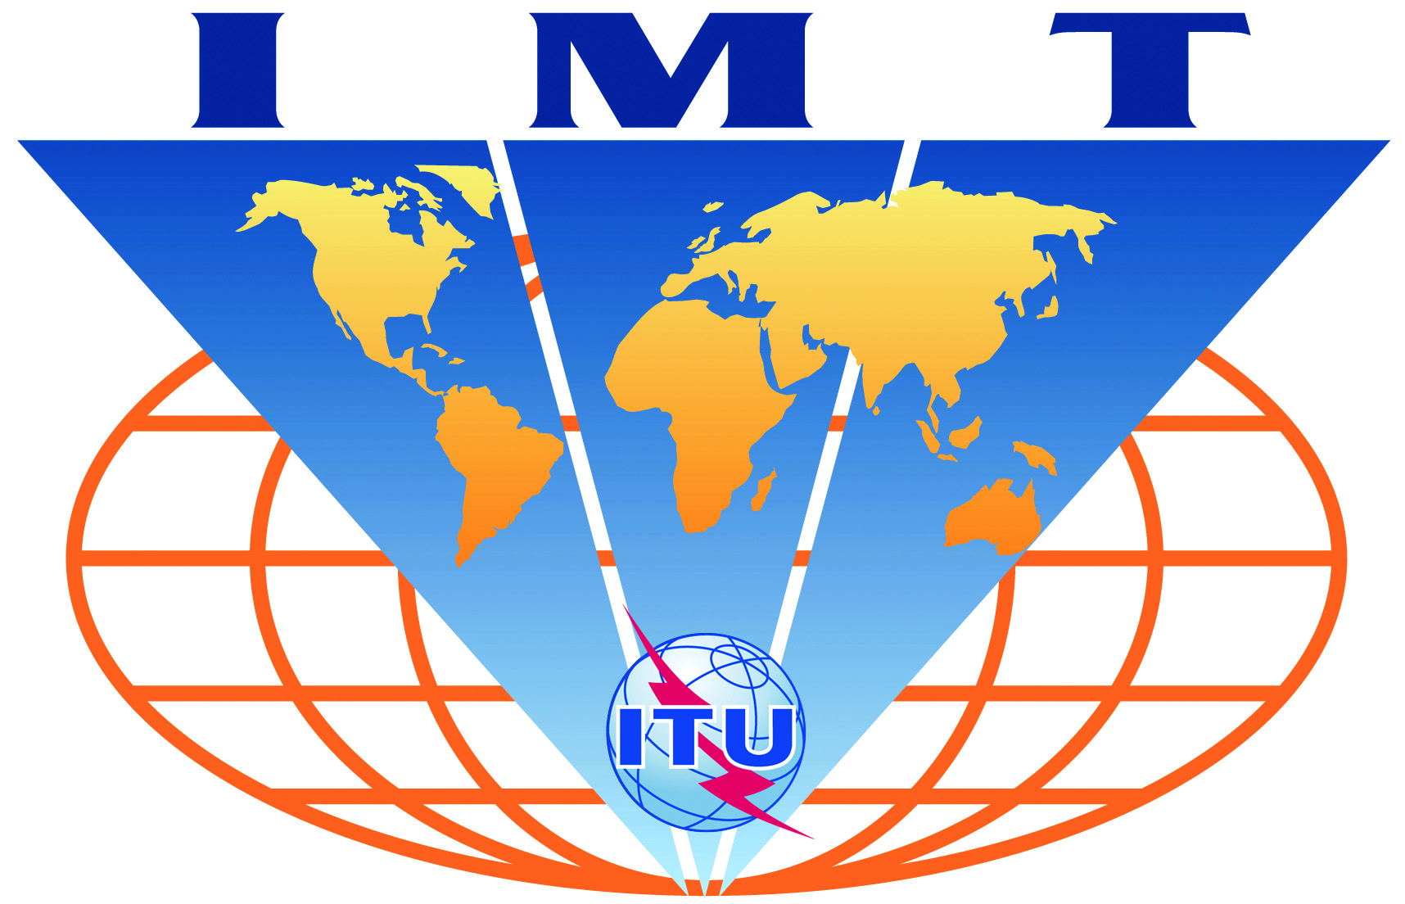

IMT-Advanced
Evaluation Group Registration Form

Name of the Evaluation Group:

ARIB Evaluation Group

Organizations participating in the Group's evaluation activities:

Members of ARIB RITSG (Radio Interface Technology Study Group)

Contact person 1:
- name: Motoi SHIRAISHI (ARIB)
- telephone: +81-3-5510-8594
- email: m-shirai@arib.or.jp
- related web site (if available): http://www.arib.or.jp/english/index.html

Contact person 2:
- name: Yuichi KIHATA (ARIB)
- telephone: +81-3-5510-8594
- email: kihata@arib.or.jp
- related web site (if available): http://www.arib.or.jp/english/index.html

