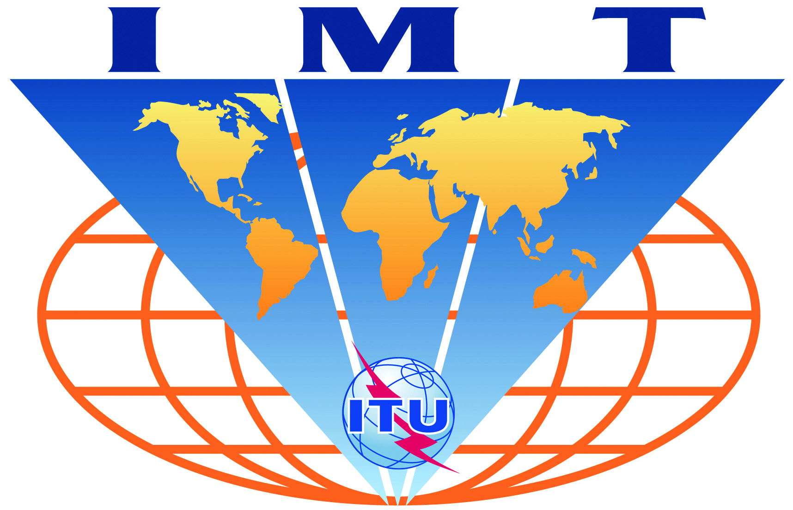

IMT-Advanced-Satellite
Evaluation Group Registration Form

Name of the Evaluation Group:

Chinese Evaluation Group (ChEG)

Organizations participating in the Group's evaluation activities:

- China Academy of Telecommunication Research of MIIT,
- China Telecom Corporation Limited,
- DaTang Telecommunication Technology & Industry Holding Co. Ltd.,
- China Satellite Communications Co., Ltd,
- 54th Research Institute, Electronic Technology Corporation, China,
- China Academy of Space Technology,
- Southeast University,
- Tsinghua University,
- Beijing University of Posts and Telecommunications,
- The State Radio Monitoring Center,
- etc...

Contact person(s):

- name: Siyang Liu
- telephone: +86 13811457607
- email: liusiyang@catr.cn
- related web site (if available):

