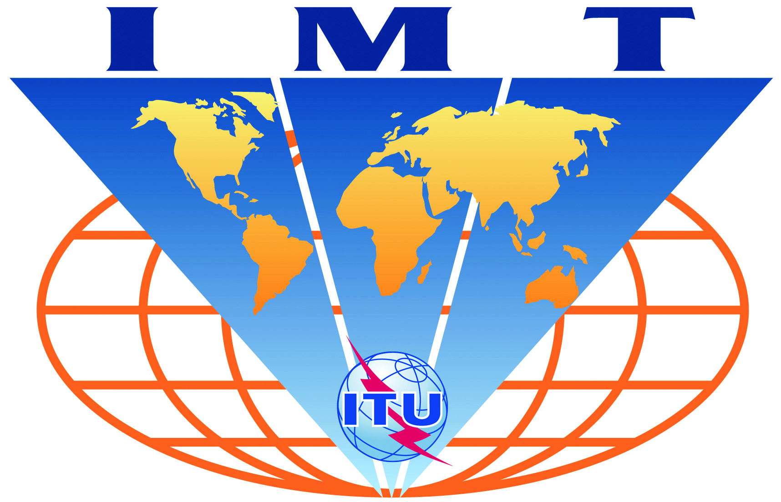

IMT-Advanced-Satellite
Evaluation Group Registration Form

Name of the Evaluation Group:

TTA PG707

Organizations participating in the Group's evaluation activities:

Members of TTA

Contact person(s):
- name: Hwang-Jae Rhee, Chairman of TTA PG707
- telephone: +82-02-710-6520
- email: rhee@kcc.go.kr

- name: HyoungJin CHOI, Secretary of TTA PG707
- telephone: +82-31-724-0091
- email: ibm686@tta.or.kr
- related web site (if available): http://www.tta.or.kr/English/new/standardization/Committee_newEngList_pop.jsp?commit_code=PG707

