Report ITU-R SM.2571-0
(06/2026)
SM Series: Spectrum management
Total radiated power by measurements of e.i.r.p. in the field including aspects of accuracy

Foreword
The role of the Radiocommunication Sector is to ensure the rational, equitable, efficient and economical use of the radio-frequency spectrum by all radiocommunication services, including satellite services, and carry out studies without limit of frequency range on the basis of which Recommendations are adopted.
The regulatory and policy functions of the Radiocommunication Sector are performed by World and Regional Radiocommunication Conferences and Radiocommunication Assemblies supported by Study Groups.

Policy on Intellectual Property Right (IPR)
ITU-R policy on IPR is described in the Common Patent Policy for ITU-T/ITU-R/ISO/IEC referenced in Resolution ITU-R 1. Forms to be used for the submission of patent statements and licensing declarations by patent holders are available from https://www.itu.int/ITU-R/go/patents/en where the Guidelines for Implementation of the Common Patent Policy for ITU-T/ITU-R/ISO/IEC and the ITU-R patent information database can also be found.

Series of ITU-R Reports
(Also available online at https://www.itu.int/publ/R-REP/en)
Series | Title
BO | Satellite delivery
BR | Recording for production, archival and play-out; film for television
BS | Broadcasting service (sound)
BT | Broadcasting service (television)
F | Fixed service
M | Mobile, radiodetermination, amateur and related satellite services
P | Radio-wave propagation
RA | Radio astronomy
RS | Remote sensing systems
S | Fixed-satellite service
SA | Space applications and meteorology
SF | Frequency sharing and coordination between fixed-satellite and fixed service systems
SM | Spectrum management
TF | Time signals and frequency standards emissions

Note: This ITU-R Report was approved in English by the Study Group under the procedure detailed in Resolution ITU-R 1.

Electronic Publication
Geneva, 2026
© ITU 2026
All rights reserved. No part of this publication may be reproduced, by any means whatsoever, without written permission of ITU.

REPORT ITU-R SM.2571-0
Total radiated power by measurements of e.i.r.p. in the field including aspects of accuracy
(2026)
TABLE OF CONTENTS
Page
1 Introduction 1
2 Terminology, definitions and abbreviations 2
3 Scope and limitations of measurements in the field 2
4 Method for the estimation of TRP 3
5 Examples of test method (for information only) 7
6 Related ITU-R Recommendations 7
7 Other references 7
Annex 1 – Example test method for 5G NR base station in-field OTA inspection in Korea (Republic of) 7
A1.1 Introduction 7
A1.2 On-site OTA inspection condition 7
A1.3 Preparations for on-site OTA inspection 8
A1.4 On-site OTA inspection procedure 8
A1.5 OTA performance inspection 16
Annex 2 – Example of extra propagation loss calculation based on the two-ray model 17

1 Introduction
This Report describes methods for the assessment/estimation of total radiated power (TRP) in the field for stations where the power delivered to the antenna of the system under test cannot be measured. TRP cannot always be accurately measured in the field based on the large number of uncertainties associated with path loss, antenna directivity, multi-path and other environment considerations. It is aimed to monitoring services when they have the task to assess the performance of Advanced Antenna System (AAS)-based systems in operation, for example in cases of interference.

2 Terminology, definitions and abbreviations
5G NR 5G New Radio
AAS Advanced antenna system
BS Base station
CQI Channel quality indicator
EESS Earth exploration-satellite service
e.i.r.p. Equivalent isotropically radiated power
FNBW First null beam width
FSPL Free space propagation loss
OCNS Orthogonal channel noise simulator
OTA Over the air
SSB Synchronization signal block
TAB Transceiver array boundary
TRP Total radiated power
NOTE – Total radiated power is understood as the integral of the power transmitted from all antenna elements in different directions over the entire radiation sphere.

3 Scope and limitations of measurements in the field
AAS-based systems do not provide a test point allowing conducted measurement; therefore, all measurements have to be performed over-the-air in the field. For some of these systems, the limits are defined in terms of TRP.
TRP cannot be measured directly, but it can only be calculated based on the over-the-air (OTA) field measurement results. The parameter measured directly is the power at the input of the measurement receiver. This process is already subject to influences from propagation and reflections. Additional uncertainties are introduced for those methods aiming to determine TRP because they include additional calculation processes that often depend on certain assumptions and may even be dependent on the availability of information from external sources (e.g. antenna characteristics, beam directions).
NOTE – TRP measurement result can vary over time, influenced by both environmental changes and dynamic behaviour of the equipment under test (EUT), such as beamforming adjustments and load variations.
For the above reasons, field measurements cannot be expected to provide the same accuracy and reproducibility as measurements in a controlled environment. The measurement methods for the in-band TRP measurement described in this Report are associated with uncertainties that have to be considered carefully before making conclusions about compliance or non-compliance with applicable limits. Often the more complex methods result in more accurate results whereas in some cases the accuracy of the simpler method may be sufficient. The desired accuracy of the result should be an important criterion when selecting a method for a specific measurement task. Based on these uncertainties, estimation of TRP in the field is left to the discretion of administrations. It is noted that harmonized approaches are generally observed to promote cross-border consistency and may help mitigate instances of regulatory fragmentation.
Unwanted emissions pose an even greater challenge when attempting to estimate TRP measurements due to the unpredictable nature of its emission patterns. For this reason, this Report will focus only on in-band emissions. When the viability of the proposed methods for estimating in-band TRP become better understood, unwanted emission measurements could be the next step in estimating the aggregate TRP.

4 Method for the estimation of TRP
Estimating TRP in the field may be associated with the following challenges:
– Generating a stable signal from the system under test so that directional (e.i.r.p.) measurements do not vary excessively during the measurement period.
– Estimating the beam directivity to translate the e.i.r.p. measurement to a TRP estimate.
The first challenge is explicitly an AAS issue whereas the second is similar for any OTA system measurement.
A stable signal can be generated either by:
– using an offline test mode (if available); or
– using known reference signals which are stable over the period of measurement.
A test mode with a known beam pattern can be used to estimate TRP. By enabling a test mode, however, normal system operation will be disrupted. Enabling dedicated test signals during normal operating thus consumes resources. If the test beam is a high gain full power beam which does not occur in normal operation, it may cause unintentional additional interference in the network.
To maintain normal operation, signals already available during normal operation can be used. However, these signals do not necessarily use high gain narrow beams and hence estimating the antenna directivity may be more complicated.
The field tester should select location(s) suitable for the test equipment (measurement antenna and signal analyser). Sometimes, airborne measurement may be needed. Figure 1 shows a diagram of e.i.r.p. calculation.
The radiation pattern in the near-field region is dependent on the distance to the antenna, while the radiation pattern in the far-field region is independent of the distance to the antenna.
The minimum measurement distance r is determined by the far field condition. The Fraunhofer far-field distance between the antenna system and the measurement antenna must fulfil:
$r≥\frac{{2d}^{2}}{λ}$
where d is the largest geometrical dimension which includes height, length or width of the transmitting antenna system and λ is the wavelength.
First, the parameter measured directly is the power at the input of the measurement receiver.
Second, calculate e.i.r.p. based on the measured power.
Figure 1
Diagram of e.i.r.p. calculation
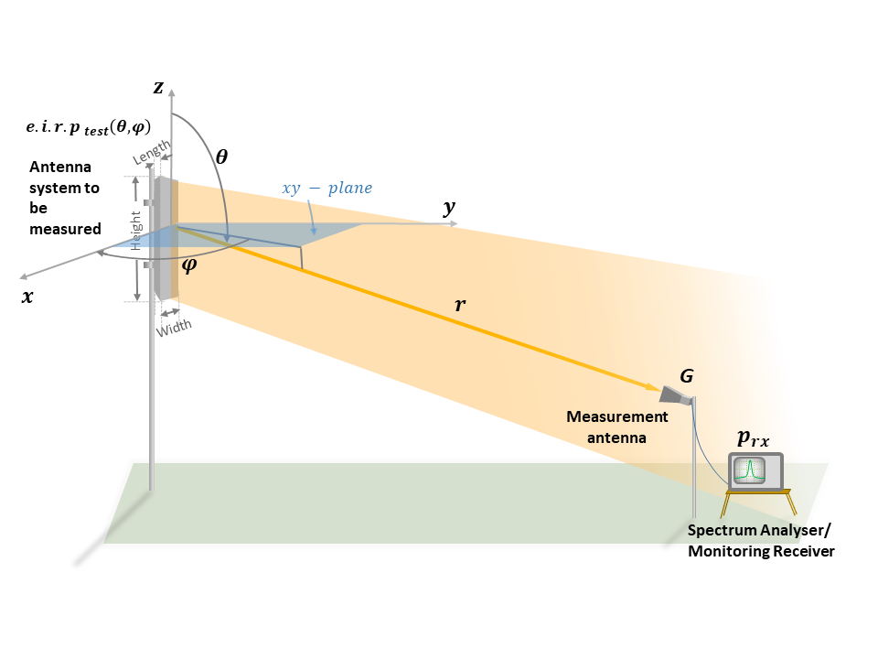
The e.i.r.p. of the test signal in the direction towards the measurement receiver antenna, denoted by ${e.i.r.p.}_{test}\left(θ, φ\right)$, can be calculated as:
${e.i.r.p.}_{test}\left(θ, φ\right)=\frac{P_{rx}L_{freespace}L_{extra}}{G_{r}}$ (1)
When the extra loss can be ignored, ${e.i.r.p.}_{test}\left(θ, φ\right)$ can be simplified as:
${e.i.r.p.}_{test}\left(θ, φ\right)=\frac{P_{rx}L_{freespace}}{G_{r}}=\frac{P_{rx}(4π{r)}^{2}}{G_{r}λ^{2}}$ (2)
where:
P_{rx}: power measured at the signal analyser input RF port
Gr: measurement receiver antenna gain towards the antenna system
$L_{freespace}$: propagation path loss between transmitter and receiver
$L_{extra}$: additional loss such as multipath propagation (see Annex 2), polarization mismatch, cable loss, and so on
r: distance between the antenna system and the measurement antenna
$λ$: wavelength
θ: elevation angle, see Fig. 1
ϕ: azimuth angle, see Fig. 1.
Third, calculate TRP.
Option 1: When the directivity of the antenna system to be measured can be acquired, the TRP can be calculated as:
${TRP}_{test}=\frac{{e.i.r.p.}_{test}\left(θ, φ\right)}{D\left(θ, φ\right)}$ (3)
where:
$D\left(θ, φ\right)$: directivity in the direction from the system to be measured to the measurement antenna.
This information may be provided by the manufacturer. In this case, it may be possible to calculate a TRP estimate from a measurement at a single location.
Option 2: In case system directivity cannot be acquired.
To achieve an accurate measurement for the TRP, the whole sphere around the transmit antenna would have to be measured.
${TRP}_{test}= \frac{1}{4π}\int_{θ=0}^{π}{\int_{φ=0}^{2π}{{e.i.r.p.}_{test}\left(θ, φ\right)}}\sin{θdθdφ}$ (4)
The e.i.r.p. samples shall be gathered using a constant density grid, i.e. with constant spatial density distribution of samples over the spherical surface.
When spherical equal angle grid over the spherical is used, equation (5) could be used to calculate the TRP_{test}:
${TRP}_{test}= \frac{π}{2NM}\sum_{m=0}^{M-1}{\sum_{n=0}^{N-1}{{e.i.r.p.}_{test}\left(θ_{n},φ_{m}\right)}}\sin{θ_{n}}$ (5)
where:
N: number of samples in the $θ$ angle
M: number of samples in the $φ$ angle,
N and M > 1 and adequate to obtain the required accuracy of the result.
If constraints of the measurement setup only support non-constant density grids (e.g. constant angular step size grids), appropriate weighting of the measurement samples shall apply (e.g. Clenshaw-Curtis weighting). Each $(θ_{n,} φ_{m})$ is a measurement sampling point and there are options of the sampling angular intervals for $θ$ and $φ$ in Annex F of 3GPP TS 37.145-2 [1].
Usually, for AAS-based stations, most of the power is transmitted from the front side of the antenna panel. If, e.g., the antenna gain of the AAS exceeds 20 dBi (like 8TRx or higher), the amount of power radiated in other directions than the main lobe is less than 1%. Entering this number to the measurement uncertainty budget calculation will probably have negligible effect on the overall uncertainty number which will be dominated by other factors (e.g. reflection, equipment, mismatch). If measurement uncertainty is not considered to be affected, measurement samples from only the front hemisphere of the antenna panel ($θ∈\left[0,π\right]$, $φ∈\left[{-π}/2,π/2\right]$) may be used. This will also result in a more reasonable test time. In this case, equation (6) should be used.
${TRP}_{test}= \frac{π}{4NM}\sum_{m=0}^{M-1}{\sum_{n=0}^{N-1}{{e.i.r.p.}_{test}\left(θ_{n},φ_{m}\right)}}\sin{θ_{n}}$ (6)
There are other methods with spherical equal area grid such as wave vector space grid in Annex F of 3GPP TS 37.145-2 [1], which can also be used to calculate TRP_{test}.
In this option 2, a number of sampling points at different locations need to be measured. Drones may be used where circumstances are favourable, and safety and regulatory constraints should be considered.
Finally, some adjustments may be needed to get the final results.
If the measurement bandwidth is less than the bandwidth of the emission, the total signal level can be calculated with:
$TRP_{carrier}=10\log_{10}{(TRP_{test})}+10\log_{10}\left(\frac{carrierBW}{testBW}\right)$ (7)
where:
TRP_{carrier} : total level of the signal [dBW]
TRP_{test} : level in measurement bandwidth
testBW : measurement bandwidth
carrierBW : complete carrier signal bandwidth.
If the power level of the signal from the system under test is different from the power level of the complete carrier signal, the carrier TRP is calculated as:
${TRP}_{carrier}={TRP}_{test}+C$ dBW (8)
where:
C : a scaling factor to account for the power of the test signal to the power of the complete carrier signal (dB).
The location and orientation for the antenna system to be measured and the measurement receiver antenna is required to determine r, θ_{n}, ϕ_{m}.
The antenna system parameters can be provided to the field tester, making it possible to calculate TRP as outlined above. More information than the directivity is required to be able to calculate TRP from a single e.i.r.p. measurement in the field.
The characteristics for an AAS-based system are created as a super positioning of signals, both wanted and unwanted, from many antenna elements. The radiating characteristics for a specific frequency vary as a function of the signal correlation applied to the antenna array and the frequency characteristics related to the radiating elements. For wanted emissions, the antenna directivity may be provided by manufacturer or system operator. In this case, equation (3) can be used to calculate TRP based on e.i.r.p. determined from a single location.
There are two options that can be used to obtain a full loaded carrier and traffic beam directed to the measurement antenna during field measurements:
1) Proprietary test configuration: The operator can enable vendor proprietary test signal schemes to generate random data to be transmitted on un-used resources to mimic a fully loaded carrier. This is a test signal that is controlled by the system operator. Coordination between the tester and operator can be established to allow for a specific test scheme. For example, the 5G NR physical signal (CSI-RS, etc.) can be used and scheduled to support the test. However, this method is only possible when the mode is available in the AAS-based system.
2) Provoking traffic during normal operation: Traffic in a specific direction can be prompted by a test user or a few test users. This kind of test is best run in a situation with no or low system traffic. The test user downloads a large amount of data to force the system to schedule all resources for the test user. For example, for 5G NR, if the test UE is capable of receiving at the full base station carrier bandwidth and it is equipped with operator specific SIM, a fully loaded carrier can be obtained. Additionally, if the UE signal is attenuated, the UE will report channel quality indicator (CQI) for QPSK which removes any uncertainty related to power back off for higher order modulations.

5 Examples of test method (for information only)
Examples of test methods are introduced in detail in Annex 1.

6 Related ITU-R Recommendations
Recommendation ITU-R P.525 – Calculation of free-space attenuation
Recommendation ITU-R P.526 – Propagation by diffraction
Recommendation ITU-R P.528 – A propagation prediction method for aeronautical mobile and radionavigation services using the VHF, UHF and SHF bands
Recommendation ITU-R P.1407 – Multipath propagation and parameterization of its characteristics
Recommendation ITU-R P.2040 – Effects of building materials and structures on radiowave propagation in the range of 1 MHz to 450 GHz
Recommendation ITU-R P.2109 – Prediction of building entry loss

7 Other references
[1] Specification 3GPP TS 37.145-2 – Active Antenna System (AAS) Base Station (BS) conformance testing; Part 2: radiated conformance testing
[2] ECC Report 345 – In-band measurement methodologies for 5G AAS base stations in the field

Annex 1
Example test method for 5G NR base station in-field OTA inspection in Korea (Republic of)

A1.1 Introduction
Korea (Republic of) started to prepare the inspection method of 5G base stations (BS) on-site for the commercialization of 5G in 2017. It was obligatory for FR1 BS manufacturers to install for inspection a Transceiver Array Boundary connector (TAB Korea (Republic of) Test port), and a new TAB inspection method was applied to FR1 5G NR BS since 2019 when 5G was commercialized. As 3GPP shows chamber standard only as OTA test method; the field OTA inspection method was made for FR1 and FR2 BS as of 2019, and the satisfaction of performance standard has been confirmed with the application of TRP of 5G BS since the second half of 2020. FR1 BS that may be conducted in the field are inspected using TAB, and FR1 BS that may not be conducted in the field are OTA-inspected.

A1.2 On-site OTA inspection condition
The inspection method is determined depending on whether the BS and spectrum analyser may be inspected in the field inspection environment. On-site OTA inspection is performed for the BS for which tests cannot be conducted.

A1.3 Preparations for on-site OTA inspection

A1.3.1 Specifications of AAS-based system
The basic specifications of all BS are provided in the radio wave control organization of Korea (Republic of). Matters needed for inspection are provided based on such specifications, which are declared by BS manufacturers.
TABLE A1-1
OTA inspection requirements
Division | Item
Data base | Frequency |  | Antenna number
Data base | Channel bandwidth |  | Antenna gain
Manufacture | e.i.r.p. |  | RF configuration
Manufacture | TRP |  | Antenna array size
Manufacture | Beam width | Horizontal | Subcarrier spacing
Manufacture | Beam width | Vertical | SSB OFFSET
Manufacture | SSB number |  | Polarization

A1.3.2 Specifications of inspection equipment
A spectrum analyser that satisfies the measurement items of 5G standard should be prepared, and the loss in measurement antennas (horn antenna) and cables that satisfy the test wave should be confirmed.

A1.3.3 Other inspection equipment
Tripod to support equipment, distance and angle finder, terminal (UE) to support test mode, and terminal (UE) for services.

A1.3.4 Support of telecommunication companies
Inspection is performed in maximum output condition of BS. The orthogonal channel noise simulator (OCNS) should be used on the condition that service may be maintained, and telecommunication companies should support OCNS setting. Properties of the beam emission patterns of BS should also be identified before inspection.

A1.4 On-site OTA inspection procedure
The directions, positions, and height of receiving antennas should be designated within the beam angle of the 5G BS array antenna. Satisfaction of performance standard may be identified when inputting the offset calculation result in the spectrum analyser and setting the BS in data emission state. As a caution, field OTA inspection should avoid factors that may influence the reflected radio waves in the surroundings.
fIGURE A1-1
Configuration of inspection
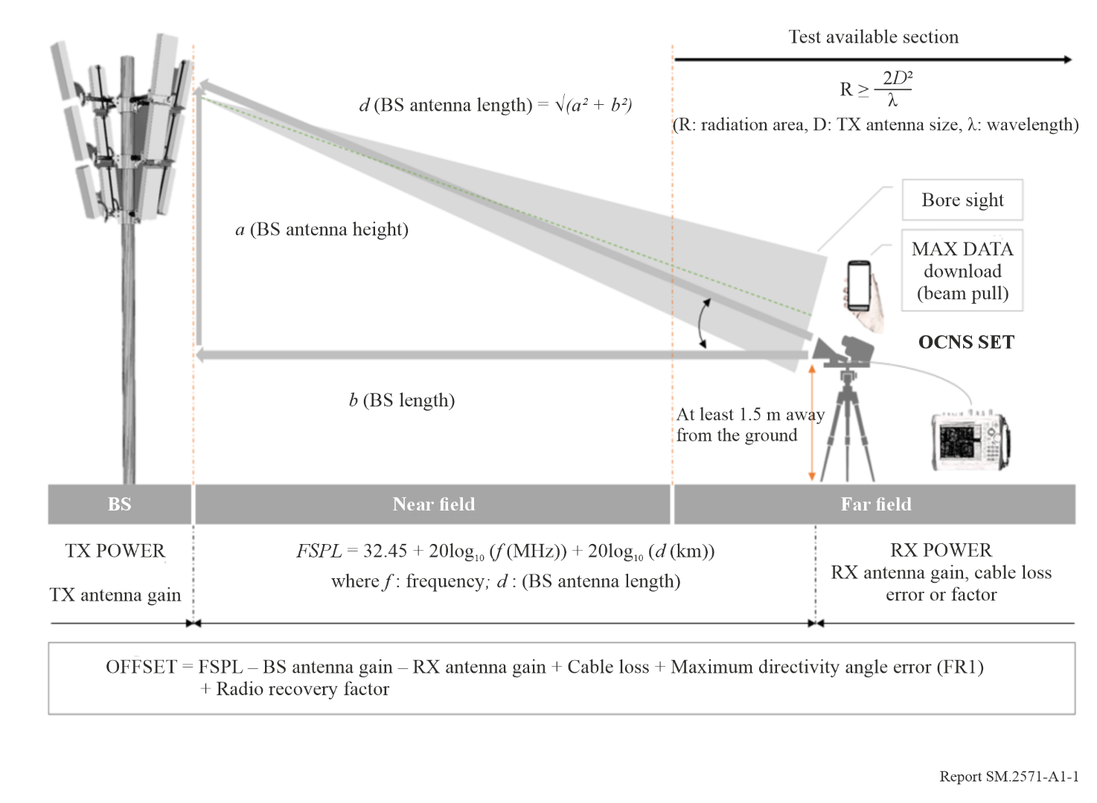

A1.4.1 Designation of inspection direction
The receiving antenna should direct within the maximum beam angle to receive maximum output emitted by the BS antenna; the receiving antenna and distance and angle finder should be combined using tripods.
fIGURE A1-2
Direction designation method
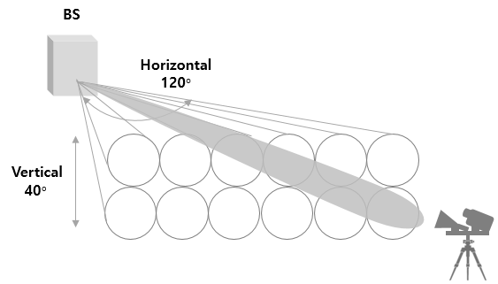

A1.4.2 Designation of inspection distance
The near field and far field emission areas should be calculated considering the size of BS antenna and wavelength of frequency, and the positions of spectrum analyser and receiving antenna should be designated in far field. The near field area should be excluded from the inspection zone because inspection errors may occur due to coupling effect.
fIGURE A1-3
Far field designation method
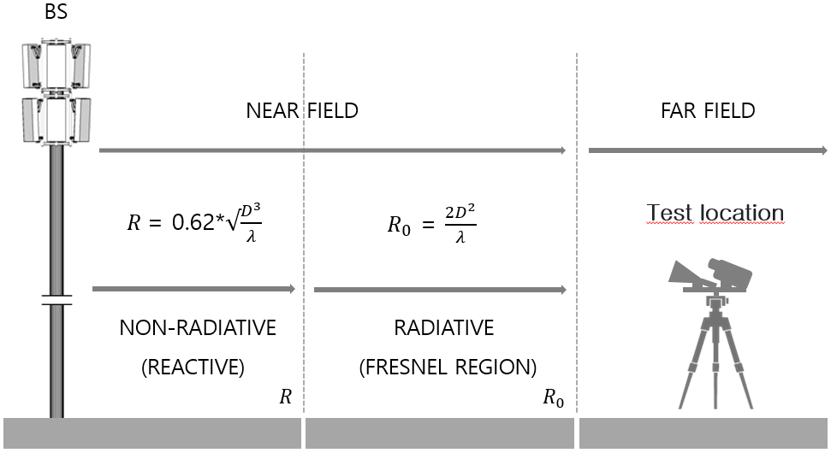
Test location

$$FR1 \frac{{2D}^{2}}{λ}≤R \left(Test location\right)≥150 m$$

$$FR2 \frac{{2D}^{2}}{λ}≤R \left(Test location\right)≥40 m$$
where:
R: far field emission area
D: BS antenna size
λ: wavelength.
When the inspection distance increases in the far field area, signal attenuation and uncertainty increase; therefore, the inspection position should be designated with the far field position adjacent to near field prepared, if possible. The maximum inspection distance in far field is set as 150 m for FR1 and 40 m for FR2 (maximum).
As it is difficult to adjust the bore sight of BS antenna and receiving antenna in the far distance field depending on the test environment, 150 m is designated for the FR1 BS based on repetitive researches on inspectable areas considering the BS height and BS antenna distance from the receiving antenna.
In case of FR2, 40 m is designated as the minimum position to get the dynamic range of spectrum analyser in order to measure the adjacent channel leakage ratio and out-of-band emission inspection items.
TABLE A1-2
(ex) FR1 BS measurable area
BS  distance | BS height
BS  distance | 5 m | 10 m | 15 m | 20 m | 25 m | 30 m | 35 m | 40 m
5 m | 85.° |  |  |  |  |  |  |  | Inspection impossibility area
10 m | 25.° | 85.° |  |  |  |  |  |  | Inspection impossibility area
15 m | 14.47° | 36.81° | 85.° |  |  |  |  |  | Inspection impossibility area
20 m | 9.48° | 25° | 43.59° | 85.° |  |  |  |  | Inspection impossibility area
25 m | 6.34° | 18.58° | 31.87° | 48.13° | 85.° |  |  |  | Inspection impossibility area
30 m | 4.39° | 14.47° | 25.° | 36.81° | 51.44° | 85.° |  |  | Inspection impossibility area
35 m | 3.21° | 11.6° | 20.38° | 29.85° | 40.58° | 54.° | 85.° |  | Inspection impossibility area
40 m | 2.18° | 9.48° | 17.02° | 25.° | 33.68° | 43.59° | 56.04° | 85.° | Inspection impossibility area
45 m | 1.38° | 7.84° | 14.47° | 21.33° | 28.75° | 36.81° | 46.06° | 57.73° | Inspection impossibility area
50 m | .74° | 6.34° | 12.46° | 18.58° | 25.° | 31.87° | 39.43° | 48.13° | Inspection impossibility area
55 m | .22° | 5.48° | 10.83° | 16.32° | 22.04° | 28.06° | 34.52° | 41.66° | Inspection impossibility area
60 m | −.22° | 4.59° | 9.48° | 14.47° | 19.62° | 25.° | 30.69° | 36.81° | Inspection impossibility area
65 m | −.59° | 3.85° | 8.34° | 12.92° | 17.62° | 22.49° | 27.58° | 32.98° | Inspection impossibility area
70 m | −.9$°$ | 3.21° | 7.37° | 11.6° | 15.92° | 20.38° | 25.° | 29.85° | Inspection impossibility area
75 m | −.1.18° | 2.66° | 6.54° | 10.47° | 14.47° | 18.58° | 22.82° | 27.23° | Inspection impossibility area
80 m | −1.42° | 2.18° | 5.81° | 9.48° | 13.21° | 17.02° | 20.94° | 25.° | Inspection impossibility area
85 m | −1.63° | 1.76° | 5.16° | 8.61° | 12.1° | 15.67° | 19.12° | 23.07° | Inspection impossibility area
90 m | −1.82° | 1.38° | 4.59° | 7.84° | 11.13° | 14.47° | 17.89° | 21.39° | Inspection impossibility area
95 m | −1.98° | 1.04° | 4.08° | 7.13° | 10.26° | 13.41° | 16.62° | 19.9° | Inspection impossibility area
100 m | −2.13° | .74° | 3.63° | 6.34° | 9.48° | 12.46° | 15.49° | 18.59° | Inspection impossibility area
105 m | −2.21° | .47° | 3.21° | 5.98° | 8.77° | 11.6° | 14.47° | 17.39° | Inspection impossibility area
110 m | −2.39° | .22° | 2.84° | 5.48° | 8.14° | 10.83° | 13.55° | 16.32° | Inspection impossibility area
115 m | −2.51° | −.01° | 2.49° | 5.02° | 7.56° | 10.12° | 12.72° | 15.35° | Inspection impossibility area
120 m | −2.61° | −.22° | 2.18° | 4.59° | 7.02° | 9.48° | 11.96° | 14.47° | Inspection possibility area
125 m | −2.71° | −.41° | 1.89° | 4.21° | 6.54° | 8.89° | 11.25° | 13.66° | Inspection possibility area
130 m | −2.8° | −.59° | 1.63° | 3.85° | 6.09° | 8.34° | 10.62° | 12.92° | Inspection possibility area
135 m | −2.88° | −.75° | 1.38° | 3.52° | 5.67° | 7.84° | 10.03° | 12.24° | Inspection possibility area
140 m | −2.95° | −.9° | 1.15° | 3.21° | 5.29° | 7.37° | 9.48° | 11.6° | Inspection possibility area
145 m | −3.02° | −1.05° | .94° | 2.93° | 4.93° | 6.94° | 8.97° | 11.01° | Inspection possibility area
150 m | −3.09° | −1.18° | .74° | 2.66° | 4.59° | 6.54° | 8.49° | 10.47° | Inspection possibility area
155 m | −3.15° | −1.3° | .55° | 2.41° | 4.28° | 6.16° | 8.05° | 9.96° | Inspection possibility area
160 m | −3.21° | −1.42° | .38° | 2.18° | 3.99° | 5.81° | 7.64° | 9.48° | Inspection impossibility area
165 m | −3.26° | −1.53° | .22° | 1.96° | 3.71° | 5.48° | 7.25° | 9.03° | Inspection impossibility area
170 m | −3.31° | −1.63° | .06° | 1.76° | 3.46° | 5.16° | 6.88° | 8.61° | Inspection impossibility area
175 m | −3.36° | −1.72° | −.08° | 1.55° | 3.21° | 4.87° | 6.54° | 8.21° | Inspection impossibility area
TABLE A1-2 (end)
BS  distance | BS height
BS  distance | 5 m | 10 m | 15 m | 20 m | 25 m | 30 m | 35 m | 40 m
180 m | −3.41° | −1.82° | −.22° | 1.38° | 2.98° | 4.59° | 6.21° | 7.84°
185 m | −3.45° | −1.9° | −.35° | 1.21° | 2.77° | 4.33° | 5.91° | 7.49°
190 m | −3.49° | −1.98° | −.47° | 1.04° | 2.56° | 4.08° | 5.62° | 7.15°
195 m | −3.53° | −2.06° | −.59° | .89° | 2.37° | 3.85° | 5.34° | 6.84°
200 m | −3.57° | −2.13° | −.7° | .74° | 2.18° | 3.63° | 5.08° | 6.54°

A1.4.3 Designation of receiving antenna inspection height
The receiving antenna should be connected with the spectrum analyser and RF cables apart from the ground by at least 1.5 m in order to avoid the influence of ground reflection waves.

A1.4.4 Calculation of spectrum analyser offset
The 5G performance standard was made by the method wherein the maximum e.i.r.p. inspection value is converted into TRP output and is applied to the performance standard based on the TRP output standard. As it is inconvenient to convert the TRP value and apply for each performance standard, the offset is calculated so that the inspection value to which offset is applied becomes the TRP to which the performance standard is applicable. Offset value is the offset value of the spectrum analyser. The equation below is applied to the offset value.
FR1
OFFSET = Free space propagation loss (FSPL) − BS antenna gain − RX antenna gain + cable loss + maximum directivity angle error + radio recovery factor
FR2
OFFSET = FSPL − BS antenna gain − RX antenna gain + cable loss + radio recovery factor
In the case of FR2, it is difficult to set the position of maximum directing angle in the service beam because the bore sight is narrow. Therefore, the maximum directing angle error is not compensated.
Offset value is calculated using the automatic calculation program application for prevention of errors and convenience of calculation.

A1.4.4.1 Total radiated power
It means that the total electric power to be emitted by the AAS-based system in the air is equivalent to the loss properties of elements constituting the antenna; it is defined as the value to be obtained by deducting antenna gain from the e.i.r.p. value.
fIGURE A1-4
TRP conversion equation
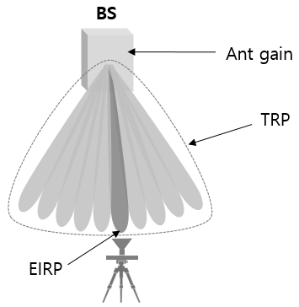 | TRP ≒ e.i.r.p. − (antenna gain + number of beams)

A1.4.4.2 Free space propagation loss
The loss value of electronic waves to be generated when wave energy is dispersed from the receiving antenna in 3D space should be calculated.
$FSPL={\left(\frac{4πd}{λ}\right)}^{2}={\left(\frac{4πdf}{c}\right)}^{2}$
$FSPL \left(dB\right)=10\log_{10}\left[{\left(\frac{4πdf}{c}\right)}^{2}\right]$
$=20\log_{10}\left(\frac{4πdf}{c}\right)$
$=20\log_{10}\left(d\right)+20\log_{10}\left(f\right)+20\log_{10}\left(\frac{4π}{c}\right)$
$=20\log_{10}\left(d\right)+20\log_{10}\left(f\right)-147.5582278$

A1.4.4.3 Maximum directivity angle error
In case of the same service directing angle, there are eight FR1 SSB and 64 FR2 SSB; as the beam of FR1 is wider than the beam of FR2, the inspection position may deviate from the maximum directing angle of e.i.r.p. It was defined so that the maximum compensation value may be derived up to the First Null Beam Width (FNBW) with application of the log value depending on the measurement angle in the beam emission pattern generated from 0°. The compensation value is designated as the result to be obtained through repetitive researches.
fIGURE A1-5
Angle compensation method
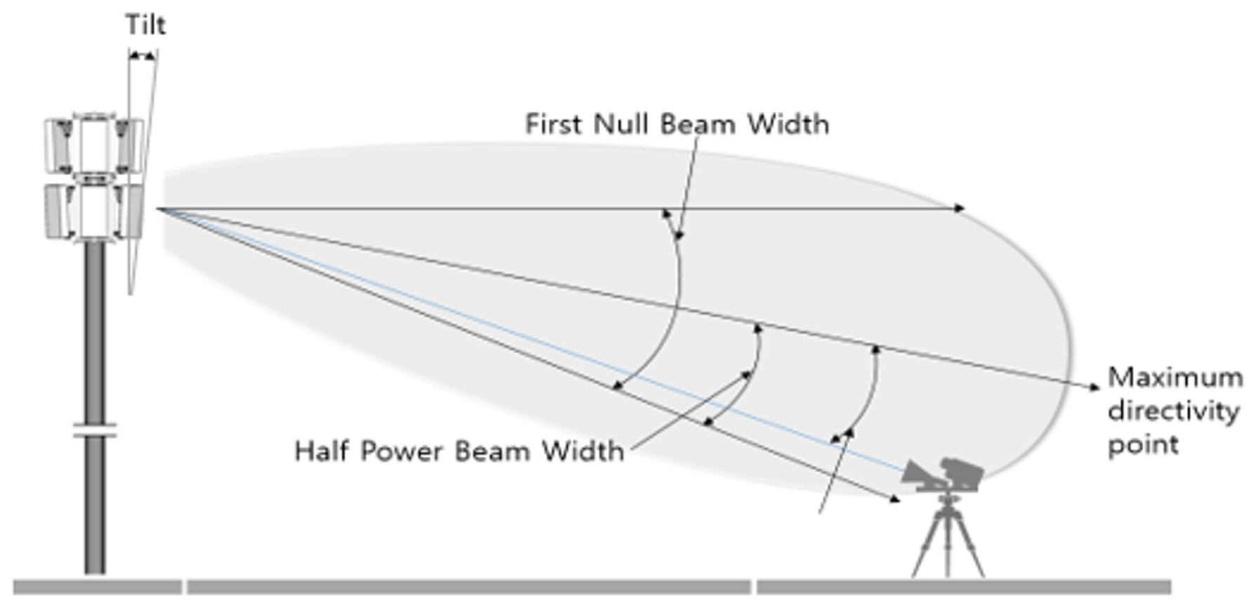
Angle compensation factor
In consideration of “Directing angle = Antenna tilt − Measurement angle”, the dB function was applied to compensate for the radiated transmit power at the spectrum analyser, and the calculation equation is 10log(Value).
TABLE A1-3
Vertical angle compensation method
Directivity angle | Value | Angle compensation factor
8° | 1.5 | 1.76
12° | 2 | 3.01
15° | 3 | 4.77

A1.4.4.4 Radio recovery factor

A1.4.4.4.1 Polarization measurement compensation
In the dual polarization signal of the AAS-based system, FR1 is +45° and −45, and FR2 is 0° and 90°, e.i.r.p. is obtained by inspecting and summing the vertical and horizontal signals of dual polarization. After each inspection, 3 dB is compensated.

$e.i.r.p.={e.i.r.p.}_{θ}+{e.i.r.p.}_{φ}$

$Maximum e.i.r.p. \left(e.i.r.p.\left({Pol}_{Link}=θ\right), e.i.r.p. \left({Pol}_{Link}=φ\right)\right)$
fIGURE A1-6
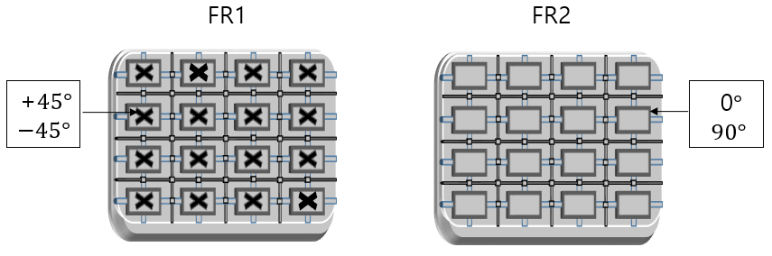

A1.4.4.4.2 Number of beams TRP compensation
If the OCNS setting is used, the equation below is used as TRP compensation method in order to convert the e.i.r.p. of measurement position into TRP.
10 log(number of beams)

A1.4.4.5 AAS-based system data emission method
When offset is inputted in the spectrum analyser, data emission of BS is set. All inspections should be performed in a state wherein services are being provided. The test mode wherein SSB is not allocated is not used because services are not provided, and OCNS or mobile maximum data download setting method is used as the method of fixing beam depending on the frequency bandwidth. When testing mobile maximum data download setting, mobile should be positioned close to the back of the receiving antenna for maximum throughput.
fIGURE A1-7
Data emission application state
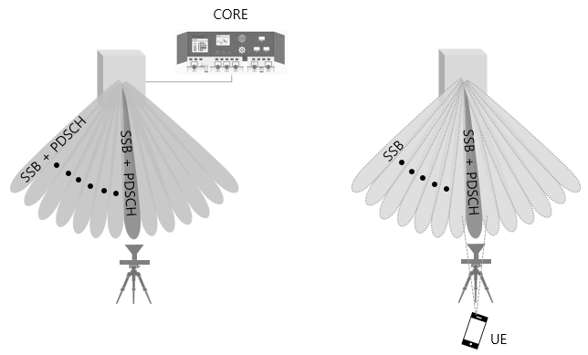
OCNS Mobile max. data download
As it is difficult for the FR1 BS to set the beam in a specific position by the hybrid beam method and to position in maximum directing angle, mobile max. data download is not set, and inspection is done by the OCNS setting method.
In the case of the FR2 BS, the mobile maximum data download method may be used in the service sector with the use of 3D beam forming; as the beam is sharp, it is easy for the receiving antenna to position in maximum directing angle, so inspection may be done by the OCNS setting method.
TABLE A1-4
Data emission setting standard
Frequency band | Beam fixing method | Signal ratio
FR1 | OCNS | SSB (50%) PDSCH (50%)
FR2 | OCNS | SSB (50%) PDSCH (50%)
FR2 | Mobile max. data download | SSB (50%) DATA Beam (50%)
In case of OCNS, PDSCH is divided by n (quantity) of service beam.

A1.5 OTA performance inspection
If the on-site OTA inspection procedure is followed, whether the performance standards of TRP, frequency error, occupied bandwidth, adjacent channel leakage ratio, out-of-band emission and spurious emission are satisfied may be tested.
fIGURE A1-8
FR1 AAU
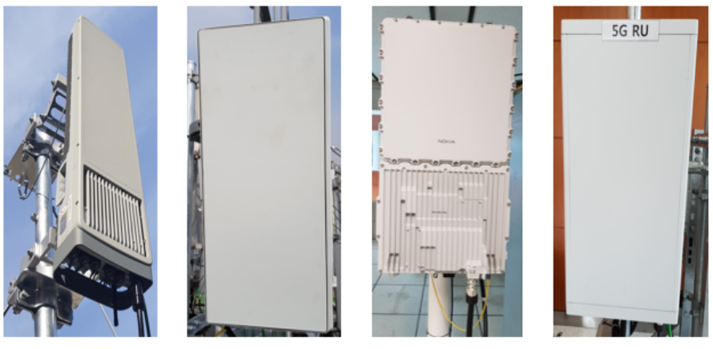
FR1 AAU TAB (Korea (Republic of) Test Port)
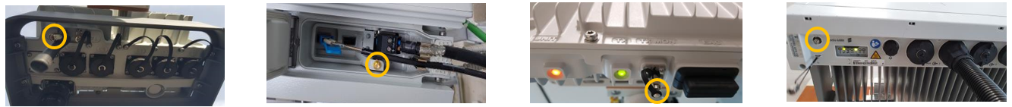
5G NR BS on-site OTA inspection
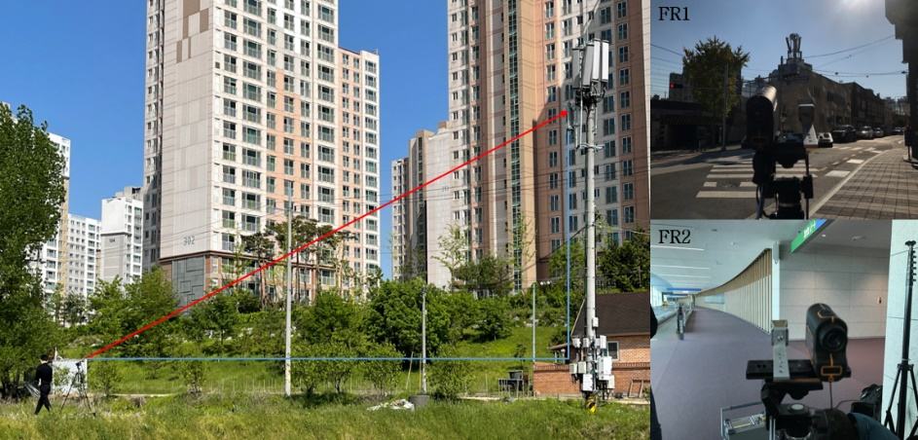

Annex 2
Example of extra propagation loss calculation based on the two-ray model
fIGURE A2-1
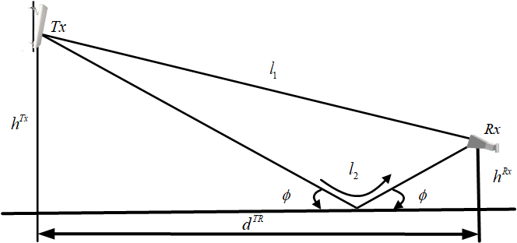
The two-ray channel model is illustrated in the figure, where the antenna system serves as the transmitter, and the measurement antenna acts as the receiver. The total received power including both the direct path and the ground-reflected path can be expressed as:

$P_{rx}=\frac{{e.i.r.p.}_{test}\left(θ, φ\right)G_{r}}{L_{freespace}{ L}_{extra}}=\frac{{e.i.r.p.}_{test}\left(θ, φ\right)G_{r}}{{L_{freespace}}/{{\left|1+{Re}^{-jkΔl}\right|}^{2}}}$ (A2-1)

where $k={2π}/λ$ is the wave number, $Δl$ is the propagation length difference between the direct path and the reflected path, and R is the reflection coefficient.
Furthermore, $Δl$ can be calculated as:

$Δl=\sqrt{(h^{\text{RX}}+h^{\text{TX}})^{2}+(d^{\text{TR}})^{2}}-\sqrt{(h^{\text{RX}}-h^{\text{TX}})^{2}+(d^{\text{TR}})^{2}}≈\frac{2h^{\text{TX}}h^{\text{RX}}}{d^{\text{TR}}}$ (A2-2)
where, and denote the heights of transmitter and receiver, respectively, and is the horizontal distance between the transmitter and the receiver. The reflection coefficients for horizontal and vertical polarization are defined respectively as:

$R=\frac{η\sin{φ}-\sqrt{η-\cos^{2}{φ}}}{η\sin{φ}+\sqrt{η-\cos^{2}{φ}}}$ (A2-3)

$R^{⊥}=\frac{\sin{φ}-\sqrt{η-\cos^{2}{φ}}}{\sin{φ}+\sqrt{η-\cos^{2}{φ}}}$ (A2-4)

where φ denotes the angle of incidence, and η represents the permittivity. Detailed information on the calculation of reflection coefficients can be found in Recommendations ITU-R P.526, ITU-R P.2040 and ITU-R P.2109.
Finally, the extra propagation loss in dB can be expressed by:

$L_{extra}\left[dB\right]=-10\log_{10}{{\left|1+{Re}^{-jkΔl}\right|}^{2}}$ (A2-5)

OFFSET: TRP measurement value.

