Report ITU-R SM.2570-0
(06/2026)
SM Series: Spectrum management
Methodologies for assessing or predicting spectrum availability countries

Foreword
The role of the Radiocommunication Sector is to ensure the rational, equitable, efficient and economical use of the radio-frequency spectrum by all radiocommunication services, including satellite services, and carry out studies without limit of frequency range on the basis of which Recommendations are adopted.
The regulatory and policy functions of the Radiocommunication Sector are performed by World and Regional Radiocommunication Conferences and Radiocommunication Assemblies supported by Study Groups.

Policy on Intellectual Property Right (IPR)
ITU-R policy on IPR is described in the Common Patent Policy for ITU-T/ITU-R/ISO/IEC referenced in Resolution ITU-R 1. Forms to be used for the submission of patent statements and licensing declarations by patent holders are available from https://www.itu.int/ITU-R/go/patents/en where the Guidelines for Implementation of the Common Patent Policy for ITU-T/ITU-R/ISO/IEC and the ITU-R patent information database can also be found.

Series of ITU-R Reports
(Also available online at https://www.itu.int/publ/R-REP/en)
Series | Title
BO | Satellite delivery
BR | Recording for production, archival and play-out; film for television
BS | Broadcasting service (sound)
BT | Broadcasting service (television)
F | Fixed service
M | Mobile, radiodetermination, amateur and related satellite services
P | Radio-wave propagation
RA | Radio astronomy
RS | Remote sensing systems
S | Fixed-satellite service
SA | Space applications and meteorology
SF | Frequency sharing and coordination between fixed-satellite and fixed service systems
SM | Spectrum management
TF | Time signals and frequency standards emissions

Note: This ITU-R Report was approved in English by the Study Group under the procedure detailed in Resolution ITU-R 1.

Electronic Publication
Geneva, 2026
© ITU 2026
All rights reserved. No part of this publication may be reproduced, by any means whatsoever, without written permission of ITU.

REPORT ITU-R SM.2570-0
Methodologies for assessing or predicting spectrum availability countries
(2026)
TABLE OF CONTENTS
Page
1 Introduction 2
2 Methodologies for assessing or predicting spectrum availability 2
2.1 Terminology 2
2.2 Approaches for assessing or predicting spectrum availability 3
3 Summary 4
Annex 1 – Case studies from Korea (Republic of) 5
A1.1 Background 5
A1.2 Criteria 6
A1.3 Methodologies and required information 9
A1.4 Technical approaches that improve spectrum availability 24
A1.5 References 24
Annex 2 – Case studies from China (People’s Republic of) 26
A2.1 Indicators for assessing or predicting spectrum availability 26
A2.2 A space-time correlation-based algorithm for predicting availability of radio spectrum 27
Annex 3 – Case studies from Indonesia (Republic of) 28
A3.1 Introduction 28
A3.2 Implementation 28
A3.3 Summary 32
Annex 4 – Case studies from Brazil (Federative Republic of) 33
Annex 5 – Case studies from India (Republic of) 36
A5.1 Spectrum surrender option 37
A5.2 Spectrum lease option 37
A5.3 Spectrum sharing option 37

Scope
This Report discusses several methodologies for assessing and predicting spectrum availability. Detailed studies conducted by some administrations are included in the Annexes for information only.
NOTE – It is recognized that the methodologies for assessing and predicting spectrum availability vary from country to country depending on the state of economy/development of telecommunications/ICT in a country. This Report merely reflects the views of some administrations and in no way reflects the views of other administrations. Therefore, the case studies are provided for information purposes only.

1 Introduction
Question ITU-R 241/1 entitled Methodologies for assessing or predicting spectrum availability was developed by ITU-R Study Group 1 and approved in 2019.
Radio frequency spectrum is a limited but infinitely renewable resource that is available only in finite amounts of frequency bandwidth during any given time interval and within any given volume of space. Taking into account that some administrations are challenged in assessing or predicting the availability of the radio frequency spectrum, and that there is lack of methodologies for assessment or prediction of spectrum availability, the ITU-R Question decides to study the following aspects:
– What criteria and information should administrations consider for assessing or predicting the availability of the radio frequency spectrum?
– What are the methodologies for assessing or predicting the availability of the radio frequency spectrum?
– What are the technical approaches, such as data-driven management, that may improve overall spectrum utilization?
As the determination of spectrum availability is a part of the spectrum planning process required to accommodate spectrum needs, the study of methodologies for assessing or predicting spectrum availability is essential. In addition, technical approaches that may improve overall spectrum utilization to increase spectrum availability, such as data-driven management, are drawing attention to accommodate increasing spectrum requirements.
The methodologies for assessing and predicting the availability of spectrum vary across different administrations. Several methodologies were presented, as information, in the Annexes to this Report.

2 Methodologies for assessing or predicting spectrum availability

2.1 Terminology
To support consistent terminology across the methodologies presented by different administrations, the following definitions are introduced and used in this Report.
Spectrum assessment is a comprehensive process which systematically evaluates how spectrum is currently getting used and how effectively it is being used, what is the intended future use and long-term strategy for meeting the future requirements. Spectrum assessment is usually done considering the requirement for different application of services which require spectrum. This becomes particularly important as spectrum is a finite and highly valuable resource for all radio communications. This assessment becomes the foundation based on which spectrum management and policy formulation is done considering technological changes and societal requirements.
Spectrum availability refers to the possibility for a radiocommunication service to operate within a pre-defined spectrum, for a certain geography and a fixed time duration, subject to technical, regulatory and operational conditions. The term spectrum in this context may broadly refer to a frequency band, or more narrowly to a specific channel. Depending on the context of the assessment, spectrum availability may refer to the general availability of spectrum for any service or its availability for a specific radiocommunication service.
Methodology for assessing spectrum availability refers to the process or approach used to quantify indicators defined in the criteria for assessing spectrum availability, based on measurable parameters or relevant information, and to apply the criteria.
Methodology for predicting spectrum availability refers to the process or approach used to estimate the future parameters or relevant information based on historical or contextual data, that are required to quantify the indicators at a future point in time for assessing future spectrum availability. This may involve statistical techniques, machine learning algorithms or other forecasting tools.

2.2 Approaches for assessing or predicting spectrum availability
Several approaches are illustrated for assessing or predicting spectrum availability on the basis of indicator/criteria, spectrum grid, and non-linear mathematical model.
There are five different case studies provided by administrations.
Case Study 1 presents indicators and criteria for assessing spectrum availability in different licensing regimes, and proposes methodologies for its assessment and prediction.
Case Study 2 illustrates the indicators for assessing or predicting spectrum availability and a specific correlation-based spectrum availability predicting method.
Case Study 3 introduces spectrum grid approach to minimize spectrum license application rejection in interference assessment caused by GPS tolerance. This approach may increase the density of spectrum usage within the grid and provide spectrum availability in the specific bands.
Case Study 4 introduces the efficiency temporal index (ETI) that tracks the spectrum utilization efficiency (SUE) over time as a mean to compute spectrum usage and demand to support the methodology presented in Case Study 1.
Case Study 5 introduces various approaches based on nonlinear mathematical models that can improve the spectrum availability.
The detailed information is indicated in the Annexes 1 to 5.

2.2.1 General process derived from above case studies (for information purposes only)
A general process for assessing or predicting spectrum availability can be identified by analysing common elements across the approaches presented in the case studies provided by administrations. This process is included for information purposes only and is intended to illustrate common features observed among the case studies. It consists of four major steps, each of which is illustrated with practical examples drawn from the case studies.
The process can be outlined as follows.
Step 1: Definition of scope and context
The assessment begins with clearly defining the target spectrum (e.g. frequency band or channel), geographic area, time duration and the radiocommunication service under consideration. It is also necessary to clarify whether the evaluation targets general spectrum availability across several services, or availability specific to a given radiocommunication service.
Step 2: Establishment of assessment criteria
Criteria for assessing spectrum availability are established based on technical, regulatory and operational factors. These criteria are supported by quantifiable indicators, such as:
– interference levels derived from analysis of coexistence or coordination scenarios; and
– spectrum utilization measured in terms of frequency, time, and spatial occupancy.
Step 3: Application of assessment methodology
Applying a structured methodology, the indicators are quantified from the relevant parameters and available information, providing the basis for applying the criteria established earlier. This may involve:
‒ Measurement campaigns or monitoring data;
‒ Database queries of licensing or regulatory frameworks;
‒ Mathematical analysis or simulation models (e.g. interference analysis, coexistence scenarios).
These quantified indicators are then evaluated using the criteria established in the previous step to determine current spectrum availability.
Step 4: Application of prediction methodology
For future-oriented analysis, a prediction methodology is adopted. This includes:
‒ collecting and analysing historical indicators or the underlying parameters used in their quantification; and
‒ applying statistical forecasting, machine learning, or other forecasting tools to estimate the future values of the parameters and indicators.
The predicted indicators are subsequently assessed using the same criteria as in current availability assessments, yielding an estimation of future spectrum availability.
The general process described above has been derived from the case studies currently included in this Report and is provided for information purposes only. As additional case studies become available, the descriptions and examples provided in this section may be updated accordingly.

3 Summary
In response to the increasing demand for spectrum and the diversity of spectrum usage environments, Question ITU-R 241/1 was established to study methodologies for assessing or predicting spectrum availability. This Report provides an overview of the results of that study, including the clarification of key concepts and the introduction of related methodologies.
This Report defines key terms such as spectrum availability, criteria for its assessment, and methodologies for assessment and prediction, and also describes, for information purposes only, a general process applicable to spectrum availability assessment or prediction, derived from national case studies.
National case studies included in the Annexes illustrate how these concepts and methodologies are interpreted and applied in practice. The examples reflect varying national conditions and perspectives, including differences in policy, regulatory environments and spectrum usage characteristics. Taking into account the rapid development of new technologies, administrations are encouraged to submit contributions on the technologies and related practical experiences on the spectrum availability assessments and predictions.

Annex 1
Case studies from Korea (Republic of)
This Annex presents studies conducted from Korea (Republic of). It discusses the spectrum availability across different categories of spectrum usage, classified by licensing conditions and modes of use. It also provides methodologies for assessing or predicting the spectrum availability and introduces technical approaches to increase the spectrum utilization. The spectrum usage categories discussed in this Annex are classified into the following three types:
‒ Exclusive use of licensed spectrum;
‒ Shared use of licensed spectrum;
‒ Shared use of unlicensed spectrum.
Each category was formulated with reference to the following sources, respectively:
‒ Report ITU-R M.2290 and reference documents [20] and [23] from Korea.
‒ NTIA, Quantitative Assessments of Spectrum Usage, Nov. 2016.
‒ Ofcom, Spectrum Commons Classes for Licence-Exemption, Nov. 2008.

A1.1 Background

A1.1.1 Factors to be considered
Spectrum demand
Demand for spectrum is generally not for the spectrum itself, but for the radiocommunication service, which translates into the required spectrum amount depending on various factors related to the service. If the spectrum amount provided by a frequency band is insufficient to meet the required spectrum amount, the radiocommunication service cannot operate within that frequency band. This implies that the spectrum demand is one of the factors affecting spectrum availability.
Spectrum sharing
Various radiocommunication services share spectrum, and the resulting interference limits their performance. Interference is related to the spectrum use of radiocommunication services, which consist of three independent components: frequency use, temporal use and geographical use. Interference occurs when an undesired signal appears at the spatial location of a receiver, within its receiver channel frequency, and at the time the desired signal is present. In other words, interference happens when the spectrum use of one radiocommunication service overlaps with that of another. Therefore, the spectrum use of radiocommunication services that share a frequency band is another factor affecting spectrum availability.

A1.1.2 Major factors for each license regime
There are three types of spectrum use: “exclusive use of licensed spectrum”, “shared use of licensed spectrum” and “shared use of unlicensed spectrum”. Each type of spectrum use has a different major factor to be considered when assessing spectrum availability.
Exclusive use of licensed spectrum
In the case of “exclusive use of licensed spectrum”, a radiocommunication service holds a license and uses a frequency band under that license. Radiocommunication services using spectrum in this manner include mobile telecommunication and broadcasting service. In this context, the radiocommunication service is referred to as the “license owner”, and the frequency band is termed the “licensed spectrum”. License owners have the exclusive right to use the licensed spectrum within a defined geographical area and period of time. Therefore, interference caused by sharing spectrum with other radiocommunication services does not need to be a concern. This implies that spectrum demand is the major factor to be considered when assessing the availability of a licensed spectrum for a license owner.
Shared use of licensed spectrum
In the case of “shared use of licensed spectrum”, a radiocommunication service wishes to use a licensed spectrum for which a license owner already exists. This radiocommunication service may be a potential license purchaser, or a secondary user, such as citizens broadband radiocommunication system, which uses the licensed spectrum without holding a license. In this context, the license owner is referred to as the “primary user”, and the licensed spectrum is termed the “shared licensed spectrum”. The rights of the primary user must not be violated. Therefore, potential license purchasers or secondary users must ensure that the primary user’s performance is not deteriorated. This means that the spectrum use of primary users is the major factor to be considered when assessing the availability of a shared licensed spectrum for a potential license purchaser or a secondary user.
Shared use of unlicensed spectrum
In the case of “shared use of unlicensed spectrum”, a radiocommunication service shares a frequency band, which does not require a license, with other radiocommunication services fairly. Radiocommunication services using spectrum in this way include Wi-Fi, NR-U, and Bluetooth. In this context, the radiocommunication service is referred to as the “spectrum sharer”, and the frequency band is termed the “unlicensed spectrum”. Any radiocommunication service can be a spectrum sharer as long as it does not impair fair coexistence with other spectrum sharers, and it can access the unlicensed spectrum without external regulation. This spectrum use by spectrum sharers may lead to interference and limit their performance. Therefore, when assessing the availability of an unlicensed spectrum for a spectrum sharer, the spectrum use of other spectrum sharers is the major factor to be considered.

A1.2 Criteria
This section establishes criteria for assessing spectrum availability across different types of spectrum use: exclusive use of licensed spectrum, shared use of licensed spectrum, and shared use of unlicensed spectrum.

A1.2.1 Exclusive use of licensed spectrum
This section presents a criterion and an index for assessing spectrum availability in the case of “exclusive use of licensed spectrum”.
When assessing the availability of a licensed spectrum for a license owner, spectrum demand is the major factor to be considered, as it influences the possibility for service within the given bandwidth of the licensed spectrum. Based on this consideration, the criterion for assessing spectrum availability is established by comparing spectrum supply and demand. Specifically, if spectrum supply exceeds spectrum demand, it can be concluded that the licensed spectrum is available for the license owner:
Criterion: Spectrum is available if and only if $D<S$ (C-1)
where:
$D$ : spectrum demand
$S$ : spectrum supply.
Additionally, spectrum availability can be quantified by the extent to which spectrum supply surpasses spectrum demand. This approach is employed because a greater oversupply increases the likelihood that the licensed spectrum will accommodate growing demand, thereby indicating greater spectrum availability:
Index: $SAI_{EL}=\left\{\begin{aligned}\frac{S-D}{S}, &D<S \\ 0, &D≥S\end{aligned}\right.$ (I-1)
where:
$SAI_{EL}$: spectrum availability index in the case of “exclusive use of licensed spectrum”
D : spectrum demand
S : spectrum supply.
To apply the above criterion, spectrum demand and supply must first be quantified based on information related to the license owner and the licensed spectrum to enable comparison. This methodology is detailed in § A1.3.1.

A1.2.2 Shared use of licensed spectrum
This sub-section presents a criterion and an index for assessing spectrum availability in the case of “shared use of licensed spectrum”.
When assessing the availability of a shared licensed spectrum for the service in question, which refers to a potential license purchaser or a secondary user, the spectrum use of the primary user is the major factor to be considered due to the regulatory requirement for their protection. Based on this consideration, the criterion for assessing spectrum availability is established by comparing the spectrum use of the primary user with that of the service in question. Spectrum use consists of three independent components: frequency, temporal use and geographic use. Therefore, one unit of spectrum use can be represented as a point in the three-dimensional coordinate plane. Let us refer to the collection of all points corresponding to spectrum use units as the “total spectrum use space”, and the collection of points corresponding to units occupied by a radiocommunication service as the “spectrum use region occupied by a radiocommunication service”. If the spectrum use region occupied by the service in question does not intersect with that of the primary user, it can be concluded that the shared licensed spectrum is available for the service in question:
Criterion: Spectrum is available if and only if $U_{su}$ does not intersect with $U_{pu}$ (C-2)
where:
$U_{su}$: spectrum use region occupied by the service in question
$U_{pu}$: spectrum use region occupied by the primary user.
To confirm that $U_{su}$ does not intersect with $U_{pu}$, two conditions must be checked:
1) There exists a system, referred to as a “spectrum-sharing system”, that enables the service in question to utilize unoccupied units.
2) The area of the region not occupied by the primary user is larger than the area required for the service in question.
Hence, the above criterion can be rewritten as follows:
Criterion: Spectrum is available if and only if condition 1 and 2 are satisfied (C-2̕)
where:
condition 1: there exists a spectrum-sharing system for utilizing unoccupied units
condition 2: $Area\left(U_{t}\right)-Area(U_{pu})>Area(U_{su})$
$Area(U)$: area of spectrum use region $U$
$U_{t}$: total spectrum use space
$U_{pu}$: spectrum use region occupied by the primary user
$U_{su}$: spectrum use region occupied by the service in question.
Additionally, spectrum availability can be quantified by the area of the remaining unoccupied region. This approach is employed because a larger remaining area indicates a greater margin between the regions occupied by the primary user and the service in question, thereby suggesting a higher likelihood that the primary user will not be interfered with:
Index: $SAI_{SL}=\left\{\begin{aligned}\frac{Area\left(U_{t}\right)-Area(U_{pu})-Area(U_{su})}{Area(U_{t})} if condition 1 and 2 are satisfied \\ 0 if condition 1 or 2 is not satisfied\end{aligned}\right.$ (I-2)
where:
$SAI_{SL}$: spectrum availability index in the case of “shared use of licensed spectrum”
$Area(U)$: area of spectrum use region $U$
$U_{t}$: total spectrum use space
$U_{pu}$: spectrum use region occupied by the primary user
$U_{su}$: spectrum use region occupied by the service in question
condition 1: there exists a spectrum-sharing system for utilizing unoccupied units
condition 2: $Area\left(U_{t}\right)-Area(U_{pu})>Area(U_{su})$.
To apply the above criterion, it is essential first to determine the level of granularity for defining spectrum use units and the method for quantifying the area of the spectrum use regions. Once this is established, the regions can be identified based on information related to the primary user, the service in question and the licensed spectrum, allowing for the quantification of the area. This methodology is detailed in § A1.3.2.

A1.2.3 Shared use of unlicensed spectrum
This sub-section presents a criterion and an index for assessing spectrum availability in the case of “shared use of unlicensed spectrum”.
When assessing the availability of an unlicensed spectrum for a spectrum sharer, the spectrum use of the other spectrum sharers is the major factor to be considered due to the potential performance degradation caused by interference. Henceforth, the spectrum sharer in question will be referred to as the “victim”, and the other spectrum sharers will be referred to as “interferers”. Based on this consideration, the criterion for assessing spectrum availability is established by comparing the spectrum use of interferers. Although this approach is similar to that used for shared licensed spectrum in terms of considering spectrum use, a key difference is that spectrum sharers are not under the direct oversight of the Administration and typically occupy spectrum use units temporarily as needed. Therefore, it is not possible to precisely identify their spectrum use regions. Instead, these regions can only be characterized probabilistically based on parameters related to their spectrum usage. If the probability that an arbitrary spectrum use unit selected by the victim falls within any of the spectrum use regions of the interferers, referred to as interference potential, is less than the victim’s tolerable limit, it can be concluded that the unlicensed spectrum is available for the victim:
Criterion: Spectrum is available if and only if $IP<ε$ (C-3)
where:
$IP$: interference potential, i.e., $Pr⁡(E)$
$Pr⁡(E)$: probability of event $E$ occurring
$E$: event that an arbitrary spectrum use unit falls within $U_{os}$
$U_{os}$: union of spectrum use regions of the interferers
$ε$: tolerable limit for interference potential.
Additionally, spectrum availability can be quantified by the probability that an arbitrary spectrum use unit does not fall within any spectrum use region of the interferers, as less interference potential indicates a greater likelihood that the spectrum is available:
Index: $SAI_{SU}=1-IP$ (I-3)
where:
$SAI_{SU}$: spectrum availability index in the case of “shared use of unlicensed spectrum”
$IP$: interference potential defined in (C-3)$.$
To apply the above criterion, it is essential first to determine the method for quantifying the interference potential based on information related to the spectrum sharers and the unlicensed spectrum. This methodology is detailed in § A1.3.3.

A1.3 Methodologies and required information
This section provides abridged methodologies and the required information for assessing or predicting spectrum availability across different types of spectrum use: exclusive use of licensed spectrum, shared use of licensed spectrum, and shared use of unlicensed spectrum.

A1.3.1 Exclusive use of licensed spectrum
This sub-section presents an abridged methodology and the required information for assessing or predicting the availability of licensed spectrum for a license owner. In the followings, it is assumed that the license owner operates the system to provide a radiocommunication service, which is composed of units that individually generate traffic or reuse the frequency band.

A1.3.1.1 Required information
The general steps and required information for assessing spectrum availability in the context of the “exclusive use of licensed spectrum” are shown in Table A1-1. To predict spectrum availability, time-accumulated data, such as monthly or annual records of the information in Table A1-1, along with projected timelines related to the Administration’s spectrum assignment plan and technological developments, are required. It should be noted that the required information may vary depending on the specific assessment methodology used.
TABLE A1-1
Required information for the “exclusive use of licensed spectrum”
Step | Required information
Quantification of spectrum supply | – Bandwidth $B$ (in Hz) of the frequency band
Quantification of spectrum demand | If traffic can be measured:  – Traffic $T_{(u)}$ (in bit/s) generated by each unit $u$ generating traffic.  Alternatively:  – Average traffic $T_{avg}$ (in bit/s) per unit generating traffic, and  – Number of units generating traffic $N_{T}$.
Quantification of spectrum demand | If spectrum usage can be measured:  – Spectrum usage $R_{(u)}$ (in Hz) of each unit $u$ reusing the frequency band.
Quantification of spectrum demand | If traffic and spectrum usage cannot be measured:  – Necessary bandwidth $B_{N}$ (in Hz).
Conversion of quantities for unit consistency | – Spectral efficiency $E$ (in bit/s/Hz).  – Spectrum reuse number $N_{R}$ of the system.  – Other information that may be required depending on the conversion method.
Comparison of spectrum supply and demand | – The supply $S$ (in Hz or bit/s), as quantified in the previous steps.  – The demand $D$ (in Hz or bit/s), as quantified in the previous steps.

A1.3.1.2 Assessment methodology
The following provides a detailed explanation of each step introduced in the previous section for assessing spectrum availability in the context of the “exclusive use of licensed spectrum”.
1) Quantification of spectrum supply
Spectrum supply of the licensed spectrum can be quantified by its frequency bandwidth, denoted as $B$ (in Hz), as determined by information of the Administration’s spectrum assignment plan.
2) Quantification of spectrum demand
If the amount of traffic generated by the system can be measured, spectrum demand can be quantified using the total generated traffic amount, denoted as $T$ (in bit/s). The total traffic amount $T$ can be calculated using the following equation and information:
$T=\sum_{u}{T_{(u)}}=T_{avg}N_{T}$ (A1-1)
where:
$T$: total traffic amount of the system (in bit/s)
$\sum_{u}{T_{(u)}}$: sum of all values of $T_{(u)}$
$T_{(u)}$: traffic amount of unit $u$ generating traffic (in bit/s)
$T_{avg}$: average traffic amount per unit (in bit/s)
$N_{T}$: number of units generating traffic.
If the amount of spectrum used by the system can be measured, the spectrum usage of the system, denoted as R (in Hz), can be also used to quantify spectrum demand. For systems where measuring the generated traffic and spectrum usage is impractical, necessary bandwidth (in Hz) can serve as an alternative to spectrum usage. The spectrum usage of the system R can be estimated using the following equation and information:
$R=\left\{\begin{aligned}Representative value of R_{(u)} \\ B_{N}\end{aligned}\right.$ (A1-2)
where:
$R$: spectrum usage of the system (in Hz)
Representative value of $R_{(u)}$: for example, mean or percentile of $R_{(u)}$
$R_{(u)}$: spectrum usage of unit $u$ reusing the frequency band (in Hz)
$B_{N}$: necessary bandwidth of the system (in Hz).
3) Conversion of quantities for unit consistency
As mentioned in § A1.2.1, spectrum availability is determined by comparing spectrum supply and demand. The spectrum usage R and the bandwidth $B$ are both spectral quantities in Hz and can be directly compared. However, the traffic amount $T$ (measured in bit/s) and the bandwidth $B$ (measured in Hz) represent different types of quantities and cannot be directly compared. Therefore, it is necessary to convert the bandwidth $B$ to system capacity, denoted by $C$ (an information quantity in bps), or convert the traffic amount $T$ to spectrum usage $R$ (in Hz).
The conversion of bandwidth $B$ (in Hz) to system capacity C (in bit/s) can be performed using the following equation and information:
$C=BEN_{R}$ (A1-3)
where:
$C$: system capacity (in bit/s)
$B$: bandwidth of the frequency band (in Hz)
$E$: spectral efficiency of the system (in bit/s/Hz)
$N_{R}$: number of units reusing the frequency band.
The conversion of traffic amount $T$ (in bit/s) to spectrum usage $R$ (in Hz) can be performed using the following equation and information:
$R=T/(EN_{R})$ (A1-4)
where:
$R$: spectrum usage of the system (in Hz)
$T$: total traffic amount of the system (in bit/s)
$E$: spectral efficiency of the system (in bit/s/Hz)
$N_{R}$: number of units reusing the frequency band.
The above conversions may also be carried out using various methodologies depending on the system. For examples, Recommendation ITU-R M.1768 methodology or Erlang-B formula can be used to convert the traffic amount $T$ (in bit/s) to spectrum usage $R$ (in Hz) depending on the system.
4) Comparison of spectrum supply and demand
The spectrum supply $S$ and demand $D$ have been quantified so far. In Hz, supply $S$ and demand $D$ are determined by the bandwidth $B$ and the spectrum usage $R$ of the system, respectively. In bit/s, supply $S$ and demand $D$ are determined by the system capacity $C$ and the total traffic amount $T$ of the system, respectively. At this stage, the criterion (C-1) from § A1.2.1 can be applied.
By comparing the supply $S$ and demand $D$, if $D<S$, the licensed spectrum is considered available for the license owner. Spectrum availability can then be quantified using the spectrum availability index $SAI_{EL}$, given by $(S-D)/S$ in (I-1) from § A1.2.1.
This procedure is presented as a flowchart in Fig. A1-1.
FIGURE A1-1
Flowchart of the assessment methodology for the “exclusive use of licensed spectrum”
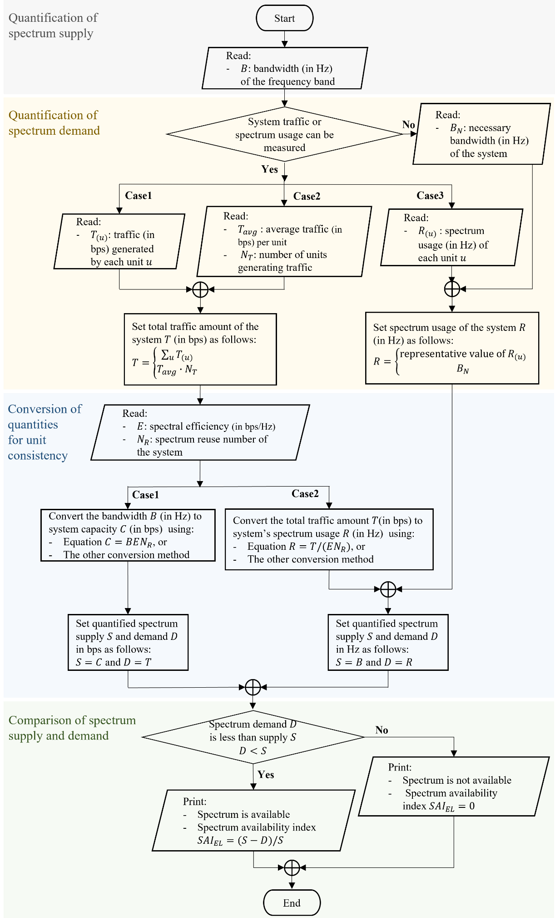

A1.3.1.3 Prediction methodology
Future spectrum availability is generally predicted by forecasting the information required for assessment and then assessing spectrum availability based on this predicted information. This approach also applies to the case of “exclusive use of licensed spectrum”.
For these forecasts, time-accumulated data on the required information are needed. For example, in this case, it includes monthly or annual records of traffic $T$ and spectrum usage $R$.
Once sufficient time-accumulated data have been collected, forecasting methodologies from fields such as mathematics, statistics, and machine learning can be employed to predict future information. Examples include regression analysis, system dynamics models, autoregressive integrated moving average models, and neural networks such as recurrent neural networks or long short-term memory networks.
Additionally, some information can be predicted based on the projected timelines related to specific plans. For instance, in this case, future bandwidth $B$ and spectral efficiency $E$ can be predicted using the projected timeline related to the Administration’s spectrum assignment plan and technological developments for the service.

A1.3.2 Shared use of licensed spectrum
This sub-section presents an abridged methodology and the required information for assessing or predicting the availability of licensed spectrum for the service in question, which refers to a potential license purchaser or a secondary user seeking to share the primary user’s licensed spectrum.

A1.3.2.1 Required information
The general steps and required information for assessing spectrum availability in the context of the “shared use of licensed spectrum” are shown in Table A1-2. To predict spectrum availability, time-accumulated data, such as monthly or annual records of the information in Table A1-2, along with projected timelines related to the Administration’s spectrum assignment plan, the primary user’s station operation plan, and technological developments, are required. It should be noted that the required information may vary depending on the specific assessment methodology used.
TABLE A1-2
Required information for the “shared use of licensed spectrum”
Step | Required information
Determination of spectrum use units granularity | – Frequency band range of the licensed spectrum.
Determination of spectrum use units granularity | – Terrain data for the territory.
Identification of primary user frequency use | – Channels assigned to the primary user’s stations.
Identification of primary user temporal use | – Actual use timeline of the primary user’s stations.
TABLE A1-2 (end)
Step | Required information
Identification of primary user geographical use | To compute the spectrum usage contour of the primary user’s transmit station:  – Transmitter power $P_{T}$ (in Watts),  – Transmitter emission necessary bandwidth $B_{N}$ (in Hz),  – Transmitter duty cycle $DC$ (in percent),  – Transmitter antenna gain for a specific up-tilt angle $θ$, $G_{T}\left(θ\right)$ (in dBi),  – Receiver antenna gain $G_{R}$ (in dBi),  – Power spectral density threshold $PSD_{th}$ (in dBW/Hz), and  – Other information that may be required depending on the contour computation method.
Identification of primary user geographical use | To compute the spectrum usage contour of the primary user’s receive station:  – Transmitter equivalent isotropic radiated power $EIRP$ (in dBW),  – Reference bandwidth $B_{R}$ (in Hz)  – Receive antenna gain as a function of off-axis angle $φ$, $G_{R}\left(φ\right)$ (in dBi)  – Power spectral density threshold $PSD_{th}$ (in dBW/Hz), and  – Other information that may be required depending on the contour computation method.
Quantification and comparison of spectrum use region areas | – Applicable spectrum sharing systems for utilizing unoccupied unit,  – Spectrum use region area of the primary user $Area(U_{pu})$ identified in the previous steps, and  – Spectrum use region area required for the service in question $Area(U_{su})$.

A1.3.2.2 Assessment methodology
The following provides a detailed explanation of each step introduced in § A1.3.2.1 for assessing the spectrum availability in the context of the “shared use of licensed spectrum”.
1) Determination of spectrum use units granularity
Spectrum use comprises three independent domains: frequency, temporal, and geographic. To define a spectrum use unit, each domain is segmented, with the resolution determined by the desired degree of analytical accuracy or complexity. This process requires information such as the frequency band range and terrain data for the territory. For example, the frequency band can be divided into sub bands with a 5 MHz bandwidth, the territory can be divided into tiles with a 1 arc-second (approximately 30 metres) resolution, time can be divided into 1‑hour intervals.
Let the segments in each domain be referred to as units in their respective domains. Let $f_{i}$, $t_{j}$, $g_{k}$ represent frequency, temporal, and geographic units with indices i, j and k, respectively. Then, one spectrum use unit can be denoted as $(f_{i}, t_{j}, g_{k})$.
2) Identification of primary user frequency use
Using frequency authorization and spectrum certification information from the Administration, frequency use of the primary user can be identified. Consider a frequency unit $f_{i}$. If a primary user station uses a channel that overlaps with unit $f_{i}$, it can be determined that some spectrum use units associated with $f_{i}$, denoted as $(f_{i}, ∙ , ∙ )$, may be occupied by the primary user; therefore, the corresponding geographical and temporal uses for the frequency unit $f_{i}$ need to be identified.
3) Identification of primary user temporal use
In this step, it is assumed that there are primary user stations using channels that overlap with the frequency unit $f_{i}$.
Using information on the actual use timeline of the stations, provided by the primary user, the temporal use for the frequency unit $f_{i}$ can be identified. Consider a temporal unit $t_{j}$. If there are stations operating during unit $t_{j}$, it can be determined that some spectrum use units associated with $f_{i}, t_{j}$, denoted as $(f_{i}, t_{j}, ∙ )$, may be occupied by the primary user; therefore, the corresponding geographical use for the frequency use unit $f_{i}$ and the temporal use unit $t_{j}$ need to be identified.
4) Identification of primary user geographical use
In this step, it is assumed that there are primary user stations using channels that overlap with the frequency unit $f_{i}$ and operating during temporal unit $t_{j}$.
To identify the geographical use for the frequency unit $f_{i}$ during the temporal unit $t_{j}$, spectrum usage contours for the stations are first computed.
For a fixed transmit station, the spectrum usage contour is the boundary around the station within which the service in question may experience interference from the station exceeding a certain level. This contour is derived as the collection of locations where the terrain-dependent propagation loss from the station to the location equals the required propagation loss $L_{T}$, which can be calculated using the following equation and information:
$L_{T}=\left\{10\log\left(P_{T}\right)-10\log\left(B_{N}\right)\right\}+10\log\left(DC/100\right)+G_{T}\left(θ\right)+G_{R}-PSD_{th}$ (A1-5)
where:
$L_{T}$: required propagation loss (in dB)
$P_{T}$: transmitter power (in Watts)
$B_{N}$: transmitter emission necessary bandwidth (in Hz)
$DC$: transmitter duty cycle (in percent)
$G_{T}\left(θ\right):$ transmitter antenna gain for a specific up-tilt angle $θ$ (in dBi)
$G_{R}:$ receiver antenna gain (in dBi)
$PSD_{th}:$ power spectral density threshold (in dBW/Hz).
For a fixed receive station, the spectrum usage contour is the boundary around the station within which the service in question may cause interference to the station exceeding a certain level. This contour is derived as the collection of locations where the terrain-dependent propagation loss from the location to the station equals the required propagation loss $L_{R}\left(φ\right)$, which can be calculated using the following equation and information:
$L_{R}\left(φ\right)=\{EIRP-10\log\left(B_{R}\right)\}+G_{R}\left(φ\right)-PSD_{th}$ (A1-6)
where:
$L_{R}\left(φ\right):$ required propagation loss as a function of off-axis angle $φ$ (in dB)
$EIRP$: transmitter equivalent isotropic radiated power (in dBW)
$B_{R}$: reference bandwidth (in Hz)
$G_{R}\left(φ\right):$ receive antenna gain as a function of off-axis angle $φ$ (in dBi)
$PSD_{th}:$ power spectral density threshold (in dBW/Hz).
For a transportable station, multiple contours are generated, each centred on a boundary point of the station’s operation area. These contours are then combined to create a composite contour around the entire operation area.
After computing spectrum usage contours for the stations, the geographical use for the frequency segment $f_{i}$ during the temporal segment $t_{j}$ is identified. Let $C^{(s)}$ be the spectrum usage contour for station $s$. Consider a geographical unit $g_{k}$. If a contour $C^{(s)}$ exists whose interior region contains the unit $g_{k}$, it can be determined that spectrum use unit $(f_{i}, t_{j}, g_{k})$ is occupied by the primary user.
5) Quantification and comparison of spectrum use region areas
The spectrum use region occupied by the primary user $U_{pu}$, defined as the collection of spectrum use units occupied by the primary user, has been identified. The areas of the total spectrum use space, defined as the collection of all units, and the region occupied by the primary user can be quantified by counting the number of spectrum use units they contain. These areas are denoted as $Area\left(U_{t}\right)$ and $Area\left(U_{pu}\right)$, respectively. Let the required area for the service in question be $Area\left(U_{su}\right)$. At this stage, the criterion (C-2) from § A1.2.2 can be applied.
Provided that there is spectrum-sharing system for utilizing unoccupied spectrum use units, if $Area\left(U_{t}\right)-Area\left(U_{pu}\right) >Area(U_{su})$, the shared licensed spectrum is considered available for the service in question. Spectrum availability can then be quantified by the spectrum availability index $SAI_{SL}$, given by $SAI_{SL}=\{Area\left(U_{t}\right)-Area\left(U_{pu}\right)-Area(U_{su})\}/Area\left(U_{t}\right)$ in (I-2) from § A1.2.2.
This procedure is presented as a flowchart in Fig. A1-2.
FIGURE A1-2
Flowchart of the assessment methodology for the “shared use of licensed spectrum”
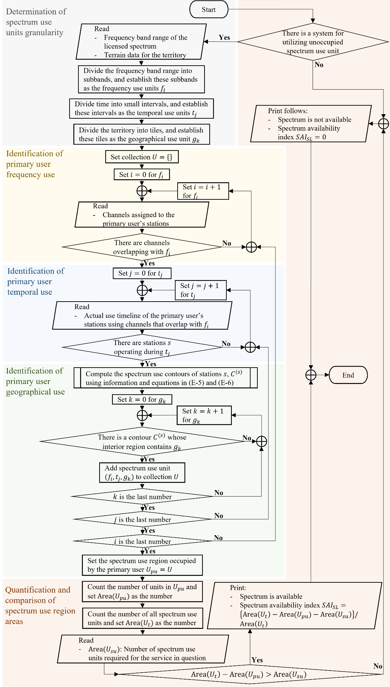

A1.3.2.3 Prediction methodology
Future spectrum availability is generally predicted by forecasting the information required for assessment and then assessing spectrum availability based on this predicted information. This approach also applies to the case of “shared use of licensed spectrum”.
For these forecasts, time-accumulated data on the required information are needed. For example, in this case, it includes monthly or annual records of the required area, $Area\left(U_{su}\right)$, for the service in question, as well as the actual use timeline of the stations.
After gathering time-accumulated data, forecasting methodologies from fields such as mathematics, statistics, and machine learning can then be utilized, as mentioned in § A1.3.1.2.
Additionally, some information can be predicted based on the projected timelines related to specific plans. For instance, in this case, primary user’s station details and the presence of the spectrum-sharing system can be predicted using the projected timeline associated with the Administration’s spectrum assignment plan, the primary user’s station operation plan, and technological developments for the spectrum-sharing system.

A1.3.3 Shared use of unlicensed spectrum
This sub-section presents an abridged methodology and the required information for assessing or predicting the availability of unlicensed spectrum for a spectrum sharer. In the following, the spectrum sharer in question is referred to as the “victim”, and the other spectrum sharers are referred to as “interferers”.

A1.3.3.1 Required information
The general steps and required information for assessing spectrum availability in the context of “shared use of unlicensed spectrum” are shown in Table A1-3. To predict spectrum availability, time-accumulated data, such as monthly or annual records of the information in Table A1-3, along with projected timelines for technological developments related to spectrum sharers. It should be noted that the required information may vary depending on the specific assessment methodology used.
TABLE A1-3
Required information for the “shared use of unlicensed spectrum”
Step | Required information
Quantification of frequency domain potential | – Bandwidth $B$ (in Hz) of the frequency band, and  – Width $B_{(s)}$ (in Hz) of the channel occupied by the transmitter for interferer $s$.
Quantification of temporal domain potential | – Duty cycle ${DC}_{(s)}$ (in percent) of interferer $s$.
TABLE A1-3 (end)
Step | Required information
Quantification of geographical domain potential | – Pathloss function $PL_{\left(s\right)}(∙)$ (in dB) for the transmitter signal for interferer $s$,  – Transmitter equivalent isotropic radiated power $EIRP_{(s)}$ (in dBm) for interferer $s$,  – Width $B_{(s)}$ (in Hz) of the channel occupied by the transmitter for interferer $s$,  – Power spectral density threshold $PSD_{th}$ (in dBm/Hz) of the victim,  – Transmitter’s antenna beamwidth $bw_{(s)}$ (in degrees) for interferer $s$,  – Number of devices per unit area $λ_{(s)}$ (in devices/$m^{2}$) for interferer $s$, and  – Other information that may be required depending on the interference coverage area computation method.
Quantification and comparison of overall interference potential | – The overall interference potential $IP$ identified in previous steps, and  – The victim’s tolerable limit $ε$ for the interference potential.

A1.3.3.2 Assessment methodology
The following provides a detailed explanation of each step introduced in the previous section for assessing spectrum availability in the context of “shared use of unlicensed spectrum”.
1) Quantification of frequency domain potential
An interfering transmitter that occupies a large portion of the frequency band has a high probability of overlapping with the frequency used by the victim receiver. Hence, the interference potential in frequency domain from interferer $s$, denoted by ${IP}_{freq}^{(s)}$, can be quantified using the following equation and information:
${IP}_{freq}^{(s)}=B_{(s)}/B$ (A1-7)
where:
${IP}_{freq}^{(s)}$: interference potential in frequency domain from interferer $s$
$B_{(s)}$: width of the channel occupied by interferer $s$ (in Hz)
$B$: bandwidth of the frequency band (in Hz).
2) Quantification of temporal domain potential
An interfering transmitter with high duty cycle is likely to overlap in time with the victim on the same channel. Hence, the interference potential in time domain from interferer $s$, denoted by ${IP}_{temp}^{(s)}$, can be quantified by the following equation and information:
${IP}_{temp}^{(s)}={DC}_{(s)}/100$ (A1-8)
where:
${IP}_{temp}^{(s)}$: interference potential in temporal domain from interferer $s$
$DC_{(s)}$: duty cycle of interferer $s$ (in percent).
3) Quantification of geographic domain potential
For a victim operating at the same frequency and time as an interfering transmitter, interference occurs only if the victim is physically located within reach of the transmissions. The interference in the geographic domain is proportional to two factors: first, the interference coverage area of the transmitter, and second, the number of transmitters in the area.
Consider a transmitter of interferer $s$. The interference coverage area of the transmitter is defined as the area where the power level of the signal from the transmitter exceeds a certain threshold. This is similar to the spectrum usage contour discussed in § A1.3.2.1. The coverage area is calculated as a function of range and antenna pattern.
The range $d_{(s)}$ is defined as the distance from the transmitter, in the direction of maximum gain of the antenna, at which the signal power reaches the threshold value determined by the victim receiver’s sensitivity to interference. It can be calculated using the following equation and information:
$PL_{(s)}\left(d_{(s)}\right)=EIRP_{(s)}-10\log\left(B_{(s)}\right)-{PSD}_{th}$ (A1-9)
where:
$PL_{(s)}(∙)$: pathloss function for the transmitter signal (in dB)
$d_{(s)}$ : range (in metres)
$EIRP_{(s)}$: transmitter equivalent isotropic radiated power (in dBm)
$B_{(s)}$: width of the channel occupied by the transmitter (in Hz)
${PSD}_{th}$: power spectral density threshold (in dBm/Hz).
Directive antennas increase power radiation in specific directions, reducing it in others. This enhancement is reflected in the $EIRP$ as antenna gain, resulting in increased radiated power and, consequently, extended range. Conversely, the reduction in coverage alters the area from a full circle to a sector determined by the antenna’s beamwidth $bw_{(s)}$. The interference coverage area $ICA_{(s)}$ can thus be calculated using the following equation and information:
$ICA_{(s)}=πd_{\left(s\right)}^{2}(bw_{\left(s\right)}/360)$ (A1-10)
where:
$ICA_{(s)}$: interference coverage area (in square meters)
$d_{(s)}$: range (in meters) defined in equation (A1-9)
$bw_{(s)}$: transmitter’s antenna beamwidth (in degrees)$.$
Finally, the interference potential in geographic domain from interferer $s$, denoted by ${IP}_{geog}^{(s)}$, can be quantified by the following equation and information:
${IP}_{geog}^{(s)}=1-\exp{(-λ_{(s)}ICA_{(s)})}$ (A1-11)
where:
${IP}_{geog}^{(s)}$: interference potential in geographical domain from interferer $s$
$λ_{(s)}$: number of devices per unit area for interferer $s$ (in devices/$m^{2}$)
$ICA_{(s)}$: interference coverage area of interferer $s$ defined in equation (A1-10).
4) Quantification and comparison of overall interference potential
To quantify the interference potential from interferer $s$, denoted by ${IP}_{(s)}$, multiply the interference potentials in the three domains as:
${IP}_{(s)}={IP}_{freq}^{(s)}{IP}_{temp}^{(s)}{IP}_{geog}^{(s)}$ (A1-12)
where:
${IP}_{(s)}:$ interference potential from interferer $s$
${IP}_{freq}^{(s)}:$ frequency domain potential defined in equation (A1-7)
${IP}_{temp}^{(s)}:$ temporal domain potential defined in equation (A1-8)
${IP}_{geog}^{(s)}:$ geographic domain potential defined in equation (A1-11).
Considering multiple interferers, the overall interference potential $IP$, which is the probability that an arbitrary spectrum use unit falls within any interferer’s spectrum use regions, is calculated as:
$IP=1-\prod_{s}{(1-IP_{\left(s\right)})}$ (A1-13)
where:
$IP:$ interference potential
$\prod_{s}{{(1-IP}_{(s)})}:$ product of all values of ${1-IP}_{(s)}$
$IP_{(s)}:$ interference potential from interferer $s$ defined in equation (A1-12).
At this stage, the criterion (C-3) from § A1.2.3 can be applied. For a given tolerable limit $ε$, if $IP<ε$, the unlicensed spectrum is considered available for the victim. Spectrum availability can then be quantified by the spectrum availability index $SAI_{SU}$, given by $SAI_{SU}=1-IP$ in equation (I-3) from § A1.2.3.
This procedure is presented as a flowchart in Fig. A1-3.
FIGURE A1-3
Flowchart of the assessment methodology for the “shared use of unlicensed spectrum”
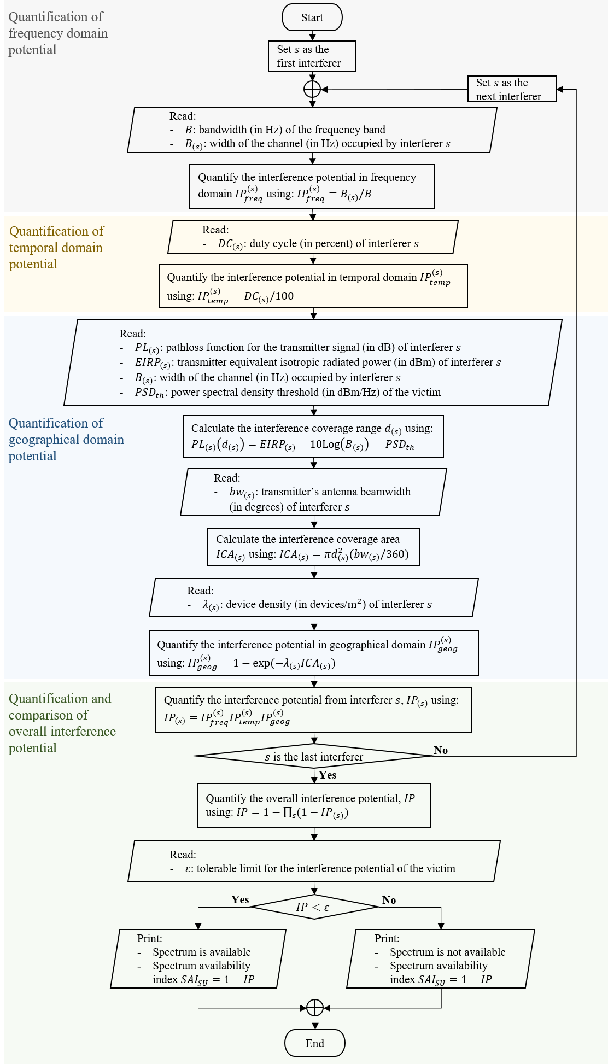

A1.3.3.3 Prediction methodology
Future spectrum availability is generally predicted by forecasting the information required for assessment and then assessing spectrum availability based on this predicted information. This approach also applies to the case of “shared use of unlicensed spectrum”.
For these forecasts, time-accumulated data on the required information are needed. For example, in this case, it includes monthly or annual records of the interferer density $λ_{s}$ and the tolerable limit for the interference potential $ε$.
Once time-accumulated data are gathered, methodologies for forecasting time series data from fields such as mathematics, statistics, and machine learning can be utilized for predicting future information, as mentioned in § A1.3.1.2.

A1.4 Technical approaches that improve spectrum availability
This section introduces technical approaches that improve spectrum availability. Spectrum availability is an indicator of whether a frequency band can accommodate specific spectrum requirement and can be improved through technical approaches related to spectrum utilization: techniques for utilizing unoccupied spectrum use units and for increasing spectrum utilization efficiency. Recently, these techniques have also been advanced using data-driven approaches and machine learning. Some of these techniques are briefly introduced below.
Cognitive Radio (CR) – The CR technique enables secondary users to opportunistically access a licensed spectrum owned by primary users. CR is a technical approach to utilize unoccupied spectrum use units and is advancing with the aid of machine learning. Traditional approaches rely on spectrum sensing techniques to detect unoccupied spectrum use units, which consume significant energy and time and require complex prior information from primary users. Machine learning approaches aim to address these shortcomings by learning spectral and temporal spectrum occupation historical data and predicting unoccupied spectrum use units.
Multiple-Input and Multiple-Output (MIMO) – MIMO is a technical approach to increase spectral efficiency, which multiplies the capacity of a radio link using multiple transmission and receiving antenna to exploit multipath propagation. With $M$ antennas at transmitter and $N$ antennas at receiver, MIMO can increase capacity by up to $\min{(M,N)}$ times, where $\min{(M,N)}$ is the minimum value of $M$ and $N$. With the help of machine learning, MIMO performance can be intelligently optimized based on environment conditions.

A1.5 References
[1] ITU-R Handbook – National Spectrum Management (Edition of 2015). (Online). Available: https://www.itu.int/pub/R-HDB-21
[2] Recommendation ITU-R SM.1046 – Definition of spectrum use and efficiency of a radio system. (Online]\). Available: https://www.itu.int/rec/R-REC-SM.1046/en
[3] Recommendation ITU-R SM.1138 – Determination of necessary bandwidths including examples for their calculation and associated examples for the designation of emissions. (Online). Available: https://www.itu.int/rec/R-REC-SM.1138/en
[4] Recommendation ITU-R P.452 – Prediction procedure for the evaluation of interference between stations on the surface of the Earth at frequencies above about 100 MHz. (Online). Available: https://www.itu.int/rec/R-REC-P.452/en
[5] Recommendation ITU-R P.1411 – Propagation data and prediction methods for the planning of short-range outdoor radiocommunication systems and radio local area networks in the frequency range 300 MHz to 100 GHz. (Online). Available: https://www.itu.int/rec/R-REC-P.1411/en
[6] Recommendation ITU-R M.1768 – Methodology for calculation of spectrum requirements for the terrestrial component of International Mobile Telecommunications. (Online). Available: https://www.itu.int/rec/R-REC-M.1768/en
[7] Recommendation ITU-R M.2091 – Methodology to calculate spectrum requirements within the frequency bands 1 545-1 555 MHz (space-to-Earth) and 1 646.5-1 656.5 MHz (Earth-to-space) for aeronautical mobile-satellite (R) service communications related to the priority categories 1 to 6 of Article 44 of the Radio Regulations. (Online). Available: https://www.itu.int/rec/R-REC-M.2091/en
[8] Report ITU-R SM.2028 – Monte Carlo simulation methodology for the use in sharing and compatibility studies between different radio services or systems. (Online). Available: https://www.itu.int/pub/R-REP-SM.2028
[9] Report ITU-R SM.2404 – Regulatory tools to support enhanced shared use of the spectrum. (Online). Available: https://www.itu.int/pub/R-REP-SM.2404
[10] Report ITU-R SM.2405 – Spectrum management principles, challenges and issues related to dynamic access to frequency bands by means of radio systems employing cognitive capabilities. (Online). Available: https://www.itu.int/pub/R-REP-SM.2405
[11] Report ITU-R F.2438 – Spectrum needs of high altitude platform stations (HAPS) broadband links operating in the fixed service. (Online). Available: https://www.itu.int/pub/R-REP-F.2438
[12] Report ITU-R M.2218 – Traffic forecasts and estimated spectrum requirements for future development of the mobile-satellite service in the range 4-16 GHz. (Online). Available: https://www.itu.int/pub/R-REP-M.2218/en
[13] Report ITU-R M.2290 – Future spectrum requirements estimate for terrestrial IMT. (Online). Available: https://www.itu.int/pub/R-REP-M.2290
[14] NTIA Redbook Annex J – Guidance for Determination of Necessary Bandwidth, (Online). Available: https://www.ntia.gov/sites/default/files/2023-11/j_2021_edition_rev_2023.pdf
[15] NTIA Technical Report TR-18-530 – A 53-Year History of Spectrum Efficiency Studies and Recommended Future Directions. (Online). Available: https://its.ntia.gov/publications/details.aspx?pub=3204
[16] NTIA, Quantitative Assessments of Spectrum Usage, Nov. 2016. (Online). Available: https://www.ntia.gov/report/2016/quantitative-assessments-spectrum-usage
[17] Ofcom, Spectrum Commons Classes for Licence-Exemption, Nov. 2008. (Online). Available: https://www.ofcom.org.uk/consultations-and-statements/category-1/scc
[18] S. Zinno, G. Di Stasi, S. Avallone, G. Ventre, “On a fair coexistence of LTE and Wi-Fi in the unlicensed spectrum: A Survey,” Computer Communications, Vol. 115, Pages 35-50, Jan. 2018. (Online). Available: https://www.sciencedirect.com/science/article/pii/S0140366417302177
[19] X. Ying, M. M. Buddhikot and S. Roy, “SAS-Assisted Coexistence-Aware Dynamic Channel Assignment in CBRS Band,” in IEEE Transactions on Wireless Communications, vol. 17, no. 9, pp. 6307-6320, Sept. 2018. (Online). Available: https://ieeexplore.ieee.org/document/8423460
[20] Y. Kim, H. Kwon and S. Park, “Prediction of LTE Spectrum Saturation Using Quantiles of Busy Hour RB Usage Rates,” in IEEE Communications Letters, vol. 23, no. 8, pp. 1427-1431, Aug. 2019. (Online). Available: https://ieeexplore.ieee.org/document/8731997
[21] C. Zhang, P. Patras and H. Haddadi, “Deep Learning in Mobile and Wireless Networking: A Survey,” in IEEE Communications Surveys & Tutorials, vol. 21, no. 3, pp. 2224-2287, third quarter 2019. (Online). Available: https://ieeexplore.ieee.org/document/8666641
[22] L. Yu et al., “Spectrum Availability Prediction for Cognitive Radio Communications: A DCG Approach,” in IEEE Transactions on Cognitive Communications and Networking, vol. 6, no. 2, pp. 476-485, June 2020. (Online). Available: https://ieeexplore.ieee.org/document/8998400
[23] K. Cheon, H. Kwon, J. Jahng, S. Park and J.K. Choi, “Methodology for assessing the network balance of 4G LTE radio network,” Electronics Letters, Vol.56, No.22, pp.1217-1219, 29th Oct. 2020. (Online). Available: https://ietresearch.onlinelibrary.wiley.com/doi/full/10.1049/el.2020.1544

Annex 2
Case studies from China (People’s Republic of)

A2.1 Indicators for assessing or predicting spectrum availability
Assessment of spectrum availability may also be implemented by Administrations to examine whether the Licensees have complied with relevant regulations of spectrum utilization rate, which were set out by the Administration in advance or as a kind of condition for using this portion of spectrum. In some countries, if the Licensees failed to comply with such regulations/conditions, the Administration has the right to cancel that spectrum License. In view of this, a practical and tangible measure to assess the corresponding spectrum availability is of great importance, while reasonable and effective indicator for assessing spectrum utilization rate is also needed. The relevant case study has been included into this report.
As recommended by Recommendation ITU-R SM.1046, the composite bandwidth-space-time domain should be used as a measure of spectrum utilization – the “spectrum utilization factor”; and the basis for calculating spectrum utilization efficiency (SUE), or spectrum efficiency in short, should be the determination of the useful effect obtained by the radio systems through the utilization of the spectrum and the spectrum utilization factor.
Meanwhile, a series of indicators can be designed to examine whether the Licensees have complied with relevant requirement/conditions of spectrum utilization rate. If the spectrum licensees cannot comply with those requirement/conditions, then administrative authority can revoke such spectrum license. By doing so, this portion of spectrum is no longer available to the original licensee, and on the contrary, it might be available again to other users. Of course, the final availability of this portion of spectrum will be decided by the authority.
China published Interim Provisions on Spectrum Utilization Requirement and Verification Management, in which relevant indicators (such as frequency band occupancy, annual time occupancy, area coverage rate and user carrying rate) were stipulated. According to this provision, “From the date of issuance of the radio frequency use license, the radio administrative authority shall regularly exam and supervise the corresponding frequency utilization rate. Except for force majeure, if the radio frequency is not used for more than 2 years after obtaining the radio frequency use license or the utilization rate fails to meet the requirements of the radio frequency licence, the radio administrative authority shall order the Licensee to make corrections, or the authority shall revoke the issued licence and will take back the radio frequency.”
Moreover, in order to standardize the supervision and inspection of the spectrum utilization rate of the public mobile communication system, China also formulated the Measures for the Evaluation of the Radio Frequency Utilization Rate of the Public Mobile Communication System (Trial) in 2022, and carried out the pilot work of utilization rate evaluation in some provinces.

A2.2 A space-time correlation-based algorithm for predicting availability of radio spectrum
Cognitive radio (CR) becomes an attractive solution since it can dynamically detect spectrum holes and access without interfering authorized services. As a method to detect the presence of primary user (PU) and examine the spectrum band, spectrum prediction algorithms play a significant role in establishing and operating the geolocation database. A space-time correlation-based prediction algorithm could be found in this reference document. The main steps of this approach are introduced as follows.
Step 1: Calculate the mesh correlation factor (MCF). MCF is a factor used to characterize correlation between spectrum meshes. The spectrum occupancy information of a target region is represented in binary form: 0 (idle) and 1 (occupied). Then the MCF between two meshes is quantized by normalized cross-correlation of their occupancy state. Considering the physical proximity of nodes and the historical data on spectrum usage, the closer MCF approaches to 1, the more effectively it can be used to predict spectrum occupancy.
Step 2: Multi-centre mesh clustering algorithm. To reduce energy consumption of spectrum predicting, meshes are separated into groups. Each merged mesh group should contain a fixed number of detecting meshes (DMs) and other meshes (EMs). The final arrangement of meshes in each group is determined by minimizing entropy among the EMs, thereby reducing uncertainty and prediction error.
Step 3: Markov process-based estimation. Markov process has been widely applied in predicting usage behaviours of a frequency band based on channel usage patterns CR, and the expression is given as:
$P_{m}(s_{i}^{t}|s_{i}^{V})=P_{m}(s_{i}^{t}|s_{i}^{t-1}, ...,s_{i}^{t-V})$
where $V$ denotes the order of the Markov process, and $P_{m}$ denotes the transition probability of an EM state. A transition matrix can be constructed to describe the dependence and probabilities of future EM states, while the initial states of EMs are known. The final EM states can be predicted through calculating the multiplication of two matrices.
Step 4: Minimum entropy merging approach decision. After conducting two independent estimations based on spatial and temporal correlation, the merging approach is proposed to avoid providing contradictory results. By comparing the entropy of EMs under the two estimation methods using predicted state probabilities, the prediction with the higher entropy is selected.
With this merging method, the space-time correlation, which combines the spatial correlation and historical dependence, is utilized to obtain a higher prediction accuracy. The method was implemented and tested in dense urban environments, showing reduced power consumption with acceptable predicting performance.

Annex 3
Case studies from Indonesia (Republic of)

A3.1 Introduction
There are several spectrum bands that are allocated for different types of services, including mobile, fixed, broadcasting, fixed satellite and mobile satellite. Wireless communication systems operate inside these channels. Indonesia, an archipelagic developing nation that spans 1.9 million square kilometres and distinguished by its varied topography and uneven population density of 280 million people, is experiencing a high rate of wireless communication usage while simultaneously dealing with difficulties related to spectrum constraint. The other problem is that some remote areas are difficult to define in administrative data.
The constraints of monitoring devices for detecting national spectrum usage further add to the challenges faced by Indonesia in executing spectrum sensing. Consequently, Indonesia was unable to utilise cognitive radio technology optimally. Cognitive radio (CR) has evolved as a novel technique to address the issue of spectrum under-utilization in next-generation networks.
To offer extensive services to prospective users of the radio frequency spectrum, an alternative method must be established to ensure public access to the available spectrum with minimal resource utilisation. The integration of multiple media platforms, such as the web-based version of spectrum availability and the mobile application version, is advantageous.
The spectrum grid is an approach to unify the gap between administrative data, field conditions and spectrum data.

A3.2 Implementation
Spectrum grid
Hundreds of thousands of applications for the use of microwave link frequencies are submitted every year in Indonesia. The number of rejections was increasing, and the peak was in 2022 that the number of rejections reached above 60%.
The current statistical data defines the distribution of the population and the economic level of the community mapped within the administrative area. However, the coverage area of the frequency spectrum cannot be defined by the administrative area because electromagnetic propagation has no border.
In conducting radio frequency interference analysis, it is carried out on a coordinate basis, both in Decimal and DMS formats. With this different mapping system, it is almost impossible to juxtapose the frequency coverage area to the coverage population data. Even in spectrum management with the coordinate-based to define station locations, problems were faced that caused the results of technical analysis to be inaccurate.
FIGURE A3-1
Microwave Link Towers in Indonesia
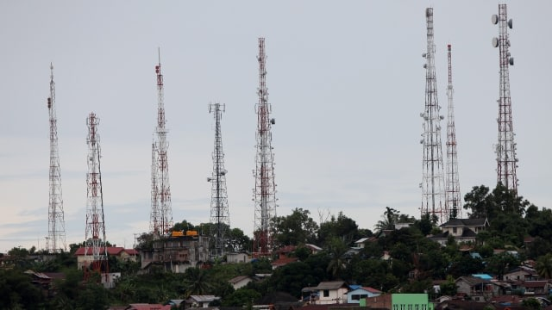
FIGURE A3-2
Rejection increasing over the year
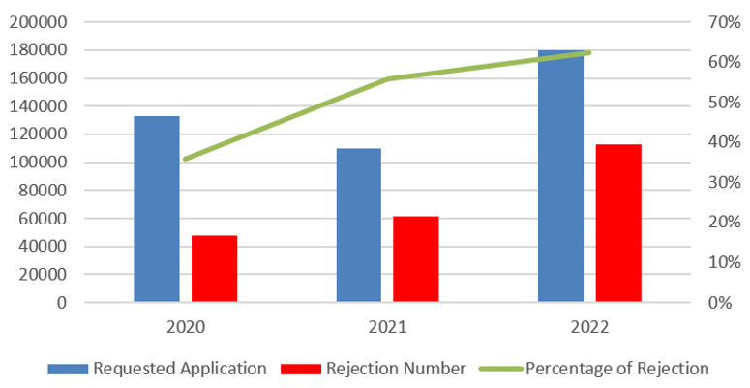
With such high rejection, mobile operators face difficulties in developing their networks. Meanwhile, telecommunication networks are currently the key to the economic development of the community. On the other hand, the government continues to encourage mobile operators to increased accessibility for all citizens across the country.
A deeper analysis was conducted to see the accuracy of the analysis results compared to the results of monitoring the use of frequencies in the field. The high rejection rate is caused by some applications at the same location being submitted with slightly different coordinate as a result of GPS measurements taken by different entities at different times. The same GPS device can give slightly different results if measured at different times and conditions.
The technical analysis of the application for the use of microwave link frequencies is carried out on a first come, first-served basis. When mobile operators, vendors, etc. want to submit a new microwave link frequency application, they re-measure the coordinates to ensure that the location is correct and submit the new application with 6-digit decimals accuracy to avoid imposing fines. It was found that a tiny meter difference causes inaccuracies in the results of the technical analysis.
FIGURE A3-3
Illustration in the same tower, where there are several licenses coordinate with very small differences
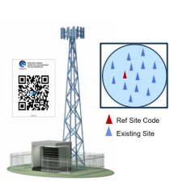
From the evaluation above, it is retained that more detailed coordinates do not always give the best technical analysis results.
FIGURE A3-4
Illustration of the google plus code grid [1]
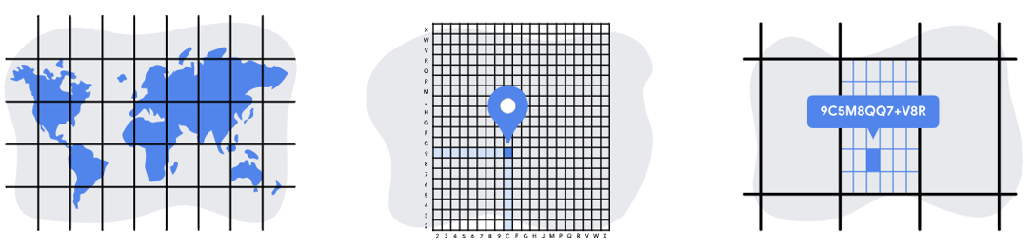
All the station coordinates are remapped and clustered into the spectrum grid, and the technical analysis is conducted using the centre of the grid.
FIGURE A3-5
Illustration of technical analysis comparison with spectrum grid
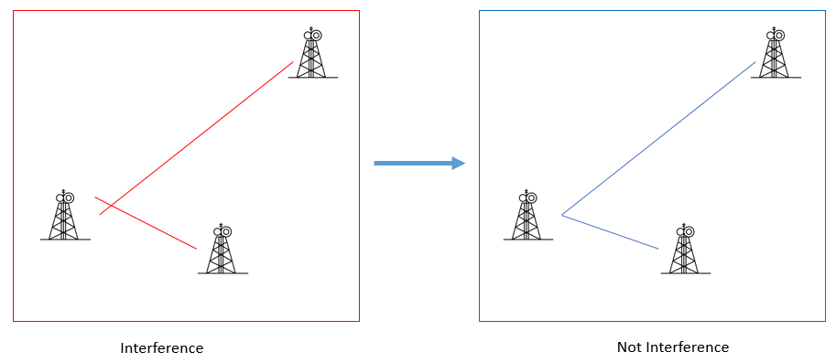
This effort has decreased the rejection rate without compromising the quality of the interference analysis.
FIGURE A3-6
Rejection decreasing after the implementation of the spectrum grid
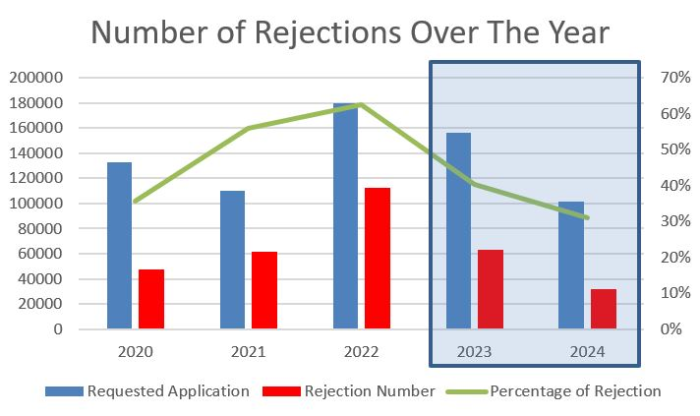
Spectrum availability
Utilising the frequency-licensed data mapped within the spectrum grid, the available spectrum frequencies may be ascertained. Such data can be utilised in the microwave link licensing (fixed service), which presently has numerous requests for channel usage within the frequency band. Additional information is provided in Fig. A3-7.
FIGURE A3-7
Spectrum availability
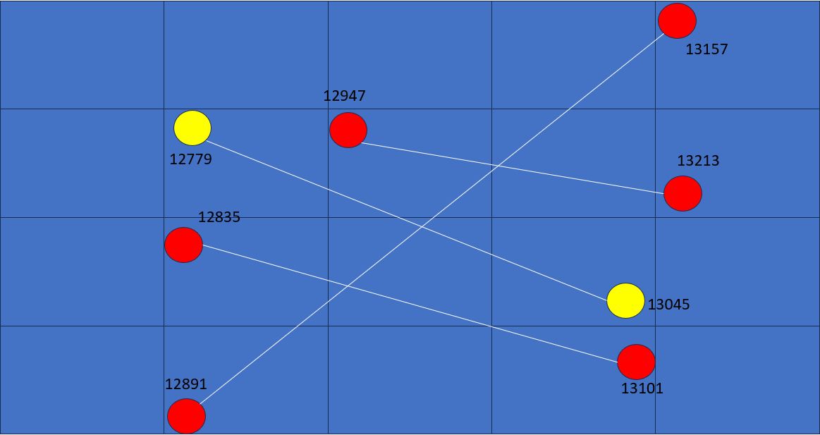
In Fig. A3-7, duplex frequency in the yellow station is the new link, and duplex frequencies in the red station are the existing link. For example, in the channelling plan of Indonesia, 12.75-13.25 GHz with a bandwidth of 56 MHz, the existing link of these channels has been mapped. Users could select specific geographical areas, such as a village or a particular section of the spectrum grid. After that, users might choose what kind of channelling plan they want to analyse. In this case, users select a specific area of the spectrum grid and then specify the frequency range of 12.75-13.25 GHz; the groups of red stations and the corresponding link will be displayed. Users could see instantly what kind of channel was available. This is the web-based version. In the future, Indonesia will incorporate it with mobile applications and utilise artificial intelligence.

A3.3 Summary
Implementation of a spectrum grid in the search for spectrum availability has potential benefits to increase the quality of users’ experience and economic spectrum management. Spectrum grids need to be integrated with other systems and other data such as populations, economies, trends and equipment. The greater the data mapped in the grid, the higher its potential for advancing economic applications, industrial projections and even artificial intelligence inside the spectrum.

Reference
[1] https://maps.google.com/pluscodes/technology/

Annex 4
Case studies from Brazil (Federative Republic of)
This Annex contains information on the development of a Spectrum Utilization Efficiency (SUE) data collection system in Brazil, as a means to compute spectrum usage (R) in direct application of the methodology described in § A1.3.1. Brazil administration intends to format follow-ups to an Annex proposal in a future contribution.
Background
Since 2011, the Brazilian telecommunications regulatory authority, Anatel, has been conducting the evaluation of the SUE of telecommunications service providers. This evaluation is based on spectrum licenses, on technical data from licensed stations and on additional information provided by the license owner. The latter is provided on a monthly basis and included in the formulas for calculating efficiencies. SUE computations may be applied, at Anatel’s discretion, in the assessments of technical projects, and support decision making on granting/extending spectrum licenses, on defining license fees, or as a technical criterion for multiple purposes. The evaluation of SUE is a theme under development as part of the ongoing process to update the regulation on frequency spectrum usage.
Temporal evaluation of SUE
For land mobile cellular radiocommunication systems, SUE is computed as described in equations (2) and (3) of Recommendation ITU-R SM.1046-3. Changes of SUE over time are tracked by the Efficiency Temporal Index (ETI), defined as the slope of the fitted line from the simple linear regression model of SUE over the course of $n$ months, given by:
$\text{ETI}=\frac{\sum_{i=1}^{n}{\left(i×\text{SU}{\text{E}}_{\text{i}}\right)}-\left(\frac{n+1}{2}\right)×\sum_{i=1}^{n}{\left(\text{SU}{\text{E}}_{\text{i}}\right)}}{\sum_{i=1}^{n}{\left(i^{2}\right)}-n×{\left(\frac{n+1}{2}\right)}^{2}}$
where $SUE_{i}$ is the computed SUE in the $i$-th month.
Each SUE evaluation has a one-to-one correspondence with a unique data element, more precisely, a row in the data layout file, and each ETI evaluation has a unique correspondence with a set of collection records that identify the evolution of the useful effect ($M$) over time, while keeping the spectrum utilization factor ($U$) constant. The useful effect $M$ obtained with the aid of the communication system is taken as the amount of traffic generated by it ($T$), as specified in § A1.3.1.
Data visualisation
Figure A4-1 illustrates a scatter plot of a simple linear regression model of SUE computed with a portion of n78 band (C-Band) in Rio de Janeiro state over the year 2023 for a given mobile operator. The $y$-axis represents SUE in $\frac{Tb}{km^{2}×MHz}$ units and the dashed line is the fitted line of the linear model.
FIGURE A4-1
Temporal evolution of SUE of the n78 band (C-Band) in Rio de Janeiro state over 2023 for a given operator
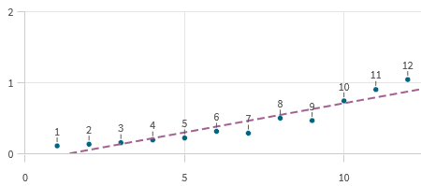
Figure A4-2 illustrates a scatter plot with circular markers at the locations specified by SUE and ETI values for a given municipality. The farther to the right, the greater the SUE. Marker sizes are proportional to municipality areas taken as the geometric/geographic spaces ($S$) considered in $U$ calculations.
FIGURE A4-2
Scatter plot with markers specified by SUE (x-axis) and ETI (y-axis) values for municipalities
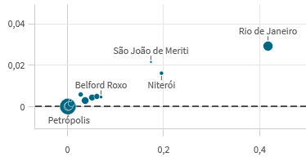
Figure A4-3 illustrates SUE values of this set of municipalities in a geographic heat map form. The hotter the colour, the greater the SUE. Geographic heat maps are straightforward representations of the amount of space denied to other potential users of the same frequency band.
FIGURE A4-3
Geographic heat map of the same set of municipalities and their SUE values
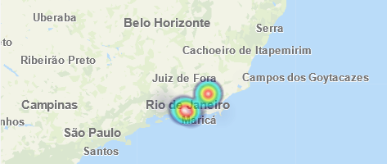
Computing geometric spaces ($S$)
Recommendation ITU-R SM.1046 states that the area unavailable for other radio users can take various forms, including an angular region around a specific location. The size of this restricted zone is determined by the power spectral density. Alternatively, this unavailable space can be defined by the actual coverage area measured for a radiocommunication station.
A method for determining the denied geometric area from a set of base stations involves computing their signal-to-interference plus noise ratio (SINR). This unavailable space, denoted as $S$, is defined by the contour based on SINR values calculated for specific receiver locations. Along radials spaced in five-degree increments, a test receiver moves and the SINR is calculated as:
$SINR = 10\log_{10}{\left.\left( \frac{s}{i+n}\right.\right)}^{}$
where:
$s$ : strength of the incident signal transmitted by the evaluated station,
$i$ : aggregate interference of the set of stations operating on the same frequency in the vicinity of the mobile,
$n$ : mobile receiver noise power $(kTBF$).
The incident, desired and interfering, signal strengths are calculated by the free-space path loss (FSPL) model of Recommendation ITU-R P.525, and the receiver noise power is calculated from a thermal noise level of −174 dBm/Hz and a noise figure of 7 dB, as given in Table 5 of Report ITU‑R M.2412.
Figure A4-4 illustrates contours generated with SINR = 0 dB in each sector of a base station of n78 band (C-Band). The e.i.r.p. values of each sector, in the direction of maximum radiation, are obtained from the Brazilian Assignment and Licensing System database, and the antennas are modelled with Gaussian radiation pattern for simplification purposes.
FIGURE A4-4
Total spectrum use space of an IMT base station based on SINR map contours
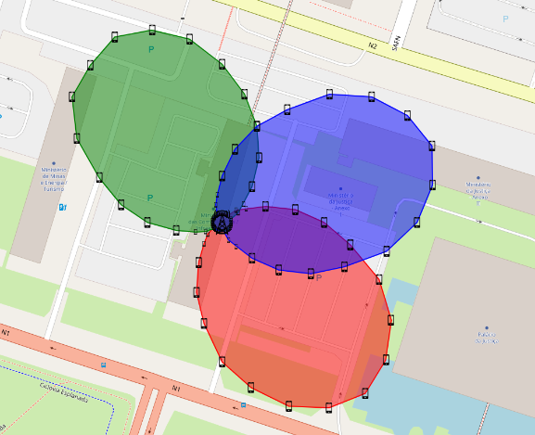
Heat maps such as those illustrated in Fig. A4-3 can then have their resolution improved by enhancing the granularity from municipalities to base stations and their occupied spectrum units. It will then be possible to observe the efficiency of the spectrum used by visual inspection and estimate the total spectrum use space by summing the occupied areas. These areas are beneficial when evaluating the criteria for assessing spectrum availability in the case of “shared use of licensed spectrum” defined in Annex 1.
Conversion of quantities for unit consistency (Annex 1 to this Report)
As stated in § A1.3.1.2, spectrum availability is assessed by comparing the supply and demand of spectrum. Both spectrum usage (R) and bandwidth (B) are measured in Hertz (Hz), allowing for direct comparison. However, since traffic amount (T) is measured in bits per second (bits/s) and bandwidth (B) is measured in Hertz (Hz), they represent different types of quantities and cannot be directly compared. It is necessary to convert the bandwidth B to system capacity (C), or convert the traffic amount (T) into spectrum usage (R) in Hertz (Hz), this is done in the aforementioned section with equations (E-3) and (E-4) in Annex 1 to this Report, respectively.
When the useful effect (M) obtained with the aid of the communication system is taken as the traffic amount (T), the spectral efficiency (E) of the system (in bits/s/Hz) can be expressed as:
$E = SUE ×S$
where:
$SUE$: spectrum utilization efficiency
$S$: Geometric/Geographic space denied by other potential users.
Thus, in terms of SUE and S values, equations (E-3) and (E-4) in Annex 1 to this Report can be written as:
$C=B×SUE×S×N_{R}$ and $R=\frac{T}{\left(SUE × S ×{ N}_{R}\right)}$
where $N_{R}$ is the number of units reusing the frequency band.

Annex 5
Case studies from India (Republic of)
This Annex introduces nontechnical approaches, that improve spectrum availability, studied in India (Republic of). Since spectrum availability is an indicator of whether a frequency band can accommodate specific spectrum requirement, it can be improved through several non-technical approaches related to spectrum utilization. There can be mechanisms through which spectrum that are of no significant use to one operator can be returned to the administration leading to increased spectrum availability. Similarly, spectrum which is not getting utilized currently can be used by other operator through short term or long-term lease. Also, sharing of spectrum by operators can enable multiple operators to use the spectrum. These techniques are briefly introduced below.

A5.1 Spectrum surrender option
Spectrum auction across various countries have adopted instalment payment as it gives scope of enhanced capital expenditure by the operator. With the rapid change of technologies in spectrum bands, it has become difficult to forecast the utility of a band in long run. This has generated a requirement where operators can exit the acquired spectrum and save on future instalment payments. Such provisions have the potential to improve the spectrum availability.

A5.2 Spectrum lease option
With the advent of IMT-2020 technology, there is enhanced demand of spectrum for the captive usage by the industry. There are challenges in terms of licensing condition, location and band identification for allocating spectrum to captive industrial application. Spectrum leasing option by the telecom service providers to industrial users will be beneficial for all the stakeholders. This option will meet the requirement of all stakeholders, thus leading to improvement in availability of spectrum.

A5.3 Spectrum sharing option
In shared use of licensed spectrum, an operator wishes to use a licensed spectrum for which a license owner already exists. Such arrangements may be decided by both users, and it can last as per their mutual requirements. This mechanism has potential to improve the availability of spectrum.
To create a non-linear mathematical model for spectrum availability, incorporating spectrum surrender, spectrum lease, and spectrum share as parameters, each of these parameters and the relationships among them should be defined.
$A\left(t\right)$ = Spectrum availability at time t
$Ss\left(t\right)$ = Spectrum surrender at time t (portion of the spectrum given up voluntarily or due to regulatory constraints)
$Sl\left(t\right)$ = Spectrum lease at time t (portion of the spectrum leased out to other entities)
$Ssh\left(t\right)$ = Spectrum share at time t (portion of the spectrum shared among users/operators)
Now, it is assumed that:
1) Spectrum availability increases with spectrum surrender: as more spectrum is surrendered, it can be allocated to others.
2) Spectrum availability increases with spectrum lease: leasing out spectrum makes it available to multiple users/operators.
3) Spectrum availability also increases with spectrum share: sharing the spectrum across different users/operators maximizes its utilization.
The availability of spectrum as a function of these parameters can be modelled with non-linear interactions. One common approach is to use an additive non-linear model:
$A\left(t\right)=Ao+f\left(Ss\left(t\right)\right)+g\left(Sl\left(t\right)\right)+h\left(Ssh\left(t\right)\right)$
where:
$Ao$ is the base spectrum availability when no surrender, lease or sharing is applied
$f\left(Ss\left(t\right)\right)$ is a linear function representing the effect of spectrum surrender on availability
$g\left(Sl\left(t\right)\right)$ is a non-linear function representing the effect of spectrum lease on availability
$h\left(Ssh\left(t\right)\right)$ is a non-linear function representing the effect of spectrum sharing on availability.
Choosing the simplistic functions:
1) Spectrum surrender $f\left(Ss\left(t\right)\right)=Ss$. It can be taken as amount of Spectrum Surrendered at time t. This will act as a constant number for any given time.
2) Spectrum lease $g\left(Sl\left(t\right)\right)=β*Sl\left(t\right)^γ$. The leasing term, where β and γ model the impact of leasing on the increase in availability. The effect grows non-linearly with more spectrum leased.
3) Spectrum Share $h\left(Ssh\left(t\right)\right)=δ*Ssh\left(t\right)^η$. This term along with δ and η models the effect of sharing, where sharing tends to increase availability but with diminishing returns as more entities share the same spectrum.
This model can be calibrated with actual spectrum data to set values for the parameters β, γ, δ and η to reflect real-world scenarios and trends.

This Annex does not address the evaluation of fairness. For information on evaluating the fairness index, please refer to [18].
Report ITU-R SM.2404 addresses regulatory solutions for shared use of spectrum, while § A1.3 covers technical assessment methodologies for spectrum.
The area of spectrum use region is equivalent to the spectrum utilization factor defined in Recommendation ITU-R SM.1046, which is the product of frequency bandwidth, geographic space and time denied to other potential users.
This abridged methodology is based on several methodologies described in Report ITU-R M.2290, [20] and [23].
This method of calculating total traffic amount is utilized in the following documents: Report ITU-R F.2438, Report ITU-R M.2218 and [23].
This method of quantifying spectrum demand through spectrum usage is utilized in [20].
Guidance on determining the necessary bandwidth of various systems can be found in Recommendation ITU-R SM.1138 and [14].
For example, if the system has $B=10 MHz$, $E=2.22 bit/s/Hz$, and $N_{R}=100$, then its capacity $C=1 GB/hour$, as calculated by equation (E-3). This method of conversing bandwidth (in Hz) to system capacity (in bit/s) is utilized in [23].
The spectral efficiency $E$ is equivalent to the spectrum utilization efficiency defined in Recommendation ITU-R SM.1046 when geographic space is not considered. More information on spectral efficiency can be found in Recommendation ITU-R SM.1046 and [15].
For example, if the system has $T=0.7 GB/hour$, $E=2.22 bit/s/Hz$, and $N_{R}=100$, then its spectrum usage $R=7 MHz$, as calculated by equation (A1-4). This method of conversing traffic amount (in bit/s) to spectrum usage (in Hz) is utilized in the following documents: Report ITU-R F.2438, Report ITU‑R M.2218, and [20].
Recommendation ITU-R M.2091 and Report ITU-R M.2290 converts total traffic amount (in bit/s) to spectrum usage (in Hz) using the Erlang-B formula and the ITU-R M.1768 methodology, respectively.
[23] measures the total traffic amount of the system each month and utilizes this time series data to derive an equation representing the future trend of traffic based on regression analysis. [20] measures the spectrum usage of the system each month and utilizes this time series data to train predictive models such as long short-term memory networks.
This abridged methodology is based on the methodology described in [16].
For propagation loss model, the following document can be referred to: Recommendation ITU-R P.452.
This abridged methodology is based on the methodologies in [17].
For pathloss function, the following document can be referred to: Recommendation ITU-R P.1411.
References relevant to CR include Report ITU-R SM.2404, Report ITU-R SM.2405, [19], [22].
References relevant to MIMO with deep learning include [21].
https://www.miit.gov.cn/jgsj/wgj/wjfb/art/2020/art_f1b30a0a1e7341bc8a3b497c04bc7da9.html
For example: − For the public mobile communication systems: The frequency band occupancy shall not be less than 80%, the area coverage rate shall not less than 60%, and the user carrying rate shall not less than 60%; − For land mobile service using HF band: The annual time occupancy shall not be less than 60%; − For maritime mobile service using HF band: The annual time occupancy shall not be less than 60%. For maritime mobile service using other bands, the annual time occupancy shall not be less than 60%, and the frequency band occupancy shall not be less than 80%.
S. Huang, Z. Feng, Y. Yao, Y. Zhang and P. Zhang, “Multi-centres cooperative estimation based fast spectrum sensing,” 2016 IEEE International Conference on Communications (ICC), Kuala Lumpur, Malaysia, 2016, pp. 1-6, doi: 10.1109/ICC.2016.7510684. [Online]. Available: https://ieeexplore.ieee.org/abstract/document/7510684
Z. Chen and R. C. Qiu, “Prediction of channel state for cognitive radio using higher-order hidden Markov model,” Proceedings of the IEEE SoutheastCon 2010 (SoutheastCon), Concord, NC, USA, 2010, pp. 276‑282, doi: 10.1109/SECON.2010.5453870. [Online]. Available: https://ieeexplore.ieee.org/abstract/document/5453870

