Report ITU-R SM.2505-0
(07/2022)
Impact studies and human hazard issues
for wireless power transmission
via radio frequency beam

SM Series
Spectrum management

Foreword
The role of the Radiocommunication Sector is to ensure the rational, equitable, efficient and economical use of the radio-frequency spectrum by all radiocommunication services, including satellite services, and carry out studies without limit of frequency range on the basis of which Recommendations are adopted.
The regulatory and policy functions of the Radiocommunication Sector are performed by World and Regional Radiocommunication Conferences and Radiocommunication Assemblies supported by Study Groups.

Policy on Intellectual Property Right (IPR)
ITU-R policy on IPR is described in the Common Patent Policy for ITU-T/ITU-R/ISO/IEC referenced in Resolution ITU-R 1. Forms to be used for the submission of patent statements and licensing declarations by patent holders are available from http://www.itu.int/ITU-R/go/patents/en where the Guidelines for Implementation of the Common Patent Policy for ITU-T/ITU-R/ISO/IEC and the ITU-R patent information database can also be found.

Series of ITU-R Reports
(Also available online at http://www.itu.int/publ/R-REP/en)
Series | Title
BO | Satellite delivery
BR | Recording for production, archival and play-out; film for television
BS | Broadcasting service (sound)
BT | Broadcasting service (television)
F | Fixed service
M | Mobile, radiodetermination, amateur and related satellite services
P | Radiowave propagation
RA | Radio astronomy
RS | Remote sensing systems
S | Fixed-satellite service
SA | Space applications and meteorology
SF | Frequency sharing and coordination between fixed-satellite and fixed service systems
SM | Spectrum management

Note: This ITU-R Report was approved in English by the Study Group under the procedure detailed in Resolution ITU-R 1.

Electronic Publication
Geneva, 2022
© ITU 2022
All rights reserved. No part of this publication may be reproduced, by any means whatsoever, without written permission of ITU.

REPORT ITU-R SM.2505-0
Impact studies and human hazard issues for wireless power transmission
via radio frequency beam
(2022)
TABLE OF CONTENTS
Page
Policy on Intellectual Property Right (IPR) ii
1 Introduction 2
2 Radio characteristics of beam WPT 3
3 Studies on the impact to the incumbent systems 4
3.1 Study A (915-921 MHz) 4
3.2 Study B (915-921 MHz) 8
3.3 Study C (917-920 MHz, 2 410-2 486 MHz, and 5 738-5 766 MHz) 11
3.4 Study D (2 483.5-2 500 MHz) 23
3.5 Study E (915-921 MHz) 26
3.6 Study F (61-61.5 GHz) 29
3.7 Study G (915-921 MHz, 2 410-2 486 MHz and 5 738-5 766 MHz) 30
4 Human hazard issues 33
5 Summary 34
Annex 1 – RF exposure environmental control to comply with the Radio Radiation Protection Guidelines, the case of Japan 35
A1.1 Beam WPT installation environments 35
A1.2 Compliance with the RRPG 36

Abbreviations/Glossary
ARIB Association of Radio Industries and Businesses
CISPR In French “Comité International Spécial des Perturbations Radioélectriques”,
International Special Committee on Radio Interference
DSRC Dedicated short-range communications
DUT Device under test
EESS Earth exploration-satellite service
EMF Electromagnetic field
GSM Global System for Mobile Communications
ICNIRP International Commission on Non-ionizing Radiation Protection
IEC International Electrotechnical Commission
IEEE Institute of Electrical and Electronics Engineers
IMT International Mobile Telecommunications
ISM Industrial, scientific and medical
LAN Local area network
LTE Long term evolution
LPWA Low-power wide-area network
MSS Mobile-satellite service
RF Radio frequency
RFID Radio frequency identification
RR Radio Regulations
SRD Short-range devices
WHO World Health Organization
WPT Wireless power transmission

1 Introduction
Wireless power transmission (WPT) technology is used to transfer power wirelessly from power sources to devices that use or consume power. Significant innovations in WPT can free users from needing electric power cords or changing batteries if electric power is supplied wirelessly. There are two major categories in WPT technologies. One of them is non-beam WPT technology, which transfers power to devices using magnetically, capacitively or inductively coupled means in the near field region and is typically used to charge devices, such as mobile phones and electric vehicles. The other category of WPT is beam WPT, which transfers power wirelessly using radio waves over longer distances (several metres or more, and the potential to cover wider areas).
Beam WPT regulations, standards and operational guidelines are currently being developed at national, regional and international levels for wireless charging technologies of mobile/portable and Internet of Things (IoT) sensor devices for applications of WPT via radio frequency beam. Report ITU-R SM.2392 − Applications of wireless power transmission via radio frequency beam, indicates diverse applications and technologies of beam WPT in the future. The Report focuses on applications of WPT technologies using radio frequency beam and highlights that such devices may be classified as Industrial, Scientific, Medical (ISM), short-range devices (SRD) or radio equipment. While both ISM and SRD beam WPT devices are discussed in Report ITU-R SM.2392, Report ITU-R SM.1896 provides a list of frequency ranges for global and regional harmonization of SRDs in its annexes, and Radio Regulations (RR) footnotes Nos 5.138 and 5.150 provide a list of frequency ranges for ISM devices. Furthermore, some administrations classify beam WPT as a radio service that needs rulemaking for practicable implementation with regulatory measures. To mitigate the impact of WPT devices on the operation of radiocommunication services as spectrum demand increases, some solutions that utilize frequency bands designated for ISM applications and other solutions for spectrum sharing with the incumbent radiocommunication services are discussed. In order to commercialize these WPT technologies, studies on the impact of WPT systems on radiocommunication systems and radiocommunication services are necessary.
The purpose of this Report is to show how the proposed beam WPT systems can coexist with radiocommunication systems by conducting impact studies and demonstrating compliance with international and/or national radio frequency regulations and RF exposure guidelines. The studies include test measurements in laboratory and field conditions as well as simulation and theoretical studies based on the proposed systems. The Report is also intended to provide guidance to the administrations wishing to allow implementation of beam WPT technologies in the proposed frequency ranges in order to minimize the potential impact of beam WPT on radiocommunication services. Furthermore, this Report is expected to contribute to discussions towards international frequency ranges and regulations for beam WPT applications.
Beam WPT technologies are also treated as a radio service with associated national regulatory measures in Japan as shown in § 3.3 Study C in this Report. In accordance with the frequency ranges and operation purposes, practical technical conditions are derived for coexistence with the incumbent radiocommunication services. If harmful interference occurs, interference can in some cases be corrected by moving or reorienting the charging device and/or affected device, or by changing the operating frequency of the charging device or affected device to avoid use of overlapping frequency channels.
NOTE – The studies reflect national experiences from administrations and approaches from sector members.

2 Radio characteristics of beam WPT
This section provides examples of the characteristics of the beam WPT system.
TABLE 1
Examples of radio characteristics of beam WPT systems
System | System 1 | System 2 | System 3 | System 4 | System 5 | System 6 | System 7
Frequency | 915-921 MHz | 915-921 MHz | 915-921 MHz | 917-920 MHz | 2 410-2 486 MHz | 5 738-5 766 MHz | 61-61.5 GHz
Output power | 4 W | 15 W | Up to 50 W | 1 W | 15 W | 32 W | 50 W
Antenna gain | 7 dBi | 8.24 dBi | 10 dBi | 6 dBi | 24 dBi | 25 dBi | 45 dBi ⁽¹⁾
e.i.r.p. | 43 dBm | 50 dBm | 54.8 dBm | 36 dBm | 65.8 dBm | 70 dBm | 92 dBm ⁽¹⁾
Bandwidth | 500 kHz | 500 kHz | 500 kHz | 200 kHz | N/A ⁽²⁾ | N/A ⁽²⁾ | 10 MHz
Beacon signals | Other wireless systems | Other wireless systems | Other wireless systems | Other wireless systems | Other wireless systems | Beam-WPT dedicated wireless system | Other wireless systems
TABLE 1 (end)
System | System 1 | System 2 | System 3 | System 4 | System 5 | System 6 | System 7
Antenna | Wide-angle directional antenna | Wide-angle directional antenna | Wide-angle directional antenna | Wide-angle directional antenna | Beam forming | Beam forming | Near field beam focusing
Applications | Wireless charging of mobile/portable devices  Wireless powered and charging of sensor networks
NOTE – The technical specifications contained in this Table describe some of the characteristics used in the respective studies and are not meant to be interpreted as regulatory limits, as there may be other beam WPT systems with higher power than those listed. In most cases, out-of-band emission limits for beam WPT devices are set by each Administration.
⁽¹⁾ The figures given for antenna gain and e.i.r.p. here are for cases where the device receiving power is in the far field of the transmitter.
⁽²⁾ The regulation on this system designates its occupied bandwidth as zero because its modulation is CW.

3 Studies on the impact to the incumbent systems
The possible incumbent systems that may require impact studies are as follows:
– Wireless LAN (2.4 GHz, 5.6 GHz band);
– DSRC (5.8 GHz band);
– IMT (900 MHz band);
– MCA (920 MHz band);
– LPWA (920 MHz band);
– RFID (920 MHz band);
– Amateur radio (2.4 GHz band, 5.7 GHz band);
– Radar (5.6 GHz band);
– Microwave link (5.9 GHz band);
– Mobile satellite communication system (2.5 GHz band);
– Radio astronomy (1.4 GHz band, 2.7 GHz band, 4.8 GHz band);
– EESS (active) (co-frequency 5 470-5 570 MHz, adjacent 5 250-5 470 MHz);
– Other systems operated in adjacent frequency bands and/or frequency range where harmonic emissions may occur.

3.1 Study A (915-921 MHz)
An over-the-air, distance charging transmitting device (DUT) operating between 915 MHz and 921 MHz was tested for impact to demonstrate interoperability with wireless devices and technologies operating in the same band. The DUT operates on a single channel with a bandwidth less than 400 kHz and maximum declared conducted average power of 37.4 dBm. The DUT is designed to charge other devices at a distance of up to 30 cm. Additionally, the DUT is compliant with Title 47, Chapter I, Subchapter A, Part 15 of the United States Electronic Code of Federal Regulations, which, inter alia, requires that devices cause no harmful interference and accept interference caused by the operation of an authorized radio station, by another intentional or unintentional radiator, by industrial, scientific and medical (ISM) equipment, or by an incidental radiator.
The tests were performed in two separate rooms. The first was a real-world test performed in a regular room and on a wooden countertop where other signals were present, as illustrated in Fig. 1. As an example of the types of signals present, a nearby train station regularly emits 900 MHz signals that are detectable in the room. The second room was an anechoic chamber, as described in ETSI EN 302 208 V3.1.1 (2016-11) Annex B.1.2 and as illustrated in Fig. 2. This anechoic chamber was used to demonstrate whether the results found in the regular room were repeatable in a free-space environment and whether any degradation of signal was due to the noisy environment. The tests were performed in the exact same manner, detailed further below, in each room. The results from each of the tests did not have any discrepancies; as such, only one set of results is presented below.
Figure 1
Test setup in room 1, open area
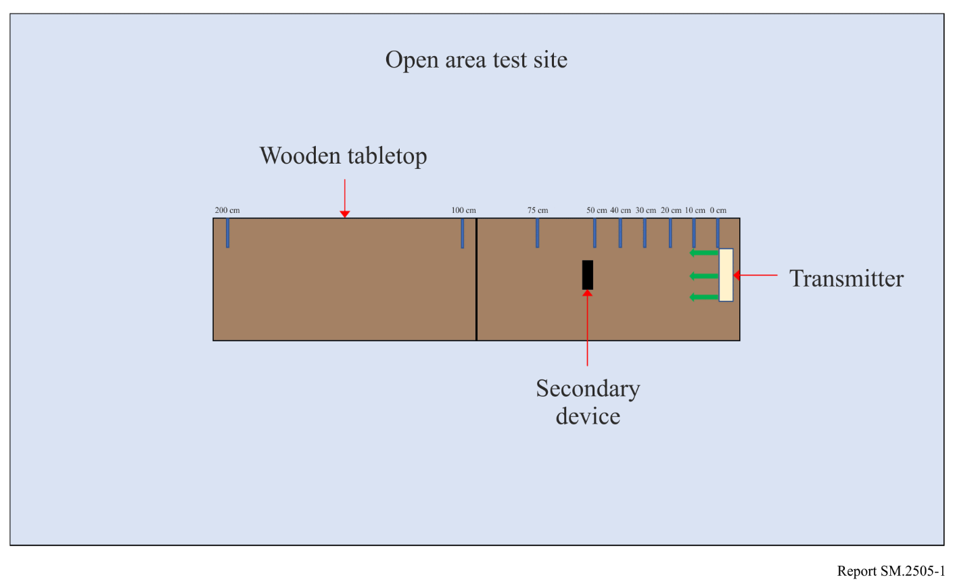
Figure 2
Test setup in room 2, anechoic chamber
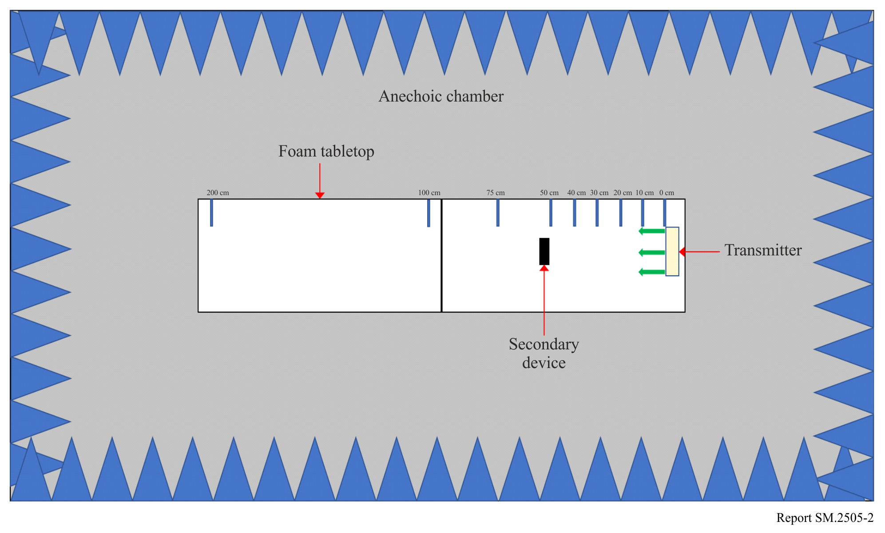
Tests were performed on the following types of wireless devices:
TABLE 2
Types of devices used, frequencies, and distances in Study A
No. | Type of device | Frequency range  (MHz) | Distances tested  (cm)
1 | Cellphone | Uplink: 888.0-915.0  Downlink: 925.2-960.0 | 0, 10, 20, 30, 40, 50, 70, 100
2 | Cellphone | Uplink: 888.0-915.0  Downlink: 925.2-960.0 | 0, 10, 20, 30, 40, 50, 70, 100
3 | Cellphone | Uplink: 888.0-915.0  Downlink: 925.2-960.0 | 0, 10, 20, 30, 40, 50, 70, 100
4 | Cellphone | Uplink: 888.0-915.0  Downlink: 925.2-960.0 | 0, 10, 20, 30, 40, 50, 70, 100
5 | Wireless Microphone and base station | 904.45-927.45  User Selectable | 0, 10, 30, 100, 200
6 | Assisted listening device | 863.25-864.75  User Selectable | 0, 10, 30, 100, 200
7 | Assisted listening device | 904.65-926.85  User Selectable | 0, 10, 30, 100, 200
8 | RFID reader | 903-927  Hopping | 0, 10, 30, 100, 200
9 | RFID reader | 865-868  Hopping | 0, 10, 30, 100, 200

Cellphone. The DUT was placed 100 cm from a mobile phone simulating a desktop environment. The cell antenna, cabled to base station simulator, was placed 3 m from the DUT and mobile phone devices. A call from the mobile phone was established to the callbox in the GSM 900 Band, on a specific frequency. After the call was established, the DUT was switched on at 917.5 MHz. The charging signal was verified with a spectrum analyser positioned in the test area. The call was monitored for 60 seconds. After which the call state was logged (call maintained, or call dropped). The distance between the DUT and mobile phone was decreased incrementally until the mobile phone was touching the DUT, measured at 0 cm. Testing was performed using five different channels.
Figure 3
Cellphone impact test setup
Figure 4
Other In-band device impact test set up
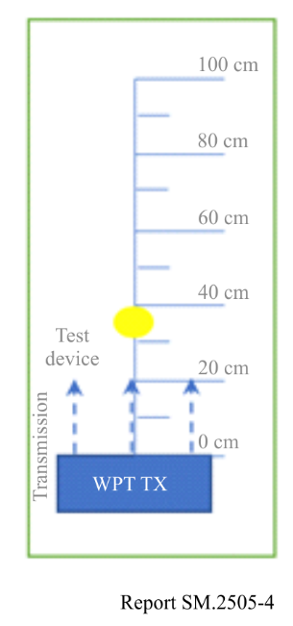
The results demonstrated that all phones were able to operate without harmful interference on at least one channel and on all channels when separated by 1 m or more from the DUT.
Wireless Microphone and base station. The base-station (receiver) was placed 30 cm from the DUT, and the Microphone (Transmitter) moved through the test distances. Subsequently, the Microphone (Transmitter) was placed 30 cm from the DUT, and the Base-station (receiver) was moved through the test distances.
Setting the audio device frequency away from that of the DUT resulted in little to no harmful interference. When operating at or close to the transmit frequency of the DUT, the devices suffered harmful interference.
Assisted listening device. The Transmitter was placed 30 cm from the DUT, and the Receiver was moved through the test distances. Following this, the Receiver was placed 30 cm from the DUT, and the Transmitter was moved through the test distances.
Setting the audio device frequency away from that of the DUT resulted in little to no harmful interference. When operating at or close to the transmit frequency of the DUT, the devices suffered harmful interference.
RFID reader. For the first device, scans were performed at 903.250; 904.250; 915.250; 915.750; 920.250; 926.750; and 927.250 MHz. The software transmitting setting was set to 30 dBm. RFID tags were then placed 30 cm from the DUT. For the second, scans were performed at 865.00; 866.00; 867.00; and 868.00 MHz with default settings. RFID tags were then placed 30 cm from the DUT.
At separation distances of 1 m or greater between the DUT and RFID reader and tags, the readers worked without error.

3.2 Study B (915-921 MHz)
A single client RF near-field contact charger, the device under testing (DUT), that operates when a receiving device is placed on the charger surface was tested for impact to demonstrate interoperability with other wireless devices and technologies. The DUT used Bluetooth Low Energy (BLE) to pair with the receiving device and transmitted a continuous carrier wave signal adjustable between 915 MHz and 921 MHz. The maximum declared average power was 33.0 dBm per port, with a measured ERP of 1.0 W, and EIRP of 1.64 W. The DUT is designed to charge other devices that rest on its surface. Additionally, the DUT is compliant with Title 47, Chapter I, Subchapter A, Part 15 of the United States Electronic Code of Federal Regulations, which, inter alia, requires that devices cause no harmful interference and accept interference caused by the operation of an authorized radio station, by another intentional or unintentional radiator, by industrial, scientific and medical (ISM) equipment, or by an incidental radiator.
The tests were performed in two separate rooms. The first was a real-world test performed in a regular room and on a wooden countertop where other signals were present, as illustrated in Fig. 5. As an example of the types of signals present, a nearby train station regularly emits 900 MHz signals that are detectable in the room. The second room was an anechoic chamber, as described in ETSI EN 302 208 V3.1.1 (2016-11) Annex B.1.2 and as illustrated in Fig. 6. This anechoic chamber was used to demonstrate whether the results found in the regular room were repeatable in a free-space environment and whether any degradation of signal was due to the noisy environment. The tests were performed in the exact same manner, detailed further below, in each room. The results from each of the tests did not have any discrepancies; as such, only one set of results is presented below.
Figure 5
Test setup in room 1, open area
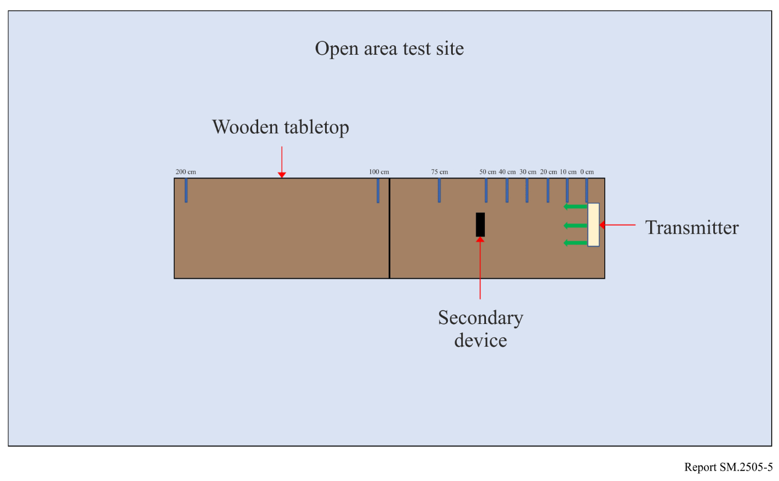
Figure 6
Test setup in room 2, anechoic chamber
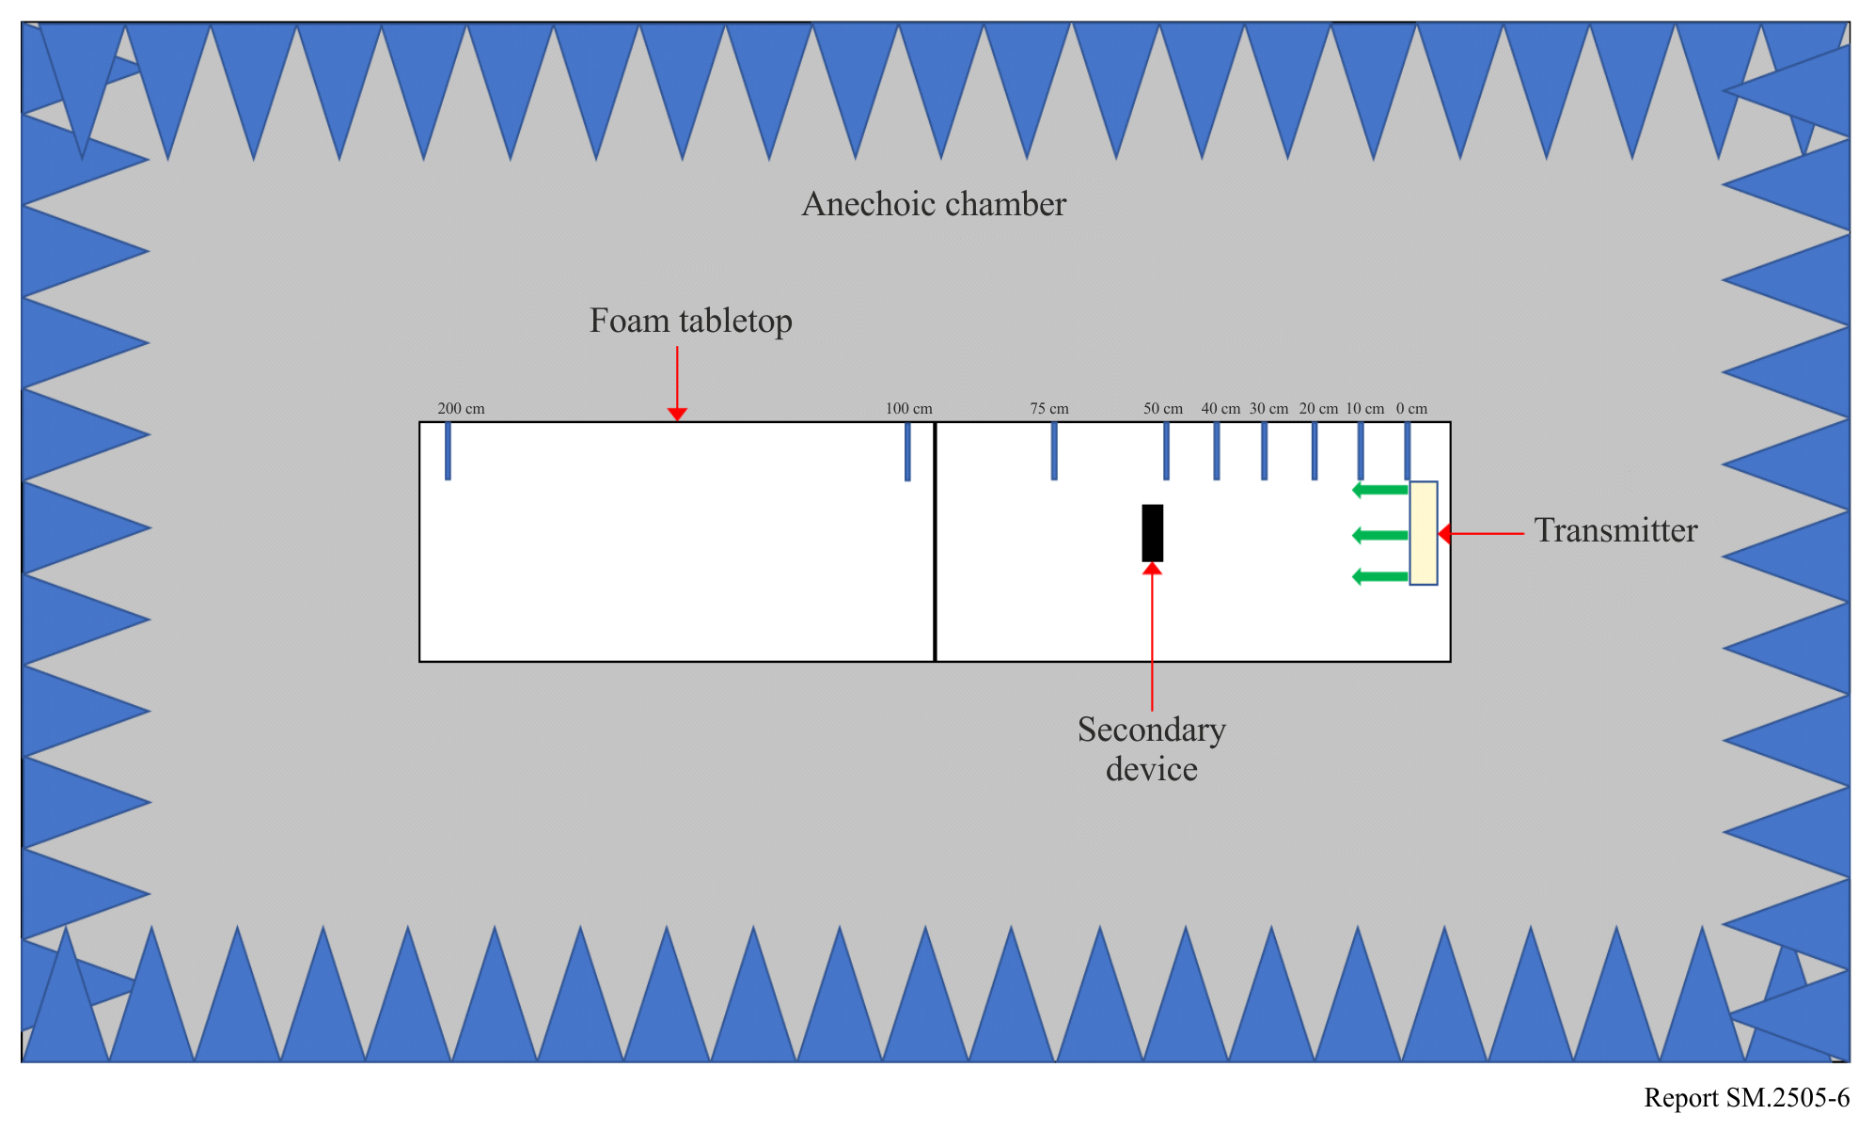
Tests were performed on the following types of wireless devices:
TABLE 3
Types of devices used, frequencies, and distances in Study B
No. | Type of device | Frequency range  (MHz) | Distances tested  (cm)
1 | Cellphone | Uplink: 888.0-915.0  Downlink: 925.2-960.0 | 0, 10, 20, 30, 40, 50
2 | Cellphone | Uplink: 888.0-915.0  Downlink: 925.2-960.0 | 0, 10, 20, 30, 40, 50
3 | Cellphone | Uplink: 888.0-915.0  Downlink: 925.2-960.0 | 0, 10, 20, 30, 40, 50
4 | Cellphone | Uplink: 888.0-915.0  Downlink: 925.2-960.0 | 0, 10, 20, 30, 40, 50
5 | Wireless Microphone and base station | 904.45-927.45  User Selectable | 0, 30, 100, 200
6 | Assisted listening device | 863.25-864.75  User Selectable | 0, 30, 100, 200
7 | RFID reader | 903-927  Hopping | 0, 10, 30, 100
8 | RFID reader | 865-868  Hopping | 0, 10, 30, 100
9 | Smart hub | 903-914 | 10, 30, 100
10 | Push button | 916 | 10, 30, 100
NOTE: The smart hub (device no. 9) and push button (device no. 10) use LoRa technology and were tested together.
Cellphone. The DUT was placed 50 cm from a mobile phone. A call to the mobile phone was setup to the callbox in the GSM 900 band on a specific frequency. The call box antenna was placed 50 cm away from the mobile phone. A call was setup between the callbox and the mobile phone under test. Then the DUT was turned on and set to a specific frequency. The call was monitored for 60 seconds. After which the call state was logged (call maintained or call dropped.). The DUT was then moved 10 cm closer to the mobile phone and the process repeated. This was continued until the DUT was touching the mobile phone (distance = 0 cm).
No harmful interference was observed for any of the test configurations.
Wireless microphone and base station. Four sets of tests were performed. For the first two, the base station (receiver) was placed 30 cm from the Charger, and the Microphone (Transmitter) was moved through the test distances. The DUT operated at 918 MHz for the first test, then 917.5 MHz for the second. For the third and fourth tests, the Microphone (Transmitter) was placed 30 cm from the Charger, and the base station (receiver) was moved through the test distances. Again, the tests were performed once with the DUT at 918 MHz then once at 917.5 MHz.
The microphone did not experience noticeable harmful interference except when it operated at 917.65 MHz; when the DUT operated at 918 MHz, this harmful interference was only experienced when the Microphone was within 30 cm of the DUT.
Assisted listening device. Four sets of tests were performed. For the first two tests, the Transmitter was placed 30 cm from the Charger, then the Receiver moved through the test distances. The DUT operated at 918 MHz for the first test, then 917.5 MHz for the second. For the third and fourth tests, the Receiver was placed 30 cm from the Charger, then the Transmitter was moved through the test distances. Again, the tests were performed once with the DUT at 918 MHz then once at 917.5 MHz.
The tests show that the assisted listening device was not affected by the DUT due to the frequency offset between the two devices.
RFID reader. The first device, scans were performed at 903.250; 904.250; 915.250; 915.750; 920.250; 926.750; and 927.250 MHz. The transmit settings was set to 30 dBm in software, and the receive was set to 0 dBm. The RFID tag was placed 30 cm from the DUT, with its operating frequencies at 918 MHz then 917.5 MHz. The second reader was set to scan at 865.00; 866.00; 867.00; and 868.00 MHz. Default settings were used for the tests. The RFID tag was placed 30 cm from the DUT, with its operating frequency set to 918 MHz.
The results show that the RFID devices operated without significant degradation at separation distances greater than 30 cm.
Smart hub with push button. The smart hub and push button were operated using default settings, with the smart hub placed 30 cm from the DUT. The results demonstrated that the smart hub with push button operated without degradation under all of the configurations assessed.

3.3 Study C (917-920 MHz, 2 410-2 486 MHz, and 5 738-5 766 MHz)
Study C shows a summary of the study taken in new rulemaking in Japan on beam WPT technology in 917-920 MHz, 2 410-2 486 MHz and 5 738-5 766 MHz. The Ministry of Internal Affairs and Communications (MIC) of Japan amended relevant ministerial ordinances in May 2022 to issue ‘premises radio station’ licenses to some types of beam WPT devices. The ‘premises radio station’ is an existing kind of station, which is not defined in the RR but is a part of national regulatory measures. A new organization named JWPT (Japan Coordinating Council for Wireless Power Transfer) was established in January 2022 for the operational coordination support to prevent harmful interference between beam WPT and other radiocommunication services. The MIC conducts examination of applications for the WPT ‘premises radio station’ licenses with reference to the result of the operational coordination.

3.3.1 Frequency bands and incumbent radiocommunication systems and services considered in the study
Incumbent radiocommunication systems and services adjacent to or included in 917-920 MHz, 2 410-2 486 MHz and 5 738-5 766 MHz, which were considered in the study, are listed in Table 4, Table 5 and Table 6 respectively.
TABLE 4
917-920 MHz radiocommunication systems and services considered in the study
System | Frequency  (MHz) | Protection criterion | References
Digital MCA Service | 930-940  (uplink) | –108.8 dBm/MHz  (in band)  –51 dBm (out of band) | ARIB⁽¹⁾ STD-T85  (Japan)
940-945
(downlink)
Advanced MCA Service | 895-900  (uplink) | –110.8 dBm/MHz  (in band)  –44 dBm (out of band, 12.5 MHz separation) | 3GPP TS36 104 ｖ8.3.0 (2008-9)
 | 850-860  (downlink) | –119 dBm/MHz (in band)  –43 dBm (out of band, modulation)  –15 dBm (out of band, CW) | 3GPP TS36 104 ｖ8.3.0 (2008-9)
LTE-A (Band 8) | 900-915  (uplink) | –110.8 dBm/MHz  (in band)  –44 dBm (out of band, 12.5 MHz separation) | 3GPP TS36 104 ｖ8.3.0 (2008-9)
 | 945-960  (downlink) | –119 dBm/MHz (in band)  –43 dBm (out of band, modulation)  –15 dBm (out of band, CW) | 3GPP TS36 104 ｖ8.3.0 (2008-9)
RFID (Passive) | 916.7-923.5 | –81 dBm/MHz (in band)  –30 dBm (out of band, 2 MHz separation) | ARIB STD-T106  ARIB STD-T107  (Japan)
RFID (Active) | 915.9-929.7 | –127 dBm/MHz  (in band)  –80 dBm (out of band) | ARIB STD-T108  (Japan)
Radio astronomy | 1 400-1 427 | –197.4 dBm/MHz | Rec. ITU-R RA.769-2
⁽¹⁾ Association of Radio Industries and Businesses (https://www.arib.or.jp/english/)

TABLE 5
2 410-2 486 MHz radiocommunication systems and services considered in the study
System | Frequency  (MHz) | Protection criterion | References
Wireless LAN | 2 400-2 497 | –92 dBm (co channel)  –66 dBm (adjacent channel),  –50 dBm (alternate adjacent channel) | IEEE Std.802.11-2016
Premises radio | 2 400-2 483.5 | –98 dBm  (including 11 dBi  antenna gain) | ARIB RCR STD-1  ARIB RCR STD-29  (Japan)
Unmanned mobile image transmission system (Wireless system for drones and other unmanned vehicles) | 2 483.5-2 494 | –98 dBm (co channel)  –72 dBm (adjacent channel),  –56 dBm (alternate adjacent channel)  (including 6 dBi  antenna gain) | Report on MIC Advisory No. 2034  (Japan)
Geostationary Mobile Satellite Service | 2 500-2 535 | –124.9 dBm/MHz  (in band)  –41 dBm  (out of band,  10-25 MHz separation) | Report on MIC Advisory No. 2032  (Japan)
Non-Geostationary Mobile Satellite Service | 2 483.55-2 500 | –119.4 dBm/MHz | Report on MIC Advisory No. 82  (Japan)
Broadcasting Service: Field Pickup (FPU) | 2 330-2 370 | –102 dBm/MHz  (mobile relay Uplink) | Report on MIC Advisory No. 2024  (Japan)
Radio astronomy | 2 695 | –187 dBm/MHz | Rec. ITU-R RA.769-2
Amateur radio | 2 400-2 450 | –110.83 dBm/MHz | JARL⁽¹⁾ requirement
⁽¹⁾ The Japan Amateur Radio League, Inc. (https://www.jarl.org/English/0-2.htm)

TABLE 6
5 738-5 766 MHz radiocommunication systems and services considered in the study
System | Frequency  (MHz) | Protection criterion | References
Wireless LAN (W56) | 5 470-5 730 | –63 dBm (adjacent channel),  –47 dBm (alternate adjacent channel) | IEEE Std.802.11-2016
Dedicated Short Range Communication (DSRC) | 5 770-5 850 | –42 dBm  (class-2, spurs response rejection),  –100 dBm (class-2) | ARIB STD-T75  (Japan)
Broadcasting Service: Studio to Transmitter Link (STL) and Transmitter to Transmitter Link (TTL) | 5 850-5 925 | –101.6 dBm  (equivalent thermal noise level) | ARIB_STD-B22  (Japan)
Broadcasting Service: Field Pickup (FPU) and Transmitter to Studio Link (TSL) systems | 5 850-5 925 | –89.4 dBm  (FPU fixed relay station) | ARIB STD-B33  (Japan)
Unmanned mobile image transmission system (Wireless system for drones and other unmanned vehicles) | 5 650-5 755 | –98 dBm (in-band),  –72 dBm (adjacent channel),  –56 dBm (alternate adjacent channel) | Report on MIC Advisory No. 2034  (Japan)
Weather radar | 5 250-5 372.5 | –120 dBm (noise),  –40 dBm (CW) | Rec. ITU-R M.1849-2
Radio astronomy | 4 700-5 140,  3 000-14 000 | –187 dBm/MHz | Rec. ITU-R RA.769-2
Amateur radio | 5 650-5 850 | –110.83 dBm/MHz | JARL requirement

3.3.2 Specifications and parameters used for the study
Expected specifications and system parameters used for the study are shown in Table 7 and in Figs 7 to 9.
TABLE 7
Expected specifications of beam WPT commercial systems considered
 | System 4  920 MHz band | System 5  2.4 GHz band | System 6  5.7 GHz band
Transmitter antenna output power | 1 W (30 dBm) | 15 W (41.8 dBm) | 32 W (45.0 dBm)
Frequency channels | 918.0, 919.2 MHz  (2 channels) | 2 412, 2 437, 2 462, 2 484 MHz  (4 channels) | 5 740, 5 742, 5 744, 5 746, 5 748, 5 750, 5 752, 5 758, 5 764 MHz  (9 channels)
e.i.r.p | 36 dBm Max. | 65.8 dBm Max. | 70.0 dBm Max.
Tolerance of occupied bandwidth | 200 kHz | Not specified | Not specified
Transmitter antenna directive gain | 6.0 dBi | 24.0 dBi | 25.0 dBi
Location and height of transmitter antenna | Located indoor area | Located indoor area and set on ceiling to look down | Located indoor area and set on ceiling to look down
 | 2.5 m above floor | 5.0 m above floor | 4.6 m above floor
Transmitter antenna directive pattern | Figure 7 | Figure 8 | Figure 9
Usage environment | Indoor | Indoor | Indoor
 | WPT controlled environment  and/or WPT general environment | WPT controlled environment | WPT controlled environment
Modulation | Not specified | CW | CW
Building entry loss | 10.0 dB | 14.0 dB | 16.0 dB

‘WPT controlled environment’ and ‘WPT general environment’ are defined. ‘WPT controlled environment’ is defined as:
– Indoor and closed area;
– Environment where limits of Japanese radio exposure guidelines in controllable area can be cleared, and/or the manager/administrator can cut off power transfer of beam WPT systems when limits of Japanese radio exposure guidelines in controllable area are happened to be not cleared;
– Environment where the manager/administrator can manage and control both of beam WPT systems and incumbent radio communication services in order to avoid or reduce harmful interference from beam WPT systems.
‘WPT general environment’ are defined as the other environment where the above conditions cannot be met.
FIGURE 7
Transmitter antenna directive pattern for 920 MHz band
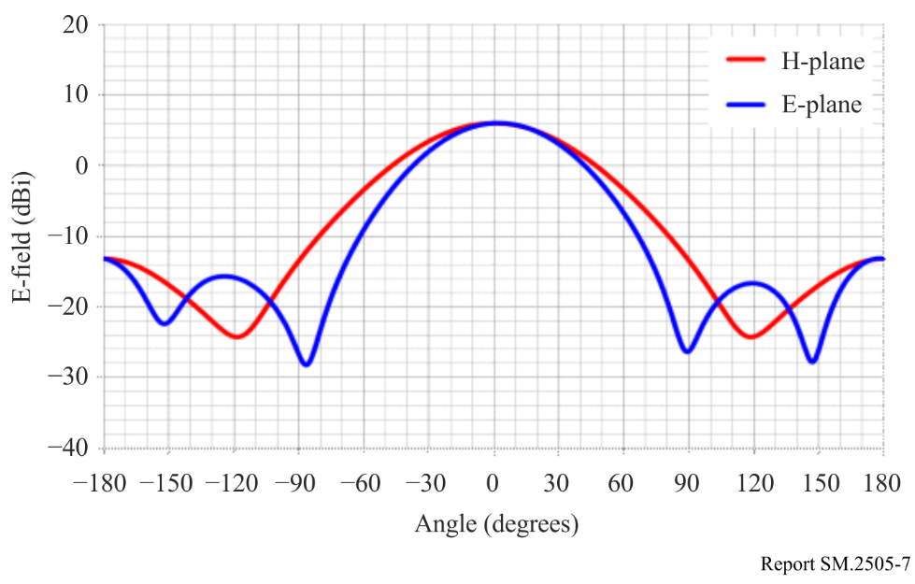
FIGURE 8
Transmitter antenna directive pattern for 2.4 GHz band
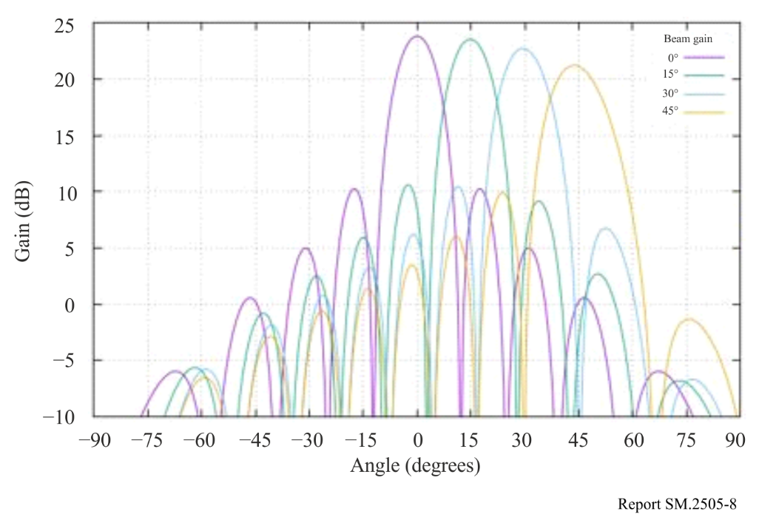
FIGURE 9
Transmitter antenna directive pattern for 5.7 GHz band
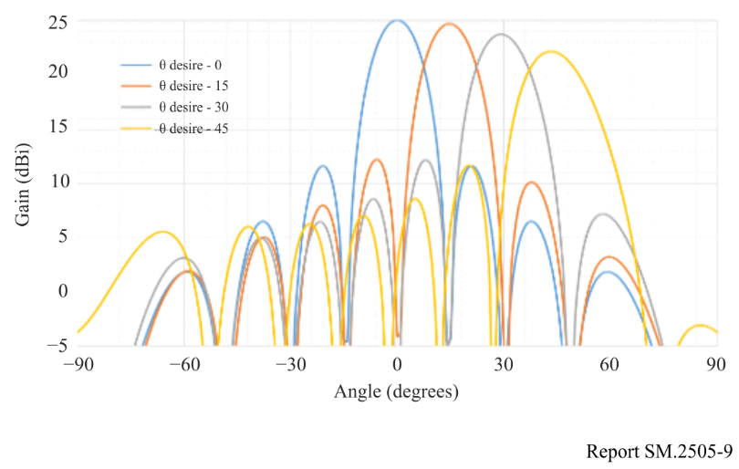

3.3.3 Building entry loss consideration
The study referred to building entry loss defined in Section 3 of Recommendation ITU-R P.2109-1.
The building entry loss value depends on the outer wall material. Two building types are shown in Recommendation ITU-R P.2109-1. One is ‘Thermally efficient’ that uses heat shield and heat insulating material with high electromagnetic wave reflection characteristics. The other is ‘Traditional’ that does not use them. The median loss L_{h} can be given by the calculation formula shown below. Moreover, the loss also depends on the frequency.

$L_{h}=r+slog\left(f\right)+t{\left(\log\left(f\right)\right)}^{2}$

where r, s, and t are the constants shown in Table 8, and f is the frequency (GHz). Table 9 shows the calculation results for the median loss for the representative frequencies of the three frequency bands used in the wireless power transmission systems via radio frequency beam.
According to Fig. 1 of Recommendation ITU-R P.2109-1, the ‘Thermally efficient’ building type has a large loss by about 15 dB compared to ‘Traditional’, but it is unlikely that thermally efficient construction materials are used for all outer walls of the buildings. The examination was based on the value of the ‘Traditional’ type.
TABLE 8
Model coefficients used for building entry loss calculation
in Recommendation ITU-R P.2109-1
Item | r | s | t
Traditional | 12.64 | 3.72 | 0.96
Thermally efficient | 28.19 | –3.00 | 8.48

TABLE 9
Calculation results of the median loss for the three frequency bands used in beam WPT
Item | 920 MHz | 2 450 MHz | 5 750 MHz
Lh (Traditional) | 12.5 dB | 14.2 dB | 16.0 dB
Lh (Thermally efficient) | 28.3 dB | 28.3 dB | 30.8 dB

TABLE 10
Building entry loss used for the studies on the impact of beam WPT
Item | 920 MHz | 2.4 GHz | 5.7 GHz
Wall loss | 10.0 dB | 14.0 dB | 16.0 dB

3.3.4 Use case scenarios and conditions for Impact Studies on beam WPT
Table 11 shows the use case scenarios and conditions for Impact Studies on beam WPT systems used for impact studies.
The System 4 is mainly used in WPT for wireless-powered sensor network. The System 4 is used in indoor and controlled environment where WPT equipment is controlled by managers of factories, nursing homes and so on. The power consumption of the sensor is about several hundred μW or less.
The System 5 and the System 6 are mainly used in WPT for small displays in addition to the application of the System 4. The System 5 and the System 6 are used in indoor and controlled environment where WPT equipment is controlled by managers of factories, plants, warehouses and so on. The power transmission to the receiver devices requires up to several watts.
TABLE 11
Use case scenarios and conditions for beam WPT systems
Beam WPT system | System 4  920 MHz band | System 5  2.4 GHz band | System 6  5.7 GHz band
Usage environment | Factory (Indoor), nursing home, etc. | Factory (indoor), plant (indoor), warehouse, etc. | Factory (indoor), plant (indoor), warehouse, etc.
Application | Charging and power supply to sensor network | Charging and power supply to sensors, display and information devices | Charging and power supply to sensors, display and information devices
Number of receiving devices per one WPT transmitter | 5 to 10 devices  (Simultaneous reception) | 1 to several ten devices  (Successive or sequential reception) | 1 to several ten devices  (Successive or sequential reception)
Power range | Several μW to several hundred μW | 50 mW to 2 W | Several mW to several hundred mW
Power transfer distance | Less than 5 m | Less than 10 m | Less than 10 m
TABLE 11 (end)
Beam WPT system | System 4  920 MHz band | System 5  2.4 GHz band | System 6  5.7 GHz band
Coexistence with other wireless systems | Feasible. Take appropriate interference mitigation and radio protection measures | Feasible. Take appropriate interference mitigation and radio protection measures | Feasible. Take appropriate interference mitigation and radio protection measures
Power transfer while human bodies exist | Possible to transfer under the condition that limits of national radio exposure guidelines are cleared | Off | Off

3.3.5 Study results
For the WPT systems intended the operation in the 920 MHz band, the system parameters assumed for the impact study (see Table 7) were compliant with the radio regulation including transmission intervals for the RFID systems currently operated in the same frequency range. Minimum separation distances were derived in accordance with the beam WPT characteristics for the case geographical separation distance is necessary to regulate. In addition, Monte-Carlo system-level simulation was performed to assess interfering likelihood from beam WPT to LTE and MCA mobile communication networks.
For the beam WPT systems intended for the operation in the 2.4 GHz band and 5.7 GHz band, the study was conducted with the system parameters (see Table 7) to determine required technical requirements and operational conditions under the current radio regulation including frequency allocation and operational conditions. Study results in 2.4 GHz band and 5.7 GHz band are summarized as follows:
1) Clear Channel Assessment (CCA) mechanism shall be adopted to coexist with WLAN systems and / or Specified Low Power Radio Stations. It turned out that WLAN system performance such as throughput can be maintained without harmful interference by adding CCA mechanism.
2) For radioastronomy, weather radar and Radio Beacon services, minimum separation distances were specified.
3) For broadcasting systems, mobile satellite communication systems and Dedicated Short Range Communication (DSRC) system, minimum separation distances were specified. In addition, operational coordination was addressed for the case beam WPT causes harmful interference.
4) For unmanned mobile image transmission system (i.e. a wireless communication system for drones and other unmanned vehicles), studies assuming practical use cases showed that spectrum sharing without causing harmful impact was possible by operational coordination as needed between WPT systems and unmanned mobile image transmission systems.
5) For amateur radio services, beam WPT installation conditions for spectrum sharing were specified. In addition, beam WPT systems shall not use the frequency band for Earth-Moon-Earth (EME) systems and repeater systems. Operational coordination is undertaken between WPT systems and amateur radio systems.
Furthermore, a comprehensive beam WPT management rule regarding WPT operation environment and WPT radio frequency EMFs was defined and can be applied specific use cases using the frequency bands to abide by the Radio Radiation Protection Guidelines. See Annex 1 for details. Thus, required technical requirements and operational conditions not to cause harmful impact to the existing systems and services were determined.
Below shows individual summaries of the study per incumbent system.

3.3.5.1 917-920 MHz
(1) Digital MCA service
The study referred to the examination methodologies and results on the past coexistence study when RFID system was introduced in 917-920 MHz. Beam WPT in the band was assumed almost the same technical conditions for assessment as RFID. Possibility of harmful impact is extremely low while keeping the given conditions and expecting additional propagation loss due to building entry loss. The condition includes the separation distance, adjustment of setting conditions and measures to mitigate interferences.
(2) Advanced MCA service
WPT can be shared by the control station (base station: downlink) by considering vertical directivity.
The mobile station (uplink) can be shared when both systems do not exist in the same room, which was shown by Monte-Carlo simulation using the extended Hata formula (300 m or less).
In the case of the same room, the required improvement amount is about 10 dB, but it can be shared because it is expected to be attenuated by obstacles and the human body in the room.
However, regarding the use with the WPT system in the same room, the WPT users will be alerted the possibility of interference to MCA stations.
(3) LTE-A (Band 8)
The WPT system can be shared in a WPT general environment even when there is no transmission time limit. On the other hand, the WPT system can be shared in the management environment by limiting the transmission time (stopping transmission for 50 ms within 4 seconds of the transmission).
(4) RFID (Passive)
The WPT system and RFID system can be shared on the same channel if a separation distance of about 6 m is secured. If the separation distance cannot be secured, those system can coexist by changing the WPT transmit channel and/or RFID channel, or shield with a wall.
(5) RFID (Active)
The passive RFID system is assumed coexisting with the active RFID system. The WPT system can be coexist with active RFID system because of the specification of WPT system is almost same as passive RFID interrogator.
(6) Radio astronomy
The minimum separation distance at the same altitudes was calculated with the free space loss model to be 37.5 km using the measured spurious emission level of –60.5 dBm/MHz. A WPT system will be located outside a restricted area with the minimum separation distance from a radio astronomy station. When a WPT system or a radio astronomy station are located with different altitude, the minimum separation distance would be different from that calculated above.

3.3.5.2 2 410-2 486 MHz
Radio characteristics example of beam WPT (non-ISM) is shown in Table 1.
(1) Wireless LAN
The simulation using the CCA mechanism on the beam WPT system was conducted to study the impact to the Wi-Fi devices located outside of the WPT controlled environment. The decline of the throughput of those Wi-Fi devices could be suppressed with appropriate parameters of CCA mechanism, compared with the case when another Wi-Fi AP was operated at the same location instead of the beam WPT inside the WPT controlled environment. Antenna directions should be adjusted not to directly face each other to prevent the device being damaged.
(2) Premises radio
Within the beam WPT controlled environment the operation of the premises radio can be managed and controlled by the same operator as for the beam WPT. Moreover, within the 84.9 m from the beam WPT location it can be suppressed the transmission with the CCA mechanism when premises radio is transmitting. Antenna directions should be adjusted not to directly face each other to prevent the device being damaged.
(3) Unmanned mobile image transmission system
Separation distance was calculated with extended Hata model and it is 3.6 km on co channel from the beam WPT to the Unmanned mobile image transmission system outdoor. However, since the system is usually operated outside the cities and the usage time and places are planned, the harmful interference can be avoided by the coordination procedure.
(4) Geostationary mobile satellite service
Separation distance was calculated with worst case scenario of out of band interference, where antenna directivity direction of the GEO MSS receiver was perfectly matched to the beam direction of the beam WPT. It is 30 m in the northern part of Japan. With the separation distance and coordination procedure if necessary, harmful interference can be avoided. If necessary, the operational coordination is performed between WPT systems and mobile satellite communication systems.
(5) Non-geostationary mobile satellite service
Separation distance was calculated of in band interference with extend Hata model and it was 0.96 km. Since Non-Geostationary Mobile Satellite Service is generally used in the location where cellular mobile system cannot be reached in Japan and the beam WPT does not possibly exist, the harmful interference can be avoided. If necessary, the operational coordination is performed between WPT systems and mobile satellite communication systems.
(6) Broadcasting service: Field Pickup (mobile Electronic News Gathering)
Separation distance was calculated in various scenarios and systems and with the antenna directivity it does not cause harmful interference when satisfying 10 m separation distance outside the WPT controlled environment. BEAM WPT systems shall abide by the condition of the necessary separation distance and installation.
(7) Radio astronomy
Separation distance was calculated for each radio astronomy station operating 2 695 MHz considering clutter loss. The minimum separation distances at the same altitudes are 5.7 km or 1.6 km depending on the environment of the site. To avoid the harmful interference to a radio astronomy station a restricted area with these separation distances around the radio astronomy station will be established. The beam WPT antenna is installed on the ceiling and radiates primarily downward. The horizontal radiation limit is defined in terms of e.i.r.p.. For this reason, horizontal radiation from inside the building to the outside will be the worst-case scenario when both a WPT station and a radio astronomy station have the same altitudes.
When the altitude of the radio astronomy station is higher than the WPT station, the directivity gain becomes lower and the separation distance becomes shorter. On the other hand, when the altitude of the radio astronomy station is lower than the WPT station, the directivity gain becomes higher and the separation distance becomes longer.
(8) Impact study for Radio Amateur
Separation distance was calculated considering clutter loss. Two out of four frequencies of beam WPT are co-channel with Radio Amateur, which need 4.4 km separation distance with 18 dBi Radio Amateur antenna. Considering antenna directive loss and using adjacent band if necessary, the harmful interference can be avoided. If necessary, the operational coordination is performed between WPT systems and amateur radio systems.

3.3.5.3 5 738-5 766 MHz
(1) Wireless LAN
Simulation was conducted to study the impact of the beam WPT system to the Wi-Fi system that operate outside the WPT controlled environment. When CCA mechanism with appropriate parameters was applied to the beam WPT system, the impact to the Wi-Fi throughput was equivalent to the case when another Wi-Fi system existed instead of the beam WPT system. In the WPT controlled environment, assuming the condition to be under control by the identical system operator of both systems, carrier sensing works well. Antenna directions should be adjusted not to directly face each other to prevent the device being damaged.
(2) Dedicated Short Range Communication (DSRC)
Study on separation distance was made for the worst-case scenario, where antenna directivity of the DSRC system perfectly matched to the beam direction of the beam WPT system. The separation distance was calculated with free space loss model to be 2.6 km from the beam WPT system to the DSRC Class 2 base station. Additional propagation loss due to building entry loss and directivity loss of DSRC antenna can be expected to further avoid harmful interference.
(3) Broadcasting service: Studio to Transmitter Link (STL) and Transmitter to Transmitter Link (TTL)
Separation distance was calculated with free space loss model to be 836 m for out band noise signal from the beam WPT to the STL/TTL base station. When difference in height is more than 5 m, 20 dB of directivity loss of STL/TTL antenna can be expected to further avoid harmful interference.
(4) Broadcasting service: Field Pickup (FPU) and Transmitter to Studio Link (TSL) systems
Separation distance was calculated to be 80 m for out band noise signal from the beam WPT to the FPU base station. When difference in height is more than 25 m, more than 14 dB of directivity loss of FPU antenna can be expected to further avoid harmful interference.
Separation distance was calculated with free space loss model to be 1 485 m for out band noise signal from the beam WPT system to the TSL base station. When difference in height is more than 7 m, 20 dB of directivity loss of STL/TTL antenna can be expected to further avoid harmful interference.
(5) Unmanned mobile image transmission system
Separation distance was calculated with free space loss model to be 23 km on co-channel and 185 m on the alternate adjacent channel from the beam WPT system to the unmanned mobile image transmission system outdoor, respectively. However, since the system is usually operated outside the cities and the usage time and places are scheduled, harmful interference can be avoided by such as coordination procedure.
(6) Weather radar
Separation distance was calculated with free space loss model to be 3 308 m for out band noise signal from the beam WPT system for each weather radar site. To avoid the harmful interference, separation distance should be kept.
(7) Radio astronomy
The minimum separation distances at the same altitudes were calculated with the free space loss model to be 1.1 km or 1.7 km for 4 995 MHz and 10 650 MHz radio astronomy stations. To avoid the harmful interference to a radio astronomy station, the minimum separation distance should be kept. The beam WPT antenna is installed on the ceiling and radiates primarily downward. The horizontal radiation limit is defined in terms of e.i.r.p. For this reason, horizontal radiation from inside the building to the outside will be the worst-case scenario.
When the altitude of the radio astronomy station is higher than the WPT station, the directivity gain becomes lower and the separation distance becomes shorter. On the other hand, when the altitude of the radio astronomy station is lower than the WPT station, the directivity gain becomes higher and the separation distance becomes longer.
(8) Impact study for Radio Amateur
Separation distance was studied considering clutter loss. The calculated separation distance with free space loss model was 1.5 km and 262 m for 30 dBi and 15 dBi Radio Amateur antennas, respectively. Antenna directivity and coordination procedure can avoid harmful interference. The operational coordination will be undertaken between WPT systems and amateur radio systems.

3.4 Study D (2 483.5-2 500 MHz)

3.4.1 General description
The frequency band 2 483.5-2 500 MHz has been used for systems of FS, Mobile, MSS, etc. Study D, provided by China, shows the simulation of compatibility analysis between the Beam WPT and the COMPASS GSO MSS system. Relevant parameters of the COMPASS GSO MSS system has been stipulated in the Recommendation ITU-R M.1184 − Technical characteristics of mobile satellite systems in the frequency bands below 3 GHz for use in developing criteria for sharing between the mobile-satellite service (MSS) and other services.
Figure 10 shows the corresponding simulation scenario, where the Beam WPT is settled in an ordinary wall room without fire-retardant coating. Assume that the transmitter of Beam WPT is placed beneath the indoor ceiling, 5 m above the ground. The COMPASS GSO MSS mobile terminal is placed outside, 10m away from the projection region of Beam WPT. When the Tx Beam WPT transmits radio signals downward, the signals penetrate the wall and may have the possibility causing interference to COMPASS GSO MSS mobile terminal.
By using the protection criteria of I/N = −6 dB and −10 dB, this study carries out the protection separation distance between the said Beam WPT transmitter and the COMPASS GSO MSS mobile terminal. Taking into account the lack of detailed parameters of Beam WPT devices, the study can only implement the parameters given in the Table 12.
FIGURE 10
The scenarios of Beam WPT with COMPASS GSO MSS receiver for interference simulation
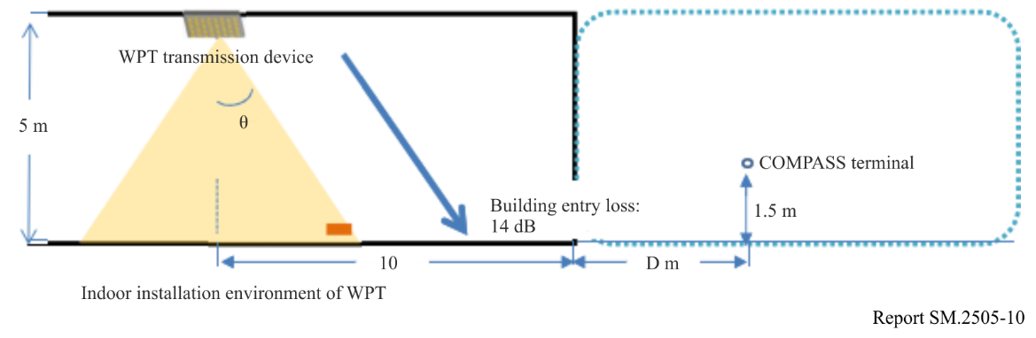

3.4.2 Parameters used in this study
The parameters used for simulation are shown in Table 12.
TABLE 12
Parameters used in the study
Beam WPT transmitters | Output Power | 15 W (41.8 dBm)
 | Centre frequency | 2 484 MHz
 | Bandwidth | 500 kHz,($Power Density=14.8 dBm/kHz$)  10 MHz,($Power Density =31.8 dBm/MHz$)
 | Location and height of transmitter antenna | Located indoor area and set on ceiling to look down
 |  | 5.0 m above floor
 | Transmitter antenna gain | Figure 11  （−5 dBi）
 | Building entry loss | 14.0 dB
COMPASS GSO MSS Receivers | Height of receivers | 1.5 m
 | Centre frequency | 2 491.5 MHz
 | Bandwidth | 16.5 MHz
 | Terminal noise temperature | 330K  （$N_{0}=-113.4142 dBm/MHz$）  （$N_{0}=-143.4142 dBm/kHz$）
Simulation conditions | Interference to noise ratio | −6 dB/ −10 dB
 | Location | Suburb
 | Propagation model | Hata model  $$L_{bs}=69.55+26.16 log\left(f\right)-13.82 log\left(h_{b}\right)-α\left(h_{m}\right)+\left(44.9-6.55lg\left(h_{b}\right)\right)∙log\left(d\right)-5.4-{2 (\log{(f/{28}))}}^{2}$$

Figure 11 shows the transmitter antenna pattern of WPT. This antenna pattern has been used in § 3.3 in the Study C. As is shown in the figure, due to the use of beam forming technology in WPT, it has five beams within 60 degrees of off-axis angle of the antenna. In order to calculate the maximum interference distance to COMPASS GSO MSS terminals, this study chose the same parameter as Study C, i.e. the beam with a phase adjustment of 60 degrees is mainly considered, and the off-axis angle of the transmitted signal is close to 90 degrees when the actual interference occurs (WPT height: 5 metres, MSS terminal height: 1.5 metres, the maximum interference distance between the both is greater than 100 metres). Therefore, the transmitting antenna gain can be set as −5 dBi.
Figure 11
Transmitter antenna pattern
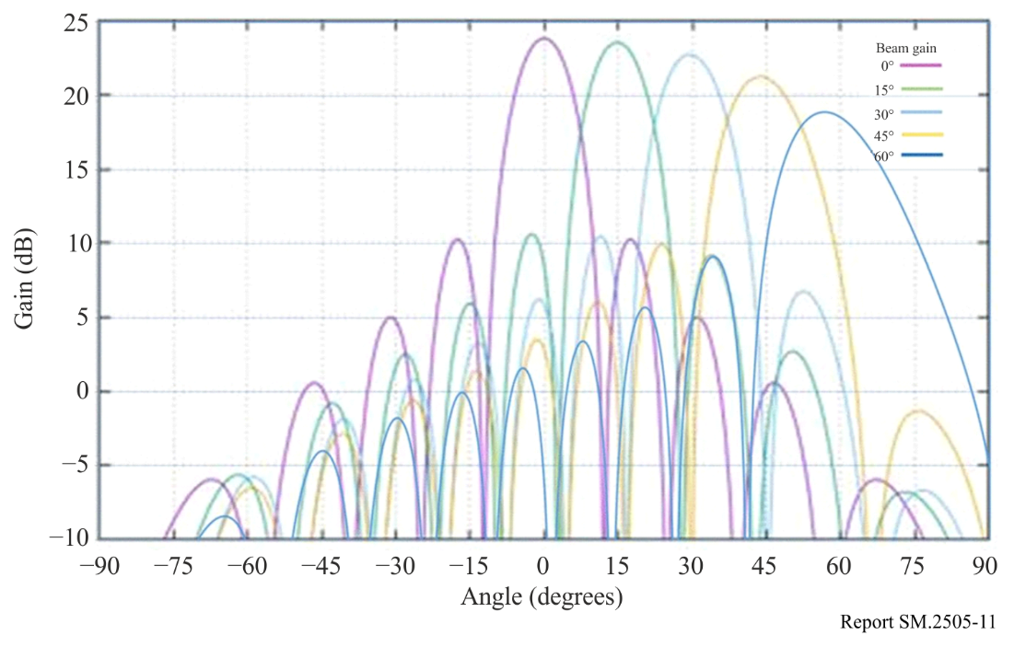

3.4.3 Study results
By considering that the Beam WPT’s transmission bandwidth is 500 kHz and 10 MHz respectively, relevant separation distances can be concluded as shown in Table 13 below. The separation ranges from 820 m to 2 160 m, between Beam WPT and COMPASS GSO MSS mobile terminal.
According to the descriptions from Report ITU-R SM.2392, some Beam WPT system operates indoor or outdoor. The actual interference situation needs further studies case by case, to determine whether the separation distance is enough or not (especially that 2 160 m is somehow a challenging separation distance for specific scenario).
It should also be highlighted, this study result is based on the parameters given in § 3.4.2, yet the parameters of future commercial products of Beam WPT and its implementing scenario are still unknown. Therefore, further studies are also needed.
TABLE 13
Maximum interference distance
I/N CRITERIA  BEAM WPT  Tx BW | −6 dB | −10 dB
500 kHz | 1.72 km | 2.16 km
10 MHz | 0.82 km | 1.03 km

3.5 Study E (915-921 MHz)
An over-the-air, distance charging transmitting device (DUT) operating between 915 MHz and 921 MHz was tested for impact to demonstrate interoperability with wireless devices and technologies operating in the same band. The DUT operates on a single channel with a bandwidth less than 400 kHz and maximum declared conducted average power of 40.0 dBm. The DUT is designed to charge other devices at a distance of up to 300 cm.
The tests were performed in two separate rooms. The first was a real-world test performed in a regular room and on a wooden countertop where other signals were present, as illustrated in Fig. 12. The second room was an anechoic chamber, as described in ETSI EN 302 208 V3.1.1 (2016-11) Annex B.1.2 and as illustrated in Fig. 13. This anechoic chamber was used to demonstrate whether the results found in the regular room were repeatable in a free-space environment and whether any degradation of signal was due to the noisy environment. The tests were performed in the exact same manner, detailed further below, in each room. The results from each of the tests did not have any discrepancies; as such, only one set of results is presented below.
Figure 12
Test setup in room 1, open area
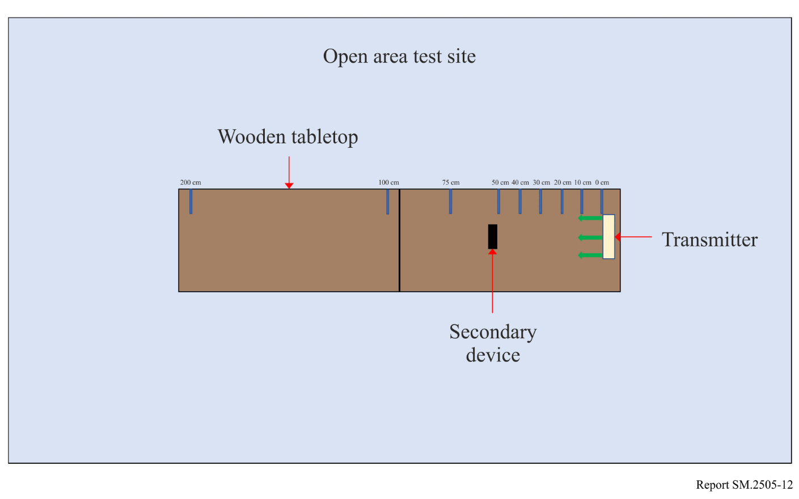
Figure 13
Test setup in room 2, anechoic chamber
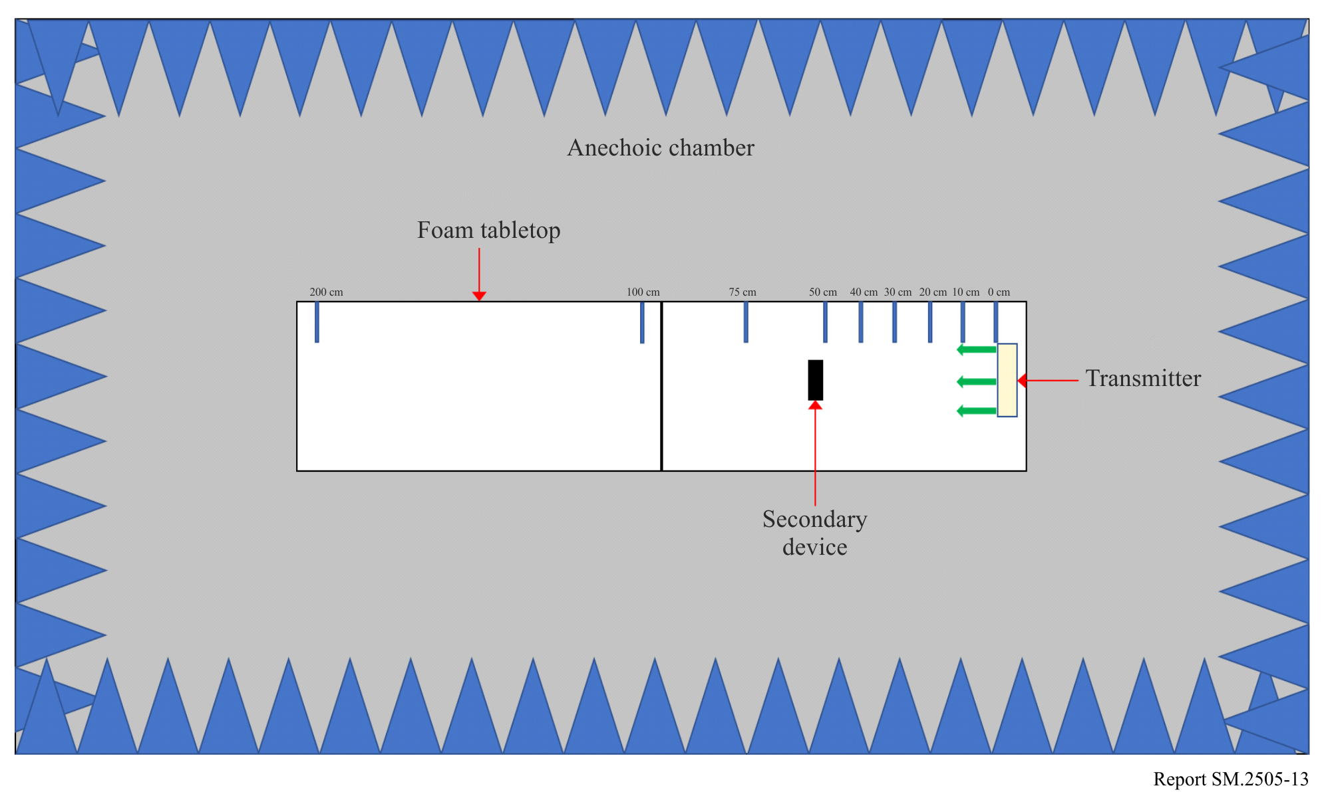
Tests were performed on the following types of wireless devices:
TABLE 14
Types of devices used, frequencies and distances in Study E
No. | Type of device | Frequency range  (MHz) | Distances tested  (cm)
1 | Cellphone | Uplink: 888.0-915.0  Downlink: 925.2-960.0 | 0, 10, 20, 30, 40, 50, 70, 100
2 | Cellphone | Uplink: 888.0-915.0  Downlink: 925.2-960.0 | 0, 10, 20, 30, 40, 50, 70, 100
3 | Cellphone | Uplink: 888.0-915.0  Downlink: 925.2-960.0 | 0, 10, 20, 30, 40, 50, 70, 100
4 | Cellphone | Uplink: 888.0-915.0  Downlink: 925.2-960.0 | 0, 10, 20, 30, 40, 50, 70, 100
5 | Wireless Microphone and base station | 904.45-927.45  User selectable | 0, 10, 30, 100, 200
6 | Assisted listening device | 863.25-864.75  User selectable | 0, 10, 30, 100, 200
7 | Assisted listening device | 904.65-926.85  User selectable | 0, 10, 30, 100, 200
8 | RFID reader | 903-927  Hopping | 0, 10, 30, 100, 200
9 | RFID reader | 865-868  Hopping | 0, 10, 30, 100, 200

Cellphone. The DUT was placed 100 cm from a mobile phone simulating a desktop environment. The cell antenna, cabled to base station simulator, was placed 3 m from the DUT and mobile phone devices. A call from the mobile phone was established to the callbox in the GSM 900 Band, on a specific frequency. After the call was established, the DUT was switched on at 917.5 MHz. The charging signal was verified with a spectrum analyser positioned in the test area. The call was monitored for 60 seconds. After which the call state was logged (call maintained, or call dropped.). The distance between the DUT and mobile phone was decreased incrementally until the mobile phone was touching the DUT, measured at 0 cm. Testing was performed using three different channels.
Figure 14
Cellphone impact test setup
Figure 15
Other In-band device impact test set up
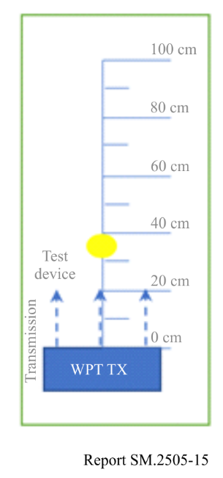
The results demonstrated that all phones were able to operate without harmful interference on at least one channel and on all channels when separated by 1 m or more from the DUT.
Wireless Microphone and base station. The base-station (receiver) was placed 30 cm from the DUT, and the Microphone (Transmitter) moved through the test distances. Subsequently, the Microphone (Transmitter) was placed 30 cm from the DUT, and the Base-station (receiver) was moved through the test distances.
When operating close to the transmit frequency of the DUT, the audio devices experienced no harmful interference.
Assisted listening device. The Transmitter was placed 30 cm from the DUT, and the Receiver was moved through the test distances. Following this, the Receiver was placed 30 cm from the DUT, and the Transmitter was moved through the test distances.
When operating at close to the transmit frequency of the DUT, the devices experienced interference however setting the audio device frequency away from that of the DUT resulted in little to no harmful interference.
RFID reader. For the first device, scans were performed at 903.250; 904.250; 915.250; 915.750; 920.250; 926.750 and 927.250 MHz. The software transmitting setting was set to 30 dBm. RFID tags were then placed 30 cm from the DUT. For the second, scans were performed at 865.00; 866.00; 867.00 and 868.00 MHz with default settings. RFID tags were then placed 30 cm from the DUT.
At separation distances of 1 m or greater between the DUT and RFID reader and tags, the readers worked without error.

3.6 Study F (61-61.5 GHz)

3.6.1 Radio services considered in the study
This section contains a study that examines the out-of-band emission limits necessary to ensure protection criteria are met for the Earth Exploration Satellite Service (passive) (EESS (passive)) and Radio Astronomy Service (RAS). This study deals with use of segments the ISM band at 61-61.5 GHz for beam WPT.

3.6.2 Considerations for 61-61.5 GHz
The technology being considered at this frequency involves a narrow band transmission which has a bandwidth of approximately 0.02% in the case of the 61 GHz ISM band. The maximum 10 MHz bandwidth comes from three sources: phase noise of the frequency source, incident random phase modulation on the transmitted signal from continuous minor adjustments of the phase shifters in the antenna elements to maintain focus on the intended destination, and low index modulation of the CW carrier for communications between the transmitter and power destination used to both maintain a tight focus of the band on the destination and to implement active safety features that decrease power when an object or a human or pet approach the high power flux-density (pfd) volume near the intended destination.

3.6.3 Impact 61-61.5 GHz beam WPT
This band is a designated ISM band per RR No. 5.138, which provides that “The use of these frequency bands for ISM applications shall be subject to special authorization by the administration concerned, in agreement with other administrations whose radiocommunication services might be affected. In applying this provision, administrations shall have due regard to the latest relevant ITU-R Recommendations.” The primary allocations for this band are fixed, inter-satellite, mobile and radiolocation. In addition, many administrations have designated this band and nearby bands for SRDs. Such SRDs generally have narrow beam width antennas, facilitated by the short wavelength at this band, and thus are resistant to point sources of RF power.
The nearest band allocated for EESS (passive) is at 59-59.3 GHz (1.7 GHz below) and the nearest band allocated for RAS is at 76-77.5 GHz, 14.5 GHz above. The EESS (passive band) at 59-59.3 GHz is within the ‘60 GHz’ oxygen absorption band, and has 13 dB/km attenuation by atmospheric gases at sea level for horizontal paths although this attenuation decreases at higher altitudes and for higher elevation angle paths. The conditions of RR No. 5.138 appear appropriate to protect other services regarding the use of this technology in this band.

3.6.4 Human hazard issues for 61-61.5 GHz WPT
Technology being considered for these bands used phased array multiple elements beams to focus power on a small area for efficient power transfer. This creates a high pfd at and near the power receiving area that could violate applicable safety standards. This situation is avoided by active measures that detect the presence of objects near the high pfd volume and reduces or ceases power transmissions when such objects are detected.
The strategy being followed is to make sure applicable safety standards are met: systems will employ multiple, independently operating and independently testable safeguards that will ensure that exposure requirements are met. These sensors can be arranged so that significant power is only transmitted if there is an authorized power destination in a position ready to receive power and without any humans or pets in a nearby position where they would be exposed to unacceptable RF power levels. Examples of these sensors are the ability to evaluate the orientation of the device being charged, including whether it is moving, fixed, or set on a stable surface; the ability to passively sense nearby movement and beam interruption; and the ability to detect Doppler signals from the device being charged or people that are moving. In this way, the distances between the beam, the charging device, and any people located in the vicinity can be calculated in milliseconds, ensuring that the power transfer will cease before a person enters the path of a beam. These independent safety features are all native to the WPT system, meaning that they are inherent in the function of the beam formation apparatus of the WPT system.
TABLE 15
RF safety standard levels for 61 GHz band in the United States
Band  (GHz) | Maximum permissible exposure (MPE) for  occupational/controlled exposure  (mW/cm²) | Maximum permissible exposure (MPE) for general population/uncontrolled exposure (mW/cm²)
61-61.5 | 5.0 | 1.0

3.7 Study G (915-921 MHz, 2 410-2 486 MHz and 5 738-5 766 MHz)
When radio telescopes are located in remote areas, this is in order to limit interference and to allow observation of the cosmos in frequency bands that are heavily used in urban areas. To assist in these goals, some radio telescopes operate in locally-administered radio quiet zones wherein emissions are managed across the radio spectrum as explained in Report ITU-R RA.2259.
WPT devices operating in frequency bands designated for the use of ISM applications present a case requiring particular care, given that they operate under RR No. 5.150. Radio astronomy is considered as a radiocommunication service operating under RR No. 4.6.

3.7.1 Radio services and bands considered in the study
The study considers compatibility of radio astronomy service operations with WPT devices operating in three ISM bands selected from among the entries in Table 1 as given in Table 16. The study calculates the isolation (in dB) from WPT radiation that is needed to reach to radio astronomy protection levels given in Recommendation ITU-R RA.769, at the frequency of the WPT operation (Table 16) and at three frequencies used by the radio astronomy service (Table 17). Calculations at the radio astronomy frequencies all assume the same radiated power density –71.3 dBW/1 MHz that many administrations specify when limiting radiation from ISM devices above 1 GHz, corresponding to an electric field of 500 μV/m measured at 3 m in a 1 MHz bandwidth, as converted to power using equation (2) in Report ITU-R RA.2131.

3.7.2 Details of the calculations

3.7.2.1 Radiation at WPT frequencies
The WPT frequencies, gains and power levels in Table 16 are those of Systems 2, 5 and 6 in Table 1. Specific attenuations Atten_wet and Atten_dry (dB/km) are taken from Recommendation ITU-R P.676 for dry and standard (std) atmospheres. The quantity T_769 is the radio astronomy service protection threshold power flux interpolated between values in column 8 of Table 1 in Recommendation ITU-R RA.769-2.
TABLE 16
Parameters used in the WPT frequency calculations
Frequency (GHz) | P_wpt  (dB W) | Gain_wpt  (dBi) | T_769  (dB W/m²) | Atten_dry  (dB/km) | Atten_std  (dB/km) | Δ at d=100 km  (dB)
0.920 | 11.761 | 8.24  0 | –183 | 0.005 | 0.005 | 95  87
2.4 | 11.761 | 24  0 | –177 | 0.006 | 0.006 | 105  81
5.8 | 15.051 | 25  0 | –169 | 0.0075 | 0.009 | 114  89

3.7.2.2 Radiation at radio astronomy frequencies
Characteristics of the radio astronomy bands shown in Table 17 were taken from Recommendation ITU-R RA.769 and RR No. 5.149, and the power levels into the bands are calculated by multiplying P'_wpt = –71.3 dB W/MHz by the RAS bandwidth.
TABLE 17
Parameters used in the radio astronomy frequency calculations
Frequency (GHz) | P_wpt  (dB W) | Gain_wpt  (dBi) | T_769  (dB W/m²) | Atten_dry  (dB/km) | Atten_std  (dB/km) | Δ at d=100 km  (dB)
1.400-1.427 | –57.0 | 0 | –180 | 0.005 | 0.005 | 12
2.69-2.70 | –61.3 | 0 | –177 | 0.006 | 0.006 | 5
6.65-6.6752 | –57.3 | 0 | –168 | 0.0075 | 0.009 | –1

Figure 16
Isolation needed at WPT frequencies
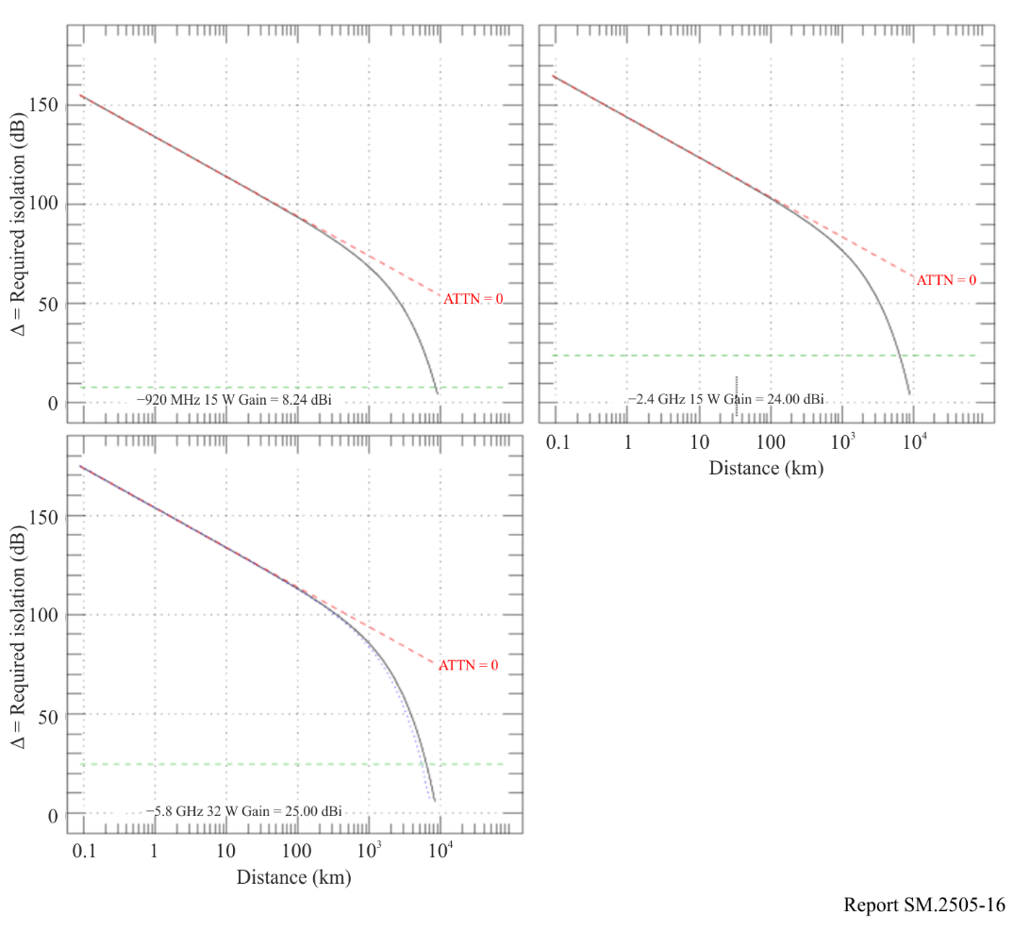

3.7.2.3 Calculations
The study calculates the power flux from WPT at distance d(m) in free space with specific attenuation A (dB/km) = Atten_dry and Atten_std, and takes the logarithmic difference of this with the threshold values in Recommendation ITU-R RA.769. Results are shown for the values of WPT gain in Table 17, including for 0 dBi. Gain of the radio astronomy system is 0 dBi as assumed to set threshold levels in Recommendation ITU-R RA.769.
Specifically, the study computes numerical values of

Δ (dB) = P_wpt + Gain_wpt – T_769 – 10 log (4π) – 20 log (d) – A*d/1000

as shown in Figs 16 and 17 for the WPT-frequency and RAS-frequency cases, respectively. In each Figure, the results are shown for the dry and standard atmospheres but the difference is barely recognizable. The WPT gain is shown in order to facilitate derivation of isolation for the case of 0 dBi WPT gain.

3.7.3 Results
Results for the calculation of Δ at the WPT frequencies are shown in Fig. 16, and the rightmost column in Table 16 shows the values of Δ calculated at d = 100 km, in this case ranging from 80 to 110 dB.
Results in radio astronomy bands are shown in Fig. 17, and values of Δ at a line-of-sight separation of 100 km are –1 to 12 dB in Table 17.
Figure 17
Isolation needed at radio astronomy frequencies
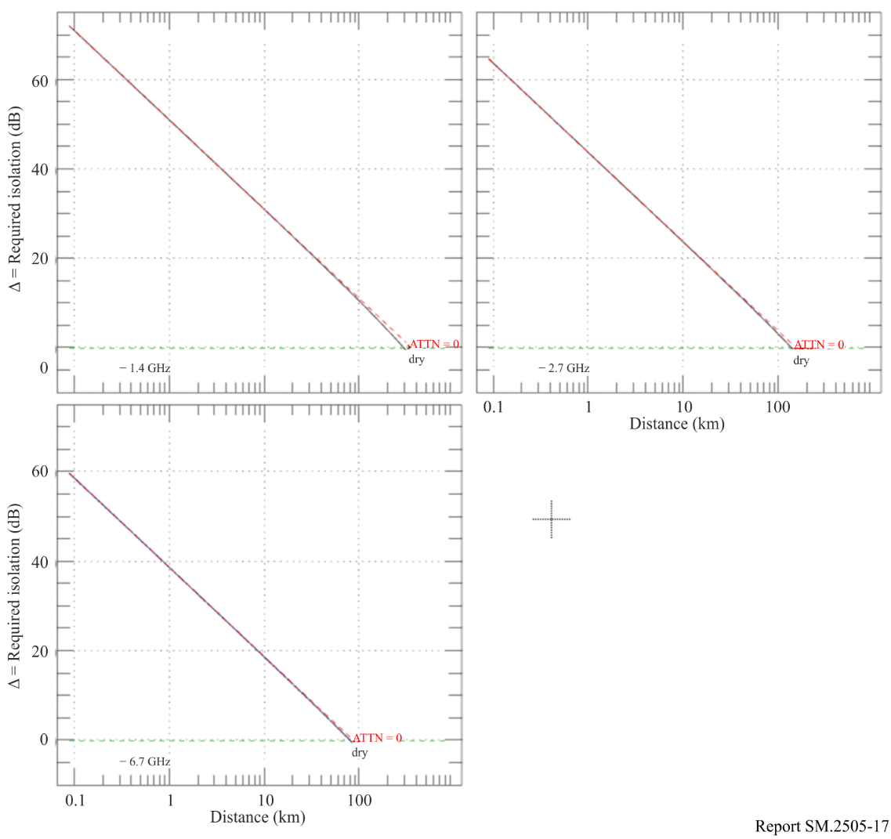

3.7.4 Summary
To meet the interference thresholds in Recommendation ITU-R RA.769, isolation of radio astronomy facilities from WPT devices operating in ISM bands is required. Under certain circumstances exclusion zones need to be considered, based on the permitted power levels and propagation losses from the local terrain. For RAS systems operating in the bands outside the fundamental emissions of beam WPT systems, national administrators need to ensure that the permitted out-of-band and spurious emissions under current national regulatory standards do not cause harmful interference by including considerations of link budgets, building entry loss, clutter and terrain loss, line of sight and diffraction considerations. This may also be determined based on a combination of measurement and analysis.

4 Human hazard issues
Administrations are encouraged to follow the guidelines set by the ICNIRP and IEEE expert groups, or limits set by their own experts. Human exposure to electromagnetic fields (EMF) is addressed by a number of regulatory agencies as well as international expert organizations such as the World Health Organization (WHO), the Institute of Electrical and Electronics Engineers (IEEE), and the International Commission on Non-Ionizing Radiation Protection (ICNIRP). Below are the ICNIRP Guidelines on EMF:
1) ICNIRP (1998): Guidelines for limiting exposure to time‐varying electric, magnetic and electromagnetic fields (up to 300 GHz);
2) ICNIRP (2020): Guidelines for limiting exposure to electromagnetic fields (100 kHz to 300 GHz).
IEEE C95.1-2019 is the “IEEE Standard for Safety Levels with Respect to Human Exposure to Electric, Magnetic, and Electromagnetic Fields, 0 Hz to 300 GHz”.
IEEE C95.1 (2019) and ICNIRP (2020) Guidelines (and ICNIRP (1998)) are largely harmonized: the power-density limits whole-body levels above 30 MHz are identical. When considering EMF exposure from beam WPT, the most relevant references are ICNIRP (2020) and IEEE C95.1-2019.
Beam WPT in the practical implementation would employ frequencies starting from UHF and higher for transmission systems. Examples are using 920 MHz band, 2.4 GHz band, and 5.7 GHz band to transmit the power. Microwaves may be beamed from an antenna, by way of point-to-point or point-to-multipoint, over a distance of several metres or more. Unlike wireless communication uses, the level of transmitted electromagnetic power required for commercial implementation of beam WPT could be greater to some extent or substantial. It is deemed appropriate that a human exposure to beam WPT EMF (including medical devices) should be assessed and managed with additional measures to be compliant with the current guidelines in the beam WPT planning and operation.
To cope with above-mentioned unique and standing technical requirements, some current beam WPT implementations are considering adoption of human body detection mechanisms in the area with expecting greater RF exposure than the guidelines to cease power transmission and / or steer the power beam direction when detected. To facilitate implementation such technical measures and ensure compliance with the guidelines, study on regulatory environmental conditions for beam WPT is also undertaken in some administrations. See Annex 1 for details.

5 Summary
It should be noted that studies provided in this Report refer mostly to specific national regulations.
The various studies in this Report have demonstrated that the proposed beam WPT systems can generally coexist with incumbent radiocommunications services and stations that have been studied. In certain cases, depending on the national regulations, some mitigations may be necessary.
Studies A, B and E presented test data for beam WPT systems in the 915-921 MHz band operating under the national regulations. The results demonstrated that such systems can coexist with incumbent devices with very little interference as permitted under the rules and with recommended user mitigation approaches.
The results presented in Study C demonstrate that the impact of beam WPT systems on other wireless devices and technologies depends on factors such as the output power of the beam WPT, the distance between devices, and whether the same operating frequencies are being used. For beam WPT systems operating in the 915-921 MHz band, results from these studies, considering national regulations, demonstrate that in most cases their operation is feasible and causes little to no interference to the following types of devices: IMT user terminals, wireless microphones and base stations, assisted listening devices, RFID readers, door/window sensors, smart hubs, and smart power outlets.
Study D carried out a case study on compatibility analysis between the Beam WPT and the COMPASS GSO MSS system (operating in the frequency band 2 483.5-2 500 MHz). The study result shows that separation ranges from 820 metres to 2 160 metres is needed to avoid harmful interference from Beam WPT to COMPASS system. Bearing in mind that some Beam WPT system operates indoor or outdoor, and the unknown commercial Beam WPT’s parameters and operating scenario, further careful studies are needed to be carried out by Administrations, even case by case, to determine whether the separation distance is enough or not (especially that 2 160 m is somehow a challenging separation distance for specific scenario).
Study C further reports frequency sharing conditions with additional measures for incumbent service protection and human body protection from WPT RF exposure. A result on beam WPT in 917-920 MHz under the WPT technical condition equivalent to the existing RFID system demonstrates coexistence capability with systems in the same and neighbouring bands. Another result in 2 410-2 486 MHz and 5 738-5 766 MHz bands addresses adoption of WLAN CCA mechanism to WPT systems and provisions on necessary separation distances. A comprehensive beam WPT operating management rule regarding WPT operation environment and EMFs is provided as a regulatory guideline.
Study F states that based on system performance analysis, current national regulations are adequate to protect incumbent systems at 61-61.5 GHz frequency band.
Study G indicates that to meet the interference thresholds in Recommendation ITU-R RA.769, isolation of radio astronomy facilities from WPT devices operating in ISM bands is required. Under certain circumstances exclusion zones need to be considered, based on the permitted power levels and propagation losses from the local terrain. For RAS systems operating in the bands outside the fundamental emissions of beam WPT systems, national administrators need to ensure that the permitted out-of-band and spurious emissions under current national regulatory standards do not cause harmful interference by including considerations of link budgets, building entry loss, clutter and terrain loss, line of sight and diffraction considerations. This may also be determined based on a combination of measurement and analysis.

Annex 1
RF exposure environmental control to comply with the Radio Radiation Protection Guidelines, the case of Japan

A1.1 Beam WPT installation environments
The Information and Communication Council of the Ministry of Internal Affairs and Communications (MIC) of Japan defined the WPT indoor installation environments by the names of the WPT controlled environment and the WPT general environment to manage and control radiofrequency EMF exposure generated from the beam WPT system to human bodies in the operation of Japanese 920 MHz band (915-930 MHz), 2.4 GHz band (2 400-2 499 MHz) and 5.7 GHz band (5 470-5 770 MHz) to comply with the Japanese Radio Radiation Protection Guidelines (RRPG) as follows.

A1.1.1 WPT controlled environment
The WPT controlled environment is summarized as shown below:
– It is categorized as indoor and closed space for beam WPT operation.
– In the environment, WPT radio frequency EMF levels meet the allowable range specified for the controlled environment in the RRPG. (Power transmission shall be ceased when detecting an individual entering the area where EMFs surpass the limits of the controlled environment specified in the RRPG.)
– When a beam WPT system is operated in the WPT controlled environment, for the purpose of avoiding and mitigating harmful effect to other radiocommunication systems, the WPT system installation personnel, the WPT system operator, the WPT licensee, and other authorized personnel shall be able to manage and control the use of other radiocommunication systems and device installation conditions in an integrated manner.
– When the concerned WPT controlled environment is bordering other indoor space (e.g. side-by-side rooms or upper-and-lower floors), WPT radio frequency EMF levels shall meet the allowable range of specified spectrum sharing conditions with the other radiocommunication systems even in those indoor spaces, or the identical WPT manager to the concerned indoor WPT controlled environment shall be able to manage the coordinated spectrum sharing in the integrated manner. (This clause is applied to the 2.4 GHz and 5.7 GHz bands operation only).

A1.1.2 WPT general environment
The WPT general environment is one of the categories of WPT indoor installation environment and means a WPT use environment that does not fulfil the definition of the WPT controlled environment. (e.g. wireless power transmission to quality management sensors in a logistics warehouse (920 MHz band application only), wireless power transmission to observation sensor devices in an elder nursing care facility (920 MHz band application only).

A1.2 Compliance with the RRPG

A1.2.1 Separation distance
To comply with the radio frequency EMF exposure requirements in the RRPG, the following separation distances were derived and specified.
TABLE A1.1
Separation distances to meet the RF exposure limits of the RRPG
Band | Environmental condition defined in the RRPG | Reflection coefficient  K = 1⁽¹⁾ | Reflection coefficient  K = 2.56⁽²⁾ | Reflection coefficient  K = 4⁽³⁾ | Adding 6 dB to EMF strength⁽⁴⁾
 |  |  |  |  | Reflection coefficient  K = 2.56 | Reflection coefficient  K = 4
920 MHz | Controlled environment | 0.102 m | 0.163 m | 0.203 m | 0.325 m | 0.4065 m
 | General environment | 0.227 m | 0.364 m | 0.456 m | 0.727 m | 0.912 m
2.4 GHz | Controlled environment | 2.45 m | 3.92 m | 4.90 m | 7.82 m | 9.80 m
 | General environment | 5.48 m | 8.76 m | 10.95 m | 17.49 m | 21.90 m
5.7 GHz | Controlled environment | 4.00 m | 6.40 m | 8.00 m | 12.80 m | 16.00 m
 | General environment | 9.00 m | 14.30 m | 17.80 m | 28.50 m | 35.70 m
⁽¹⁾ No reflections counted.
⁽²⁾ Reflections from the ground counted.
⁽³⁾ Reflections from the water surface and from those other than the ground counted.
⁽⁴⁾ 6 dB is added in the case greater reflection is expected to observe due to buildings such as an office building nearby the evaluation point.

A1.2.2 Directions
The beam WPT systems being considered for the operation in the 920 MHz band, the separation distance to meet the limits in the RRPG is comparatively short; and therefore, it is possible for them to operate in the WPT general environment.
Those for the 2.4 GHz band and the 5.7 GHz band assume adoption of human body detection mechanisms in the area expecting greater RF exposure than the limits specified in the RRPG to cease power transmission when detected. In addition, the systems are to take safety measures to ensure correct functioning of the detect and protect mechanism. Moreover, some alert such by indicating attentional area and setting a fence is conducted, too.
Beam WPT transmitters are not used at a very close proximity (within 20 cm) from the human body according to use case scenarios and also taking appropriate safety measures mentioned above. Therefore, study on specific energy absorption rate (SAR) for the human body nearby is not necessary.

