Report ITU-R SM.2452-1
(07/2022)
Electromagnetic field measurements to assess human exposure

SM Series
Spectrum management

Foreword
The role of the Radiocommunication Sector is to ensure the rational, equitable, efficient and economical use of the radio-frequency spectrum by all radiocommunication services, including satellite services, and carry out studies without limit of frequency range on the basis of which Recommendations are adopted.
The regulatory and policy functions of the Radiocommunication Sector are performed by World and Regional Radiocommunication Conferences and Radiocommunication Assemblies supported by Study Groups.

Policy on Intellectual Property Right (IPR)
ITU-R policy on IPR is described in the Common Patent Policy for ITU-T/ITU-R/ISO/IEC referenced in Resolution ITU-R 1. Forms to be used for the submission of patent statements and licensing declarations by patent holders are available from http://www.itu.int/ITU-R/go/patents/en where the Guidelines for Implementation of the Common Patent Policy for ITU-T/ITU-R/ISO/IEC and the ITU-R patent information database can also be found.

Series of ITU-R Reports
(Also available online at http://www.itu.int/publ/R-REP/en)
Series | Title
BO | Satellite delivery
BR | Recording for production, archival and play-out; film for television
BS | Broadcasting service (sound)
BT | Broadcasting service (television)
F | Fixed service
M | Mobile, radiodetermination, amateur and related satellite services
P | Radiowave propagation
RA | Radio astronomy
RS | Remote sensing systems
S | Fixed-satellite service
SA | Space applications and meteorology
SF | Frequency sharing and coordination between fixed-satellite and fixed service systems
SM | Spectrum management

Note: This ITU-R Report was approved in English by the Study Group under the procedure detailed in Resolution ITU-R 1.

Electronic Publication
Geneva, 2022
© ITU 2022
All rights reserved. No part of this publication may be reproduced, by any means whatsoever, without written permission of ITU.

REPORT ITU-R SM.2452-1
Electromagnetic field measurements to assess human exposure
(2019-2022)
TABLE OF CONTENTS
Page
Policy on Intellectual Property Right (IPR) ii
1 Introduction 2
2 Regulatory framework 2
2.1 ICNIRP 2020 and IEEE 2019 exposure levels around transmitters 2
2.2 Presenting maps of calculated field-strength around transmitters 7
3 A practical guide for EMF measurements to assess human exposure 9
3.1 Basic knowledge for a successful EMF assessment measurement process 9
3.2 Measurement instruments with specific features for EMF assessment 12
3.3 Reducing the number of measurement points in space 15
3.4 Reducing the observation time and extrapolation to the maximal exposure 16
3.5 How to assess the exposure due to specific services 17
4 References 20
5 Glossary and abbreviations 22
Annex Electromagnetic field around an Amateur Radio Station, 14 MHz to 440 MHz 23
Attachment 1 to the Annex Site information, the station, the surrounding area and measurements 23
Attachment 2 to the Annex Tx power and antennas 24
Attachment 3 to the Annex Measurement equipment 24
Attachment 4 to the Annex Measurements results 14 to 440 MHz, field-strengths 25
Attachment 5 to the Annex Summary and conclusions of the Annex 26

1 Introduction
The proliferation of wireless installations of all types around the world obligates careful measurements. This concern is reflected in Question ITU-R 239/1 “Electromagnetic field measurements to assess human exposure”; ITU Plenipotentiary Resolution 176 (Rev. Dubai, 2018) “Measurement and assessment concerns related to human exposure to electromagnetic fields”; and the ITU Handbook on Spectrum Monitoring (Edition 2011), where section 5.6 details non-ionizing radiation measurements.
The Electromagnetic Field (EMF) exposure limits are implemented at national level, mostly with references to international standards that specify different exposure limits for the general public and for workers accessing areas close to wireless installations.
The International Commission for Non-Ionizing Radiation Protection (ICNIRP) and the Institute of Electrical and Electronics Engineers (IEEE) are the expert groups for setting the safety exposure levels. Many Administrations have adopted or may at some point adopt these guidelines or modified/updated guidelines based on their own experts’ studies.
Compliance with EMF limits should be assessed considering several aspects:
– The power density and field strength are aggregated from different sources;
– The exposure levels in the proximity of wireless installations may occur in the near-field;
– The exposure levels should be measured in areas accessible to people (workers or the public as appropriate);
– Wireless installations may not transmit with their maximum theoretical power at the time of measurement, and so should be power scaled to reflect their maximal power, when determining compliance;
– There may be a need for measuring the E and the H field separately, especially in the near-field domain, where the relationship between E and H field is very complicated as opposed to the far-field;
– The results of the measurements may be presented in a variety of formats concerning the intended use and potential audience.
Compliance of portable user equipment such as handsets or notebooks intended for use close to the head or body is outside the scope of this Report.
While ICNIRP limits have been established to protect the public, concerns on EMF effects encourage measures in some countries to monitor and control the power density and field strength of the emissions. It is necessary to share good practices in EMF monitoring that guides Administrations to check compliance with the limits established by ICNIRP.

2 Regulatory framework

2.1 ICNIRP 2020 and IEEE 2019 exposure levels around transmitters

2.1.1 Overview
ICNIRP aims to protect people and the environment against adverse effects of non-ionizing radiation (NIR). ICNIRP Guidelines have been widely adopted in standards and regulations around the world; where national limits do not exist, or if they do not cover the frequencies of interest, then ICNIRP limits should be used. Those are the ICNIRP Guidelines:
– ICNIRP (1998): Guidelines for limiting exposure to time‐varying electric, magnetic and electromagnetic fields (up to 300 GHz);
– ICNIRP (2010): Guidelines for limiting exposure to time‐varying electric and magnetic fields (1 Hz – 100 kHz);
– ICNIRP (2020): Guidelines for limiting exposure to electromagnetic fields (100 kHz to 300 GHz).
The limits below 100 kHz are the ones published in ICNIRP (2010), and, with the publication of the 2020 Guidelines, the 1998 Guidelines have become obsolete. It should be noted, however, that in some regions, standards concerning EMF assessment methods continue referring to basic restrictions, and reference levels in the ICNIRP 1998 Guidelines. Until the relevant standards have been updated, the 1998 Guidelines can still be used as the valid basis for compliance framework.

2.1.2 ICNIRP (2020) Tables and Figures
ICNIRP (2020) Table 5 is the most relevant to Monitoring base-stations. It details reference levels for exposure to RF-EMF, averaged, over 30 minutes and the whole body, from 100 kHz to 300 GHz (unperturbed rms values). The re-elaborated Figures depict the values. Bolds indicate the significant parameter. The ICNIRP Table and Figures quantify and depict how the exposure depends on the transmitted frequency. The RF-EMF Reference Levels for the Occupational and General Public whole-body exposures decrease 0.1-30 MHz, stay steady 30-400 MHz, increase again between 400-2 000 MHz and stay steady 2-300 GHz.
TABLE 1
(ICNIRP 2020 Table 5) Reference levels for exposure from 100 kHz to 300 GHz
Exposure scenario | Frequency range | Incident E-field  strength; E_{inc} (V m⁻¹) | Incident H-field  strength; H_{inc} (A m⁻¹) | Incident power density; S_{inc} (W m⁻²)
Occupational | 0.1 – 30 MHz | 660/f_{M}^{0.7} | 4.9/f_{M} | NA
 | >30 – 400 MHz | 61 | 0.16 | 10
 | >400 – 2 000 MHz | 3f_{M}^{0.5} | 0.008f_{M}^{0.5} | f_{M}/40
 | >2 – 300 GHz | NA | NA | 50
General public | 0.1 – 30 MHz | 300/f_{M}^{0.7} | 2.2/f_{M} | NA
 | >30 – 400 MHz | 27.7 | 0.073 | 2
 | >400 – 2 000 MHz | 1.375f_{M}^{0.5} | 0.0037f_{M}^{0.5} | f_{M}/200
 | >2 – 300 GHz | NA | NA | 10
NOTE – ‘NA’ signifies ‘not applicable’; f_{M} is frequency in MHz.

The following two ICNIRP figures appear in the ‘Differences Between the ICNIRP (2020) and Previous Guidelines’. The reference-levels of ICNIRP (2020) stop electric-field at frequencies above 2 000 MHz and start power-density above 30 MHz. The two following Figures reference for the whole-body average and 30 min time-averaging. Thus, to focus the reader and depict the differences, the titles are simplified, and the titles’ specifics are underlined:
Figure 1
Comparing general public reference levels for ICNIRP (1998), (2010) and (2020) Guidelines
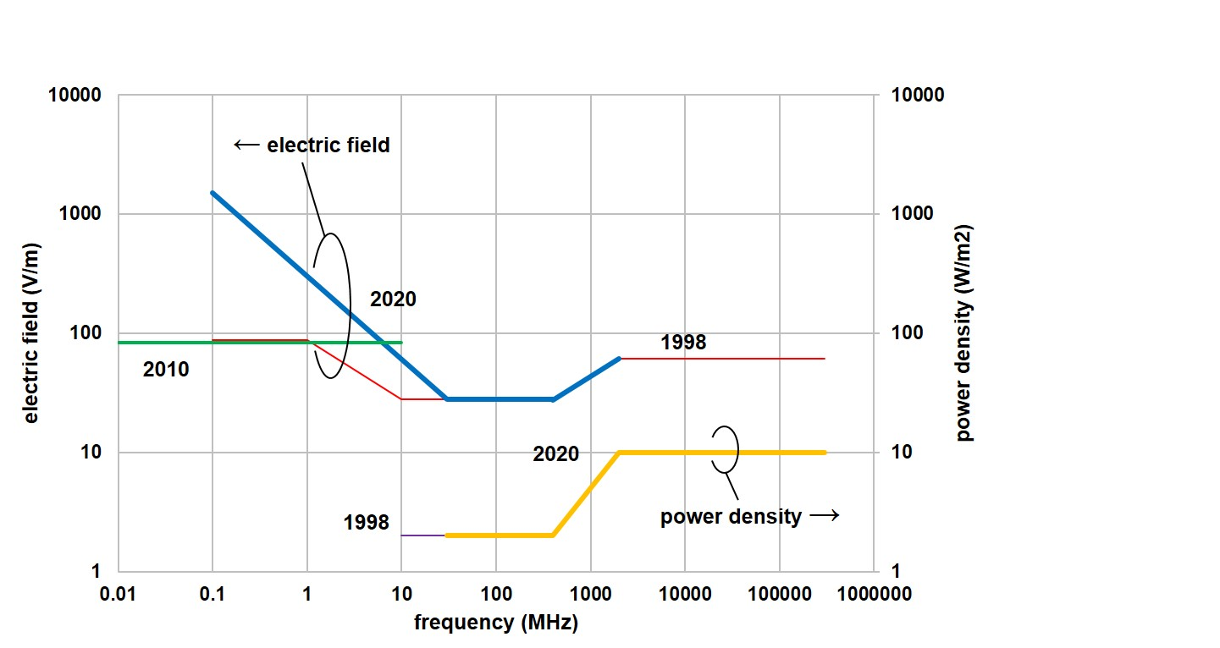
Figure 2
Comparing workers reference levels for ICNIRP (1998), (2010) and (2020) Guidelines
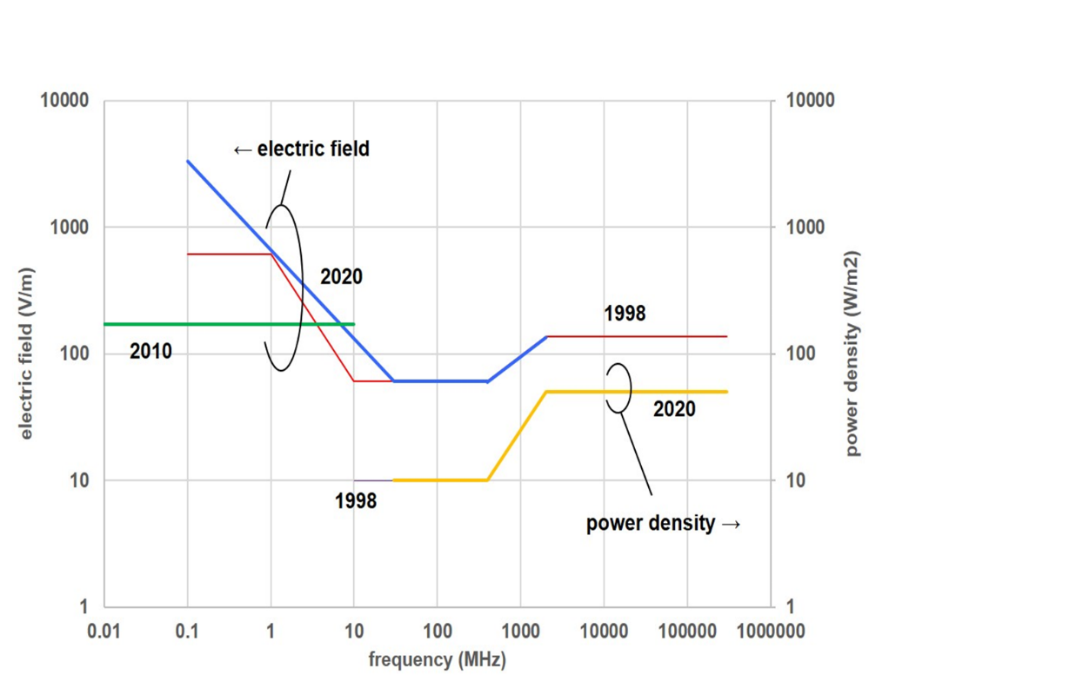
The values in Figs 1 and 2 above represented by the green lines in comparing (2010 reference levels) are included in a separate table in ICNIRP (2020). Table 8 provides reference levels for local exposure for frequencies in the range 100 kHz – 10 MHz. Since these localized values are lower than the whole body values, for frequencies below around 7 MHz, it follows that, in many cases, the higher, whole body reference levels will be relevant only when aggregating the thermal effect from multiple sources.
The following Figure depicts the differences between the ICNIRP (2020) field-strength and power-density exposure levels above 30 MHz of occupational and general-public exposure, averaged over 30 min and the whole body. The power-density ratio of 5 in ICNIRP (2020) Table 5 (e.g. at 30-400 MHz, Watts ratio 50/10) results in V/M ratio 61.0/27.7 = 2.2 ~ √(5).
Figure 3
Comparing ICNIRP (2020) Table 5, power-density 30 MHz–300 GHz
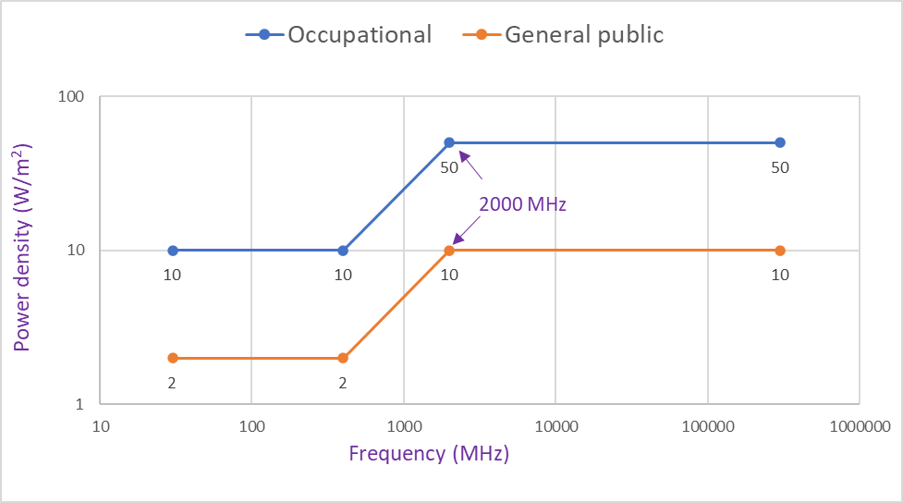
ICNIRP (2010) and ICNIRP (2020) are based on two different biological mechanisms, and averaging is diverse:
– nerve stimulation- instantaneous below 10 MHz;
– thermal effect, produced by power over time (for frequencies above 100 kHz).
Below 100 kHz, ICNIRP (2010) should be applied. Between 100 kHz and 10 MHz both mechanisms may exist, in that case, restrictions for every frequency should be met simultaneously.
Moreover, ICNIRP (2020) Table 8 states (pay attention to the bold text) “reference levels for local exposure to EMFs from 100 kHz to 10 MHz (unperturbed rms values), for peak values, the occupational limit is 170 V/m and the general public is 83 V/m.”.

2.1.3 Comparison of ICNIRP (1998), IEEE 95-1 (2019) and ICNIRP (2020)
The ICNIRP Guidelines (1998, and 2020) and the IEEE Standard (2019) separate between persons in unrestricted environments (general public) and persons permitted in restricted environments (occupational). The most relevant to Monitoring base-stations ICNIRP (1998) Tables 6 and 7, IEEE C95.1 (2019) Tables 7 and 8 are compared with ICNIRP (2020) Table 5. The exposure levels of ICNIRP 2020 and the IEEE Standard are largely harmonized, and the power-density limits whole-body levels above 30 MHz are identical!
– Localised SAR limits in the Head/Torso equals 2 W/kg for general-public and 10 W/kg for occupational.
– Whole-body average SAR limit equals 0.08 W/kg for general-public and 0.4 W/kg for occupational.
– Exposure power-density reference-levels equal at:
• 30 to 400 MHz: 2 W/m² for general-public and 10 W/m² for occupational;
• 400 to 2 000 MHz: f_{M}/200 W/m² for general-public and f_{M}/40 W/m² for occupational;
• 2 000 to 300 000 MHz: 10 W/m² for general-public and 50 W/m² for occupational.
Figures 4 to 6 illustrate that IEEE C95.1 (2019) and ICNIRP (2020) Guidelines are largely harmonized.
In Fig. 4 (source Dr Lewicki Fryderyk), note that the ICNIRP (2020) electric field reference-levels for general-public stop at frequencies above 2 000 MHz. Electric-field units and measurements are convenient for administrations to monitor field strengths if needed. As between 100 kHz and 10 MHz, the more stringent value of ICNIRP (2010) or ICNIRP (2020) for every frequency should be followed, below 6.27 MHz the general public limit is 83 V/m.
Figure 4
Reference levels- for ICNIRP (1998), IEEE (2019) and ICNIRP (2020) guidelines
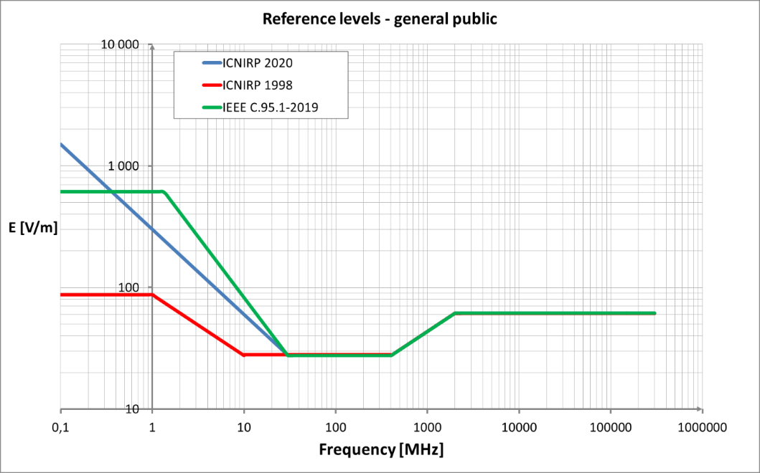

2.2 Presenting maps of calculated field-strength around transmitters

2.2.1 Definitions, free-space calculation and some assumptions
p_{t}: transmitter power (watts)
g_{t} : transmitter antenna gain (numeric)
e.i.r.p.: equivalent isotropically radiated power (watts)
d: distance from transmitter (meter)
e: electric field-strength Volt/metre (V/M).
For free-space propagation loss, and
To exemplify, disregarding buildings and other obstacles, the safety distance for e.i.r.p. 60 kW, under free-space propagation conditions, the safety-contours are 45 m for 30 V/m (general-public exposure reference-level at 482 MHz), and 20 m for 66 V/m (occupational exposure reference-level). Taking into account terrain map and buildings, non-free-space propagation loss, the calculated safety-distances are lower.
In the following simulations, the propagation model takes into account the attenuation due to buildings.
Except for the point to point links, the receiver altitude Above Ground Level (AGL) is assumed at 1.5 m. The Figures depict field-strength values (V/m); for example, at 482 MHz: 5, 15, 30 (the ICNIRP general public reference-level), 45 and 66 (the occupational reference-level) V/m.
The calculations performed are the following:
– 3D: three dimensions coverage on buildings facades is performed for a receiving antenna height varying from 1 m to rooftop. The highest power received on each building is used to provide the field-strength colour to the whole building.
– 2D: two dimensions similar to 3D, but shown in 2D top view.

2.2.2 Calculated field-strength around digital TV (DTV) transmitters
The following analysis refers to UHF Channel 22 (in Region 1):
– 478-486 MHz (centre RF 482 MHz),
– transmitter of 60 000 Watts e.i.r.p.,
– 60 m above ground level.
At 482 MHz the electric field-strength ICNIRP general-public exposure reference-level (see Table 1) equals 30 V/m: 1.375f^{1/2} (MHz) = 1.375 × 482^{1/2}. The field strength (V/m) ICNIRP occupational exposure reference-level is 66 V/m: 3f^{1/2} (MHz) = 3 × 482^{1/2}.
The following Figure depicts buildings impacted in 3D view.
FIGURE 5
Three dimensions DTV general-public and occupational exposure-contours
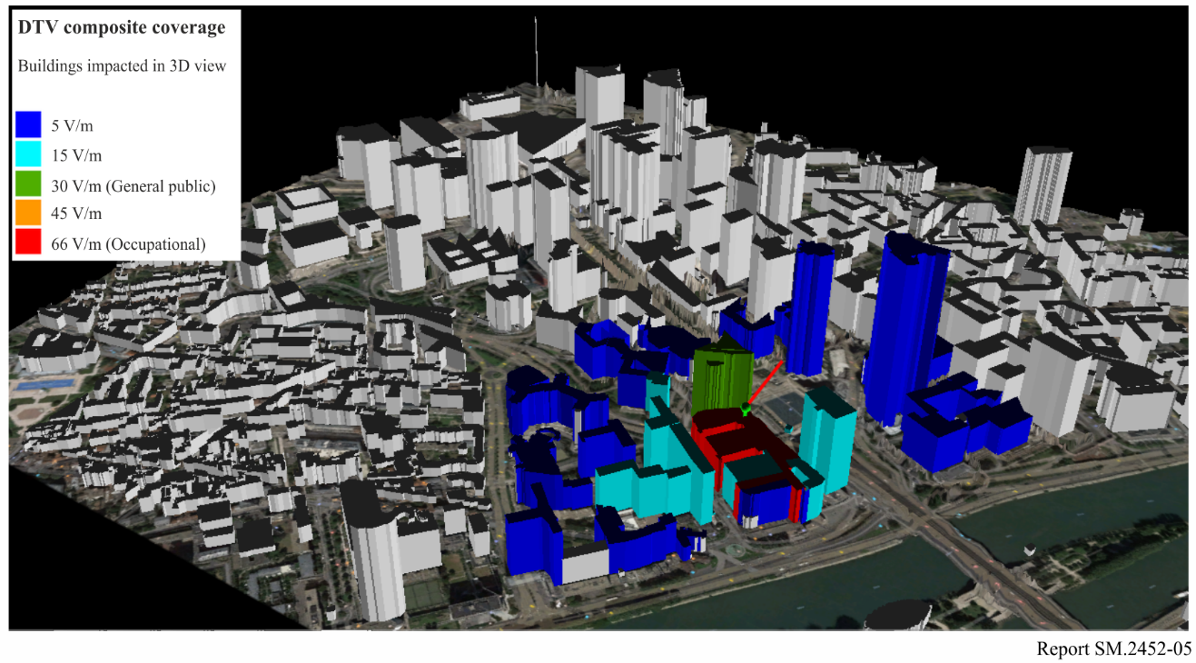

2.2.3 Calculated field-strength around land mobile transmitters
The following figures refer only to the downlink signals: from base stations to the mobile device. In general, the cellular patterns may be non-directive in Azimuth, or sectorial (such as three 120 degrees sectors).

2.2.3.1 Field-strength around cellular transmitters
At 900 MHz, 30 metres above the roof, for maximum downlink power of 100 W and antenna gain (including losses) 17 dBi, e.i.r.p. is 5 kW, the receiver 1.5 m AGL.
The ICNIRP general-public reference-level is 41 (1.375f ^{1/2} = 1.375 × 30) V/m and the occupational reference-level is 90 V/M: 3f ^{1/2} (MHz); the field strength scales are 1, 5, 10, 20, 41 (general-public) and 90 (occupational) V/m.
Figure 6 depicts the buildings impacted.
FIGURE 6
Two dimensions satellite view of cellular exposure distances
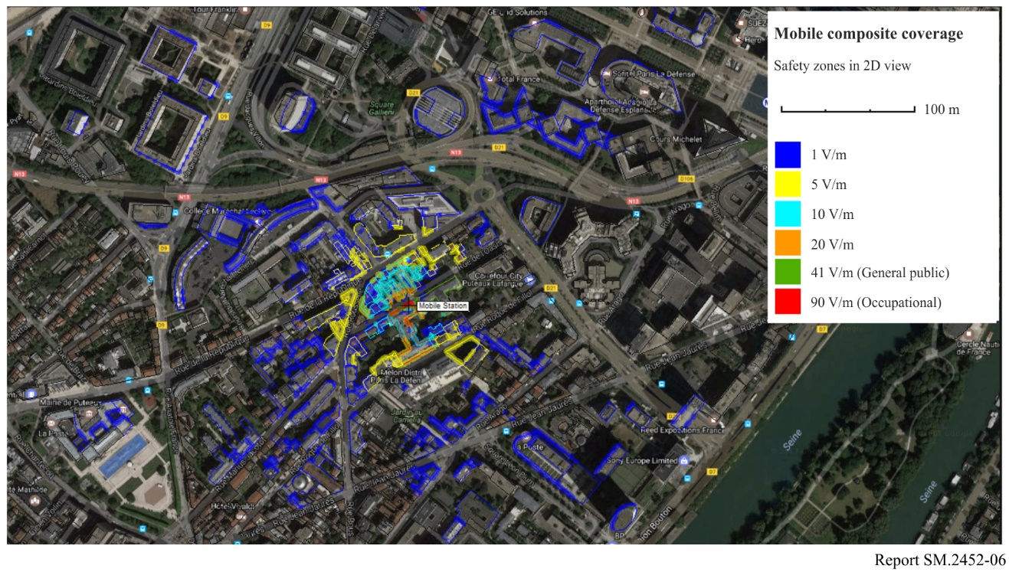

3 A practical guide for EMF measurements to assess human exposure

3.1 Basic knowledge for a successful EMF assessment measurement process
Current guidelines provide limits for the effects of electrostimulation and thermal heating. At frequencies below 100 kHz, the main effect is described by the induction law and Lapicque’s law for electrostimulation. At frequencies above 10 MHz the main effect is the thermal effect. In the frequency range between 100 kHz and 10 MHz both effects can occur. Note that both effects have to be assessed separately because they do not aggregate, and their assessment methods are completely different.
The appropriate assessment method for electrostimulation effects is called the weighted peak method and is described in the ICNIRP 2010 Guidelines. Only highly specialized EMF measurement systems have implemented this assessment method yet. Common spectrum analysers are not suitable for the assessment of the electrostimulation effect. Note that the ICNIRP Guidelines from 2020 supersede the ICNIRP 2010 Guidelines in the frequency range above 100 kHz. However, the electrostimulation effects above 100 kHz are covered now in Table 8 of the ICNIRP 2020 Guidelines.
The assessment method for the exposure due to the thermal effect of external electromagnetic fields is described by equations (3), (4) and (7) of the ICNIRP 2020 Guidelines. These equations refer to the squared RMS (root mean square) value of the weighted external electric and magnetic field strength or to the weighted external power density and external energy density. The result is a normalized exposure value. Exposure values up to unity are permissible. The frequency response of the weighting filter is the reciprocal of the reference levels, which vary with frequency.
The integration time of the RMS detector can be as high as 30 minutes for the whole-body exposure covered by equation (3). Note that shorter integration times may be used, but they may lead to an overestimation of the actual exposure. If the level fluctuations of the assessed field are fast, compared to the actual integration time, an overestimation will not occur.
For the local exposure covered by equation (4) the averaging time is defined as 6 minutes. Note that in the frequency range from 100 kHz to 30 MHz the field strength reference levels for equation (4) are the square root of 5 times higher compared to the reference levels for equation (3). In the frequency range from 30 MHz to 400 MHz the power density reference levels for equation (4) are 5 times higher compared to the reference levels for equation (3). Between 400 MHz and 2 GHz the ratio of the power density reference levels decreases from 5 to 4. Between 2 GHz and 6 GHz the ratio of the power density reference levels is 4. Between 6 GHz and 300 GHz the ratio of the power density reference levels decreases from 4 to 2.
Local exposure with averaging times smaller than 6 minutes is defined by the permitted energy density and covered by equation (7). Below 400 MHz the permitted energy density is constant over the averaging time. Above 400 MHz the permitted energy density decreases with the square root of the averaging time until it reaches a value of 0.05 times the permitted energy density for 6 minutes averaging time. Note that for an averaging time of 6 minutes the permitted energy density for equation (7) is identical with the permitted power density for equation (4) multiplied by 6 minutes.
In practice it will be difficult to assess the exposure with equations (3), (4) and (7) separately. It is possible to simplify the assessment with a modified equation (4), if a potential overestimation of the exposure is accepted.
If the local exposure is assessed with equation (4) but using the whole body reference levels of equation (3), the assessed exposure index will be higher than the exposure indices of the equation (3) and the original equation (4). The ratio of the exposure index of modified equation (4) to the original equation (4) depends on frequency and is 5, for frequencies below 400 MHz, 4 from 2 GHz to 6 GHz and 2 for 300 GHz. The ratio of the exposure index of modified equation (4) to equation (3) is greater than unity and is due to the 5 times lower averaging time and the search of local maxima instead of spatial averaging over the volume a virtual human body.
If an averaging time lower than 6 minutes is used in the modified equation (4), it is also possible to overestimate equation (7). The minimum permitted energy density limit of equation (7) is achieved if the original equation (4) and an averaging time of 6 minutes times 0.05 which equals 18s is used. If equation (4) with the lower whole body reference levels is used then the permitted averaging time are higher and we obtain the maximum permitted averaging time of Table 2.
The simplified assessment method can now be described briefly: use equation (4) of the ICNIRP 2020 Guidelines, but with the reference levels for the whole-body exposure and the maximum permitted averaging times shown in the following Table. Find the local maxima of the exposure and do not use spatial averaging.
TABLE 2
The maximum permitted averaging time for the simplified assessment method
Frequency range | Maximum permitted averaging time
0.1-400 MHz | 360 s
400-2000 MHz | $${\left(\frac{f}{400 MHz}\right)}^{-0,139}∙90 s$$
2-6 GHz | 72 s
6-300 GHz | $${\left(\frac{f}{6 GHz}\right)}^{-0,177}∙72 s$$

Note that above 30 MHz the ratio between the reference levels of the electric and magnetic field is constant and has the same value as the free space field impedance, 377 Ω. Both reference levels also correspond with the reference level of the power density. Below 30 MHz, however, there is no reference level of the power density and the ratio between the reference levels of the electric and magnetic fields is smaller than the free space field impedance.
In IEC 62232, three source regions around a transmitting antenna are defined: I, II and III. Source region I is defined as the reactive near field and the part of the radiative near field where the reactive power components are still not negligible. Source region II is the part of the radiative near field where the reactive power components are already negligible. Source region III is the far field region. For the boundary distance d_{I} between region I and II the following three conservative limit values are depicted in Table A.2 of IEC 62232: λ, D and D²/4λ (λ and D use in the same unit). Therein, λ is the wavelength of the transmitted field and D is the largest dimension of the transmitting antenna. The highest of the three values is the relevant value for d_{I}, and it is a conservative estimate for the minimum distance where reactive power components are negligible. In other words, for distances higher than d_{I} the ratio of the magnitude of electric field strength to the magnitude of the magnetic field strength, measured at the same point in space, can be assumed to be the free space field impedance.
Note that although ICNIRP 2020 provides detailed information on what assessments need to be carried out in which zone, those used by ICNIRP do not map directly to those in IEC 62232. Therefore, in source region II or III only the electric field component needs to be assessed because the exposure due to the magnetic field component is the same for the frequency range above 30 MHz. Only in the frequency range below 30 MHz the exposure due to the magnetic field is different and namely lower. In source region I however both field components need to be assessed. The higher of both exposure values is the relevant one. Above 1 GHz only the electric field component is assessed in practice because in this frequency range probes or antennas for the magnetic field component are barely available, and they are also not necessary because in the majority of cases source region II or III can be assumed. Further details, including where ICNIRP deems that its reference levels are not appropriate, can be found in the notes to the Tables 5, 6, 7 and 8.
The ICNIRP Guidelines assume maximum coupling of the external field to the exposed individual. This implies that an exposure estimate for a specific point in space must be independent of the polarization and propagation direction of the external field. In practice, this is done by measuring the RMS values of three collocated orthogonal sensors or antenna elements and calculating the isotropic RSS (root of sum of squares) value from these three RMS values. Isotropic probes are available for frequencies up to 90 GHz. Isotropic antennas are available for frequencies up to 6 GHz.
The ICNIRP Guidelines assume that the unperturbed external field strength is averaged over the entire body of the virtually exposed individual, before they are compared with the reference levels for the whole-body exposure. But for the local exposure, no spatial averaging above 4 cm² is allowed. The simplified assessment method described above is conservative, based on the assessment of the local exposure and is implemented in practice as described here:
Measure the local exposure values with the simplified assessment method in the entire area of interest, without humans being present and use no spatial averaging at all. Use the maximum exposure as the relevant exposure for the area of interest. It is good practice to exclude any measurement points with distances closer than 0.5 m to conductive objects. Doing so means that overestimation due to coupling effects between the measuring antennas and the objects and due to re-radiation from the objects can be avoided.
As a summary, an ideal assessment method for the exposure due to non-electrostimulation effects of external electromagnetic fields in an area of interest can yet be clearly formulated:
– Measure the squared, isotopic and weighted RMS value of the electric and/or the magnetic field strength at any position in the area of interest where humans are likely to be exposed;
– Use no spatial averaging around each position;
– Make sure that the humans to be exposed are not present during the measurements;
– Exclude any position from the measurements where the distance to conductive objects is less than 0.5 m;
– Use an RMS integration time, which is not longer than the maximum permissible integration time shown in Table 1;
– Measure over a time span, which is long enough to ensure that the maximum exposure over time will occur within this time span;
– Use the maximum exposure value of all positions and over the complete observation time as the final exposure result. If this result is less than unity, the exposure in area of interest is permissible.
Of course, this ‘ideal’ assessment method cannot be used in practice because too many points in space and time must be assessed, but it clearly shows the objective of real assessment methods.
The next sections will concentrate on assessment of compliance with non-electrostimulation effects only because assessment of the other ICNIRP limits is very different from the assessment of thermal effects and not relevant for most wireless transmitters. The next sections will instead show how such exposures can confidently, precisely and yet effectively be assessed.

3.2 Measurement instruments with specific features for EMF assessment

3.2.1 Personal monitors
Personal EMF Monitors are designed to be carried on the body of persons who are likely to be exposed to high electromagnetic fields. The monitors invoke an acoustic, optical or vibrational alert once a certain threshold value of the actual exposure is exceeded. During measurements of the EMF exposure, also the personal which executes the measurements is likely to be exposed to high EMF. It is therefore a good idea to carry a personal monitor during the measurements. Figure 7 depicts a personal monitor equipment for persons working near the antenna.
FIGURE 7
Personal monitor for occupational exposure
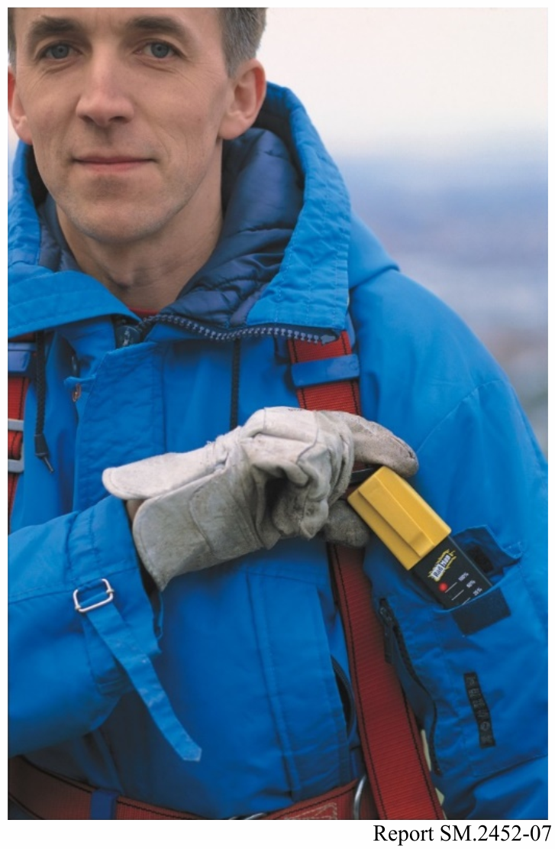

3.2.2 Broadband meters
Broadband meters with ‘shaped probes’ measure the EMF exposure directly because they display the squared, isotropic and weighted RMS value of the electric field strength. The RMS integration time can be set from about 100 ms up to some 10 minutes. Shaped probes are available for frequencies up to 50 GHz and for several standards including ICNIRP 1998 and IEEE C95.1-2019.
Broadband meters for EMF measurement are able to measure exposure values much greater than unity. This implies that their electronic must be immune to such high field strength levels. This also implies that the person executing the measurements must be able to read out the measurement results from a safe distance. Therefore, broadband meters for EMF measurement usually have an optical link and can display their results on a second meter acting as a controller or on a common computer device.
Some very helpful features of broadband meters are a graph displaying the exposure values over time, the support of spatial averaging and a maximum hold function.
If the exposure due to all relevant transmitters has to be assessed, a broadband meter with a shaped probe is sufficient to carry out all necessary measurements in most cases. If diodes instead of thermocouples are used as detectors in the probes, it must be noted that signals with high crest factors may lead to significant measurements’ uncertainties, if the measured RMS values are higher than the true RMS range of the probes. Even if the exposure due to several transmitters has to be assessed separately, broadband meters are extremely useful for a quick overview of the spatial and temporal structure of the total exposure values. After the local hot spots and the temporal structures at the hot spots are known, a selective measurement procedure can be set up much more effectively.
Also isotropic, broadband probes with flat frequency response are available for broadband meters: magnetic field up to 1 GHz and electric field up to 90 GHz.
FIGURE 8
Broadband meter with isotropic probe
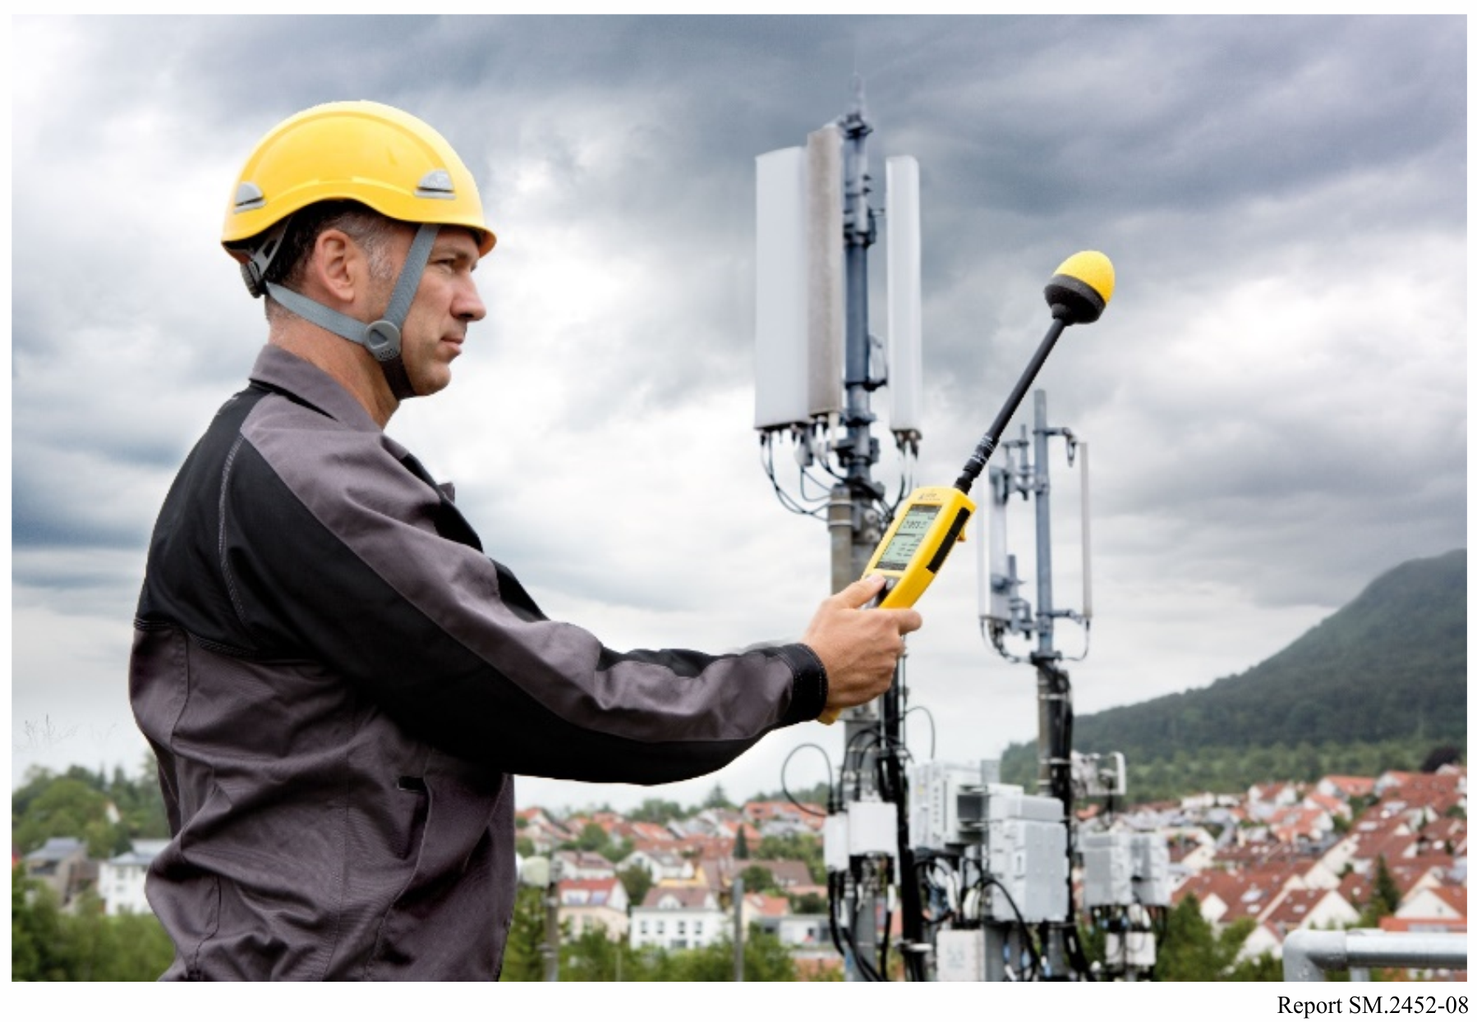

3.2.3 Frequency selective meters
Frequency selective measurement is necessary if the exposure due to several transmitters has to be assessed separately. Selective meters for EMF are either regular spectrum analysers or dedicated selective meters without the additional features of normal spectrum analysers. Useful features for EMF measurements are:
• Handheld and battery powered;
• Immunity against high field strength levels;
• Remote control (electrical or optical);
• Direct support of isotropic antennas;
• RMS detector with configurable integration time and Max Hold function in all measurement modes;
• Automatic RSS value calculation;
• Results in field strength and exposure units;
• Measurement of each service with dedicated settings;
• Demodulators for UMTS, LTE and 5G;
• Channel power options;
• Traceable calibration of the meter and the antennas;
• Frequency range at least 9 kHz to 6 GHz, preferably 9 kHz to 18 GHz or 40 GHz, to cover new wireless communication bands. Further extension by external mixers is useful for wireless systems like short range devices 60 to 66 GHz, wireless-gigabit (WiGig) devices, automotive radars and scanners.
Figure 9 depicts frequency-selective monitoring meters, using isotropic antennas.
FIGURE 9
Frequency selective meters for EMF
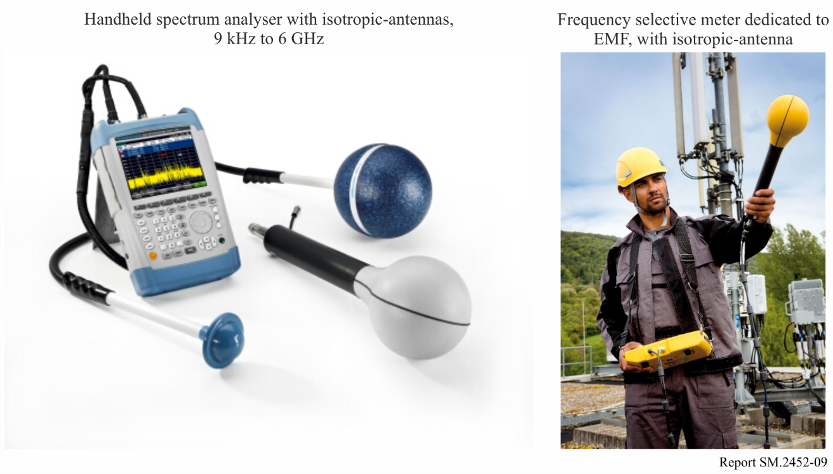

3.3 Reducing the number of measurement points in space
The exposure of humans due to electromagnetic fields can vary extremely between different points in space. The distance to and the directional pattern of the transmitter antennas have a huge effect on the exposure level even under free space conditions. In real scenarios also obstacles and reflecting objects can have an additional huge effect on the exposure level at a different point in space. It is very helpful to get an overview of all potentially relevant transmitters and the electromagnetic environment before starting a measurement campaign.
One way to get the desired overview is an optical inspection of the area of interest. At least all visible transmitter antennas should be discovered, and their potential relevance should be assessed by estimating their transmitted power and directional patterns. The most relevant obstacles and reflectors should be identified too. With this information, smaller areas, which are likely to contain the positions of the highest exposure, can be identified. Especially areas with line of sight within the main lobes of the directional patterns of the transmitter antennas are likely candidates for such hot spot areas. For indoor measurements it is important to note that windows can attenuate electromagnetic field significantly. Thus, windows should be kept open during indoor measurements if possible.
The second way to get the desired overview is to make quick exposure overview measurements using broadband meters with shaped probes. If flat-frequency probes are used for this purpose, it must be noted that the spatial field strength maxima are indeed strongly correlated with the spatial exposure maxima, but they are not identical. If only the exposure due to a single transmitter has to be measured, and if this transmitter is not clearly dominating the total exposure, then frequency selective meters are mandatory for the quick overview measurement. Specifically, areas with high exposure values need to be assessed in more detail in a second step. Moving the probe of a broadband meter with a constant speed on straight lines in a recognized hot spot area and watching the recorded exposure values on graphs over time shows which space resolution is necessary to find the local maxima in this hotspot area in a second step.
Figure 10 shows an FM signal measured at 101.6 MHz, and GSM down-link at 947.4 MHz.
FIGURE 10
Field-strength distribution in a room
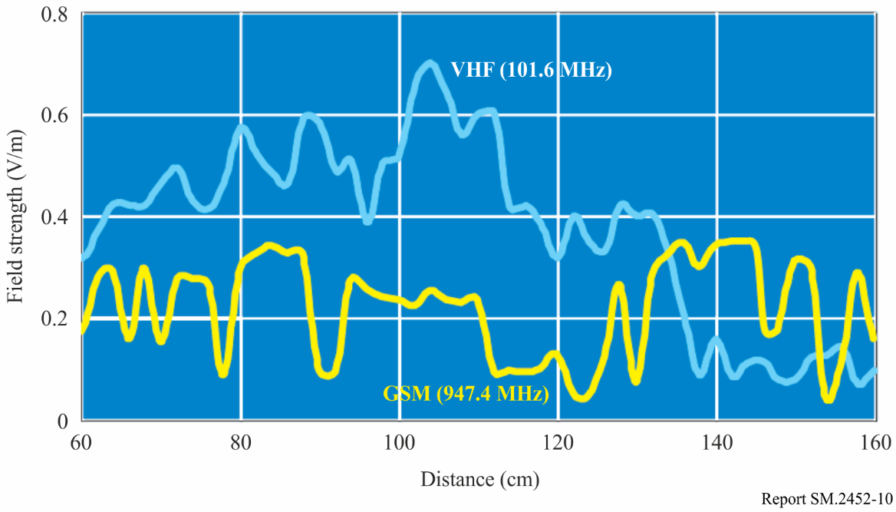
Once hot spot areas are recognized, the local exposure maxima in these areas have to be found. Note that spatial averaging over moderate volumes is permissible, referring to ICNIRP. Avoiding spatial averaging at all may lead to a significant overestimation of the actual exposure. Finding a local maximum with isotropic probes or antennas is easy. The fastest method is to scan the hot spot area by a random movement of the probe or antenna in this area and use a maximum hold function during the scan. Moderate spatial averaging can be done in the same procedure just by setting an RMS integration time, which suits the desired integration volume and the actual speed of the movement. The second method is called grid method: a grid of points within the hotspot area is defined with a sufficient spatial resolution and the exposure is measured at each point in the grid. The grid method can be combined with moderate spatial averaging too. For a small grid consisting of 3 or 6 points, this is a useful alternative, avoiding the influence of the person carrying out the measurement. For large grids, this method is quite time consuming.
For frequencies higher than 6 GHz, isotropic antennas are not yet available. Thus, broadband meters with isotropic probes or spectrum analysers with biconical or directional antennas are used in this frequency range. Finding a local maximum of the exposure with biconical or directional antennas takes more time compared to isotropic probes or antennas. In practice the stirring method is used most often with such antennas: the antenna position, direction and polarization are changed randomly within the volume of interest by moving the antenna by hand. The local maximum is detected by using a maximum hold function in the selective meter or spectrum analyser during the stirring process. A grid method with directional antennas would be extremely time consuming because for each point of the grid the polarization and direction of the antenna would need to be changed many times in order to ensure that an exposure value with the maximum coupling of the field to the antenna has been captured for each point.

3.4 Reducing the observation time and extrapolation to the maximal exposure
The radiated power of some transmitters may vary extremely over time. Especially for base stations of cellular mobile services the transmitted power depends highly on the actual traffic load and user behaviour. Even during an observation time of 24 h the maximum power might not be reached because the traffic load may also depend on the day of the week or even the season. It is essential to reduce the observation time to a reasonable value in practical measurements. Therefore, it is common practice to measure the exposure due to some signal components, which are transmitted with a power that does not depend on the traffic load or the user behaviour. In a second step, the exposure is extrapolated to that exposure that would occur when the maximum transmitter power would be used. Extrapolation is however not necessary if the transmitter power is more or less constant over time. In this case, even short observation times are sufficient to assess the maximum exposure.

3.5 How to assess the exposure due to specific services
With broadband meters and shaped probes, the current total exposure can be assessed comfortably. However, if the exposure due to several transmitters needs to be assessed separately, a selective measurement technique is necessary. The following subsections describe how to assess the exposure due to specific services with selective measurement technique. The extrapolation process is described where adequate.

3.5.1 General approach for services where extrapolation is not of interest
Extrapolation is not necessary for systems, which transmit with more or less constant power. Examples for such services are FM Radio, digital radio and digital terrestrial television. Such transmitters can be assessed very easily. A frequency selective meter can be used for such assessments. Also, if the transmitted average e.i.r.p. is not constant, the following measurement can be applied, but it will result in the actual exposure only, not in the maximum one.
The first step is to select an appropriate selection filter in order to capture nearly 100% of the power of the channel of interest and as less power of the adjacent channels as possible.
The usage of the Gaussian selection filters in spectrum modes can lead to significant measurements’ uncertainties if systems with narrow channel spacing are measured. These additional uncertainties can be avoided by using channel power options or receiver modes with appropriate channel filters.
The next step deals with the appropriate integration time of the RMS detector. The integration time selected must be sufficiently long to reduce the fluctuations of the detected power to a negligible value but should not be much longer, in order to speed up the measurement process. It must also be shorter than the maximum permissible integration time of the relevant exposure limits. Finally, the integration time must be long enough to contain at least 100 samples.

3.5.2 Approaches for specific services

3.5.2.1 GSM base stations
The GSM cellular network is one of the services where the transmitted power depends highly on the traffic load and user behaviour. As with every service, the actual exposure can be assessed with the general approach described in previous sections. But the maximum possible exposure due to a base station often has to be judged also by regulators or operators.
At least one time slot of the eight time slots of a GSM frame is transmitted with the maximum power on the broadcast control channel (BCCH) of a GSM cell. Other time slots can transmit the same or lower power. Some time slots may use Gaussian Minimum Shift Keying (GMSK) modulation and some enhanced data rates for GSM evolution (EDGE) modulation. The power of EDGE time slots fluctuates around the mean power of the timeslot because this modulation type generates noise like signals. The RMS integration time for BCCH measurements must be less than the length of a time slot (577 µs) in order to ensure that the maximum power of a single timeslot can be captured without attenuation. The integration time should not be much shorter because the power fluctuations due to EDGE modulation have to be reduced to negligible values. The maximum of the RMS values over time then corresponds with the maximum transmitted power of the BCCH. A cell also transmits on traffic channels (TCHs) at different frequencies. The maximum possible exposure due to all channels of a GSM cell can be extrapolated now. It is the maximum possible exposure due to the BCCH multiplied with the total number of frequency channels of the cell which can be operated simultaneously. The exposure due to all cells receivable at the location of interest is the addition of all cell specific exposure values.

3.5.2.2 UMTS base stations
The UMTS cellular network is also one of the services where the transmitted power depends highly on the traffic load and user behaviour. The following procedure is state of the art, if extrapolation to the maximum possible exposure is desired:
UMTS is a code division multiple access (CDMA) system. Up to 512 data channels can be transmitted per cell. The different relatively low data rate channels are spread by different channelization codes over the relatively high bandwidth of a UMTS frequency channel. Because different cells use different scrambling codes, signals from different cells using the same frequency channel can also be separated. In each cell there is a P-CPICH (primary common pilot channel) which is transmitted with a constant power. The service provider can set the ratio of the maximum cell power to the P-CPICH power. Usually, this power ratio lies in range from 8 to 15. Thus, measuring the exposure due to the P-CPICH of a specific cell and multiplying it with the power ratio of this cell results in the maximum possible exposure due to this cell. The exposure due to all cells is the sum of all cell specific exposure values.

3.5.2.3 LTE base stations
The LTE cellular network is also one of the services where the transmitted power depends highly on the traffic load and user behaviour. The following procedure is state of the art, if extrapolation to the maximum possible exposure is desired:
LTE is an orthogonal frequency division multiplexing (OFDM) system. It can use frequency division duplex (FDD) or time division duplex (TDD) mode. There are one, two or four cell specific reference signals embedded in the resource grid of an LTE frame. The number of the reference signals is the same as the number of the transmitting antennas. Each reference signal is transmitted over its associated antenna only and with constant power. Note that the transmitted power of traffic dependent symbols is distributed equally over all antennas in use.
The mean value of the exposure due to single resource elements transmitting cell specific reference signals is measured in a first step for each antenna and cell separately. The sum over all antennas used by a specific cell is calculated in a second step. In a third step, this sum is multiplied with an extrapolation factor which results in the maximum possible exposure due to the specific cell. The exposure due to all cells is the addition of all cell specific exposure values.
According to IEC 62232, the extrapolation factor for cells in FDD mode is the number of subcarriers divided by a ‘boost factor’. The number of the subcarriers depends on the bandwidth of the cell only (72, 180, 300, 600, 900 or 1 200 subcarriers for a bandwidth of 1.4, 3, 5, 10, 15 or 20 MHz). The ‘boost factor’ may depend on the cell settings and has to be requested from the service provider if in doubt. The correct “boost factor” in the sense of IEC 62232 is identical to the number of antennas in many cases.
For a cell in TDD mode the extrapolation factor is the same as for a cell in FDD mode, but multiplied with a correction factor, defined by the ratio of the time used for downlink within a frame to the frame length. The actual ratio can be measured roughly in “scope” mode of a selective meter or it can be calculated exactly if the uplink-downlink configuration, special-subframe configuration and the cyclic prefix length of the specific cell is known. The possible range of the correction factor is 34/140 up to 106/120. If in doubt or, if the service provider does not guarantee not to change the uplink-downlink configuration, the maximum correction factor should be used.

3.5.2.4 Wi-Fi access points
Wi-Fi networks are an application where the transmitted power depends highly on the traffic load and user behaviour. The OFDM RF signal is emitted in bursts, so all the carriers of the channel are active at certain times, depending on the traffic. As a consequence, the most difficult scenario for assessing the exposure is the idle mode, in which only 0.5 ms duration sequence of beacons is transmitted every some tens of milliseconds. With the following measurement procedure, it is possible to extrapolate the maximum exposure.
The channel power of the Wi-Fi signal is measured continuously with an RMS integration time less than 0.5 ms. The maximum channel power over time is determined. This maximum channel power should be converted to the corresponding field strength. This field strength can be compared with the exposure limit. If the duty cycle of the Wi-Fi system is limited to values lower than 100%, the maximum exposure must be adjusted, according to the duty cycle.

3.5.2.5 5G New Radio base stations
The 5G New Radio (NR) cellular network is also one of the applications where the transmitted power depends highly on the traffic load and user behaviour. The following procedure is state of the art, if extrapolation to the maximum possible exposure is desired:
5G NR is an orthogonal frequency division multiplexing (OFDM) system. It can use frequency division duplex (FDD) but uses mainly time division duplex (TDD). The only signal which is always transmitted is the synchronization signal and physical broadcast channel (SS/PBCH) block. Between one and 64 SS/PBCH blocks are transmitted, on different beams in a sequence within some half frames of 5 ms length. The sequence is normally repeated every 20 ms. The secondary synchronization signal (SSS) is cell specific and its power density per resource element can be measured for each cell identification (ID) separately. The beam index of each beam in a sequence can be decoded using the demodulation reference signals (DM-RS) of the PBCH. The knowledge of the beam indices is however not necessary for an accurate extrapolation. More details about the signal structure of the SS/PBCH block can be found in H. Keller (2019).
The mean value of the exposure due to single resource elements transmitting SSS is measured in a first step for each beam and cell separately. The maximum over all beams transmitted by a specific cell is calculated in a second step. In a third step, this value is multiplied by an extrapolation factor which results in the maximum possible exposure due to the specific cell. The exposure due to all cells is the addition of all cell specific exposure values.
The extrapolation factor is the product of four separate extrapolation factors:
k_{BW}: bandwidth of the cell divided by the subcarrier spacing of the SSS
k_{DC}: duty cycle due to TDD mode
k_{PR}: power reduction factor due to traffic power or e.i.r.p. limiters
k_{beam}: angle dependent e.i.r.p. envelope ratio of traffic to SSS beams.
The first two extrapolation factors are trivial and need no further explanation.
The third extrapolation factor is 1 if there are no means to limit the average power or e.i.r.p. of the traffic over the maximum permitted averaging time of the applicable safety standard to values which are smaller than the maximal theoretical power or e.i.r.p. Otherwise, it is the ratio of the limited power or e.i.r.p. to the maximum theoretical power or e.i.r.p.
The fourth extrapolation factor reflects the different power, beamforming and polarisations that might be used for the SSS beams and the traffic beams. To obtain this extrapolation factor two e.i.r.p. envelopes must be known. Note that the e.i.r.p. is a function of the azimuth and elevation angle.
– The first e.i.r.p. envelope (SSS e.i.r.p. envelope) is maximum e.i.r.p. of one resource element over all SSS beams multiplied by k_{BW};
– The second e.i.r.p. envelope (traffic e.i.r.p. envelope) is maximum e.i.r.p. over all possible traffic beams.
The ratio of the traffic e.i.r.p. envelope to the SSS e.i.r.p. envelope at a specific azimuth and elevation angle is the k_{beam} for this azimuth and elevation angle. Note that k_{beam} can only be obtained if there is a deep knowledge about the specific cell. In some cases, this information may be provided by the operator, but in the absence of this information, the following cases can be distinguished:
a) The measurement location is within the angle range covered by the SSB beams and they use the same gain and power as the traffic beams. In this case k_{beam} can be set to 1.
b) The measurement location is within the angle range covered by the SSB beams and they use different gain or power as the traffic beams. In this case k_{beam} is more or less constant over azimuth and elevation and might be provided by the operator. If this is still not the case then case c) is applicable.
c) The measurement location is outside the angle range of the SSB beam or gain or power is different for SSB and traffic beams. In this case, the measurement has to be performed in a traffic beam. This requires either a test signal being transmitted in the direction of the measurement location, or other means to ensure that a traffic beam is directed to the measurement location.
The assessment method for case c) is described here:
A spectrum analyser is used to find the maximum channel power within a channel bandwidth which is much higher than 12 traffic subcarrier spacings and with an RMS integration time of about one traffic symbol length. The maximum power density value obtained over the observation time (long enough to ensure that at least one symbol occupying the complete channel bandwidth of the analyser was transmitted with maximum power and gain into the direction of the measurement location is recorded. The maximum power density of a traffic resource element is estimated by multiplying the recorded maximum with the channel bandwidth and dividing it by the traffic subcarrier spacing. The maximum exposure at the measurement point is the exposure due to the maximum power density of a traffic resource element multiplied by the product of k_{BW} , k_{DC} and k_{PR}.
Methods to attract a beam with the required properties for case c) are still under development.

4 References
ITU Handbook on Spectrum Monitoring, Chapter 5.6
Output Report on ITU-D Question 7/2 for the study period 2018-2021 – Policies, guidelines, regulations and assessments of human exposure to radio-frequency electromagnetic fields
ITU-T Recommendations
Enclosed the most relevant EMF ITU-T Recommendations (standards), and related supplements:
– K.52: Guidance on complying with limits for human exposure to electromagnetic fields
– K.61: Guidance on measurement and numerical prediction of electromagnetic fields for compliance with human exposure limits for telecommunication installations
– K.70: Mitigation techniques to limit human exposure to EMFs in the vicinity of radiocommunication stations
– K.83: Monitoring of electromagnetic field levels
– K.90: Evaluation techniques and working procedures for compliance with exposure limits of network operator personnel to power-frequency electromagnetic fields
– K.91: Guidance for assessment, evaluation and monitoring of human exposure to radio frequency electromagnetic fields
– K.100: Measurement of radio frequency electromagnetic fields to determine compliance with human exposure limits when a base station is put into service
– K.113: Generation of radiofrequency electromagnetic field level maps
– K.122: Exposure levels in close proximity of radiocommunication antennas
– K.145: Assessment and management of compliance with radio frequency electromagnetic field exposure limits for workers at radiocommunication sites and facilities.
This list demonstrates that there is already a comprehensive suite of ITU Recommendations / Standards to address realistic concerns about exposure to RF-EMF from networks and devices.
Enclosed some relevant ITU-T K supplements:
– K Suppl. 1: ITU-T K.91 – Guide on electromagnetic fields and health
– K Suppl. 4: ITU-T K.91 – Electromagnetic field considerations in smart sustainable cities
– K Suppl. 9: 5G technology and human exposure to radiofrequency electromagnetic fields
– K Suppl. 13: Radiofrequency electromagnetic field (RF-EMF) exposure levels from mobile and portable devices during different conditions of use
– K Suppl. 14: The impact of RF-EMF exposure limits stricter than the ICNIRP or IEEE guidelines on 4G and 5G mobile network deployment
K Suppl. 16: Electromagnetic field compliance assessments for 5G wireless networks
– K Suppl. 19: Electromagnetic field (EMF) strength inside underground railway trains
– K Suppl. 20: ITU-T K.91 radiofrequency exposure evaluation around underground base stations
ICNIRP
– ICNIRP (1998): Guidelines for limiting exposure to time‐varying electric, magnetic and electromagnetic fields (up to 300 GHz)
– ICNIRP (2010): Guidelines for limiting exposure to time‐varying electric and magnetic fields (1 Hz – 100 kHz)
– ICNIRP (2020): Guidelines for limiting exposure to electromagnetic fields (100 kHz to 300 GHz)
IEEE
– IEEE Std C95.1-2005: Safety Levels with Respect to Human Exposure to Radio Frequency Electromagnetic Fields, 3 kHz to 300 GHz
– IEEE C95.1-2019: IEEE Standard for Safety Levels with Respect to Human Exposure to Electric, Magnetic, and Electromagnetic Fields, 0 Hz to 300 GHz

5 Glossary and abbreviations
2D Two dimensions
3D Three dimensions
AGL Above ground level
BCCH Broadcast control channel
DTM Digital terrain mapping
DTV Digital TV
e.i.r.p. Equivalent isotropically radiated power
EMF Electromagnetic field
ERL Exposure reference level
FDD Frequency division duplex
ICNIRP International Commission on Non-Ionizing Radiation Protection
IEC International Electrotechnical Commission
IEEE Institute of Electrical and Electronics Engineers
LTE Long-term evolution
NR New radio
OFDM Orthogonal frequency division multiplexing
PBCH Physical broadcast channel
P-CPICH Primary common pilot channel
RF Radio frequency
RMS Root mean square
RSS Root of sum of squares
SSS Secondary synchronization signal
TDD Time division duplex
UMTS Universal mobile telecommunications system
WiGig Wireless gigabit
WHO World Health Organization

Annex
Electromagnetic field around an Amateur Radio Station, 14 MHz to 440 MHz
This Annex is an example of a specific measurement, at a specific site.

Attachment 1
to the Annex
Site information, the station, the surrounding area and measurements

Site information
Call-sign 4X1YS; address Hashikma 21, Lapid Israel; Tx Coordinates: Israel Transverse Mercator (ITM). ITM East: 203453, ITM North: 646963; Latitude: 31.915584° North, Longitude 35.035307° East; date 20 June 2021. Measurement’s person: Daniel Rosenne, Affiliation: QRP Ltd., ‘Standards Institution of Israel’ EMC and EMF, call-sign 4X1SK.
Measurements were carried out between 08:00 and 11:00 local time (UTC 5:00- 8:00); weather conditions: dry, sunny; suburban/rural area.
Description of the station, the surrounding area and measurements
1 An amateur’s station located in a home adjacent to a two-story single-family residence. On the roof of the building is a 6.5 m mast on which:
a Four-elements HF Yagi antenna is installed; at a distance of 1.5 metres above, three elements Yagi antenna for the low-VHF, with a 360-degree antenna rotator.
b 3-metre mast on which a vertical antenna (a pair of antennas 5/8 wavelength) for VHF/UHF is installed.
2 The measurements were carried out at the amateur’s station and its adjacent residential building, on a sidewalk near the amateur’s house and in a residential building across the road (at 22 DeadSea Street).
3 Since most of the measurements were monitored at a distance about one wavelength from the antenna, the electric field E and magnetic field H were measured at each point. E and H field measurements are required by EN 50413:2019 only below 10 MHz, and are required in a measurement distance of at least 1 wavelength λ (highest tested λ equals 21.4 m @ 14 MHz) from the transmitter. Results demonstrate the H measurement was unnecessary.
Blanks ‘-‘ in the two results’ tables indicate that the measured signal level was below the measured noise level.
4 Ambient Noises (E @ V/m and (H @ A/m) were measured when the amateur transmitters were silent. The frequency domain measurements are wide-band; the amateur operated one source on and others off.
5 The amateur station does not transmit continuously. Normally, the station operates for a few hours a day (and not every day), and during its operation it transmits only a small part of the time.
6 The amateur antenna main-beam was directed toward the residence at 135 degrees.
7 Field measurements results are very close (within 3 dB) to calculation results, either by simple manual calculation or by a detailed computation using program, such as UK EMF calculator.

Attachment 2
to the Annex
Tx power and antennas
TABLE 3
Tx power and antennas
 | Power (W) ⁽¹⁾ | Antenna | Gain | Measured signal
HF ⁽²⁾ | 150 | KLM KT34 HF 4 el Yagi | 7 dBd | CW ⁽³⁾ RMS
VHF ⁽⁴⁾ | 25 | Cushcraft A503S 6m Yagi | 8 dBd | CW
V/UHF ⁽⁵⁾ | 30 | Diamond X300 Vertical | 6.5 dBi @ 2m,  9.0 dBi @ 70 cm | continuous FM
⁽¹⁾ ICNIRP 2020 Guidelines, Table 4 ‘Basic restrictions… from 100 kHz to 10 MHz, for peak spatial values’ was not used, as the tested frequencies are above 10 MHz.
⁽²⁾ Actual RF- 14.250, 21.250 and 28.500 MHz.
⁽³⁾ SSB; PEP 1,000 W; multiplied duty factor of 0.4 (converting PEP to RMS), multiplied by 1/3 (converting to 6 minutes average, assuming that in a 6-minute period, the amateur station transmits for 2 minutes and listens for 4 minutes).
⁽⁴⁾ Actual RF- 50.3 MHz.
⁽⁵⁾ Actual RF- 145.5 and 433.4 MHz.

Attachment 3
to the Annex
Measurement equipment
Electromagnetic Field Meter SMP-2, serial number 18SN0699; placed on a wooden stand, with the following sensors:
- Isotropic electric field-probe model WPF8, serial number 18WP040777; frequency range: 0.1 to 8,000 MHz; calibrated till 16 January 2022. Probe uncertainty: ±0.75 dB for E field.
- Isotropic magnetic field-probe model WPH60, sensitivity 0.018 A/m, serial number 21WP110083; frequency range: 0.3 to 60 MHz; calibrated till 8 Feb. 2023. Probe uncertainty: ±1.33 dB for H field.
Figure 11
Measurement equipment and amateur antennas
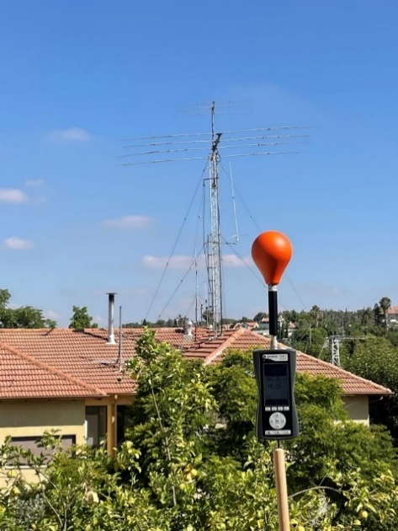

Attachment 4
to the Annex
Measurements results 14 to 440 MHz, field-strengths
In the last column of the following two Tables, instead of ambient-noise, the term displays value with sources off: the amateur transmitters were not transmitting.
TABLE 4
Measurements results 14 to 440 MHz electric field-strength
Test point | Range from Tx (m) |  | Results (V/m), RF band (MHz) |  |  |  |  |  | E with sources off (V/m)
 | Horizontal | Vertical | 14 | 21 | 28 | 50 | 144 | 440
Amateur station | 6.5 | 1.5 | 1.2 | 0.6 | 0.96 | 0.6 | 0.6 | 0.4 | 0.2
2nd floor, Hashikma 21 | 1.5 | 8.5 | 0.05 | 0.05 | 0.05 | 0.2 | 0.3 | 0.4 | 0.01
Floor 1, Hashikma 21 | 1.5 | 11.5 | 0.05 | - | - | - | 0.25 | 0.15 | 0.02
Sidewalk in DeadSea st’ | 9 | 12 | 0.9 | 0.8 | 1.3 | 1.2 | 0.4 | 0.25 | 0.06
Floor 2 terrace DeadSea 22 | 40 | 2 | 1.2 | 1.2 | 1.4 | 0.8 | 1.8 | 0.4 | 0.05
Floor 2 childroom DeadSea22 | 42 | 2 | 0.2 | 0.2 | 0.3 | 0.4 | 0.4 | 0.3 | 0.05
Garden, DeadSea 22 | 40 | 6 | 0.9 | 0.7 | 1.4 | 1.6 | 1.1 | 0.2 | 0.14
ICNIRP 2020 Guidelines, Table 5 | Occupational  RF in MHz |  | 660/f_{M}^{0.7}  =104 | 660/f_{M}^{0.7}  =78 | 660/f_{M}^{0.7}  =64 | 61 |  | 3f_{M}^{0.5}  =63
 | General Public  RF in MHz |  | 300/f_{M}^{0.7}  =47 | 300/f_{M}^{0.7}  =36 | 300/f_{M}^{0.7}  =29 | 27.7 |  | 1.375f_{M}^{0.5}  =29

TABLE 5
Measurements results 14 to 440 MHz magnetic field-strength
Test point | Range from Tx (m) |  | Results (A/m) |  |  |  |  |  | H with sources off (A/m)
 | Horizontal | Vertical | 14 | 21 | 28 | 50 | 144 | 440
Amateur station | 6.5 | 1.5 | - | - | - | - | - | - | 0.01
2^{d} floor, Hashikma 21 | 1.5 | 8.5 | - | - | - | - | - | - | 0.025
Floor 1, Hashikma 21 | 1.5 | 11.5 | - | - | - | - | - | - | 0.05
Sidewalk in DeadSea st’ | 9 | 12 | 0.011 | 0.011 | - | - | - | - | 0.01
Floor 2 terrace DeadSea 22 | 40 | 2 | 0.011 | 0.011 | 0.013 | 0.012 | - | - | 0.01
Floor 2 childroom DeadSea 22 | 42 | 2 | - | - | - | - | - | - | 0.01
Garden, DeadSea 22 | 40 | 6 | 0.011 | - | 0.011 | - | - | - | 0.01
ICNIRP 2020 Guidelines, Table 5 | Occupational  RF in MHz |  | 4.9/f_{M}  =0.35 | 4.9/f_{M}  =0.2 | 4.9/f_{M}  =0.2 | 0.16 |  | 0.008f_{M}^{0.5}  =0.2
 | General Public  RF in MHz |  | 2.2/f_{M}  =0.16 | 2.2/f_{M}  =0.1 | 2.2/f_{M}  =0.08 | 0.073 |  | 0.037f_{M}^{0.5}  =0.08

Attachment 5
to the Annex
Summary and conclusions of the Annex
The measured electromagnetic field strengths from the amateur radio station, under the measuring conditions, at all the measurement points and frequencies tested, meet the occupational and general-public ICNIRP 2020 exposure levels. The EMF tests indicate that inside the building, even on the top floor, in the vicinity of the building and in adjacent buildings, in front the antenna main-beam, the measured signals are negligible.

The units of the two y-axes (i.e. electric field and power density) are independent of each other.
Retrieved on 28 June 2022 from https://www.icnirp.org/en/differences.html
Mazar 2016, Wiley ‘Radio Spectrum Management: Policies, Regulations and Techniques’ revised 2021 Chapter 9 Figure 9.6.
Reference levels for occupational exposure to time-varying electric and magnetic fields.
Reference levels for general public exposure to time-varying electric and magnetic fields.
Exposure Reference Levels (ERLs) for whole-body exposure of persons in unrestricted environments (100 kHz to 300 GHz).
ERLs for whole-body exposure of persons permitted in restricted environments (100 kHz to 300 GHz).
Reference levels for exposure, averaged over 30 min and the whole body, to electromagnetic fields from 100 kHz to 300 GHz.
Presentation at the ITU Regional Symposium for Europe and CIS on Spectrum Management and Broadcasting 02 July 2020, Electromagnetic Fields and 5G Implementation.
“The product of the power supplied to the antenna and the antenna gain in a given direction relative to an isotropic antenna”, ITU Radio Regulations, volume 1 provision No. 1.161. e.i.r.p. is not necessarily the product of maximum power and maximum gain; it is the power radiated toward the point of investigation. The cellular transmitters are power controlled and they do not transmit all time at maximal level. Near a cellular antenna, below it, the e.i.r.p. is low, as a side lobe in elevation is much attenuated relatively to the antenna main-beam.
“On the assessment of human exposure to electromagnetic fields transmitted by 5G NR base stations”, Health Physics, 117(5):541–545
Basic standard on measurement and calculation procedures for human exposure to electric, magnetic and electromagnetic fields (0 Hz - 300 GHz).

