Report ITU-R SM.2422-3
(06/2026)
SM Series: Spectrum management
Visible light for broadband communications

Foreword
The role of the Radiocommunication Sector is to ensure the rational, equitable, efficient and economical use of the radio-frequency spectrum by all radiocommunication services, including satellite services, and carry out studies without limit of frequency range on the basis of which Recommendations are adopted.
The regulatory and policy functions of the Radiocommunication Sector are performed by World and Regional Radiocommunication Conferences and Radiocommunication Assemblies supported by Study Groups.

Policy on Intellectual Property Right (IPR)
ITU-R policy on IPR is described in the Common Patent Policy for ITU-T/ITU-R/ISO/IEC referenced in Resolution ITU-R 1. Forms to be used for the submission of patent statements and licensing declarations by patent holders are available from https://www.itu.int/ITU-R/go/patents/en where the Guidelines for Implementation of the Common Patent Policy for ITU-T/ITU-R/ISO/IEC and the ITU-R patent information database can also be found.

Series of ITU-R Reports
(Also available online at https://www.itu.int/publ/R-REP/en)
Series | Title
BO | Satellite delivery
BR | Recording for production, archival and play-out; film for television
BS | Broadcasting service (sound)
BT | Broadcasting service (television)
F | Fixed service
M | Mobile, radiodetermination, amateur and related satellite services
P | Radio-wave propagation
RA | Radio astronomy
RS | Remote sensing systems
S | Fixed-satellite service
SA | Space applications and meteorology
SF | Frequency sharing and coordination between fixed-satellite and fixed service systems
SM | Spectrum management
TF | Time signals and frequency standards emissions

Note: This ITU-R Report was approved in English by the Study Group under the procedure detailed in Resolution ITU-R 1.

Electronic Publication
Geneva, 2026
© ITU 2026
All rights reserved. No part of this publication may be reproduced, by any means whatsoever, without written permission of ITU.

REPORT ITU-R SM.2422-3
Visible light for broadband communications
(Question ITU-R 238/1)
(2018-2019-2022-2026)
TABLE OF CONTENTS
Page
1 Scope 2
2 History of visible light communication (VLC) 4
3 Visible light and broadband 4
3.1 Possibilities of broadband use via visible light 4
3.2 Efficiency gains of the use of visible light for broadband communications 5
3.3 Use of the spectrum 5
3.4 Possible applications/services benefiting from VLC 5
4 Spectrum management aspects relevant to visible light 6
4.1 Issue 1: Spectrum opportunities and spectrum allocation 7
4.2 Issue 2: Spectrum planning principles 7
4.3 Issue 3: International and regional harmonization 8
5 Technical and operational characteristics of short distance broadband communication via visible light 8
5.1 Visible light communication transmitter 8
5.2 Visible light communication receiver 9
5.3 Current standardization activities 10
5.4 Collected VLC related activities in the countries 11
5.5 Collected VLC related activities in the Academia, Industry and Research Institutes 11
6 Other relevant aspects (user needs, socio-economic aspects) for decisions on visible light 14
7 Conclusions 21
Annex 1 – Tsinghua University lab results of an indoor broadband broadcasting system based on power line communication and visible light communication 22
A1.1 Brief introduction 23
A1.2 Demonstration implementation and evaluation 24
A1.3 Future work 32
Annex 2 – High-speed point-to-point visible light communication system with motion alignment 36
A2.1 Overview 36
A2.2 System introduction 36
A2.3 Main units 38
A2.4 Measurement result 40
A2.5 Summary 42
Annex 3 – 2.4 Gbit/s real-time visible light communication system based on
blue laser diodes 42
A3.1 Overview 42
A3.2 System introduction 42
A3.3 Measurement results 45
A3.4 Summary 48
Annex 4 – A 25 Gbit/s plug-and-play self-alignment optical wireless communication
system 48
A4.1 Overview 48
A4.2 System introduction 49
A4.3 Measurement results 50
A4.4 Summary 54

1 Scope
This Report considers how, in which way, and to what extent the use of (near) visible light communication (VLC) (or perhaps a better term might be: Optical Wireless Communication) can help to ease the congestion in the radio spectrum.
The following topics are addressed:
− distinctive characteristics (technical and operational) of the use of (near) VLC for broadband communications in terms of its use of the spectrum;
− advantages and disadvantages of the use of (near) VLC (these might include: efficiency, interference, health risks, cybersecurity);
− new applications associated with visible light used for broadband communications;
− barriers for the development of broadband communications in order to move to worldwide implementation of (near) VLC (e.g. regulatory, cultural and/or economical);
− way in which (near) VLC connects to current telecom systems (fixed and mobile).
It should be noted that VLC is a technology and not a radiocommunication service.
Abbreviations/Glossary
ADC Analogue-to-digital converter
APD Avalanche photon diode
APSK Amplitude phase shift keying
BAN Body area network
DAC Digital-to-analogue converter
DC Direct current
DDC Digital down conversion
EMI Electromagnetic interference
FEC Forward error correction
FoV Field of view
FSO Free space-optical communication
FSOI Free-space-optical interconnect
FWF-OWC Fibre-wireless-fibre OWC
GaN Gallium arsenide
HR-PC High-rate photodiode receiver communications
IoRL Internet of radio light
IoT Internet of things
ISC Image sensor communications
LAN Local area network
LD Laser diodes
LED Light-emitting diodes
LR-PC Low-rate photodiode receiver communications
MER Modulation error ratio
MIMO Multiple transmitters and multiple receivers
OCC Optical camera communication
OFDM Orthogonal frequency-division multiplexing
OWBAN Optical WBAN
OWC Optical wireless communications
OWSN FSO Optical wireless satellite network FSO
PAN Personal area network
PLC Powerline communication
PLL Phase locked loop
PN Pseudo noise
QAM Quadrature amplitude modulation
RF Radio frequency
SC Single carrier
SGC Surface grating coupler
TCP Transmission control protocol
TDS-OFDM Time domain OFDM
TIG Topic interest group
UDP User datagram protocol
VAT Vehicular assistant technology
VLC Visible light communication
VLCC Visible light communications consortium
WBAN Wireless body area network
WPAN Wireless area network

2 History of visible light communication (VLC)
From ancient times to the 19th century, all VLC communication systems relied on the human eye as the receiver. The invention of the Photophone by Alexander Graham Bell and Charles Sumner Tainter changed the nature of VLCs. They used the fact that selenium resistance varies with respect to light intensity and used this property by connecting it to a phone receiver in order to send audio signals. Many improvements were achieved on these systems until the 1950s, however most of the materials used for detection have higher sensitivity to infra-red radiations, hence precluding visible light to be used as a transmission medium.
The introduction of light-emitting diodes (LED) created new interest in the use of VLC. More specifically, the introduction of Gallium Arsenide (GaN) LEDs [1] and white light-emitting phosphors [2] provided visible light sources, which can be modulated at higher speeds, without sacrificing their main illuminating role. In 2004, the first high-speed communication demonstrations with LEDs were performed in Japan, using photodiodes. The proliferation of cellular phones with cameras, enabled them to be used as VLC receivers. Researchers started using LCD screens and other display elements as transmitters.
One of the first standardization bodies to work on a VLC standard was the Visible Light Communications Consortium (VLCC) of Japan. They expanded the infrared Dara Association (irDA) standard for infrared communications with the visible light spectrum in 2008.

3 Visible light and broadband

3.1 Possibilities of broadband use via visible light
Visible light optical wireless access data rates ranging from a few bits/s to excess of 10 Gbit/s are possible at standard indoor illumination levels. VLC has the potential capability to ease congestion with low radio frequency (RF) spectrum bands since light spectrum can be used as an additional spectrum resource for broadband communications.

3.2 Efficiency gains of the use of visible light for broadband communications
VLC establishes a directional optical wireless link. For instance, a single optical link can originate from a lamp on the ceiling pointing directly to the floor. It allows more than one user to share the same link. A number of VLC devices are available to be accommodated without interference through spatial reusability.

3.3 Use of the spectrum
VLC uses the visible spectrum (wavelengths between 390 and 750 nm) and can provide wireless communications using illumination and display elements.
Optical Wireless Communications (OWC) has the potential to ease congestion in the lower RF spectrum bands since light can be used as an additional spectrum resource for broadband communications.

3.4 Possible applications/services benefiting from VLC
Possible visible light communication can be classified into three groups:
– Image sensor communications (ISC).
– Low-rate photodiode receiver communications (LR-PC).
– High-rate photodiode receiver communications (HR-PC).
With regards to the definition of low rate and high rate, the throughput threshold data rate is 1 Mbit/s as measured at the physical layer output of the receiver. Throughputs less than 1 Mbit/s rate are considered low rate, and higher than 1 Mbit/s are considered high rate.
Image sensor communications
ISC enable OWCs using lighting sources as a transmitter and image sensors as a receiver. Possible applications include:
– Location-based services/Indoor positioning and navigation
– Indoor office/home applications (conference rooms, shopping centres, museums, exhibition halls, etc.)
– Vehicular communications
– LED based tag applications
– Point-to-(multi)point/relay/communications
– Healthcare
– Digital signage and location-based content delivery
– In-Vehicle data services (flight, train, ship, bus, etc.)
– Connected-cars and Autonomous Vehicles
– Underwater/Seaside Communications
– Internet of Things (IoT)
The requirements to be observed by the ISC are: dimming control, power consumption control, coexistence with ambient light, coexistence with other lighting systems, simultaneous communication with multiple transmitters and multiple receivers (MIMO), nearly point image data source, identification of modulated light sources, low overhead repetitive transmission, image sensor compatibility, and localization.
For MIMO communications, a MIMO MAC protocol may be incorporated, so that the camera enabled receiving device knows how to process the received data. ISC should support communication when the light source appears as nearly a point source; i.e. the light source illuminates only a small number of image pixels.
ISC is capable of supporting several channels of communication between multiple coordinated/uncoordinated transmitters and multiple coordinated/uncoordinated receivers.
ISC should support compatible communication with a variety of cameras with different image sensing sampling rates (read-out time), resolutions and frame rates. Specifically, either constant frame rate or varying frame rate will be supported. Either constant resolution or varying resolution will be supported.
Low-rate photodiode communications
Low-rate photodiode communications require light sources as a transmitter and low speed photodiodes as receivers. The main applications are similar to those for image sensor applications.
LR-PC is mainly for the light tag sources (such as LED Tags and the smart phone flash lights) as transmitters. It may provide mechanisms to support handover between light sources, allowing the users to maintain a continuous network connection.
LR-PC may provide mechanisms that can be used to develop and deliver interference coordination techniques by higher layers and may support link recovery mechanisms to maintain connection in unreliable channels and reduce connectivity delays.
High-rate photodiode communications
The use of high-rate photodiode receivers will enable high-speed, bidirectional, networked and mobile wireless communications. The main applications of this mode are:
– Indoor office/home applications (e.g. conference rooms, shopping centres, museums, exhibition halls)
– Data centres/industrial establishments, secure wireless (e.g. manufacturing cells, factories)
– Vehicular communications.
– Wireless backhaul (small cell backhaul, surveillance backhaul, LAN bridging).
– Healthcare
– In-Vehicle data services (e.g. flight, train, ship, bus)
– Connected-cars and Autonomous Vehicles
– Underwater/Seaside Communications.
– Internet of Things (IoT).
In HR-PC, continuous data streaming for all applications should be supported with bidirectional functionality as well as short packet transmissions where low latency is required. Mechanisms to support adaptive transmission as well as multiple users communicating with different data streams from the same light source (multiple access) should be included.

4 Spectrum management aspects relevant to visible light
VLC are subject to substantially different propagation characteristics relative to frequencies in the radio frequency spectrum. As a result, the probability of interference is small, and light communications does not need to be managed by spectrum regulators.
IEEE 802 believes that light communications operations should be classified as license-exempt and not subject to exclusive licensing. This point of view was confirmed by a study commissioned by the Radio communications Agency Netherlands [18]. One of the conclusions from this study was: “There are still challenges to overcome before being deployed commercially. We recommend to focus more on standardisation efforts by ITU or IEEE rather than governmental rules and limit governmental regulation primarily to limits with regard to health hazards, carbon footprint, and commercial competition. Standardisation will increase not only compatibility among industrial products but also compatibility with already deployed technologies”. Adherence to the relevant local health and safety regulations regarding human eye safety and sensitivity is essential. Devices using VLC or OWC should adhere to any local regulations regarding spurious RF emissions and should avoid causing interference in RF spectrum bands.
Frequencies for optical communications are usually expressed in their wavelength. While 1 550 nm is the most widely used wavelength for fibre optical communications due to the absorption and scattering characteristics of glass, this limitation does not apply to VLC in normal air. The usable frequency range is therefore 1.4-2.5 THz or 400-700 nm.

4.1 Issue 1: Spectrum opportunities and spectrum allocation
Increasing spectrum opportunities by combining radio, such as 2.4/5/60 GHz, with optical wireless, both indoors and outdoors: exploit possible synergies between Wi-Fi and Li-Fi, take care for fog and sunlight mitigation in outdoor scenarios, see [9] and [10]. It can be read in [18] that “The deployment of Optical Wireless Communication may be particularly interesting in environments where many high bandwidth demanding users access the network within a confined space, or where conventional radio technologies cannot be used, or cannot provide the necessary service level. Bringing together representatives from potential user groups, construction industry, communication industry, device manufacturers and solution providers may help to further advance use cases and requirements for standards and further developments and to identify niche markets where the introduction of OWC will be most beneficial”.

4.2 Issue 2: Spectrum planning principles
VLC systems are typically deployed using the (existing) LED illumination system, wherein the LEDs’ visible light is modulated in intensity in order to convey wirelessly data information to devices. Such illumination systems are usually designed to cover a large area, and thus typically provide data connections to multiple devices within that area. Hence these devices need a protocol according to which they share the capacity of the LED system, i.e. a medium-access-control protocol. Such a MAC protocol typically partitions the total communication capacity of the LED system in smaller parts, where each active device gets a part in competition with the other ones, thus implying that when one device wants more capacity, another device will get less. Working with a MAC protocol and thus sharing resources implies that it is difficult to provide a guaranteed amount of capacity to a device. Establishing a link to a device via a MAC protocol means that a connection has to be established in a negotiation process with the other devices. This process takes time, and the outcome is not guaranteed. This negotiation time reduces the net available time for data transmission, and thus reduces the network data throughput. Moreover, the LED illumination system needs to be switched on, in order to support the data transfer. This illumination-on state may not always be desired, e.g. when the room is already filled with bright daylight, or when the user prefers no or only dimmed light. Hence a VLC system may introduce undesired extra energy consumption when just communication is needed and no illumination.
Alternatively, one may use multiple confined beams of light to convey the data information (e.g. [4]). Each beam serves a single device and needs to be steered with sufficient accuracy towards it. The full capacity of that beam is thus dedicated to only one device. Hence no MAC protocol is needed, and there is no sharing of capacity with other devices. Thus, a guaranteed capacity can be offered to a device, no time is lost in a MAC process, and the net throughput of the network is improved. Moreover, the light beam is only offered to those devices which need it, and is confined to those places; therefore, the beam’s energy is optimally spent, and thus the energy consumption for the data communication is minimized. The light beams are preferably using light with a wavelength larger than 1.4 μm, as this allows beam powers up to 10 mW to be used without eye safety risks. The IR beam steering needs control processes which register first whether the device requests service, subsequently localizes the device, and with that localization information steers the beam into the right direction and thus establishes the communication link. The IR beam-steered system thus provides communication capacity on those places where and when needed, and therefore operates in the most energy-conscious way.
Channel models are a common method to perform “in system” management of the available light spectrum, this can be managed by the respective technical standards for the particular applications. Some information can be found in [17].

4.3 Issue 3: International and regional harmonization
Visible light spectrum preferably fit or comply with international standards (i.e. for Europe ETSI) and as any system and device, should comply with countries’ law and regulations. However, it is important that the visible light communication devices do not impose any health hazards. They should be correctly and safely installed so that they do not produce any harmful Electromagnetic interference (EMI).

5 Technical and operational characteristics of short distance broadband communication via visible light
This section also includes text about products and prototypes taken from [16]. These are not necessarily broadband applications but included to demonstrate available technology.

5.1 Visible light communication transmitter
Carrier frequency: The carrier frequency will be limited in visible light frequency band.
Transfer mode: The ITU-R may provide multiple physical visible light device operating modes for low and high data rate communications that allow the optimal use of the available optical bandwidth on a given luminaire to support Image sensor communications, Low-rate photodiode communications and High-rate photodiode communications.
Eye safety and flicker: The modulated light will be safe for human eye in the aspects of frequency and intensity of light. In addition, the modulated light will not stimulate sickness such as photosensitive epilepsy.
Dimming control: The standard will support dimming control for all of applications.
Communication range: The communication range depends on multiple external factors (signal magnification, signal collimation, source power, etc.). These are implementation aspects and are provided as guidelines only. The committee will agree to use the same channel model to assess the performance capabilities of the proposed schemes.
Coexistence with ambient light: The standard will co-exist with ambient light that may be reflected on a surface of a transmitter and with three classified visible light communication service groups.
Coexistence with other lighting systems: The standard will co-exist with other lighting systems.
Identification of transmitter: The standard will support a scheme to identify transmitters when a receiver or a transmitter is moved to another location. A receiver can trace a transmitter identification of transmitting device.

5.2 Visible light communication receiver
VLC receiver measures the intensity of visible light and decodes the transmitted information, as application usage need.
Being part of the user’s device, an OWC receiver should be compact and low-cost, should not require tedious alignment and should capture enough optical power to enable a high down-stream data capacity. Hence it should have a large angle-of-view and a large aperture. However, increasing the active area of a photodetector typically is accompanied by a reduction of its bandwidth, and the “etendue” principle, which characterizes how “spread out” the light is in terms of angle and area, implies that the aperture times solid angle cannot decrease. Fish-eye lenses may be used to enlarge the receiver’s aperture, or non-imaging optics such as a compound parabolic concentrator mirror, typically used for solar energy concentration. A 2D array of fast photodetectors, co-integrated with individual electrical pre-amplifiers and a summation stage can preserve a large bandwidth [11]. Alternatively, the light collection function may be separated from the light detection function, optimizing these functions separately.
A wide surface grating coupler (SGC), which collects incident light integrated with a waveguide to a fast photodiode, can support multi-Gbit/s OOK reception [12]. With an array of SGCs plus an on-chip combiner, the aperture can be extended further without compromising the bandwidth. The “etendue constraint” may be removed by λ-converting the received light and confining it in a fluorophore-doped slab waveguide [13].
In particular for beam steered OWC, localization and tracking of the user devices is needed. For example, Wi-Fi techniques can be used, 60 GHz antenna pattern nulling [14], or IR LED tags on the user’s device monitored by a cheap camera [15].
Optical wireless communication is especially fit for environments where radio is (or will be) less feasible because of a combination of factors:
– Spectrum scarcity
– Need for very high capacity
– Reluctance to use radio technology
– Legislation
– Need for wireless transmission that can be contained within the building.
Optical communication is applicable to various systems. How it is implemented within these systems depends on the required transmission range. Based on these ranges OWC applications can be divided into five classifications, namely:
– Ultra-short range wireless communication is a range that is applied to chip-to-chip communications where OWC can be applied through a means called Free-Space-Optical Interconnect (FSOI). It allows direct interconnection between chips through a beam of light. This application could solve some issues current copper-based electrical interconnections have like, data rates, electromagnetic interference, and power consumption.
– Short range wireless communication is commonly applied to wireless body area network (WBAN) and wireless area network (WPAN) applications. It is meant to collect and transmit data in the vicinity of an individual. New systems are being developed using OWC in Healthcare known as optical WBAN (OWBAN), since it may provide a safe and interference free alternative to RF based WBANs.
Medium range wireless communication is a range applied to wireless local area networks (WLANs). Current OWC systems within this range classification can be distinguished into VLC and beam-steered infrared light communication. VLC typically builds on the existing LED ambient illumination system, and re-uses the LEDs for data modulation. The VLC system thus covers a wide area, in which multiple user terminals have to share its capacity by a suitable MAC protocol. Beam-steered IR light communication only provides a direct connection between devices. Multiple beams may independently serve user terminals within the room, hence each terminal can get a guaranteed capacity without conflict with other terminals. These systems can replace or offload current systems (e.g. Wi-Fi) since it works in a higher spectrum range contrast to RF based WLANs. Other applications for a medium range wireless communication are inter-vehicular and vehicle-to-infrastructure communications.
Long range wireless communication is capable of reaching distances from 300 m to circa 10 km. It is, for instance, applied to building-to-building connections and wireless metropolitan area networks by enterprises and urban markets. OWC applies a system called Free-Space-Optical Communication (FSO), which is a direct beam connection between a transmitter and a receiver.
Ultra-long range wireless communication can reach a distance of circa 84 000 km, which makes it ideal for aeronautical and space communication. For this, a system similar to FSO is applied; only, it uses a very narrow light beam and a vacuum channel to transmit and receive the information. This system is called an Optical Wireless Satellite Network FSO (OWSN FSO).
Many efforts have been made to predict specific applications for access technologies. But in reality, is very difficult to predict what will be the most important applications and devices in more than a few years. Think about ‘internet’, ‘smart phones’, ‘tablets’ and ‘navigation systems’, the success of which could only be predicted once their success had already begun.
Success of applications is driven by worldwide success of combination of devices/operating systems/fixed and mobile infrastructures/existing application ecosystems.

5.3 Current standardization activities
The IEEE 802.15 Working Group completed, in 2011, IEEE Std 802.15.7-2011 on “Short-Range Wireless Optical Communication Using Visible Light” [3] A project to revise IEEE Std 802.15.7-2011 was authorized in December 2014 with the name of Optical Wireless Communications (OWC) which includes LED-ID, Optical Camera Communication (OCC) and LiFi, and is currently active [6]. It intends to develop a standard for optically transparent media using light wavelengths from 10,000 nm to 190 nm. In March 2017, the group is divided. 802.15.7m will continue work on Optical Camera Communications, whereas the IEEE 802.15.13 Task Group established for “Multi-Gigabit per Second Optical Wireless Communications (OWC)” project which employs high-speed photodiodes [7]. In addition, IEEE 802.15 Vehicular Assistant Technology (VAT) Interest Group is considering VLC as a communication option.
The IEEE 802.11 Working Group initiated, in late 2016, a Topic Interest Group (TIG) on Light Communication [8], aiming to determine the technical and economic opportunity presented by using the light medium for wireless communications. In 2018, the project authorization request of the group is approved. 802.11 Task Group bb is responsible for the development of the standard document.
ITU-T Study Group 15 is responsible in ITU-T for the development of standards for the optical transport network, access network, home network and power utility network infrastructures, systems, equipment, optical fibres and cables. This includes related installation, maintenance, management, test, instrumentation and measurement techniques, and control plane technologies to enable the evolution toward intelligent transport networks, including the support of smart-grid applications. The group is responsible of G.vlc standard which is entitled “High speed indoor visible light communication transceiver – System architecture, physical layer and data link layer specification”.

5.4 Collected VLC related activities in the countries

5.4.1 VLC research in China
Huawei, China Telecom, Sanan Optoelectronics, Shenzhen Absen, Unilumin, Cnlight and Tsinghua University are the VLC based research and product development focused institution/companies in China.

5.4.2 VLC research in Japan
Nakagawa Laboratory in Keio University, Panasonic Corporation, CASIO, NEC and FUJI Electric are the VLC research and product development institutions/companies in Japan.

5.4.3 VLC research in Korea
Seoul National University of Science and Technology, Kookmin University, Kongju University, Namseoul University, Samsung, LG, and ETRI are the VLC research and product development institution/company in South Korea.

5.4.4 VLC research in The Netherlands
Eindhoven University of Technology, department Telecommunication Technology and Electromagnetics, Group electro-optical communication. Signify (recently known as Philips Lighting), KPN and KIEN are also partner in VLC related projects.

5.4.5 VLC research in Turkey
Main research institutions working on VLC are Tubitak Bilgem, Okatem, Ozyegin University and Istanbul Medipol University. Ford Otosan, Farba, Aselsan and Turk Telekom are partners in VLC related projects.

5.4.6 EU-China collaboration
Internet of Radio Light (IoRL) EU-China collaborative research project is being managed by Eurescom GmbH and collaboratively performed by Brunel University, Viavi Solutios, University of Leicester, Institut supérieur d'électronique de Paris, Mostlytek, Issy Media, Building Research Establishment, Fraunhofer Institute for Integrated Circuits IIS, National Centre for Scientific Research Demokritos, Joada, Warsaw University of Technology, Arcelik, RunEL, Holon Institute of Technology, Ferrovial, Oledcom, Fundación Centro de Innovación de Infraestructuras Inteligentes, Tsinghua University, Leadpcom and Shanghai-Feilo/Yaming. It develops a 5G Network Function Virtualisation/Software Defined Network for buildings whose hybrid VLC and mmWave radio access network points are integrated within pervasively located light systems access points.

5.5 Collected VLC related activities in the Academia, Industry and Research Institutes

5.5.1 Basic6
Basic6 is a start-up company founded in the United States of America developing an indoor positioning system GeoLiFi, which uses a store’s lighting infrastructure to anonymously deliver proximity messaging, information about products, related promotions, and visual shopping lists to customers and employees. At the same time, the solution provides the retailer with detailed analytics of such metrics as customer and employee engagement rates as well as store and department dwell times. The company works on software and actively partners with other lighting companies that provide hardware for LiFi (such as OLEDCOMM [28] a French start-up company of the University of Versailles Saint-Quentin-en-Yvelines).

5.5.2 Fraunhofer Heinrich Hertz Institute (HHI)’s LiFi Hotspot
The LiFi Hotspot developed at Fraunhofer HHI allows for the installation of a private, high-speed network without imposing cables. The system offers high data rates of up to 1 Gbit/s, over a distance of up to 30 m and its small size is easily aligned and inexpensive to install. A prototype has been installed in a conference room on Mainau Island, Germany (Constance Lake). HHI also provides components for Visible Light Communication with off-the-self white light LEDs using three light colours (RGB), capable of speeds of up to 3 Gbit/s.
In addition to LiFi broadcasting modules sending data in one direction, technology developed at Fraunhofer IPMS offers the possibility of a real-time capable and bidirectional, ‘full duplex’ communication.

5.5.3 Hyperion technologies
Hyperion technologies, a Turkish start-up company, develops cutting-edge optical wireless communication-based solutions to empower next generation wireless networks both at access and backhaul levels. The company contributed 802.15.7r1 standardization project and continues to attend 802.11 light communications and 802.15.13 optical wireless communication standardization groups.

5.5.4 Lucibel
Lucibel, a French company that specializes in the design of new-generation lighting solutions based on the LED technology, have developed and are in the process of marketing Europe’s first, fully industrialized LiFi luminaire: Ores LiFi [5]. The Lucibel LiFi solution enables the deployment of a full wireless network through a bidirectional line rate up to 42 Mbit/s. The Lucibel LiFi system offers high-speed mobile connectivity within a network while supporting multiple access and the “handover.” Each LiFi luminaire can simultaneously serve multiple (up to eight) LiFi stations. The implemented handover functionality allows users to keep automatically a stable connection from one luminaire to another. Sogeprom, major property developer subsidiary of Société Générale Group, was the first user to test the LiFi high bandwidth in its Parisian premises by installing the first Lucibel prototype. Microsoft is also implementing the LiFi solution at its innovation centre in Issy-les-Moulineaux in order to provide the next generation of wireless connectivity for its customers.

5.5.5 Luciom
LUCIOM is a French start-up company created in October 2012. The company has several products in their portfolio such as:
– Geo VLC: low bandwidth transmitter/receiver kits for indoor location with different functionality.
– High data rate solutions with LED LiFi internet transmitters and USB LiFi/infrared dongles providing data rates of 20 Mbit/s (downlink) and 5 Mbit/s (uplink).

5.5.6 LVX system
LVX System is a US company based in Kennedy Space Center with a patented technology offering high quality LED light systems that also securely stream high-speed data. They have recently signed a Space Act Agreement with NASA.

5.5.7 pureLiFi
pureLiFi is a start-up company founded in 2012 by Prof. Haas of the University of Edinburgh to market visible light communication technology after four years of extensive research. The company first developed a ceiling unit called Li-Flame capable of 10 Mbit/s downlink and 10 Mbit/s uplink communication with a range of up to 3 m using standard LED light fixtures. pureLiFi has now evolved the Li-Flame into the LiFi-X, a new generation of drivers and receivers that were introduced at the 2016 Mobile World Congress. LiFi-X provides an access point that connects to any LiFi enabled LED light. It offers full duplex communication with a 40 Mbit/s downlink and 40 Mbit/s uplink as well as full mobility and multiple users per LiFi Access Point.

5.5.8 Velmenni
Velmenni is an Estonian start-up company that had successful trials of the LiFi technology in various offices and industrial environments in Tallinn, Estonia and are presently doing numerous pilot projects to utilize Visible Light Communication in diverse industrial contexts (in collaboration with Airbus to test the technology on the airplanes). The prototype consists of a LED transceiver and an external photodetector receiver that is connected to a laptop via USB. The system works in duplex regime (uplink and downlink) and the reported data rates go as fast as 1 Gbit/s. The demonstrated distances between Tx-Rx are several tens of cm. However, it will take some years before the prototype becomes a commercial product.

5.5.9 Tsinghua advanced integrated visible light and power line communication system
Tsinghua University is a national university in China. Tsinghua University focuses on the key technical R&D and industrialization of PLC and VLC. After several years R&D, an advanced Integrated Visible Light and Power Line Communication System was proposed. The system provides a unified framework for signal processing in both electrical and optical domains. It supports information services without an RF signal or at high RF sensitivity environments such as deep mining and power tunnels, power stations, aircrafts, factories, and hospitals.
The system takes advantage of the natural connections between power network and illumination network, with powerline communication (PLC) as a backbone and LED-based visible light communication (VLC) as an access point, to support mobile services as well. It utilizes the single-frequency network to effectively increase the system coverage, and significantly reduce the communication interruption caused by user movement and object blocking. The system adopts amplify-and-forward method in transmission to lower the implementation cost, power consumption, and space requirement inside the luminaire.
This system is already used in an underground tunnel of power supply cable by State grid of China.
Some lab measurement results are shown in Annex 1.

5.5.10 EU-China Research Project – Internet of Radio Light
IoRL is a joint EU-China Horizon 2020 5G research project, which develops broadband communication solutions for buildings by exploiting the pervasiveness and accessibility of the existing electric light access points, the broadband capacities of both mmWave and VLC technologies and the flexibility of SDN/NFV. It industrially designs a radio-light solution with a sufficiently small electronic footprint so that it can be integrated into the myriad of form factors of existing electric light systems and consumer products.

5.5.11 High-speed point-to-point visible light communication system with motion alignment
Compared with LEDs, laser diodes (LD) have a higher modulation bandwidth and can achieve higher communication data rates. A LD-based visible light communication system is shown in Annex 2. A real-time high-speed visible light communication experimental platform is built using LD as the light source, and a communication rate of 3 Gbit/s is achieved. A beam auto-alignment mechanism is introduced to make the VLC system applicable to mobile scenarios. The system can adjust the beam emission direction of the transmitter in real time. The adaptive tracking alignment mechanism, which utilises a camera and galvo, is controlled by real-time image processing and computing. The demonstration system can automatically align and achieve communication data rates exceeding 900 Mbit/s when the relative movement between transceivers stops.

5.5.12 2.4 Gbit/s real-time visible light communication system based on blue LD
A 2.4 Gbit/s real-time VLC system with a 600 MHz transmission bandwidth based on blue LD is shown in Annex 3. Field-programmable gate array (FPGA) chips are used to implement high-speed signal modulation and demodulation, and a VLC experiment prototype is developed with other key devices. Signal-to-noise ratio (SNR) at the receiver side is about 20 dB and BER is 10⁻⁵ magnitude at a distance of 1 m visible light link without forward error correction (FEC).

5.5.13 A 25 Gbit/s plug-and-play self-alignment optical wireless communication system
A Fibre-Wireless-Fibre OWC (FWF-OWC) self-alignment system is shown in Annex 4. The system performs alignment using a camera and a dual-axis stepper motor rotation platform, while being compatible with off-the-shelf optical modules. Experimental results demonstrate that the system provides stable, plug-and-play IP-level connectivity over a 2-metre distance within a 10-degree field of view, achieving transmission control protocol (TCP) and user datagram protocol (UDP) transmission rates of 24.2 Gbit/s and 25.0 Gbit/s, respectively. Additionally, the system can also maintain an alignment tolerance of ±0.2 degrees at a distance of 2 metres.

6 Other relevant aspects (user needs, socio-economic aspects) for decisions on visible light
Regarding eye safety, the modulated light that can be seen by the human eye shall be safe with respect to the frequency and intensity of light (e.g. IEC 60825-1:2014), and the modulated light should not stimulate sickness, such as photosensitive epilepsy.
Eye safety aspects plus references
The most vulnerable part of the human eye is the retina, located in the back of the eye, which performs the actual vision process. Visible light (obviously) reaches the retina, and the power exposure should stay limited in order not to cause any (permanent) harm to the retina. In VLC, the LED systems have been designed for illumination purposes and typically send out diverging cones of light and will, in practical circumstances, not harm the retina. In optical beam-steered communication, visible light beams (such as may come from laser pointers) clearly can be harmful; their power should stay below a fraction of a mW. However, when infrared beams are used, the physiology of the human eye implies that the beam’s intensity is heavily attenuated (by the cornea, the lens, the vitreous body) before it can reach the retina. Thus, much higher powers are allowed before the eye safety limit is exceeded; at wavelengths beyond 1 400 nm, CW powers up to 10mW are acceptable.
The eye safety standards are specified in the regulatory documents IEC 60825 and ANSI Z136. The study in [18] recommends “For optical wireless, eye- and skin-safety are the most critical issues. Although the use of optical wireless by the general public can be made safe for almost all conditions, it is recommended to take a closer look to safety issues for people who are working in a close proximity of intense light sources for installation and maintenance”.
Acceptance and deployment
As with all communication systems both functionality and protection of user data is required. See [18], where it is stated: “Acceptance and deployment of OWC will benefit from a clear vision on interworking with existing or emerging popular wireless standards, such as Wifi, for instance in the area of authentication, encryption and seamless roaming between Access Points. It is recommended to promote reuse of existing solutions where possible, for instance with regard to authentication and signal encryption. Such reuse may ease the development of interworking mechanisms (for instance handovers) between OWC and radio communication technologies. Also, this way of new developments with a still relatively small user base may benefit from improvements of solutions with a large user base”.
Industrial and manufacturing
In industrial and manufacturing scenarios, nowadays wired solutions are mainly used because of high requirements with respect to robustness, security and low latency. Industrial protocols (i.e. ProfiNet) assign regular network access to the clients and ensure the transmission of data within a specific period and low latency. Industrial wireless is also attractive due to easy deployment and flexibility. VLC based solutions may provide benefits over RF based solutions with respect to:
i) Suitability for dense deployment: Manufacturing belongs to the so-called dense wireless scenarios with multiple links maintained, simultaneously all offering the above-mentioned high service quality. VLC can deliver safe wireless communications with low latency because it has well-confined propagation conditions in very small cells. Moreover, VLC can be used complementary to RF systems for data off-loading.
ii) Coexistence with other RF services: One big issue for industrial wireless networks is coexistence with other services. Using other RF links in the same spectrum requires protocols, such as “listen before talk”, which implies unpredictable delays and contradicts low latency requirements. Getting dedicated spectrum for industrial wireless is one way. VLC could be another way to alleviate the current situation. Note that ambient light imposes little interference on VLC as discussed below in “VLC Technical Feasibility”.
iii) Robustness against jamming: it is possible for attackers to easily jam the used RF spectrum from great distances outside the plant with simple RF devices. The use of RF-based wireless links instead of cables obviously has a potentially harmful impact on the safe operation of the connected manufacturing facilities in general. In addition, the presence of strong electromagnetic interference may not be suitable for RF communication, such as in a steel mill, in nuclear power plants, or in a power station. On the other hand, VLC is inert against RF jamming and EMI, the propagation is confined inside the plant.
Figure 1
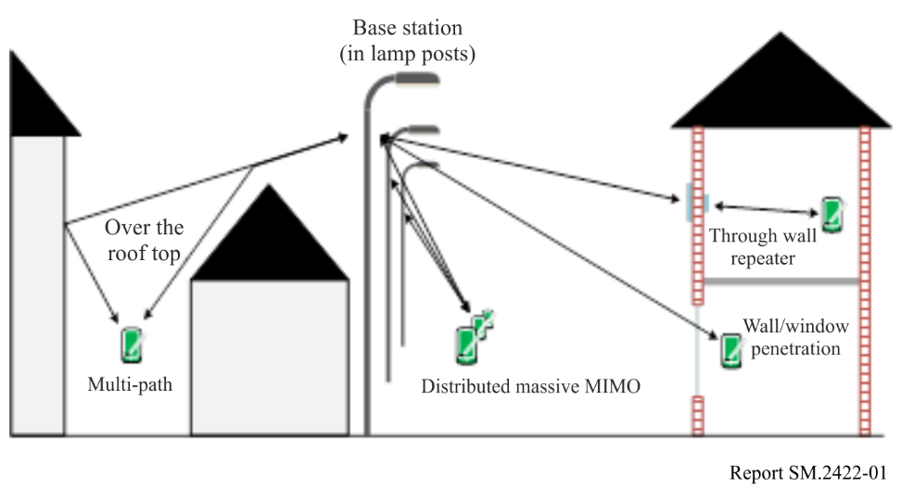
Smart home
Presently, smart home includes many kinds of home appliances, an energy management system, a healthcare system, advanced multimedia services, and a surveillance and security system, through complex wired and wireless connectivity. The connected devices for smart home can be operated in interactive and independent way, and these capabilities improve the quality of life within the household in various respects, such as automation of routine tasks, provision of health services, rationalization of energy consumption, improved individual efficiency, and enhanced home security, as well as entertainment, etc.
The smart home uses the local wireless networking approach and is based on standards such as Local Area Network (LAN), Body Area Network (BAN) or Personal Area Network (PAN), which are used to describe a network of a smaller scale ranging from 12 to 100 m such as Bluetooth, ZigBee, WiFi, Z-Wave and others.
VLC can be used to connect devices that convey sensitive information like CCTV cameras, baby monitors and others, and can be a more private and secure network [19].
Figure 2
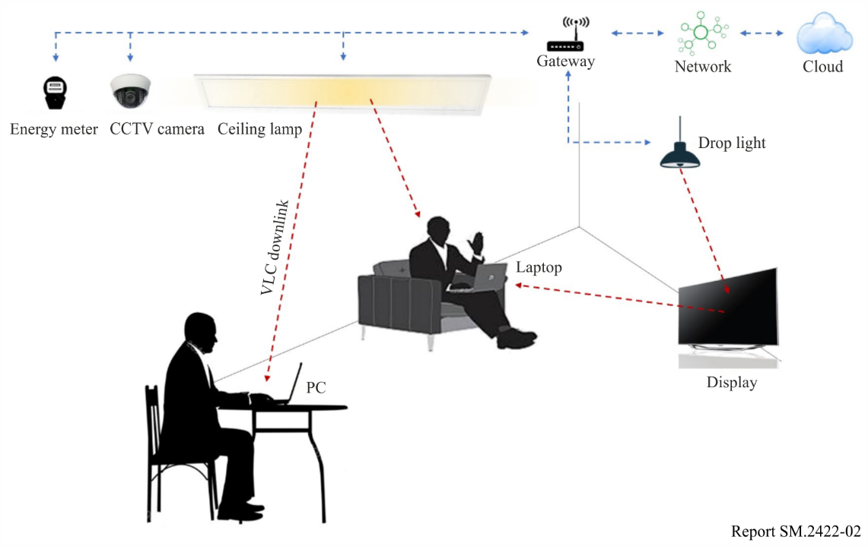
Smart city mapping (city genome)
Cities can be considered as evolving living complex organisms. This is not just because of the people who live in the city and who are complex ‘systems’ in themselves. Life itself seems to become increasingly complex through disruptive and exponential developments. Technological developments, especially in the realm of ICT, are playing a crucial part. However, it is not a given that quality of life, a major goal, will benefit. There exist enormous opportunities, but equally ominous threats may emerge. To make true qualitative progress, an integral systemic approach is a necessity. Incremental, linear thinking and design will not suffice. A first step is to understand the distinction between the ‘hardware’ and the ‘software’ of the city, like respectively ‘body’ and ‘mind’ in a human being or living entity, or ‘genotype’ and ‘phenotype’, ‘house’ and ‘home’. The first parts are palpable, the latter not. Generically, the first is denoted as ‘infrastructure’ and the second as ‘suprastructure’. Obviously, infrastructure and suprastructure are interdependent and cannot be dealt with on their own. This is a challenge, because the infrastructures are the domain of the technical sciences and the expertise for the suprastructures dominantly resides in the alpha sciences.
Looking at the infrastructures, the ICT-networks have become more and more important. It is here that the centres for wireless and photonics can contribute. All optical, photonic networks are foreseen in which a new generation of fibres and Photonic Integrated Circuits (PICs) will be the main components. This certainly is the case in the core and metropolitan networks. Nearing the access points, wireless technologies will have a place. As a future development, it can be seen that at the edges of the network, a transition from fixed to wireless is realized. Such a place could be very well a piece of street furniture, more specifically a ‘streetlight’. Note that in the Netherlands alone there are close to 4 million streetlights. The latter can be configured in an optical mesh network. From the streetlights bandwidth can be transferred towards or from the home, using repeaters in a next generation of multi-functional windows of all 7,5 million houses and 300 000 buildings. Inside the houses and buildings, VLC will be the future technology.
Figure 3
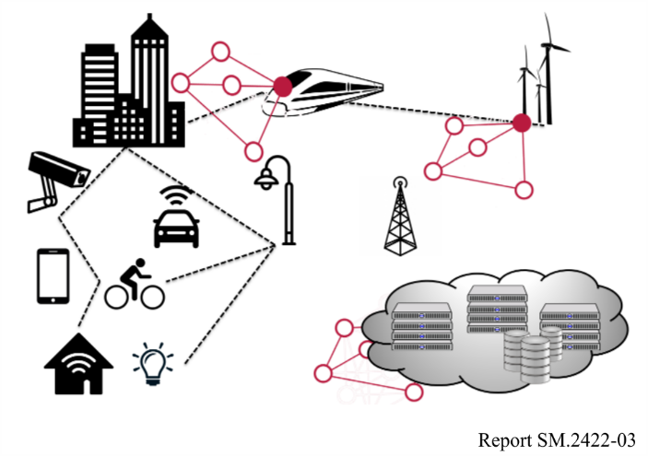
Looking at the houses and buildings themselves and how they are connected by more physical infrastructures in the public space, it is obvious that the faculty of the Built Environment can contribute with its expertise. As a near maverick development, the gain in looking at the build-up of houses, buildings and public infrastructures and suprastructures can be seen as living things with their body and mind, their genotype and phenotype are studied. Indeed, if today a human genome can be determined within one hour for less than a hundred euros, why would that not be possible for these far simpler physical constructions? And what enormous options could then be realized! Macro-parameters such as energy, safety and sustainability labels can then be accurately calculated. Scenarios for improvement can be designed and valued.
Figure 4
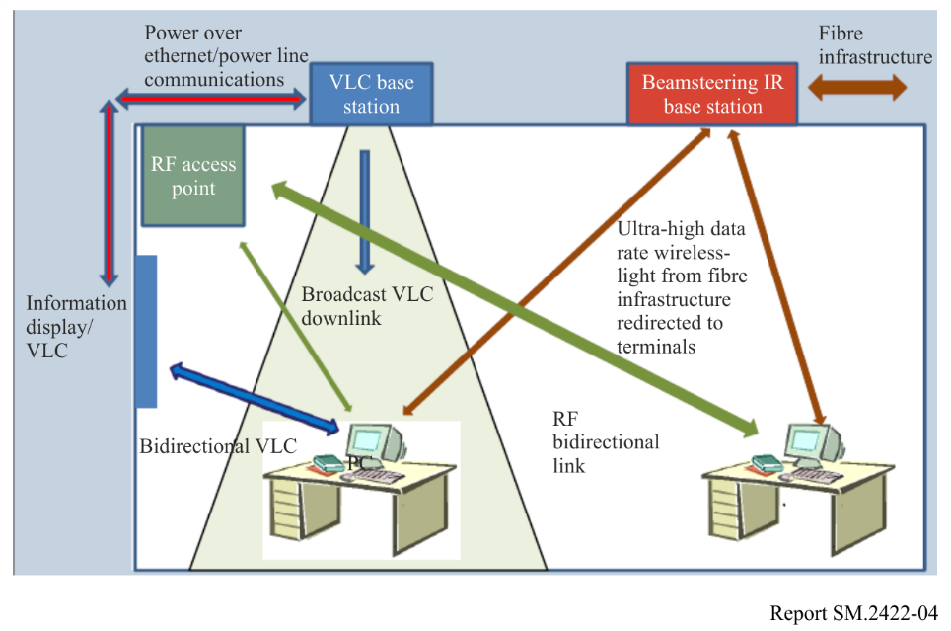
Looking at the data that can be tapped or fed to the houses, buildings and public infrastructures, it is clear that the data science centre is the centre that can play a crucial role. The journey from pure data towards information, knowledge and new wisdom will generate countless applications for both infrastructures and suprastructures, networks and services, houses and homes. They inherently will need to be designed in a secure and safe way. Likewise, investigations can be carried on the method by which the complex systems encountered can be modelled, using e.g. Complex Adaptive Systems Graph- and matrix theory.
The above brings modelling of overall realistic scenarios for smart cities substantially closer through an integral systemic approach.
In relation to the user needs and socio economical aspects more study is required since the fields of application are very diverse and not fully explored. As stated in [18], “It is also recommended to stimulate close contacts between (national) industrial R&D and academic research, as there is (still) much diversity in the OWC technologies being explored. Early identification of which are potential winning technologies among them and facilitating and promoting convergence and interworking will support the industrial development and speed up market introduction”.
There is also work and research to be done on the actual placement of VLC equipment in buildings and offices as stated in [18]: “OWC is not replacing, but is complementing the use of other transmission as e.g. Wifi for in-building communication infrastructures in which OWC can off-load the bandwidth-hungry applications from Wifi. Due to this co-existence with the current Wifi technology, we recommend designing and building offices, public spaces and houses such that the potential of OWC is taken into account especially for creating the fixed (wired) infrastructure accommodating sufficient OWC access points and backhaul. Combining transporting data with powering optical wireless Access Points using Ethernet cables (Power over Ethernet) becomes increasingly interesting, and therefore it is recommended to pay attention to it for construction purposes”.
Connected-cars and autonomous vehicles
VLC can be applied for the Connected-cars and Autonomous Vehicles. Usually drivers should watch the traffic signs while driving. Autonomous Vehicles should recognize the traffic signs as image recognition technology, but sometimes it can be misread. One example of Connected-cars and Autonomous Vehicles is traffic sign recognition using VLC and Graphic Data Dictionary (GDD). GDD has been developed by ISO TC204with the intent of creating a common basis for transmitting encoded information for existing road traffic signs and pictograms. The coding system of it has been developed as language independent, such that data that can be interpreted, irrespective of language or regional differences. This is intended to support Intelligent Transport System messaging. An approach was required to characterize the large set of existing road traffic signs and pictograms into functional groups – this is done by means of Information Elements.
In the transmitter part, a suggested GDD data encoder (generator) is designed. The encoded data can be transmitted using two types of transmitters, one is simply to install a LED signal transmitter together with existing traffic sign, and the LED transmit the encoded data fit for a specific traffic sign. The advantage of this simple type of transmitter is that it can be applied to every existing traffic sign. The only difference between each sign is that uniquely encoded data is transmitted from it.
In the receiver part, the GDD receiver is composed of a camera with image sensor and data decoding unit. The images could be sensed on the image sensor behind the optical camera lens, and it receives data transmitted by optical camera communication [20].
Figure 5
Autonomous vehicle receiving OCC signal from traffic sign
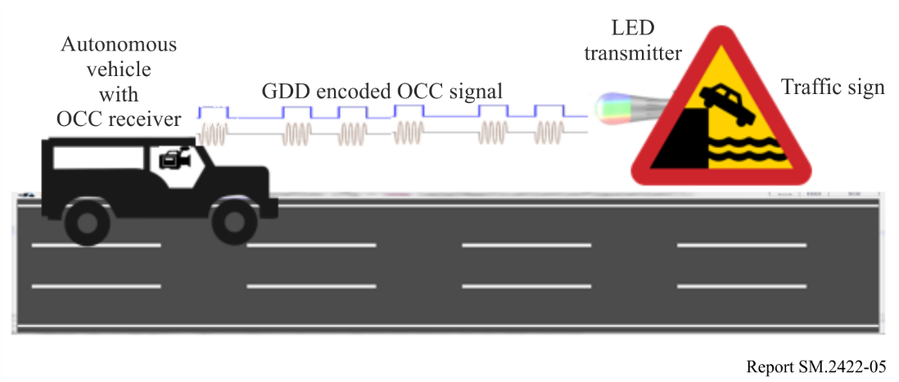
Information communication for intelligent mining and tunnel monitoring
Visible light communication technology, capable to support communication, data exchanges, and positioning functionalities, has found broad applications in the intelligent mining and tunnel monitoring.
The communication function requirement arises from the fact that mines or tunnels located at a depth of tens to several hundred metres underground or with a length of more than a kilometre. Due to the structure of mines or tunnels and the physical characteristics of cable, the attenuation on wireless signals is very large, and the wiring of the wired systems is very difficult. For the maintenance, inspectors need to regularly communicate with the people at the control centre. At the same time, during the event of the connection failures or accidents, it is absolutely necessary to contact the control centre for fault elimination and rescue. Visible light communication is not affected by the structure of mines or tunnels as it uses the lighting equipment for the information acquisition or exchanges (more specifically, combining the powerline communication and visible light communication) to transmit voice and video information, and maintains the real-time communication with the control centre.
Figure 6
VLC-PLC system and control server
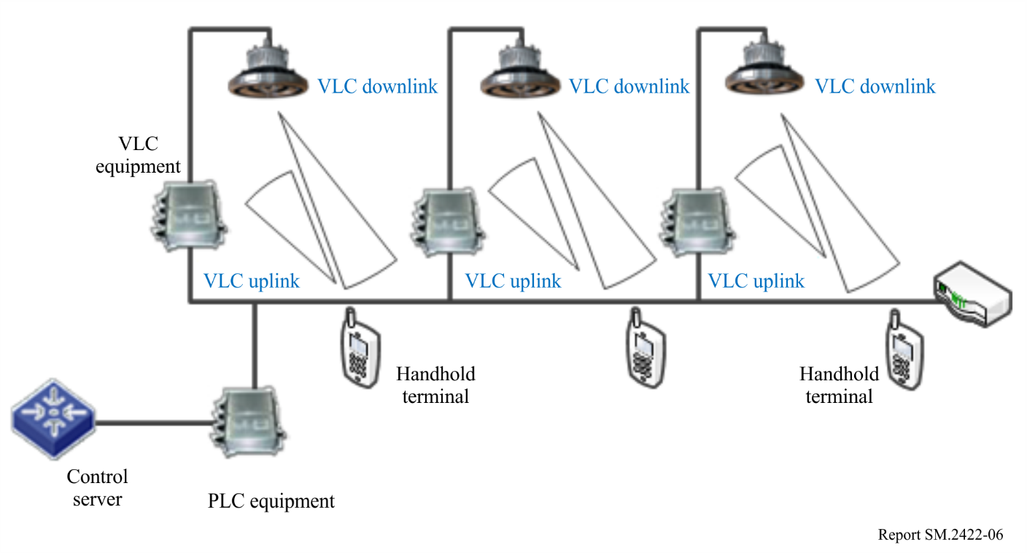
The requirements of information exchanges include the data transmission for the fixed sensors and the data transmission for the mobile applications. This system can integrate online monitoring, video surveillance, infrared temperature sensor integrated equipment at cable joints, temperature, fan, water pump, ground current, fire, gas combined with inductive devices such as intrusion alarms and tube defences for the online real-time transmission of the monitoring data. The regular transmission of monitoring data will identify and help eliminate faults more accurately and timely. It can also shorten emergency repairing time and reduce corresponding losses. During this process, the inspection personnel can use this system to maintain data exchanges and service interaction with the control centre, thereby greatly facilitating the automation-level of the online monitoring and improve the efficiency of inspection.
Internet of radio-light for media and entertainment in buildings
Wireless networks in buildings suffer from congestion, interference, security and safety concerns, restricted propagation and poor in-door location accuracy. The Internet of Radio-Light (IoRL) project develops a safer, more secure, customizable and intelligent building network that reliably delivers increased throughput ( > 10 Gbit/s within a building) from access points pervasively located within buildings with latencies of < 1 ms, whilst minimizing interference and harmful EM exposure and providing location accuracy of < 10 cm. It thereby solves problem of broadband wireless access in buildings and promotes establishment of a global standard in ITU. Building landlords will be incentivized to find funding to realize this solution for their properties to increase their value resulting in a stimulated market for broadband networking products in buildings, benefiting society and stimulating the world Gross Domestic Product. The IoRL project is developing a proof of concept portable demonstrator, which acts as the basis for standardization of a global solution exploiting the broadband capacities of VLC, mmWave, the flexibility of NFV/SDN technologies, and the accessibility of the existing electric light access points. It shows how an industrial redesigned VLC and mmWave radio-light solution can be integrated into existing electric light consumer products to become a universal electromagnetic access point in rooms within buildings, and in the final year of the project it aims to demonstrate its operation in homes, museums, train stations and supermarkets.

7 Conclusions
Recent developments in OWC, standardization activities and existing lighting products show that VLC is a mature technology with many benefits for offloading the radio spectrum.
It may be concluded that the management of VLC devices and the VLC spectrum is not a regulatory task but something that should be organized in technical standards. A close cooperation of the standardization bodies involved in VLC and those in the traditional radio applications could be beneficial.

References
[1] S. Nakamura, T. Mukai, and M. Senoh, “Candela Class High Brightness InGaN/AlGaN Double Heterostructure Blue Light Emitting Diodes”, Applied Physics Letters, vol. 64, no. 13, pp. 1687-1689, 1994.
[2] J. S. Kim, et al., “White-light Generation Through Ultraviolet-emitting Diode and White-emitting Phosphor”, Applied Physics Letters, vol. 85, no. 17, pp. 3696-3698, 2004.
[3] IEEE Standard for Local and Metropolitan Area Networks – Part 15.7: “Short-Range Wireless Optical Communication Using Visible Light”, in IEEE Std 802.15.7-2011, vol., no., pp. 1-309, Sept. 6, 2011.
[4] A.M.J. Koonen, C.W. Oh, K. Mekonnen, Z. Cao, E. Tangdiongga, “Ultra-high capacity indoor optical wireless communication using 2D-steered pencil beams”, IEEE/OSA Journal of Lightwave Technology, 2016, 34(20):7482669.
[5] Jaesang Cha et al., “A new band plan for IEEE802.15.7m”, Online: https://mentor.ieee.org/802.15/dcn/17/15-17-0174-00-007a-a-new-band-plan-for-15-7m.pdf
[6] IEEE 802.15.7r1 Short-Range Optical Wireless Communications Task Group http://www.ieee802.org/15/pub/IEEE%20802_15%20WPAN%2015_7%20Revision1%20Task%20Group.htm
[7] “Multi-Gigabit per Second Optical Wireless Communications (OWC) with Ranges up to 200 meters” https://development.standards.ieee.org/get-file/P802.15.13.pdf?t=92735500003
[8] http://www.ieee802.org/11/Reports/lctig_update.htm
[9] M. Ayyash et al., “Coexistence of WiFi and LiFi toward 5G: concepts, opportunities, and challenges”, in IEEE Communications Magazine, vol. 54, no. 2, pp. 64-71, February 2016.
[10] D. Schulz et al., Long-Term Outdoor Measurements Using a Rate-Adaptive Hybrid Optical Wireless/60 GHz Link over 100 m”, Proc. ICTON 2017 (invited).
[11] A.M. Khalid et al, “10 Gbps indoor optical wireless communication employing 2D passive beam steering based on arrayed waveguide gratings”, Proc. IEEE Summ. Top., TuC2.3, Newport Beach (2016).
[12] J. Zeng et al., “A 5Gb/s 7-Channel Current-mode Imaging Receiver Front-end for Free-Space Optical MIMO”, Proc. IEEE MWSCAS, Cancun (2009).
[13] Z. Cao et al., “200 Gbps OOK Transmission over an Indoor Optical Wireless Link Enabled by an Integrated Cascaded Aperture Optical Receiver”, Proc. OFC, PDP Th5A.6, Los Angeles (2017).
[14] S. Collins et al., “High gain, wide field of view concentrator for optical communications”, Opt. Lett., p. 1756-(2014).
[15] A.M. Khalid et al., “Bi-directional 35-Gbit/s 2D Beam Steered Optical Wireless Down-link and 5-Gbit/s Localized 60-GHz Communication Uplink for Hybrid Indoor Wireless Systems”, Proc. OFC, Th1E.6, Los Angeles (2017).
[16] Ivica Stevanović, “Light Fidelity (LiFi)” Federal Office of Communications OFCOM Licences and Frequency Management Division Radio Technology Section, December 14, 2016.
[17] https://mentor.ieee.org/802.15/dcn/15/15-15-0746-01-007a-tg7r1-channel-model-document-for-high-rate-pd-communications.pdf
[18] Optical Wireless Communication: options for extended spectrum use, Stratix and Technical University of Eindhoven commissioned by the Dutch Radiocommunications Agency (Agentschap Telecom) Ministry of Economic Affairs and Climate policy, December 2017.
[19] https://mentor.ieee.org/802.15/dcn/15/15-15-0492-05-007a-technical-considerations-document.docx
[20] GDD based Automatic Traffic Sign Recognition Using CamCom Technology, IEEE 15-18-0031-00-0vat, 2018. 1.
Other references
R. D. Roberts, S. Rajagopal and S. K. Lim, “IEEE 802.15.7 physical layer summary”, IEEE GLOBECOM Workshops, pp. 772-776, Houston, TX, 2011.
Shuzhou Chai, Hongming Zhang, Jian Song and Jinghui Zhu, “High-Speed Indoor Visible Light Communication System Using Red Laser Diodes” in 2020 International Conference on Engineering and Telecommunication (En&T), 2020
T. Baykas et al., “Let there be Light Again! An Amendment to IEEE 802 Visible Light Standard is in Progress” IEEE COMSOC MMTC E-Letters March 2016.
M. Uysal, et al. “TG7r1 CIRs Channel Model Document for High-rate PD Communications”, Online: https://mentor.ieee.org/802.15/dcn/15/15-15-0747-00-007a-tg7r1-cirs-channel-model-document-for-high-rate-pd-communications.zip
I. Stevanovic “Light Fidelity”, Report OFCOM Switzerland.
Jinheng Shao and Chao Zhang, “2.4 Gbps Real-Time Visible Light Communication System Based on Blue Laser Diode,” in 2023 Fourteenth International Conference on Ubiquitous and Future Networks (ICUFN), 2023
Tianyi Lin, Siyuan Wang, Hongming Zhang, and Jian Song, “OWC4DT: A 25 Gbps Plug-and-Play Self-Alignment Optical Wireless Communication System for Distributed Training in Data Center,” in ICC 2025 – IEEE International Conference on Communications, 2025.

Annex 1
Tsinghua University lab results of an indoor broadband broadcasting system based on power line communication and visible light communication
Visible light communication (VLC) using the light-emitting diode (LED) has become an appealing alternative to the radio-frequency communication technology for indoor wireless broadband broadcasting. However, the LED lamps should have access to the backbone information network, and this requirement is not easily satisfied. Power line communication (PLC) systems utilise the ubiquitous power line network to power the LED lamps while serving as the backbone network for the indoor VLC systems naturally. China is considering an indoor broadband broadcasting system based on the deep integration of PLC and VLC. The proposed scheme significantly reduces the complexity of the VLC network protocol, and requires much less modification to the current infrastructure, while providing better signal coverage. Lab test result of this system with orthogonal frequency-division multiplexing (OFDM) modulation is introduced in this Annex.

A1.1 Brief introduction
A deeply integrated PLC and VLC system for efficient indoor broadcasting is shown in Fig. 7. In this scheme, the data is first modulated by the PLC modulator and becomes analogue signals. Then the signals are coupled to the power line through the coupler. The system uses a ‘PLC to VLC’ module in the LED illumination fixture to receive the coupled signal from the power line, as shown in Fig. 8. After signal amplification, this module adds the data signal to the direct current (DC) bias of LED by driving the LED lamps, and acts as an optical transmitter to cover the indoor area. All the LED lamps connected to the same power adapter transmit the same data. In this way, the broadcasting network could be homogeneous and simplified as an SFN, which could well solve the problem above. For the LED lamps connected to different power adapters, the transmitted signal could be different for various services and better signal coverage.
Figure 7
System models of proposed schemes based on PLC and VLC
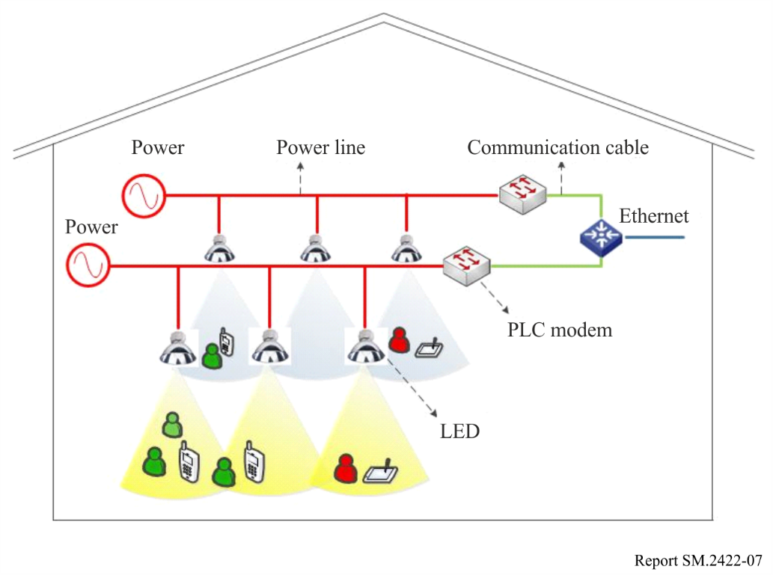
Figure 8
Block diagram of ‘PLC to VLC’ module
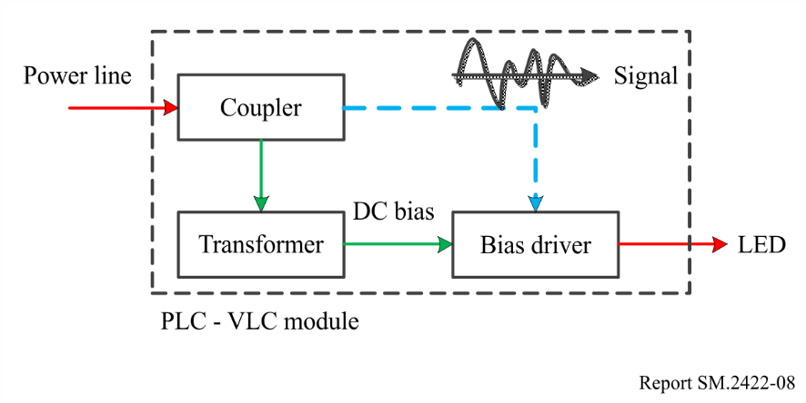

A1.2 Demonstration implementation and evaluation

A1.2.1 Demonstration setup
In the laboratory environment, a demonstration is built and its feasibility is shown through experiments, as shown in Fig. 9. The video data are encoded, modulated and coupled to the power line in the PLC modulator. In the ‘PLC to VLC’ module, the signal is added to the DC offset to drive the LED lamp, which is the key component of the integrated system. The signal is detected in the avalanche photo diode (APD), then demodulated and decoded at the receiver. To evaluate the interference of the LED lamps, two LED lamps were used to construct a simplest SFN, as described in Fig. 10.
This composition of whole system is quite simple and does not require new installation of communication wiring. After the basic communication modules of the system, such as PLC modulator, ‘PLC to VLC’ module and the receiver being plugged in, the system will start to work without too much modification of the existing infrastructures. In fact, such modules can be small enough to be easily installed for commercializing. From implementing the system in real-life, some key parameters, such as the system operating point, the modulation depth and the sensitivity of the optical detector, should be rationally chosen. The key parameters are listed in Table 1 for illustration. All the hardware except the optical detector is designed as shown in Figs 11 to 13.
Figure 9
Demonstration setup of the broadcasting system in the laboratory environment
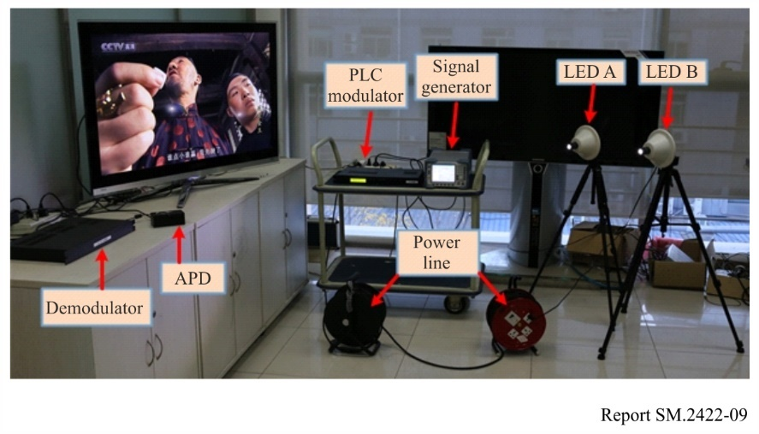
Figure 10
Block diagram of the demonstration
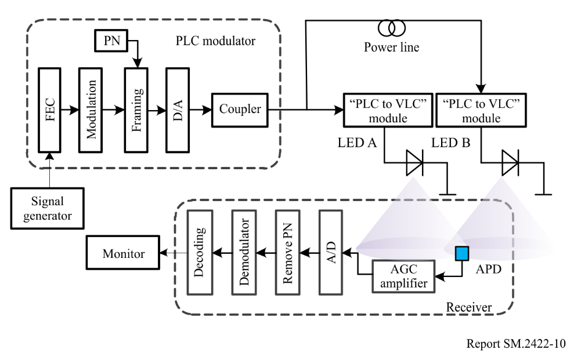
Figure 11
LED lamp and 'PLC to VLC' module
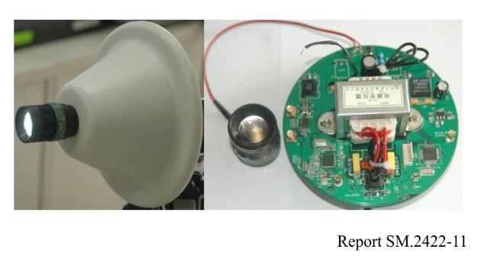
Figure 12
PLC modulator
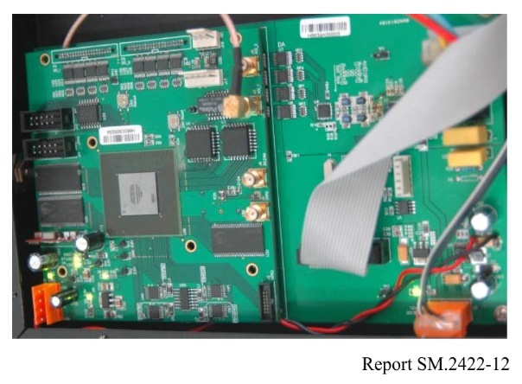
Figure 13
Demodulator in the receiver
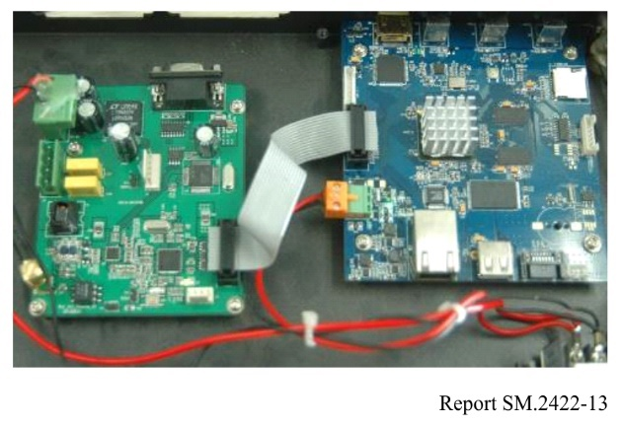
TABLE 1
Demonstration configurations
Index | Value
Input voltage (V) | 3.8
Operating current (A) | 0.26
Illuminance at the APD (lx) | 300
Half-intensity beam angle (degrees) | 30
Modulation depth (percentage) | 15
Photo sensitivity (A/W) | 0.42
Distance between the LED lamp and receiver (m) | 3

A1.2.2 Performance evaluation
A high-definition TV programme is modulated by the time domain OFDM (TDS-OFDM), and then transmitted in the hybrid system to evaluate its performance. The mode (16QAM, Multi-carrier, PN420, FEC 0.6, TI720) was used for the test.
The system bandwidth is 8 MHz. The point-to-point system (with one LED lamp on) can still work well with the visible light path up to 8 metres when there is the interference from the normal indoor lighting devices and provide a raw date rate up to 48 Mbit/s within 8 MHz bandwidth when 64QAM is used.
For the two LED lamps, LED A is connected directly to the PLC modulator and LED B is connected to the modulator via a section of power line. The receiver which contains the APD is placed with an equal distance of 3 metres away from the two LED lamps to imitate the case that the receiver is located in the overlapping area or roaming between different LED lamps. In order to evaluate the system performance under different multipath propagations, the length of power line connected to the LED B and the power of the transmitted signal from LED B are set to different values (the power of the transmitted signal from LED A is fixed) in our demonstration configurations. The evaluation configurations are provided in Table 2.
TABLE 2
Evaluation configurations
Power line length | 0 dB | 3 dB | 6 dB
100 m | Case 1 | Case 2 | Case 3
200 m | Case 4 | Case 5 | Case 6

The spectrum of the received signal as well as the multipath channel of the whole system were also measured, as shown in Figs 14 to 17. It can be seen from Figs 16 and 17 in the proposed scheme that the multipath effect will cause channel frequency selectivity.
Figure 14
Spectrum of the received signal only from LED A (Cases 1 to 6)
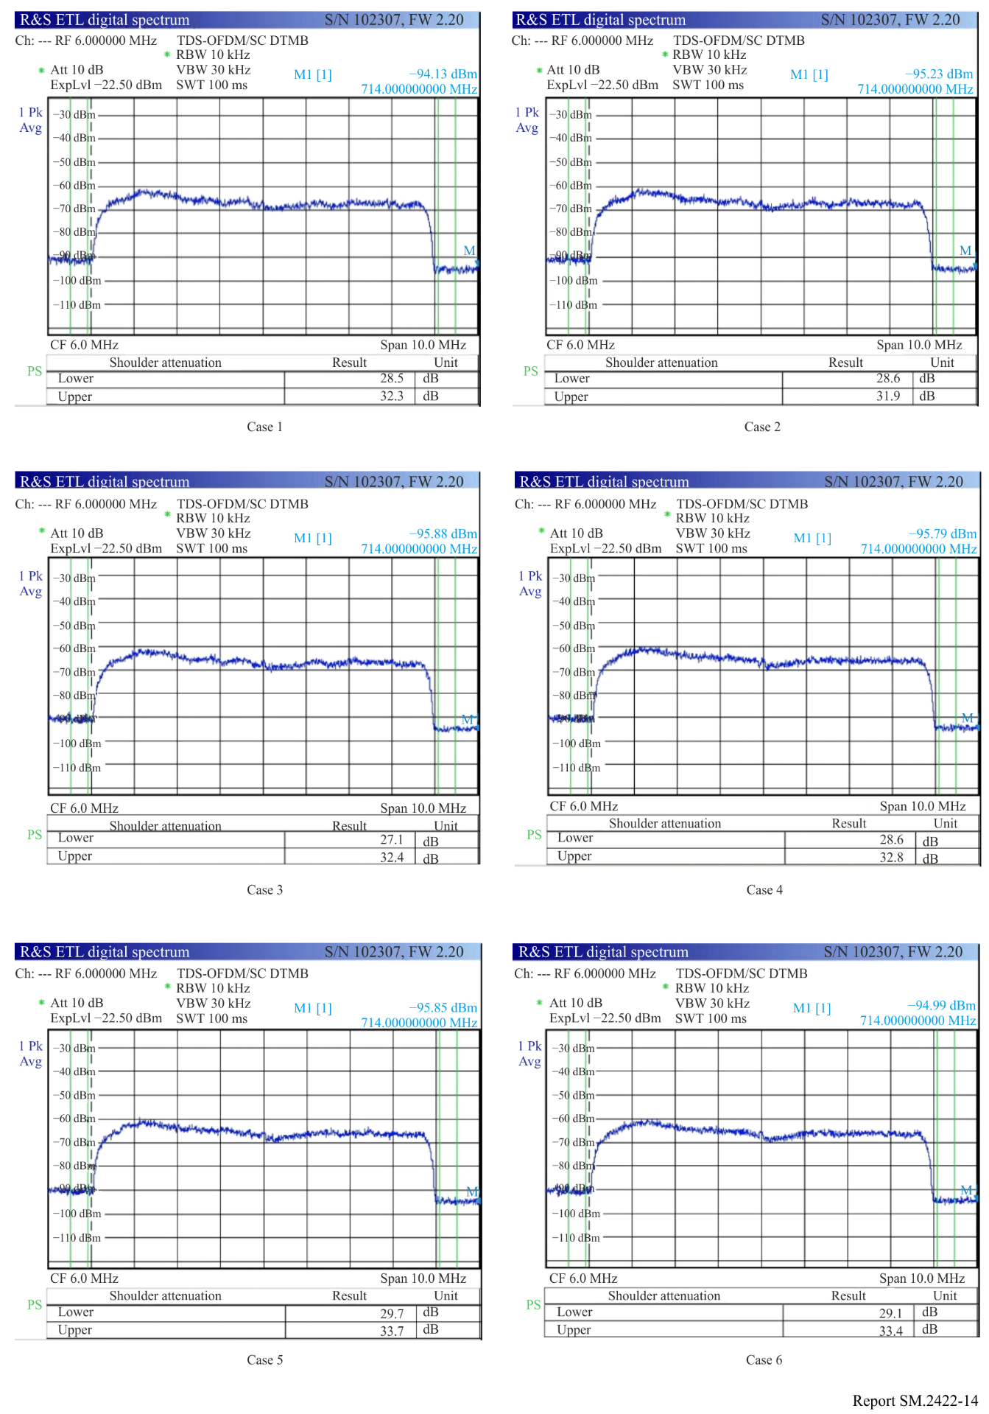
Figure 15
Spectrum of the received signal only from LED B (Cases 1 to 6)
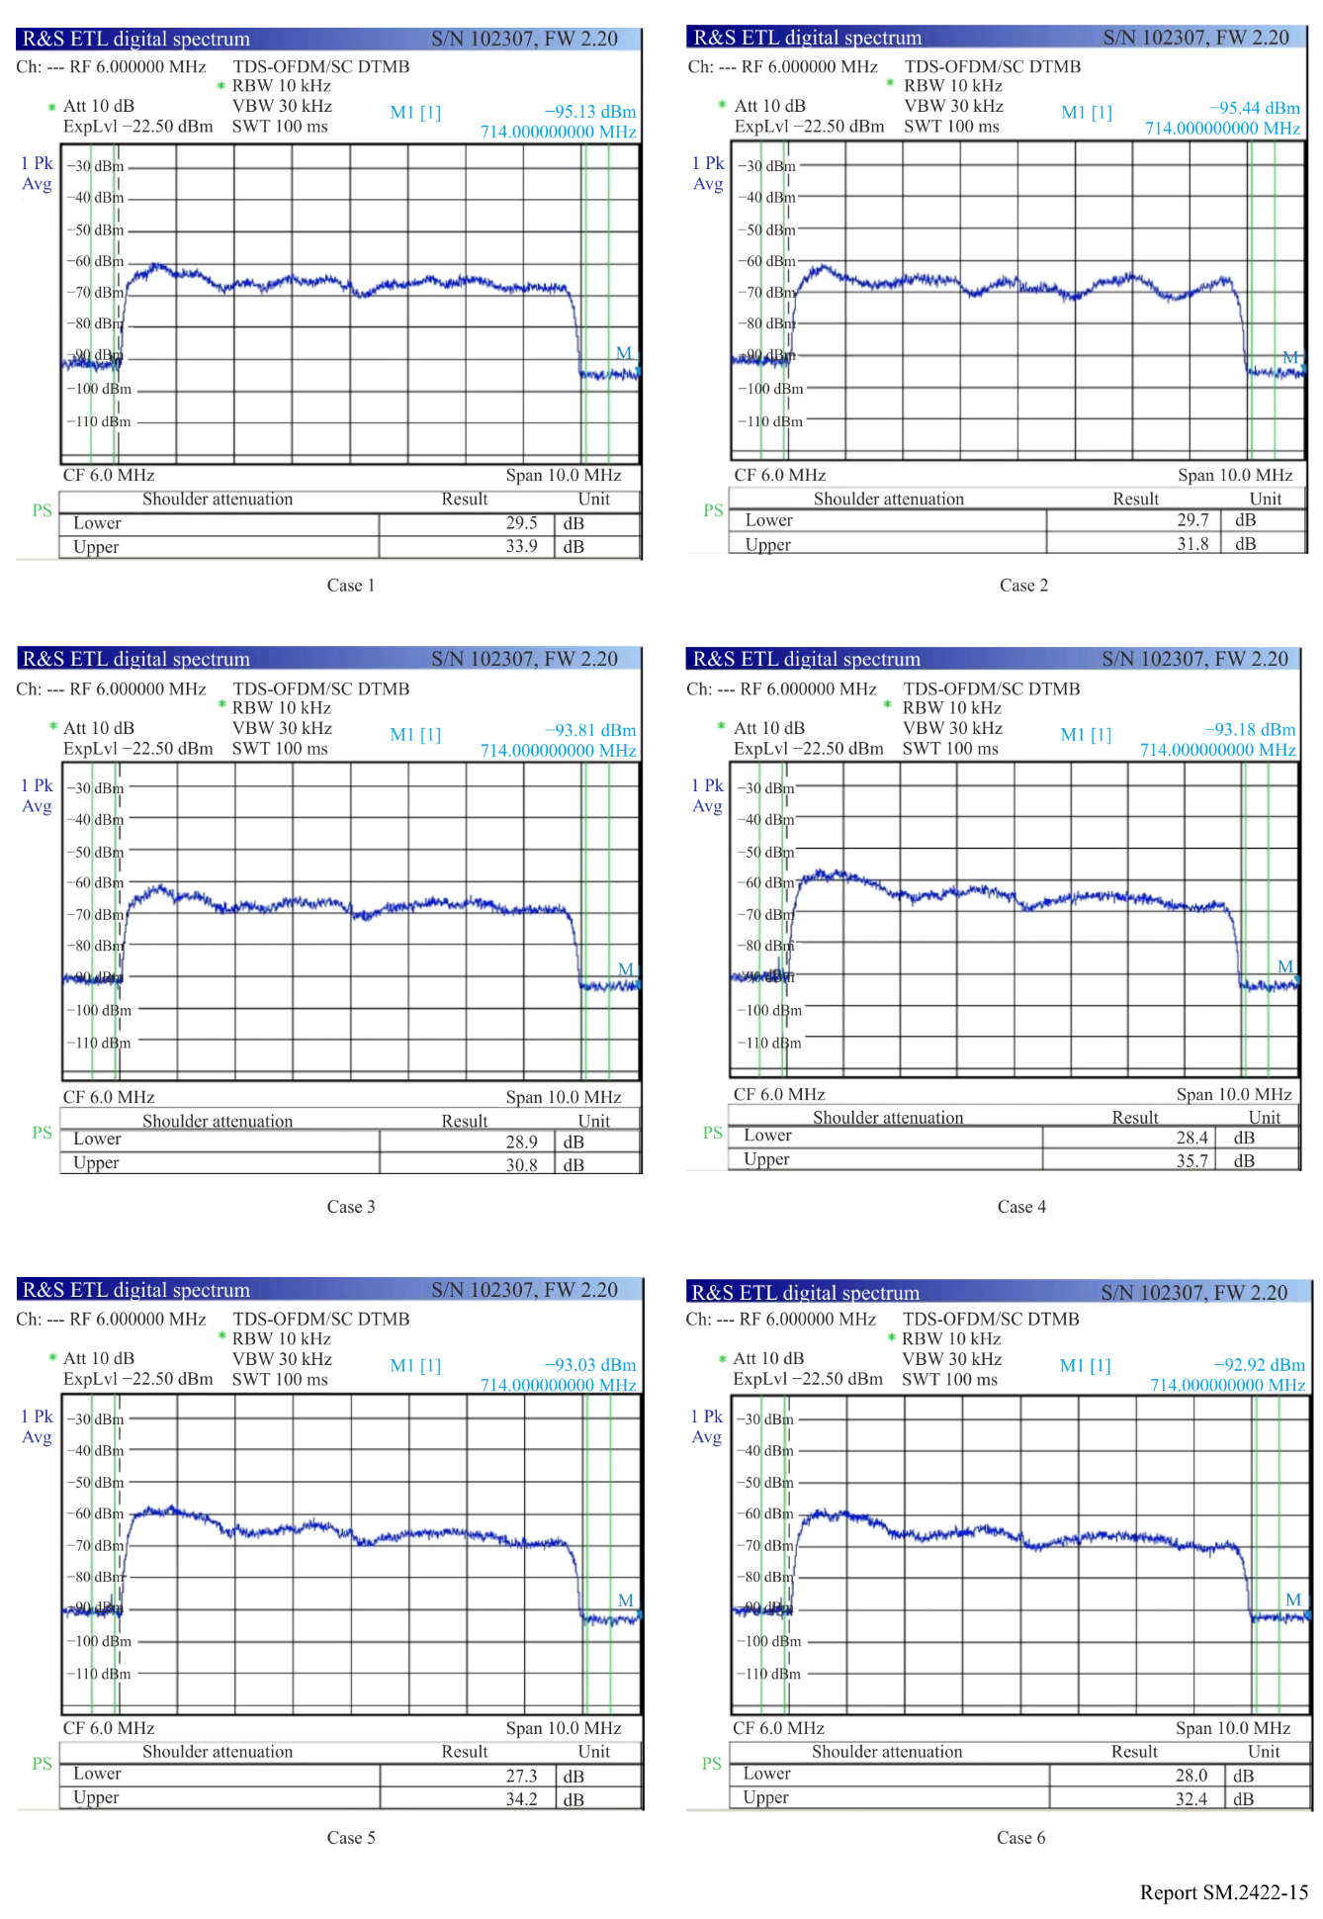

Figure 16
Spectrum of the received signal when the power of the transmitted signal from LED B is equal to that from LED A (Cases 1 to 6)
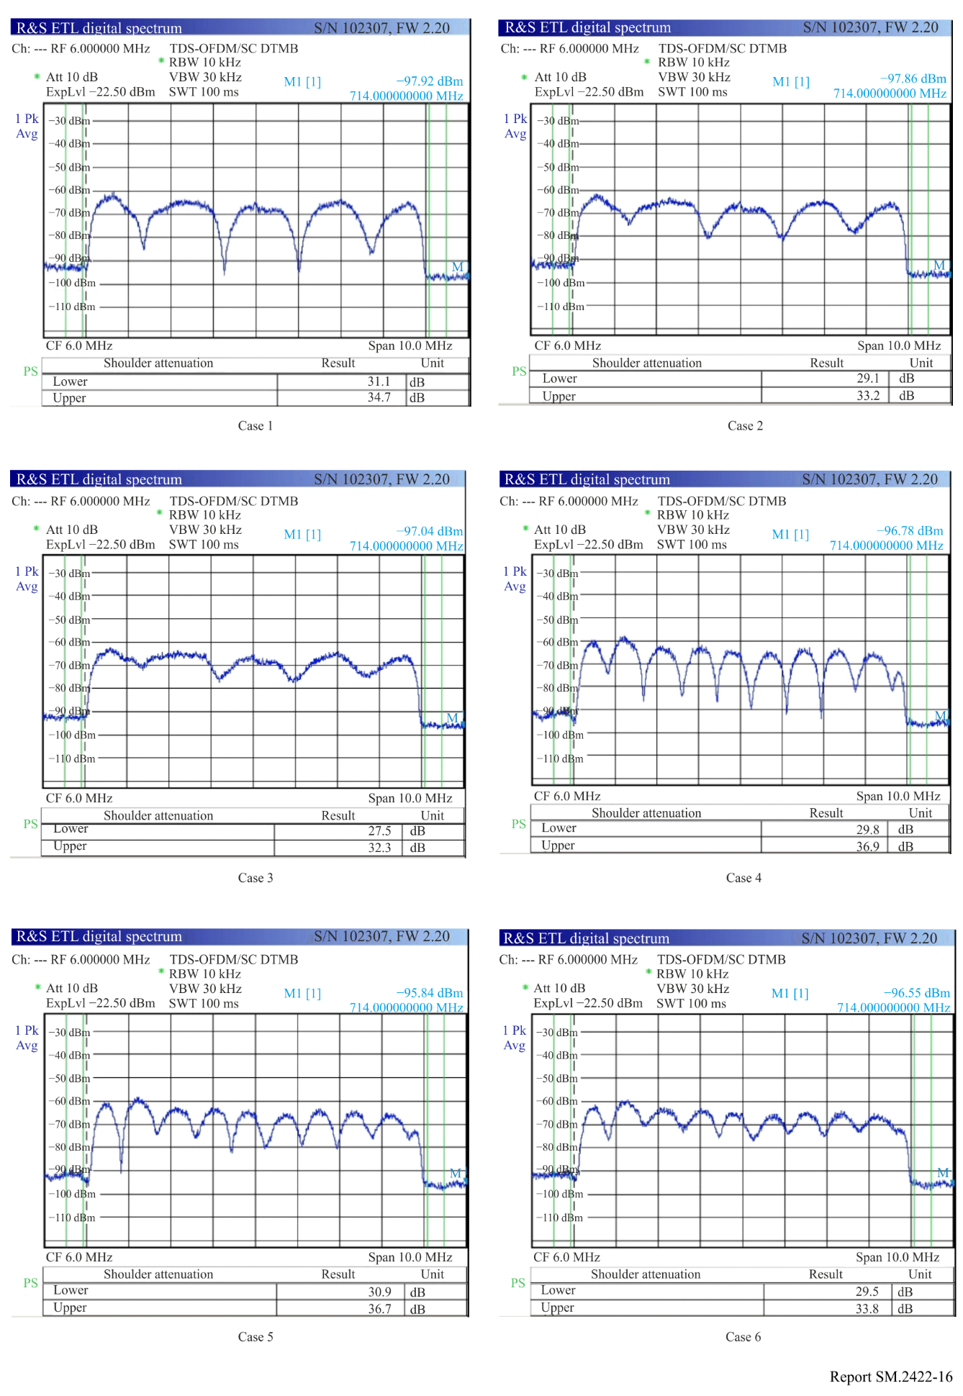
Figure 17
Measurement of the multipath channel of the whole system (Cases 1 to 6)
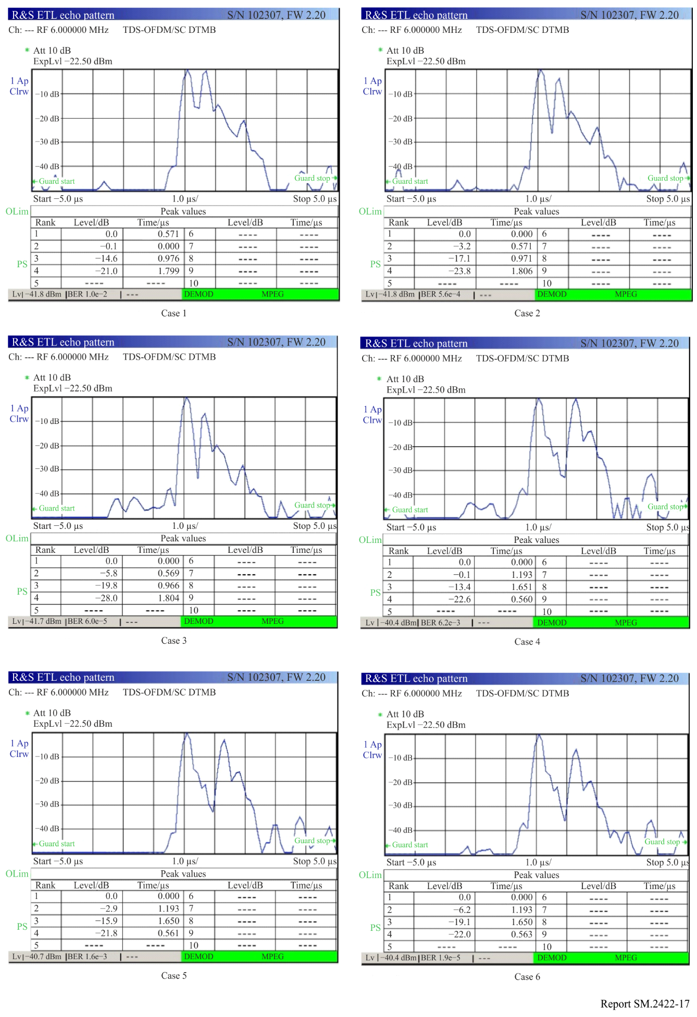
Furthermore, the modulation error ratio (MER), a common parameter to quantify the communication link quality, is used to evaluate the demo, which is defined as below.
$MER=10\log_{10}{\frac{\sum{\left[{\left(I_{j}-{\hat{I}}_{j}\right)}^{2}+{\left(Q_{j}-{\hat{Q}}_{j}\right)}^{2}\right]}}{\sum{\left({\hat{I}}_{j}^{2}+{\hat{Q}}_{j}^{2}\right)}}}$
where:
$I_{j}$ : real component of the ideal j-th symbol
$Q_{j}$ : imaginary component of the ideal j-th symbol
${\hat{I}}_{j}$ : real component of the received j-th symbol
${\hat{Q}}_{j}$ : imaginary component of the received j-th symbol.
The MER represents the signal-to-ratio quality per symbol, and higher MER ensure the probability of successful demodulation for the system. As shown in Table 3, the MER is proportional to the power line length and inversely proportional to the power of the transmitted signal from LED B. It can be explained by that the interference will be less as the delay of the secondary path becomes larger or the power of it reduces. The constellation diagrams of the received signals are measured for the 16QAM mode, diagram of LEDA, LEDB and LEDA+LEDB for cases 1 to 6 as shown in Figs 18 to 22.
TABLE 3
Measured MERs
Case 1 | Case 2 | Case 3 | Case 4 | Case 5 | Case 6
20.0 dB | 22.8 dB | 24.4 dB | 20.8 dB | 22.4 dB | 24.4 dB

A1.3 Future work
The next step for the demonstration is to try higher order constellation mapping and wider band occupation to fully utilize the system potential. The integrated system was implemented with the raw data rate of 192 Mbit/s in a 24 MHz bandwidth when 256APSK is used. At the same time, some efficient techniques such as the Gray amplitude phase shift keying (APSK) constellation, the appropriate channel coding, MIMO and the relays, will be adopted as the system options to enhance the robustness and throughputs of the system and satisfy different quality of services. Moreover, the handover or switching protocols for the other schemes will be investigated.
The implementation has also started on a low data rate integrated VLC and PLC communication by utilizing the commercial camera of the mobile phones.
Figure 18
Measured constellation diagram of the received signals for LEDA (Cases 1 to 6)
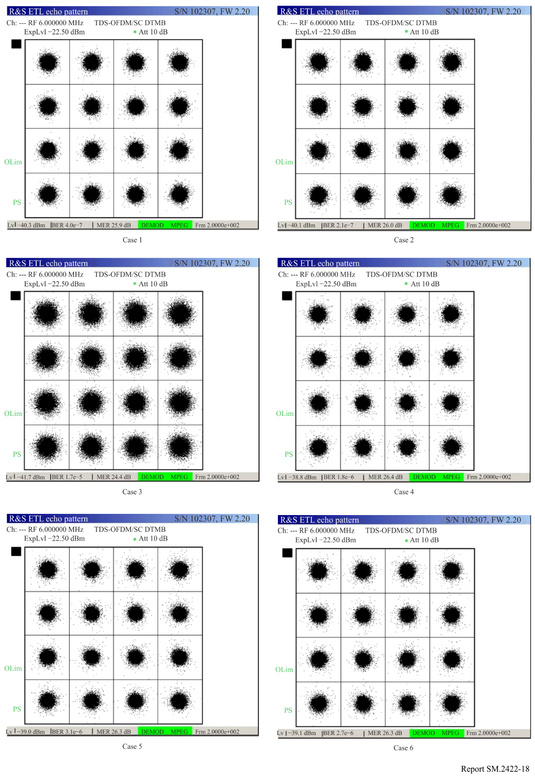
Figure 19
Measured constellation diagram of the received signals for LEDB (Cases 1 to 6)
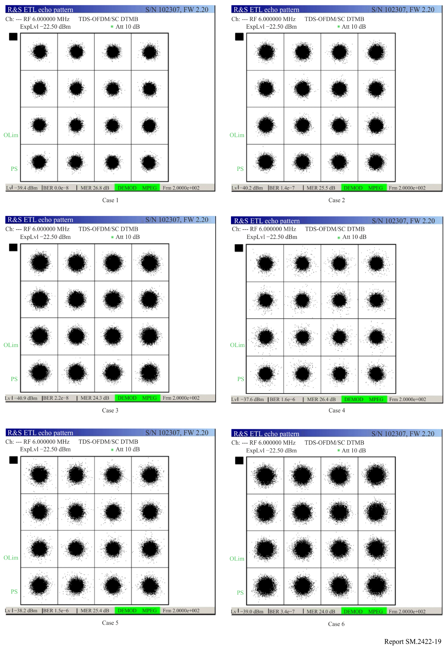
Figure 20
Measured constellation diagram of the received signals for the 64QAM mode (Cases 1 to 6)
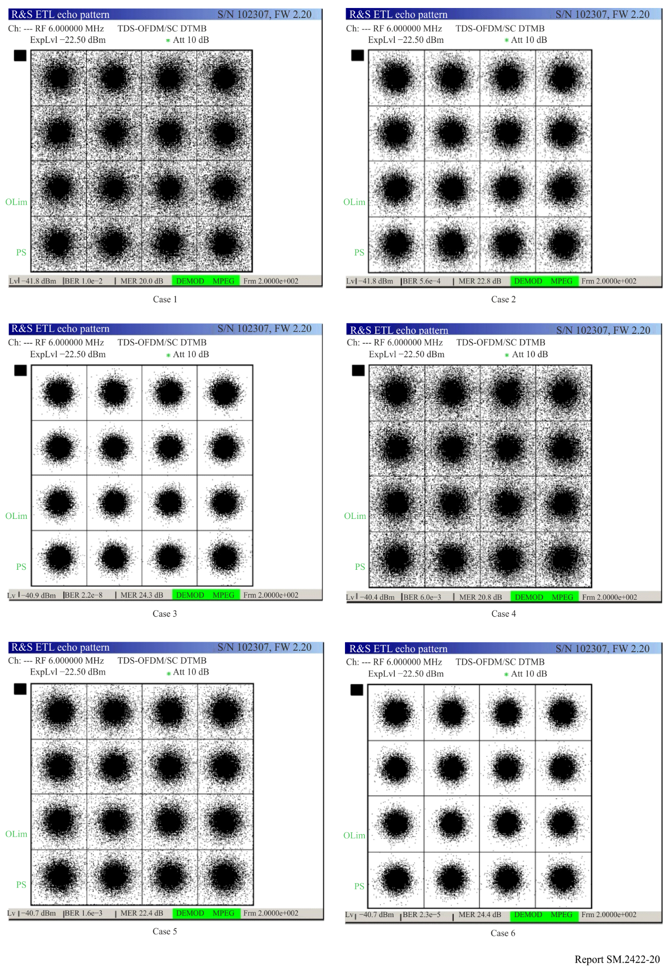

Annex 2
High-speed point-to-point visible light communication system with motion alignment

A2.1 Overview
Compared with LED, LD have a higher modulation bandwidth than LEDs and can achieve higher communication data rates. In this Annex, a LD based visible light communication (VCL) system is introduced, a real-time high-speed visible light communication experimental platform is built using a LD as the light source, and a communication rate of 3 Gbit/s is achieved. In order to make the visible light communication system applicable to mobile scenarios, a beam auto-alignment mechanism is introduced. When the receiver moves, the system can adjust the beam emission direction of the transmitter in real time, so that the light-sensitive surface of the receiver can be within the spot range of the LD emitting beam, thus restoring communication after the movement stops. The adaptive tracking alignment mechanism, which utilises a camera and galvo, is controlled by real-time image processing and computing. A real-time high-speed visible light mobile communication demonstration is adapted to the Gigabit Ethernet protocol. The demonstration system can automatically align and achieve communication data rates exceeding 900 Mbit/s when the relative movement between transceivers stops.

A2.2 System introduction

A2.2.1 LD-based VLC experimental platform
A red-light LD is used as the transmitting light source. The LD-based VLC experimental system is shown in Fig. 21, where the data transmitted by the system is generated by a signal quality analyser and converted to analogue signal to be sent through the LD. The clock of the signal quality analyser is controlled by a signal generator so that different data rates of pseudo noise (PN) sequence can be obtained. At the receiver side, the APD converts the received optical signal into electrical signal and amplifies it, and after removing the DC component, it is fed to the signal quality analyser for BER analysation. The equipment used in this platform is detailed as Table 4.
TABLE 4
Equipment used in VLC test platform
No. | Equipment | Image
1 | Signal quality analyser | 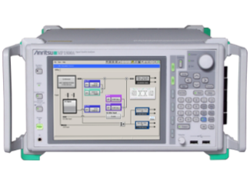
2 | Signal generator | 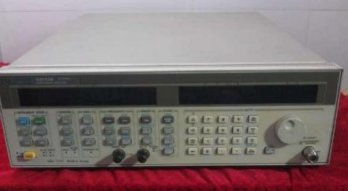

TABLE 4 (end)
No. | Equipment | Image
3 | Oscilloscope | 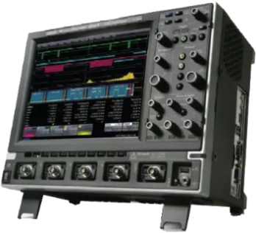

FIGURE 21
Experimental platform of VLC system
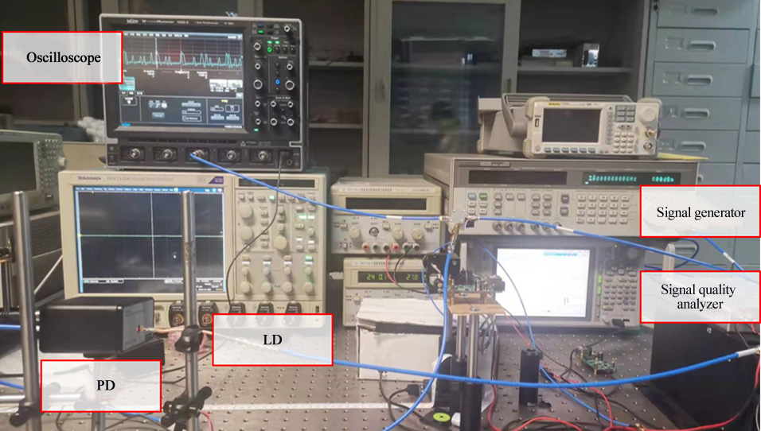

A2.2.2 Adaptive motion tracking alignment VLC system
The adaptive motion tracking aligned VLC system is shown as Fig. 22. A small lens is used in the transmitter to converge the light from the LD into a narrow beam which can still maintain a small spot area when it reaches the receiver. The receiver is equipped with a clear graphic marker which can be easily recognised by the camera and image processing module at the transmitter side.
In order to control the direction of the emitted light beam, galvo and camera are added to the transmitter. The camera is used to obtain the position information of the receiver through image acquisition and processing, and then control the galvo to adjust the beam direction to point to the receiver. The camera module continuously acquires the image of the receiver and identifies the specific position coordinates of the receiver by processing the image.
Based on the coordinate data of the receiver at the two moments (before and after), the angles at which the beam should be deflected at the current moment are calculated. The obtained deflection angles are output by the calculation unit and converted to a signal through the controller to drive the two deflecting mirrors of the galvo, so that the beam is emitted in the direction of the current receiver's light-sensitive surface position.
FIGURE 22
Architecture of adaptive motion tracking-aligned VLC system
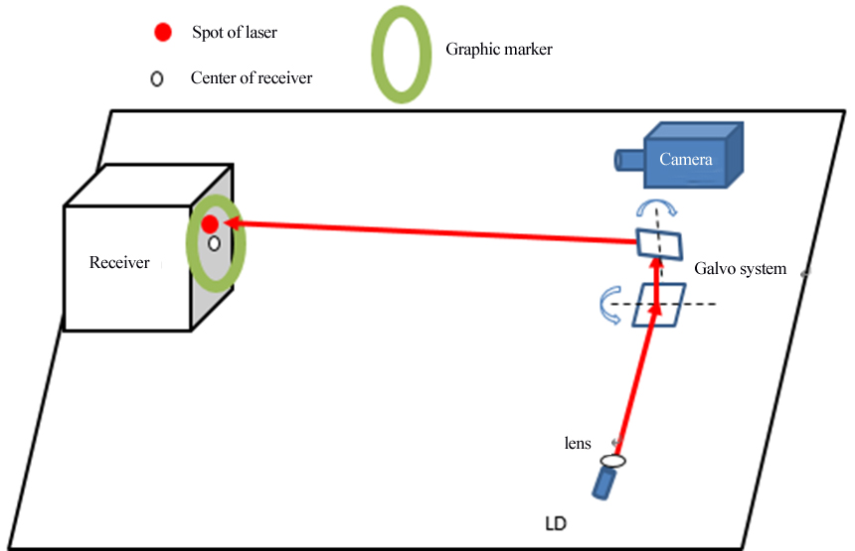

A2.3 Main units
The following part will describe the main module of the adaptive motion tracking alignment VLC system including galvo system, camera system and transceiver module.

A2.3.1 The camera system
The camera system includes camera and computer processing module which acquire and processing images on receiver side.
Identification of the receiving area centre: According to the images taken by the camera, the graphic marker is recognised and identified, by methods such as template matching or Hoff circle. After identifying the centre of the marker, the position of the receiving area centre is calculated (the relative position of the two centres is fixed for the same system).
Laser spot recognition: In the case of successful circle recognition, the coordinates of the receiving centre are calculated, and the centre of the spot is recognised in a rectangular area near the receiving centre. After the image binarized, the mean filtering is performed, and take the point with the largest value as the search result. If the searched position takes a value lower than the pre-established threshold, the recognition is judged to be fail; otherwise, the recognition of the spot is successful.
Calculation of coverage ratio: Since there will be some deviation between the receiving centre and the identified spot centre, the discriminative condition based on the distance between the two coordinates is not reliable enough. By Proportional-Integral-Derivative algorithm, the spot can converge to the receiving centre, but there may still be oscillation phenomenon, or the laser spot is not ideal for receiving area coverage.
Coordinate processing: This module is used for the processing of the graphic marker recognition results. The main considerations are as the follows since the camera recognition results may have jitter, the results of the frame sequence processing are stored in the form of a fixed-length queue, and the average value of the coordinates within the queue is calculated as the centre of the current graphic marker to reduce the jitter; and the coordinates are corrected and predicted using the Kalman filter, the predicted values can be used to compensate for the delay time of the recognition and control process, and to achieve real- time tracking.
Galvo angles calculation: After getting the coordinates of the centre of the circle in the images, pinhole camera model is used to calculate the coordinates of the centre of the marker in the camera coordinate system, and also calculate the coordinates of the receiving area centre in the galvo coordinate system, as well as the deflection angles of the two lenses.

A2.3.2 Galvo system
The calculated deflection angles are input to the microcontroller of the galvo system, which controls the deflection angles of the two reflector surfaces of the mirrors, enabling the system to control the beam deflection according to the corresponding angles. So, the beam emitted by the LD can always point towards the receiver’s light-sensitive surface, which enabling the system to maintain high-speed communication after the movement of the receiver.
The beam deflection is achieved through the galvo system. The controller of the galvo system is a microcontroller, which controls two stepper motors through DA converter and current drive module to rotate pair of mutually perpendicular mirror to a specific angle, so that the laser beam points to the predetermined direction.
As shown in Fig. 23, the host computer sends commands to the microcontroller of the galvo system through the serial port, and the microcontroller adjusts the deflection angles of the galvo motors through DA conversion and motor drive module. Figure 24 shows the hardware of the galvo system.
FIGURE 23
Block diagram of galvo system
FIGURE 24
Hardware of the galvo system
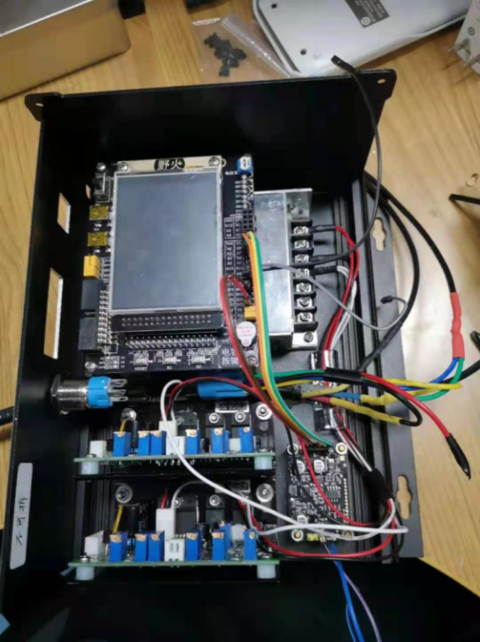

A2.3.3 Transceiver module
The transceiver modules on both sides are based on a Gigabit Ethernet chip and an optical driver. The LD and photodetector are integrated. Figure 25 shows the PCB of transceiver module.
FIGURE 25
Hardware of transceiver module
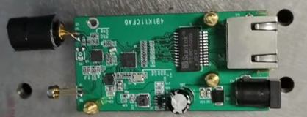
LD + lens
PD

A2.4 Measurement result

A2.4.1 LD-based visible light communication trial
Signals with different data rates are used to test the performance of the visible optical communication system. When the data rate is 3.0 Gbit/s, test results show that the BER is 1.32 × 10⁻³, which is less than 3.8 × 10⁻³, the threshold of FEC. The results of the data rate/error ratio tests are shown in Table 5.
TABLE 5
Test results of the data rate/error ratio
Data rate  (Gbit/s) | Error ratio
3.0 | $$1.32×10^{-3}$$
2.6 | $$1.08×10^{-3}$$
2.3 | $$1.00×10^{-3}$$

A2.4.2 Prototype of adaptive motion tracking alignment visible light communication system
Based on the above system architecture, an adaptive motion tracking aligned visible light communication system prototype was developed, adapted to bi-directional Gigabit Ethernet transmission, as shown in Fig. 26. In the prototype demonstration, the transceivers on both sides are 60 cm apart and move in the range of ±10°. The test results show that the system is capable of communication data rates higher than 900 Mbit/s when the movement stops. Figure 27 shows the test results.
FIGURE 26
Experimental platform of adaptive motion tracking-aligned visible light communication system
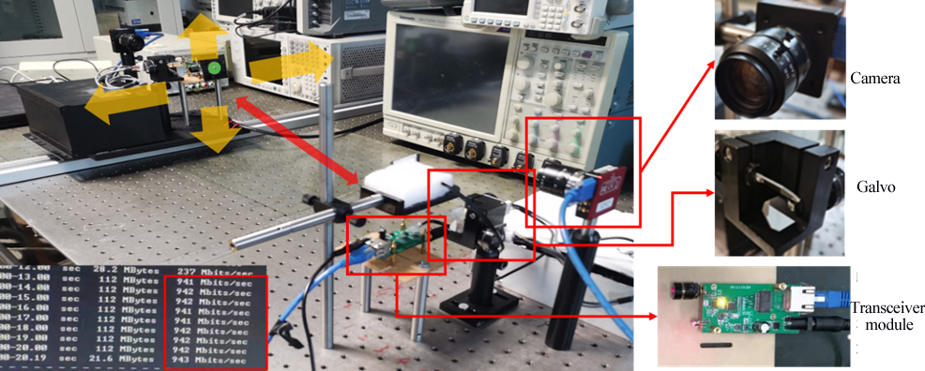
FIGURE 27
Communication rate test results of adaptive motion tracking-aligned VLC system
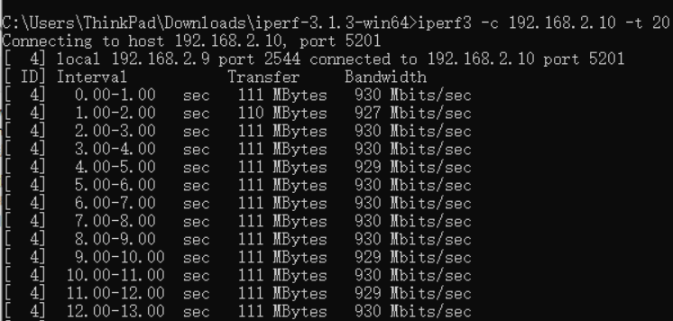

A2.5 Summary
A real-time high-speed VLC system based on LD is developed, which can achieve a communication rate of 3 Gbit/s. An adaptive motion tracking-aligned VLC system prototype is developed, which can maintain high-speed communication even when the receiver is moving. The test results indicate that when the distance between the receiver and transmitter is 60 cm and moves within a 10-degree range, the visible light system can adjust the beam direction in real-time and reach a communication rate above 900 Mbit/s after the movement stops.

Annex 3
2.4 Gbit/s real-time visible light communication system based on blue laser diodes

A3.1 Overview
VLC offers advantages such as rich spectrum resources, high transmission rates and immunity to electromagnetic interference. Under the challenges of rapidly growing communication demand and increasingly crowded spectrum in traditional radio frequency, VLC has received widespread attention and in-depth research, becoming a key technology for future communication.
This Annex presents the implementation of a 2.4 Gbit/s real-time VLC system with 600 MHz transmission bandwidth based on blue laser diodes (LD). FPGA chips are used to implement high-speed signal modulation and demodulation, and a VLC experiment prototype is developed with other key devices. SNR at the receiver side is about 20 dB and BER is 10⁻⁵ magnitude at a distance of 1 m visible light link without FEC.

A3.2 System introduction
Quadrature amplitude modulation (QAM) single carrier (SC) modulation was used in this system. Compared to OFDM, SC has lower peak to average power ratio. Transmission bandwidth of this system is 600 MHz, and total communication rate is 2.4 Gbit/s by using 16 QAM. Table 6 shows parameters of this real-time VLC system.
TABLE 6
System parameters
Parameters | Value
Modulation | 16 QAM single carrier
Transmission bandwidth (MHz) | 600
Roll-off factor | 0.2
Sampling frequency (GHz) | 2.4
Intermediate frequency (MHz) | 432

A3.2.1 System description
The block diagram of proposed real-time VLC system is shown in Fig. 28. The FPGA based transmitter performs real-time modulation of input binary signal and 2.4 Gbit/s analogue-to-digital converter (ADC) converts signal to analogue current. After 1.1 GHz low pass filter (LPF) and amplifier, an analogue pre-equalizer is used to compensate nonlinear distortion from LD and other devices to make spectrum flat. Then bias-tee adds DC bias voltage for driving LD to emit light while the signal modulates the intensity of laser beam. After 1 m free space VLC link, blue light with signal is directed detected by APD in the receiver side and subsequently converted light to electrical signal. The front-end analogue devices consist of attenuator, variable gain amplifier (VGA), LPF and digital-to-analogue converter (DAC) that samples signal and sends to FPGA. The FPGA receiver recovers original signal via real-time demodulation.
Figure 28
Block diagram of the real-time VLC system
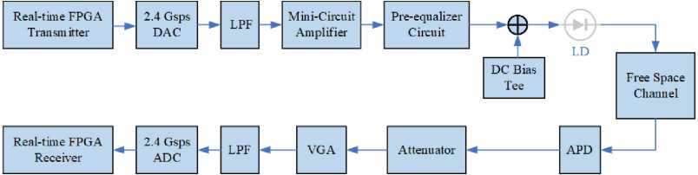

A3.2.2 Transmitter architecture
A block diagram of the transmitter is shown in Fig. 29. Four symbols in parallel are read from ROM and mapped to 16 QAM constellation. A 64-point PN sequence is added for frame synchronization and parameter estimation, followed by 2 304 data symbols. To reduce complexity and clock frequency of modulation, time-domain parallel architecture of polyphase filter is utilized. By quadrature multiplexing of polyphase filter bank from multiphase decomposition of square root raised cosine shaping filter, 16 band-limited signal output is obtained. Digital up converter is also based on this parallel structure with 16 direct digital synthesizers (DDS). Finally, symbols modulated in parallel by FPGA are sampled by DAC. Thus, modulation and transmission of 2.4 GHz sampling rate signal using only 150 MHz FPGA clock is achieved.
Figure 29
Block diagram of the transmitter implementation
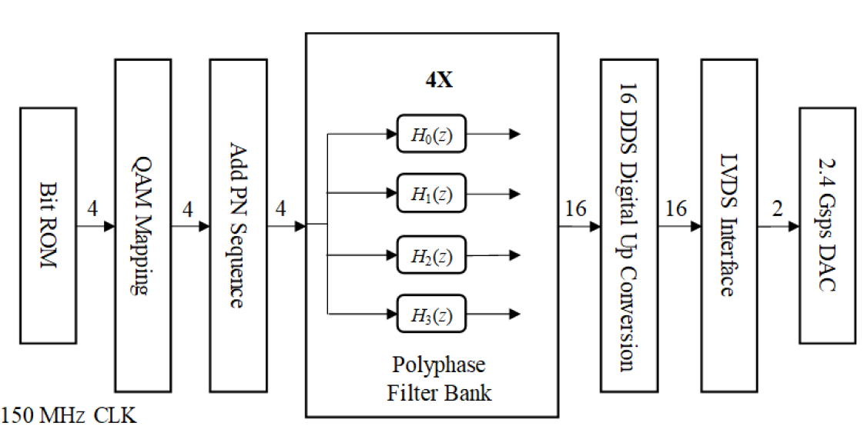

A3.2.3 Receiver architecture
A block diagram of the receiver implementation is shown in Fig. 30. Alternate parallel receiver architecture is used in the design, which converts time-domain convolution of matched filtering into frequency-domain multiplication via DFT. ADC performs direct sampling of the intermediate frequency signal converted by APD and obtains 32 parallel paths. Then IF signal is transformed to baseband by digital down conversion (DDC) in parallel. Overlap and save method is used to make circular convolution from DFT multiplication equivalent to linear convolution. Alternate parallel receiver architecture has identical performance to conventional serial receiver with low implementation complexity and resource consumption.
Figure 30
Block diagram of the receiver implementation
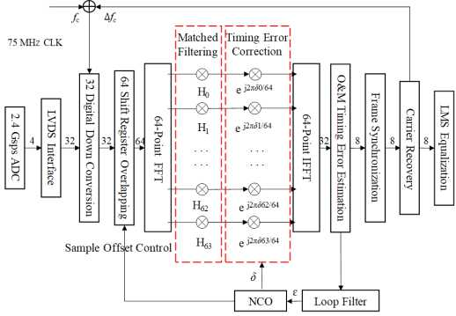
Timing synchronization is based on phase locked loop (PLL). The O&M algorithm is used for timing error estimation. Frame synchronization is achieved by performing correlation operations with a known PN sequence. The correlation peak of adjacent frames can also be used for carrier frequency offset estimation, which adjusts frequency at the input of DDC by similar feedback after loop filter and NCO of PLL.
In addition, carrier recovery contains carrier phase offset synchronization, which is based on decision feedback PLL by calculating phase difference between the constellation points on the diagonal and their decision values. Finally, linear least mean square adaptive equalization is utilized to eliminate distortion and interference of VLC channel.
To validate the feasibility of structure and algorithms, fixed-point simulation is conducted in MATLAB. The BER performance is shown as Fig. 31.
Figure 31
Simulation BER performance of proposed receiver
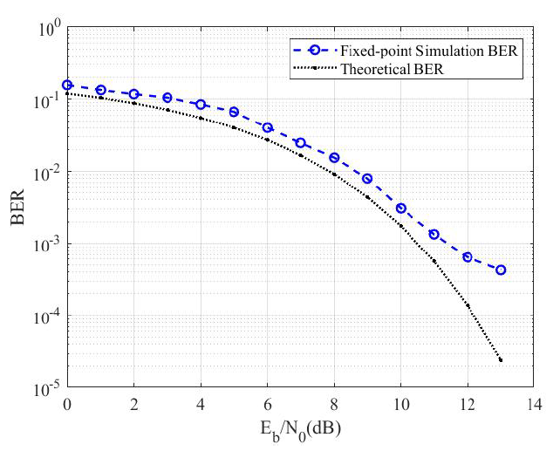

A3.3 Measurement results
The real-time transmitter and receiver are implemented on FPGAs, the resources and timing reports is shown as Table 7. The receiver used quite more resources than transmitter because of containing more demodulation algorithm like FFT/IFFT and timing synchronization in parallel, and 98% DSP block is used for massive multiplication. Maximum clock frequency (Fmax) of the transmitter and receiver are respectively 166.94 MHz and 82.9 MHz, both meeting 2.4 Gbit/s data rate requirement with 16 paths and 32 paths.
TABLE 7
FPGA resources and timing reports
Parameters | Transmitter | Receiver
Combinational ALUTs | 27 697 (8%) | 155 580 (44%)
Total registers | 19 898 | 85 102
Block memory | 3 417 088 (16%) | 6 078 464 (29%)
DSP block | 64 (6%) | 1 008 (98%)
Fmax | 166.94 MHz | 82.9 MHz

As shown in Fig. 32, a prototype VLC system is demonstrated with FPGAs and other VLC components. Spectrum in Fig. 33 illustrates that the signal is pre-distorted by a pre-equalizer circuit before driving LD, resulting in flat spectrum after APD at the receiver end and SNR is about 20 dB. Real-time constellation output of the implemented VLC system is shown in Fig. 34, which is 32 times of normalized constellation after quantization. The signal is successfully demodulated and low BER is achieved via hard decision de-mapping without FEC.
Figure 32
Photograph of the VLC experimental setup
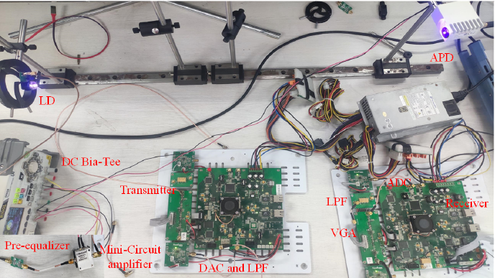
Figure 33
Spectrum of transmitted signal and received signal
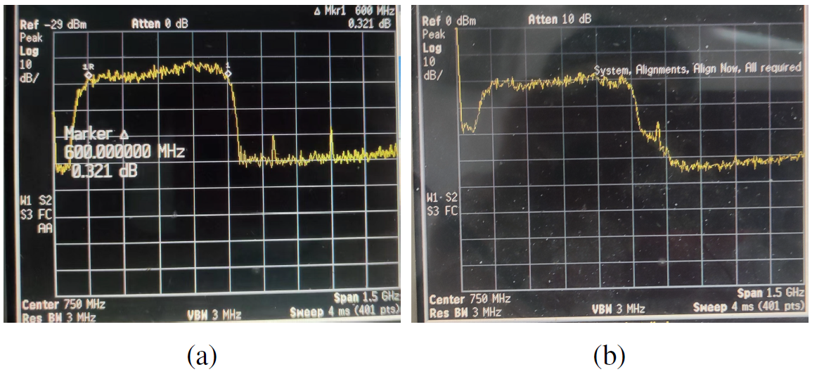
Transmitted signal Received signal
Figure 34
Real-time constellation of the VLC system
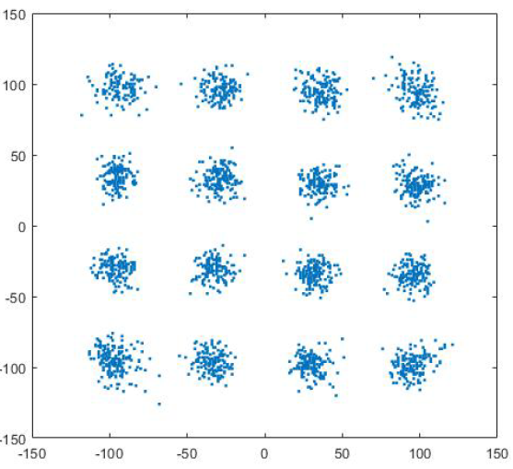
BER at different link distances ranging from 0.3 m to 0.8 m is shown in Table 8. Three experimental measurements are conducted by transmitting approximately 2 × 10⁷ frames, with total 2 × 10¹¹ bits each time. Average BER is 10⁻⁵ magnitude, which has small performance loss compared to theoretical values.
TABLE 8
BER measured results
Distance  (m) | Experiment 1 | Experiment 2 | Experiment 3 | Average BER
0.3 | 5.33 × 10⁻⁵ | 5.05 × 10⁻⁵ | 5.88 × 10⁻⁵ | 5.42 × 10⁻⁵
0.4 | 5.52 × 10⁻⁵ | 5.02 × 10⁻⁵ | 6.02 × 10⁻⁵ | 5.52 × 10⁻⁵
0.5 | 6.23 × 10⁻⁵ | 6.30 × 10⁻⁵ | 6.32 × 10⁻⁵ | 6.28 × 10⁻⁵
0.6 | 6.91 × 10⁻⁵ | 6.44 × 10⁻⁵ | 6.75 × 10⁻⁵ | 6.70 × 10⁻⁵
0.7 | 5.86 × 10⁻⁵ | 5.89 × 10⁻⁵ | 6.04 × 10⁻⁵ | 5.93 × 10⁻⁵
0.8 | 6.74 × 10⁻⁵ | 7.57 × 10⁻⁵ | 7.78 × 10⁻⁵ | 7.36 × 10⁻⁵

A3.4 Summary
In this Annex, a real-time, high-speed VLC system based on blue LD and FPGA is introduced. The transmission bandwidth is 600 MHz and payload data rate is 2.4 Gbit/s using 16 QAM. Laboratory measurements show that 10⁻⁵ magnitude BER is achieved without FEC in a 1 m free space optical link.
Higher order modulation 64 QAM is now being tried in the lab to enhance spectral efficiency and improve payload data rate to 3.6 Gbit/s. Low-density parity check code is also considered to reduce BER and enhance robust and anti-interference capability of system.

Annex 4
A 25 Gbit/s plug-and-play self-alignment optical wireless communication system

A4.1 Overview
Optical wireless communication (OWC) is a wireless communication technology that utilizes light in the visible or infrared spectrum as the medium for information transmission, achieving direct communication in the air. OWC technology offers higher bandwidth compared to traditional radio-based technologies and exhibits strong resistance to interference, making it an emerging research focus.
This Annex gives an overview of the FWF-OWC self-alignment system. This system performs alignment using a camera and a dual-axis stepper motor rotation platform, while being compatible with off-the-shelf small form-factor pluggable 28 optical modules. Experimental results demonstrate that the system provides stable, plug-and-play IP-level connectivity over a 2-metre distance within a 10-degree field of view, achieving TCP and UDP transmission rates of 24.2 Gbit/s and 25.0 Gbit/s, respectively. Additionally, the system can also maintain an alignment tolerance of ±0.2 degrees at a distance of 2 metres.

A4.2 System introduction

A4.2.1 Optical communication system
The system is based on an FWF-OWC architecture and off-the-shelf small form-factor pluggable 28 optical modules were used as transceivers. Existing optical modules come in two types: single-fibre and dual-fibre. Single-fibre modules use WDM within a single fibre, typically utilizing wavelengths of 1 310 nm for transmission and 1 550 nm for reception. Dual-fibre modules, on the other hand, have separate TX and RX ports, both operating at the 1 310 nm wavelength. Single-fibre modules using WDM face challenges in increasing transmission rates due to signal dispersion from the two different wavelengths, requiring dispersion compensation components, such as collimators with dispersion compensation, for coupling free-space light to the fibre. Additionally, single-fibre modules must be used in pairs, with complementary wavelength configurations at each end. However, dual-fibre modules avoid this issue by operating on a single wavelength band. Therefore, the system selects dual-fibre optical modules, which operate at 1 310 nm and support a maximum fibre transmission distance of 40 km.
Since the 1 310 nm signal light is in the near-infrared range, it cannot be captured by low-cost standard visible-light cameras. To enable the camera to track the beam position in real-time as feedback for the self-alignment system, fibre-optic coupler is used to combine 90% of the 1 310 nm signal light with 10% of a beacon light. The beacon light is produced by either a 525 nm green fibre-coupled LD or a 660 nm red fibre-coupled LD. The significant difference in wavelengths between the signal and beacon lights allows the internal filter of the optical module to effectively block the beacon light, ensuring it functions solely as a marker for the invisible signal lights position and does not interfere with communication. The collimator converts the combined light into a narrow parallel beam for transmission. At the receiving end, the same type of collimator is used as an optical antenna to couple the free-space light into the fibre.
As shown in Fig. 35, the beacon lights on the A-side and B-side are different. From the camera’s perspective, it can view not only the light spot from its own beam but also the interfering light spot emitted from the opposing side’s beam. Therefore, the cameras were equipped on the A-side and B-side with filters centred at 660 nm and 525 nm, matching their beacon lights. This configuration ensures that each camera observes only the light spot of its own beam while filtering out interference from the opposite side.
Figure 35
Overall system architecture
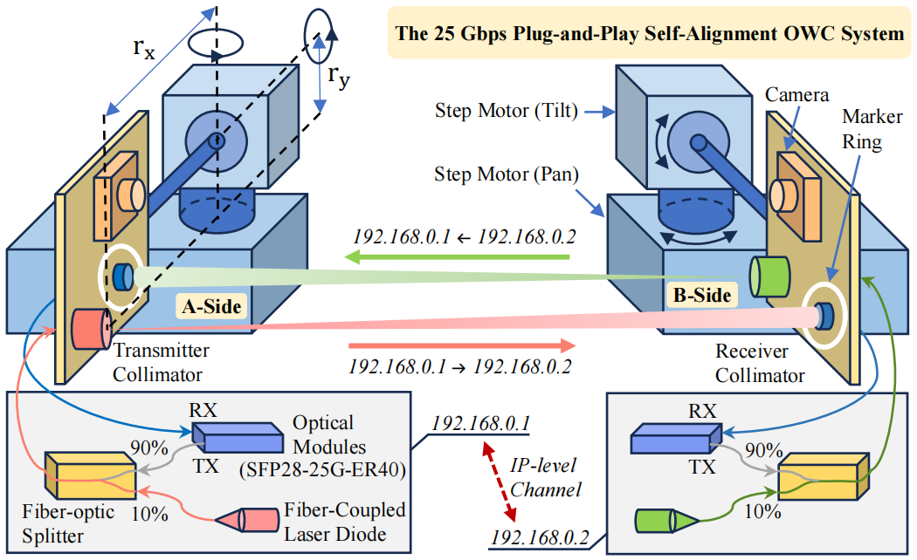

A4.2.2 Dual-axis mechanical rotation platform
In the system, beam alignment between the transmitter and receiver is achieved through a dual-axis mechanical rotation platform, allowing the beam emitted by the transmitter collimator to be received by the receiver collimator. The dual-axis rotation platform consists of two independent single-axis rotation platform, each driven by a stepper motor with a step angle of 1.8 degree. A worm gear transmission system with a 1/90 reduction ratio is used for speed reduction.
Additionally, the stepper motor driver is designed for a two-phase hybrid stepper motor, allowing the subdivision precision to be set by adjusting switches, with a maximum subdivision of 32. To interface the control system on the server, which is equipped with self-alignment control system, with the stepper motor driver, the control board converts the control commands into pulse commands for the driver.
As for the rotation platform setup, a 32-step subdivision was chosen, meaning each pulse signal causes the motor to rotate 0.05625 degree, meeting requirements for precise control of the rotation. Furthermore, a 100 µs pulse duration was set for the motor drive, achieving a rotation speed of 6.25 degrees per second to enhance alignment speed and maintain accuracy.

A4.2.3 Self-alignment control system
The self-alignment control system is a software program deployed on the server. It detects the current position of the light spot and the centre of the marker ring, which corresponds to the centre of the receiver’s collimator, within pixel coordinates by analysing images captured by the camera. Through a coordinate transformation, the program calculates the angular offset between the light spot and the marker ring centre in both tilt and pan dimensions based on their pixel offset. The offset angle acts as the error signal for the PID algorithm, generating real-time rotation control signals sent to the driver to adjust the two-axis rotation platform’s azimuth, aligning the light spot with the marker ring centre and completing transmitter-receiver alignment.

A4.3 Measurement results
In order to verify the system performance, the self-alignment OWC system on a 2-metre-long optical experiment platform was built, with the experimental setup shown in Fig. 36. Dual-port optical modules were used, capable of achieving a physical layer transmission rate of 25.78 Gbit/s over a maximum fibre distance of 40 km. In this setup, the A-side transceiver is mounted on a sliding rail, while the B-side transceiver is fixed on the optical platform, with a straight-line distance of 2 metres between them. The sliding rail allows a maximum movement of 0.4 metres, corresponding to a Field of View (FoV) angle of 10 degrees.
Figure 36
The system setup of experimental validations
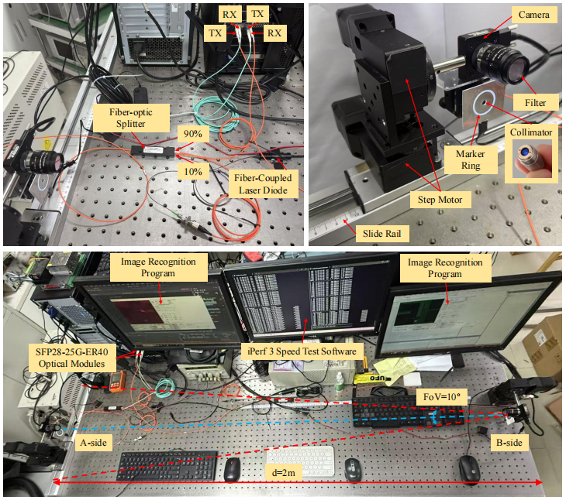
The self-alignment program is implemented in C# with a graphical user interface, as shown on the right side of Fig. 37. In order to constructing a plug-and-play, IP-level communication link, Therefore, a tool (iPerf3) specifically designed to actively measure the maximum achievable bandwidth on IP networks, was selected for testing. During the test, PC is configured with a 14 700K CPU and 32GB of memory, equipped with an ethernet network adapter. The adapter has two small form-factor pluggable 28 ports, each connected to one of the optical modules. Both modules are set to different IP addresses within the same subnet, simulating communication between two computer terminals.
Figure 37
Photograph of receiving screen after alignment and recognition results
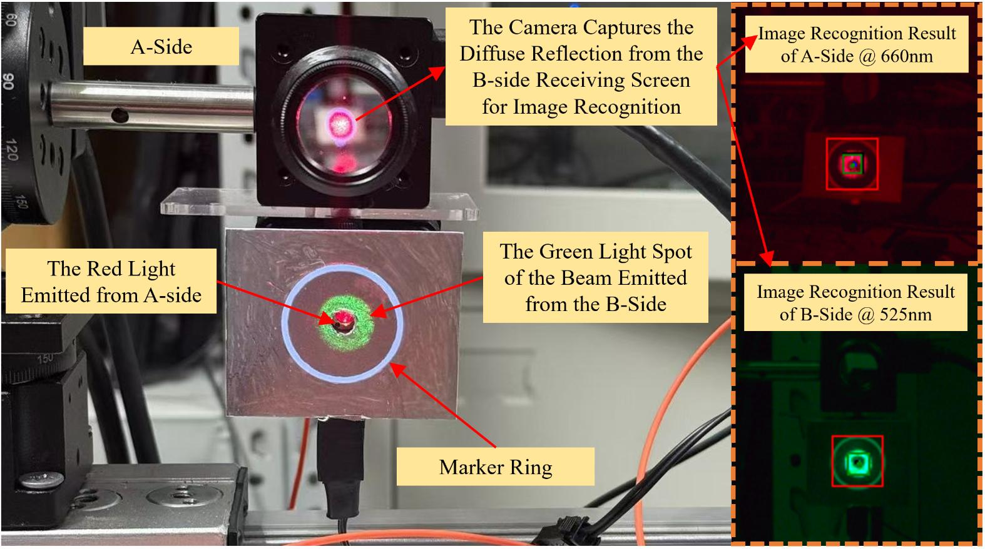
Specifically, the iPerf3 command was used in TCP mode with the -P 10” option to establish ten simultaneous connections for testing. The TCP rate remains consistently above 24 Gbit/s, with peak rates reaching 24.2 Gbit/s, as shown in Fig. 38. Through extensive testing, the UDP mode of iPerf3 experiences significant packet loss at high throughput rates, even with the socket buffer size set to the maximum of 512 MB using the “-w 512M” option. To address this issue, a Python script was developed which initiates iPerf3 UDP tests across five separate pairs of command line windows, with each pair configured to a 5 Gbit/s UDP rate bound to a unique IP port. Figure 39 shows the UDP test results for one of the connections, and the results for the other connections are nearly identical. Each individual UDP rate stabilises at 5 Gbit/s, bringing the total UDP rate to 25 Gbit/s. The jitter ranges from 0.616 to 0.655 ms, with a packet loss rate of zero.
Figure 38
TCP rate test
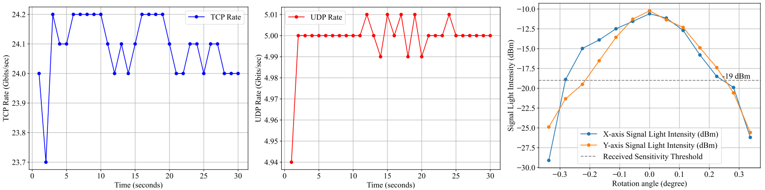
Figure 39
UDP rate test
Additionally, Fig. 37 shows the alignment of the light spot and marker ring on the A-side receiving screen after the alignment process. It can be seen that the light spot is precisely coaxial with the collimator. Furthermore, the variation in signal light intensity coupled into the optical fibre through the collimator under non-coaxial conditions were tested, as shown in Fig. 40.
Figure 40
Signal intensity variation with alignment error
Specifically, after completing alignment, intentional alignment error is introduced via program control, scanning in the x and y directions at the minimum step angle of the stepper motor, which is 0.05625 degrees. From Fig. 40, it is evident that due to certain manufacturing tolerances in the collimator, the beam profile is not a perfect Gaussian, exhibiting some asymmetry. The receiving sensitivity of the optical modules are both −19 dBm, which means this system can still function effectively with an angular misalignment of ±0.2 degrees at a distance of 2 metres. In the case of a shorter communication distance, the tolerance for angular misalignment would be greater. This finding can increase coaxial alignment tolerance and reduce alignment mechanism costs.

A4.4 Summary
This study explains an FWF-OWC system that aligns the transceiver axes using a camera to recognise light spot and marker ring positions, controlling a dual-axis rotation platform. Unlike other offline-validation approaches, this system offers a plug-and-play IP-level channel, establishing a reliable 2-metre connection with a 10-degree FoV, achieving TCP speeds of 24.2 Gbit/s and UDP speeds of 25.0 Gbit/s. It also features a ±0.2-degree alignment tolerance at 2 metres.

Other terminology used for Power Line Communication is Power Line Telecommunication (PLT).
Here, the communication distance of the VLC part is set to be 3 metres because 3 m is the typical height of the ceilings in many indoor scenarios.

