Report ITU-R SM.2392-2
(06/2026)
SM Series: Spectrum management
Applications of wireless power transmission via radio frequency beam

Foreword
The role of the Radiocommunication Sector is to ensure the rational, equitable, efficient and economical use of the radio-frequency spectrum by all radiocommunication services, including satellite services, and carry out studies without limit of frequency range on the basis of which Recommendations are adopted.
The regulatory and policy functions of the Radiocommunication Sector are performed by World and Regional Radiocommunication Conferences and Radiocommunication Assemblies supported by Study Groups.

Policy on Intellectual Property Right (IPR)
ITU-R policy on IPR is described in the Common Patent Policy for ITU-T/ITU-R/ISO/IEC referenced in Resolution ITU-R 1. Forms to be used for the submission of patent statements and licensing declarations by patent holders are available from http://www.itu.int/ITU-R/go/patents/en where the Guidelines for Implementation of the Common Patent Policy for ITU-T/ITU-R/ISO/IEC and the ITU-R patent information database can also be found.

Series of ITU-R Reports
(Also available online at https://www.itu.int/publ/R-REP/en)
Series | Title
BO | Satellite delivery
BR | Recording for production, archival and play-out; film for television
BS | Broadcasting service (sound)
BT | Broadcasting service (television)
F | Fixed service
M | Mobile, radiodetermination, amateur and related satellite services
P | Radio-wave propagation
RA | Radio astronomy
RS | Remote sensing systems
S | Fixed-satellite service
SA | Space applications and meteorology
SF | Frequency sharing and coordination between fixed-satellite and fixed service systems
SM | Spectrum management
TF | Time signals and frequency standards emissions

Note: This ITU-R Report was approved in English by the Study Group under the procedure detailed in Resolution ITU-R 1.

Electronic Publication
Geneva, 2026
© ITU 2026
All rights reserved. No part of this publication may be reproduced, by any means whatsoever, without written permission of ITU.

REPORT ITU-R SM.2392-2
Applications of wireless power transmission via radio frequency beam*
(2016-2021-2026)
TABLE OF CONTENTS
Page
Report ITU-R SM.2392-2 1
Policy on Intellectual Property Right (IPR) ii
1 Introduction 3
2 Applications developed for use of WPT technologies via radio frequency beam 3
2.1 Wireless powered sensor network 4
2.2 Wireless charging of mobile/portable devices 10
2.3 Wireless power transfer sheet 12
2.4 MPT in a pipe 14
2.5 Microwave buildings 16
2.6 WPT to moving/flying target 17
2.7 Point-to-point WPT 22
2.8 Wireless charging for electric vehicles 26
2.9 Space based solar power via satellite 30
3 Technologies employed in WPT applications 36
4 Organizations expected to contribute to the standardization of WPT 36
4.1 European cooperation in science and technology (COST) 36
4.2 WiPoT (Wireless power transfer consortium for practical applications) [73] 37
4.3 BWF (Broadband wireless forum) [74] 37
4.4 Other international organizations 38
5 Spectrum for WPT via radio frequency beam 38
6 Summary 39

Glossary and abbreviations
AIA Active integrated antenna
AP Access point
DWPT 2DWPT two-dimensional waveguide power transmission; and three-dimensional waveguide power transmission
EV Electrical vehicle
FWA Fixed wireless access
GER Ground energy receiver
IoT Internet of Things
IRS Intelligent reflecting surface
ISM Industrial, scientific and medical
JSS Japan Space Systems
MAV Micro aerial vehicle
METI Ministry of Economy, Trade and Industry
MIT Massachusetts Institute of Technology
MPT Microwave power transmission
NOMA Non-Orthogonal Multiple Access
PB Power beacon
PVPCM Power-variable phase-controlled magnetrons
QoS Quality of service
Rectenna RECTifying antENNA
RF Radio frequency
RFID Radio frequency identification
SBSP Space based solar power
SEI Space energy initiative
SIC Successive interference cancellation
SPS Solar power satellites
UAV Unmanned aerial vehicle
UPS Ubiquitous power source
WBLS Wireless batteryless sensing system
WPCN Wireless powered communication networks
WPT Wireless power transmission
WSN Wireless sensor network

1 Introduction
It should be noted that national experiences provided in this Report are for information purposes only.
Wireless power transmission (WPT) technology is considered as one of the game-changing technologies. People will be able to become free from lacking electric power when electric power will be supplied wirelessly.
Power transmission by radio waves dates back to the early work of Nikola Tesla in 1899. Tesla carried out his first attempt to transmit power without wires in 1899. He used low frequency power of 150 kHz, but his attempts failed. Parallel to Tesla’s first WPT experiments, M. Hutin and M. Le-Blanc proposed an apparatus and method for powering an electrical vehicle (EV) inductively in 1894 using an approximately 3-kHz AC generator [2]. EVs were developed during the period of time shortly after the steam engine, approximately one hundred years ago. Both inductive WPT which is a type of ‘non-beam’ WPT and the WPT via radio frequency beam which is called ‘beam’ WPT were started in the early 20th century.
The present development of the WPT via radio frequency beam owes to William Brown in 1960s using microwave technology developed during the World War II. He transmitted the microwave power from a transmitter to a receiver (point-to-point) with the overall (DC-microwave-DC) efficiency of 54% in his laboratory [1]. When we use the microwave frequency, the WPT via microwave is called a microwave power transmission (MPT). A lot of the inductive WPT research projects for a wireless charging of EVs were carried out in 1980s and 1990s [4]. Commercial products of contactless cables are produced after 1900s. A turning point of the inductive WPT was in 2006, when Massachusetts Institute of Technology (MIT) demonstrated non-beam wireless power technology called resonance coupling WPT [3]. Nowadays, resonant WPT technologies are coming out to consumer market. Automotive industry looks at WPT for EV applications in near future. Information about WPT using technologies other than radio frequency beam, as partial answers to the Question ITU-R 210-3/1 was published as Report ITU-R SM.2303 in 2014. After the MIT’s demonstration, a variety of WPT technologies including magnetic induction, resonance coupling, transmission via radio frequency beam, etc. are paid attention as game-changing technologies.
This Report provides information about WPT applications using radio frequency beam. The ITU Radio Assembly considers that WPT is defined as the transmission of power from a power source to an electrical load wirelessly using the electromagnetic field. The ITU Radio Assembly also considers that WPT technologies utilize various mechanisms, such as transmission via radio frequency radiated transmissions in the far field (WPT beams) and near-field inductive, resonant and capacitive coupling (WPT non-beam). WPT beams do not specify between directed or non-directed electromagnetic waves. Also, some antenna configurations will allow the mechanism of radiated transmission for power without regard for distance. In these cases, the use of the terms near-field and far-field are not needed. This Report also covers power transmission by non-directed, radiated electromagnetic waves, which can include non-beam applications, such as energy harvesting, but does not include magnetic induction, magnetic resonance, nor capacitive coupling technology, which are treated in Report ITU-R SM.2303.
Further studies for the impact between such WPT systems and existing other systems, and safety aspects such as human exposure to electromagnetic fields are necessary in order to realize these applications.

2 Applications developed for use of WPT technologies via radio frequency beam
Major characteristics of the WPT via radio frequency beam are:
1) intention for radiated transmissions without regard for distance,
2) no intention for inductive, resonant or capacitive coupling, and
3) various applications, e.g., weak powered sensors, high power wireless chargers, huge power transfer from power station, etc.

2.1 Wireless powered sensor network
Recommendation ITU-T Y.2221 [6] defines sensor network as: A network comprised of interconnected sensor nodes exchanging sensed data by wired or wireless communication. Wireless sensor networks (WSNs) are one of the most rapidly developing information technologies and promise to have a variety of applications in next generation networks (NGNs) based on ITU-T Technical Paper Y.2000 [7]. Energy efficiency is quite important. This paper states as follows:
“The WSN parts may be spatially distributed on the area of many kilometres, especially if a WSN user is managing it via the Internet. At the same time, sensor nodes can be located in the inaccessible places, or the concrete location of each sensor node can be unknown. Also, a WSN may consist of dozens, hundreds or even thousands of sensor nodes. Under these conditions charging of sensor nodes by the user is out of question. That is why a sensor node must have high energy efficiency in order to keep working on small and inexpensive battery for a few months and even years. This ultra-low-power operation can only be achieved by using low-power hardware components.”
Wireless power enables a wide variety of applications for sensor networks that would otherwise be unfeasible. These include sensor networks to support environmental monitoring of metrics such as air quality, light, humidity, temperature and others. Industrial applications of wireless powered sensor networks are also being implemented for physical asset management and logistics. In this regard, WPT via radio frequency beam (beam WPT) serves as an enabling factor for the deployment of Internet of Things (IoT) systems. These beam WPT systems operate with transmitter powers varying from 1 W to 15 W using directional antennas. An example of beam WPT charging of an IoT sensor network is illustrated in Fig. 1.
FIGURE 1
Example of diagram of a beam WPT application for IoT sensor network
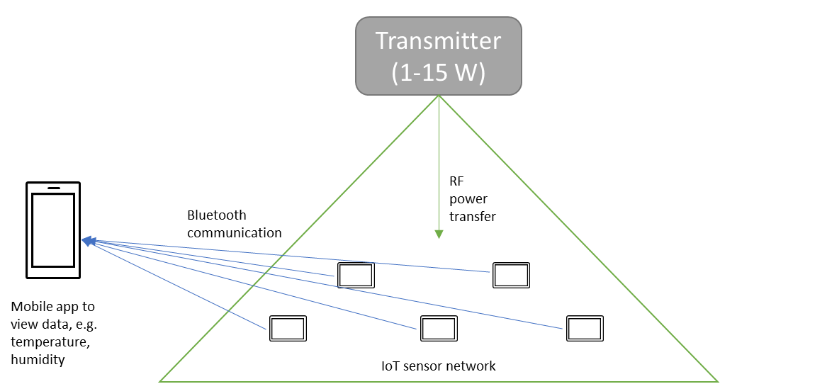

2.1.1 Situation in Japan
Microwave power can drive a wireless sensor without a battery. Wireless power can be actively transmitted to sensors requiring electricity (Fig. 2). This system could solve the above problem. A rectifying antenna (rectenna), which consist of an antenna and rectifying circuit with diodes, receives and rectifies a radio wave to direct current (DC). Radio frequency (RF) – DC conversion efficiency is theoretically 100%, and reaches approximately 90% at 2.45 GHz for a developed rectenna.
FIGURE 2
Image of wireless powered sensors (ZigBee) [5]
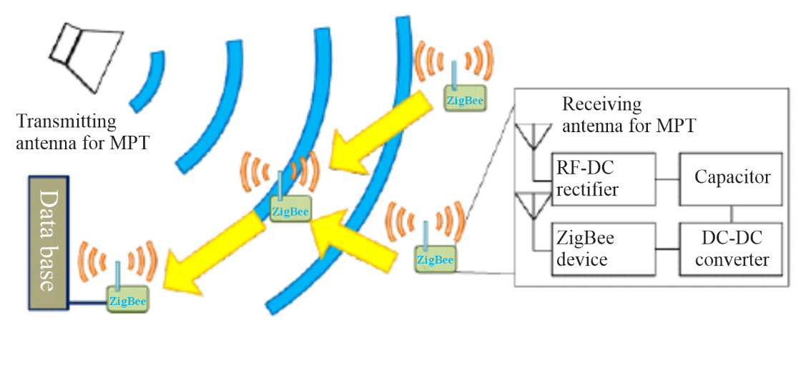
The ZigBee/IEEE802.15.4 sensor represents a potential wirelessly powered sensor. The ZigBee network is configured as a coordinator, router, and an end device. The coordinator is just one device in the network and coordinates the network. The router has the function of relaying data from other routers and end devices as well as sensing information. The end device sends data only; otherwise, it sleeps. Therefore, power consumption of the end device is lower than the other devices. The router and end device send a total of nearly 2 ms of data every 1.14 s. The coordinator drops either device from its network if it does not receive data from either for 15 s. The out of network device must perform the necessary routines to rejoin the network. When the end device and the router rejoin the network and communicate with each other, they expend 9.46 mW and 57.4 mW, respectively, to do so. When they do not join the network and sleep, they expend 61.8 mW and 57.1 mW, respectively [5]. The electricity consumption is one example that indicates we can drive the ZigBee sensor strictly with microwave power.
Another Japanese proposed wireless powered sensor network is called wireless grid or microwave illumination whose concept is shown in Fig. 3 [10] [11]. The system provides wireless power and wireless information of active RFID in the 920 MHz band. The system uses four channels (1 W) without carrier sensing for passive Radio Frequency Identification (RFID) for wireless power. 77 channels (1 mW) for active RFID are used for the sensor network. Instantaneous received power should be larger than the power consumed by the sensor. The average consumed power is controlled by changing the duty cycle. A multi-power transmitter is used in the room and a carrier shift diversity is proposed in which multi frequencies are used to reduce standing waves in a closed room. The carrier shift diversity effectively reduced standing waves and created an approximately uniform power density in the room.
FIGURE 3
Concept of the wireless grid (microwave illumination) [11]
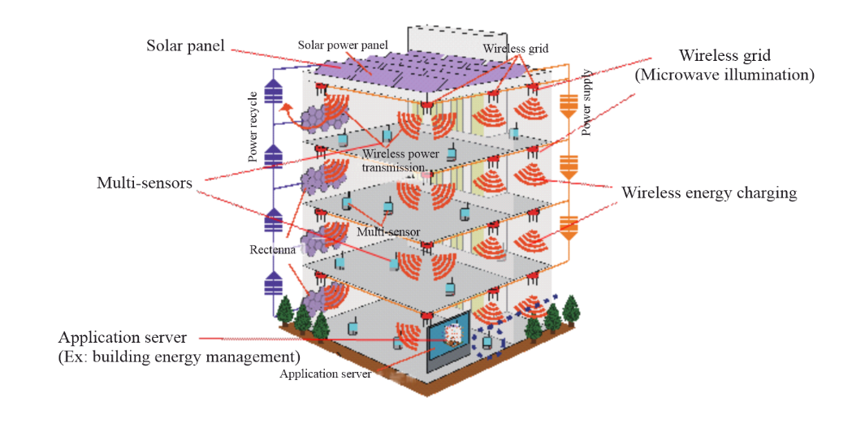
Japanese company provides a commercial wireless sensor using WPT in the 920 MHz band [8]. The distance of application is less than 5 m. The RF-DC conversion efficiency is approximately 60%. The company proposes applications of the wireless sensor for sensing in high temperature environments (85-120 °C), sensing on a rotating or moving object, and sensing in severe environments; for example, in outdoor or marine environments, etc. They have developed a high efficiency rectenna whose RF-DC conversion efficiency is approximately 91.6% at 8 W, 2.45 GHz and 7 W [9].
A wireless sensor application by using a flying drone is proposed in Japan in 2015. One of weak point of the WPT is a miss match between a required power and system size of the WPT which includes an antenna size and a transmitting radio wave power. When a distance between a transmitting antenna and a receiving antenna of the WPT becomes longer, beam efficiency becomes lower than a user expectation. Even for the WPT sensor, it sometimes happens. By using the flying drone, the distance between a transmitting antenna and a receiving antenna of the WPT becomes shorter and WPT system can be smaller than that without the drone. The proposed WPT system is named a “Multicopter Assisted Wireless Batteryless Sensing System (WBLS)”. The first experiment was carried out in July 2015 at Kyoto University by WiPoT, Kyoto Univ., Mini-Surveyor Consortium, and Autonomous Control Systems Laboratory Ltd. 5.8 GHz, 8.74 W microwave power was transmitted from 8 × 8 array antenna (21 dBi) on a flying drone (multicopter) as shown in Fig. 4. Received and rectified 6.1 mW DC power drives a sensor. Hopeful applications of the Multicopter Assisted WBLS are rescue of victims, WPT-powered sensors at volcano, and inspection of infrastructures (bridges, tunnels) amongst others.
fIGURE 4
Concept of Multicopter Assisted WBLS and its demonstration in July 2015 in Japan
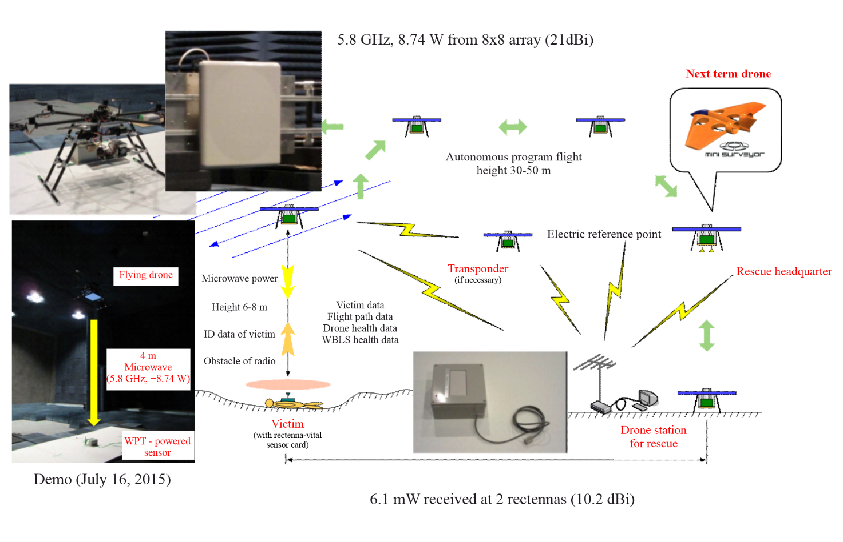

2.1.2 Situation in Brazil
The Brazilian scientific community has progressed in advancing WPT technologies, particularly in three key domains: far-field radio frequency beam applications, energy harvesting solutions for IoT devices, and seamless integration with contemporary wireless architectures. Academic investigations have successfully tackled numerous technical hurdles, including spectral efficiency enhancement, mitigation of channel imperfections, and rectenna hardware optimization, frequently incorporating innovative approaches such as Non-Orthogonal Multiple Access (NOMA) protocols and Intelligent Reflecting Surface (IRS) implementations.
Research efforts have extensively examined Wireless powered communication networks (WPCNs), systems where terminal devices extract operational energy from RF signals. The standard WPCN operational paradigm divides the communication cycle into two distinct intervals: an initial power transfer phase and a subsequent data transmission period. During the first interval, a dedicated Power Beacon (PB) node facilitates wireless energy transfer while user equipment performs energy harvesting operations. Modern PB implementations often incorporate multiple antenna elements to enable directional energy transmission through beamforming techniques. The subsequent phase involves sensor nodes transmitting collected data to an Access Point (AP), utilizing various multiple access schemes to manage potential interference. In integrated system designs where the AP and PB functionalities merge into a single unit, the configuration is termed a Hybrid Access Point (HAP). Figure 5 illustrates some of the presented concepts.
FIGURE 5
WPCN system with AP, PB, and devices with a time frame divided into two phases: energy transfer and data transmission [15]
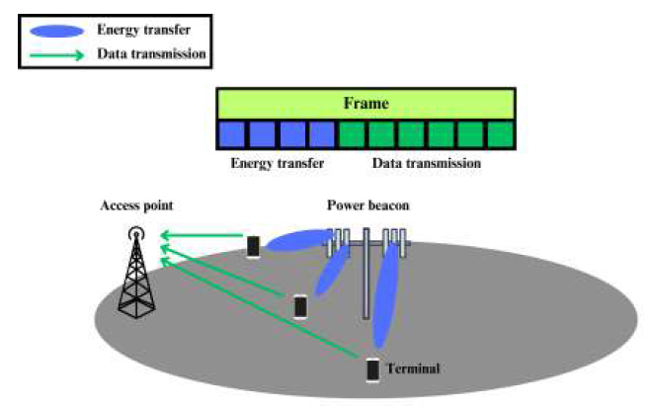
A primary research focus has been optimizing temporal allocation between these two phases within fixed-duration communication frames. Various optimization criteria have been explored across different studies, including aggregate data rate enhancement [12], [13], [14], [15], [16], equitable rate distribution among users or fairness [17], packet error rate reduction [18], and minimization of the energy transfer duration [19]. These optimization frameworks typically incorporate practical constraints such as maintaining specified Quality of Service (QoS) thresholds for user data rates [20], [14], [15].
The selection of appropriate multiple access techniques for the data transmission phase has received considerable attention due to its significant impact on overall system performance. NOMA has emerged as a particularly promising approach, permitting concurrent uplink transmissions from multiple devices on shared spectral resources [12], [13], [14], [15], [16], [17], [20]. This technique relies on power domain multiplexing, where devices transmit at varying power levels while the receiving AP employs Successive Interference Cancellation (SIC). The SIC algorithm operates through sequential signal decoding, beginning with the most powerful signal, removing its contribution from the composite signal, and iteratively processing subsequent signals. Brazilian researchers have contributed substantially to understanding and mitigating imperfect SIC conditions, where residual interference persists after cancellation attempts [13], [20].
Alternative multiple access schemes have also been investigated, including Irregular Slotted Aloha (IRSA) protocols. In such systems, devices transmit multiple copies of their data packets across randomly selected time slots, with the AP employing collision resolution algorithms to reconstruct original transmissions from successfully received replicas [18].
Recent technological advancements have incorporated IRS to address power transfer efficiency challenges in WPCNs. These surfaces comprise configurable metamaterial arrays capable of dynamically altering incident electromagnetic wave properties through precise phase shift adjustments. Key advantages of IRS technology include: 1) enhanced coverage through synthetic line-of-sight path creation, 2) superior energy efficiency via RF power concentration, and 3) simplified hardware architecture by eliminating active amplification components. Phase control typically employs Positive-Intrinsic-Negative diodes or varactors, permitting rapid reconfiguration of reflection characteristics. In WPCN applications, IRS implementations demonstrate dual benefits: augmenting harvested energy during power transfer phases and improving signal integrity during data transmission periods. Figure 6 illustrates this concept. The study documented in [14] demonstrates these advantages through genetic algorithm optimization of IRS parameters, achieving notable uplink rate improvements while maintaining QoS requirements. Subsequent research [16] reveals that coordinated phase shift optimization across multiple IRS units can yield throughput gains compared to independent optimization approaches, while simultaneously reducing energy expenditure.
FIGURE 6
IRS-assisted WPCN network [14]
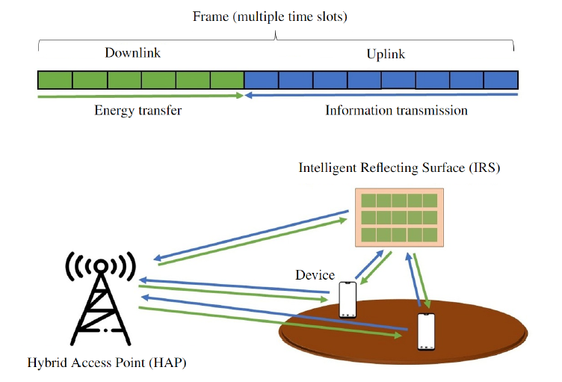
Multiple antenna configurations at PB nodes represent another area of active research, enabling more precise energy focusing through analogue beamforming techniques. This approach manipulates signal phase and amplitude relationships across antenna elements to generate constructive interference patterns in desired directions while suppressing radiation elsewhere. Practical implementations utilize phase shifter networks and variable gain amplifiers to create dynamically steerable beam patterns, with weighting coefficients derived from channel state estimations. Research documented in [15] applies matched filter beamforming with optimized power distribution, while [19] presents a more pragmatic solution using statistical channel knowledge, demonstrating only marginal performance degradation compared to ideal channel state scenarios.
Hardware development efforts have yielded significant achievements, including the dual-band rectenna design presented in [21]. This implementation achieves power conversion efficiency exceeding 50% while delivering a 1.6 V DC output, utilizing two substrate materials: FR4 and Rogers 5880. Such innovations provide crucial enabling technology for practical microwave-powered IoT implementations. Complementary work [22] has developed comprehensive behavioural models for supercapacitor-based RF-WPT systems, enabling precise characterization of energy storage dynamics during both harvesting and transmission cycles. These models facilitate accurate prediction of charging durations and optimal transmission scheduling for autonomous IoT devices.

2.2 Wireless charging of mobile/portable devices
Wireless charging technologies have been in constant evolution, currently offering support for radiated transmissions without regard for distance (beam WPT). Beam WPT technology can offer substantial improvements in some applications as compared to non-beam WPT, which utilizes inductive, resonant and capacitive coupling technologies.
Beam WPT technology can be designed and implemented into many different sized electronic devices for the home and office, as well as the medical, industrial, retail and automotive industries, and it ensures interoperability across products. These devices include wearables, hearing aids, earbuds, Bluetooth headsets, IoT devices, smartphones, tablets, e-book readers, keyboards, mice, remote controls, rechargeable lights, cylindrical batteries, medical devices and any other device with similar charging requirements that would otherwise need a battery or a connection to a power outlet.
Beam WPT transmitters use narrowband spectrum, typically 400 kHz or less, to transmit RF energy to its client device. The transmitter is inactive until an authorized client device has been identified, authenticated, and determined to be at zero distance from the WPT charger pad. Beam WPT over-the-air technology operates in similar spectrum and rely on antenna arrays and beam focusing techniques to transmit RF energy to precise client device locations. Because some beam WPT power transmissions from wireless charging systems are directed to a client device, they should not be viewed as an isotropic radiator, as they focus their energy on specific locations and transmit only when an authorized client is present.

2.2.1 Situation in Japan
Sensors are suitable devices to take advantage of WPT via radio waves because they are very low power devices. However, various kinds of mobile devices exist that operate using battery storage and WPT should be applied for wireless power feeding or wireless charging of these various mobile devices. For this purpose, a concept termed ubiquitous power source (UPS) was proposed near the end of 1990s [27] [28] and is based on the concept that microwaves are everywhere at all times (ubiquitous) and are always available for WPT.
The concept of UPS is shown in Fig. 7(a). Microwave power at 2.45 GHz (industrial, scientific, and medical (ISM) band frequencies reside in the 2.40-2.50 GHz range) is transmitted from the edges of a ceiling to charge mobile phones. It is quite possible to create a uniform microwave power density in a UPS room with antennas installed at the ceiling edges. Slot antennas are selected as the transmitting antennas because of their reduced cost. For the same reason, a frequency stabilized and phase controllable magnetron is used. However, because the UPS concept is based on a “wireless power source all the time and everywhere,” the design of UPS is limited by safety issues associated with prolonged exposure to microwaves by human beings. The safety level set is under 1 mW/cm² for continuous exposure over the entire human body. For an experimental room of 5.8 × 4.3 m, approximately 150 W of microwave power was transmitted from a magnetron to create a uniform microwave power density of 1 mW/cm² or less. High-efficiency rectennas are also necessary for operation at a microwave power density of 1 mW/cm² or less. Under these conditions, an experiment was successful at charging mobile phones, as shown in Fig. 7(b). Furthermore, a mobile phone can still be used in the UPS room because of the difference between the 2.45 GHz microwave power and the 1.9 GHz communication system frequencies.
FIGURE 7
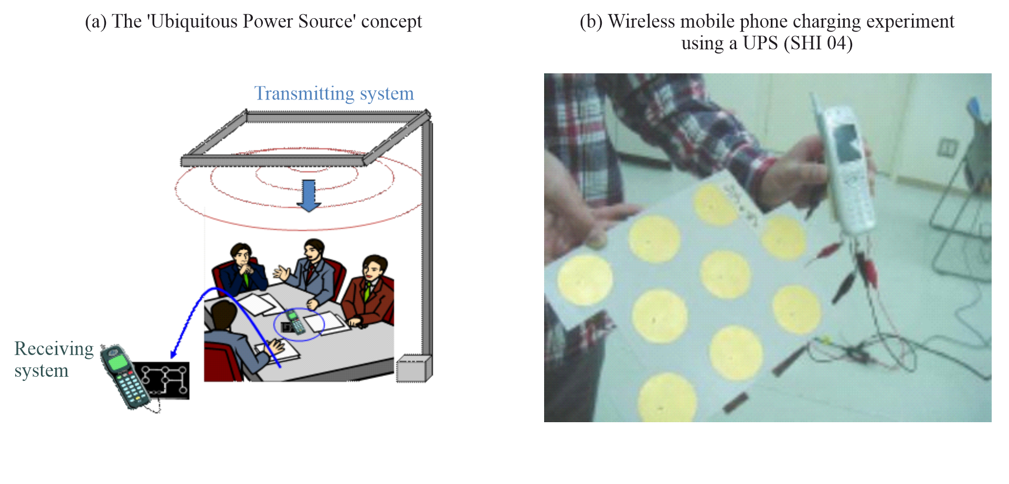
As an extension of UPS systems, a phased array should be used to reduce the total transmitting power and to reduce unexpected radiation at positions where power is not needed (Fig. 8). For directional UPS in a room size equivalent to the UPS experiment described above, only 22 W of microwave power (versus 150 W for the conventional UPS system) is required if the power density around a device is to be 1 mW/cm². The phase array is still expensive for commercial WPT and UPS. The cost of the array depends on component costs, especially the phase shifter.
Therefore, systems without phase shifters are proposed to reduce the total microwave power necessary for UPS while lowering the cost [25].
FIGURE 8
Present UPS vs future UPS using a phased array
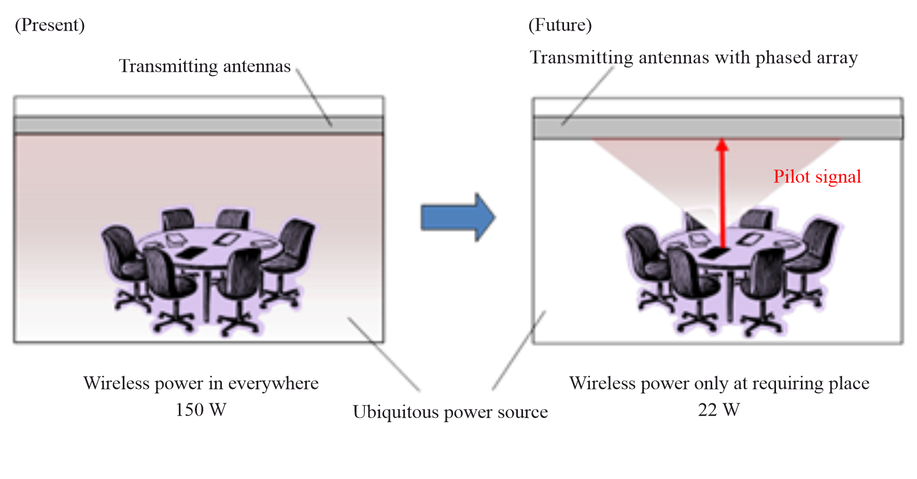
Emergency UPS was proposed, and an experiment was carried out in 2009 in Japan [26], as discussed in § 2.4. An image of the experimental system is shown in Fig. 9. Worldwide, there are some research projects involving emergency base stations for mobile phones by balloon or by airship. However, even if a base station for mobile phones is established for emergencies, a mobile phone cannot be used without electricity. So, an emergency UPS system is proposed for rapid and periodic recovery of electricity by wireless power. In the experiment from 2009, a mobile phone was charged using only wireless power from an airship.
FIGURE 9
Image of an emergency UPS system and photo of experiment (2009)
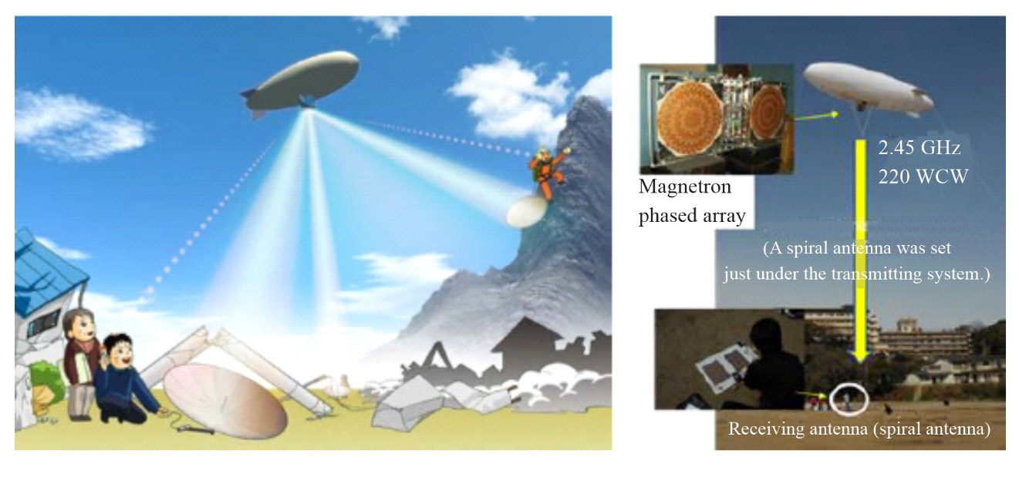

2.2.2 Situation in the United States of America
Several U.S. companies have developed beam WPT technology similar in purpose to use cases of radiated transmissions without regard for distance technology. A U.S. based company in 2020 demonstrated a digital shelf labelling system for retailers that requires no wires or batteries. Its technology operates at 2.4 and 5.8 GHz. It has an operating range of up to about 10 metres and can also power smartphones, compatible smart home devices, automotive sensors and many other devices. Other U.S. companies have technologies that operate at different frequencies. However, existing beam WPT technologies are not currently authorized by the FCC to operate at these larger distances in public settings in the U.S. Another U.S. company uses ISM mm wave frequencies [23].
Additionally, another U.S. company has demonstrated its technology, which operates in ISM and RFID frequency ranges in the 900 MHz frequency band [24].

2.3 Wireless power transfer sheet

2.3.1 Situation in Japan
A MPT operating through closed waveguides is a good potential application under present radio wave regulations. Another MPT operating through closed waveguides was proposed and developed in Japan. It is called the “two-dimensional waveguide power transmission (2DWPT) system or surface WPT system” [33]. In 2DWPT systems, the microwave propagates along a waveguide sheet and is selectively received by special receiving devices on the sheet (Fig. 10). The 2DWPT system also has an inevitable trade-off between the safety and power transmission capacity. Figures 11(a) and 11(b) illustrate an improved waveguide surface which has been demonstrated to enhance electro-magnetic compatibility (EMC) performance [30] [31]. The microwave is received at a waveguide-ring resonator (WRR) coupler which extracts the power from the waveguide across a thick insulator (Fig. 11(c)). Extraneous objects near or even touching the sheet are not exposed to the strong electromagnetic fields. The WRR coupler has a significantly high-quality factor (high-Q) in the resonant state, which is essential to support the selective power transmission. The WRR is connected to a rectifying circuit which is driven in class F. The total efficiency, defined as the ratio of the DC output of the rectifying coupler to the microwave input into the sheet, was 40.4% at maximum where the microwave input was 1 W in the 2.4 GHz band with a 6.4 × 3.6 cm² coupler on a 56 × 39 cm² sheet (nearly 100 times the area of the coupler) [31].
FIGURE 10
Photographs of the 2DWPT system
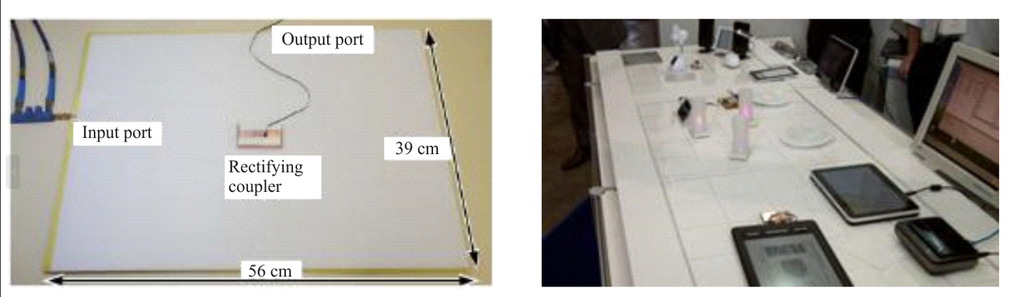
FIGURE 11
Wireless power transfer sheet
(a) Upper view of the waveguide sheet around its edge | (b) Schematic drawing  of its cross section | (c) Receiver of wireless power [30] [31]
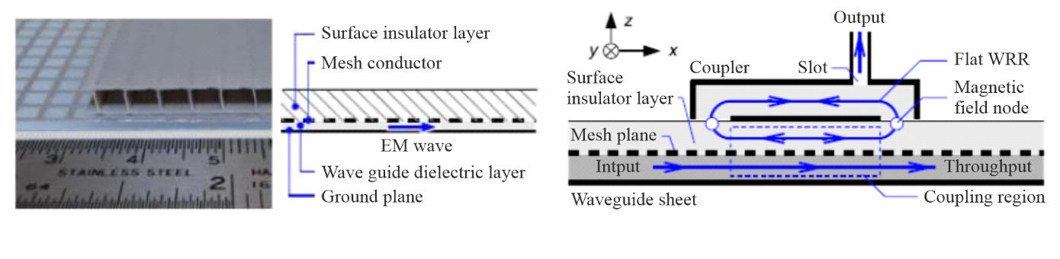
FIGURE 12
Block diagram of the microwave power supply system using a phased array which has seven RF amplifiers along each edge [32]
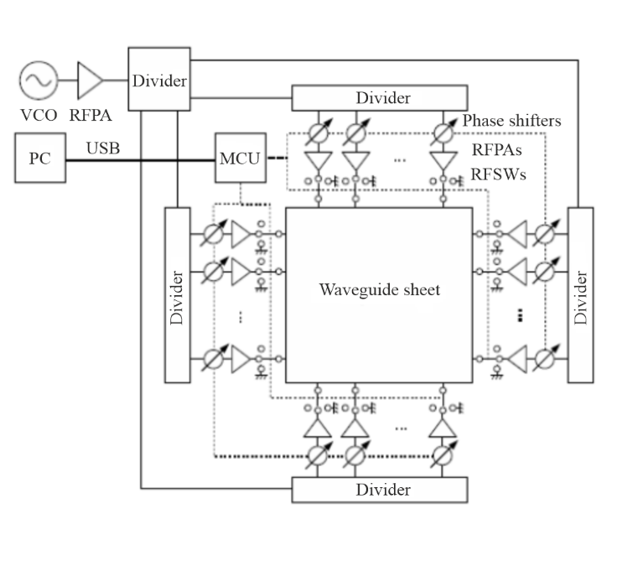
Microwaves are used in the 2DWPT system and the microwave diffuses in accordance with Maxwell’s equations even if the dimension decreases from 3D to 2D. To suppress unexpected radiation, a phased array can be applied to the 2DWPT system, which is equivalent to a 3DWPT system [32]. Figure 12 presents a proposed experimental 2DWPT system using a phased array at the University of Tokyo. Results of the experiment indicated that the variation of the efficiency at a receiving point on the sheet using the phased array is suppressed within 2 dB, wherein the variation was more than 10 dB without the phased array system.
The 2DWPT system has been standardized in ARIB (Association of Radio Industries and Business) as ARIB STD-T113 [29]. Frequency is 2.498 GHz ± 1 MHz and its power is below 30 W.

2.4 MPT in a pipe

2.4.1 Situation in Japan
In the 1990s in Japan, a micro robot moving in a pipe and powered by MPT in a pipe was developed. The concept is shown in Fig. 13(a). The MPT in a pipe system was developed at 14 GHz microwaves, as shown in Fig. 13(b) [38], propagating down a 15 mm diameter circular pipe, as a circular waveguide, in the TE₁₁ mode (Fig. 13(b)) with a transmission loss estimated to be < 1 dB/m. The rectenna, which was composed of a monopole antenna and a rectifying circuit, received the microwave power and fed the rectified DC power to the robot’s inertial drive system composed of a piezoelectric bimorph cell to drive the microrobot. The microrobot received 50 mW of microwave power and was able to move at a rate of 1 mm/s in the pipe when 1 W of microwave power was transmitted through the pipe.
FIGURE 13
(a) The concept of a robot in a pipe powered by MPT | (b) Conventional method of power conversion from a circular waveguide to a coaxial cable [38]
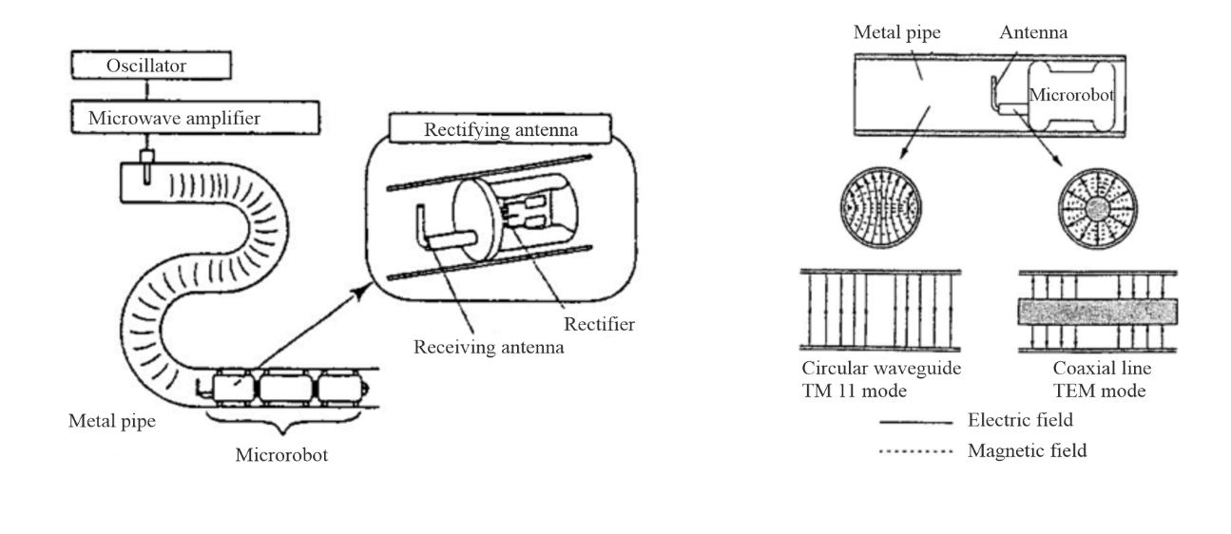
In the 1990s, an MPT system was proposed in Japan for powering an observation robot in a gas pipe [34] [35]. The diameter of the gas pipe was approximately 155 mm, which was suitable for propagation of microwaves operating at a frequency of 2.45 GHz. The problems associated with this particular MPT application were (1) an unknown propagation loss in rusty gas pipes, and (2) the complex branching of the gas pipe network. The propagation loss was estimated by experiments and theory and was on the order of −0.1 to −1.0 dB/m. It was concluded that the loss was sufficiently low to propagate microwave power in the gas pipe.
The complexity of the pipe branch network posed a bigger problem. Theoretically, radio waves cannot propagate to all branches of the waveguide, and some branches would not be serviced with radio waves. Experimental results supported the theory, which indicated that the proposed MPT in a pipe system had limited application.
A new radio wave hose for a WPT application is proposed and developed in 2015 in Japan [36] [37]. The radio wave hose is plated and processed into a resin hose with a conductive coating. They constructed an experimental system for WPT using the radio wave hose and confirmed the possibility of WPT of a 100-mW class on a 5.8 GHz band. The radio wave hose will be applied for harnessless car as shown in Fig. 14.
FIGURE 14
Concept of a harnessless car with radio wave hose of the WPT in pipe [36]
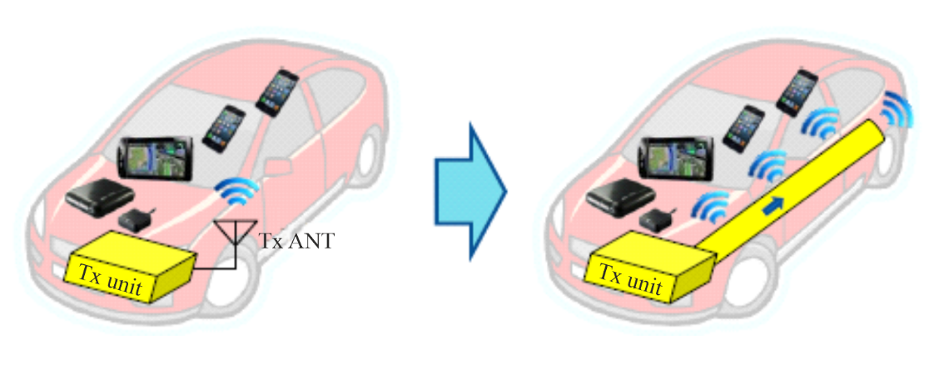

2.5 Microwave buildings

2.5.1 Situation in Japan
A Japanese building company jointly proposed with Kyoto University a wireless building using microwave power technology [39]. The proposed power system is shown in Fig. 15. This system wirelessly supplied electric power using a deck plate consisting of extra cover boards that acted as microwave transmission waveguides. A frequency of 2.45 GHz was selected on the basis of size limitations of the conventional deck plate and a magnetron was used as the microwave transmitter to reduce cost. The flow of microwave power could be controlled by variable power dividers that supplied microwave power only to users requiring it and blocked flow to places where there were no users. Rectennas as DC converters and as DC power sources were placed under the floor. Adjusting the position of the rectenna was quite easy because microwaves were present practically everywhere under the floor. Total efficiency from electricity to DC via microwave transfer was assumed to be 50%. Although the day by day running costs of electricity for the microwave building system is approximately twice that of a conventionally wired home, the initial cost of the building is reduced because of reduced construction costs. Therefore, it was estimated that the overall life cycle cost of the building can be reduced by using the microwave building system.
FIGURE 15
Wireless building using microwave power transmission [40]
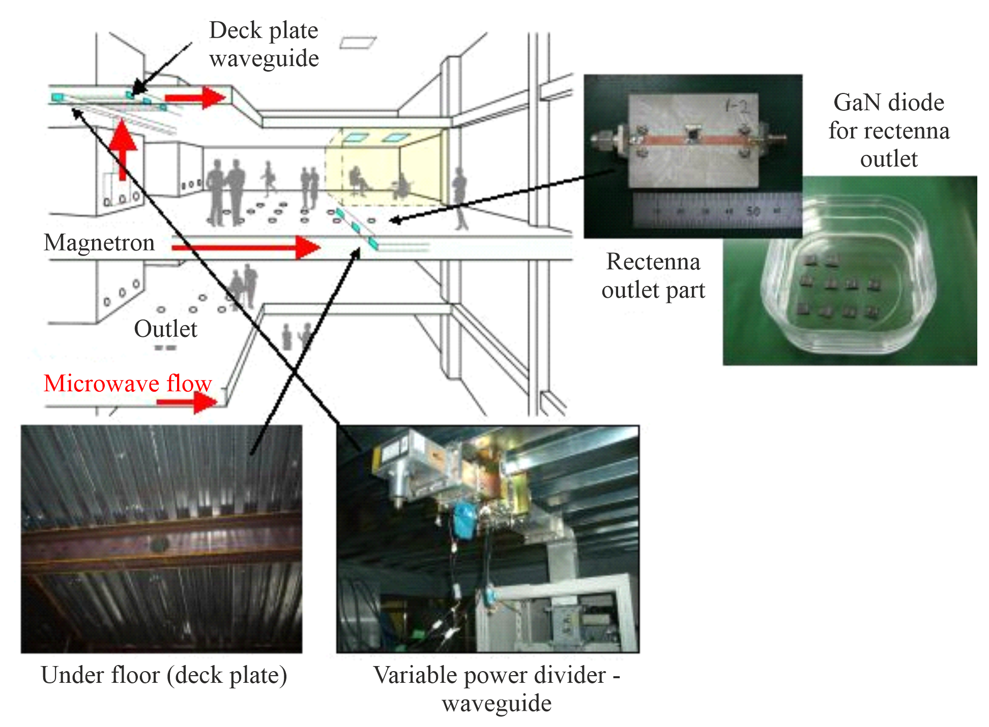
In the initial phase, the wireless system was considered for office buildings where DC-driven computers and other OA instruments are mainly used. It is estimated that one DC converter requires < 50 W, and > 3 kW of microwave power is provided to a single room, indicating that the system provides sufficient power to run a number of typical electrical devices per room. The microwave traveling through the waveguide in this application serves as a UPS system.

2.6 WPT to moving/flying target

2.6.1 Situation in Canada
The WPT via radio frequency beam is suitable for a WPT to a moving/flying target. A Canadian group of the Communication Research Centre (CRC) successfully conducted a fuel-free airplane flight experiment using MPT in 1987, which was called SHARP (Stationary High Altitude Relay Platform; Fig. 16) [SCH 88] [SHA 88]. They transmitted a 2.45 GHz, 10 kW microwave signal to a model airplane, having a total length of 2.9 m and a wingspan of 4.5 m, flying more than 150 m above ground level.
FIGURE 16
The Canadian SHARP flight experiment and the 1/8 model airplane in 1987 [SHA 88]


2.6.2 Situation in Japan
In Japan, a fuel-free airplane flight experiments with MPT phased arrays operating at 2.411 GHz for the MILAX project was succeeded in 1992 (Fig. 17) [MAT 93]. It was the first MPT experiment with the phased array beam forming in the world. The MPT experiments conducted during the SHARP and MILAX projects aimed at a stationary high altitude relay platform in the stratosphere.
FIGURE 17
The MILAX project airplane experiment showing the model airplane and the phased array used in Japan in 1992

In the early 21st century, the MPT to micro aerial vehicle (MAV) [45] and Mars observation airplane [42] [43] projects, which were MPT systems directed towards small airplanes, were proposed and developed in Japan (Fig. 18). The MPT to the MAV was proposed by the University of Tokyo. Researchers transmitted 5.8 GHz microwave power to a flying MAV from which a pilot signal of 2.45 GHz was transmitted as a signal for target detection. Rectennas were installed on the body of the MAV. Initially, five horn antennas were used as a phased array. The diameter of the phased array was 330 mm and its element spacing was 2λ. Microwave power from the horn antennas was 4 W each.
For the base system, a phased array using eight microstrip antennas whose element spacing was 1.36λ was adopted. Microwave power from the microstrip antennas was 8 W each.
FIGURE 18
First concept of a MPT to micro aerial vehicle [45]
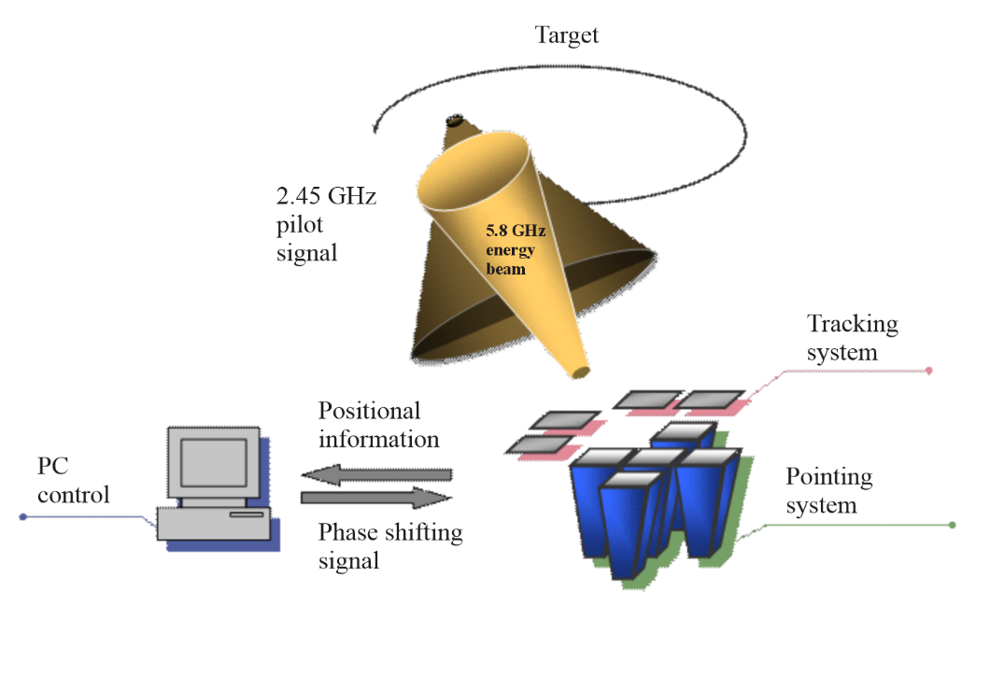
FIGURE 19
A description of the MPT to Mars observation airplane [42] [43]
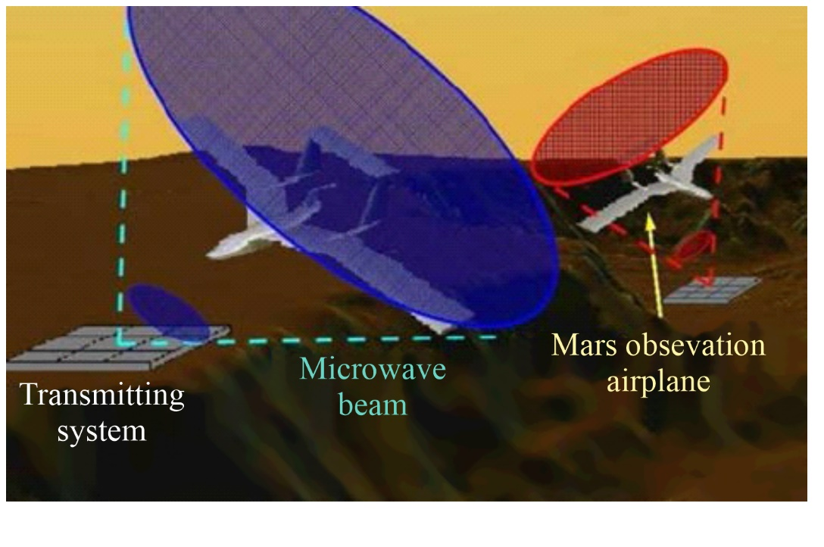
The Mars observation microwave airplane system was proposed by Kyoto University and Kyushu Institute of Technology, Japan. Wide-ranging, continuous observation of the surface of Mars is of interest for understanding the physical properties of that planet. The Mars surface has been mainly observed by a rover, which can neither move rapidly nor observe bumpy areas. Therefore, small airplane observation is receiving attention as an alternative to the rover. In order to realize stable flight in the greatly reduced atmosphere of Mars, the weight of the airplane must be reduced.
MPT is an excellent possible technology to reduce or even eliminate the fuel requirements of an airplane. A description of a possible future Mars observation airplane is shown in Fig. 19 [42] [43]. An experimental setup is shown in Fig. 20. The MPT system using a phased array antenna composed of “power-variable phase-controlled magnetrons (PVPCMs)” was used in the experiment. The PVPCM is a derivative technology from the phase-controlled magnetron (PCM) developed at Kyoto University. A PVPCM can transmit 2.45 GHz, 61 dBm microwave power and can control the beam direction using phase control [42]. The transmitter traces the airplane’s location with a camera using an image processing application [43].
FIGURE 20
(a) Schematic diagram and photograph of the magnetron-based phased array | (b) Alignment of the six rectennas on the airplane body for ground experiments [43]
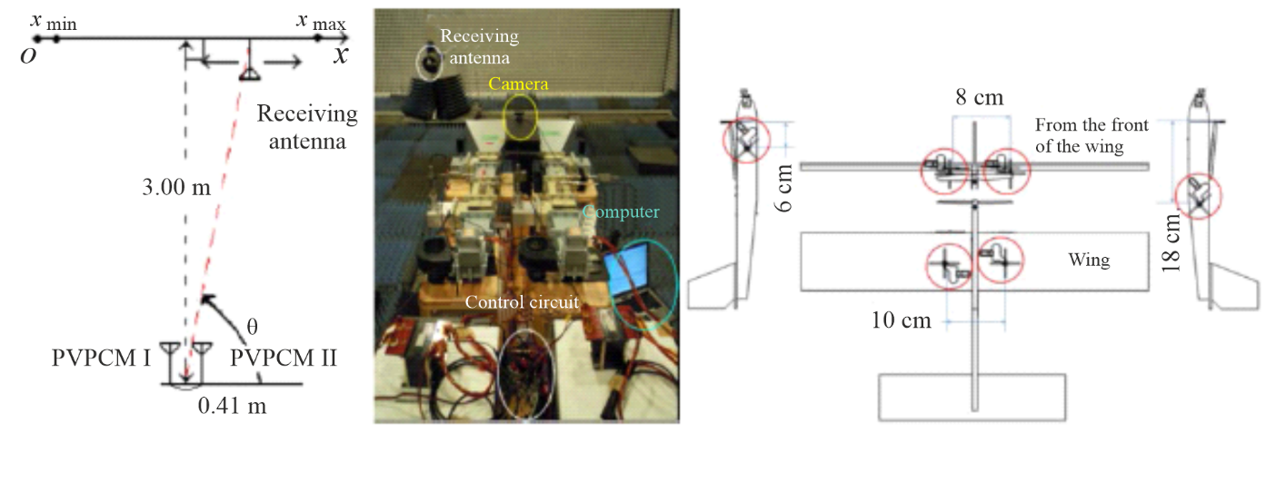
MPT to a moving rover is another potential application, as shown in Fig. 21. From 2004 in Japan, MPT using active integrated antenna (AIA) technology was developed [46]. The target of this project was (1) development of very light power-to-weight-ratio microwave power transmitter using AIA technology (with a target below 50 g/W), (2) advancement of the power management of the rectified microwave power at the rectenna, receiver, and rectifier of the microwave power, especially against changes in the connected load, and (3) fundamental experiments of the coexistence of 100 W microwaves and 10 mW wireless communication waves. For the target of the project, MPT to a moving rover was chosen. The microwave transmitting sub-system was composed of a 32 element AIA with a linear polarized rectangular microstrip antenna array and 4 W output 3-stage GaAs high power amplifiers on a bent dielectric base for an expanded cooling area, whose total power is 120 W at 5.8 GHz. The system uses no phase shifter. A photograph of the MPT experiment in an anechoic chamber is shown in Fig. 22. The rover moved only by means of the microwave power provided by MPT.
Ritsumeikan University’s group in Japan carried out a WPT demonstration to flying drone in 2015 (Fig. 23) [44]. They used 430 MHz frequency band and approximately 30 W radio wave power to supply power to the drone. A weight of the drone model was 25 g and it required 2 W DC to fly. Presently, the drone could fly above a transmitting antenna at a distance of approximately 10 cm. The system is under revision.
US group in University of Colorado and ISAE, France, are developing a WPT system to flying micro-unmanned aerial vehicle (UAV) in 2015 (Fig. 24) [41].
FIGURE 21
Experimental system of MPT for the moving rover [46]
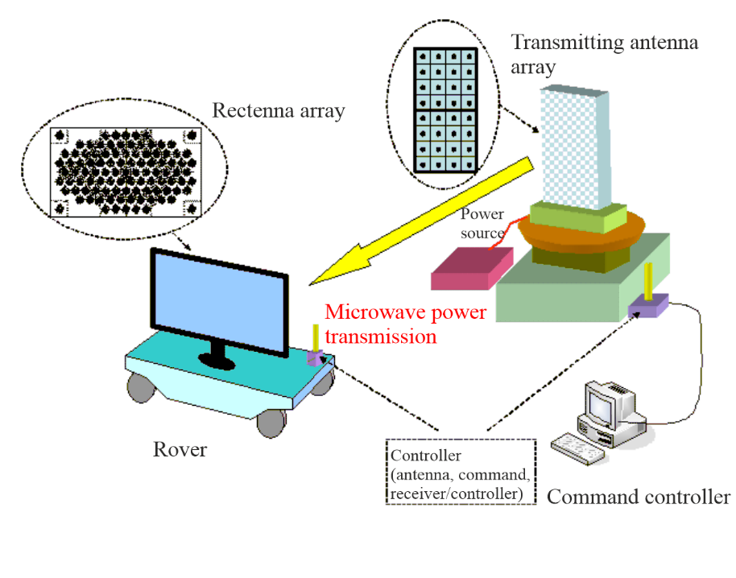
FIGURE 22
Photograph of the MPT rover experiment [46]
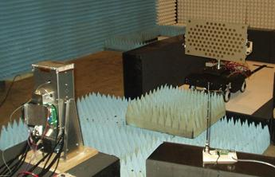
FIGURE 23
Experimental system of WPT to flying drone [44] and its demonstration in Japan (March 2016, in Japan)
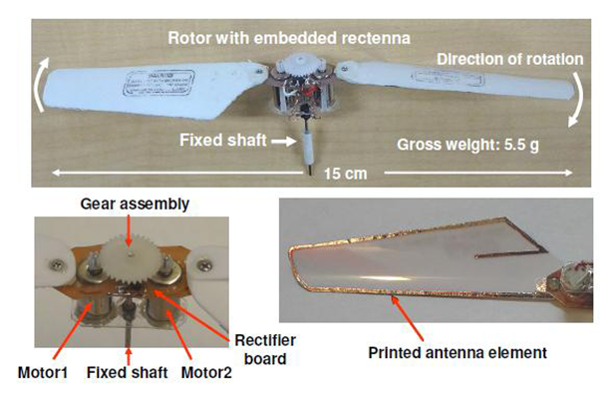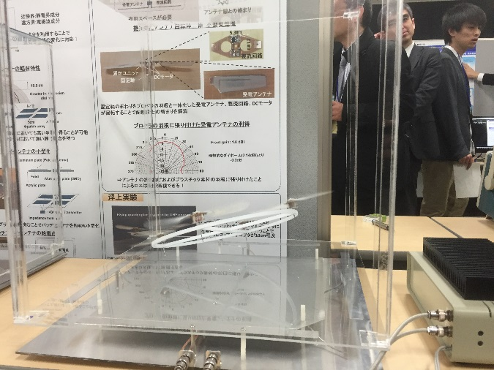
FIGURE 24
Experimental system of WPT to Micro-UAV
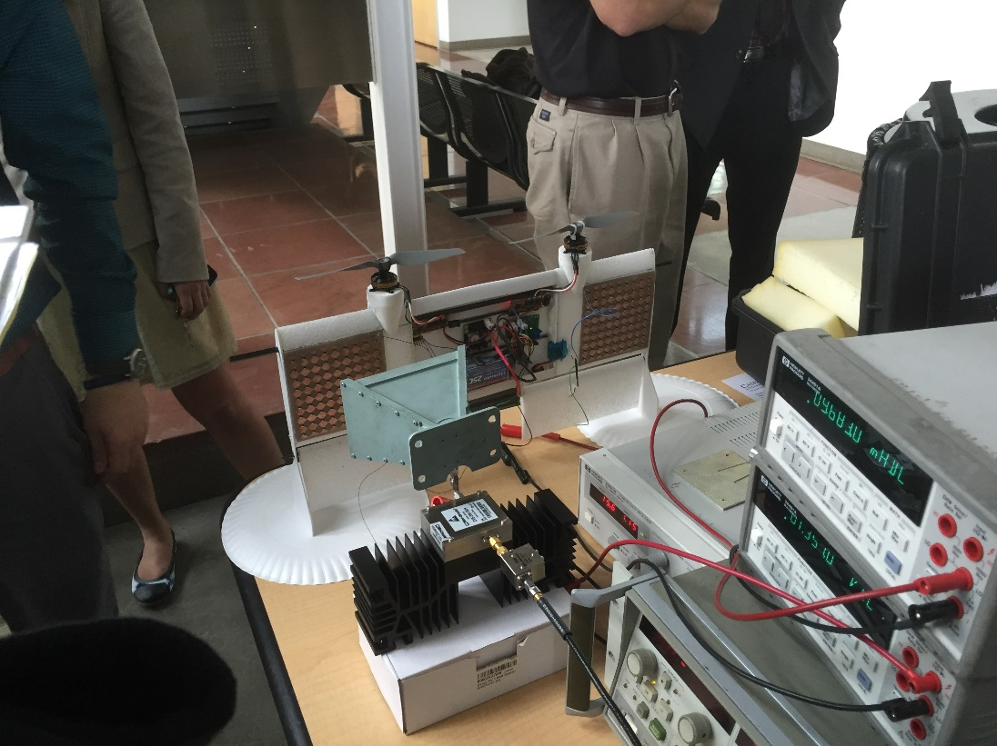

2.7 Point-to-point WPT
It is easy to imagine a point-to-point WPT via radio waves in over km distance instead of a wired power transfer (Fig. 25). In the 1960s, point-to-point WPT operating in the km range via microwaves was highly expected for WPT application. Brown and Dickinson carried out MPT experiments at JPL in 1975 (Fig. 26) [47]. However, the size of the transmitting and receiving antennas was decided by theory and they were too large to realize a commercial point-to-point MPT application with reasonable cost as an alternative to wired power transfer. Point-to-point MPT systems were revised and further experiments were proposed in the 1990s (Fig. 27) [48] [49]. They have developed a rectenna array. Under certain conditions, such as providing electrical power to an isolated mountain top or an island where the cost of a wired power supply is too expensive and/or electric power needs are sporadic, the point-to-point MPT system has a distinct advantage over wired power transfer.
FIGURE 25
Image of point-to-point WPT
FIGURE 26
1 Mile point-to-point MPT experiment with 26 m parabolic antenna and 450 kW-2.388 GHz Klystron as a transmitter and 3.4 × 7.2 m Rectenna array as a receiver
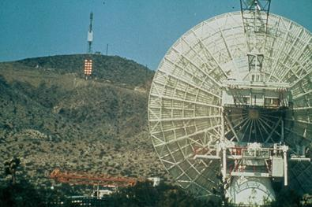
FIGURE 27
50 m point-to-point MPT experiment with 3 kW-2.45 GHz magnetron in Japan (1995)
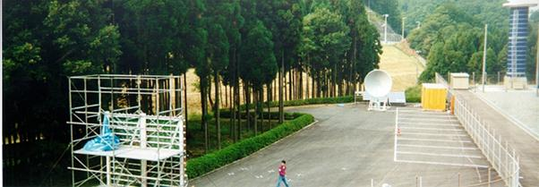

2.7.1 Situation in Japan
On February 2015, two long distance WPT experiments were carried out in Japan. One is 55 m distance WPT experiment with 5.8 GHz, 1.8 kW microwave (Fig. 28). The microwave was transmitted from 2.5 cm thickness phased array with GaN MMIC amplifiers and 5-bit MMIC phase shifters. Efficiency of the GaN high power amplifier is approximately 70% at 7 W, 5.8 GHz. The thin phased array and GaN amplifiers were developed by Mitsubishi Electric Corp. and a rectenna was developed by IHI Aerospace. In this experiment, a recto directive target detecting and rotating electromagnetic vector (REV) method was adopted to detect a position of a rectenna and to control a microwave beam. The target detecting and beam forming system was developed by JAXA and Mitsubishi Electric Corp. The other long distance WPT was carried out at 500 m distance with 2.45 GHz, 10 kW from magnetron phased array by Mitsubishi Heavy Industries (Fig. 29). Both experiments were conducted by Japan Space Systems (JSS) and supported by the Ministry of Economy, Trade and Industry (METI). These were field experiments as results of six-year R&D project for a Solar Power Satellite. The R&D project by METI continues until 2017 and more.
FIGURE 28
55 m point-to-point MPT experiment with 1.8 kW-5.8 GHz phased array with GaN MMIC amplifiers in Japan by JSS and METI (2015)
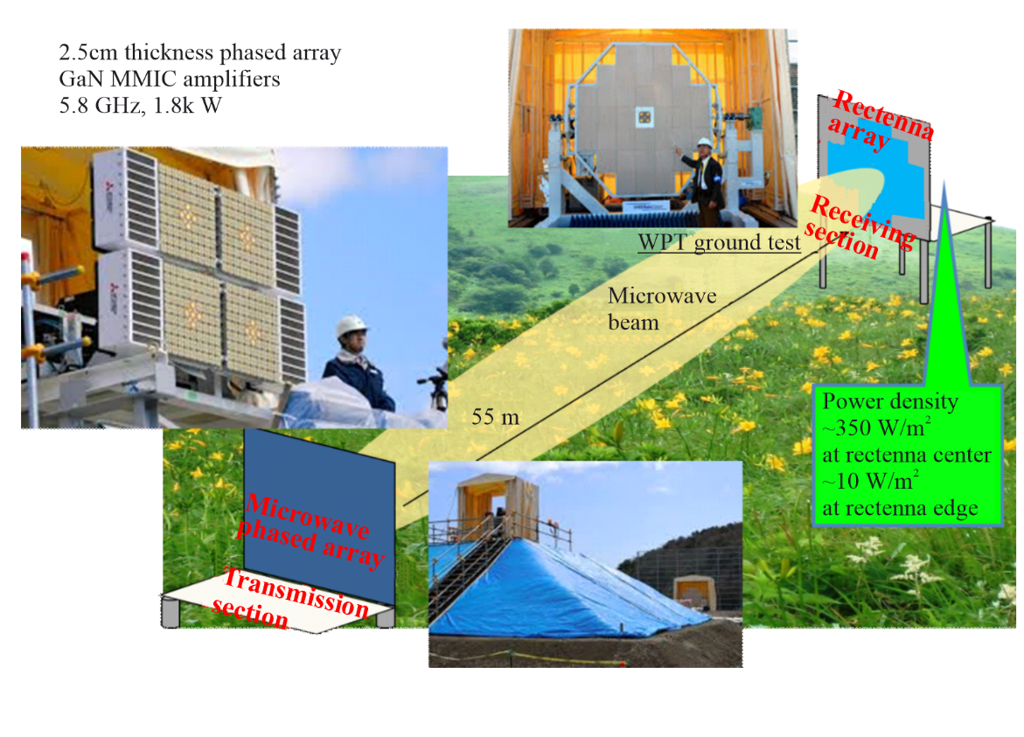
FIGURE 29
500 m point-to-point MPT experiment with 10 kW-2.45 GHz magnetron phased array in Japan by JSS and METI (2015)
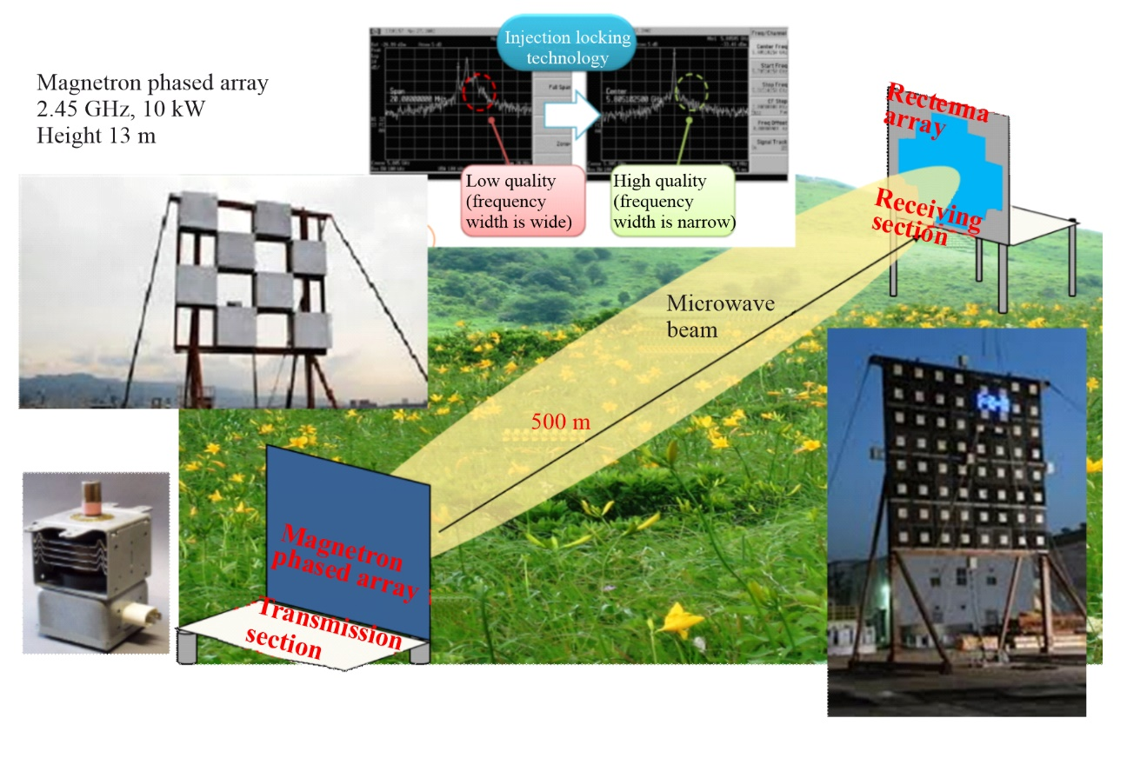
The size of the antenna and the expense of an MPT system depend on the MPT’s intended range. In Japan, a short-distance point-to-point MPT system has been proposed by NTT Corp. and Kyoto University, which is called MPT for fixed wireless access (FWA). Figure 30 shows an image of the proposed system [50]. The outdoor device communicates with the Internet by the FWA or an optical fibre. The inside device and the outside device wirelessly communicate with each other. The inside device transmits power to the outside device by microwave. The outside device can operate without a battery. For the system, it is preferred that both information and power are carried by the same microwave carrier to reduce the size of the system. At first, a frequency of 24 GHz was selected and a MMIC rectenna with a class-F load output filter was developed, as shown in Fig. 4.5.18 of [51].
FIGURE 30
Concept of a microwave-driven FWA system [50]
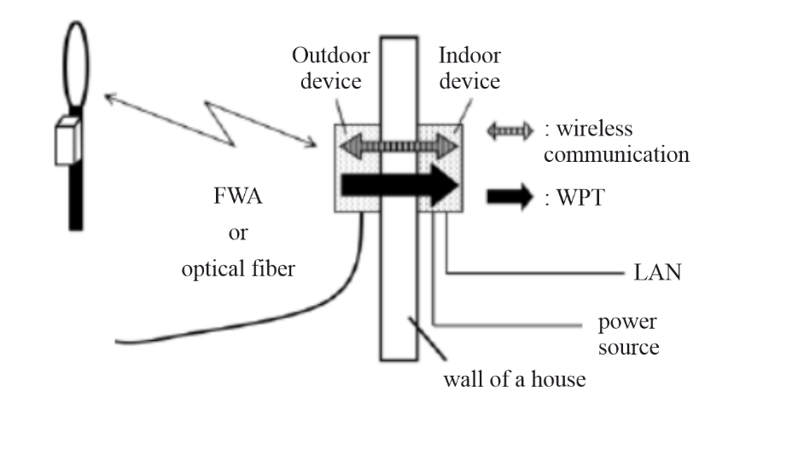
In 2015, Kyoto University and MHI group developed a wireless charging system for small electric cart with 2.45 GHz, 100 W microwave (Fig. 31). This is one of point-to-point WPT at short distance. In 2016, the WPT system are investigated for daily use in Kyoto University.
FIGURE 31
Wireless charging system for small electric cart
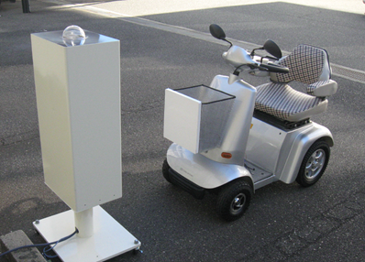

2.8 Wireless charging for electric vehicles
Highly efficient MPT can be applied not only through closed waveguides, but also over short distances with smaller antennas. Photographs of the wireless charging of an EV using MPT are shown in Fig. 32. It is convenient to apply MPT for wireless charging both for parked EVs and for EVs in motion because the transmitting and receiving antennas are not coupled. The impedance of the antennas is not changed by a change in the position of the EV nor is the efficiency of MPT changed. Problems of safety and interference by microwaves are diminished for both MPT in a closed waveguide and over short distances because there is almost no diffusion of unexpected microwaves. In short-distance power transfer systems, the magnitude of wireless power can be also increased to the kW range because the transmission does not interact with humans or other living things between the transmitting and the receiving antennas.
FIGURE 32
Images of wireless charging of EVs (a) for parked EVs, and (b) for EVs in motion
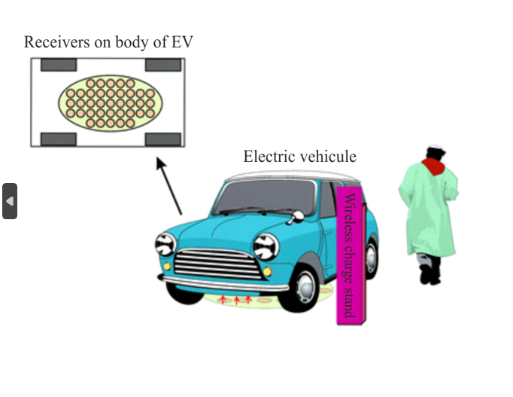 | 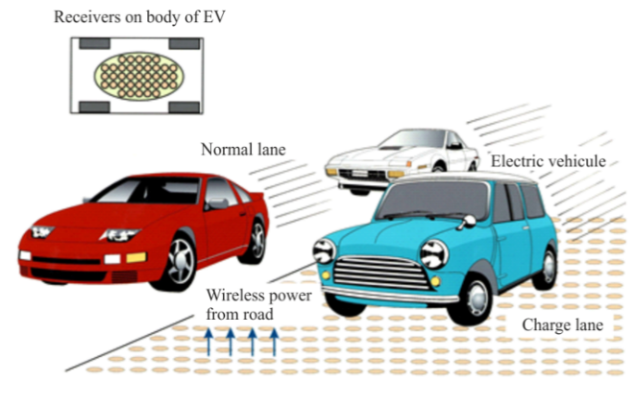
(a) | (b)

2.8.1 Situation in Japan
A MPT system for EVs was proposed and implemented (Fig. 33) [52]. From 2003 to 2008, the collaborative research between Japanese car company and university was carried out to develop a MPT system between the road and the body of an EV using a microwave frequency of 2.45 GHz (Fig. 34) [53] [54]. Magnetrons and slot antennas were used to reduce the system cost. The distance between the transmitting and the receiving antennas was approximately 12.5 cm, a distance of 1λ at the 2.45 GHz frequency. The battery on the electric vehicle can be effectively charged using microwave transmissions having a theoretical beam efficiency of at least 83.7% and an experimental beam efficiency of at least 76.0% [54]. This efficiency is sufficiently high to realize the transmission of wireless power using microwaves. For this application, a new GaN Schottky diode was utilized to increase the rectified power and to reduce the EV charging time.
In 2000, a scaled MPT model for running an EV was developed [52]. To reduce power loss, the position of the model EV was detected by positioning sensors and microwave power was transmitted only to the position of the model EV.
FIGURE 33
Short-distance wireless microwave charging road system for EVs [52]
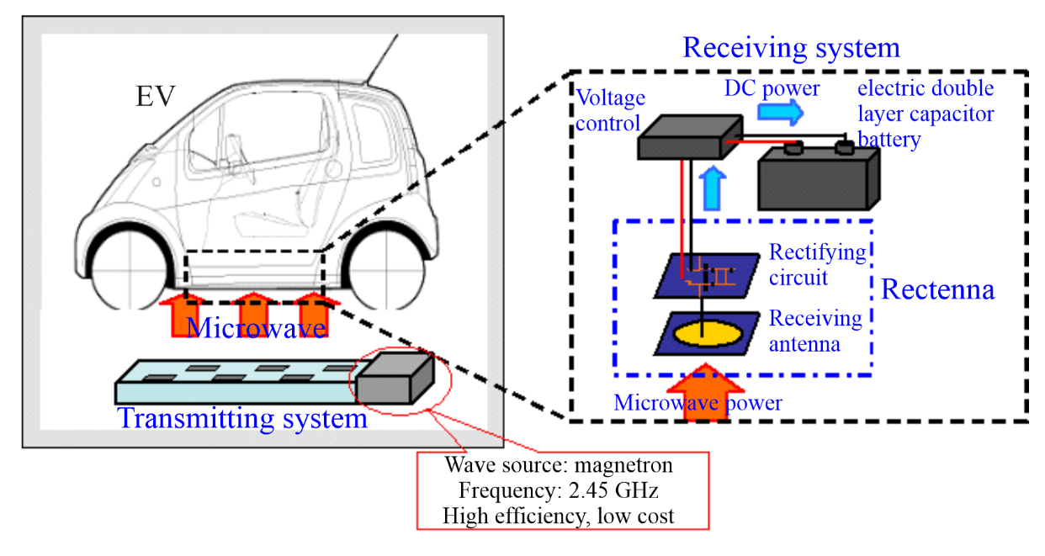
FIGURE 34
Wireless charging experiment with microwaves by Kyoto University, (a) the System, (b) Microwave transmitting antenna on the road, (c) Rectenna array on the body of the EV [54]
 | 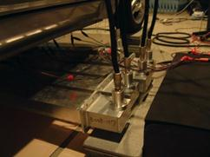 | 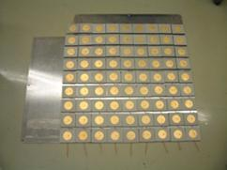
(a) | (b) | (c)
From 2006 to 2008, Japanese company conducted a MPT R&D project for EVs with Japanese three car company [56]. To reduce the power loss, they used (1) 6.6 kV directly to drive the 2.45 GHz magnetrons as microwave transmitters, (2) a blocking wall around which microwaves pass between the transmitting antennas and receivers, and (3) a heat recycling system. The total efficiency, including the heat recycling, was approximately 38% with an output power of 1 kW at a distance of 12.5 cm. The prototype released in 2009 is shown in Fig. 35.
In 2012, a Japanese branch of Swedish automotive company and Japanese company began to develop a new MPT system for an electric truck. The former system led to mutual coupling problems between the transmitting and receiving antennas because the MPT distance was too short; therefore, the new MPT system was changed from a road-to-body to a top-to-roof configuration (Fig. 36) [55] [57] to take advantage of the MPT as long distance WPT. The distance between the transmitting antennas and the receiving antennas on the roof-top of the EV was 2-6 m, depending upon the type of the EV used. To keep a high efficiency over the varying distance, a phased array system that can create a flat beam on the receiving antennas was proposed.
On 6th July 2012, they released a 10 kW rectenna array with an efficiency of 84% operating at a frequency of 2.45 GHz for the mid-distance WPT system (Fig. 37) [9]. The received microwave power density was over 3.2 kW/m² at a distance of approximately 4 m from the transmitter.
FIGURE 35
Wireless charging experiment with microwaves by Mitsubishi Heavy Industries’ group in 2009 [56]

FIGURE 36
Proposed mid-distance wireless charging for EV and the FDTD simulation of the microwave beam [55]
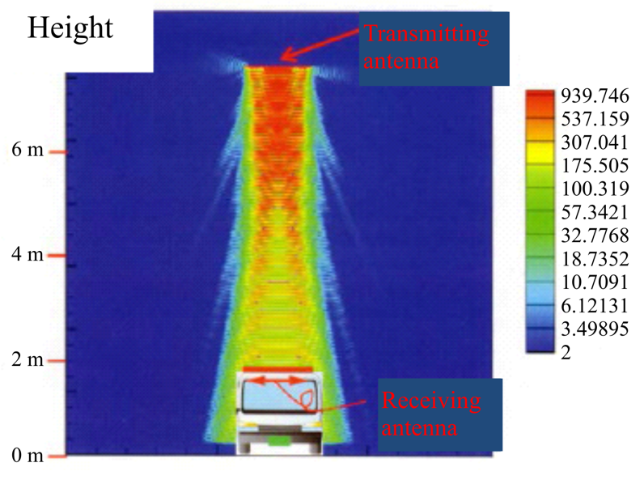
FIGURE 37
Photograph of the 10 kW Rectenna operating at 2.45 GHz for wireless charging of EVs [9]

2.9 Space based solar power via satellite
General concept
Space based solar power (SBSP) is an application of WPT via radio frequency beam, where solar power generating satellites are utilised for energy production. Large solar power satellites (SPS) would harvest solar energy in space and beam this energy to Earth into land-based receivers. It can provide both baseload and dispatchable power at GigaWatt scale, essential for electricity grid balancing and stability.
Recent independent studies commissioned by the UK Government [60], and the European Space Agency [59] confirm that the technology is both technically and economically viable, though with a substantial engineering development programme required to mature the technology towards an operational system.
The Total Addressable Market (TAM) represents the total share of the global energy market that can be addressed by SBSP and is conservatively around 20% of the global electricity demand. This is estimated at around 10 000 TWh, or 1 200 GW of capacity by mid-century.
SPS designs will typically deliver net power at 1-2 GW, and thus the total number of operational systems globally could be between 600 and 1 200 SPS in a range of different orbits, with Geosynchronous orbits being a favoured choice.
A general concept diagram for SPS is shown in Fig. 38, and work undertaken earlier in 2007 is addressed in the Report of the URSI Inter-Commission Working Group on Solar Power Satellite (SPS) [64].
FIGURE 38
Image of solar power satellite
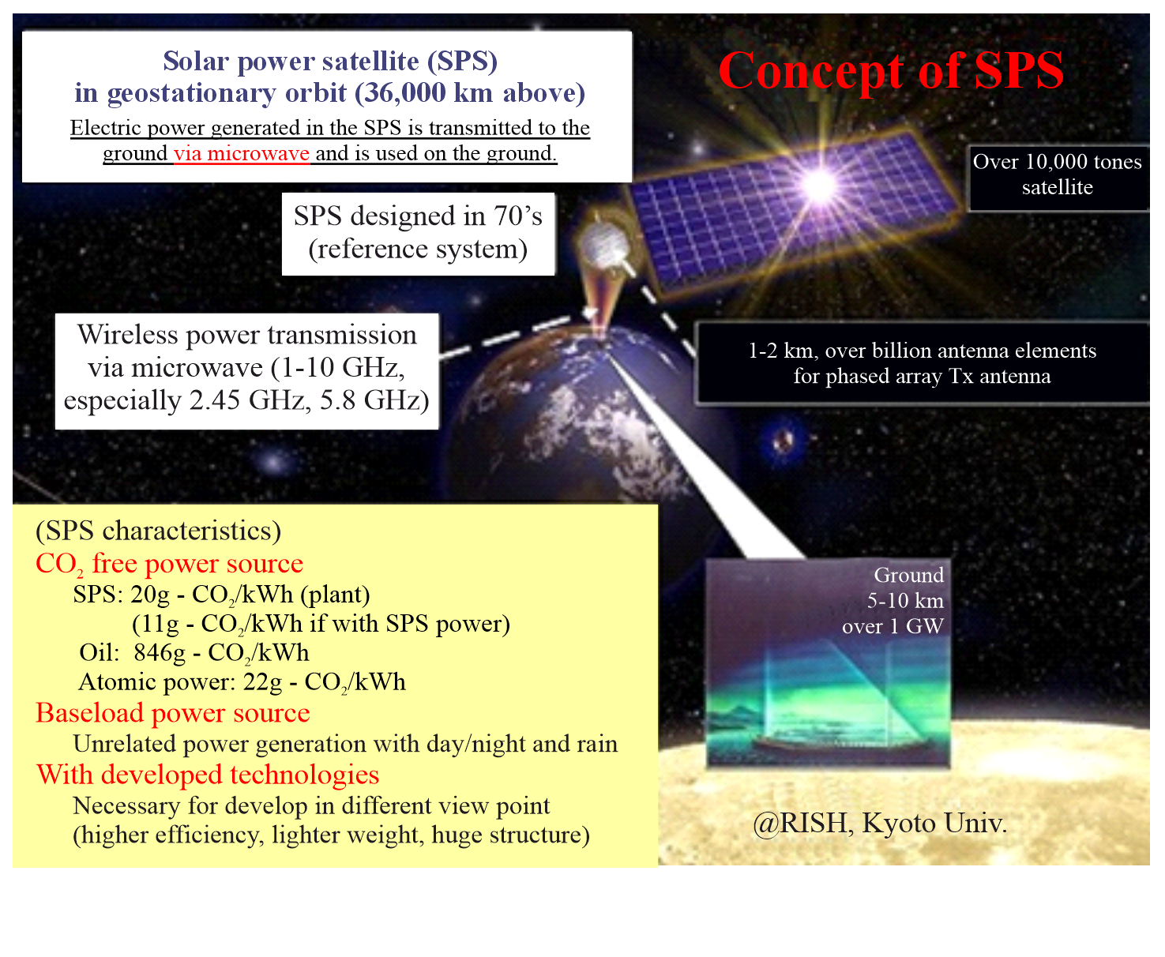
As is illustrated in Fig. 38, the SPS would utilise a relatively large solar power collection array in geostationary orbit. The generated power is transmitted to the ground via microwave frequency bands. The theoretically calculated large antenna size, required to achieve high beam efficiency from a far distant target like the SPS, is approximately 2 km size antennas at 5.8 GHz. As microwave energy is not absorbed by air, cloud, and rain it is therefore possible to obtain from the SPS using MPT technology, approximately ten times the solar power, when compared to terrestrial solar sources being much more independent of weather effects making it a stable and CO₂-free energy source.
In the MPT system of the SPS, a large phased array with a high efficiency must be employed. The phased array is necessary for steering a power beam to a small rectenna target on the ground within a highly precise and accurate tolerance although, the transmitting antenna of the SPS will always have some movement and fluctuation. The power beam should be generated, and transmitted, with the minimal amount of energy loss so as a maximise the economic viability of the systems.

2.9.1 Developing system design features
Several SPS architectures have been proposed [63] [62] [58] [61], with the MR-SPS and CASSIOPeiA architectures shown in Fig. 39. Figure 40 provides more information on the different SBSP subsystems with reference to the CASSIOPeiA architecture. There are several commonalities between these architectures in relation to the system design, which are highlighted below.
FIGURE 39
Different Solar Power Satellite architectures: (a) MR-SPS [61]; (b) CASSIOPeiA [58]
(a) 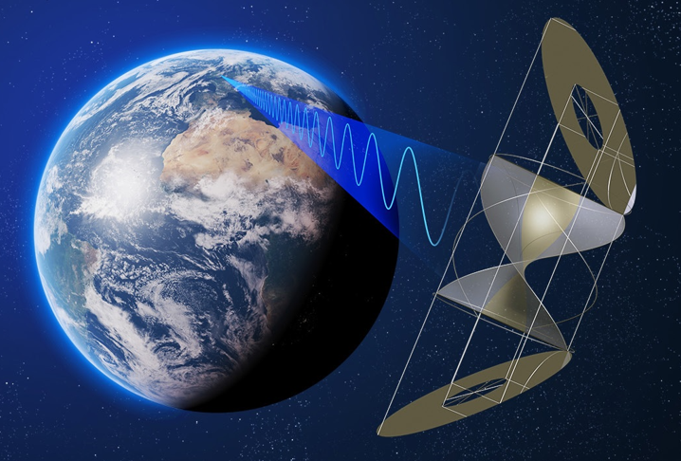 (b)
FIGURE 40
Description of the different subsystems of SBSP, with the CASSIOPeiA architecture as the reference SPS system
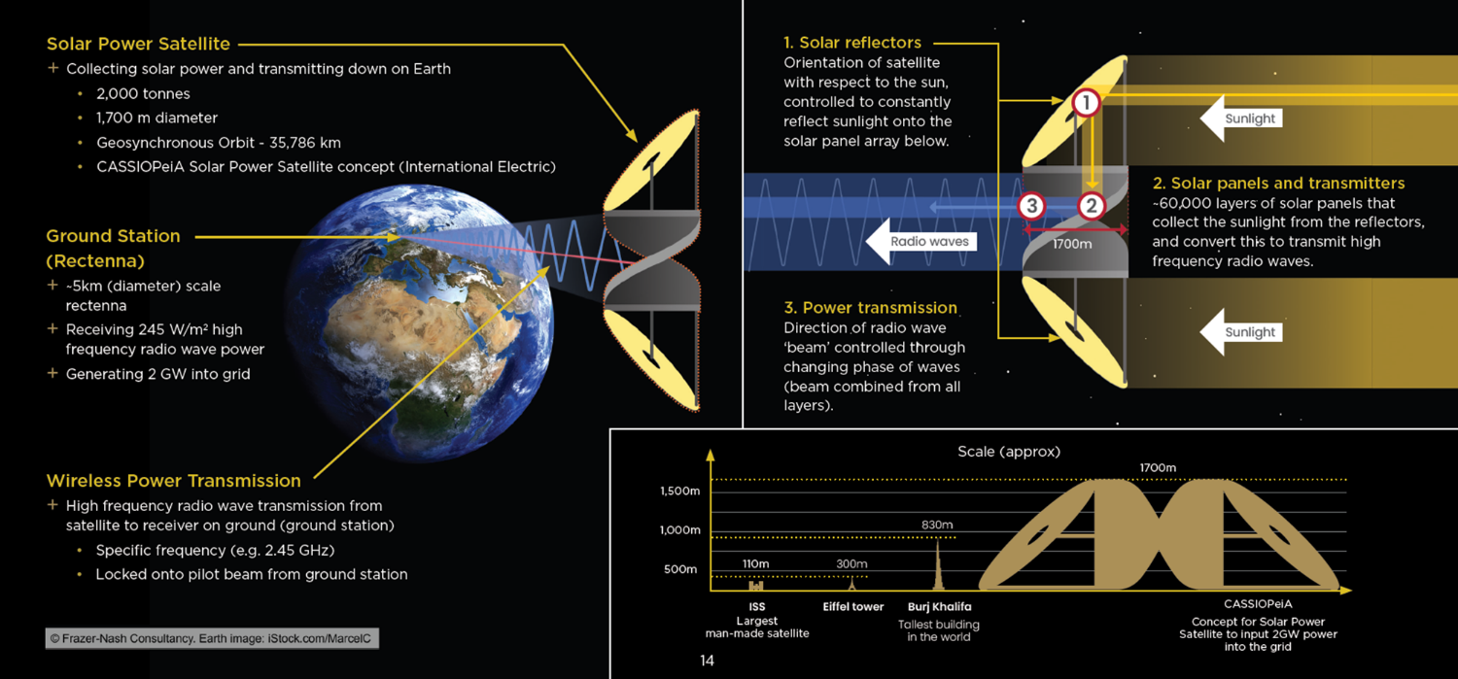
Achieving continuous power delivery
The most important and valuable requirement from an energy system perspective is the ability for SBSP to provide continuous power day and night, through all weather, and all year round. To achieve this, the solar collector needs to point at the sun continuously, and the RF transmitter needs to point at the Earth-based receiver continuously through the orbit, which requires a rotational joint between these two functions. Not all SPS designs incorporate the rotational joint. The Tethered SPS (Fig. 39) does not have such a joint and is an example of an SPS which does not provide 24/7 power, as the solar panels are edge-on to the solar illumination twice per day. The other architectures from Fig. 39 do provide 24/7 continuous power by incorporating the joint in different ways: MR-SPS rotates the large solar arrays via electro-mechanical motors; SPS-Alpha tracks the sun via motorised heliostats; CASSIOPeiA is ‘sun-pointing’ and steers the RF beam via a phased array system which can rotate through 360°.
Power beaming frequency
The power is beamed at radio frequencies to take advantage of the atmospheric window between 1-10 GHz, allowing all weather operation. Within this band, the loss due to atmosphere and weather is very small, a maximum of 2% loss. This is essential for both the economics and its utility as a baseload energy system to provide resilience to energy networks. Within this spectrum band, most SPS designs assume the use of ISM bands at either 2.45 GHz or 5.8 GHz.
System scale and orbits
A GigaWatt scale SPS, in a geosynchronous orbit (35 786 km above Earth), is a very large structure. This is typically up to two kilometres in transmitting aperture diameter, and several kilometres long in overall extent. This size is dictated by the diffraction physics of electromagnetic radiation propagation, and a large transmitting aperture is necessary to form the very tight beam of energy and an acceptable size of Earth-based receiver. Smaller systems (hundreds of metres) are possible in other orbits, such as sun-synchronous or highly elliptical orbits. An SPS in a Geosynchronous orbit can provide continuous power to a rectenna on the ground. This power can be switched rapidly to a different receiver within the field of regard of the SPS, providing great flexibility of power transmission within an energy system. SPS in orbits other than Geosynchronous require at least three or four satellites in a constellation to provide continuous power to one or more receiver locations on the ground.
Hyper-modular architecture and in-space assembly
Central to the design of the SPS is a hyper-modular architecture, with hundreds of thousands of identical modules. With distributed functionality and no single points of failure, this modularity gives both resilience and lower unit production cost of the space component. It also allows for rapid scale up of production systems, with the potential for tens of gigawatts of capacity to be built, assembled and commissioned each year.
The mass of each SPS is several thousands of tonnes, requiring each system to be launched via a number of rocket launches. The modules would be deployed or assembled in orbit. Assembly may include ‘deployment’ of folded structures and sub-assemblies, as well as ‘assembly’ of these sub-assemblies to form the final SPS.
Ground Energy Receiver
The Earth-based Ground Energy Receiver (GER) contains a rectenna, which converts the incoming RF energy into DC electricity. It is a sparse net-like structure suspended on poles, and occupying a contiguous area of around 10 to 50 km² depending on the beaming frequency (2.45 GHz or 5.8 GHz). The higher frequency provides lower power but with a much smaller rectenna.
The rectenna can be sited offshore, potentially as a floating structure, or onshore where the land area permits, and with the ability to provide for dual use of the land underneath the rectenna. The area occupied is less than 10% of the area occupied by an offshore wind farm, delivering the same energy output over the course of a year.
At any time, each SPS will be beaming power to one rectenna, where the rectenna converts the microwaves back to electricity, which is then fed onto the grid. A single SPS can beam to any rectenna within its field of view, depending on where the energy is required.
The maximum power density can be limited by design, so that at the edge of the receiver the microwave intensity is less than the regulation limit for public exposure at this frequency. A nationally managed physical safety and security zone would be required at the location of the receiving rectenna.
The shape of the GER depends on the latitude and (relative) longitude with respect to the satellite. For a Geosynchronous SPS, a rectenna sited near the equator is circular. For UK latitudes, it is 3.5 to 6.5 km E-W, and 7 to 13 km N-S. This is the beam footprint which coincides with the safety exclusion zone.
FIGURE 41
Artist impression of (a) offshore GER; (b) onshore GER with dual use of land
(a)  (b) 

2.9.2 Concept of operations
Figure 42 shows the concept of operations of an operational SBSP system, with a focus on the communications and power beams. The main power beam is emitted towards the rectenna at the power beam frequency within a very narrow bandwidth, expected to be within 10 Hz. In most concepts, a ‘pilot beam’ is present, to enable retrodirective steering of the phased array. This secured pilot beam is emitted from the relevant Earth-based receiver that the SPS needs to beam power to. The frequency of this pilot beam can be close to the power beam frequency or at a different frequency. In addition to these SBSP-specific radiofrequency beams, there are several command and control and monitoring signals associated with the SPS and its ancillary systems (e.g. attitude and orbital control, health monitoring, assembly machines). These signals are expected to follow existing space-ground telecommunication protocols.
FIGURE 42
Concept of operations of SBSP
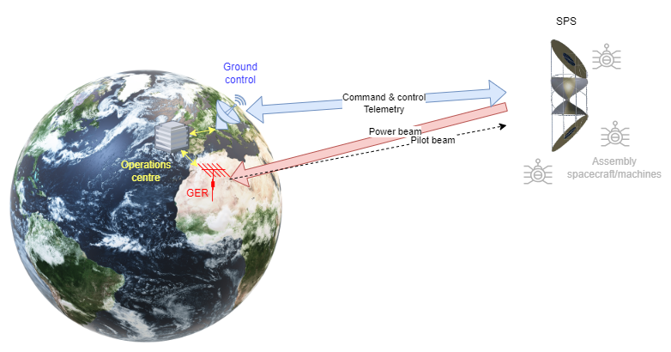

2.9.3 Core technology maturity
The core technologies include wireless power beaming; in-space robotic assembly; high capacity, low cost, fully reusable space transportation from Earth to Orbit; lightweight structures. Individually these technologies are at Technology Readiness Level 5-7 [60].

2.9.4 Situation globally
The International Academy of Astronautics (IAA) has established a permanent committee on Space Based Solar Power, and as of 2024 is in the process of setting up subcommittees to share information and conduct studies in a range of related disciplines.

2.9.5 Situation in the United Kingdom
In the United Kingdom, the Space Energy Initiative (SEI) was established in 2020 and brings together government, research and industry in the energy and space sectors to develop and deliver a coordinated programme of technology development and demonstration. SBSP is seen as an international venture, and whilst the SEI is initiated in the UK, it is international in its outlook. A senior level advisory board provides governance and oversight. Working Groups have been established across Technical, Environmental, Energy and Market, Industry and Supply Chain, International, Legal and Regulation, Communications, with a Core Team providing co-ordination across the Working Groups. As of 2024, there is strong cross-government support to advance research and development, given the strong potential and attractive economics of SBSP as a future energy generation and transmission technology which could help deliver Net Zero and energy security. In 2021, the UK Space Agency published its National Space Strategy which includes the development of SBSP.
Space Solar is a UK commercial entity with a mission to develop and commercialise SBSP in the UK. Space Solar’s programme is structured around a 12-year, four-phase development and industrialisation plan, summarised in Fig. 43 below. The company is working with many members of the SEI as well as broader international partners and intends to deliver a series of ‘proof of concept’ products which progressively increase in scale and capability to deliver data and understanding. This will inform and validate the engineering programme, addressing and retiring major technical risks, and ultimately demonstrating the ability to deliver SBSP on a commercial scale.
FIGURE 43
Space Solar roadmap for SBSP development and industrialisation
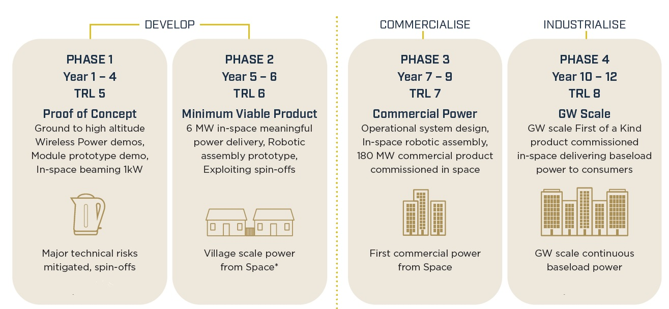
NOTE – Images by kind permission of Space Solar.

3 Technologies employed in WPT applications
In a WPT system via radio frequency beam, antennas are used to transmit and to receive radio waves. The transmitting and receiving antenna are not electromagnetically coupled. So the number of transmitters and receivers are free from circuit parameters of transmitters and receivers. Main theory of the WPT via radio frequency beam is based on Friis’ transmission formula. The radio wave which transmits wireless power does not need modulation like a wireless communication system.
In the narrow beam WPT and in the WPT in closed area, it is possible to suppress unexpected radiation in spacing with antenna technology. Phased array antenna, which can control beam direction and beam form with phase and amplitude controlled plural antennas, are sometimes used in the narrow beam WPT. The phased array antennas were developed for WPT and WPT field experiments were carried out [69].
The radio wave itself is an electric power. The only difference between the radio wave and the electricity is the frequency. MHz-GHz radio wave is used for the WPT via radio frequency beam, the wireless communications, and remote sensing. DC or 50/60 Hz (commercial power frequency) is used as the electricity. So, frequency conversion from the radio frequency to DC/commercial power frequency is only required in the WPT, including not only the WPT via radio frequency beam but also an inductive WPT and a resonance coupling WPT. Rectenna, antenna with rectifying circuit with diodes, is used as a receiver and rectifier in the WPT via radio frequency beam (Fig. 44). RF-DC conversion efficiency of developed rectenna was approximately 90% at 2.45 GHz [65] [9] and 80% at 5.8 GHz [67]. The rectenna can be applied for all WPT via radio frequency beam, for example, at UHF [68], X-band [66], K-band [70], and W-band [71].
FIGURE 44
Rectenna, rectifying antenna
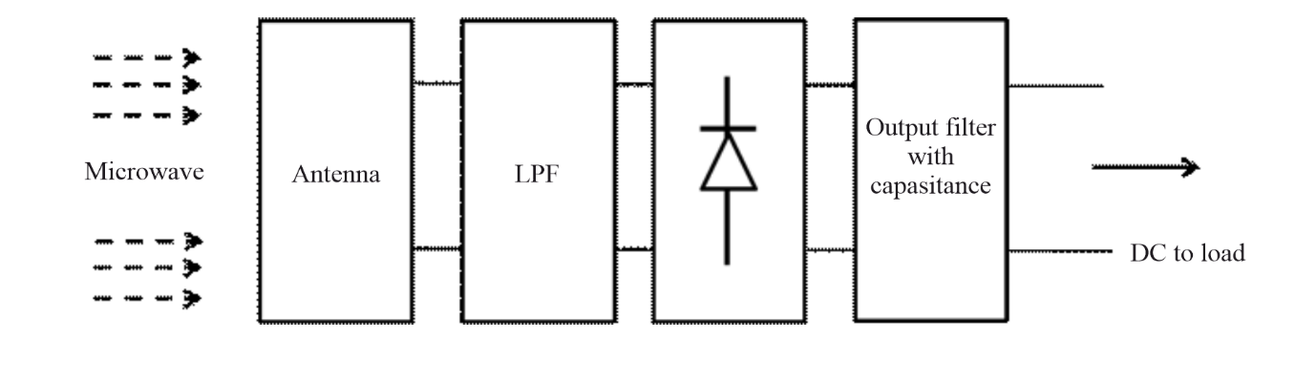

4 Organizations expected to contribute to the standardization of WPT
Although no standardization organization for WPT for radio waves exists, some organizations to promote the WPT are expected to contribute WPT’s standardization.

4.1 European cooperation in science and technology (COST)
WiPE (Wireless Power Transmission for Sustainable Electronics) [72]
COST has been an intergovernmental framework for European Cooperation in the field of Scientific and Technical Research since its creation in 1971. Its goal is to strengthen the competitiveness of Europe's scientific and technical research for peaceful purposes.
The COST Action aims to address efficient WPT circuits, systems and strategies specially tailored for battery‑less systems. Battery‑free sensors, passive RFID, near field communications (NFC) are all closely related concepts that make use of WPT and energy harvesting systems to remotely power up mobile devices or to remotely charge batteries, contributing to develop and foster the IoT evolution.
In this context, this COST Action aims at bringing together RF circuit and system designers with different backgrounds to: 1) provide enhanced circuit and subsystem solutions to increase the efficiency in WPT; and 2) investigate the use of novel materials and technologies that allow minimizing cost and maximizing integration of the electronics with the environment and with the targeted applications.
The COST Action expected benefits include the creation of a wide network of experts both from academia and industry that can address the existing and upcoming challenges in WPT scenarios in an interdisciplinary manner paving the way for the future generations of WPT solutions and the associated regulation.
COST is an ideal framework towards joining efforts at an international level and establishing Europe as a leading scientific and industrial community in the field of WPT.
WiPE Management Committee includes 27 European countries at this time with more than 100 entities participation in regular meetings and workshops. WiPE also organizes a yearly PhD school on WPT.
WiPE has five research workgroups (WGs). These are:
WG1: Far-field WPT systems
WG2: Near-field WPT systems
WG3: Novel materials and technologies
WG4: Applications (space, health, agriculture, automotive systems, home appliances)
WG5: Regulation and Society Impact.

4.2 WiPoT (Wireless power transfer consortium for practical applications) [73]
The objectives of the consortium are: 1) matching new ideas and solutions to society’s needs regarding WPT technologies, particularly with regards to MPT, and 2) accelerating the development of practical applications of WPT. To achieve these objectives, the WiPoT shares information about not only technology, but also standardization, safety, and user needs. The consortium also advertises WPT technologies, including MPT, throughout the world. The consortium was established in 2013 and has 29 company members, 38 university members, and three institute members as of May 2016.
The consortium considers that MPT can be base technology of all WPT and has the following working groups:
WG1: Wide Beam and Low Power applications
WG2: Narrow Beam and High Power applications
WG3: WPT in Closed Area
WG4: Commercialization
WG5: Standardization.

4.3 BWF (Broadband wireless forum) [74]
The Forum shall aim at contributing to sound advancement of new radio use systems and services to promote early commercialization and international development of the systems and services using new radio communication technologies. To achieve these aims, the Forum conducts R&D, investigation, information collection, liaison and coordination with related organizations, and dissemination activities, etc., on new radio communication technologies. Its members are 128 bodies as of 11 January 2013.
Its activities are:
1) R&D on new radio communication technologies utilizing test beds.
2) Investigation on new radio communication technologies.
3) Collection, exchange, and provision of information on new radio communication technologies.
4) Liaison and coordination with organizations related to new radio communication technologies.
5) Dissemination and awareness raising of new radio communication technologies.
6) Other activities necessary for the achievement of the Forum's aim.
Technology Application Subcommittee has Wireless Power Transmission Working Group.
The Sub Group-5 in WPT-Working Group of BWF is taking responsibility for drafting WPT using microwave technical standards utilizing the ARIB (Association of Radio Industries and Businesses) drafting protocols. A draft standard developed by BWF will be sent to ARIB for approval.

4.4 Other international organizations
IEEE MTT (Microwave Theory and Technique) Society currently promotes the Wireless Energy or Power Transmission and conversion technologies, using either near-field or far-field techniques, for either fixed or mobile access platforms. For the purpose, they established Technical Committee 26 named Wireless Energy Transfer and Conversion in MTTS in 2011 [75]. Wireless energy harvesting from RF sources is also part of the interest of this committee. In the international microwave symposium (IMS), they conduct student design competitions every year since 2012. 15 teams from 12 countries joined the competition in IMS2014. The TC26 has been organizing an international conference named Wireless Power Transfer Conference (WPTc) since 2013, which started as a workshop in 2011 and was repeated in 2012. The number of paper submissions to this conference is over 170 in 2015.
URSI (International Union of Radio Science) is composed of 10 commissions. URSI organized the inter commission working group (ICWG) on SPS, which is one of MPT applications, and published the white paper on SPS in 2007 with the cooperation of all the commissions including those which cover SPS systems, radio technologies as well as MPT, electromagnetic interference, radio astronomy, and safety issues. URSI general assemblies (GA) which are held every three years have sessions on SPS and/or WPT since 2002 to 2014 (latest). A general lecture of RF energy harvesting and WPT was held in 2014 URSI GA.

5 Spectrum for WPT via radio frequency beam
The beam WPT may be considered as an ISM (Industrial, Scientific and Medical) application, even for operation outside bands designated for ISM use. Beam WPT systems may also be classified as Short-Range Devices, operating in some bands listed in Recommendation ITU-R SM.1896 and Report ITU-R SM.2153. Since WPT signals do not normally carry data communications, it may not be considered as a conventional radiocommunication service.
The main frequency bands being proposed at some administrations for WPT applications are 915 MHz (917-920 MHz), 2.45 GHz (2 400-2 500 MHz), 5.8 GHz (5 725-5 875 MHz) and 24 GHz (24.1-24.15 GHz). At frequencies below 800 MHz, the WPT systems are unable to easily generate the desired small area of field. At higher frequencies, the systems become inefficient due to path loss. The 2.45 GHz band is more desirable than higher frequency bands because propagation impairments are smaller. For those applications where transmission failure due to rain can be addressed by backup systems, alternate energy systems or adequate energy storage, the 5.8 GHz band provides advantages due to the reduction in aperture sizes. Compared to the 2.45 GHz and 5.8 GHz bands, the 915 MHz band has technical advantages for some applications and is less crowded with consumer electronics.
For solar power satellite (SPS) or SBSP presently experimental systems in some countries have used ISM bands as well as the bands between 5.8 GHz and 24 GHz have been investigated.
Unlike other power transfer applications work over much larger distances, there are system design issues between physical size of antennas and the active devices to generate the power where efficiency varies with frequency.

6 Summary
This Report contains possible applications of WPT via radio frequency beam, technologies employed in those applications and candidate frequency bands.
Wireless powered sensor network, wireless charger of mobile devices, WPT sheet, MPT in a pipe, microwave buildings, WPT to moving/flying target, point-to-point WPT, wireless charging for electric vehicles and SPS/SBSP are studied for applications of WPT via radio frequency beam. WPT technologies using beam to multi-users at short range, WPT technologies in closed area and WPT technologies using narrow beam to single user at short/long range are being studied and developed.
WPT technologies using beam to multi-users at short range have been studied in the 915 MHz, 2.45 GHz, 5.8 GHz and 24 GHz bands. Wireless powered sensor network and wireless charging of mobile/portable devices are studied under these technologies.
WPT technologies in closed area have been studied in the 2.45 GHz and 5.8 GHz bands. WPT sheet, MPT in a pipe and microwave buildings are studied under these technologies.
WPT technologies using narrow beam to single user at short/long range have been studied in the 2.45 GHz and 5.8 GHz bands. WPT to moving/flying target, point-to-point WPT, and solar power satellite are studied under these technologies.
References
[1] Brown, W.C., “Adapting Microwave Techniques to Help Solve Future Energy Problems”, 1973 G-MTT International Microwave Symposium Digest of Technical Papers 73.1, pp. 189-191, 1973.
[2] Hutin, M. and M. Le-Blanc, “Transformer System for Electric Railways”, US Patent Number 527,875, 1894.
[3] Kurs, A., A. Karalis, R. Moffatt, J.D. Joannopoulos, P. Fisher and M. Soljačić, “Wireless power transfer via strongly coupled magnetic resonances”, Science, Vol. 317, pp. 83-86, 2007.
[4] Shinohara, N., “Wireless Power Transfer via Radiowaves (Wave Series)”, ISTE Ltd. and John Wiley & Sons, Inc., Great Britain and United States, 2014.
[5] Ichihara, T., T. Mitani, and N. Shinohara, “Study on Intermittent Microwave Power Transmission to a ZigBee Device”, Proc. of 2012 IEEE MTT-S International Microwave Workshop Series on Innovative Wireless Power Transmission: Technologies, Systems, and Applications (IMWS-IWPT2012), pp. 209-212, 2012.
[6] “Requirements for support of ubiquitous sensor network (USN) applications and services in the NGN environment.” Recommendation ITU-T Y.2221 (2010).
[7] “Applications of Wireless Sensor Networks in Next Generation Networks,” ITU-T Technical Paper Y.2000 (2014).
[8] DENGYO Corporation http://www.den-gyo.com/solution/solution10_b.html (in Japanese).
[9] Furukawa, M., T. Minegishi, T. Ogawa, Y. Sato, P. Wang, H. Tonomura, M. Teramoto, and N. Shinohara, “Wireless Power Transmission to 10kW Output 2.4 GHz-band Rectenna Array for Electric Trucks Application (in Japanese)”, IEICE Technical Report, WPT2012-7, pp. 36-39, 2013.
[10] Maehara, D., R. Akai, G.K. Tran, K. Sakaguchi, S. Sampei, K. Araki, and H. Iwai, “Experiment on Battery-less Sensor Activation via Multi-point Wireless Energy Transmission”, Proc. of 2013 IEEE 24th Annual Int. Sympo. On Personal, Indoor, and Mobile Radio Communications (PIMRC), pp. 2346-2350, 2013.
[11] Sakaguchi, K., R.P. Wicaksono, K. Mizutani, and T. Khanh, “Wireless Grid to Realize Ubiquitous Networks with Wireless Energy Supply (in Japanese)”, IEICE Tech. Report, Vol. 109, No. 442.
[12] Carvalho, J.A., Costa, D.B., Lima, F.R.M., Oliveira, R. and Dias, U.S., “Non-Orthogonal Multiple Access in Two-Hop Wireless Powered Communication Networks”, IEEE Wireless Communications Letters, vol. 9, no. 9, pp. 1-5, September 2020.
[13] Lima, F.R.M., Bastos, J.O. and Melo, J.O., “Optimal SIC Decoding Order and WPT Time Length for WPCN With Imperfect SIC”, IEEE Wireless Communications Letters, vol. 10, no. 10, pp. 1-5, October 2021.
[14] Pinho, C.A.M. and Lima, F.R.M., “Rate maximization with QoS guarantees in IRS-assisted WPCN-NOMA systems”, Proc. of 7th Workshop on Communication Networks and Power Systems (WCNPS 2022), pp. 1-6, 2022.
[15] Castro, P.V.M. and Lima, F.R.M., “A Heuristic for Mixed Integer and Nonlinear Programming in a WPCN-NOMA Scenario with Imperfect SIC”, Proc. of XLII Brazilian Symposium on Telecommunications and Signal Processing (SBrT 2024), Belém, PA, October 2024.
[16] Fonseca, L.S., Lima, F.R.M. and Pinho, C.A.M., “Resource Allocation for Spectral Efficiency Maximization in WPCN-NOMA Systems with Multiple IRSs”, Proc. of 2024 19th International Symposium on Wireless Communication Systems (ISWCS), pp. 1-6, 2024.
[17] Melo, J.O., Castro, P.V.M. and Lima, F.R.M., “User Fairness Maximization in Multicarrier Cognitive NOMA-WPCN with Imperfect SIC”, Proc. of XLII Brazilian Symposium on Telecommunications and Signal Processing (SBrT 2024), Belém, PA, October 2024.
[18] Scaciota, R., Brante, G., Souza, R., Lopez, O., Sarbu, S., Bennis, M., and Samarakoon, S., “Decentralized RL-Based Data Transmission Scheme for Energy Efficient Harvesting”, Proc. of 2024 EuCNC & 6G Summit, pp. 1-6, 2024.
[19] Souto, V.D.P., Rosabal, O.M., Montejo-Sánchez, S., López, O.L.A., Alves, H., and Souza, R.D., “An Analog Beamforming Strategy Based on Statistical Channel Information for Recharging Wireless Powered Sensor Networks”, IEEE Sensors Journal, vol. 24, no. 14, pp. 1-12, July 2024.
[20] Melo, J.O. and Lima, F.R.M., “Hybrid SIC with Residual Error Factor in Wireless Powered Communications”, Proc. of 2022 IEEE 27th International Workshop on Computer Aided Modeling and Design of Communication Links and Networks (CAMAD), pp. 1-6, 2022.
[21] Viana, A.M.S., Gonçalves, S.T.M., Resende, U.C. and Mello, T.H.G., “Dual Band Analysis of a Novel Rectenna for Wireless Power Transmission and Energy Harvesting Applications”, Proc. of 2024 IEEE International Magnetic Conference (INTERMAG), pp. 1-5, 2024.
[22] Lacerda, P.C., Mariano, A.A., Brante, G., López, O.L.A., Mikhaylov, K. and Souza, R.D., “Behavioral Modeling of a Radio Frequency Wireless Power Transfer System for Batteryless Internet of Things Applications”, IEEE Access, vol. 12, pp. 1-15, 2024.
[23] Fowler, Ben, Consumer Reports. https://www.consumerreports.org/emerging-technology/wireless-charging-the-next-leap-wireless-power/
[24] Davies, Alex, ReThink, https://rethinkresearch.biz/articles/ces-ossia-energous-unleash-rival-long-range-wireless-charging-specs/
[25] Hashimoto, K., T. Ishikawa, T. Mitani, and N. Shinohara, “Improvement of a ubiquitous power source”, Proc. of International Union of Radio Science (URSI) General Assembly 2011, CD-ROM CHGBDJK-1.pdf, 2011.
[26] Mitani, T., H. Yamakawa, N. Shinohara, K. Hashimoto, S. Kawasaki, F. Takahashi, H. Yonekura, T. Hirano, T. Fujiwara, K. Nagano, H. Ueda, and M. Ando, “Demonstration Experiment of Microwave Power and Information Transmission from an Airship”, Proc. of 2nd International Symposium on Radio System and Space Plasma 2010, pp. 157-160, 2010.
[27] Shinohara, N., H. Matsumoto, T. Mitani, H. Shibata, T. Adachi, K. Okada, K. Tomita, and K. Shinoda, “Experimental Study on “Wireless power Space” (in Japanese), IEICE Tech. Report, SPS2003-18, pp. 47-53, 2004.
[28] Shinohara, N., T. Mitani, and H. Matsumoto, “Study on Ubiquitous Power Source with Microwave Power Transmission”, Proc. of International Union of Radio Science (URSI) General Assembly 2005, CD-ROM C07.5(01145).pdf, 2005.
[29] Wireless Power Transmission Systems ARIB-Standard (https://www.arib.or.jp/english/html/overview/doc/5-STD-T113v1_1-E1.pdf)
[30] Noda, A., and H. Shinoda, “Selective wireless power transmission through high-Q flat waveguide-ring resonator on 2-D waveguide sheet,” IEEE Trans. MTT, Vol. 59, No. 8, pp. 2158-2167, 2011.
[31] Noda, A., and H. Shinoda, “Waveguide-Ring Resonator Coupler with Class-F Rectifier for 2-D Waveguide Power Transmission”, Proc. of 2012 IEEE MTT-S International Microwave Workshop Series on Innovative Wireless Power Transmission: Technologies, Systems, and Applications (IMWS-IWPT2012), pp. 259-262, 2012.
[32] Noda, A., and H. Shinoda, “A Phased Array Feeding System for 2-D Waveguide Power Transmission (in Japanese)”, Proc. of IEICE, BSC-1-8, March 2013.
[33] Shinoda, H., Y. Makino, N. Yamahira, and H. Itai, “Surface sensor network using inductive signal transmission layer,” Proc. of Int. Conf. on Networked Sensing Systems (INSS) 2007, pp. 201-206, 2007.
[34] Hirayama, K., N. Shinohara, K. Hashimoto, H. Matsumoto, T. Nakauchi, and Y. Yoshida, “Fundamental Study of Microwave Power Transmission to a Robot Moving in Gas Pipes (in Japanese)”, Proc. of IEICE Comm., p. 116, March 1997.
[35] Hirayama, K., N. Shinohara, H. Matsumoto, and I. Nagano, “Study of Microwave Power Transmission to a Robot Moving in Gas Pipes (in Japanese)”, Proc. of IEICE Comm., p. 25, March 1999.
[36] Ishino, S., A. Kishimoto, Y. Takimoto, Y. Arai, Y. Huang, and N. Shinohara, “Study on WPT System Using a Radio Wave Hose as a New Transmission Line”, Proc. of 2015 IEEE Wireless Power Transfer Conference (WPTc2015), P4.1, May 2015.
[37] Ishino, S., T. Miyagawa, and N. Shinohara, “A New Slotted Waveguide Using a Resin Hose with Metallic Coating”, Proc. of 2015 Asia-Pacific Microwave Conference (APMC), Dec. 2015.
[38] Shibata, T., Y. Aoki, M. Otsuka, T. Idogaki, and T. Hattori, “Microwave Energy Transmission System for Microrobot”, IEICE Trans. Electr., Vol.E80-C, No. 2, pp. 303-308, 1997.
[39] Shinohara, N., N. Niwa, K. Takagi, K. Hamamoto, S. Ujigawa, J.-P. Ao, and Y. Ohno, “Microwave Building as an Application of Wireless Power Transfer”, Wireless Power Transfer, pp. 1-9, 2014.4.
[40] Takahashi, K., J.-P. Ao, Y. Ikawa, C.-Y. Hu, H. Kawai, N. Shinohara, N. Niwa, and Y. Ohno, “GaN Schottky Diodes for Microwave Power Rectification”, Japanese Journal of Applied Physics (JJAP), Vol. 48, No. 4, pp. 04C095-1 - 04C095-4, 2009.
[41] Dunbar, S., F. Wenzl, C. Hack, R. Hafeza, H. Esfeer, F. Defay, S. Prothin, D. Bajon, and Z. Popovic, “Wireless Far-Field Charging of a Micro-UAV”, Proc. of IEEE Wireless Power Transfer Conference (WPTc), T1.2, May 2015.
[42] Nagahama, A., T. Mitani, N. Shinohara, N. Tsuji, K. Fukuda, Y. Kanari, and K. Yonemoto, “Study on a Microwave Power Transmitting System for Mars Observation Airplane”, Proc. of 2011 IEEE MTT-S International Microwave Workshop Series on Innovative Wireless Power Transmission: Technologies, Systems, and Applications (IMWS-IWPT2011), pp. 63-66, 2011.
[43] Nagahama, A., T. Mitani, N. Shinohara, K. Fukuda, K. Hiraoka, and K. Yonemoto, “Auto Tracking and Power Control Experiments of a Magnetron-based Phased Array Power Transmitting System for a Mars Observation Airplane”, Proc. of 2012 IEEE MTT-S International Microwave Workshop Series on Innovative Wireless Power Transmission: Technologies, Systems, and Applications (IMWS-IWPT2012), pp. 29-32, 2012.
[44] Nishikawa, H., Y. Kiani, T. Furukoshi, H. Yamaguchi, A. Tanaka, and T. Douseki, “UHF Power Transmission System for Multiple Small Self-rotating Targets and Verification with Batteryless Quadcopter having Rotors with Embedded Rectenna”, Proc. of IEEE Wireless Power Transfer Conference (WPTc), T1.1, May 2015.
[45] Miyashiro, K., F. Inoue, K. Maki, K. Tanaka, S. Sasaki, and K. Komurasaki, “Sequentially Rotated Array Antenna for Wireless Power Transmission to an MAV (in Japanese)”, IEICE Tech. Report, WPT2012-30, pp. 59-61, 2012.
[46] Shinohara, N., K. Nagano, T. Ishii, S. Kawasaki, T. Fujiwara, S. Nakayama, Y. Takahashi, S. Sasaki, K. Tanaka, Y. Hisada, Y. Fujino, S. Mihara, T. Anzai, and Y. Kobayashi, “Experiment of Microwave Power Transmission to the Moving Rover”, Proc. of Int. Sympo. on Antennas and Propagation (ISAP2007), 3B1-1, 2007.
[47] Brown, W.C., “The History of Power Transmission by Radio Waves”, IEEE Trans. MTT, Vol. 32, No. 9, pp. 1230-1242, 1984.
[48] Shinohara N. and H. Matsumoto, “Dependence of dc Output of a Rectenna Array on the Method of Interconnection of Its Array Element”, Electrical Engineering in Japan, Vol. 125, No. 1, pp. 9-17, 1998.
[49] Celeste, A., J-D. L.S. Luk, J.P. Chabriat, and G. Pignolet, “The Grand-Bassin Case Study: Technical Aspects”, Proc. of SPS’97, pp. 255-258, 1997.
[50] Hatano, K., N. Shinohara, T. Mitani, T. Seki, and M. Kawashima, “Development of Improved 24GHz-Band Class-F Load Rectennas”, Proc. of 2012 IEEE MTT-S International Microwave Workshop Series on Innovative Wireless Power Transmission: Technologies, Systems, and Applications (IMWS-IWPT2012), pp. 163-166, 2012.
[51] Hatano, K., N. Shinohara, T. Seki, and M. Kawashima, “Development of MMIC Rectenna at 24 GHz”, Proc. of 2013 IEEE Radio & Wireless Symposium (RWS), pp. 199-201, 2013.
[52] Shinohara, N. and H. Matsumoto, “Wireless Charging System by Microwave Power Transmission for Electric Motor Vehicles (in Japanese)”, IEICE Trans. C, Vol. J87-C, No. 5, pp. 433-443, 2004.
[53] Shinohara, N., “Beam Efficiency of Wireless Power Transmission via Radio Waves from Short Range to Long Range“, Journal of the Korean Institute of Electromagnetic Engineering and Science, Vol. 10, No. 4, pp. 224-230, 2011.
[54] Shinohara, N., “Wireless Charging System of Electric Vehicle with GaN Schottky Diodes”, Proc. of Int. Microwave Sympo. (IMS) Workshops, WFA “Wireless Power Transmission”, 2011.
[55] Shinohara, N. and Yuta Kubo, “Suppression of Unexpected Radiation from Microwave Power Transmission System toward Electric Vehicle”, Proc. of 2013 Asia-Pacific Radio Science Conference (AP-RASC), E3-4 (No. 290450), 2013.
[56] Shinohara, N., “Wireless Power Transmission Progress for Electric Vehicle in Japan”, Proc. of 2013 IEEE Radio & Wireless Symposium (RWS), pp. 109-111, 2013.
[57] Shinohara, N., Y. Kubo, and H. Tonomura, “Mid-Distance Wireless Power Transmission for Electric Truck via Microwaves”, Proc. of 2013 International Symposium on Electromagnetic Theory (EMT-S2013), pp. 841-843, 2013.
[58] I. Cash, “CASSIOPeiA – A new paradigm for space solar power”, Acta Astronautica, vol. 159, pp. 170–178, Jun. 2019, doi: 10.1016/j.actaastro.2019.03.063.
[59] ESA SOLARIS Cost vs. benefits studies. Available: https://www.esa.int/Enabling_Support/Space_Engineering_Technology/SOLARIS/Cost_vs._benefits_studies
[60] Frazer-Nash Consultancy, “Space Based Solar Power as a Contributor to Net Zero: De-risking the pathway to Net Zero”, 2021. Available: https://www.fnc.co.uk/discover-frazer-nash/news/frazer-nash-report-for-uk-government-shows-feasibility-of-space-solar-power/
[61] Hou X. B., Wang L., Zhang X. H., and Zhou L., “Concept Design on Multi Rotary Joints SPS”, Journal of Astronautics, vol. 36, no. 11, pp. 1332–1338, 2015, doi: 10.3873/j.issn.1000-1328.2015.11.016.
[62] J. C. Mankins, “SPS-ALPHA Mark-III and an Achievable Roadmap to Space Solar Power”, presented at the 72nd International Astronautical Congress, 2021.
[63] S. Sasaki et al., “A new concept of solar power satellite: Tethered-SPS”, Acta Astronautica, vol. 60, no. 3, pp. 153-165, Feb. 2007, doi: 10.1016/j.actaastro.2006.07.010.
[64] Report of the URSI Inter-Commission Working Group on SPS, URSI, 2007, available at URL: http://www.ursi.org/files/WhitePapers/WPSPS-ReportMin.pdf
[65] Brown, W.C., “The History of the Development of the Rectenna”, Proc. of SPS microwave systems workshop, pp. 271-280, Jan. 15-18, 1980, at JSC-NASA.
[66] Epp, L.W., A.R. Khan, H.K. Smith, and R.P. Smith, “A compact dual polarized 8.51GHz-rectenna for high-voltage (50 V) actuator applications”, IEEE Trans. MTT, Vol. 48, No. 1, pp. 111-119, 2000.
[67] McSpadden, J.O., L. Fun, and K. Chang, “A High Conversion Efficiency 5.8 GHz Rectenna”, IEEE MTT-S Digest, pp. 547-550,1997.
[68] Sample, A.P. and J.R. Smith, “Experimental Results with two Wireless Power Transfer Systems”, Proc. of 2009 IEEE Radio & Wireless Symposium (RWS), MO2A-5, pp. 16-18, 2009.
[69] Shinohara, N., “Beam Control Technologies with a High-Efficiency Phased Array for Microwave Power Transmission in Japan”, Proceeding of IEEE, vol. 101, Issue 6, pp. 1448-1463, 2013.
[70] Takacs, A., H. Aubert, L. Despoisse, and S. Fredon, “K-band Energy Harvesting for Satellite Application”, Proc. of Int. Microwave Sympo. (IMS), WE3G-1, 2013.
[71] Weissman, N., S. Jameson and E. Socher, “W-Band CMOS On-Chip Energy Harvester and Rectenna”, Proc. of Int. Microwave Sympo. 2014, TH2C-5, 2014.
[72] Wireless Power Transmission for Sustainable Electronics http://www.cost-ic1301.org/
[73] Wireless power transfer consortium for practical applications http://www.wipot.jp/english/
[74] Broadband wireless forum http://bwf-yrp.net/english/
[75] IEEE MTTS TC-26 http://www.mtt-archives.org/~mtt26/

* It should be noted that national experiences provided in this Report are for information purposes only.

