Report ITU-R SM.2352-1
(07/2022)
Technology trends of active services
in the frequency range 275-3 000 GHz

SM Series
Spectrum management

Foreword
The role of the Radiocommunication Sector is to ensure the rational, equitable, efficient and economical use of the radio-frequency spectrum by all radiocommunication services, including satellite services, and carry out studies without limit of frequency range on the basis of which Recommendations are adopted.
The regulatory and policy functions of the Radiocommunication Sector are performed by World and Regional Radiocommunication Conferences and Radiocommunication Assemblies supported by Study Groups.

Policy on Intellectual Property Right (IPR)
ITU-R policy on IPR is described in the Common Patent Policy for ITU-T/ITU-R/ISO/IEC referenced in Resolution ITU-R 1. Forms to be used for the submission of patent statements and licensing declarations by patent holders are available from http://www.itu.int/ITU-R/go/patents/en where the Guidelines for Implementation of the Common Patent Policy for ITU-T/ITU-R/ISO/IEC and the ITU-R patent information database can also be found.

Series of ITU-R Reports
(Also available online at http://www.itu.int/publ/R-REP/en)
Series | Title
BO | Satellite delivery
BR | Recording for production, archival and play-out; film for television
BS | Broadcasting service (sound)
BT | Broadcasting service (television)
F | Fixed service
M | Mobile, radiodetermination, amateur and related satellite services
P | Radiowave propagation
RA | Radio astronomy
RS | Remote sensing systems
S | Fixed-satellite service
SA | Space applications and meteorology
SF | Frequency sharing and coordination between fixed-satellite and fixed service systems
SM | Spectrum management

Note: This ITU-R Report was approved in English by the Study Group under the procedure detailed in Resolution ITU-R 1.

Electronic Publication
Geneva, 2022
© ITU 2022
All rights reserved. No part of this publication may be reproduced, by any means whatsoever, without written permission of ITU.

REPORT ITU-R SM.2352-1
Technology trends of active services in the frequency range 275-3 000 GHz
(Question ITU-R 237/1)
(2015-2022)
Scope
This Report contains technology trends of active services in the frequency range 275-3 000 GHz. This Report intends to provide technical information for preparation of sharing and compatibility studies between active and passive services, as well as among active services in the frequency range 275-3 000 GHz.

TABLE OF CONTENTS
Page
1 Introduction 3
2 THz features, characteristics and typical applications 4
2.1 Overview of frequency band above 275 GHz 4
2.2 The characteristics of the band over 275 GHz 4
2.3 Typical active THz applications 5
3 Regulatory information 6
4 THz wireless communication 7
4.1 Possible use case of THz communication systems 8
4.2 THz transmitter and receiver technologies 14
5 Sensing and imaging 20
5.1 THz generation method 20
5.2 THz cameras 22
5.3 Spectroscopy 24
5.4 Non-destructive testing 25
5.5 THz radar applications 27
6 Integrated communication and sensing in a radio access network 31
7 THz related activities within the international standard organization 34
8 Summary 34
9 References 34

Abbreviations and acronyms
ATR Attenuated total reflection
BER Bit error ratio
BNA N-Benzyl-2-Methyl-4-Mitroaniline
BWO Backward-wave oscillator
CMOS Complementary metal oxide semiconductor
D2D Device-to-device
DAST Diethylaminosulfur Trifluoride
DFG Difference frequency generation
EVM Error vector magnitude
FEL Free-electron laser
FM-CW Frequency modulated continuous wave
FTIR Fourier transform infrared spectroscopy
GaAs Gallium Arsenide
HBT Heterojunction bipolar transistor
HEMT High electron mobility transistor
IMPATT Impact ionization avalanche transit-time
InP Indium Phosphide
ISAC Integrated sensing and communication
ISAR Inverse synthetic aperture radar
LFMCW Linear frequency modulated continuous wave
LoS Line of sight
LT-GaAs Low temperature grown Gallium Arsenide
MMIC Monolithic microwave integrated circuit
NDT Non-destructive testing
NEP Noise equivalent power
NFC Near field communication
NLoS Non line of sight
QAM Quadrature amplitude modulation
QCL Quantum cascade laser
RTD Resonant tunnelling diode
SAR Synthetic aperture radar
TDS Time domain spectroscopy
TNNNET Tunnel injection transit-time
THz Terahertz
UTC-PD Uni-traveling-carrier photodiode
V2V Vehicle-to-vehicle
WLAN Wireless local area network
Related ITU-R Recommendations and Reports
Recommendation ITU-R P.676 – Attenuation by atmospheric gases and related effects
Recommendation ITU-R P.838 – Specific attenuation model for rain for use in prediction methods
Recommendation ITU-R P.840 – Attenuation due to clouds and fog
Report ITU-R F.2107 – Characteristics and applications of fixed wireless systems operating in frequency ranges between 57 GHz and 134 GHz
Report ITU-R F.2416 – Technical and operational characteristics and applications of the fixed service operating in the frequency band 275-450 GHz
Report ITU-R M.2417 – Technical and operational characteristics of land mobile service applications in the frequency band 275-450 GHz
Report ITU-R SM.2450 – Sharing and compatibility studies between land-mobile, fixed and passive services in the frequency range 275-450 GHz

1 Introduction
The frequency bands above 275 GHz are not allocated for specific services, but identified for passive service, land mobile and fixed service applications in the Radio Regulations (RR). The spectrum regulation of frequencies above 3 000 GHz is still under study in accordance with Resolution 118 (Marrakesh, 2002). At the World Radiocommunication Conference 2012 (WRC-12), RR No. 5.565 was amended to identify for use by administrations for passive service applications, such as radio astronomy service, Earth exploration-satellite service (passive) and space research service (passive), while the use of the range 275-1 000 GHz by the passive services does not preclude use of this range by active services.
WRC-19 approved to add RR No. 5.564A which identifies the frequency bands 275-296 GHz, 306-313 GHz, 318-333 GHz and 356-450 GHz for use by administrations for the implementation of land mobile and fixed service applications, where no specific conditions are necessary to protect Earth exploration-satellite service (passive) applications and indicates that the frequency bands 296-306 GHz, 313-318 GHz and 333-356 GHz may only be used by fixed and land mobile service applications when specific conditions to ensure the protection of Earth exploration-satellite service (passive) applications are determined in accordance with Resolution 731 (Rev.WRC-19).
Question ITU-R 237/1 – Technical and operational characteristics of the active services operating in the range 275-1 000 GHz, was developed and approved in 2013 to encourage administrations to study the technical and operational characteristics of active services in the frequency range 275-1 000 GHz. In addition to the technical and operational characteristics, sharing studies between active and passive services, as well as among active services are expected to be carried out taking into account those characteristics in accordance with the new Question ITU-R 237/1.
Due to progress in the recent technologies above 275 GHz, the integrated devices and circuits operating above 275 GHz enable us to achieve the sophisticated applications, such as spectroscopy, imaging, non-destructive testing and THz camera. Although the advantages of such high frequencies are to use ultra-broad bandwidth which cannot be achieved in the microwave and millimetre-wave frequency ranges, those advantages are not yet utilized to develop the ultra-high speed wireless communication systems and other active systems.
In addition to progress of THz technologies, IEEE 802 established IEEE 802.15.3d Task Group, which completed IEEE Std. 802.15.3d-2017 in 2017. IEEE 802.15 Standing Committee THz is now in charge to monitor and discuss further prospective opportunities for IEEE 802.15 standards for THz communications.
This Report overviews the technology trend of active systems studied in the frequency ranges above 275 GHz and intends to provide technical and regulatory information for preparation of sharing and compatibility studies. The technologies discussed in this Report are in the areas of THz wireless communication, sensing and imaging.

2 THz features, characteristics and typical applications
The development of THz wireless applications is based on traditional wireless applications, which goes through microwave, millimetre wave to THz wave; meanwhile, it shows partial thought of laser wireless applications. Microwave and laser applications will not be replaced by THz, but THz applications have unique advantages which most microwave and laser applications do not have.

2.1 Overview of frequency band above 275 GHz
The band above 275 GHz is the main part of terahertz band. Terahertz waves, also known as submillimetre radiation, usually refers to the frequency band between 0.1 THz-10 THz with the corresponding wavelength of 0.03 mm-3 mm.
The position of terahertz band in the electromagnetic spectrum is shown in Fig. 1.
FIGURE 1
Position of terahertz band in the radio spectrum
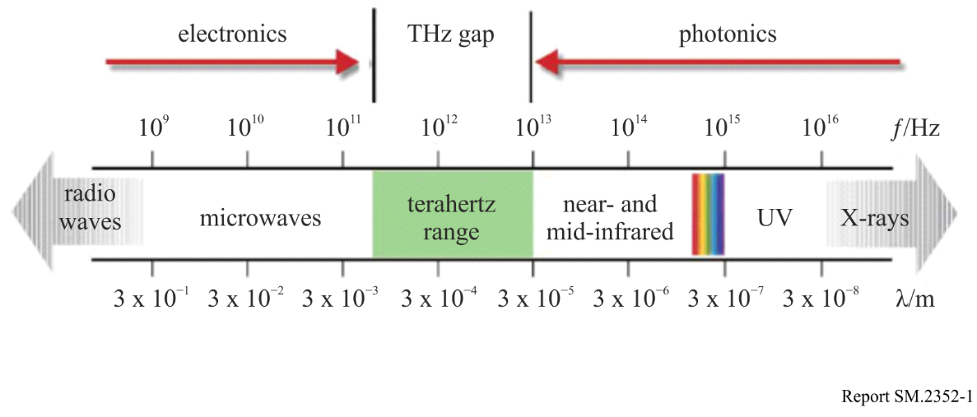

2.2 The characteristics of the band over 275 GHz
Because of its unique properties, the band above 275 GHz has many special characteristics compared with other radio-frequency bands. The main unique characteristics are as follows:
(1) High permittivity
Radio signal above 275 GHz has good penetration of many dielectric materials and non-polar liquid, so it can image opaque materials or objects and also could be used for non-destructive testing in safety inspection or quality control.
Besides, its wavelengths are longer than that of the suspended dust or dirt particles in the air, and there is only very small transmission loss in the dust or smoke, so it could be used for imaging in the smoke environment like fire rescue field, or wind dust environment such as desert.
(2) Rapid attenuation in the water
Radio signal above 275 GHz has a severe attenuation in water, which can be used in medical field. As the water content in tumour tissues is significantly different from the normal tissue cells, so the cancer tissues can be located by analysis of tissue water content.
(3) Safety
The photon energy of the terahertz is only Mini-electron Volt, which is significantly lower than the energy in most chemical bonds. That is why it will not cause ionization reaction and it is crucial for detection of biological samples and human body check. In addition, water has a strong absorption effect on this band. Since the radio signal in the band cannot get through human skin and it is safe for people, so it could be used for medical detection such as skin diseases detection.
(4) Spectral resolution
Terahertz band contains abundant spectral information including physical and chemical information. Many molecules, especially organic molecules, have relatively strong dispersion and absorption properties in this band. Through the study on spectral properties of material in this band, the structural characteristics of materials could be understood, their composition identified, and their physical and chemical properties analysed.
(5) High spatial resolution
The band above 275 GHz has relatively better spatial resolution than microwave band. Theoretically speaking, because of the shorter wavelength, its imaging resolution is higher than that of the microwave.
(6) Short wavelength and good directivity
Compared with the microwave, the frequency is higher which could be used as the communication carrier to carry more information in a unit of time. With shorter wavelength and good directivity, it is very promising to be used in certain wireless communication application scenarios.

2.3 Typical active THz applications
With more research of the terahertz wave, its outstanding characteristics are more and more conveyed. Currently, the band is still mainly used for astronomical observation, but with the advent of high-power terahertz radiation sources, the band above 275 GHz shows potential broad prospects in more applications. The potential typical applications are as follows:
(1) Application in molecular detection
All matters have movement, even though the object looks stationary, its internal molecular has a fast motion, since where there is motion, there is radiation. Electromagnetic radiation has its own vibrating frequency or wavelength called ‘fingerprint spectrum’. Most of the molecular ‘fingerprints’ are in the infrared band and the band above 275 GHz, the terahertz solid-state laser can be used to detect the radiation caused by small molecular vibrational which cannot be detected by infrared ray.
(2) Application in the security inspection
Since the majority of molecular rotational levels of explosives, drugs are in the terahertz region, so spectroscopy of the terahertz band could be able to conduct safety inspections of the human body, for the detection of explosives, drugs, biological macromolecules and weapons and other contraband. Different from the existing X ray and ultrasonic imaging technology, spectroscopy and imaging can provide not only the shape of the object, but also can compare the measured spectral information with existing hazard terahertz spectrum library to identify the material properties. Besides, with very low energy, the wave will not produce harmful ionization to biological tissues. Therefore, compared with the shortcomings of X rays which will cause potential harm to human body and whose metal detectors cannot detect non-metallic material, terahertz technology has a good application prospect in the security inspection.
(3) Application in biomedicine
Radio signal above 275 GHz is easily absorbed by polar molecules like water or oxygen, and different molecules have different absorption spectrum. Through the use of these spectral lines and the imaging technology, diagnosis of early lesions caused by skin cancer and other surface tissue can be achieved. In the surgical operation, terahertz imaging system is often used to check cancer excision in real-time, this method can achieve clearer soft tissue imaging than ultrasonic. In addition, the terahertz time-domain spectroscopy system (THz-TDS) can also be used to study organic macromolecules whose biological molecular vibration energy level or rotational levels is in the terahertz region, then guide the drug production and medical research.
(4) Application in the wireless communication field
The band above 275 GHz is in the transition position from optical to electronics, it has both characteristics of microwave and lightwave communications with its own nature. First of all, with the rapid development in communication, the traditional microwave communication has difficulty to meet the requirements of high-speed, broadband wireless communications, while, because of the high data transmission rate and wide spectrum bandwidth, this band could become the potential force of future wireless communications. On the other hand, the lightwave has large transmission attenuation in the dust, walls, plastic, cloth and other non-metallic or non-polar substances, The band above 275 GHz can penetrate these substances with a low attenuation, this makes it capable of penetrating well in harsh environment. But this band also has its own shortcomings, the most fatal one is that it can be easily absorbed by polar molecules in the atmosphere, therefore, its atmospheric attenuation is relatively strong, especially in the rainy day. These characteristics has decided it can mainly be used for future interplanetary communications, ground short range wideband mobile communication, and the harsh environment such as the dry and smoky climate or the battlefield.
(5) Application in radar
The applications of terahertz wave in the fields of radar, target recognition, precision guidance and fuze have potential prospects. With the advantages of terahertz wave such as good directivity and energy concentration, high resolution radar and tracking radar with low elevation angle can be made. With the advantage of imaging through material, objects which are hidden in the cover or smoke can be detected. With the advantage of through the dust and smoke, all-weather navigation system can be produced, then, guide aircraft landing in the fog become possible. The terahertz wave is wideband compared with other wave bands, such as it has a wider frequency range compared with the band of stealth technology used these days, so the ultra-wide-band radar using terahertz wave as source of radiation can get the image of stealthy aircrafts.

3 Regulatory information
Radio Regulations No. 5.565 was amended to identify for use by administrations for passive service applications, such as radio astronomy service, Earth exploration-satellite service (passive) and space research service (passive) at WRC-12. RR No. 5.564A was added to identify four frequency bands for the operation of land mobile and fixed service applications at WRC-19. Radio Regulations (Edition of 2020) Nos. 5.564A and 5.565 are shown below.
248-3 000 GHz
Allocation to services
Region 1 | Region 2 | Region 3
…
275-3 000 (Not allocated) 5.564A 5.565

5.564A For the operation of fixed and land mobile service applications in frequency bands in the range 275-450 GHz:
The frequency bands 275-296 GHz, 306-313 GHz, 318-333 GHz and 356-450 GHz are identified for use by administrations for the implementation of land mobile and fixed service applications, where no specific conditions are necessary to protect Earth exploration-satellite service (passive) applications.
The frequency bands 296-306 GHz, 313-318 GHz and 333-356 GHz may only be used by fixed and land mobile service applications when specific conditions to ensure the protection of Earth exploration-satellite service (passive) applications are determined in accordance with Resolution 731 (Rev.WRC-19).
In those portions of the frequency range 275-450 GHz where radio astronomy applications are used, specific conditions (e.g. minimum separation distances and/or avoidance angles) may be necessary to ensure protection of radio astronomy sites from land mobile and/or fixed service applications, on a case-by-case basis in accordance with Resolution 731 (Rev.WRC-19).
The use of the above-mentioned frequency bands by land mobile and fixed service applications does not preclude use by, and does not establish priority over, any other applications of radio services in the range of 275-450 GHz. (WRC-19)

5.565 The following frequency bands in the range 275-1 000 GHz are identified for use by administrations for passive service applications:
– radio astronomy service: 275-323 GHz, 327-371 GHz, 388-424 GHz, 426-442 GHz, 453-510 GHz, 623-711 GHz, 795-909 GHz and 926-945 GHz;
– Earth exploration-satellite service (passive) and space research service (passive): 275-286 GHz, 296-306 GHz, 313-356 GHz, 361-365 GHz, 369-392 GHz, 397-399 GHz, 409-411 GHz, 416-434 GHz, 439-467 GHz, 477-502 GHz, 523-527 GHz, 538-581 GHz, 611-630 GHz, 634-654 GHz, 657-692 GHz, 713-718 GHz, 729-733 GHz, 750-754 GHz, 771-776 GHz, 823-846 GHz, 850-854 GHz, 857-862 GHz, 866-882 GHz, 905-928 GHz, 951-956 GHz, 968-973 GHz and 985-990 GHz.
The use of the range 275-1 000 GHz by the passive services does not preclude use of this range by active services. Administrations wishing to make frequencies in the 275-1 000 GHz range available for active service applications are urged to take all practicable steps to protect these passive services from harmful interference until the date when the Table of Frequency Allocations is established in the above-mentioned 275-1 000 GHz frequency range.
All frequencies in the range 1 000-3 000 GHz may be used by both active and passive services. (WRC-12)

4 THz wireless communication
There are a number of research activities on ultra-broadband wireless communication systems in the frequency band above 275 GHz. Some researches aim at ultra-high-speed wireless communication systems which interface 40-Gbit/s and 100-Gbit/s Ethernet.
Due to high-capacity transmission capability and large propagation loss of communication links using THz technologies, these links are operated as the last mile access links. With the development of semiconductor technologies and advanced antenna technologies in the THz frequency ranges in recent years, THz wireless communication are also deployed as an optical fibre replacement in some application scenarios with a longer transmission distance (i.e. several miles). Several trials using the frequency above 275 GHz have been demonstrated by research and development organizations.

4.1 Possible use case of THz communication systems
In examining use cases of THz communications, the following specific points should be considered:
– Utilization of ultrawide frequency bandwidth.
– Possibility of miniaturization of antenna and device.
– High directivity and large free space propagation loss (wavelength is less than 1/5 of the 60 GHz band, and although free space propagation loss is 25 times or more, it is compensated by high gain antenna characteristics).
– Development of manufacturing technology such as for oscillators, power amplifiers, and beam steering antennae.

4.1.1 Inter-chip and intra-device communications
Figure 2 shows a use case of inter-chip and intra-device communications. Wirelessly connecting parts and circuit boards are expected to have the effect of eliminating wiring and miniaturizing substrates and devices.
Table 1 shows the typical requirements of this use case. It is summarized that communication distances when implementing ICs and/or layering IC-implemented substrates in the same housing will range from a few mm to a few tens of cm.
Regarding transmission speed, a speed of 10 Gbit/s has already been prescribed for USB3.1, and for PCIExpress 4.0, a transfer speed for the data link layer has been standardized at 4 GB/s = 32 Gbit/s (bidirectional), and additionally, up to 4 GB/s × 64 = 256 GB/s (2 Tbit/s) which bundles up to 64 lanes having been specified.
While it is not always necessary to support communication exceeding Tbit/s, with inter-chip and intra-device communications utilizing THz ultra-high speed transmission exceeding at least a few tens of Gbit/s will be required.
Regarding propagation environment, it is necessary to examine both LoS and NLoS communication as a proximity model or close proximity in housing which assumes a metallic housing accompanied by the strong reflective waves. It is necessary to consider the effect of multipath between devices arranged in close proximity, and multipath via device housing inner walls by the penetration of THz waves through substrates.
Figure 2
Use case of inter-chip and intra-device communications
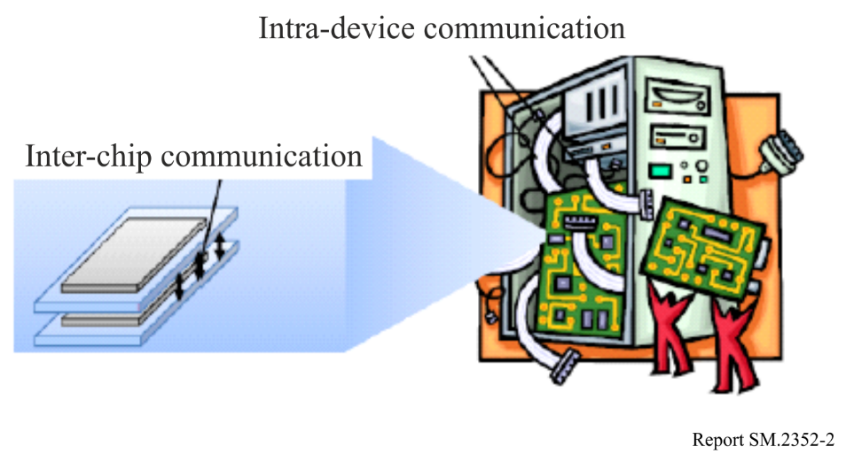
TABLE 1
Typical requirements
Communication distance | A few mm (inter-chip) to a few cm (intra-device)
Data speed | A few tens of Gbit/s
Propagation environment | Close proximity in housing and proximity model (LoS/NLoS)
Required BER | 10⁻⁹

4.1.2 Content synchronization with the cloud through close proximity communication
Figure 3 shows a use case of content synchronization with the cloud by close proximity communication. Recently, services which utilize the cloud have been rapidly increasing, together with collaboration services between a rapidly increasing smartphone and the cloud.
Cloud storage service is one of cloud services which store photos and video shot on a user’s smartphone through a network without making the user conscious of this synching process. However, packet communication utilizing 3G and LTE used by smartphones to frequently synchronize contents on the cloud without the user being conscious of it, leads to unexpected increases in battery consumption.
This use case assumes that, in addition to IC charging function at automated ticket gates at train stations, users can possess smartphones equipped with THz communication function. When passing through a train station ticket gate on your way to the office or school, simultaneously content synchronization through THz communication will suppress smartphone battery consumption.
Table 2 shows the typical requirements for these use cases. Although communication distance is less than a few cm, to synchronize an effective data volume or content during a very short time period of about 1 second, it is desirable that communication speed be made as fast as possible. For this purpose, in addition to communication speed, it will also be necessary to develop an authentication and association system which will enable the communication link establishment time to be made very short. On the other hand, even if THz close proximity communication exceeding 100 Gbit/s is feasible, it is necessary to investigate whether or not the storage reading and writing speed, which smartphones assumed in these use cases are equipped with, is compatible with such high-speed transmission. As one example, the reading and writing speed of SSD (Solid State Disc) declared to presently be the fastest in the world, is about 500 Mbytes/s (4 Gbit/s).
It is also assumed that the propagation environment will be an inter-device proximity model which applies only to LoS. Investigating whether or not multipath reflections between devices in proximity will affect data transfer needs to be studied.
Figure 3
Use case of content synchronization with the cloud by close proximity communication
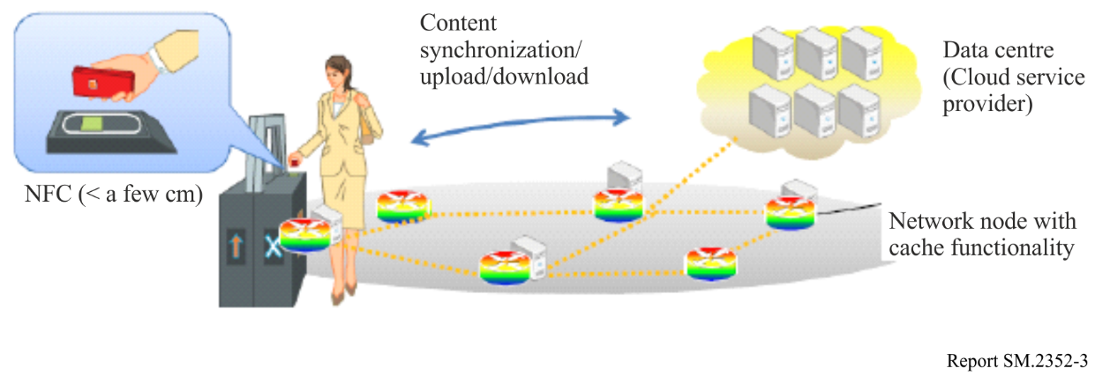
TABLE 2
Typical requirements
Communication distance | Up to a few cm (proximity)
Data speed | 4 Gbit/s – a few tens of Gbit/s
Propagation environment | Inter-device proximity model (LoS)
Required BER | 10⁻¹²

4.1.3 Wireless links between servers inside a data centre
Figure 4 shows a use case of THz communication between servers inside a data centre. Recently, services utilizing the cloud have been rapidly increasing and have accelerated the construction of data centres. Generally, several server racks equipped with various servers including storage and multiple switches can be found in data centres, and it is desirable that the wiring between servers within server racks and the wiring between racks be made wireless.
Table 3 shows the typical requirements in this use case. Communication distances from a few cm, assuming connection between servers arranged vertically within server racks, to 100 m assuming connection between racks.
Regarding the propagation environment, it is necessary to consider both LoS and NLoS which assumes an office model where building materials with comparatively low permeability (high reflectivity) are utilized, but if a special case where the server rack is placed near the wall surface and cable connections between rear panels are replaced by THz communication link is envisioned, a two-ray model can be applied between rear panels.
Figure 4
Wireless links between servers inside a data centre
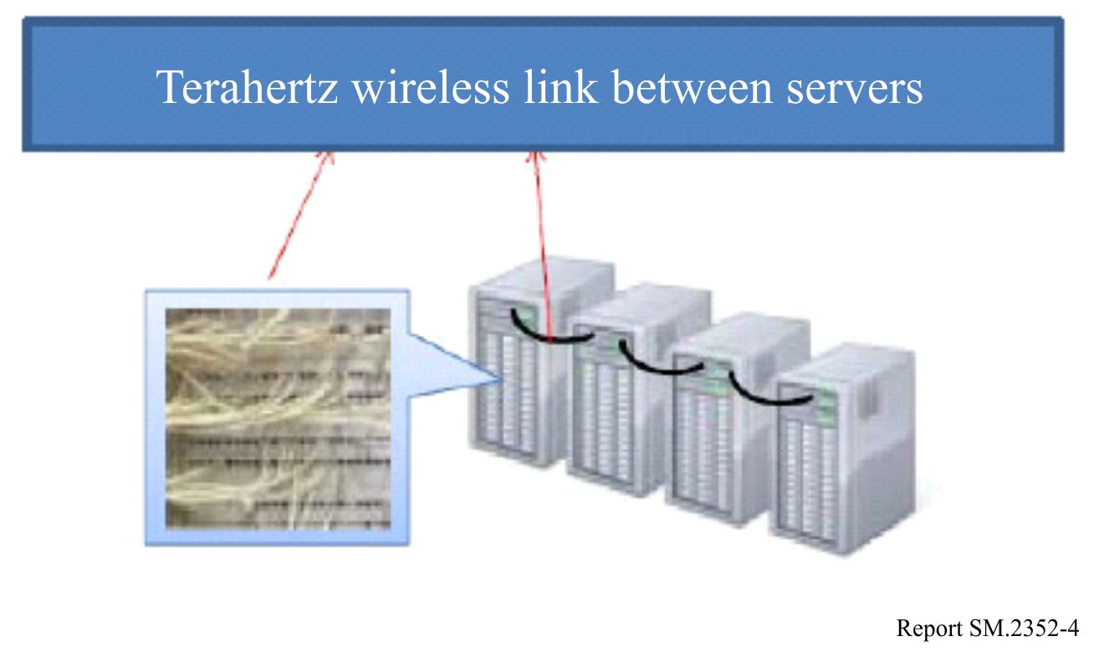
TABLE 3
Typical requirements
Communication distance | A few cm (proximity) – 100 m
Data speed | A few tens of Gbit/s – a few hundreds of Gbit/s
Propagation environment | Office model/two-wave model (LoS/NLoS)
Required BER | 10⁻¹²

4.1.4 Wireless Backhauling/Fronthauling
A backhaul link is a connection between the base station and a more centralized network element, whereas the fronthaul link is the link between the radio equipment controller of a base station and the remote radio head (radio unit). Future developments like massive deployment of small cells, the implementation of cooperative multipoint transmission (CoMP) and/or Cloud Radio Access Networks (C-RAN) may increase the required data rates for either fronthauling or backhauling or both. Realizing these links using wireless links may be attractive in situations, where fibre links are not available.
In cases, where several tens of Gbit/s are required the THz frequency range can be seen as an attractive solution. In the demonstration described in [1], a data rate of 24 Gbit/s has been achieved over a link distance of 1 km.
TABLE 4
Typical requirements
Communication distance | 100 m to 300 m
Data speed | Up to 100 Gbit/s
Propagation environment | Outdoor
Required BER | Not provided

4.1.5 THz wireless local area network (THz WLAN)
Figure 5 shows a case of THz wireless local area network (WLAN). With the development of wireless communication technology, WLAN plays a more and more important role in human life, it makes people free from the constriction of wires. Nowadays, just like internet and mobile communication network, WLAN has become an important means of information transmission and has been widely used in airport, office, restaurant, home and others. The frequency of THz is 1-4 order of magnitude, which is higher than microwave, and its data rate can be 10 Gbit/s. Considering the characteristics of high speed, wide band, compact structure, small size, low radiation damage and strong anti-interference of THz WLAN, it can be used in commercial and military applications such as future high quality video phone, video conferencing and real 3D game among others.
FIGURE 5
Use case of THz WLAN
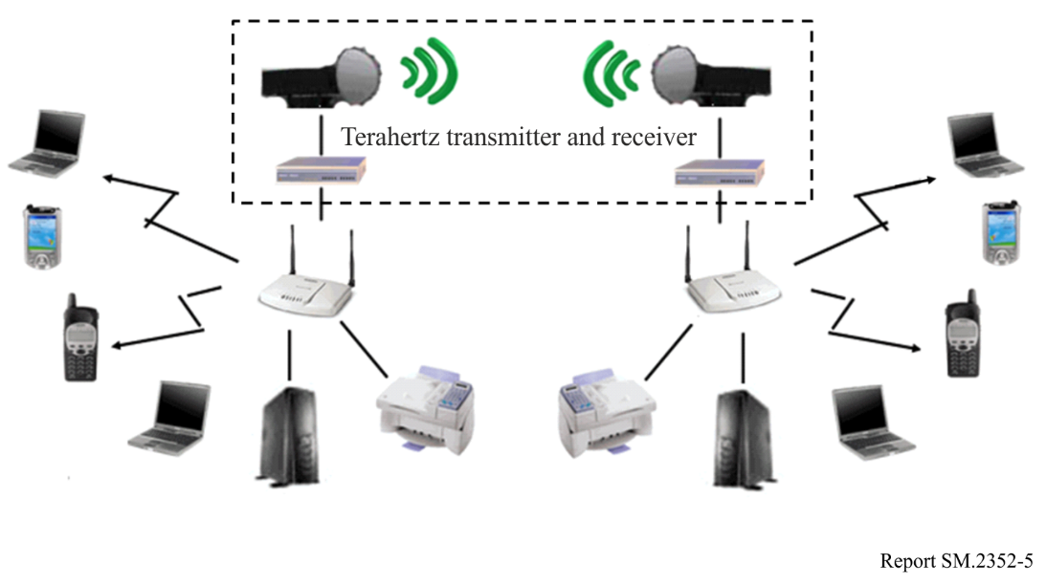
TABLE 5
Typical requirement
Communication distance | A few tens of metres
Data speed | A few Mbit/s to a few tens of Mbit/s
Propagation environment | Office, airport, restaurant
Required BER | ≤ 1 × 10⁻⁶

4.1.6 THz fixed wireless access
Fixed wireless access (FWA) provides a stable and reliable broadband access service for individual or enterprise customers in the places where the fibre links are unavailable or costly. Benefiting on its advantages such as rapid deployment and low cost, it has been widely used commercially throughout the world. As house broadband services and bandwidth-hungry applications have increasing demand on the transmission data rates (i.e. hundreds of or more Gbit/s) in the recent years, THz frequency bands are seen as an attractive solution.
Figure 6 shows a use case of THz fixed wireless access. Multiple users connect to a base station simultaneously through a dedicated device, called CPE (i.e. customer premise equipment). The communication distance may range from dozens of metres to several kilometres. In some cases, in order to reduce the penetration loss of the building materials, the CPE is installed outdoors.
Table 6 presents the typical requirements in this use case. In term of the propagation environment, both LoS and outdoor-to-indoor (O2I) models will be examined.
Figure 6
Use case of THz fixed wireless access
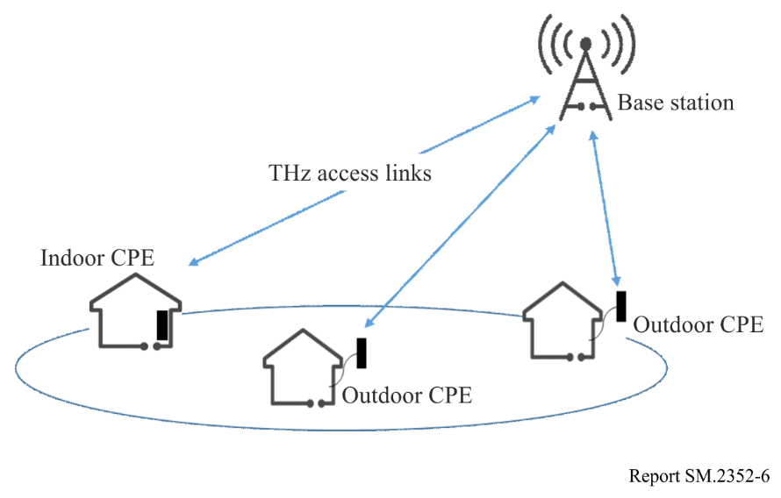
TABLE 6
Typical requirements
Communication distance | 50 m to 1 000 m
Data speed | Up to Tbit/s
Propagation environment | Outdoor, Outdoor to Indoor
Required BER | 10⁻⁵

4.1.7 THz sidelink communications
Figure 7 shows a use case of THz wireless sidelink communications. A sidelink is an auxiliary peer-to-peer communication link, which reuses the key features of the radio access links and is an integral part of the radio access network. It enables mobile devices to communicate with the nearby devices directly over short or mid-range distance. Therefore, the data traffic of the base station is offloaded, whereas the interaction delay between these mobile devices is also reduced. Device-to-device (D2D) and vehicle-to-vehicle (V2V) communications are two representative sidelink communications.
Recently, new wireless applications such as holographic interaction, automatic or assisted driving have emerged and have further requirements on bandwidth and transmission latency of communication links. It then is desirable to use sidelink communications in the THz frequency range.
Table 7 presents the typical requirements in this use case. Regarding the propagation environment, it is necessary to consider both outdoor and indoor cases.
Figure 7
Use case of THz sidelink communications
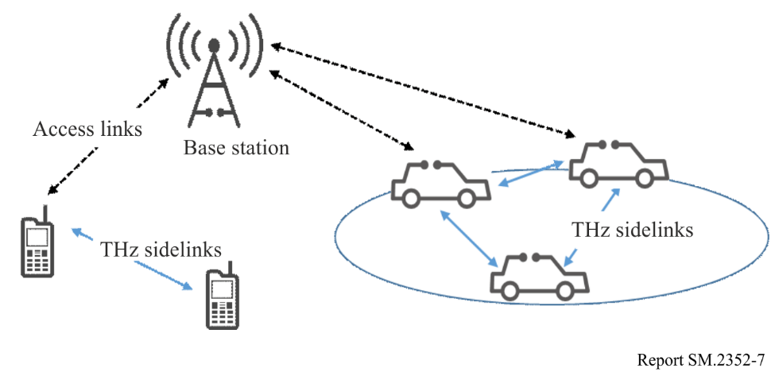
TABLE 7
Typical requirements
Communication distance | A few metres to several tens of metres
Data speed | A few tens of Gbit/s – Up to Tbit/s
Propagation environment | Outdoor/Indoor
Required BER | Not provided

4.2 THz transmitter and receiver technologies

4.2.1 300 GHz transmitter and receiver modules using MMIC
Figure 8 shows a block diagram of the overall structure of a transmitter module. A diagonal horn antenna, power amplifier, modulator, and multiplier are mounted in the metal waveguide package. The multiplier multiples 75 GHz carrier generated by local oscillator and the 20 GHz signals are supplied to the modulator. To evaluate the transmission module, an evaluation system is configured by installing a receiver module to perform evaluation. The receiver module consists of a standard horn antenna (24 dBi) and a waveguide module equipped with a Schottky barrier diode. Figure 9 shows the measured spectrum of a 20 Gbit/s ASK signal (300 GHz) at the power amplifier output terminal. A modulating signal at a centre frequency of 300 GHz ±20 GHz was observed by the output spectrum the modulator, as shown in Fig. 10.
Figure 8
Block diagram of transmitter module
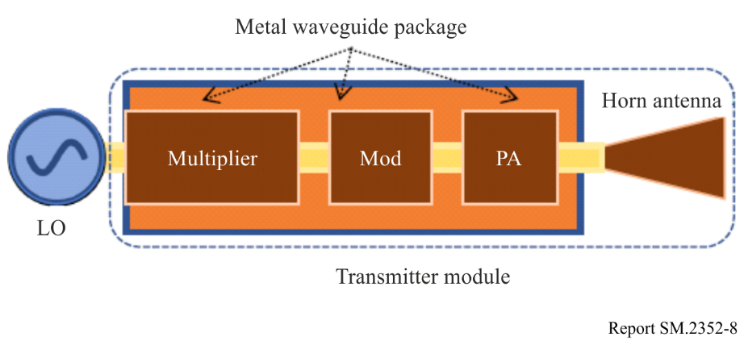
Figure 9
Eye diagram of 20 Gbit/s signal of transmitter module
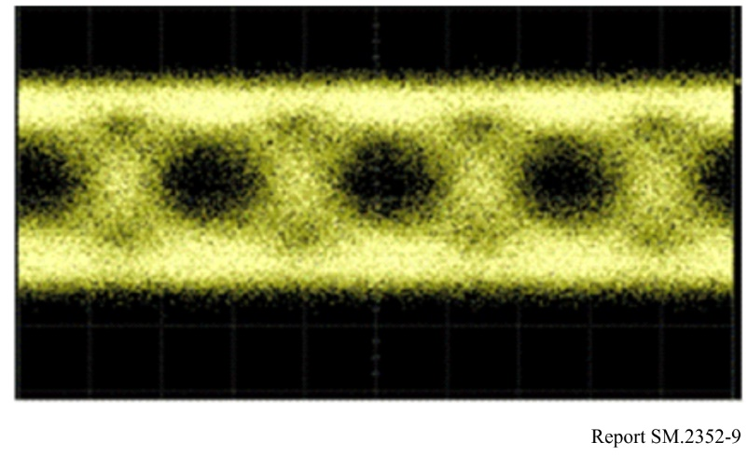
Figure 10
Output spectrum of power amplifier
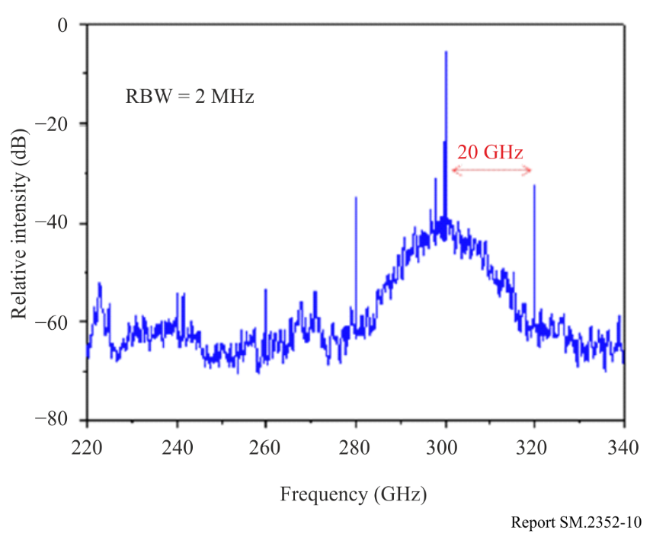
Another approach using MMIC technology is reported in [1], where a sub-harmonic quadrature transmitter operating at 240 GHz is presented. Transmitter characteristics are contained in [1] as well. Although the carrier frequency with this solution is below 275 GHz, the information gives some hints on the integrated transmitter and receiver characteristics, which can be expected in the lower THz frequency range.
In [2], a wireless communication system operating at 237.5 GHz able to deliver a data rate of 100 Gbit/s over a distance of 20 m is presented. Whereas at the receiver side the same technology is used as described in [1], at the transmitter a photonic approach is applied using a uni-travelling-carrier photodiode, from which the output is then radiated over a beam-focusing antenna.

4.2.2 300 GHz band CMOS integrated transmitter and receiver [3]
Since the maximum oscillation frequency of CMOS devices are limited to around 300 GHz, it may be difficult to fabricate CMOS amplifiers operating in the frequency band above 300 GHz. The integrated circuit architecture without CMOS amplifiers is proposed for 300-GHz integrated transmitter and receiver, and designed, fabricated using 40-nm CMOS process and experimentally evaluated. Figure 11 shows the frequency characteristics of the output power of the CMOS one-chip transmitter, as shown in Fig. 12(a), and the noise figure and conversion gain of the CMOS one-chip receiver, as shown in Fig. 12(b). The 3-dB bandwidth over 20 GHz of the output-power of the transmitter in the frequency range 250-280 GHz is achieved by the CMOS integrated circuit. The noise figure less than 28 dB of the receiver without low-noise amplifiers is achieved in the frequency range 240-290 GHz. The transmitter and receiver consist of frequency conversion circuits such as mixers, doublers and triplers, and quadrature modulators. The spectrum of 16-QAM signal whose data rate is 80 Gbit/s and the constellation which is less than 12% rms of EVM (Error Vector Magnitude) are shown in Figs 13(a) and (b), respectively. The output power of the transmitter and the noise figure of the receiver could be improved by connecting the high-power and low-noise amplifiers, respectively, made by such III-VI compound semiconductor devices as GaAs (Gallium Arsenide) and InP (Indium Phosphide).
Figure 11
Output power, noise figure and conversion gain of CMOS transmitter and receiver
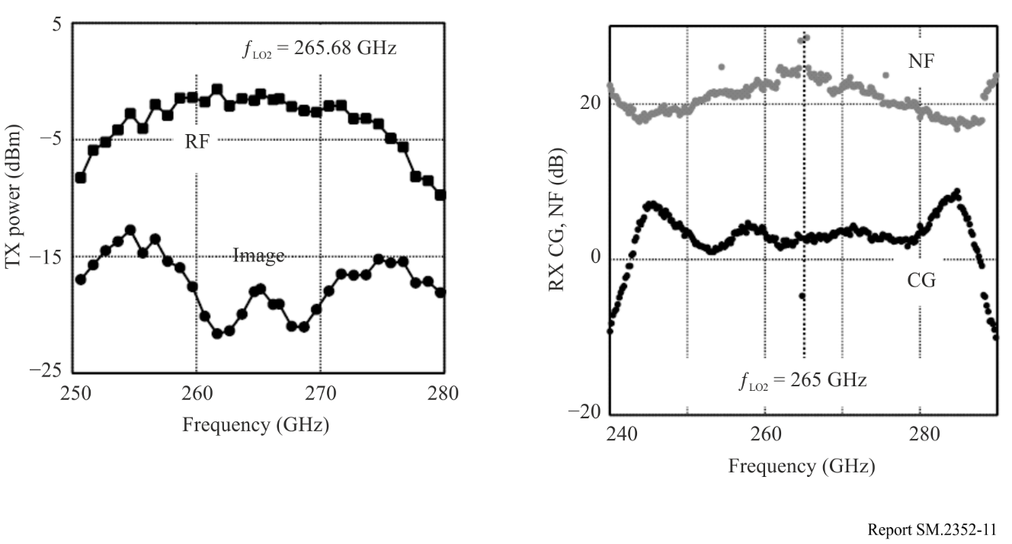
Figure 12
Photos of CMOS transmitter and receiver chips
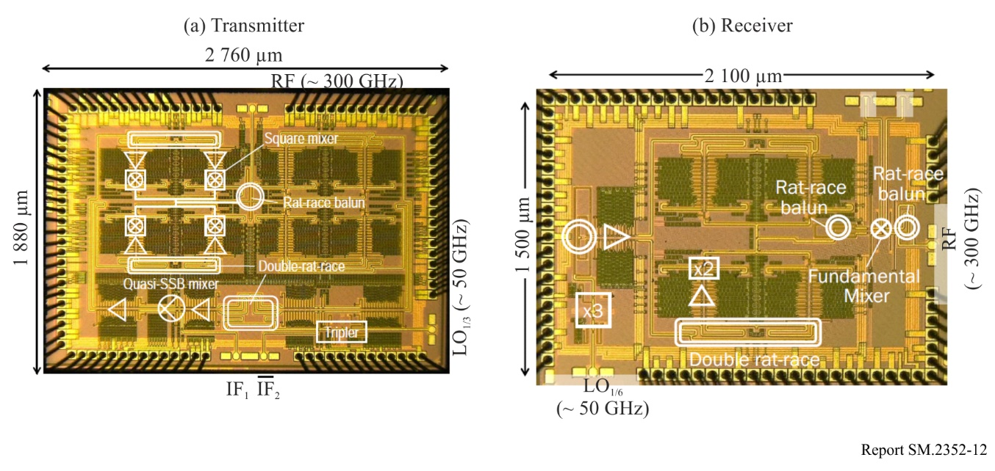
Figure 13
Performance of CMOS transmitter and receiver chips
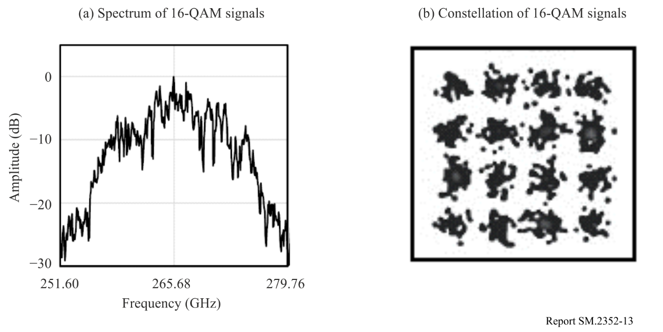

4.2.3 300 GHz transmitter and receiver using RTD
The oscillator is the so-called resonant tunnelling diode (RTD), which oscillates at an appropriate DC bias voltage. By changing the bias voltage, 300-GHz carrier signal is modulated as ON and OFF depending on the amplitude of the bias voltage. As for the receiver, the direct-detection receiver is used, as shown in Fig. 14. The maximum bit rate was 1.5 Gbit/s, and the transmission of uncompressed HDTV signals was succeeded by diode technologies. It is also demonstrated that the RTD can be also operated as a detector with high sensitivity. An error-free 2.5 Gbit/s transmission at 625 GHz using frequency multiplier for the transmitter was also demonstrated.
Figure 14
Block diagram of the wireless link using diode technologies
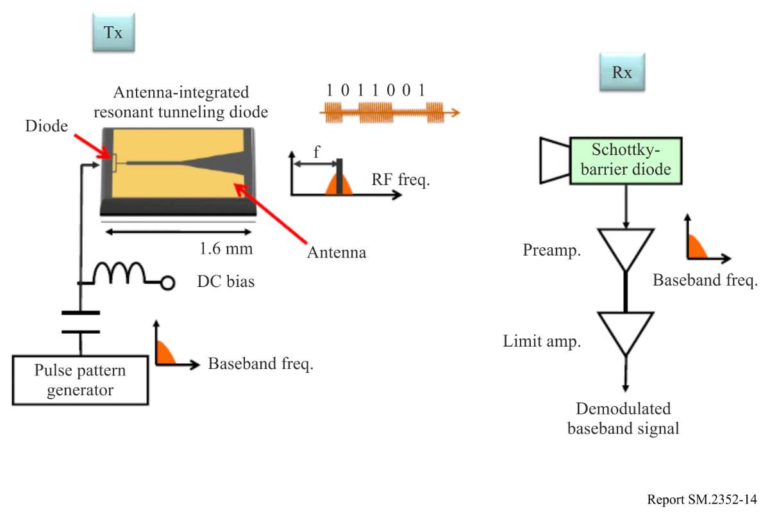

4.2.4 0.34-THz WLAN based on IEEE 802.11
Figure 15 shows the schematic of 0.34-THz WLAN, which is realized by a 0.34-THz wireless communication integrated transmitter and receiver end based on solid state semiconductor electronics technology and a WLAN device based on IEEE 802.11. The speed data of 0.34-THz WLAN can be 6.536 Mbit/s over 50 m and its BER is lower than 10⁻⁶. The MAC layer and partial physical layer are established through a commercial IEEE 802.11 wireless module, which operates at 2.4 GHz with the speed of 150 Mbit/s. The 2.4 GHz carrier based on IEEE 802.11 can be moved to 16.8 GHz by using mixer. The 16.8 GHz carrier signal is received by the receiver end of 0.34-THz WLAN and moved to 0.34 THz, and then the 0.34 THz signal is launched by antenna. If the receiver end of 0.34-THz receives signal, it converts the signal down to 2.4 GHz and sends it to wireless device based on IEEE 802.11.
FIGURE 15
Schematic of 0.34-THz WLAN node
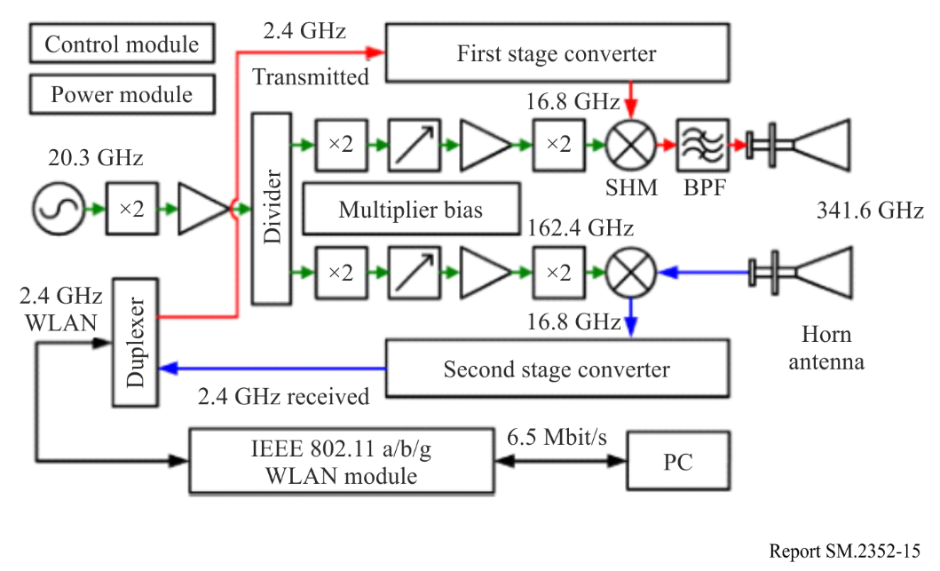
Figure 16 shows the structure of integrated transmitter and receiver front end of 0.34-THz, which is composed of 0.34-THz cavity filter, 0.34-THz harmonic mixer, 0.17-THz double frequency chain and feed bias circuit. 0.34-THz harmonic mixer is the most important module of integrated transmitter and receiver front end; its working principle is based on anti-parallel Schottky diode non-linear current-voltage (I-V) effect. 0.17 THz double frequency chain with 8 harmonic structure provides vibration signal to 0.34-THz harmonic mixer, which is composed of Q band two frequency multiplier, Q band amplifier, Q band power divider, W band two frequency multiplier, W band adjustable attenuator, W band amplifier, G band two frequency multiplier and others. It also includes three-order double frequency multiplication circuit and two-order driving amplifier.
FIGURE 16
Integrated transmitter and receiver end of 0.34-THz WLAN
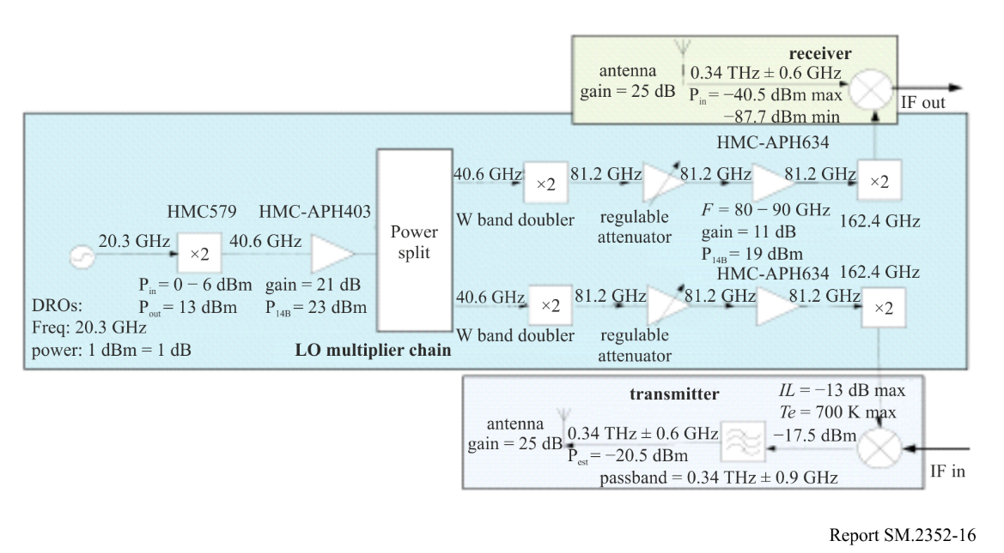

5 Sensing and imaging
THz waves possess moderate substance permeability and good spatial resolution, as well as unique characteristics which other electromagnetic frequency bands do not have, such as spectral fingerprinting of reagents, differentiation of single-stranded and double-stranded DNA, absorption difference of water and ice, and sensitivity toward semiconductor impurities; moreover, THz waves are also safe for the human body. Based on these facts, a wide range of sensing and imaging applications are expected.

5.1 THz generation method
Table 8 summarizes the relationship between THz generation methods and their technologies.
TABLE 8
THz generation methods and their technologies
Generation method | Generation technology | Material | Function
Ultra-short pulse photoexcitation | Photoconductive antenna | LT-GaAs | THz-TDS  Room temperature operation
Non-linear optics | Parametric  DFG | GaAs, GaP, GaSe, ZGP, PPLN, BD-GaAs, OP-GaAs | Variable wavelength  Room temperature operation
Photomixing | Photoconductor  UTC-PD | LT-GaAs  InP/InGaAs | Room temperature operation
Laser | QCL | GaAs/AlGaAs, InGaAs-AlInAs/InP | Narrow linewidth  Cryogenic temperature operation
Solid state electronics | Gunn, IMPATT, RTD  Compound Semiconductor | GaAs, InP, Si  AlAs/GaInAs/AlAs  HBT, HEMT, mHEMT, pHENT | Fixed wavelength  Room temperature operation
Electron tube | BWO, Gyrotron |  | Variable wavelength  Room temperature operation
(1) Ultrashort pulse photoexcitation
Presently, this is the most common THz pulse generation method. By photoexciting non-linear crystal (NLC), photo-conductive antenna (PCA), semiconductors, and superconductors among others, using an ultrashort pulsed laser with a duration of about a femtosecond, subpicosecond photoconductive current modulations within semiconductors can be brought about, and a wide band THz optical pulse can be generated by utilizing secondary non-linear polarization (light rectification) using non-resonant, non-linear media. This method is widely utilized in THz Time Domain Spectroscopy (THz-TDS).
THz-TDS has an extremely high signal-to-noise ratio (S/N) compared to the Fourier transform far-infrared spectrophotometer using a conventional thermal light source, and is being applied in THz spectroscopy and imaging among others. Although the structure, crystal makeup and excitation laser wavelength should be respectively selected for the structure of the photo-conductive antenna, and the semiconductor and non-linear crystal, owing to recent advancements in ultrashort pulse laser technology, and by using a regenerative amplifier to generate a high strength pulsed light as the excitation light, a THz pulse possessing a high electric field strength can be derived.
(2) Non-linear optics
This generation method is classified into parametric generation and difference frequency generation (DFG). Parametric generation involves wavelength conversion by way of phonon polaritons within non-linear crystals such as LiNbO3. It features tuneable wavelength and operation at room temperature, and the miniaturization of light source size from desktop-size to palm-size is possible together with the miniaturization of excitation lasers. Recently, a peak strength THz pulse exceeding 1 kW has been derived, which is comparable to values using a free-electron laser (FEL).
On the other hand, difference frequency generation (DFG) is the generation of a difference frequency utilizing the secondary non-linear optical effect of non-linear crystals. In recent years, generation methods with organic crystals such as DAST and BNA have been reported, and in terms of generation strength, mW output using intracavity DFG have been reported.
(3) Photomixing
By injecting a two-wavelength laser light into a photo-conductive device or photo diode, a THz wave which is an optical differential frequency is generated applying photoelectric conversion through photomixing. As for the photo diode, THz light exceeding 1 THz can be generated owing to the uni-traveling-carrier photodiode (UTC-PD) possessing high speed and high output characteristics.
(4) Laser
The quantum cascade laser (QCL) possesses a structure which is layered with semiconductor materials of different energy barrier heights in nanometre-order thicknesses and realizes laser oscillation through intersubband transition. Although, in principle, it will be a very narrow line width, in actuality it is limited to low temperature operation (max. operating temperature through pulse drive is 200 K). However, the output power at a frequency exceeding 1 THz is relatively large.
(5) Solid-state electronics
They are traditionally developed as microwave or millimetre-wave devices. Gunn diodes utilize intervalley transition having conduction bands with different effective masses, and Impact Ionization Avalanche Transit-Time (IMPATT) diodes and Tunnel Injection Transit-Time (TNNETT) diodes are transit time diodes which create structurally high field areas where electrons travel.
RTDs consist of a double barrier structure with semiconductor thin film and realize differential negative resistance using the tunnelling phenomenon which occurs there, deriving a basic oscillation exceeding 1 THz (although output is small).
As a practical high frequency semiconductor device currently applied in oscillators, amplifiers, and even MMIC (Monolithic microwave integrated circuit), there is HBT (Heterojunction bipolar transistor) which utilizes compound semiconductors, and HEMT (High electron mobility transistor). While InP type semiconductors with material characteristics such as high electron mobility are expected to operate faster, there also have been reports of devices which operate at more than a few hundred GHz, by applying technology such as pHEMT (pseudomorphic HEMT) and mHEMT (metamorphic HEMT) which aspire toward higher speeds.
(6) Electron tube
THz wave is generated by the backward-wave oscillator (BWO) through the interaction of the slow wave circuit and electrons; by Smith-Purcell radiation through the Smith-Purcell effect which occurs when electrons pass over a metallic diffraction grating; by the gyrotron through the cyclotron resonance maser action involving electron mass changes due to the relativistic effect. While output is generally large, housing size is also large.

5.2 THz cameras
The following are trends in the THz two-dimensional array sensor which is based on bolometer-type non-cooled infrared array sensor technology.
Figure 17 shows an image of an infrared camera equipped with two-dimensional infrared array sensor with a pixel count 320 × 240 and a pixel pitch 23.5 μm when injected with QCL of a 3.1-THz frequency. The pixel structure in this case has an additional THz absorption layer, and by adjusting the metallic thin film sheet resistance from a vacuum impedance matched to 377 Ω, sensitivity at approximately 3 THz is improved by about one digit (Fig. 18(a)). In addition, the narrow bandwidth THz array sensor shown in Fig. 18(b) has been developed for the purpose of improving sensitivity by an additional two to four times only at certain wavelengths.
Figure 19 shows the wavelength dependency of the noise equivalent power (NEP) for the wide bandwidth and narrow bandwidth THz array sensors themselves. As can be seen by looking at the characteristics of the wide bandwidth THz array sensor, it exhibits roughly flat NEP characteristics from wavelength 3 μm to a little less than 200 μm, and NEP starts to worsen from above 200 μm. Figure 20 and Table 9 show an external view and specifications of a palm-size THz camera equipped with one of the two types of array sensors, a wide bandwidth THz array sensor. Using high resistivity silicon as THz lens material, a parylene film as a non-reflective coating is formed on the silicon. As well, an infrared blocking filter (metal mesh filter which allows transmission of wavelengths more than about 30 μm) is attached in front of the THz lens. This camera can be driven from a computer via a USB 2.0 interface and also can record digital image data to a computer.
Figure 17
(a) Broadband THz array sensor; (b) Narrowband THz array sensor
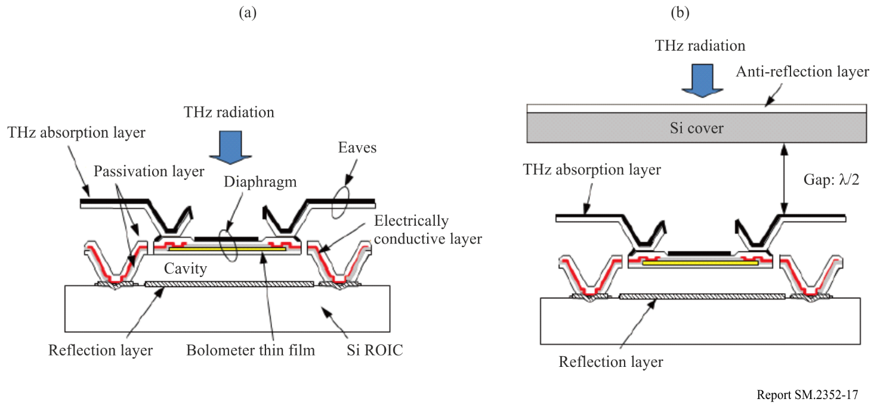
Figure 18
QCL beam pattern of THz array sensor with a pixel count 320 × 240 and a pixel pitch 23.5 μm
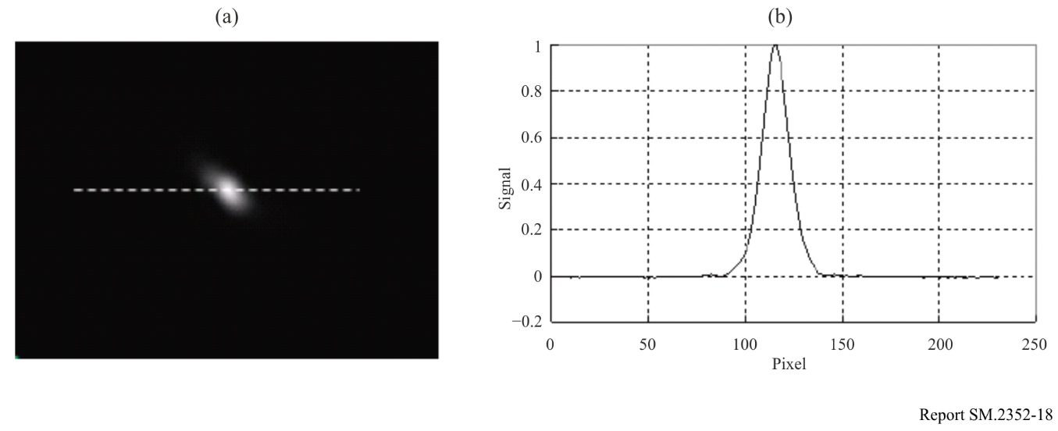
Figure 19
Wavelength dependency of NEP of THz array sensor
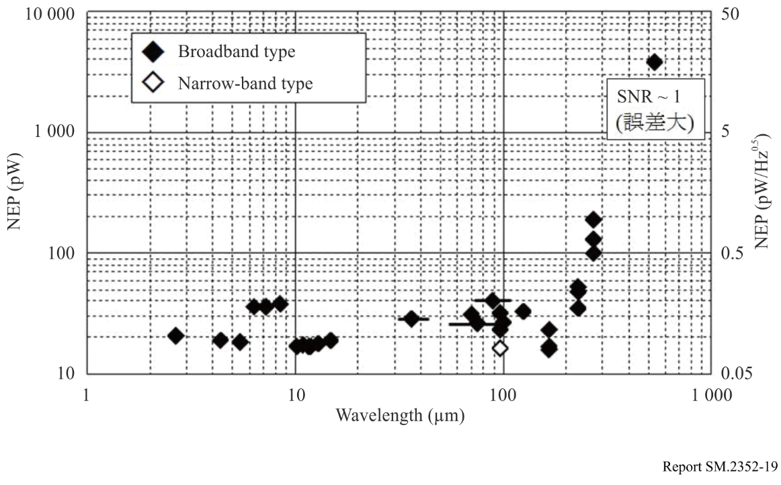
Figure 20
External view of THz camera
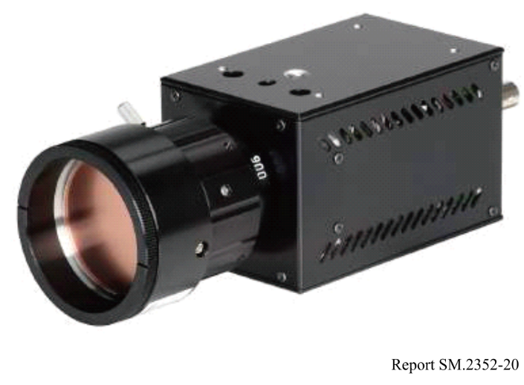
TABLE 9
Specification of THz camera
Method | Bolometer type
Array format | Pixel count: 320 × 240  Pixel pitch: 23.5 μm
Visual field | Approx. 15° × 11°  (when equipped with a focal point distance 28 mm lens)
Frame rate | 30 Hz
Output | Digital image data: USB2.0  Synchronous signal: BNC
Lock-in imaging function | Synchronous signal: 15 Hz, 7.5 Hz, 3.75 Hz, 1.875 Hz  (TTL output: +5V)
Signal processing function | Frame integration  Spatial filter
Weight | Approx. 550 g (not including lens and filter)

5.3 Spectroscopy
Spectroscopic systems can be classified into the conventional Fourier transform infrared spectrometer (FTIR), and the wavelength sweeping spectroscopic system and THz time domain spectroscopic system (THz-TDS). The Martin-Puplet system which is an extension of conventional infrared technology is an example of the FTIR. Wavelength sweeping spectroscopic systems utilize a backward-wave tube to directly change the wavelength of a THz wave, and difference frequency methods which utilize two variable wavelength lasers. However, there are issues with the variable range and wavelength accuracy.

5.3.1 THz-TDS (Time domain spectroscopy)
A powerful new tool for measuring in the THz region called THz-TDS was developed in the past decade. Electric waveforms of mono-cycle THz radiation pulse are generated and measured by gated detection with a short near-infrared spectroscopy (NIR) laser pulse. Usually, the mono-cycle THz radiation pulse contains very wide range of spectrum, typically, between 100 GHz and 10 THz. This method is becoming popular for material diagnosis.

5.3.2 FTIR (Fourier transform infrared) spectroscopy
Many materials have a so-called fingerprint spectra in the frequency range above 275 GHz. Indeed, spectroscopy in the frequency range above around 1 000 GHz has been used since 1960s, and some commercial products have been already developed. The system covers the frequency band fully up to mid-infrared range. In the mid-infrared band, spectra depend on intra-molecule behaviour, and spectral libraries of almost all standard chemicals are available. Thus, chemists can use a commercial system as a common tool to identify unknown materials. In the far-infrared region, or in THz frequency band, the fingerprint spectra depend on inter-molecule behaviour, phonon absorption, hydrogen bonds, or similar molecules conditions. Unlike mid-infrared there is no commercial spectral library.

5.3.3 Material analysis
Solid and liquid property analysis is performed applying THz-TDS. THz band polarimetry is used, for example, for evaluating material birefringence characteristics at each frequency. Utilizing this kind of evaluation function, devices are also starting to be marketed which are equipped with analysis functions for the development of new materials, such as analysis of polymer optical isomers. On the other hand, although THz waves are very susceptible to absorption by water, it has become possible to measure samples containing water, which was traditionally considered difficult in application, utilizing attenuated total reflection spectrometry (ATR method) at THz frequencies.
With this method, as sample characteristics can be derived without penetrating water, it is also possible to detect cells within the culture fluid using the ATR method and is being anticipated as an effective method for THz applications in biotechnology.

5.4 Non-destructive testing

5.4.1 Industrial products applications
The demand for THz imaging in industrial products and materials continues to be very strong-rooted. This is because only radio waves to THz bands, or radiation such as X-rays can be used to see through opaque objects in visible light. Of these, the handling of ionized radiation such as X rays is accompanied by risk and constraints, while radio waves to THz bands have low energy as quanta and are non-ionizing, and X rays are generally problematic in terms of detecting light elements such as carbon. Of radio waves to THz bands, compared to microwaves among others which, in principle, have long wavelengths and poor image resolution (spatial resolution), millimetre waves to THz waves which achieve spatial resolution at mm order or less have a far greater utility for application in imaging.
In industrial products, non-metallic materials which transmit THz waves are abundant in our everyday lives. Some of the most typical of these products are made of plastics, vinyl, and paper, while others are made of ceramics and rubber and possess various functions and often have high added value. As examples, there are medical components which utilize the heat resistance of ceramics and the flexibility of rubber. These products are widely used in the energy area and medical area and are highly needed in foreign particle detection. The size of defects is frequently at least about 1–10 μm, and a high S/N ratio and speed are required.
THz CT technology is promising as THz imaging technology in non-destructive testing that cannot be managed using X rays. THz waves which can derive spectroscopic information can detect defects, as well as information on what kind of defects they are, and are attracting attention as a technology that can bring new added value to analysis. Defects which require detection include foreign particles, as well as thin film unevenness and defects in coating among others.
The desired accuracy depth is generally about a few μm, but in an inspection of semiconductor substrates and others, there are cases when electrical characteristics of thin film thickness of less than about a few 100 nm are required. Although measuring such thin film was thought to be difficult using THz waves, owing to recent advances in technology development, this is starting to be shown to be possible.

5.4.2 Biological and medical applications
Nowadays, clinical inspection applications are wide ranging from inspections for lifestyle diseases to cancer markers if research applications are included. Of the basic principles for sensing in-vivo target proteins among others, there are many which are modelled after the recognition mechanism of organisms such as the antigen-antibody reaction.
However, for a human to discern the presence/absence of this recognition, one level higher of processing is required. For example, in the detection method for allergens utilizing an inspection method called enzyme immunoassay, a capture antibody which specifically binds with the allergen is affixed to a substrate, and after reacting with a sample, the presence/absence of this allergen is detected using a detection antibody or detection marker. In this way, multi-stage reactions are employed to indicate the test results through colour or fluorescence. Such markers have been designed to efficiently produce colour through the slightest reaction with the substrate, and in chemiluminescent measurements, detection sensitivity in the order of picogram is achieved. However, multi-stage inspections also have issues such as requiring numerous reagents and long inspection time, as well as an increase in error factors through multi-stage processing.
Within this background, a German research group in 2000 reported on the possibility of no marker detection using THz waves. These researchers showed in their experiments that there were differences in THz band refractive index and transmittance in single-stranded and double-stranded DNA. Later, a research group in the United States of America proposed a method of detecting the binding of avidin and biotin through the phase delay in the THz-TDS time waveform. This means that it is possible to detect the presence/absence of binding, without the use of markers, from changes in the refractive index and absorbance of biological polymers at THz bands. In Japan, utilizing an imaging measuring system comprised of a quantum cascade laser and THz camera, a line of small-molecule compounds was affixed on a membrane filter, and proteins which specifically bind with them were successfully detected in image format, verifying that it is possible to detect biological substances such as proteins swiftly, conveniently, and in a marker-free fashion.
On the other hand, there is the issue of detection sensitivity as an important technology development theme. The inspection sensitivity required for clinical inspections is in the range of milligram to picogram, and the inspection sensitivity particularly in the range from nanogram to picogram is most needed in no marker inspections. As an example of inspection applications requiring such small sensitivity, application in predictive diagnosis for autoimmune diseases stemming from autoantibodies in the blood can be raised.
Generally, protection from the invasion of bacteria and viruses from the outside occurs through immune reaction within the body. However, with autoimmune diseases, substances involved in immunity within the body attack the body. For example, with type 1 diabetes, autoantibodies which target three types of pancreatic proteins have been discovered, and it is known that 70 to 90% of patients possess at least one of these autoantibodies. In addition, the relationship between these three autoantibodies and their incidence has been investigated, and clear relationships have been presented. Therefore, by conducting preliminary inspections to know whether or not these autoantibodies exist within the body, onset can be predicted, and they can also be used in prevention.
It is desirable that such inspections be performed for health examinations, and it is important that inspection technology, which is convenient, fast and cheap be developed. When applied in health examinations, it is ideal if various diseases can be predicted in one inspection, and not just for type I diabetes indicated here. In other words, to perform inspections at one time by reacting the autoantigens of various diseases affixed onto a single inspection chip with small amounts of autoantibodies found in drawn blood, technology that can perform no marker inspections and detect picogram order biological substances is required.
Among clinical inspections, test drugs for conventional immune serum inspections, including inspections based on antigen-antibody reaction, were expected to have a domestic market of 157.2 billion yen in FY2008 and 168 billion yen in FY2013, according to a survey conducted by Fuji-Keizai. This market amounts to over 40% of the test drug market and occupies the highest ratio. With their advent, no marker and high accuracy inspection technology is expected to enter these markets and contribute to the expansion of market size.
On the other hand, such needs for no marker and trace substance inspection are assumed in various settings, and their spillover effect is great. They include the security field in inspecting dangerous gases, bacteriological weapons, and explosives; infectious virus inspection such as for new type influenzas where there are concerns of pandemic; and inspection of trace substances in the environment, residual pesticides in agricultural products, and residual antibiotics in livestock.
Therefore, it is important to pursue the early development of no marker inspection technology as an infrastructure, research relating to the selectivity of inspection substances based on this technology, and research and development to improve detection sensitivity. As one technology to improve the detection sensitivity of THz waves, there is a method utilizing a metallic mesh as a sensor, which has led to technologies enabling the detection of proteins in the order of nanogram/mm.
By merging technology for the no marker detection of trace substances with imaging technology, the range of uses will continue to expand. In particular, it will be possible to comprehensively inspect proteins which specifically bind to small molecule arrays and sugar chain arrays and will become a technology which can advance into the drug discovery field. In addition, no marker detection using THz wave technology will clarify the existence of proteins which have been overlooked until now as they could not be marked and is expected to become a powerful screening technology in life science research.

5.4.3 NDT system based on synthetic multi-band LFMCW imaging system
THz NDT system also uses FMCW signal. The synthetic multi-band LFMCW imaging system has been designed. In order to further expand the system bandwidth and enhance the range resolution, the imaging systems operating in the different frequency bands are spliced and synthesized. The system uses the “time division multiplexing” method to complete the frequency sweep of the multi-channels, and then stitch the intermediate frequency data of the multi-channels to complete the synthetic bandwidth. And the quasi-optical focusing system with shared aperture is designed and realized. The observation points of multi-channels are aligned. Finally, the effectiveness of the 110-500 GHz synthetic system is verified by the three-dimensional imaging experiments. Therefore, THz imaging has gradually become a new supplementary method for non-destructive testing.

5.5 THz radar applications
Compared to microwave, THz wave has narrower pulse width, smaller antenna size, narrower beamwidth and better directivity, which make THz radar be able to detect smaller targets and achieve more accurate positioning than microwave radar. Furthermore, with the advantage of imaging through material, THz radar can detect objects which are hidden in the cover or smoke.

5.5.1 Radar active imaging
THz Radar active imaging could be implemented mainly by SAR/ISAR methods.
Synthetic aperture radar (SAR) imaging is an imaging technology which is not restricted by the optical aperture of the detected target. According to whether the radar is moving or not, the imaging can be divided into SAR imaging and inverse synthetic aperture radar (ISAR) imaging. By using the ultra-broad bandwidth, ultra-narrow pulse width and the better directivity of THz wave, THz SAR and ISAR radar can achieve very high imaging resolution compared to traditional microwave radar.
Depending on the methods generating THz waves, the THz imaging radars could be divided into electronics and photonics. Due to the implementation difficulties of photonics radars, more THz imaging radars are developed based on the electronics method. This section mainly describes the electronics THz imaging radars.
The THz imaging radars are usually composed of frequency synthesizers, multipliers, mixers, low-noise amplifiers (LNA), data sampling units and signal processing units among others. Compared to the traditional pulsed radar, limited by the current power level of THz signal source, most of the THz imaging radars use frequency-modulated continuous-wave (FMCW) waveforms. A typical block diagram of THz imaging radars is shown in Fig. 21 [5].
Figure 21
Typical block diagram of THz imaging radars
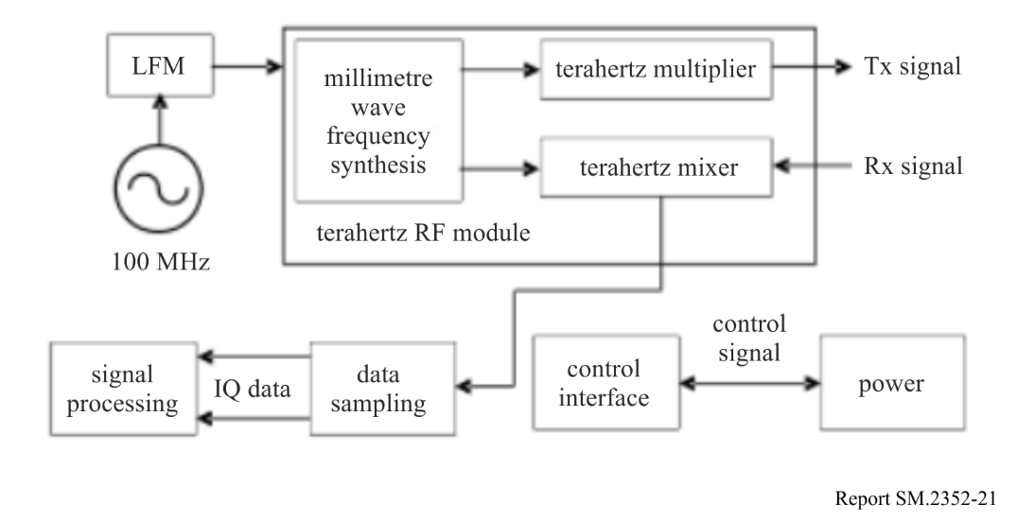
In past one or two decades, many institutes and universities worldwide developed various THz imaging radars. Most of them are under experimental or prototype stage, while some others are close to practicality. The main characteristics of several THz imaging radar systems are showed in Table 10.
TABLE 10
Characteristics of several THz imaging radar systems
 | System A  [6] | System B  [6] | System C  [6] | System D  [6][7]
Operating freq. (GHz) | 330 | 670 | 670 | 300
Bandwidth (GHz) | 6.4 | 28.8 | 28.8 | 44
Output power (mW) | 10 | 0.5 | 1.2 | 1
Modulation mode | FMCW | FMCW | FMCW | FMCW
Detection mode | Beam Scanning | Beam Scanning | ISAR | ISAR
Operating distance (metre) | 20 | 25 | 2-8 | 700 (human body)
Resolution (cm) | 1 | 1 | 1.3 | 0.37
Year | 2010 | 2011 | 2013 | 2015

It is expected that the THz imaging radar will make obvious progress and become operational in the next decade, as the performance of terahertz devices improve, and system design matures.

5.5.2 Non-contacting security inspection
THz radar could be used in non-contacting security inspection. Based on the abilities of penetrating clothing, cardboard and other non-polar materials while maintaining high-resolution, THz radar can achieve high-resolution perspective imaging of hidden dangerous goods. The detection distance can reach 20 to 100 metres [8], which can provide early warning beyond the radius of dangerous goods attack. In addition, the terahertz photon energy is low, far less than the ionization energy of human skin, which can eliminate people's anxiety about radiation damage.

5.5.3 Walk-through scanning system
Walk-through scanning systems, as shown in Fig. 22, with high throughput and detection performance have been investigated to not only detect metallic and non-metallic threats but also avoid long passenger’s queues at the airport security checkpoint. Figure 22(a) shows the schematic illustration of the walk-through scanning systems which consist of two panels which enable simultaneous viewing person’s both sides. Figure 22(b) shows the block diagram of the integrated transmitter and receiver which functions FM-CW radar performing a high signal-to-noise ratio [9]. The resolution of such scanning systems using FW-CW radars is dependent on the bandwidth of carrier frequencies. The frequency bands which provide the contiguous bandwidth over 8 GHz for radiolocation services as a primary service are shown as follows in accordance with Radio Regulations:
– 8-GHz bandwidth; 92-94 GHz, 94-94.1 GHz, 94.1-95 GHz and 95-100 GHz;
– 12.5-GHz bandwidth; 136-141 GHz and 141-148.5 GHz;
– 10-GHz bandwidth; 238-240 GHz, 240-241 GHz and 241-248 GHz.
Although the maximum contiguous bandwidth of 12.5 GHz is available in the current regulation, a range resolution less than 5 mm required for the scanning system cannot be achieved using the frequency bands below 275 GHz. Table 11 also summarizes the other specifications for the walk-through scanning systems. Due to THz frequency operation, the clothing materials may impact the performance of the system. The specific parameters such as output power and antenna type of the walk-through scanning system should be carefully examined taking into account the attenuation and reflection characteristics of clothing materials in the operating frequency range 275-600 GHz. Figure 23 shows the relationship between possible frequency ranges for operation of the walk-through scanning systems and absorption attenuation due to atmospheric gases. The centre frequencies 325 GHz, 380 GHz, 447 GHz and 555 GHz for Band 1, Band 2, Band 3 and Band 4, respectively, are proposed to attempt to avoid harmful interference to passive service applications to be operated in the co-frequency and adjacent frequency bands.
Transmission properties, absorption measurements and refractive index of several clothing materials in the terahertz range are provided by non-ITU publications [10]-[15]. They indicate that clothing materials are transparent in the condition of operational frequencies, thickness and density of materials, and periodicity of weave patterns, and that transmittance of several clothing materials generally changes from transparency to opaque as the frequency increases. Metal as well as contraband materials under clothing may be discernible if the reflectivity of those materials is larger than that of clothing materials in the frequency range 0.1-1 THz.
Figure 22
Concept of walk-through scanning system using THz
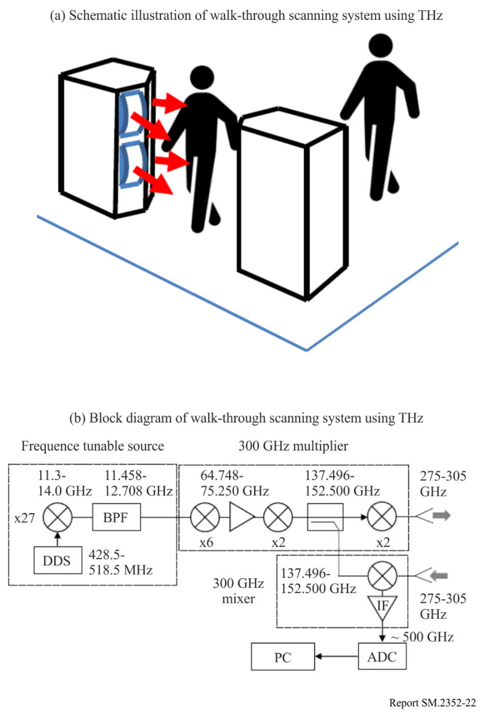
TABLE 11
Specifications of walk-through scanning systems
Parameters | Values
Centre frequency (GHz) | 325, 380, 447, 555
Output power at 325 GHz (mW) | > 10
Antenna pattern | Gaussian
Antenna type | Horn
Frequency bandwidth (GHz) | 30
Range resolution (mm) | 5
Maximum detection distance (m) | 3
Pedestrian speed (km/h) | 2-4
Number of radars | 8-16
Detectable concealed materials | Metal, ceramic, explosive, combustible liquid
Figure 23
Possible frequency range for operation of walk-through scanning systems
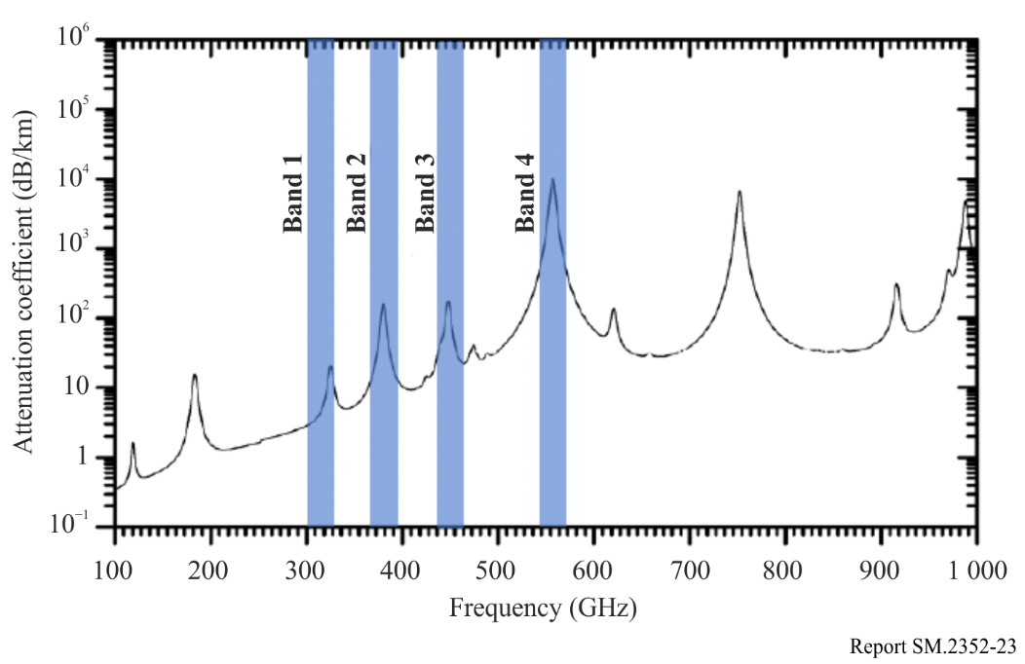

6 Integrated sensing and communication (ISAC) in a radio access network
RANs were originally designed for wireless communication between the base stations and the user equipment. With the rapid growth of the demand for location-based applications, e.g. advertisement push based on the terminal’s location, existing RAN systems are enabled with a certain capability of positioning if the system reference signals could be used for detecting the surrounding environment, which can be seen as an attempt to integrate sensing into a communication system.
Future RANs are expected to shift more to the higher frequency bands, including the THz bands where a large amount of spectrum is available. This will allow RANs to have greater transmission capabilities as well as the sensing capabilities comparable to the typical radio localization systems. Integrated sensing and communication in a radio access network are being studied [16]-[19].
Figure 24 shows a use case of integrated sensing and communication in a radio access network, where the links suitable for operating in the THz frequency bands are marked with blue circles. Either the base stations or the terminal devices can extract information about the object of interest in the surrounding environment from the received RF signals, such as existence, distance, speed, shape, and orientation. This information can be used for services such as localization and tracking, environment mapping and reconstruction as well as gesture/activity recognition among others. Furthermore, it can also be used to improve the performance of communication services. With respect to the source of the RF signals, they may either be a communication signal or a dedicated sensing signal.
From the perspective of spectrum, the co-designed system for sensing and communication simultaneously will improve the efficiency of spectrum utilization.
Figure 24
Use case of THz integrated sensing and communication in a radio access network
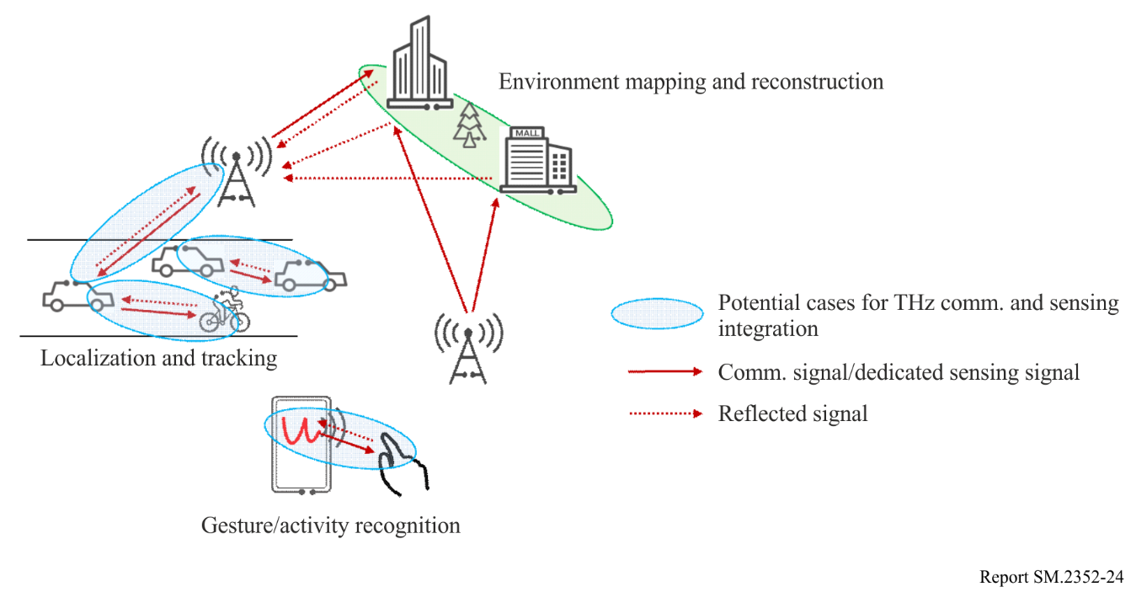
Figure 25 shows an implementation structure of THz integrated sensing and communication system, including antenna panel, radio frequency (RF) front-end, intermediate frequency (IF) circuit, Analogue-to-Digital (AD)/DA sampler, and baseband processing unit. The baseband units of transmitter and receiver are connected through a digital loopback network, to jointly process the transmitted and received sensing signals. One RF channel can drive one or multiple antenna panel (s) with several antenna elements.
Based on this structure, Fig. 26 provides an RF front-end implementation with four-transmit and sixteen-receive (4T16R) for THz integrated sensing and communication system. Specifically, it is composed of one set of transmitter chip and four set of receiver chips. As shown in Fig. 26(a), in each set of chips, four channels share one up or down-converter for transmitter or receiver, and each channel has the independent phase shifter and the gain-controllable driving amplifier, then connects to the antenna panel with one element only. The transmitted and received signals share a local oscillator (LO) system.
Figure 25
An implementation structure of THz integrated sensing and communication transmitter and receiver
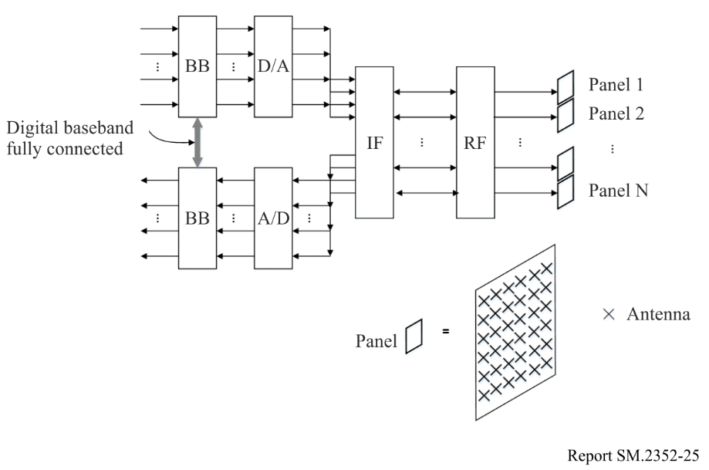
Figure 26
A RF front-end chip with four-transmit and sixteen-receive (4T16R) for THz integrated sensing and communication transmitter and receiver. (a) the implementation structure of a transmitter/receiver front-end chip, (b) the picture of the 4T16R front-end module
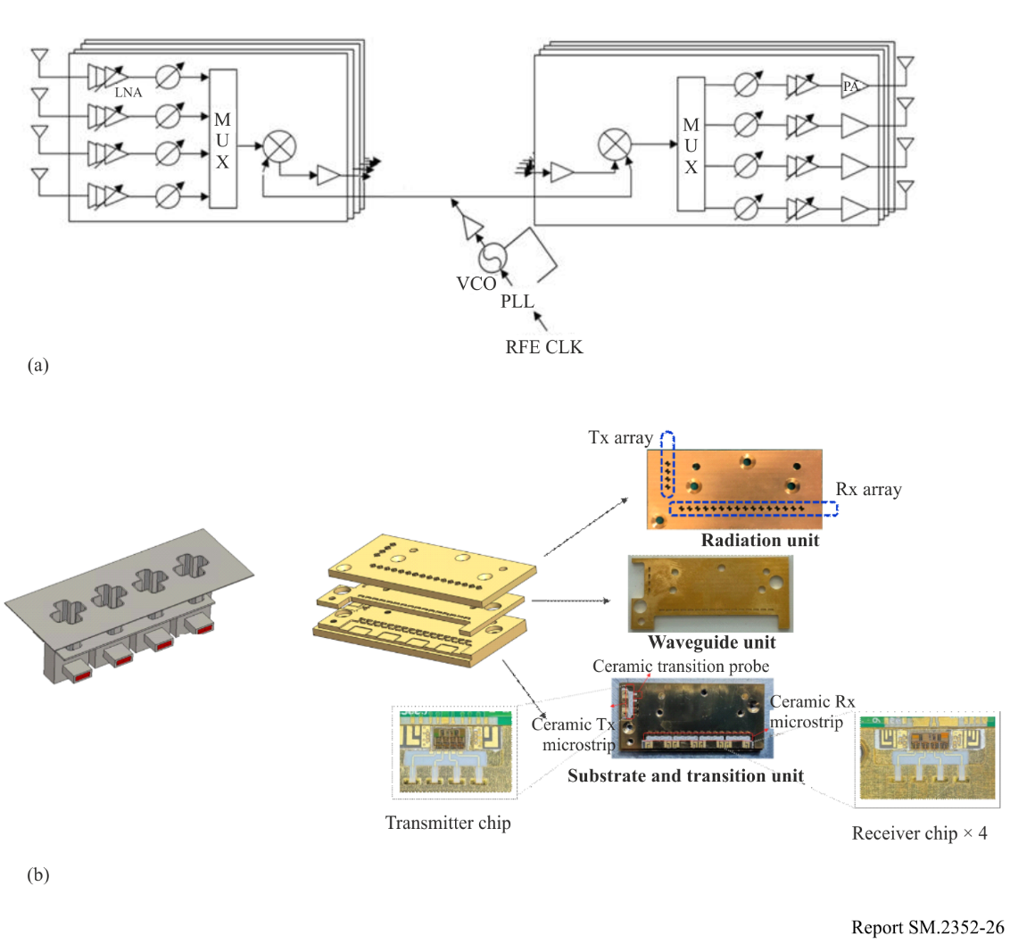
Depending on the different system requirements of the operating frequencies, the implementation of the chip will have to choose between the different semiconductor processes. For example, the cut-off frequency of SiGe transistors typically supports the chips which work on the frequency bands below 300 GHz [20], while InP transistors are applied in the cases up to 600 GHz [21] because of its better electron mobility. Furthermore, in order to improve the output power of the transmitter and the sensitivity of the receiver, heterogeneous integration with III-V compound semiconductor devices such as GaN and InP is also taken into account.

7 THz related activities within the international standard organization
In 2008 IEEE 802.15 created the THz Interest Group (IG THz). The focus was primarily concerned with THz communications and related network applications operating in the THz frequency bands between 275-3 000 GHz. Such THz communication applications would include: component to component, board to board, machine to machine, human to machine and human to human (indoor and outdoor) wireless communications. THz communication applications cover multiple categories with varying requirements. As envisioned, THz communications would overall employ wireless modulation methods of limited complexity, omni and/or directional antenna systems, and would typically offer very high data transfer rates in multiples of 10 Gbit/s, and up to 100 Gbit/s, for parity with future fibre optic capacities. THz wireless systems could support transmission distances ranging from the very short (few centimetres or less) to relatively long distances of several hundred metres.
The IG THz has focused on open spectrum issues, channel modelling and monitoring the development of technology. With the development of more mature integrated transmitter and receiver technologies 802.15 made a step forward towards the development of the first wireless 300 GHz standard by establishing Task Group 3d in 2014, which completed its work in October 2017, when the amendment IEEE Std 802.15.3d-2017 was published. This amendment is based on IEEE Std 802.15.3c and defines a wireless switched point-to-point physical layer to IEEE Std 802.15.3-2016 operating at PHY data rates typically in the range of up to of 100 Gbit/s. Operation is considered in bands 252-321 GHz at ranges as short as a few centimetres and up to several hundred metres. The development of IEEE Std 802.15.3d-2017 was in parallel to IEEE Std 802.15.3e-2017, which developed an amendment for 60 GHz high-rate close-proximity (HRCP) communications. Large parts of the MAC layer as well as the defined modulation and coding schemes are identical in both amendments.
Potential applications of interest include wireless data centres, kiosk downloading, wireless intra-device communication and wireless backhauling and fronthauling.
Prospective opportunities to develop further amendments in the THz frequency range are evaluated in the THz Standing Committee, which replaced the IG THz in 2018.

8 Summary
The characteristics of THz devices and systems discussed in this Report are rapidly being improved by the advancement of device technologies. THz wireless communication systems, in particular, may have large potential to transmit high data rate close to 100 Gbit/s whose speed is currently discussed within IEEE 802. The sharing study between passive and active services and the review of RR needs to be taken into account to introduce those devices into market in the near future.

9 References
[1] J. Antes et al., High Data Rate Wireless Communication using a 240 GHz Carrier IEEE 802.15-14-0017-00-0thz, Los Angeles, January 2014; https://mentor.ieee.org/802.15/dcn/14/15-14-0017-00-0thz-high-data-rate-wireless-communication-using-a-240-ghz-carrier.pdf
[2] S. König et al., Wireless sub-THz communication system with high data rate, Nature Photonics 7, 977–981 (2013), http://www.nature.com/nphoton/journal/vaop/ncurrent/abs/nphoton.2013.275.html
[3] M. Fujishima, 300-GHz-band CMOS transceiver for ultrahigh-speed terahertz communication, Proc. SPIE, Terahertz, RF, Millimeter, and Submillimeter-Wave Technology and Applications XII (2019).
[4] APT/ASTAP/REPT-04 – Technology trends of telecommunications above 100 GHz.
[5] WU Fu-Wei et al., A 220GHz terahertz Synthetic Aperture Radar, Journal of Terahertz Science and Electronic Information Technology, Vol. 15, No. 3, Jun. 2017.
[6] D.S. li et al., Research Progress of THz Imaging Radar System, Journal of Microwaves, Vol. 31, No. 6, Dec. 2015.
[7] H.Q. Wang et al., Review of Terahertz Radar Technology, Journal of Radars, Vol. 7, No. 1, Feb. 2018.
[8] X.B. Yang et al., Terahertz Band Radar, National Defense Industry Press (China), December 2017.
[9] C. Otani et al., Development of MMW-to-THz Radar Imaging Technology and Systems, 2020 IEEE International Symposium on Radio-Frequency Integration Technology (RFIT), September 2020.
[10] D.T. Petkie, et al., “Active and passive millimeter and sub-millimeter-wave imaging,” in Proc. SPIE, 2005, vol. 5989, pp. 598918-1 – 598918-8.
[11] A.J. Gatesman, et al., “Terahertz behaviour of optical components and common materials,” in Proc. SPIE, 2006, Vol. 6212, pp. 62120-E1 – 62120-E12.
[12] M.C. Kemp, "Millimetre wave and terahertz technology for the detection of concealed threats: a review," in Proc. SPIE, 2006, Vol. 6402, pp. 64020D-1-64020D-19.
[13] R. Appleby and H. B. Wallace, “Standoff detection of weapons and contraband in the 100 GHz to 1 THz region,” IEEE Trans. Antennas Propagation, Vol. 55, No. 11, pp. 2944-2956, Nov. 2007.
[14] R.E. Miles, X.-C. Zhang, H. Eisele, and A. Krotkus, (Editors), “Terahertz Frequency Detection and Identification of Materials and Objects,” in NATO Science for Peace and Security Series – B: Physics and Biophysics, Springer, 2007, pp. 225-240.
[15] P.F. Goldsmith, et al., “Focal plane imaging systems for millimeter wavelengths,'' IEEE Trans. Microwave Theory Techniques., Vol. 41, No. 10, pp. 1664-1675, Oct. 1993.
[16] C. Lima et al., Convergent communication, sensing and localization in 6G systems: an overview of technologies, opportunities and challenges, IEEE Access, Vol. 9, June 2021.
[17] M. Rahman et al., Framework for a perceptive mobile network using joint communication and radar sensing, IEEE Transactions on Aerospace and Electronic Systems, Vol. 56, No. 3, June 2020.
[18] W. Tong, P. Zhu, et al., 6G: The Next Horizon: From Connected People and Things to Connected Intelligence. Cambridge: Cambridge University Press, 2021.
[19] Oupeng Li, Jia He, Kun Zeng, Ziming Yu, Xianfeng Du, et al., “Integrated Sensing and Communication in 6G A Prototype of High Resolution THz Sensing on Portable Device,” in 2021 Joint European Conference on Networks and Communications & 6G Summit (EuCNC/6G Summit), 2021, pp. 544-549.
[20] X. Deng, Y. Li, J. Li, C. Liu, W. Wu and Y. Xiong, “A 320-GHz 1x4 Fully Integrated Phased Array Transmitter Using 0.13 um SiGe BiCMOS Technology,” IEEE Trans. Terahertz Science and Technology, Vol. 5, No. 6, pp. 930-940, Nov. 2015.
[21] W.R. Deal et al., “A Low-Power 670-GHz InP HEMT Receiver,” IEEE Trans. Terahertz Science and Technology, Vol. 6, No. 6, pp. 862-864, Nov. 2016.

It should be noted that all of the walk-through scanning system’s proposed frequency ranges overlap frequency bands identified for use by passive service applications, see RR No. 5.565. Additional analysis is needed to determine what practicable steps can be taken to protect these passive services from harmful interference.

