Report ITU-R SM.2256-2
(06/2026)
SM Series: Spectrum management
Spectrum occupancy measurements and evaluation

Foreword
The role of the Radiocommunication Sector is to ensure the rational, equitable, efficient and economical use of the radio-frequency spectrum by all radiocommunication services, including satellite services, and carry out studies without limit of frequency range on the basis of which Recommendations are adopted.
The regulatory and policy functions of the Radiocommunication Sector are performed by World and Regional Radiocommunication Conferences and Radiocommunication Assemblies supported by Study Groups.

Policy on Intellectual Property Right (IPR)
ITU-R policy on IPR is described in the Common Patent Policy for ITU-T/ITU-R/ISO/IEC referenced in Resolution ITU-R 1. Forms to be used for the submission of patent statements and licensing declarations by patent holders are available from https://www.itu.int/ITU-R/go/patents/en where the Guidelines for Implementation of the Common Patent Policy for ITU-T/ITU-R/ISO/IEC and the ITU-R patent information database can also be found.

Series of ITU-R Reports
(Also available online at https://www.itu.int/publ/R-REP/en)
Series | Title
BO | Satellite delivery
BR | Recording for production, archival and play-out; film for television
BS | Broadcasting service (sound)
BT | Broadcasting service (television)
F | Fixed service
M | Mobile, radiodetermination, amateur and related satellite services
P | Radio-wave propagation
RA | Radio astronomy
RS | Remote sensing systems
S | Fixed-satellite service
SA | Space applications and meteorology
SF | Frequency sharing and coordination between fixed-satellite and fixed service systems
SM | Spectrum management
TF | Time signals and frequency standards emissions

Note: This ITU-R Report was approved in English by the Study Group under the procedure detailed in Resolution ITU-R 1.

Electronic Publication
Geneva, 2026
© ITU 2026
All rights reserved. No part of this publication may be reproduced, by any means whatsoever, without written permission of ITU.

REPORT ITU-R SM.2256-2
Spectrum occupancy measurements and evaluation
(2012-2016-2026)
Summary
Spectrum occupancy measurements and evaluation in modern RF environments with increasing density of digital systems and frequency bands shared by different radio services become a more and more complex and challenging task for Monitoring Services. Based on Recommendations ITU-R SM.1880, ITU-R SM.1809 and information provided in the 2011 Edition of the ITU Handbook on Spectrum Monitoring, this Report provides a far more detailed discussion on different approaches to spectrum occupancy measurements, possible issues related to them and their solutions.

TABLE OF CONTENTS
Page
1 Introduction 3
2 Terms and definitions 5
2.1 Spectrum resource 5
2.2 Frequency channel occupancy measurement 5
2.3 Frequency band occupancy measurement 5
2.4 Measurement area 5
2.5 Duration of monitoring (T_{T}) 5
2.6 Sample measurement time (T_{M}) 5
2.7 Observation time (T_{Obs}) 6
2.8 Revisit time (T_{R}) 6
2.9 Occupancy time (T_{O}) 6
2.10 Integration time (T_{I}) 6
2.11 Maximum number of channels (N_{Ch}) 6
2.12 Transmission length 6
2.13 Threshold 7
2.14 Busy hour 7
2.15 Access delay 7
2.16 Frequency channel occupancy (FCO) 7
2.17 Frequency band occupancy (FBO) 7
2.18 Spectrum resource occupancy (SRO) 8
3 Measurement parameters 9
3.1 Selectivity 9
3.2 Signal to noise ratio 11
3.3 Dynamic range 11
3.4 Threshold 12
3.5 Measurement timing 15
3.6 Directivity of the measurement antenna 16
4 Site considerations 18
5 Measurement procedure 19
5.1 FCO measurement with a scanning receiver 19
5.2 FBO with a sweeping analyser 19
5.3 FBO with FFT methods 19
6 Calculation of occupancy 20
6.1 Combining measurement samples on neighbouring frequencies 20
6.2 Classifying emissions in bands with different channel widths 21
7 Presentation of results 22
7.1 Traffic on a single channel 23
7.2 Occupancy on multiple channels 23
7.3 Frequency band occupancy 25
7.4 Spectrum resource occupancy 27
7.5 Availability of results 28
8 Special occupancy measurements 28
8.1 Frequency channel occupancy in frequency bands allocated to
point-to-point systems of fixed service 28
8.2 Separation of occupancy for different users in a shared
frequency resource 29
8.3 Spectrum occupancy measurement of WLAN (Wireless Local Area
Networks) in 2.4 GHz ISM band 30
8.4 Determining the necessary channels for the transition from analogue to
digital trunked systems 31
8.5 Estimation of RF use by different radio services in shared bands 34
9 Uncertainty considerations 34
10 Interpretation and usage of results 34
10.1 General 34
10.2 Interpretation of occupancy results in shared channels 34
10.3 Using occupancy data to assess spectrum utilization 35
11 Conclusions 36
Annex 1 – Impact of measurement parameters on accuracy and confidence level 37
A Preface 37
A1 Statistical approach to define spectrum occupancy 37
A2 Impact of the measurement timing 39
A3 Accuracy and confidence level 40
A4 Parameters affecting the statistical confidence of occupancy measurement 41
A4.1 Pulsed and lengthy signals and signal flow rate 41
A4.2 Relative instability of revisit time 41
A5 Measurement considerations 42
A5.1 Radio channels with lengthy signals 42
A5.2 Radio channels with pulsed signals 48
A5.3 Selecting the number of samples in the absence of a priori information on an occupancy level 51
A5.4 Effect of reduced number of samples on the confidence level and the occupancy measurement error 53
Reference to Annex 1 53

1 Introduction
The increasing use of radio makes it more and more difficult to accommodate all users in the limited spectrum available. Some frequency bands are already overcrowded at times and spectrum managers more often need to know the actual occupancy in certain frequency bands.
The following ITU documentation concerning occupancy has been taken into account when developing this Report:
• Question ITU-R 233/1
Raised in 2007, this question calls for studies on methods to measure, evaluate and present frequency channel and band occupancy measurements.
• Recommendation ITU-R SM.1880
This Recommendation describes different aspects to consider when performing occupancy measurements and shows ways to present the results.
• Recommendation ITU-R SM.1809
This Recommendation defines a common data format for channel occupancy measurement results enabling the exchange of this data between administrations using different hard- and software for the actual measurement.
• Handbook on Spectrum Monitoring, Chapter 4.10.
The 2011 edition of this Handbook summarizes occupancy measurement methods described in more detail in the Recommendations above.
The following factors, however, make it more and more difficult to measure spectrum occupancy and present the results in a way that spectrum managers can easily derive the necessary information:
• Self-organizing radio systems
Some modern radio systems do not have a single and/or fixed frequency that they operate on. Instead, they can sense the current occupancy inside a certain frequency band and automatically select a frequency that is currently free. The next time this device accesses the spectrum, the selected frequency may be different. One example of this behaviour is the DECT personal phone system.
• Frequency agile radio systems
Some radio systems change frequency very fast based on a fixed or even flexible scheme that appears random to an occupancy measurement system. One example is Bluetooth. Standard occupancy measurement systems usually are not fast enough to capture each short burst and may regard the whole frequency band as being used although only one station is active.
• Pulsed (bursted) digital systems
Digital systems using TDMA multiple access methods usually transmit in bursts. Even if an occupancy measurement system would be fast enough to capture every single burst, the question still arises how occupancy is defined in this case: Should the frequency be regarded as being occupied just because one time slot is used, or should it state the amount of time in between the bursts as “available”?
• Frequency bands shared by users with different bandwidths
In some frequency bands, co-existing systems may have a completely different channel bandwidth and spacing. One example is the UHF broadcast band which may be used by Television transmitters having 8 MHz channel bandwidth and wireless microphones having 25 kHz spacing. An occupancy measurement with an 8 MHz resolution may show the occupied TV channels but cannot recognize wireless microphones occupying only a fraction of a TV channel. If the measurement is done on the basis of a 25 kHz channel spacing, a TV transmission would show up as a series of adjacent fully occupied wireless microphone channels.
This Report describes the different aspects of measuring and evaluating spectrum occupancy in a more detailed way, also addressing the aspects mentioned above.

2 Terms and definitions

2.1 Spectrum resource
Spectrum resource describes the availability of spectrum in terms of space (e.g. location, service area), time and number of channels (in a channelized band) that all users on a certain territory may access.
Regarding a single frequency assignment, the spectrum resource may be only one single frequency channel. In case of self-organizing networks such as trunked networks or cellular systems, the spectrum resource may consist of all frequency channels in a certain band but may be limited in time, e.g. one time slot in a TDMA system.
Hence, the spectrum resource very much depends on the radio service and the specific problem under consideration.

2.2 Frequency channel occupancy measurement
Measurement of individual channels, either with the same or with different channel width, and possibly spread over several different frequency bands to determine the degree (percentage) of occupancy of these channels.

2.3 Frequency band occupancy measurement
Measurement of a frequency band, specified by start and stop frequency, with a step width (or frequency resolution) that is usually smaller than the channel spacing, to determine the degree of occupancy over the whole band.

2.4 Measurement area
In this context, the measurement area is the area for which the occupancy results are valid. A frequency or channel determined to have certain occupancy can be assumed to be representative for any location inside the measurement area, not only at the location of the monitoring antenna.

2.5 Duration of monitoring (T_{T})
This is the total time during which the occupancy measurements are carried out.
Common monitoring durations are 24 h, working hours or another appropriate period. The optimum duration of monitoring depends on the purpose of the occupancy measurement and the available a priori knowledge about the behaviour of the radio systems using the spectrum resource. If, for example, the band to be measured contains only broadcast stations, it may be sufficient to measure the channels or frequency band only once, provided all stations are expected to transmit 24 h. Another extreme may be the need to measure a rarely used private mobile network in which case measurements over a whole week may be necessary.
Optimizing the monitoring time using all available information can considerably save on manpower and costs without reducing the accuracy of the result.

2.6 Sample measurement time (T_{M})
This is the actual (net) measurement time on one channel or frequency.

2.7 Observation time (T_{Obs})
Observation time the time needed by the system to perform the necessary measurements on one channel, including any processing overheads such as storing the results to memory/disk and setting the receiver to the desired frequency (T_{Obs} = T_{M} + processing overhead).

2.8 Revisit time (T_{R})
Revisit time T_{R} is the time taken to visit all the channels to be measured (whether or not occupied) and return to the first channel. If only one channel is measured, the revisit time is equal to the observation time.

2.9 Occupancy time (T_{O})
This is the time during a defined “integration time” where a particular channel has a measured level above the threshold. When multiple channels are measured, a channel cannot be continuously observed. When, after the revisit time, a channel is still found to be occupied, it is assumed that it has also been occupied during the time in between two subsequent measurements on that channel.

$T_{O}=N_{O}⋅T_{R}$

where:
N_{O} : number of measurements with level above threshold
T_{R} : revisit time.
In the most common case where the measurement is done by repeatedly taking samples (“snapshots”) on a certain channel, the value calculated by the above formula may not represent the true occupancy because any changes of the signal in between consecutive samples remain undetected.
In case of digital systems applying TDMA methods or low duty cycle systems, the occupancy result should ideally reflect the percentage of time that a certain system uses the resource.
Example: If a GSM station occupying one of eight possible time slots is present the whole time, the occupancy value given should be 12.5% (1/8), although the channel may not be usable for a different system for 100% of the time.

2.10 Integration time (T_{I})
It has to be understood that the momentary occupancy of a channel can only be 0 or 100%: In a specific moment, a channel is either occupied or not. To be of any meaning, all occupancy figures calculated must be averages over a certain time period. This averaging time is called integration time. It is the time for which a certain occupancy value is given. It may be set according to the expected rate at which occupancy changes and according to the desired time resolution of the result. Common values are 5 min, 15 min, one hour, one day, or the whole monitoring duration. The integration time here is not to be confused with the detector integration time used in monitoring equipment.

2.11 Maximum number of channels (N_{Ch})
This is the maximum number of channels which can be visited in the revisit time.

2.12 Transmission length
This is the average duration of an individual radio transmission.

2.13 Threshold
The threshold is a certain level at the receiver input that determines whether a channel is considered to be occupied. It may be a fixed, predefined level or a variable level. The resulting occupancy greatly depends on the threshold. Thorough investigation of the necessary method to define the threshold and careful setting of its value is therefore required. See § 3.4 for details on the different methods to set the threshold.

2.14 Busy hour
The busy hour is determined by the highest level of occupancy of a channel or a band in a 60 min period.

2.15 Access delay
As long as a fixed channel is free or – in a self-organizing network – there are still free channels available, a “new” user can immediately access the channel or network. If the assigned fixed channel or all available channels of a network are occupied, additional users have to wait for a certain time to get access to the resource. This time is called access delay. Its value depends on the number of channels available and the (average) transmission length. The maximum acceptable access delay may be predefined (for example in networks for safety of life services). The maximum actual access delay can be calculated statistically from spectrum occupancy measurements.

2.16 Frequency channel occupancy (FCO)
A frequency channel is occupied as long as the measured level is above the threshold. For one channel, the FCO is calculated as follows:

$FCO=\frac{T_{O}}{T_{I}}$
where:
T_{O} : time when measured level in this channel is above the threshold
T_{I} : integration time.
Assuming a constant revisit time, the FCO can also be calculated as follows:

$FCO=\frac{N_{O}}{N}$
where:
N_{O} : number of measurement samples on the channel concerned with levels above threshold
N : total number of measurement samples taken on the channel concerned during the integration time.

2.17 Frequency band occupancy (FBO)
The occupancy of a whole frequency band counts every measured frequency and calculates a total figure in percent for the whole band, regardless of the usual channel spacing. The number of measured frequencies determined by the frequency resolution is usually higher than the number of usable channels in a band. If the measurement time of each sample is equal, the FBO is calculated as follows:
$FBO=\frac{N_{O}}{N}$
where:
N_{O} : number of measurement samples with levels above the threshold
N : total number of measurement samples during the integration time.
If the frequency resolution of a band occupancy measurement is very high, the value for the FBO usually is much lower than the FCO values of the channels in this band.
Example: The frequency band from F_{start} = 112 MHz to F_{stop} = 113 MHz is measured with a resolution of ∆F = 1 kHz. The number of measured frequencies N_{F} is then

$N_{F}=\frac{F_{stop}-F_{start}}{ΔF}=1 000$

The usual channel spacing in this band is 25 kHz, so the measured band covers 40 usable channels. If 20 channels are continuously occupied, and the bandwidth of each transmission is 4 kHz, the number of samples above the threshold would be 20 × 4 = 80. This would result in a frequency band occupancy of (80 × N/1000 × N) = 0.08 or 8%.

2.18 Spectrum resource occupancy (SRO)
Spectrum resource occupancy is the ratio of the number of channels in use to the total number of channels in a whole frequency band.
If frequency channel occupancy measurement was done on multiple channels, the SRO is calculated as follows:

$SRO=\frac{N_{O}}{N}$

where:
N_{O} : number samples on any channel with a level above threshold
N : total number samples taken on all channels during the integration time.
When only one channel was measured, the SRO is equal to the FCO.
If a frequency band occupancy measurement was done, the SRO is calculated as follows:
First, the channel occupancy has to be calculated from all measurement samples. See § 6.1 for detailed information.
Then, calculate the SRO according to the FCO:

$SRO=\frac{N_{OCh}}{N_{Ch}}$
where:
N_{OCh} : number of samples on centre frequencies of any channel with levels above threshold
N_{Ch} : total number of samples taken on centre frequencies of any channel during the integration time.
So the SRO can be seen as the averaged (or accumulated) FCO of multiple channels. The following figure illustrates the differences between FCO, FBO and SRO with an example.
Figure 1
Example occupancy situation
Ch. 1
Ch. 2
Ch. 3
Ch. 4

Ch. 5
Meas. No.
FBO
SRO
FCO
0.7
0.6
0.4
0.3
0.6
0.225
0.52
1
2
3
4
5
6
7
8
9
10
0.1
0.2
0.3
0.8
0.3
0.8
0.2
0.6
0.35
0.6
0.25
0.4
0.4
0.8
0.2
0.6
0.15
0.4
0
0
t
f

In the example, a frequency band containing five channels is measured with a resolution of ¼ of a channel width, so the measurement equipment takes four samples from each channel within the revisit time.
The FCO is calculated for each channel separately. The channel is regarded occupied whenever any of the four samples inside that channel are above the threshold.
The FBO may be calculated for every time slot separately (if desired) which is the shortest possible integration time. To calculate the FBO value, all 20 samples of the measurement have to be taken into account. The FBO for all 10 time slots may either be calculated by averaging the results for each time slot, or by counting all of the 200 samples taken on any frequency that are above the threshold and divide the result by 200 (in the example, 45 out of the 200 samples are occupied, resulting in an FBO of 45/200 = 0.225).

3 Measurement parameters

3.1 Selectivity
One of the most critical aspects when measuring multiple channels or whole frequency bands is to separate emissions from adjacent channels even when their level is quite different. If the measurement bandwidth is too high, a strong emission causes neighbouring channels to appear occupied, too.
Figure 2
Correct setting of measurement bandwidth
1
A
Threshold
Channel
2
3
4
5
Figure 2 shows an example of the RF signal of five adjacent channels. Channels 2 and 4 are occupied by signals with different level. The short horizontal lines represent the channel level after evaluation. In this example the measurement bandwidth setting is correct: only the channels 2 and 4 have levels above the threshold.
Figure 3
Measurement bandwidth setting too wide
1
A
Threshold
Channel
2
3
4
5
In Fig. 3 the measurement bandwidth is too wide: Whereas the occupancy of channel 2 still shows correctly, the strong signal on channel 4 produces phantom occupancies on channels 3 and 5.
It is obvious that the frequency resolution of the measurement equipment must be at least as fine as the (narrowest) channel spacing in the frequency band under investigation. However, depending on the measurement setup, the maximum resolution bandwidth may be much smaller:
– If a standard monitoring receiver is used that is fitted with channel filters, a measurement bandwidth equal to the (narrowest) channel spacing may be used. However, smaller bandwidths are preferred.
– If a sweeping spectrum analyser with Gaussian or CISPR filters is used, the resolution bandwidth should not be wider than 1/10 of the (narrowest) channel spacing in the band.
– If the spectrum is calculated with the FFT method, the maximum distance between adjacent frequency bins is the (narrowest) channel spacing in the band. In this case, however, the frequency bins must lie on the channel centre frequencies. If this cannot be achieved, the distance between adjacent frequency bins must be less than half of the (narrowest) channel spacing in the band.
In bands with frequency hopping spread spectrum (FHSS) systems, the measurement bandwidth may be determined as described above. However, the 99% bandwidth of a single burst in the hopping sequence has to be used as the channel spacing.

3.2 Signal to noise ratio
The sensitivity of the measurement setup should be in the same range as the sensitivity of common user equipment in the band. This ensures that signals detectable for user equipment show with sufficient signal to noise ratio (S/N) in the measurement result in order to separate them from the noise floor. The following minimum S/N may be assumed for this purpose:
– 20 dB for narrowband analogue communications (e.g. private networks).
– 40 dB for wideband analogue communications (e.g. FM broadcasting).
– 15 dB for digital systems (except direct sequence spread spectrum).
Occupancy measurements in bands with direct sequence spread spectrum (DSSS) systems cannot be done with standard measurement equipment because the useful level in the frequency domain is often at or below the noise floor. In these cases, the signal to noise ratio of a standard measurement system would not be sufficient to detect these emissions. The presence and level of DSSS emissions can only be measured after dispreading in the code domain.

3.3 Dynamic range
One critical parameter of an occupancy measurement system is the dynamic range. On the one hand, it must be sensitive enough to detect even weak signals; on the other hand, it has to cope with very strong signals from nearby transmitters. When determining the suitable RF attenuation or amplification in the measurement system and when selecting measurement locations, care must be taken to prevent overloading of the receiver during the measurement. Overloading often results in a considerable raise of the noise level. Depending on the threshold setting, this may lead to phantom emissions of many channels if not the whole band.
Figure 4
Frequency domain in an overload situation
1
A
Threshold
Channel
2
3
4
5
Figure 4 shows the same occupancy situation as Fig. 2, only the high level of the emission on channel 4 drives the measurement equipment into overload. The effect is that all five channels show as being occupied. This problem could even not completely be solved by raising the threshold because the actual occupancy on channel 2 would then disappear.

3.4 Threshold
One of the factors influencing the occupancy result is the threshold. It should be low enough to enable detection of all signals that would be usable by a commercial receiver at that location, but setting it too low would result in phantom emissions that are in fact not present.
There are principally two different methods to set the threshold:
– Pre-set: A fixed value that remains constant through the whole duration of monitoring.
– Dynamic: A value that adapts to the current situation.

3.4.1 Pre-set threshold
A fixed, pre-set threshold may be used if the result should exactly reflect the situation at the monitoring location perceived by user equipment with a specific receiver sensitivity and bandwidth. The required signal to noise ratio of the system and the minimum wanted field strength has to be known too.
The threshold is then set to either:
– The minimum wanted field strength.
– The receiver sensitivity plus minimum S/N for the specific radio service.
Care must be taken that the measurement bandwidth matches the bandwidth of the user equipment. If the measurement bandwidth (RBW) is considerably smaller than the occupied bandwidth of the monitored emission (OBW), the threshold must be reduced by 10×log(OBW/RBW).

3.4.2 Dynamic threshold
If the aim of the measurement is to detect as many emissions as possible, regardless of their level, a dynamic threshold that adapts to the current noise level is preferred. The critical part is the reliable detection of the current noise level. In principle, there are several methods:
Direct measurement of the noise level on an unused frequency
This method relies on the availability of a channel (or frequency) near the actual channel (or band) to be monitored that is free of wanted and unwanted emissions. The noise measurement has to be done with the same settings (measurement time and bandwidth) as used for the actual occupancy measurement. The simplest realization of this method is to measure the noise level once and use the result for the whole occupancy measurement. This is only suitable if:
– All channels to be measured (or the whole band, respectively) are relatively close to the frequency of the channel used for the noise measurement.
– The man-made noise level does not change considerably during the monitoring time, or it is lower than the noise level of the measurement system. In bands below 30 MHz this method is generally not advisable because the noise level changes with time due to varying propagation conditions.
If the noise level cannot be assumed to remain constant with time, it is advisable to include an unused channel (or frequency) in the list of frequencies to be measured. This assures that the noise level is measured every revisit time just before the actual occupancy scan starts.
The final threshold of the occupancy measurement must be higher than the measured noise level by a margin of at least 3 to 5 dB. Otherwise, short-term peaks in the noise level will result in phantom occupancy.
Direct measurement of the noise level in free time slots
In TDMA systems or analogue systems where a channel is not continuously occupied, the noise level can directly be measured during times at which a channel is not occupied. This method is preferred over the method described above, because the noise measurement is done on the actual channel to be monitored for occupancy. The advantage, especially in occupancy measurements over many channels or a whole frequency band, is that this method is able to consider frequency- and time-dependant noise levels. For example, a strong emission on one channel may produce a rise of the noise level in neighbouring channels due to phase noise of the transmitter.
Figure 5
Noise level and adaptive threshold
1
A
Common threshold
Channel
2
3
4
5
Adaptive threshold
In Fig. 5 the noise level on channels 2, 3 and 5 are raised due to a signal on channel 4 (thin red trace). If the unused channel 1 is used to measure the common noise level (thick black dashed lines), the resulting common threshold (thin green dashed line) would be so low that channels 3 and 5 would also show occupied when a signal like in the example is showing up on channel 4. If the noise level is measured on each channel separately (thick black lines), the resulting adaptive thresholds (thin red dashed lines) prevent these phantom occupancies. The sensitivity of the whole measurement is not reduced, because when the signal on channel 4 disappears (thin green trace), the thresholds for channels 2, 3 and 5 would lower down to the common threshold again.
As with the noise level measurement on unused frequencies, the key settings (time, bandwidth) have to be equal to the settings used for the actual occupancy measurement, and the threshold has to be at least 3 to 5 dB above the measured noise level. For the same reasons as mentioned above this method is more accurate if the noise measurement is performed every revisit time just before the actual occupancy measurement.
Calculated threshold
If neither suitable unused frequencies nor times where a channel is known to be unused are available, the threshold can also be calculated from the levels measured throughout one scan. This method, however, works only in frequency band occupancy measurements or occupancy measurements of multiple channels with equal bandwidths.
The so-called “80% method” described in Recommendation ITU-R SM.1753 may be used to calculate the noise level as follows: 80% of all samples representing the highest levels are discarded and the remaining 20% of the samples representing the lower levels are linearly averaged. The result is the noise level. As with the other methods, the final threshold has to be at least 3 to 5 dB above the calculated noise level.
The simplest way to apply this method is to use all measurement samples on all channels (or frequencies) throughout the whole monitoring time for the calculation. This will result in one fixed value for the threshold. Again, this approach can only be used if the noise level does not change with time.
A better adaption of the threshold to the momentary noise level is achieved when only the samples from one scan (or one round through all channels, respectively) are used for the 80% method and the noise level calculation is repeated just before each single scan.
The advantage of the calculation method is that it requires no unused channels or idle times (or knowledge thereof). The disadvantage, however, is that the calculated noise level rises when more channels are occupied with high levels. At these times, measurement sensitivity is lost.
Figure 6
Dependency of threshold and occupancy
1
A
Threshold 1
Channel
2
3
4
5
Threshold 2
Figure 6 shows an example of a measurement on five channels at times when only two of them are occupied (green, lower, spectrum trace) and when four channels with high level are occupied (blue, upper spectrum trace). The threshold calculated from the lowest 20% samples is lower when only few channels with low level are occupied. Threshold 2, calculated during high occupancy and high levels, fails to detect the occupancy on channel 2 which means that during these times sensitivity is lost.

3.5 Measurement timing
Especially modern digital systems often operate with short transmission lengths and relatively long times of inactivity (low duty cycle). For a standard occupancy measurement setup, it will normally not be possible to capture each single burst of an emission. But this is not necessary because the results will be evaluated on a statistical basis anyway. Provided a large number of samples are taken on one channel/frequency, the duty cycle of interrupted emissions will show up in the result with reasonable accuracy. Unless it is required to investigate the occupancy inside the frame structure of a TDMA system, it is sufficient to mark a particular frequency as occupied at all times where at least one station is transmitting, regardless of how many time slots in a radio frame it uses.
Considering the performance of the measurement system in terms of scanning speed, the time settings for the measurement will normally be a compromise between measurement time on one channel and revisit time. The following considerations may be taken as a guideline when determining the time settings:
– The revisit time should be as short as possible. In any case it has to be shorter than the average transmission time.
– The sample measurement time should be as short as possible. In any case, it should be shorter than a radio frame in a band used by TDMA systems.
When FFT equipment is used, the sample measurement time is equal to the acquisition time. If the minimum requirements for revisit time cannot be fulfilled, either the sample measurement time has to be shortened or the number of channels (or width of the band in FBO) has to be reduced.
Annex 1 provides more detailed information on the dependencies of these parameters.
Figure 7 illustrates the different times involved in occupancy measurements and their dependencies.
Figure 7
Timing dependencies
T_{R}
T_{M}
T_{obs}
t₁
t₂
t₃
t₄
t
f
f₁
f₂
f₃
A
B
C
D
D
D
D
D
D
D

T_{R} = revisit time
T_{M} = measurement time
T_{obs} = observation time (T_{M} + overhead)

Transmission A on f₁ is assumed to last between t₁ and t₄ which is the revisit time, although it is actually shorter. Transmission B on f₁ is not detected at all because it is outside any measurement window T_{M}. Hence, the revisit time has to be much shorter to increase the detection probability of the short transmissions on frequency f₁.
Transmission C on f₂ is detected in both measurements because if a peak detector is used the resulting level is independent of whether the emission was present during the whole measurement time T_{M} or only a part of it.
Transmission D on f₃ is a TDMA system with a certain duty cycle. Because usually the revisit time of the measurement and the frame duration of the TDMA system are not synchronized, there is a good chance that some bursts remain undetected if the revisit time is longer than the frame length. In this case, when a large number of samples were taken on f₃, the likelihood of detecting a burst would be equal to the duty cycle and represent the channel occupancy as well.
To improve the probability of hitting the short emissions from pulsed digital systems such as WLAN and thereby enhancing the confidence level of the result, multiple measurement samples may be taken on one channel before moving to the next channel. This reduces the “blind” times occurring during the processing overhead which includes the time to tune to the next channel. This principle is illustrated in Fig. 8.
FIGURE 8
Timing optimization for short duration signals

3.6 Directivity of the measurement antenna
In most cases data from occupancy measurements should be valid for the location of the monitoring or a specified area around that location. To achieve validity of the results for a circle area around the monitoring location, a non-directional measurement antenna has to be used. This will be the standard setup in most cases.
In the following cases, however, a directional measurement antenna would have to be used:
– The measurement should show occupancy for one specific location and service that also uses directional antennas. Example: The occupancy of the communication network of a railroad company is to be measured. The base stations of the user are positioned along the railroad tracks and bidirectional antennas are used to focus the radio beam on the tracks (see Fig. 9). In this case, the measurement antenna may have the same directivity as the antenna of the base station. The same situation is given when occupancy is measured in a band with point-to-point radio links.
Figure 9
Example setup of a railroad communication network
Railroad track
Base station

– The measurement result should be valid for an area not evenly distributed around the monitoring location, so the monitoring site is on the border or even outside the measurement area. Example: Occupancy should be measured for an area in a valley where the optimum monitoring site is on a hill overlooking the valley (see Fig. 10). In this case, a directive monitoring antenna ensures that mainly signals from the measurement area are picked up. Users outside the measurement area (e.g. the next valley at the back of the monitoring site) are largely excluded from the result.
Figure 10
Monitoring site outside the measurement area

Measurement area
Monitoring location
Other users, to be suppressed

To further enhance the probability that only wanted emissions from the measurement area are taken into account, signal identification methods such as decoding could be applied (e.g. determining the service set identifier (SSID) from RLAN).

4 Site considerations
Apart from the special cases mentioned in § 3.6 above, the optimum monitoring location depends on the expectations regarding the validity of the results:
If the measurement should only reflect the occupancy in view if a specific, fixed user station, the monitoring location should be at or very close to the location of that station. If possible, the user antenna itself should be used for the measurement. However, if the user station is already operable and also transmitting during the monitoring period, special measures must be taken to prevent overloading of the measurement equipment. This could for example be done by implementing notch filters (for measurements with a separate antenna) or directional couplers (for measurements directly at the user’s antenna).
If the measurement should reflect the occupancy of a larger area, the optimum monitoring site is in the centre of that area (measurement area). The size of the measurement area depends on the following factors:
– Value of the threshold (lower thresholds result in larger measurement areas).
– Height of the monitoring antenna (higher antennas result in larger measurement areas).
– Height profile of the terrain (measurement area limited by hills or other obstructions).
If the purpose of the measurements is to pick up as many as possible emissions in the monitoring area, a higher monitoring location would be preferred.
If the sensitivity of the measurement system is not higher than that of the user’s equipment in the band, the occupancy as seen by users on the rim of the measurement area may be different from the calculated result. Figure 11 shows an example of a shared company network with two base stations inside the measurement area.
Figure 11
Example distribution of stations on a shared company frequency
Mobile 1
Base 1
Base 2
Monitoring location
Coverage area of Base 1
Coverage area of Base 2
Mountains
Mobile 2
In Fig. 11, the location of the monitoring vehicle is placed in the centre region of the measurement area. Emissions from base 1 and base 2 are covered. The measurement area is limited to the south by mountains but this is not serious since they also limit the coverage ranges of the mobile network. The sensitivity of the monitoring equipment is equal to that of the base stations and hence the measurement area has the same size as their coverage area.
Emissions from Mobile 1 are detected which is correct in the view of the associated Base 1. However, in the view of Base 2, the frequency appears free although Base 2 is inside the measurement area for which, by definition, the occupancy result should be valid.
Emissions from Mobile 2 are not detected by the monitoring equipment which is correct because Mobile 2 is outside the measurement area. However, the frequency appears to be occupied in the view of the associated Base 2.
The situation in the example leads to inaccurate occupancy results if the expected validity is the whole measurement area. However, on a statistical base the occupancy result is still valid because the likelihood of both effects may be assumed being equal. In our example: the probability of missing a transmission from Mobile 2 may possibly be equal to that of including a transmission from Mobile 1. Therefore, in the view of Base 2, the statistical occupancy is the same as it would be if the monitoring equipment had been placed at the location of Base 2.
To avoid the above-mentioned problem, the sensitivity of the monitoring system has to be increased. This can sometimes be achieved by choosing a different, higher monitoring location (in our example on the hill to the south).

5 Measurement procedure
Depending on the measurement task (FBO or FCO) and the nature of the measurement receiver, the actual measurement procedure and the important settings have to be adapted.
Generally, the measurement should record the momentary level detected on each channel or frequency, together with the time. Alternatively, if the actual time is not stored, it is also possible to calculate the actual time of each sample from the beginning of the monitoring and the revisit time, provided it is constant.
For the level measurement, the peak detector must be used. This ensures that even pulsed emissions are captured with their full level.
If the measurement receiver or analyser does not have capabilities to store the results, it has to be connected to a computer that performs this function.

5.1 FCO measurement with a scanning receiver
During the measurement, the receiver repeatedly scans all channels to be measured one by one. For best performance it is necessary to choose an optimum compromise between actual measurement time on one channel and scanning speed (see § 3.5 on timings).

5.2 FBO with a sweeping analyser
During the measurement, the analyser repeatedly sweeps from start to stop frequency. The resolution bandwidth (RBW) is determined by the width of the (narrowest) channels in the band according to the principles in § 3.1. The revisit time is equal to the sweep time. In the setting “auto”, most analysers automatically set the fastest sweep time possible according to the RBW and span.

5.3 FBO with FFT methods
During the measurement, the FFT analyser or wideband receiver repeatedly captures the band to be measured. Ideally, the whole band to be measured can be processed in parallel. However, the maximum spacing of adjacent frequency bins after the FFT must fulfil the requirements explained in § 3.1. This spacing, together with the order of the FFT, determines the maximum bandwidth that can be processed in one shot. Example: The channel spacing and hence the minimum spacing between adjacent frequency bins is 20 kHz (if frequency bins fall on the channel centre frequencies). If the receiver performs a 1k FFT, the maximum bandwidth that can be captured in one shot is 20 kHz × 1 024 = 20.48 MHz.
The revisit time and the observation time are equal to the acquisition time plus time needed to perform the FFT.
If the maximum capture bandwidth of the equipment is less than the desired frequency band (either limited by equipment specifications or by the calculation described above), it must be divided into several sub-bands that are processed subsequently. In this case, the revisit time is considerably higher.

6 Calculation of occupancy
The principle calculation of frequency FCO, FBO and resource occupancy is already explained in § 2 above. The following therefore only focuses on some special methods to pre-process the measurement data in order to achieve results with reasonable accuracy.

6.1 Combining measurement samples on neighbouring frequencies
Especially when a FBO measurement was performed and the occupancy of certain channels is to be calculated, it is often required to combine measurement results on neighbouring channels to determine the occupancy figure of one channel. This procedure is always necessary when the frequency resolution of the measurement is higher than the channel spacing.
The simplest way is to regard only those measurement samples that are on the frequency nearest to the channel centre frequency and discard all other measurement samples. Figure 12 shows this principle.
Figure 12
Simple way of combining measurement samples
1
A
Threshold
Channel
2
3
4
5
used samples
discarded samples
The disadvantage of this method is that especially broadband and/or digitally modulated signals may go undetected because their spectrum is noise-like and the spectral density varies in time so that during a momentary measurement, the level of a sample inside the used bandwidth may fall below the threshold. In Fig. 12, the signal on channel 2 is such an example. A similar problem may occur if the centre frequency of a narrowband emission differs considerably from the nominal channel centre frequency.
The best way to combine the measurement samples for the occupancy determination of a channel is to integrate all samples that lie inside the channel boundaries and calculate the channel power. When applying this method, the channel power of the noise has to be the measure that determines the threshold, not the power of a single measurement sample containing noise.
Figure 13 shows an example for this method, using the same measurement samples as in Fig. 12.
Figure 13
Measurement sample combination by channel power calculation
1
A
Threshold
Channel

2
3
4
5
Channel Power on ch4
Channel Power on ch5
In Fig. 13, channel 2 shows occupied because the total power of all measurement samples inside this channel is higher than the threshold calculated from the total power on channels containing only noise (channels 1, 3 and 5).

6.2 Classifying emissions in bands with different channel widths
Sometimes radio applications with different bandwidths share the same frequency band. One example is the UHF broadcast band (in Europe: 470-790 MHz). In this band TV signals with bandwidths of 6-8 MHz are operated together with narrowband talkback systems and wireless microphones having maximum bandwidths in the range of 25 kHz.
If occupancy measurements are done in such bands, it is often desirable to distinguish between occupancy by TV and other systems. In this case, evaluation has to be done in multiple steps:
First, determine the occupancy for the widest system in the band. Then, using only the remaining part of the observed band, determine the occupancy for the next narrower system, and so on.
To detect occupancy by a wide system, the measurement samples have to be evaluated as follows:
1. The frequency band is divided into the channels of the wideband system.
2. The measurement samples are sorted by frequency and assigned to the relevant channel.
3. The measurement samples falling into one channel are checked individually against the threshold.
4. If more than 50% of the samples in one channel exceed the threshold, the channel is marked as occupied by the wideband system.
5. All samples falling into channels that have been identified as occupied by the wideband system are excluded from the following evaluation.
6. The remaining parts of the frequency band are divided into channels of the next narrowest system.
7. Steps 2) to 6) are repeated with the remaining samples to determine the channels occupied by the next narrowest system.
This procedure is repeated until the narrowest system in the band has been processed. Figure 14 shows an example for 2 wideband channels or 8 channels for a narrowband system that have ¼ of the wideband channel width.
Figure 14
Evaluating measurement samples in a band with different channel widths
threshold
A
f
1
narrowband channels
wideband channels
2
3
4
5
6
7
8
1
2
In Fig. 14, the emission on the narrowband channel 3 will not show up in the first evaluation run for the wideband channels because only 7 out of the 48 samples contained in wideband channel 1 are above the threshold (15%). The signal on wideband channel 2, however, will be detected because 34 of the 48 samples are above the threshold (71%). In the second evaluation run for the narrowband channels, all samples from wideband channel 2 are excluded and will therefore not show up again as four narrowband emissions. The signal on narrowband channel 3, however, will be detected because 7 out of the 12 samples inside this channel are above the threshold (58%).
For this evaluation it is necessary that the frequency resolution of the FBO is at least 4 times higher than the width of the second narrowest channel in the band. If FFT techniques are used, at least 4 frequency bins must fall into the width of the second narrowest channel.
Example: the band to be measured uses channel widths of 25 kHz, 50 kHz and 8 MHz. The frequency resolution for the measurement has to be better than 50/4 = 12.5 kHz. This ensures that there are at least three samples inside each 50 kHz channel which allows the 50%-method to distinguish these signals from the narrowest ones using a 25 kHz spacing.

7 Presentation of results
There are many ways to present the results of occupancy measurements. The optimum way depends on the exact questions that should be answered with the measurement, and on some measurement parameters such as number of channels, bandwidth and duration of monitoring.
The following sections give some examples of result presentation, not necessary being a complete list of all possible ways.

7.1 Traffic on a single channel
The simplest way to present results of FCO measurements is to plot the relative occupancy of the frequency or channel vs. time. For this purpose, the samples are averaged over a certain integration time, e.g. over 15 min or 1 h. Shorter integration times improve the time resolution and allow a more detailed analysis of short-term changes in the occupancy. However, if the integration time is lower than the average transmission time, the result becomes difficult to interpret as the occupancy values will most often be either 0% or 100%. An integration time of 15 min is widely used.
Figure 15 shows an example of a traffic plot for one channel.
Figure 15
Traffic pattern on one frequency channel
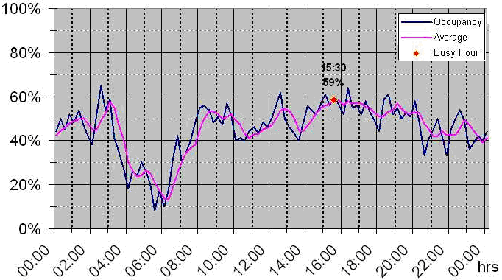
The blue line labelled “Occupancy” uses a 15 min integration interval. The magenta line labelled “average” is a running average over the last hour.

7.2 Occupancy on multiple channels
If it is not necessary to present information about the traffic load over the day, the result of an FCO on multiple channels can also be shown in one graph. The x axis shows the frequency or channel and the y axis shows the occupancy averaged over the whole monitoring period.
Figure 16 shows an example for a frequency band that is shared by services with different bandwidths and channel spacing.
Figure 16
Example occupancy on multiple channels with different widths
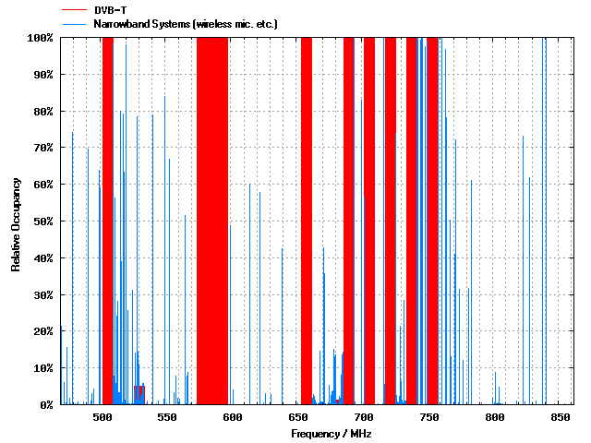
The thick red bars in Fig. 16 are occupancies by 8 MHz wide DVB-T signals, the thin blue bars present occupancy by narrowband wireless microphones and talkback links.
This presentation, however, does not provide information on how the occupancy of each channel is distributed over the whole monitoring period. To get that information, an occupancy histogram may be presented. It displays the frequency on the x axis and the time on the y axis. The occupancy value is represented by different colours.
Figure 17 shows an example of such an occupancy histogram (magnified part).
Figure 17
Occupancy histogram
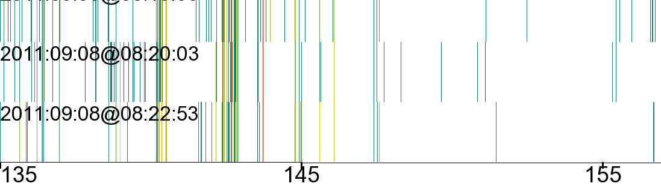
Relative occupancy, values below 0.01% are displayed in white
MHz
MHz
MHz
f₁
f₂
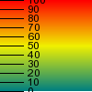

For better readability, the results in Fig. 17 are integrated over time intervals of about 3 minutes, during which the maximum occupancy value is displayed. The frequency f₁, for example, is occupied continuously in all three displayed time intervals (red line = 100% occupancy). Frequency f₂, although also present in all three-time intervals, is occupied less than 10% (dark green line).

7.3 Frequency band occupancy
One common way to present the occupancy results for a whole frequency band is the spectrogram. It shows the frequency on the x-axis and the time on the y-axis. The level of the emissions is indicated by the colours, usually in the so-called “temperature scale” where blue represents the lowest and red the highest level.
Figure 18 shows an example of such a presentation from a measurement in the 868 MHz Industrial, Scientific and Medical (ISM) band.
Figure 18
Frequency band occupancy presentation
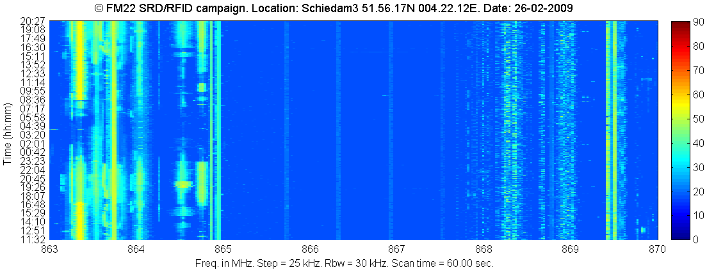
f₁
f₂

The advantage of this presentation method is that it provides a good, although subjective, impression on the band occupancy at a glance. The disadvantage is that it does not quantify the occupancy on each frequency so that there is no objective value allowing direct comparison with other results. This, however, may be provided by an accompanying diagram showing the relative time during which each frequency was occupied. Figure 19 shows this diagram for the same measurement as in Fig. 18.
Figure 19
Objective frequency band occupancy
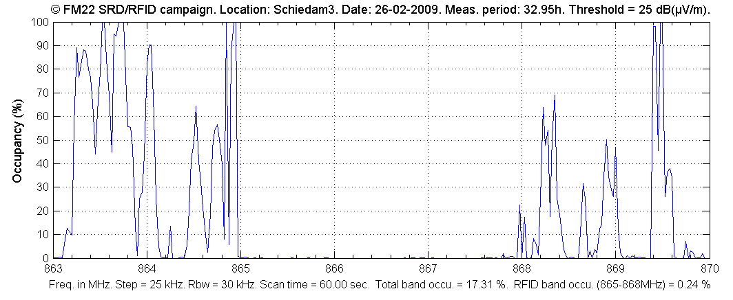
f₁
f₂

To get the complete information, both presentations are necessary. From Fig. 18, for example, it can be seen that the frequency 868.35 MHz (f₂) was occupied for around 70% of the time. However, it cannot be seen how the occupancy was spread over the day. It may be a constant emission for 7 out of 10 h of monitoring. Only by also looking at Fig. 17 it becomes clear that the transmitter was present during the whole monitoring period, but it was a TDMA system with an average duty cycle of 70% rather than a constant emission for 7 of 10 h. The occupancy value of 864.5 MHz (f₁) is nearly the same (65%), but its distribution over the day is completely different, as can be seen in Fig. 18.
The total band occupancy (FBO) of 17.31% at the bottom of Fig. 19 is the pure integration of all measurement samples collected on any frequency over the whole monitoring period that had levels above the threshold. In other words, this is the area in Fig. 18 that is not blue. This value should not be mixed up with frequency resource occupancy (SRO) which is considerably higher. When only the spectrogram like in Fig. 17 is presented, the resulting FBO should also be given as a figure in order to provide a means to quantify the result and compare it with others.
Example: There are only four usable channels in the frequency range 865.4 to 867.6 MHz (RFID channels). In Fig. 18 it can be seen that all four channels are continuously occupied, but with a level below the threshold which is why these emissions do not contribute to the occupancy in Fig. 18. Had their levels been above the threshold, they would appear as four narrow lines in Fig. 18 and four distinct peaks of 100% in Fig. 19. The FBO value of this frequency range would still be very low because most of the area in Fig. 18 would still be blue. However, the SRO of this frequency range would be 100% because all available resources (four channels) are continuously occupied.
The information in Fig. 18 is somewhat similar to Fig. 16 also displaying the results of a band measurement. However, both diagrams have a different frequency resolution: Fig. 16 shows one vertical bar per frequency channel (which even may be of different widths), whereas the horizontal resolution in Fig. 19 is the frequency resolution used for the measurement (independent of the channel width). Therefore, the band occupancy (FBO) cannot be directly taken from Fig. 16.

7.4 Spectrum resource occupancy
As an example of utilizing the results of spectrum resource occupancy measurements, a long-term measurement of two different frequency bands allocated to FM broadcasting links was carried out using fixed and mobile monitoring equipment as illustrated in Fig. 20.
FIGURE 20
Used fixed (left) and mobile (right) monitoring system to measure the spectrum occupancy
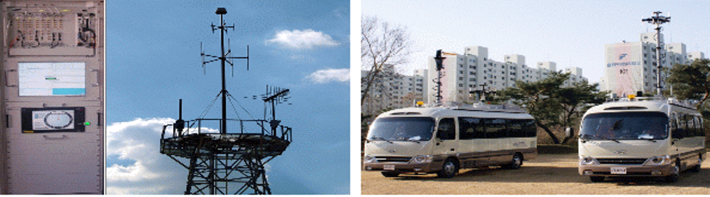
The FM broadcasting links are used to transport programme contents from a remote production site to the nearest studio, between studios, or from the studio to a transmitter site.
Because the spectrum usage was expected to be very low, the results should justify a reallocation of the 900 MHz range to other communication services. Figure 21 shows the occupancy results for each available channel in both bands separately.
FIGURE 21
Measurement result of the FM broadcasting links service (942~959 MHz, 1 700~1 710 MHz)
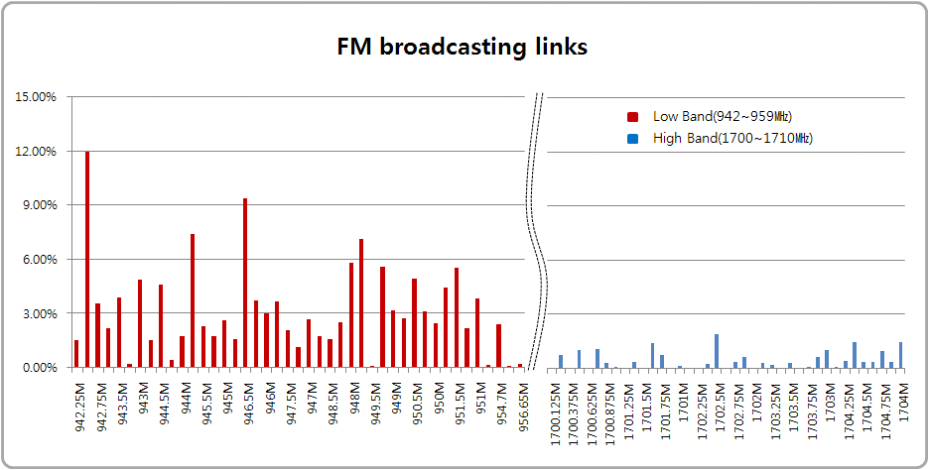
The calculated SRO of the lower band was 3.85% and it was less than 1% in the higher band. This result led to the decision to combine all FM broadcast links services in the upper band, making the lower band available to the mobile communication service which is growing fast.

7.5 Availability of results
The results should be made available to all those are working with occupancy results, either in the frequency planning or licensing and enforcement sections. It is preferable to publish them on a website of the intranet of the organization or even on the internet.
In case the organisation is using a computerized spectrum management and/or licensing programme, the results should be available in the monitoring part of the relevant data base, preferably via an automated data interface.
Neighbouring Administrations may be interested in exchanging occupancy data, especially concerning regions near the country borders, to assist in frequency assignments. In such cases it is important to use a unique and unambiguous format that allows correct interpretation of the data the cooperating parties deliver to each other. As an example, Recommendation ITU-R SM.1809 “Standard data exchange format for frequency band registrations and measurements at monitoring stations” recommends the use of comma-delimited ASCII (comma separated value – CSV) file format for this purpose when exchanging occupancy data. Most common database and spreadsheet programs can read this format.

8 Special occupancy measurements

8.1 Frequency channel occupancy in frequency bands allocated to point-to-point systems of fixed service
Some terrestrial point-to-point systems of fixed service (for example, fixed WiMAX, radio-relay communications, interconnection of base stations for cellular radio systems etc.) use directional links. In this case the detection of an emission at one site using omni-directional antennas results in a certain amount of channel occupancy at this site only (see Fig. 22). But it doesn’t mean that this channel is not usable for other links, even if signal level exceeds threshold level. Several fixed links can use the same channel without creating any harmful interference to each other.
Figure 22
Monitoring of frequency channel occupancy in frequency bands allocated to point-to-point systems of fixed service
However, results of a frequency channel occupancy measurement at the site of the monitoring unit using omni-directional antennas shows the frequency channel as occupied even if there is an emission from a single link only (for example, Link A).
In this case, the standard occupancy measurement setup will normally not provide the desired information. Depending on the purpose of the occupancy measurement, the following cases may be distinguished:
– If the measurement is done to find available frequencies for a proposed new fixed link, the measurement should be done with a directional antenna. The monitoring unit has to be placed at both locations of the proposed new link.
– If the measurement is done to provide an overview of the utilization of the frequency band, regardless of the exact location, the measurement can be done with an omni-directional antenna at the location indicated in Fig. 22, where a maximum of links can be received.

8.2 Separation of occupancy for different users in a shared frequency resource
If field strength is recorded, additional information can be extracted from the measurement.
The left plot in Fig. 23 is a commonly used way to present the occupancy with a resolution of 15 min, normally with only one curve. The red curve in the left plot represents the total occupancy caused by all users on that channel. The green curve is the occupancy caused by the station received with about 49 dB(μV/m) (see right side plot) and the blue curve is the occupancy caused by all the other users, in this case the second user received with about 29 dB(μV/m).
The plot in the middle represents the received levels over time. Only received levels above the threshold level (here: 20 dB(μV/m)) are evaluated.
The right plot shows the statistical distribution of the received field strength levels. In this example 49 dB(μV/m) has been measured about 380 times in a 24 h period, 50 dB(μV/m) about 350 times, etc.
Figure 23
Enhanced processing of occupancy data

8.3 Spectrum occupancy measurement of WLAN (wireless local area networks) in 2.4 GHz ISM band
The 2.4 GHz ISM (Industrial, Scientific and Medical) band is mainly used for Wireless LAN (IEEE 802.11b/g/n), Bluetooth, Zigbee and DECT (in North America) without requiring an individual license. As the use of wireless internet increased rapidly in recent years, there are often a number of WLAN APs (access points) and mobile stations on the same channel.
Because the channel spacing of 5 MHz with a usual occupied bandwidth of up to 20 MHz, channel overlap exists and neighbouring channels cannot be used at the same location without any interference potential.
Figure 24 shows the power over time of WLAN channel 1.
FIGURE 24
Power vs. time graph of WLAN ch.1 (Freq. = 2.412 GHz, BW = 5 MHz)
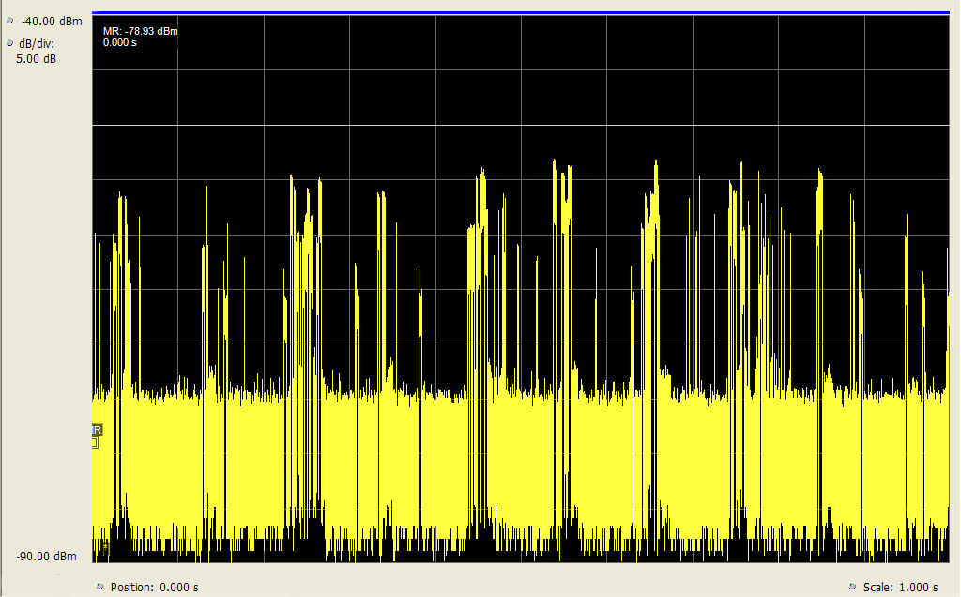
For some purposes it is useful to obtain occupancy figures only for a specific user on a frequency, for example to identify interference sources or to recommend channel changes in order to use the available band most efficiently. In the 2.4 GHz WLAN band, this can be achieved by using standard user equipment as a receiver and publicly available scanning software. Figure 25 shows an example output of such a setup where channel 11 is occupied by four different Access Points.
FIGURE 25
Example of APs List
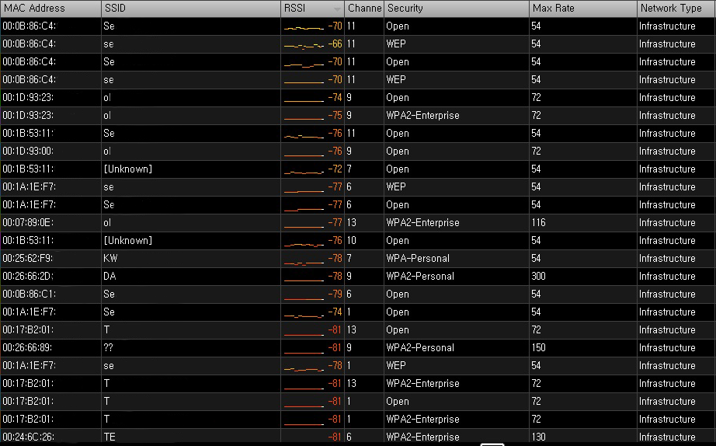
A second possible reason to identify the MAC address of each transmission is that this method is also capable of separating WLAN emissions from other ISM emissions in the same band (e.g. Bluetooth, Zigbee, DECT).

8.4 Determining the necessary channels for the transition from analogue to digital trunked systems
Currently, many formerly analogue systems are transferred to digital. If an analogue mobile network undergoes this transition, a digital trunked network may be the solution. However, whereas an analogue network needs a separate frequency for each communication channel, trunked networks organize the frequency resources dynamically according to current traffic, thereby getting along with far less frequency channels. An occupancy measurement of the analogue network during peak times can determine how many channels would be needed in a trunked network to manage the traffic with the same quality of service.
As an example, occupancy measurements of an analogue police network were made during major events where peak traffic was expected. This network is to be transferred into a TETRA network. The question was raised how many TETRA channels would be needed without noticeable degradation of the quality of service.
The current analogue police network uses 60 channels, spread over a frequency range with a channel spacing of 20 kHz. The setup for the occupancy measurement was able to measure all channels with a revisit time of 1 s. For each round through the channels, it was counted how many of them were occupied simultaneously. The result is shown in Fig. 26.
Figure 26
Number of channels occupied at the same time
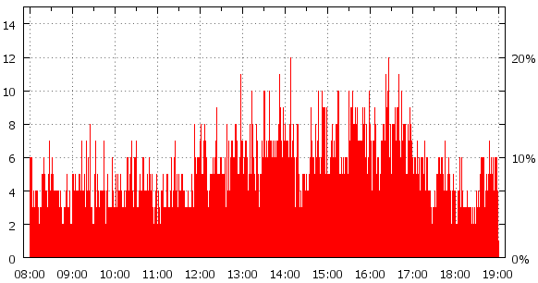
Time
Channels used concurrently
It can be seen that a maximum of 12 channels are occupied at the same time. To manage this amount of traffic, three TETRA channels would be necessary since TETRA is able to carry four communication channels on one frequency using TDMA techniques.
Although this already gives a big improvement in terms of spectrum efficiency, the question may be raised whether it is necessary to provide capacity for a peak traffic situation that may only occur once a year for a short moment. To answer this question, it is necessary to evaluate the occupancy measurement in different ways.
Sorting the scans over the band by the number of occupied channels in each scan results in a row starting with the number of scans where no channel is occupied, then the number of scans with one occupied channel and so on. This result may be visualized in a graph such as in Fig. 27.
Figure 27
Number of scans with concurrent occupied channels
It can be seen that the case where 12 channels are occupied occurred twice during the whole monitoring period. However, it cannot be determined whether this occupancy situation occurred once for a two-second period or twice for a period of one second each. To visualize this also, a 3-D diagram may be drawn where the duration of occupancy of a certain number of concurrent channels used is combined. The probability that each situation occurs is shown on the y axis.
Figure 28
Probability and duration of concurrently used channels
From this Figure it can be seen that the situation of 12 and even 11 concurrently occupied channels occurs only for a maximum time of 1 s. This means, if a future TETRA network would provide only 10 communication channels, the 11th user at that moment would have to wait for a maximum of one second to get access to the network. Since this is certainly acceptable, 10 TETRA communication channels would be sufficient. Using this evaluation of the occupancy measurement result together with the user’s tolerable access delay allows determining the necessary number of TETRA channels while maintaining maximum spectrum efficiency at minimum costs.

8.5 Estimation of RF use by different radio services in shared bands
Some frequency bands are allocated to different radio services having the same or similar RF properties. Many sub-bands of the HF frequency range are examples for this situation. If signal identification methods are available during the occupancy measurement, the results may be presented separately for each of the services in a band.

9 Uncertainty considerations
The measurement uncertainty depends on various factors such as the revisit time, number and length of transmissions on a channel, number of measurement samples, monitoring duration, whether systems with pulsed emissions (TDMA) are measured, and even the actual occupancy value itself. Some of these parameters have a complex dependency. Calculations of these parameters and details about their dependencies can be found in Annex 1 to this Report.
It should be noted that, although the measurement results may be regarded as accurate, they are valid only for the location and time of the measurement. However, they are normally used to “predict” the occupancy for future times or different locations/areas. The accuracy of this “prediction” strongly depends on the situation and/or service in question: The occupancy of a public phone mobile network will usually be somewhat constant during normal working days, so a measurement taken on one day may be used to assess the usage of the band during all of these days. On the other hand, the occupancy of a shared company channel strongly depends on the actual activity of all users which may differ considerably from day to day, so a measurement taken on one working day may not be usable at all to assess the average traffic load on that channel.

10 Interpretation and usage of results

10.1 General
The results of spectrum occupancy measurement on a specific frequency band may be used to establish frequency allocations and assignment policies gaining an effective spectrum use and economic value of the spectrum resource. For example, they may lead to the re-allocation of frequency bands.
Performing occupancy measurements repeatedly under the same measurement conditions can show trends in the usage of spectrum resources. This may provide valuable information for the future allocation of spectrum to certain services.

10.2 Interpretation of occupancy results in shared channels
As mentioned in the definition of occupancy time, the result provided by the monitoring services should reflect the true occupancy of a channel as accurate as possible. This includes the fact that a channel used by TDMA systems does not already show 100% occupancy when just one station is using it. This makes it necessary for the spectrum management or licensing section to interpret the results depending on the purpose of the occupancy measurement.
Example: If the purpose of an occupancy measurement in a frequency band assigned to a certain network is to check which traffic channels are in use and are therefore not available to other systems at the particular location, all frequencies showing an occupancy typical for that network may be regarded as “full”.

10.3 Using occupancy data to assess spectrum utilization
So far, spectrum occupancy was related to a specific location or the area around the monitoring location only. Sometimes, information about the occupancy of a resource over a large territory (e.g. the whole country) is of interest. To characterize this, Recommendation ITU-R SM.1046-2 defines a spectrum utilization factor, U, as the product of the bandwidth B, the geometric (geographic) space (usually area) S, and the time T during which the spectrum resource is denied to other potential users:

$U=B∙S∙T$

The spectrum utilization factor is therefore a three- dimensional parameter: frequency × space × time. The formula is non-linear and only valid for one particular application during a measurement. When a “spectrum utilization map” of a larger area is requested, the most efficient way is to perform a spectrum occupancy measurement using mobile monitoring vehicles. Together with the current occupancy situation, the geographic coordinates are stored so that the occupancies taken in geographic rectangles of a defined size can be averaged. The result may be presented in a map where the different spectrum utilization values are represented by different colours. Figure 29 provides an example of such a spectrum utilization map.
Figure 29
Example spectrum utilization map
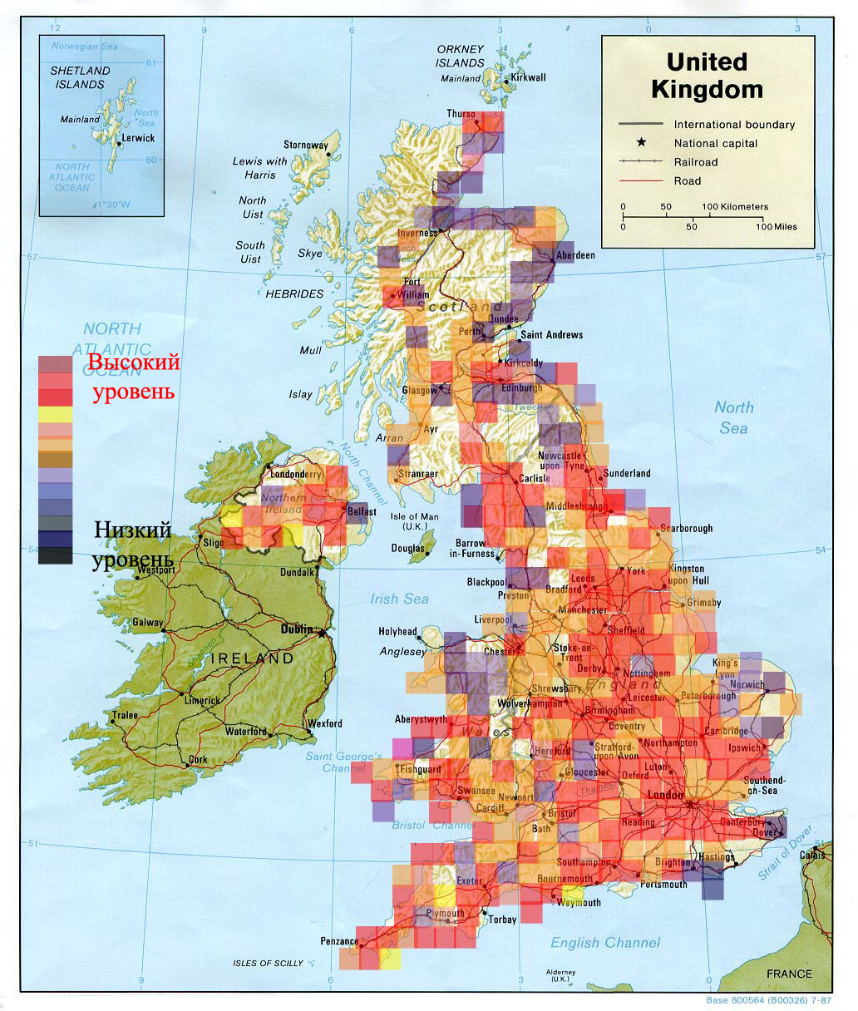
low utilization
High utilization

11 Conclusions
high utilization
Taking into account that the current Recommendation ITU-R SM.1880 describes only the basic procedures, the various examples in this Report have shown that measurement and especially evaluation of occupancy may be quite a complex task. Thorough knowledge of the radio services and particularly an in-depth analysis of the goal of the measurements are indispensable to specify the measurement and evaluation methods appropriate.

Annex 1
Impact of measurement parameters on accuracy and confidence level

A Preface
This Annex covers in detail the dependencies of measurement parameters such as revisit time, required number of samples, and their impact on measurement accuracy and confidence level. The mathematical calculations described here are especially relevant in circumstances such as:
– Unevenly timed measurement samples.
– Measurement delays when detecting used channels.
– Equipment being used for different measurement tasks simultaneously, thereby not being able to dedicate all time to the occupancy measurement task.
The relevance and application of the principles of this annex may be decided on a case-by-case basis, depending on the aim of the measurement, required accuracy and/or confidence level, and capabilities of the measurement equipment.

A1 Statistical approach to define spectrum occupancy
The Annex describes the requirements for measuring equipment and for relevant data handling process that allows determination of spectrum occupancy for a large set of radio channels on the stipulated time interval with the desired accuracy and statistical confidence. The findings described in this Annex have already found their practical implementation showing good results.
The statistical approach described below is based on the definition of spectrum occupancy as the probability that, at a randomly selected moment in time, a radio channel, frequency band or other frequency resource being analysed will be in use for the transmission of information [A.1]. Its description is presented in [A.2].
From a statistical point of view, on the basis of limited observations, occupancy can only be estimated. Due to the influence of random factors, this estimation may differ from the true value of occupancy, which could be determined only in the case of continuous monitoring of the channel. Therefore, in this Annex, a distinction is made between true values of occupancy and its estimation obtained by calculation. For the sake of simplification, this Annex focuses on measurements of distinct radio channels, although the principles are valid for other spectrum resources like frequency band occupancy. The general term “spectrum occupancy (SO)” is used to denote the true value of occupancy and the term “spectrum occupancy calculation result(s) (SOCR)” is the result of relevant processing of the measurement data.
For the analysis of SO, it is considered that only two channel states are possible: “occupied”, whereby the signal level in the channel exceeds a selected detection threshold, and “free”, whereby the signal level in the channel is small. SO is determined by the probability of it being in the occupied state.
figure A1
Definition of the concept of radio channel occupancy
Figure A1 shows an example of the possible change over time in the level U(t) of a signal in a channel over an integration time T_{I}. The probability that an occupied signal state will be detected at a randomly selected sample point on the time axis will be equal to the ratio of the aggregate duration of occupied state intervals Δt₁, Δt₂ …Δt_{v} to the total integration time T_{I}. Thus, spectrum occupancy over this integration time is expressed by:

$SO=\sum_{v=1}^{V}{{{Δt}_{v}}/{T_{I}}}$ (A-1)

where:
SO : true value of occupancy over the current integration time
T_{I} : duration of the integration time
V : number of occupied state intervals during the integration time T_{I}
Δt₁, Δt₂ …Δt_{v} : duration of occupied state intervals in the radio channel in case of its continuous monitoring.
Channel occupancy may change over time. To monitor the changes, the time axis has to be divided into a set of integration times of fixed duration T_{I}, usually between 5 and 15 minutes. The current occupancy has to be calculated for each integration time, and, when the overall duration of monitoring T_{T} is significant, i.e. after collecting occupancy data for a large set of integration times T_{I}, it becomes possible to evaluate overall occupancy, a value which describes the properties of stationary radio channels over an infinite period of time.
Because of the relatively short duration of the individual integration times, results (SOCR) for consecutive integration times T_{I} may vary significantly, even for stationary radio channels. To obtain an overall estimation of stationary radio channel occupancy, as described in [A.1], it is necessary to take an arithmetical average of all current SOCR for the total duration of monitoring T_{T}.
Formally, both current occupancy values observed at times T_{I} and the final occupancy evaluation formed over a prolonged duration of monitoring T_{T} are determined using a single rule (equation (A-1)) or similar rules, as described in §§ 2.16 to 2.18 of this Report. However, because of the difference in the time periods to which the current and final occupancy evaluations correspond, the statistical properties of the evaluations differ. This Annex provides methods to ensure a confident evaluation of current occupancy values at intervals T_{I}.
Reference documents [A.1] and [A.6] are dedicated to the issues involved in establishing the total duration of monitoring T_{T} for a confident evaluation of the stationary radio channel occupancy. See § A5.1.4 for more detail on the difference between the statistical properties of current and overall occupancy evaluations.

A2 Impact of the measurement timing
When monitoring frequency ranges containing a large number of radio channels, continuous monitoring of each channel is problematic. Instead, monitoring equipment collecting data for occupancy measurements generally check the state of channels only intermittently. The number of channel state samples J_{I} during the current occupancy integration time depends on the length of this time T_{I} and the channel state sampling revisit time T_{R} (which, in turn, depends on the operating speed of the monitoring equipment and the number of frequency channels in which occupancy is being measured).
With intermittent sampling, it is not possible to accurately pinpoint the instant in time when a channel changes from an occupied to free state and vice versa; thus, for measuring current occupancy, instead of the exact equation (A-1), it is necessary to use approximations. For example, for an even placement of channel state samples on the time axis, the following estimation can be used to calculate current occupancy:

$SOCR={J_{O}}/{J_{I}}$ (A-2)
where:
SOCR : spectrum occupancy calculation result
J_{O} : number of samples in which occupied channel states detected during the integration time
J_{I} : total number of channel state samples throughout the integration time
It is possible to demonstrate the potential current spectrum occupancy measurement error for a signal behaving as depicted in Fig. A2.
FIGURE A2
Occupancy measurement error
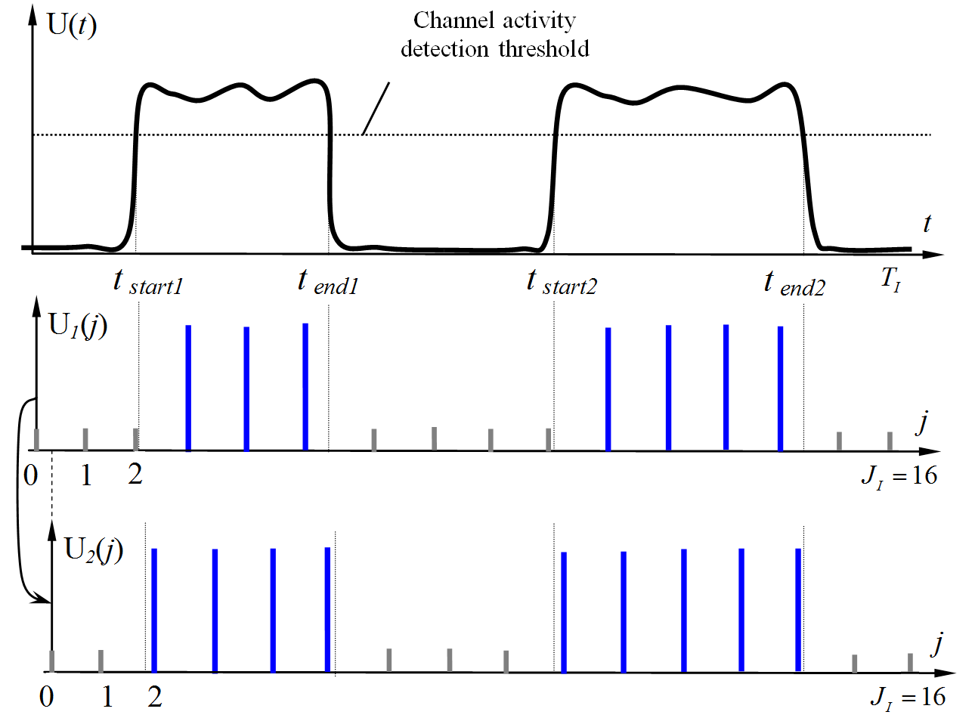
The top diagram U(t), which shows the continuous change in the signal level in the channel over time, corresponds to a true value SO ≈ 50%. The two following diagrams illustrate occupancy measurement with the same number of samples J_{I}, but with a slight “mismatch” of the points from which the time is counted. Comparing diagrams U₁(j) and U₂(j), it can be seen that the measured occupancy value in the first case will be SOCR₁ = 7/16 ≈ 43.75% and in the second case SOCR₂ = 9/16 ≈ 56.25%.
It is obvious that:
1) In addition to the first and second diagram presented, other options are possible with different measurement start points, in which there would be exactly eight instances of channel activity over the integration time, giving a precise occupancy estimate of SOCR = 8/16 = 50%.
2) Increasing the number of samples J_{I} reduces the potential spread of measurement results and makes it possible to guarantee negligible error irrespective of the start time selected.
Thus, SOCR are random values, and the quality of these measurements has to be analysed from a statistical standpoint.

A3 Accuracy and confidence level
For the reasons considered under § A2 above, radio channel occupancy measurement is, in practice, subject to error. It may be shown (see, for example, [A.2]) that the occupancy measurement error in a specific r-th test case (SOCR_{r} – SO) is a random value with, as a rule, a close-to-normal distribution. Error magnitudes may vary significantly in different tests. This means that conditions have to be imposed on the quality of occupancy evaluation from the standpoints of accuracy and confidence.
Confidence P_{SOC} is the probability that the calculated occupancy SOCR will differ from the true value SO by no more than the permissible absolute error Δ_{SO}.

$P_{SOC}=P\left\{\left|SOCR-SO\right|≤Δ_{SO}\right\}$ (A-3)

where:
P_{SOC} : confidence level of the occupancy measurement
SOCR : calculated occupancy value obtained for the current integration time
SO : true value of occupancy over the integration time
Δ_{SO} : permissible absolute measurement error tolerance corresponding to half of the confidence interval.
Accuracy requirements are also often expressed in terms of the permissible relative measurement error tolerance δ_{SO}, which is linked to the permissible absolute error by equation (A-4).

(A-4)

Accuracy should be expressed in terms of absolute or relative error depending on what magnitude of occupancy values is more important to measure in practice (small or large).
Limitation of the permissible relative measurement error imposes higher demands on measurement accuracy in radio channels with a low occupancy and relaxes the demands on measurement accuracy for channels with high occupancy. For example, taking a typical value δ_{SO} = 10%, for a channel with an occupancy SO = 2% values in the range 1.8% ≤ SOCR ≤ 2.2% will be considered as falling into the confidence interval (whose size is 0.4%), whereas for an occupancy SO = 20% the confidence interval will increase up to 4%. For a channel with an occupancy SO = 92% any values will be considered as acceptable within the wide range of 82.8% ≤ SOCR ≤ 100%.
When the permissible absolute measurement error is limited, the size of the confidence interval is independent of the actual channel occupancy. In particular, with the value of Δ_{SO} = 0.5% that is recommended for use in practice, the size of the confidence interval remains at 1% for both low-occupancy and high-occupancy channels. This corresponds to a very rough estimate for channels with low occupancy, and a very accurate estimate for channels with high occupancy. For instance, for an occupancy SO = 92%, values lying in the range 91.5% ≤ SOCR ≤ 92.5% are considered acceptable.
As regards the required confidence levels, values in the range 90-99% are generally recommended for use in practice. In this Annex, a value of P_{SOC} = 95% will henceforth be used as a basis.

A4 Parameters affecting the statistical confidence of occupancy measurement

A4.1 Pulsed and lengthy signals and signal flow rate
The statistical properties of occupancy calculation results depend on the typical duration of the signals in the radio channel analysed. If the signal duration is larger than the revisit time, such signals cannot be missed and the state changeover points tend to fall at different, independent intervals relative to the samples. Signals with a duration shorter than the revisit time are registered only sometimes, and the statistical properties of occupancy calculations for the channels with these signals are significantly different. Of course, in practice, the edge between these types of signals is rather thin. Lengthy signals are considered to be those whose duration Δt_{v} is at least one thousandth of the integration time, i.e. meeting the condition Δt_{v} ≥ 10⁻³ · T_{I}; pulsed signals are those with a duration Δt_{v} < 10⁻⁴ · T_{I}.
It is shown in [A.2] that the accuracy and confidence level of occupancy measurements for lengthy signals is strongly dependent on the number of transmissions (or the number of changeovers in state of the channel) within the integration time. Section A5 of this Annex also contains examples showing that for different numbers of signals detected during the integration time, the required number of samples for a confident occupancy measurement may vary by an order of magnitude. In case of occupancy measurements for channels with lengthy signals, the concept of signal flow rate can be useful.
Signal flow rate, λ, is the average number of signals present in the channel over a given time period. For example, if, in a particular channel, 140 transmission sessions are observed on average within every one-hour time period, then the signal flow rate for that channel will be λ = 140 signals/hour. Recommendations regarding the consideration of signal flow rate in occupancy measurement is provided in § A5.1.3.
It should be noted that the signal flow rate in a radio channel λ for different time periods may vary significantly. This means that the variation in signal flow rate has to be tracked during the course of the measurements and the average number of signals expected within the occupancy integration time has to be adjusted accordingly.

A4.2 Relative instability of revisit time
There are a number of reasons that might lead to an uneven placement of channel state samples on the time axis:
– When measuring occupancy in channels with significantly different signal flow rates, the required number of samples may vary five or tenfold. Strictly cyclical sampling of the state of such channels is ineffective, and changing to a flexible channel sampling procedure will lead to an uneven placement of samples on the time axis.
– State-of-the-art monitoring systems are extremely fast and, when the number of channels to be monitored is small, are capable of performing occupancy measurement data collection and other monitoring tasks in parallel. However, when equipment resources are divided up in this way, the placement of samples on the time axis also becomes uneven.
There may be other reasons causing instability of the revisit time between samples.
Let the times t_{j} (1 ≤ j ≤ J_{I}) correspond to the real placement of samples on the time axis. The intervals T_{R j} between samples:

$T_{Rj}=t_{j}-t_{j-1},1<j≤J_{1}$ (A-5)

in practice experience random fluctuations in relation to the mean value of the revisit time:

$T_{R}={T_{I}}/{J_{I}}$ (A-6)

where:
T_{I} : duration of the integration time
J_{I} : number of channel state samples within the integration time.
The relative instability of the revisit time is called δT, and is determined by the maximum deviation of the interval between samples from its mean value. It is expressed by:
$δT=\underset{j}{\text{max}}\left\{\left|t_{j}-t_{j-1}-{\left.T_{R}\right|}/{T_{R}}\right.\right\},1<j≤J_{I}$ (A-7)
where:
δT : relative instability of the revisit time
t_{j} : real sampling times
T_{R} : mean value of the revisit time, derived from equation (A-6)
J_{I} : number of samples within the integration time

A5 Measurement considerations

A5.1 Radio channels with lengthy signals

A5.1.1 Data collection and occupancy measurement rule for the case of small instability of the revisit time
With the relative instability δT of an interval between repeated measurements not exceeding one percent during data collection for each time period of integration T_{I}, it is sufficient to count the samples related to the occupied state of a channel J_{O} among the total number of samples of the channel state J_{I}.
When there are predominantly lengthy signals in the channel, in order to ensure measurement confidence, information is also required on the signal flow rate λ. When such information is lacking, it is worthwhile to track the grouping of occupied and free states so as to determine a quantity V_{r} of signals detected in the channel in the r-th integration time. The number of signals detected V_{r} is considered to be equal to the number of changeovers from free to occupied state and vice versa.

A5.1.2 Data collection and occupancy measurement rule for the case of meaningful instability of the revisit time
At an instability δT exceeding 10%, instead of the number of samples it is necessary to record the actual integration time T_{AI} and the aggregate length of time spent by the channel in occupied state T_{O}.
At the start of the measurements, one should set T_{AI} = 0 and T_{O} = 0 and determine the channel state corresponding to time t₀. After each subsequent observation, the value T_{AI} should be increased up to the duration of the revisit time t_{R j} determined by equation (A-5):

$T_{AI}(j)=T_{AI}(j-1)+T_{Rj}$ (A-8)

If the channel state was occupied at both sampling points t_{j-1} and t_{j}, then T_{O} should be also increased up to the same increment:

$T_{o}(j)=T_{o}(j-1)+T_{Rj}$ (A-9)

If within the interval T_{R j} a change in channel state is observed, then only a half of the revisit time should be included as an occupied state duration:

$T_{o}(j)=T_{o}(j-1)+T_{Rj}/2$ (A-10)
And if the channel is observed to be in passive state at both sampling points the occupied state length T_{O} should be left unchanged.
The rule for calculating occupancy takes the form:

$SOCR={T_{o}}/{T_{AI}}$ (A-11)
where:
SOCR : spectrum occupancy calculation result
T_{O} : aggregate length of time spent by the channel in occupied state
T_{AI} : length of the actual integration time
In order to determine the confidence level of the measurements, one should record the quantity of signals observed over the occupancy integration time (see § A3.1.1).

A5.1.3 Selecting the number of samples on the base of the expected signal flow rate
Requirements for measuring equipment and for relevant data handling processes of occupancy calculations for channels with lengthy signals will be different from channels with pulsed signals. For channels with lengthy signals, it is determined first by the quantity of signals within the integration time. For channels occupied by pulsed signals, confidence depends on the value of radio channel occupancy itself (see § A5.2.2).
For radio channels with lengthy signals, the number of samples required to achieve a confidence P_{SOC} with a permissible absolute measurement error tolerance Δ_{SO} may be calculated as follows:

$J_{I min}=\frac{x_{p}}{Δ_{SO}}∙\frac{\sqrt{V_{avr}∙\left(1.06+{δT}^{2}\right)}}{2}$ (A-12)

where:
J_{I min} : required (minimum necessary) number of samples
Δ_{SO} : maximum permissible absolute measurement error, corresponding to half of the confidence interval
δT : relative instability of revisit time
V_{avr} : average number of signals expected within the occupancy integration time
x_{P} : percentage point of the probability integral, corresponding to the required confidence value P_{SOC}, for the calculation of which the following approximation can be recommended.

$x_{p}=y-\frac{2.30753+y⋅0.27061}{1+y⋅(0.99229+y⋅0.04481)}$ (A-13)
where:
$y=\sqrt{2⋅ln\left(\frac{2}{1-P_{SOC}}\right)}$ (A-14)

The average number V_{avr} of signals expected within the integration time used in equation (A-12) can be predicted as:

$V_{avr}=λ⋅T_{I}$ (A-15)

where:
λ : signal flow rate in the channel (see § A4.1)
T_{I} : duration of the occupancy integration time
For a confidence level P_{SOC} = 95% with a permissible absolute measurement error tolerance Δ_{SO} = 0.5% equation (A-12) can be represented as:

$J_{I min}=194.2∙\sqrt{V_{avr}⋅\left(1.06+δT^{2}\right)}$ (A-16)
Examples of the application of equation (A-16) to radio channels with different signal flow rates are shown in Table A1.
TABLE A1
Number of samples for a channel with lengthy signals required to achieve an absolute occupancy measurement error tolerance Δ_{SO} of no more than ±0.5% with a confidence of P_{SOC} = 95% for measurements with a relative instability of revisit time δT ≤ 0.5
Signal flow rate in the channel λ (average number of signals observed in the current occupancy integration time), not exceeding: | Required number of samples
10 | 703
30 | 1 217
50 | 1 572
100 | 2 223
300 | 3 850
500 | 4 970

According to the data in Table A1, for channels with lengthy signals and a low occupancy (hence, also a low signal flow rate λ), statistically reliable measurement results are obtained with a number of samples J_{I} < 10³, which diverges from the information given in Table 4.10-1 of the ITU Handbook on Spectrum Monitoring [A.3] and Table 1 of Recommendation ITU-R SM.1880-2 [A.4]. The discrepancies are explained by the fact that, in Table A1 shown here, the data were obtained with a limitation not on the relative but on the absolute measurement error, which does not assume any narrowing of the confidence interval for cases of low radio channel occupancy (see § A3). When measuring occupancy on channels with lengthy signals, the source of error arises from the lack of accurate information on the instants in time when the radio channel changes from an occupied to free state and vice versa [A.2]. Thus, the more changeovers during the integration time, the greater the potential measurement error. For this reason, to achieve statistic confidence in the results, it is necessary in equation (A-1) to increase the number of samples as the average number of signals expected in the channel over the integration time increases (not as the occupancy value increases). By setting the permissible absolute error tolerance Δ_{SO} for both channels with low occupancy and channels with high occupancy but with only few changes in state (such as those occupied by broadcasting stations), it is sufficient to carry out only between 632 and 703 revisits. The required number of samples becomes significant only for channels with a large number of state changes over the integration time.
If the signal flow rate λ over the occupancy integration time is not previously known, then it is recommended to stipulate a value selected with some margin. To adjust the signal flow rate in the course of the measurements, it is recommended to use the equation:

$λ_{(r+1)}={\left(wλ_{r}+V_{r}\right)}/{\left(w+1\right)}$ (A-17)
where:
λ_{(r+1)} : flow rate expected in the next integration time
λ_{r} : flow rate for the current (elapsed) integration time
V_{r} : number of signals that has been determined in the current integration time
w : weighting coefficient determining the response time of the adaptation procedure, usually selected within the range 5 ≤ w < 20.
To start the evolution according to equation (A-17) an initial value λ₀ is needed which is usually unknown a priori. It is advisable to choose a maximum among all values expected within the given frequency range, which corresponds to the worse case.

A5.1.4 Impact of signal flow rate in the radio channel and sample dependence on the confidence level of spectrum occupancy evaluations
When evaluating the stationary radio channel occupancy, the duration of monitoring must last at least be as long as the time required to cover on average of 800 transmissions in the channel (see [A.6]. This period can, however, be very long for radio channels with a high level of sample dependence, i.e. those typically with lengthy transmissions. Accordingly, the lower the channel occupancy and the slower the change of channel states (i.e. the higher the level of sample dependence), the longer the total duration of monitoring T_{T} is required to evaluate overall occupancy of a stationary radio channel with a suitable level of confidence. This kind of estimation is discussed in [A.1] and [A.6].
When generating current occupancy evaluations for only short integration times (5 to 15 minutes), any dependency of samples influences the confidence level of the measurements. A series of simple examples is given below to illustrate this fact.
Occupancy calculations for radio channels with a significantly different number of signals over the integration time shall be analysed. In all the cases compared, the real occupancy value remains the same, namely SO = 5%. The accuracy requirements imposed entail a permissible absolute measurement error of Δ_{SO} = 0.5%, which for SO = 5% corresponds to a relative error of δ_{SO} = 10%.

A5.1.4.1 Case A: One single signal present in the integration time
Assuming that, throughout the integration time T_{I}, only one signal is observed in the channel with a duration T_{s} = 0.05 · T_{I}, which corresponds to an occupancy SO = 5%. To achieve a confidence level of P_{SOC} = 100% with an even placement of channel state samples on the time axis, it is sufficient to collect J_{I} ≥ 200 samples.
In reality, with a revisit time T_{R} determined from equation (A-6), the number of samples recorded for the period of signal activity will be either:
$J_{O min}=\operatorname{int}\left[{T_{s}∙J_{I}}/{T_{I}}\right]=\operatorname{int}\left[0.05∙J_{I}\right]$ (A-18)
where int [·] is the operation of returning the integer portion of the argument, or (J_{O min} + 1) samples. Taking into account rule (A-1), the occupancy measurement error is equal to:
$(SOCR- SO)_{r}≤\text{max}\left(\left|SOCR-SO\right|\right)≤\text{max}\left(0.05-\frac{J_{o\text{min}}}{J_{I}};\frac{J_{o\text{min}}+1}{J_{I}}-0.05\right)$ (A-19)
For J_{I} ≥ 200, the maximum absolute error actually achievable in accordance with equation (A-19) is , which corresponds to a relative error of 10%. Instead, for J_{I} ≥ 600, from equation (A-19), $\text{max}\left(\left|SOCR-SO\right|\right)=0.00167$, which, (for SO = 5%) corresponds to a relative error less than 3.5% (for a 100% confidence level).

A5.1.4.2 Case B: Twelve signals throughout the integration time
Assuming now that in the integration time T_{I} there are 12 pulses of equal duration T_{s} = 0.00417 · T_{I}, which again corresponds to an occupancy of SO = 5%. With the number of samples within the range 485 ≤ J_{I} < 715, the pulse length remains higher than the revisit time T_{R}, and so each pulse will, depending on its position in relation to the “grid” of samples, be represented by either two J_{O min} = T_{s}/T_{R max} = int [0.00417 · J_{I min}] = 2 or three J_{O max} = int [0.00417 · J_{I max}] + 1 = 3 occupied samples. For J_{I} ≈ 500, an active channel state will more often occur in pairs of points, whereas with J_{I} ≈ 700, occupied samples will more often be grouped in threes.
In the following analyses, the case J_{I} = 600, in which both scenarios of sample groupings will be equally probable. The total number of occupied samples J_{O} may in this situation be between J_{O min} = 12 · 2 = 24 and J_{O max} = 12 · 3 = 36. In measurement instances where the value J_{O} falls in the range from 27 to 33, the occupancy estimation obtained from equation (A-1) will fall within the limits of ±10% of the relative error. The probability of 24 ≤ J_{O} ≤ 26 or 34 ≤ J_{O} ≤ 36 may be calculated from the rule:
$P_{error}=0.5^{12}⋅\left(C_{12}^{0}+C_{12}^{1}+C_{12}^{2}+C_{12}^{10}+C_{12}^{11}+C_{12}^{12}\right)=\frac{2⋅(1+12+66)}{4 096}≈3.86\%$ (A-20)
Here, corresponds to k cases of fixation of pairs of occupied samples with respect to 12 radio signals falling within the integration time.
Thus, for the same occupancy SO = 5% as in case A, and with the same number of samples J_{I} = 600, although the occupancy calculation SOCR satisfies the requirements in [A.3], [A.4], there is an almost 4% probability that it the occupancy calculation will deviate from the real value SO with a relative error exceeding ±10%.

A5.1.4.3 Case C: Several dozen signals throughout the integration time
Finally, assuming that throughout the integration time T_{I} there are 80 pulses of equal length T_{s} = 6.25·10⁻⁴ ·T_{I}, which again gives SO = 5%. For J_{I} = 600 samples the revisit time will be T_{R} ≈ 1.67 · 10⁻³ · T_{I}. Here, each of the radio pulses will be represented as being not longer than a single occupied sample, and with a probability of P_{miss} = 1 − T_{s}/T_{R} ≈ 62.5% that the pulse will not be detected.
Disregarding the probability of pulse overlapping and treating cases of pulse “detection” as independent, the mathematical expectation of the number of occupied samples J_{O} is equal to:
$m_{1}\left\{J_{o}\right\}=80⋅\left(1- P_{miss}\right)=80⋅0.375=30$ (A-21)
And, hence:
$m_{1}\left\{SOCR\right\}=30/600=0.05$ (A-22)
In this way, the average occupancy value remains unbiased. This is explained by the fact that, even though some of the radio pulses may be missed, the remainder will be treated as having a duration of T_{R}, rather than T_{s} which compensates for the previous effect.
For analysing the quality of occupancy calculations under these conditions, the results corresponding to a relative error within ±10% will be obtained only for a number of recorded occupied samples lying within the range from 27 to 33. The real number of recorded occupied samples will be a random value following a binomial distribution.
Taking into account that with a sufficiently large overall number of detectable pulses n = 80 this distribution may be approximated to normal, the following expression for the confidence level of the measurement may be used:
$P_{SOC}=F_{st}\left(\frac{33-30}{4.33}\right)-F_{st}\left(\frac{27-30}{4.33}\right)≈F_{st}(0.7)-F_{st}(-0.7)≈52\%$ (A-23)
where $F_{st}(z)$ is a function of the probability distribution of the standard normal random value:
$F_{st}(z)=\frac{1}{\sqrt{2π}}⋅\int_{-∞}^{z}{exp\left(-\frac{t^{2}}{2}\right)dt}$ (A-24)
and $σ=\sqrt{n⋅(1- P_{miss})⋅P_{miss}}=\sqrt{80⋅0.375⋅0.625}≈4.33$ is the standard deviation of the measurement SOCR.
Thus, with a large number of short pulses falling within the integration time T_{I}, the occupancy values obtained will on average be close to the real values, but the confidence level of the measurement will be low (in this case P_{SOC} = 52%).
The above examples show that for radio channels containing lengthy signals, the confidence level of the current occupancy measurement primarily does not depend on the occupancy value itself, but on the number of changes of state taking place during the integration time. When there are infrequent changes of state in the radio channel, even a small number of samples will ensure a relatively accurate and reliable current occupancy result. When there are frequent changes of state in the radio channel, accurate and reliable current occupancy results can be ensured only by significantly increasing the number of samples falling within the integration time. A summary of these effects is provided in Table A2.
TABLE A2
Impact of the number of signals present in the integration time on the statistical properties of occupancy calculation results for fixed number of samples J_{I} = 600 and absolute occupancy measurement error tolerance Δ_{SO} of no more than ±0.5%
Case | Number of signal present in the integration time | Confidence level P_{SOC}  (%)
A | 1 | 100
B | 12 | 96
C | 80 | 52

A5.2 Radio channels with pulsed signals

A5.2.1 Data collection and occupancy measurement rule
To measure occupancy, one must, at the very least, determine the number J_{O} of occupied channel state samples for each integration time.
For channels with pulsed signals, calculation (A-1) gives an unbiased occupancy measurement but requires significantly more samples to achieve a confidence P_{SOC} with a permissible absolute measurement error tolerance Δ_{SO}.

A5.2.2 Selecting the number of samples on the base of the expected occupancy level
When measuring occupancy on channels with pulsed signals, the necessary number of samples J_{Imin} can be calculated as:
$J_{I min}=SO∙\left(1-SO\right)∙{\left(\frac{x_{p}}{Δ_{SO}}\right)}^{2}$ (A-25)
where:
J_{I min} : required (minimum necessary) number of samples
SO : expected radio channel occupancy for the channel with pulse signals
x_{p} : percentage point of the probability integral (see equation (A-13))
Δ_{SO} : maximum permissible absolute measurement error, corresponding to half of the confidence interval.
For a confidence level P_{SOC} = 95% and a maximum permissible absolute measurement error Δ_{SO} = 0.5% equation (A-25) can be expressed as follows:
$J_{I min}=153 664∙SO∙\left(1-SO\right)$ (A-26)
With pulsed signals, the confidence of the calculation (A-1) is determined by the occupancy value itself and is practically independent of instability of sample placement along the time axis. The application of equation (A-26) to radio channels with different occupancies is illustrated in Table A3.
TABLE A3
Number of samples for a channel with pulse signals required to achieve an absolute occupancy measurement error tolerance Δ_{SO} of no more than ±0.5% with a confidence of P_{SO} = 95%
Radio channel occupancy SO  (%) | Required number of samples, J_{I} | Maximum acceptable revisit time, T_{R}  (ms)
Radio channel occupancy SO  (%) | Required number of samples, J_{I} | for T_{I} = 5 minutes | for T_{I} = 15 minutes
5 | 7 300 | 41.1 | 123.2
10 | 13 830 | 21.7 | 65.0
20 | 24 586 | 12.2 | 36.6
35 | 34 960 | 8.6 | 25.7
50 | 38 416 | 7.8 | 23.4
NOTE – The required number of samples for channels with an occupancy SO* > 50% coincides with the number of samples for an occupancy SO = 1 − SO*. In other words, for instance, to achieve statistically confident measurements in a channel with an occupancy of 80% it is necessary to select J_{I} = 24 586, as in the case of occupancy SO = 1 − 0.80 = 20%.

To obtain practical recommendations for selecting the numbers of samples, it is useful to analyse the differences in relationships J_{I min} (SO) brought about by limiting the permissible absolute (Δ_{SO}) and relative (δ_{SO}) evaluation errors.
Table 2 in Recommendation ITU-R SM.1880 [A.4] (which, for convenience, is reproduced below as Table A4) sets out the results of calculations of the number of samples required to achieve a maximum 10% relative error or a 1% absolute error depending on channel occupancy.
As can be seen from the Table, a fixed (10%) limitation of the relative error for small occupancy values (lower than 5%) will lead to a significant increase in the required number of samples because the resulting absolute error is small. At the same time, ensuring a comparable degree of accuracy for large (over 30%) occupancy values requires only a small number of samples. In contrast, a fixed (1%) limitation of the absolute error will lead to an increase in the required number of samples for large (greater than 20%) occupancy values, because the resulting relative error is small. At the same time, ensuring such a degree of accuracy for an occupancy of less than 3% requires only a small number of samples.
In order to minimize the required number of samples over the entire range of occupancy variations, a possible solution is to make an estimate while, for large occupancy values, customarily limiting the permissible relative error, and, for small values, limiting the permissible absolute error [A.5]. If the transition from one type of limitation to the other is at the 10% occupancy level, the required number of samples will be determined by the values shown in bold type in Table A4, which is acceptable from the practical standpoint.
TABLE A4
Number of samples required to achieve a maximum 10% relative error δ_{SO} or a 1% absolute error Δ_{SO} with a 95% confidence level
Channel occupancy (%) | Required relative error δ_{SO} = 10% |  | Required absolute error Δ_{SO} = 1%
Channel occupancy (%) | Resulting magnitude of absolute error (%) | Required number of independent samples | Resulting magnitude of relative error (%) | Required number of independent samples
1 | 0.1 | 38 047 | 100.0 | 380
2 | 0.2 | 18 832 | 50.0 | 753
3 | 0.3 | 12 426 | 33.3 | 1 118
4 | 0.4 | 9 224 | 25.0 | 1 476
5 | 0.5 | 7 302 | 20.0 | 1 826
10 | 1.0 | 3 461 | 10.0 | 3 461
15 | 1.5 | 2 117 | 6.7 | 4 900
20 | 2.0 | 1 535 | 5.0 | 6 149
30 | 3.0 | 849 | 3.3 | 8 071
40 | 4.0 | 573 | 2.5 | 9 224
50 | 5.0 | 381 | 2.0 | 9 608
60 | 6.0 | 253 | 1.7 | 9 224
70 | 7.0 | 162 | 1.4 | 8 071
80 | 8.0 | 96 | 1.3 | 6 149
90 | 9.0 | 43 | 1.1 | 3 459

With this approach, the relative evaluation error increases for small occupancy values; however, from the practical standpoint, this can be acceptable since the absolute evaluation error will be small. Thus, for a 2% occupancy, the boundaries of the confidence interval are 1% and 3% corresponding to a 50% relative evaluation error and characterize an extremely low channel occupancy. In this case, it may not be worth the effort to spend the additional computing resources to confirm this obvious fact with the additional accuracy amounting to no more than a few tenths of a percent.
The meaning of the required number of samples shown in bold type in Table A4 can be explained as follows. Where a channel for which there is no prior occupancy information is evaluated on the basis of 1 000 samples, the measurement accuracy for occupancy values in the order of 27% and 3% will be approximately as shown in Table A4, i.e. an approximate 10% relative error for 27% occupancy and an approximate 1% absolute error for 3% occupancy. Occupancy values greater than 27% will be measured with a relative error of less than 10%, while occupancy values lower than 3% will be measured with an absolute error of less than 1%. For radio channels with an occupancy from 3% to 27%, measurements will be characterized by a relative error exceeding 10% and an absolute error exceeding 1%.
Thus, adopting an approach to evaluating spectrum occupancy measurement quality for small occupancy values based on permissible absolute error simply implies accepting the possibility of increased relative measurement error for small occupancy values, recognizing that the absolute error values remain small.

A5.3 Selecting the number of samples in the absence of a priori information on an occupancy level
By analysing the dependencies shown in Table A4 between the required number of samples and channel occupancy, it is easy to observe that among the values shown in bold type, the most significant (3 461) corresponds to an occupancy of 10%. This means that by selecting a higher value, for example 3 600 samples (corresponding to a sampling rate of four times per second over a period of 15 minutes), this can be used as the single universal number of samples for the entire range of occupancy variation from 1% (and below) to 100%.
The measurement error will then be lower than 10% of the relative error for channels with an occupancy exceeding 10%, and lower than 1% of the absolute error for channels with an occupancy of less than 10%. A decrease in occupancy (from 10%) will be accompanied by a consequential decrease in the absolute estimation error, while an increase in occupancy (relative to 10%) will be accompanied by a consequential decrease in the relative error. Specific calculated values for the resulting errors are shown in bold type on the left-hand side of Table A5.
TABLE A5
Occupancy measurement errors corresponding to a 95% confidence level, achievable when estimating occupancy with exactly 3 600 and 1 800 data samples
Occupancy (%) | Number of samples: 3 600 |  | Number of samples: 1 800
Occupancy (%) | Resulted absolute error (%) | Resulted relative error (%) | Resulted absolute error (%) | Resulted relative error (%)
1 | 0.33 | 32.5 | 0.46 | 46.0
2 | 0.46 | 22.9 | 0.65 | 32.3
3 | 0.56 | 18.6 | 0.79 | 26.3
4 | 0.64 | 16.0 | 0.91 | 22.6
5 | 0.71 | 14.2 | 1.01 | 20.1
10 | 0.98 | 9.8 | 1.39 | 13.9
15 | 1.17 | 7.8 | 1.65 | 11.0
20 | 1.31 | 6.5 | 1.85 | 9.2
30 | 1.50 | 5.0 | 2.12 | 7.1
40 | 1.60 | 4.0 | 2.26 | 5.7
50 | 1.63 | 3.3 | 2.31 | 4.6
60 | 1.60 | 2.7 | 2.26 | 3.8
70 | 1.50 | 2.1 | 2.12 | 3.0
80 | 1.31 | 1.6 | 1.85 | 2.3
90 | 0.98 | 1.1 | 1.39 | 1.5

In most cases, it is possible to use half the number of samples, i.e. 1 800 samples, as a single universal number, corresponding to a sampling rate of twice per second over a period of 15 minutes, thereby allowing for the use of slower equipment. The calculated values of the resulting errors for 1 800 samples are shown on the right-hand side of Table A5.
Where 1 800 samples are used instead of 3 600, both absolute and relative estimation errors increase by a factor of . In the case of 10% occupancy, the relative error is increased from 10% to 14%. Nevertheless, with 1 800 samples, the corresponding absolute error values remain relatively small, differing from the 3 600 case only by tenths of a per cent, which is acceptable for practical purposes. Additionally, Fig. 1 in Recommendation ITU-R SM.1880 [A.4] shows the resulting relative error values for 1 800 samples do not fall within the no-go area, confirming acceptability.
Therefore, in the absence of a priori data on an occupancy level in an analysed radio channel, it is recommended to make a primary occupancy estimation on the basis of a universal sample number, e.g. 3600 (or 1800 samples in the case of the low-speed radio monitoring equipment). If more accurate measurements are needed, modify the number of samples on the basis of the obtained SO value and the recommendations of § A5.2.2, and repeat the calculation.
As already mentioned above, the values shown in Table A5 correspond to the occupancy measurement of channels with pulsed signals. For channels with lengthy signals, the absolute estimation errors are inversely proportional to the number of processed samples and, as can be seen in Fig. A3, can be significantly smaller. When it is known that such signals are occurring in the channel, the number of samples can be reduced to 600, as can be seen from the data in Table A6. This shows the calculated values of the relative and absolute errors according to channel occupancy and the ratio τ_{s} / T_{I}, where τ_{s} is the duration of each lengthy signal, and T_{I} is the integration time. In the model used to build the table, lengthy signals are considered to be of equal length in time. From Table A6 it can be seen that the measurement errors diminish considerably as the relative duration of lengthy signals increases.
TABLE A6
Error corresponding to the confidence level of 95% observed when estimating occupancy in a channel with lengthy signals of a duration not less than the specified value of the ratio τ_{s} / T_{I} for 600 data samples
Channel occupancy  (%) | τ_{s} / T_{I} = 0.0025 |  | τ_{s} / T_{I} = 0.01
Channel occupancy  (%) | Resulted absolute error (%) | Resulted relative error (%) | Resulted absolute error (%) | Resulted relative error (%)
1 | 0.34 | 33.64 | 0.17 | 16.82
2 | 0.48 | 23.79 | 0.24 | 11.89
3 | 0.58 | 19.42 | 0.29 | 9.71
4 | 0.67 | 16.82 | 0.34 | 8.41
5 | 0.75 | 15.04 | 0.38 | 7.52
10 | 1.06 | 10.64 | 0.53 | 5.32
15 | 1.30 | 8.69 | 0.65 | 4.34
20 | 1.50 | 7.52 | 0.75 | 3.76
30 | 1.84 | 6.14 | 0.92 | 3.07
40 | 2.13 | 5.32 | 1.06 | 2.66
50 | 2.38 | 4.76 | 1.19 | 2.38
60 | 2.61 | 4.34 | 1.30 | 2.17
70 | 2.81 | 4.02 | 1.41 | 2.01
80 | 3.01 | 3.76 | 1.50 | 1.88
90 | 3.19 | 3.55 | 1.60 | 1.77
FIGURE A3
Absolute error Δ_{SO} of a spectrum occupancy estimate with a 95% confidence level, in the case of 1 800 samples for pulsed signals in channel (1), or 500 (2), 250 (3), 100 (4) or 30 (5) lengthy signals in the channel over the integration time
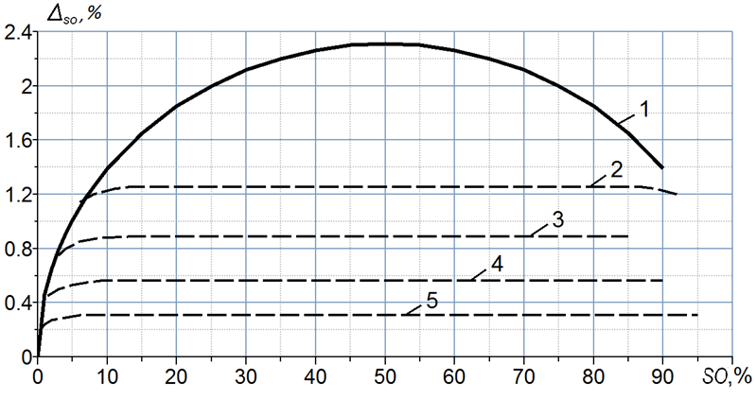

A5.4 Effect of reduced number of samples on the confidence level and the occupancy measurement error
Reducing the number of samples J_{I} by a factor of K in relation to what is recommended in Tables A1 to A3 will reduce reliability, or widen the confidence interval proportionally with K.
For example, if the occupancy of a radio channel with a signal flow rate of no more than 50 signals within the integration time has to be determined, the last column in Table A1 shows that the recommendation in this case is to sample the channel state 1 572 times. Complying with this recommendation, the occupancy calculation (A-1) will deviate by no more than Δ_{SO} = 0.5% from the real value, with a confidence level of P_{SOC} = 95%. Assuming now, that the system is actually capable of taking only 393 channel state samples over the integration time, i.e. four times less than the recommended number, then on average, the occupancy will as before be measured accurately, but the range within which the real occupancy value will occur with a confidence level of 95% is increased fourfold to ±2% of the measurement result.
A reduced number of samples J_{I} may also be observed when data collection for the occupancy calculation is curtailed prematurely. In such cases, the occupancy calculation (A-1) remains unbiased but the confidence level of the results is diminished similarly to the example discussed above.

Reference to Annex 1

[А.1] SPAULDING, A.D., HAGN, G.H. [August 1977] − On the definition and estimation of spectrum occupancy. IEEE Trans. In EMC, Vol. EMC-19, No. 3, p. 269-280.
[A.2] KOZMIN, V.A., TOKAREV, A.B. − A method of estimating the occupancy of the frequency spectrum of an automated radio-control server in the following paginated issue of Measurement Techniques: Volume 52, Issue 12 (2009), Page 1336. http://www.springerlink.com/openurl.asp?genre=article&id=doi:10.1007/s11018-010-9442-9
[А.3] Handbook on Spectrum Monitoring, ITU, 2011.
[А.4] Recommendation ITU-R SM.1880 − Spectrum occupancy measurement and evaluation.
[A.5] KOZMIN, V.A, PAVLYUK, A.P., TOKAREV, A.B. – Optimization of requirements to the accuracy of radio-frequency spectrum occupancy evaluation. Electrosvyaz, 2014 – No. 6 (in Russian – the article translated into English is available at the website: http://www.ircos.ru/en/articles.html).
[A.6] TOKAREV A. B., KOZMIN V. A., PAVLYUK A. P., POLEV V. Y. – Duration of data collection when measuring occupancy of stationary radio channels / Systems of Control, Communication and Security, No. 1, 2024. https://sccs.intelgr.com/arch.html (in Russian – the article translated into English is available at: http://www.ircos.ru/en/articles.html).

