Report ITU-R SM.2154
(09/2009)
Short-range radiocommunication
devices spectrum occupancy
measurement techniques

SM Series
Spectrum management

Foreword
The role of the Radiocommunication Sector is to ensure the rational, equitable, efficient and economical use of the radio-frequency spectrum by all radiocommunication services, including satellite services, and carry out studies without limit of frequency range on the basis of which Recommendations are adopted.
The regulatory and policy functions of the Radiocommunication Sector are performed by World and Regional Radiocommunication Conferences and Radiocommunication Assemblies supported by Study Groups.

Policy on Intellectual Property Right (IPR)
ITU-R policy on IPR is described in the Common Patent Policy for ITU-T/ITU-R/ISO/IEC referenced in Annex 1 of Resolution ITU-R 1. Forms to be used for the submission of patent statements and licensing declarations by patent holders are available from http://www.itu.int/ITU-R/go/patents/en where the Guidelines for Implementation of the Common Patent Policy for ITU-T/ITU-R/ISO/IEC and the ITU-R patent information database can also be found.

Series of ITU-R Reports
(Also available online at http://www.itu.int/publ/R-REP/en)
Series | Title
BO | Satellite delivery
BR | Recording for production, archival and play-out; film for television
BS | Broadcasting service (sound)
BT | Broadcasting service (television)
F | Fixed service
M | Mobile, radiodetermination, amateur and related satellite services
P | Radiowave propagation
RA | Radio astronomy
RS | Remote sensing systems
S | Fixed-satellite service
SA | Space applications and meteorology
SF | Frequency sharing and coordination between fixed-satellite and fixed service systems
SM | Spectrum management

Note: This ITU-R Report was approved in English by the Study Group under the procedure detailed
in Resolution ITU-R 1.

Electronic Publication
Geneva, 2009
© ITU 2009
All rights reserved. No part of this publication may be reproduced, by any means whatsoever, without written permission of ITU.
REPORT ITU-R SM.2154
Short-range radiocommunication devices spectrum occupancy
measurement techniques

(2009)

TABLE OF CONTENTS
Page
1 Introduction 2
1.1 Why SRD monitoring? 2
1.2 How does the monitoring of SRDs differ from normal monitoring? 2
1.3 Relation between SRD monitoring and other monitoring operations 2
2 Technical description of the main issues to consider when monitoring SRDs 3
2.1 Locations 3
2.2 Monitoring period and choice of location 3
2.3 Scanning speed and sensitivity of the setup 4
2.4 Notes about real-time measurements 5
2.5 Are mobile measurements needed? 5
2.6 Detection threshold (how do I program my spectrum analyser or receiver?) 6
2.7 Antenna 9
2.8 The quality of the receiving system 9
3 Data analysis and presentation 9

1 Introduction
Industry request more licence exempt frequency space under the argument that the available frequency bands are not sufficient and sometimes even congested. A balanced opinion from a frequency management point of view can only be obtained when this is based on objective information, including spectrum monitoring information. Also many non ISM bands used by different services are nowadays occupied by short-range radiocommunication devices (SRDs) sharing these frequencies under no interference no protected basis. This Report does not describe UWB or UWB related measurements.
Typical values given in the Report are based on the example of a 863-870 MHz monitoring campaign. For other frequency bands and SRDs in those bands, other values may be more appropriate without changing the basic measurement methodology.

1.1 Why SRD monitoring?
Since SRDs are entering a market which does not confine the use to a single country also ITU needs to consider developing or adapting SRD monitoring methods. Examples are wireless LAN’s on board aircraft, SRDs for monitoring the technical condition of parts in airplanes, cell phones with integrated SRDs such as inductive readers and micro FM transmitters and medical implants asking for global harmonised SRD frequency space.

1.2 How does the monitoring of SRDs differ from normal monitoring?
The monitoring of SRDs has some differences with conventional spectrum monitoring. Not only the occupancy is of interest but also the effectiveness of the politeness protocols needs to be investigated. The latter is something to be obtained by processing the monitoring data. In most cases only occupancy information is required since standardisation takes care of the proper implementation of the politeness protocols. Testing against a standard is therefore sufficient in many cases.

1.3 Relation between SRD monitoring and other monitoring operations
Monitoring organisations may carry out noise monitoring, SRD monitoring and traditional monitoring. All of these methods have their specific features but are specially in the case of SRD monitoring closely related.

Monitoring task | Expected result | Geography | Method
Noise <30 MHz | Noise effects of PLT, EMC and inductive SRD applications | Local at a few number of specific sites  Global at a quiet receiving site to asses the cumulative effects received by ionospheric propagation | According Recommendation ITU-R SM.1753  After that correlation between local and global sites
Noise >30 MHz | Noise effects of UWB, cumulative SRD emissions, spurious radiation of both SRD and non SRD applications (services) | Local at a large number of different types of sites | According Recommendation ITU-R SM.1753
SRD monitoring | Occupancy of allocated/shared SRD bands | Local at a large number of different types of hotspots. For each specific frequency band multiple measurement points for each hotspot | According the guidelines in this Report
Traditional monitoring | Occupancy/coverage of frequencies and frequency bands allocated to services  Spurious and other unwanted effects and technical properties of individual systems/transmitters  Also suitable for relative stationary SRD systems like RFID interrogators | Fixed  Mobile  On route | Fixed (remote) monitoring/  measurements  Mobile monitoring/  measurements  Signal analysis  On route monitoring/  measurements

2 Technical description of the main issues to consider when monitoring SRDs
SRDs are in most cases, but not always, low power transmitters for indoor use with a low duty cycle and a low probability of intercept with common monitoring setups. Based on experiences it is therefore suggested not to use fixed or remote controlled fixed monitoring stations since they are almost always too far from the so called “hot spots” of SRDs. A mobile or semi mobile setup at the locations where the interception of these devices is most likely is recommended. Common definitions of locations and their descriptions such as rural, semi rural, industrial etc are not suitable in this case.

2.1 Locations
Locations could be based on the devices expected in the frequency bands as found in applicable frequency plans. The following list is an example and is not exhaustive. It needs to be modified depending on the national situation.

Type | SRD hotspot or warm area location
RFID | Distribution centres, shopping malls, airports
Social alarms | Hospitals, homes for elderly people
Alarms | Industrial areas with offices
Metering & monitoring | (E.g. remote controlled traffic lights and parking lots) in city centres
Non specific SRDs | Densely populated areas
Radio microphones | Theatres, football stadiums
Wireless audio | Densely populated areas
Medical implants | Anywhere but dominant in hospitals and medical centres

UHF RFIDs are used as an example for the following considerations. The scope, however, can be extended to monitoring of other SRDs.

2.2 Monitoring period and choice of location
A monitoring campaign should include time periods based on the expected frequency use, for example one 24 h period on a working day and a 24 h period on a weekend day for RFID’s. Monitoring results could vary within a locations area so moving the setup each hour, or another time period, is necessary to give reliable results. For example at an airport most luggage handling is done underground so measuring at the terminal gives different results than in the cellar. A few different locations in a city centre could give different results due to shielding of buildings so moving the setup periodically is an advantage. The results of a typical locations area should be combined. Synchronisation of the mutual monitoring periods between administrations if a coordinated monitoring campaign is performed is not necessary since there is no schedule or day to day synchronisation between the use in different nations. During the development of methods and guidelines it seemed to be an advantage to harmonise some terminology. Note that these defined terms are only related to SRD monitoring and valid for this report. The locations with activity are for example called hot spots and warm areas, not to be confused with WIFI hotspots.
Warm area: A large area with distributed activity like a car parking place.
Hotspot: A confined area with activity. A hotspot can be situated within a warm area.
Monitoring location: A location with one or more hotspots and/or warm areas.
Monitoring position: A position within a warm area or hotspot from which the results will be combined to one measurement result.
Coverage area: Area around a monitoring position from where signals are received.
Figure 1
Definitions

hotspot
Monitoring position
Warm area
Monitoring location
Coverage area

2.3 Scanning speed and sensitivity of the setup
SRDs can have a low duty cycle, 10% or lower is not uncommon and a power between 25µW and 100 mW e.i.r.p. typical. They are also mostly used in areas with shielding of buildings. It is tempting to use the narrowest observation bandwidth available in a monitoring receiver to overcome at least the limitations of the low e.i.r.p spectral power density a SRD produces. Narrow observation bandwidths, however, offer a better receiver sensitivity but also limit the registration speed of the receiver. SRDs are used within buildings with a shielding up to 20-30 dB so the covered area and probability of intercept is inherently low.
A suitable balance between sensitivity and scanning speed should therefore be investigated. A setup comparable with a radio noise measurement system in terms of speed and sensitivity is recommended. Calibration of the setup can be performed using a test transmitter mimicking the power levels and duty cycles. An SRD measurement system with a limited coverage area needs to be moved to different locations to obtain a view of the whole area of interest. The coverage area for the setup can be calculated and in turn this information can be used to determine the number of locations for the setup to be moved.
It needs to be noted that a representative occupancy figure cannot be obtained without including the attenuation of the surroundings into the final occupancy calculation. For low power SRDs like RFID tags a cart or trolley can be used and moved trough the location.

2.4 Notes about real-time measurements
A real-time measurement is a measurement where the time signal in a certain bandwidth is sampled without the loss of any sample. The question is do we need this for SRD monitoring? If we want to determine the behaviour of individual devices or if the transmitting characteristics are unknown the answer is yes but we need to be careful. For occupancy figures of devices with reasonable constant and known transmitting characteristics the answer is no. The devices will transmit at regular intervals so there is a high detection probability. This principle of repetitive sampling works well but for converting the result to a reasonable accurate occupancy figure we need to choose the measurement speed and revisiting time carefully. The quotient (measurement period)/(revisiting time) needs to be tailored to the transmit period of the expected devices.
If a real-time (digital) analyser is used we need as said to be careful because of the following phenomenon. For converting time data to spectrum data a block of samples with a certain time span needs to be taken. Within this block of samples changes can occur that are not presented in the spectral display. Due to the short transmitting times of the SRDs the occupancy can be overestimated if the time for the block of samples is chosen to high. For this type of analyser the same “rules” as for a sweeping or scanning analyser apply. Here we need to do a similar tailoring as for the sweeping analyser but the formula to be used changes in (measurement period)/(sampling time*window size) which again needs to be based on the transmit period of the expected devices.

2.5 Are mobile measurements needed?
In § 2.2 we concluded that a fixed setup doesn’t give representative results but full mobile measurements do not give the actual occupancy of a low probability of intercept.
A mobile setup however can be used to investigate the presence of relatively high power SRDs but also to find hotspots and warm areas. A full mobile investigation in addition to the static measurement at the hotspot or warm area is recommended but can be performed with a lower intercept probability than the fixed measurements. Figure 2 is the result of an actual measurement performed on a parking area in the United Kingdom.
Figure 2
Mobile measurement example
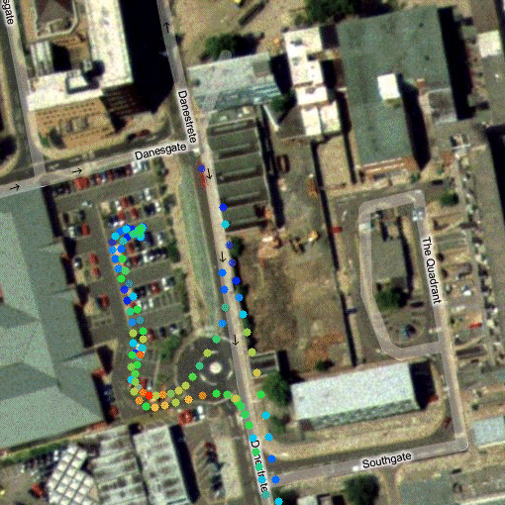
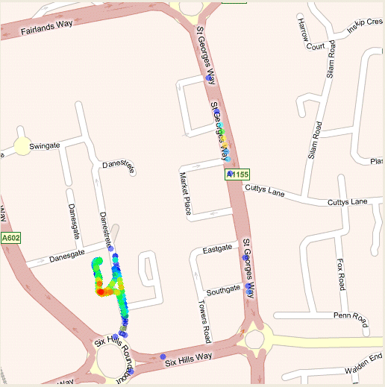

2.6 Detection threshold (how do I program my spectrum analyser or receiver?)
Some typical values for the detection threshold based on a medium end spectrum analyser are given in the following table. The criterion for detection is that a signal is at least 3 dB above the receivers noise floor.

Filter bandwidth  (kHz) | Detection threshold for input voltage  (dB(µV)) | Revisiting time  (ms)
1 | 0 | 7 000
3 | 5 | 780
10 | 7 | 70
30 | 10 | 10
100 | 13 | 2.5
300 | 14 | 2.5

– First we need to calculate the antenna factor of the intended monitoring antenna and using this information we calculate the detection threshold for field strength. This field strength is based on the assumption that a signal is matched to or is narrower than the chosen filter bandwidth.
– The next step is to estimate the wall attenuation for single and multiple walls and add this to the detection threshold for field strength.
– With this modified detection threshold and knowledge of the SRDs radiated power (e.r.p. or e.i.r.p.) the distance at which the SRD still can be detected can be calculated.
Figure 3 shows field strengths for SRDs with different typical e.r.p.’s taken from typical SRD applications. The detection threshold for the different analyser settings is plotted so the coverage of the measurement setup can be estimated.
Figure 3
Field strength vs distance free space
Figure 4 shows the same result with 20 dB additional (wall) attenuation, the x scale is limited to the first 500 m of Fig. 2.
Figure 4
Field strength vs distance free space 20 dB attenuation
We can conclude that sufficient coverage is gained even using a filter of 3 kHz and the internal attenuator of the analyser set to 10 dB. There is therefore no problem in using a receiver with lower performance than the mentioned analyser as long as the attenuator is switched off. This is not a problem for an occupancy measurement (absolute level measurements are nor possible due to mismatch uncertainty). A wall attenuation of even 20 dB guaranties a theoretical coverage of at least 350 m with the widest IF filter setting and a SRD e.i.r.p. of 5 mW. Tests have shown that for lower power SRDs a preamplifier with preselection filter can be an advantage in areas with multiple wall attenuations.
Problems however arise when measuring very low power devices and low power wideband devices such as RFID tags, these tags need to be detected with a 200 or 300 kHz IF filter due to their bandwidth. Wall attenuation limits the detection range to less than 10 m to have a reasonable probability of intercept for these devices a high quality sensitive analyser needs to be used with the attenuator switched off. Wall attenuation needs to be avoided. This means measuring indoor scanning the area with a setup mounted on a cart or trolley. When we assume a wall attenuation of 10 dB, no attenuator switched on and a filter of 300 kHz the coverage looks as in Fig. 5.

Figure 5
Field strength vs distance for RFID Tag’s

It makes no sense to estimate coverages more that 500 m for ground based measurements since multiple attenuation factors will be present. Practical measurements show that the coverage is even less in most cases.

Power | Duty cycle  (%) | Detection range 20 dB loss 30 kHz IF  (m) | Detection range 10 dB loss 300 kHz IF, no attenuator  (m)
10 µW (–20 dBm) | 100 | 55 | 150
5 mW | 10-100 | >500 | –
10 mW | 0.1-1 | >500 | –
25 mW | 0.1-10 | >500 | –
100 mW | <10% | >500 | –
500 mW | <10% | >500 | –
1W | <10% | >500 | –
We can conclude that:
– An IF filter setting of 30 or 25 kHz is suitable for all measurements except RFID tags, the corresponding revisiting time is 10ms. Coverage radius will be about 500 m maximum.
– An IF filter setting of 300 kHz is suitable for RFID measurements under the assumption that the attenuator of the analyser is switched off and the overall wall and environmental attenuation is not larger than 10 dB. The coverage radius will then be about 150 m.
– It makes no sense to estimate coverages more than 500 m radius because multiple attenuation factors will be present.
– Using a preamplifier with preselector can be of help when a mid end analyser or receiver in situations with heavy wall attenuation is used.

2.7 Antenna
Measuring in a SRD hotspot is comparable with a radio noise measurement, no fixed direction from which most radiation arrives can be given in most cases. For the relatively high power RFID interrogators there is an exception. The use of a vertical antenna with vertical gain, such as a collinear has an advantage above a Ground plane vertical or log periodic antenna unless there is a strong indication that SRDs are transmitting under elevated angles. In that case measurements with directional antennas or antennas with low vertical gain can be performed. A passive antenna followed by a bandfilter and preamplifier or narrowband active antenna is preferred above a wideband active antenna because even extremely low IM products can disturb the measurement results.

2.8 The quality of the receiving system
For SRD monitoring a normal monitoring receiving system can be used. However the quality of the monitoring data relies solely on the quality of the receiver since aural monitoring is impractical. Intermodulation products are difficult to separate from genuine SRD transmissions so these should be more or less technically excluded. The system needs a defined balance between sensitivity and linearity. If the receiver needs a preamplifier it is likely that a preselection filter is needed.
For a typical setup an analyser with a noise figure of 8 dB and a 3rd order IP of 25 dBm needs a 10-15 dB preamplifier and a preselection filter.

3 Data analysis and presentation
A spectrogram gives an insight of the frequency bands dynamics and is useful as an additional information source. An occupancy plot reveals details of occupancy for each location not visible in the tabular format so this should also be added. A resolution lower than the highest bandwidth for frequency bands with mixed transmitter bandwidths should be chosen for these plots.
It can be assumed that figures for spectrum occupancy are very much country dependent. An analysis based on the observations within a country is therefore desired when performing a international monitoring campaign. Occupancy figures should represent 10 dB values above the receiver’s rms noise threshold. A manual analysis and interpretation of the figures should be presented with the occupancy plots. A percentage of use over specific frequency segments, for example only the RFID section can be used to indicate the possibility of sharing.
A tabular form like below can be used. Values are not actually measured and are just examples. The table needs to be modified/detailed according the band containing traffic. A few examples are given and occupancy figures per application can be used to indicate location dependent sharing possibilities.
Occupancy figures are calculated using a time frequency matrix in which each value 10 dB above the mentioned receiver’s rms noise threshold can be considered occupied. Due to the noisy properties of SRD transmissions a conventional dynamic squelch or threshold which is adjusted at relatively long intervals should not be used. A fixed threshold should be used based on the actual receiver and measured environment noise floor. Another possibility is to determine the noise floor on a scan by scan basis and adjust the threshold accordingly.
Due to the resolution bandwidth and the bandwidth of the transmitting devices some values will be correlated depending on the monitored band. This is not a problem since we do not perform an analysis of the number of devices in a particular band.

Location | Type | Occupancy  (%)
Location | Type | Total | Non specific | Alarms | Audio
Location | Type | 863-870 | 868.0-868.6  868.7-868.2  869.4-869.5  869.7-870.0 | 869.250-869.300  869.650-869.700  869.200-869.250  869.300-869.400 | 863.0-865.0  864.8-865.0
Amsterdam WTC | Office | 20 | 0 | 2 | 0
Amsterdam WTC | Parking | 3 | 2 | 0 | 0

Location | Type | Occupancy  (%)
Location | Type | Total | Non specific | RFID
Location | Type | 863-870 | 868.0-868.6  868.7-868.2  869.4-869.5  869.7-870.0 | 865.0-865.6  865.6-867.6  867.6-868.0
Schiphol | Luggage handling area | 20 | 0 | 20
Schiphol | Shopping area | 5 | 0 | 5
Schiphol | Long-term parking | 1 | 1 | 0
Schiphol | Short-term parking | 2 | 2 | 0

Location | Type | Occupancy  (%)
Location | Type | Total | Specific high power licensed
Location | Type | 863-870 | 865.4-867.6
Specific | Specific | 30 | 80

The Figures 6 and 7 show two typical scenarios in the 863-870 MHz band, one investigation is performed in a city centre and another in a luggage handling area at an airport. The analyser settings and antenna configuration is the same in both situations. Although this is a momentary single investigation at two hotspots one could conclude something about sharing possibilities.
Because SRD monitoring is not limited to bands exclusively used for SRDs it can also be necessary to distinguish between SRDs and ISM transmissions or transmissions of services. In some cases it is not possible to eliminate these ISM and other non SRD transmissions from the dataset but advanced statistical methods can be used to eliminate them. In the available Recommendations and Reports about radio noise measurement some of these methods are described. When elimination is not possible the conventional monitoring approach would be to accept these transmissions but consider the effect on the actual occupancy as a factor lowering the absolute accuracy of the measurement. A careful assessment of possible occupancy of the frequency band to be measured is advised to determine if this approach is needed.
Figure 6
Spectrum registration 863-870 MHz typical RFID populated area
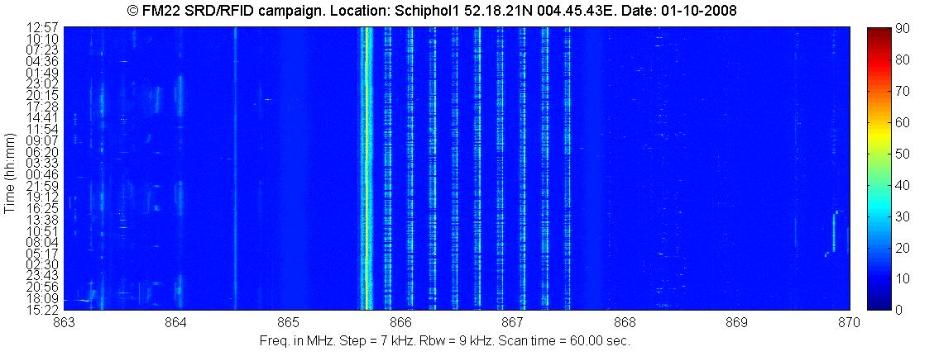
RFID iterrogators
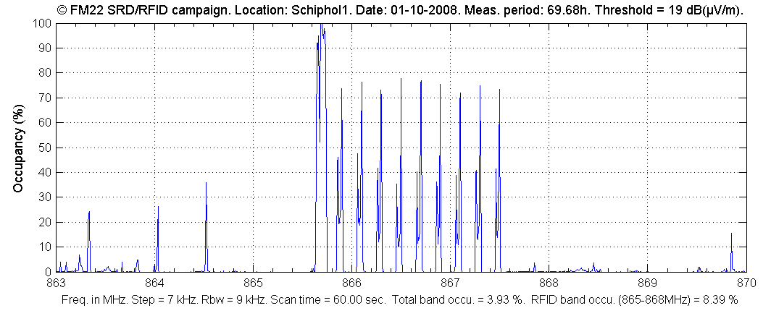
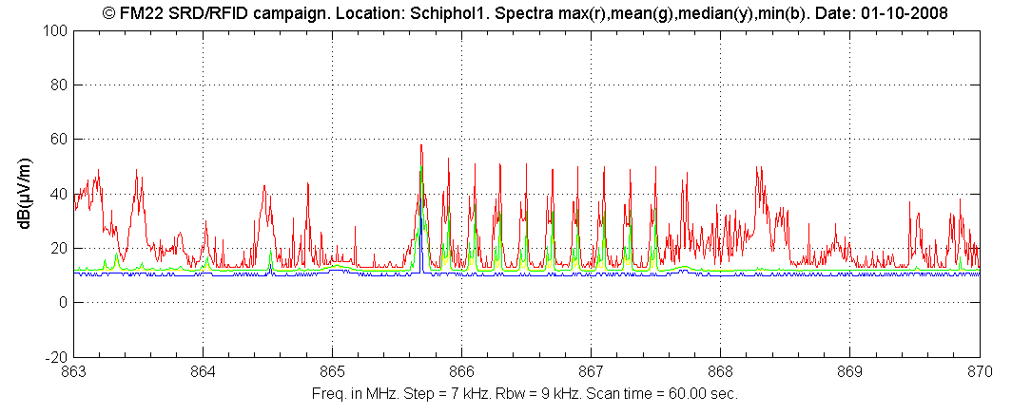
Figure 7
Spectrum registration 863-870 MHz typical populated city area
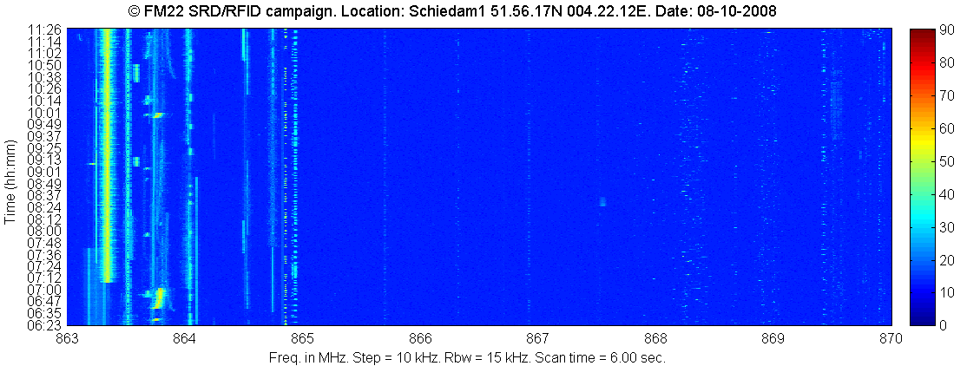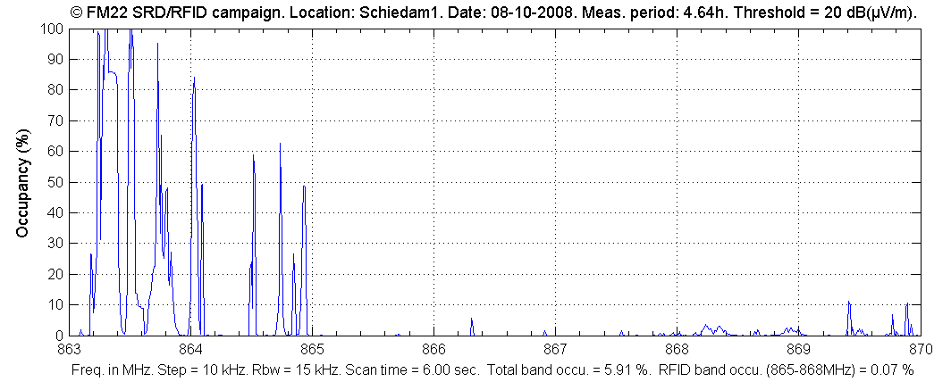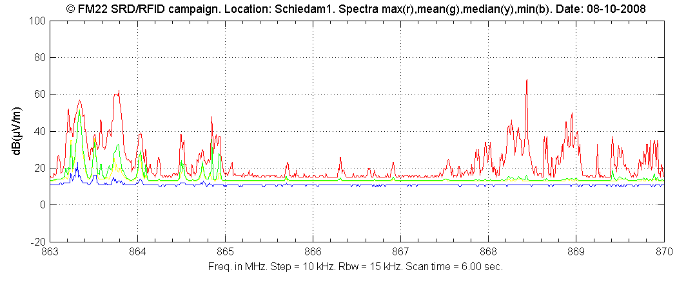
Wireless audio

