Report ITU-R SM.2015-3

(06/2025)

SM Series: Spectrum management

Methods for determining “national long-term strategies” for spectrum utilization in certain countries

Foreword

The role of the Radiocommunication Sector is to ensure the rational, equitable, efficient and economical use of the radio-frequency spectrum by all radiocommunication services, including satellite services, and carry out studies without limit of frequency range on the basis of which Recommendations are adopted.

The regulatory and policy functions of the Radiocommunication Sector are performed by World and Regional Radiocommunication Conferences and Radiocommunication Assemblies supported by Study Groups.

# Policy on Intellectual Property Right (IPR)

ITU-R policy on IPR is described in the Common Patent Policy for ITU-T/ITU-R/ISO/IEC referenced in Resolution ITU‑R 1. Forms to be used for the submission of patent statements and licensing declarations by patent holders are available from <https://www.itu.int/ITU-R/go/patents/en> where the Guidelines for Implementation of the Common Patent Policy for ITU‑T/ITU‑R/ISO/IEC and the ITU-R patent information database can also be found.

|  |  |
| --- | --- |
| Series of ITU-R Reports  (Also available online at <https://www.itu.int/publ/R-REP/en>) | |
| **Series** | Title |
| **BO** | Satellite delivery |
| **BR** | Recording for production, archival and play-out; film for television |
| **BS** | Broadcasting service (sound) |
| **BT** | Broadcasting service (television) |
| **F** | Fixed service |
| **M** | Mobile, radiodetermination, amateur and related satellite services |
| **P** | Radiowave propagation |
| **RA** | Radio astronomy |
| **RS** | Remote sensing systems |
| **S** | Fixed-satellite service |
| **SA** | Space applications and meteorology |
| **SF** | Frequency sharing and coordination between fixed-satellite and fixed service systems |
| **SM** | **Spectrum management** |
| **TF** | Time signals and frequency standards emissions |

|  |
| --- |
| ***Note****: This ITU-R Report was approved in English by the Study Group under the procedure detailed in Resolution ITU‑R 1.* |

*Electronic Publication*

Geneva, 2025

© ITU 2025

All rights reserved. No part of this publication may be reproduced, by any means whatsoever, without written permission of ITU.

REPORT ITU-R SM.2015-3

Methods for determining “national long-term strategies” for spectrum utilization in certain countries

(Question [ITU-R 205-2/1](https://www.itu.int/pub/R-QUE-SG01.205))

(1998-2019-2022-2025)

TABLE OF CONTENTS

Page

Chapter 1 5

1 Introduction 3

2 National long-term planning process 4

2.1 Spectrum requirements definition 5

2.2 Spectrum availability 5

2.3 Spectrum planning options 5

2.4 Spectrum planning implementation 5

2.5 The iterative process 5

3 The management or administrative body 5

Annex 1 to Chapter 1 – Influencing factors 6

[Annex 2 to Chapter 1 – Methodology of the long-term spectrum management   
plan development 8](#_Toc184629928)

Chapter 2 17

1 Introduction 15

2 The consultative approach 15

2.1 Inquiry into future spectrum/service requirements 16

2.2 Interaction among/with representative groups 16

2.3 Analysis of usage trends 17

2.4 Example 17

3 The analytical approach 18

3.1 Introduction 18

3.2 Steps for the analytical approach development 18

[3.3 The use of the analytical technique in the long-term spectrum   
requirements planning process 19](#_Toc184629938)

Chapter 3 22

1 Identification of long-term spectrum management objectives 20

2 Evaluation of current spectrum management process 20

3 Transition procedures 21

3.1 Encourage effective spectrum utilization 21

3.2 Enhance spectrum use flexibility and agility in spectrum management 23

[3.3 Maximize the social and economic benefits that can be achieved by   
appropriate spectrum management 23](#_Toc184629944)

3.4 Ensure that the spectrum is used in all regions of the country where it is needed 24

3.5 Build a skilled work force and develop proper spectrum engineering tools 24

[Annex 1 to Chapter 3 – Example on evaluation procedures of spectrum   
utilization efficiency in Korea (Rep. of) 24](#_Toc184629947)

1 Background 24

2 The process of the evaluation 25

3 Actual evaluation cases 27

4 Countermeasures and expected effects according to evaluation results 28

[Annex 2 to Chapter 3 – A white paper on a future-looking perspective on   
an agile and sustainable spectrum management regime for the next   
decade in the United Arab Emirates 30](#_Toc184629952)

1 Executive summary 30

2 Purpose of White Paper 31

[3 The UAE digital strategy, foresight, scenarios, and spectrum agility   
implications 31](#_Toc184629955)

[4 The TDRA strategic vision: Towards always more agile system   
management systems 34](#_Toc184629956)

4.1 Current approach to authorizing spectrum use 34

4.2 Agile spectrum management 34

4.3 Benchmarking 37

4.4 Summary 37

[5 Driving forces and evolutions in spectrum management for wireless   
technologies and services 37](#_Toc184629961)

5.1 Technology developments and changing user requirements 38

[5.2 Spectrum management solution opportunities and the developing   
capabilities of regulators 40](#_Toc184629963)

[6 TDRA 2031: Roadmap, scenarios, and timeline for the evolution of   
smart spectrum management systems 48](#_Toc184629964)

6.1 Scenario A: Trend towards incremental agility 49

6.2 Scenario B: Leap towards full agility conditions 50

6.3 Scenario C: Objective based approach: The road to 2031 51

6.4 TDRA initiatives and the ITU framework 53

6.5 The road to 2031: UAE digital objectives and TDRA initiatives 54

7 Timeline and benefits of implementing an agile SMS 55

CHAPTER 1

Long-term planning process

# 1 Introduction

Recommendation [ITU-R SM.1047-2](https://www.itu.int/rec/R-REC-SM.1047-2-201209-I/en) – National spectrum management, adopted in 2012, *recommends* that the development of national spectrum management programmes should address the spectrum planning among other subject areas. Moreover, administrations are guided by the appropriate sections of the ITU-R Recommendations, Reports and ITU Handbooks. The [Handbook on National Spectrum Management](https://www.itu.int/pub/R-HDB-21), adopted in 2015, defines terminologies related to spectrum planning on Chapter 2 “Spectrum Planning”.

According to the Handbook, spectrum planning can be classified by time (short term, long term and strategic) and the areas covered (spectrum use and spectrum management systems). ‘Long term planning’ means planning that considers issues needing resolution or systems to be implemented within five to ten years, whereas ‘short term planning’ is to be implemented within three to five years. In comparison, strategic planning is involving the identification of a limited number of key issues, which require concentrated spectrum management attention for solutions that need more than ten years to be implemented.

Therefore, long-term strategy is about a defining vision and mission to solve key issues which will be implemented over ten years related to spectrum management for spectrum utilization.

At present, most spectrum planning is relatively short-term. However, if spectrum resources are to adequately support national goals and objectives, long-term planning is essential. It can provide a basis for effective spectrum management to ensure that spectrum is efficiently allocated and assigned, to accommodate constantly evolving spectrum requirements by new systems and their applications. It also facilitates decision-making by providing a basis for the practical consideration and evaluation of alternative courses of action.

Long-term planning should endeavour to:

– make today’s decisions on spectrum planning strategies in view of their consequences for the future;

– identify the impact of past decisions on the future; handle the process of new data and deal with the complex and fast changing nature of wireless signals;

– periodically adjust decisions to changing circumstances and requirements of evolving technologies.

It should be sufficiently comprehensive to accommodate the national spectrum requirements of both known and anticipated radiocommunication systems within its stated timeframe.

It also leads to:

– revision of the national table of frequency allocations;

– the development of national positions on international radio conference agendas; and

– revision to spectrum regulations, policies and standards.

NOTE – National experiences provided in this Report are only representing the views of the respective Administrations. They are for information purpose only and do not engage other members on confirming or otherwise of these experiences.

# 2 National long-term planning process

The development of national long-term strategies for spectrum use will require the implementation of a national long‑term spectrum planning process.

One part of such process can be the development and implementation of a Plan of the spectrum prospective usage. Such plan should be revised and adjusted according to new information every 1 to 3-5 years. It should be based on civil and government users’ spectrum requirements investigations as well as trends of new technologies development. An example of such plan is provided in Table 1.

TABLE 1

An example of a Plan of the spectrum prospective usage

|  |  |  |  |  |
| --- | --- | --- | --- | --- |
| Frequency band  (kHz, MHz, GHz) | Existing and planned services /applications | Specifics | Planned changes | Notes |
| 915-921 MHz | ARNS  Space operation service for telemetry, tracking, and control purposes  Mobile, except aeronautical mobile on secondary basis.  RFID | ARNS operate on primary basis | Decommissioning of ARNS after the end of depreciation period and deployment same service in other bands |  |

The stages of the development of the Plan as well as factors that need to be taken into account are given below. A methodology that can be used to develop long-term spectrum utilization plan is given in Annex 2 to this Chapter.

## 2.1 Spectrum requirements definition

Spectrum requirements definition determines future broad-based national spectrum requirements for all radio services and technological, policy and economic factors (see Annex 1 to this Chapter) which may influence spectrum use.

Spectrum requirements can be defined based on the evaluation of potential scenarios (see Chapter 2). Traditionally, spectrum use scenarios have been evaluated based on consultative inputs from concerned parties including national spectrum planning organizations within governmental departments or agencies, individual user requests, and the public.

Recently, steps have been taken to perform scenario evaluation based on analytical modelling techniques (see Chapter 2, also applicable to the spectrum availability and spectrum option phases).

## 2.2 Spectrum availability

The objective of this phase is to assess the availability of spectrum across all national radio services and to accommodate the spectrum requirements identified in the requirements definition phase. Inputs are primarily derived from within the administration itself but also can come from the ITU International Frequency List, ITU allotment Plans and any existing regional spectrum planning studies.

## 2.3 Spectrum planning options

The aim of this phase is to develop suitable spectrum planning options to satisfy spectrum requirements on the basis of the data from the two preceding phases. Any analysis for the development of spectrum options would need to take account of technical, policy and economic factors. The analysis would also assess the various opportunities for services given existing and projected radiocommunication environments and/or allocations. Recommendations regarding those service requirements unable to be accommodated within current national allocations will be based on these analyses and any available spectrum monitoring results. Allocation options are developed and the relative costs of any reallocation to and/or movement of existing spectrum users assessed.

## 2.4 Spectrum planning implementation

This phase would provide for the implementation of various spectrum planning strategies (see Chapter 3) and could be expected to be an on-going process. The introduction of new services may require changes to national spectrum allocation tables and revisions to national and ITU regulations. Revisions to international regulations would be undertaken at the ITU World Radiocommunication Conferences (WRCs).

## 2.5 The iterative process

Previous decisions can be re-evaluated periodically or triggered by specific events and, if necessary, modified based on the updated information. The planning process is therefore a continuous process of exploration and data processing rather than a linear process.

A record of all changes can be maintained to provide a history of developments in the long-term plan.

# 3 The management or administrative body

The establishment of a management or administrative body providing leadership and supervision for the implementation of the spectrum planning programme is necessary to ensure that issues relating to long-term spectrum utilization strategies can be addressed. This will include the introduction of an early recognition system within the framework of its planning procedures. However, the body may be supported by special planning bodies such as project groups and task forces.

Long-term planning is usually a primary task at management level and one that cannot be delegated, due to the consequences and significance of the decisions to be taken. Such planning bodies are responsible for:

– developing detailed strategic policies and solving problems concerning the conversion of strategic policies into operational plans;

– allocating financial and human resources;

– strategic review of procedures, results and requirements in conjunction with the implementation of strategies;

– any necessary recommendations concerning adjustments to organization and management systems, and

– updating the planning data used as a basis for frequency management.

Annex 1   
to Chapter 1  
  
Influencing factors

The following is the list of influencing factors to be considered in the long-term planning process:

1 Policy and legal factors

1.1 Regulatory factors

1.1.1 International frequency allocation (ITU-R)

1.1.2 Regional frequency management bodies

1.1.3 National frequency allocation procedure

1.1.4 Frequency management procedures of neighbouring administrations

1.1.5 Standardizations policy

1.1.6 Telecommunications infrastructure factors

1.2 Industrial factors

2 Economic factors

2.1 User mobility

2.2 Globalization

2.3 Overall economic development

2.4 Market factors

2.4.1 Structure of prices and tariffs for equipment and services

2.4.2 Market needs and marketing factors

2.4.3 Procedures and practices used by service providers

2.4.4 Spectrum auctioning

2.5 The impact of new services, technology developments and changing user requirement

3 Social factors

3.1 Changes in demand as a result of changes in the social structure

3.2 Changes in demand as a result of changes in the daily and life-time working hours

3.3 Security and public safety

3.4 Public acceptance of radio applications

4 Ecological factors

4.1 Electromagnetic pollution and radio-frequency interference

4.2 Public dislike of large antenna structures and proliferation of sites

4.3 Debris in space

4.4 Sustainability

5 Technical factors

5.1 Basic technologies

5.1.1 Microelectronics

5.1.2 Signal processing

5.1.3 Equipment components

5.1.3.1 Power supplies

5.1.3.2 Batteries

5.1.4 Communication media

5.2 Coding and modulation techniques

5.2.1 Source coding

5.2.2 Channel coding

5.2.3 Modulation techniques

5.3 Channel access techniques

5.3.1 Time division multiple access (TDMA)

5.3.2 Frequency division multiple access (FDMA)

5.3.3 Code division multiple access (CDMA)

5.3.4 Orthogonal frequency division multiple access (OFDMA)

5.4 Transmission modes

5.4.1 Diversity techniques

5.4.1.1 Time diversity

5.4.1.2 Frequency diversity

5.4.1.3 Antenna diversity

5.4.1.4 Space diversity

5.4.1.5 Direction diversity

5.4.2 Spatial multiplexing techniques

5.4.2.1 Direct multiplexing

5.4.2.2 Transmit beamforming techniques

5.4.3 Spread spectrum techniques

5.5 Antennas

5.5.1 Antenna optimization

5.5.1.1 Use of new technologies and manufacturing methods to reduce side lobe level and reduce correlation among antennas

5.5.1.2 New methods in antenna development

5.5.1.3 Massive multiple-input multiple-output (MIMO) antennas

5.6 Data processing in telecommunications

Annex 2   
to Chapter 1  
  
Methodology of the long-term spectrum management plan development

The main aim of the development of a long-term spectrum management plan is efficiency of frequencies usage. Depending on its goals an Administration can choose technical, economic, policy criteria of efficiency.

The process of the development of a long-term spectrum management plan includes the following steps (see Fig. 1):

1 The evaluation of the current spectrum utilization by different technologies and applications.

2 The development of the list of perspective technologies.

3 The assessment of frequency resource that is required and sufficient for the following systems and applications: mobile, fixed, broadcasting, satellite, short-range devices (SRD).

4 The development of measures to provide perspective technologies with sufficient amount of spectrum.

Figure 1

The evaluation of the current spectrum utilization by different technologies and applications

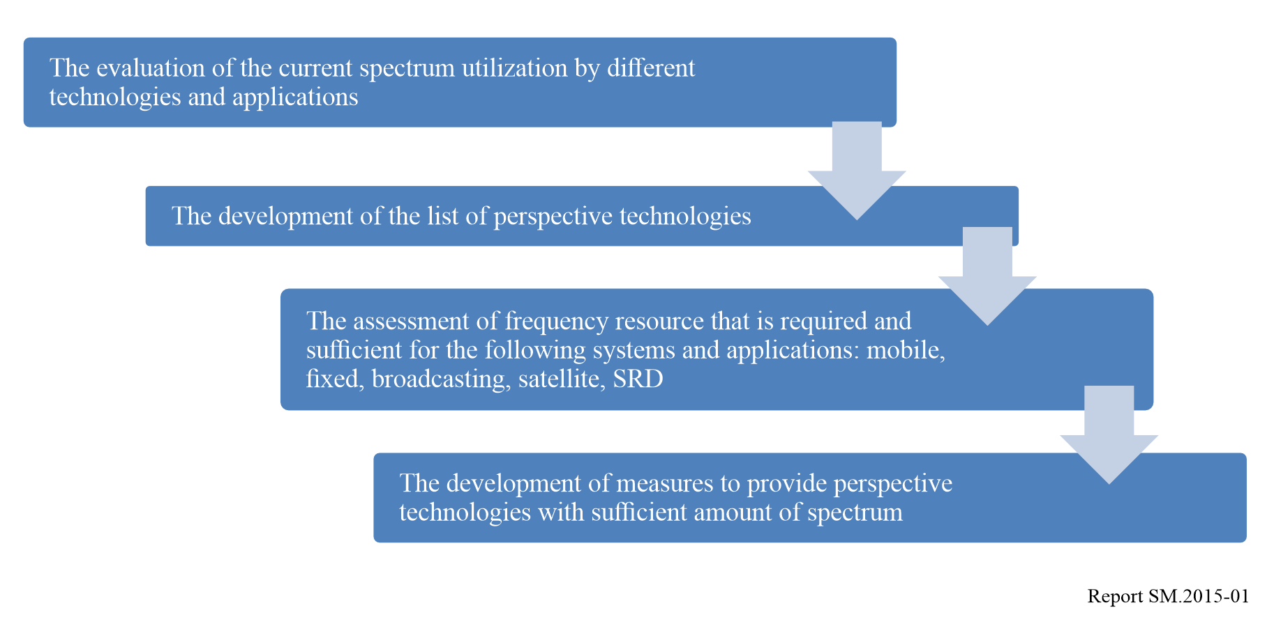

The main tasks on the stage of the evaluation of the current spectrum utilization by different technologies and applications are:

– The assessment of spectrum actually used by mobile, fixed, broadcasting, satellite, SRD applications and systems;

– Definition of frequency bands where new technologies and applications could be implemented;

– Definition of frequency bands utilized inefficiently.

The development of the list of perspective technologies

Expert methods can be used to develop the list of perspective technologies. This category has been chosen because there is few statistic data on usage of new technologies if any.

The required information can be gathered through discussions or questionnaires.

Expert judgments are opinions of highly qualified professionals expressed as qualitative or quantitative assessments of the object, and are to be used in the decision-making process.

To assess qualitative indicators, verbal-numeric scale, which comprises the description of its levels and appropriate numeric values or ranges, could be used.

An expertise can be individual or collective, having one round or multiple rounds, allowing experts to exchange information between each other or prohibiting it. They can also be open or anonymous. The variety of fields in which they can be used makes expert methods multifarious and flexible. However, implementing one of the famous and widespread schemes is not always possible. Therefore, when implementing complex and uncommon expertise, it is recommended for Administrations to be creative in using well known expert techniques and to combine the possibilities of each of them. Sometimes it could be appropriate to develop a new expert approach. The simplest and most well-known expert techniques are methods of commissions, jury of executive opinion and brainstorming. The first one is a set of open discussions on a topic to develop an integrated opinion. The second method (jury of executive opinion) assumes that expertise is performed by analogy with trial.

When brainstorming, each idea should be discussed and cannot be rejected. The administrator of expertise knows the final goal of a discussion and directs it.

Each technology chosen by experts is given an assessment of its prospectivity. To assess the technology prospectivity one can use the Delphi technique, which is often used to perform expertise. This method allows to consider independent opinions of every expert involved by consecutive consolidation of ideas, conclusions and proposals and to achieve an agreement. This method is based on multiple round anonymous group interviews.

The Delphi technique is a group of methods combined by general procedure’s organization requirements, and forms of receiving assessment from the experts. The effectiveness of expert’s work is provided by anonymity of the procedure and possibility to get more information about the subject of expertise. As a rule, the expertise is carried out in multiple rounds in order to provide feedback. This allows experts to adjust their opinion taking into account interim average assessments and experts’ clarifications. Today there is no agreement on number of rounds of Delphi procedure. It depends on the specifics of the expertise and its goals. As a rule, assessments do not change after second round.

Each step involves typical procedures. Experts are asked to assess the subject qualitatively by answering questions such as: expected time of some event, the importance of characteristics in scores etc. After receiving answers from experts data is ranked, median and quartiles of ordered data are calculated. The results are given to experts and they are asked to clarify their opinion. This especially applies to experts whose assessments fall out of limit of quartiles. Before the start of the procedure experts are given all available information on the subject.

Each expert gets a questionnaire. If the questions are difficult, they should be followed by an explanatory note. Figure 2 gives a scheme for assessing technology prospectivity.

Figure2

Assessment of the technology prospectivity

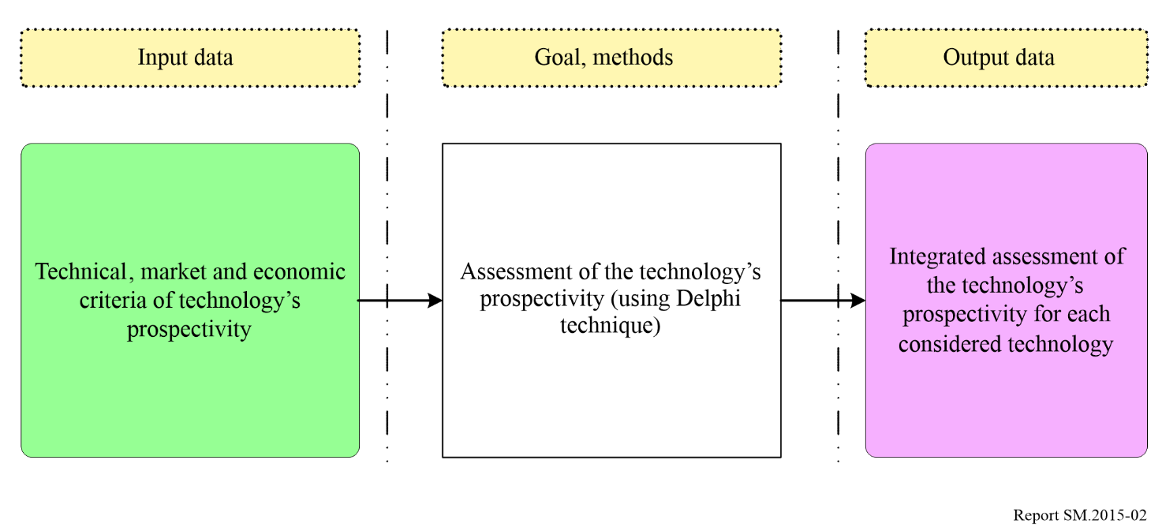

Figure 3 shows algorithm developed to get input data for assessment of the technology prospectivity using the Delphi technique.

Figure 3

Algorithm for carrying out an expert poll using the Delphi method

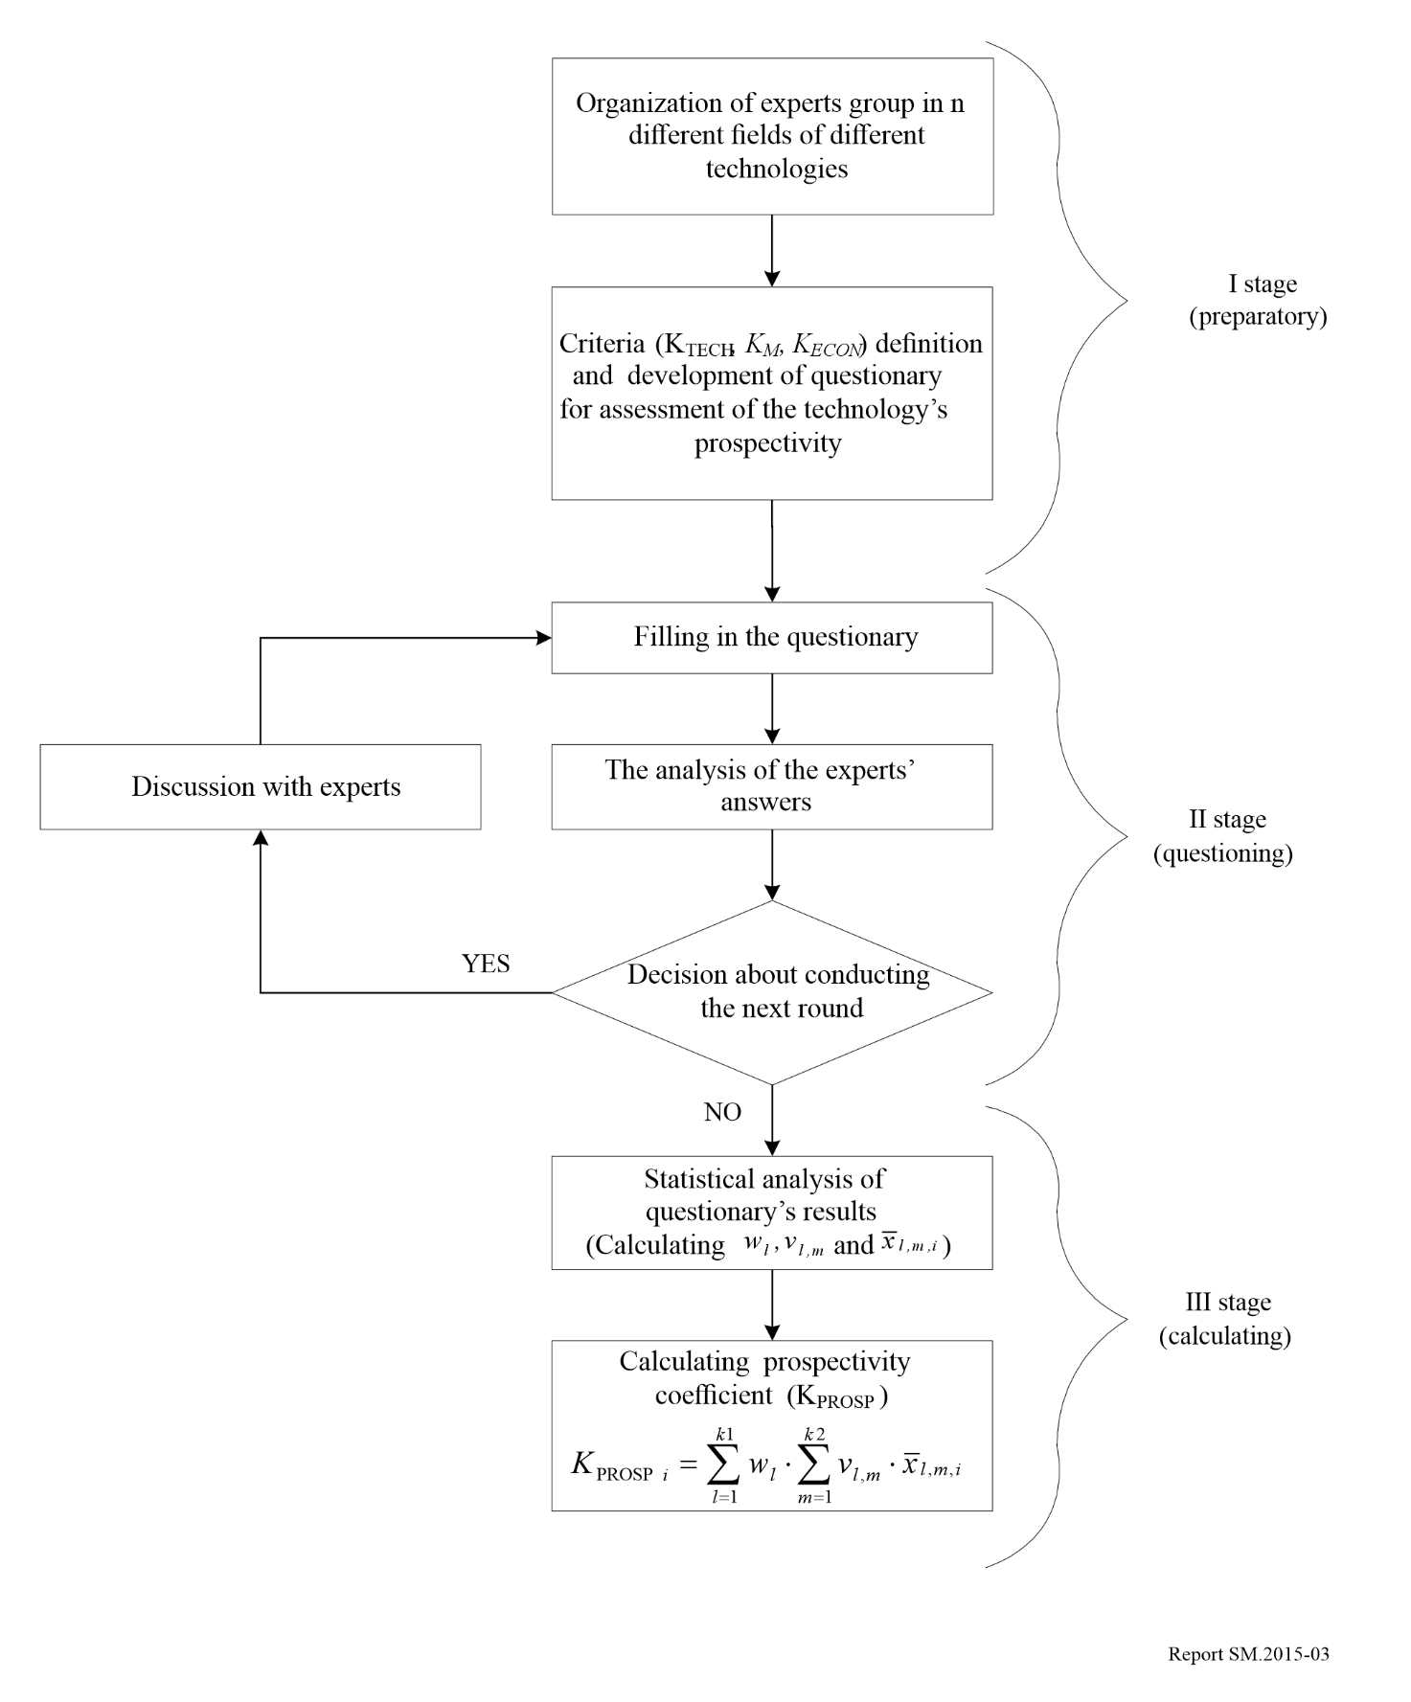

According to the developed procedure, the group of experts is formed on the first stage. To define the number of experts needed to get representative results, the following formula is used.

 (1)

Here *ZP* is determined in accordance with the table by the confidence probability value of 1 − α. For 1 – α = 0.95, *ZP* = 1.96; $σ^{2}$– experts’ assessments variance; Δ – accuracy of assessment.

On this stage experts also define criteria for assessment of the technology prospectivity. There are three groups of criteria:

– Technical;

– Market;

– Economic.

An example of each group of criteria is given below.

Technical criteria:

|  |  |  |
| --- | --- | --- |
| *КV* | – | expected term for spectrum release. It is important not only for operator but for government as well. Spectrum release term determines the term of new technology implementation and receiving benefits. The sooner spectrum is released, the more perspectives there are for development of the considered technology (higher score). |
| *КD* | – | The number of types of devises that are removed from the band. This indicator shows complexity and duration of measures for spectrum refarming. The more types of devices are removed, the less perspectives there are for development of the considered technology (lower score) |
| *КH* | – | Interference immunity of new technology’s devices shows the possibilities for compatibility of perspective technology in available band. The higher interference immunity is the more perspective technology is (higher score). |
| *КS* | – | Spectral efficiency of perspective technology. This criterion shows the effectiveness of spectrum usage by perspective technology. The higher spectrum efficiency is the more perspective technology is (higher score). |

Market criteria:

|  |  |  |
| --- | --- | --- |
| *КR* | – | Availability of approved standards and regulations. This indicator reflects the availability of technology standards approved by international and regional standardization organizations. This promotes the development of technology. |
| *КK* | – | Market competition between manufactures. This characterizes the prospectivity of the technology’s development through the influence of market competition between vendors. Due to specifics of market pricing and law of supply and demand the more vendors are there in the market the lower prices for devices are. The more competitive the market is, the more perspectives are there for the development of the considered technology. (higher score). |
| *КE* | – | Experience in using new technology. Availability of experience makes the deployment of new technology faster and allows to consider all peculiarities of pilot and commercial networks. |

Economic criteria:

|  |  |  |
| --- | --- | --- |
| *Кдох* | – | Economic efficiency (profitability) of using new technology. This indicator shows economic efficiency of using spectrum by different technologies. The more effectiveness is the more perspectives there are for the development of the technology (higher score). |

When the criteria are defined, they are arranged in a questionnaire where experts are asked to score the technologies by these criteria (from 0 to 10). Especially, they are asked to give their assessment on the impact of:

– defined groups of criteria on perspectives of the development of technologies in general;

– each factor on perspectives of the development of technology within the selected group;

– each factor on the development perspectives of each radio technology under consideration.

The second stage consists in questioning procedure itself, which is organized in two rounds.

On the third stage statistical analysis of the received results is performed. For this stage the following condition is adopted: if for any technology the importance of one of the criteria is estimated as “0” by all experts then this radio technology is excluded from further calculations.

For data processing the following algorithm can be used:

1 The average value of expert assessments of the impact of the identified groups of criteria in their combined effect on the development prospects of radio technologies ():

 (2)

where  is a score for group of criteria *l* given by expert *j* (*j*=1÷*n*, *n* – number of experts).

In order to move from scores to relative units, the relative weight of the significance of each group of criteria in their combined effect is calculated:

 (3)

where  is weight of the significance of group *l* in relative unites;  – the average value of expert assessments for group *l* in scores (*l=1÷k*1, *k*1-number of groups of criteria, *k*1*=*3). is calculated by equation (2).

2 The average value of expertsʼ assessment of each criterion of the development prospects of radio technologies is calculated.

 (4)

where  is a score given to criterion *m* in group *l* by expert *j*.

To move from the scores to relative units a weight for each criteria in a group is calculated.

 (5)

where  is weight of criterion m in relative units (*m=*1*÷k*2*, k*2– a number of criteria in considered group – technical or economic);  – average score of criterion *m*.  is defined by equation (4).

3 An average score of each criterion for each technology is calculated. For convenience, the scores given by experts are divided by 10.

 (6)

where  is an average score given to technology *i* by criterion considered (*i=*1*÷k*3*, k*3– number of technologies considered); $x_{l,m.i,j}$– score given to technology *i* by expert *j* divided by 10.

4 A prospectivity coefficient is calculated for each technology considered.

 (7)

where  is the prospectivity coefficient for technology *i* (*i=*1*÷k*3, *k*3– number of technologies), relative unites; – weight of group of criteria *l* (*l=*1*÷k*1, *k*1– number of groups of criteria), relative units; – weight of criterion *m* (*m=*1*÷k*2, *k*2– number of criteria in group *l*), relative units;  – average score of technology *I* by criterion *m* in criteria’s group *l,* relative units*.*

The assessment of frequency resource that is required and sufficient for the following systems and applications: mobile, fixed, broadcasting, satellite, SRD

When determining the minimum necessary frequency resource, all selected technologies are grouped by categories: mobile communication systems, fixed communication systems, radio broadcasting systems, satellite systems, and short-range devices.

The methodology for determining spectrum demand can be described as follows:

– Selection of the parameters of the provided communication services.

– The number of subscribers per square metre is calculated by dividing the total number of subscribers by the service area (cell).

– Selection of penetration factors (%). For each zone there can be a different penetration factor.

– The number of subscribers per cell is calculated (for cellular systems).

– Traffic parameters’ values definition:

• the load in peak hours (calls / hour);

• the duration of the communication session (in seconds);

• the coefficient of subscribers’ activity (in units).

– Calculation of traffic per subscriber.

– Total traffic calculation (Mbit/s).

– Calculation of system performance taking into account the quality of communication lines and the acceptable number of call blocking.

– Assessment of spectrum required to implement new technology.

If more details are needed in assessing the required spectrum, Recommendations [ITU-R M.1390](https://www.itu.int/rec/R-REC-M.1390/en) and [ITU-R M.1768](https://www.itu.int/rec/R-REC-M.1768/en) can be the references which introduce methodologies to calculate spectrum requirements for IMT-2000 and IMT-Advanced. In addition, Recommendation [ITU-R M.1651](https://www.itu.int/rec/R-REC-M.1651/en) also introduces how to assess the required spectrum for broadband nomadic wireless access systems using 5 GHz band.

The development of measures to provide perspective technologies with sufficient amount of spectrum

Conversion, reframing or use of new spectrum management methods (for example LSA[1]) can be used as measures to provide promising technologies with radio frequency resources.

CHAPTER 2

Evaluation of scenarios

# 1 Introduction

Depending on the national outlook, the available resources, and the spectrum regulatory framework, a national spectrum manager may select from a number of methods to evaluate scenarios with respect to their potential impact on spectrum use. The evaluation of the scenarios that impact spectrum use can rely on consultative or analytical approaches or on a combination of approaches. It can be very detailed, considering all potential factors, or more cursory in its overview. Furthermore, the responsibility for consideration of factors can be primarily that of the national spectrum manager (see also Chapter 1) or be distributed to the interested constituents. This evaluation of scenarios ultimately helps to form the basis for national spectrum manager decisions regarding spectrum allocation or regulations. A scenario is a hypothetical sequence of events based on events and developments related to a specific field (e.g. a country’s population trends) or to a specific period of time, that in some manner relate to each other. A scenario is not a forecast in itself but it complements traditional forecasting by providing a record of a possible sequence of individual events related to one particularly interesting system aspect.

Within the framework of long-term planning, scenarios are used to predict possible developments. They serve to:

– increase the reliability of forecasts and interpret risks (reliability), and

– identify potential strategic options.

The scenarios are based on the main factors of influence, i.e. the policy, economic, social and technical factors. They can be developed systematically with different configurations of factors and their estimated degrees of probability.

# 2 The consultative approach

The consultative approach is based on the premise that spectrum planners can, through collaborative proceedings involving spectrum users, service providers, equipment manufacturers, and research institutes, arrive at a reasonably accurate and cost‑effective determination of long-term spectrum requirements and use. Thus, it takes into consideration analytical and intuitive inputs from the spectrum community, placing the weight of responsibility for much of the analysis and forecasting on those who have the most at stake. The detail given to the analysis of factors is up to the user community. Given the rapid changes in the radiocommunications industry and the limited resources available to national spectrum managers, such an approach often represents the best, cost-effective option for spectrum planners.

## 2.1 Inquiry into future spectrum/service requirements

The consultative approach starts with an initial public notice or announcement, informing all interested parties that a long‑term spectrum plan, or, in some cases, specific strategic component of a plan, is to be developed, and requesting technical, social and economic information relative to such a plan. The notice should be widely distributed, preferably in an official publication known to have a large audience. The public nature of the notice is essential to gaining maximum interest and feedback from potential system operators. Limitations on its availability will limit the response. However, in countries where such official publication methods do not exist or in cases where time is limited, the use of ongoing advisory bodies may represent an effective approach to gathering information.

The scope of the inquiry must be defined, as well as the timetable for responses. Responses can be expected from spectrum users’ groups, radio service providers, equipment manufacturers, government organizations, including the military, and the general public. Spectrum planners can require that responses be in writing or through direct dialogue. In any case, the responses received from these groups form the basis for determining spectrum requirements and lead to spectrum management decisions.

As noted above, a number of groups provide information to this consultative process. User groups are end users of telecommunications services that have a common interest in receiving the best service at the lowest cost. These user groups may be able to voice requirements for new or expanded radio services. Radiocommunication service providers are those commercial entities that supply services to the end users. Service providers have expectations of service growth based on their own surveys and business acumen. This service growth could be reflected in a demand for additional spectrum. Radio equipment manufacturers have a vested interest in the growth of radio-based systems, and can provide technical comments on the suitability of various frequency bands for a proposed radio service, along with forecasts of technical advances that may improve spectrum efficiency.

The national and local governments, as well as the military, will have spectrum requirements for the satisfaction of future radiocommunications systems. Although commercial services can satisfy a portion of these requirements, many may be unique and will require spectrum and unique radio systems devoted to these purposes. It is probable that some of the systems may involve national security to the extent that knowledge of these systems will not be in the public domain, and must be protected by the regulatory body.

The underlying principle of the consultative process is that users, service providers and manufacturers are the ones able to best evaluate their spectrum needs. Because they operate businesses or fulfil a government function, they must be able to evaluate their needs, costs, and user demands. Therefore, the societal and economic factors must be considered and identified by the participants in stating their requirements.

As those who want spectrum respond to the inquiry, there may be an understandable tendency to exaggerate their spectrum and service requirements. Therefore, the national spectrum managers may use interactive dialogue and analysis of usage trends to help ensure sufficient accuracy.

## 2.2 Interaction among/with representative groups

Formal consultative processes can be carried out through a several-step iterative approach. While interaction of interested parties can occur through formal responses and counter responses to the inquiry, it increases the amount of time required to complete the inquiry process. In many cases, this time may be invaluable in giving the national spectrum manager adequate opportunity to consider the issues. Furthermore, it ensures that all ideas are recorded and considered.

However, in the interest of maximizing interaction and, in some cases, speeding the process, it is appropriate to meet with representatives of the major responding groups during the period of inquiry. This interaction affords the opportunity of establishing a dialogue among users, service providers, and regulators to make clear the intent of the proceeding and to reduce or eliminate possible exaggeration of spectrum requirements. It places each requirement in the context of other requirements (both new and old) thereby bringing a note of reality to negotiations for spectrum and ultimately to the planning outcome. In many cases such a dialogue helps proponents revise their requests as they work together with others.

## 2.3 Analysis of usage trends

The results of any inquiry should be compared with requirements based on an analysis of the usage trends for current radio services. Increased spectrum requirements for a user population that is stable or declining would be highly suspect, unless a current lack of available service keeps the number of users from growing. Extrapolation of usage data and computation of the required spectrum assuming spectrum-efficient technologies, will provide the regulator with an approximation of future usage to compare with the results of the inquiry. Forecasting based on usage trends can be somewhat misleading in the case of non-linear trends (breakthroughs). These are cases where usage may rise exponentially in the near future due to a breakthrough in technology or significant price reductions for the service. However, in a consultative approach, the emphasis is on cost-effective processes. Therefore, the extent of the analysis of usage trends must be evaluated in terms of the improved accuracy which is judged to result from them.

## 2.4 Example

In 1993, an agency of the United States of America administration initiated a programme to determine the national spectrum requirements for a period of ten years into the future. A notice of inquiry was published in the Federal Register, a daily government publication in which proposed federal regulations, inquiries and general notices relating to government activities are disseminated to the public. This inquiry described the need for spectrum requirement forecasting, and posed a series of questions regarding future spectrum needs. The inquiry requested responses from organizations, firms and individuals.

In response to the inquiry, over 70 comments were received from industry, user groups, individuals, and government agencies. The extent of comments ranged from two to several hundred pages. The comments were reviewed and the future spectrum requirements for the various allocated radio services were compiled.

Statistics regarding government and private sector radio licenses were examined to determine the degree of correlation with the comments received regarding future spectrum requirements. Following the analysis, meetings were held with land mobile user groups, personal communications service providers, and manufacturers, to share additional information relating to future spectrum needs.

Preliminary results of future spectrum needs were provided to government advisory committees consisting of experts in the telecommunication field. These committees reviewed the results and provided additional comments on spectrum requirements.

Finally, having considered all the comments received, a report was prepared[2] forecasting the future spectrum requirements for the radio services allocated in the United States of America. Based on this report and the spectrum requirements documented in other committees, plans could be made to revise national and international allocation tables to satisfy the future telecommunication service demands.

# 3 The analytical approach

## 3.1 Introduction

The analytical approach comprises a detailed analysis of the factors affecting the trend to be forecast. The analysis’ findings and assumptions are converted into comprehensible figures. These figures are calculated mathematically with the aid of software if available.

This method combining analysis and mathematics has the following advantages:

– a comprehensive bottom-up method based on detailed data is used to produce and record the results;

– the data for the influencing factors are derived from statistics for previous years. The figures for future years are extrapolated from these statistics;

– the weighting for each influencing factor can be determined using surveys and/or other research material (e.g. evaluation of external studies, technical reports and also advertising material);

– any effects that changes an individual influencing factors with respect to the forecast results can be determined immediately;

– the analytical method does not necessarily require extensive input from outside the spectrum management organizations and can be applied using existing statistics;

– the detailed and comprehensive analytical method using reliable statistics produces a relatively objective result.

## 3.2 Steps for the analytical approach development

The analytical approach has the following steps:

*Step 1:* thorough analysis of the current situation;

*Step 2:* reasonable assumptions made with respect to factors (see Annex 1 to Chapter 1);

*Step 3:* development of possible scenarios

– one reliable scenario indicating any elements of uncertainty and their underlying reasons;

– further scenarios which focus on the most significant factors of uncertainty;

*Step 4:* assessment of scenarios

– the scenarios are assessed for completeness, validity of the factors and their individual risks, benefits and priorities;

*Step 5:* presentation of a set of conclusive outputs.

Figure 4 further elaborates the development of scenarios as shown in step 3. The cone represents the range of possible evaluation over time and illustrates the scenario characteristics.

Figure 4

Development of scenarios

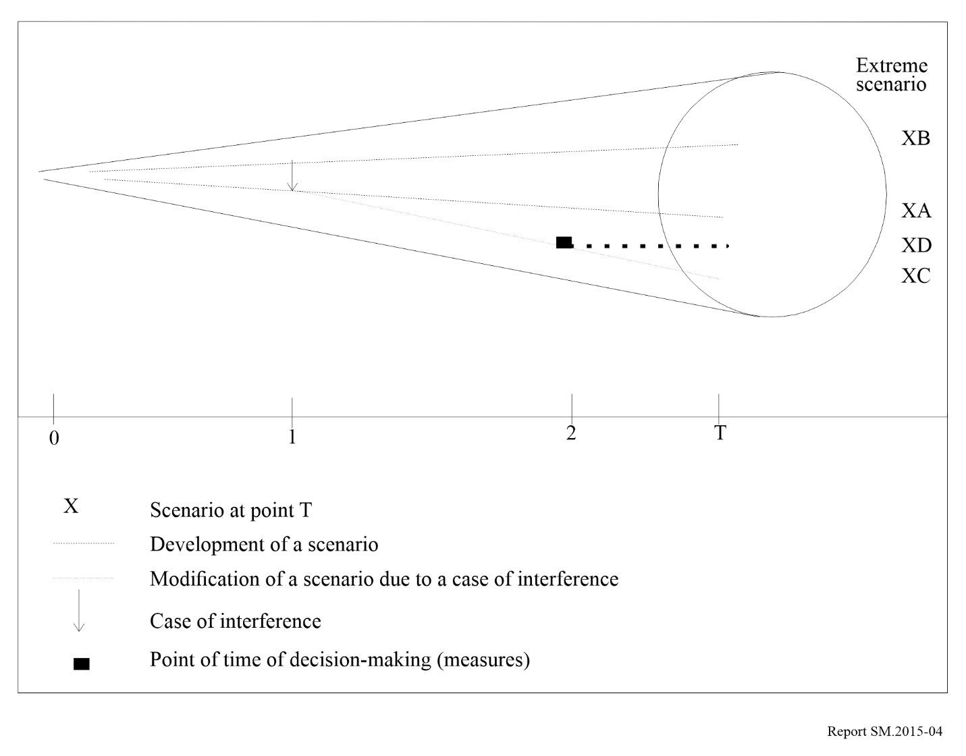

Near-future developments are largely determined by the present (excluding unforeseeable events). The further the future, the wider the range of possible developments. The cone illustrates how the range of possible developments widens. The diameter of the cone’s base is determined by the number of variable factors taken into account. All possible paths of developments in the period 0 to T end on the base. Some of these paths are described through scenarios: it is neither possible nor economically sensible to study all imaginable paths within the three scenarios. Scenarios A and B represent two average paths taking account of all factors. If an event occurs at 1 and interferes with the path, the path will change course and end at C. If decision is taken at 2, the path will change course again and end at D.

## 3.3 The use of the analytical technique in the long-term spectrum requirements planning process

The analytical technique can be viewed as a model which can be turned into a computer programme or analysed manually.

As an example, the German Regulatory Authority for Telecommunications and Posts produced, *inter* *alia*, a scenario for UMTS user number trends up to 2010. The scenario differentiated between private and business users.

Three major factors affecting private user numbers were identified:

– income trends;

– age distribution; and

– household size.

These factors were determined using Federal Statistical Office documents combined with data on mobile radio price and tariff trends, the population’s age and purchasing-power distribution, leisure activities, and the increase in the number of small (double-income, no children) households. These data were derived from previous analyses and research, technical literature and demographic statistics.

The maximum potential number of business users was determined taking account of the number and trends in the number of gainfully employed and company vehicles. The expected potential number of users by year 2010 was determined by subtracting a certain percentage to allow for dual users, i.e. persons using the UMTS for both private and business purposes.

These user data were used to produce a traffic model which ultimately led to a forecast of the UMTS spectrum requirements in 2010, taking account of technical influencing factors such as system bandwidth, channel spacing, cell radius and cell configuration.

Where a scenario has been developed in the past, it can be compared with current developments to confirm its accuracy and be revised if necessary.

CHAPTER 3

Appropriate procedures for transition from present spectrum utilization   
to long-term objectives

# 1 Identification of long-term spectrum management objectives

The identification of long-term spectrum management objectives should consider the maximization of the use of the radio spectrum by various technical and operational methodologies that are currently known or under development. These objectives should consider the potential growth of existing radio services as well as the introduction and growth of new services and applications. Moreover, considerations should be given to changes in use of the spectrum by the local industry and general public, changes in technology as well as to the technical and non-technical factors described in Annex 1 to Chapter 1.

The objectives for long-term spectrum management can be broadly identified as: to foster the development and use of the radio spectrum to support the changing technological, social, political and economic environments, for the maximum net benefit of all.

The long-term objectives should include inputs from government(s), local industry and, within industry, from large and small organizations and from a number of geographic locations.

# 2 Evaluation of current spectrum management process

This evaluation should include a study of the current national spectrum management process to determine its weaknesses and strengths as perceived by the industry and by the government. The outcome of this evaluation will form the basis for the development of updated long-term spectrum management strategies (an example is provided in Annex 1 to this Chapter). Another dimension is the process autonomy where the extent of developments and agility[3] in spectrum management depends on:

− Wireless technologies opportunities, in particular dynamic autonomous sharing and machine learning/data analytics-based application at network management level;

− Machine learning/data analytics management solutions; and

− The scope of institutional policy decisions in spectrum management systems requiring policy defined intervention.

# 3 Transition procedures

The foundation of the long-term spectrum management process depends on the careful selection of strategies to meet the long-term spectrum management objectives. The selected strategies should be integrated into a national long-term spectrum plan. A list of key spectrum utilization transition procedures and long-term spectrum management strategies are provided below:

## 3.1 Encourage effective spectrum utilization

Transition from present spectrum utilization to long-term objectives can be achieved by the use of advanced spectrum engineering techniques and procedures including the development from current automated spectrum management systems to future agile spectrum management systems as shown in Fig. 10 of Annex 2 to Chapter 3 on (Current and future spectrum management systems). Service providers should be encouraged to use such techniques and procedures by, for example, reduced or fixed licence fees. The transition procedures addressed here are:

### 3.1.1 Effective use of new technologies to improve the reuse of frequencies

Frequency re-use can be defined as the number of times the same frequency can be used in a given geographic area without negatively affecting any user of the frequency. Frequency coordination is usually one of the determinant issues in the reuse technique. Effective spectrum utilization can be achieved by the use of advanced engineering techniques to increase frequency re-use; reduce channel bandwidth; improve coding techniques, improve modulation techniques; improve access strategies; improve band sharing without interference; introduce new spectrum sharing criteria; develop frequency assignment strategies and spectrum usage models; and by other engineering and operational techniques.

The technical approaches to frequency re-use, system overlays between services are well-known. The ITU Handbook on National Spectrum Management 2015, in its chapters on Spectrum Engineering Practices and Spectrum Use, covers matters which include measurements of spectrum utilization and spectrum utilization efficiency when these approaches are implemented. In addition, the Handbook addresses such techniques as interference cancellers, interference screens, millimetre wave reflecting antennas and land mobile adaptive antennas. These matters will not be duplicated here.

### 3.1.2 Channel splitting

This involves increasing the utilization of the spectrum through re-planning of existing spectrum bands by the use of narrower bandwidth channels. Channel splitting entails the use of more spectrally efficient technologies and the introduction of new technical and operational standards. Channel splitting procedures have to take into account the fact that the spectrum under consideration for re-planning is usually intensively utilized. Several other issues have to be analysed to consider in the development of a channel splitting plan including:

– Continuity of service: redistribution is to be performed without service interruption.

– Costs: an evolutionary approach to implementation to reduce costs on spectrum user.

– Compatibility: some measure of backward compatibility and interoperability is essential, while looking forward to the improved functionality and capacity that new technology will bring.

– Risk: a balance should be made between policies to provide additional capacity and user’s needs of low‑risk solutions.

– Harmonization: it is necessary to harmonize, where possible, with neighbouring countries and internationally.

### 3.1.3 Spectrum redeployment

A spectrum plan may, in accordance with certain circumstances and under appropriate long-range decisions, result in redeployment of services. This could mean transitioning existing users of a spectrum band to either new technologies or to new frequency bands. The requirement for redeployment can arise for several reasons:

– a spectrum allocation may have been in operation for a considerable period of time and currently no longer meets the requirements of users, or the capabilities of modern systems;

– an allocation within a specific range of frequencies is required for a new radio service and these frequencies are occupied by services with which the new service cannot share; or

– a decision by a World Radiocommunication Conference to allocate a currently occupied frequency band to a different service on a global or regional basis.

### 3.1.4 Service overlay and frequency band sharing

Effective sharing of the frequency bands for a number of services can play a significant role in reducing the demand for new spectrum. The identification of current and future shared bands is essential.

The concept of broadband services sharing the spectrum with narrow band services is a promising approach for reducing demand for more spectrum. This concept addresses situations where, because of the characteristics of a specific modulation scheme or specific system parameters, it is possible for radio services to co-use a spectrum band without causing harmful interference to each other. This approach is termed service overlay.

A typical example of service overlay is the ability of spread spectrum systems to operate efficiently with conventional systems. Techniques such as Orthogonal Frequency Division Multiple (OFDM), code division multiple access (CDMA) and time division multiple access (TDMA) are commonly used to provide co-sharing systems. System overlay should be considered on a case-by-case basis with the particular protocols and architectures of the potentially interfering services being specifically analysed. It may require to spectrum sharing, frequency allocation strategies and models of spectrum use.

### 3.1.5 Shared radio systems

A number of organizations can share one radio system rather than operating their own individual systems. Technology is needed to create the necessary firewalls between the functions of different users and to provide transparent prioritisation. This requires a mechanism to determine, and take into account, the different loading patterns of each service on the shared system to maximize sharing capability. Sharing a radio system by a number of organizations (police, fire, ambulance) have the capability to significantly improve the utilization of the radio spectrum, especially in spectrally congested areas. This sharing will also reduce the cost of the radio system. A spectrum sharing framework perspective for regulatory entity can act as a catalyst for new spectrum access regimes combined with dynamic databases.

### 3.1.6 Use of the unused spectrum

Lack of finances or equipment, or the economic benefits of blocking the use of spectrum by others, currently results in some licensees not using their licensed spectrum. Policies, regulations and programmes should aim to minimize the low usage of authorized licensed spectrum by licensees. This can be achieved, for example, by penalization for non-use of the licensed spectrum perhaps by withdrawal of the licence.

Policies, regulations and programmes should also encourage service expansion into the high gigahertz bands (> 40 GHz), especially for services requiring exclusive spectrum and/or broadband applications. The radio spectrum above 40 GHz is currently under-utilized. This segment of spectrum has the potential for supporting very wide broadband services, and high frequency re-use due to the small cell-size at such high frequencies. This segment of spectrum also brings several implementation advantages including smaller antennas, narrower beamwidths, reduced hardware size and weight, and ease of installation and re-configuration.

### 3.1.7 Use of wireline distribution networks as a supplement

Wireline networks could be used as an alternative to wireless to reduce demand on spectrum especially in congested areas and for broadband applications. Policies and regulations should be drawn to encourage the use of advanced intelligent network technologies to: permit the seamless interfaces between wireline distribution and short-distance wireless links.

## 3.2 Enhance spectrum use flexibility and agility in spectrum management

A long-term spectrum management programme should be designed from the beginning to permit flexibility of strategies and their prioritisation. This programme should:

– allow service flexibility i.e. the use of the radio spectrum to provide any service (voice, data, image, etc.) subject to the technical limitations of the frequency band concerned;

– allow technical flexibility i.e. the use of any technology to provide a service subject to interference limitations;

– introduce flexible, non-prescriptive policies and regulations to accommodate for innovation and market forces. Policies and regulations must have the flexibility to meet the changing social, economic and technical needs.

As an example, a programme that promotes spectrum use flexibility is the concept of block or spectrum licensing. This is where a block of spectrum, usually several megahertz, is licensed to a user on a geographic basis. The licensee becomes responsible for system engineering and for frequency co-ordination, both at the limits of the licensed area and, where the spectrum is shared with other block licensees, within the licensed area. Licensing a large block of frequencies rather than a channel-by-channel basis enables better use of the radio spectrum. An important component for moving towards spectrum use flexibility would be implementing feasible spectrum sharing on gradual steps toward a long-term enhancement.

## 3.3 Maximize the social and economic benefits that can be achieved by appropriate spectrum management

Spectrum management plays a major role in increasing the country’s social and economic well‑being by maximizing the use of the spectrum for wireless applications. It is strongly emphasized that economic benefit in this sense must be used in a broad context rather than that of merely increasing license revenue. Implementation of this concept can be achieved during the licensing process that:

– ensures use of the best available frequency range appropriate to the application with the highest efficiency permitted by technology;

– promotes sustainable competition among service providers;

– leads to higher density usage within service allocations by using spectrum efficient technologies, frequency re-use, improved frequency planning models, improved sharing criteria and traffic density projections;

– promotes new radio service entrants;

– identifies, quantifies (to the extent possible) and maximizes the social benefits accruing to the licensing strategy under consideration.

The long-term spectrum management policies, regulations, standards and programmes should be: flexible, efficient, strategic, non-prescriptive, and technology and service neutral. Considerations should be given to the implications of perceived or actual negative health impacts of spectrum use. Plans should be drawn up to accurately and effectively educate the public on these matters.

## 3.4 Ensure that the spectrum is used in all regions of the country where it is needed

Major cities tend to be given higher priority by service providers, leaving the smaller cities and less populated areas poorly served. The use of the spectrum in all regions of the country, including smaller cities and towns may be achieved by considering this issue in the licensing process.

## 3.5 Build a skilled work force and develop proper spectrum engineering tools

Develop appropriate policies and programmes to train and maintain the quality and competence of the national spectrum management work force. This work force should be provided with the latest tools particularly in terms of automated systems and computer aids to enable it to deal effectively with licensing demands and interference analysis for existing and new technologies.

Investments should also be made on research and development related to spectrum management to meet the objective of long-term spectrum utilization.

Annex 1  
to Chapter 3   
  
Example on evaluation procedures of spectrum utilization   
efficiency in Korea (Rep. of)

# 1 Background

As the spectrum demand increases, securing spectrum resources in a timely manner becomes necessary. Although many countries have researched and analysed the current status of spectrum utilization periodically, it was difficult to produce an appropriate policy that takes into account future demand and supply comprehensively because of the limitations from fragmentary and qualitative analyses. As a result, some countries have recently applied a method of discovering candidate bands and evaluating their priority in order to secure spectrum systematically in the long‑term planning process.

Since 2019, Korea (Republic of) has implemented an evaluation system to improve spectrum utilization efficiency in the process of determining national long-term strategies under the goal of responding to the rapidly increasing spectrum demand and discovering spectrum scientifically.

The results that evaluate the spectrum usage status with various factors for each frequency band to discover maintenance targets are disclosed to the public through the "Spectrum Redeployment Forecast system" to announce the timetable and measures of maintenance in advance.

# 2 The process of the evaluation

All frequency bands are divided into low (lower than 3 GHz), mid (3 to 10 GHz) and high (higher than 10 GHz) bands, and one of three bands is evaluated step by step every year. The evaluation process has been performed in order of self-evaluation → advisory evaluation → evaluation committee → stakeholder opinion → forecast and notification of guidance.

The criteria for evaluation of spectrum utilization efficiency are based on articles of the Radio Waves Act, and a four-level matrix for priority evaluation has been proposed, considering both demand urgency and supply ease.

Prioritizing among the various alternatives is not an easy matter because each criterion is not proportional to each other, and criteria’s trade-offs should be quantified when those are in the conflicting relationship. Therefore, for this kind of evaluation to choose alternative solutions, the Analytic Hierarchy Process (AHP) which is one of multi criteria decision making methods can be applied. The AHP provides a comprehensive and rational framework for structuring decision problems, for representing and quantifying its elements, for relating those elements to overall goals and for evaluating alternative solutions.

Figure 5

The process of selecting evaluation criteria for spectrum utilization efficiency (AHP)

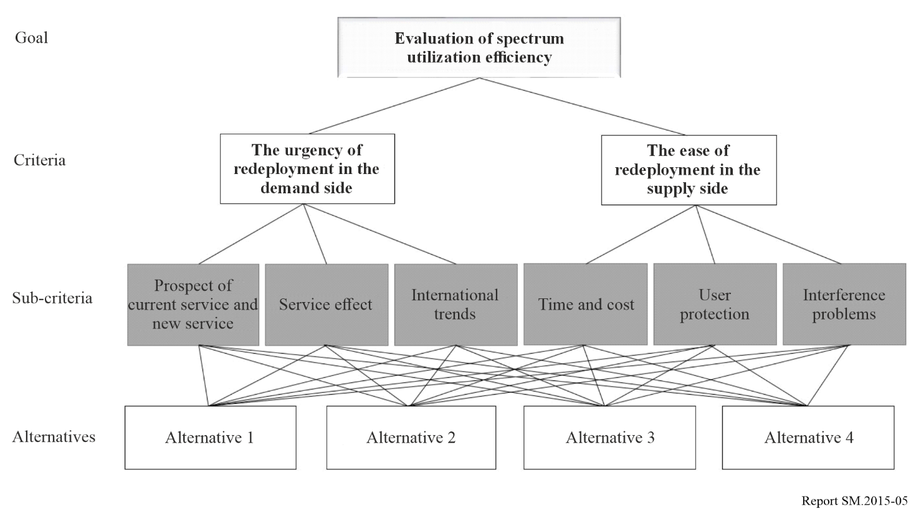

The evaluation of spectrum utilization efficiency uses several criteria that are consist of demand and supply aspects. The demand side attempts to evaluate the prospects for new services and quantity demanded based on the current service and demand status, the levels that require action to improve spectrum efficiency, and whether it is consistent with international standards and trends in major countries, in order to identify the urgency of redeployment. In comparison, on the supply side, with the aim of assessing the ease of redeployment, it is being used as an evaluation criterion of the time and cost needed, the possibility of the user protection measures, and the possibility of resolving interference problems.

TABLE 2

Evaluation criteria

| Aspect | Factor | Evaluation criteria | Method |
| --- | --- | --- | --- |
| Demand analysis | The utilization rate of existing services | The trend of radio stations figures | Quantitative |
| The degree of technological evolution | Qualitative |
| Economic effect | Qualitative |
| Social and public interest | Qualitative |
| Potential demand for new services | Technical indicator | Qualitative |
| Ecosystem indicator | Qualitative |
| Actual demand for new services | Spectrum usage plan | Quantitative |
| Status of domestic demand raised | Quantitative |
| Economic effect | Qualitative |
| Social and public interest | Qualitative |
| Subtotal of the score for the degree of service demand (Y) | | | |
| The possibility of spectrum supply | Unused rate of spectrum | Unused rate in the territory | Quantitative |
| Unused rate in big cities | Quantitative |
| The possibility of securing spectrum | The availability of alternative frequency bands | Quantitative |
| The possibility of spectrum maintenance | Qualitative |
| The cost of migration to alternatives | Qualitative |
| Other considerations | The acceptability of incumbent users | Qualitative |
| The relevance of the public interest for new uses | Qualitative |
| Subtotal of the score for the possibility of spectrum supply (X) | | | |
| Total (X,Y) | | | |

The results of evaluation for each band are displayed in the matrix chart to rank the redeployment priority to four grades. The vertical scale shows that the degree of service demand (0 to 5) and the horizontal scale represents the possibility of spectrum supply (0 to 5). If the evaluated band is located in the first quadrant (Grade I), spectrum redeployment will be carried out to improve spectrum utilization efficiency, and if it falls under the second quadrant (Grade II), additional new licenses will be prohibited and long-term efficiency measures will be reviewed through pre‑announcement. If it is located in the third quadrant (Grade III), it means that it will be used continuously, and the fourth quadrant (Grade IV) means promoting the use of the services currently in use or discovering new demands.

Figure 6

Example of the evaluation results of spectrum utilization efficiency

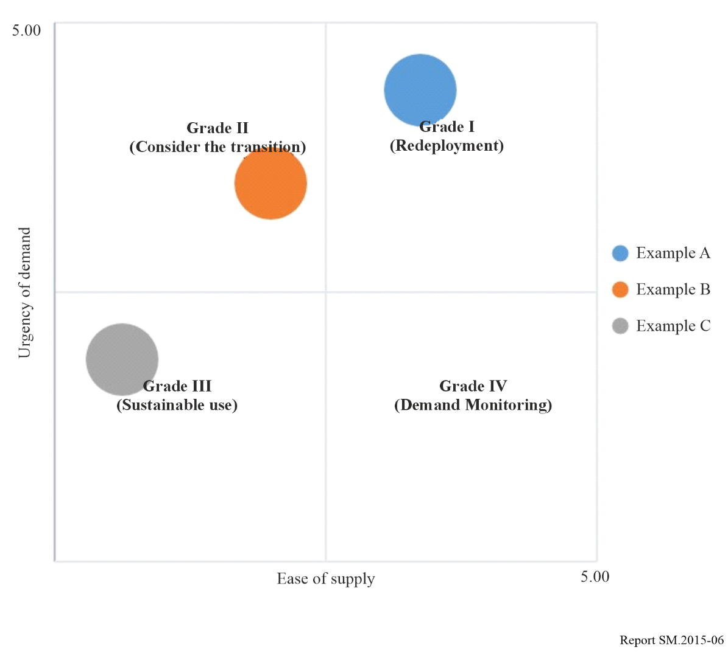

# 3 Actual evaluation cases

In 2020, the evaluation was conducted on the mid bands (3 to 10 GHz) where demand for frequencies has been increasing rapidly internationally, such as 5G and Wi-Fi. It was evaluated that the 3.7~4.0 GHz/3.42 GHz/6 GHz bands need spectrum reallocation and there are actual domestic demands for frequencies such as 5G, Wi-Fi, etc. and it can be supplied through spectrum redeployment. Additionally, the 5.85~5.925 GHz band for Intelligent Transportation System (ITS) requires activation of use because the new demand is low, and the existing service is underused. The 8 GHz band, which has low demand for new services and low possibility of supply of substitute bands due to saturation of existing services, was evaluated as a band that continues to be used.

To follow up the evaluation results, the Spectrum Redeployment Forecast system was implemented for 3.7 to 4.0 GHz (including 3.4 to 3.42 GHz)/6 GHz bands that was evaluated as requiring spectrum redeployment. Through the forecast system, incumbent users, device manufacturers, and sellers were informed of administrative plans such as spectrum allocation tables and related notices, as well as user measures to apply compensation for loss due to spectrum redeployment.

Figure 7

Evaluation results for spectrum utilization efficiency (2020)

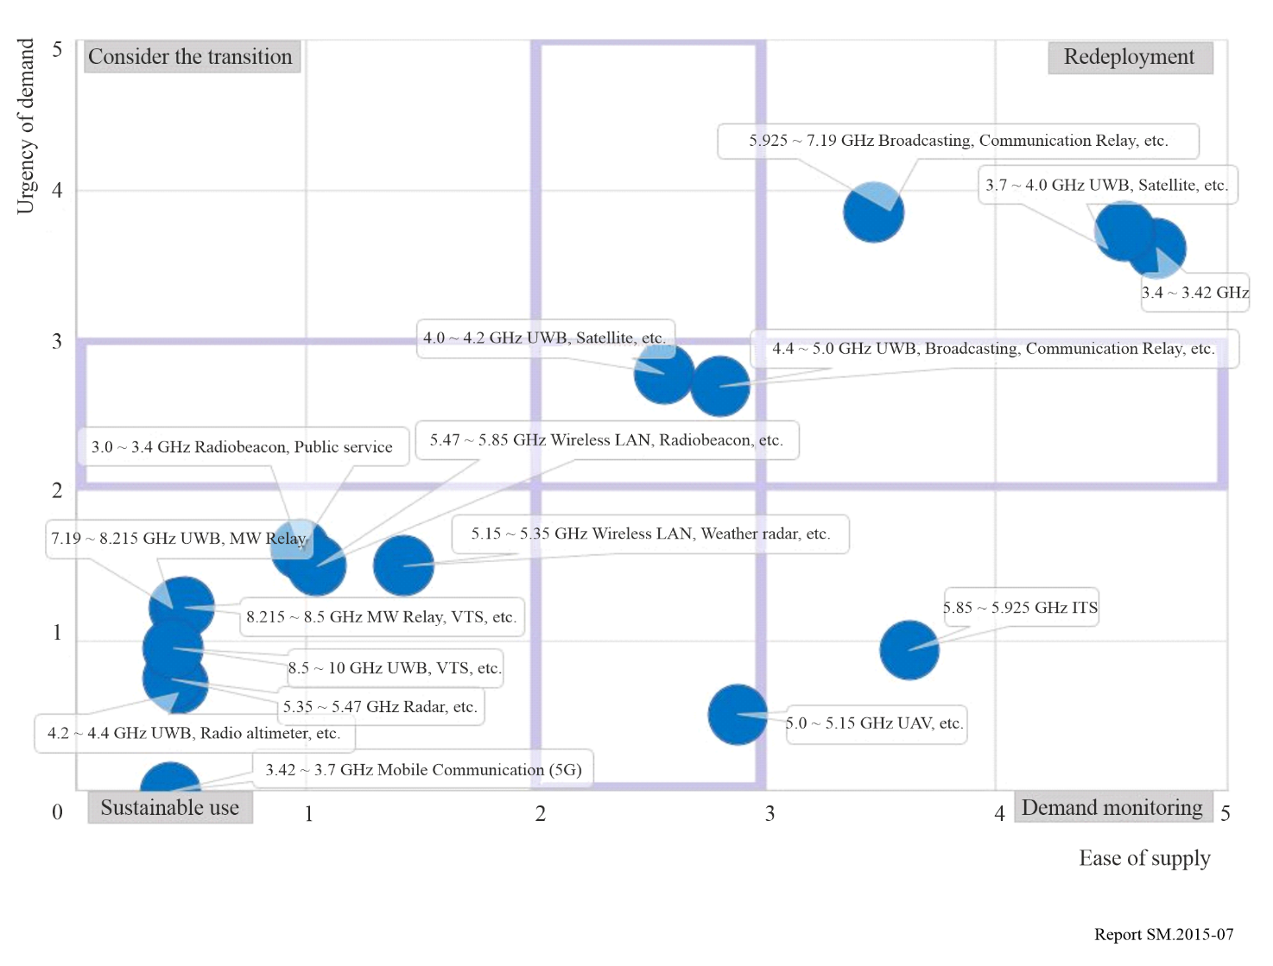

# 4 Countermeasures and expected effects according to evaluation results

Depending on the evaluation results, the regulatory authority can modify its national long-term strategies for spectrum utilization, and stakeholders can devise countermeasures against the bands they are using or intend to use in advance. It is expected that this evaluation system can help secure the spectrum in a timely manner, protect incumbent users properly and promote new spectrum-based businesses.

TABLE 3

The example of government policy and stakeholder’s countermeasures   
according to evaluation

|  |  |  |
| --- | --- | --- |
|  | Government policy | Stakeholder’s countermeasures |
| Grade I | Efficiency improvement through withdrawal and reallocation of spectrum frequencies, conversion of technical standards, etc. | Preparation of new service, development of equipment, etc. |
| Grade II | Suspension of the new authorization, implementation (possibility) notice of efficiency improvement, execution plan of efficiency improvement, stakeholder consultation, etc. | Suspension of the new investment in existing facilities, relocation of subscribers, preparation of equipment development etc. |
| Grade III | Monitoring the new demand and usage of radio frequencies, excavation of spectrum | Sustainable use |
| Grade IV | Monitoring new demand and discovery of spectrum frequencies, promoting efficiency improvement in case of demand occurrence | Demand expression of new radio frequencies, promotion of new technology and service introduction, etc. |

List of abbreviations

AHP Analytic hierarchy process

ARNS Aeronautical radio navigation service

CDMA Code division multiple access

FDMA Frequency division multiple access

ITS Intelligent transportation system

LSA Licensed shared access

MIMO Multiple-input multiple-output

OFDMA Orthogonal frequency division multiple access

RFID Radio frequency identification

SRD Short-range device

TDMA Time division multiple access

UMTS Universal Mobile Telecommunications System

Annex 2  
to Chapter 3  
  
A white paper on a future-looking perspective on an agile and sustainable spectrum management regime for the next decade in the United Arab Emirates

# 1 Executive summary

The Telecommunications and Digital Government Regulatory Authority (TDRA) presents a future-looking perspective on an agile and sustainable spectrum management regime for the next decade in the UAE. TDRA, by enhancing its spectrum management system and implementing the best available spectrum management solutions, promotes further industry development in line with UAE Digital Strategy and objectives. TDRA undertook a study on spectrum agility with LS Telcom and the final result was a white paper. The White Paper considers more efficient and effective use of advanced, data driven spectrum management solutions generally and their potential impact for the UAE.

TDRA has a mission to make spectrum available for innovative wireless services, as they play a major role in the significant transitions in which the UAE is engaged. In its endeavour to contribute to its objectives, TDRA cooperates and collaborates with all its strategic partners.

This White Paper is intended for all stakeholders interested in future wireless opportunities and the evolution towards agile spectrum management systems. It provides insights into the driving forces for change and possible approaches to reaching the UAE’s digital goals. The following driving forces are explored:

• Digital policy goals and strategic drivers of the UAE;

• Wireless technology opportunities and developments;

• Spectrum management solutions developments;

• UAE specific agility in spectrum management scenarios.

Increasingly, development requires ubiquitous connectivity. Alongside this “connectivity and capacity when required” offering, advanced, flexible and software driven radios (with cognitive capabilities) are expected to develop further so as to be a viable industrial technology, allowing devices to themselves choose the most appropriate frequency band and technology for communications.

There is a need for networks to meet sustainability targets, ensuring higher consumption efficiency. 5G, whilst delivering a lower watts per bit consumption, consumes more energy than previous networks, suggesting that 6G may need to make further improvements in power efficiency.

Wireless technology developments, as well as user expectations to be able to access the required spectrum quickly and with minimal administrative burden, invite regulators to ensure that their regulatory frameworks and approaches are fit for purpose. Agility, as defined in this white paper, will aid regulators in this regard in that systems will be better able to handle changing requirements.

The future scenarios TDRA has explored focus on the degree of development of maturity and technology factors. The extent of development in process autonomy and agility in the next decade will depend on:

• Wireless technologies opportunities, in particular dynamic autonomous sharing and AI application at network management level;

• Progress of AI in spectrum management solutions; and

• The scope of institutional policy decisions in SMS requiring policy defined intervention.

To explore the changeovers towards Agility 2031, TDRA presents a series of initiatives based on extensive research related to the following objectives:

• “Users as part of the ecosystem”;

• “Promoting AI”;

• “Enhanced Automation/Autonomy”.

The high level approach to this project is shown in Fig. 8.

Figure 8

Project approach

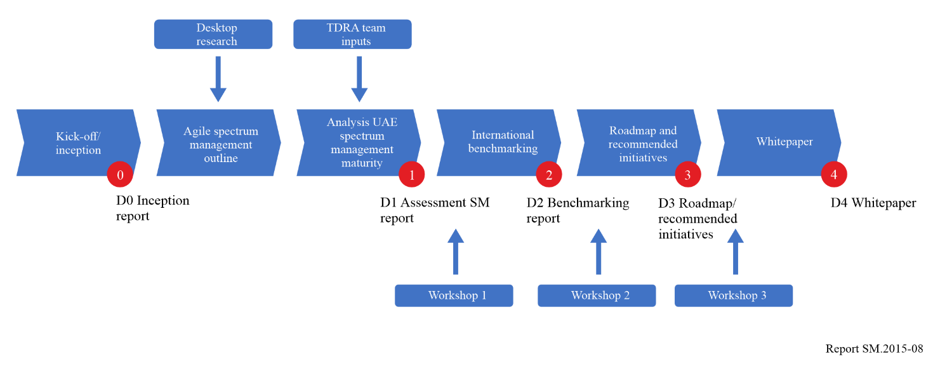

# 2 Purpose of White Paper

This TDRA “Spectrum Agility” White Paper presents a future-looking perspective on an agile and sustainable spectrum management regime for the next decade in the UAE. TDRA, by enhancing its spectrum management system and implementing the best available spectrum management solutions, promotes further industry development in line with UAE Digital Strategy and objectives. This White Paper considers more efficient and effective use of advanced, data driven spectrum management solutions generally and their potential impact for the UAE.

This White Paper is intended for all stakeholders interested in future wireless opportunities and the evolution towards agile spectrum management systems. It provides insights into the driving forces for change and possible approaches to reaching the UAE’s digital goals. The following driving forces are explored:

– Digital policy goals and Strategic drivers of the UAE;

– Wireless technology opportunities and developments;

– Spectrum management solutions developments;

– UAE specific agility in spectrum management scenarios.

# 3 The UAE digital strategy, foresight, scenarios and spectrum agility implications

The UAE intends to take advantage, in a proactive way, of advanced and emerging digital technologies. It aims to deliver the best digital services to its society, industry and government in a future-oriented, inclusive, and sustainable manner, making it a priority to take into account the future needs of users and customers[4].

The digital future goes beyond phones, towards global connectivity, enhanced industrial processes, smarter cities and sustainable climate targets[5]. Inclusion, resiliency, user involvement, openness and proactiveness require a strong, efficiently and dynamically managed, world class, wireless connectivity infrastructure. The implications in terms of radio spectrum policy, management and access are far-reaching, as the radio spectrum provides the support for always more numerous digital applications.

The Telecommunications Regulatory Authority (TRA) was established as the Government Agency in charge of telecommunications and radio spectrum management in 2004. It became the Telecommunications and Digital Regulatory Authority (TDRA) in 2020 with the inclusion of Digital Government objectives. Its mission is to:

“… strive to be a leading organisation in the ICT sector in United Arab Emirates, committed to maintaining positive competition to protect the interests of the subscribers, and promoting electronic transformation of the federal agencies and their services, by relying on national competencies to apply the best international standards and practices in supervision of the sectors and to encourage innovation and investment”[6].

Its Telecommunication Sector is in charge of Spectrum Management, Regulatory Affairs, and Technology Development.

In 2022, TDRA has engaged in an in-depth “Spectrum Agility” research effort which aims at aligning its mission, policies, spectrum management systems and procedures with a 2031 Vision, in support of the UAE National Digital Government Visions, Strategies, and Policies.

TDRA refers to the 50 years (Centennial Plan) UAE vision and foresight[7]. It relies on the UAE scenario building methodology and future shaping tools[8][9]. To conceive this White Paper, TDRA has performed an extensive scientific and policy literature research effort, conducted a wide regional and international survey of radio spectrum regulators policies and practices, and consulted vendors and subject matter experts.

The ‘We the UAE 2031’ vision[10], published in November 2022, builds upon the previous foresight exercises and presents “…four pillars that cover all sectors including the society, economy, diplomacy and ecosystem:

1 Forward Society – achieving the prosperity of society by enhancing the capabilities of the citizens to maximise their effective contribution in all sectors

2 Forward Economy – reflecting the UAE's belief in the importance of human capital as the main driver of the next 10-year development plan

3 Forward Diplomacy – consolidating the pivotal role and influence of the UAE based on respect for human values

4 Forward Ecosystem – enhancing the government performance and the UAE’s infrastructure and its development according to the latest technological methods, including the development of digital infrastructure.”

Of particular relevance for this TDRA White Paper is Pillar 4, the “Forward Ecosystem”, which emphasises the performance of UAE Government entities. Notably also, the “Forward Diplomacy” pillar emphasises the increasing international influence of the UAE. International influence is at play in technology innovation, as well as in the very lively and highly internationalised area of spectrum management, with so many technology and regulatory issues debated in regional and international fora, in particular the ITU.

As the Government agency in charge of radio spectrum management, alongside other wide ranging telecommunications tasks, TDRA has a proven record of excellency in the performance of its missions, recognised on a global level by the award of the top level ‘G5’ rating in the ITU Generations of Regulation framework[11] in 2022.

As another example of TDRA involvement in current digital developments is the UAE Pass. The UAE Pass provides a national digital identification that allows individuals to identify themselves with a single sign-on, enabling access to a range of government services (including spectrum authorisations). For TDRA, this also acts as an online or smartphone-based authorisation portal and facilitates validation of spectrum authorisations by enforcement agencies.

At the dawn of 2023, spectrum management is facing new technological developments and the correlated regulatory adjustments. This can be summarised in a future looking approach to spectrum access as:

• “Anywhere spectrum agility”, agile access to the required radio spectrum resources at any time; and

• “Forward looking agility”, agility in providing the radio spectrum to accommodate technology and service evolutions over time.

TDRA has a mission to make spectrum available for innovative wireless services as they play a major role in the significant transitions in which the UAE is engaged. In its endeavour to contribute to its objectives, TDRA cooperates and collaborates with all its strategic partners.

In dealing with foresight in highly innovative digital environments, the UAE adopts a foresight and scenario approach, as illustrated by the UAE Government publications[12][13].

Within the global international and UAE economic and digital policy context, this “Agility in Spectrum Management” White Paper is based on a comprehensive research project which has included forward looking scientific and technological analyses, a benchmarking exercise of spectrum management practices and numerous interviews with stakeholders in the UAE, regionally and internationally. As a result, this White Paper presents scenarios of wireless technologies and service evolution over the next decade, as well as of evolutions in spectrum management systems and solutions. This comprehensive research effort results in a developed vision that will allow TDRA to transition in the next decade to the most appropriate spectrum management platforms to contribute to the objectives of the UAE economy and society.

# 4 The TDRA strategic vision: Towards always more agile system management systems

Demand for spectrum continues to grow alongside economic growth in the UAE. The TDRA “Spectrum Agility” project has assessed this current situation within the UAE and TDRA and how this compares to other countries and regulators globally, as well as TDRA’s aspirations with regards to implementing an agile spectrum management system. Through the project work, the comparison with other regulators has allowed identification of a realistic target for TDRA in terms of future spectrum agility (as characterised by the highest agility level in the spectrum management maturity assessment metrics).

## 4.1 Current approach to authorizing spectrum use

TDRA’s current spectrum management tool dates from 2008 (which itself is an update of the original 2005 system). It has been subject to many updates since then. Key aspects of the original specification and subsequent development were minimal wait times for applicants and good visibility for management of the status of applications. TDRA, and the UAE government generally, places great emphasis on customer experience. As such, its systems and processes are designed to make authorisation applications as straightforward for stakeholders as possible.

The TDRA provides an authorisation portal on its web site for users to apply for spectrum use as demand dictates (noting that some spectrum usage is also authorised through general authorisations or exemptions). It is also possible to modify, renew and cancel authorisations via the TDRA web site and all spectrum authorisations are now electronic.

The UAE telecommunications sector is characterised as a duopoly with two main licensees: e& by Etisalat and du. There are also sector specific licensees which hold licences for specific services. To provide public telecommunications services within the UAE, applicants need to obtain a telecommunications licence. Private networks do not require a telecommunications licence but do require a spectrum authorisation to be able to make use of the radio spectrum, noting that trading and leasing of spectrum are not permitted within the UAE[14].

## 4.2 Agile spectrum management

Against this current situation background of spectrum management within the UAE, and based on research of industry, regulatory and academic developments, ‘agile’ spectrum management can be characterised as follows:

• The system should be flexible, enabling the automatic selection of a frequency based on certain system inputs;

• The system should be user friendly, accepting multiple input types, e.g. single, batch, automated, and pre-configured;

• The system should be able to easily integrate into any spectrum monitoring/sensing solution;

• The system should be able to easily integrate into any IT system (e.g. finance, type approval) used by spectrum regulators;

• The system should minimise application and authorisation times towards zero (considering both application completion times and application processing times, i.e. the inputs from both the applicant and TDRA colleagues) and reduce human intervention;

• The system should be live, intelligent and data driven; and

• The system should take advantage of advanced technologies such as artificial intelligence and distributed ledger systems.

Specifically:

Agility in spectrum management has been defined as “the ability to meet evolving user needs in a user-friendly and timely manner. It touches upon the flexibility of spectrum management systems to accommodate all possibilities and requirements, bringing the time from application to BiU (bringing into use) ideally to zero, with minimal or no human intervention. This also applies to the way we provide frequencies for emerging technologies and services”

A set of spectrum management maturity assessment metrics has been developed alongside the agility definition, as laid out in Table 4, based around a number of attributes with varying levels of automation and interaction. For each attribute, a possible value between 1 and 4 is possible, where 4 represents the most agile state and 1 the least. Based on the research and benchmarking work conducted, level 4 in all attributes is considered to be a reasonable and achievable aim for TDRA.

There are numerous external factors that exist outside of this definition. Some of these are global and beyond the reach of regulators at an individual level, for example changes to the Radio Regulations resulting from WRC resolutions. Others result from national priorities, for example due to data privacy and national security concerns, and can impact the achievable agility of a country’s spectrum management approach.

However, the continued policy of TDRA is to establish a strong relationship with its users to understand future needs, allowing it to meet them with an agile, user-friendly and flexible spectrum management system which integrates with all necessary data and processes.

TABLE 4

Spectrum management maturity assessment metrics

|  |  |  |  |  |
| --- | --- | --- | --- | --- |
| Attribute | Level 1 | Level 2 | Level 3 | Level 4 |
| Spectrum Database (authorisations and technical parameters) | Basic/Excel | Off the shelf tool (SMS4DC) | Self-developed or dedicated, customised COTS[15] tool (to meet applicant’s requirements) | Live, dynamic, configurable and flexible |
| Technical Analysis Tools (Software) | Basic/Excel | Off the shelf tool (SEAMCAT) | Self-developed or dedicated, customised COTS tool (to meet regulator’s requirements) | Live (operational values), dynamic, customisable, configurable and flexible, e.g. ANFR AR[16] fixed link tool |
| Customer application process | Paper/letter/email/ phone | Online form (electronic submission) | Online portal (automatic submission) | Smart portal with virtual assistant |
| Spectrum occupancy data | Measurement campaigns | Fixed and mobile monitoring stations | Dynamic and mesh sensors | Integration of monitoring sensors to live database |
| Spectrum occupancy shared online | No visibility beyond NFAT/NFP | Published band plans | Searchable licence database | Full, live visibility for target bands |
| Assignment | Manual/paper | Electronic assignment | Automated assignment | Real time/live assignment |
| Authorisation Duration Flexibility | Fixed period | Fixed period with flexibility to review | Totally flexible | Live, on the go |

## 4.3 Benchmarking

Input from regulators around the world was sought to both validate the approach taken and determine currently deployed agile developments.

The benchmarking analysis found that TDRA ranks highly in most of the maturity assessment metrics considered, and when compared to many of the world’s advanced regulators. Opportunities for development for TDRA exist in aspects such as technical analysis tools and making spectrum occupancy information available to entities outside of TDRA.

The benchmark analysis shows that Private Mobile Radio (PMR), Programme Making and Spectrum Events (PMSE), Dynamic Spectrum Access (DSA) and application processing are the services/processes most associated with ‘agile’ spectrum management technologies (for example, AI and the use of mesh sensors). The use of DSA schemes is most associated with sharing between mobile and other services, although some regulators also associate this with RLAN, broadcasting, PMSE and satellite.

## 4.4 Summary

The current approach to spectrum management within TDRA has been considered, reaching the conclusion that TDRA already operates in a mature manner, i.e. the application process is straightforward and readily accessible, and analysis and assignment is conducted in a technologically advanced and fast manner.

Through consideration of TDRA’s approach to spectrum management, and consideration of the current and future technology capability, spectrum agility has been defined, along with a set of assessment metrics. The benchmarking exercise found that TDRA’s approach is broadly similar or slightly more advanced than many of the other regulators in many of the aspects considered.

# 5 Driving forces and evolutions in spectrum management for wireless technologies and services

Major innovations in wireless technologies and services, as well as advances in spectrum management solutions, are expected in the next decade. How regulators ensure they manage spectrum effectively in the face of these developing industries will be determined by the interplay and adjustment of both factors.

On the one hand, innovations in wireless technologies and services will require changes in the spectrum demands of innovative services, and possibly evolutions in frequency allocations and authorisations. This might represent changes in the scale of demand, but also in the nature of the required spectrum. For example, new technologies may require spectrum in different locations, over different time periods and in different quantities. These can be described as push factors, in that new spectrum usage will force spectrum management approaches to adapt.

On the other hand, developments in spectrum management solutions, i.e. the solutions that spectrum management organisations use in managing the spectrum, will also change the way that spectrum use is authorised. Developments in the capabilities of management solutions, either self-developed by regulators or introduced by industry or academia, will allow spectrum to be authorised in new innovative ways. These can be described as pull factors in that regulators draw by themselves to new more agile methods.

This TDRA “Spectrum Agility” White Paper explores how the push and pull factors interact, and the implications for the handling of user requirements and satisfaction which are a central focus for TDRA.

## 5.1 Technology developments and changing user requirements

A wide array of innovative wireless technologies and services are on the horizon for 2031. These are expected to affect operators, regulators, industry and the public in general. To know how the spectrum regulator can best serve its customers, this White Paper explores in detail the changing wireless technologies and service landscape within which it will operate.

A survey of wireless technologies visions from the ITU[17], equipment vendors (e.g. Nokia[18], Ericsson[19] and Huawei[20]) and research institutions projects (NSF NextG Research[21] and the EU HEXA-X Research project[22]) was conducted. The main expected evolutions in the mid-term are the following:

• The developing capabilities of 6G;

• The growing demand for localised spectrum usage, both for PMSE type applications and for private networks (industries, local entities, referred to as “verticals”);

• The need for improved connectivity to and in homes (through Wi-Fi and expansion of fixed wireless access), ‘not spots’ (increasingly being addressed through satellite constellations, particularly non-geostationary, NGSO, low earth orbits, LEO) and things (Internet of Things, IoT);

• The integration of multiple network topologies for enhanced coverage and service (3D networks);

• The development of networks as a service (NaaS) and on demand access to spectrum;

• The growing importance of the sustainability and carbon footprint of ICT;

• The importance of, cybersecurity, trustworthiness, and resilience in networks; and

• The growing role that cognitive radio could have in spectrum access and monitoring.

Many of the identified developments have implications for network management and are primarily of interest for operators, but many are also relevant to radio spectrum management, in particular the challenging but promising nature of cognitive radios.

### 5.1.1 Cognitive radios

Cognitive radios can dynamically select the best available frequency by detecting which would provide the best performance whilst ensuring protection of incumbent users. The pace of development of cognitive radios will be a major factor in the evolution of radio spectrum usage and management. The use of cognitive radios could allow for a decentralised management system if devices are able to conduct the sensing and decision aspects themselves and could potentially allow for more opportunistic access to spectrum for users. Of course, devices themselves are likely to be more complex and expensive than non-cognitive radios, as devices will need to be capable of operating over multiple frequency bands, and ultimately support the use of different bandwidths and modulation schemes. In addition, devices will need to be capable of sensing spectrum occupancy, or at least be able to seek this information from alternative sources, and be sufficiently intelligent to analyse the information to determine a suitable transmission arrangement. As such it is likely that the use of cognitive radios will not, in the short term at least, be appropriate for all services.

There are several regulatory approaches that provide similar outcomes to cognitive radios, for example TVWS (TV White Spaces), CBRS (Citizens Broadband Radio Service) or AFC (Automatic Frequency Coordination).

### 5.1.2 Sustainability targets

In 2017, the UAE launched its ‘Energy Strategy 2050’[23], which aims to increase the contribution of clean energy in the total energy mix from 25% to 50% and reduce the carbon footprint of power generation by 70%, thus saving AED 700 billion by 2050. It also seeks to increase the consumption efficiency of individuals and corporations by 40%.

To comply with the UAE objectives of a 40% increase in energy consumption efficiency, further advances in network technologies are required. The requirements for 6G are still under development, but these may present an opportunity to better meet sustainability targets. For example, the European initiative Hexa-X has set targets for 6G in terms of sustainability[24]:

• Enabling carbon emissions reductions of more than 30% using 6G;

• More than 30% reduction for the Total Cost Ownership (TCO), including energy fees; and

• More than 90% reduction in energy consumption per bit.

### 5.1.3 UAE expectations of spectrum management processes

Within the UAE, it is a requirement that government services in general be available to citizens in a straightforward way that is appropriate for them. Specifically, this means that services are required to be available online, having easy to use interfaces with minimal burden to users. One of the ways this is characterised within the current TDRA spectrum management system is in the number of clicks required to submit a spectrum application. Significant development work has been undertaken to minimise the number of clicks required. One of TDRA’s main KPIs is that of waiting time for spectrum authorisations. Some services are fully automated, for example authorisation renewals, whereas others require intervention from TDRA staff to process the application.

The requirement to make access to spectrum as quick as possible means that continued effort to minimise the authorisation delay will be required. In addition, the developments identified with regards to ad-hoc and flexible demand for spectrum make it clear that TDRA’s approach to spectrum management will need to cater for this aspect as well.

### 5.1.4 Summary

Several developing trends within the wireless telecommunications industry have been identified. The first trend is that of developments in IMT (International Mobile Telecommunications) technology: 5G is now widely being deployed globally, but 6G is on the horizon, and with it will come new spectrum requirements and network topologies. Alongside developments in IMT comes the growing demand for localised spectrum access in the form of private networks, or verticals, and increased demand for PMSE equipment at events.

A further development regards the need for ubiquitous connectivity. Connectivity to end users is increasingly foreseen to be delivered from space by LEO and MEO satellites, instead of the more common mobile or fixed terrestrial networks. Where terrestrial connectivity does exist, moves to implement FWA and improved Wi-Fi connectivity serve to improve the experience for end users. Connectivity is also increasingly required by devices and things for applications such as location tracking. This connectivity can be provided by a number of different IoT networks.

Developments in networks themselves are also expected. For example, integrated networks are foreseen to offer better connectivity through the use of different layers, e.g. traditional macro base stations, small cells, HAPS and satellites. Further, it is expected that end users will be able to purchase networks as a service, accessing network capacity only when required. Alongside this “connectivity and capacity when required” offering, cognitive radios are expected to develop further so as to be a viable industrial technology, allowing devices to themselves choose the most appropriate frequency band and technology for communications.

There is a need for networks to meet sustainability targets, ensuring higher consumption efficiency. 5G, whilst delivering a lower watts per bit consumption, consumes more energy than previous networks, suggesting that 6G may need to make further improvements in power efficiency.

All of these developments, as well as developing user expectations to be able to access the required spectrum quickly and with minimal administrative burden, invite regulators to ensure that their regulatory frameworks and approaches are fit for purpose and capable of dealing with the latest developments. Agility, as defined in this white paper, will aid regulators in this regard in that systems will be better able to handle changing requirements.

## 5.2 Spectrum management solution opportunities and the developing capabilities of regulators

As the requirement for access to spectrum develops, so too do the approaches and solutions that regulators use to manage the spectrum. This section considers the developments that have been identified and that allow regulators to manage spectrum in more agile and innovative ways.

### 5.2.1 Alternative spectrum licensing and authorisation models[25]

Traditionally, spectrum authorisations have tended to be based around three premises:

• Spectrum licences (as is often used for mobile licences);

• Site or transmitter licences (authorising the use of a specific frequency at a specific location, noting that this includes licensed shared access); or

• General authorisations and licence exemptions (whereby no individual licence is required so long as equipment complies with certain usage criteria).

Increasingly however, other less conventional licensing and authorisation schemes are being implemented.

Figure 9

Five levels of spectrum sharing models   
(Reproduced from Pucker, 2020)

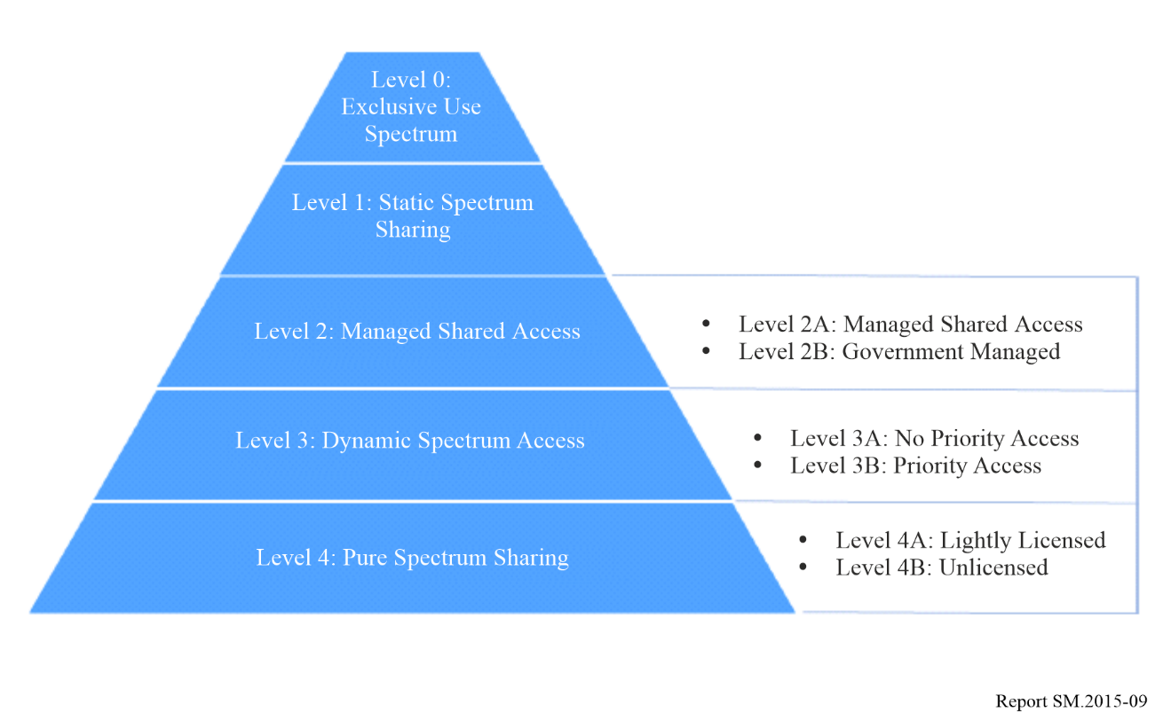

One of the first alternative models is local licensing, whereby spectrum is still block assigned, i.e. frequencies are assigned, but for a specific area rather than an entire region or country. In many countries, this type of approach is used to authorise verticals. For example, 10 of the 27 European Union Member States had implemented local licensing schemes (mainly in 3.6 GHz spectrum) as of March 2022. These local licensing schemes often remain administrative in nature but do facilitate a more flexible way of authorising spectrum for certain uses.

Another alternative model is light licensing, whereby users of equipment are required to register with the regulator to access the spectrum, but an individual licence is not necessarily required.

#### 5.2.1.1 Spectrum sharing regimes

Spectrum sharing ranks high on the agenda of some spectrum policy makers as a potential “agile” solution to address excess demand for spectrum. Growing demand for spectrum is resulting in high levels of congestion in certain spectrum bands and areas of the world. In some cases, sharing between users can help to increase the spectrum efficiency of the bands in question. Similarly, access to specific bands, for example as required by IMT (International Mobile Telecommunications), can result in challenging incumbency scenarios that are, in some cases, best addressed through sharing.

Sharing technologies are already commercially available in some countries, with dynamic spectrum access (DSA) represented by CBRS (Citizens Broadband Radio Service, representing time-based sharing) and AFC (Automated Frequency Coordination, representing location-based sharing). However, the growing demand for spectrum suggests that further network sharing technologies and approaches may be required in the future, depending on the issue to be addressed and the physical characteristics of the frequency bands.

Sharing regimes such as CBRS make use of sensing to facilitate sharing, noting that there is a move within the US to move away from sensing-based systems, instead making use of ‘Incumbent Informant Capability’[26] (IIC) to notify users in lower tiers when incumbents require access to spectrum. Other regimes such as AFC make use of centralized databases to coordinate usage. These regimes can be specific to certain contexts, or they could be viewed as building blocks which may be useful for sharing regimes in other contexts and bands. For instance, a CBRS type approach could be used in the context of PMSE when there is a need to protect an incumbent user. However, the implementation of such sharing regimes can be complex and costly, meaning regulators are often hesitant to commit to such regimes until demand is evident.

Changing the use of a frequency band begins at the ITU, with new allocations secured by a specific service in the Radio Regulations. This allocation is then entered into national frequency allocation tables (NFAT), with access to the band then determined by the regulator. The choice of access regime for a band is dependent on several factors, for example the presence of incumbent users, user needs (both existing and new), device characteristics and commercial viability.

In the case of some bands, for example maritime radars in the C-Band in the US, the cost to “refarm” (move to different frequencies) existing users (maritime radar) and put in place the necessary new equipment, was considered excessive. Instead, it was determined that the cost and complexity involved in developing the CBRS sharing approach (and not migrating maritime radar users) was viable given the huge benefit that access to C-Band spectrum for 5G would bring.

An important component for moving towards spectrum agility in the UAE would be implementing feasible spectrum sharing. Table 5 shows an indicative timeline for the developments required:

TABLE 5

Indicative spectrum sharing timeline

|  |  |
| --- | --- |
| Time period | Developments |
| 2024-26 | AI-ready policy rules combine with sensors and cognitive radio to make greater levels of sharing, automated spectrum access and frequency assignment within single technology and service areas possible. |
| 2026-31 | AI extends to sharing and decision-making across all technology and service areas. |
| 2031+ | It is also feasible that in future a common sharing approach applicable to all shared spectrum bands could be developed. In this instance, a single tool would be able to manage sharing by all users, without regulators having to put in place dedicated systems for each. |

### 5.2.2 Increased intelligence and agility in databases

Spectrum Management Systems (SMS) are at the core of solutions in making spectrum available to users. Staff at national regulators interact with the SMS in granting authorisations (for example through collection of user demand information and analysis of any requests) and applicants interact with the system in order to provide the relevant information.

One area where developments may come into play in the shorter term is that of more developed and automated spectrum management systems. For example, certain SMS vendors already offer semi-automated processing of licence requests, and countries contacted through the benchmarking exercise verified that a number of services are now subject to automatic authorisations. Further integration of these, and extension of the processes used to other services, is likely to continue.

Furthermore, greater levels of intelligence may be possible within the SMS, offering users a more personalised experience. For example, users logging into accounts on an authorisation portal could be guided towards actions related to their existing authorisations, for example renewal, or be initially guided towards relevant authorisation applications. Whilst not common amongst the benchmarked regulators, a number had identified that work in this area was ongoing, particularly with regards to improving customer experience without impacting upon the ability of regulators to collect the necessary information.

Beyond simply greater levels of automation, it could also be expected that SMS themselves will become more flexible and dynamic. Spectrum management systems today rely heavily on centralised licensing databases, interacting with various other systems including application portals, technical analysis tools and finance and type approval portals. A generalised system diagram for the current spectrum management tools is shown below.

Figure 10

Current and future spectrum management systems

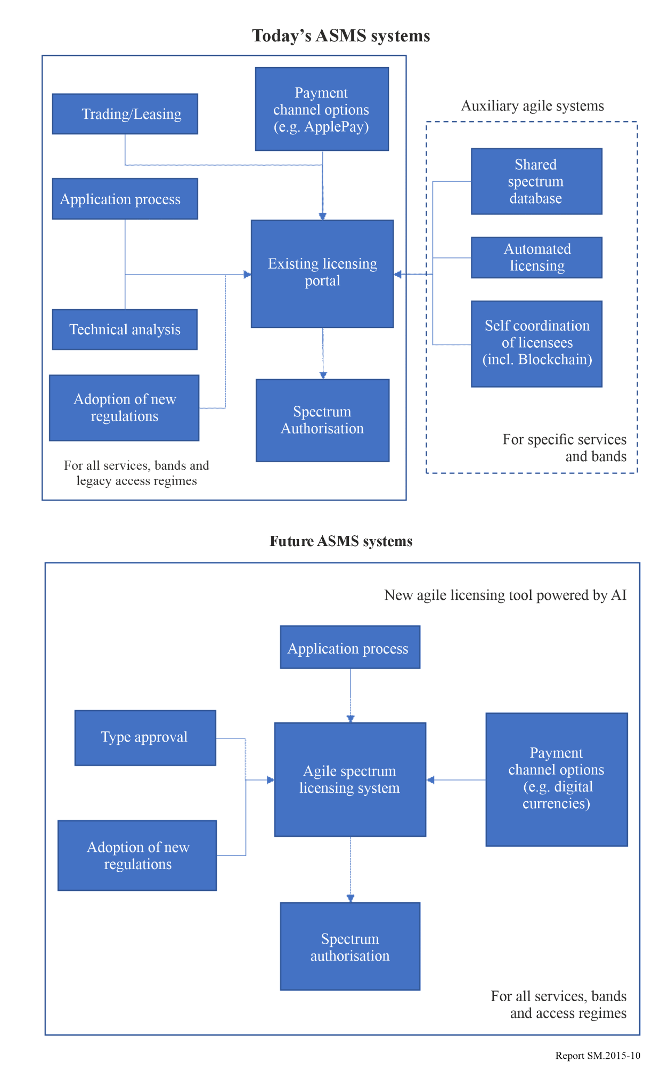

On the horizon for these is an integration into a single solution. Such a system would not feature dedicated auxiliary tools to handle ‘agile’ parts of the spectrum management approach, but rather all services, bands and access regimes would be handled in a centralised tool, alongside more traditional legacy access regimes. The tool would be sufficiently intelligent to consider applications under the appropriate access regime, interacting with other systems as needed. Such a system would be better able to deliver the sort of spectrum management agility represented by the higher levels of the assessment metrics that have been defined.

Greater integration of SMS with other tools is also likely to be beneficial to both regulator and end user experience of systems. For example, direct integration of the SMS with monitoring data could facilitate immediate licence authorisations by allowing automated and more accurate interference potential calculations, especially for applications such as PMSE.

### 5.2.3 Artificial intelligence

Artificial intelligence (AI) is typically taken to mean the ability of machines and computers to augment data processing methods and speed to an advanced level beyond human capabilities. Many sources include in the definition the ability to be able to learn, problem solve, or at least deduct rules, as opposed to the more traditional input-output approach historically taken by computers and machines. Instead, AI systems can perceive and analyse their environment and act accordingly to maximise the chances of success. An application is machine learning, whereby AI systems are trained using large datasets to be able to identify the most successful outcomes.

Artificial intelligence in spectrum management is not yet mature. For example, the ITU considers artificial intelligence as important in several aspects of spectrum management[27] but its publications regarding the application of artificial intelligence in spectrum management pertain mostly to cognitive radio.

It is considered that AI can be applied beyond general spectrum management aspects but also to more practical and IT-related elements, for instance smart assistants could be used to help applicants making applications for spectrum use to navigate the portal and automatically recognise user profiles and provide personalised guidance to users.

Research in AI is expected to play a role in managing dynamic spectrum access systems. Arguably, using the above definitions of AI, techniques such as CBRS and AFC (considered previously in the White Paper) already illustrate artificial intelligence as they take account of environmental conditions, learning as they go, to maximise the chances of success in spectrum authorisations. Research suggests that AI could be suitable in the management of Dynamic Spectrum Access (DSA) as, once trained, AI-based DSA schemes should be able to process new data easily and be able to deal with the complex and fast changing nature of wireless signals that humans and traditional equipment may find challenging[28]. A further usage of AI in DSA could be to price spectrum based on the levels of instantaneous demand, such that spectrum pricing is able to change in real time, in theory helping to maximise the levels of spectral efficiency that can be obtained.

One aspect of spectrum management that could definitely benefit from AI is that of monitoring. The role that AI could have in processing the vast amounts of monitoring data, and making this available to authorisation systems, could be highly useful[29]. AI’s proven ability for pattern recognition could be of particular use in identifying signals which, when coupled with a dense network of sensors, could enable real time spectrum occupancy measurements.

Regulators around the world are beginning to implement automated licensing systems (typically focussed on PMR, PMSE, fixed links and maritime and aeronautical), but these are based on well-defined and understood assignment algorithms. The extension of AI to systems where higher levels of policy decision making are required in assignment (e.g. refarming, satellite) or for security and defence considerations, is considered significantly more difficult.

A further area where AI may prove useful is in identifying the impact of changes to the ITU Radio Regulations, as updated at World Radio Conferences (WRC). Currently, the process of updating national frequency allocation tables (NFAT) requires identifying what changes have been made to the services allowed to access each frequency range. This can be a manual and time-consuming process following WRC. It is quite possible that AI is able in the short term to identify the relevant changes in the Radio Regulations and update the NFAT in a shorter timescale and with fewer errors than a human.

Artificial intelligence to recognise potentially successful satellite ITU filings is also worthy of consideration. Based on a TDRA staff suggestion, this requires either a machine learning approach, based on successful satellite filings to date, or the development of an algorithm to determine likely probability of success.

### 5.2.4 Blockchain and secure cooperative assignment procedures

A blockchain is a decentralised ledger of information, shared across several so-called nodes. It is not currently widely deployed in spectrum management systems but blockchain or other secure cooperative assignment procedures may be considered a promising solution to solve some of the future challenges related to data verification.

It is very difficult for users to falsify the information as each node (computer) holds a complete copy of the information, and transactions (changes to the information) are verified prior to adoption into the blockchain. Five key benefits of blockchains are considered below[30]:

• Decentralisation, i.e. no one party is responsible for the information;

• Transparency, i.e. the history of transactions leading to the current state is visible to all users;

• Immutability, i.e. it is difficult to change the information;

• Availability, i.e. the blockchain is replicated across many nodes, offering large amounts of redundancy; and

• Security, i.e. all entries in the ledger are cryptographically signed.

Between them, these key features can eliminate the need for a trusted entity responsible for the administration of many spectrum management aspects and allow for better visibility of spectrum occupancy, particularly if the blockchain can be updated in (near) real time.

Opening the blockchain to all users has the drawback that more complex verification mechanisms and blockchain nodes are required but removes administrative burden from the regulator.

Whilst there are several foreseen benefits and use cases related to the usage of blockchain in spectrum management, there are also a number of potential drawbacks. Firstly, the processing power required to validate blockchain transactions is potentially a limiting factor in their applicability. Many devices that could use the imagined blockchains are likely to be mobile in nature and hence battery powered. The battery drain that will be generated by the requirement to validate transactions could potentially prove prohibitive. Similarly, validating transactions will also require additional communication between nodes or devices accessing spectrum and the other blockchain nodes. This could require additional spectrum resources, thereby reducing the efficiency of the system. The validation also requires time. As such, blockchain as a real time spectrum authorisation or management system may be limited.

There are promising use cases for blockchain, but its limitations must be understood. At best, it provides a decentralised, potentially near real time spectrum management tool that can help to incentivise users to share spectrum more effectively and efficiently. At worst, it is an inefficient way to replicate what regulators already have. ANFR’s successful implementation of a blockchain for self-coordination of frequencies between PMSE users demonstrates that for specific cases, blockchain can provide useful benefits. However, most regulators remain unconvinced of the benefits of deploying a blockchain in spectrum management more generally. Other, more simple, secure cooperative assignment procedures could be explored.

### 5.2.5 Payments in digital currencies (UAE 2019-20 Project Aber)

The UAE launched in 2019 Project Aber, a Central Bank Digital Currency (CBDC) intended to explore domestic and cross-border payments through a distributed payment system. The project found significant efficiency improvements and transaction cost savings when using a centralised payment system[31]. In November 2020, the deployment of a CBDC in UAE was deemed feasible, pending further studies. In particular, CBDCs face significant regulatory challenges requiring careful consideration, for example privacy concerns, consumer protection, and anti-money laundering rules[32]. CBDCs have already been launched in a significant number of countries.

Through the research, digital currencies such as CBDC were found to have some benefits in certain scenarios, although mainly due to the complementary nature of CBDCs and blockchains, allowing for example smart contracts. Regulators contacted through the benchmarking exercise saw that the use of digital currencies, whether private or CBDC, was a matter for a nation’s central bank rather than the organisation responsible for spectrum management.

### 5.2.6 Summary

Developments in spectrum management solutions are expected to be significant. Currently, spectrum management solutions and regulatory approaches tend to be fragmented, with a dedicated system and approach handling access to most bands and services, and standalone auxiliary tools and approaches for the more specific access regimes.

Developments in spectrum management solutions and technologies, such as AI and secure cooperative assignment procedures, are expected to allow a better integration of the various aspects of the SMS, and development of more agile and flexible tools. An ultimate aim would be for a single agile tool to be sufficiently intelligent and flexible to be able to authorise all services and spectrum as required.

Such a system could then feasibly implement new authorisation and regulatory approaches and sharing regimes as required (without the need to implement a dedicated new system), as well as possibly determining pricing dynamically if required. It is possible to provide a better service to customers through, for example, smart assistants to guide applicants through the application process, automated authorisations and analysis based on operational parameters rather than worst case values. A spectrum sharing framework perspective for the UAE will act as a catalyst for new spectrum access regimes combined with dynamic databases.

# 6 TDRA 2031: Roadmap, scenarios and timeline for the evolution of smart spectrum management systems

The TDRA 2022 “Spectrum Agility” project has extensively researched wireless technology opportunities and the evolution of spectrum management solutions, the agility benefits they provide, and their implementation among entities in charge of spectrum management around the world.

Agility factors, technologies and spectrum management solutions will evolve in a non-linear and not fully predictable way over the next decade. There are notable uncertainties in their timeline. It is therefore necessary in this White Paper, in accordance with the UAE recommended scenario approach[33], to consider more than one possible path in the development of agile models. Answering the question “how can spectrum management be fit for purpose and enable excellent experience for customers and spectrum users in the UAE?”, is best assessed through three scenarios, and a discussion of the initiatives TDRA itself needs to take to achieve its agility goals.

The future scenarios TDRA has explored have focussed on the degree of development of maturity and technology factors. The extent of developments in process autonomy and agility in the next decade will depend on:

• Wireless technologies opportunities, in particular dynamic autonomous sharing and AI application at network management level;

• Progress of AI in spectrum management solutions; and

• The scope of institutional policy decisions in SMS requiring policy defined intervention.

Based on the comprehensive international comparisons and benchmarking TDRA has performed, considering the future network technology opportunities and the improvements in SMS spectrum management solutions, TDRA considers three key paths to agility scenarios over the 2023-2031 period:

TABLE 6

Spectrum management development scenarios for the 2023-2031 period

|  |  |  |  |
| --- | --- | --- | --- |
| Agility scenario | Description | Path to agility | Outcome |
| A) Trend towards incremental agility | Step-by-step improved agility in spectrum management | Evolutionary adoption of new agile processes including some additional intelligence | Incremental maturity level |
| B) Leap towards full agility conditions | Full Agility conditions | Generalised adoption of all fully agile processes to be conceived and developed | Fully agile maturity (“dream” reference scenario) |
| C) Objective based approach: The Road to 2031 | Significantly enhanced agility in spectrum management | – Adoption of new agile processes  – TDRA future-oriented initiatives | Quantum progress in maturity level |

## 6.1 Scenario A: Trend towards incremental agility

The benchmarking exercise conducted in the TDRA Spectrum Agility project has found somewhat cautious expectations from regulators around the world regarding the possibility of quick and substantial further advances in spectrum management automation in the foreseeable future. Spectrum management automation might take place, but only progressively, as illustrated in Fig. 11.

Figure 11

Example spectrum management development roadmap for Scenario A

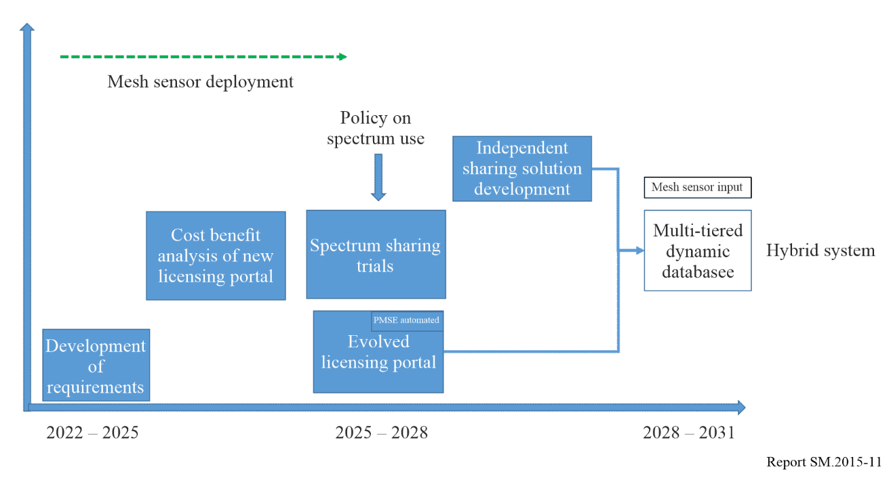

In this baseline scenario, live databases will take time to be set up and be fully operational. Sharing will be limited by prevalent claims of exclusive rights by incumbents, the complexity and relatively slow pace of development of effective cognitive radios, and the limited spectrum bands open to this innovation. Blockchain and cooperative frequency assignment will be limited to few services where relatively basic requirements can be handled by the users themselves. This does not mean that Agility will not improve in the next few years, but it will progress in an incremental, evolutionary way.

## 6.2 Scenario B: Leap towards full agility conditions

Fully autonomous spectrum management is considered as a goal worth considering, but on an indeterminate horizon by the community of radio spectrum stakeholders and regulators. This fascinating perspective is often referred to in radio spectrum management circles as a “dream” or even a “fantasy”. Figure 12 describes such a hypothetical path towards “fully agile automation”.

Figure 12

Example spectrum management development roadmap for Scenario B

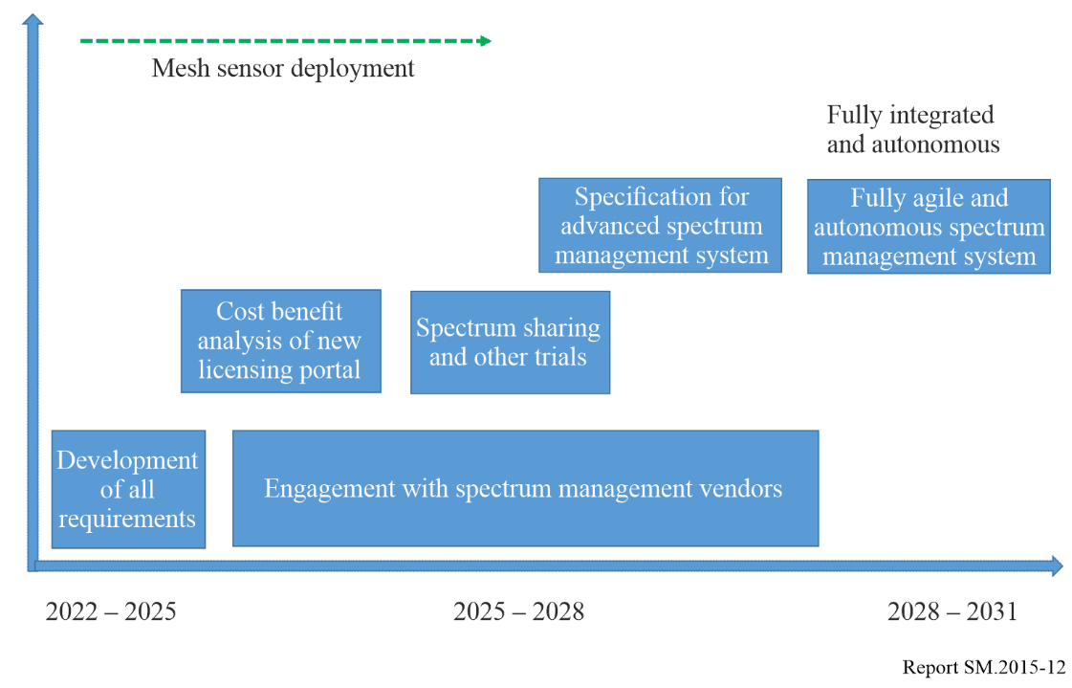

The possibility of perfectly accurate cognitive radios combining with super powerful AI to make possible real-time, fully autonomous and optimally efficient spectrum allocation, assignment, authorisation and management across extensive frequency bands is explored in testbeds research projects conducted mostly in the United States by DARPA and the NSF.

According to the TDRA survey of stakeholders, the generally accepted expert opinion is that there still will be limitations on what spectrum management solutions can achieve in terms of autonomous spectrum assignment and authorisation. Beyond the lab, in real-life conditions, a combination of technical and policy considerations is in play for spectrum authorisation for many services. Dynamic spectrum access is already widely in use for determinate technologies and services but is far from extending beyond service allocations and covering the whole radio spectrum. Competition conditions, security and defence issues, can benefit from AI analysis, but they will not easily fit into autonomous systems, however smart they are.

Although they provide a useful reference vision, the conditions for the advent of such a fully autonomous spectrum management solution will not be ready by 2031. Interestingly, though, this provides a glimpse at what radio spectrum management might comprehensively look like someday. It allows some useful metrics of the gap between the current state, the practical realities of the wireless ecosystem demands, developments, spectrum management solutions, and what can be ambitiously but reasonably aimed at. It defines a space, a framework, within which to define initiatives that will be implemented to achieve the best possible outcomes in an objective based approach until 2031.

## 6.3 Scenario C: Objective based approach: The road to 2031

Facing the realities at the beginning of 2023, it turns out that the road to 2031 for the TDRA Agility timeline will result from a combination of technology and spectrum management solution opportunities, reinforced by TDRA’s own initiatives and developments, contributing to the UAE “2031 Ecosystem” digital objectives wherever spectrum management is implied.

The selected major initiatives TDRA is taking to speed up the journey on the Agility highways to escalate the maturity level of spectrum management regime, involves, but is not limited to, the following considerations:

• The degree of systemic, dynamic integration of the application, authorisation, monitoring process;

• The implementation of live and dynamic databases;

• The use of Blockchain and secure cooperative procedures for self-organisation of spectrum assignments;

• The extent of single decision-direct assignments, verticals, FWA which increase the burden of tasks of the regulator; and

• The extension of sharing approaches (advanced sensing, integration of databases and sensing, dynamic access).

Table 7 describes the objectives pursued by TDRA on its path towards a high agility and autonomy maturity level.

TABLE 7

Description of the objectives associated with Scenario C

|  |  |
| --- | --- |
| Objective | Description |
| 1) Users | Users as part of the agile, real-time, spectrum management system |
| 2) Promoting AI | Promoting AI in the ASMS process anticipating and fulfilling user needs |
| 3) Enhanced automation/ autonomy | Enhanced automation/autonomy for Agility implementation: roadmap towards 2031 |

The objectives of this changeover process are the following.

### 6.3.1 Objective 1: Users as part of the agile, real-time, spectrum management system

In line with the UAE Digital objectives, TDRA aims to achieve high user satisfaction, which is part of its charter. The “Spectrum Agility” research project, in its definition of agility and flexibility, has led to consider users as part the spectrum management system itself. Indeed, the role of TDRA does not stop once an authorisation has been issued to a user. TDRA is required to ensure continued interference free operation for the duration of the authorisation, and allow users to flexibly modify, renew or cancel their authorisations when needed.

A potential application of this concept lies in managing users’ frequencies in real time to ensure higher levels of service and spectral efficiency. Live usage and authorisations can take place. For example, if a frequency at a given location can be useful for another applicant, TDRA could (under certain conditions) modify the authorisation of an incumbent user to dynamically clear space for the new applicant. This could be described as ‘live spectrum management’.

As another implementation of the “user as part of the spectrum management system”, it may be possible to provide users dynamically (under certain conditions) with expedited authorisations for usage of spectrum. If users are registered with TDRA and equipment is fully type approved and connected to TDRA’s systems, it could be possible to automate parts of the authorisation process with minimal human intervention.

Currently authorisations in the UAE are for a single year, but an application of the sort of real time and connected system considered could be to authorise usage for much shorter durations, e.g. a number of minutes, if required. This could also facilitate charging for spectrum access dynamically. For example, users could be charged once devices are switched on until they are switched off, with the frequency automatically selected by TDRA’s database on behalf of the device. This would also give TDRA better visibility of spectrum usage and device ownership.

It could also be possible to define priority levels for users such that if concurrent access is required, those with a higher priority are ensured access. This is akin to the approach used in CBRS for example.

Actually, it could be possible to define spectrum management in 5 dimensions: x, y, z (i.e. coordinates), time and frequency. For some services, it is likely to be possible to further automate and make almost autonomous, most, if not all, aspects of an authorisation. However, for some services, the level of complexity is such that automation will not be possible for all aspects in the short term, for example those that require significant amounts of coordination. Certain aspects, for example technical analysis or exchange of information, could potentially be automated.

The main objective in this scenario is to enhance the level of system autonomy in the authorisation process.

### 6.3.2 Objective 2: Promoting AI in the ASMS process: Anticipating and fulfilling user needs

In this TDRA Objective, AI intervenes as a major Agility factor at each step of the spectrum management process.

TABLE 8

Development levels for AI

|  |  |
| --- | --- |
| Application of AI at | Description |
| 1 Application submission | This is an AI assistant that could potentially offer support in completing the application autonomously as an interactive online solution. Elementary AI, with data in the hundreds, closer to an evolving expert system, will help identify the user and its needs in an always more precise manner. User profiles could be used as part of the application portal to help offer a more personalised service to applicants. It could also be possible to pre-calculate and publish the available fixed link channels in each area, for example to make applications easier for users. |
| 2 Application processing and authorisation | Autonomous processing of with the objective of no human intervention to include RF predictions, technical analysis, calculations, collaborative authorisation processes, getting closer to automated assignment decisions in many cases. As more data is generated and higher resolution needed to enable/support spectrum authorisation, evolved algorithms will play a pivotal role, allowing a level 2 AI. |
| 3 Monitoring process | The monitoring stage, which includes preventive monitoring, deals with lots of measurement data incoming from a range of sensors (e.g. mesh sensors). The data will need to quickly be processed, interpreted and presented in a meaningful way to support live authorisations. Thus, a Level 3 Advanced AI application would be needed. |

This three-steps spectrum management process can constantly and robustly evolve over time. However, within an advanced dynamic spectrum management solution, possibly including sharing provisions, the three steps can be integrated in a system with feedback and loops. This would represent the most promising application of AI in the future.

Furthermore, once more data on spectrum usage can be collected, AI could contribute to policy making and improve cost effectiveness. This is being considered in 6G with the increased use of ML and AI.

### 6.3.3 Objective 3: Enhanced automation/autonomy for agility implementation: roadmap towards 2031

Spectrum management regimes in future will increasing be more agile, this means enhanced levels of automation/autonomy beyond what is available today.

Evolution from today’s systems to future systems is based on certain developments currently arising, notably more intelligence in data processing, more automation and autonomy of spectrum management processes, and an increase in the use of dynamic spectrum access systems across different bands and services. Figure 13 shows the transition and initiatives from today’s systems to future systems.

Figure 13

Current and future spectrum management systems

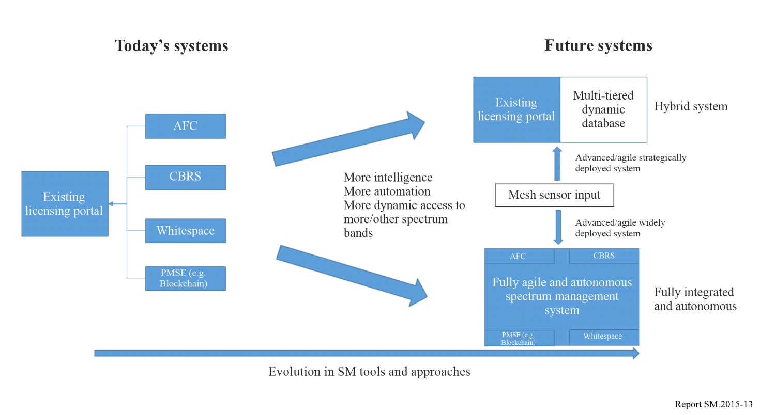

## 6.4 TDRA initiatives and the ITU framework

The international table of frequency allocations evolves step by step, following the ITU conferences quadrennial calendar. Agility is on the horizon, but the path towards it conforms to a strict institutional framework. Cognitive approaches, however, if applied across technologies and services, have potentially wide-ranging international implications. ITU procedures might have to change in the future to allow for more flexibility/agility. In terms of spectrum management solutions though, something can be achieved.

The ITU spectrum management handbook was last updated in 2015 and refers to computer systems and automation. It does not refer to more futuristic elements such as the use of AI or more intelligence incorporated into spectrum management. It might be useful, through the findings from this study, for the ITU to consider an update to their Spectrum Management Handbook and consider future initiatives and spectrum management capabilities over the next decade.

Whilst changes at an ITU level are beyond the scope of this White Paper, there are some considerations around the potential limitations on flexibility and agility that could be achieved for some aspects due to the requirement to comply with the ITU regulatory framework. As the ITU cycle requires a number of actions and requires consensus based decision making, changes to the framework can potentially require significant amounts of effort and time to enter into national implementations. Previously, there have been a number of suggestions regarding changes to the ITU process, but to date none have been found suitable. Thus, where decisions need to be made, the possible extent and pace of automated agility processes implementation is still limited.

## 6.5 The road to 2031: UAE digital objectives and TDRA initiatives

In its endeavour to foster Agility in spectrum management, TDRA conforms to a rigorous management approach which:

• Focuses on outcomes;

• Achieves high impacts;

• Supports experimentation on networked collaboration;

• Follows adaptive resource allocations;

• Opens knowledge flow in a disruptive, innovative and transformational manner; and

• Focuses on engagement and co-creation.

This will need to be a realistic manifesto of spectrum management evolution so that TDRA is able to implement the initiatives in a timely and cost effective manner.

To reinforce the opportunities offered by technologies and the progress in spectrum management solutions, and to explore the changeovers towards Agility 2031, TDRA considers the following initiatives:

Initiatives related to the “users” objective

• **Personalised procedures** with AI to guide users;

• A **more open spectrum**: Expand sharing to facilitate user access;

• Empower users with **secure collaborative assignment** procedures whenever possible.

Initiatives related to the “Promoting AI” Objective

• Extensive research into “Algorithm based” spectrum application, authorisations, and monitoring.

Initiatives related to the “Enhanced Automation/Autonomy” objective

• Define efficient workflows combining automation and policy orientations, including priority and emergency communications;

• Extend research efforts to enhance spectrum efficiency and sustainability in spectrum management with UAE Research institutions, vendors, international partners.

These initiatives are intended to complement the opportunities offered by new wireless technologies and spectrum management solutions to speed up the path towards agility in radio spectrum management.

# 7 Timeline and benefits of implementing an agile SMS

TDRA intends to initiate a programme of activities to implement an agile SMS over the next 9 years based on the objectives and initiatives discussed in this White Paper. The following timeline sets out the main time ranges in which TDRA will implement its plan.

**2023**

In the already implemented first stage 2022-23, TDRA baseline SMS compares favourably to international spectrum management standards, as demonstrated by the TDRA’s ranking in the ICT global competitiveness indicators and indices, thus already engaged in evolutionary process.

**2024-26**

In the next stage, TDRA implements supply driven evolutions on the horizon, AI, advanced spectrum sharing approaches.

**2026-31**

In the third stage, TDRA mixes supply trends with its own initiative-driven approach, defined in accordance with the UAE Vision 2031 and the TDRA strategic objectives.

TDRA will keep track of the evolution towards an agile spectrum management system through the development of dedicated agility objectives, focusing on inclusion, users as part of the ecosystem, AI developments at the service of spectrum application, authorisation and monitoring, and the progress of automation towards autonomous processes in spectrum management systems.

Furthermore, a programme of this nature needs to demonstrate a clear set of benefits to justify pursuing the work plan and to ensure maximum value is delivered to TDRA from a future SMS. The following are some of the main benefits that would arise:

**•** Customer happiness – an enhancement in customer satisfaction with their dealings with TDRA resulting from, for example, easier applications or faster authorisation timescales;

**•** Spectrum efficiency – an improvement in the spectral efficiency achieved by services operating in the UAE;

**•** Flexibility - an improvement in TDRA’s ability to offer flexibility to users, for example with regards to access to different bands or under different conditions; and

**•** TDRA capability–an improvement in TDRA’s ability to perform its spectrum management functions, for example an ability to process a greater number of applications in less time.

1. For more information, see Report [ITU-R SM.2404](https://www.itu.int/pub/R-REP-SM/publications.aspx?lang=en&parent=R-REP-SM.2404)-0 – Regulatory tools to support enhanced shared use of the spectrum.
2. U.S. National Spectrum Requirements: Projections and Trends, U.S. Department of Commerce, March 1995.
3. Definition of “Agility in Spectrum management” is provided in § 4.2 of Annex 2 to Chapter 3.
4. UAE, 2022. The UAE Digital Government Strategy 2025. Available at: [https://u.ae/en/about-the-uae/strategies-initiatives-and-awards/strategies-plans-and-visions/government-services-and-digital-transformation/uae-national-digital-government-strategy](https://eur03.safelinks.protection.outlook.com/?url=https%3A%2F%2Fu.ae%2Fen%2Fabout-the-uae%2Fstrategies-initiatives-and-awards%2Fstrategies-plans-and-visions%2Fgovernment-services-and-digital-transformation%2Fuae-national-digital-government-strategy&data=05%7C02%7CPhilippe.Aubineau%40itu.int%7C165bfc6500f249c8000d08dd1e7fc537%7C23e464d704e64b87913c24bd89219fd3%7C0%7C0%7C638700256330688884%7CUnknown%7CTWFpbGZsb3d8eyJFbXB0eU1hcGkiOnRydWUsIlYiOiIwLjAuMDAwMCIsIlAiOiJXaW4zMiIsIkFOIjoiTWFpbCIsIldUIjoyfQ%3D%3D%7C0%7C%7C%7C&sdata=mUMkcKpRNzX%2BhizpteExPg8LfExZksHYn2eWWM6aM%2F0%3D&reserved=0).
5. UAE, 2020. 2020: Towards the next 50. Available at: [https://u.ae/en/about-the-uae/uae-in-the-future/designing-the-next-50](https://eur03.safelinks.protection.outlook.com/?url=https%3A%2F%2Fu.ae%2Fen%2Fabout-the-uae%2Fuae-in-the-future%2Fdesigning-the-next-50&data=05%7C02%7CPhilippe.Aubineau%40itu.int%7C165bfc6500f249c8000d08dd1e7fc537%7C23e464d704e64b87913c24bd89219fd3%7C0%7C0%7C638700256330718943%7CUnknown%7CTWFpbGZsb3d8eyJFbXB0eU1hcGkiOnRydWUsIlYiOiIwLjAuMDAwMCIsIlAiOiJXaW4zMiIsIkFOIjoiTWFpbCIsIldUIjoyfQ%3D%3D%7C0%7C%7C%7C&sdata=J%2BgVRAa%2BHYXnDkf8jw5D3rKGgFaZp8Xx959gRBy%2FfoE%3D&reserved=0).
6. TDRA, 2022. About TDRA. Available at: <https://tdra.gov.ae/en/About>.
7. UAE, 2022. UAE Centennial 2071. Available at: [https://u.ae/en/about-the-uae/strategies-initiatives-and-awards/strategies-plans-and-visions/innovation-and-future-shaping/uae-centennial-2071](https://eur03.safelinks.protection.outlook.com/?url=https%3A%2F%2Fu.ae%2Fen%2Fabout-the-uae%2Fstrategies-initiatives-and-awards%2Fstrategies-plans-and-visions%2Finnovation-and-future-shaping%2Fuae-centennial-2071&data=05%7C02%7CPhilippe.Aubineau%40itu.int%7C165bfc6500f249c8000d08dd1e7fc537%7C23e464d704e64b87913c24bd89219fd3%7C0%7C0%7C638700256330744855%7CUnknown%7CTWFpbGZsb3d8eyJFbXB0eU1hcGkiOnRydWUsIlYiOiIwLjAuMDAwMCIsIlAiOiJXaW4zMiIsIkFOIjoiTWFpbCIsIldUIjoyfQ%3D%3D%7C0%7C%7C%7C&sdata=ar8aBUXORdhJPnB105df2ziQD4HT%2FqK85v1PN%2FQUlWU%3D&reserved=0).
8. MOCA, 2019. Shaping the Future. Available at: <https://www.moca.gov.ae/en/area-of-focus/future-foresight>.
9. MOCA. Scenario Planning Toolkit. Available at: <https://www.moca.gov.ae/docs/default-source/default-document-library/scenario-planning--toolkits/scenario-planning--toolkits.pdf?sfvrsn=2>.
10. UAE, 2022. ‘We the UAE 2031’ Vision. Available at: <https://u.ae/en/about-the-uae/strategies-initiatives-and-awards/strategies-plans-and-visions/innovation-and-future-shaping/we-the-uae-2031-vision>.
11. ITU, 2022. Policy & Regulatory Frameworks. Available at: <https://www.itu.int/en/ITU-D/Regulatory-Market/Pages/Policy-&-Regulatory-Frameworks.aspx>.
12. UAE Ministry of Cabinet Affairs, 2020. Publications. Available at: <https://www.moca.gov.ae/en/publications>.
13. MOCA. Scenario Planning Toolkit. Available at: <https://www.moca.gov.ae/docs/default-source/default-document-library/scenario-planning--toolkits/scenario-planning--toolkits.pdf?sfvrsn=2>.
14. Under article 50 of the UAE Telecommunications Law, entities have to obtain an authorisation directly from TDRA in order to make use of the spectrum.
15. COTS, Commercial Off-the-shelf.
16. AR, Augmented Reality.
17. IEEE ComSoc, 2022. Excerpts of ITU-R preliminary draft new Report: Future technology trends of terrestrial IMT systems towards 2030 and beyond. Available at: <https://techblog.comsoc.org/2022/02/27/excerpts-of-itu-r-preliminary-draft-new-report-future-technology-trends-of-terrestrial-imt-systems-towards-2030-and-beyond/>.
18. Nokia, 2021. Network evolution towards the 6G era. Available at: <https://www.nokia.com/blog/network-evolution-towards-the-6g-era/>.
19. Ericsson, 2022. Future technologies for an intelligent society. Available at: <https://www.ericsson.com/en/future-technologies>.
20. Huawei, 2022. Communications Network 2030. Available at: <https://www.huawei.com/en/giv/communications-network-2030>.
21. NSF, 2022. IEEE Next G Summit Plenary (An Overview of NSF’s Support for NextG Research) Alex Sprintson, NSF. Available at: <https://www.youtube.com/watch?v=B6_ywxYHzAM>.
22. HEXA-X, 2022. A flagship for 6G vision and intelligent fabric of technology enablers connecting human, physical, and digital worlds. Available at: <https://hexa-x.eu>.
23. UAE, 2022. UAE Energy Strategy 2050. Available at: [https://u.ae/en/about-the-uae/strategies-initiatives-and-awards/strategies-plans-and-visions/environment-and-energy/uae-energy-strategy-2050](https://eur03.safelinks.protection.outlook.com/?url=https%3A%2F%2Fu.ae%2Fen%2Fabout-the-uae%2Fstrategies-initiatives-and-awards%2Fstrategies-plans-and-visions%2Fenvironment-and-energy%2Fuae-energy-strategy-2050&data=05%7C02%7CPhilippe.Aubineau%40itu.int%7C165bfc6500f249c8000d08dd1e7fc537%7C23e464d704e64b87913c24bd89219fd3%7C0%7C0%7C638700256330770159%7CUnknown%7CTWFpbGZsb3d8eyJFbXB0eU1hcGkiOnRydWUsIlYiOiIwLjAuMDAwMCIsIlAiOiJXaW4zMiIsIkFOIjoiTWFpbCIsIldUIjoyfQ%3D%3D%7C0%7C%7C%7C&sdata=5O4gNhE%2FrDtMxypZUbID6RRR0o39mfkhIoFHEJ4Amlg%3D&reserved=0)
24. Hexa-X, 2020. Deliverable D1.2 Expanded 6G vision, use cases and societal values. Available at: <https://hexa-x.eu/wp-content/uploads/2022/04/Hexa-X_D1.2_Edited.pdf>
25. In this section, referring to common international practices, “licensing” and “authorisation” are generically and indifferently applied to spectrum.
26. NTIA, 2020. Incumbent Informing Capability (IIC) For Time-Based Spectrum Sharing. Available at: <https://www.ntia.doc.gov/files/ntia/publications/iic_for_time-based_spectrum_sharing.pdf>.
27. ITU, 2022. AI will make radiocommunications smarter. Available at: <https://www.itu.int/en/action/ai/emerging-radio-technologies/Pages/default.aspx>.
28. Y.-C. Liang, 2020. Dynamic Spectrum Management, Signals and Communication Technology. <https://doi.org/10.1007/978-981-15-0776-2_6>.
29. Telecommunication Engineering Centre, 2021. AI in Spectrum Management. Available at: <https://www.tec.gov.in/pdf/Studypaper/AI_in_Spectrum_management.pdf>.
30. Martin BH Weiss et al., 2019. On the Applications of Blockchain to Spectrum Management. IEEE Transactions on Cognitive Communications and Networking.
31. Central Band of the UAE, 2020. CBUAE and SAMA Issue Report on Results of Joint Digital Currency Project "Aber". Available at: <https://www.centralbank.ae/media/nigd2put/cbuae-and-sama-issue-report-on-results-of-joint-digital-currency-project-aber_en.pdf>.
32. Atlantic Council, 2022. Central Bank Digital Currency Tracker. Available at: <https://www.atlanticcouncil.org/cbdctracker/>.
33. Scenario planning toolkit, UAE Government guide, 2019.