Report ITU-R SA.2573-0
(09/2026)
SA Series: Space applications and meteorology
Evolution of Earth exploration-satellite service systems in the 7 190-7 250 and 8 025-8 400 MHz frequency bands

Foreword
The role of the Radiocommunication Sector is to ensure the rational, equitable, efficient and economical use of the radio-frequency spectrum by all radiocommunication services, including satellite services, and carry out studies without limit of frequency range on the basis of which Recommendations are adopted.
The regulatory and policy functions of the Radiocommunication Sector are performed by World and Regional Radiocommunication Conferences and Radiocommunication Assemblies supported by Study Groups.

Policy on Intellectual Property Right (IPR)
ITU-R policy on IPR is described in the Common Patent Policy for ITU-T/ITU-R/ISO/IEC referenced in Resolution ITU-R 1. Forms to be used for the submission of patent statements and licensing declarations by patent holders are available from https://www.itu.int/ITU-R/go/patents/en where the Guidelines for Implementation of the Common Patent Policy for ITU-T/ITU-R/ISO/IEC and the ITU-R patent information database can also be found.

Series of ITU-R Reports
(Also available online at https://www.itu.int/publ/R-REP/en)
Series | Title
BO | Satellite delivery
BR | Recording for production, archival and play-out; film for television
BS | Broadcasting service (sound)
BT | Broadcasting service (television)
F | Fixed service
M | Mobile, radiodetermination, amateur and related satellite services
P | Radiowave propagation
RA | Radio astronomy
RS | Remote sensing systems
S | Fixed-satellite service
SA | Space applications and meteorology
SF | Frequency sharing and coordination between fixed-satellite and fixed service systems
SM | Spectrum management
TF | Time signals and frequency standards emissions

Note: This ITU-R Report was approved in English by the Study Group under the procedure detailed in Resolution ITU-R 1.

Electronic Publication
Geneva, 2026
© ITU 2026
All rights reserved. No part of this publication may be reproduced, by any means whatsoever, without written permission of ITU.

REPORT ITU-R SA.2573-0
Evolution of Earth exploration-satellite service systems in the 7 190-7 250 and 8 025-8 400 MHz frequency bands
(2026)

1 Introduction
Over the past years the number of Earth observation and remote sensing satellites has significantly increased, and this trend is expected to continue in the future, thanks to initiatives like the development of new constellation projects from private or public-private-partnership, new government programs or the growing maturity of space agencies in a number of countries.
Driven by a growing demand for Earth observation data and images and by the need for enhanced disaster early warning, prevention, preparedness, relief and recovery systems, these new projects, as well as the number of satellite networks submitted to ITU in the frequency bands allocated to the Earth exploration-satellite service (EESS) for data downlink purposes, are increasing very rapidly.
Among other frequency bands, the 8 025-8 400 MHz frequency band plays a key role for the downlink of Earth observation data and the 7 190-7 250 MHz frequency band supports the uplink of tracking, telemetry and command for the operation of associated spacecrafts. These frequency bands allow rapid data transmissions due to the available bandwidth, the available technologies and the existing earth station infrastructures.
New constellations of Earth observation and new ground infrastructure deployments, aiming to complement existing and future systems, are examples of the growing need for these bands.
This Report provides characteristics for new applications, deployment scenarios and technology developments that are not provided in other recommendations or reports, such as Report ITU-R SA.2488. These characteristics can be used either to analyse potential interference from and to these satellite systems, achieve operational compatibility or support further considerations on other spectrum management issues.

2 Frequency allocations in the frequency bands 7 190-7 250 and 8 025-8 400 MHz

2.1 Frequency allocations in the frequency band 7 190-7 250 MHz
The frequency band 7 190-7 250 MHz is currently allocated on a primary basis to the Earth exploration-satellite service (Earth-to-space) as well as the fixed and mobile services and the frequency band 7 190-7 235 MHz is also allocated on a primary basis to the space research service (Earth-to-space). In addition, the footnotes RR Nos. 5.458, 5.459, 5.460, 5.460A, 5.460B are also applicable in the frequency range 7 190-7 250 MHz.
RR No. 5.460A provides more detailed provisions applicable to the Earth exploration-satellite service as well as sharing conditions with existing and future stations of the fixed and mobile services in the frequency band 7 190-7 250 MHz. More specifically the footnote indicates that space stations operating in the Earth exploration-satellite service (Earth-to-space) shall not claim protection from existing and future stations in the fixed and mobile services, and RR No. 5.43A does not apply and RR No. 9.17 applies. Additionally, it also indicated that to ensure protection of the existing and future deployment of fixed and mobile services, the location of earth stations in the Earth exploration-satellite service shall maintain separation distances from the border(s) of neighbouring countries.

2.2 Frequency allocations in the frequency band 8 025-8 400 MHz
The frequency band 8 025-8 400 MHz is currently allocated on a primary basis to the Earth exploration-satellite service (space-to-Earth) as well as the fixed and mobile services and the fixed satellite service (Earth-to-space). In addition, the frequency band 8 175-8 215 MHz is also allocated on a primary basis to the meteorological-satellite service (Earth-to-space). Footnotes RR Nos. 5.462A, 5.463 are also applicable in the frequency range 8 025-8 400 MHz.
Radio Regulations No. 5.462A provides additional power flux-density limits in Regions 1 and 3 (except Japan) applicable to geostationary satellites operating under the earth exploration-satellite service (space-to-Earth).
Radio Regulations No. 5.463 indicates that the use of the frequency band 8 025-8 400 MHz by transmitting aircraft stations is not permitted.

3 Overview of existing and planned EESS systems operated in the frequency bands 7 190-7 250 and 8 025-8 400 MHz
The Earth observation sector has been rapidly evolving, complementing missions which usually rely on few relatively large satellites with constellations of smaller and usually cheaper satellites. Such a trend expanded the focus from increasing spatial resolution to the search for better coverage and revisit time, with the aim of providing near-real time Earth observation monitoring for all. Ever increasing amounts of data are being produced and Earth observation, which once was limited to highly trained users, is becoming more accessible. The service model of Earth observation data providers is also expected to evolve from the provision of raw data (e.g. EO images of areas affected by natural disasters) to the provision of intelligent information (e.g. prediction and early warnings of surge-related natural disasters).
This naturally translates into a massive increase of the amount of data generated by the Earth observation systems, and therefore in an increase of the need of downlink capacity.
In ITU, this trend has been reflected in the growing number of submissions of non-GSO EESS satellite systems, as can be seen in Figs 1 and 2 below, that shows this evolution in the band 8 025-8 400 MHz over time.
FIGURE 1
Number of non-GSO EESS API/A in 8 025-8 400 MHz per year of first submission
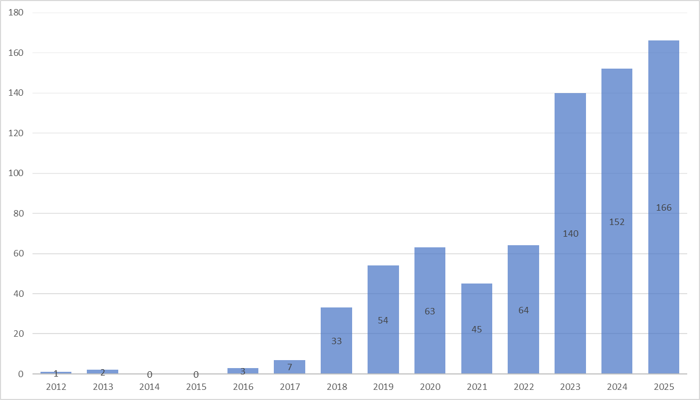
Notes to Fig. 1:
Note 1: The numbers of filings are counted according to the associated satellite names.
Note 2: The data used in this Figure are based on BR IFIC3074.
FIGURE 2
Number of non-GSO EESS notifications in 8 025-8 400 MHz per year of submission
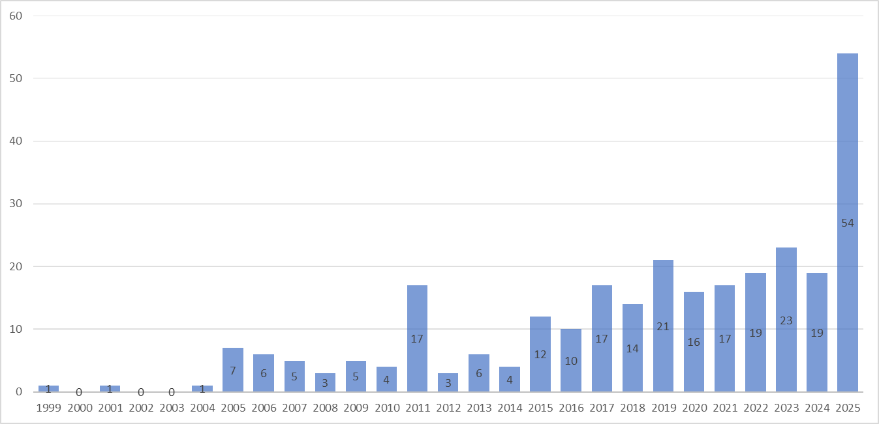
Note to Fig. 2:
Note 1: The same database and approach have been followed as in Fig. 1.
It can be seen from Figs 1 and 2, that the number of these non-GSO EESS satellite systems is rapidly accelerating since 2015.
This trend is also observable in the band 7 190-7 250 MHz which was allocated to the EESS (Earth-to-space) service for tracking, telemetry and command for the operation of spacecraft in 2015. Figure 3 shows the evolution of the number of EESS filings in this band over time.
FIGURE 3
Number of non-GSO EESS satellite systems (API/A) in 7 190-7 250 MHz per year of first submission
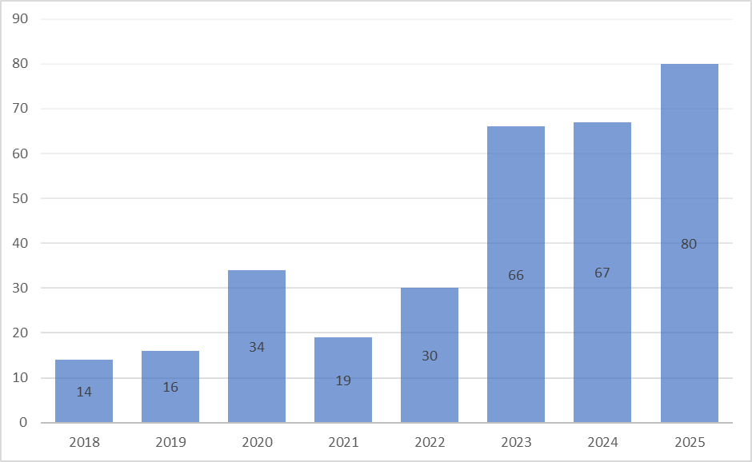
Note to Fig. 3:
Note 1: The same database and approach have been followed as in Fig. 1.
Furthermore, the number of earth stations being deployed in these bands has also rapidly increased in the last years, together with an increasing number of commercial companies who deploy earth stations all over the world and offer their capacity as a service to all those EO satellite operators who do not want to deploy their own ground segment. This is known as earth station as a service or Ground Segment as a Service (GSaaS) (see § 4.3.1.1).
Figure 4 shows the number of earth stations associated to the satellite systems in the band 8 025-8 400 MHz per year of first submission of the corresponding satellite system.
FIGURE 4
Number of earth stations associated to non-GSO EESS satellite systems (API/A) in 8 025-8 400 MHz per year of first submission of the satellite system
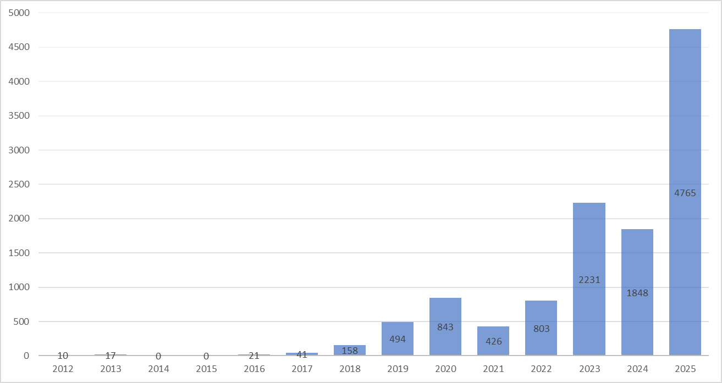
Note to Fig. 4:
Note 1: The same database and approach have been followed as in Fig. 1.
Among the total number of 12 192 earth stations associated to existing API/A submitted between 2012 and 2025, 85% are specific earth stations installed at specific locations, while 15 % of the total corresponds to typical earth station characteristics which can be deployed anywhere in the service areas of the satellite systems.
In practice, the deployment of typical earth stations can therefore correspond to a much higher number of real earth stations.

3.1 Satellite systems in the frequency range 7 190-7 250 MHz
Table 1 provides technical characteristics of evolving non-GSO satellite systems in the frequency range 7 190-7 250 MHz.
TABLE 1
Typical system parameters of EESS non-GSO satellite components
in the 7 190-7 250 MHz band
 | System 1 | System 2 | System 3
Earth station(s) | Specific | Specific, or Typical (service area) | Specific, or Typical (service area)
Carrier frequency (MHz) | Single or multiple frequency(ies) within the 7 190-7 250 MHz band | Single or multiple frequency(ies) within the 7 190-7 250 MHz band | Single or multiple frequency(ies) within the 7 190-7 250 MHz band

TABLE 1 (end)
 | System 1 | System 2 | System 3
Necessary bandwidth (kHz) | 0.007 to 256 | 80 to 60 000 | 80, 200, 600
Minimum elevation angle (degree) | 5 | 5 | 5
Satellite noise temperature (Kelvin) | 289 | 300 to 800 | 800
Satellite antenna radiation pattern | Isoflux | Isoflux, Directional or specific | Isoflux, Directional  (ITU-R S.672-4)
Satellite antenna maximum gain (dBi) | 5.1 | 3 to 27 | 5 or 22.5
Satellite antenna polarization | Circular | Circular | Circular
Typical orbital altitude (km) | 600 | 380 to 800 | 50 500 to 21 000 (elliptical)
Typical inclination angle (degree) | 97.8 | 0, 30 to 70 or 97 | 20 to 63

3.2 Satellite systems in the frequency range 8 025-8 400 MHz
Table 2 provides technical characteristics of evolving non-GSO satellite systems in the frequency range 8 025-8 400 MHz.
TABLE 2
Typical system parameters of EESS non-GSO satellite components
in the band 8 025-8 400 MHz
 | System 1 | System 2 | System 3
Earth station(s) | Specific, or Typical (country territory or worldwide) | Specific, or Typical (service area) | Specific, or Typical (service area)
Carrier frequency (MHz) | Single or multiple frequency(ies) within the 8 025-8 400 MHz band | Single or multiple frequency(ies) within the 8 025-8 400 MHz band | Single or multiple frequency(ies) within the 8 025-8 400 MHz band
Necessary bandwidth (MHz) | 1 to 375 | 1 to 375 | 1 to 320
Minimum elevation angle (degree) | 5 | 5 | 5
Satellite antenna input power (dBW) | −14 to 20 | −15 to 27 | −5 to 10
Satellite antenna radiation pattern | Isoflux, Directional or specific | Isoflux, Directional or specific | Isoflux, Directional or specific
Satellite antenna maximum gain (dBi) | 1.5 to 28 | 2 to 29 | 4 to 16
Satellite antenna polarization | RHCP, LHCP or both | RHCP, LHCP or both | RHCP, LHCP or both

TABLE 2 (end)
 | System 1 | System 2 | System 3
Information data rate (Mbit/s) | Max 4 800 Mbps | Max 4 800 Mbps | Max 4 800 Mbps
Modulation and coding information | BPSK, (O)QPSK, 8PSK, 8PSK Reed Solomon, 16QAM, 16APSK, 32APSK, 64APSK | BPSK, (O)QPSK, 8PSK, 8PSK Reed Solomon, 16QAM, 16APSK, 32APSK, 64APSK | BPSK, (O)QPSK, 8PSK, 8PSK Reed Solomon, 16QAM, 16APSK, 32APSK, 64APSK
Typical orbital altitude (km) | 500 to 800 | 300 to 500 | 850 to 1 200
Typical inclination angle (degree) | 97 to 99 | 24 to 99 | 10 to 60 and 97

NOTE 1 – The possible combinations of satellite antenna gain and maximum input power shall comply with power flux density limits in RR No. 21.16 and Table 21-4.
NOTE 2 – In addition to the traditional satellite antenna systems, future satellites are expected to benefit from the development of active phased array antennas.

4 Application and deployment scenarios for these systems

4.1 Applications
Satellite remote sensing offers a wide range of applications and consequent socioeconomic benefits, making it an indispensable tool for governments, businesses, and researchers worldwide.
It aids in the preparation for natural disasters, monitoring geophysical parameters as well as biodiversity, and adjusting agricultural, shipping, and development practices to optimise efficiency. Additionally, it is used to provide information facilitating the safe delivery of humanitarian aid and establishment of humanitarian corridors. In the following sections some possible remote sensing applications are described in detail.

4.1.1 Disaster management, early warning, and emergency response
Disasters can cause drastic environmental changes. A large amount of spatial data is required for managing the disasters and to assess their impacts and space-based remote sensing systems can provide vital information over large areas in near-real-time intervals as well as supplementary information at short-time and long-time intervals.
The capability offered by remote sensing satellites not only saves lives but also helps reducing infrastructure and property damages.
As natural catastrophes affect more and more people on Earth and cause damages for hundreds of billions of dollars, data from remote sensing satellites provide unique information to plan, minimise the hazards created by disaster, support the recovery and contribute to mitigation.
With the evolution and advancement of different technologies like Artificial Intelligence, some initiatives seek to increase the amount of processing on-board and download the outcomes of the Artificial Intelligence (AI) inference (of one or multiple relevant sensing devices) to the ground with a very short delay, directly to emergency or rescue services operating where disasters occur. This can be particularly relevant for applications related to floods, fires and storms monitoring, within the frame of disaster management and early warning.

4.1.2 Monitoring biodiversity
Whether it is on land or at sea, remote sensing satellites are essential to monitor and therefore preserve biodiversity. Biodiversity is essential not only for limiting the effect of human activities but to ensure as well long-term sustainability of the planet. Remote sensing satellites contribute to the protection and restoration of critical habitats, whether these are marine sanctuaries, virgin forests in central-eastern Europe, Mangrove forests at the equator or rainforest in Borneo and Amazonia. They also provide information on the health of coral reef and seaweed in coastal regions, tracking migration patterns and insect infestations.

4.1.3 Maritime and multi-domain situational awareness
Satellite remote sensing data is an essential and unique source to map, track and fight illegal fishing activities.
A combination of remote sensing techniques and Artificial Intelligence has brought to light that a significant number of fishing vessels operating without providing AIS data. RF-monitoring satellites have been deployed to triangulate and track RF transmissions not detectable by existing maritime Automatic Identification Systems to support governments in monitoring their fishing areas.
In addition, remote sensing satellites contribute to contrasting human trafficking, mapping sea ice, detect environmental accidents and protect trade routes from piracy.

4.1.4 Forest fires
In addition, as presented in the Disaster management and early warning section, some initiatives are proposing to make use of technologies such as Artificial Intelligence to do almost real-time fire monitoring (with delays lower than 1 min) and fast wildfire detection (with delays lower than 16 min) and download the relevant information to the ground. The readiness of the information, and capacity to download and/or broadcast it directly to stations on-the-move, close to the fire detection sites, will be key in how fast the fires are managed.

4.1.5 Intelligence, surveillance, and reconnaissance
Satellite remote sensing plays an important role in enhancing national and global security. Particularly in near-real-time applications, satellite data is indispensable for monitoring and responding to urgent security threats, illegal activities, and crises. They enable monitoring of the movements of people and goods, and detect illegal activities, such as human trafficking, arms smuggling, and illegal migration. Additionally, satellite remote sensing is increasingly used for infrastructure monitoring – providing timely information on the status and integrity of critical assets such as transportation networks, energy facilities, and communications systems. The ability to access this data rapidly ensures that law enforcement and security agencies can act quickly to prevent security breaches before they escalate but also assist in rapid response and disaster relief operations. Earth stations deployed worldwide facilitate a near-real time dissemination and processing of this data, potentially resulting in faster decision-making, efficient resource allocation, and a more effective response.

4.1.6 Sub-surface earth monitoring (such as resource exploration)
Resource exploration is a central application of sub-surface earth monitoring, where satellite remote sensing is used to identify minerals, hydrocarbons, and geothermal deposits for mining, oil, and gas operations. Hazard assessment is another important function, utilizing satellite data to detect voids, monitor landslides, evaluate seismic risks, and assess site amplification (all of which contribute to disaster preparedness and risk mitigation). Geological imaging enables the mapping of crustal and upper mantle structures and the analysis of shear-wave velocities at various scales to provide valuable insights into the composition and dynamics of the Earth’s interior. Engineering and monitoring activities are also supported, with remote sensing facilitating geotechnical analysis, volcano monitoring, and fault mapping to enhance the safety and resilience of infrastructure and communities.

4.2 Technical characteristics of the earth stations

4.2.1 Earth stations in the frequency range 7 190-7 250 MHz
Table 3 below provides technical characteristics of EESS non-GSO earth stations for evolving EESS systems in the frequency range 7 190-7 250 MHz.
TABLE 3
EESS earth station transmit characteristics in the frequency range 7 190-7 250 MHz
Parameter | Antenna 1 | Antenna 2 | Antenna 3
Antenna size (m) | 1 | 3 | 6
Minimum height above ground⁽¹⁾ (m) | 1 | 2 | 3
Antenna gain (dBi) | 36 | 45 | 52
Antenna pattern | Rec. ITU-R S.465-5 or RR Appendix 8, Annex 3
Maximum input power (dBW) | –3 to 28 | 8 to 27.5 | 18 to 20.5
Minimum elevation (degree) | 3 ⁽²⁾
Polarization | Circular
⁽¹⁾ “Height above ground” is understood as the height of the antenna radiation centre above ground. Please note that earth stations 1-3 might also be deployed on rooftops, such that the height above ground might increase to values e.g. between 10-25 m.
⁽²⁾ Per RR No. 21.14.

4.2.2 Earth stations in the frequency range 8 025-8 400 MHz
Table 4 provides technical characteristics of typical evolving EESS non-GSO earth stations in the frequency range 8 025-8 400 MHz.
TABLE 4
EESS earth station receive characteristics in the frequency range 8 025-8 400 MHz
Parameter | Antenna  1 | Antenna  2 | Antenna  3 | Antenna  4 | Antenna  5 | Antenna  6
Antenna size (m) | 0.6 ⁽¹⁾ | 1.25 | 3.4 | 3.4 | 5.5 | 11.3
Minimum height above ground⁽²⁾ (m) | 1 | 1 | 2 | 2 | 3 | 6
Antenna gain (dBi) | 31.0 | 38.0 | 47.0 | 47 to 49.5 | 51.0 | 57.5
Antenna pattern | Rec. ITU-R S.465-5 or RR Appendix 8, Annex 3
System noise temperature (K) | 200 | 125 | 160 | 92-136 | 140 | 125
Minimum elevation (degree) | 3 ⁽³⁾
Polarization | Circular

Notes to Table 4:
⁽¹⁾ Antenna 1 can also benefit from development from active phased array antennas, with lower antenna gains and smaller sizes (e.g. 8 × 8 elements with an antenna gain of ~23 dBi).
⁽²⁾ “Height above ground” is understood as the height of the antenna radiation centre above ground. Please note that earth stations 1-3 might also be deployed on rooftops, such that the height above ground might increase to values e.g. between 10-25 m.
⁽³⁾ Per RR No. 21.14.

4.3 Operational and deployment scenarios of EESS operations
The 7 190-7 250 MHz and 8 025-8 400 MHz bands will remain important for EESS for high-capacity systems in the future as it offers unique properties in terms of propagation characteristics and system availability and bandwidth.
In line with the increasing number of non-GSO filings, the number of EESS satellite systems and as well the need for more Earth observation data and for higher accuracy are increasing very rapidly, as they play a key role in improving and managing critical sectors of activities on Earth.
As it becomes more difficult to serve this demand with the existing networks of earth stations and to coordinate at the same time new satellite systems using the same or nearby locations for their ground segment, new deployment scenarios with higher diversity of locations and a much higher number of earth stations are expected to grow in proportion.
In addition, other frequency alternatives, are currently subject to uncertainties regarding the possibility to access these bands due to the current identification for terrestrial systems with high density scenario on a co-primary basis (e.g. 25.5-27 GHz band) or the secondary status of the Earth exploration-satellite service with respect to other primary services (e.g. 37.5-40.5 GHz). Therefore, the frequency range 7 190-8 400 MHz remains important for the development of future EESS systems.
This traditional approach is well adapted in the case where one satellite system is associated with a limited number of earth stations at specific locations. However, when considering the development of Ground Segment as a Service (GSaaS) networks or Direct Receiving Stations (DRS), a different way of conceiving the operation of earth stations as part of Earth observation systems will progressively depart from this traditional model, with the addition of a third component which would be considered as the user segment:
1 Satellite operators may no longer have a clear or final picture of the earth stations they will utilize and serve until very close to launch date. Since the locations of all earth stations may not be known at the time of filing, this situation will likely call for an increasing use of typical earth stations.
2 Earth stations will be also increasingly decoupled from specific satellite systems. For instance, the operators and end users of the Direct Receiving earth stations may not be the same as the satellite systems’ operators and could even establish contracts to receive data from multiple satellite systems.
3 In seeking global or specific coverage, GSaaS and DRS operators will also have to establish stations in multiple and new countries.

4.3.1 Store-and-forward and global ground segment
Earth Observation satellites are in most cases placed in LEO and their operators have traditionally downloaded their data whenever an earth station is in visibility in a store-and-forward approach.
However, satellites in LEO take ~15 revolutions to come back to the same point on Earth. This means that, for most locations on Earth the satellite will be seen one or two times per day. In the particular case where the satellite is in a polar orbit, there are a few locations on the Earth where it can be seen at each revolution, and therefore, multiple times per day: high latitude locations close to the polar circles.
In order to maximise the amount of data downloaded to the ground and minimise the cost of the ground segment, Earth observation satellite operators are generally inclined to place their earth stations at high-latitude locations close to the polar circles like Svalbard, Kiruna, Inuvik or Fairbanks.
In each of these key locations, there are multiple antennas, which enables the possibility to track multiple satellites simultaneously and maximise the total amount of data that can be downloaded to the ground. This is particularly important, since the number of EO satellites has been constantly increasing in the last decade.
However, even if these locations are particularly interesting due to the high revisit, they are not the only ones. Earth stations can be located anywhere in the world. The most common locations for earth stations are:
– Elevated areas – positioned on elevated terrain gives earth stations a better line of sight to the satellite. Whether on hills or mountains, this reduces the potential for signal blockage, weather interference and generally facilitates better communication.
– Remote locations – these areas have fewer physical objects that may impact signal transmission and greater visibility of the sky.
– Coastal locations – being by the coast is common in maritime and satellite applications for maritime communications as earth stations here offer excellent visibility of the horizon.
– Urban communications centres – high-tech centres or technology parks in urban or semi-urban areas provide robust and reliable infrastructure and power supply facilities. For example, earth stations can be placed on tops of buildings, providing better line of sight to the satellite.
The type of antennas to be deployed in this type of scenario are usually going to be large earth stations (i.e. antennas 3 to 5 in Table 4). The reason for this is that with this type of deployment the goal is to maximise the amount of data that is downloaded to the ground.
This concept is suitable for those applications where the data is not needed within a short period of time. Several hours or even days (depending on the level of processing of the information) can pass until the data is ready for use.

4.3.1.1 Ground Segment as a Service (GSaaS)
A particular case of these types of stations is the so-called GSaaS. For a single operator to launch an EO system and the associated ground segment can be extremely costly (earth stations are quite expensive to build, operate and maintain), especially if they want to deploy an earth station in multiple locations. The trade-off between cost and amount of downloaded data is very complicated, in particular for small entities like start-ups, small and medium-sized enterprises (SMEs), universities, etc.
Since the early 2010s, the satellite industry has witnessed a significant increase in the number of satellites launched globally. This growth has been particularly driven by the emergence of small satellites and the ecosystem of services that have made launching and operating a satellite much more accessible to a wider number of actors. With this, the ground segment concept has slightly shifted, from a more traditional approach, with a few costly earth stations deployed in various places towards the concept of earth station as-a-service.
The concept of GSaaS is simple: GSaaS providers operate networks of (fixed) earth stations, offering satellite operators the ability to communicate with their satellites, without the need for the satellite operator to own or manage proprietary ground infrastructure. These GSaaS providers deploy earth stations in strategic locations worldwide and can additionally integrate existing earth stations with available spare capacity into their networks. Utilizing cloud-based technology and software-defined radios, these networks can be orchestrated and set remotely in a short amount of time, enabling operations with different spacecrafts from multiple locations at different technical parameters, ensuring to satellites a global and reliable access to earth stations.
The development of GSaaS has brought significant benefits to the satellite industry. It has lowered the barrier of entry for space activities, enabling smaller operators to conduct satellite operations at scale without large initial investments in ground infrastructure or relevant in-house expertise. Satellite operators can focus on spacecraft operations while abstracting ground segment operations and outsourcing the costs associated with deploying and maintaining a global network of earth stations.
In addition, the worldwide coverage of GSaaS networks, ensures higher mission success rates, particularly during critical mission stages like Launch and Early Orbit Phases (LEOPs) or emergencies.

4.3.2 Specific location deployment of Direct Receiving station (DRS) ()
In some cases, though, the user needs to have the data of a specific area available within a short period of time. This is possible thanks to satellite tasking, which gives users the ability to commission satellites and capture imagery for a specific area, according to particular parameters and project needs.
This can be achieved by placing an earth station in the vicinity of the area to image. These stations are often called DRS. Some commercial Earth observation satellite operators offer the possibility to the user to place a DRS in the desired location, and task EO satellite(s) to downlink the data directly to their earth station.
In most cases the EO system to access is composed of several satellites that can be tasked, in which case the user can choose which satellite pass is most convenient. This can be planned according to factors like the desired resolution, the weather prediction and/or the cloud situation in the area to image.
In some other cases, the system has different type of sensors (optical, thermal IR, Synthetic Aperture Radar (SAR)) in which case the user has additionally the possibility to plan the satellite pass according to the type of image the satellite can take. For example, if the user desires to ensure a cloud-free image and the system contains a SAR satellite, the user may want to schedule a pass where the SAR will take the image.
The DRS earth stations typically deployed can be both large or small earth stations depending on the specific scenario and user needs (i.e. antennas 2 to 4 in Table 4).
Generally, the DRS are installed nearby the premisses of end users, such as research or university centres in the country where the areas of interest are located.
An example of this is illustrated in Figs 6 and 7. These Figures contain examples of possible points of interest for the installation of such stations in Western Europe. These examples do not mean to illustrate the density of deployment, but rather the geographic variety of the possible locations.
FIGURE 6  University centres in Western Europe  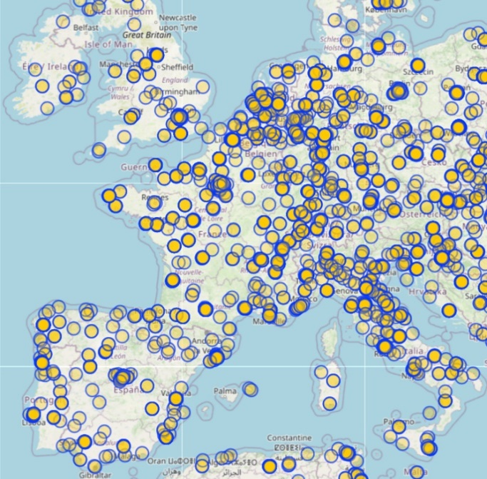 | FIGURE 7  Research institutes in Western Europe  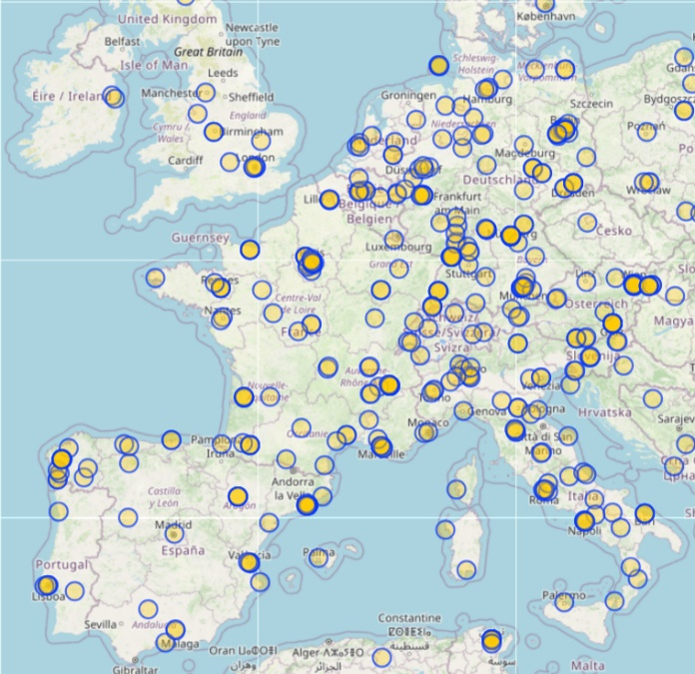

4.3.3 Non-fixed deployment of DRS
As new applications and technology evolve and develop, new deployment scenarios and needs arise. One of these scenarios is the direct transmission of Earth Observation data to itinerant earth stations installed at typical locations or on moving platforms (e.g. aerial, maritime or land vehicles).
This type of deployment scenario is currently planned for applications where system responsiveness and persistence of the service are critical, such as forest fires, natural disaster monitoring and early warning or illegal fishing among others.

5 Technological developments and innovation trends

5.1 On-board data processing
The rapidly increasing use of AI technologies is pushing the boundaries of technology. Recent advances in semiconductor technology and space avionics have led to commercial processors that are increasingly compute-powerful, which allow for a more decentralized on-board computing. Commercial off-the-shelf (COTS) edge processors are ideally positioned to deliver low-latency and distributed edge computing at source for value-added services from orbit.
The performance of these COTS devices, and in particular their efficiency and ability to implement state-of-the-art AI algorithms with low-power consumption at the edge, leads to an increasingly large gap between their capabilities and those of traditional, reliable space flight hardware.
This paradigm opens new prospects and new opportunities enabled by robust and accurate on-board processing. This allows for L1 to L2 product generation on-board, in comparison to the classical approach where mainly raw data is downloaded to the ground for subsequent processing. For information, data observations are processed in five main different levels ranging from Level 0 to Level 4. The exact definitions are shown in Table 5.
TABLE 5
Data processing levels
Processing level | Note
Level 0 (L0) | Unprocessed instrument data.
Level 1 (L1) | Data processed to sensor unit.
Level 2 (L2) | Derived geophysical variables.
Level 3 (L3) | Georeferenced data.
Level 4 (L4) | Data have had the greatest amount of processing applied, possibly including modelled output and measurements from several satellites and several days. All input data are validated.

With this, satellites are progressively becoming smarter and are being driven to have enhanced processing capabilities on-board. This allows for achieving highly responsive and persistent systems with latencies below 1 min and a revisit time lower than 1 hour.
In some cases, COTS devices that were originally developed for other applications such as terrestrial mobile and embedded applications have been successfully tested in space. They were integrated on-board small satellites and launched into space on a LEO, successfully testing AI computing capabilities.
This technological advancement in the field of space AI, and the use of low-power COTS hardware-accelerated inference, paves the way for the exploitation of on-board AI in future EO and remote sensing applications, enabling the development of smarter and more efficient satellites for Earth observation.

5.2 Artificial Intelligence and cloud computing in space
Artificial intelligence is paving the way for a new era of algorithms focusing directly on the information contained in the data, autonomously extracting relevant features for a given application.
It shows the ability to solve very complex problems exploiting only the intrinsic information contained within data, reducing the pre-processing and postprocessing that is required by standard on-board techniques. In this sense, AI can provide the needed boost in actual performance that will allow new applications to be realised. AI algorithms, and especially those related to image processing, are not suited for the typical class of processors used on-satellite due to their limited computational power and memory resources.
However, the potential for innovative AI applications and the higher computation power AI algorithms require have pushed the industry to develop more powerful on-board processors for space applications, capable of running complex AI algorithms.
As already mentioned in a previous section, this combination allows for new applications where AI algorithms are run directly on-board the spacecraft and the outcomes of the AI inference are downloaded to the ground with a very short delay, directly to emergency or rescue services.
Some other initiatives are looking at forecasting global storm surges to create and develop early warning models. Early warning systems serve as a vital measure to mitigate, for example, flood risks, as some studies from the World Health Organization have demonstrated. They show that such early warning systems can decrease flood-related fatalities by up to 43%. With the combination of satellite-derived data and machine learning, the generated generalized model could predict storm surges in locations where specific ocean-related information is not available. This could then, in the future, be used directly on-board the satellite for faster early warning.
With this, a new world of applications opens, such as new space applications and concepts that try to combine spacecraft and in-space cloud/edge computing with artificial intelligence.
A promising application is, for example, on satellite constellations. The number of satellite constellation projects has considerably increased in the last years. But these systems are complicated to operate and require, for instance, regular collision avoidance manoeuvres. This need can be developed into the autonomous management of complex constellations with the use of cognitive cloud computing in space.
Another possible application on satellite constellations can be for example, how AI can be used in advanced mission operations and technologies, as well as in innovative security concepts, mechanisms and architectures.
There is a promising future for AI and cloud computing in space applications. The evolution towards more autonomous satellites that can directly analyse their collected data on-board and download smarter information to the ground, such as early warning predictions, allow for additional scenarios where smaller antennas can be used. These smaller antennas could be deployed in any location, including moving vehicles, for applications such as disaster management or rescue operations.

5.3 Directive antennas and phased array antennas
Technological developments and new designs of steerable and active antennas is progressing rapidly and should be implemented in a growing number of new Earth observation satellite systems in a near future.
For instance, active phased array antennas can play an important role to improve the performance of Earth observation missions as they can provide high gain antenna radiation patterns while avoiding the use of heavy amplification stages. In addition, such antennas can provide the capability of rapidly re-pointing the antenna beam during the satellite pass enabling the electronic beam steering to automatically track the earth station during the download of payload data. The electronic beam steering eliminates the need of platform repointing and thus mission operation can also proceed during downlink.
At ground level, the use of such antennas can also facilitate the deployment of smaller earth stations in a broader range of locations and areas.

6 Summary
The evolution of Earth exploration-satellite service (EESS) systems is characterised by a significant increase in the number of satellites, particularly small satellite constellations, driven by a global demand for timely and near-real-time delivery of higher-resolution Earth observation data. This trend is evident in the rapidly accelerating number of non-geostationary satellite orbit (non-GSO) EESS filings in the 7 190-7 250 and 8 025-8 400 MHz frequency ranges, as well as a corresponding increase in the deployment of associated earth stations worldwide.
The 7/8 GHz frequency band is proving to be crucial for this evolution, serving as a primary conduit for the downlink of large amounts of data. This is due to its favourable propagation characteristics, technological readiness, and available bandwidth. The increasing reliance on this band is leading to new operational and deployment scenarios. Beyond the traditional model of large, fixed earth stations, there is a growing trend towards GSaaS networks and the deployment of a higher number of smaller, more diverse earth stations, including those at itinerant or mobile locations for applications such as disaster management and early warning systems.
Technological advancements, such as on-board data processing and the use of AI, are enabling a shift from transmitting raw data to sending more intelligent, processed information. This not only enhances the value of the data but also optimises the use of the downlink capacity. Additionally, the development of active phased array antennas on satellites and at earth stations facilities allow for more efficient data transfer while enabling the use of smaller, more mobile ground equipment.
In summary, the 7/8 GHz band will continue to be integral to the future of EESS, as an increasing number of systems and the development next generation opportunities bring new technologies and applications that are broadening the use of these frequency bands.

