Report ITU-R SA.2553-0
(03/2025)
SA Series: Space applications and meteorology
Technical and operational characteristics for space research systems in the vicinity of the Moon

Foreword
The role of the Radiocommunication Sector is to ensure the rational, equitable, efficient and economical use of the radio-frequency spectrum by all radiocommunication services, including satellite services, and carry out studies without limit of frequency range on the basis of which Recommendations are adopted.
The regulatory and policy functions of the Radiocommunication Sector are performed by World and Regional Radiocommunication Conferences and Radiocommunication Assemblies supported by Study Groups.

Policy on Intellectual Property Right (IPR)
ITU-R policy on IPR is described in the Common Patent Policy for ITU-T/ITU-R/ISO/IEC referenced in Resolution ITU-R 1. Forms to be used for the submission of patent statements and licensing declarations by patent holders are available from https://www.itu.int/ITU-R/go/patents/en where the Guidelines for Implementation of the Common Patent Policy for ITU-T/ITU-R/ISO/IEC and the ITU-R patent information database can also be found.

Series of ITU-R Reports
(Also available online at https://www.itu.int/publ/R-REP/en)
Series | Title
BO | Satellite delivery
BR | Recording for production, archival and play-out; film for television
BS | Broadcasting service (sound)
BT | Broadcasting service (television)
F | Fixed service
M | Mobile, radiodetermination, amateur and related satellite services
P | Radiowave propagation
RA | Radio astronomy
RS | Remote sensing systems
S | Fixed-satellite service
SA | Space applications and meteorology
SF | Frequency sharing and coordination between fixed-satellite and fixed service systems
SM | Spectrum management
TF | Time signals and frequency standards emissions

Note: This ITU-R Report was approved in English by the Study Group under the procedure detailed in Resolution ITU-R 1.

Electronic Publication
Geneva, 2025
© ITU 2025
All rights reserved. No part of this publication may be reproduced, by any means whatsoever, without written permission of ITU.

REPORT ITU-R SA.2553-0
Technical and operational characteristics for space research systems
in the vicinity of the Moon
(2025)
TABLE OF CONTENTS
Page
Policy on Intellectual Property Right (IPR) ii
1 Introduction 3
2 General overview 3
3 Concept of operations for communications in the vicinity of the Moon, including its surface and with lunar orbiting satellites 5
3.1 Use cases 5
3.2 Lunar surface-to-surface communications terminals 7
3.2.1 EVA communications – Operational and technical capabilities 7
3.2.2 Lunar communications terminals on stationary platforms – Operational and technical capabilities of communications stations on the lunar surface 9
3.2.3 Lunar Communications Terminals on Non-Stationary Platforms – Operational and technical capabilities of communications stations on the lunar surface 10
3.2.4 Operational and technical capabilities of the lunar surface backhaul 12
3.2.5 Propagation considerations 12
3.2.6 Deployment scenarios 12
3.2.7 Summary of lunar surface-to-surface transmit characteristics 12
3.3 Lunar surface to/from lunar-orbiting space stations 14
3.3.1 Operational and technical capabilities 14
3.3.2 Technical characteristics for communications between lunar surface and lunar orbit space stations 14
3.3.3 Propagation considerations 16
3.4 Lunar data relay satellite systems 17
3.4.1 Concept of operations for lunar data relay satellite systems to provide communications in the vicinity of the Moon, including its surface and lunar orbiting satellites 17
3.4.2 Technical and operational characteristics of LDRS links 17
4 Summary 19
Scope
Direct communications between landers, rovers, extravehicular activity (EVA) astronauts conducting sortie missions and experiments is crucial to enable effective scientific activities and consideration of the health of the crew in the lunar environment. Considering the unique topology of the Moon’s surface, shielded zone of the Moon (SZM) considerations, unique science opportunities in radio astronomy, and remote sensing in the lunar region/surface, technical and operational characteristics are required to determine the feasibility of frequency bands to support any envisioned lunar surface network using standards-based technologies. This Report describes the concept of operations for communications in the vicinity of the Moon, including on its surface and with lunar orbiting satellites, and identifies as examples certain technical and operational characteristics for the different use cases on the Moon’s surface and by lunar-orbiting systems communicating with systems on the Moon’s surface for frequency bands identified for study in Resolution 680 (WRC-23).
Keywords
Landers, rovers, Moon, surface, shielded zone of the Moon
Glossary/Abbreviations
CDMA Code division multiple access
CP Circular polarization
EVA Extravehicular activity
FDMA Frequency division multiple access
HAB Habitat
LCT Lunar communications terminal
LDRS Lunar data relay satellite
LSS Lunar space station
LTV Lunar terrain vehicle
ND Non-directional
PNT Positioning, navigation and timing
PR Pressurized rover
RF Radio frequency
SZM Shielded zone of the Moon
TDMA Time division multiple access
TT&C Tracking, telemetry and telecommand
WLAN Wireless local area network
Related ITU Recommendations
Recommendation ITU-R P.525 – Calculation of free-space attenuation
Recommendation ITU-R RA.479 – Protection of frequencies for radioastronomical measurements in the shielded zone of the Moon
Recommendation ITU-R SA.609 – Protection criteria for radiocommunication links for manned and unmanned near-Earth research satellites

1 Introduction
The need exists to support the most efficient and effective use of spectrum resources on the surface of the Moon and in the lunar orbit for short-term and long-term communications and continuous commercial and scientific operations on and around the Moon. Operations in the lunar space include communications in the vicinity of the Moon, including its surface and in the lunar orbit.

2 General overview
Administrations in all three ITU Regions have announced and are pursuing lunar missions, with remote unmanned exploration already underway, and with human visits to the Moon set to occur as early as 2026. Technological and business model development is underway, and much of this development will transcend the scientific arena and include commercial activity.
It is of utmost importance to the successful exploration and conduct of continuous operations on the Moon for there to be a reliable, understandable, usable, and flexible communications architecture in place to handle operational scenarios for a few users or multiple groups of users. The timely and effective development of this communications architecture is essential to the advancement of human lunar exploration, scientific research and the innovation and investments in other potential lunar space activities. As a limited natural resource, radio frequency spectrum is utilized in a rational, efficient, and economical manner to build a reliable, interoperable, and flexible communications architecture on Earth. These aspects should also be considered in communications operations around the Moon, including the lunar surface and lunar orbit.
The framework for how the substantial communications requirements for operations in lunar/cislunar space (i.e. cislunar communications relay and data services for missions on the lunar surface and in lunar orbit) and beyond will be structured is rapidly taking shape. Systems have been and are being designed to create an internet-like architecture to support lunar missions. One of these systems, the LunaNet architecture, is designed to promote maximum interoperability and to enable use by a broad range of lunar region missions and has been adopted by the Interagency Operations Advisory Group (IOAG). LunaNet will include networking services capable of communication between nodes; positioning, navigation and timing (PNT) services for orientation and velocity determination; time synchronization and dissemination; and science services providing situational alerts and scientific measurements. Space agencies around the world are developing similar initiatives including jointly developing network architectures to lay the groundwork, through governmental investments and pathfinding missions, for maximum interoperability and to facilitate space commerce development in the years to come. Presently commercial development of lunar surface and lunar orbit communications systems in the form of public/private partnerships characterize significant aspects of space activities – from launch services to space transportation and more.
The primary focus of the communications systems described in this Report are between or among types of space stations on the lunar surface or in lunar orbit as identified in Resolution 680 (WRC-23).
In addition, envisioned systems are being designed to facilitate communications to and from Earth (Earth station) for lunar assets (service users in lunar orbit and on the lunar surface) through lunar orbiting relay satellites (space stations), or to facilitate communications between lunar assets. Communications links, coupled with radiometric navigation techniques to provide location, velocity, and time information to assets on the lunar surface and in lunar orbit, will also be used. The planned systems will provide real-time relay capabilities when both ends of the link (Moon and Earth) are visible.
Some core elements likely to be included in all systems would include:
– Lunar surface communications (notional concept of operation in Fig. 1)
• Functionally similar to terrestrial mobile services topology and standards-based wireless communication topologies.
• These links also include stations near the lunar surface.
• These links are used for direct local area communications between spacesuits, experiments, habitation, other lunar assets and communication stations, landers, rovers, and extravehicular activity (EVA) supporting sortie missions and experiments. These links are crucial to enable effective scientific activities and health monitoring of the crew and equipment in the lunar environment.
• All of these lunar surface communications described in this report will use space-hardened equipment in closed systems, within a service radius and have no direct communication with Earth.
• In some cases, existing spectrum allocations in the space research service or inter-satellite service are used to provide direct communication with Earth and intra-lunar relay communication capabilities. Spectrum needs will determine if these existing allocations could enable implementation of needed local area point-to-multipoint network capabilities that leverage advanced wireless technologies for envisioned applications.
– Lunar surface to/from lunar-orbiting satellites
• The reference mission concepts involve scenarios where multiple exploration EVA teams are tens of kilometres from the lander/habitats and each other, resulting in the need for support from lunar-orbiting satellites to accomplish mission objectives.
• These links are similar to Earth-to-space/space-to-Earth links but use the Moon in place of the Earth.
• All of these lunar surface to/from lunar-orbiting satellite operations described in this report will occur on lunar surface and in lunar orbit, with no direct communication with Earth.
• In some cases, existing spectrum allocations in the space research service (space-to-space) or inter-satellite service could be used to support these links; in other cases, additional frequency bands would help to leverage existing commercial standards and equipment.
Figure 1
Notional lunar surface scenario
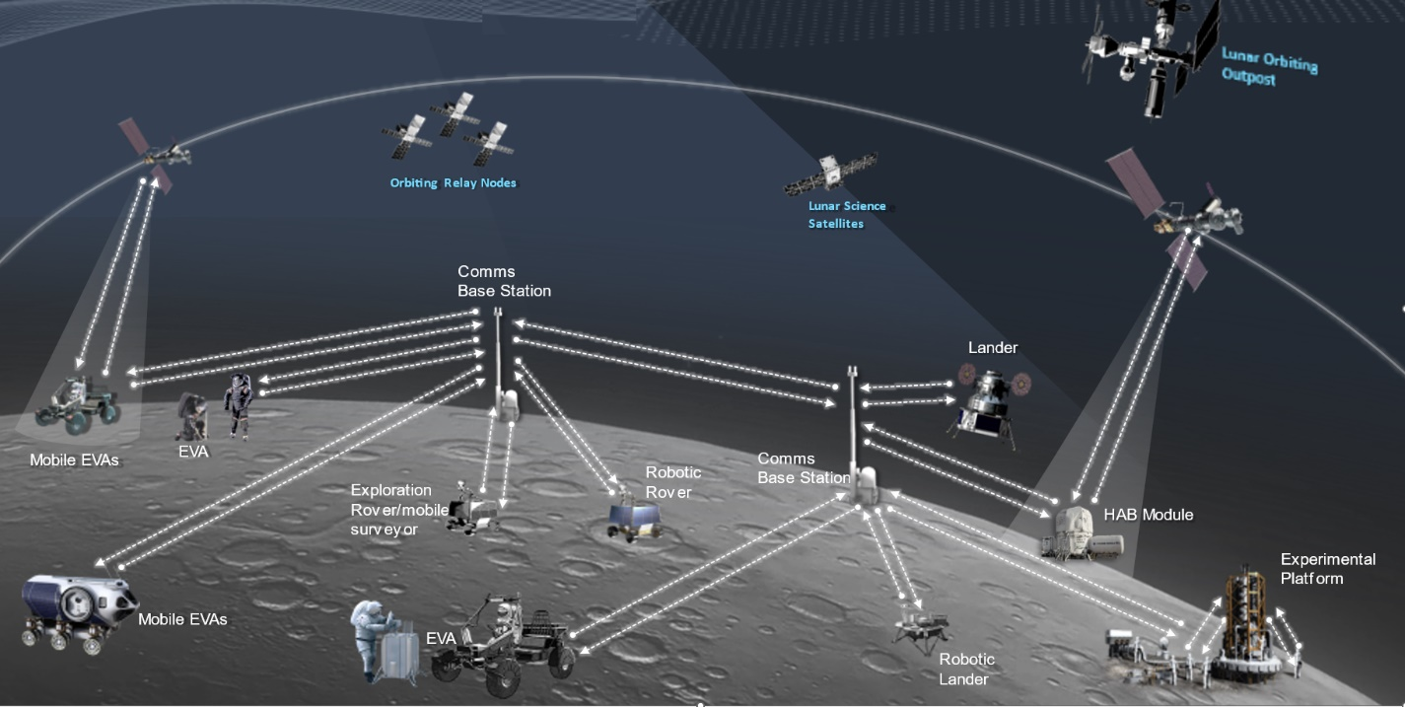

3 Concept of operations for communications in the vicinity of the Moon, including its surface and with lunar orbiting satellites

3.1 Use cases
For scientific lunar robotic and human surface missions, there are three categories of elements involved in the radio-frequency architecture: surface elements, in-space elements and Earth-based elements. The radio links between the in-space elements and the Earth-based elements are planned to utilize spectrum that is currently allocated to space research service (space-to-Earth) (Earth-to-space) and supported by multiple networks of ground stations. In-space elements include transportation spacecraft, space platforms and relay satellites. These in-space elements around the Moon’s orbits may possess capabilities to communicate with the Earth, with another spacecraft/platform/satellite in the Moon’s orbit, and/or surface elements, depending on their individual mission objectives and whether humans are onboard. For surface elements, there are stationary and non-stationary elements. These surface elements may have direct links to the Earth (in a frequency band/service not under consideration under Resolution 680 (WRC-23)), or links with an in-space element or another lunar surface element. The ubiquitous connectivity between surface elements is the means to maximize scientific return and to serve as the safety net to maintain visibility to the instrumentation and astronauts working/traveling on the Moon. Spaceflight lessons-learned confirmed a RF architecture with a minimum number of single point failures and redundancy to enable link connectivity to and between in-space and surface elements is essential, especially in the initial scientific mission roadmap for future missions. Additionally, regulatory certainty and protection are fundamental in spaceflight missions.
Various frequency ranges (low band, high band) are needed to address varying data rate requirements and distances from the base camp for different expedition crews. Reliable communications including high-definition video, clear audio, high speed bi-directional data transfer between the base camp and each element in a point-to-multipoint network topology that leverages existing commercial technologies would reduce development cycles and non-recurring costs. Additionally, higher frequency bands can support wider bandwidths for increased data throughput, local network capability for high activity areas, and point-to-point links for throughput and/or greater distances. Selecting potential frequency bands that have commonality with earth-based services leads to efficiencies in hardware and testing.
A number of user scenarios are planned for compatible local communications, for example between a surface vehicle and an orbiter, between surface vehicles, and between orbiters. Sufficient frequency separation is also required to enable compatible and simultaneous communications in the lunar space. As such, a variety of frequencies may be needed to address this type of operation.
Additional use cases requiring radio communications include space suits, handhelds, robotic landers and payloads, lunar vehicles, EVA, robotic/pressurized rovers, habitation system support, manufacturing assets and human landing systems. Such systems require spectrum access on both the lunar surface and with lunar orbiting satellites.
TABLE 1
Use cases and data rates for communications
Users | Service type | Typical data rate per user | Max data rate per user
EVAs | Voice/data (comm and PNT)/video | 3-12 Mbit/s | 100 Mbit/s
Stationary comm terminal  (including habitation) | Voice/data (comm and PNT)/video | 30 Mbit/s | 100 Mbit/s
Non-stationary terminals (landers, robotic/  pressurized rover) | Voice/data (comm and PNT)/video | 3-16 Mbit/s | 100 Mbit/s
In-space and surface elements | PNT | 500 bit/s | 2 kbit/s
Robotic/pressurized rover – LCT/landers | Voice/data (comm and PNT)/video | 3 Mbit/s | 100 Mbit/s
EVAs – landers, robotic/pressurised rover | Voice/data (comm and PNT)/video | 3 Mbit/s –  30 Mbit/s | 100 Mbit/s
In space and surface elements network | Voice/data (comm and PNT)/video | 30 Mbit/s | 100 Mbit/s
Surface backhaul | Voice/data (comm and PNT)/video | 9.5 Mbit/s | 1 Gbit/s
Lunar surface power grid/  elements | Data | 1 kbit/s | 100 kbit/s

Sharing studies to ensure compatibility with existing services will be based on frequencies used on both the lunar surface and on the lunar surface to lunar orbit, as shown in Table 2.
TABLE 2
Envisaged concept of operations of spectrum use for SRS systems in the lunar environment
Frequency band | Lunar surface to lunar surface | Lunar orbit to lunar surface | Lunar surface to lunar orbit
390-406 MHz ⁽¹⁾ |  | X
406-406.1 MHz ⁽¹⁾ |  |  | X
420-430 MHz ⁽¹⁾ | X
440-450 MHz ⁽¹⁾ |  |  | X
TABLE 2 (end)
Frequency band | Lunar surface to lunar surface | Lunar orbit to lunar surface | Lunar surface to lunar orbit
2 400-2 483.5 MHz | X
2 483.5-2 500 MHz |  | X
2 500-2 690 MHz | X
3 500-3 800 MHz | X
5 150-5 570 MHz | X
5 570-5 725 MHz | X
5 775-5 855 MHz | X
5 855-5 925 MHz | X
7 190-7 235 MHz |  | X
8 450-8 500 MHz |  |  | X
27.5-28.35 GHz | X
⁽¹⁾ Outside the shielded zone of the Moon.

3.2 Lunar surface-to-surface communications terminals
These communication terminals and links include both those on the lunar surface as well as those near the lunar surface. The links can be limited to a range up to 50 km to enhance technical compatibility and frequency re-use.
Communication technology is well-developed and widely deployed on the Earth using industry standards that could be applied to lunar communications.
Tables 3 through 5 contain the transmit and receiver characteristics for communications stations on the lunar surface that communicate with other stations on the lunar surface as described in this section.
The following frequency ranges are under consideration for communications between lunar surface stations:
– 420-430 MHz, limited to outside the Shielded zone of the Moon (SZM);
– 2 400-2 483.5 MHz, 2 500-2 690 MHz, 3 500-3 800 MHz, 5 150-5 570 MHz, 5 570-5 725 MHz, 5 775-5 925 MHz, and 27.5-28.35 GHz.

3.2.1 EVA communications – Operational and technical capabilities
The EVA suit provides voice/data/video service for astronauts performing activities on the lunar surface outside of the habitation module, lunar lander, or lunar rover. The EVA concept of operations involves different scenarios, including short range direct links between astronauts and longer range line-of-sight links between the astronaut and a lunar communications terminal on a lander or lunar terrain vehicle (LTV). The astronaut may also command a robotic/pressurized rover for remote exploration of the lunar surface during the EVA.
The EVA communications system is designed to provide astronauts with full audio/video capabilities at walking distances up to 2 km from the lander/LTV, with data rates up to 12 Mbit/s for high definition video. For contingency walk-back scenarios where the astronaut must walk back to the lander or habitation module, the EVA link is required to support telemetry data and voice up to 10 km. Due to propagation loss at higher frequencies which impacts the coverage area, critical EVA communications are best suited for frequencies below 6 GHz.
Figure 2
Example of EVA suit
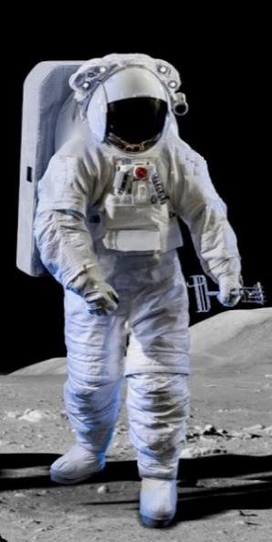
TABLE 3
Typical technical characteristics of EVA communications links for communications on the lunar surface
EVA links | Data rate  per user | Number of links per user | Total data rate | Example operating distance | Antenna height (AGL) | Frequency band(s)
EVA suit-to-suit comms | 100 kbit/s  (voice and data) | Up to 4 | 400 kbit/s | 200 m | 1.5-2 m | 420-430 MHz  5 855-5 925 MHz
EVA WLAN  (to lander/LTV) | 30 Mbit/s  (data and video) | 2 | 60 Mbit/s | 300 m | 1.5-2 m | 2 400-2 483.5 MHz  5 150-5 725 MHz  5 775-5 855 MHz
EVA  (to lander/LTV) | 64 kbit/s (voice)  34 kbit/s (data)  3-12 Mbit/s (video) | 1 | 12.1 Mbit/s | 2 km | 1.5-2 m | 2 500-2 690 MHz  3 500-3 800 MHz  27.5-28.35 GHz
EVA  (to robotic/  pressurized rover/LTV)) | 100 kbit/s  (commands) | 1 | 100 kbit/s | 2 km | 1.5-2 m | 2 500-2 690 MHz  3 500-3 800 MHz
EVA contingency (Walk-back) | 98 kbit/s⁽¹⁾  up to 3.1 Mbit/s⁽²⁾ | 1 | 3.1 Mbit/s | 10 km | 1.5-2 m | 420-430 MHz  2 500-2 690 MHz  3 500-3 800 MHz
⁽¹⁾ Required; voice and data only.
⁽²⁾ Voice, data, and limited video depending on range and link availability.

3.2.2 Lunar communications terminals on stationary platforms – Operational and technical capabilities of communications stations on the lunar surface
The habitation module and lunar lander are examples of stationary platforms on the lunar surface that may host a lunar communications terminal. The lunar lander is included as a stationary platform because it does not move after landing on the lunar surface, even though it moves during the ascent and descent phases. Under the envisioned concept of operations, the lander will provide EVA communications to the crew members after landing including voice, data, and video. The lander may also transmit to an LTV, primary for commanding. The LCT on the lander may also be used to command robotic/pressurized rovers used for remote surface exploration. Antennas for lunar surface communications on the stationary platforms such as landers or habitation modules will typically be pointed between ±10 degrees from the horizontal direction.
Table 4 shows some typical characteristics for LCTs on a stationary platform, using the lander as an example.
Figure 3
Pictorial Example of a Lunar Lander (stationary LCT)
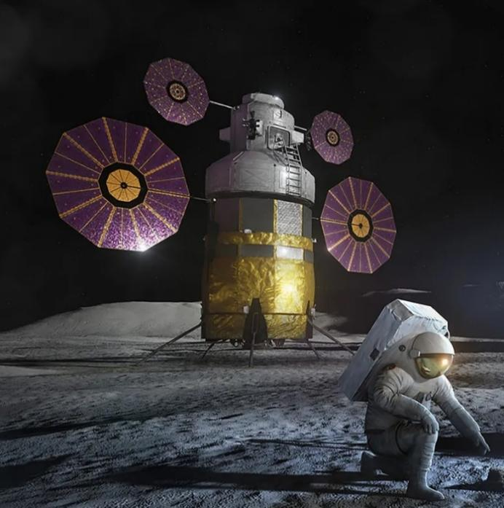
TABLE 4
Typical technical characteristics of stationary LCTs on the lunar surface
LCT on stationary platform | Data rate  per link | Number of links | Total data rate | Example operating distance | Antenna height (AGL) | Frequency band(s)
Lander  (to EVA) | 64 kbit/s (voice)  3 Mbit/s (video) | 4 | 12.3 Mbit/s | 10 km | 16-50 m | 420-430 MHz  2 500-2 690 MHz  3 500-3 800 MHz  27.5-28.35 GHz
Lander WLAN  (to EVA) | 30 Mbit/s  (data and video) | 6 | 180 Mbit/s | 300 m | 16-50 m | 2 400-2 483.5 MHz  5 150-5 725 MHz  5 775-5 855 MHz
TABLE 4 (end)
LCT on stationary platform | Data rate per link | Number of links | Total data rate | Example operating distance | Antenna height (AGL) | Frequency band(s)
Lander  (to LTV) | 100 kbit/s  (commands) | 1 | 100 kbit/s | 10 km | 16-50 m | 2 500-2 690 MHz  3 500-3 800 MHz
Lander  (to robotic/  pressurized rover) | 16-100 Mbit/s  (voice, data, and video)  64 kbit/s (commands, etc.) | 1 | 100 Mbit/s  64 kbit/s | 20 km | 16-50 m | 2 400-2 483.5 MHz  2 500-2 690 MHz  3 500-3 800 MHz  27.5-28.35 GHz

3.2.3 Lunar Communications Terminals on Non-Stationary Platforms – Operational and technical capabilities of communications stations on the lunar surface
Examples of non-stationary platforms deployed on the lunar surface include the LTV and robotic/pressurized rovers. The LTV (shown in Fig. 4) provides transport for the crew members, while the robotic rovers carry instrument payloads for lunar exploration and scientific discovery.
Both the LTV and robotic/pressurized rovers will host lunar communication terminals. Under the envisioned concept of operations, the LTV is assumed to support up to two crew members with full voice, data, and video capability. In addition, the LTV will host two high definition cameras and various scientific payloads. To support these functions, the LTV communications terminal is required to accommodate at least 16 Mbit/s data rate. Depending on the mission scenario, the LTV communicate with fixed surface assets (such as a lander or habitat module), EVA suits, and/or with other non-stationary platforms such as robotic rovers. The LTV may also serve as a portable relay point between two lunar surface elements.
The robotic/pressurized rover is assumed to host a camera as well as various scientific instruments. The robotic/pressurized rover communications terminal will transmit video and data, and receive commands for remote operations. Similar to the LTV, the robotic/pressurized rover may communicate with fixed/stationary surface assets, EVA suits, and/or other non-stationary platforms. Antennas on the non-stationary platforms such as LTVs or pressurized rovers will typically be pointed ±20 degrees from the horizontal direction.
Figure 4
Pictorial example of LTV (non-stationary LCT)

TABLE 5
Typical technical characteristics of non-stationary LCTs on the lunar surface
LCT on non-stationary platform | Data rate per link | Number of links | Total data rate | Example operating distance | Antenna height (AGL) | Frequency  band(s)
LTV/  pressurized rover  (to EVA suit) | 3-12 Mbit/s (voice, data, and video) | 2 | 6-24  Mbit/s | 2 km | 3 m | 420-430 MHz  2 500-2 690 MHz  3 500-3 800 MHz  27.5-28.35 GHz
LTV/  pressurized rover  WLAN | 30 Mbit/s  (data and video) | 4 | 120 Mbit/s | 300 m | 6 m | 2 400-2 483.5 MHz  5 150-5 725 MHz  5 775-5 855 MHz
LTV/  pressurized rover  (to robotic rover) | 100 kbit/s  (commands) | 2 | 200 kbit/s | 2 km | 3 m | 2 500-2 690 MHz  3 500-3 800 MHz
LTV/  pressurized rover  (to stationary platform) | 16-100 Mbit/s  (voice, data and video) | 1 | 16-100  Mbit/s | 10 km | 3 m | 2 500-2 690 MHz  3 500-3 800 MHz  27.5-28.35 GHz
Robotic rover  (to EVA suit) | 3 Mbit/s  (video and data) | 1 | 3 Mbit/s | 2 km | 1 m | 420-430 MHz  2 500-2 690 MHz  3 500-3 800 MHz
Robotic rover  (to LTV/ pressurized rover) | 3 Mbit/s  (video and data) | 2 | 6 Mbit/s | 2 km | 1 m | 2 500-2 690 MHz  3 500-3 800 MHz
Robotic rover  (to stationary platform) | 3 Mbit/s  (video and data) | 2 | 6 Mbit/s | 10 km | 1 m | 2 500-2 690 MHz  3 500-3 800 MHz

3.2.4 Operational and technical capabilities of the lunar surface backhaul
The lunar surface backhaul is envisioned as point-to-point surface wireless links connecting various sites on the Moon to the core network. These may range in data rate from 9.5 Mbit/s up to 1 Gbit/s depending on the network traffic demands. The envisioned frequency range for this application is 27.5-28.35 GHz.

3.2.5 Propagation considerations
The composition and electrical characteristics of the lunar atmosphere (exosphere) and lunar surface (regolith) are significantly different than the composition and electrical characteristics of the terrestrial atmosphere and terrestrial surface, and the radius of the Moon is significantly less than the radius of the Earth. As a result, there are no existing ITU-R P-series Recommendations directly applicable to propagation between communications systems on the lunar surface.
Working Party 3J recommends that the propagation prediction methods contained in Annex 21 to WP 3J Chair’s Report (Document 3J/116) and its attached Appendices, be used for links between systems on the lunar surface. The Longley-Rice irregular terrain model modified for the lunar environment is the best available prediction method applicable to propagation between communication systems on the lunar surface.
An example of a United States of America implementation of the Irregular Lunar Model is available at https://github.com/NTIA/ILM.

3.2.6 Deployment scenarios
From a deployment perspective, human activity on the lunar surface will typically be clustered around landers, habitation modules, LTVs, and pressurized rovers. The location of each cluster will depend on areas of scientific interest and human exploration on the lunar surface. For modelling purposes, it can be assumed that the location of the clusters is random and evenly distributed across the lunar surface, and that the number of active clusters at any given time is no more than 10.
Each cluster will contain multiple radio access networks for different use applications. The networks can broadly be categorized into wide area coverage (10 km radius), small area coverage (2 km radius), and picocell coverage (200 m radius) networks, and can be either indoor or outdoor networks. For modelling purposes, it can be assumed that the wide area coverage base station(s) is a stationary LCT with characteristics from Table 2 and is deployed near the centre of the cluster to form either contiguous cells or spot-type coverage; while the small area and picocell networks are deployed for spot-type coverage at random areas within the cluster and are EVAs and non-stationary LCTs with characteristics from Tables 1 and 3, respectively.

3.2.7 Summary of lunar surface-to-surface transmit characteristics
Table 6 summarizes the transmit characteristics for lunar SRS surface-to-surface communication by frequency band, rather than by application as shown in the previous Tables.

TABLE 6
Lunar surface-to-surface transmit characteristics by frequency bands
 | 420-430 MHz ⁽¹⁾ | 2 400-2 483.5 MHz |  | 2 500-2 690 MHz |  | 3 500-3 800 MHz | 5 150-5 725 MHz  5 775-5 855 MHz | 5 855-5 925 MHz | 27.5-28.35 GHz
Peak antenna gain (dBi) | 0 | 7 | 0 | 16 | 0 | 26.2 | 6 | 3 | 29.1 | 42.5
Max EIRP (dBW) | 2.6 | 6 | 1 | 29 | −2 | 42.3 | 6 | 0 | 39.2 | 42.5
Channel BW (MHz) | 2 | 20 | 0.004 | 10 | 0.128 | 100 | 40 | 40 | 200 | 250
EIRP density (dB(W/MHz)) | ‒0.4 | ‒7 | 25 | 19 | 7 | 22.3 | ‒10 | ‒16 | 16.2 | 18.5
Antenna polarization | Vertical | Vertical | CP | Linear ±45º | CP | Linear ±45º | Vertical | Linear ±45º | Linear ±45º | Vertical
Antenna pattern | ND | ND | ND | Rec. ITU-R F.1336 | ND | Doc. 5D/716 Annex 4.4 | ND | ND | Rec. ITU-R M.2101 | Rec. ITU-R F.699
Applications | EVA suit-to-suit, lander/LTV/rover/ HAB to EVA, EVA contingency | Lander/LTV/ rover/HAB WLAN | Lander to rover | Lander/LTV/ rover/HAB to EVA, EVA contingency | Rover to lander | Lander/LTV/ rover/HAB to EVA, EVA contingency | Lander/LTV/ rover/HAB WLAN | EVA Suit-to-Suit | Lander/LTV/  rover/HAB to EVA | Backhaul surface comms
Deployment characteristics
Coverage area | Wide area  (10 km radius) | Small area  (2 km radius) | Small area  (1 km radius) | Wide area  (10 km radius) | Small area  (1 km radius) | Wide area  (10 km radius) | Small area  (2 km radius) | Picocell  (200 m radius) | Small area  (2 km radius) | P-P
Deployment density | 1-3 LCTs and 1-6 EVAs per cell | 1 LCT and 1-6 EVAs  per cell | 1 lander, 1 rover | 1-3 LCTs and 1-6 EVAs  per cell | 1 lander, 1 rover | 1-3 LCTs and 1-6 EVAs per cell | 1 LCT and 1-6 EVAs per cell | 2-6 EVAs  per picocell | 1-3 LCTs and  1-6 EVAs  per cell | 1-3 LCTs  per cluster
Activity factor (average) | 20% | 5% | 1% | 20%, 50% | 50% | 20%, 50% | 5% | 20% | 20% | 75%
⁽¹⁾ Only used outside the shielded zone of the Moon.

3.3 Lunar surface to/from lunar-orbiting space stations

3.3.1 Operational and technical capabilities
Where EVA teams are tens of kilometres from the lander/habitats and each other, reliance exclusively on lunar-surface point-to-multipoint networks will not be sufficient, resulting in the need for support from lunar-orbiting space stations to accomplish mission objectives.
Lunar surface to/from lunar-orbiting space station links support lunar relay services including low and high-rate mission data, ranging and timing operations, and extend communications to beyond the approximate 50 km range.
The lunar PNT system will transmit navigation messages which are meant to provide users with the data needed to compute the position and time solutions, to aid various receiver tasks, and to improve positioning accuracy. The PNT message data rate is low, typically around 500 bit/s. The envisioned frequency range for this application is 2 483.5-2 500 MHz.
The following frequency ranges are under consideration for lunar surface to/from lunar-orbiting space station communications:
– 390-406, 406-406.1 MHz (for emergency beacon; crew search and rescue), 440-450 MHz, limited to outside the SZM;
– 2 483.5-2 500 MHz (for lunar PNT), 7 190-7 235 MHz, 8 450-8 500 MHz, and 27-27.5 GHz.

3.3.2 Technical characteristics for communications between lunar surface and lunar orbit space stations
There are multiple application types to be operated within these frequency bands:
(1) Robotic landers and payloads (Stationary)
(2) Robotic/Pressurized rovers (Non-stationary)
(3) Human landing systems (Stationary and Non-Stationary)
(4) Spacesuits (Non-stationary)
(5) Handheld terminals (Stationary and Non-Stationary)
(6) Habitation systems (Stationary)
(7) Power support (Stationary)
(8) Resource assets (Stationary and Non-Stationary)
The transmit and receiver parameters are listed in the following Tables.
Tables 7 through 10 contain typical transmit and receiver characteristics for stations that communicate between lunar orbit and lunar surface as described in this section.
TABLE 7
Lunar surface receiver characteristics from lunar orbit
Band (MHz) | 390-406 | 2 483.5-2 500 | 7 190-7 235
Beam type | Fixed | Fixed | Omni
Polarization | CP | CP | CP
Receive gain (dBi) | 0.0 | 3.0 | −4
G/T (dB/K) | −26.4 | −19.9 | −35
Antenna height (m) | < 5 | < 5 | < 5
Channel BW (MHz) | 2.0 | 16 | 0.5
Applications | 4, 5 | 1-8 (PNT) | 1, 2

TABLE 8
Lunar surface transmitter characteristics to lunar orbit
Band (MHz) | 406-406.1 ⁽¹⁾ | 440-450 ⁽¹⁾ | 8 450-8 500  System A | 8 450-8 500  System B
Beam type | Fixed | Fixed | Omni | Fixed
Polarization | CP | CP | CP | CP
Peak gain (dBi) | 0.0 | 0.0 | −4 | 15
Max. EIRP density (dBW/Hz) | −27.5 | −61.0 | −54.5 | −45
Max. EIRP (dBW) | 2.5 | 2.0 | ‒1.5 | 22
Antenna height (m) | < 5 | < 5 | < 5 | < 5
Channel BW (MHz) | 0.05 | 2.0 | 0.2 | 5.0
Applications | 4, 5 | 4, 5 | 1, 2 | 1, 2
Transmit antenna pattern | ND | ND | ND | Rec. ITU-R S.672-4  (Ls= −20 dB)
Deployment characteristics | Emergency beacon; random locations on the lunar surface | 1-4 transmitters per activity cluster  5% activity factor | 1-4 transmitters per activity cluster  5% activity factor | 1-2 transmitters per activity cluster  10% activity factor
⁽¹⁾ Outside of SZM only.

TABLE 9
Lunar orbit space station receiver characteristics from lunar surface
Band (MHz) | 406-406.1 | 440-450 | 8 450-8 500
Beam type | Fixed | Fixed | Fixed
Polarization | CP | CP | CP
Receive gain (dBi) | 0 | 0 | 47.5
G/T (dB/K) | −26.4 | −26.4 | 16
Orbital characteristics  Apolune (km)  Perilune (km) | 7 000-11 000  600-2 700 | 7 000-11 000  600-2 700 | 9 000-18 000  300-2 000
Channel BW (MHz) | 0.05 | 2.0 | 5
Applications | 4, 5 | 4, 5 | 1, 2

TABLE 10
Lunar orbit space station transmitter characteristics to lunar surface
Band (MHz) | 390-406 ⁽¹⁾ | 2 483.5-2 500 | 7 190-7 235
Beam type | Fixed | Fixed | Fixed
Polarization | CP | CP | CP
Peak gain (dBi) | 0 | 16 | 46
Max. EIRP density (dBW/Hz) | −63 | −48 | 14.5
Max. EIRP (dBW) | 0 | 24 | 57.5
Orbital characteristics  Apolune (km)  Perilune (km) | 7 000-11 000  600-2 700 | 7 000-11 000  600-2 700 | 9 000-18 000  300-2 000
Channel BW (MHz) | 2.0 | 16 | 0.5
Applications | 4, 5 | 1-8 (PNT) | 1, 2
Transmit antenna pattern | ND | Rec. ITU-R S.672-4 | Rec. ITU-R S.672-4  (Ls= −20 dB)
Deployment characteristics  Number of orbiting stations | 3-6 | 4-8 | 1-3
⁽¹⁾ Outside of SZM only.

3.3.3 Propagation considerations
Recommendation ITU-R P.525 should be used for propagation calculations between lunar orbiting systems, between lunar orbiting systems and lunar surface systems, and between lunar orbiting and lunar surface systems and systems on or orbiting the Earth.

3.4 Lunar data relay satellite systems

3.4.1 Concept of operations for lunar data relay satellite systems to provide communications in the vicinity of the Moon, including its surface and lunar orbiting satellites
Figure 5
Lunar data relay satellite system scenario
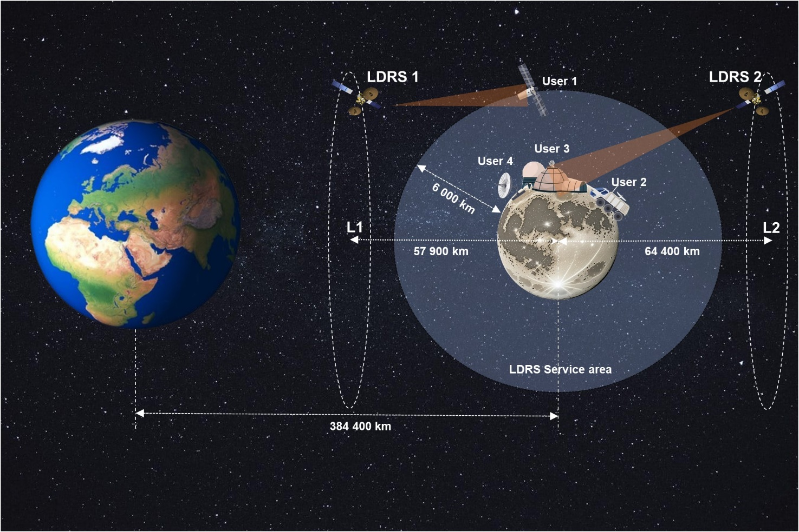
Satellite component of the envisaged lunar data relay satellite system will be based on two Lunar data relay satellites (LDRS), located in Lagrange points L1 and L2 of the Earth-Moon system, using halo orbits with time period of 13 to 16 days. A satellite component of another envisaged lunar relay satellite system will be located in the southward elliptical frozen orbit around the moon with an orbital period of 12 hours or 24 hours.
LDRS will provide tracking, telemetry and telecommand (TT&C) functions, as well as voice and data communication links for various lunar space stations (LSS): orbiters (6 000 km maximum orbit height), landers and rovers, as well as planned manned missions. Forward inter-orbit links (LDRS – LSS) will be operated in the frequency band 7 190-7 235 MHz. Return inter-orbit links (LSS – LDRS) will be operated in the frequency band 8 450-8 500 MHz. LDRS feeder links will use existing Ku-band SRS allocation in the 14.8-15.35 GHz band. LDRS could be used to establish communications between LSS on the lunar surface and between lunar orbit and the lunar surface.
LDRS will provide TT&C and low data rate/voice communications in multiple access links, involving FDMA, CDMA and TDMA schemes, as well as medium data rate/voice communications in single access links.

3.4.2 Technical and operational characteristics of LDRS links
Technical and operational characteristics of LDRS links are provided in Tables 11 and 12.
TABLE 11
Technical and operational characteristics of LDRS System A
LDRS links | LDRS – LSS (multiple access) | LDRS – LSS (single access) | LSS – LDRS (multiple access) | LSS – LDRS (single access)
Frequency band (MHz) | 7 190-7 235 | 7 190-7 235 | 8 450-8 500 | 8 450-8 500
Data rate per user | 8-64 kbit/s  (TT&C, voice and low data rate) | 4-12 Mbit/s | 8-64 kbit/s  (TT&C, voice and low data rate) | 4-24 Mbit/s
Number of users | Up to 8 | 1 | Up to 8 | 1
Total data rate | 64 kbit/s | 12 Mbit/s | 64 kbit/s | 24 Mbit/s
Necessary bandwidth (MHz) | 6 | 10 | 6 | 10
Operating distance to LDRS (km) | 51 000-80 400 | 51 000-80 400 | 51 000-80 400 | 51 000-80 400
Peak transmitting antenna gain (dBi) | 22.6 | 47.7 | 29.9 | 29.9-39.5
Transmit antenna gain pattern | Rec. ITU-R  S.672  (Ls= −20 dB) | Rec. ITU-R S.672  (Ls= −20 dB) | Rec. ITU-R S.672  (Ls= −20 dB) | Rec. ITU-R  S.672  (Ls= −20 dB)
EIRP (dBW) | 38.5 | 63.6 | 38.9 | 38.9-50.5
Multiple access scheme | CDMA, TDMA | – | CDMA | –
Receiving antenna gain | 28.6 | 28.6 | 23.9 | 49
Receive antenna gain pattern | Rec. ITU-R  S.672  (Ls= −20 dB) | Rec. ITU-R S.672  (Ls= −20 dB) | Rec. ITU-R S.672  (Ls= −20 dB) | Rec. ITU-R  S.672  (Ls= −20 dB)
System noise temperature | 350 K | 350 K | 800 K | 800 K

TABLE 12
Technical and operational characteristics of LDRS System B
LDRS links | LDRS – LSS  (multiple access) | LSS – LDRS  (multiple access)
Frequency band(s) | 7 190-7 235 MHz | 8 450-8 500 MHz
Data rate per user | 1 kbit/s  (TT&C) | 0.7 kbit/s – 5 Mbit/s  (TT&C, lower data rate)
Number of users | Up to 3 | Up to 6
Total data rate | 3 kbit/s | 10 Mbit/s
Necessary bandwidth (MHz) | 3 | 20
Operating distance to LDRS (km) | 3 000-18 000  50 000-80 000 | 3 000-18 000  50 000-80 000
Peak transmit antenna gain (dBi) | 46 | –4 to 15
Transmit antenna gain pattern | Rec. ITU-R S.672  (Ls= −20 dB) | Rec. ITU-R S.672  (Ls= −20 dB)
TABLE 12 (end)
LDRS links | LDRS – LSS  (multiple access) | LSS – LDRS  (multiple access)
Max. EIRP (dBW) | 50 | 21
Multiple access scheme | FDMA | FDMA
Receive antenna gain (dBi) | −4 | 46
Receive antenna gain pattern | Rec. ITU-R S.672  (Ls= −20 dB) | Rec. ITU-R S.672  (Ls= −20 dB)
System noise temperature | 350 K | 800 K

4 Summary
The technical and operational characteristics of SRS systems operating on the lunar surface, or SRS systems in lunar orbit communicating with SRS systems on the lunar surface, are provided for use in sharing and compatibility studies.

See David Israel et al., LunaNet: a Flexible and Extensible Lunar Exploration Communications and Navigation Infrastructure and the Inclusion of SmallSat Platforms, Presentation and Paper before Technical Session XII: Communications at Utah State University Small Satellite Conference, SSC20-XII-03, at Table 1 (2020), https://bit.ly/3LCI3n0
IOAG Member Agencies, https://www.ioag.org/Lists/Participants/Agencies.aspx

