|  |
| --- |
| **Report ITU-R SA.2430-0**  **(09/2018)** |
| **Technical studies for establishing in-band power limits for earth stations operating  in the frequency ranges 399.9-400.05 MHz and 401-403 MHz within the MSS, EESS  and MetSat services** |
| **SA Series**  **Space applications and meteorology** |

Foreword

The role of the Radiocommunication Sector is to ensure the rational, equitable, efficient and economical use of the radio-frequency spectrum by all radiocommunication services, including satellite services, and carry out studies without limit of frequency range on the basis of which Recommendations are adopted.

The regulatory and policy functions of the Radiocommunication Sector are performed by World and Regional Radiocommunication Conferences and Radiocommunication Assemblies supported by Study Groups.

# Policy on Intellectual Property Right (IPR)

ITU-R policy on IPR is described in the Common Patent Policy for ITU-T/ITU-R/ISO/IEC referenced in Annex 1 of Resolution ITU-R 1. Forms to be used for the submission of patent statements and licensing declarations by patent holders are available from <http://www.itu.int/ITU-R/go/patents/en> where the Guidelines for Implementation of the Common Patent Policy for ITU‑T/ITU‑R/ISO/IEC and the ITU-R patent information database can also be found.

|  |  |
| --- | --- |
| Series of ITU-R Reports  (Also available online at <http://www.itu.int/publ/R-REP/en>) | |
| **Series** | Title |
| **BO** | Satellite delivery |
| **BR** | Recording for production, archival and play-out; film for television |
| **BS** | Broadcasting service (sound) |
| **BT** | Broadcasting service (television) |
| **F** | Fixed service |
| **M** | Mobile, radiodetermination, amateur and related satellite services |
| **P** | Radiowave propagation |
| **RA** | Radio astronomy |
| **RS** | Remote sensing systems |
| **S** | Fixed-satellite service |
| **SA** | **Space applications and meteorology** |
| **SF** | Frequency sharing and coordination between fixed-satellite and fixed service systems |
| **SM** | Spectrum management |

|  |
| --- |
|  |

|  |
| --- |
| ***Note****: This ITU-R Report was approved in English by the Study Group under the procedure detailed in Resolution ITU-R 1.* |

*Electronic Publication*

Geneva, 2018

© ITU 2018

All rights reserved. No part of this publication may be reproduced, by any means whatsoever, without written permission of ITU.

REPORT ITU-R SA.2430-0

Technical studies for establishing in-band power limits for earth stations operating in the frequency ranges 399.9-400.05 MHz and 401-403 MHz  
within the MSS, EESS and MetSat services

(2018)

# 1 Introduction

Resolution **765 (WRC-15)** on WRC-19 agenda item 1.2 “*resolves to invite the 2019 World Radiocommunication Conference* – to take into account the results of ITU-R studies, and consider the possibility of establishing in-band power limits for earth stations in the EESS and MetSat in the frequency bands 401-403 MHz and in the MSS frequency band 399.9-400.05 MHz”. The objective of this agenda item is to establish, within the Radio Regulations, in-band power limits applicable to earth stations in the frequency bands 399.9-400.05 MHz and 401-403 MHz in order to ensure the operation of existing and future systems that usually implement low or moderate output powers for EESS, MetSat and MSS systems.

Two frequency bands: 399.9-400.05 MHz for Mobile Satellite Service (MSS) (Earth-to-Space), 401-403 MHz for Earth exploration-satellite service (EESS) (Earth-to-space) and meteorological satellite service (MetSat) (Earth-to-space) are under the scope of this agenda item.

The Radio Regulations do not contain any power limit for frequencies below 1 GHz. In the 401‑403 MHz frequency band, the EESS and the MetSat (Earth-to-space) are currently used for data collection systems (DCS) that implement devices with moderate/low power levels. It is to be noted that very often, the devices are operated with very low powers to ensure extended life time of the platforms.

In these frequency bands, earth stations, also called data collection platforms (DCP), are deployed to send specific information to dedicated meteorological or Earth exploration satellites (non‑geostationary or geostationary) which collect the corresponding data when the platforms are in the satellite footprint. Systems deployed in the frequency band 399.9‑400.05 MHz are limited to non-geostationary orbits. The frequency band 401-403 MHz is used by many geostationary and non-geostationary DCS gathering information related to the Earth, the environment and scientific application, weather, environment observations.

A growing number of satellite system operators are operating and/or planning to operate in these frequency bands for telemetry, tracking and command (TT&C) (Earth-to-space) operation for other in accordance with RR No. **1.23** than EESS/MetSat/MSS purposes. This is largely attributable to increased interest by educational institutions, by private and commercial entities seeking to operate large numbers of satellites. While such TT&C operation is permissible under RR No. **1.23** (in conjunction with operation of related frequency band allocations within the same service allocation), output power levels at the antenna port of these telecommand links (Earth-to-space) of the corresponding earth stations, as well as the gain of these earth stations can be very much higher than the power /gain levels used for existing DCS applications. Consequently, the growing number of telecommand links is increasingly likely to cause harmful interference to the existing DCS receivers.

## 1.1 Frequency band 399.9-400.05 MHz

The available bandwidth in the 399.9-400.05 MHz frequency band is 150 kHz. The 399.9‑400.05 MHz frequency band allocation is limited to non-geostationary MSS systems and subject to coordination under RR No. **9.11A**. However, based on administrations notified filings in this frequency band, large majority of satellite systems currently deployed (declared as brought into use by administrations) and/or notified, have parameters for earth station antenna gains and transmit power levels which suggest the use of telecommand operations rather than operations as defined for MSS use.

This type of use is aggravated by the fact that the corresponding telecommand earth stations are being filed and notified as typical uplink earth stations, rather than specific earth stations with defined geographic locations (with specific latitude and longitude). Given this current issue, it will not be possible to successfully receive low equivalent isotropic radiated power (e.i.r.p.) of non-GSO DCS signals in the 399.9-400.05 MHz frequency band in cases where non-GSO DCS satellites receive the telecommand transmissions at the same time, unless specific immediate measures are employed in these telecommand Earth stations. Such measures might include implementing in‑band e.i.r.p. limits, reducing duty cycle and setting specific fixed telecommand earth station locations.

## 1.2 Frequency band 401-403 MHz

In the frequency band 401-403 MHz, tens of thousands of data collection platforms (DCPs) communicating with Geostationary-Satellite Orbit (GSO) satellites and non-GSO satellites are deployed worldwide for the purpose of collecting essential weather and climate data. Therefore, it is necessary to establish in-band power limits/e.i.r.p. for all earth stations operating under the EESS, MetSat allocations within the 401-403 MHz frequency band in order to ensure long term compatible operations of existing and future systems operating under the EESS and MetSat services.

Given the significant difference in the power level ranges of DCPs communicating to non-GSO (Low Earth Orbit (LEO) and Medium Earth Orbit (MEO)) satellites compared to platforms communicating to GSO and Highly Elliptical Orbits (HEO) MetSat and EESS satellites further described in this report, the establishment of power/e.i.r.p. limits will have to differentiate between these categories of DCS in the 401-403 MHz frequency band.

The ITU-R developed ITU-R Recommendations detailing the usage of these frequency bands and applicable interference thresholds.

# 2 Radiocommunication services having allocations in the frequency bands 399.9-400.05 MHz and 401‑403 MHz

Based on the Radio Regulations, Article **5**, Section IV, Table of Frequency Allocations, the 399.9‑400.05 MHz frequency band is allocated on a primary basis to the MSS (Earth-to-space), and the 401‑403 MHz frequency band is allocated on a primary basis to the EES and MetSat services (Earth-to-space).

# 3 Satellite services and applications in relevant frequency bands

This section provides background on the Data Collection Systems operating in the frequency bands 401‑403 MHz and 399.9-400.05 MHz.

The 401-403 MHz frequency band is currently used by many geostationary (GSO) and non‑geostationary (non-GSO) DCS. The DCP information gathered by DCPs is related to the Earth, environmental and scientific applications, weather and environment observations. Similar systems in the MSS are planned to be brought into operation in the frequency band 399.9-400.05 MHz.

A DCP is an electronic device used to collect observations and measurements of the physical, chemical or biological properties of oceans, rivers, lakes, solid Earth, animals and atmosphere. These data support public weather warnings and alerts, operational decision support for dams, locks and maritime operations on the coasts and within inland waterways, emergency response and management for flood scenarios, relay of wildfire weather conditions for wildfire firefighters and other critical uses. These platforms should be light-weight and compact, and use as little power as possible.

DCPs can be used for the following applications: meteorological and oceanographic monitoring, seismic observation, volcanology, geodesy and geodynamics, fishing vessel monitoring, wildlife tracking, homeland security, law enforcement, test/evaluation, monitoring shipments of dangerous goods, humanitarian applications, managing water resources, etc. The DCS is often used in critical real-time data collection. Many emergency warning systems rely on communications through the DCS. The data which are collected by DCPs are sent to the corresponding satellites that retransmit the retrieved information to dedicated earth stations.

Most of the DCPs which are supported by the various EESS and MetSat satellite systems all around the world are the self-timed type transmitting their reports automatically within pre-set schedules. The reporting intervals are determined by a pre-set clock inside the platform. Another type of DCP which operate on random access mode, transmit warnings when a fixed threshold of the phenomenon being measured is met or exceeded. Other DCPs are triggered by interrogated signals. After receiving such a signal, they transmit their data.

The DCS is particularly useful for the collection of data from remote and inhospitable locations where it may provide the only possible option for data relay. Even so, the system also has many uses in regions with a highly developed infrastructure. The installations required for relay of the data tend to be inexpensive, unobtrusive and normally blend easily into the local environment.

## 3.1 Overview of DCS, various types of satellites

Non-geostationary DCS enable scientists to gather information from any platform equipped with an appropriate transmitter, anywhere in the world.

Nearly 2 000 users in over 100 countries currently collect data from more than 22 000 active DCPs operating via non-GSO DCS. ARGOS is a satellite-based system which collects, processes, and disseminates environmental data from fixed and mobile platforms worldwide. ARGOS currently contributes about 30 000 daily meteorological-ocean observations into the Global Telecommunication System which is a coordinated global system that operates through the collection, exchange, and distribution of information within the framework of the World Weather Watch. Figure 1 shows the global distribution of the active ARGOS data collection platforms.

ICARUS, short for “International Cooperation for Animal Research Using Space”, is another example of a DCS used for tracking animals with small low-power transmitters weighting only 5 grams. A miniaturized tag attached to the animal is determining its position using GPS. The tag transmits the data to a transceiver on the International Space Station (ISS) which relays data between the animal tags and its associated operations centre.

The Brazilian Data Collection System (B-DCS) is another non-GSO DCS collecting environmental data daily in the different regions of the Brazilian national territory. The Brazilian Data Collection Platforms (B‑PCD) collect the data which are used in applications such as weather forecasting, ocean currents studies, tides, atmospheric chemistry, and agricultural planning.

Meteor-3M hydrometeorological and oceanographic satellite system of the Russian Federation, comprising of two sun-synchronous LEO satellites, Meteor-M №1 (launched in 2009) and Meteor‑M №2 (launched in 2014), also carries a DCS data relay payload, which is used to provide meteorological and environmental data collection in different regions of the Russian national territory and polar regions.

Other non-GSO DCSs have been demonstrated by Japanese micro-satellites including WEOS (Whale Ecology Observation Satellite) collecting data from probes attached to whales, other animals and buoys and Hodoyoshi-3/4 for water level monitoring to detect flood, drought or inundation.

Figure 1

Snapshot of the global distribution of active ARGOS data collection platforms

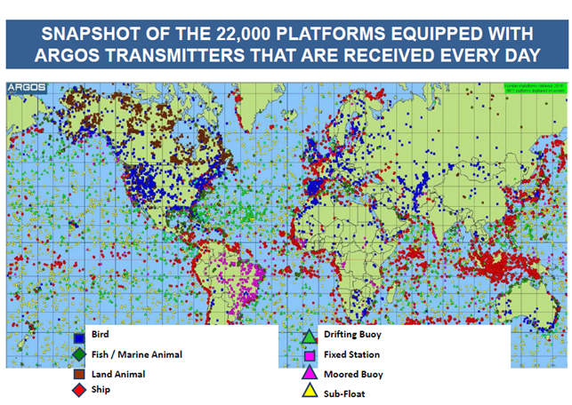

Other DCS are provided by several geostationary meteorological satellite operators, giving almost total coverage around the world, except the polar regions. For example, the EUMETSAT contribution to the global DCS network of geostationary meteorological satellites (also including satellites from Russia, China and USA) is provided by the current fleet of Meteosat satellites and will be continued by the Meteosat Third Generation satellites (MTG). The Meteosat satellites located at 0° longitude (Meteosat-10) and over the Indian Ocean (Meteosat-7) at 57.5°E and Meteosat-8 at 41.5°E (replacing 57.5°E fully by April 2017) acquire DCP data, in the form of observations and environmental parameters (e.g. temperature, humidity, etc.), transmitted from operators of DCPs, which are located within the footprint of the satellites. When the platform is always under the footprint of a single geostationary meteorological satellite it is related to a regional transmission channel. If however it is located on a ship or aircraft, which travels across the footprint of several satellites, it is allocated to an international channel.

For regional DCS, especially to cover polar regions, satellites systems in HEO could be used. Typical HEO orbits have apogee altitudes as high as 40 000 km which could provide the visibility to the polar regions for a long duration of time by a small number of HEO satellites. HEO DCS has similar power requirements as GSO DCS. GSO and HEO DCS together achieve global coverage of the Earth. Deployment of two hydrometeorological ARCTICA-M satellites, located at HEO orbit (Perigee = 3 000 km, Apogee = 40 000 km, Inclination = 62.80°), is planned after 2018. These satellites will carry DCS payload to enhance coverage of polar regions and would increase performance of existing Russian DCS systems, consisting of GSO (Luch-5 and Elektro-L) and LEO (Meteor-M) constellations.

The international DCS (IDCS) comprises eleven channels which are reserved for DCP mounted on aircraft, ship, drifting ocean buoy or balloon, to transmit environmental data continuously. The transmissions are received by the nearest geostationary meteorological satellite, relayed to its primary ground station and then distributed to the relevant user community.

Figure 2

DCS data collection platforms processed by HADS

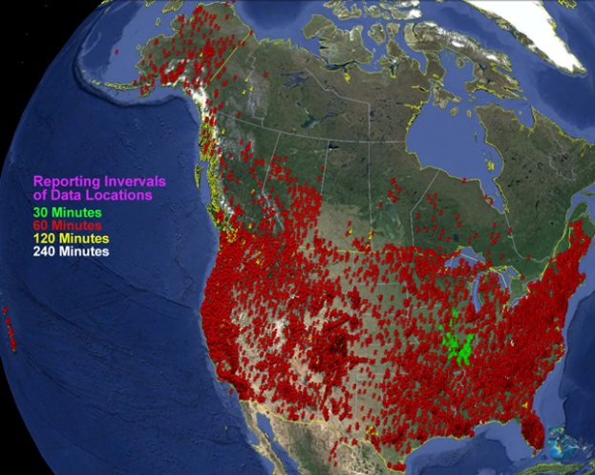

For geostationary satellites, one example is the Geostationary Operational Environmental Satellites (GOES) DCS. Federal, state, local and tribal governments and private entities relay time-sensitive, near real-time hydrological and environmental data from over 29 000 data collection platforms within the hemisphere via the GOES satellites to government and non-government users. The DCS data is provided through satellite bent-pipe transponders to the Direct Readout Ground Stations (DRGS). GOES DCS satellite telemetry delivers over 8 million mission critical observations per day and is growing rapidly. These data support public weather warnings and alerts, operational decision support for dams, locks and maritime operations on our coasts and within our inland waterways, emergency response and management for flood scenarios, relay of wildfire weather conditions for wildfire firefighters and other critical uses. Thousands of non-government users benefit from the DCS system. Figure 2 shows the GOES DCS Data Collection Platforms processed by the Hydrometeorological Automated Data System (HADS), which is one of the DCS applications. HADS processes over 3.6 million observations from more than 16 000 GOES DCPs daily.

Himawari-DCS is another GSO data collection system of the Himawari series of satellite which is designed for use in collecting and distributing real-time meteorological, tidal/tsunami, seismological, or oceanographic observational data obtained through regional DCPs.

## 3.2 Frequency band 399.9-400.05 MHz

The frequency band 399.9-400.05 MHz, allocated to the Mobile Satellite Service (earth-to-space), is currently planned to be used for uplink data transmission of DCS platforms by non-GSO DCS systems such as ARGOS, Magnitude or Fleet Space Technologies, as well as for space telecommand functions associated with MSS operations in accordance with RR No. **1.23**.

## 3.3 General partitioning and sharing conditions for the frequency band 401-403 MHz

In the frequency band 401-403 MHz two types of space segments which coexist: GSO satellite and non-GSO satellites. The coexistence of these two types of DCS systems is facilitated by the framework set forth by the general partitioning and sharing conditions contained in Recommendation ITU-R SA.2045 (see Fig. 3 below).

The Recommendation ITU-R SA.2045 also provides information on the performance and interference criteria for non-GSO DCS in the frequency band 401-403 MHz.

The increased spectrum requirements for both geostationary and non-geostationary MetSat and EESS systems require all operators of DCS to adhere to a basic general partitioning of the frequency band 401‑403 MHz for current and future DCS in addition to intra-service sharing conditions. It is recommended that operators of current and future DCS on geostationary and non‑geostationary MetSat and EESS satellites implement a frequency plan in accordance with the basic general partitioning of the frequency band 401-403 MHz as shown in Fig. 3.

It should be noted that there are also DCS platforms using spread spectrum techniques that may result in reducing the interference to other systems. Due to the spreading of the signal, these systems may not fit in the general partitioning; however, their consideration should include information about the maximum number of DCS devices that could simultaneously operate on co‑frequency basis.

Figure 3

Basic general partitioning of the band 401-403 MHz for future long-term coordinated use of DCS systems on geostationary and non-geostationary MetSat and EESS systems

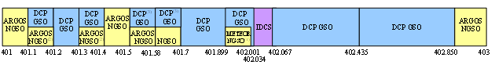

The intra-service sharing conditions as detailed below are contained in the Recommendation.

1 in the frequency band 401.899-401.998 MHz the non-geostationary MetSat system Meteor-3M will only operate over the territory of the Russian Federation;

2 for the use of the frequency bands 401.1-401.2 MHz and 401.3‑401.4 MHz by ARGOS platforms:

– Maximum e.i.r.p. of −3 dBW;

– Maximum number of ARGOS active platforms to be deployed in each of the two sub-bands not to exceed 1 000 within the visibility circle of FY-2 and FYGEOSAT series satellites;

– Maximum duty cycle (ratio of transmission duration over the repetition period) of each platform not to exceed 0.01 (on average 0.6 s over 60 s);

3 the frequency band 401.5-401.7 MHz can also be used by DCP GSO systems of the Russian Federation, noting that for the sub-band 401.58‑401.7 MHz, these systems must be limited to operation over the Russian territory with a maximum e.i.r.p. of 16 dBW.

# 4 Protection criteria

## 4.1 Frequency band 399.9-400.05 MHz

The protection criteria for non-GSO MSS systems are specified in Recommendation ITU-R M.2046 based on one single MSS system. Since the frequency band 399.9-400.05 MHz is planned to be used by several MSS non-GSO systems in the near future, this Recommendation may need to be revised and updated to take into account other systems.

## 4.2 Frequency band 401-403 MHz

Applicable recommendations listing performance criteria interference criteria, sharing and coordination criteria and characteristics of data collection systems include:

– Recommendation ITU-R [SA.1159](https://www.itu.int/rec/R-REC-SA.1159-4-201707-I/en)

– Recommendation ITU-R [SA.1163](https://www.itu.int/rec/R-REC-SA.1163-2-199910-I/en)

– Recommendation ITU-R [SA.1164](https://www.itu.int/rec/R-REC-SA.1164-2-199910-I/en)

– Recommendation ITU-R [SA.2044](https://www.itu.int/rec/R-REC-SA.2044-0-201312-I/en)

# 5 Technical characteristics of the planned and deployed DCS systems

## 5.1 Frequency band 399.9-400.05 MHz

The ARGOS DCS plans to use the frequency band 399.9-400.05 MHz for the uplink transmissions for the non-environmental applications, such as sensitive use, homeland security, maritime applications, and humanitarian applications.

The Magnitude system is planning to use the frequency band 399.9-400.05 MHz (Earth-to-space) on a global basis (semi) wide band, with very low e.i.r.p. density Code Division Multiple Access (CDMA) uplink emissions.

The Fleet Space Technologies non-GSO satellite system is planning to use the frequency band 399.9-400.05 MHz for the uplink transmissions of low-power MSS emissions from user terminals operated on a global basis. Table 1 lists the characteristics of the DCS systems operating and planned to be operating in the frequency band 399.9‑400.05 MHz.

TABLE 1

RF Characteristics of selected DCS System in 399.9-400.05 MHz frequency band

|  |  |  |  |  |
| --- | --- | --- | --- | --- |
| Type of platforms | Low Data rate | | | |
| Generic name | ARGOS | | Magnitude Space | Fleet Space System |
| BD-A2 | NG-A3 |
| Maximum output power (W) | ≤ 3 | ≤ 2 | ≤ 6 | ≤ 4 |
| Maximum e.i.r.p. (dBW) | 5 | 5 | 5 | ≤ 5 |
| Modulation | PCM/PM | QPSK | QPSK | QPSK |
| Data rate (bps) | 400 | 400 | 9375 | 19 200 |
| Bandwidth (kHz) | 1.6 | 1.6 | 150 | 18 |
| Symbol rate (sps) | 400 | 400 | N/A | 9 600 |
| Symbol rate (kcps) | N/A | N/A | 100 | N/A |

## 5.2 Frequency band 401-403 MHz

### 5.2.1 GSO and HEO system

The DCP transmissions via the meteorological GSO systems vary between regional and international services. Platforms transmitting to geostationary satellites have fixed individual channels. Thirty‑three channels, of 3 kHz each, in the 402.0 to 402.1 MHz range are available for international stations. The table below provides the characteristics of the data collection systems for GSO and HEO DCS satellite systems.

The HEO DCS system in the Table 2 is based on an orbit with apogee of 40 000 km, which makes the characteristics of these HEO DCPs similar to characteristics of the GSO DCPs.

TABLE 2

RF Characteristics of Data Collection Platforms of GSO and HEO System   
in the 401-403 MHz frequency band

| Orbit | System | | e.i.r.p. (dBW) | Bit rate (bit/s) and modulation | Carrier bandwidth (Hz) | Channel bandwidth (Hz) | Receiver bandwidth |
| --- | --- | --- | --- | --- | --- | --- | --- |
| GSO | IDCS | Typical GSO | 5‑22 | 100 (NRZ split-phase Manchester encoded) | 400 Hz | 3000 | 33 kHz  (402.034-402.067 MHz) |
| GOES DCS | 7-11 | 300 (trellis coded 8PSK) | 300 | 750 | 100 KHz (402-402.1 MHz) |
| 13-17 | 1 200 (trellis coded 8PSK) | 1 200 | 2 250 |
| FENGYUN DCS | 13-19 | 100 (Manchester encoded BPSK) | 400 | 3000 | 100 kHz  (402-402.1 MHz) |
| Himawari-DCS | 13-16 | 100 (NRZ-L and Manchester encoded BPSK) | 1800 | 3000 | 30 kHz  (402.0355-402.0655 MHz) |
| Russian DCS | 12‑18 | 100 (Manchester encoded BPSK) | 400 Hz | 3000 | 100 kHz  (402-402.1 MHz) |
| RDCS | Typical GSO | 5-22  (Average 15) | 100 (Manchester encoded BPSK) | 100 | 750-4 000 | 300-900 kHz |
| 5-19  (Average 15) | 300 (trellis coded 8‑PSK) | 300 | 750-4 000 | 300-900 kHz |
| 5-22 | 1 200 (trellis coded 8‑PSK) | 1200 | 750-4 000 | 300-900 kHz |
| GOES DCS | 7-11 | 300 (trellis coded 8PSK) | 300 | 750 | 400 kHz  (401.7-402.1 MHz)  (402-402.4 MHz) |
| 13-17 | 1 200 (trellis coded 8PSK) | 1200 | 2 250 |
| FENGYUN DCS | 13-19 | 600 (QPSK) | 600 | 750 | 300 kHz  (401.1-401.4 MHz) |
| Himawari-DCS | 13-16 | 100 (NRZ-L and Manchester encoded BPSK) | 1800 | 3000 | 331.5 kHz  (402.0685-402.400 MHz) |
| 15-18 | 300 (NRZ-L and Manchester encoded BPSK) | 1 800 | 3 000 |
| Russian DCS | 12-18 | 100 (Manchester encoded BPSK) | 400 | 3000 | 900 kHz  (401.5-402, 402.1‑402.5 MHz) |
| 18 | 1 200 (QPSK) | 2400 | 3000 |
| HEO | ARCTICA-M | | 18 | 100 (Manchester encoded BPSK) | 400 | 3000 | 1 MHz  (401.5-402.5 MHz) |
| 16 | 1 200 (QPSK) | 2400 | 3000 | 2 MHz  (401-403 MHz) |

#### 5.2.1.1 Receiver characteristic

– Range of the power flux density (pfd) received from a DCP: −160 to −140 dB(W/m2);

– Range of receiver sensitivities: *G*/*T* = −28.5 to –18 dB(K-1);

– Data relay receive bandwidth: 0.2 MHz or more depending on the type of satellite.

#### 5.2.1.2 Range of output power/e.i.r.p.

Data collection via the International Data Collection System (IDCS) is based on the use of GSO satellites, where the e.i.r.p. at the antenna output shall not exceed 22 dBW under any combination of operational conditions. The transmitted radio frequency shall be within one of the 11 IDCS channels (with centre frequencies spaced 3 kHz apart), from 402.034‑402.067 MHz regardless of the GSO spacecraft.

The other channels available for GSO DCS are reserved for regional DCS, and there are various types of DCP transmitters in operation generally ranging from 2.5W to 20 W output power with a directional antenna, or 40 W output power with an omnidirectional antenna. The resulting uplink e.i.r.p. is between 5 and 22 dBW.

For DCP’s operating with HEO satellites (ARCTICA-M), uplink e.i.r.p. would not exceed 16‑18 dBW.

### 5.2.2 Non GSO System (LEO and MEO)

Non-GSO satellites have the advantage of relaying data from DCPs using a moving satellite to allow for locating an in-situ platform using Doppler shift calculations. This positioning capability permits applications such as monitoring drifting ocean buoys and studying wildlife migration paths. Another advantage is that some of non-GSO satellites have polar orbits, which allow collecting data in all regions in the world.

Table 3 lists the characteristics of ARGOS, ICARUS, Meteor-3M and Brazilian DCS platforms, which are examples of DCS operating via non-geostationary satellites (LEO and MEO).

TABLE 3

RF Characteristics of ARGOS A-DCS, Brazilian DCS, ICARUS and Meteor-3M

|  |  |  |  |  |  |  |  |  |  |
| --- | --- | --- | --- | --- | --- | --- | --- | --- | --- |
| Type of platforms | ARGOS A-DCS | | | | | Brazilian DCS  Low Data Rate | ICARUS | Meteor-3M | |
| A-DCS  Low Data rate | | A-DCS  Very Low Data Rate | A-DCS  High Data Rate | |
| Generic name | LD-A2 | LD-A3 | VLD-A4 | HD-A3 | HD-A4 | B-PCD |  |  |  |
| Maximum output power (W) | ≤ 3 | ≤ 2 | ≤ 0,5 | ≤ 5 | ≤ 3 | <2 | 0.004 | 8 | 10 |
| Bandwidth (Hz) | 1 600 | 1 600 | 800 | 6 400 | 9 600 | 1 200 | 900 000 | 1 600 | 2 400 |
| Modulation | PCM/PM | QPSK | PCM/PM | GMSK BT=0,5 | GMSK BT=0,5 | PM | 8PSK/QPSK/BPSK | PCM/PM | QPSK |
| Data rate (bit/s) | 400 | 400 | 124 | 4 800 | 1 200 and 4 800 | 400 | 521 | 400 | 1 200 |
| Symbol rate (sps) | 400 | 400 | 200 | 6 400 | 9 600 | 400 | 900 | 400 | 1 200 |

#### 5.2.2.1 Receiver characteristic

The LEO satellites are generally placed in circular orbits at altitudes between 600 and 1 800 km, with the orbital period of approximately two hours. TABLE 4 lists the characteristics of the LEO DCS satellite receivers, ARGOS DCS, Brazilian DCS, ICARUS DCS and Meteor-3M.

TABLE 4

Characteristics of LEO Satellite DCS Receivers in 401-403 MHz frequency band

|  |  |  |  |  |
| --- | --- | --- | --- | --- |
|  | ARGOS DCS | Brazilian DCS | ICARUS DCS | Meteor-3M |
| Range of power received within the receiver from DCP | −169 to −138 dBW | −160 to −130 Dbw | −155 to −145 dBW | −156 to −128 dBW |
| Noise power density level | −201 dB(W/Hz) | −201 dB(W/Hz) | −192.80 dB(W/Hz) | −201 dB(W/Hz) |
| Noise temperature | 600 K | 600 K | 439 K | 600 K |
| BER (for interference free messages) | < 1×10-5 | < 1×10-5 | < 5.5×10-6 | < 1×10-5 |
| Receiver bandwidth | Rec. ITU-R SA.2045 | Rec. ITU-R SA.2045 | 900 kHz centred at 402.25 MHz | Rec. ITU-R SA.2045 |

#### 5.2.2.2 Range of output power / e.i.r.p.

The maximum value of output power of DCP platforms in operation with non-GSO satellites is lower than with GSO satellites. In practice, the values of output power range from –3 dBW to 7 dBW (i.e. 0.5W to 5W). In some applications, the power may decrease to −25 dBW using specific techniques such as Spread Spectrum Multiple Access. For the Meteor-M LEO satellite the uplink DCP e.i.r.p. does not exceed 12 dBW (normal output power range from 9 dBW to 10 dBW). DCPs typically use non-directional low-gain antennas with 0 to 3 dBi gain. In practice, the antenna gain does not exceed 0 dBi at low elevation angles and falls to −16 dBi at nadir.

The maximum corresponding antenna gain is below 3 dBi. Most of time, the omnidirectional or whip antennas are used.

# 6 Analyses related to the planned and deployed telecommand systems

## 6.1 Technical characteristics

### 6.1.1 Frequency band 399.9-400.05 MHz

Earth station uplinks use this frequency band to telecommand non-GSO MSS satellites, which are providing critical communications including M2M- and IoT-type services in this frequency band.

The Fleet Space Technologies non-GSO is planned to use the 399.9-400.05 MHz frequency band for limited space operations functions from a small number of telecommand uplink earth stations which are currently planned to be located in Australia, the Solomon Islands and at up to 6 further locations distributed around the world These telecommand sites will be selected to ensure maximal operational coexistence with other systems utilising the band in order to facilitate frequency coordination. There are other Non-GSO systems operating in this frequency band. Tables 5 and 7 provide those characteristics. Other satellite systems also plan on using this frequency band for MSS telecommand uplink operations

TABLE 5

RF characteristics of the telecommand of fleet space technologies non-GSO   
satellite system in 399.9-400.05 MHz

|  |  |
| --- | --- |
|  | Fleet Space Technologies |
| Maximum e.i.r.p. (dBW) | ≤ 18* |
| Modulation | FSK/GMSK |
| Data rate (bit/s) | 9 600 – 19 200 |
| Bandwidth (Hz) | 8 000 – 16 000 |
| Symbol rate (sps) | 9 600 – 19 200 |
| Tx earth-station gain (dBi) | 15 |
| Duty Cycle | ~100% |
| * Under normal mode; this value may be exceeded by up to 14 dB under emergency mode, for short periods only during emergency situations. | |

Table 6 contains a comparative link budget for 3 MSS telecommand uplinks in the frequency band 399.9-400.05 MHz.

TABLE 6

Link budgets for some MSS telecommand satellite uplinks in 399.9-400.05 MHz

|  |  |  |  |  |
| --- | --- | --- | --- | --- |
|  |  | EV9 MSS | M3MSAT MSS | ADS MSS |
| Earth station (tx) | Centre frequency (MHz) | 399.975 | 399.975 | 399.975 |
| Transmitting power (dBW) | 14 | 15.8 | 2.4 |
| Antenna gain (dBi) | 22 | 2 | 2 |
| Tx line loss (dB) | 0 | 0 | 0 |
| e.i.r.p. (dBW) | 36.0 | 17.8 | 4.4 |
| Bandwidth (kHz) | 40 | 15 | 1.5 |
| Max. e.i.r.p. power density (dB(W/Hz)) | −10 | −24 | −27.4 |
| Space & Earth loss | Orbit altitude (km) | 650 | 650 | 850 |
| Min. elevation (degree) | 5 | 5 | 5 |
| Slant range (km) | 2448 | 2448 | 2890 |
| Space loss (dB) | 152.2 | 152.2 | 153.7 |
| Polarization loss (dB) | 3.2 | 3.2 | 3.2 |
| Atmospheric loss (dB) | 2.1 | 2.1 | 2.1 |
| Space station (rx) | S/C antenna gain (dBi) | 4.0 | 3.0 | 3.5 |
| System noise temperature (K) | 600 | 324 | 900 |
| Rx line loss (dB) | 0 | 0 | 0 |
| G/T (dB/K) | −24.3 | −22.6 | −26.5 |
| Link analysis | *C*/*N*0 (dB-Hz) | 82.8 | 66.3 | 47.5 |

Information about some Systems extracted from their relevant MIFR filings with the ITU has been summarized and presented in Table 7.

TABLE 7

Characteristics of MSS uplinks in 399.9-400.05 MHz

|  |  |  |  |  |  |
| --- | --- | --- | --- | --- | --- |
| System name | Bandwidth (kHz) | Antenna gain (dBi) | Power range (dBW) | e.i.r.p. range (dBW) | e.i.r.p. density range (dB(W/Hz)) |
| EV9 | 40 | 22 | 14 to 9 | 36 to 31 | −10 to −15 |
| M3MSAT | 15 | 2 | 15.8 to −5 | 17.8 to -3 | −24 to −44.7 |
| M3MSAT | 1.45 | 2 | 2.8 to 0 | 4.8 to 2 | −24.8 to −29.6 |
| ADS | 15 | 2 | 12.4 to −16.7 | 14.4 to -14.7 | −25.6 to −56.5 |
| ADS | 1.5 | 2 | 2.4 to −26.7 | 4.4 to -24.7 | −25.6 to −54.7 |
| ADS | 150 | 16.5 | 27 to 2 | 43.5 to 18.5 | −8.3 to −33.2 |
| ADS | 15 | 16.5 | 17 to −8 | 33.5 to 8.5 | −8.3 to −33.2 |
| Summary - All |  |  | 27 to −26.7 | 43.5 to −24.7 | −8.3 to −44.7 |

The link budgets in Table 6 show that telecommand uplinks for MSS operate within a range of 36 to 4.4 dBW. Some systems require more power, in particular to overcome spacecraft antenna pointing losses. The corresponding e.i.r.p. density for these stations ranges between −10 to −27.4 dB(W/Hz) in 399.9-400.05 MHz.

### 6.1.2 Frequency band 401-403 MHz

The frequency band 401-403 MHz is also used for telecommanding Earth observation satellite systems performing multi-spectral and hyper-spectral optical observation and radio observation like satellite systems performing GNSS-Radio Occultation and GNSS-Reflectometry.

As an example of a telecommand earth station operating in the non-GSO EESS that uses the frequency band 401-403 MHz, Table 8 shows the link budget of GRUS non-GSO EESS telecommand uplinks using the 401-403 MHz frequency band. Link budgets for the GHGSAT system is also included to show that there is significant difference in the e.i.r.p. and e.i.r.p. densities for these example systems.

Figures 4 and 6 show respectively the radiation pattern of directional antenna of GRUS and GHGSAT-D non-GSO EESS earth station that tracks the spacecraft during operation.

For compatibility analysis with DCS, Fig. 5 shows simplified relative gain model of the real antenna pattern provided in Fig. 4. Table 9 shows a list of NGSO EESS satellite networks that is under operation or to be brought into use in the near future. Associated Earth stations that are used for operations for those satellite networks are listed in Table 10.

TABLE 8

Example link budgets for telecommand operation of some satellite uplinks in 401-403 MHz

|  |  |  |  |
| --- | --- | --- | --- |
|  | Parameter | GRUS | GHGSAT-D |
| Earth station (Tx) | Centre frequency (MHz) | 401.78 | 402 |
| Transmitting power (dBW) | 10 | 21 |
| Antenna gain (dBi) | 20 | 19 |
| Tx line loss (dB) | 3 | 1.0 |
| e.i.r.p. (dBW) | 27 | 39 |
| Bandwidth | 30 | 35 |
| Max. e.i.r.p. density (dB(W/Hz)) | −17.8 | −6.4 |
| Max. duty ratio | 0.5 | N/A |
| Space & Earth loss | Orbit altitude (km) | 575 | 505 |
| Min. elevation (degree) | 5 | 5 |
| Slant range (km) | 2268.3 | 2091 |
| Space loss (dB) | 151.6 | 150.9 |
| Polarization loss (dB) | 3.2 | 2 |
| Atmospheric loss (dB) | 2.1 | 1 |
| Space station (Rx) | S/C antenna gain (dBi) | −6 | −10.2 |
| System noise temperature (K) | 800 | 600 |
| Rx line loss (dB) | 0.5 | 1.3 |
| G/T (dB/K) | −35.5 | −39.3 |
| Link analysis | *C*/*N*0 (dB-Hz) | 63.2 | 68.4 |
| Bit rate (bit/s) | 9 600 | 4000 |
| Modulation (N/A) | GFSK | GFSK |
| Available *Eb*/*N*0 (dB) | 23.2 | 32.4 |
| Required *Eb*/*N*0 (BER=10-6) (dB) | 13.4 | 20.7 |
| Implementation loss (dB) | 2 | 2 |
| Link margin (dB) | 8.0 | 9.7 |

Figure 4

Relative gain antenna pattern of GRUS non-GSO EESS telecommand earth station

地図 が含まれている画像

高い精度で生成された説明

FIGURE 5

Simplification of the relative gain antenna pattern mask of GRUS NGSO EESS   
telecommand Earth station used in studies

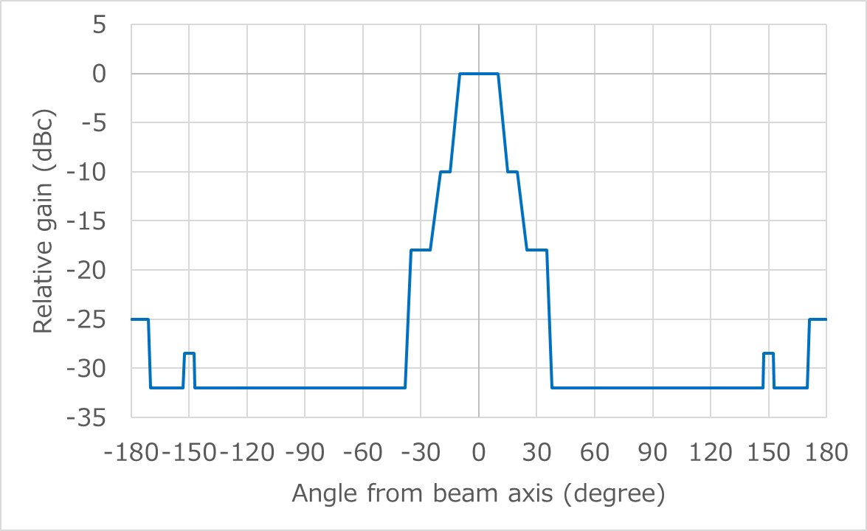

FIGURE 6

Relative gain antenna pattern of GHGSAT-D non-GSO EESS telecommand earth station

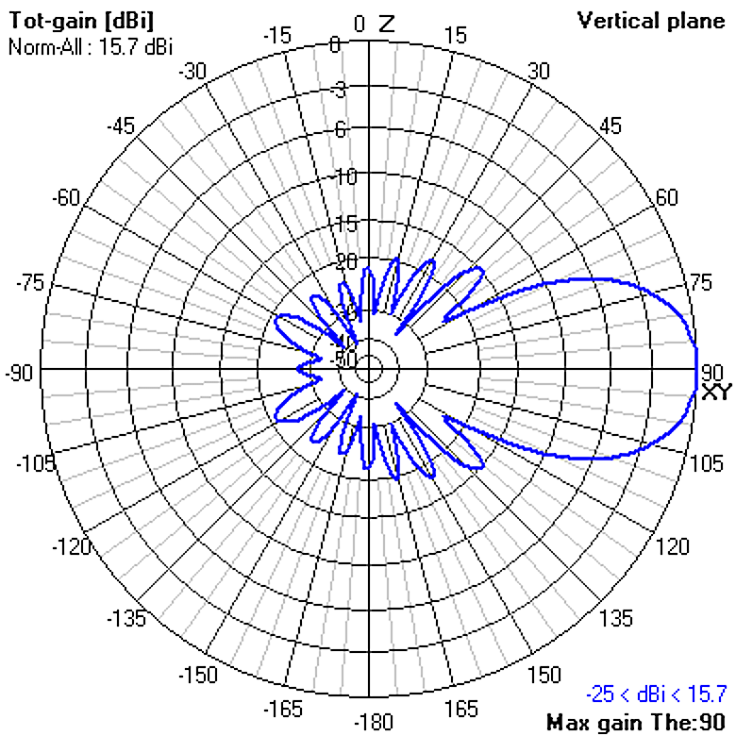

TABLE 9

List of some NGSO EESS satellites that use 401-403 MHz band for telecommand operation

|  |  |  |  |  |  |  |
| --- | --- | --- | --- | --- | --- | --- |
| **ITU filing name** | Num. of satellites | Centre frequency (MHz) | Altitude (km) | LTAN | Launch | Estimated end of operation |
| PRISM2 | 1 | 401.05 | 800 | 15:00 | Nov. 2013 | Mar. 2024 |
| HODOYOSHI | 2 | 401.78 | 500  /600 | 23:00  /11:30 | Nov. 2014  /Jul. 2017 | Dec. 2025 |
| GRUS (1) | 3 | 401.7-401.899 | 550 | 11:30 | Dec. 2018 | Dec. 2025 |
| MSTD | 1 | 401.7-401.899 | 500 | 21:30 | Dec. 2018 | Dec. 2020 |
| TRICOM-1 (2) | 1 | 401.05 | 180-1 500 | N/A | Feb. 2018 | Aug. 2018 |
| SPRITE-SAT | 1 | 401.25 | 660 | 13:00 | Jan. 2009 | Jan. 2019 |
| RISE-SAT | 1 | 401.25 | 630 | 12:00 | May 2014 | May 2024 |
| JCUBES-A (3) | 1 | 401.25 | 613 | 13:00 | Oct. 2018 | Oct. 2028 |
| JCUBES-B (3) | 5 | 401.25 | 613  /500 | 13:00  /21:00 | Oct. 2018  /Dec. 2018 | Oct. 2028  /Dec. 2028 |
| SPATIUM (4) | 1 | 401.25 | 400 | N/A (deployed from ISS) | Aug. 2018 | Dec. 2019 |

|  |
| --- |
| *Notes du Table 9:*  (1) Only the first three out of 50 satellites of the GRUS constellations use 401.7-401.899 MHz band for telecommand operation.  (2) TRICOM-1 is expected to re-enter into the atmosphere in August 2018.  (3) JCUBES-A and B use S-band for main telecommand. Telecommand operation in 401.25 MHz will only be used when the satellites are in emergency.  (4) Only the first one out of 10 constellation of SPATIUM satellites use 401.25 MHz for telecommand operation. |

TABLE 10

List of some NGSO telecommand Earth stations that use 401-403 MHz band

|  |  |  |  |
| --- | --- | --- | --- |
| Earth station | Longitude | Latitude | Operating satellites |
| ISSL TOKYO UHF | 139E 45’29” | 35N 42’ 54” | HODOYOSHI, GRUS, MSTD, TRICOM-1 |
| WNI-MTG | 140E 02’ 30” | 35N 39’ 06” | PRISM2, HODOYOSHI |
| CRESS | 140E 50’ 10” | 38N 15’ 29” | SPRITE-SAT, RISE-SAT, JCUBES-A, JCUBES-B |
| KIT | 130E 50’ 26” | 33N 53’ 28” | SPATIUM |

Some DCPs in 401-403 MHz frequency band operate within an e.i.r.p. density range −1.26 to −53.45 dB(W/Hz) when transmitting to DCS satellite networks. These DCPs corresponding e.i.r.p. values are in the range of −0.2 to 31 dBW.

The link budgets in Table 8 show that telecommand uplinks for EESS and MetSat systems require e.i.r.p. within a range of 39 to 27 dBW for EESS/MetSat systems to ensure proper operation of their links. Some systems require more power, in particular to overcome spacecraft antenna pointing losses. The corresponding e.i.r.p. density for these stations ranges between −6.4 to −17.8 in 401‑403 MHz bands.

## 6.2 Compatibility analyses with DCS

### 6.2.1 Frequency band 399.9-400.05 MHz

The static and dynamic analyses were performed to assess the interference power levels on NGSO DCS satellite receiver from SOS NGSO Earth station (E-s) transmissions. Per Recommendation ITU-R M.2046, the protection criteria is −197.9 dB(W/(m2·Hz)) maximum aggregate acceptable spectral power flux-density (spfd) at the antenna of a non-GSO MSS ARGOS4 system for broadband noise interference, not be exceeded for more than 1% of time in the field of view of the MSS satellite. This is equivalent to −209.3 dB(W/Hz) into the MSS satellite receiver.

Static and dynamic analyses were performed to assess the interference impact on MSS satellite receiver.

#### 6.2.1.1 Static analysis of SOS NGSO Earth station (E-s) transmissions into NGSO MSS DCS satellite receiver (STUDY A)

The RF characteristics of telecommand of Fleet Space Technologies NGSO satellite system listed in Table 5 are used in the analysis. Table 11 shows the results of the interference power levels from a SOS NGSO earth station (E-s) to NGSO MSS DCS satellite receiver.

TABLE 11

Interference from SOS NGSO earth station (E-s) transmissions   
into NGSO MSS DCS satellite receiver

| Parameter | Value |
| --- | --- |
| NGSO SOS Earth station | |
| Frequency (MHz) | 399.975 |
| Channel bandwidth (kHz) | 8 |
| Earth station antenna gain (dBi) | 15 |
| Earth station e.i.r.p. (dBW) | 18 |
| Earth station e.i.r.p. power density (dB(W/Hz)) | −21.0 |
| NGSO MSS DCS satellite | |
| Altitude (km) | 824 |
| non-GSO DCS spacecraft antenna gain (dBi) | 4.9 |
| Path loss (dB) | 142.8 |
| Interfering signal at non-GSO MSS DCS satellite receiver (dB(W/Hz)) | −158.9 |
| Rec. ITU-R M.2046 Interference criteria (no more than 1% of the time) (dB(W/Hz)) | −209.3 |
| **Exceed interference criteria (dB)** | **50.4** |

As Table 11 shows, a single interfering SOS uplink signal from the NGSO satellite’s earth station into the non-GSO MSS DCS satellite receiver may exceed the protection criteria by more than 50 dB.

#### 6.2.1.2 Dynamic analysis of SOS NGSO Earth station (E-s) transmissions into NGSO MSS DCS satellite receiver (STUDIES B and C)

##### 6.2.1.2.1 Study B

Dynamic studies were performed to assess the effect of uplink telecommand signals from a NGSO MSS satellites’ earth station into the non-GSO DCS satellite receiver over a period of 30 days with time increment of 10 seconds. The coordinates of the telecommand Earth station are assumed at 24.827°S, 113.672°E. The technical parameters of the NGSO telecommand Earth station are listed in both Table 5 and Table 11. The Earth station antenna used in the analysis is a directional antenna with 15.0 dBi maximum gain and 16.0 degree beamwidth. The space station antennas of NGSO MSS satellites are omnidirectional antennas with 5 dBi gain. The telecommand Earth station is tracking the NGSO MSS satellites with minimum 5 degree elevation then chooses the satellite with the highest elevation. The parameters of non-GSO DCS satellite are listed in Table 4.

The satellites orbital parameters used in the analyses are based on the ITU filing of Fleet Space Technologies, as listed in Table 12 below. One earth station tracks a constellation of 101 NGSO MSS satellites.

TABLE 12

SOS NGSO MSS Satellites Orbital Parameters

| Orbital Plane No. | No. of satellites in this plane | Orbital altitude (km) | Inclination (degree) | Mean anomaly (degree) | Arg. of perigee (degree) | Right ascension of the ascending node (degree) | Eccentricity |
| --- | --- | --- | --- | --- | --- | --- | --- |
| 1 | 5 | 577 | 45 | Uniform distribution | 0 | 0 | 0 |
| 2 | 5 | 577 | 45 | Uniform distribution | 7.2 | 18 | 0 |
| 3 | 5 | 577 | 45 | Uniform distribution | 14.4 | 36 | 0 |
| 4 | 5 | 577 | 45 | Uniform distribution | 21.6 | 54 | 0 |
| 5 | 5 | 577 | 45 | Uniform distribution | 28.8 | 72 | 0 |
| 6 | 5 | 577 | 45 | Uniform distribution | 36 | 90 | 0 |
| 7 | 5 | 577 | 45 | Uniform distribution | 43.2 | 108 | 0 |
| 8 | 5 | 577 | 45 | Uniform distribution | 50.4 | 126 | 0 |
| 9 | 5 | 577 | 45 | Uniform distribution | 57.6 | 144 | 0 |
| 10 | 5 | 577 | 45 | Uniform distribution | 64.8 | 162 | 0 |
| 11 | 5 | 577 | 45 | Uniform distribution | 72 | 180 | 0 |
| 12 | 5 | 577 | 45 | Uniform distribution | 79.2 | 198 | 0 |
| 13 | 5 | 577 | 45 | Uniform distribution | 86.4 | 216 | 0 |
| 14 | 5 | 577 | 45 | Uniform distribution | 93.6 | 234 | 0 |
| 15 | 5 | 577 | 45 | Uniform distribution | 100.8 | 252 | 0 |
| 16 | 5 | 577 | 45 | Uniform distribution | 108 | 270 | 0 |
| 17 | 5 | 577 | 45 | Uniform distribution | 115.2 | 288 | 0 |
| 18 | 5 | 577 | 45 | Uniform distribution | 122.4 | 306 | 0 |
| 19 | 5 | 577 | 45 | Uniform distribution | 129.6 | 324 | 0 |

TABLE 12 (*end*)

| Orbital Plane No. | No. of satellites in this plane | | Orbital altitude (km) | | Inclination (degree) | | Mean anomaly (degree) | Arg. of perigee (degree) | | Right ascension of the ascending node (degree) | | Eccentricity |
| --- | --- | --- | --- | --- | --- | --- | --- | --- | --- | --- | --- | --- |
| 20 | 5 | 577 | | 45 | | Uniform distribution | | | 136.8 | | 342 | 0 |
| 21 | 1 | 407 | | 52 | | 0 | | | 58.7 | | 263.9 | 0 |

Figure 7 compares the interference thresholds from Rec. ITU-R M.2046 with the interference signal power levels from the simulation. The red line indicates the interference signal levels received at the non-GSO DCS satellite receiver from the uplink telecommand signals of the Earth station to the NGSO MSS satellites. The blue line indicates the protection criteria, −209.3 dB(W/Hz) not be exceeded for more than 1% of the time. The interference levels exceed the protection criteria for over 4% of the entire simulation time. Dynamic simulation confirms that there is potential for harmful interference.

Figure 7

Uplink telecommand interference signal levels from the Earth station of the NGSO MSS   
satellites into non-GSO DCS satellite receiver

##### 6.2.1.2.2 Study C

A dynamic simulation was performed to assess the effect of Earth-to-space signals from Fleet Space Technologies NGSO satellites to NGSO EESS/MetSat spacecraft receivers.

BRIFIC 2850 describes the NGSO Fleet Space Technologies constellation: around 100 satellites are planned in total. For this compatibility analysis, only one Fleet Space Technologies satellite is used and the corresponding Earth transmitting station is located in Solomon Islands. The altitude of the satellite equals 575 km and the inclination is 45 degrees. The minimum elevation angle is 5 degrees. The earth station has an output power of 3 dBW (bandwidth of 8000 Hz) and can go up to 17 dBW. The antenna has a maximum gain of 15 dBi (the antenna pattern of the Fleet Space Technologies earth station is similar as in Fig. 4 to track the corresponding NGSO satellite. Therefore, the maximum e.i.r.p. is from 18 to 32 dBW (maximum of 1 585 W).

For the purpose of this study Recommendation ITU-R M.2046 was used to calculate an interference threshold not to be exceeded for more than 1% of time in the field of view of the NGSO EESS/MetSat DCS satellite (−197.9 dB(W/m2Hz)). The NGSO EESS/MetSat satellite has an altitude of 835 km and has an inclination of 99 degrees.

The following Fig. 8 shows the result of the simulation for the case of a transmission of an earth station transmitting an e.i.r.p. of 18 dBW: the cumulative density function is computed according to the received pfd in dB(W/m2Hz).

Figure 8

Received power in the NGSO EESS/MetSat DCS satellite in frequency band 399.9-400.05 MHz



According to this Figure, the interference threshold would be exceeded by about 20 dB. Using this approach suggests that sharing is not feasible between a possible NGSO telecommand link and NGSO EESS/MetSat DCS satellite within the frequency band 399.9-400.05 MHz.

#### 6.2.1.3 Summary of studies B and C

In Study B, the analyses show that the levels of interference from the NGSO satellites’ earth station uplink telecommand signals into the non-GSO MSS DCS satellite receiver would significantly exceed the relevant ITU-R thresholds by 18 dB. The use of mitigation techniques may reduce the interference to GSO DCS and NGSO DCS satellite receiver uplink operations; however, such techniques have not been identified or studied to date.

In Study C, no duty cycle has been introduced within this calculation. However, taking into account that this simulation has been conducted using only one satellite (100 satellites are planned for Fleet Space Technologies) the simulation conducted using a higher number of satellites would result in a more negative margin, even with the usage of a duty cycle. In addition, the introduction of an e.i.r.p. of 32 dBW will provide results having a much more negative margin by 14 dB. For a single satellite, and without duty cycle, for a telecommand link of 32 dBW e.i.r.p., the resulting negative margin would be 34 dB.

### 6.2.2 Frequency band 401-403 MHz

#### 6.2.2.1 Compatibility studies of SOS NGSO (E-s) transmissions into GSO DCS (E-s)

The static and dynamic analyses were performed to assess the interference impact on GSO DCS satellite receiver. The short-term interference criteria, −186.3 dB(W/100 Hz) per Recommendation ITU-R SA.1163 (equivalent to −206.3 dB(W/Hz)) specified at the input to the satellite receiver is used in the analyses.

##### 6.2.2.1.1 Static analyses (Study D)

Assuming that the NGSO satellite’s earth station is at the edge of the GSO DCS satellite’s footprint which is at 5 degree elevation angle, it would result the largest free space propagation loss between the NGSO satellite’s Earth station and GSO DCS satellite. The technical parameters of the telecommand Earth station listed in Table 8 with bandwidth of 9120 Hz are used in the analysis. Table 13 shows the results of static interference analysis from a NGSO satellite’s Earth station uplink telecommand signal into the GSO DCS satellite receiver.

TABLE 13

Interference power level calculation results from a NGSO satellite’s earth station telecommand (Earth-to-space) into GSO DCS satellite receiver

| Parameter | Value | Units |
| --- | --- | --- |
| Frequency | 401.78 | MHz |
| GSO satellite altitude | 35786 | km |
| Slant range between GSO and earth station at GSO 5 degree elevation angle | 41119 | km |
| Free space loss between earth station and GSO satellite | 176.8 | dB |
| Earth station transmit power | 10 | dBW |
| Earth station antenna gain | 20 | dBi |
| Tx Line loss | 3 | dB |
| Earth station e.i.r.p. | 27 | dBW |
| Earth station e.i.r.p. power density | −12.6 | dBW/Hz |
| GSO spacecraft antenna gain | 13.8 | dBi |
| Interfering signal at GSO satellite receiver | −175.6 | dB(W/Hz) |

TABLE 13 (*end*)

| Parameter | Value | Units |
| --- | --- | --- |
| Rec. ITU-R SA.1163 Interference criteria (no more than 0.1% of the time) | −206.3 | dB(W/Hz) |
| Exceed interference criteria | 30.7 | dB |

As Table 13 shows, a single interfering telecommand uplink signal from a NGSO satellite’s Earth station into the GSO DCS satellite receiver may exceed the protection criteria by over 30 dB.

##### 6.2.2.1.2 Dynamic analysis (Study E)

Dynamic studies were performed to assess the effect of uplink telecommand signals from NGSO satellites’ Earth station into the GSO DCS satellite receiver over a period of 30 days with time increment of 10 seconds. The coordinates of the earth station are assumed at 35.715°N, 139.758°E. The technical parameters of the telecommand Earth station are as listed in Table 8 with bandwidth of 9120 Hz. The Earth station antenna used in the analysis is directional antenna with the antenna pattern for the GRUS NGSO telecommand earth station as shown in Fig. 4. The telecommand Earth station is tracking the NGSO satellites with minimum 5-degree elevation then picks the satellite with the highest elevation. The GSO DCS satellite, located at 135°E was studied. Dynamic simulations confirm that there is potential for harmful interference.

**a) One Earth station telecommand and one NGSO satellite (Study E#1)**

This analysis assumes that one earth station tracks one NGSO satellite. Figure 9 compares the interference thresholds from Recommendation ITU-R SA.1163 with the interference signal power levels from the simulation. The red line indicates the interference signal levels received at the GSO DCS satellite receiver from the telecommand uplink signals of the earth station of the NGSO satellite. The blue line indicates the protection criteria, −206.3 dB(W/Hz) not be exceeded for more than 0.1% of the time. The interference levels exceed the protection criteria for 0.3% of the entire simulation time.

Figure 9

Uplink telecommand interference signal levels from one NGSO satellite’s earth station   
into GSO DCS satellite receiver

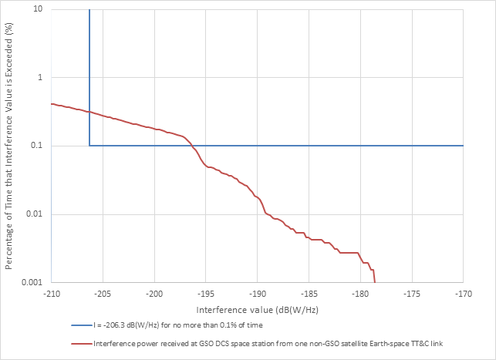

**b) One earth station telecommand and a constellation of three NGSO satellites (Study E#2)**

This dynamic analysis assessed the interference power levels of telecommand uplink signals from one earth station which tracks a constellation of three NGSO satellites, with the orbital parameters listed in Table 14 below.

TABLE 14

SOS NGSO satellites orbital parameters

| Orbital altitude (km) | Inclination (degree) | Mean anomaly (degree) | Arg of periapsis (degree) | Right ascension of the ascending node (degree) | Eccentricity |
| --- | --- | --- | --- | --- | --- |
| 600 | 98 | 0 | 0 | 0 | 0 |
| 600 | 98 | 120 | 0 | 0 | 0 |
| 600 | 98 | 240 | 0 | 0 | 0 |

Figure 10 compares the interference thresholds from Recommendation ITU-R SA.1163 with the interference signal power levels from the simulation. The red line indicates the interference signal levels received at the GSO DCS satellite receiver from the telecommand uplink signals of the Earth station of the NGSO satellite. The blue line indicates the protection criteria, −206.3 dB(W/Hz) not be exceeded for more than 0.1% of the time. The interference levels exceed the protection criteria for 0.95% of the entire simulation time.

Figure 10

Uplink telecommand interference signal levels from NGSO satellites’ earth station   
into GSO DCS satellite receiver

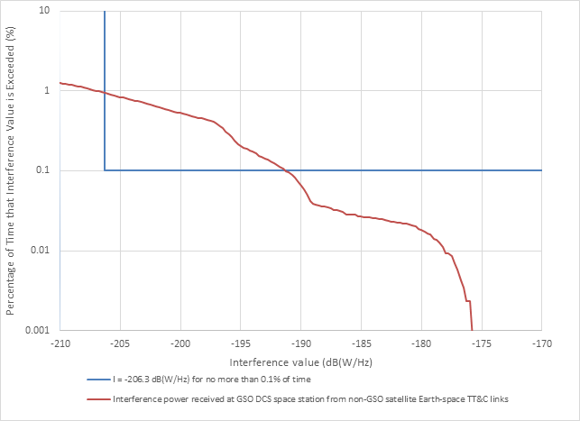

**c) One earth station telecommand and a constellation of fifty NGSO satellites (Study E#3)**

This dynamic analysis assessed the interference of telecommand uplink signals from one earth station which tracks a constellation of fifty NGSO satellites, with orbital parameters listed in Table 15 below.

TABLE 15

SOS NGSO satellites orbital parameters

| Orbital Plane No. | No. of satellites in this plane | Orbital altitude (km) | Inclination (degree) | Mean anomaly (degree) | Arg of periapsis (degree) | Right ascension of the ascending node (degree) | Eccentricity |
| --- | --- | --- | --- | --- | --- | --- | --- |
| 1 | 10 | 600 | 98 | Using a uniform distribution | | | 0 |
| 2 | 20 | 600 | 98 | Using a uniform distribution | | | 0 |
| 3 | 20 | 600 | 98 | Using a uniform distribution | | | 0 |

The simulation lasted a period of 30 days with time-increment of 10 seconds. Figure 11 compares the interference thresholds from Recommendation ITU-R SA.1163 with the interference signal power levels from the simulation. The red line indicates the interference signal levels received at the GSO DCS satellite receiver from the telecommand uplink signals of the Earth station of the NGSO satellite. The blue line indicates the protection criteria, −206.3 dB(W/Hz) not be exceeded for more than 0.1% of the time. The interference levels exceed the protection criteria by 29 dB for 7.32% of the entire simulation time.

Figure 11

Uplink telecommand interference signal levels from NGSO satellites’ earth station   
into GSO DCS satellite receiver

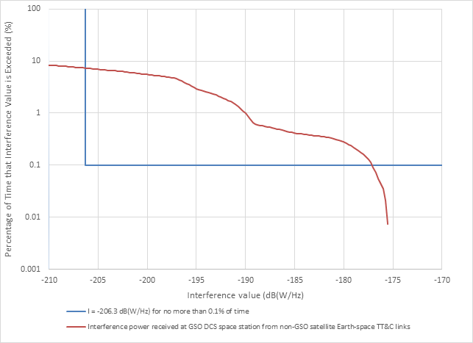

**d) Dynamic analysis of interference from multiple SOS NGSO earth stations (E-s) transmissions into GSO DCS satellite receiver (Study E#4)**

This dynamic analysis assessed the interference power levels of uplink telecommand signals from three earth stations which track a constellation of 175 non-GSO satellites, into the GSO DCS satellite receiver over a period of 30 days with time increment of 10 seconds. The GSO DCS satellite, located at 75°W was studied.

The orbital parameters of a constellation of 175 NGSO satellites are listed in Table 16 below.

TABLE 16

SOS NGSO satellites orbital parameters

| Orbital Plane No. | No. of satellites in this plane | Orbital altitude (km) | Inclination (degree) | Mean anomaly (degree) | Arg of periapsis (degree) | Right ascension of the ascending node (degree) | Eccentricity |
| --- | --- | --- | --- | --- | --- | --- | --- |
| 1 | 32 | 650 | 0 | Using a uniform distribution | | | 0 |
| 2 | 32 | 650 | 51.6 | Using a uniform distribution | | | 0 |
| 3 | 32 | 650 | 20 | Using a uniform distribution | | | 0 |
| 4 | 79 | 650 | 98 | Using a uniform distribution | | | 0 |

The coordinates of the three earth stations are listed in Table 17. The telecommand earth stations track the NGSO satellites with minimum 5-degree elevation then select the satellite with the highest elevation.

TABLE 17

Coordinates of NGSO telecommand earth stations

| Telecommand earth station location No. | Latitude | Longitude |
| --- | --- | --- |
| 1 | 39°N | 77°W |
| 2 | 37.8°N | 122.8°W |
| 3 | 7.3°S | 36.6°W |

The earth station telecommand antenna used in the analysis is a directional antenna with the antenna pattern for the GRUS NGSO telecommand earth station as shown in Fig. 4, which is a high gain and narrow beamwidth antenna. The maximum e.i.r.p. density of the telecommand signal is assumed to be −12.6 dB(W/Hz).

Figure 12 compares the interference thresholds from Recommendation ITU-R SA.1163 with the interference signal power levels from the simulation. The red line indicates that the interference signal levels received at the GSO DCS satellite receiver from the telecommand uplink signals of the earth stations to the NGSO satellites. The blue line indicates the protection criteria, −206.3 dB(W/Hz) not be exceeded for more than 0.1% of the time. The interference levels exceed the protection criteria by 30.6 dB and 41.8% of the time.

FIGURE 12

Uplink telecommand interference signal levels into GSO DCS satellite receiver from NGSO satellites’ earth stations with telecommand signal e.i.r.p. density at −12.6 dB(W/Hz)

FIGURE 13

Uplink telecommand interference signal levels into GSO DCS satellite receiver from NGSO satellites’ earth stations with telecommand signal e.i.r.p. density at 2 dB(W/Hz)

A similar analysis was performed to assess the interference from the telecommand signals with higher e.i.r.p. density levels. This analysis assumed 2 dB(W/Hz) of the maximum e.i.r.p. density of the telecommand signal while the other parameters remain the same. Figure 13 depicts the results of the analysis that the interference levels exceed the protection criteria by 45 dB and 100% of the time.

Another analysis was performed to assess the interference from the telecommand signals with a different type of telecommand antenna used for the frequency band 401-403 MHz, while the other parameters remain the same. Antenna model filed for GHGSAT-D is used this analysis, which pattern is also shown in Fig. 6. The e.i.r.p. density of the telecommand earth station signal is kept as −12.6 dB(W/Hz). Figure 14 depicts the results of the analysis that the interference levels exceed the protection criteria by 33 dB and 99.8% of the time.

FIGURE 14

Uplink telecommand interference signal levels into GSO DCS satellite receiver from NGSO satellites’ earth stations with telecommand signal e.i.r.p. density at −12.6 dB(W/Hz) and GHGSAT-D antenna

**e) Summary of study E**

The analyses show that the levels of interference from the NGSO satellites’ earth station uplink telecommand signals into the GSO DCS satellite receiver would significantly exceed the relevant ITU-R thresholds for all interference cases. In the case of multiple telecommand earth stations tracking a constellation of satellites, the amount of exceedance and time of exceedance is much higher than a single telecommand earth station. Also, except the last analysis, all the other analyses used the high gain and narrow beamwidth telecommand antenna. If a wider beamwidth telecommand antenna is used, while maintaining the same e.i.r.p. density, then the amount of exceedance and time of exceedance is much higher.

#### 6.2.2.2 Compatibility studies of SOS NGSO (E-s) transmissions into NGSO DCS (E-s)

The static and dynamic analyses were performed to assess the interference impact on NGSO DCS satellite receiver. The protection criteria is −197.9 dB(W/(m2·Hz)) maximum aggregate acceptable spfd at the antenna of a NGSO EESS/MetSat DCS instrument for broadband noise interference, not be exceeded for more than 1% of time in the field of view of the satellite. This is equivalent to −209.3 dB(W/Hz) into the satellite receiver.

##### 6.2.2.2.1 Static analysis (Study F)

The technical parameters of the Telecommand Earth station listed in Table 8 with bandwidth of 9 120 Hz are used in the analysis. Table 18 shows the results of the interference power levels from a SOS NGSO system (E-s) into NGSO DCS satellite receiver.

TABLE 18

Interference power level calculation results from a NGSO satellite’s earth station telecommand (Earth-to-space) into NGSO DCS satellite receiver

| Parameter | Value | Units |
| --- | --- | --- |
| **NGSO Earth station telecommand** |  |  |
| Frequency | 401.78 | MHz |
| Transmit power | 10 | dBW |
| Tx antenna gain | 20 | dBi |
| Tx line loss | 3 | dB |
| Earth station e.i.r.p. | 27 | dBW |
| Bandwidth | 9 | kHz |
| Earth station e.i.r.p. power density | −12.6 | dB(W/Hz) |
| **NGSO DCS satellite** |  |  |
| Altitude | 824 | km |
| Inclination | 98.6 | degree |
| NGSO DCS spacecraft antenna gain | 4.9 | dBi |
| Free space path loss | 142.8 | dB |
| Received interference power at NGSO DCS spacecraft antenna | −150.5 | dB(W/Hz) |
| Rec. ITU-R SA.2044 Protection criteria (no more than 1% of the time) | −209.3 | dB(W/Hz) |
| **Exceedance** | **58.8** | **dB** |

As Table 18 shows, a single interfering telecommand uplink signal from a NGSO satellite’s Earth station into the NGSO DCS satellite receiver may exceed the protection criteria by over 58 dB.

##### 6.2.2.2.2 Dynamic analysis (Studies G and H)

###### 6.2.2.2.2.1 Study G

Dynamic studies were performed to assess the effect of telecommand uplink signals from NGSO satellites’ Earth station into the NGSO DCS satellite receiver over a period of 7 days with time increment of 10 seconds. The coordinates of the Earth station are assumed at 35.715°N, 139.758°E. The technical parameters of the telecommand Earth station are as listed in Table 8 with bandwidth of 9120 Hz. The Earth station antenna used in the analysis is directional antenna with the antenna pattern for the GRUS NGSO telecommand Earth station as shown in Fig. 4. The parameters of telecommand space station antenna of NGSO satellite is as listed in Table 8. The telecommand Earth station is tracking the NGSO satellites with minimum 5 degree elevation then pick the satellite with the highest elevation. Dynamic simulations confirm that there is potential for harmful interference.

**a) One Earth station telecommand and a constellation of three NGSO satellites (Study G#1)**

This dynamic analysis assessed the interference of telecommand uplink signals from one Earth station which tracks a constellation of three NGSO satellites, with orbital parameters listed in Table 14.

The results of the analysis are illustrated in Fig. 15. The interference thresholds criterion from Recommendation ITU-R SA.2044 was compared to the interference power levels from the simulation. The red line indicates the interference signal levels received at the NGSO DCS space station receiver from the telecommand uplink signals of the earth stations of NGSO satellites. The blue line indicates the protection criteria, −209.3 dB(W/Hz) not be exceeded for more than 1% of the time. The interference levels exceed the protection criteria for 1.6% of the entire simulation time.

Figure 15

Uplink telecommand interference signal levels from NGSO satellites’ earth station   
into NGSO DCS satellite receiver

**b) One earth station telecommand and a constellation of fifty NGSO satellites (Study G#2)**

This dynamic analysis assessed the interference of telecommand uplink signals from one earth station which tracks a constellation of fifty NGSO satellites, with orbital parameters listed in Table 15.

Figure 16 compares the interference thresholds from Recommendation ITU-R SA.2044 with the interference signal power levels from the simulation. The red line indicates the interference signal levels received at the NGSO DCS space station receiver from the telecommand uplink signals of the Earth station of NGSO satellites. The blue line indicates the protection criteria, −209.3 dB(W/Hz) not be exceeded for more than 1% of the time. The interference levels exceed the protection criteria by 23 dB for 4% of the entire simulation time.

Figure 16

Uplink telecommand interference signal levels from NGSO satellites’ earth station   
into NGSO DCS satellite receiver

**c) Dynamic analysis of interference from multiple SOS NGSO earth stations (E-s) transmissions into non-GSO DCS satellite receiver (Study G#3)**

This dynamic analysis assessed the interference power levels of uplink telecommand signals from three earth stations which track a constellation of 175 non-GSO satellites, into the non-GSO DCS satellite receiver over a period of 30 days with time increment of 10 seconds. The orbital parameters of the non-GSO DCS satellite studied are listed in Table 19 below.

TABLE 19

Non-GSO DCS satellite parameters used in the analysis

| Parameter | Value | Units |
| --- | --- | --- |
| Satellite altitude | 824 | km |
| Inclination | 98.6 | degree |
| Eccentricity | 0 |  |
| RAAN | 0 | degree |
| NGSO DCS spacecraft antenna gain | 4.9 | dBi |
| Interference criterion | Recommendation ITU-R SA.2044 | |

The orbital parameters of a constellation of 175 NGSO satellites are as listed in Table 16. The coordinates of the three earth stations are as listed in Table 17. The telecommand earth stations track the NGSO satellites with minimum 5-degree elevation then select the satellite with the highest elevation.

The earth station telecommand antenna used in the analysis is a high gain, narrow beamwidth, directional antenna with the antenna pattern as shown in Fig. 4. The maximum e.i.r.p. density of the telecommand signal is assumed to be 2 dB(W/Hz).

The results of the analysis are illustrated in Fig. 17. It compares the interference thresholds from Recommendation ITU-R SA.2044 with the interference signal power levels from the simulation. The red line indicates the interference signal levels received at the NGSO DCS satellite receiver from the telecommand uplink signals of the earth stations of the NGSO satellites. The blue line indicates the protection criteria, −209.3 dB(W/Hz) not be exceeded for more than 1% of the time. The interference levels exceed the protection criteria by 47 dB and 12.1% of the entire simulation time.

FIGURE 17

Uplink telecommand interference signal levels from NGSO satellites’ earth stations   
into NGSO DCS satellite receiver

**d) Summary of Study G**

The analyses show that the levels of interference from the NGSO satellites’ Earth station uplink telecommand signals into the NGSO DCS satellite receiver would significantly exceed the relevant ITU-R thresholds for all interference cases. In the case of multiple telecommand earth stations tracking a constellation of satellites, the amount of exceedance and time of exceedance is much higher than a single telecommand earth station. Also, the analyses used the high gain and narrow beamwidth telecommand antenna. If a wider beamwidth telecommand antenna is used, while maintaining the same e.i.r.p. density, then it would result in more interference.

###### 6.2.2.2.2.2 Study H

A dynamic simulation was performed to assess the effect of Earth-space signals from NGSO GRUS satellites to NGSO EESS/MetSat spacecraft receivers.

API/A/11947 (BRIFIC 2845) describes the NGSO GRUS constellation: 50 satellites are planned in total. For this compatibility analysis, only one GRUS satellite is used and the corresponding Earth transmitting station is located in Japan (139E15, 35N42). The altitude of the satellites equal 575 km and the inclination is 98°. The minimum elevation angle is 5 degrees. The earth station has an output power of 10 W (bandwidth of 9 120 Hz) and the antenna has a maximum gain of 20 dBi (the antenna pattern of the GRUS earth station is shown in Fig. 4 to track the corresponding NGSO GRUS satellite. A feeder loss of 3 dB is used. Therefore, the maximum e.i.r.p., is 27 dBW or 502 W.

According to Recommendation ITU-R SA.2044, the interference threshold not to be exceeded for more than 1% of time in the field of view of the NGSO EESS/MetSat DCS satellite is −197.9 dB(W/m2/Hz). The NGSO EESS/MetSat satellite has an altitude of 835 km and has an inclination of 99 degrees.

The following Fig. 18 shows the result of the simulation: the cumulative density function is computed according to the received pfd in dB(W/m2/Hz).

Figure 18

Received power in the NGSO EESS/MetSat DCS satellite in frequency band 401-403 MHz



According to this Figure, the interference threshold is exceeded by about 34 dB. Therefore, it appears that sharing is not feasible between a possible NGSO telecommand link and NGSO EESS/MetSat DCS satellite within the frequency band 401-403 MHz. In addition, it is to be noted that this simulation has been conducted using only one satellite. Since 50 satellites are planned for GRUS, the simulation conducted using a higher number of satellites would result in a more negative margin.

### 6.2.3 Summary of interference analysis from telecommand operations to GSO and non‑GSO DCS satellites receivers

Tables 20 and 21 summarize the results of interference analyses of telecommand operations to GSO and non-GSO DCS satellites receivers in the frequency bands 399.9-400.05 MHz and 401‑403 MHz respectively.

TABLE 20

Analysis summary for 399.9-400.05 MHz frequency band from § 6.2.1

| Analysis | | | Protection criteria exceedance (dB) | Protection criteria exceedance time | Antenna Model | Telecommand earth station e.i.r.p. (dBW) | Telecommand earth station e.i.r.p. density (dB(W/Hz)) | Number of telecommand earth station | Number of non-GSO satellites being tracked |
| --- | --- | --- | --- | --- | --- | --- | --- | --- | --- |
| **Interference from non-GSO telecommand signals to non-GSO MSS satellite receiver** | | | | | | | | | |
| Static | A | | 50.4 | N/A | GRUS antenna | 18 | −21 | 1 | 1 |
| Dynamic | | B | 18 | 4% | GRUS antenna | 18 | −21 | 1 | 101 |
| C | 20 | N/A | GRUS antenna | 18 | −21 | 1 | 1 |

TABLE 21

Analysis summary for 401-403 MHz frequency band from § 6.2.2

|  |  |  |  |  |  |  |  |  |  |  |  |  |
| --- | --- | --- | --- | --- | --- | --- | --- | --- | --- | --- | --- | --- |
| Analysis | | | Protection criteria exceedance (dB) | Protection criteria exceedance time | | Antenna Model | Telecommand earth station e.i.r.p. (dBW) | Telecommand earth station e.i.r.p. density (dB(W/Hz)) | | Number of telecommand earth stations | Number of non-GSO satellites being tracked | |
| Interference from non-GSO telecommand signals to GSO DCS satellite receiver | | | | | | | | | | | | |
| **Static** | **D** | | 30.7 | N/A | GRUS antenna | | 27 | −12.6 | | 1 | 1 | |
| **Dynamic** | **E** | **Study 1** | 10 | 0.4% | GRUS antenna | | 27 | | −12.6 | 1 | | 1 | |
| **Study 2** | 15 | 0.95% | GRUS antenna | | 27 | | −12.6 | 1 | | 3 | |
| **Study 3** | 29 | 7.32% | GRUS antenna | | 27 | | −12.6 | 1 | | 50 | |
| **Study 4** | 30.6 | 41.8% | GRUS antenna | | 27 | | −12.6 | 3 | | 175 | |
| 45 | 100% | GRUS antenna | | N/A | | 2 | 3 | | 175 | |
| 33 | 99.8% | GHGSAT-D antenna | | 27 | | −12.6 | 3 | | 175 | |
|  | | | | | | | | | | | | |
| **Interference from non-GSO telecommand signals to non-GSO DCS satellite receiver** | | | | | | | | | | | | |
| **Static** | **F** | | 58.8 | N/A | GRUS antenna | | 27 | | −12.6 | 1 | | 1 | |
| **Dynamic** | **G** | **Study 1** | 13 | 1.6% | GRUS antenna | | 27 | | −12.6 | 1 | | 3 | |
| **Study 2** | 23 | 4% | GRUS antenna | | 27 | | −12.6 | 1 | | 50 | |
| **Study 3** | 47 | 12.1% | GRUS antenna | | N/A | | 2 | 3 | | 175 | |
| **H** | | 34 | N/A | GRUS antenna | | 27 | | −12.6 | 1 | | 50 | |

### 6.2.4 Interference mitigation to GSO DCS satellite receivers

Annexes A, B, C and D consider different assessments regarding the GSO arc avoidance mitigation technique to mitigating potential interference from NGSO satellites’ earth station uplink telecommand signals into GSO DCS satellite receivers.

# 7 Summary of Analysis

## 7.1 Use of e.i.r.p. to establish limits

The parameters provided in § 5, have been used to derive a relevant set of limits for earth stations in the MSS in the frequency band 399.9-400.05 MHz and EESS and MetSat services in the frequency band 401-403 MHz, based on and are consistent with current and future DCS characteristics. Table 22 presents summary of e.i.r.p. values for the systems described in this Report.

TABLE 22

e.i.r.p. limit for DCS

|  |  |  |  |  |
| --- | --- | --- | --- | --- |
|  | | Frequency band (MHz) | System | Peak e.i.r.p. (dBW) |
| non-GSO  (LEO and MEO) | | 399.9-400.05 | System 1 (ARGOS) | 4.8 |
| System 2  (Magnitude Space) | 5 |
| System 3 (Fleet Space Technologies*)* | 5 |
| 401-403 | System 1 (A-DCS) | 7 |
| System 2 (Brazilian) | 3 |
| System 3 (ICARUS) | −24 |
| System 4  (Meteor-3M) | 12 |
| GSO and HEO | 401-403 | | System 1  (IDCS and RDCS) | 22 |
| System 2 (GOES) | 17 |
| System 3 (FENGYUN) | 19 |
| System 4 (JMA) | 16 |
| System 5 (GSO) | 18 |
| System 6 (HEO ARCTICA-M) | 18 |

## 7.2 Use of e.i.r.p. density to establish limits

In view of the different e.i.r.p. and bandwidth used by the satellite systems to meet their telecommand requirements, that are higher than the e.i.r.p. limits provided in § 7.1, consideration was given to establish e.i.r.p. density limits in these bands.

As shown in Tables 23 and 24, while the e.i.r.p. densities for some non-GSO DCS and MSS systems in the band 399.9-400.05 MHz seem comparable, there are larger differences in the e.i.r.p. densities among the satellite systems considered here. Similarly, large differences are observed between e.i.r.p. density levels of satellite systems in 401-403 MHz bands.

Above information implies that if any e.i.r.p. density limits are to be established, they should ensure continued operation of the existing operating satellite systems, while encouraging future systems to be designed towards use of a more harmonized e.i.r.p. density parameters and or plan deployment of mitigation techniques to ensure proper coexistence of the various types of carriers used in these systems providing different functions essential for operation of satellites.

TABLE 23

Peak e.i.r.p. and peak e.i.r.p. density limit for DCS

|  |  |  |  |  |
| --- | --- | --- | --- | --- |
|  | Frequency band (MHz) | System | Peak e.i.r.p (dBW) | Peak e.i.r.p. density (1) (dB(W/Hz)) |
| non-GSO (LEO and MEO) | 399.9-400.05 | System 1 (ARGOS) | 4.8 | −31 |
| System 2  (Magnitude Space) | 5 | −46.8 |
| System 3 (Fleet Space Technologies*)* | 5 | −37.6 |
| 401-403 | System 1 (A-DCS) | 7 | −31.1 |
| System 2 (Brazilian) | 3 | −27.8 |
| System 3 (ICARUS) | −24 | −83.5 |
| System 4  (Meteor-3M) | 12 | −23 |
| GSO and HEO | 401-403 | System 1  (IDCS and RDCS) | 22 | −4 |
| System 2 (GOES) | 17 | −13.8 |
| System 3 (FENGYUN) | 19 | −7 |
| System 4 (JMA) | 16 | −10 |
| System 5 (GSO) | 18 | −8 |
|  |  | System 6  (HEO ARCTICA-M) | 18 | −8 |
| (1) This calculation of peak e.i.r.p. density is based on an assumption of a uniform distribution of the e.i.r.p. over the whole bandwidth and therefor is not representative of the maximum peak e.i.r.p. density in every Hz. | | | | |

TABLE 24

Peak e.i.r.p. and peak e.i.r.p. density limit for telecommand

|  |  |  |  |
| --- | --- | --- | --- |
| System | | Peak e.i.r.p. (dBW) | Peak e.i.r.p. density (dB(W/Hz)) |
| non-GSO in band 399.9-400.05MHz | EV9 | 36 | −10 |
| M3MSAT | 17.8 | −24 |
| ADS(MSS) | 4.4 | −27.4 |
|  | System 1 (Fleet Space Technologies | 18* | N/A |
| non-GSO in band  401-403 MHz | System 5 (GRUS NGSO EESS) | 27 | −17.8 |
|  | GHGSAT | 39 | −6.4 |
| * Under normal mode. This value may be exceeded by up to 14 dB under emergency mode, for short periods only during emergency situations | | | |

# 8 Conclusions

## 8.1 Studies regarding the e.i.r.p. limits

In the frequency band 401-403 MHz, according to on-going ITU-R studies, in practice, for non‑GSO satellite networks, the values of output power range from −3 dBW (bandwidth of 800 Hz) up to 7 dBW (bandwidth of 6 400 Hz). In some applications, the power may decrease down to −25 dBW using specific techniques such as Spread Spectrum Multiple Access.

For specific bands within 401-403 MHz satellite uplink e.i.r.p. for DCS low Earth orbiting (LEO) systems could reach 12 dBW for existing non-GSO MetSat system (i.e. Meteor-3M). The maximum value of the corresponding antenna gain is below 3 dBi, and in practice the antenna gain does not exceed 0 dBi. The antennas are most of time omnidirectional and whip antennas are used. Thus, any additional use, other than for DCS, of this limited and unique spectrum resource for DCS systems would have to blend in with appropriate power levels such that the reception of signals from data collection platforms at the satellite receivers is not interfered.

For GSO networks, it can be noted that the International Data Collection System (IDCS) of the DCP is based on the usage of GSO satellites, and the e.i.r.p. at the antenna output shall not exceed 22 dBW under any combination of operational conditions. The transmitted radio frequency shall use the 11 IDCS channels (with center frequencies spaced 3 kHz apart), from 402.034-402.067 MHz regardless of the GSO spacecraft. Other GSO channels are reserved for DCP, and there are various types of DCP transmitters in operation generally ranging from 5 W, 10 W, and 20 W output power with a directional antenna, or 40 W or even higher output power with an omnidirectional antenna. The resulting uplink e.i.r.p. is between 6 and 22 dBW. Highly elliptical orbit (HEO) DCS systems are based on the orbits with apogee of 40 000 km, which makes their characteristics similar to characteristic of the GSO DCP. For DCP’s operating with HEO satellites (ARCTICA-M), uplink e.i.r.p. would not exceed 16-18 dBW.

Given the significant difference in the power level ranges of non-GSO data collection platforms compared to platforms communicating to GSO MetSat and EESS satellites, as outline above, the establishment of e.i.r.p. limits will have to differentiate between non-GSO (LEO and medium Earth orbit (MEO)) and GSO/HEO DCS in the 401-403 MHz frequency band.

In this respect, the establishment of an appropriate set of in-band e.i.r.p. limits in the 401‑403 MHz band will have to take into account the framework set forth by the general partitioning in Recommendation ITU-R SA.2045 to ensure the protection of existing and future use of meteorological operations (MetSat and EESS (Earth-to-space)) in the 401-403 MHz frequency band for both non-GSO (LEO and MEO) and GSO/HEO DCS systems.

This Report contains the technical characteristics and results of current ITU-R studies for in-band power limits applicable to the earth stations in the MSS in the frequency band 399.9-400.05 MHz and the MetSat and the EESS in the frequency band 401‑403 MHz. The Report shows that the power limits for the earth stations operating in the EESS and MetSat in the frequency band 401‑403 MHz are based on two categories: GSO/HEO and non-GSO (LEO and MEO). Regarding the MSS in the frequency band 399.9-400.05 MHz, since this band is limited to non-GSO, only one set of limit for DCS is necessary, noting that these limits will not support associated space operation functions.

The conclusion of this Report (see Tables 25 and 26 below) are that the earth station maximum e.i.r.p. for non-GSO DCS systems in the MSS in the frequency band 399.9-400.05 MHz, and both GSO and non-GSO DCS systems in the MetSat and the EESS in the frequency band 401-403 MHz, shall comply with the following conditions:

TABLE 25

|  |  |
| --- | --- |
| Frequency band | Maximum e.i.r.p. of the earth stations |
| 399.9‑400.05 MHz | 5 dBW |

TABLE 26

|  |  |  |
| --- | --- | --- |
| Frequency band | Maximum e.i.r.p. of the earth stations | |
| 401‑403 MHz | GSO/HEO | 22 dBW |
| non-GSO (MEO and LEO) | 7 dBW(1) |
| (1) The maximum e.i.r.p for existing non-GSO MetSat system in the 401.898‑402.522 MHz can be increased up to 12 dBW. | | |

The telecommand earth station maximum e.i.r.p. for associated space operation functions in the frequency band 399.9-400.05 MHz is 18 dBW under normal mode of operation, but this value may be exceeded by up to 14 dB under emergency mode, for short periods only, during emergency situations.

## 8.2 Studies regarding the e.i.r.p. density limits

This report contains the technical characteristics and results of current ITU-R studies for in-band power limits applicable to the MetSat and the EESS in the frequency band 401-403 MHz and associated telecommand links in these bands.

One study indicated that the associated e.i.r.p. density for the GSO systems deployed in 401‑403 MHz frequency band could be used, however, it is important to take into account the requirement for coexistence of different types of carriers operating within these frequencies, including telecommand operations, while ensuring protection of DCS systems through use of various methods including mitigation measures. Mitigation methods could be further developed and captured in ITU-R Recommendations, as appropriate. Table 27 provides the limits that may be imposed on different types of operations in the band of interest to ensure efficient and proper use of this band and fall within the range of e.i.r.p. density used by current systems. It has to be noted that these values are only consistent with the telecommand links.

TABLE 27

|  |  |  |
| --- | --- | --- |
| Frequency band | Maximum e.i.r.p. density of the earth stations | |
| 401–403 MHz | GSO/HEO DCS | 2 dB(W/Hz) |
| non-GSO (MEO and LEO) DCS | −27 dB(W/Hz)(1) |
| (1) The maximum e.i.r.p density for existing non-GSO MetSat system in the 401.898‑402.522 MHz can be increased up to −20 dB(W/Hz) | | |

Regarding the non-GSO space operation service (SOS), the maximum e.i.r.p. density of the earth stations is −5 dB(W/Hz).

This study indicated that the associated e.i.r.p. density for the GSO systems deployed in 401‑403 MHz frequency band could be between −25.8 to 2 dB(W/Hz), suggesting a range of 28 dB (e.i.r.p. range of 5 to 22 dBW). This wide range is indicative of the earth stations deployed in this band use of links based on wide range of e.i.r.p. and/or bandwidth parameters. Furthermore, for non-GSO satellite DCS systems in this band, the values of typical earth stations e.i.r.p. densities range between −35 to −20 dB(W/Hz) or an e.i.r.p. range of −3 to 13 dBW (excluding ICARUS system). For the telecommand links described in this Report, the peak e.i.r.p. density ranges from −17.8 to −6.4 dB(W/Hz) or an e.i.r.p. range of 27 to 39 dBW. Given the larger differences in the e.i.r.p. density level ranges of non-GSO data collection platforms compared to platforms communicating to GSO MetSat and EESS satellites, as outline above, the establishment of e.i.r.p. density limits will have to differentiate between non-GSO (LEO/MEO) and GSO/HEO DCS in the 401-403 MHz frequency band.

It should be noted that these e.i.r.p. densities figures were derived assuming a uniform spectrum shape of carriers. On the basis of this analysis, this study proposes the following e.i.r.p. density limits to be considered under this agenda items:

TABLE 28

|  |  |
| --- | --- |
| GSO/HEO DCS | 2 dB(W/Hz) |
| non-GSO SOS | 2 dB(W/Hz) |
| non-GSO (MEO and LEO) DCS | −27 dB(W/Hz) |

It should be noted that using these e.i.r.p. densities for DCS and SOS applications, the resulting e.i.r.p. figures would be much larger for SOS applications, due to their large bandwidth. The above proposal was not supported by sharing analysis to confirm that they would allow protection of DCS systems.

## 8.3 Studies regarding potential mitigation techniques

Some mitigation techniques have been proposed considering the use of angle avoidance technique and high-gain antenna (see Annexes A, B and C).

Annex D also provides discussion regarding the elements contained in Annex A and Annex B.

Views were expressed that proposed mitigation technique, introducing avoidance angle towards DCS satellites to be applied for transmitting Telecommand earth stations was based on specific scenarios (small number of ES with specific locations, limited orbit constellations), as well as input parameters (ES antenna pattern with fast roll-off side-lobes performance), which wouldn’t represent general case and would be practically inapplicable for future satellite systems, representing large constellations.

Another view was also expressed that in the 401-403 MHz frequency band the proposed mitigation technique could provide opportunity for efficient use of spectrum for systems with specific telecommand earth stations for future systems considering use of such techniques in their systems design, including use of EESS/MetSat telecommand satellite ground stations with narrow beamwidth antennas.

# 9 Abbreviations

A-DCS Advanced data collection system

ARGOS A satellite-based DCS system

BER Bit error rate

B-PCD Brazilian data collection platform

BPSK Binary phase shift keying

CDMA Code division multiple access

dBi Ratio of antenna gain relative to an isotropic antenna in decibels

dBW power ratio relative to one watt in decibels

DCP Data collection platform

DCS Data collection system

DRGS Direct readout ground station

Eb/N0 ratio of energy per bit (Eb) to the spectral noise density (N0)

EESS Earth exploration satellite service

e.i.r.p. equivalent isotropic radiated power

GMSK Gaussian minimum shift keying

GOES Geostationary operational environmental satellites

GSO Geostationary-satellite orbit

G/T Ratio of the antenna gain-to-system noise temperature

HADS Hydrometeorological automated data system

HEO Highly elliptical orbit

ICARUS International cooperation for animal research using space

IDCS International data collection system

kcps kilochips/second

LEO Low earth orbit

MetSat Meteorological satellite

MEO Medium earth orbit

MSS Mobile satellite service

NRZ Non-return to zero

non-GSO Non-geostationary satellite orbit

PCM Pulse code modulation

PM Phase modulation

PSK Phase shift keying

QPSK Quadrature phase shift keying

RDCS Regional data collection system

spfd Spectral power flux density

TT&C Telemetry, tracking and command

Annex A  
  
Use of high-gain antenna and orbit avoidance technique as mitigation measures (Study 1)

## A.1 Introduction

This Annex A describes the result of study focusing on the NGSO EESS satellite systems (see Table A-2) using the frequency bands of 401.2-401.3 MHz and 401.7-401.899 MHz for telecommand from associated earth stations. This study analyses interference from those telecommand earth stations of the NGSO EESS satellite systems towards NGSO DCS satellite receivers and demonstrates introducing the avoidance angle as mitigation measures can be effective for those NGSO satellite systems to comply with sharing criteria.

## A.2 NGSO telecommand characteristics and information of the satellites

Table A-1 shows the link budget of GRUS NGSO EESS uplink. Figure A-1 shows radiation pattern of directional antenna of GRUS NGSO EESS earth station that tracks the space craft during operation. Figure A-2 shows simplified relative gain model that masks Fig. A-1 antenna pattern. Table A-2 shows a list of NGSO EESS satellite systems that is under operation or to be brought into use in the near future. Associated earth stations that are used for operations for those satellite systems are listed in Table A-3.

TABLE A-1

Link Budget of GRUS NGSO EESS

|  |  |  |  |
| --- | --- | --- | --- |
|  |  | Value | Units |
| Earth station (tx) | Centre frequency | 401.78 | MHz |
| Transmitting power | 6* | dBW |
| Antenna gain | 20 | dBi |
| Tx line loss | 3 | dB |
| e.i.r.p. | 23 | dBW |
| Max. e.i.r.p. power density | −16.6 | dB(W/Hz) |
| Max. duty ratio | 0.5 | N/A |
| Space & Earth loss | Orbit altitude | 575 | km |
| Min. elevation | 5 | degree |
| Slant range | 2 268.3 | km |
| Space loss | 151.6 | dB |
| Polarization loss | 3.2 | dB |
| Atmospheric loss | 2.1 | dB |
| Space station (rx) | S/C antenna gain | -6 | dBi |
| System noise temperature | 800 | K |
| Rx line loss | 0.5 | dB |
| *G*/*T* | −35.5 | dB/K |
| Link analysis | *C*/*N*0 | 59.1 | dB-Hz |
| Bit rate | 9.6 | Kbit/s |
| Modulation | GFSK | N/A |
| Available *Eb*/*N*0 | 19.2 | dB |
| Required *Eb*/*N*0 (BER=10-4) | 13.4 | dB |
| Implementation loss | 2 | dB |
| Link margin | 3.8 | dB |
| * Under normal operations; this value may be exceeded by up to 10 dB under emergency mode, for short periods only when satellites are in emergency situations. | | | |

FIGURE A-1

Antenna pattern of GRUS NGSO EESS telecommand earth station

地図 が含まれている画像

高い精度で生成された説明

FIGURE A-2

Numerical model of relative gain antenna pattern mask of GRUS NGSO EESS telecommand earth station



TABLE A-2

List of Japanese NGSO EESS satellites that use 401-403 MHz band   
for telecommand operation

|  |  |  |  |  |  |  |
| --- | --- | --- | --- | --- | --- | --- |
| **ITU filing name** | Num. of satellites | Centre frequency | Altitude | LTAN | Launch | Estimated end of Operation |
| PRISM2 | 1 | 401.05 MHz | 800 km | 15:00 | Nov. 2013 | Mar. 2024 |
| HODOYOSHI | 2 | 401.78 MHz | 500 km  /600 km | 23:00  /11:30 | Nov. 2014  /Jul. 2017 | Dec. 2025 |
| GRUS (1) | 3 | 401.7-401.899 MHz | 550 km | 11:30 | Dec. 2018 | Dec. 2025 |
| MSTD | 1 | 401.7-401.899 MHz | 500 km | 21:30 | Dec. 2018 | Dec. 2020 |
| TRICOM-1 (2) | 1 | 401.05 MHz | 180-1 500 km | N/A | Feb. 2018 | Aug. 2018 |
| SPRITE-SAT | 1 | 401.25 MHz | 660 km | 13:00 | Jan. 2009 | Jan. 2019 |
| RISE-SAT | 1 | 401.25 MHz | 630 km | 12:00 | May 2014 | May 2024 |
| JCUBES-A (3) | 1 | 401.25 MHz | 613 km | 13:00 | Oct. 2018 | Oct. 2028 |
| JCUBES-B (3) | 5 | 401.25 MHz | 613 km  /500 km | 13:00  /21:00 | Oct. 2018  /Dec. 2018 | Oct. 2028  /Dec. 2028 |
| SPATIUM (4) | 1 | 401.25 MHz | 400 km | N/A (deployed from ISS) | Aug. 2018 | Dec. 2019 |
| (1) Only the first three out of 50 constellation of GRUS satellites use 401.7-401.899 MHz band for telecommand operation.  (2) TRICOM-1 is expected to re-enter into the atmosphere in August 2018.  (3) JCUBES-A and B use S-band for main telecommand. Telecommand operation in 401.25 MHz will only be used when the satellites are in emergency.  (4) Only the first one out of 10 constellation of SPATIUM satellites use 401.25 MHz for telecommand operation. | | | | | | |

TABLE A-3

List of Japanese NGSO telecommand Earth stations that use 401-403 MHz band

|  |  |  |  |
| --- | --- | --- | --- |
| Earth station | Longitude | Latitude | Operating satellites |
| ISSL TOKYO UHF | 139E 45’29” | 35N 42’ 54” | HODOYOSHI, GRUS, MSTD, TRICOM-1 |
| WNI-MTG | 140E 02’ 30” | 35N 39’ 06” | PRISM2, HODOYOSHI |
| CRESS | 140E 50’ 10” | 38N 15’ 29” | SPRITE-SAT, RISE-SAT, JCUBES-A, JCUBES-B |
| KIT | 130E 50’ 26” | 33N 53’ 28” | SPATIUM |

## A.3 Interference mitigation technique by orbital avoidance

In order to mitigate interference from NGSO telecommand uplink towards DCS satellite receivers,mitigation technique of orbital avoidance is introduced, which is widely adopted in a number of ITU-R Recommendations.

As shown in Fig. A-3, the avoidance angle  is defined as angle between main beam axis of telecommand Earth station that points NGSO satellite and a victim DCS satellite that receives interference. Telecommand Earth station suspends uplink transmission when the avoidance angle  is within the range that interference level at DCS satellite receiver input exceeds sharing criteria.

FIGURE A-3

Interference mitigation by orbital avoidance

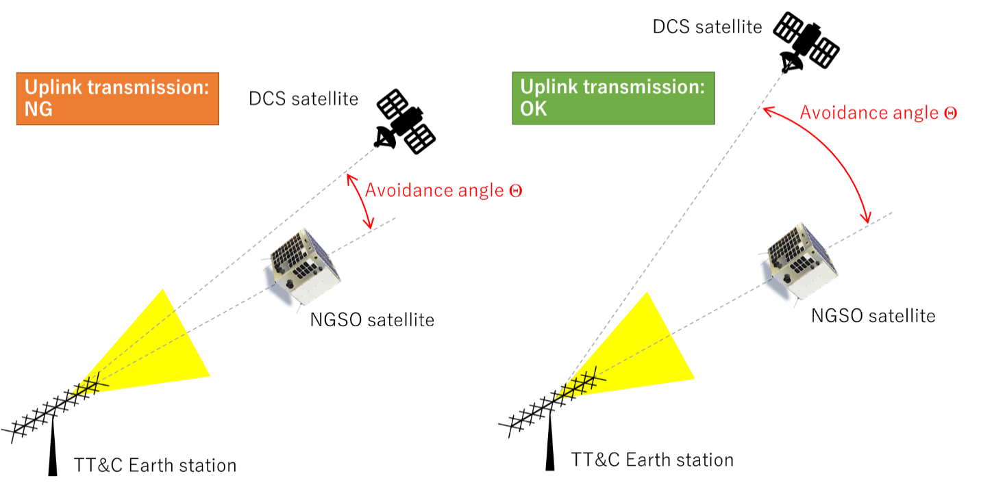

## A.4 Static Analyses

Assuming that the NGSO satellite’s earth station is located at 0 degree of latitude and the same longitude as the GSO DCS satellite, it would result in the shortest free space propagation loss between the NGSO satellite’s earth station and GSO DCS satellite. The technical parameters of the telecommand earth station listed in Table A-1 and Fig. A-2 antenna model are used in the analysis. Table A-4 shows the results of static interference analysis from a NGSO satellite’s earth station uplink telecommand signal into the GSO DCS satellite receiver.

The short-term interference criteria in Recommendation ITU-R SA.1164, −87.7 dBW per 100 Hz (equivalent to −207.7 dB(W/Hz)) specified at the input of the satellite receiver is used in this analysis.

TABLE A-4

Results of static interference analysis from a NGSO satellite’s telecommand earth station uplink into GSO DCS satellite receiver

| Parameter | Value | Units |
| --- | --- | --- |
| Frequency | 401.78 | MHz |
| GSO satellite altitude (shortest range between GSO and Earth station located at latitude 0 degree) | 35 786 | km |
| Free space loss between Earth station and GSO satellite | 175.6 | dB |
| Earth station transmit power | 6 | dBW |
| Earth station antenna gain | 20 | dBi |
| Tx line loss | 3 | dB |
| Earth station e.i.r.p. | 23 | dBW |
| Earth station e.i.r.p. power density | −16.6 | dB(W/Hz) |
| GSO spacecraft antenna gain | 13.8 | dBi |
| Rec ITU-R SA.1164 Interference criteria (no more than 0.025%) | −207.7 | dB(W/Hz) |
| Interfering signal at GSO satellite receiver  (avoidance angle  =0 degree) | −178.4 | dB(W/Hz) |
| Interfering signal at GSO satellite receiver  (38 < || < 147 degrees or 153 < || < 170 deg.) | −210.4 | dB(W/Hz) |
| Exceed interference criteria (avoidance angle  =0 degree) | 29.3 | dB |
| Exceed interference criteria (38 < || < 147 degrees or 153 < || < 170 degrees) | −2.7 | dB |

As Table A-4 shows, interference level of telecommand uplink from a single NGSO Telecommand Earth station into GSO DCS satellite receiver can comply with the protection criteria with orbital avoidance even in case of shortest free space loss.

## A.5 Dynamic analysis

Dynamic studies were performed to assess the effect of uplink telecommand signals from NGSO satellites’ Earth station into the GSO DCS satellite receiver over a period of 30 days from 1 January to 31 January 2017 with time increment of 1 second. The coordinates of the earth station are assumed at 35.715°N, 139.758°E. The technical characteristics of the telecommand earth station are as listed in Table A-1 with antenna pattern model of Fig. A-2. The telecommand earth station is tracking the NGSO satellites with minimum elevation angle of 5 degree. The assumed GSO DCS satellites, HIMAWARI-8 (140.7E), FENGYUN4A (99.5E), METEOSAT7 (57.7E), which are visible from the assumed NGSO earth station, were studied.

Results of dynamic simulations showed that there is potential for harmful interference without any mitigation technique. But by introducing orbital avoidance, interference level can comply with sharing criteria defined in Recommendations ITU-R SA.1163 and ITU-R SA.1164.

**a) One Earth station telecommands vs one NGSO satellite**

This analysis assumes that one earth station tracks one NGSO satellite. The short-term interference criteria in Recommendation ITU-R SA.1164, −187.7 dBW per 100 Hz (equivalent to −207.7 dB(W/Hz)) specified at the input of the satellite receiver is used in this analysis.

Figure A-4 shows the simulation results of interference signal levels received at the GSO DCS satellite receivers from the telecommand uplink signals of the Earth station of the NGSO satellite without orbital avoidance, compared with the protection criteria, −207.7 dB(W/Hz) not be exceeded for more than 0.025% of the time. Without orbital avoidance, the interference levels exceed the protection criteria for 0.15% of the entire simulation time at the worst.

Figure A-4

Uplink telecommand interference signal levels from one NGSO satellite’s earth station   
into GSO DCS satellite receiver without orbital avoidance

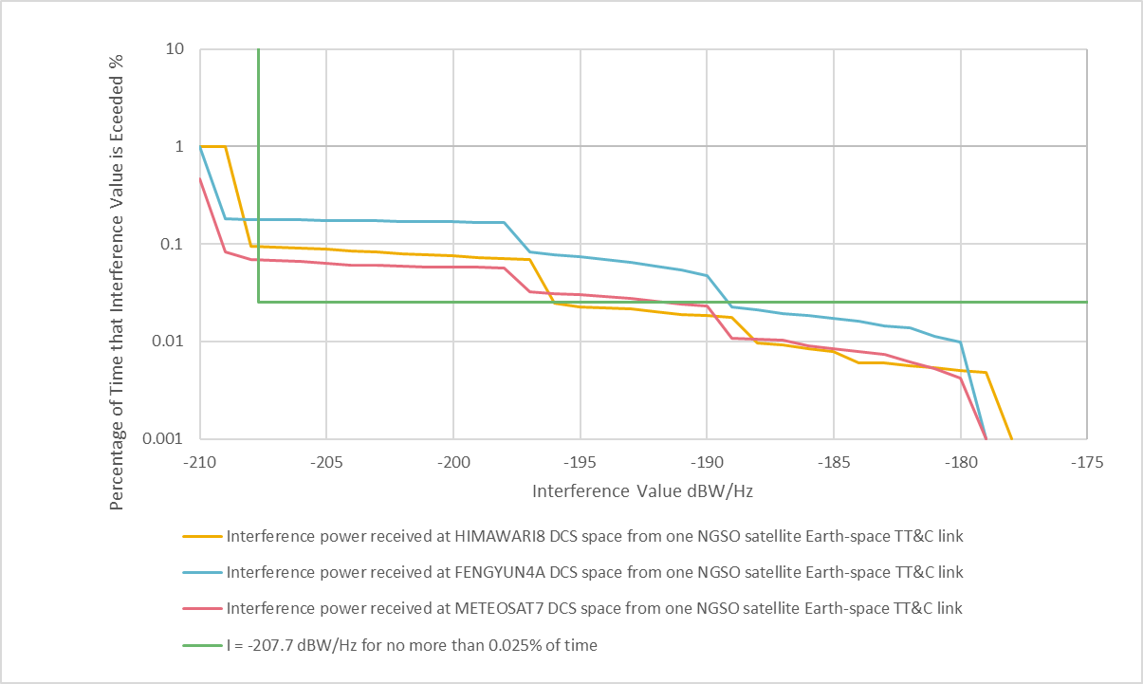

To mitigate interference, orbital avoidance as described in § A.3 is introduced in the dynamic simulation. Uplink transmission from telecommand Earth station is enabled only when the avoidance angle is within the range of 38 < || < 170 degrees. Figure A-5 compares the interference thresholds from Recommendation ITU-R SA.1164 with the interference signal power levels from the simulation with orbital avoidance. As shown in the Figure, the interference levels satisfy the protection criteria.

Figure A-5

Uplink telecommand interference signal levels from one NGSO satellites’ earth station   
into GSO DCS satellite receiver with orbital avoidance

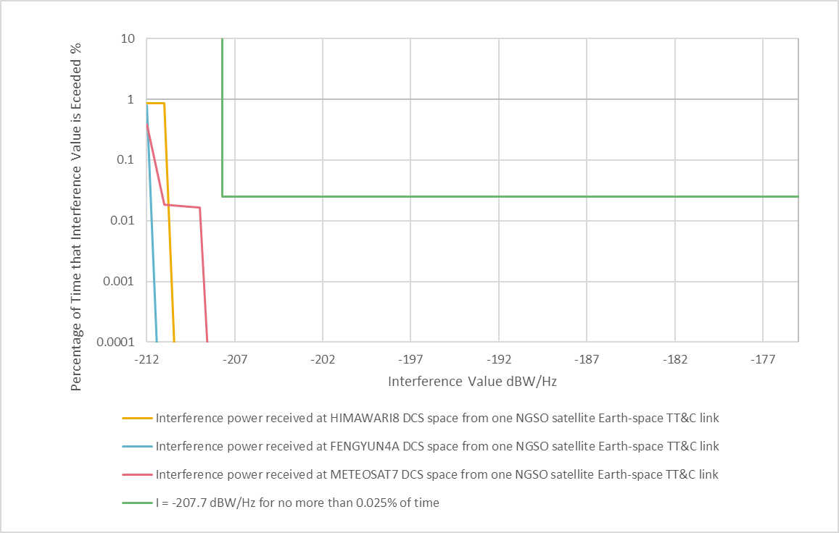

**b) Multiple Earth stations telecommand vs multiple NGSO satellites**

This dynamic analysis assessed the interference of telecommand uplink signals from Japanese earth stations which tracks associated NGSO satellites as described in Table A-3. Among the Japanese NGSO satellites listed in Table A-2, total 10 satellites based on Table A-2 are taken into account for this analysis. Although these NGSO satellites, associated earth stations and the above mentioned GSO DCS satellites use multiple DCS frequency bands and rarely transmit telecommands simultaneously in reality, this study assumes that all of them use the same GSO DCS band for worst case analysis.

The simulation lasted a period of 30 days with time-increment of 1 second. Figure A-6 compares the interference thresholds from Recommendation ITU-R SA.1163 with the interference signal power levels from the simulation. The lines indicate the interference signal levels received at the GSO DCS satellite receiver from the telecommand uplink signals of the earth station of the NGSO satellite. The green line indicates the protection criteria, −206.3 dB(W/Hz) not be exceeded for more than 0.1% of the time. The interference levels can comply with the protection criteria with the same orbital avoidance as described in a) of this section.

Figure A-6

Uplink telecommand interference signal levels from NGSO satellites’ Earth station   
into GSO DCS satellite receiver

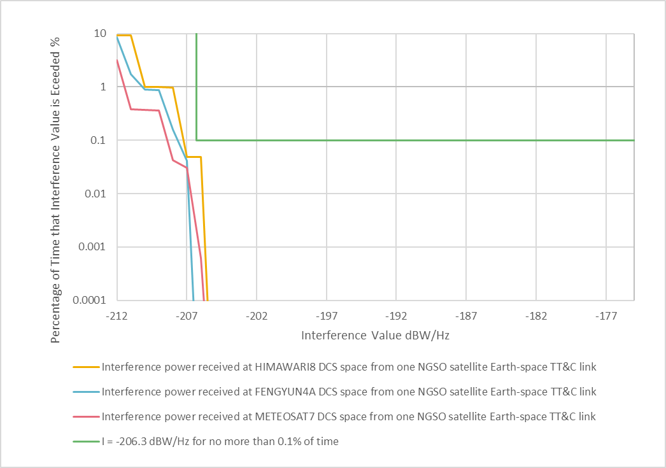

## A.6 Summary

The analyses show that the levels of interference from the NGSO satellites’ earth station uplink telecommand signals into the GSO DCS satellite receiver can comply with Recommendations ITU‑R SA.1163 and ITU-R SA.1164 protection criteria with proposed mitigation technique of orbital avoidance.

Based on these technical analyses, interference from telecommand earth stations of Japanese NGSO ESSS satellite systems into GSO DCS satellite receivers can comply the relevant ITU-R protection criteria by introducing the avoidance angle Ɵ, measured from telecommand NGSO Earth station antenna pointing direction towards GSO DCS satellites. By limiting telecommand uplink transmission from NGSO earth station only when the avoidance angle Ɵ is out of range of e.i.r.p. towards GSO DCS satellites exceeds interference criteria.

Most of the existing NGSO satellite systems of Japanese administration use frequencies in the bands 401.2‑401.3 MHz and 401.7-401.899 MHz for telecommand, which are overlapped with the frequency partitioning for GSO DCS under Recommendation ITU-R SA.2045. For the earth stations telecommanding these existing Japanese NGSO satellite systems, the application of the abovementioned orbital avoidance angle is considered effective and can allow the telecommand earth stations of these Japanese NGSO ESSS satellite systems to continue their operation.

Annex B  
  
Use of high-gain antenna and orbit avoidance technique as mitigation measures (Study 2)

As stated in § 1, the objective of this agenda item is to consider establishing, within the Radio Regulations, in-band power limits applicable to earth stations in the frequency bands above in order to ensure the operation of existing and future systems that usually implement low or moderate output powers for EESS, MetSat and MSS systems. The interference protection criteria given in Recommendations ITU-R SA.2044 for MetSat and EESS non-GSO systems in 401-403 MHz band and in ITU-R M.2046 for non-GSO MSS in the band 399.9-400.05 MHz requires very low values of pfd for non‑GSO DCS systems (-197 dB(W/m2Hz)) and the power density of Recommendation ITU‑R SA.1163 (−187.4 dB(W/100 Hz)) for GSO DCS. Regardless of any power limits for earth stations, they are likely to be exceeded and interference mitigation as discussed in this section will be required to ensure protection of the DCS systems. Interference mitigation practices can allow for non-GSO MSS/ESSS telecommand satellite uplinks to share the 399.9-400.05 MHz and 401‑403 MHz frequency bands with non-GSO and GSO DCS satellites.

In the following sections, some proposed mitigation measures are described which require further study to develop details for such measures and their deployment to ensure protection of the DCS systems in these bands.

NGSO MSS/EESS telecommand earth stations could use high gain, directional antennas to avoid pointing at other non-GSO DCS satellites during in-line incidents involving the transmitting earth station, desired non-GSO satellite and the interfered-with non-GSO or GSO satellite in order to mitigate interference to non-GSO and GSO DCS satellites.

Non-GSO MSS/EESS telecommand earth station uplinks can reduce interference to GSO and other non-GSO DCS satellites also operating in these frequency bands by using smaller-beamwidth, high‑gain antennas. Additionally, to ensure the interference criteria for non-GSO DCS set forth in Recommendations ITU-R SA.2044 and ITU-R M.2046 is not exceeded for more than 1% of the time in the field of view of a non-GSO DCS satellite, MSS/EESS telecommand uplink operators in the 399.9‑400.05 MHz and 401-403 MHz frequency bands can use predictive RFI conjunction analysis and turn their transmitters off during a predicted in-line event.

Use of high-gain antenna and orbit avoidance technique are discussed further in the following sections.

## B.1 Use of high gain, directional telecommand earth station antenna

As shown in Tables 6 and 8, MSS/EESS telecommand uplink stations that track MSS/EESS satellites normally utilize a 15-20 dBi directional antenna. The directivity of the earth station antenna is beneficial because it decreases interference from MSS/EESS telecommand uplink stations to non-GSO DCS satellites if they are distant in angle from the viewpoint of an earth station.

As a case study, antenna gain from a telecommand earth station (that tracks a non-GSO EESS satellite) toward a non-GSO DCS is simulated under the following conditions.

– Telecommand earth station

• Location: Tokyo, JAPAN

• Directional antenna: simplified pattern as defined in Figure B-1, which masks Fig. B‑1 pattern

– Non-GSO EESS telecommand satellite

• Orbit height: 600 km

• Orbit type: Sun Synchronous Orbit

• Local Time Ascending Node: 11:30

– Non-GSO DCS satellite

• METOP-A

– Simulation period: 1 year from Oct. 15

FIGURE B-1

Simplified antenna pattern of non-GSO EESS telecommand earth station

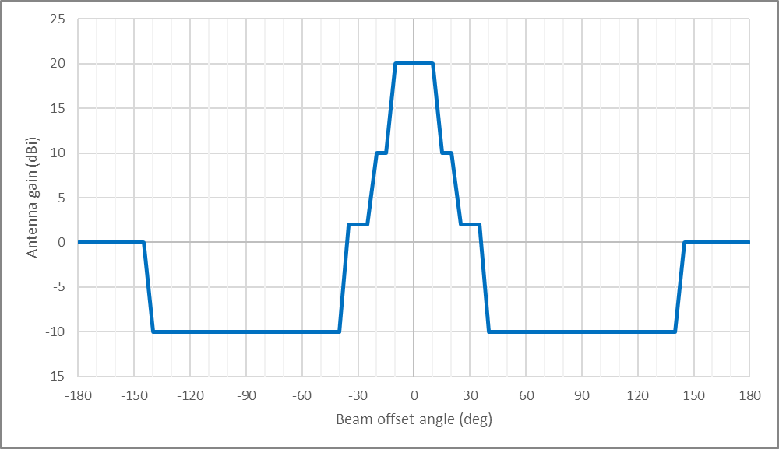

TABLE B-1

Antenna gain toward non-GSO DCS from EESS telecommand earth station

|  |  |  |
| --- | --- | --- |
| Antenna gain | Time (min/year) |  |
| 20 dBi | 29.3 | 2.67% |
| 10 dBi | 51.7 | 4.71% |
| 2 dBi | 93.7 | 8.53% |
| 0 dBi | 148.0 | 13.5% |
| -10 dBi | 775.2 | 70.6% |

Table B-1 shows that directional antenna usage (instead of an omnidirectional antenna) could decrease interference from EESS telecommand uplinks toward non-GSO DCS satellites over 70% of time.

# B.2 Use of predictive RFI in-line analysis

To ensure the protection criteria for non-GSO DCS set forth in Recommendations ITU-R SA.2044 and ITU-R M.2046 is not exceeded for more than 1% of time in the field of view of a non-GSO DCS satellite, MSS/EESS telecommand satellite ground station uplink operators in this frequency band can use predictive RFI in-line analysis and turn their transmitters off during a predicted in-line event.

# B.3 Conclusion

To ensure the protection criteria for GSO DCS set forth in Recommendation ITU-R SA.1163 is not exceeded for more than 0.1% of time at the antenna output of a GSO DCS satellite, EESS telecommand uplink would be required to avoid transmissions towards the GSO DCS satellites. This requirement could be arranged and designed into operation of the telecommand earth station equipment.

Annex C  
  
Use of high-gain antenna and orbit avoidance technique as mitigation measures (Study 3)

## C.1 Dynamic analysis of one SOS NGSO earth station (E-s) transmission into GSO DCS satellite receiver

Dynamic studies were performed to assess the effects of using pointing avoidance to mitigate interference into the GSO DCS satellite receiver. Three cases are analysed: (i) the first is one earth station operating with a constellation of fifty (50) NGSO satellites in a single plane and no interference (GSO arc avoidance) mitigation technique; (ii) the second is one earth station operating with a constellation of fifty (50) NGSO satellites in a single plane and with the earth station avoiding its pointing to the GSO DCS satellite such to meet the interference protection criteria (“IPC”); (iii) the third determines the minimum pointing loss required to meet the IPC. The simulations were over a period of seven (7) days with a time increment of one (1) second. Table C-1 describes the orbital parameters of the NGSO satellite constellation.

TABLE C-1

NGSO satellite constellation orbital parameters

|  |  |  |  |  |  |  |  |
| --- | --- | --- | --- | --- | --- | --- | --- |
| Orbital Plane No. | No. of satellites in plane | Orbital altitude (km) | Inclination (degree) | Mean anomaly (degree) | Arg of periapsis (degree) | RAAN (degree) | Eccentricity |
| 1 | 50 | 650 | 98 | Using a uniform distribution | | | 0 |

The coordinates of the earth station are assumed at 43.54°N, 96.74°W (Sioux Falls, South Dakota, USA). A static interference analysis and the technical parameters of the telecommand earth station are as listed for GRUS in Table C-2 using the transmit power, losses, and antenna gain reported earlier in § 6.1.2, Table 8 and with an emission bandwidth of 30 kHz. This is the same emission bandwidth indicated in the ITU Advanced Publication Information filing for GRUS. The earth station antenna used in the analysis is a 20 dBi gain directional antenna with the antenna gain pattern as shown in Fig. 4. For the dynamic interference analysis studies, the telecommand earth station is tracking the NGSO satellites with a minimum 5-degree elevation, and RFI conjunctions with the GOES West satellite located at 135°W were studied.

TABLE C-2

Interference power calculation results from an NGSO satellite earth station   
telecommand signal (Earth-to-space) into GSO DCS satellite receiver

| Parameter | GRUS | Units |
| --- | --- | --- |
| Frequency | 401.78 | MHz |
| GSO satellite altitude | 35786 | km |
| Minimum Slant range between GOES West DCS and the NGSO earth station | 38894 | km |
| Free Space loss between earth station and GSO DCS satellite | 176.3 | dB |
| Earth station transmit power | 10 | dBW |
| Earth station antenna gain | 20 | dBi |
| Tx Line loss | 3 | dB |
| Earth station e.i.r.p. | 27 | dBW |
| Emission bandwidth | 30 | kHz |
| Earth station e.i.r.p. density | −17.8 | dB(W/Hz) |
| GSO spacecraft antenna gain | 13.8 | dBi |
| Interfering signal at GSO satellite receiver | −180.3 | dB(W/Hz) |
| Rec. ITU-R SA.1163 Interference criteria (no more than 0.1% of the time) | −206.3 | dB(W/Hz) |
| Exceed interference criteria | 26.0 | dB |

## C.2 One earth station telecommands fifty NGSO satellites without and with pointing avoidance

This analysis assumes that one earth station tracks fifty (50) NGSO satellites. Figures C-1 and C-2 compares the interference thresholds from Recommendation ITU-R SA.1163 with the interference signal power levels from the simulation for the case of without pointing avoidance (no interference mitigation) and with pointing avoidance (mitigating interference) respectively. The red line indicates the interference signal levels received at the GSO DCS satellite receiver from the telecommand uplink signals of the earth station of the NGSO satellite. The blue line indicates the protection criteria, -206.3 dB(W/Hz), which should not be exceeded for more than 0.1% of the time. For the case of without pointing avoidance, Fig. C-1 shows the interference levels exceed the protection criteria for 33.5% of the entire simulation time. For the case of with pointing avoidance, the green line in Fig. C-2 shows the interference levels meet the protection criteria the entire simulation time. The pointing avoidance in this case (Fig. C-2) means the earth station will stop transmissions whenever it is pointed to the GSO satellite within 40 degrees (just past the second sidelobe).

Figure C-1

Uplink telecommand interference signal levels from one NGSO satellite earth station tracking fifty satellites into GSO DCS satellite receiver with no earth station pointing avoidance

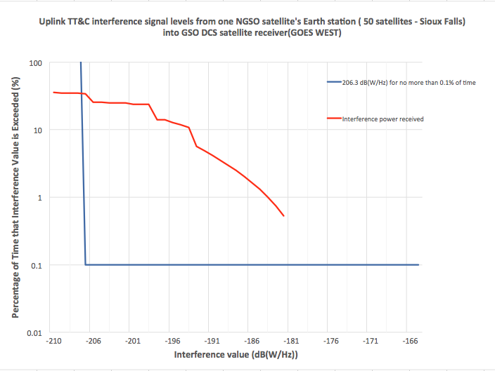

Figure C-2

Uplink telecommand interference signal levels from one NGSO satellite earth station tracking fifty satellites into GSO DCS satellite receiver with earth station pointing avoidance

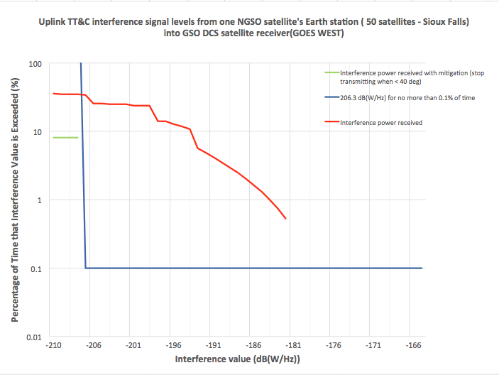

The simulation time in this study was only seven days. The simulation time needs be expanded to at least 30 days to ensure adequate samples of all beam alignments

The protection criteria in the Recommendation ITU-R SA.1163 is the aggregate interference criteria. Annex D only studied one earth station scenario. It needs to expand its study to include multiple earth stations and multiple constellations for a comprehensive assessment of the interference mitigation technique. Also, the studies in Annex D used an assumed antenna pattern which is based on an antenna filed by the GRUS mission and is included as an alternative analysis in this Report.

## C.3 Determine the minimum requirement to meet the interference protection criteria for the case of fifty NGSO satellites operating at one earth station

A dynamic study for the case of fifty (50) satellites operating with one earth station was performed using the minimum pointing avoidance angle such to just meet the IPC for the GSO DCS satellite receiver. Several hypothetical antenna off-axis pointing losses are shown and the lines that miss an intersection with the blue line represent protection criteria being met as shown in Fig. C-3. It was found that at −26 dBc relative gain (yellow line) the protection criteria for the GSO DCS is minimally met.

Figure C-3

Uplink telecommand interference signal levels from one NGSO satellite’s earth station into GSO DCS satellite receiver with minimum earth station pointing loss

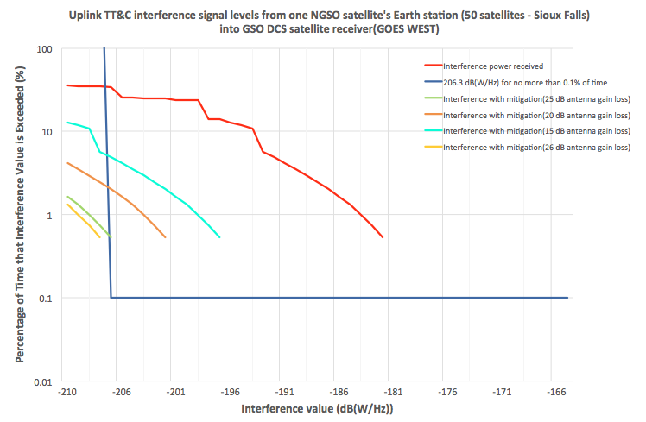

## C.4 Summary

Table C-3 (below) summarizes the results of the interference analysis from the NGSO telecommand operations into the GOES GSO DCS satellite receiver.

In all cases the earth station transmit power is 27 dBW e.i.r.p., −17.8 dB(W/Hz) e.i.r.p. density, and the earth station antenna gain is 20 dBi. The analyses show that the levels of interference from the NGSO satellites’ earth station uplink telecommand signals into the GOES GSO DCS satellite receiver without mitigation in addition to the limited e.i.r.p. density and the high gain GRUS antenna pattern would significantly exceed the relevant ITU-R thresholds for all interference cases. In the case where the NGSO earth station avoids pointing at the GOES West GSO DCS satellite sufficient for the antenna off-axis loss to reduce levels into the GSO DCS receivers to meet the relevant ITU-R thresholds for interference exceedance, interference is avoided. This pointing avoidance mitigation is shown to work for the case of limited e.i.r.p. density of −17.8 dB(W/Hz), the high gain GRUS antenna pattern and fifty NGSO satellites in a single plane operating with a single NGSO earth station.

TABLE C-3

Interference analysis summary from §§ C.1 to C.3

|  |  |  |  |  |  |  |  |  |
| --- | --- | --- | --- | --- | --- | --- | --- | --- |
| Analysis | | IPC  exceedance (dB) | IPC exceedance time | Antenna Model | ES stop transmit pointing angle | ES stop transmit pointing loss  (dB) | Number of earth stations | Number of NGSO satellites being tracked |
| **Interference from NGSO earth station telecommand signals into GSO satellite receiver** | | | | | | | | |
| Static | | 26.0 | N/A | GRUS antenna | N/A | N/A | 1 | 1 |
| Dynamic | Study  C.1  (C-1) | 26.0 | 33.5% | GRUS antenna | 0 | 0 | 1 | 50 |
| Study  C.2  (C-2) | 0 | 0% | GRUS antenna | 40 | 32 | 1 | 50 |
| Study  C.3  (C-3) | 0 | 0% | GRUS antenna | n/a | 26 | 1 | 50 |

The studies in Annex C emulate the constellation scenario with 50 satellites and one earth station as described in Table C-2 and does not replicate Annex C for the case of 175 satellites at three earth stations. Other scenarios need to be studied.

The study in Annex C only studied the interference affects to the GOES West DCS satellite located at 135°W. There are many other DCS satellites in operations which may need further analysis.

Annex D  
  
Discussion regarding the elements contained in Annexes A and B

This study provides a number of comments and additional analysis regarding the analysis contained in Annexes A and B It addresses the interference issues of earth station telecommand operations (Earth-to-space) interfering with the GSO and non-GSO satellite receivers in the frequency band 401-403 MHz within the EESS and MetSat services.

It is noted that many EESS and MetSat satellite systems that operate telecommand functions under RR No. **1.23** do not operate EESS and MetSat applications within the 401-403 MHz frequency band. They only use this frequency band for telecommand function purposes.

## D.1 Interference power calculations at GSO DCS satellite receiver in the frequency band 401-403 MHz

Table D-1 calculates the interference power from a non-GSO satellite’s earth station telecommand signal (Earth-to-space) into the GSO DCS satellite receiver. The technical parameters of the telecommand earth station for GRUS and GHGSAT-D listed in Table 8 are used in the analysis. In addition, the telecommand earth station e.i.r.p. density limit of 2 dBW listed in Table 28 is used here.

TABLE D-1

Interference power calculation results from a NGSO satellite’s earth station telecommand signal (Earth-to-space) into GSO DCS satellite receiver

| Parameter | GRUS | GHGSAT-D | From Table 28 | Units |
| --- | --- | --- | --- | --- |
| **Frequency** | **401.78** | **401.78** | **401.78** | **MHz** |
| GSO satellite altitude | 35786 | 35786 | 35786 | km |
| Slant range between GSO and earth station at GSO 5-degree elevation angle | 41119 | 41119 | 41119 | km |
| Free Space loss between earth station and GSO satellite | 176.8 | 176.8 | 176.8 | dB |
| Earth station transmit power | 10 | 21 | N/A | dBW |
| Earth station antenna gain | 20 | 19 | N/A | dBi |
| Tx Line loss | 3 | 1 | N/A | dB |
| Earth station e.i.r.p. | 27 | 39 | N/A | dBW |
| Earth station e.i.r.p. power density | −12.6 | −6.4 | 2 | dB(W/Hz) |
| GSO spacecraft antenna gain | 13.8 | 13.8 | 13.8 | dBi |
| Interfering signal at GSO satellite receiver | −175.6 | −169.4 | −161 | dB(W/Hz) |
| Rec ITU-R SA.1163 Interference criteria (no more than 0.1% of the time) | −206.3 | −206.3 | −206.3 | dB(W/Hz) |
| Exceed interference criteria | 30.7 | 36.9 | 45.3 | dB |

The analysis shows that the telecommand signals from the non-GSO satellites’ telecommand earth stations would cause significant interference into the GSO DCS satellite receiver and exceed the relevant ITU-R thresholds.

## D.2 Telecommand earth station antennas used in the frequency band 401‑403 MHz

In Annex A, interference mitigation technique orbital avoidance was studied with a high gain, narrow beamwidth telecommand antenna. However, it is noted that a typical earth station telecommand antenna used in the frequency band 401-403 MHz has relatively lower gain, much wider beamwidth, and higher side-lobes.

Figures D-1 through D-6, for comparison, provide examples of antenna patterns filed with ITU for the earth station telecommand operations in the frequency band 401-403 MHz.

Figure D-1

GRUS telecommand earth station antenna

地図 が含まれている画像

高い精度で生成された説明

Figure D-2

Sprite-Sat telecommand earth station antenna from API/A/4638

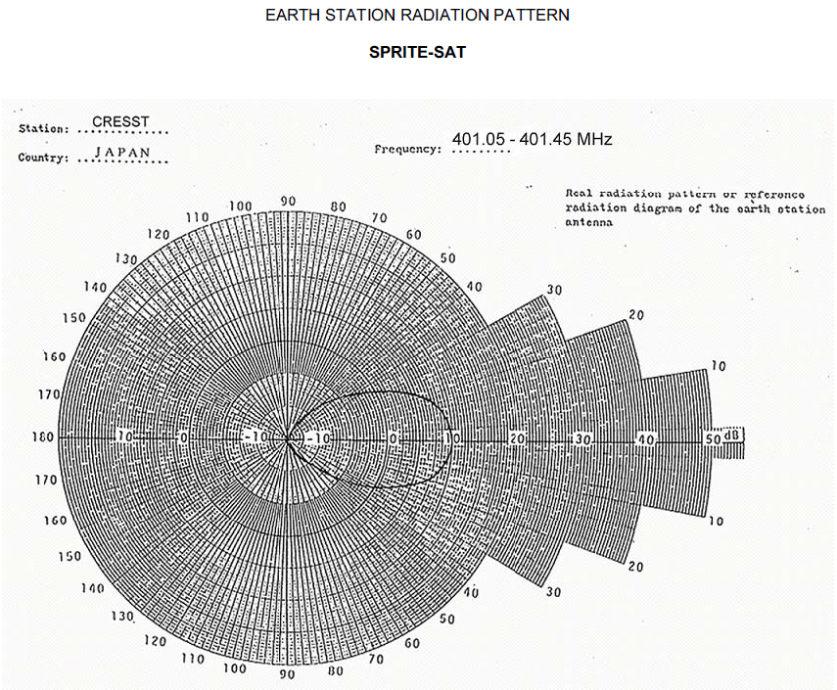

Figure D-3

GHGSAT-D telecommand earth station antenna



Figure D-4

M2 antenna

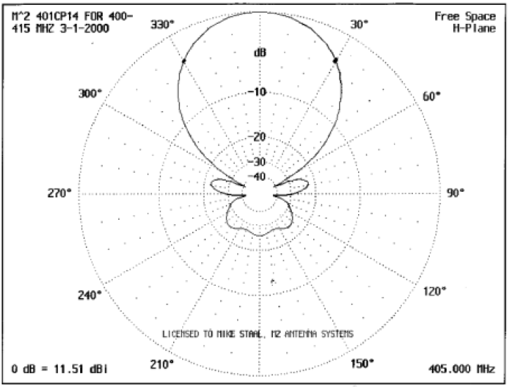

Figure D-5

Telecommand earth station antenna UHF1 from API/A/12127

Phi 0 degrees Phi 90 degrees

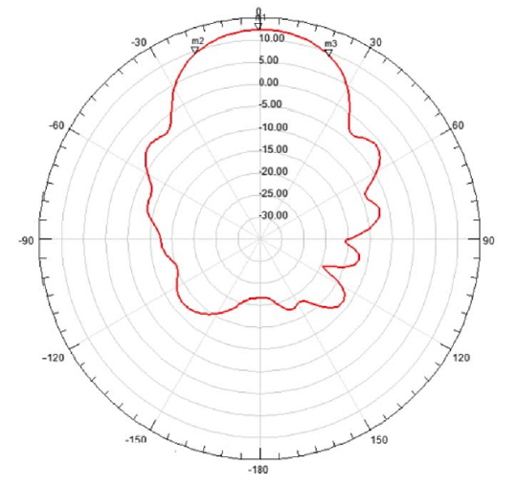 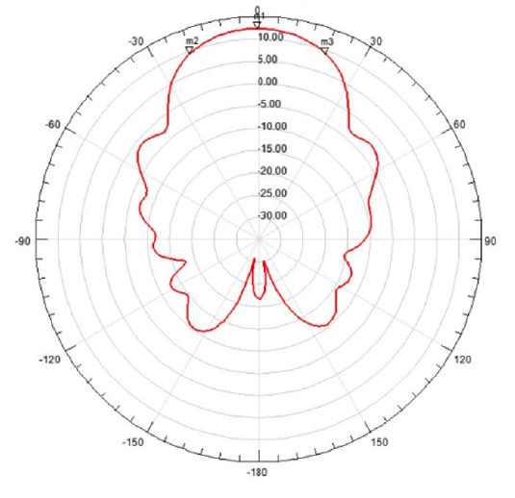

Figure D-6

Telecommand earth station antenna UHF2 from API/A/12127

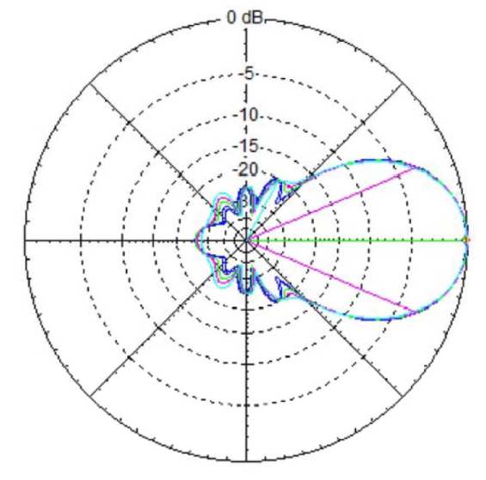

Table D-2 compares the characteristics of the telecommand antenna patterns depicted above. It shows that the 3-dB beamwidth of most of the antennas is in the range of 35 to 60 degrees, about twice to almost four times of the beamwidth of telecommand antenna filed for the GRUS system. This would result in a much wider angle of avoidance than that studied in Annex A. Table D-2 also shows that most of the antenna side lobes are about 20 dB below the maximum gain of their main lobe. This means that a typical telecommand antenna is limited to the capability of reducing a maximum 20 dB of interference when implementing the orbital avoidance mitigation technique, which avoids main beam-to-main beam transmissions and only point the side lobes of the telecommand antenna to the GSO DCS satellite. However, as shown in the interference calculations in Table D-1 and Table 21, the amount of interference exceedance from non-GSO telecommand operations into the GSO DCS satellite receiver can range from 30.7 dB to 45.3 dB. Therefore, a typical telecommand antenna would not be able to mitigate the amount of interference using the orbital avoidance technique without additional measures taken.

TABLE D-2

Comparison of the characteristics of telecommand antennas filed for the 401-403 MHz frequency band

| Antenna | Max. gain (dBi) | Side lobe level  (dB below the max. gain) | 3-dB beamwidth (degree) | First null beamwidth (degree) |
| --- | --- | --- | --- | --- |
| GRUS | 20 | 30 | 16 | 30 |
| SPRITE-SAT | 10 | 20 | 32 | 100 |
| GHGSAT-D | 15.7 | 20 | 35 | 65 |
| M2 | 11.5 | 22 | 60 | 125 |
| UHF1 antenna from API/A/12127 | 13.5 | 18 | 46.2 | 80 |
| UHF2 antenna from API/A/12127 | 12.4 | 20 | 38 | 100 |

## D.3 Summary for GSO DCS

Taking into account the analyses above, the non-GSO satellites telecommand uplink operations in the frequency band 401-403 MHz are not compatible with the existing GSO EESS and MetSat services. The mitigation technique using orbital avoidance would not provide sufficient protection without additional measures to ensure the normal operations of GSO EESS and MetSat services, such as the DCS systems. The non-GSO SOS power limit listed in Table 28 would cause significant interference to the operations of DCS systems.

## D.4 Interference mitigation to non-GSO DCS satellite receivers

Annex B mentions that the interference from non-GSO telecommand uplinks to the non-GSO DCS satellite receivers can be mitigated through use of predictive RFI in-line analysis and turn the telecommand transmitters off during a predicted in-line event. However, more studies exploring this concept and its real-world feasibility are required before they can be considered as a mitigation technique for the EESS/MetSat DCS systems. One inherent issue with this type of mitigation technique is in the critical dependence of discerning the real time location of all EESS/MetSat DCS satellites. The method and responsible governing body for obtaining, managing, and distributing the EESS/MetSat DCS position data would need to be identified for this approach. This method should also not place undue constraints on the current and future EESS/MetSat DCS missions which include any requirement for the EESS/MetSat DCS operators to provide this data. Additional studies would be needed to determine the necessary accuracy of the position of EESS/MetSat DCS satellites as well as to determine the size of the avoidance angle to ensure adequate protection. It is also worth noting that no such avoidance system has been implemented successfully with any non-GSO EESS/MetSat DCS system in this band within the ITU. Before these techniques could be considered as a mitigation technique within the ITU, the above-mentioned issues and technical challenges must be studied and addressed.