|  |
| --- |
| **Report ITU-R SA.2426-0**  **(09/2018)** |
| **Technical characteristics for telemetry, tracking and command in the space operation service below 1 GHz for non-GSO satellites with short duration missions** |
| **SA Series**  **Space applications and meteorology** |

Foreword

The role of the Radiocommunication Sector is to ensure the rational, equitable, efficient and economical use of the radio-frequency spectrum by all radiocommunication services, including satellite services, and carry out studies without limit of frequency range on the basis of which Recommendations are adopted.

The regulatory and policy functions of the Radiocommunication Sector are performed by World and Regional Radiocommunication Conferences and Radiocommunication Assemblies supported by Study Groups.

# Policy on Intellectual Property Right (IPR)

ITU-R policy on IPR is described in the Common Patent Policy for ITU-T/ITU-R/ISO/IEC referenced in Annex 1 of Resolution ITU-R 1. Forms to be used for the submission of patent statements and licensing declarations by patent holders are available from <http://www.itu.int/ITU-R/go/patents/en> where the Guidelines for Implementation of the Common Patent Policy for ITU‑T/ITU‑R/ISO/IEC and the ITU-R patent information database can also be found.

|  |  |
| --- | --- |
| Series of ITU-R Reports  (Also available online at <http://www.itu.int/publ/R-REP/en>) | |
| **Series** | Title |
| **BO** | Satellite delivery |
| **BR** | Recording for production, archival and play-out; film for television |
| **BS** | Broadcasting service (sound) |
| **BT** | Broadcasting service (television) |
| **F** | Fixed service |
| **M** | Mobile, radiodetermination, amateur and related satellite services |
| **P** | Radiowave propagation |
| **RA** | Radio astronomy |
| **RS** | Remote sensing systems |
| **S** | Fixed-satellite service |
| **SA** | **Space applications and meteorology** |
| **SF** | Frequency sharing and coordination between fixed-satellite and fixed service systems |
| **SM** | Spectrum management |

|  |
| --- |
|  |

|  |
| --- |
| ***Note****: This ITU-R Report was approved in English by the Study Group under the procedure detailed in Resolution ITU-R 1.* |

*Electronic Publication*

Geneva, 2018

© ITU 2018

All rights reserved. No part of this publication may be reproduced, by any means whatsoever, without written permission of ITU.

REPORT ITU-R SA.2426-0

Technical characteristics for telemetry, tracking and command in   
the space operation service below 1 GHz for non-GSO satellites   
with short duration missions

(2018)

# 1 Introduction

This Report responds to *invites* 1 in Resolution **659 (WRC-15)** described below and contains the technical characteristics for telemetry, tracking and command (TT&C) in the space operations service for non-GSO (NGSO) satellites with short duration missions. These characteristics are intended to inform further studies on the spectrum requirements of short duration missions (see Report ITU-R SA.2425-0) as well as sharing studies carried out in Report ITU-R SA.2427-0.

Short duration missions are understood in this context to have a mission lifetime not exceeding more than three years.

Examples of similar missions are described in Report ITU-R SA.2312, and descriptions of current regulatory practices relating to space network notification are contained in Report ITU‑R SA.2348. It is understood that the number of missions of this category may increase.

A maximum mission lifetime of three years is understood to be typical for these short duration missions. *Resolves* 1.1 of Resolution **4 (Rev.WRC-03)** states that the period of validity “shall be limited to that for which the satellite network was designed”. Furthermore, according to *resolves* 1.2 of this Resolution, a notifying administration has to inform the Bureau more than three years before the expiry of the period of validity if it wishes to extend the period of validity. Therefore, for short duration mission satellites, such extension is not a possibility, and it should be noted that is in line with their typical lifetime.

The term “short duration mission” used in Resolution **659 (WRC-15**) refers to a mission having a limited period of validity of not more than typically three years. Therefore, the term “short duration mission” is not directly tied to the lifetime of the spacecraft. For example, a single spacecraft with a lifetime of less than typically three years, where the operator does not launch a replenishment or replacement spacecraft, is a short duration mission. However, in the case of a (or multiple) spacecraft with a lifetime of less than typically three years, where the operator launches a (or multiple) replenishment or replacement spacecraft(s) such that the operator has a persistent frequency assignments longer than typically three years, is not a short duration mission.

Resolution **659 (WRC-15)** calls to study the spectrum needs for telemetry, tracking and command in the space operation service below 1 GHz for NGSO satellites with short duration missions, to assess the suitability of existing allocations to the space operation service and, if necessary, to consider new allocations.

Resolution **659** **(WRC-15)** *invites ITU-R*:

1 to study the spectrum requirements for telemetry, tracking and command in the space operation service for the growing number of non-GSO satellites with short duration missions, taking into account RR No. **1.23**;

2 to assess the suitability of existing allocations to the space operation service in the frequency range below 1 GHz, taking into account *recognizing a)* and current use;

3 if studies of the current allocations to the space operations service indicate that requirements cannot be met under *invites ITU-R* 1 and 2, to conduct sharing and compatibility studies, and study mitigation techniques to protect the incumbent services, both in-band as well as in adjacent bands, in order to consider possible new allocations or an upgrade of the existing allocations to the space operation service within the frequency ranges 150.05-174 MHz and 400.15‑420 MHz.

# 2 Technical and operational characteristics of non-GSO satellites with short duration missions

The following Tables are applicable only to individual short duration NGSO spacecraft.

## 2.1 Orbital characteristics

Most NGSO satellites with short duration missions are launched into low earth orbit (LEO). Table 1 provides typical orbital characteristics of these satellites.

TABLE 1

Typical orbital characteristics of NGSO satellites with short duration missions

|  |  |  |
| --- | --- | --- |
| Parameter | RR Appendix 4  data element | Value |
| Apogee altitude | A.4.b.4.d | 300-1 000 km |
| Perigee altitude | A.4.b.4.e | 300-1 000 km |
| Angle of inclination of the orbital plane with respect to the Earth’s equatorial plane | A.4.b.4.a | 0-100 degrees |

## 2.2 Technical characteristics specific to the space-to-Earth direction

Report ITU-R SA.2312 provides a number of characteristics related to nanosatellites and picosatellites. Table 1 of Report ITU-R SA.2312 states a mission duration (which is directly linked to the period of validity) of typically less than three years, while Table 4 of the Report states typical RF parameters of bandwidth, antenna gain factors and transmission power.

Table 2 below provides typical characteristics for NGSO satellite networks with short mission duration applicable to the space-to-Earth direction. The value for necessary bandwidth renders the values stated in Report ITU-R SA.2312 (which states less than 100 kHz) more precisely. The value in the Table is based on an analysis of currently filed systems that could be regarded as short duration missions. Moreover, it is in line with available transceivers for these systems, which typically employ data rates of not more than 9.6 kbit/s and a spectral efficiency of at least 0.5 bit/s/Hz. Since the link under discussion should only be used for TT&C and the amount of TT&C data for short duration missions is low, this value should also be suitable for future missions.

TABLE 2

Typical technical characteristics for the use of frequency bands below 1 GHz   
in the space-to-Earth direction

| Parameter | RR Appendix 4 data element | Typical values  at VHF frequencies,  30-300 MHz | Typical values  at UHF frequencies,  300-1 000 MHz |
| --- | --- | --- | --- |
| Necessary bandwidth | C.7 | ≤ 25 kHz | ≤ 25 kHz |
| Space station transmit power delivered to antenna | C.8.a.1 | ≤ 1 W | ≤ 1 W |
| Space station antenna gain | B.3.a.1 | ≤ 3 dBi | ≤ 3 dBi |
| Space station antenna pattern | B.3.c.1 | ND-SPACE | ND-SPACE |
| Space station/earth station tracking antenna pointing loss | N/A | 1 dB | 1 dB |
| Space station antenna type | N/A | Omnidirectional | Omnidirectional |
| Space station antenna polarization | C.6 | Linear | Linear |
| Space station emission mask description (e.g. −3 dB, −20 dB, −60 dB, −80 dB) | N/A | Refer to § 2.5 | Refer to § 2.5 |
| Earth station system noise temperature (including cable loss, filter, etc.) | C.10.d.6 | 1 500 K | 500 K |
| Earth station antenna type | N/A | Yagi-Uda or Parabolic | Yagi-Uda or Parabolic |
| Earth station peak antenna gain | C.10.d.3 | 10-17 dBi;  typically 12 dBi | 10-17 dBi;  typically 16 dBi |
| Earth station antenna pattern | C.10.d.5.a | Rec. ITU-R F.699-7 | Rec. ITU-R F.699-7 |
| Earth station antenna 3 dB beamwidth | N/A | 50 degrees | 30 degrees |
| Earth station antenna polarization | N/A | Circular | Circular |
| Earth station emission mask description (e.g. −3 dB, −20 dB, −60 dB, −80 dB) | N/A | Refer to § 2.5 | Refer to § 2.5 |
| Earth station minimum elevation angle | N/A | 5 degrees | 5 degrees |
| *C*/*N* objective | C.8.e.1 | 12 dB | 12 dB |
| Operational duty cycle during earth station contact | N/A | up to 100% | up to 100% |
| SOS Protection criteria | N/A | Rec. ITU-R SA.363-5 | Rec. ITU-R SA.363-5 |

## 2.3 Technical characteristics specific to the Earth-to-space direction

Table 3 provides typical characteristics for NGSO satellite networks with short mission duration applicable to the Earth-to-space direction.

Note that for the earth station antenna radiation pattern, a pattern according to Recommendation ITU-R F.699 is assumed, furthermore assuming that the antenna is tracking such that the maximum gain is always directed at the satellite associated with that respective earth station.

The space station antennas used for short duration NGSO satellites are typically simple dipole antennas, of which the radiation pattern is typically influenced by the satellite structure and appendages in the antenna’s proximity. A non-directional space station (ND-SPACE) pattern is therefore assumed to cater for the variations in the radiation pattern among short duration NGSO satellites with different structural and antenna configurations.

TABLE 3

Typical technical characteristics for the use of frequency bands below 1 GHz in   
the Earth-to-space direction

| Parameter | RR Appendix 4  data element | Typical values  at VHF frequencies,  30-300 MHz | Typical values  at UHF frequencies,  300-1 000 MHz |
| --- | --- | --- | --- |
| Necessary bandwidth | C.7 | ≤ 25 kHz | ≤ 25 kHz |
| Earth station transmit power delivered to antenna | C.8.a.1 | ≤ 50 W (17 dBW) | ≤ 50 W (17 dBW) |
| Earth station antenna type | N/A | Yagi-Uda or Parabolic | Yagi-Uda or Parabolic |
| Earth station peak antenna gain | C.10.d.3 | 10-17 dBi;  typically 12 dBi | 10-17 dBi;  typically 16 dBi |
| Earth station antenna pattern | C.10.d.5.a | Rec. ITU-R F.699-7  (tracking antenna) | Rec. ITU-R F.699-7  (tracking antenna) |
| Earth station antenna 3 dB beamwidth | N/A | 50 degrees | 30 degrees |
| Earth station antenna polarization | N/A | Circular | Circular |
| Earth station minimum elevation angle | N/A | 5 degrees | 5 degrees |
| Antenna pointing loss | N/A | 1 dB | 1 dB |
| Space station system noise temperature (including cable loss, filter, etc.) | C.5.a | 500-1 000 K | 500-1 000 K |
| Space station antenna gain | B.3.a.1 | ≤ 3 dBi | ≤ 3 dBi |
| Space station antenna pattern | B.3.c.1 | ND-SPACE | ND-SPACE |
| Space station antenna type | N/A | Omnidirectional | Omnidirectional |
| Space station antenna polarization | C.6 | Linear | Linear |
| *C/N* objective | C.8.e.1 | 20 dB | 20 dB |
| Operational duty cycle during earth station contact | N/A | up to 100% | up to 100% |
| SOS Protection criteria | N/A | Rec. ITU-R SA.363-5 | Rec. ITU-R SA.363-5 |

## 2.4 Link budget analysis

The Annex to the present Report contains basic link budget analyses in the space-to-Earth direction for bands around 137 MHz and 400 MHz taking into account the typical characteristics for short duration mission satellites as defined in Tables 2 and 3. Furthermore, link budgets in the Earth‑to‑space direction are provided for a frequency of 148 MHz. As can be seen, the technical characteristics given in Tables 2 and 3 provide for links with positive link margin.

Note – There are no SOS Earth-to-space allocations below 1 GHz that are not subject to RR No. **9.21**. There are allocations to the SOS subject to RR No. **9.21** in the band 148-149.9 MHz as well as in the band 449.750 to 450.250 MHz. Therefore uplink frequencies of 148 and 450 MHz have been assumed as an indicative input parameter for the link budget calculations.

## 2.5 Unwanted emissions

Unwanted emissions consist of out-of-band domain and spurious domain emissions as defined in RR No. **1.146.** In this section, measurements of unwanted emissions on typical space station and earth station transmitters are provided.

### 2.5.1 Out-of-band emissions in the space-to-Earth direction

Figure 16 of Recommendation ITU-R SM.1541 provides an out-of-band emission mask for space research service (SRS), space operations service (SOS) and Earth exploration-satellite service (EESS) systems operating in the space-to-Earth and Earth-to-space directions in bands between 1 GHz and 20 GHz. In the absence of any ITU guidance on out-of-band emission masks below 1 GHz, the mask contained in this Recommendation was used. This mask assumes that the boundary between the out-of-band domain and the spurious domain is at 250% of the necessary bandwidth as recommended by Recommendation ITU-R SM.1539. For a necessary bandwidth of 25 kHz, the boundary thus becomes 62.5 kHz from the centre frequency of the emission. Out-of-band emission measurements have been performed on a typical space station transmitter used on short duration NGSO missions. The measurements were taken at the connection to the transmission line connecting the transmitter to the space station antenna. Figure 1 provides results along with a comparison with the mask contained in Recommendation ITU-R SM.1541.

Figure 1

Measured out-of-band emissions (upper frequency range) in the space-to-Earth direction   
versus out-of-band emission mask from Recommendation ITU-R SM.1541

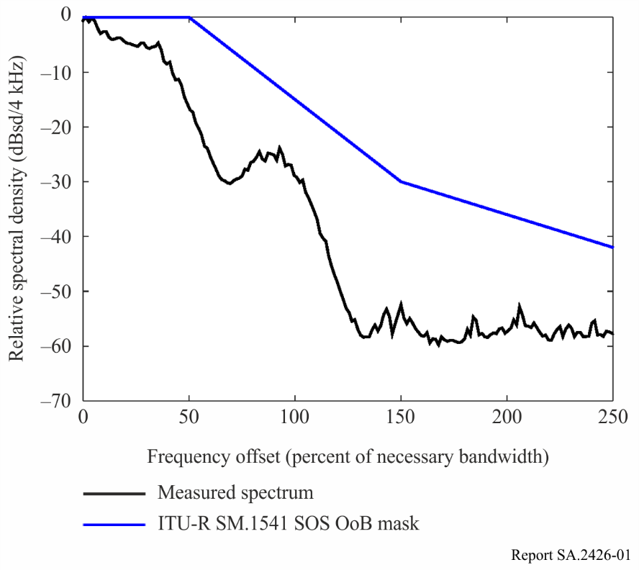

As can be seen, the transmitter complies with the limits defined by the out-of-band contained in the Rec. ITU-R SM.1541 spectral mask with margin.

### 2.5.2 Spurious emissions in the space-to-Earth direction

Figure 2 provides measurement results of the same transmitter over a 25 MHz frequency range in the spurious domain in comparison to the spurious emission limit for space services as contained in Recommendation ITU-R SM.329. This Recommendation specifies that the attenuation should be 43 + 10 log *P*, or 60 dBc, whichever is less stringent, in a 4 kHz reference bandwidth. Assuming a value of 0 dBW for *P*, the required attenuation becomes 43 dBc, equivalent to a spurious emission limit of −43 dBc. The measurements were taken at the connection to the transmission line connecting the transmitter to the space station antenna.

Figure 2

Measured spurious emissions (upper frequency range) in the space-to-Earth direction versus spurious emission limit from Recommendation ITU-R SM.329 as well as −60 dBc limit

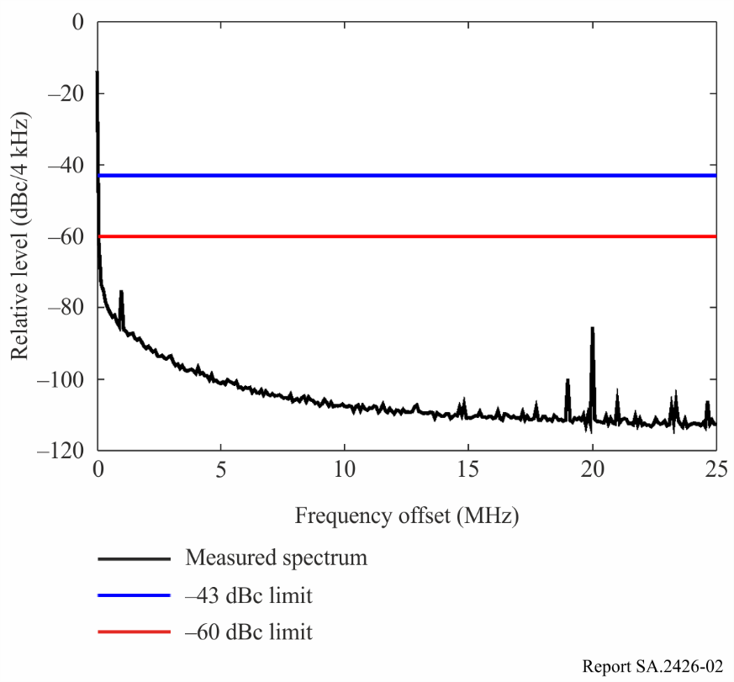

The transmitter complies with the spurious emission limits of −43 dBc defined by Recommendation ITU-R SM.329 from a frequency offset of 70 kHz. However, the spurious emission limit contained in this Recommendation should be regarded as a “safety net”. In fact, the transmitter meets a limit of −60 dBc in a 4 kHz reference bandwidth from a frequency offset of 120 kHz. The −60 dBc limit therefore appears to be a more appropriate limit while still assuring sufficient margin to allow for variations between short duration NGSO space station transmitters.

Since unwanted emissions can vary in nature and are typically composed of narrowband emissions and broadband noise, it has to be noted that these spectral masks may not provide sufficient information to evaluate compatibility with the radio astronomy service, in particular for the case of broadband noise interfering with continuum observations. Although Recommendation ITU-R SM.329 specifies that space station spurious emissions shall be specified in a 4 kHz reference bandwidth, measurements of broadband noise in a 1 MHz reference bandwidth were made in order to aid compatibility studies with the radio astronomy service. Table 4 provides measured values of spurious emission levels in a 1 MHz bandwidth. The measurements were taken at the connection to the transmission line connecting the transmitter to the space station antenna.

TABLE 4

Measured spurious emissions in the space-to-Earth direction in dBc in   
a 1 MHz reference bandwidth

|  |  |
| --- | --- |
| Frequency offset (MHz) | Measured spurious emissions in dBc in a 1 MHz reference bandwidth |
| 1.5 | −69 |
| 5 | −85 |
| 10 | −92 |
| 20 | −81 |

### 2.5.3 Out of band emissions in the Earth-to-space direction

Similar measurements as described in the previous section have been carried out on a typical short duration earth station transmitter. The results are found in the following Figures and Table.

Figure 3

Measured out-of-band emissions (upper frequency range) in the Earth-to-space direction versus out-of-band emission mask from Recommendation ITU-R SM.1541

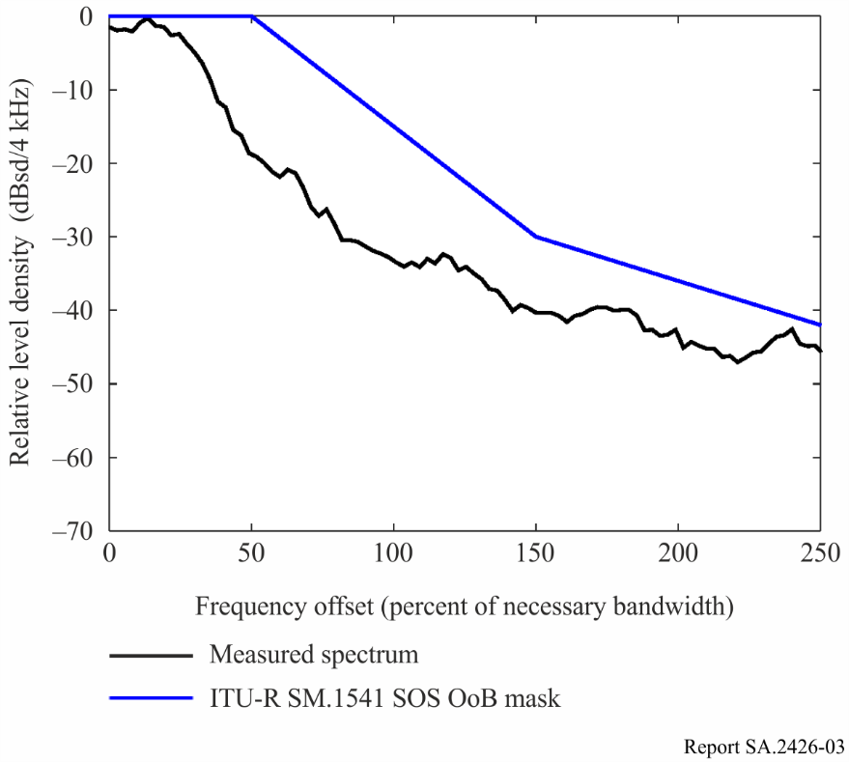

Figure 4

Measured spurious emissions (upper frequency range) in the Earth-to-space direction versus spurious emission limit from Recommendation ITU-R SM.329 as well as −60 dBc limit

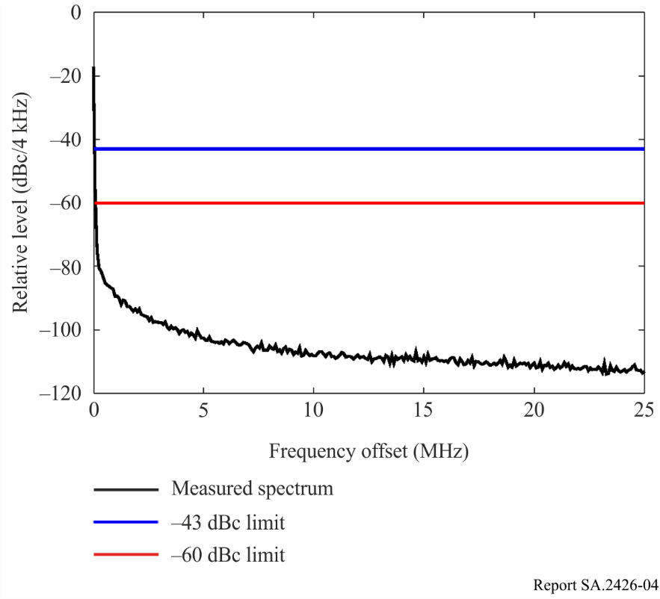

TABLE 5

Measured spurious emissions in the Earth-to-space direction in dBc in   
a 1 MHz reference bandwidth

|  |  |
| --- | --- |
| Frequency offset (MHz) | Measured spurious emissions in dBc in a 1 MHz reference bandwidth |
| 1.5 | −71 |
| 5 | −82 |
| 10 | −87 |
| 20 | −91 |

As for the case of the space station transmitter, the earth station transmitter complies with the spurious emission limits of −43 dBc defined by Recommendation ITU-R SM.329 from a frequency offset of 70 kHz. However, the spurious emission limit contained in this Recommendation should be regarded as a “safety net”. In fact, as for the space station transmitter, the earth station transmitter meets a limit of −60 dBc in a 4 kHz reference bandwidth from a frequency offset of 120 kHz. The −60 dBc limit therefore appears to be a more appropriate limit while still assuring sufficient margin to allow for variations between short duration NGSO earth station transmitters.

# 3 Summary

This Report provides typical characteristics of for telemetry, tracking and command in the space operation service below 1 GHz for NGSO satellite networks with short duration missions. Besides orbital parameters, the typical RF parameters in VHF and UHF are summarized for the space-to-Earth and the Earth-to-space directions. A link budget analysis shows that using these characteristics the communication link has sufficient margins for both VHF and UHF bands. In addition, information on unwanted emissions is provided in order to aid sharing and compatibility studies.

Annex   
  
Short Duration Mission Satellite Link Budgets

TABLE 6

Short duration mission link budget in the space-to-Earth direction,   
300 km orbital altitude case

| Parameter | Scenario | | | | Unit |
| --- | --- | --- | --- | --- | --- |
| Case | 5 degrees elevation, 137 MHz, 300 km | 5 degrees elevation, 400 MHz, 300 km | 90 degrees elevation, 137 MHz, 300 km | 90 degrees elevation, 400 MHz, 300 km |  |
| Satellite transmitter power | 0.0 | 0.0 | 0.0 | 0.0 | dBW |
| Satellite antenna gain  *Note – Typical operational value* | 0.0 | 0.0 | 0.0 | 0.0 | dBi |
| Satellite e.i.r.p. | 0.0 | 0.0 | 0.0 | 0.0 | dBW |
| Frequency | 137 | 400 | 137 | 400 | MHz |
| Orbital altitude | 300000.0 | 300000.0 | 300000.0 | 300000.0 | m |
| Elevation angle | 5 | 5 | 90 | 90 | degrees |
| Range | 1499807.4 | 1499807.4 | 300000.0 | 300000.0 | m |
| Path loss | 138.7 | 148.0 | 124.7 | 134.0 | dB |
| Atmospheric loss (based on Rec. ITU-R P.676) | 0.07 | 0.4 | 0.01 | 0.1 | dB |
| Ionospheric loss due to absorption (based on Rec. ITU-R P.531, middle latitude) | 0.19 | 0.02 | 0.01 | 0.0 | dB |
| Ionospheric loss due to scintillation (based on Rec. ITU-R P.531, middle latitude) | 2.6 | 0.4 | 2.6 | 0.4 | dB |
| Polarization losses | 3.0 | 3.0 | 3.0 | 3.0 | dB |
| Earth station antenna gain | 12.0 | 16.0 | 12.0 | 16.0 | dBi |
| Antenna pointing loss | 1.0 | 1.0 | 1.0 | 1.0 | dB |
| Earth station system noise temperature | 1500 | 500 | 1500 | 500 | K |
| Earth station figure of merit | −19.8 | −11 | −19.8 | −11 | dB/K |
| Bitrate | 25000 | 25000 | 25000 | 25000 | bit/s |
| Spectral efficiency | 1.0 | 1.0 | 1.0 | 1.0 | bit/s/Hz |

TABLE 6 (*end*)

| Parameter | Scenario | | | | Unit |
| --- | --- | --- | --- | --- | --- |
| Necessary bandwidth | 25000.0 | 25000.0 | 25000.0 | 25000.0 | Hz |
| Received carrier power | −133.6 | −136.8 | −119.3 | −122.5 | dBW |
| Noise power spectral density | −196.8 | −201.6 | −196.8 | −201.6 | dBW/Hz |
| Received noise power | −152.9 | −157.6 | −152.9 | −157.6 | dBW |
| Received carrier-to-noise ratio | 19.3 | 20.8 | 33.5 | 35.2 | dB |
| Carrier-to-noise ratio objective | 12.0 | 12.0 | 12.0 | 12.0 | dB |
| Link margin | 7.3 | 8.8 | 21.5 | 23.2 | dB |

TABLE 7

Short duration mission link budget in the space-to-Earth direction, 1000 km   
orbital altitude case

| Parameter | Scenario | | | | Unit |
| --- | --- | --- | --- | --- | --- |
| Case | 5 degrees elevation, 137 MHz, 1000 km | 5 degrees elevation, 400 MHz, 1000 km | 90 degrees elevation, 137 MHz, 1000 km | 90 degrees elevation, 400 MHz, 1000 km |  |
| Satellite transmitter power | 0.0 | 0.0 | 0.0 | 0.0 | dBW |
| Satellite antenna gain  *Note – Typical operational value* | 0.0 | 0.0 | 0.0 | 0.0 | dBi |
| Satellite e.i.r.p. | 0.0 | 0.0 | 0.0 | 0.0 | dBW |
| Frequency | 137 | 400 | 137 | 400 | MHz |
| Orbital altitude | 1000000.0 | 1000000.0 | 1000000.0 | 1000000.0 | m |
| Elevation angle | 5 | 5 | 90 | 90 | degrees |
| Range | 3194480.4 | 3194480.4 | 1000000.0 | 1000000.0 | m |
| Path loss | 145.3 | 154.6 | 135.2 | 144.5 | dB |
| Atmospheric loss (based on Rec. ITU-R P.676) | 0.07 | 0.4 | 0.01 | 0.1 | dB |
| Ionospheric loss due to absorption (based on Rec. ITU-R P.531, middle latitude) | 0.19 | 0.02 | 0.01 | 0.0 | dB |

TABLE 7 (*end*)

| Parameter | Scenario | | | | Unit |
| --- | --- | --- | --- | --- | --- |
| Ionospheric loss due to scintillation (based on Rec. ITU-R P.531, middle latitude) | 2.6 | 0.4 | 2.6 | 0.4 | dB |
| Polarization losses | 3.0 | 3.0 | 3.0 | 3.0 | dB |
| Earth station antenna gain | 12.0 | 16.0 | 12.0 | 16.0 | dBi |
| Antenna pointing loss | 1.0 | 1.0 | 1.0 | 1.0 | dB |
| Earth station system noise temperature | 1500 | 500 | 1500 | 500 | K |
| Earth station figure of merit | −19.8 | −11 | −19.8 | −11 | dB/K |
| Bitrate | 25000 | 25000 | 25000 | 25000 | bit/s |
| Spectral efficiency | 1.0 | 1.0 | 1.0 | 1.0 | bit/s/Hz |
| Necessary bandwidth | 25000.0 | 25000.0 | 25000.0 | 25000.0 | Hz |
| Received carrier power | −140.1 | −143.4 | −129.8 | −133.0 | dBW |
| Noise power spectral density | −196.8 | −201.6 | −196.8 | −201.6 | dBW/Hz |
| Received noise power | −152.9 | −157.6 | −152.9 | −157.6 | dBW |
| Received carrier-to-noise ratio | 12.7 | 14.2 | 23.1 | 24.6 | dB |
| Carrier-to-noise ratio objective | 12.0 | 12.0 | 12.0 | 12.0 | dB |
| Link margin | 0.7 | 2.2 | 11.1 | 12.6 | dB |

TABLE 8

Short duration mission link budget in the Earth-to-space direction,   
300 km orbital altitude case

| Parameter | Scenario | | | | Unit |
| --- | --- | --- | --- | --- | --- |
| Case | 5 degrees elevation, 148 MHz, 300 km | 5 degrees elevation, 450 MHz, 300 km | 90 degrees elevation, 148 MHz, 300 km | 90 degrees elevation, 450 MHz, 300 km |  |
| Earth station transmitter power | 17.0 | 17.0 | 17.0 | 17.0 | dBW |
| Earth station antenna gain | 12.0 | 16.0 | 12.0 | 16.0 | dBi |
| Earth station e.i.r.p. | 29.0 | 33 | 29.0 | 33 | dBW |
| Frequency | 148 | 450 | 148 | 450 | MHz |
| Orbital altitude | 300000.0 | 300000.0 | 300000.0 | 300000.0 | m |

TABLE 8 (*end*)

| Parameter | | Scenario | | | | | Unit |
| --- | --- | --- | --- | --- | --- | --- | --- |
| Elevation angle | 5 | | 5 | 90 | 90 | degrees | |
| Range | 1499807.4 | | 1499807.4 | 300000.0 | 300000.0 | m | |
| Path loss | 139.4 | | 149.0 | 125.4 | 135 | dB | |
| Atmospheric loss (based on Rec. ITU-R P.676) | 0.08 | | 0.52 | 0.01 | 0.05 | dB | |
| Ionospheric loss due to absorption (based on Rec. ITU-R P.531, middle latitude) | 0.16 | | 0.02 | 0.01 | 0.02 | dB | |
| Ionospheric loss due to scintillation (based on Rec. ITU-R P.531, middle latitude) | 2.2 | | 0.36 | 2.2 | 0.36 | dB | |
| Polarization losses | 3.0 | | 3.0 | 3.0 | 3.0 | dB | |
| Satellite antenna gain  *Note К Typical operational value* | 0.0 | | 0.0 | 0.0 | 0.0 | dBi | |
| Antenna pointing loss | 1.0 | | 1.0 | 1.0 | 1.0 | dB | |
| Satellite system noise temperature | 500 | | 500 | 500 | 500 | K | |
| Satellite figure of merit | −27.0 | | −27.0 | −27.0 | −27.0 | dB/K | |
| Bitrate | 25000 | | 25000 | 25000 | 25000 | bit/s | |
| Spectral efficiency | 1.0 | | 1.0 | 1.0 | 1.0 | bit/s/Hz | |
| Necessary bandwidth | 25000.0 | | 25000 | 25000.0 | 25000 | Hz | |
| Received carrier power | −116.8 | | −120.9 | −102.6 | −106.5 | dBW | |
| Noise power spectral density | −201.6 | | −201.6 | −201.6 | −201.6 | dBW/Hz | |
| Received noise power | −157.6 | | −157.6 | −157.6 | −157.6 | dBW | |
| Received carrier-to-noise ratio | 40.8 | | 36.7 | 55.0 | 51.2 | dB | |
| Carrier-to-noise ratio objective | 20.0 | | 20.0 | 20.0 | 20 | dB | |
| Link margin | 20.8 | | 16.7 | 35.0 | 31.2 | dB | |

TABLE 9

Short duration mission link budget in the Earth-to-space direction,   
1000 km orbital altitude case

| Parameter | Scenario | | | | Unit |
| --- | --- | --- | --- | --- | --- |
| Case | 5 degrees elevation, 148 MHz, 1000 km | 5 degrees elevation, 450 MHz, 1000 km | 90 degrees elevation, 148 MHz, 1000 km | 90 degrees elevation, 450 MHz, 1000 km |  |
| Earth station transmitter power | 17.0 | 17.0 | 17.0 | 17.0 | dBW |
| Earth station antenna gain | 12.0 | 16.0 | 12.0 | 16.0 | dBi |
| Earth station e.i.r.p. | 29.0 | 33.0 | 29.0 | 33.0 | dBW |
| Frequency | 148 | 450 | 148 | 450 | MHz |
| Orbital altitude | 1000000.0 | 1000000.0 | 1000000.0 | 1000000.0 | m |
| Elevation angle | 5 | 5 | 90 | 90 | degrees |
| Range | 3194480.4 | 3194480.4 | 1000000.0 | 1000000.0 | m |
| Path loss | 145.9 | 155.6 | 135.8 | 145.5 | dB |
| Atmospheric loss (based on Rec. ITU-R P.676) | 0.08 | 0.52 | 0.01 | 0.05 | dB |
| Ionospheric loss due to absorption (based on Rec. ITU-R P.531, middle latitude) | 0.16 | 0.02 | 0.01 | 0.02 | dB |
| Ionospheric loss due to scintillation (based on Rec. ITU-R P.531, middle latitude) | 2.2 | 0.36 | 2.2 | 0.36 | dB |
| Polarization losses | 3.0 | 3.0 | 3.0 | 3.0 | dB |
| Satellite antenna gain  *Note – Typical operational value* | 0.0 | 0.0 | 0.0 | 0.0 | dBi |
| Antenna pointing loss | 1.0 | 1.0 | 1.0 | 1.0 | dB |
| Satellite system noise temperature | 500 | 500 | 500 | 500 | K |
| Satellite figure of merit | −27.0 | −27.0 | −27.0 | −27.0 | dB/K |
| Bitrate | 25000 | 25000 | 25000 | 25000 | bit/s |
| Spectral efficiency | 1.0 | 1.0 | 1.0 | 1.0 | bit/s/Hz |
| Necessary bandwidth | 25000.0 | 25000 | 25000.0 | 25000 | Hz |
| Received carrier power | −123.4 | −127.5 | −113.1 | −116.9 | dBW |
| Noise power spectral density | −201.6 | −201.6 | −201.6 | −2016. | dBW/Hz |
| Received noise power | −157.6 | −157.6 | −157.6 | −157.6 | dBW |

TABLE 9 (*end*)

| Parameter | | Scenario | | | | | Unit |
| --- | --- | --- | --- | --- | --- | --- | --- |
| Received carrier-to-noise ratio | 34.3 | | 30.1 | 44.6 | 40.7 | dB | |
| Carrier-to-noise ratio objective | 20.0 | | 20.0 | 20.0 | 20.0 | dB | |
| Link margin | 14.3 | | 10.1 | 24.6 | 20.7 | dB | |