|  |
| --- |
| **Report ITU-R SA.2349-0**  **(05/2015)** |
| **Compatibility between GSO EESS (Earth-to-space), and the fixed service, the mobile service, the space research service, or the space operation service in the band 7 190-7 235 MHz** |
| **SA Series**  **Space applications and meteorology** |

Foreword

The role of the Radiocommunication Sector is to ensure the rational, equitable, efficient and economical use of the radio-frequency spectrum by all radiocommunication services, including satellite services, and carry out studies without limit of frequency range on the basis of which Recommendations are adopted.

The regulatory and policy functions of the Radiocommunication Sector are performed by World and Regional Radiocommunication Conferences and Radiocommunication Assemblies supported by Study Groups.

# Policy on Intellectual Property Right (IPR)

ITU-R policy on IPR is described in the Common Patent Policy for ITU-T/ITU-R/ISO/IEC referenced in Annex 1 of Resolution ITU-R 1. Forms to be used for the submission of patent statements and licensing declarations by patent holders are available from <http://www.itu.int/ITU-R/go/patents/en> where the Guidelines for Implementation of the Common Patent Policy for ITU‑T/ITU‑R/ISO/IEC and the ITU-R patent information database can also be found.

|  |  |
| --- | --- |
| Series of ITU-R Reports  (Also available online at <http://www.itu.int/publ/R-REP/en>) | |
| **Series** | Title |
| **BO** | Satellite delivery |
| **BR** | Recording for production, archival and play-out; film for television |
| **BS** | Broadcasting service (sound) |
| **BT** | Broadcasting service (television) |
| **F** | Fixed service |
| **M** | Mobile, radiodetermination, amateur and related satellite services |
| **P** | Radiowave propagation |
| **RA** | Radio astronomy |
| **RS** | Remote sensing systems |
| **S** | Fixed-satellite service |
| **SA** | **Space applications and meteorology** |
| **SF** | Frequency sharing and coordination between fixed-satellite and fixed service systems |
| **SM** | Spectrum management |

|  |
| --- |
|  |

|  |
| --- |
| ***Note****: This ITU-R Report was approved in English by the Study Group under the procedure detailed in Resolution ITU-R 1.* |

*Electronic Publication*

Geneva, 2015

© ITU 2015

All rights reserved. No part of this publication may be reproduced, by any means whatsoever, without written permission of ITU.

REPORT ITU-R SA.2349-0

Compatibility between GSO EESS (Earth-to-space), and the fixed service,  
the mobile service, the space research service, or the space operation  
service in the band 7 190-7 235 MHz

(2015)

TABLE OF CONTENTS

Page

1 Introduction 2

2 Characteristics of potential GSO EESS mission uplinks in the 7-8 GHz range 2

3 Characteristics of space research service mission uplinks 4

4 Characteristics of space operation service mission uplinks 5

5 Interference criteria 7

5.1 EESS systems interference criteria 7

5.2 SRS Systems interference criterion 8

5.3 SOS Systems interference criterion 8

6 Assessment of interference from space research service uplinks into GSO EESS satellites 8

6.1 Interference analysis approach and main assumptions 9

6.2 Static interference analysis (GSO EESS victim from SRS and SOS sources) 9

6.3 Dynamic interference analysis (GSO EESS victim) 10

7 Assessment of interference from GSO EESS uplinks into space research service satellites 11

7.1 Dynamic interference analysis (SRS victim) 11

8 Assessment of interference from GSO EESS uplinks into space operation service satellites 12

9 Compatibility between GSO EESS (Earth-to-space) and fixed services 13

9.1 Fixed service characteristics 13

9.2 GSO EESS (Earth-to-space) earth station characteristics 14

9.3 TIG methodology (from RR Appendix 7) 15

9.4 Conclusions 18

10 Compatibility between GSO EESS (Earth-to-space) and mobile services 18

11 Summary and conclusions 19

# 1 Introduction

WRC-15 agenda item 1.11 deals with the consideration of a primary allocation to the Earth exploration-satellite service (EESS) (Earth-to-space, E-s) in the 7-8 GHz range in accordance with Resolution **650 (WRC-12)**. This Resolution invites to conduct compatibility studies between EESS systems (Earth-to-space) and existing services in the 7-8 GHz range with priority to the band 7 145‑7 235 MHz. Figure 1 shows an overview of the frequency allocations in the 7-8 GHz range.

The band 7 145-7 235 MHz is currently used by space research service (SRS) mission uplinks, mobile service (MS) and fixed service (FS). Additionally, by RR footnote No. **5.459**, the Russian Federation has an additional primary allocation to the space operation service (SOS) (Earth-to-space) in the frequency bands 7 100-7 155 MHz and 7 190-7 235 MHz, subject to agreement obtained under RR No. **9.21**.

Report ITU-R SA.2309 deals in detail with the issues of compatibility between EESS in NGSO mode and the incumbent services in 7 145-7 250 MHz. Considering that deep space SRS (7 145‑7 190 MHz) has already been deemed as incompatible with the NGSO EESS, this document is concerned with the 7 190‑7 235 MHz frequency band.

This Report presents an assessment of the compatibility between the GSO EESS (Earth-to-space) and SRS mission uplinks when both operate at the same frequency (co-frequency) in the 7 190‑7 235 MHz band.

This Report also provides an analysis of the compatibility between the GSO EESS and SOS mission uplinks (Earth-to-space) when both operate at the same frequency in the 7 190‑7 235 MHz frequency bands.

FIGURE 1

Overview of ITU-R frequency allocations in the 7-8 GHz range

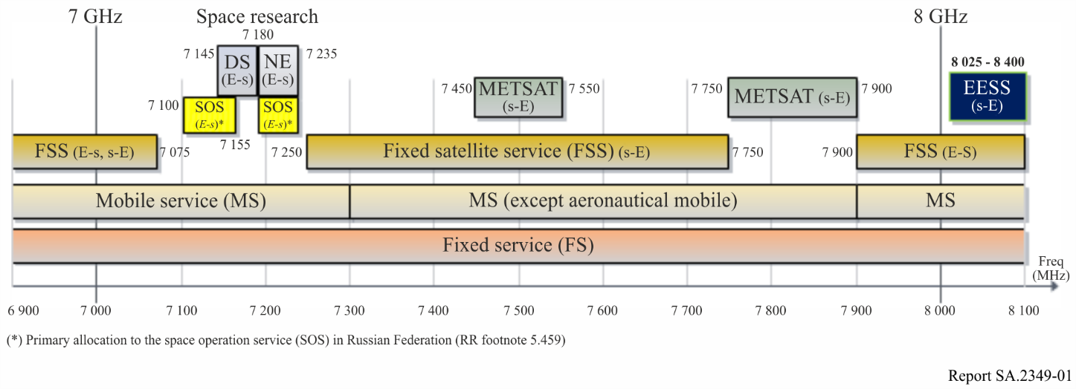

# 2 Characteristics of potential GSO EESS mission uplinks in the 7-8 GHz range

The EESS missions currently perform the functions of TT&C (Tracking, Telemetry & Control) and data transmission/dissemination in the S-Band. The 2 025-2 110 MHz band is used to uplink the command and ranging signals, and the 2 200-2 290 MHz band is used to downlink the spacecraft telemetry and ranging signals.

The same frequency bands are also used for data transmission and dissemination links. Both up/downlink bands are shared with the SRS and the SOS. The EESS missions perform the payload data download in the 2 200-2 290 MHz and 8 025‑8 400 MHz bands, depending on the data rate requirements.

An EESS (Earth-to-space) allocation in the 7-8 GHz range would allow its use for TT&C in combination with the existing EESS (space-to-Earth) allocation in the band 8 025‑8 400 MHz (or other appropriately allocated bands) used for data transmission, thereby alleviating the congestion problem in S-Band, mitigating the frequency coordination problem, and eventually leading to a simplified on-board architecture and operational concept for future EESS missions.

The technical characteristics of potential new EESS (Earth-to-space) systems operating in the 7‑8 GHz frequency range would be similar to those of SRS near-Earth systems, but with lower transmit power requirements and typically antenna sizes in the 13 to 16 m range as compared to typical SRS Earth station antenna sizes for Lagrange missions of > 34 m.

Table 1 presents the technical characteristics representative of potential GSO EESS missions in the 7-8 GHz range. The GSO EESS high rate telecommanding was assumed to be in continuous use for this analysis representing a worst-case non-typical situation.

TABLE 1

Technical characteristics representative of potential GSO EESS missions   
with uplinks in 7-8 GHz

|  | Representative parameters | Remarks |
| --- | --- | --- |
| **Orbit description** |  |  |
| Type of orbit | GSO |  |
| Orbit altitude | 35 786 km |  |
| Inclination | 0 degree |  |
| **Earth station** |  |  |
| Location | Typically low to medium latitudes |  |
| RF transmit power level | 21.8 dBW | At antenna interface |
| Antenna type | 16.4 m parabolic reflector |  |
| Antenna gain | 59.8 dBi | Dual linear polarization |
| Antenna pattern | Recommendation ITU-R F.1245 | Representative of average side lobes as the antenna is tracking the satellite |
| Minimum elevation angle | 5° | Also depends on the terrain shielding surrounding the Earth station |
| e.i.r.p. | 81.6 dBW | Maximum e.i.r.p. |
| Information data rate (Mbit/s per polarization) | 15.5 |  |
| Necessary bandwidth (MHz) | 9.8 and 10.9 | Coded rates 23.48 and 17.33 Mbit/s |
| Modulation | QPSK or 8-PSK |  |
| **Satellite** |  |  |
| Antenna gain (dBi) | 35.8 | Dual linear polarizations |
| Noise temperature at the receiver input (K) | 1 200 | Antenna noise Tant ≈ 300 K Receiver noise temperature ≈ 900 K |
| Protection criteria | –161 dB(W/kHz), 0.1% of the time | Recommendation ITU-R SA.514-3 |

# 3 Characteristics of space research service mission uplinks

The SRS (Earth-to-space) is one of the services allocated in the band 7 145-7 235 MHz. The use of the lower part of the band (i.e. 7 145-7 190 MHz) is restricted to deep space, while the upper part (i.e. 7 190-7 235 MHz) is used by near-Earth SRS missions. Four types of SRS mission uplinks are considered in this preliminary compatibility analysis:

– SRS near-Earth missions in the Lagrangian points L1/L2 (range 1.2-1.8 M-km from Earth);

– SRS near-Earth missions in highly elliptical orbits;

– SRS near-Earth missions in low earth orbits;

– SRS deep-space missions (range > 2 M-km from Earth).

Table 2 presents the representative parameters for the type of SRS missions considered. It should be noted that the transmit earth stations are meant to be representative for the purpose of the analysis and are not in all cases those actually used.

In the Launch and Early Orbit Phase (LEOP), SRS systems typically operate with omni-directional coverage. Maximum uplink power is generally not used but adjusted according to the distance of the satellite from the Earth. The SRS satellites at low altitude orbits can be considered to be comparable to EESS satellites in terms of uplink power requirements.

TABLE 2

Technical characteristics representative of SRS missions uplinks   
 in the frequency band 7 190-7 235 MHz

|  |  |  |  |
| --- | --- | --- | --- |
|  | Near-Earth SRS missions (7 190-7 235 MHz) | | |
| LAGRANGE | HEO | LEO |
| Representative orbits | Herschel (L2) | Cluster | Koronas-Photon |
| Orbit description |  |  |  |
| Type of orbit | Around L1 / L2 | Highly elliptical | Low Earth |
| Orbit altitude | 1.2 to 1.8 M-km | 118.500 × 19.200 km | 550 km |
| Inclination (degrees) | 23.4 (in ecliptic) | 134-137 | 85.5 |
| Earth station |  |  |  |
| Location | Cebreros (Spain)  Malargue (Argentina)  New Norcia (Australia) | Villafranca (Spain)  Kiruna (Sweden)  Cebreros (Spain)  New Norcia (Australia) | Svalbard (Norway)  Kiruna (Sweden)  Moscow (Russia)  Krasnoyarsk (Russia) |
| Power supplied to the input of antenna (dBW) | 33 to 43  (2 to 20 kW)  2 kW used in nominal configuration | 30 (1 kW) | 20 (100 W) |
| Antenna diameter (m) | 35 | 15 | 5 |
| Antenna gain (dBi) | 66 | 56.5 | 47 |
| Antenna pattern | Recommendation ITU‑R F.1245 | Recommendation ITU‑R F.1245 | Recommendation ITU‑R S.465 |
| Min elevation angle (°) | 5 | 5 | 5 |
| e.i.r.p. (dBW) | 99 to 109 max | 86.5 max | 67 max |
| Uplink signal | TC + Ranging | TC + Ranging | TC + Data |

TABLE 2 (*end*)

|  |  |  |  |
| --- | --- | --- | --- |
|  | Near-Earth SRS missions (7 190-7 235 MHz) | | |
|  | LAGRANGE | HEO | LEO |
| Telecommand (data rate & modulation) | Rb = 2 kbit/s (64 kHz BW) | Rb = 4 kbit/s (64 kHz BW) | Rb = 2 kbit/s (2 MHz BW) |
| PCM(NRZ)/PSK/PM 16 kHz subcarrier | PCM(NRZ)/PSK/PM 16 kHz subcarrier | BPSK |
| Ranging | RNG tone Ft = 480 kHz | Ft = 100 kHz |  |
| Satellite |  |  |  |
| a) Low gain antenna (dBi) | *G* = *–*2 @ 90̊ *G* = +7 @ ± 10̊ | *G* = – 2 @ ± 90̊ *G* = + 7 @ ± 10̊ | *G* = +2 |
| b) Medium gain antenna (dBi) | *G* = +13 @ ±10̊  *G* = +18 @ ± 3̊ | – | – |
| c) High gain antenna (dBi) | – | – | – |
| System noise temperature (K) | 350 | 780 | 450 |
| Protection criteria | –177 dB(W/kHz), 0.1% of the time Recommendation ITU-R SA.609-2 | | |

# 4 Characteristics of space operation service mission uplinks

The SOS systems can provide TT&C functions for satellite located at any orbits: low, medium, high or geostationary. Typical technical characteristics of SOS systems uplinks operating in the frequency band 7 190‑7 235 MHz are provided in Table 3.

TABLE 3

Technical characteristics representative of SOS mission uplinks  
 in the frequency band 7 190-7 235 MHz

|  |  |  |  |
| --- | --- | --- | --- |
| Representative orbits | COMPARUS-C | COMPARUS-E | Type 3 |
| Orbit description |  |  |  |
| Type of orbit | Low-Earth, circular | Low-Earth, elliptical | Low-Earth, circular |
| Orbit altitude (km) | 350 | 200-450 | 550 |
| Inclination (°) | 70 | 70 | 85.5 |
| **Earth station** |  |  |  |
| Locations (assumed for this study) | Russian Federation: Moscow  and Krasnoyarsk | Russian Federation: Moscow  and Krasnoyarsk | Russian Federation |
| Power range at antenna input (dBW)  *(NOTE – Adaptive power control is applied.)* | –14 to –34 (mode 1)*  –3 to –23 (mode 2)** | –14 to –34 (mode 1)*  –3 to –23 (mode 2)** | 0 to 20 |
| Antenna diameter (m) | 5 | 5 | 5 |
| Antenna gain (dBi) | 47 | 47 | 47 |

TABLE 3 (*end*)

|  |  |  |  |
| --- | --- | --- | --- |
| Representative orbits | COMPARUS-C | COMPARUS-E | Type 3 |
| Antenna pattern | Recommendation ITU-R S.465 | Recommendation ITU-R S.465 | Recommendation ITU-R S.465 |
| Minimum elevation angle (°) | 5 | 5 | 5 |
| Max e.i.r.p. range (dBW) | 33 / 13 (mode 1)  44 / 24 (mode 2) | 33 / 13 (mode 1)  44 / 24 (mode) | 47 / 67 |
| Uplink signal | Telemetry, tracking and telecommand | Telemetry, tracking and telecommand | Telemetry, tracking and telecommand |
| Necessary bandwidth (MHz) | 1.2 | 1.2 | 2 |
| Telecommand data rate (kbit/s) | TBD (***) | TBD (***) | 2.0 |
| Telecommand modulation | TBD (***) | TBD (***) | BPSK |
| Ranging | TBD (***) | TBD (***) | - |
| **Space station** |  |  |  |
| a) Low gain antenna (dBi) | +1 (mode 2) | +1 (mode 2) | +2 |
| b) High gain antenna (dBi) | +12 (mode 1) | +12 (mode 1) |  |
| System noise temperature (°K) | 1 000 | 1 000 | 450 |
| Protection criteria | The ratio of signal power to total interference power in each band 1 kHz wide must not fall below 20 dB for more than 1% of the time, each day  (Recommendation [ITU-R SA.363-5](http://www.itu.int/rec/R-REC-SA.363/en)). NOTE – See § 5.3. | | |
| * Mode 1 – Operation with a narrow-beam tracking space-borne antenna (see Fig. 2).  ** Mode 2 – Operation with a nadir pointed wide-beam space-borne antenna (see Fig. 3).  *** This information has not been provided by the relevant administration, therefore only a worst-case analysis has been considered. | | | |

Figure 2

Mode 1 antenna pattern

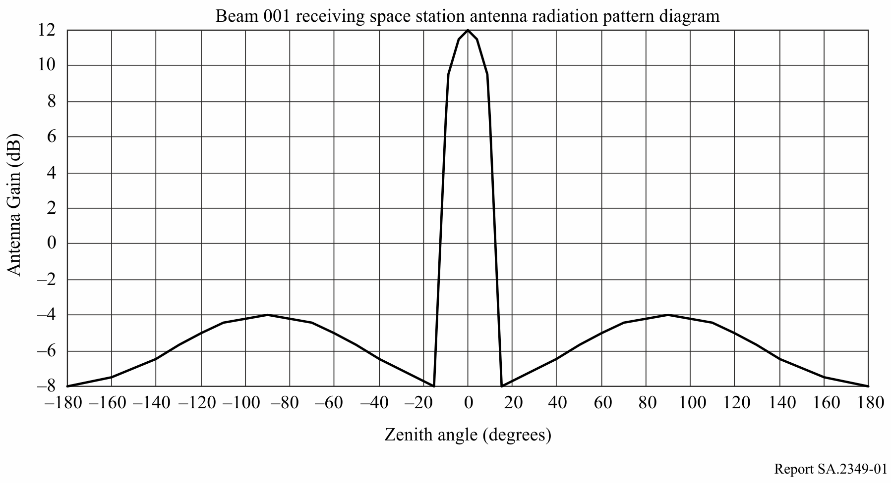

Figure 3

Mode 2 antenna pattern

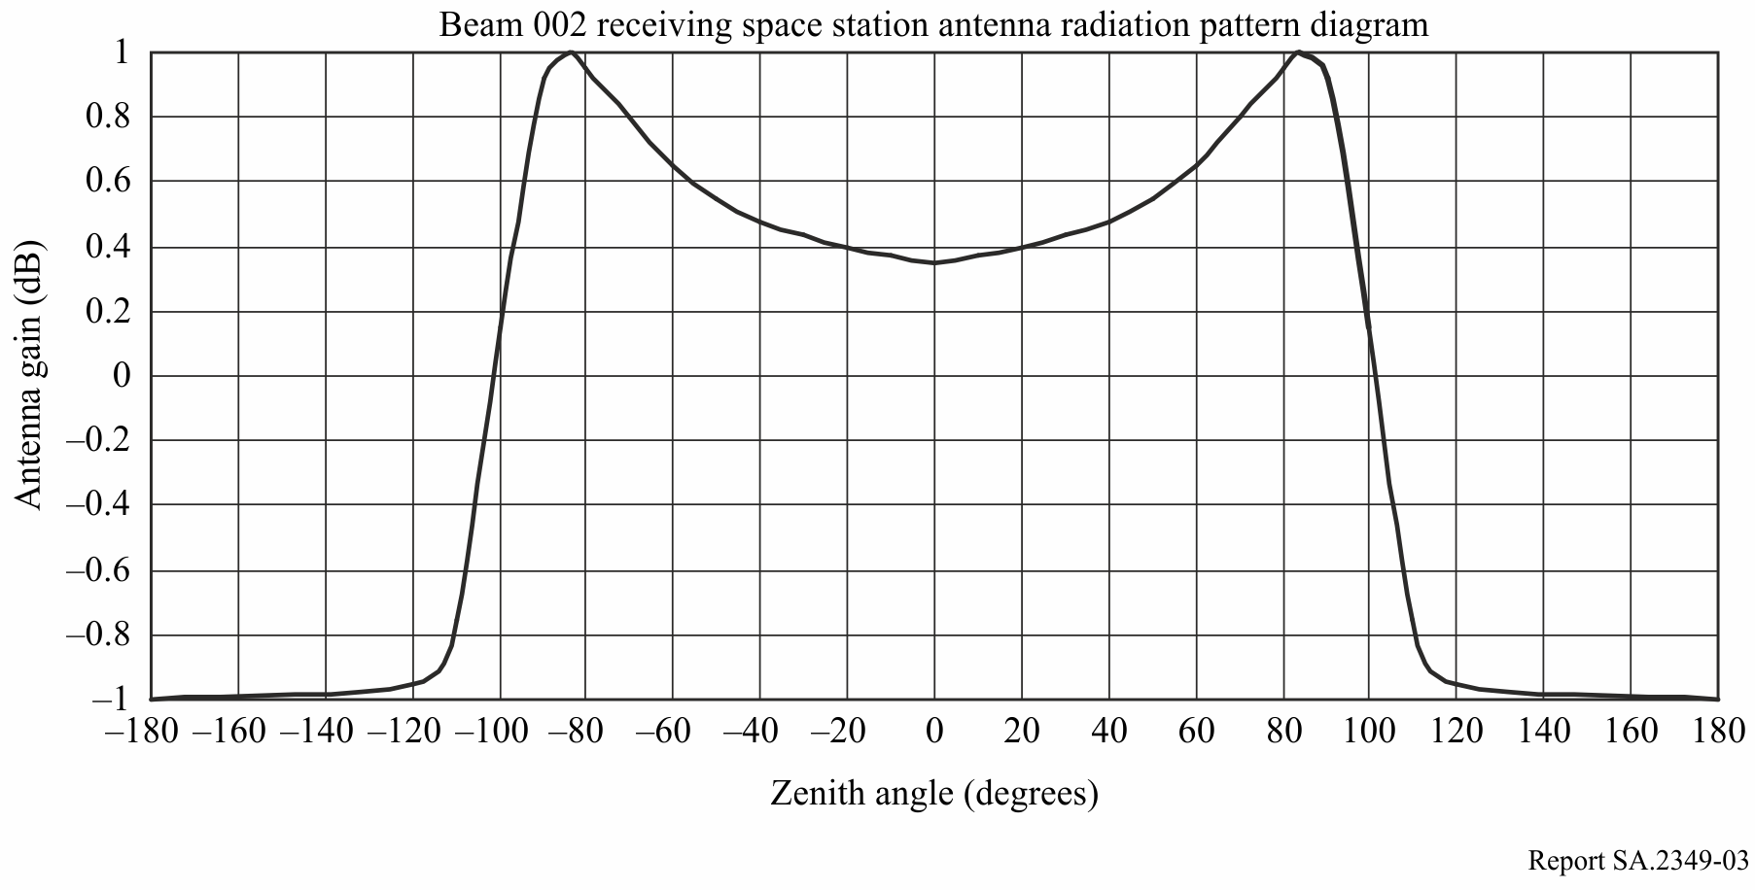

# 5 Interference criteria

## 5.1 EESS systems interference criteria

GSO EESS Systems interference criterion Recommendation ITU-R SA.514-3 provides the protection criteria for command and data transmission systems operating in the EESS and METSAT services. For frequencies between 300 MHz and 10 GHz, “the power spectral density of noise-like interference or the total power of CW-type interference in any single band or in all sets of bands 1 kHz wide shall not exceed –161 dB(W/kHz) at the receiver input for more than 0.1% of the time”.

It should be noted that Recommendations ITU-R SA.1160 and ITU-R SA.1163 contain the protection criteria for GSO Earth-to-space links used in the data dissemination systems, direct data readout systems and also data collection systems operating in the EESS and METSAT. These systems are not addressed in the Report because they are not TT&C applications and therefore the obtained results cannot be applied to them.

## 5.2 SRS Systems interference criterion

The interference criterion applicable to near-Earth (NE) SRS systems in the frequency band 7 190‑7 235 MHz specified in Recommendation ITU-R SA.609-2 provides the protection criterion for radiocommunication links for manned and unmanned near-Earth research satellites. The permissible interference level is established as –177 dB(W/kHz) at the input terminals of the receiver, for 0.1% of the time for bands in the 100 MHz-30 GHz frequency range.

## 5.3 SOS Systems interference criterion

Recommendation ITU-R SA.363-5 specifies “that the protection criteria for spacecraft receivers be as follows: the ratio of signal power to total interference power in each band 1 kHz wide must not fall below 20 dB for more than 1% of the time, each day”.

# 6 Assessment of interference from space research service uplinks into GSO EESS satellites

Figure 4 illustrates the potential interference scenarios from SRS uplinks into EESS on-board receivers in the band 7 190-7 235 MHz.

FIGURE 4

Potential interference cases from SRS uplinks to potential EESS on-board receive systems   
in the band 7 190-7 235 MHz

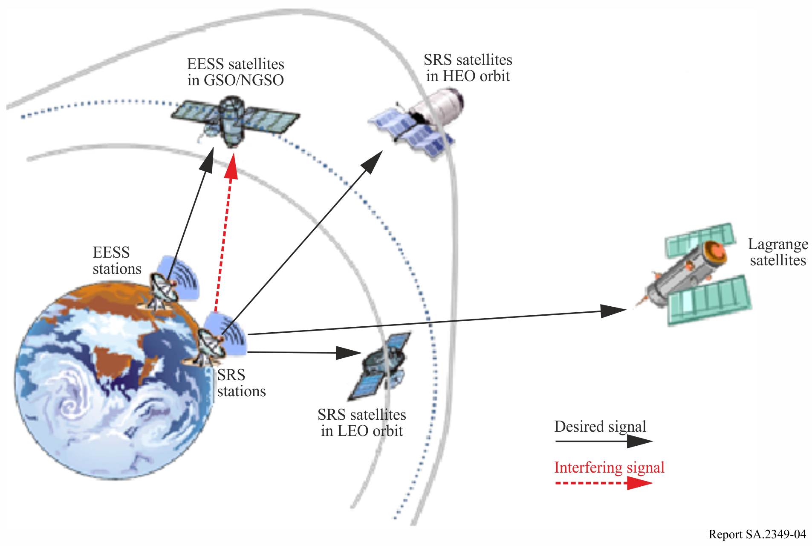

## 6.1 Interference analysis approach and main assumptions

GSO EESS-SRS static and dynamic interference analyses have been performed under the assumption that the victim and interfering systems are operating at the same uplink frequency.

The static analysis is indicative of the worst case interfering levels received by the victim satellite through the main lobe of the interfering earth station, considering the maximum e.i.r.p. at the interfering earth station and the maximum antenna gain for the victim satellite receiver.

The dynamic analysis allows a statistical assessment of interference as a function of the location, pointing directions and antenna characteristics of the interfering earth station and the victim satellite. The dynamic analysis was performed under the assumption that the interfering earth stations only transmit when they are in view of their respective space assets.

The dynamic simulations presented for the EESS-SRS analysis in the near Earth SRS band (7 190‑7 235 MHz) were conducted with commercial simulation software. For each simulation, the interference was computed for 1 minute intervals of time that spanned a period of 1 year (with few exceptions). The interference was then plotted as a probability density function.

## 6.2 Static interference analysis (GSO EESS victim from SRS and SOS sources)

The maximum interference power level received, *Imax* (dBW), at the victim EESS receiver from a SRS uplink earth station is calculated using the following equation:

$I_{max}=e.i.r.p.+20 log\left(\frac{c}{4πfR}\right)+G_{r}$

where:

e.i.r.p.: equivalent isotropic radiated power of the SRS uplink station (dBW)

*c*: speed of light (≈ 300 000 000 m/s)

*f*: EESS victim satellite receive frequency (Hz)

*R*: slant range between interferer and victim station (m)

*Gr*: EESS victim satellite maximum antenna gain in direction of interferer (dBi).

All calculations in Table 4 were performed on the basis of co-frequency operations at 7 190 MHz and maximum antenna gain at the victim EESS satellite (*G* = +35.8 dBi) whose receiver bandwidth is 9.8 MHz. Four types of SRS uplink stations were considered with different e.i.r.p. levels: 44 dBW (COMPARUS C/E, SOS), 99 dBW to 109 dBW (Herschel, L2), 86.5 dBW (Cluster) and 67 dBW (Koronas-Photon, SRS LEO).

The range was assumed to be 39 000 km (slant range to geostationary orbital altitude) and the spacecraft antenna gain was 35.8 dBi. The frequency for this portion of the analysis was 7 216.6 MHz. The same e.i.r.p. were used as described above. The GSO EESS interference threshold of –161 dB(W/kHz) per Recommendation ITU-R SA.514-3 was used. As shown below, the SRS missions described in Table 2 have the capability to exceed the GSO EESS interference threshold, therefore dynamic analysis was performed with respect to SRS missions. Noting that the worst case RFI caused by the SOS mission COMPARUS C/E is below the EESS criterion, no dynamic analysis is performed for that case.

TABLE 4

Results of static interference analysis

|  |  |  |  |  |  |  |
| --- | --- | --- | --- | --- | --- | --- |
|  |  | Interfering system | | | | |
| Analysis parameter | Units | SOS | L2 | | Cluster | Koronas-Photon |
| Interfering e.i.r.p. | dBW | 44 | 99 | 109 | 86.5 | 67 |
| Path loss (39 000 km) | dB | 201.4 | 201.4 | 201.4 | 201.4 | 201.4 |
| Victim receive gain (max) | dBi | 35.8 | 35.8 | 35.8 | 35.8 | 35.8 |
| Interference power density | dB(W/kHz) | –161.5 | –106.5 | –96.5 | –119.0 | –138.5 |

## 6.3 Dynamic interference analysis (GSO EESS victim)

A study was conducted to perform the analysis of interference from the existing near Earth SRS into the GSO EESS systems using dynamic simulation tools and the parameters given in §§ 2 and 3.

Assumptions made in the analysis are listed below.

1) Both victim and interfering systems are co-frequency.

2) Interferer’s psd (power spectral density) is assumed constant over the victim bandwidth.

3) Earth stations only transmit when in view of their respective space station.

The results of the analysis of interference from SRS into EESS uplinks are provided in Table 5. The GSO EESS interference threshold is –161 dB(W/kHz) (see § 5.1).

TABLE 5

SRS interference levels in dB(W/kHz) exceeded 0.1% of the time for collocated earth stations

|  |  |  |
| --- | --- | --- |
| SRS systems (interferer) | GSO EESS victim (Wallops with satellite longitude indicated) | |
|  | EESS satellite at 137°W | EESS satellite at 75°W |
| Herschel (L2) | –146.5 | –145.5 |
| Koronas-Photon (LEO) | –181.0 | –190.0 |
| Cluster (HEO) | –160.0 | –160.0 |

The results show that the interference from HEO to GSO EESS marginally exceeds the threshold while L2 uplink could cause higher interference into EESS uplinks. There are other factors that may mitigate this predicted interference sufficiently such as polarization losses, non-collocated earth stations, frequency separation, etc. It is noted that the GSO EESS may be required to accept any such remaining interference. The above interference results are very similar to the ones faced by SRS LEO satellites using the band currently which require them to engage in frequency and earth station coordination for successful operations. GSO EESS systems would also have to adopt such frequency coordination techniques to establish compatibility with the incumbent SRS near Earth services.

As discussed in § 6.2, no analysis is required for interference from SOS into GSO EESS. It may be further suggested that SOS uplinks are likely to be remote from GSO EESS uplinks, mitigating any interference potential.

# 7 Assessment of interference from GSO EESS uplinks into space research service satellites

Figure 5 illustrates the potential interference scenarios. The on-board SRS systems may receive part of the EESS uplink signal through the main and/or side lobes of the EESS earth stations.

FIGURE 5

Potential interference cases from EESS uplink stations to SRS on-board receive systems   
in the band 7 190-7 235 MHz

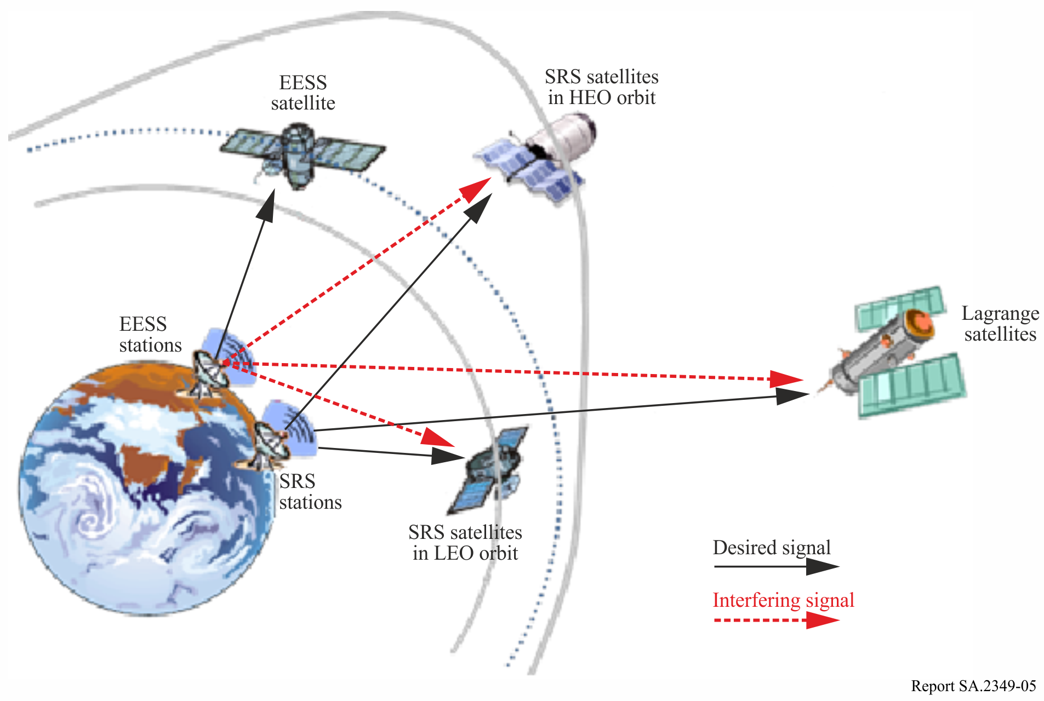

## 7.1 Dynamic interference analysis (SRS victim)

A study was conducted to perform the dynamic simulation analysis of interference from the newly proposed EESS into the existing SRS systems in the band 7 190‑7 235 MHz using the parameters given in §§ 2 and 3. The study was performed using a commercial interference prediction tool. For the L2 spacecraft location modelled, the actual location is not in earth orbit and could not be modelled exactly; as an approximation, the satellite was modelled in a 1 500 000 km altitude orbit, with a period of 213 days, and at a 23.4° inclination. This results in a behaviour similar to that of a spacecraft in L2, but not properly aligned with the sun and compressed from 1 year to 213 days. For all other cases, the orbits were modelled for a year at 1 minute intervals; for L2 the orbit was modelled for 213 days at 1 minute intervals. It was assumed as a worst case, that the interfering EESS earth station was collocated at Wallops (USA) with the desired SRS uplink. The results of the dynamic analysis are presented in Table 6. The SRS near-Earth mission interference threshold is –177 dB(W/kHz). The results of the study indicate that GSO EESS uplink is compatible with SRS uplinks.

TABLE 6

GSO EESS interference levels {Io, dB(W/kHz)} exceeded 0.1% of the time for collocated earth stations

|  |  |  |
| --- | --- | --- |
| SRS victim mission | EESS GSO Locn = 137°W | EESS GSO Locn = 75°W |
| Herschel (L2) | –197.5 | –216 |
| Koronas-Photon (LEO) | –188 | –191 |
| Cluster (HEO) | –204 | –203 |

# 8 Assessment of interference from GSO EESS uplinks into space operation service satellites

This section presents an assessment of the compatibility between uplinks of SOS systems with EESS systems when both operate co-frequency in the frequency bands 7 100‑7 155 MHz or 7 190‑7 235 MHz. General description of the technical characteristics of potential new EESS (Earth-to-space) systems operating in the 7 GHz frequency band are described in § 2 (Table 1).

Typical technical characteristics of SOS system uplinks operating in the frequency bands 7 100‑7 155 MHz and 7 190‑7 235 MHz are provided in § 4 (Table 3).

The protection criterion for SOS spacecraft receivers is provided in § 5.3.

Figure 6 illustrates the potential interference scenario from EESS uplinks into SOS satellite receiver in the frequency bands 7 100‑7 155 MHz or 7 190-7 235 MHz.

Figure 6

Interference scenario from EESS uplinks into SOS satellite receiver

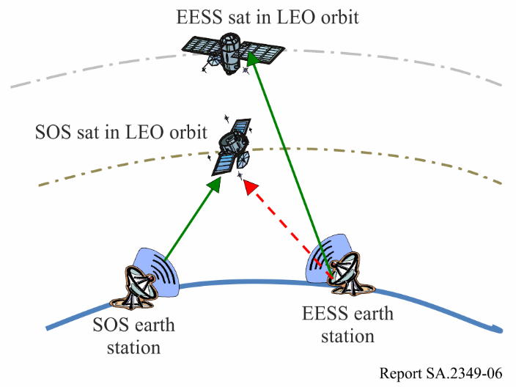

Dynamic interference analysis (SOS victim)

A study was conducted to assess the interference from the proposed GSO EESS system uplink into the SOS system uplink. This analysis assumes that the victim and the interfering systems are co‑frequency, and that the Earth stations transmit only when in view of their respective satellites. The dynamic simulations were done to compute *C/I* for 30 consecutive days with 12 second intervals. The analysis considered COMPARUS C/E systems in MODE 1 and 2 with earth stations in Moscow where the EESS earth station was collocated.

Based on the dynamic simulation studies, the minimum *C/I* received by the SOS receivers assuming collocated victim and interfering earth stations is more than 20 dB. As the sidelobe gain envelope is the same for all earth station sizes with *D*/λ > 100, for a given psd, the analysis resulted in the same interference results for different EESS ES sizes ranging from 4.2 m to 15.0 m. Table 7 shows the minimum *C/I* received by SOS from EESS uplinks using different antenna sizes and collocated with SOS uplinks in Russia.

TABLE 7

Interference from GSO EESS into SOS, COMPARUS C/E with collocated earth stations

|  |  |  |  |  |  |
| --- | --- | --- | --- | --- | --- |
| EESS Ant. Gain (dBi) | EESS Ant. Size (m) | Max psd (dB(W/kHz)) | Bandwidth (MHz) | Max e.i.r.p. (dBW) | Min *C/I*, 1% time (dB) |
| 59.8 | 15 | –18.1 | 9.8 | 81.6 | > 20 |
| 56.5 | 11.5 | 78.3 |
| 47.7 | 4.2 | 69.5 |

It can therefore be concluded on the basis of the protection criteria contained in the applicable Recommendation ITU‑R SA.363-5, that the Earth exploration-satellite in GSO mode and the space operation services are compatible.

# 9 Compatibility between GSO EESS (Earth-to-space) and fixed services

The CPM text on WRC-15 AI 1.11 proposes a method to satisfy the agenda item and the options in that method (Method A) considers a modification of RR No. **5.460** in the Table of Frequency Allocations in RR Article **5** in order to indicate that geostationary EESS satellite systems shall not claim protection from existing and future stations of the fixed and mobile services, and that No. **5.43A** does not apply.

Therefore, the compatibility analysis is done only to develop conditions required to protect the FS from GSO EESS uplinks. For the analysis, the methodology applied consists in determining the size of a coordination area around the EESS earth station which will depend on the characteristics of both the EESS as well as the FS. It should be noted that the SOS and SRS are already allocated in this frequency range and that provisions exist in RR Appendix **7** with regard to coordination between SRS and SOS on one side and FS on the other side, including the characteristics of the reference FS system to be taken into account in the determination of the coordination area.

## 9.1 Fixed service characteristics

The characteristics of fixed service links as shown in Table 8 were taken from Table 7b of RR Appendix **7** in the band 7 100-7 235 MHz shared between the FS and the SOS in Russia and the SRS worldwide. The sharing situation is similar. Only the digital FS system was considered here, since most of the analog systems are no longer in operation and no longer appear in Recommendation ITU-R F.758-5.

TABLE 8

FS characteristics from Table 7b of RR Appendix 7

|  |  |  |  |
| --- | --- | --- | --- |
| Frequency bands (MHz) | | 7 100-7 235 | |
| Receiving terrestrial service designations | | Fixed, mobile | |
| Method to be used | | § 2.2 | |
| Modulation at terrestrial station1 | | *N* | |
| Terrestrial station interference parameters and criteria | *p*0 (%) | 0.005 | |
| *n* | 2 |
| *p* (%) | 0.0025 |
| *NL* (dB) | 0 |
| *Ms* (dB) | 37 |
| *W* (dB) | 0 |
| Terrestrial station parameters | *Gx* (dBi)2 | 46 | |
| *Te* (K) | 750 |
| Reference bandwidth | *B* (Hz) | 106 | |
| Permissible interference power | *Pr*( *p*) (dBW) in *B* | –103 | |
| 1 *N*: digital modulation.  2 Feeder losses are not included. | | | |

This reference system used for the determination of coordination contours may be compared to the characteristics of FS systems contained in Recommendation ITU-R F.758-5 for the same frequency bands and the long-term criterion (20%) derived from Recommendation ITU-R F.758-5 is –150 dB(W/MHz) as given in Table 4 of Report ITU-R SA.2275.

The characteristics given in RR Appendix **7** are quite consistent with the characteristics contained in Recommendation ITU-R F.758-5. Since the determination of coordination contour with regard to space research and space operation is currently done with the characteristics of Table 8, it is proposed to use them also with regard to EESS.

## 9.2 GSO EESS (Earth-to-space) earth station characteristics

The technical characteristics of potential new GSO EESS (Earth-to-space) systems operating in the 7‑8 GHz frequency range would be similar to those of SRS near-Earth systems, which operate today in the same frequency range, but with lower transmit power requirements and antenna gains of 59.8 dBi (antenna size of 12‑15 metre diameter). The assumptions considered in the interference analysis are based on the technical parameters listed in Table 1.

In view of the characteristics of the modulation schemes used by the GSO EESS earth station, it has been considered in the following paragraphs that the EESS earth station emission power falls completely into the FS reference bandwidth of 1 MHz.

The number of GSO EESS earth stations operating Earth-to-space in this new allocated band is expected to be limited to a very few and they will be located in the mid to low latitudes. These stations are often shared by users from many different space agencies.

For operating cost reasons, it is expected that any new earth station with EESS (Earth-to-space) capability in the new band will be co-located with the existing S-band earth stations.

It can be estimated that roughly two thirds of the stations operating in the S-band will be equipped with an additional EESS (Earth-to-space) capability, leading to an estimated number of ~20 EESS stations that will be operating in the new EESS (Earth-to-space) band in the 7/8 GHz range in the long period.

## 9.3 TIG methodology (from RR Appendix 7)

Section 2.1 of RR Appendix **7** contains the procedures for determining the coordination area for the case of earth stations operating with a geostationary space station sharing bands with terrestrial stations.

### 9.3.1 Description

The attenuation required to limit the level of interference between a transmitting terrestrial station or earth station and a receiving terrestrial station or earth station to the permissible interference power for *p*% of the time is represented by the “minimum required loss”, which is the loss that needs to be equalled or exceeded by the predicted path loss for all but *p*% of the time.

For propagation mode (1) the following equation applies:

*Lb*( *p* ) = *Pt* + *Gt* + *Gr* – *Pr*( *p* )                   dB (1)

where:

*p*: maximum percentage of time for which the permissible interference power may be exceeded

*Lb(p)*: propagation mode (1) minimum required loss (dB) for *p*% of the time; this value must be exceeded by the propagation mode (1) predicted path loss for all but p% of the time

*Pt*: maximum available transmitting power level (dBW) in the reference bandwidth at the terminals of the antenna of a transmitting terrestrial station or earth station

*Pr(p)*: permissible interference power of an interfering emission (dBW) in the reference bandwidth to be exceeded for no more than *p*% of the time at the terminals of the antenna of a receiving terrestrial station or earth station that may be subject to interference, where the interfering emission originates from a single source

*Gt*: gain (dB relative to isotropic) of the antenna of the transmitting terrestrial station or earth station. For a transmitting earth station, this is the antenna gain towards the physical horizon on a given azimuth; for a transmitting terrestrial station, the maximum main beam axis antenna gain is to be used

*Gr*: gain (dB relative to isotropic) of the antenna of the receiving terrestrial or earth station that may be subject to interference. For a receiving earth station, this is the gain towards the physical horizon on a given azimuth; for a receiving terrestrial station, the maximum main beam axis antenna gain is to be used.

### 9.3.2 Determination of the coordination distance for the worst case azimuth

Using the pattern provided in Recommendation ITU-R F.1245 for the EESS earth station antenna, the maximum EESS earth station antenna gain *Gt* towards the horizon at the lowest elevation angle of 5° is 11.5 dBi.

The FS station is assumed to be pointing towards the direction of the EESS earth station, which is a worst case assumption. *Gr* is therefore the FS maximum antenna gain, 46 dBi.

The propagation loss is then calculated for separation distances ranging from 200 m to 300 km using the complete clear air methodology in Recommendation ITU-R P.452-14 for the percentages of time 0.005 (short-term) and 20 (long-term). The location considered was Wallops (USA) where an EESS earth station receiving data from satellites in the band 8 025-8 400 MHz is already implemented.

An antenna height of 11 m above the ground was considered for the EESS station, and 20 m for the FS station (station on top of a building). Using the same long-term and short-term criteria for FS used in Table 4 of Report ITU-R SA.2275, results are shown in Table 9 by applying the TIG methodology when considering a worst case situation with the FS station in Wallops pointing straight at the EESS earth station and with no shielding.

TABLE 9

TIG maximum coordination distance at Wallops with FS pointed towards EESS antenna

|  |  |  |  |  |  |  |
| --- | --- | --- | --- | --- | --- | --- |
| *p* (%) | *Pt* (dBW) | *Gt* (dBi) | *Gr* (dBi) | *Pr* (dBW) | *Lb* (dB) | *D* (km) |
| 20 | 11.8 | 11.5 | 46 | –150 | 219.3 | 218 |
| 0.005 | –103 | 172.3 | 334 |

When the FS antenna is pointed away from the EESS antenna with a 20 degree off axis angle, the FS antenna gain is 0 dBi assuming the FS antenna pattern follows Recommendation ITU-R F.699. The results of the TIG methodology for such a case are shown in Table 10.

TABLE 10

TIG maximum coordination distance at Wallops with 20 degree offset pointing of FS antenna

|  |  |  |  |  |  |  |
| --- | --- | --- | --- | --- | --- | --- |
| *p* (%) | *Pt* (dBW) | *Gt* (dBi) | *Gr* (dBi) | *Pr* (dBW) | *Lb* (dB) | *D* (km) |
| 20 | 11.8 | 11.5 | 0 | –150 | 173.3 | 48 |
| 0.005 | –103 | 126.3 | 33 |

Another second worst case assumption used in deriving the above coordination distances is that the EESS earth station transmits towards the GSO at the lowest elevation angle of 5 degree whereas in reality, the elevation/azimuth angles of the EESS earth station would be much larger depending on the GSO satellite location it is pointing towards. Figure 7 shows the elevation/azimuth angles for an earth station at Wallops towards the GSO arc.

Figure 7

Elevation/Azimuth angles towards GSO arc seen from Wallops

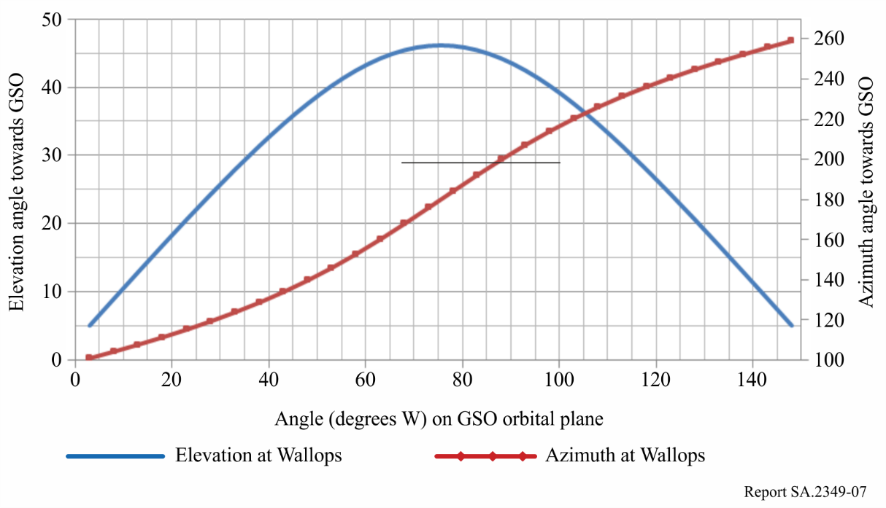

In Tables 9 and 10, the TIG methodology was applied to the worst case where an EESS earth station elevation of 5 degrees is used. The EESS satellite could be located anywhere in the GSO arc. As the maximum elevation angle from Wallops is 46 degrees, three representative cases of elevation angles (5°, 25° and 46°) are used to compute the coordination distances required. Table 11 shows the coordination distances for the EESS earth station at those elevation angles using both the short-term and long-term criteria, assuming that the FS antenna is pointed towards the EESS antenna.

TABLE 11

TIG maximum coordination distance at Wallops for different Elevation angles

|  |  |  |  |  |  |  |
| --- | --- | --- | --- | --- | --- | --- |
|  |  |  |  |  | Coordination distance (km) | |
| EESS earth station El angle (°) | *p*  (%) | *Pt*  (dBW) | *Gr*  (dBi) | *Gt*  (dBi) | *Cri* = 0.005% | *Cri* = 20% |
| 5 | 20 | 11.8 | 46 | 11.5 | 334 | 218 |
| 25 | –5.9 | 200 | 94 |
| 46 | –12.6 | 143 | 71 |

### 9.3.3 Relevance of the long-term and short-term criteria

Based on the results seen in Tables 9 and 11, the coordination distances derived using long-term criterion are higher when the FS antenna offset pointing is large whereas the coordination distance derived using short-term criterion are higher when the FS antenna offset pointing is low.

Therefore, the worst case distances are considered using both the short- and long-term criteria.

### 9.3.4 Application for different pointing angles for the FS station

The TIG methodology was extended to the case of a FS station which is not pointing towards the EESS earth station. As an example, when an offset angle of 20° is applied to the FS station, the FS antenna gain decreases to 0 dBi assuming the FS antenna pattern follows Recommendation ITU-R F.699, and the coordination distance decreases to about 48 km for 5 degree elevation angles. Table 12 gives the results for different FS offset angles.

TABLE 12

Coordination distance for EESS ES at Wallops vs FS offset pointing angle

|  |  |  |  |  |  |
| --- | --- | --- | --- | --- | --- |
| Percentage of FS stations concerned | FS offset pointing angle | FS antenna gain towards the EESS earth station | Coordination distance (km) for different EESS earth station Elevation angles | | |
| (%) | (°) | (dBi) | El = 5° | El =25° | El =46° |
| 100 | 0 | 46 | 334* | 200* | 143* |
| 99 | 2 | 25 | 171* | 55 | 49 |
| 97 | 5 | 15 | 81* | 46 | 41 |
| 94 | 10 | 8 | 55 | 41 | 34 |
| 89 | 20 | 0 | 48 | 34 | 30 |
| 83 | 30 | –4 | 45 | 32 | 28 |
| 78 | 40 | –7 | 43 | 30 | 26 |
| 72 | 50 | –9 | 41 | 29 | 25 |
| * Cases are derived using short-term criterion. | | | | | |

For 90% of FS stations, the coordination distance would therefore reduce to less than 50 km. Additionally, the terrain elevation around the EESS earth station constitutes an important factor that may considerably reduce the coordination distance. The GSO EESS earth station, before implementing the service would have to take sufficient measures in coordinating with the FS sites within the coordination distances noted above.

## 9.4 Conclusions

The TIG methodology described in RR Appendix **7** was applied to assess the coordination area around GSO EESS earth stations where coordination would be required with FS. The static analysis leads to a maximum coordination distance of 334 km for a GSO EESS earth station at Wallops (USA) when considering that the victim FS station is pointing directly towards the EESS earth station.

This coordination distance drops rapidly to less than 50 km when the FS station does not point directly towards the EESS earth station, which would likely be the case when dealing with cross border coordination. The 50 km distance is obtained for offset angles greater than 20°. For 90% of FS stations, the coordination distance would be lower than 50 km.

It should also be noted that these findings are based on a flat terrain assumption but, when taking into account the actual terrain elevation, on a site-by-site basis, the coordination distance would be much more reduced.

# 10 Compatibility between GSO EESS (Earth-to-space) and mobile services

Within the range 7-8 GHz, the band above 7 125 MHz is not currently used by the MS and therefore no study was performed with regard to MS. However if the MS would use this band in the future, it is considered that the conditions applied for the protection of the FS would be sufficient for the protection of the MS.

# 11 Summary and conclusions

This Report provides an analysis of compatibility between the proposed new EESS frequency allocation (Earth-to-space), and the existing SRS (near Earth) and SOS uplinks as well as the FS and MS having a primary allocation in the frequency range 7 190-7 235 MHz.

The results of the analyses in this Report are consistent with and augment the results of studies of interference between NGSO EESS missions and SRS near-Earth and SOS missions given in Report ITU-R SA.2275.

Overall, considering a potential GSO EESS (Earth-to-space) allocation within the 7 190-7 235 GHz band, the following conclusions can be drawn:

Concerning the compatibility with near-Earth SRS

The analysis in this Report indicate that interference levels from GSO EESS uplinks into near-Earth SRS satellite receivers in the band 7 190-7 235 MHz are compliant with the applicable ITU criterion and that this type of operation is compatible without the need of any special mitigation techniques.

On the other hand, for co-frequency operations and either geographically co-located or nearby earth station operations, the interference levels from certain near-Earth SRS uplinks into EESS satellites could marginally exceed the applicable ITU criterion. This could put some limitations in the selection of individual frequency assignments or station locations for EESS (Earth-to-space) within the range 7 190‑7 235 MHz.

However, it should be noted that a similar situation currently exists for near-Earth SRS uplinks of different missions and that these missions are successfully coordinated among space agencies in the frame of the Space Frequency Coordination Group (SFCG) and the applicable ITU procedures. Therefore, there should be compatibility between SRS and GSO EESS (Earth-to-space) in the 7 190‑7 235 MHz if frequency and earth station coordination takes place.

Concerning the compatibility with SOS

In the Russian Federation, the frequency bands 7 100-7 155 MHz and 7 190-7 235 MHz are also allocated by RR No. **5.459** to the space operation service (Earth-to-space) on a primary basis, subject to agreement obtained under RR No. **9.21 (WRC-97)**. A study using the applicable SOS protection criteria contained in Recommendation ITU-R SA.363-5 concludes that the uplinks in GSO EESS and the space operation service are compatible. The study also shows that the EESS using any earth station antenna size from 4.2 m to 15 m with an uplink psd of –18.1 dB(W/kHz) in GSO mode inside the victim SOS bandwidth and with earth station inside Russia is compatible with the SOS. It can therefore be concluded that on the basis of the protection criteria contained in the applicable Recommendation ITU-R SA.363-5, the EESS and the space operation service are compatible.

Concerning the compatibility with FS

The TIG methodology described in RR Appendix **7** was applied to assess the coordination area around GSO EESS earth stations where coordination would be required with FS. The static analysis leads to a maximum coordination distance of 334 km for a GSO EESS earth station at Wallops (USA) when considering that the victim FS station is pointing directly towards the EESS earth station.

This coordination distance drops rapidly to less than 50 km when the FS station does not point directly towards the EESS earth station, which would likely be the case when dealing with cross border coordination. The 50 km distance at Wallops is obtained for offset angles greater than 20°. For 90% of FS stations, the coordination distance would be lower than 50 km.

It should also be noted that these findings are based on a flat terrain assumption but, when taking into account the actual terrain elevation, on a site-by-site basis, the coordination distance would be much more reduced.

It should be pointed out that a number of SRS earth stations operating today in the band 7 190‑7 235 MHz have been successfully coordinated with the FS, although they use a much higher emission power density than that used with GSO EESS earth stations, leading sometimes to larger coordination areas.

Similar to what is happening for these SRS earth stations, for each individual EESS satellite mission and earth station, a specific uplink licence will have to be obtained from the relevant administration. This implies that the compatibility with the FS systems operating within the coordination area will always have to be analysed (in a few cases this could involve the neighbouring administrations). Only when and if the administration(s) will have verified that there will be no impact to the FS systems the individual licences for operating the uplinks will be given. In other words, the FS systems will always be fully protected.

Given the relatively small separation distance requirements, coordination of FS stations and EESS earth stations becomes a national matter for all currently known locations. To this effect, a separation distance between the location of the EESS earth station and the border of neighbouring administrations might be included in the RR, as a replacement for coordination. In addition, existing provisions within RR Article **21** ensure that FS systems will not be constrained beyond that with which they currently operate in the 7 190-7 250 MHz band in regards to other co-primary services.

No change is being proposed on the sharing criteria that are currently applied to sharing between the FS and the SRS in the 7 190-7 235 MHz, and no additional constraints will be placed on the FS in this band or other bands under WRC-15 Agenda item 1.11.

Concerning the compatibility with MS

Within the range 7-8 GHz, the band above 7 125 MHz is not currently used by the MS and therefore no study was performed with regard to MS.