Report ITU-R SA.2329-0
(11/2014)
Sharing assessment between meteorological-satellite systems
and IMT stations in the
1 695-1 710 MHz frequency band

SA Series
Space applications and meteorology

Foreword
The role of the Radiocommunication Sector is to ensure the rational, equitable, efficient and economical use of the radio-frequency spectrum by all radiocommunication services, including satellite services, and carry out studies without limit of frequency range on the basis of which Recommendations are adopted.
The regulatory and policy functions of the Radiocommunication Sector are performed by World and Regional Radiocommunication Conferences and Radiocommunication Assemblies supported by Study Groups.

Policy on Intellectual Property Right (IPR)
ITU-R policy on IPR is described in the Common Patent Policy for ITU-T/ITU-R/ISO/IEC referenced in Annex 1 of Resolution ITU-R 1. Forms to be used for the submission of patent statements and licensing declarations by patent holders are available from http://www.itu.int/ITU-R/go/patents/en where the Guidelines for Implementation of the Common Patent Policy for ITU-T/ITU-R/ISO/IEC and the ITU-R patent information database can also be found.

Series of ITU-R Reports
(Also available online at http://www.itu.int/publ/R-REP/en)
Series | Title
BO | Satellite delivery
BR | Recording for production, archival and play-out; film for television
BS | Broadcasting service (sound)
BT | Broadcasting service (television)
F | Fixed service
M | Mobile, radiodetermination, amateur and related satellite services
P | Radiowave propagation
RA | Radio astronomy
RS | Remote sensing systems
S | Fixed-satellite service
SA | Space applications and meteorology
SF | Frequency sharing and coordination between fixed-satellite and fixed service systems
SM | Spectrum management

Note: This ITU-R Report was approved in English by the Study Group under the procedure detailed in Resolution ITU-R 1.

Electronic Publication
Geneva, 2015
© ITU 2015
All rights reserved. No part of this publication may be reproduced, by any means whatsoever, without written permission of ITU.

REPORT ITU-R SA.2329-0
Sharing assessment between meteorological-satellite systems and
IMT stations in the 1 695-1 710 MHz frequency band
(2014)

1 Introduction/Background
In order to support requirements for “mobile broadband”, the frequency band 1 695-1 710 MHz has been called for studies.
This frequency band is allocated to the meteorological-satellite service (MetSat) and used in particular for data downlink from non-geosynchronous orbit (NGSO) satellites and is essential for providing operational and time-critical meteorological information to the users around the world with receiving earth stations operated by almost all national meteorological services and many other users worldwide.
On the basis of some existing MetSat earth stations locations, the present Report provides an assessment of the separation distance that would be required between IMT stations (base stations and user equipment (UE)) and MetSat receiving earth stations in the 1 695-1 710 MHz frequency band.

2 Technical characteristics

2.1 Meteorological systems
There are hundreds of MetSat stations worldwide in the 1 695-1 710 MHz frequency band operated by almost all national meteorological services and many other users worldwide.
Meteorological-satellite systems use the frequency band 1 695-1 710 MHz to disseminate meteorological data directly to the users. The frequency band 1 695-1 698 MHz is used for earth stations to receive data from geostationary MetSat systems, such as FY-2 and FY-4 from China, GOES from USA, Meteosat from EUMETSAT, COMS from Korea, MTSAT from Japan and others. In the frequency band 1 698-1 710 MHz a number of users operate earth stations to receive High Resolution Picture Transmission (HRPT) from NGSO satellites such as FY-3 from China, NOAA from USA and METOP from EUMETSAT.
The characteristics of such stations are provided in Table 1.
TABLE 1
Characteristics used for meteorological earth stations
Parameter | Value
Signal | HRPT, High Resolution Picture Transmission
Nominal carrier centre frequency | Either 1 701.300 MHz or 1 707.000 MHz
RF bandwidth | 4.5 MHz (99% of the total signal power)
TABLE 1 (end)
Parameter | Value
Polarization | RHCP
Antenna diameter | 1.8 m
Antenna height | 12 m
Antenna gain | 29.8 dBi
Antenna pattern | Appendix 8 of the Radio Regulations
Minimum elevation angle | 5°
Protection criterion long-term  (as per Rec. ITU-R SA.1027 for terrestrial path) | –151 dBW per 2 668 kHz equivalent to –148.7 dBW per 4.5 MHz, no more than 20% of the time
Protection criterion short-term  (as per Rec. ITU-R SA.1027 for terrestrial path) | –138 dBW per 2 668 kHz equivalent to –135.7 dBW per 4.5 MHz, no more than 0.009 4% of the time

The permissible interference power P_{r}(p) is specified with respect to the actual percentage of time the receiver is in visibility of the satellite, and not the total elapsed time.
Similar stations are used by a number of users in almost all countries worldwide. Table 2 below gives some example locations.
TABLE 2
Example locations of meteorological earth stations
Station Name | Country | Operated by | Location (lat, long)
Edmonton | Canada | EC | 53.33°N, 113.5°W
Gander |  |  | 48.95°N, 54.57°W
Gilmore Creek | USA | NOAA | 64.97°N, 147.40°W
Monterey |  |  | 36.35°N, 121.55°W
Ewa Beach |  |  | 21.33°N, 158.07°W
Miami |  |  | 25.74°N, 80.16°W
Wallops |  |  | 37.8°N, 75.3°W
Maspalomas | Spain | INTA/INSA | 27.78°N, 15.63°W
Kangerlussuaq | Greenland | DMI | 66.98°N, 50.67°W
Svalbard | Norway | KSAT | 78.13°N, 15.23°E
Athens | Greece | HNMS | 37.81°N, 23.77°E
Lannion | France | CMS | 48.75°N, 3.5°W
Saint-Denis (La Réunion) |  |  | 20.91°S, 55.50°E
Moscow | Russian Federation | SRC Planeta | 55.76°N, 37.57°E
Beijing | CHN | CMA | 40.05°N, 116.27°E
Guangzhou | CHN | CMA | 23.16°N, 113.33°E
Xinjiang | CHN | CMA | 43.86°N, 87.57°E
TABLE 2 (end)
Station Name | Country | Operated by | Location (lat, long)
Kashi | CHN | CMA | 43.86°N, 75.94°E
Jiamusi | CHN | CMA | 46.9°N, 130.34°E
Sanya | CHN | CMA | 18.26°N, 109.49°E
Antarctic | CHN | CMA | 72°S, 2.52°E
Melbourne | AUS | BOM | 38.36°S, 145.17°E
Kiruna | S | SSC | 68°N, 21°E

2.2 Mobile service (IMT systems)
The following parameters have been considered in the 1 695-1 710 MHz frequency band.
TABLE 3
Selected set of IMT characteristics for base stations (rural case)
Parameter | Value
Transmitted power (dBm) | 46
Bandwidth (MHz) | 10
Activity factor (%) | 50
Antenna gain (dBi) | 18
Feeder loss (dB) | 3
Antenna height (m) | 30
Antenna tilt angle (degrees) | 3

TABLE 4
Selected set of IMT characteristics for UE (as used in Annex A)
Parameter | Value
Average transmitted power | 2
Antenna gain (dBi) | –3
Transmission bandwidth (MHz) | 10
Antenna height (m) | 1.5

TABLE 5
LTE user equipment technical characteristics (as used in Annex C)
Technical characteristic | Value
Aggregate total UE e.i.r.p for cities with population < 250 000 | –53.12 dBW/Hz
Average individual UE e.i.r.p for cities with population < 250 000 | 8.08 dBm/10 MHz (TBC with the revision of the study in Annex C)
Aggregate total UE e.i.r.p. for cities with population ≥ 250 000 | –50.78 dBW/Hz
Average individual UE e.i.r.p. for cities with population ≥ 250 000 | 5.87 dBm/10 MHz (TBC with the revision of the study in Annex C)
UE channel bandwidth | 5, 10 and 15 MHz
UE antenna height | 1.5 m
Number of simultaneously transmitting UE per base station sector for each channel bandwidth | 5 MHz  3 | 10 MHz  6 | 15 MHz  9
Antenna pattern | Omni directional
Cellular deployment scenario | LTE base stations and UE as presented in Annex C

3 Analysis
Based on the above assumptions and mobile service deployments, three different analyses have been performed and described in:
– Annex A: Compatibility of NNGSO MetSat earth stations with IMT base stations and UE.
– Annex B: Compatibility of NGSO and geosynchronous orbit (GSO) MetSat earth stations with IMT base stations and UE.
– Annex C: Compatibility of NGSO MetSat earth stations with IMT UE.

4 Summary/Conclusions
This Report shows that the required protection area around MetSat stations from which potential IMT base stations in the 1 695-1 710 MHz frequency band would have to be excluded, would be up to several hundred kilometres, as calculated in Annexes A and B. Therefore, sharing between IMT base stations and MetSat stations in the 1 695-1 710 MHz frequency band is not feasible.
This Report also provides assessments of protection areas around MetSat stations from which IMT UE in the 1 695-1 710 MHz frequency band would have to be excluded, with diverging results. Studies in Annexes A and B depict required separation distances from 46 km (GSO case) and 60 km (NGSO case) up to more than 120 km (NGSO case), even considering low rural deployment and conclude that IMT UE deployment is not compatible with MetSat stations in the 1 695-1 710 MHz. The study in Annex C provides an example calculation resulting in separation distances ranging from 32 to 46 km (NGSO case) and concludes that IMT UE can be deployed compatibly with MetSat stations.

Annex A
Compatibility assessment between meteorological-satellite systems
and IMT stations in the 1 695-1 710 MHz frequency band

1 Introduction/Background
This frequency band is allocated to the meteorological-satellite service and used in particular for data downlink from NGSO satellites.
This frequency band is essential for providing operational and time-critical meteorological information to the users around the world with receiving earth stations operated by almost all national meteorological services and many other users worldwide.
On the basis of existing MetSat earth stations locations, the present Annex provides an assessment of the separation distance that would be required between IMT base stations and MetSat receiving earth stations in the 1 695-1 710 MHz frequency band.

2 Technical characteristics

2.1 Meteorological systems
Meteorological-satellite systems use the frequency band 1 695-1 710 MHz to disseminate meteorological data directly to the users. A number of users operate earth stations to receive HRPT from NGSO satellites such as METOP from EUMETSAT.
The characteristics of such stations are provided in Table 6.
TABLE 6
Characteristics used for meteorological earth stations
Parameter | Value
Signal | HRPT, High resolution picture transmission
Nominal carrier centre frequency | Either 1 701.300 MHz or 1 707.000 MHz
RF bandwidth | 4.5 MHz (99 % of the total signal power)
Polarization | RHCP
Antenna diameter | 1.8 m
Antenna height | 12 m
Antenna gain | 29.8 dBi
Antenna pattern | Appendix 8 to the Radio Regulations
Minimum elevation angle | 5°
Protection criterion long-term  (as per Rec. ITU-R SA.1027 for terrestrial path) | –151 dBW per 2 668 kHz equivalent to –148.7 dBW per 4.5 MHz, no more than 20% of the time
Protection criterion short-term  (as per Rec. ITU-R SA.1027 for terrestrial path) | –138 dBW per 2 668 kHz equivalent to –135.7 dBW per 4.5 MHz, no more than 0.0094% of the time

The permissible interference power P_{r}(p) is specified with respect to the actual percentage of time the receiver is in visibility of the satellite, and not the total elapsed time.
Similar stations are used by a number of users in almost all countries worldwide. Table 7 below gives some example locations.
TABLE 7
Example locations of meteorological earth stations
Station Name | Country | Operated by | Location (lat, long)
Edmonton | Canada | EC | 53.33°N, 113.5°W
Gander |  |  | 48.95°N, 54.57°W
Gilmore Creek | USA | NOAA | 64.97°N, 147.40°W
Monterey |  |  | 36.35°N, 121.55°W
Ewa Beach |  |  | 21.33°N, 158.07°W
Miami |  |  | 25.74°N, 80.16°W
Wallops |  |  | 37.8°N, 75.3°W
Maspalomas | Spain | INTA/INSA | 27.78°N, 15.63°W
Kangerlussuaq | Greenland | DMI | 66.98°N, 50.67°W
Svalbard | Norway | KSAT | 78.13°N, 15.23°E
Athens | Greece | HNMS | 37.81°N, 23.77°E
Lannion | France | CMS | 48.75°N, 3.5°W
Saint-Denis (La Réunion) |  |  | 20.91°S, 55.50°E
Moscow | Russian Federation | SRC Planeta | 55.76°N, 37.57°E
Muscat | Sultanate of Oman | DGMAN | 23.59°N, 58.29°E

2.2 Mobile service (IMT systems)
In the absence of IMT parameters for this frequency band, the following parameters have been considered in the 1 695-1 710 MHz frequency band, consistent with parameters in the current IMT frequency bands.
TABLE 8
Selected set of IMT characteristics for base stations
Parameter | Value
Transmitted power (dBm) | 43 for BW = 5 MHz  46 for BW = 10 MHz  46 for BW = 20 MHz
Antenna gain (dBi) | 18
Feeder loss (dB) | 3
Antenna height (m) | 30
Antenna tilt angle (degrees) | 2.5 rural  5 urban

TABLE 9
Selected set of IMT characteristics for UE
Parameter | Value
Typical transmitted power (dBm) | 23
Antenna gain (dBi) | 0
Transmission bandwidth (MHz) | 5, 10 or 20
Antenna height (m) | 1.5

3 Analysis for base stations and UE

3.1 Methodology for the base station case
As the frequency band is used by EUMETSAT for the NGSO METOP satellites, the MetSat earth station is continuously tracking the satellite when in visibility. The antenna gain of the earth station towards the horizon changes continuously. The distribution of the interference will therefore be the convolution of the distribution of the antenna gain with the distribution of the propagation loss for an IMT base station.
This may be approximated by the time-variant gain (TVG) method described in section 4 of Annex 6 to RR Appendix 7.
The TVG method closely approximates the convolution of the distribution of the horizon gain of the earth station antenna and the propagation loss. This method may produce slightly smaller distances than those obtained by an ideal convolution. An ideal convolution cannot be implemented due to the limitations of the current model for propagation loss. The propagation loss required distance, at the azimuth under consideration, may be rewritten for the n-th calculation in the following form:
dB (1)
with the constraint:
where:
P_{t}: maximum available transmitting power level (dBW) in the reference bandwidth at the base station
P_{r}(p): interference power of an interfering emission (dBW) in the reference bandwidth to be exceeded for no more than p% of the time at the terminals of the antenna of a receiving earth station, where the interfering emission originates from a single source
G_{x}: maximum antenna gain assumed for the base station towards the horizon (dBi)
G_{e}(p_{n}): the horizon gain of the earth station antenna (dBi) that is exceeded for p_{n}% of the time on the azimuth under consideration
L_{b}(p_{v}): the minimum required propagation loss (dB) for p_{v}% of the time.
The values of the percentages of time, p_{n}, to be used in equation (1) are determined in the context of the cumulative distribution of the horizon antenna gain. This distribution needs to be developed for a predetermined set of values of horizon antenna gain spanning the range from the minimum to the maximum values for the azimuth under consideration. The notation G_{e}(p_{n}) denotes the value of horizon antenna gain for which the complement of the cumulative distribution of the horizon antenna gain has the value corresponding to the percentage of time p_{n}. The p_{n} value is the percentage of time that the horizon antenna gain exceeds the n-th horizon antenna gain value. This is evaluated only when the satellite is in visibility from the earth station.
For each value of p_{n}, the value of horizon antenna gain for this time percentage, G_{e} p_{n}), is used in equation (1) to determine a minimum required propagation loss. The propagation loss is to be lower than this required propagation loss for no more than p_{v}% of the time, as specified by the constraint associated with equation (1). A series of distances are then determined using Recommendation ITU-R P.452-14.
The antenna gain of the IMT base stations towards the horizon may be determined using Recommendation ITU-R F.1336. Assuming a maximum antenna gain of 18 dBi, and aperture in azimuth of 65°, a down tilt angle of 2.5° and a coefficient k of 0.7, this leads to a gain between 8.1 and 16.1 dBi, depending of the azimuth pointing angle of the base station. The maximum value corresponds to a base station pointing in the same direction as the MetSat earth station, the minimum value corresponds to a base station pointing at an angle of 60° from the MetSat earth station.

3.2 Calculations for the base station case
The calculations have been done for three different receiving stations in the EUMETSAT Advanced Retransmission Service (EARS) network, namely in Lannion, Moscow and Miami.

Lannion | France | 48.75°N; 3.5°W
Moscow | Russian Federation | 55.76°N; 37.57°E
Miami | USA | 25.74°N; 80.16°W

Several cases have been considered, depending whether the base station is pointing towards the MetSat earth station or not, and depending on the location and height of the first obstacle.
In addition, the required exclusion zone has been determined around each of those stations using actual terrain model elevation and calculated for a base station pointing towards the MetSat station, as well as the antenna gain for the MetSat earth station and the percentage of time for the propagation model which gave the worst case separation distances in the generic calculations over flat terrain (so-called “max flat distance”. This may however underestimate the separation distances in case of obstacles on the path profile.

3.2.1 Results for Lannion
TABLE 10
Results for Lannion
Pointing azimuth of the base station | First obstacle | MetSat earth station antenna gain towards the horizon for the “max flat distance” | Percentage of time for the propagation model for the “max flat distance” | Separation distances depending on the azimuth
Towards the MetSat station | None | –2 dBi | 0.0094% | 354 km
 | 10 km – 50 m | –2 dBi | 0.0094% | 315 km
 | 10 km – 100 m | 10 dBi | 0.12% | 128 to 149 km
 | 20 km – 200 m | 18 dBi | 0.9% | 90 to 100 km
 | 10 km – 300 m | 18 dBi | 0.9% | 60 to 68 km
60° off pointing angle | None | 11 dBi | 0.1% | 284 to 294 km
 | 10 km – 50 m | –2 dBi | 0.0094% | 239 to 251 km
 | 10 km – 100 m | 16 dBi | 0.4% | 66 to 75 km
 | 20 km – 200 m | –2 dBi | 0.0094% | 21 km
 | 10 km – 300 m | –2 dBi | 0.0094% | 11 km

Figure 1
Exclusion zones around Lannion for base station
(The colour indicates the level by which the protection criterion is exceeded)
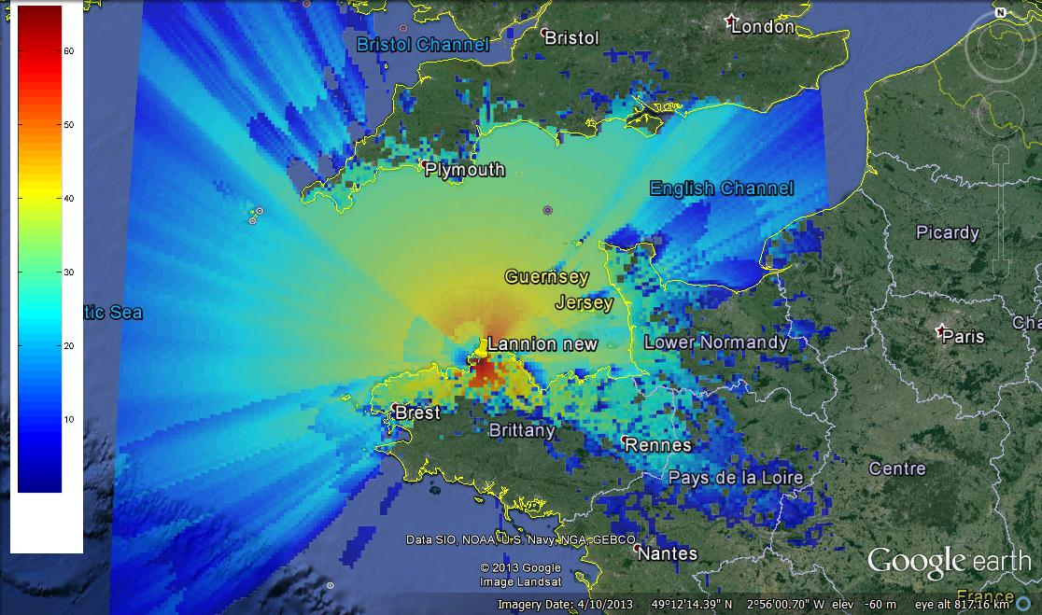

The required separation distance extends up to 369 km in the South East, which is consistent with the calculation in Table 10 above. It can also be noted that the protection of the MetSat station is not limited to a national issue since the protection area extends from France to the UK.

3.2.2 Results for Moscow
TABLE 11
Results for Moscow
Pointing azimuth of the base station | First obstacle | MetSat earth station antenna gain towards the horizon for the “max flat distance” | Percentage of time for the propagation model for the “max flat distance” | Separation distances depending on the azimuth
Towards the MetSat station | None | –2 dBi | 0.0094% | 339 to 347 km
 | 10 km – 50 m | –2 dBi | 0.0094% | 301 to 310 km
 | 10 km – 100 m | 12 dBi | 0.1% | 84 to 146 km
 | 20 km – 200 m | 18 dBi | 0.7% | 86 to 102 km
 | 10 km – 300 m | 18 dBi | 0.6% | 59 to 71 km
60° off pointing angle | None | 11 dBi | 0.1% | 269 to 290 km
 | 10 km – 50 m | –2 dBi | 0.0094% | 225 to 248 km
 | 10 km – 100 m | 15 dBi | 0.2% | 63 to 80 km
 | 20 km – 200 m | –2 dBi | 0.0094% | 21 km
 | 10 km – 300 m | –2 dBi | 0.0094% | 11 km

Figure 2
Exclusion zones around Moscow for base station
(The colour indicates the level by which the protection criterion is exceeded)
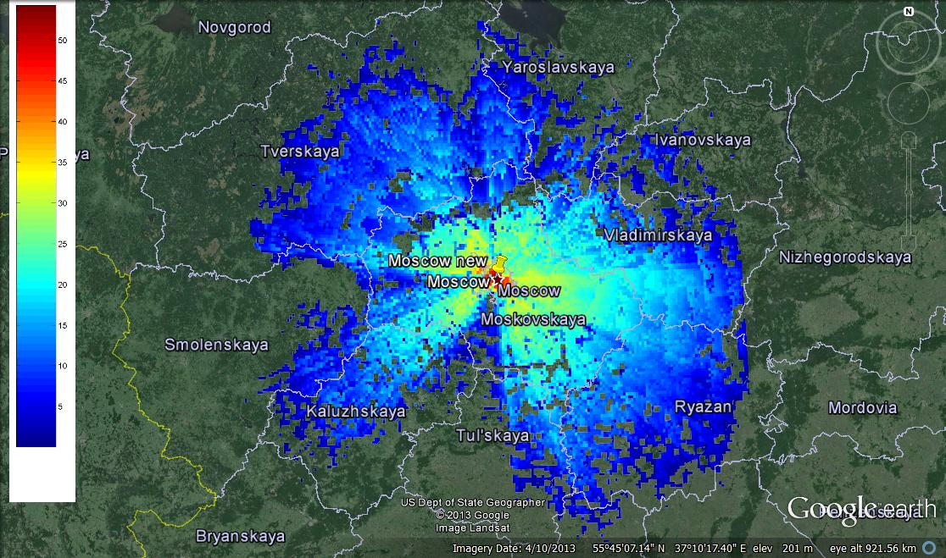

The required separation distance extends up to 351 km in the South East, which is consistent with the calculation in Table 11 above.

3.2.3 Results for Miami
TABLE 12
Results for Miami
Pointing azimuth of the base station | First obstacle | MetSat earth station antenna gain towards the horizon for the “max flat distance” | Percentage of time for the propagation model for the “max flat distance” | Separation distances depending on the azimuth
Towards the MetSat station | None | 7 dBi | 0.1% | 382 to 395 km
 | 10 km – 50 m | –2 dBi | 0.094% | 367 km
 | 10 km – 100 m | 10 dBi | 0.2% | 191 to 208 km
 | 20 km – 200 m | 18 dBi | 1.4% | 99 to 103 km
 | 10 km – 300 m | 18 dBi | 1.3% | 63 to 66 km
60° off pointing angle | None | –2 dBi | 0.0094% | 337 to 345 km
 | 10 km – 50 m | 9 dBi | 0.2% | 293 to 304 km
 | 10 km – 100 m | 11 dBi | 0.3% | 122 to 138 km
 | 20 km – 200 m | –2 dBi | 0.0094% | 21 km
 | 10 km – 300 m | –2 dBi | 0.0094% | 11 km

Figure 3
Exclusion zones around Miami for base station
(The colour indicates the level by which the protection criterion is exceeded)
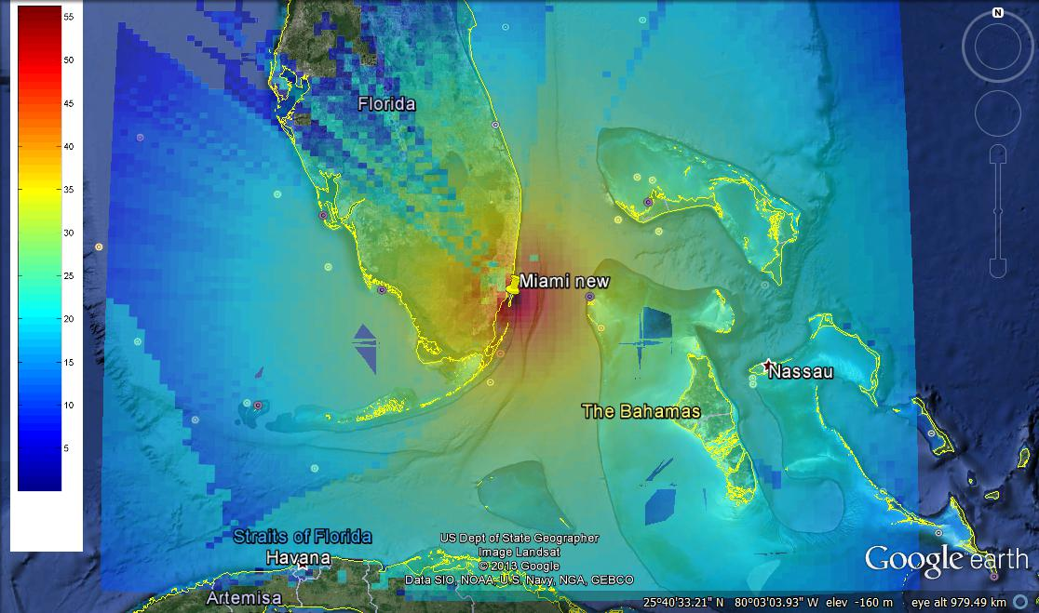

In this case, the required separation distance extends even over the maximum distance determined in Table 12 (i.e. 395 km) due to the location of the station close to the sea, where propagation is much more favourable than over land. On the other hand, the distances found over land are consistent with the calculation in Table 12 above. It can also be noted that the protection of the MetSat station is not limited to a national issue since the protection area extends from USA to Cuba and the Bahamas.

3.3 Analysis and results for the terminal user case

3.3.1 IMT systems deployment
A number of IMT base stations has been deployed over land with a given separation distance from the MetSat earth station. The base stations are deployed in a cellular network with a cell size of 5 km, representative of rural environment. Obviously, a cellular deployment in suburban or urban environment would lead to a higher number of base stations.
For each base station (with three sectors), one active UE per sector is transmitting with an e.i.r.p. following a Rayleigh distribution, as shown in Fig. 4.
Figure 4
Distribution of UE e.i.r.p.
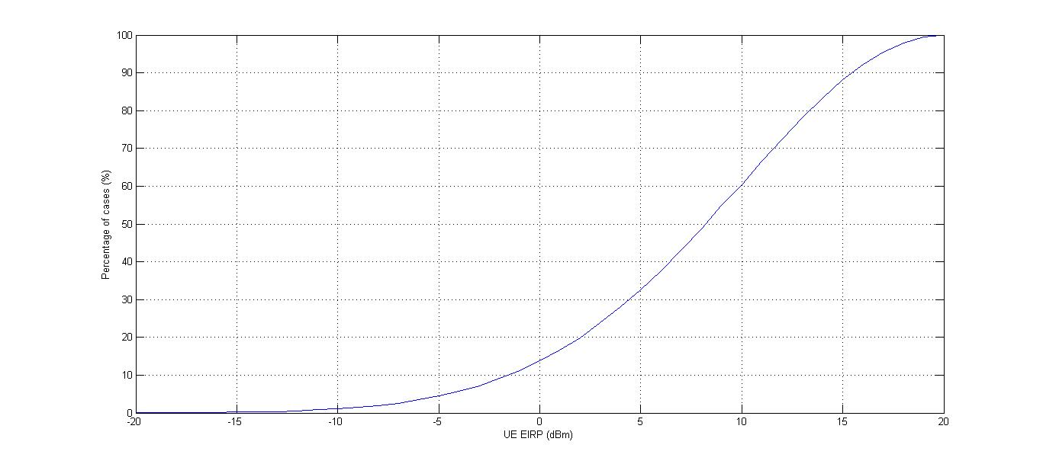
Figures 5 and 6 give an example of deployment around respectively Lannion and Miami MetSat stations for a 60 km separation distance. The IMT base stations are represented by the diamond shape, while the UEs are represented with a red plot.
Figure 5
Example of mobile deployment for Lannion assuming a 60 km separation distance
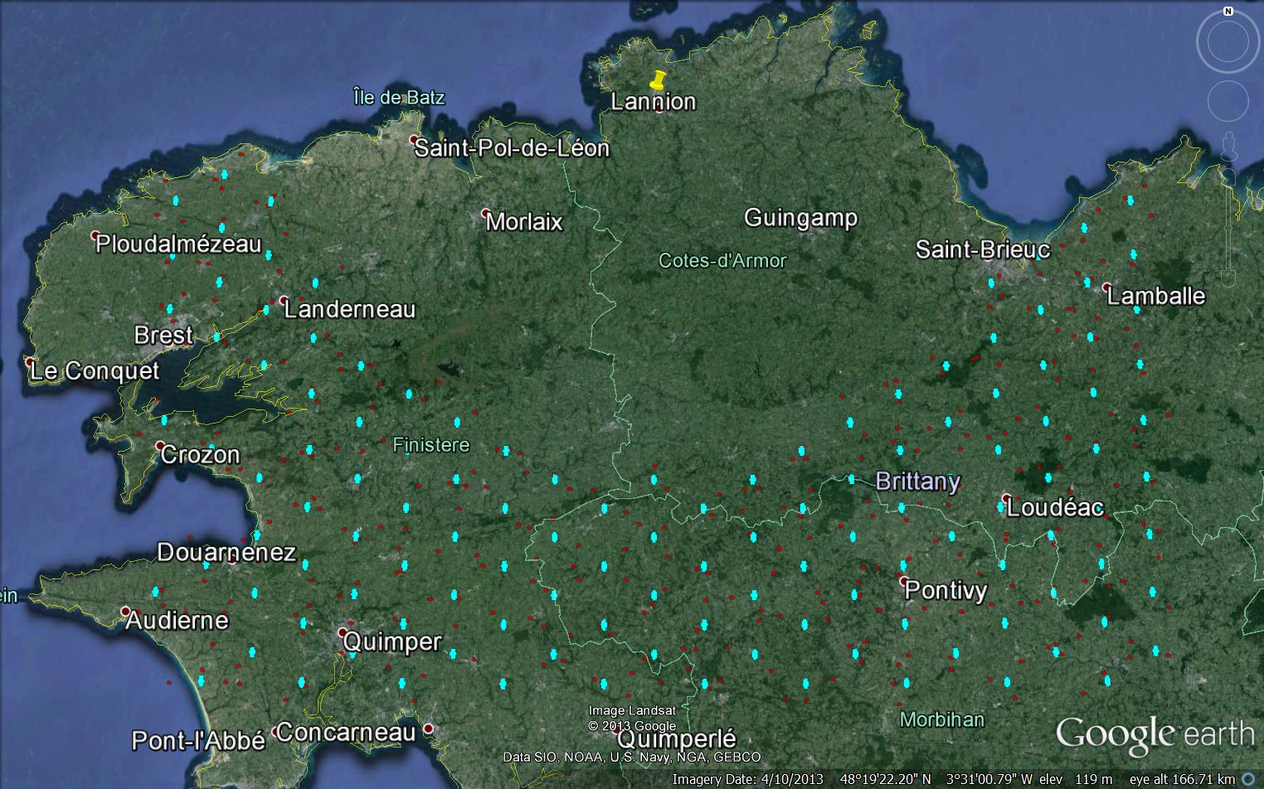
Figure 6
Example of mobile deployment for Miami assuming a 60 km separation distance
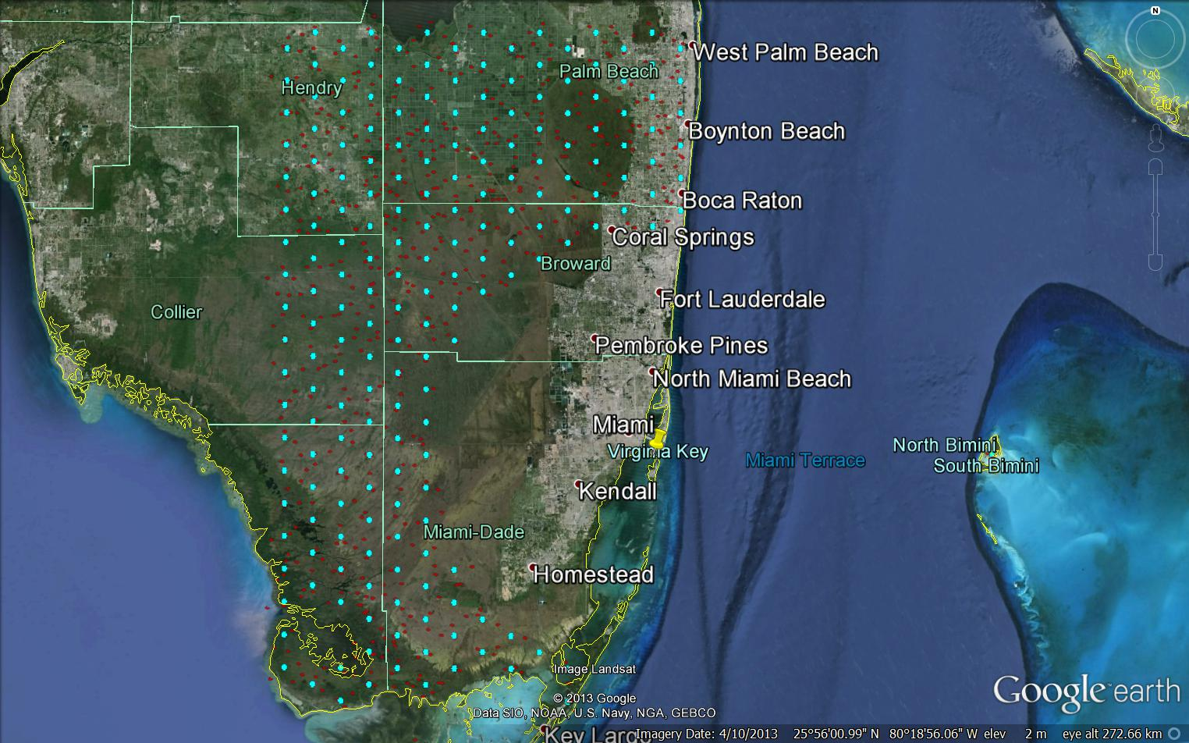
One could argue that in an actual IMT deployment, few to no base station or UE might be expected in the everglades in the southwest of Miami. However, this is not the case when considering a separation distance of 120 km as shown in Fig. 7 below.
Figure 7
Example of mobile deployment for Miami assuming a 120 km separation distance
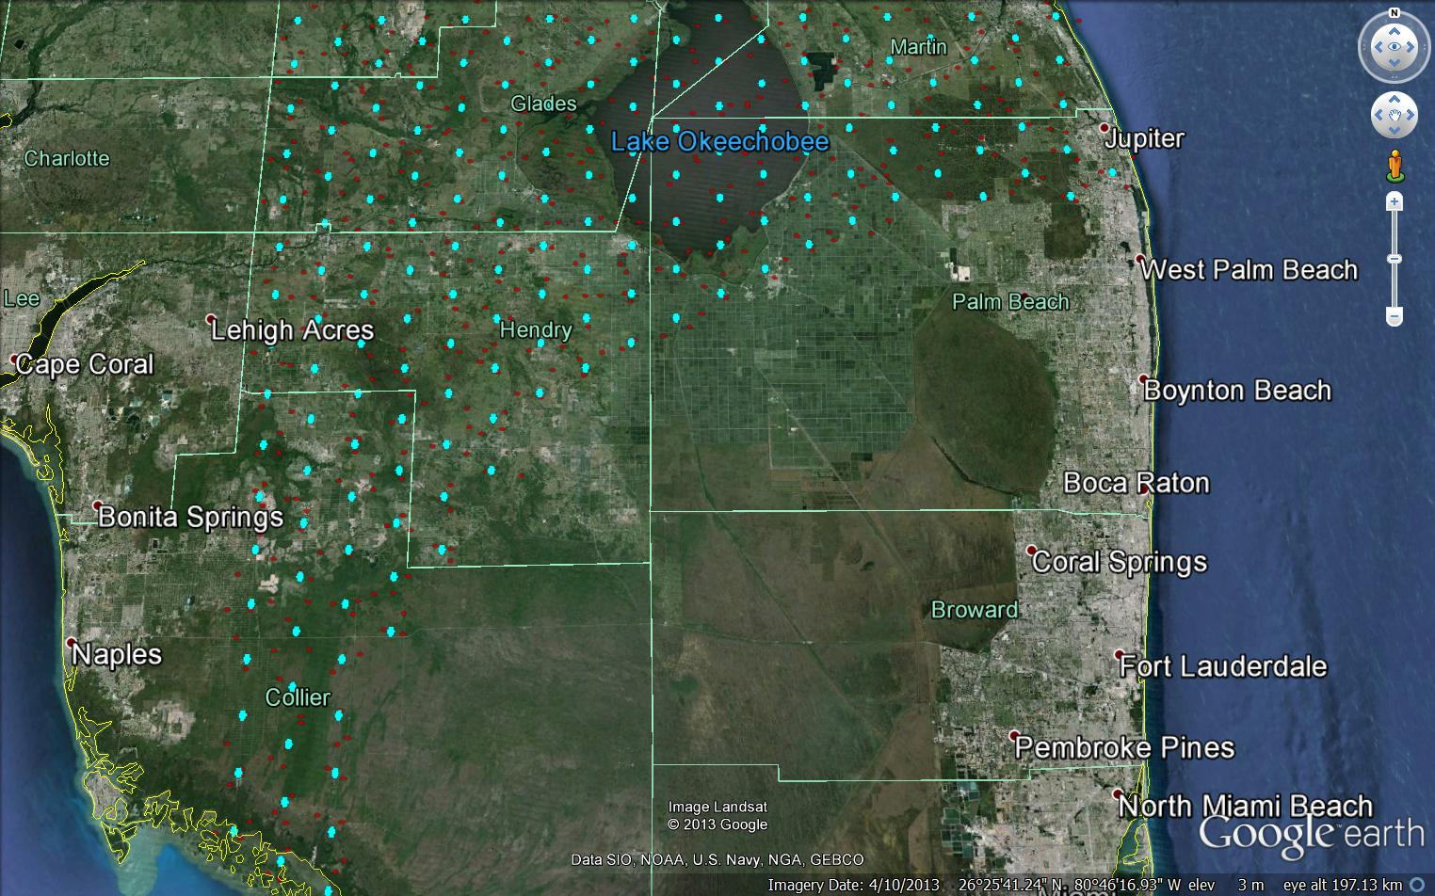
In addition, the study considered an IMT deployment limited to a rural environment, whereas one would expect in Miami and close vicinity a much larger number of base stations to cover the urban and suburban environments.
Finally, the present study only considers three UEs per base station whereas in an urban/suburban environment, the number of terminals would be much larger. Thus, the IMT deployment scenario used to assess the interference potential on a MetSat earth station in this study can be considered as quite low and far from being worst case.

3.3.2 Methodology
A Monte-Carlo simulation was developed in order to assess the aggregate interference from multiple UEs deployed at a given distance from the MetSat earth station, taking into account the actual terrain elevation.
For each trial, the following steps are followed:
– the MetSat earth station antenna is randomly pointed with a uniform distribution in the volume (in steradians) above the minimum elevation angle of 5° (a uniform distribution in azimuth and elevation would lead to an overestimation of the high elevation events, not representative of reality);
– the e.i.r.p. of each UE is determined following the Rayleigh distribution as on Fig. 1;
– the propagation loss value over each UE-to-MetSat path follows a distribution given by Recommendation ITU-R P.452 with a percentage that is randomly determined. (a constant value such as 50% would not be correct as it does not allow to encompassing the possibility of anomalous atmospheric events such as ducting);
– the aggregate interference from all UEs at the MetSat receiver level is then computed, taking into account the relative MetSat antenna gain in the direction of each UE, considering the following equation:
(dB)
where:
n: index of the UE (1 to 48)
e.i.r.p._{n}: UE e.i.r.p. (based on the distribution in Fig. 4)
L_{n}: propagation loss between the UE of index n and the MetSat station (for p% based on Recommendation ITU-R P.452)
p%: random percentage for Recommendation ITU-R P.452 (from 0.0001% to 50%) different
G_{metsat}: Relative antenna gain (dBi) of the MetSat station in the direction of the UE of index n.

3.3.3 Results for the UE case
A number of 30 000 to 40 000 trials have been performed for each separation distance and each MetSat earth station studied allowing to draw the following interference cdf curve shown in Figs 8 and 9.
Figure 8
Interference cumulative distribution function from 10 MHz UEs to Lannion MetSat earth station
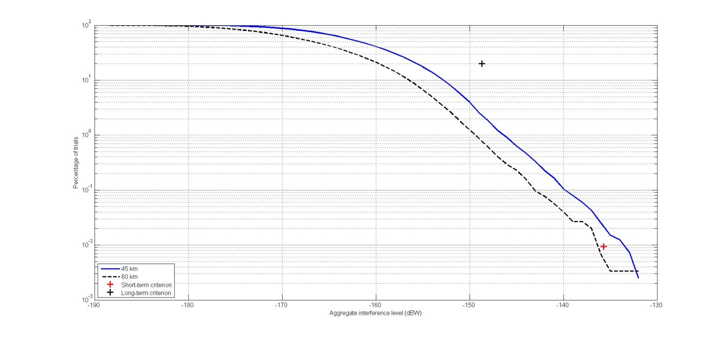
Figure 8 shows that, for the case of the Lannion MetSat earth station, even considering a limited number of UEs with a rural deployment of base stations, assuming a separation distance of 45 km leads to an interference level corresponding to 0.0094% of the time at –133.5 dBW (i.e. 2.2 dB above the MetSat protection short-term criterion).
It should also be noted that these calculations were made with UE bandwidth of 10 MHz whereas the MetSat station bandwidth is of 4.5 MHz (and hence a 3.5 dB bandwidth factor). When considering a UE bandwidth of 5 MHz (and hence a 0.5 dB bandwidth factor), the interference from the same UE deployment would hence be 5.2 dB above the MetSat protection short-term criterion.
Figure 8 also shows that in order to meet the MetSat protection criterion the separation distance should be increased to a 60 km value when considering UE bandwidth of 10 MHz.
Figure 9
Interference cumulative distribution function from 10 MHz UE to Miami MetSat earth station
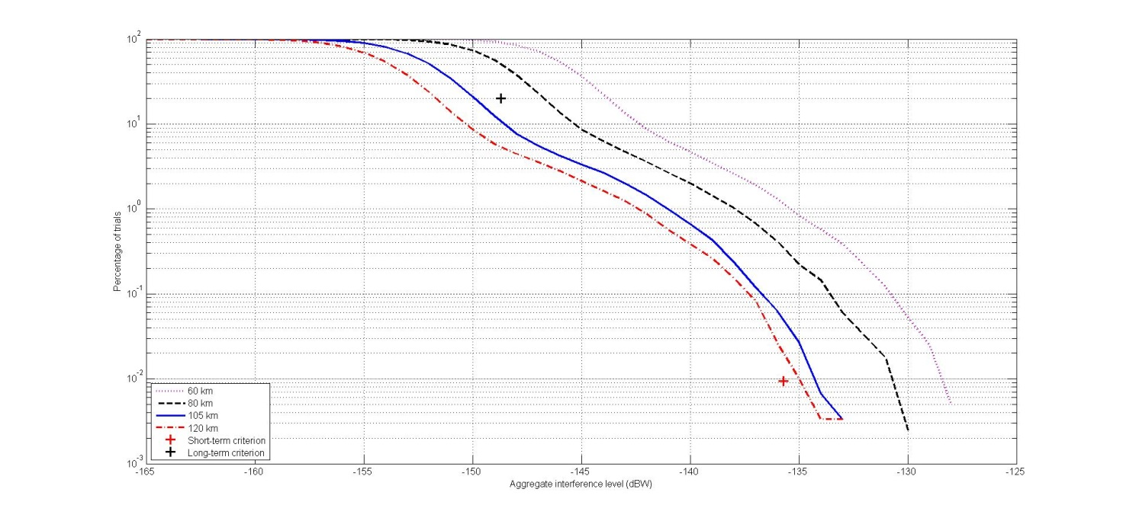
Figure 9 shows that, for the case of the Miami MetSat earth station, even considering a limited number of UEs with a rural deployment of base stations, assuming a separation distance of 60 km leads to an interference level corresponding to 0.009 4% of the time at –128.5 dBW (i.e. 7.2 dB above the MetSat protection short-term criterion). It also shows that for the same separation distance of 60 km, the long-term criterion is also exceeded by 4.7 dB.
Similarly, when considering a UE bandwidth of 5 MHz, the interference from the same UE deployment would hence be 10.2 dB above the MetSat protection short-term criterion and 7.7 dB above the MetSat protection long-term criterion when considering a 60 km separation distance.
Figure 9 also shows when considering UE bandwidth of 10 MHz, at 80 km separation distance, both protection criteria are still exceeded and that in order to meet the MetSat protection criterion the separation distance should be even higher than 120 km (at this distance the short-term protection criterion is still exceeded, although by a very small amount).

4 Summary/Conclusions of Annex A
The present Annex shows that the required protection area around MetSat stations from which potential IMT base stations in the 1 695-1 710 MHz frequency band would have to be excluded would be very large, of several hundred kilometres and that, for UE, large separation distances of 60 km up to 120 km are also required in order to ensure the protection of MetSat earth stations supporting NGSO meteorological satellites.
In addition, the following elements have to be taken into consideration when assessing the suitability of this band for mobile broadband systems:
− There are hundreds of MetSat stations worldwide in the 1 695-1 710 MHz frequency band operated by almost all national meteorological services and many other users worldwide.
− The necessary protection of these stations will require large exclusion zones, in which IMT operators will not be able to deploy their stations.
− In a number of countries, probably the majority, the protection of MetSat earth stations will totally preclude deployment of IMT stations (terminals and base stations) in large areas including major cities as well as it would impact the deployment of IMT in neighbouring countries.
On this basis, it appears obvious that a deployment of IMT systems in the 1 695-1 710 MHz frequency band is not compatible with MetSat and will not reach the goal set by Resolution 233 (WRC-12) of a worldwide and harmonized spectrum.
One can therefore conclude that an IMT identification (base stations or UE) is not compatible with current and planned MetSat use of the 1 695-1 710 MHz band.

Annex B
Compatibility assessment between meteorological-satellite systems
and IMT stations in the 1 695-1 710 MHz frequency band

1 Introduction
This Annex provides an analysis of the compatibility between IMT system and meteorological-satellite (MetSat) systems in the frequency band 1 695-1 710 MHz. The following interference scenarios for sharing situations are considered:
– the single-entry and aggregated interference from IMT base station to GSO MetSat earth station;
– the single-entry and aggregated interference from IMT base station to NGSO MetSat earth station;
– the aggregated interference from IMT UE to GSO MetSat earth station;
– the aggregated interference from IMT UE to NGSO MetSat earth station.

2 Background
Up to now, the 1 695-1 710 MHz band is used by all meteorological-satellite systems with earth stations operated by almost all National Meteorological and Hydrological Services (NMHS) and many other users. This frequency band is essential for providing operational and time-critical meteorological information to the users around the world.
Considering that each of these two services may be provided by GSO satellite systems and NGSO satellite systems, based on Recommendation ITU-R SA.1158, MetSat operators have agreed to separate the band 1 695-1 710 MHz and its adjacent band 1 670-1 695 MHz into two sub-bands which are being used and are expected to continue to be used as follows:
– the 1 670-1 698 MHz band should be used by GSO meteorological satellites;
– the 1 698-1 710 MHz band should be used by NGSO meteorological satellites.
Although only a very few countries have their own MetSat systems, all the data collected by meteorological satellites are provided freely to all the countries and regions of the world, and are performed for the benefit of the whole international community.

3 Technical characteristics

3.1 MetSat service

3.1.1 FENGYUN MetSat systems deployment
There are several FENGYUN (FY) MetSat systems operating in the 1 695-1 710 MHz band in China currently, including polar-orbiting satellites such as FY-3A, FY-3B and FY-3C, and also geostationary satellites such as FY-2D, FY-2E and FY-2F; and the second generation FY geostationary meteorological satellites FY-4 series will continue to use this band. Chinese current and future FY series MetSat systems in the band 1 695-1 710 MHz are provided in Table 13.
TABLE 13
Uses of the band 1 695-1 710 MHz by FY MetSat systems
Mission name(Orbit) | Status | Frequency  (MHz) | Direction | Polarization | Service
FY-2C (123.5°E)  FY-2D (86.5°E)  FY-2E (105°E)  FY-2F (112°E) | In orbit | 1 699.487  –  1 699.513 | S-E | V | S-WEFAX
FY-4 satellites | Planned | 1 690-1 696 | S-E | H | Ranging
 |  | 1 696-1 698 | S-E | V | LRIT/EWAIB
FY-3A (NGSO) | In orbit | 1 701.1-1 707.9 | S-E | CR | HRPT
FY-3B (NGSO) | In orbit | 1 701.1-1707.9 | S-E | CR | HRPT
FY-3C (NGSO) | In orbit | 1 698.7-1 703.9 | S-E | M | HRPT
FY-3D (NGSO) | Planned | 1 704.1-1 709.3 | S-E | M | HRPT

Table 14 gives some example locations of meteorological-satellite earth stations.
TABLE 14
Example locations of FY meteorological earth stations
Station Name | Country | Operated by | Location (lat, long)
Beijing | CHN | CMA | 40.05°N, 116.27°E
Guangzhou |  |  | 23.16°N, 113.33°E
Xinjiang |  |  | 43.86°N, 87.57°E
Kashi |  |  | 43.86°N,75.94°E
Jiamusi |  |  | 46.9°N, 130.34°E
Sanya |  |  | 18.26°N, 109.49°E
Antarctic |  | CMA | 72°S, 2.52°E
Melbourne | AUS | BOM | 38.36°S,145.17°E
Kiruna | Sweden | SSC | 68°N, 21°E

3.1.2 FY MetSat system parameters
The key parameters of FY-3 and FY-4 meteorological-satellite earth stations to be used in interference assessment from IMT system are listed in Tables 15 and 16, respectively.
TABLE 15
Characteristics for FY-3 (NGSO) meteorological-satellite earth stations
Parameter | Value
Signal | HRPT, High Resolution Picture Transmission
Centre frequency | Either 1 701.300 MHz or 1 706.7 MHz
RF bandwidth | 5.2 MHz
Elevation angle | 5° ~ 90°
Antenna diameter | 2.4 m
Antenna height | 15 m
Antenna gain | 30.05 dBi
Antenna pattern | RR Appendix 8

TABLE 16
Characteristics for FY-4 (GSO) meteorological-satellite earth stations
Parameter | Value
Signal | LRIT/EWAIB
Centre frequency | 1 697 MHz
RF bandwidth | 2 MHz
Elevation angle | 34.48°
Antenna diameter | 1.8 m
Antenna height | 15 m
Antenna gain | 28 dBi
Noise temperature | 249 K
Antenna pattern | RR Appendix 8

3.1.3 Interference criteria
Based on Recommendation ITU-R SA.1027, two interference criteria were identified for use in the 1 695-1 710 MHz band when assessing the interference from terrestrial service to NGSO MetSat systems:
– Long-term interference criteria: –151 dBW per 2 668 kHz corresponding to the total interference to be exceeded no more than 20% of the time, which is equivalent to −148.1 dBW per 5.2 MHz.
– Short-term interference criteria: –138 dBW per 2 668 kHz corresponding to the total interference to be exceeded no more than 0.0094% of the time, which is equivalent to −135.1 dBW per 5.2 MHz.
For GSO MetSat system, Recommendation ITU-R S.1432 provides the long-term interference criteria: I/N = –12.2 dB (ΔT/T = 6%) corresponding to the total interference from other systems having co-primary status for 100% of the worst month, or I/N = –10 dB (ΔT/T = 10%) corresponding to the aggregate interference from co-primary allocation for 20% of any month.

3.2 Mobile service (IMT systems)
The following IMT parameters have been used in this study, and were taken from Report ITU-R M.2292.
TABLE 17
IMT base station parameters
Cell structure  Characteristics | Macro rural | Macro suburban | Macro urban
Cell radius/  Deployment density | > 3 km  (typical figure to be used in sharing studies 5 km) | 0.5-3 km  (typical figure to be used in sharing studies 1 km) | 0.25-1 km  (typical figure to be used in sharing studies 0.5 km)
Antenna height | 30 m | 30 m | 25 m
Sectorization | 3-sectors | 3-sectors | 3-sectors
Downtilt | 3 degrees | 6 degrees | 10 degrees
Antenna pattern | Recommendation ITU-R F.1336 (see “Antenna Pattern” recommends 3.1)  • k_{a} = 0.7  • k_{p} = 0.7  • k_{h} = 0.7  • k_{v} = 0.3  Horizontal 3 dB beamwidth: 65 degrees  Vertical 3 dB beamwidth: determined from the horizontal beamwidth by equations in Recommendation ITU-R F.1336. Vertical beamwidths of actual antennas may also be used when available.
Below rooftop antenna deployment | 0% | 0% | 30%
Feeder loss | 3 dB | 3 dB | 3 dB
Maximum output power (5/10/20 MHz) | 43/46/46 dBmW | 43/46/46 dBmW | 43/46/46 dBmW
Maximum antenna gain | 18 dBi | 16 dBi | 16 dBi
Maximum output power (e.i.r.p.) | 58/61/61 dBmW | 56/59/59 dBmW | 56/59/59 dBmW
Average activity | 50% | 50% | 50%

TABLE 18
IMT UE parameters
Cell structure  Characteristics | Macro rural | Macro suburban | Macro urban
Indoor UE usage | 50% | 70% | 70%
Indoor UE penetration loss | 15 dB | 20 dB | 20 dB
Maximum UE output power | 23 dBm | 23 dBm | 23 dBm
Average UE output power | 2 dBm | –9 dBm | –9 dBm
Typical antenna gain for UEs | –3 dBi | –3 dBi | –3 dBi
Body loss | 4 dB | 4 dB | 4 dB

4 Analysis for IMT base station

4.1 Methodology
This Annex analyses the interference from IMT base stations to GSO and NGSO MetSat systems, including single-entry interference and aggregated interference.
For the single-entry interference, the worst case is taken into account, i.e. the antenna main-lobe of the IMT base station is facing the antenna of the MetSat earth station.
In the case of the aggregated interference from the multiple IMT base stations, it is assumed that there are two rings of equi-spaced IMT base stations located around the MetSat earth station. Thus the radius of the inner ring is the required separation distance meeting the interference criterion. The number of IMT base stations is assessed according to the separation distance and the base station inter-site distance as following:

FIGURE 10
Aggregated IMT base stations scenario
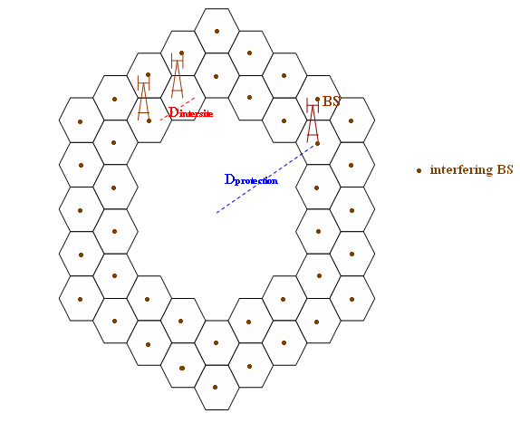
earth station
The analyses are based on the propagation models described in Recommendation ITU-R P.1546. Different building losses and clutter effects representing urban suburban and rural environment respectively have been assumed in these analyses.

4.2 Calculations
In order to calculate the antenna gain of MetSat earth station in the direction of IMT base station, the off-axis angle of IMT base station from MetSat earth station antenna boresight must be determined firstly. Figure 11 illustrates the geometry, where MetSat earth station is at point O and IMT base station is at point A. So the angle between line OA and line OB is the off-axis angle, and it is given by:
$$φ=\cos^{-1}\left(\frac{\cos\left(α2-α1\right)*(h^{2}\cos^{2}α1+R^{2}\cos^{2}θ\cos^{2}α1+h^{2}\cos^{2}θ)}{2*R^{2}cosθ}\right)$$
where:
$α1$: IMT base station’s elevation angle (degrees)
$θ$: IMT base station’s azimuth angle (degrees)
$α2$: MetSat earth station’s elevation angle (degrees)
$R$: distance from IMT base station to MetSat earth station (m)
$h$: relative height between IMT base station and MetSat earth station (m)
$φ$: off-axis angle (degrees).
FIGURE 11
Geometry of off-axis angle from MetSat earth station to IMT base station

4.3 Results

4.3.1 For GSO MetSat earth station
The maximum allowable interference into FY-4 earth station is –126.84 dBmW/MHz calculated according to its characteristic parameters and protection criteria.
For single-entry interference, the relationship between the interference power and the separation distance is shown in Fig. 12. In urban environment, the separation distance is 17 km. For suburban and rural environment, the distance increases to 43.8 km and 47.6 km respectively.
FIGURE 12
Separation distance for FY-4 earth station with single-entry interference
Figure 13 shows the separation distance relative to different interference power for the aggregated interference scenario. The separation distance is 47.3 km for urban, 157.1 km for suburban, and 113.8 km for rural.
FIGURE 13
Separation distance for FY-4 earth station with aggregated interference

4.3.2 For NGSO MetSat earth station
The calculation of separation distances for FY-3 earth station is the same as that for FY-4, except that the elevation angle of FY-3 earth station antenna is not constant. The results of single-entry interference with short-term criteria are given in Table 19 and Fig. 14, with long-term criteria given in Table 20 and Fig. 15. The results for aggregated interference scenario are given in Table 21, Fig. 16 (short-term criteria) and Table 22, Fig. 17 (long-term criteria).
TABLE 19
Single-entry interference results for FY-3 earth station with short-term criteria
Interference criteria | –138 dBW/2 668 kHz, i.e. –135.1 dBW/5.2 MHz
Environment | Urban |  | Suburban |  | Rural
Earth station elevation angle | 5° | 90° | 5° | 90° | 5° | 90°
Separation distance | 17.4 km | 6.3 km | 45.8 km | 19.6 km | 49.9 km | 23.4 km

FIGURE 14
Single-entry interference results for FY-3 earth station with short-term criteria
TABLE 20
Single-entry interference results for FY-3 earth station with long-term criteria
Interference criteria | –151 dBW/2 668 kHz, i.e. –148.1 dBW/5.2 MHz
Environment | Urban |  | Suburban |  | Rural
earth station elevation angle | 5° | 90° | 5° | 90° | 5° | 90°
Separation distance | 30.3 km | 13 km | 81.3 km | 34.4 km | 89.7 km | 36.7 km

FIGURE 15
Single-entry interference results for FY-3 earth station with long-term criteria
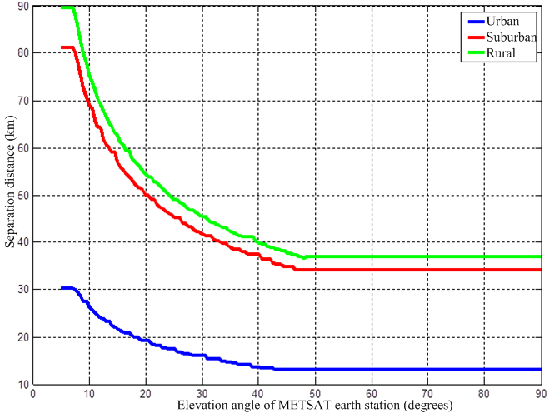

TABLE 21
Aggregated interference results for FY-3 earth station with short-term criteria
Interference criteria | –138 dBW/2 668 kHz, i.e. –135.1 dBW/5.2 MHz
Environment | Urban |  | Suburban |  | Rural
earth station elevation angle | 5° | 90° | 5° | 90° | 5° | 90°
Separation distance | 36.2 km | 20 km | 126.9 km | 60.8 km | 79.1 km | 43.2 km

FIGURE 16
Aggregated interference results for FY-3 earth station with short-term criteria
TABLE 22
Aggregated interference results for FY-3 earth station with long-term criteria
Interference criteria | –151 dBW/2 668 kHz, i.e. –148.1 dBW/5.2 MHz
Environment | Urban |  | Suburban |  | Rural
Earth station elevation angle | 5° | 90° | 5° | 90° | 5° | 90°
Separation distance | 73.2 km | 38.7 km | 248.7 km | 139.1 km | 184.5 km | 86.9 km

FIGURE 17
Aggregated interference results for FY-3 earth station with long-term criteria

5 Analysis for IMT UEs

5.1 Methodology
The following paragraphs describe what kind of methodology is used to analyse the aggregate interference from IMT UEs into the MetSat earth station receivers.
Figure 18 shows a view of the IMT base station distribution around a MetSat station, the MetSat station is at the centre of the distribution.
There are two different densities of the IMT base stations: from the centre out to a 30 km distance is the urban/suburban region with a 1.732 km inter-site distance (ISD) between base stations, and from a distance of 30 km out to a distance of 100 km is the rural region with a 7 km ISD, so the 1 090 base stations in the urban/suburban region and 664 base stations in the rural region is concerned.
FIGURE 18
Distribution of IMT base stations
There are three hexagonal sectors with each IMT base station. And several UEs are randomly distributed within each sector from 10 m from the base station out to the edge of its coverage. The number of simultaneously transmitting UEs per base station sector for each channel bandwidth is shown in Table 23.
TABLE 23
Number of simultaneously transmitting UE
Channel bandwidth | 5 MHz | 10 MHz | 15 MHz
Number of simultaneously transmitting UE per sector | 3 | 6 | 9
Number of simultaneously transmitting UE per base station | 9 | 18 | 27

A Monte Carlo simulating method was used in this analysis. The aggregated interfering power from IMT UEs into MetSat earth station is computed by randomizing the location of the UE for different separation distance. Then the protection distance is achieved according to the interference criteria of MetSat service. When this procedure is iterated for many times, the probability of interference can be calculated finally. The separation distance changes from 1 to 99 km with one kilometre increments. If one IMT base station is out of a separation distance circle, then its associated UEs would be included in the aggregate interference calculation for the separation distance radius. Otherwise if the base station is in the separation distance circle, its associated UEs should be excluded in the aggregate interference calculation.

Table 24 gives the propagation model used in the analysis.
TABLE 24
Propagation Model
Distance between the IMT base station and the IMT UE (km) | ≤ 0.04 | ≥ 0.1 | 0.04 ~ 0.1
Propagation model | Free space | COST-231 Hata | Linear log interpolation of the former

5.2 Calculations
The interference power I from one IMT UE received by the MetSat earth station is:
$$I=e.i.r.p.-G_{r}-L_{p}-L_{a}-FDR$$
where:
$e.i.r.p.$: IMT UE’s e.i.r.p. (dBm)
$G_{r}$: antenna gain of MetSat station receiver at the direction of UE (dB)
$L_{p}$: propagation loss of electromagnetic wave from IMT UE to MetSat station (dB)
$L_{a}$: additional loss including indoor UE penetration loss and body loss (dB)
$FDR$: frequency dependent rejection (dB).
So the aggregated interference power $I_{ag}$ from all of the IMT UEs can be calculated as:
$$I_{ag}=10lg\left(\sum{I_{i}}\right)$$
where:
$I_{i}$: interference power I from $ith$ IMT UE (mW).
It should be noted that in the simulation the transmitting power $P_{t}$ of the IMT UE is determined by the following equation:
$${ P}_{t}=P_{max}×min\left\{1,max\left[R_{min},{\left(\frac{L_{p}}{{L_{p}}_{x-ile}}\right)}^{γ}\right]\right\}$$
where:
$P_{max}:$ maximum IMT UE’s transmitting power (dBm)
$R_{min}$: ratio of the maximum IMT UE’s transmitting power to the minimum
$L_{p}$: propagation loss of electromagnetic wave from IMT UE to MetSat station (dB)
${L_{p}}_{x-ile}$: predefined propagation loss (dB)
$γ$: balance factor.
The parameters controlling $P_{t}$ used in the study is given in Table 25.
TABLE 25
Parameters controlling the IMT UE’s transmitting power
$$γ$$ | $${L_{p}}_{x-ile}$$
 | 20 MHz bandwidth | 15 MHz bandwidth | 10 MHz bandwidth | 5 MHz bandwidth
1 | 109 | 110 | 112 | 115

5.3 Results

5.3.1 For GSO MetSat earth station
The protection distances around FY-4 earth station for 10 MHz channel bandwidth of the IMT UEs is provided in Table 26 and Fig. 19.
TABLE 26
FY-4 earth station protection distances (10 MHz channel bandwidth)
Number of iterations | Minimum distance  (km) | Mean distance  (km) | Maximum distance  (km)
1 | 46 | 46 | 46
10 | 46 | 46 | 46
100 | 45 | 45.98 | 46
500 | 45 | 45.98 | 47
1000 | 45 | 46.99 | 47

FIGURE 19
FY-4 earth station protection distances (10 MHz channel bandwidth)
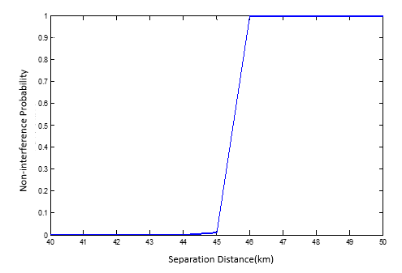

5.3.2 For NGSO MetSat earth station
The protection distances around FY-3 earth station for 10 MHz channel bandwidth of the IMT UE is provided in Table 27 and Fig. 20.
TABLE 27
FY-3 earth station protection distances (10 MHz channel bandwidth)
Number of iterations | Minimum distance  (km) | Mean distance  (km) | Maximum distance  (km)
1 | 56 | 56 | 56
10 | 56 | 56.5 | 57
100 | 56 | 56.84 | 59
500 | 56 | 56.92 | 61
1000 | 56 | 56.95 | 61

FIGURE 20
FY-3 earth station protection distances (10 MHz channel bandwidth)
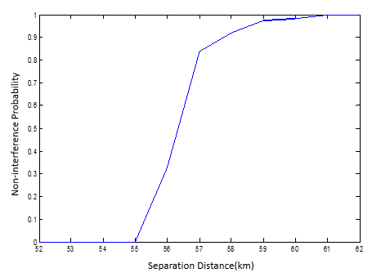

6 Summary

6.1 From IMT base station into MetSat earth station
From the results mentioned above, the required separation distances around MetSat stations in the 1 695-1 710 MHz band are summarized as below:
− 47.3 km, 157.1 km and 113.8 km with urban, suburban and rural scenario respectively to prevent the aggregated interference from the IMT base station to GSO MetSat earth station;
− 73.2 km, 248.7 km, 184.5 km with urban, suburban and rural scenario respectively for long-term interference criteria to prevent the aggregated interference from the IMT base station to NGSO MetSat earth station;
− 36.2 km, 126.9 km, 79.1 km with urban, suburban and rural scenario respectively for the short-term interference criteria to prevent the aggregated interference from the IMT base station to NGSO MetSat earth station.
If more than two rings of base stations are considered, the protection distances will be much larger obviously.

6.2 From IMT UE into MetSat earth station
Based on the results mentioned above simulation result from IMT UE into MetSat earth station, the required separation distances around MetSat stations in the 1 695-1 710 MHz band are summarized as below:
− 46 km separation distance is needed to prevent the aggregated interference from IMT UE into GSO MetSat earth station;
− 61 km separation distance is needed to prevent the aggregated interference from IMT UE into NGSO MetSat earth station;

7 Conclusion of Annex B
Based on the above study results, further considering that there are one or more typical MetSat receiving systems in the 1 695-1 710 MHz band in almost every large and medium-sized cities of China, it appears that sharing between MetSat service and IMT applications in this frequency band is incompatible.

Annex C
Protection of the meteorological-satellite service from proposed mobile broadband applications in the mobile service in the
frequency band 1 695-1 710 MHz

1 Introduction
The analysis methodology used for computing the separation distances necessary to protect the meteorological-satellite receivers operating in and adjacent to the 1 695-1 710 MHz frequency band from interference by mobile broadband user equipment (UE) transmitters is described. The protection distances can be used to establish the geographic sharing arrangements for mobile broadband applications in the mobile service in this frequency band.

2 Analysis methodology description
An electromagnetic compatibility analysis was performed between UE transmitters and meteorological-satellite receivers operating in and adjacent to the 1 695-1 710 MHz frequency band. The analyses supported the determination of the required separation distances necessary to preclude potential interference between meteorological-satellite receivers and UE transmitters. The analysis methodology is applicable to both earth station receivers for geostationary and polar satellites. The methodology was used to develop protection zones for both geostationary and polar receive stations.

2.1 Overview of LTE UE technical parameters
The UE technical characteristics are presented in Table 28.
TABLE 28
LTE user equipment technical characteristics
Technical characteristic | Value
Aggregate total UE e.i.r.p. for cities with population < 250 000 | –53.12 dBW/Hz
Average individual UE e.i.r.p. for cities with population  < 250 000 | 8.08 dBm/10 MHz
Aggregate total UE e.i.r.p. for cities with population ≥ 250 000 | –50.78 dBW/Hz
Average individual UE e.i.r.p. for cities with population  ≥ 250 000 | 5.87 dBm/10 MHz
Antenna pattern | Omni Directional
Cellular deployment scenario | Same as LTE base stations presented in § 3.2.1

2.2 Overview of MetSat receiver characteristics
Technical characteristics for the Miami, Florida (PEOS) site
Parameter | Value
Latitude/longitude | 254405 N/0800945 W
Centre frequency (MHz) | 1702.5, 1707, 1698
Receiver 3 dB intermediate frequency bandwidth (MHz) | 2.4
Noise temperature (K) | 100
Mainbeam antenna gain (dBi) | 27.5
Antenna height (metres) above local terrain | 11
Elevation angle (degrees) | 3
Worst case azimuth angle (degrees) | 335
Protection threshold (dBm) | –124.8

2.3 Calculation of mobile broadband UE aggregate interference level
The interference power levels at the meteorological-satellite receiver are calculated using equation (1) for each UE transmitter considered in the analysis.
$I=e.i.r.p. +G_{R}-L_{Add}-L_{P}-FDR$ (1)
where:
I: Received interference power at the output of the meteorological-satellite receive antenna (dBm)
e.i.r.p.: UE transmitter e.i.r.p. (dBm)
G_{R}: Antenna gain of the meteorological-satellite receiver in the direction of the UE transmitter (dBi)
L_{Add}: Additional losses (dB)
L_{P}: Propagation loss (dB)
FDR: Frequency dependent rejection (dB).
Using equation (1), the values of interference power level are calculated for each mobile/portable station being considered in the analysis. These individual interference power levels from each UE transmitter are then used in the calculation of the aggregate interference to the meteorological-satellite receivers using equation (2).
 | $$I_{AGG}=10\log\left[\sum_{j=1}^{N}{I_{j}}\right]+30$$ | (2)
where:
I_{AGG} Aggregate interference to the meteorological-satellite receiver from UE transmitters (dBm)
N Number of UE transmitters
I Interference power level at the input of the meteorological-satellite receiver from an individual UE transmitter (watts).
The difference between the received aggregate interference power level computed using equation (2) and the receiver interference protection criteria represents the available margin. When the available margin is positive, compatible operation is possible. The distance at which the available margin is zero represents the minimum distance separation that is necessary to protect the meteorological-satellite receiver.

2.4 Mobile broadband UE e.i.r.p.
The e.i.r.p. of each UE used to compute the aggregate interference level can be randomly selected using Monte-Carlo analysis techniques. There will be a need to establish separate sets of potential UE e.i.r.p. values for each of the urban/suburban and rural regions. The maximum and minimum values for the e.i.r.p. levels used in the analysis will also need to be determined.

2.5 Meteorological-satellite receive earth station antenna model
The antenna model for the meteorological-satellite receiving earth stations is based on Recommendation ITU-R F.1245-1. The model is used to represent the azimuth and elevation antenna gain.
In cases where the ratio between the antenna diameter and the wavelength is greater than 100 (D/λ > 100), the following equations will be used:

$G\left(φ\right)=G_{max}-2.5×{10}^{-3}{\left(\frac{D}{λ}φ\right)}^{2} \text{ for }0°<φ<φ_{m}$ (3)
$G\left(φ\right)=G_{1}\text{ }\text{ }\text{ }\text{ }\text{ }\text{ }\text{ }\text{ }\text{ }\text{ }\text{ }\text{ }\text{ }\text{ }\text{ }\text{ }\text{ }\text{ }\text{ }\text{ }\text{ }\text{ }\text{ }\text{ }\text{ }\text{ }\text{ }\text{ }\text{ }\text{ }\text{ }\text{ }\text{ }\text{ }\text{ }\text{ }\text{ }\text{ }\text{ }\text{ }\text{ }\text{ }\text{ }\text{ }\text{for}\text{ }φ_{m}≤φ<\max_{}\left(φ_{m},φ_{r}\right)$ (4)
$G\left(φ\right)=29-25\log{φ}\text{ for }\max_{}\left(φ_{m},φ_{r}\right)≤φ<48°$ (5)
$G\left(φ\right)=-13\text{ for }48°≤φ≤180°$ (6)
where:
Gmax: maximum antenna gain (dBi)
G(ϕ): gain relative to an isotropic antenna (dBi)
ϕ: off-axis angle (degrees)
D: antenna diameter (m)
λ: wavelength (m)
G₁: gain of the first side lobe = 2 + 15 log (D/λ).
 | $$φ_{m}=\frac{20λ}{D}\sqrt{G_{max}-G_{1}}\text{ degrees}$$ | (7)
 | $$φ_{r}=12.02{\left(D/λ\right)}^{-0.6}\text{ degrees}$$ | (8)
In cases where the ratio between the antenna diameter and the wavelength is less than or equal to 100 (D/λ ≤ 100), the following equation will be used:
 | $$G\left(φ\right)=G_{max}-2.5×{10}^{-3}{\left(\frac{D}{λ}φ\right)}^{2}\text{ for }0°<φ<φ_{m}$$ | (9)
 | $$G\left(φ\right)=39-5\log\left(D/λ\right)-25\log{φ} \text{for }φ_{m}≤φ<48°$$ | (10)
 | $$G\left(φ\right)=-3-5\log\left(D/λ\right) \text{for }48°≤φ≤180°$$ | (11)
D/λ is estimated using the following expression:
$$20\log{\frac{D}{λ}≈G_{max}-7.7}$$
where:
G_{max}: Maximum antenna gain (dBi).
The antenna pattern for a 43 dBi mainbeam antenna gain is shown in Fig. 21.
Figure 21
Azimuth and elevation antenna pattern
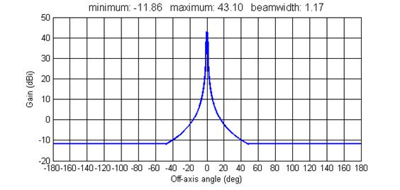
The minimum elevation angle for each meteorological-satellite receive antenna is used to determine the antenna gain in the direction of the UE.
Signals from the polar orbiting meteorological-satellites can be received at any azimuth angle. An analysis was performed using minimum propagation loss to determine the worst-case azimuth angle used in the analysis. The worst case azimuth angle for each of the polar orbiting meteorological-satellite receivers should be determined.
Signals from the geostationary meteorological-satellites are received at fixed azimuth angles that should be used in the analysis.

2.6 Additional losses
An additional factor is included for additional losses associated with meteorological-satellite receiver insertion loss, cable loss, polarization mismatch loss, etc. A nominal value of 1 dB will be included in the analysis.

2.7 Propagation model
A propagation model that takes into account the terrain around a meteorological-satellite receive site should be used.

2.8 Frequency dependent rejection
Frequency dependent rejection (FDR) accounts for the fact that not all of the undesired transmitter energy at the receiver input will be available at the detector. FDR is a calculation of the amount of undesired transmitter energy that is rejected by a victim receiver. This FDR attenuation is composed of two parts: on-tune rejection (OTR) and off-frequency rejection (OFR). The OTR is the rejection provided by a receiver selectivity characteristic to a co-frequency transmitter as a result of an emission spectrum exceeding the receiver bandwidth, in dB. The OFR is the additional rejection, caused by specified detuning of the receiver with respect to the transmitter, in dB. The FDR values used in this analysis were computed using an automated program.
In the case of an undesired transmitter operating co-frequency to a victim receiver, the FDR is represented by the OTR using the following simplified form shown in equation (12).
 | $$OTR=\max_{}\left[0.10\log\left(\frac{B_{tx}}{B_{rx}}\right)\right]$$ | (12)
where:
: emission bandwidth of the transmitter
: intermediate frequency (IF) bandwidth of the receiver.
The transmitter emission spectrum and receiver selectivity curves used to compute the FDR are defined in terms of a relative attenuation level specified in decibel as a function of frequency offset from centre frequency in megahertz.

2.9 Meteorological-satellite receiver interference protection criteria
The interference protection criteria (I_{T}) for the meteorological-satellite receivers are determined using equation (13).
 | $$I_{T}=I/N+N$$ | (13)
where:
I/N: Maximum permissible interference-to-noise ratio at the receiver IF output (detector input) necessary to maintain acceptable performance criteria (dB)
N: Receiver inherent noise level at the receiver IF output referred to the receiver input (dBm).
For a known receiver IF bandwidth and receiver noise figure (NF) or system noise temperature, the receiver inherent noise level is given by:
 | $$N=-114 \left[dBm\right]+10\log\left(B_{IF}\left[MHz\right]\right)+NF$$ | (14)
 | $$N=kT_{s}B_{IF}=-198.6 \left[{dBm}/{K/{Hz}}\right]+10\log\left(T_{s} \left[K\right]\right)+10\log\left(B_{IF} \left[Hz\right]\right)$$ | (15)
where:
B_{IF}: receiver IF bandwidth (see equations for units)
NF: receiver noise figure (dB)
k: Boltzmann’s constant, 1.38 × 10⁻²³ (Watts/K/Hz)
T_{s}: system noise temperature (Kelvin).
The analysis will use an I/N of –10 dB, corresponding to a 0.4 dB increase in the receiver noise to establish the interference protection criteria for the meteorological-satellite receivers.
Recommendations ITU-R SA.1026-3 and ITU-R-SA.1158 which recommends an interference criteria of –180 dBW/4kHz for long-term interference (favourable sharing case). For a receiver with a noise temperature of 269 K and a 4 kHz bandwidth the system noise is –168.3 dBW. This results in an I/N of –11.7 dB.
So the value of I/N of –10 dB is between the I/N of –8.3 dB (Recommendation ITU-R SA.1026-3) and the I/N of –11.7 dB (Recommendation ITU-R SA.1158).

3 Analysis
Here we show how the analysis methodology, presented above, can be used to compute the required separation distances to protect meteorological-satellite receivers based on controlling aggregate interference by eliminating base stations and their associated user equipment (UE). The Miami, Florida polar earth orbiting system (PEOS) site is used as an example calculation for the separation distances necessary to protect the earth station.
Commercial system technical parameters
UE transmitter power levels
The e.i.r.p. CDF curves shown in Fig. 22 were generated for UE operating in suburban and rural environments.
Figure 22
Suburban and rural UE CDF
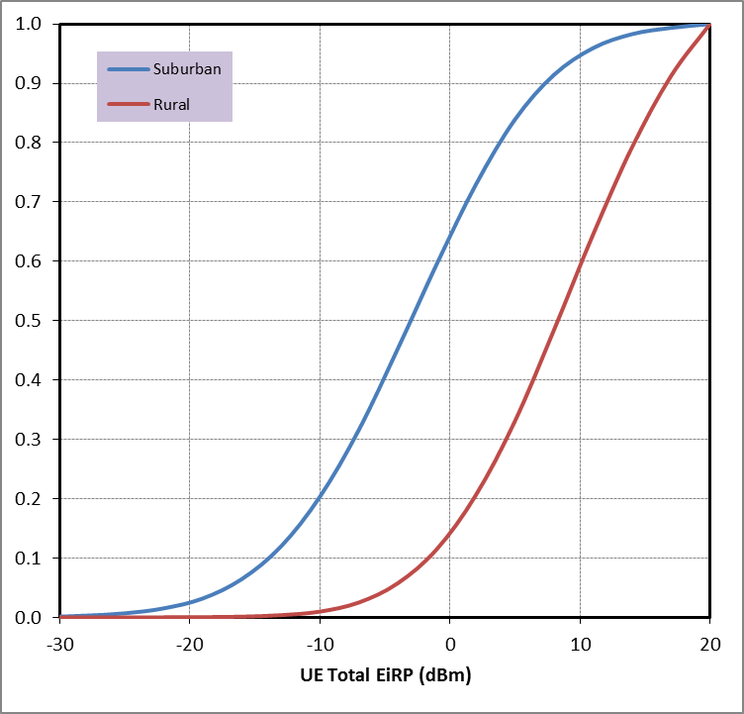
The e.i.r.p. for each UE will be randomly selected in accordance with the CDF curves shown in Fig. 22 for each independent Monte-Carlo analysis trial.
UE channel bandwidth
The analysis considered channel bandwidths of 5 MHz, 10 MHz, and 15 MHz for the UE in the analysis. For UE transmissions all of the frequencies within a channel are not used simultaneously under the LTE standard. Rather, transmissions are scheduled using subcarriers referred to as Physical Resource Blocks (PRBs), containing 12 subcarriers that each have a bandwidth of 180 kHz. There are various options on how to allocate PRBs but they limit the maximum throughput available for a particular UE. Channel bandwidths of 5 MHz, 10 MHz and 15 MHz should be considered in the analysis.
The frequency bandwidth of a UE at any instant in time will depend on the data rate of the transmission. The analysis assumed the channel bandwidth is divided equally among the number of UEs actively transmitting within a sector. For example, if the UEs have a channel bandwidth of 10 MHz and there are six transmitting UEs within the sector, the transmitter bandwidth for each UE is 1.6667 MHz.
UE antenna height
The antenna height of 1.5 metres is used for all of the UE.
Number of simultaneously transmitting UE
In the LTE technology, each UE only occupies a fraction of the available channel bandwidth. The LTE base station provides uplink resource allocations for the UE, distributing 100 percent of the resources equally among the transmitting UEs in each base station sector. The number of simultaneously transmitting UE per base station sector for each channel bandwidth is shown in Table 29.
TABLE 29
Number of simultaneously transmitting UE
Channel bandwidth | 5 MHz | 10 MHz | 15 MHz
Number of simultaneously transmitting UE per sector | 3 | 6 | 9
Number of simultaneously transmitting UE per base station | 9 | 18 | 27

Propagation model
A propagation model that takes into account the actual terrain around the meteorological-satellite receiver was used in the analysis. For the aggregate compatibility analysis associated with the meteorological-satellite receivers, the propagation model described in Recommendation ITU-R P.452 was used. This propagation model uses actual terrain data and it should provide a better estimate of the propagation loss. The statistical and environmental parameters used with the actual terrain profiles in calculating propagation loss are shown in Table 30.
TABLE 30
Parameters used in application Recommendation ITU-R P.452
Parameter | Value
Surface refractivity | 301 N-units
Refractivity Gradient | 50 N-units
Polarization | Vertical
Percentage of Time | 50 percent
Frequency | 1 702.5 MHz
Transmitter antenna height | 1.5 metres
Receiver antenna height | Variable
Terrain database | United States Geological Survey (USGS) – 3 second GLOBE – 30 second

There were no additional losses associated with clutter or building attenuation included in the analysis.
Meteorological-satellite receive earth station antenna model
The antenna model for the meteorological-satellite receive earth stations is based on Recommendation ITU-R F.1245. The model is used to represent the azimuth and elevation antenna gain.
In cases where the ratio between the antenna diameter and the wavelength is greater than
100 (D/λ > 100), the following equations will be used:

 | $$G\left(φ\right)=G_{max}-2.5×{10}^{-3}{\left(\frac{D}{λ}φ\right)}^{2}\text{ for }0°<φ<φ_{m}$$ | (16)
 | $$G\left(φ\right)=G_{1}\text{ for }φ_{m}≤φ<\max_{}\left(φ_{m},φ_{r}\right)$$ | (17)
 | $$G\left(φ\right)=29-25\log{φ}\text{ for }\max_{}\left(φ_{m},φ_{r}\right)≤φ<48°$$ | (18)
 | $$G\left(φ\right)=-13\text{ for }48°≤φ≤180°$$ | (19)
where:
G_{max}: maximum antenna gain (dBi)
G(ϕ): gain relative to an isotropic antenna (dBi)
ϕ: off-axis angle (degrees)
D: antenna diameter (m)
λ: wavelength (m)
G₁: gain of the first side lobe = 2 + 15 log (D/λ).

 | $$φ_{m}=\frac{20λ}{D}\sqrt{G_{max}-G_{1}}\text{ degrees}$$ | (20)
 | $$φ_{r}=12.02{\left(D/λ\right)}^{-0.6}\text{ degrees}$$ | (21)
In cases where the ratio between the antenna diameter and the wavelength is less than or equal to
100 (D/λ ≤ 100), the following equations will be used:
 | $$G\left(φ\right)=G_{max}-2.5×{10}^{-3}{\left(\frac{D}{λ}φ\right)}^{2}\text{ for }0°<φ<φ_{m}$$ | (22)
 | $$G\left(φ\right)=39-5\log\left(D/λ\right)-25\log{φ} \text{for }φ_{m}≤φ<48°$$ | (23)
 | $$G\left(φ\right)=-3-5\log\left(D/λ\right) \text{for }48°≤φ≤180°$$ | (24)
D/λ is estimated using the following expression:
$20\log{\frac{D}{λ}≈G_{max}-7.7}$ (25)
where:
G_{max}: Maximum antenna gain (dBi).
The azimuth and elevation antenna pattern for a 43 dBi mainbeam antenna gain is shown is shown below in Fig. 23.
Figure 23
Azimuth and elevation antenna pattern
The minimum elevation angle for each meteorological-satellite receive antenna is used to determine the antenna gain in the direction of the UE. Signals from the polar orbiting meteorological-satellites can be received at any azimuth angle. An analysis was performed using minimum propagation loss to determine the worst-case azimuth angle used in the analysis.
Example protection distances
This section provides an example of the meteorological-satellite receiver protection distances. The analysis considered channel bandwidths of 5 MHz, 10 MHz, and 15 MHz. The protection distances for each meteorological-satellite receiver were computed for various iterations of the analysis model randomizing the equivalent isotropically radiated power levels and the location of the user equipment (UE). Randomizing the UE location also varies the meteorological-satellite receive antenna gain.
The technical characteristics for the Miami Florida PEOS site are provided in Table 31.
TABLE 31
Technical characteristics for the Miami, Florida (PEOS) site
Parameter | Value
Latitude/Longitude | 254405 N/0800945 W
Centre frequency (MHz) | 1702.5, 1707, 1698
Receiver 3 dB intermediate frequency bandwidth (MHz) | 2.4
Noise temperature (K) | 100
Mainbeam antenna gain (dBi) | 27.5
Antenna height (metres) above local terrain | 11
Elevation angle (degrees) | 3
Worst case azimuth angle (degrees) | 335
Protection threshold (dBm) | –124.8

The protection distances for each user equipment channel bandwidth are provided in Tables 32 through 34.
TABLE 32
Miami Florida PEOS protection distances – 5 MHz channel bandwidth
Number of iterations | Minimum distance  (km) | Mean distance  (km) | Maximum distance  (km)
1 | 34 | 34 | 34
10 | 30 | 32.6 | 40
100 | 30 | 33.5 | 40
500 | 30 | 33.8 | 40
1 000 | 34 | 38.3 | 46

Figure 24
Miami Florida PEOS protection distances – 5 MHz channel (1 000 iterations)
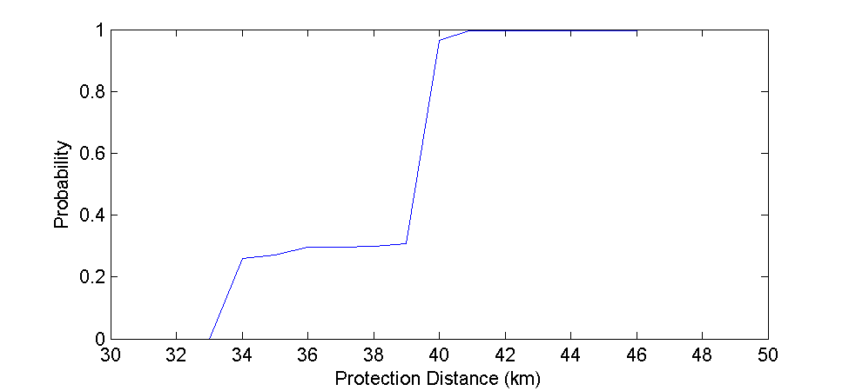
TABLE 33
Miami Florida PEOS protection distances – 10 MHz channel bandwidth
Number of iterations | Minimum distance  (km) | Mean distance  (km) | Maximum distance  (km)
1 | 40 | 40 | 40
10 | 34 | 38.8 | 40
100 | 34 | 37.4 | 40
500 | 43 | 37.6 | 46
1 000 | 40 | 41.1 | 46

Figure 25
Miami Florida PEOS protection distances – 10 MHz channel (1 000 Iterations)
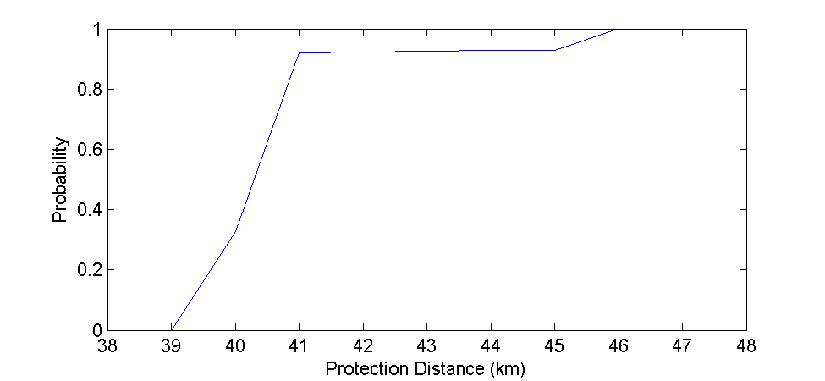
TABLE 34
Miami Florida PEOS protection distances – 15 MHz channel bandwidth
Number of iterations | Minimum distance  (km) | Mean distance  (km) | Maximum distance  (km)
1 | 46 | 46 | 46
10 | 40 | 40.6 | 46
100 | 34 | 39.5 | 46
500 | 34 | 39.9 | 46
1 000 | 40 | 44.1 | 46
Figure 26
Miami Florida PEOS protection distances – 15 MHz channel (1 000 Iterations)
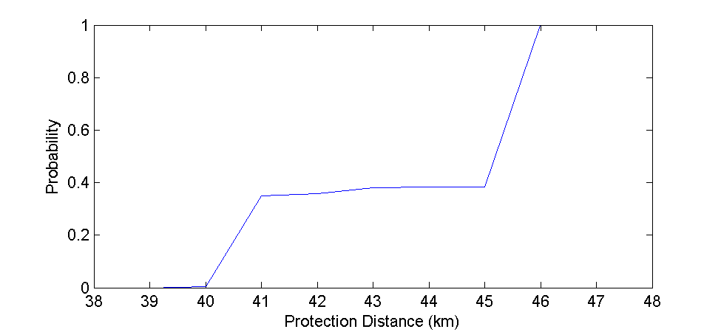
Conclusion of Annex C
Based on the results presented here, the use of geographical limitations on terrestrial mobile broadband, computed using the analysis methodology described above, shows that the proposed mobile broadband applications in the mobile service in the frequency band 1 695-1 710 MHz are compatible with the incumbent meteorological-satellite service operating in and adjacent to this band.

This Report was approved jointly by Radiocommunication Study Groups 5 and 7, and any future revision should also be undertaken jointly.
Additional losses for polarization mismatch are not included.
The interference power calculated in equation (1) must be converted from dBm to watts before calculating the aggregate interference seen by meteorological-satellite system receiver using equation (2).
Recommendation ITU-R F.1245-2 – Mathematical model of average or related radiation patterns for line-of-sight point-to-point radio relay system antenna for use in certain coordination studies and interference assessment in the frequency range from 1 GHz to about 70 GHz (2012).
The receiver interference protection criteria are referred to as long-term criteria because their derivation assumes that the interfering signal levels are present most of the time.
The 3GPP standard specifies channel bandwidths of 1.4 MHz, 3 MHz, 5 MHz, 10 MHz, 15 MHz and 20 MHz.
Recommendation ITU-R P.452-15 – Prediction procedure for the evaluation of interference between stations on the surface of the Earth at frequencies above about 0.1 GHz.
The USGS terrain data downloadable from the following links: http://ntiacsd.ntia.doc.gov/msam/TOPO/USGS_CDED/T3Sec01.zip http://ntiacsd.ntia.doc.gov/msam/TOPO/USGS_CDED/T3Sec02.zip http://ntiacsd.ntia.doc.gov/msam/TOPO/USGS_CDED/T3Sec03.zip http://ntiacsd.ntia.doc.gov/msam/TOPO/USGS_CDED/T3Sec04.zip
The GLOBE 30 second terrain data can be downloaded from the http://www.ngdc.noaa.gov/mgg/topo/gltiles.html website. The GLOBE data was used in areas where there is no USGS terrain data.
Recommendation ITU-R F.1245-2 – Mathematical model of average or related radiation patterns for line-of-sight point-to-point radio relay system antenna for use in certain coordination studies and interference assessment in the frequency range from 1 GHz to about 70 GHz (2012).

