Report ITU-R SA.2309-0
(09/2014)
Compatibility between Earth exploration-satellite service (Earth-to-space)
and the space research service
or the space operation service
in the band 7 100-7 235 MHz

SA Series
Space applications and meteorology

Foreword
The role of the Radiocommunication Sector is to ensure the rational, equitable, efficient and economical use of the radio-frequency spectrum by all radiocommunication services, including satellite services, and carry out studies without limit of frequency range on the basis of which Recommendations are adopted.
The regulatory and policy functions of the Radiocommunication Sector are performed by World and Regional Radiocommunication Conferences and Radiocommunication Assemblies supported by Study Groups.

Policy on Intellectual Property Right (IPR)
ITU-R policy on IPR is described in the Common Patent Policy for ITU-T/ITU-R/ISO/IEC referenced in Annex 1 of Resolution ITU-R 1. Forms to be used for the submission of patent statements and licensing declarations by patent holders are available from http://www.itu.int/ITU-R/go/patents/en where the Guidelines for Implementation of the Common Patent Policy for ITU-T/ITU-R/ISO/IEC and the ITU-R patent information database can also be found.

Series of ITU-R Reports
(Also available online at http://www.itu.int/publ/R-REP/en)
Series | Title
BO | Satellite delivery
BR | Recording for production, archival and play-out; film for television
BS | Broadcasting service (sound)
BT | Broadcasting service (television)
F | Fixed service
M | Mobile, radiodetermination, amateur and related satellite services
P | Radiowave propagation
RA | Radio astronomy
RS | Remote sensing systems
S | Fixed-satellite service
SA | Space applications and meteorology
SF | Frequency sharing and coordination between fixed-satellite and fixed service systems
SM | Spectrum management

Note: This ITU-R Report was approved in English by the Study Group under the procedure detailed in Resolution ITU-R 1.

Electronic Publication
Geneva, 2014
© ITU 2014
All rights reserved. No part of this publication may be reproduced, by any means whatsoever, without written permission of ITU.

REPORT ITU-R SA.2309-0
Compatibility between Earth exploration-satellite service (Earth-to-space) and the space research service or the space operation service
in the band 7 100-7 235 MHz
(2014)

TABLE OF CONTENTS
Page
1 Introduction 3
2 Characteristics of potential EESS mission uplinks in the 7-8 GHz range 3
3 Characteristics of SRS mission uplinks 4
4 Characteristics of SOS mission uplinks 7
5 Interference criteria 9
5.1 EESS Systems interference criterion 9
5.2 SRS Systems interference criterion 10
5.3 SOS Systems interference criterion 10
6 Assessment of interference from SRS uplinks into EESS satellites 10
6.1 Interference analysis approach and main assumptions 11
6.2 Static interference analysis (EESS victim) 12
6.3 Dynamic interference analysis (EESS victim) 13
6.3.1 Study #1: Interference from SRS near Earth and deep-space missions into EESS missions 13
6.3.2 Study #2: Interference from SRS near-Earth missions into EESS 16
7 Assessment of interference from EESS uplinks into SRS satellites 18
7.1 Static interference analysis (SRS victim) 18
7.2 Dynamic interference analysis (SRS victim) 20
7.2.1 Study #1: Interference from EESS into SRS Near-Earth and deep-space missions 21
7.2.2 Study #2: Interference from EESS uplinks into SRS near-Earth mission uplinks 24

Page
8 Assessment of interference from EESS uplinks into SOS satellites 26
9 Summary and conclusions 27
Annex A – Feasibility of sharing space research service (deep-space) and Earth exploration-satellite service 30
Annex B – Compatibility space operation service and Earth exploration-satellite
service Study SOS-1 33
Annex C – Compatibility space operation service and Earth exploration-satellite
service Study SOS-2 42
Annex D – Compatibility space operation service and Earth exploration-satellite
service Study SOS-3 45

1 Introduction
WRC-15 agenda item 1.11 deals with the consideration of a primary allocation to the Earth exploration-satellite service (EESS) (Earth-to-space, E-s) in the 7-8 GHz range in accordance with Resolution 650 (WRC-12) of the Radio Regulations (RR). This Resolution invites to conduct compatibility studies between EESS systems (Earth-to-space) and existing services in the 7-8 GHz range with priority to the band 7 145-7 235 MHz. Figure 1 shows an overview of the frequency allocations in the 7-8 GHz range.
The band 7 145-7 235 MHz is currently used by space research service (SRS) mission uplinks, mobile service (MS) and fixed service (FS). Additionally, by RR footnote No. 5.459, the Russian Federation has an additional primary allocation to the space operation service (SOS) (Earth-to-space) in the frequency bands 7 100-7 155 MHz and 7 190-7 235 MHz, subject to agreement obtained under RR No. 9.21.
This Report presents an assessment of the compatibility between the EESS (Earth-to-space) and SRS mission uplinks when both operate at the same frequency (co-frequency) in the 7 145-7 235 MHz band.
This Report also provides an analysis of the compatibility between the EESS and SOS mission uplinks (Earth-to-space) when both operate at the same frequency in the 7 100-7 155 MHz and 7 190-7 235 MHz frequency bands.
FIGURE 1
Overview of ITU-R frequency allocations in the 7-8 GHz range
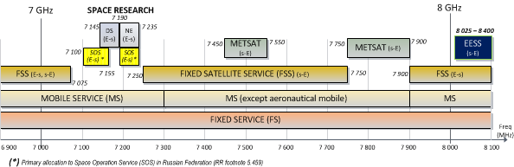

2 Characteristics of potential EESS mission uplinks in the 7-8 GHz range
The EESS missions currently perform the functions of TT&C (Telemetry, Tracking & Command) in S-Band. The 2 025-2 110 MHz band is used to uplink the command and ranging signals, and the 2 200-2 290 MHz band is used to downlink the spacecraft telemetry and ranging signals. Both up/downlink bands are shared with the SRS and the SOS. The EESS missions perform the payload data download in the 2 200-2 290 MHz and 8 025-8 400 MHz bands, depending on the data rate requirements.
An EESS (Earth-to-space) allocation in the 7-8 GHz range would allow its use for TT&C in combination with the existing EESS (space-to-Earth) allocation in the band 8 025-8 400 MHz, thereby alleviating the congestion problem in S-Band, mitigating the frequency coordination problem, and eventually leading to a simplified on-board architecture and operational concept for future EESS missions.
The technical characteristics of potential new EESS (Earth-to-space) systems operating in the 7-8 GHz frequency range would be similar to those of SRS near-Earth systems, but with lower transmit power requirements and typically smaller antenna sizes.
The EESS missions uplinks in S-Band are currently using telecommand data rates from 4 to 64 kbit/s. However it is expected that in the near future higher data rates, up to 2.048 Mbit/s, may be required as considered in the CCSDS Recommendations for radio frequency and modulation systems (CCSDS 401.0-B). The telecommand uplink is typically established during all passes, while the ranging measurements can be initiated during some or all passes, depending on the mission phase and operational procedures. Table 1 presents the technical characteristics representative of potential EESS missions in the 7-8 GHz range. EESS missions typically use earth stations located at high latitudes to maximise the satellite contact times (e.g. Kiruna/Sweden, Svalbard/Norway, Troll/Antarctica, Fairbanks/USA) although they may also use earth stations at medium latitudes.

3 Characteristics of SRS mission uplinks
The SRS (Earth-to-space) is one of the services allocated in the band 7 145-7 235 MHz. The use of the lower part of the band (i.e. 7 145-7 190 MHz) is restricted to deep space, while the upper part (i.e. 7 190-7 235 MHz) is used by near-Earth SRS missions. Four types of SRS mission uplinks are considered in this preliminary compatibility analysis:
– SRS near-Earth missions in the Lagrangian points L1/L2 (range 1.2-1.8 M-km from Earth);
– SRS near-Earth missions in highly elliptical orbits;
– SRS near-Earth missions in geosynchronous orbits;
– SRS near-Earth missions in low earth orbits;
– SRS deep-space missions (range > 2 M-km from Earth).
Table 2 presents the representative parameters for the type of SRS missions considered. It should be noted that the transmit earth stations are meant to be representative for the purpose of the analysis and are not in all cases those actually used.
In the Launch and Early Orbit Phase (LEOP), SRS systems typically operate with omni-directional coverage. Maximum uplink power is generally not used but adjusted according to the distance of the satellite from the Earth. The SRS satellites at low altitude orbits can be considered to be comparable to EESS satellites in terms of uplink power requirements.
TABLE 1
Technical characteristics representative of potential EESS missions with uplinks in 7-8 GHz
 | Representative parameters | Remarks
Orbit description
Type of orbit | Circular low Earth orbit (LEO) | Typically circular or near-circular polar orbit
Orbit altitude | 700 km | 400-900 km
Inclination | 98 degrees | Typically 97-99 degrees
Earth station
Location | Typically high latitudes | High latitudes preferable to maximise the satellite contact times
RF transmit power level | 16 dBW (40 W) | At antenna interface
Antenna type | 15 metre parabolic reflector | Typically 12-15 m
Antenna gain | 56.5 dBi
Antenna pattern | Rec. ITU-R F.1245 | Representative of average side lobes as the antenna is tracking the satellite
Minimum elevation angle | 5° | Also depends on the terrain shielding surrounding the Earth station
e.i.r.p. | 72.5 dBW max | Maximum e.i.r.p.
Uplink signal: | Telecommand and Ranging
• Telecommand | Low rate: Rb = 4 kbit/s | Up to 4 kbit/s  Modulation: PCM(NRZ-L)/PSK/PM (*)  Max BW 99% ≈ 100 kHz
• Telecommand | Medium rate: Rb = 64 kbit/s | 8 to 256 kbit/s  Modulation PCM(SPL)/PM (*)  Max BW 99% ≈ 780 kHz (for 64 ksps) to 3 MHz (for 256 ksps) with filtering
• Telecommand | High rate: Rb = 1.024 Mbit/s | 1 to 2048 kbit/s  Modulation BPSK (*)  Not compatible with simultaneous ranging  Max BW 99% ≈ 2 MHz (for 1 Mbit/s),  4 MHz (for 2 Mbit/s) with filtering
• Ranging | Tone ranging or PN code ranging systems | Max BW ≈ 2.5 × Ft, where Ft is the ranging tone frequency  250 kHz (for 100 kHz tone) to 3.75 MHz (for 1.5 MHz tone) (*)
Satellite
Antenna type 1: Low gain antenna (LGA) | G = –2 dBi @ 90 degrees (nom)  G = +7 dBi (±10 degrees peak gain) | Hemispherical coverage by using two or more LGAs.  Dynamic simulations: G = 0 dBi considered
Antenna type 2: Shaped isoflux antenna | G = +6 dBi max at ± 60 degrees  G = –4 dBi min at 0 degrees | Antenna pointing to Earth centre. Pattern assumed as currently used for many EESS downlink in the 8 025-8 400 MHz frequency band
TABLE 1 (end)
 | Representative parameters | Remarks
Noise temperature at the receiver input | 800 K | Antenna noise Tant ≈ 300 K  Receiver noise figure F ≈ 2.5 dB
Protection criteria | –161 dBW/kHz, 0.1% of the time | Rec. ITU-R SA.514-3
(*) CCSDS Recommendations for radio frequency and modulation systems (CCSDS 401.0-B).
TABLE 2
Technical characteristics representative of SRS missions uplinks
in the frequency band 7 145-7 235 MHz
 | Near-Earth SRS missions  (7 190-7 235 MHz) |  |  |  | Deep-space SRS  (7 145-7 190 MHz)
 | LAGRANGE | HEO | GSO | LEO | DS
Representative orbits | Herschel (L2) | Cluster | GOES-R | Koronas-Photon | Mars Express
Orbit description
Type of orbit | Around L1/L2 | Highly elliptical | GSO (0E) | Low Earth | Orbiting Mars
Orbit altitude | 1.2 to 1.8 M-km | 118.500 × 19.200 km | 35.786 km | 550 km | Range to Earth  54 to 400 M-km
Inclination | 0 degrees | 65 to 90 degrees | 0 degrees | 85.5 degrees | 86.3 degrees (Mars orbit)
Earth station
Location | Cebreros (Spain)  Malargüe (Argentina)  New Norcia (Australia) | Villafranca (Spain)  Kiruna (Sweden)  Cebreros (Spain) | Cebreros (Spain)  Kiruna (Sweden) | Svalbard (Norway)  Kiruna (Sweden)  Moscow (Russia)  Krasnoyarsk (Russia) | Cebreros (Spain)
Power supplied to the input of antenna (dBW) | 33 to 43  (2 to 20 kW)  2 kW used in nominal configuration | 30 (1 kW) | 26  (400 W) | 20 (100 W) | 43 to 49  (20 to 80 kW)
Antenna diameter (m) | 35 | 15 | 16 | 5 | 35, 70
Antenna gain (dBi) | 66 | 56.5 | 59 | 47 | 66, 72
Antenna pattern | Rec. ITU-R F.1245 | Rec. ITU-R F.1245 | Rec. ITU-R F.1245 | Rec. ITU-R S.465 | Rec. ITU-R F.1245
Min elevation angle | 5° | 5° | 5° | 5° | 10°
e.i.r.p. (dBW) | 99 to 109 max | 86.5 max | 85 max | 67 max | 115 max
TABLE 2 (end)
 | Near-Earth SRS missions  (7 190-7 235 MHz) |  |  |  | Deep-space SRS  (7 145-7 190 MHz)
 | LAGRANGE | HEO | GSO | LEO | DS
Uplink signal: | TC + Ranging | TC + Ranging | Data | TC + Data | TC + Ranging
•Telecommand  (data rate &  modulation) | Rb = 2 kbit/s  (64 kHz BW) | Rb = 4 kbit/s  (64 kHz BW) | 12 MHz BW | Rb = 2 kbit/s  (2 MHz BW) | Rb up to 1 kbit/s  (64 kHz BW)
•Telecommand  (data rate &  modulation) | PCM(NRZ)/PSK/  PM  16 kHz subcarrier | PCM(NRZ)/PSK/  PM  16 kHz subcarrier | BPSK | BPSK/  spread spectrum | PCM(NRZ)/PSK/  PM  16 kHz subcarrier
• Ranging | RNG tone Ft = 480 kHz | Ft = 100 kHz |  |  | Ft = 1 MHz
Satellite
a) Low gain antenna (dBi) | G = –2 @ 90°  G = +7 @ ±10° | G = –2 @ ±90°  G = +7 @ ±10° | G = 19 | G = +2 | G = –2 @ 90°  G = +7 @ ±10°
b) Medium gain antenna (dBi) | G = +13 @ ±10°  G = +18 @ ±3° | --- | G = 29 | --- | G = +13 @ ±15°  G = +18 @ ±3°
c) High gain ant (dBi) | ---- | --- |  | --- | G = +48 (3.7 m)
System noise temp (K) | 350 | 780 | 500 | 450 | 350
Protection criteria | –177 dB(W/kHz), 0.1% of the time  ITU-R SA.609-2 |  |  |  | –190 dB(W/20 Hz)  ITU-R SA.1157-1

4 Characteristics of SOS mission uplinks
Typical technical characteristics of SOS systems uplinks operating in the frequency bands 7 100-7 155 MHz and 7 190-7 235 MHz are provided in Table 3.

TABLE 3
Technical characteristics representative of SOS mission uplinks in the frequency bands
7 100-7 155 MHz and 7 190-7 235 MHz
Representative orbits | KORONAS-PHOTON | COMPARUS-C | COMPARUS-E
Orbit description
Type of orbit | Low-Earth, circular | Low-Earth, circular | Low-Earth, elliptical
Orbit altitude (km) | 550 | 350 | 450-200
Inclination (°) | 85.5 | 70 | 70
Earth station
Location | Moscow (Russia)  Krasnoyarsk (Russia) | Russian Federation | Russian Federation
Power range at antenna input (dBW)  (Note: Adaptive power control is applied) | +20 to 0 | –14 to –34 (mode 1)*  –3 to –23 (mode 2)** | –14 to –34 (mode 1)*  –3 to –23 (mode 2)**
Antenna diameter (m) | 5 | 5 | 5
Antenna gain (dBi) | 47 | 47 | 47
Antenna pattern | Rec. ITU-R S.465 | Rec. ITU-R S.465 | Rec. ITU-R S.465
Minimum elevation angle (°) | 5 | 5 | 5
Max e.i.r.p. range (dBW) | 67 / 47 | 33 / 13 (mode 1)  44 / 24 (mode 2) | 33 / 13 (mode 1)  44 / 24 (mode)
Uplink signal | Telecommand | Telemetry, Tracking and Telecommand | Telemetry, Tracking and Telecommand
Necessary bandwidth (MHz) | 2 | 1.2 | 1.2
• Telecommand Data rate (kbit/s) | 2.0 | (***) | (***)
• Telecommand Modulation | BPSK/spread spectrum | (***) | (***)
• Ranging | N/A | (***) | (***)
Space station
a) Low gain antenna (dBi) | +2 | +1 (mode 2) | +1 (mode 2)
b) High gain antenna (dBi) | N/A | +12 (mode 1) | +12 (mode 1)
System noise temperature (°K) | 450 | 1 000 | 1 000
Protection criteria | The ratio of signal power to total interference power in each band 1 kHz wide must not fall below 20 dB for more than 1% of the time, each day  (Recommendation ITU-R SA.363-5), NOTE – See § 5.3.
* Mode 1 – Operation with a narrow-beam tracking space-borne antenna (see Fig. 2).
** Mode 2 – Operation with a nadir pointed wide-beam space-borne antenna (see Fig. 3).
*** This information has not been provided by the relevant administration, therefore only a worst-case analysis has been considered.
Figure 2
Mode 1 antenna pattern
Figure 3
Mode 2 antenna pattern

5 Interference criteria

5.1 EESS Systems interference criterion
Recommendation ITU-R SA.514-3 provides the protection criteria for command and data transmission systems operating in the EESS and METSAT services. For frequencies between 300 MHz and 10 GHz, “the power spectral density of noise-like interference or the total power of CW-type interference in any single band or in all sets of bands 1 kHz wide shall not exceed
–161 dB(W/kHz) at the receiver input for more than 0.1% of the time”.
Based on the characteristics of EESS TT&C receivers in S-Band and SRS TT&C receivers in X-Band, it is estimated that the maximum power level for EESS satellite receivers is –50 dBm and the interfering damaging level typically is ≥ –10 dBm at the receiver input.

5.2 SRS Systems interference criterion
There are two types of interference criterion applicable to SRS systems:
a) Near-Earth SRS
Recommendation ITU-R SA.609-2 provides the protection criterion for radiocommunication links for manned and unmanned near-Earth research satellites. The permissible interference level is established as –177 dB(W/kHz) at the input terminals of the receiver, for 0.1% of the time for bands in the 100 MHz-30 GHz frequency range.
b) Deep-space SRS
For deep-space research satellites the protection criterion is provided by Recommendation ITU-R SA.1157-1. The power spectral density (PSD) of wideband interference, or the total power of CW interference in any 20 Hz band should be no larger than –190 dB(W/20 Hz) at the receiver input terminals. The 20 Hz bandwidth specification is the carrier tracking loop bandwidth of the spacecraft transponder at the receiver threshold level.

5.3 SOS Systems interference criterion
Recommendation ITU-R SA.363-5 specifies “that the protection criteria for spacecraft receivers be as follows: the ratio of signal power to total interference power in each band 1 kHz wide must not fall below 20 dB for more than 1% of the time, each day”.
One of the studies presented in this report for the EESS-SOS compatibility analysis is based on more stringent protection criteria than the applicable criteria in Recommendation ITU-R SA.363-5 (See Annex D).

6 Assessment of interference from SRS uplinks into EESS satellites
Figure 4 illustrates the potential interference scenarios from SRS uplinks into EESS on-board receivers in the band 7 145-7 235 MHz.
FIGURE 4
Potential interference cases from SRS uplinks to potential EESS on-board receive systems
in the band 7 145-7 235 MHz
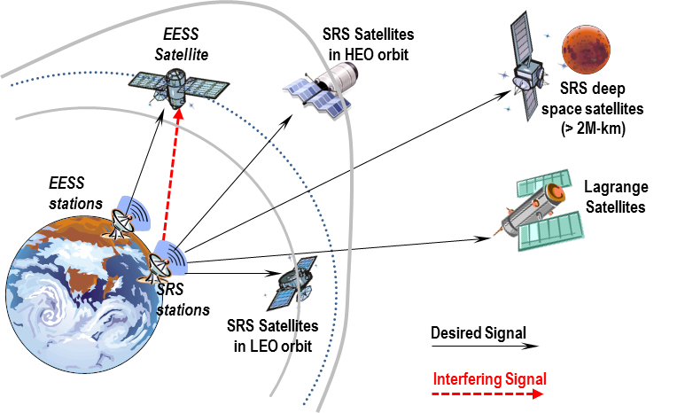

6.1 Interference analysis approach and main assumptions
EESS-SRS static and dynamic interference analyses have been performed under the assumption that the victim and interfering systems are operating at the same uplink frequency.
The static analysis is indicative of the worst case interfering levels received by the victim satellite through the main lobe of the interfering earth station, considering the maximum e.i.r.p. at the interfering earth station and the maximum antenna gain for the victim satellite receiver. This analysis is useful to identify interfering levels that could potentially damage the victim receiver.
The dynamic analysis allows a statistical assessment of interference as a function of the location, pointing directions and antenna characteristics of the interfering earth station and the victim satellite. The dynamic analysis was performed under the assumption that the interfering earth stations only transmit when they are in view of their respective space assets.
The dynamic simulations presented for the EESS-SRS analysis in “Study 1” have been conducted with ESA’s Radio Frequency Interference Assessment Tool (RFIAT). For each simulation the interference was computed for a duration of one year at 5 seconds intervals, corresponding to 6 307 200 instances of time. The program takes into account that in practice an interfering signal often overlaps only partially with the wanted signal. Moreover, the spectral overlap can change for different case studies as Doppler effects may result in a significant frequency shift between the two spectra. This is of particular importance for narrowband signals such as carriers, ranging signals or low rate telecommand signals. The simulation tool is able to take into account partial spectral overlap as well as dynamic changes of the wanted and interfering spectra in frequency.
The dynamic simulations presented for the EESS-SRS analysis in “Study 2” were conducted with NASA RFI simulation software. For each simulation, the interference was computed for 30 000 random instances of time that spanned a period of 1 year.

6.2 Static interference analysis (EESS victim)
The maximum interference power level received, I_{max} (dBW), at the victim EESS receiver from a SRS uplink earth station is calculated using the following equation:
$I_{max}=e.i.r.p.+20 log\left(\frac{c}{4πfR}\right)+G_{r}$
where:
e.i.r.p.: equivalent isotropic radiated power of the SRS uplink station (dBW)
c: speed of light, (≈ 300 000 000 m/s)
f: EESS victim satellite receive frequency (Hz)
R: slant range between interferer and victim station (m)
G_{r}: EESS victim satellite maximum antenna gain in direction of interferer (dBi).
All calculations were performed on the basis of co-frequency operations at 7 190 MHz and maximum antenna gain at the victim EESS satellite (G = +7 dBi; LGA antenna, worst case). Four types of SRS uplink stations were considered with different e.i.r.p. levels: 89.5 dBW (15 m / 2 kW Tx), 109 dBW (35 m / 20 kW Tx), 115 dBW (35 m antenna / 80 kW or 70 m antenna / 20 kW) and 121 dBW (70 m / 80 kW). Nowadays the maximum e.i.r.p. for SRS earth stations is typically 115 dBW however it is assumed that future SRS deep-space missions may require higher e.i.r.p. and 121 dBW (70 m antenna / 80 kW) is also considered as a potential e.i.r.p. value in the analysis.
Figure 5 shows the results of this analysis. The interference levels for the victim EESS systems are below the damage levels, when radiated from a SRS earth station with e.i.r.p. below 109 dBW. However, higher e.i.r.p. levels, as may be needed for future SRS deep-space missions, can produce interference levels that potentially could damage the receiver for EESS satellites at 800 km altitude and below.
FIGURE 5
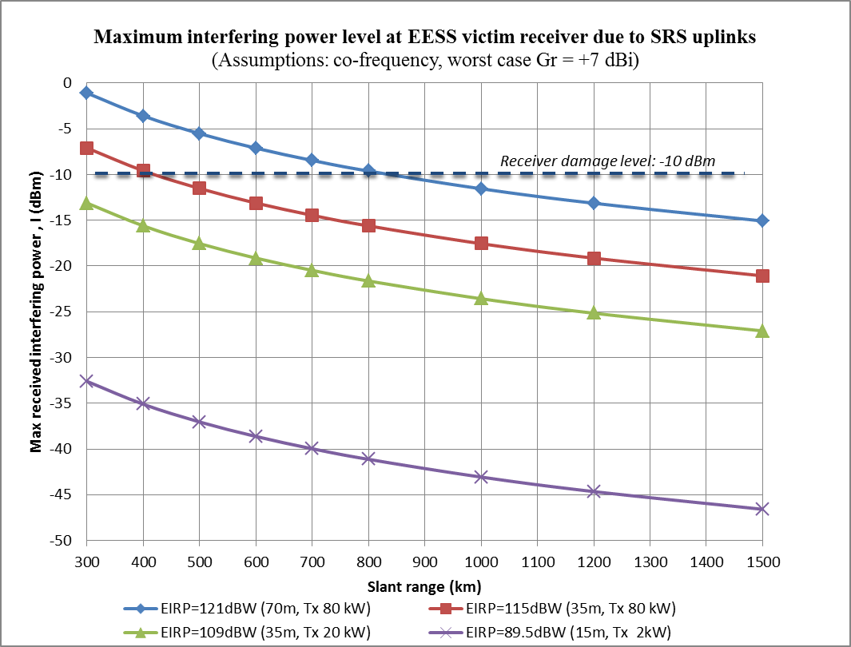

6.3 Dynamic interference analysis (EESS victim)
Two studies were conducted independently to perform the dynamic simulation analysis of interference from the existing SRS into the newly proposed EESS systems using the parameters given in §§ 2 and 3. The results of the studies are reported below.

6.3.1 Study #1: Interference from SRS near-Earth and deep-space missions into EESS missions
The following scenarios have been considered:

Interfering systems | Victim system
1 Lagrange SRS uplink from station at medium latitude (Cebreros) | EESS satellite, with earth stations located at medium and high latitudes
2 HEO SRS uplink from station at medium latitude (Cebreros)
3 LEO SRS uplink from station at high latitude (Svalbard)
4 DS SRS uplink from station at medium latitude (Cebreros)

The simulations were computed for one year duration at 5 s intervals. The results are summarised in Table 4. Considering co-frequency operations, the results of these initial simulations suggest that in most cases the interference from SRS uplinks into EESS receivers may exceed the applicable ITU criterion in the case that the earth stations for both EESS and SRS missions are geographically co-located or near-by. The simulation results also indicate that interference from deep space SRS uplink could potentially exceed the ITU criterion by more than 15% of the time. However the interference levels are within the ITU criterion in the case that the earth stations are not co-located.
Figures 6A/B/C and Fig. 7 represent the probability of time exceeding the applicable ITU criterion for the different scenarios. It is noted that for SRS missions in LEO orbits and with earth stations radiating low e.i.r.p. the interference levels into EESS space receivers are within the ITU criterion for both, co-located and geographically dispersed EESS and SRS earth stations (see Fig. 6C).
TABLE 4
Assessment of compliance with ITU protection criterion for victim EESS satellite and
SRS missions uplinks as interfering systems
 |  | Victim EESS satellite (LGA 0 dBi, 64 kbit/s) (*)
Interfering SRS mission | SRS station location | EESS uplink station in high latitude /Kiruna (Sweden) | EESS uplink station in medium latitude/ Cebreros (Spain)
1. LAGRANGE  35 m/ 20 kW/ e.i.r.p. 109 dBW/  2 kbit/s | Cebreros (Spain) | Criterion NOT exceeded  I_{o} < –161 dB(W/kHz) | Criterion exceeded  I_{o} exceeded 2.45% of time  Max excess: 47.7 dB  Average duration: 105 s
2. HEO  15 m/ 1 kW/ e.i.r.p. 86.5 dBW/  4 kbit/s | Cebreros (Spain) | Criterion NOT exceeded  I_{o} exceeded 0.0002% of time  Max excess: 2 dB  Average duration: 5 s | Criterion exceeded  I_{o} exceeded 0.35% of time  Max excess: 46.9 dB  Average duration: 40 s
3. LEO  5 m/ 100 W/ e.i.r.p. 67 dBW/  2.0 kbit/s | Svalbard (Norway)  Kiruna (Sweden) | Criterion NOT exceeded  I_{o} exceeded 0.0002% of time  Max excess: 14 dB  Average duration: 8 s | Criterion NOT exceeded  I_{o} < –161 dB(W/kHz)
4. DEEP-SPACE  35 m/ 80 kW/ e.i.r.p. 115 dBW/  1 kbit/s | Cebreros (Spain) | Criterion NOT exceeded  I_{o} < –161 dB(W/kHz) | Criterion exceeded  I_{o} exceeded 15% of time  Max excess: 62 dB  Average duration: 182 s
(*) Interference criterion: I_{o} ≥ –161 dB(W/kHz) for more than 0.1% of the time (Rec. ITU-R SA.514-3).
FIGURE 6A
Case 1: LAGRANGE SRS station in Cebreros/EESS with stations in Kiruna and Cebreros
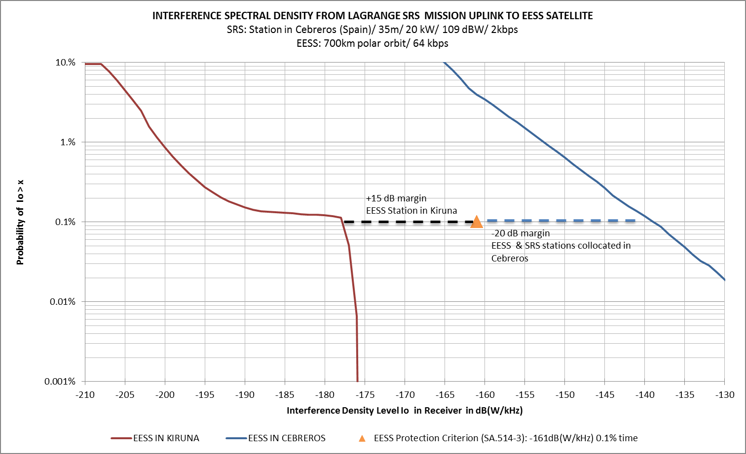
FIGURE 6B
Case 2: HEO SRS station in Cebreros/EESS with stations in Kiruna and Cebreros
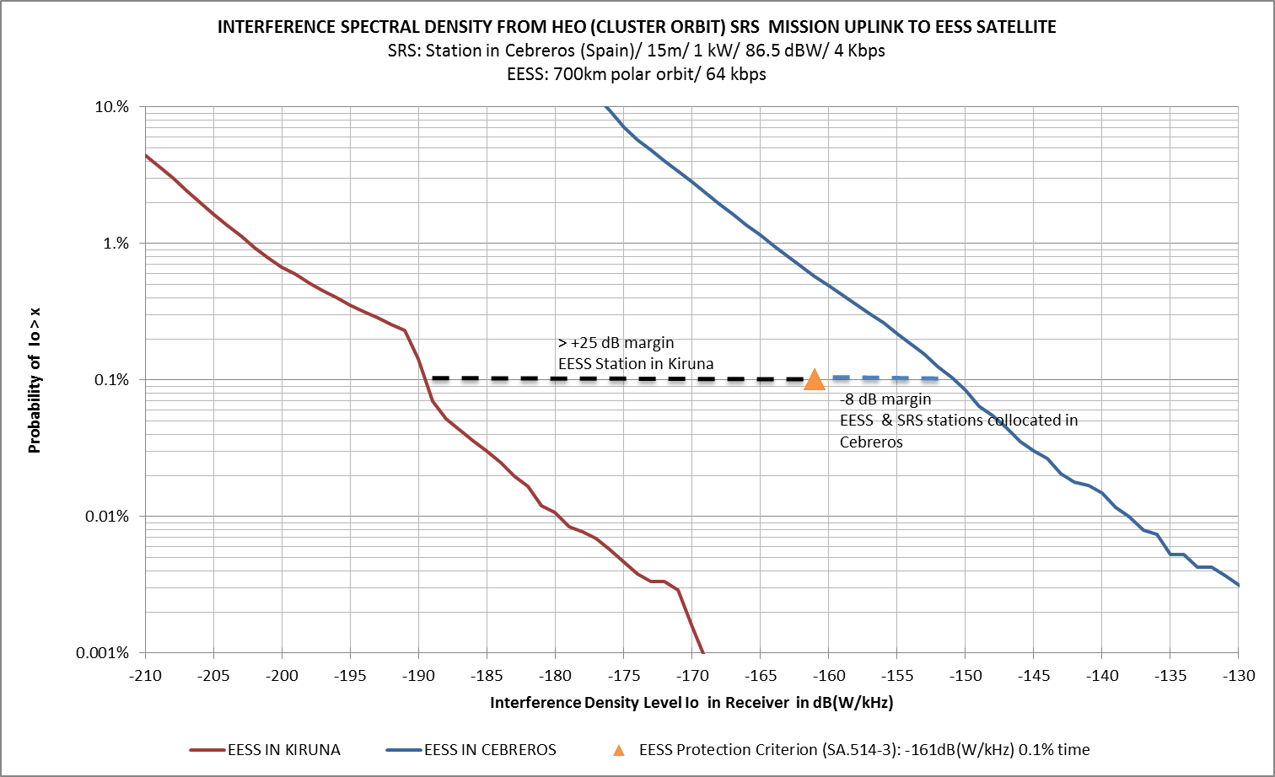
FIGURE 6C
Case 3: LEO SRS station in Svalbard/EESS with stations in Kiruna and Cebreros
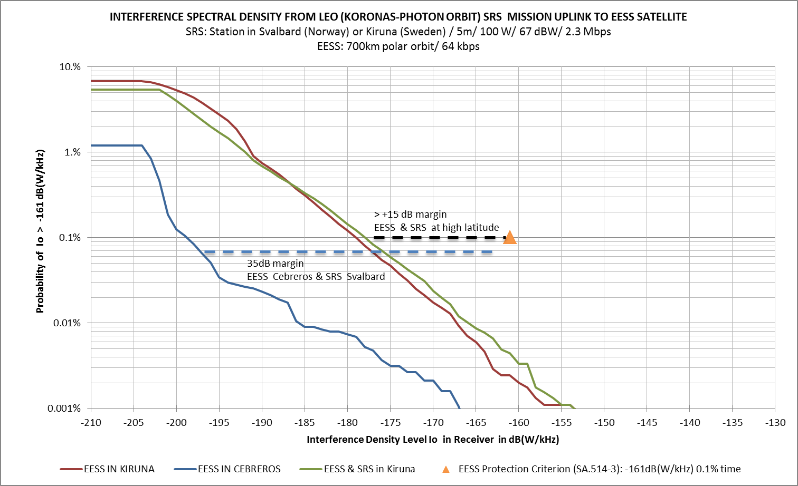
FIGURE 7
Case 4: DS SRS station in Cebreros/EESS with stations in Kiruna and Cebreros
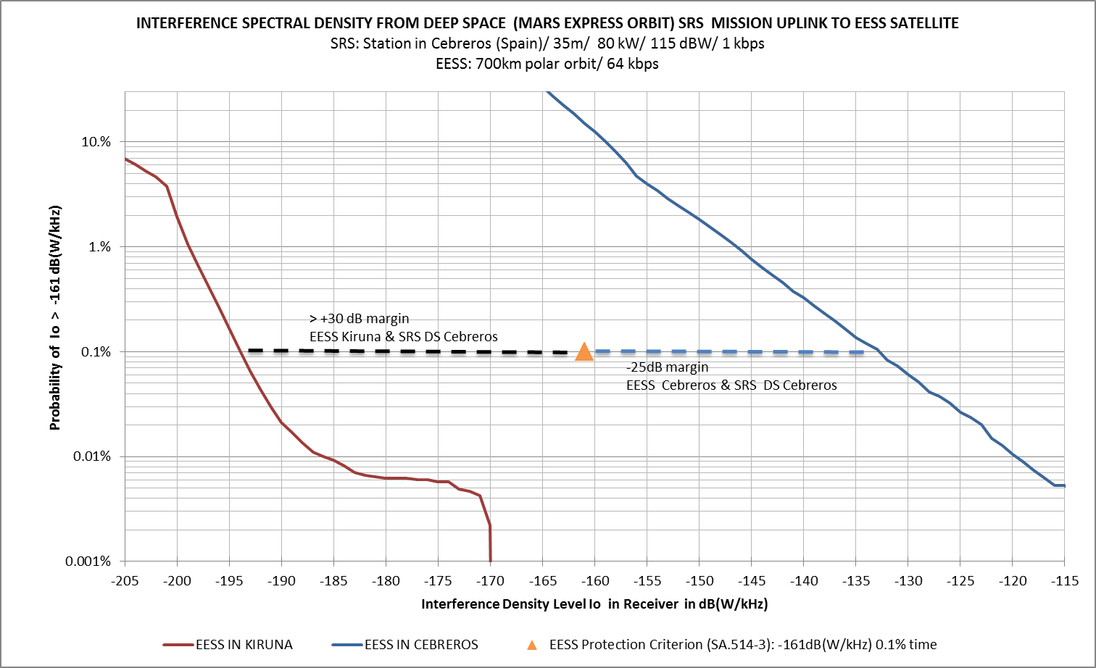

6.3.2 Study #2: Interference from SRS near-Earth missions into EESS
In the second study, a dynamic analysis was performed with a number of simulations that were run using the technical and operating characteristics listed in §§ 2 and 3. Assumptions made in the analysis are listed below.
1) Both victim and interfering systems are co-frequency.
2) Interferer’s PSD is assumed constant over the victim bandwidth.
3) Earth stations only transmit when in view of their respective space station.
For each simulation, the interference was computed for 30 000 random instances of time that spanned a period of 1 year. The results of this analysis are discussed below.

6.3.2.1 Interference from SRS near-Earth uplinks into EESS uplinks
Table 5 shows the results of interference from the SRS mission uplinks into the proposed EESS mission uplinks. The results show that the interference levels from the SRS L2 and HEO (i.e. higher power) mission uplinks are well above the ITU criterion, while the interference levels from the SRS GSO and LEO (i.e. lower power) mission uplinks systems are within the criterion. The above results suggest that interference from SRS uplinks into EESS uplinks would exceed the applicable ITU criterion for co-frequency and either co-located or nearby earth station operations. It is noted, though, that a similar situation currently exists for SRS uplinks as shown in the next section.
TABLE 5
Results of interference from SRS (L2, HEO, GSO and LEO) into EESS

6.3.2.2 Interference from SRS near-Earth uplinks into SRS uplinks
SRS uplinks currently exist in the 7 190-7 235 MHz band with high powered L2 and Cluster missions and low powered LEO missions and therefore the possibility exists for interference from the high powered missions into LEO missions. Therefore, an additional analysis is conducted in order to quantify what co-frequency sharing between SRS mission uplinks would look like relative to the ITU criterion.
Table 6 shows the results of interference from the high powered SRS mission uplinks into other low powered SRS mission uplinks. The results show that the interference levels from the uplinks into SRS LEO uplinks are well above the ITU criterion in many cases. It is noted, though, that these SRS uplinks do successfully co-exist, although frequency coordination does take place. Therefore, there should be compatibility in terms of SRS uplinks interfering into EESS uplinks, if frequency and earth station coordination takes place under the applicable Radio Regulation.
TABLE 6
Results of interference from SRS L2, HEO, GSO into SRS LEO

7 Assessment of interference from EESS uplinks into SRS satellites
Figure 8 illustrates the potential interference scenarios. The on-board SRS systems may receive part of the EESS uplink signal through the main and/or side lobes of the EESS earth stations.
FIGURE 8
Potential interference cases from EESS uplink stations to SRS on-board receive systems
in the band 7 145-7 235 MHz
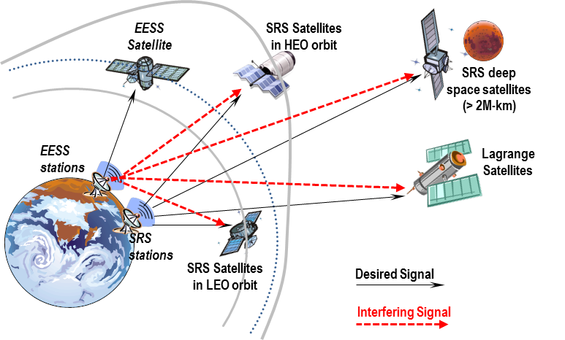

7.1 Static interference analysis (SRS victim)
The maximum interference power spectral density, I_{o} (dBW/kHz), at the victim SRS receiver from an EESS uplink earth station is calculated using the following equation:
$I_{o, max}=e.i.r.p.+20 log\left(\frac{c}{4πfR}\right)+G_{r}-L_{carr}$
where most parameters were introduced in § 7.1, and L_{carr} is the modulated carrier suppression in dB when using residual carrier modulation schemes.
The maximum interference PSD, I_{o,max} (dBW/kHz), depends on the modulation scheme used. For residual carrier modulation schemes, the maximum I_{o} can be identified around the carrier of the modulated spectrum and the modulated carrier suppression varies between –2 dB and –5 dB, depending on the modulation index. For suppressed carrier modulation schemes, the maximum I_{o} can be estimated as an average of the transmitted power over the transmit signal bandwidth. This corresponds to a power drop of 6 dB or more, depending on the data rate. In order to evaluate the worst case conditions for the static simulations the spectral density at the carrier considers a 3 dB suppression.
A parametric analysis was performed to calculate I_{o} vs. the slant range for SRS victim receivers equipped with different antennas: LGA (0 dBi), MGA (18 dBi) and HGA (48 dBi). The uplink e.i.r.p. considered for potential EESS uplink earth stations was 72.5 dBW (15 m, Ptx 16 dBW). This static analysis does not consider any atmospheric or pointing losses. It gives an estimation of potential maximum interference spectral density in case of co-frequency operation.
Figure 9 shows the results for near-Earth SRS missions in case of coupling with the EESS earth station antenna main lobe. It can be seen that the interference PSD, I_{o} max, received by SRS missions in LEO, HEO and Lagrange orbits is greater than the threshold
–177 dB(W/kHz). Therefore it is necessary to run dynamic simulations to assess if the ITU maximum allowed interference levels are exceeded for more than 0.1% of the time.
However it should be noted that the EESS earth stations are tracking the EESS satellites that typically are moving much faster than the SRS satellites and that the earth station passes only last 8-10 minutes. Therefore, coupling events with the EESS earth station main lobe are expected to be infrequent and occur for a very short duration.
For the case of deep-space (DS) SRS missions, the maximum PSD was calculated for two cases:
– Coupling with the main lobe of the EESS earth station antenna (G_{txmax} = 56.5 dBi).
– Coupling with the far side lobes of the EESS earth station antenna (G_{tx} = –10 dBi).
Two types of antennas have been considered on-board the DS SRS satellite: HGA with +48 dBi gain and LGA with 0 dBi gain. The ITU protection criteria for DS SRS missions is
–190 dB(W/20 Hz). The range for DS SRS satellites exceeds 2 M-km, however perigee heights can be as low as 2 000-5 000 km during fly-bys. Regular fly-bys can occur for example if the inclination of an orbit needs to be changed. It is critical that no harmful interference occurs during such critical phases. If commands are not executed exactly on time, the satellite could end up in a different orbit and the mission could potentially be lost. During the Launch and Early Orbit Phase (LEOP) the DS SRS satellites are also flying at low altitudes. The LEOP is generally less critical than fly-bys and sample return manoeuvres although they can also be key to ensure the mission success. The results of the static analysis (worst case) are shown in Fig. 10.
FIGURE 9
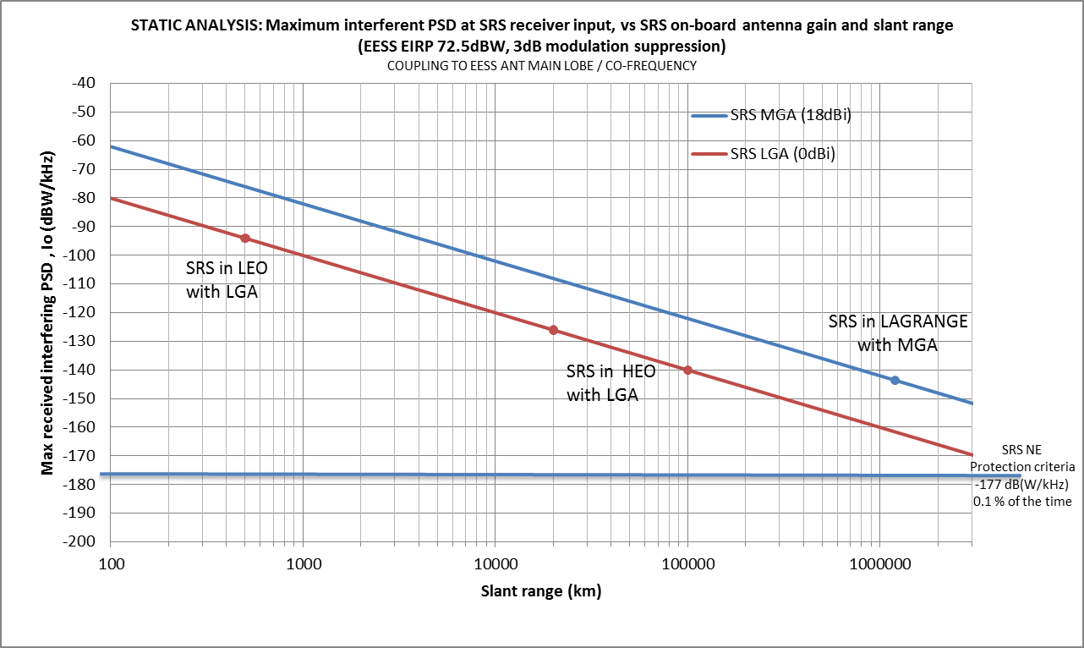
FIGURE 10
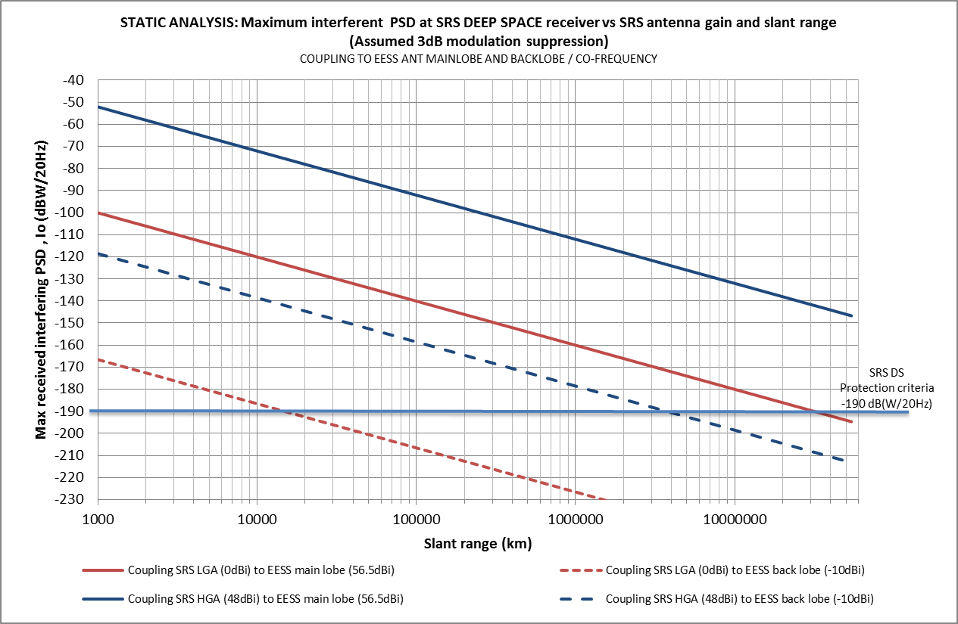
The main outcome is summarised as follows:

 | Coupling with main lobe of the EESS earth station antenna | Coupling with far-end lobes of the EESS earth station antenna
For DS satellite with HGA  (48 dBi) | Protection criterion is largely exceeded e.g. 40 dB negative margin at 54 M-km (Mars minimum distance) | Protection criterion can be exceeded for slant ranges below 3 M-km
For DS space satellite with LGA (0 dBi) | Protection criterion is exceeded for slant ranges below 30 M-km | Protection criterion is exceeded for slant ranges below 15 000 km

This initial analysis suggests that interference from EESS uplinks into DS SRS satellites would exceed the applicable ITU criterion for co-frequency operations.

7.2 Dynamic interference analysis (SRS victim)
Two studies were conducted independently to perform the dynamic simulation analysis of interference from the newly proposed EESS into the existing SRS systems in the band 7 145-7 235 MHz using the parameters given in §§ 2 and 3. The results of the studies are reported below.

7.2.1 Study #1: Interference from EESS into SRS near-Earth and deep-space missions
The following scenarios have been considered:

Interfering system | Victim systems
EESS uplink from earth stations located at medium (Cebreros/Spain) and high latitudes (Kiruna/Sweden) | 1 Lagrange SRS satellite, SRS earth station at medium latitude (Cebreros/Spain)
 | 2 HEO SRS satellite, SRS earth station at medium (Cebreros/Spain) and high latitudes (Kiruna/Sweden)
 | 3 LEO SRS satellite, SRS earth station at medium (Cebreros/Spain) and high latitudes (Kiruna/Sweden)
 | 4 Deep-space SRS, SRS earth station at medium (Cebreros & Villafranca/Spain) and high latitudes (Kiruna/Sweden)

The simulations do not take into account any atmospheric or precipitation effects, and are computed for one year duration at 5 s intervals. The results are summarised in Table 7A (for near-Earth SRS satellites) and Table 7B (for deep-space SRS satellites).
It should be noted that for SRS near-Earth victim systems in HEO and LEO orbits, the simulation results will be very much dependant on the orbit characteristics of both the SRS (victim) and EESS (interfering) satellites. Therefore further analysis may be necessary to consider additional sharing scenarios.
TABLE 7A
Assessment of excessive interference into victim near-Earth SRS satellite from EESS uplinks
Interfering EESS uplink
15 m / 40 W / e.i.r.p. 72.5 dBW/64 kbit/s
Victim near-Earth SRS mission (*) | SRS station location | EESS uplink station in Kiruna (Sweden) | EESS uplink station in Cebreros (Spain)
1. LAGRANGE satellite  (MGA antenna, 18 dBi) | Cebreros (Spain) | Criterion NOT exceeded  I_{o}< –177 dB(W/kHz) | Criterion NOT exceeded  I_{o} < –177 dB(W/kHz)
2. HEO satellite  (LGA antenna, 0 dBi) | Cebreros (Spain) | Criterion NOT exceeded  I_{o} exceeded < 0.0001% of time  Max excess: 4.5 dB  Average duration: 5 s | Criterion NOT exceeded  I_{o} exceeded < 0.00001% of time
2. HEO satellite  (LGA antenna, 0 dBi) | Kiruna (Sweden) | Criterion NOT exceeded  I_{o} exceeded < 0.0001% of time  Max excess: 4.8 dB  Average duration: 5 s | Criterion NOT exceeded  I_{o} < –177 dB(W/kHz)
TABLE 7A (end)
Interfering EESS uplink
15 m/ 40 W/ e.i.r.p. 72.5 dBW/64 kbit/s
Victim near-Earth SRS mission (*) | SRS station location | EESS uplink station in Kiruna (Sweden) | EESS uplink station in Cebreros (Spain)
3. LEO satellite  (LGA antenna, 0 dBi) | Kiruna (Sweden) | Criterion NOT exceeded  I_{o} exceeded 0.03% of time  Max excess: 23.5 dB  Average duration: 16 s (very much dependent on the geometry of both LEO orbits) | Criterion NOT exceeded  I_{o} < –177 dB(W/kHz)
(*) Interference criterion: I_{o} ≥ –177 dB(W/kHz) for more than 0.1% of the time.
TABLE 7B
Assessment of excessive interference into victim deep space SRS satellite from EESS uplinks
Interfering EESS uplink
15 m/40 W/ e.i.r.p. 72.5 dBW/64 kbit/s
Victim DS SRS mission (*) | SRS station location | Several EESS earth stations and EESS satellites: | EESS uplink station in Cebreros (Spain)
Uplink from Kiruna to Sentinel-1
Uplink from Cebreros to Sentinel-1
Uplink from Vilspa (Spain) to Sentinel-2
Uplink from Vilspa (Spain) to Sentinel-3
4. DEEP SPACE satellite  (HGA antenna, 48 dBi)  Mars Express orbit was used as reference for simulation. | Cebreros (Spain) | Io exceeded < 0.00001% of time  Max excess: –23 dB  Average duration: -- | I_{o} exceeded < 0.00001% of time  Max excess: –30 dB  Average duration: --
(*) Interference criterion: I_{o} ≥ –190 dB(W/20 Hz)/ –173 dB(W/kHz)
Figures 11 A/B/C/D represent the probability of time exceeding the applicable ITU criterion for the different simulation cases.
FIGURE 11A
Case 1: EESS station in Kiruna & Cebreros/Lagrange SRS satellite with uplink station in Cebreros
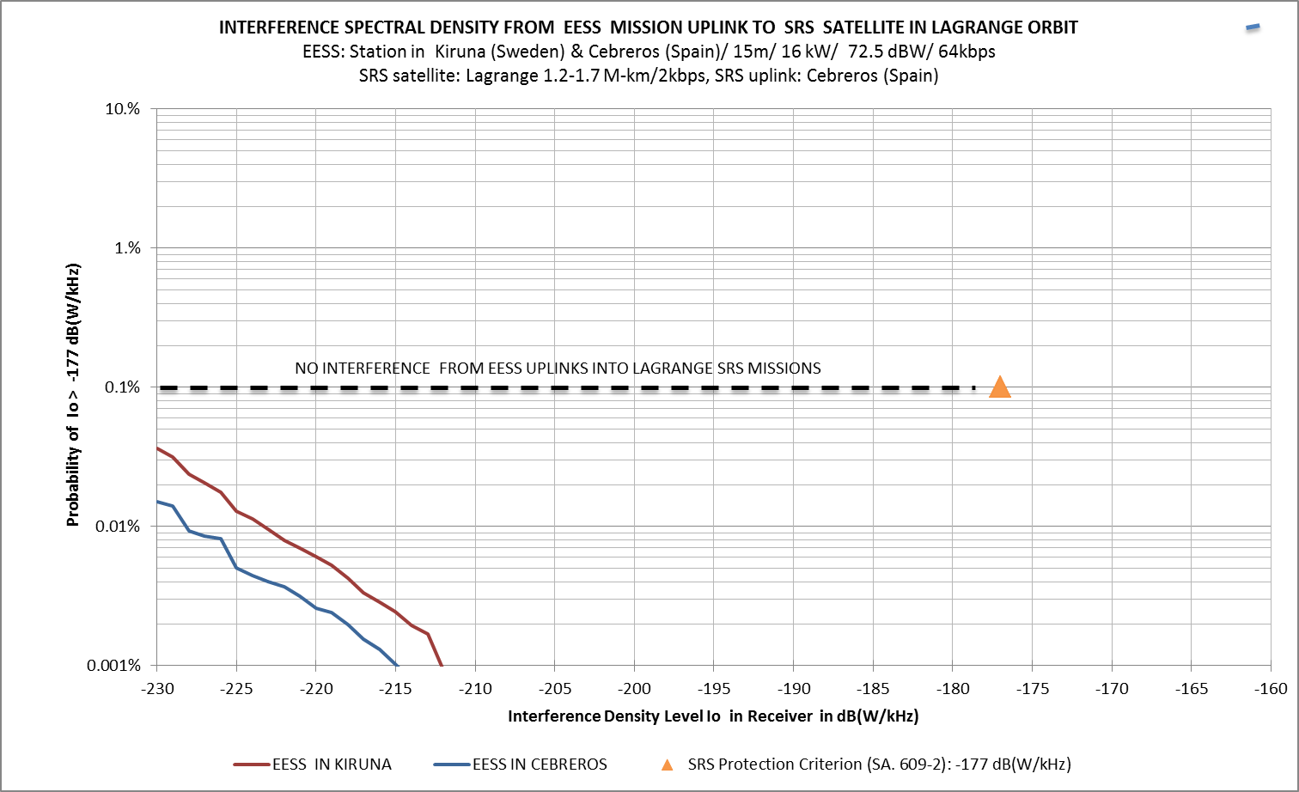
FIGURE 11B
Case 2: EESS station in Kiruna & Cebreros/HEO SRS satellite with uplink station in Cebreros
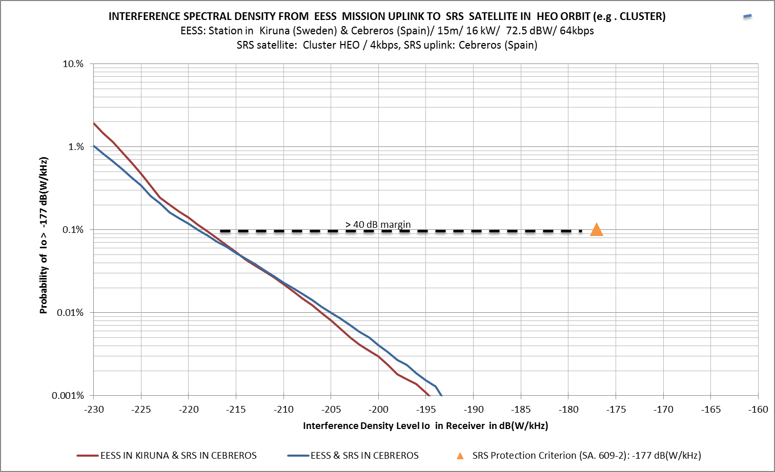
FIGURE 11C
Case 3: EESS station in Kiruna/LEO SRS satellite with uplink station in Kiruna
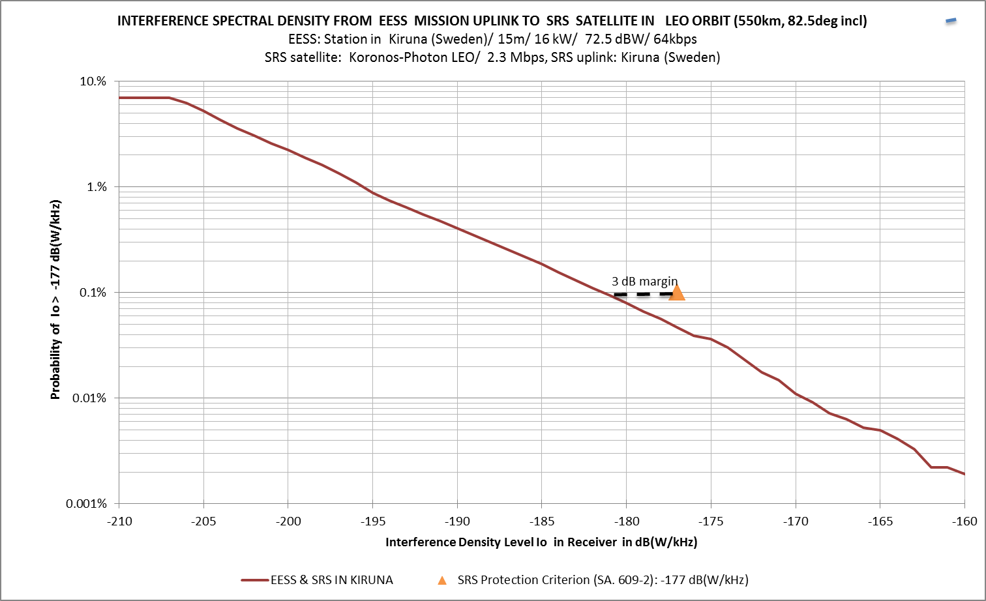
FIGURE 11D
Case 4: EESS stations at several locations/Deep space SRS satellite with uplink station in Cebreros
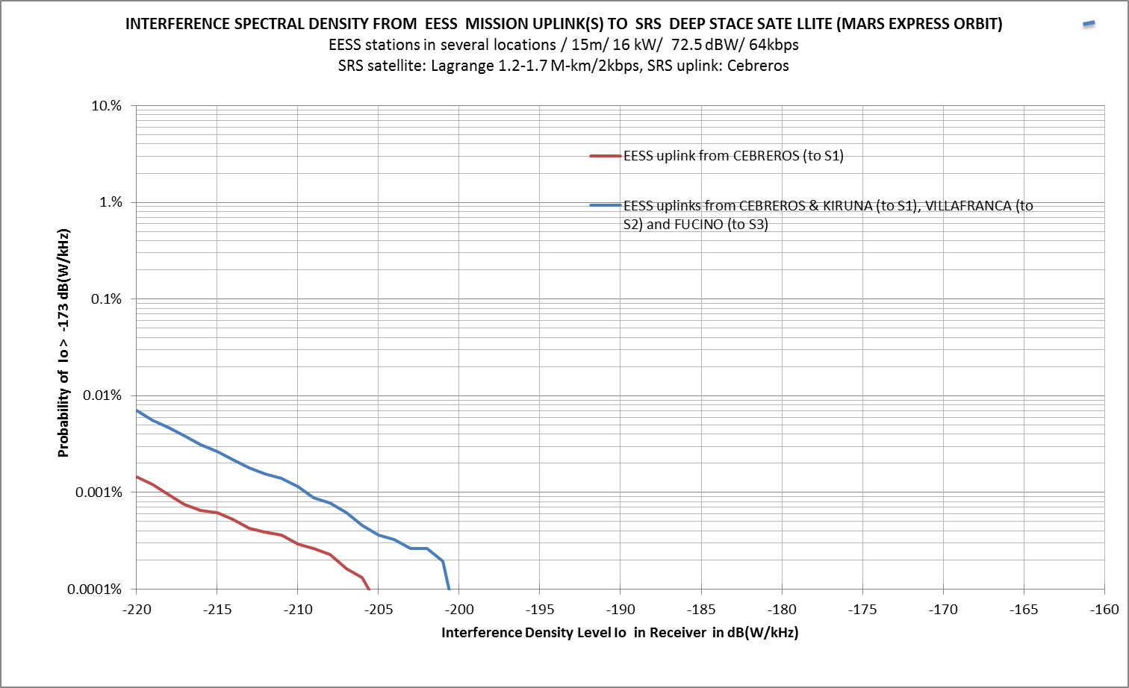

7.2.2 Study #2: Interference from EESS uplinks into SRS near-Earth mission uplinks
In the second independent study, a dynamic analysis was performed with a number of simulations that were run using the technical and operating characteristics listed in §§ 2 and 3. Assumptions made in the analysis are listed below.
1) Both victim and interfering systems are co-frequency.
2) Interferer’s PSD is assumed constant over the victim bandwidth.
3) Earth stations only transmit when in view of their respective space station.
For each simulation, the interference was computed for 30 000 random instances of time that spanned a period of 1 year. The results of this analysis are discussed below.
Table 8 shows the results of interference from the proposed EESS mission uplink into the SRS mission uplinks. The results show that the interference levels from the proposed new EESS mission uplinks into SRS uplinks are within the protection criteria. Although, interference into the SRS LEO system uplinks from EESS uplinks may be very close to the protection criteria, it is only a case happening when both systems operate with the same earth station location. The results suggest operation of EESS uplinks is compatible with the operation of SRS near-Earth mission uplinks without special mitigation techniques.
TABLE 8
Results of interference from EESS into SRS
 |  |  |  |  | Interference from EESS into SRS |  |  |  | Interference from EESS into SRS
 |  |  |  |  | I_{o} (dBW/Hz) for 0.1% time  SRS Interference (I_{o}) Criterion:  –207 dBW/Hz  EESS Bandwidth: 780 kHz, ES P_{wr} = 16 dBW; ES G = 56.5 dBi  EESS Orbit: 700 km (polar);  98 degrees incl |  |  |  | Excess Interference (dB) for 0.1% time  SRS Interference (I_{o}) Criterion:  –207 dBW/Hz  EESS Bandwidth: 780 kHz, ES P_{wr} = 16 dBW; ES G = 56.5 dBi  EESS Orbit: 700 km (polar);  98 degrees incl
SRS Mission | SRS transmit station locn | SRS orbit parameters | SRS sat gain (dBi) | SRS signal bandwidth | EESS-up: Cebreros, Spain | EESS-up: Kiruna, Sweden | EESS-up: Svalbard, Norway | EESS-up: Malargüe, ARG | EESS-up: Cebreros, Spain | EESS-up: Kiruna, Sweden | EESS-up: Svalbard, Norway | EESS-up: Malargüe, ARG
L2  (LISA PF) | Cebreros Spain | Alt = 1.5 mil km  Incl = 0 degees | 18 | 64 kHz | –253.9 | –251.2 | –247.2 | –260.4 | –46.9 | –44.2 | –40.2 | –53.4
L2  (LISA PF) | Malargüe, Argentina | Alt = 1.5 mil km  Incl = 0 degees | 18 | 64 kHz | –259.0 | –252.2 | –250.6 | –257.2 | –52.0 | –45.2 | –43.6 | –50.2
L2  (LISA PF) | New Norcia, Australia | Alt = 1.5 mil km  Incl = 0 degees | 18 | 64 kHz | –258.0 | –254.7 | –250.7 | –268.9 | –51.0 | –47.7 | –43.7 | –61.9
HEO (Cluster) | Cebreros, Spain | Apogee = 118 500 km  Perigee = 19 200 km  Incl = 65 degrees | 0 | 64 kHz | –245.6 | –244.6 | –243.1 | –250.2 | –38.6 | –37.6 | –36.1 | –43.2
HEO (Cluster) | Kiruna, Sweden | Apogee = 118 500 km  Perigee = 19 200 km  Incl = 65 degrees | 0 | 64 kHz | –247.2 | –240.6 | –241.5 | –253.3 | –40.2 | –33.6 | –34.5 | –46.3
HEO (Cluster) | Svalbard, Norway | Apogee = 118 500 km  Perigee = 19 200 km  Incl = 65 degrees | 0 | 64 kHz | –247.6 | –241.1 | –240.0 | –252.8 | –40.6 | –34.1 | –33.0 | –45.8
GSO  (GOES R) | Cebreros, Spain | GSO satellite (0E)  Incl = 0 degrees | 29 | 12 MHz | –226.8 | –221.2 | –217.8 | –243.9 | –19.8 | –14.2 | –10.8 | –36.9
GSO  (GOES R) | Kiruna, Sweden | GSO satellite (0E)  Incl = 0 degrees | 29 | 12 MHz | –229.5 | –218.5 | –215.8 | –243.9 | –22.5 | –11.5 | –8.8 | –36.9
GSO  (GOES R) | Svalbard, Norway | GSO satellite (0E)  Incl = 0 degrees | 29 | 12 MHz | –229.1 | –218.7 | –215.8 | –243.9 | –22.1 | –11.7 | –8.8 | –36.9
LEO (KORONAS-PHOTON) | Cebreros Spain | Alt = 550 km (Polar)  Incl = 85.5 degrees | 2 | 2 MHz | –213.8 | –237.2 | –253.8 |  | –6.8 | –30.2 | –46.8
LEO (KORONAS-PHOTON) | Kiruna, Sweden | Alt = 550 km (Polar)  Incl = 85.5 degrees | 2 | 2 MHz | –240.5 | –209.7 | –210.8 |  | –33.5 | –2.7 | –3.8
LEO (KORONAS-PHOTON) | Svalbard, Norway | Alt = 550 km (Polar)  Incl = 85.5 degrees | 2 | 2 MHz | –264.2 | –210.8 | –207.9 |  | –57.2 | –3.8 | –0.9
LEO (KORONAS-PHOTON) | Moscow, Russia |  |  |  | –240.9 | –211.8 | –220.0 |  | –33.9 | –4.8 | –13.0
LEO (KORONAS-PHOTON) | Krasnoyarsk (Russia) |  |  |  |  | –238.0 | –237.5 |  |  | –31.0 | –30.5

Annex A includes an additional study that considers exclusively the analysis of the potential interference to the SRS deep-space uplinks from EESS uplinks and interference from the SRS deep-space uplinks to EESS uplinks in the 7 145-7 190 MHz.

8 Assessment of interference from EESS uplinks into SOS satellites
This section presents an assessment of the compatibility between uplinks of SOS systems with EESS systems when both operate co-frequency in the frequency bands 7 100-7 155 MHz or 7 190-7 235 MHz. General description of the technical characteristics of potential new EESS (Earth-to-space) systems operating in the 7 GHz frequency band are described in § 2 (Table 1).
Typical technical characteristics of SOS system uplinks operating in the frequency bands 7 100-7 155 MHz and 7 190-7 235 MHz are provided in § 4 (Table 3).
The protection criteria for SOS spacecraft receivers is provided in § 5.3.
Figure 12 shows the interference scenario under consideration.
Figure 12
Interference scenario from EESS uplinks into SOS satellite receiver
Three studies have been conducted independently to assess the interference from the proposed EESS system uplink into the SOS system uplink. These analyses are considering that the victim and the interfering systems are co-frequency, and that the Earth stations transmit only when in view of their respective satellites. The dynamic simulations were computed for 30 consecutive days.
Table 9 summarizes the different assumptions considered in the studies.

TABLE 9
 | Study SOS-1  (Annex B ) | Study SOS-2  (Annex C) | Study SOS-3  (Annex D)
EESS mission uplink
EESS e.i.r.p. | Max. e.i.r.p. (72.5 dBW) | Max. e.i.r.p. (72.5 dBW) | Max. e.i.r.p. (72.5 dBW)
EESS signal bandwidth | 100 kHz | 100 kHz | 1 200 kHz
PSD | 52.5 dBW/kHz  Assumed constant over EESS signal bandwidth | 52.5 dBW/kHz  Assumed constant over EESS signal bandwidth | 41.7 dBW/kHz  Assumed constant over the SOS signal bandwidth
SOS uplink system
Satellite | COMPARUS-E | COMPARUS-C and E | COMPARUS-C and E
SOS e.i.r.p. | Max. e.i.r.p.  (mode 1: 33 dBW,  mode 2: 44 dBW)  Minimum e.i.r.p. power  (20 dB lower) | Maximum e.i.r.p. power (mode 1: 33 dBW,  mode 2: 44 dBW) | Max. e.i.r.p.  (mode 1: 33 dBW,  mode 2: 44 dBW)  Power control mode  (for constant level at Rx input −130.6 dBW )
SOS signal bandwidth | 1 200 kHz | 1 200 kHz | 1 200 kHz
PSD | Assumed constant over the SOS receiver bandwidth | Assumed constant over the SOS receiver bandwidth | Assumed constant over the SOS receiver bandwidth
Protection criteria | ITU-R RS.363-5  C/I < 20 dB (per kHz) during less than 1% of the day (15 min) | ITU-R RS.363-5  C/I < 20 dB (per kHz) during less than 1% of the day (15 min) | C/I < 20 dB (per kHz) during less than 1% of the daily contact time of the SOS station  (i.e. 1-3 minutes)

These three studies are presented in Annexes B (SOS-1), C (SOS-2) and D (SOS-3).
The two studies (SOS-1 and SOS-2) using the applicable SOS protection criteria contained in Recommendation ITU-R SA.363-5 concluded that EESS and SOS are compatible.
The third study (SOS-3) indicates potential interference under certain conditions. This study was based on the protection ratio C/I given in the applicable Recommendation ITU-R SA.363-5; however, a more stringent percentage of time than the associated percentage contained in that Recommendation was used.
It can therefore be concluded that on the basis of the protection criteria contained in the applicable Recommendation ITU-R SA.363-5, EESS and SOS are compatible.

9 Summary
This Report provides an analysis of the potential levels of interference between the proposed new EESS frequency allocation (Earth-to-space), and the existing SRS and SOS uplinks in the frequency range 7 145-7 235 MHz.
The SRS has a primary allocation worldwide in the frequency band 7 145-7 235 MHz: for deep-space (7 145-7 190 MHz) and for near-Earth operations (7 190-7 235 MHz).
This Report contains the results of two independent studies of interference between SRS near-Earth missions and EESS missions. The results of these analyses are consistent. Similarly, these analyses have been further considered and confirmed in Annex A dealing with deep-space SRS.
In the Russian Federation, the frequency bands 7 100-7 155 MHz and 7 190-7 235 MHz are also allocated to the SOS (Earth-to-space) on a primary basis, subject to agreement obtained under RR No. 9.21
This Report also contains the results of three independent studies of interference between SOS systems and EESS systems. These three studies are presented in Annexes B, C and D.
Overall, considering a potential EESS (Earth-to-space) allocation within the 7 145-7 235 GHz band, the following conclusions can be drawn:
Concerning the compatibility with deep-space (DS) SRS
The protection of SRS deep-space uplinks in the 7 145-7 190 MHz is critical to the success of the deep-space missions. This is especially important as almost all current and future SRS deep-space missions rely on this band as their lifeline for routine and emergency operations. Interference to the uplink of these missions should be minimized during their routine operations, but must be avoided completely during their near-Earth operations.
The analysis in this Report indicate that interference levels from EESS uplinks into DS SRS satellite receivers (7 145-7 190 MHz) are compliant with the applicable protection criteria when the spacecraft is in deep space (i.e. at distances greater than 2 M-km from the earth). However, interference levels may be above the protection criteria during their near-Earth operations, such as launch and early orbit operation phases, flybys, and sample returns.
Additionally, the interference from DS SRS uplinks into EESS satellite receivers would be well above the applicable protection criteria in case of co-frequency operations and either geographically co-located or nearby earth station operations.
Finally, the interference levels from SRS deep-space uplinks could potentially damage the satellite receiver for certain EESS missions.
Therefore, this analysis suggests that the co-existence of EESS and deep-space SRS uplinks would not be practical within the same operational frequency band. The band 7 145-7 190 MHz band should hence not be considered for future EESS Earth-to-space links.
Concerning the compatibility with near-Earth SRS
The analysis in this Report indicate that interference levels from EESS uplinks into near-Earth SRS satellite receivers in the band 7 190-7 235 MHz are compliant with the applicable ITU criterion and that this type of operation is compatible without the need of any special mitigation techniques.
On the other hand, for co-frequency operations and either geographically co-located or nearby Earth station operations, the interference levels from near-Earth SRS uplinks into EESS satellites would exceed the applicable ITU criterion. This could put some limitations in the selection of individual frequency assignments or station locations for EESS (Earth-to-space) within the range 7 190-7 235 MHz.
However, it should be noted that a similar situation currently exists for near-Earth SRS uplinks of different missions and that these missions are successfully coordinated among space agencies in the frame of the Space Frequency Coordination Group (SFCG) and the applicable ITU procedures. Therefore, there should be compatibility between SRS and EESS (Earth-to-space) in the 7 190-7 235 MHz if frequency and earth station coordination takes place.
Concerning the compatibility with SOS
In the Russian Federation, the frequency bands 7 100-7 155 MHz and 7 190-7 235 MHz are also allocated by RR footnote No. 5.459 to the SOS (Earth-to-space) on a primary basis, subject to agreement obtained under RR No. 9.21. Three studies have been conducted independently to assess the interference from the proposed EESS system uplink into the SOS system uplink.
Two studies using the applicable SOS protection criteria contained in Recommendation ITU-R SA.363-5. Those studies conclude that EESS and SOS are compatible.
The third study indicates potential interference under certain conditions. This study was based on the protection ratio C/I given in the applicable Recommendation ITU-R SA.363-5, however a more stringent percentage of time than the associated percentage contained in that Recommendation was used.
It can therefore be concluded that on the basis of the protection criteria contained in the applicable Recommendation ITU-R SA.363-5, EESS and SOS are compatible.

Annexes: 4

Annex A
Feasibility of sharing space research service (deep-space) and Earth exploration-satellite service
Feasibility of sharing the 7 145-7 190 MHz (Earth-to-space)
SRS (deep-space) frequency band with EESS uplink

1 Introduction
This Annex considers exclusively the analysis of the potential interference to the SRS deep-space uplinks from EESS uplinks and interference from the SRS deep-space uplinks to EESS uplinks in the 7 145-7 190 MHz.

2 Protection of SRS deep-space mission critical events
Except for two deep-space spacecraft launched in the late 1970s, all deep-space spacecraft use the 7 145-7 190 MHz band for their primary Earth-to-space links. Recommendation ITU-R SA.1157 has established –190 dBW/20 Hz as the protection criterion of the SRS deep-space Earth-to-space links. The protection criterion was chosen to protect the mission critical events, such as launch, early-orbit operations, planetary fly-bys, orbit insertions, entry-decent-and-landing (EDL), etc.
In general, the SRS deep-space uplinks are susceptible to potential interference from the EESS uplinks in the same band when the SRS deep-space spacecraft are near-Earth. The potential interference may occur during mission critical periods such as launch and early-orbit phases, Earth fly-bys, and sample-return phases of deep-space missions. During the near-Earth operations of the deep-space missions, interference from potential EESS uplinks may cause an interruption of the uplink command since, during this near-Earth phase, the deep-space uplink power and an EESS uplink power are comparable. In some cases, the carrier tracking loops of deep-space spacecraft receivers may be pulled away from the desired frequencies by the EESS uplinks and miss the desired uplink signals for many minutes. When there is an anomaly of deep-space spacecraft during the launch and early-orbit phases, it is vital for the operators to acquire and maintain uninterrupted telecommunication links with the spacecraft. The SRS deep-space mission operators may have a short time to establish communication and check on the health of the spacecraft before sending the spacecraft towards its destination as the favourable window for the interplanetary transit may be brief. For SRS deep-space missions that return samples to Earth, like JAXA’s Hayabusa, and missions that perform Earth fly-by maneuvers, the uplink in the 7 145-7 190 MHz band is necessary for accurate navigation of the spacecraft and for commanding the spacecraft to perform corrective maneuvers when necessary. Disruption in the uplink during these critical periods can lead to catastrophic events including the loss of a spacecraft and exposing potentially hazardous materials, such as propellants and return samples from the other planets and/or asteroids, to the environment.

3 Analysis of the interference from EESS uplink to SRS deep-space uplink
Figure A-1 shows the trajectory and coverage map of NASA Mars Science Laboratory (MSL) mission during the launch and early-orbit phases of the mission. It shows that the spacecraft travelled within the coverage area of some earth stations typically used for EESS satellites.
Figure A-1
Early trajectory of NASA MSL mission
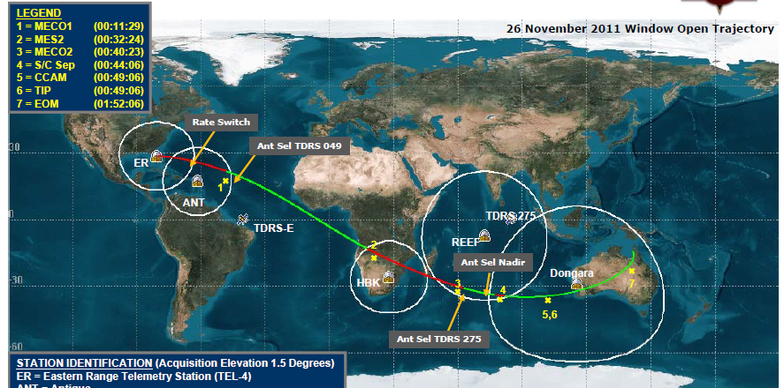
Figure A-2 below shows the potential co-channel interference power from EESS uplinks to an SRS deep-space spacecraft as a function of slant range between a deep-space spacecraft and an EESS earth station. An 11-m EESS earth station with a peak antenna gain of 55.6 dB is assumed to be transmitting at 20 dBW with a 45 degrees modulation index. The SRS deep-space spacecraft is assumed to use a 0 dBi low-gain antenna (LGA). The first line from top in Fig. A-2 shows the potential interference power in 20 Hz when the deep-space spacecraft is at the boresight of the EESS earth station. The second line from top in Fig. A-2 shows the potential interference power when the EESS earth station antenna gain is at –10 dBi, which is the minimum antenna gain whenever there is line-of-sight between the earth station and the deep-space spacecraft. Figure A-2 shows that in the best case, the potential interference from the co-channel EESS uplink can exceed the SRS deep-space protection criterion up to 20 000 km away whenever the deep-space spacecraft is in-view of the EESS earth station. In the worst case when the deep-space spacecraft is at the boresight of the EESS earth station, the potential interference may exceed the deep-space protection up to 45 × 10⁶ km away.
Figure A-2
Interference power from an EESS uplink to a SRS deep-space
spacecraft in the 7 145-7 190 MHz band
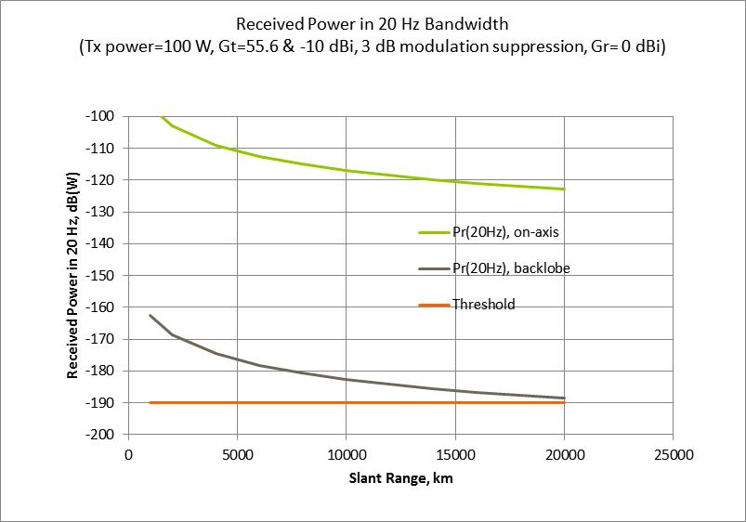
Although most SRS deep-space missions in the launch and early-orbit phases and in sample return phases do not fly over the high-latitude regions where many non-GSO EESS earth stations are located, there may still be visibility between the SRS deep-space spacecraft and the EESS earth stations. In addition, not all SRS deep-space missions operate near the ecliptic plane. Some SRS deep-space missions, such as solar probes, may fly over the high-latitude stations.

4 Operational coordination
Operational coordination between EESS and SRS deep-space mission operators to mitigate interference to deep-space missions operating near Earth is not practical for technical and operational reasons. First, it would be very time- and resource-consuming. This is especially true during the launch and early-orbit phases of the SRS deep-space missions. Second, the launch windows of a deep-space mission may last for thirty or more days, and launches are often postponed due to weather or technical reasons. To avoid potential interference to the SRS deep-space uplinks, EESS operators would need to cease uplink operations for potentially long periods. This disruption to EESS satellite operations may be too severe. Third, as the number of government and commercial EESS operators increases, it would be extremely difficult to communicate and coordinate with all EESS operators. Finally, it is not practical for EESS operators across different administrations and regions to cooperate and take immediate action to protect deep-space missions during a near-Earth anomaly.

5 Potential interference to EESS uplinks from SRS deep-space uplinks
The e.i.r.p. of an SRS deep-space uplink can be as high as 115.5 dBW in the 7 145-7 190 MHz band. The interference from an SRS deep-space uplink to an EESS satellite with 0 dBi low-gain antenna at 500 km altitude can be as high as –48 dBW. Even if the EESS satellite does not use the same frequency as the deep-space uplink, the interference power may be high enough to saturate or even damage the receiver hardware of EESS satellites.

6 Conclusion
The protection of SRS deep-space uplinks in the 7 145-7 190 MHz is critical to the success of the deep-space missions. This is especially important as almost all current and future SRS deep-space missions rely on this band as their lifeline for routine and emergency operations. Interference to the uplink of these missions should be minimized during their routine operations, but must be avoided completely during their near-Earth operations. Operational coordination is costly, time consuming, and is not practical, particularly during prolonged near-Earth operations of the SRS deep-space missions. Thus, it is prudent that the 7 145-7 190 MHz band is excluded from consideration for future EESS Earth-to-space links.

Annex B
Compatibility space operation service and
Earth exploration-satellite service
Study SOS-1
Assessment of interference from EESS missions uplinks into SOS missions (*)
in the frequency bands 7 100-7 155 MHz and 7 190-7 235 MHz
(*) by RR footnote No. 5.459, the Russian Federation has an additional primary allocation to the space operation service (SOS) (Earth-to-space) in the frequency bands 7 100-7 155 MHz and 7 190-7 235 MHz, subject to agreement obtained under RR No. 9.21.

1 Static analysis of interference from EESS system uplink into SOS system uplink
A static interference analysis is performed with the following worst case assumptions:
1) Both victim and interfering systems are co-frequency.
2) Interferer’s PSD (i.e. EESS uplink signal) is assumed constant over the interferer bandwidth (BW_{EESS}).
3) Victim’s PSD (i.e. SOS uplink signal) is assumed constant over the victim bandwidth (BW_{SOS}).
4) Earth stations of SOS and EESS systems are geographically co-located or near-by.
5) Interferer’s earth station antenna is assumed to be pointing towards the SOS satellite.
Taking into account that the slant from SOS and ESSS earth stations to the SOS satellite is the same for co-located stations, the ratio of signal power to a single interference power (C/I) in each band 1 kHz wide may be calculated using the following expression:
$\frac{C}{I}={PSD}_{SOS}-{PSD}_{EESS}$
$\frac{C}{I}={e.i.r.p. }_{SOS}{-e.i.r.p. }_{EESS}+10log\left(\frac{{BW}_{EESS}}{{BW}_{SOS}}\right)$
$\frac{C}{I}={e.i.r.p. }_{SOS}{-e.i.r.p. }_{EESS}+ABW$
where:
PSD_{SOS,} PSD_{EESS}: power spectral density of the SOS and EESS signals, dB (W/kHz)
e.i.r.p._{sos}, e.i.r.p._{EESS}: equivalent isotropic radiated power of the SOS and EESS uplink earth stations, dBW
ABW: bandwidth advantage factor (dB).
ABW is a factor takes into account the different bandwidth of the SOS and EESS signals. When the bandwidth of both SOS and EESS signals are the same, then the ABW is 0 dB. However, if the SOS signal has 1.2 MHz bandwidth, and the EESS signal has 100 kHz bandwidth, then the bandwidth advantage factor is –10.8 dB. Table B-1 shows the interference power, C/I, per 1 kHz as calculated for different e.i.r.p. power levels transmitted at the SOS earth station and different EESS signal bandwidths.
TABLE B-1
Interference power, C/I, per 1 kHz at the SOS space receiver input for different e.i.r.p. power
levels transmitted at the SOS earth station and different EESS signal bandwidths
 |  |  |  | e.i.r.p._{SOS} (dBW)
 |  |  |  | KORONAS-PHOTON |  | COMPARUS MODE 1 |  | COMPARUS MODE 2
 |  |  |  | e.i.r.p. max | e.i.r.p. min | e.i.r.p. max | e.i.r.p. min | e.i.r.p. max | e.i.r.p. min
 |  |  |  | 67 | 47 | 33 | 13 | 44 | 24
e.i.r.p._{EESS}  = 72.5 dBW | BW_{EESS}  (kHz) | ABW (dB) | C/I (dB) per 1 KHz band
e.i.r.p._{EESS}  = 72.5 dBW | 100 | –10.8 | –16.3 |  | –36.3 | –50.3 | –70.3 | –39.3 | –59.3
e.i.r.p._{EESS}  = 72.5 dBW | 1 200 | 0.0 | –5.5 |  | –25.5 | –39.5 | –59.5 | –28.5 | –48.5
e.i.r.p._{EESS}  = 72.5 dBW | 2 000 | 2.2 | –3.3 |  | –23.3 | –37.3 | –57.3 | –26.3 | –46.3
e.i.r.p._{EESS}  = 72.5 dBW | 4 000 | 5.2 | –0.3 |  | –20.3 | –34.3 | –54.3 | –23.3 | –43.3

According to Recommendation ITU-R SA.363-5 the ratio of signal power to total interference power, C/I, must not fall below 20 dB. The obtained result shows that a single EESS system uplink might create interference to a SOS system uplink between 20 dB and 90 dB higher than the limit specified in Recommendation ITU-R SA.363-5.
However, taking into account the dynamic nature of SOS and EESS systems, the final conclusion should be based on the result of dynamic simulation of systems’ operation.

2 Dynamic analysis of interference from EESS system uplink into SOS system uplink
A dynamic interference analysis is performed with the following assumptions:
1) Both victim and interfering systems are co-frequency.
2) Interferer’s PSD (EESS) is considered approximately constant over 100 kHz bandwidth (modulation BPSK, 50 ksps).
3) Earth stations only transmit when in view of their respective space station.
4) Victim’s PSD (SOS) is considered approximately constant over 1.2 MHz bandwidth (modulation BPSK, 600 ksps).
5) The reference bandwidth considered to compute C/I at the victim receiver is 1 kHz.
SOS protection criterion used in the analysis
The SOS protection criterion has been evaluated according to Recommendation ITU-R SA.363-5, which specifies that the percentage of time during which space operation links can tolerate an interference level above the protection level is fixed at 1% each day, which is about 15 minutes, in accordance with the “15 consecutive minutes” mentioned in § 5.4 of Annex 1 to this Recommendation:
“This value is based on the assumption that the spacecraft is equipped with memory and automatic devices to ensure its safety during interruptions of telecommunications. This condition was not always fulfilled in the past, but it is considered reasonable to require it to be met by future systems.
However interference lasting for as long as 15 consecutive minutes is intolerable during certain foreseeable critical stages, such as launch phases, critical spacecraft manoeuvres, or for such short-lived spacecraft as rocket probes. It would be unreasonable to lay down protection criteria on the basis of such exceptional situations, and it would be preferable to invite concerned administrations to carry out special analyses of the interference likely to be caused and to take countermeasures which should be temporary and limited to specific regions”.
The dynamic analysis was performed for several scenarios using the technical and operating characteristics listed in the previous sections. For each simulation, the ratio of signal power to total interference power for 1 kHz bandwidth reference was computed for 30 consecutive days with 5 second steps.
The SOS victim system considered was COMPARUS-E (LEO elliptical orbit, 450-200 km, 70 degrees inclination). Two representative locations for SOS earth stations (ES) were considered: Moscow and a high latitude location (68.58N, 33.4E). Three locations were considered for EESS earth stations: one ES in Kiruna (Sweden) and the other two ESs are geographically co-located with the SOS ESs in the Russian Federation.
Scenario with the SOS earth station located in Moscow
For the case of SOS ES located in Moscow, the simulation results show that the interference levels from the EESS uplink into SOS operations in the band 7 190-7 235 MHz are compliant in all cases with the applicable ITU protection criterion, as shown in Table B-2.
Scenario with the SOS earth station located at high latitude within the Russian Federation (68.58N, 33.4E)
For the case of SOS ES located at high latitude within the Russian Federation, the simulation results show that the interference levels from the EESS uplink into SOS operations in the band 7 190-7 235 MHz are compliant with the ITU protection criterion in most cases, except when both EESS and SOS earth stations are co-located in the Russian Federation at high latitude and the SOS system is operated in Mode 1 with minimum e.i.r.p. (+13 dBW). See Table B-3.
It should be noted that these cases could take advantage of using the frequencies in the range 7 235-7 250 MHz, that is not allocated to the SOS service in FN 5.459.
The simulation results show that the ITU protection criterion is satisfied considering the EESS earth station located in Kiruna (Sweden) and the SOS earth station located at high latitude in the Russian Federation. The distance considered in the simulations between the EESS and SOS earth stations is approx. 550 km.
A worst case for the EESS uplink has been considered, i.e. maximum EESS e.i.r.p. and minimum bandwidth (100 kHz). EESS systems operating with higher data rate (i.e. occupying more bandwidth) will benefit from the ABW explained earlier. Considering an EESS signal with the maximum bandwidth specified in Table 1 (i.e. 4 MHz) the excess in C/I deficit would be decreased up to 16 dB.
TABLE B-2
Sharing analysis between EESS system uplink and COMPARUS SOS system
uplink with SOS earth station located in Moscow
 | SOS earth station in Moscow (55.75N, 37.62E)
 | Min e.i.r.p.:  Mode 1 (+13 dBW), Mode 2 (+24 dBW) | Max e.i.r.p.:  Mode 1 (+33 dBW), Mode 2 (+44 dBW)
Non  co-located  EESS station: Kiruna | Mode 1: Protection criteria not exceeded  • Max deficit over C/I < 20 dB: 15.6 dB  • Max duration: 5.6 min in day 16  (0.39% of the day) | Mode 1: Protection criteria not exceeded  • Max deficit over C/I < 20 dB: none  • Max duration: not applicable
Non  co-located  EESS station: Kiruna | Mode 2: Protection criteria not exceeded  • Max deficit over C/I < 20 dB: 20.6 dB  • Max duration: 10 min in day 16  (0.51% of the day) | Mode 2: Protection criteria not exceeded  • Max deficit over C/I < 20 dB: 0.6 dB  • Max duration: 15 s in day 25  (0.60% of the day)
Co-located  EESS station: Moscow | Mode 1: Protection criteria not exceeded  • Max deficit over C/I < 20 dB: 44.1 dB  • Max duration: 13 min 40 s in day 12 (0.94% of the day) | Mode 1: Protection criteria not exceeded  • Max deficit over C/I < 20 dB: 24.1 dB  • Max duration: 3 min in day 12  (0.2% of the day)
Co-located  EESS station: Moscow | Mode 2: Protection criteria not exceeded  • Max deficit over C/I < 20 dB: 33.1 dB  • Max duration: 6.4 min in day 12  (0.33% of the day) | Mode 2: Protection criteria not exceeded  • Max deficit over C/I < 20 dB: 13.1 dB  • Max duration: 40 s in day 12  (0.05% of the day)
TABLE B-3
Sharing analysis between EESS system uplink and COMPARUS SOS system uplink
with SOS earth station located at high latitude in the Russian Federation
 | SOS earth station at Russia high latitude (68.58N, 33.4E)
 | Min e.i.r.p.:  Mode 1 (+13 dBW), Mode 2 (+24 dBW) | Max e.i.r.p.:  Mode 1 (+33 dBW), Mode 2 (+44 dBW)
Non co-located  EESS station: Kiruna | Mode 1: Protection criteria not exceeded  • Max deficit over C/I < 20 dB: 31 dB  • Max duration: 8.5 min in day 16  (0.6% of the day) | Mode 1: Protection criteria not exceeded  • Max deficit over C/I < 20 dB: 11.1 dB  • Max duration: 70 s in day 24  (0.08% of the day)
Non co-located  EESS station: Kiruna | Mode 1: Protection criteria not exceeded  • Max deficit over C/I < 20 dB: 34.6 dB  • Max duration: 13 min 30 s in day 20 (0.86% of the day) | Mode 1: Protection criteria not exceeded  • Max deficit over C/I < 20 dB: 14.6 dB  • Max duration: 60 s in day 24  (0.07% of the day)
Co-located  EESS station: high latitude | Mode 1: Protection criteria exceeded  • Interference level exceeded during more than 1% of the day for five days in the month (days 3, 12, 16, 20 and 29)  • Max deficit over C/I < 20 dB: 32.9 dB  • Max duration: 22 min in day 16  (1.52% of the day) | Mode 1: Protection criteria not exceeded  • Max deficit over C/I < 20 dB: 12.9 dB  • Max duration: 2 min 35 s in day 20 (0.18% of the day)
Co-located  EESS station: high latitude | Mode 2: Protection criteria not exceeded  • Max deficit over C/I < 20 dB: 21.9 dB  • Max duration: 6 min in day 25  (0.39% of the day) | Mode 2: Protection criteria not exceeded  • Max deficit over C/I < 20 dB: 2 dB  • Max duration: 45 s in day 24  (0.05% of the day)

3 Detailed results of dynamic sharing analysis
Simulation assumptions

Victim system: | SOS COMPARUS-E uplink at 7 190 MHz
SOS orbit | LEO elliptical orbit, 450-200 km, 70 degrees inclination
SOS sat Rx system noise temp | 1 000 K
SOS earth station (ES) antenna gain | 46 dBi (5 m diameter)
SOS signal | PSD approx. constant over 1.2 MHz  Simulated signal: BPSK 600 kbit/s, RF Bandwidth 1.2 MHz
SOS earth station location | Moscow (55.75N, 37.62E)  Location at high latitude (68.58N, 33.4E)
SOS system in Mode 1  • Satellite antenna  • ES e.i.r.p. | • Narrow beam tracking antenna (G_{max} = +12 dBi)  • +33 dBW max, +13 dBW min
SOS system in Mode 2  • Satellite antenna gain  • ES e.i.r.p. | • Nadir pointed wide-beam antenna (G_{max} = +1 dBi)  • +44 dBW max, +24 dBW min
Protection criterion for SOS spacecraft receivers | Ratio of signal power to total interference power in each band 1 kHz wide must not fall below 20 dB for more than 1% of the time, each day (Rec. ITU-R SA.363)
Interfering system: | Representative EESS uplink at 7 190 MHz
EESS orbit | LEO circular orbit, 700 km, 98 degrees inclination
EESS ES Earth antenna gain | 56.5 dBi (15 m diameter)
EESS e.i.r.p. | +72.5 dBW (maximum power)
EESS signal | PSD approx. constant over 100 kHz  Simulated signal: BPSK 50 kbit/s, RF Bandwidth 100 MHz
EESS earth station location | Kiruna (Sweden) (67.51N, 20.57E)  Moscow (55.75N, 37.62E)  Location at high latitude (68.58N, 33.4E)
NOTE – The min e.i.r.p. case has been applied for the whole pass (absolute worst case), although it is expected that in reality it would apply only to the period in which COMPARUS is visible from its Earth station with high elevation angles.
The simulation results are presented in the following tables:
COMPARUS-E Mode 1 Tables B-4 & B-5: SOS ES located in Moscow and at high latitude.
COMPARUS-E Mode 2 Tables B-6 & B-7: SOS ES located in Moscow and at high latitude.
Summary of simulation results
Case of SOS and EESS earth stations non co-located
Considering the EESS earth station located in Kiruna and the SOS earth station located in either Moscow or at high latitude within the Russian Federation, the interference levels from the proposed new EESS mission uplinks into SOS uplinks are within the ITU criterion.
Case of SOS and EESS earth stations co-located in the Russian Federation
When the SOS system is operated with the maximum power levels filed at ITU, the interference levels from the proposed new EESS mission uplinks into SOS uplinks are within the ITU criterion.
However, the interference criterion can be exceeded during few days over 30 days if the SOS system is operated in Mode 1 (narrow beam tracking antenna) with the minimum e.i.r.p. filed for the COMPARUS system (e.i.r.p. = +13 dBW).
TABLE B-4
SOS ES Moscow/Mode 1: Results of interference C/I per day from EESS into SOS
Victim system: COMPARUS-E SOS link, Mode 1 (i.e. satellite with HGA)
Protection criteria: C/I < 20 dB in each band 1 kHz not more than 1% of the time, each day
Earth station in Moscow
SOS signal: PSD approx. constant over 1.2 MHz
 | Min e.i.r.p. = +13 dBW;  PSD = –17.8 dBW/kHz |  |  |  | Max e.i.r.p. = +33 dBW;  PSD = +2.2 dBW/kHz
Interferer: EESS system  ES at Kiruna (Sweden)  ** NO-COLLOCATED**  EESS signal  (BPSK, 50 ksps):  e.i.r.p. = +72.5 dBW/+52.5 dBW/kHz | Day | Duration (s) | Time %  per day |  | Day | Duration (s) | Time % per day
 | 3 | 270 | 0.31
 | 7 | 75 | 0.09
 | 12 | 260 | 0.30
 | 16 | 340 | 0.39
 | 20 | 240 | 0.28
 | 24 | 50 | 0.06
 | 25 | 230 | 0.27
 | 29 | 200 | 0.23
 | Protection criteria NOT exceeded |  |  |  | Protection criteria NOT exceeded
 | Max threshold exceedence: 15.6 dB
 | Max duration: 5.6 min in day 16 (0.39% of the day)
Interferer: EESS system  ES at Moscow  ** COLLOCATED**  EESS signal  (BPSK, 50 ksps):  e.i.r.p. = +72.5 dBW/+52.5 dBW/kHz | Day | Duration (s) | Time %  per day |  | Day | Duration (s) | Time % per day
 | 3 | 555 | 0.64 |  | 3 | 70 | 0.08
 | 7 | 125 | 0.14 |  | 12 | 185 | 0.21
 | 8 | 405 | 0.47
 | 12 | 815 | 0.94
 | 16 | 625 | 0.72
 | 20 | 5 | 0.01
 | 25 | 200 | 0.23
 | 29 | 670 | 0.78
 | Protection criteria NOT exceeded |  |  |  | Protection criteria NOT exceeded
 | Max threshold exceedence: 44.1 dB |  |  |  | Max threshold exceedence: 24.1 dB
 | Max duration: 13 min 40 s in day 12 (0.94% of the day) |  |  |  | Max duration: 3 min in day 12  (0.2% of the day)

TABLE B-5
SOS ES High Latitude/Mode 1: Results of interference C/I per day from EESS into SOS
Victim system: COMPARUS-E SOS link, Mode 1 (i.e. satellite with HGA)
Protection criteria: C/I < 20 dB in each band 1 kHz not more than 1% of the time, each day
Earth station at Russia high latitude (68.58N, 33.4E)
SOS signal: Mode 1, PSD approx. constant over 1.2 MHz
 | Min e.i.r.p. = +13 dBW;  PSD = –17.8 dBW/kHz |  |  |  | Max e.i.r.p. = +33 dBW;  PSD = +2.2 dBW/kHz
Interferer: EESS system  ES at Kiruna (Sweden)  ** NO-COLLOCATED**  EESS signal  (BPSK, 50 ksps):  e.i.r.p. = +72.5 dBW/  +52.5 dBW/kHz | Day | Duration (s) | Time % per day |  | Day | Duration (s) | Time % per day
 | 3 | 250 | 0.29 |  | 16 | 10 | 0.01
 | 4 | 155 | 0.18 |  | 20 | 35 | 0.04
 | 7 | 225 | 0.26 |  | 21 | 55 | 0.06
 | 8 | 325 | 0.38 |  | 24 | 70 | 0.08
 | 11 | 105 | 0.12
 | 12 | 415 | 0.48
 | 16 | 510 | 0.59
 | 20 | 245 | 0.28
 | 21 | 180 | 0.21
 | 24 | 340 | 0.39
 | 25 | 340 | 0.39
 | 28 | 45 | 0.05
 | 29 | 465 | 0.54
 | Protection criteria NOT exceeded |  |  |  | Protection criteria NOT exceeded
 | Max threshold exceedence: 31.0 dB |  |  |  | Max threshold exceedence: 11.1 dB
 | Max duration: 8.5 min in day 16 (0.59% of the day) |  |  |  | Max duration: 70 s in day 24  (0.08% of the day)
Interferer: EESS system  ES at Russia high lat  ** COLLOCATED**  EESS signal  (BPSK, 50 ksps):  e.i.r.p. = +72.5 dBW/  +52.5 dBW/kHz | Day | Duration (s) | Time % per day |  | Day | Duration (s) | Time % per day
 | 3 | 970 | 1.12 |  | 3 | 35 | 0.04
 | 4 | 195 | 0.23 |  | 16 | 100 | 0.12
 | 7 | 535 | 0.62 |  | 20 | 155 | 0.18
 | 8 | 645 | 0.75 |  | 21 | 65 | 0.08
 | 11 | 105 | 0.12 |  | 24 | 120 | 0.14
 | 12 | 1 165 | 1.35
 | 16 | 1 310 | 1.52
 | 20 | 1 155 | 1.34
 | 21 | 270 | 0.31
 | 24 | 410 | 0.47
 | 25 | 800 | 0.93
 | 29 | 1 035 | 1.20
 | Protection criteria EXCEEDED 5 out of 30 days |  |  |  | Protection criteria NOT exceeded
 | Max threshold exceedence: 32.9 dB |  |  |  | Max threshold exceedence: 12.9 dB
 | Max duration: 22 min in day 16 (1.52% of the day) |  |  |  | Max duration: 2 min 35 s in day 20 (0.18% of the day)

TABLE B-6
SOS ES Moscow/Mode 2: Results of interference C/I per day from EESS into SOS
Victim system: COMPARUS-E SOS link, Mode 1 (i.e. satellite with HGA)
Protection criteria: C/I < 20 dB in each band 1 kHz not more than 1% of the time, each day
Earth station in Moscow (55.75N, 37.62E)
SOS signal: Power spectral density approx. constant over 1.2 MHz
 | Min e.i.r.p. = +24 dBW/  –6.8 dBW/kHz |  |  |  | Max e.i.r.p. = +44 dBW/  +13.2 dBW/kHz
Interferer: EESS system  ES at Kiruna (Sweden)  ** NO-COLLOCATED**  EESS signal  (BPSK, 50 ksps):  e.i.r.p. = +72.5 dBW/+52.5 dBW/kHz | Day | Duration (s) | Time % per day |  | Day | Duration (s) | Time % per day
 | 3 | 375 | 0.43 |  | 25 | 15 | 0.02
 | 7 | 190 | 0.22
 | 8 | 75 | 0.09
 | 11 | 5 | 0.01
 | 12 | 440 | 0.51
 | 16 | 605 | 0.70
 | 20 | 365 | 0.42
 | 21 | 80 | 0.09
 | 24 | 160 | 0.19
 | 25 | 450 | 0.52
 | 29 | 365 | 0.42
 | Protection criteria NOT exceeded |  |  |  | Protection criteria NOT exceeded
 | Max threshold exceedence: 20.6 dB |  |  |  | Max threshold exceedence: 0.62 dB
 | Max duration: 10 min in day 16 (0.51% of the day) |  |  |  | Max duration: 15 s in day 25 (0.02% of the day)
Interferer: EESS system  ES at Moscow  ** COLLOCATED**  EESS signal  (BPSK, 50 ksps):  e.i.r.p. = +72.5 dBW /+52.5 dBW/kHz | Day | Duration (s) | Time % per day |  | Day | Duration (s) | Time % per day
 | 3 | 210 | 0.24 |  | 12 | 40 | 0.05
 | 7 | 25 | 0.03
 | 8 | 115 | 0.13
 | 12 | 385 | 0.45
 | 16 | 85 | 0.10
 | 20 | 5 | 0.01
 | 25 | 140 | 0.16
 | 29 | 245 | 0.28
 | Protection criteria NOT exceeded |  |  |  | Protection criteria NOT exceeded
 | Max threshold exceedence: 33.1 dB |  |  |  | Max threshold exceedence: 13.1 dB
 | Max duration: 6.4 min in day 12 (0.33% of the day) |  |  |  | Max duration: 40 s in day 12  (0.05% of the day)

TABLE B-7
SOS ES High Latitude/Mode 2: Results of interference C/I per day from EESS into SOS
victim system: COMPARUS-E SOS link, Mode 1 (i.e. satellite with HGA)
Protection criteria: C/I < 20 dB in each band 1 kHz not more than 1% of the time, each day
Earth station at Russia high latitude (68.58N, 33.4E)
SOS signal: Power spectral density approx. constant over 1.2 MHz
 | Min e.i.r.p. = +24 dBW |  |  |  | Max e.i.r.p. = +44 dBW
Interferer: EESS system  ES at Kiruna (Sweden)  ** NO-COLLOCATED**  EESS signal  (BPSK, 50 ksps):  e.i.r.p. = +72.5 dBW/  +52.5 dBW/kHz | Day | Duration (s) | Time % per day |  | Day | Duration (s) |  | Time % per day
 | 3 | 705 | 0.82 |  | 16 | 30 |  | 0.03
 | 7 | 560 | 0.65 |  | 24 | 60 |  | 0.07
 | 11 | 105 | 0.12
 | 12 | 280 | 0.32
 | 16 | 415 | 0.48
 | 20 | 745 | 0.86
 | 21 | 135 | 0.16
 | 24 | 575 | 0.67
 | 25 | 465 | 0.54
 | 28 | 45 | 0.05
 | 29 | 345 | 0.40
 | Protection criteria NOT exceeded |  |  |  | Protection criteria NOT exceeded
 | Max threshold exceedence: 34.6 dB |  |  |  | Max threshold exceedence: 14.6 dB
 | Max duration: 13.5 min in day 20 (0.86% of the day) |  |  |  | Max duration: 60 s in day 24 (0.07% of the day)
Interferer: EESS system  ES at high lat  ** COLLOCATED**  EESS signal  (BPSK, 50 ksps):  e.i.r.p. = +72.5 dBW/  +52.5 dBW/kHz | Day | Duration (s) | Time % per day |  | Day |  | Duration (s) | Time % per day
 | 3 | 225 | 0.26 |  | 16 |  | 5 | 0.01
 | 8 | 35 | 0.04 |  | 20 |  | 5 | 0.01
 | 12 | 180 | 0.21 |  | 24 |  | 45 | 0.05
 | 16 | 275 | 0.32
 | 20 | 280 | 0.32
 | 21 | 150 | 0.17
 | 24 | 120 | 0.14
 | 25 | 340 | 0.39
 | 29 | 50 | 0.06
 | Protection criteria NOT exceeded |  |  |  | Protection criteria NOT exceeded
 | Max threshold exceedence: 21.9 dB |  |  |  | Max threshold exceedence: 2.0 dB
 | Max duration: 6 min in day 25  (0.39% of the day) |  |  |  | Max duration: 45 s in day 24 (0.05% of the day)

Annex C
Compatibility space operation service and
Earth exploration-satellite service
Study SOS-2
Assessment of interference from EESS missions uplinks into SOS missions (*)
in the frequency bands 7 100-7 155 MHz and 7 190-7 235 MHz
(*) by RR footnote No. 5.459, the Russian Federation has an additional primary allocation to the space operation service (SOS) (Earth-to-space) in the frequency bands 7 100-7 155 MHz and 7 190-7 235 MHz, subject to agreement obtained under RR No. 9.21.

1 Considerations about different factors used in the dynamic simulation
The following factors are used in the dynamic simulation for the analysis of interference from a EESS system into SOS system whose parameters are given in Tables 1 and 3 respectively.
a) Discussion on the SOS Power levels used in the analysis
The representative SOS systems (COMPARUS-E/C) use an uplink e.i.r.p. of 33 dBW and 44 dBW in Modes 1 and 2 when using maximum power levels. Table C-1 shows the estimated S/N values for those power levels, and it can be seen that S/N values of approximately 7 dB are achieved for SOS when using a receiver bandwidth of 1.2 MHz. Use of the minimum power levels would reduce this S/N by 20 dB, so only the maximum power levels are used in the interference analysis.
TABLE C-1
Estimated S/N values for COMPARUS-C/E
Parameters | Units | SOS maximum power levels
SOS Rx gain mode |  | HG (Mode 1) | LG (Mode 2)
ES Elevation | degrees | 0 | 0
Frequency | MHz | 7 150 | 7 150
Path loss | dBW | 176.0 | 176.0
Power Input | dBW | –14 | –3
Tx ES Gain | dB | 47 | 47
Tx ES e.i.r.p. | dBW | 33 | 44
Bandwidth | MHz | 1.2 | 1.2
Rx Satellite Gain | dBi | 12 | 1
Sat Temp | km | 1 000 | 1 000
S/N | dB | 6.8 | 6.8
b) SOS Protection Criterion used in the analysis
According to Recommendation ITU-R SA.363, the protection criterion is defined as:
“For space stations carrying out space operation functions, the ratio of signal power to total interference power in any 1 kHz band should not fall below 20 dB for a period exceeding 1% of the time each day.”
With regard to the percentage of time, the Recommendation also states that generally the percentage of time during which space operation links can tolerate an interference level above the protection level may be fixed at 1% each day. This value is based on the assumption that the spacecraft is equipped with memory and automatic devices to ensure its safety during interruptions of telecommunications.
Therefore for the SOS interference analysis, the dynamic simulation is done for 30 days to observe the minimum C/I for 99% of time of each day to compute the excess interference over the protection criterion of C/I = 20 dB for 1% time of the day.
c) Bandwidth advantage factor used in the analysis
The SOS has a receiver bandwidth of 1.2 MHz. Whenever the interfering signal has a bandwidth less than the victim bandwidth, a bandwidth advantage factor needs to be used in interference calculations as described in Recommendation ITU-R S.741. This is also related to the frequency dependent rejection factor dealt in Recommendation ITU-R SM.337. Thus, based on the frequency overlap, it is possible to define a “Bandwidth Advantage Factor” (ABW) which reduces the interfering spectral density level by that factor. Example:
– Bwi = 100 kHz (EESS signal)
– BWv = 1 200 kHz (Russian SOS signal)
– ABW = 10* Log (Bwi/ BWv) = 10* Log (100/1200) = –10.8 dB.

2 Dynamic analysis of interference from EESS system uplink into SOS system uplink
A dynamic interference analysis is performed with the following assumptions:
1) Both victim and interfering systems are co-frequency.
2) The interfering EESS carrier with an input power of 16 dBW and e.i.r.p. of 72.5 dBW using a bandwidth of 100 kHz assumed.
3) When the interferer’s PSD is assumed constant over the victim bandwidth (1.2 MHz), the bandwidth advantage factor is 10.8 dB.
4) Earth stations only transmit when in view of their respective space station.
5) Dynamic simulation to compute C/I is run for 30 consecutive days with 12 second intervals.
6) For applying the SOS protection criterion, C/I calculations are made for 1% of the total time in each day.
The dynamic analysis was performed using the technical and operating characteristics listed in the previous sections. COMPARUS-C and E are selected as the victim missions. Two representative locations for EESS earth stations are selected: one collocated inside Russia and another outside, but close to, Russia, like in Sweden.
Tables C-2 and C-3 show the results of interference from the representative EESS system uplink into the representative SOS (COMPARUS-C and E) system uplink. The results show the number of days when the C/I values fall below the criterion of 20 dB for 1% of the time in each day. The results are shown assuming 10.8 dB bandwidth advantage factor. The excess interference results are also shown for Mode 1 and 2 of the SOS system while when assuming two cases of earth station locations: (a) earth station colocation where, the victim and interfering earth stations are collocated at a high latitude location in Russia (b) earth station non-colocation in which the victim ES is in Moscow and interfering ES is in Sweden which is close to Russia.
TABLE C-2
Excess Interference from EESS into SOS, COMPARUS-C
Victim SOS: COMPARUS-C |  | Dynamic simulation with 10.8 dB bandwidth advantage factor
Earth station locations | SOS Mode | Number of days with criterion not met (referred to 30 days) | Max deficit over criterion  (dB)
COLLOCATION:  EESS and SOS stations collocated at a high latitude | Mode 1 | 0 | 0
 | Mode 2 | 0 | 0
NON-COLLOCATION:  EESS ES in Kiruna and SOS ES in Moscow | Mode 1 | 0 | 0
NON-COLLOCATION:  EESS ES in Kiruna and SOS ES in Moscow | Mode 2 | 0 | 0
TABLE C-3
Excess Interference from EESS into SOS, COMPARUS-E
Victim SOS: COMPARUS-E |  | Dynamic simulation with 10.8 dB bandwidth advantage factor
Earth station locations | SOS Mode | Number of days with criterion not met (referred to 30 days) | Max deficit over criterion  (dB)
COLLOCATION:  EESS and SOS stations collocated at a high latitude | Mode 1 | 0 | 0
 | Mode 2 | 0 | 0
NON-COLLOCATION:  EESS ES in Kiruna and SOS ES in Moscow | Mode 1 | 0 | 0
NON-COLLOCATION:  EESS ES in Kiruna and SOS ES in Moscow | Mode 2 | 0 | 0

The results of the analysis of interference into SOS systems from EESS system using an uplink e.i.r.p. of 72.5 dBW/100 kHz indicate the following:
a) The excess interference into COMPARUS-C/E is about 3.4 dB when no bandwidth advantage factor is taken into account, assuming an EESS e.i.r.p. density of 52.5 dBW/kHz over the entire SOS bandwidth. This interference is only inside Russia.
b) There is no excess interference into COMPARUS-C/E when the bandwidth advantage factor is taken into account.
As the interference levels from EESS uplinks into SOS operations in Russia in the band 7 190-7 235 MHz meet SOS protection, it can be concluded that the EESS and SOS operations are compatible in the band 7 190-7 235 MHz.

Annex D
Compatibility space operation service and
Earth exploration-satellite service
Study SOS-3
Assessment of interference from EESS missions uplinks into SOS missions (*)
in the frequency bands 7 100-7 155 MHz and 7 190-7 235 MHz
(*) by RR footnote No. 5.459, the Russian Federation has an additional primary allocation to the space operation service (SOS) (Earth-to-space) in the frequency bands 7 100-7 155 MHz and 7 190-7 235 MHz, subject to agreement obtained under RR No. 9.21.

1 Considerations about the protection criteria for SOS spacecraft receivers
Recommendation ITU-R SA.363-5 specifies “that the protection criteria for spacecraft receivers be as follows: the ratio of signal power to total interference power in each band 1 kHz wide must not fall below 20 dB for more than 1% of the time, each day”.
However interference lasting for as long as 15 consecutive minutes unacceptable for COMPARUS-C/E systems as the average duration of one communication session of this systems is about 10 minutes and interference with such duration can result in loss of one communication session.
Therefore it is proposed to consider 1% of the aggregate link operation time of SOS per day as a permissible time percentage for the sharing studies between EESS and SOS.

2 Static analysis of interference from EESS system uplink into SOS system uplink
A static interference analysis is performed with the following assumptions:
1) Both victim and interfering systems are co-frequency.
2) Interferer’s PSD is assumed constant over the victim bandwidth.
3) Earth stations of SOS and EESS systems are geographically co-located or near-by.
Taking into account that the slant from SOS and ESSS earth stations to the SOS satellite is the same for co-located stations the ratio of signal power to a single interference power, S/I, may be calculated using the following expression:
$I_{o, max}=e.i.r.p.+20 log\left(\frac{c}{4πfR}\right)+G_{r}-L_{carr}$$I_{o,max}=e.i.r.p.+20log\left(\frac{c}{4πfR}\right)+G_{r}{-L}_{carr}$
where:
e.i.r.p._{sos}: equivalent isotropic radiated power of the SOS uplink station (dBW)
e.i.r.p._{EESS}: equivalent isotropic radiated power of the EESS uplink station (dBW)
G_{r}: SOS victim satellite maximum antenna gain (dBi).
The C/I values calculated for Koronas-Photon, COMPARUS-C, COMPARUS-E, systems affected by interference from EESS system are given in Table D-1.
TABLE D-1
C/I at the SOS SS receiver front end affected
SOS system | Koronas-Photon |  | COMPARUS-C / COMPARUS-E, mode 1 |  | COMPARUS-C / COMPARUS-E, mode 2
SOS system e.i.r.p. (dBW) | Max. | Min. | Max. | Min. | Max. | Min.
SOS system e.i.r.p. (dBW) | 67 | 47 | 33 | 13 | 44 | 24
EESS system e.i.r.p. (dBW) | 72.5
SOS system C/I (dB) | –5.5 | –25.5 | –39.5 | –59.5 | –28.5 | –48.5

According to Recommendation ITU-R SA.363-5 the ratio of signal power to total interference power in each band 1 kHz wide must not fall below 20 dB. The obtained result shows that a single EESS system uplink in worst case might create interference to a SOS system uplink exceeding the specified limit by 79.5 dB.
However, taking into account the dynamic nature of SOS and EESS systems, the final conclusion should be based on the result of dynamic simulation of systems’ operation.

3 Dynamic analysis of interference from EESS system uplink into SOS system uplink
A dynamic interference analysis is performed with the following assumptions:
1) Both EESS (E-s) and SOS (E-s) systems are co-frequency.
2) Interferer’s PSD is assumed constant over the victim bandwidth.
3) The EESS earth station operates with the maximum power in COMPARUS-C / COMPARUS-E system receiver band (maximum e.i.r.p. density of 41.7 dBW/kHz or 72.5 dBW/1.2 MHz).
4) PSD of the wanted signal is assumed constant over the receiver bandwidth.
5) The SOS Earth station operates either with the maximum power or in power control mode with the constant signal level of –130.6 dBW at the receiver input.
6) Earth stations only transmit when in view of their respective space station. The antennas of both EESS and SOS earth stations operate in a tracking mode.
7) Polarization discrimination was not taken into account.
The dynamic analysis was performed with a number of simulations that were run using the technical and operating characteristics and assumptions mentioned above. For each simulation, C/I value was calculated. The estimation period covered 30 days with simulation step of 1 second.
Simulation results
The simulation was performed for two options of SOS and EESS earth stations locations:
Option 1 – co-location of SOS and EESS earth stations;
Option 2 – separated location of SOS and EESS earth stations.
For two options the following locations of the transmitting SOS earth stations were considered:
– 55°45' N, 37°37' E; (ES 1);
– 68°58' N, 33°4' E; (ES 2).
For Option 2 when SOS and EESS earth stations are separated from each other and the interfering EESS ES deployed at the following points:
– 78°13' N, 15°24' E (Svalbard);
– 67°51' N, 20°57' E (Kiruna).
The estimation of interference caused by EESS ES to COMPARUS-E SS receivers was performed.
Tables D-2 and D-3 contain the estimation results of time percentage of SOS system operation in each day when the C/I value could be below 20 dB at the SOS receiver front end. For the cases when the protection criteria is not met C/I deficit (dB) is indicated in brackets. Table D-2 gives the results for the case when SOS ES operates with the maximum power and Table D-3 gives the results for the case when SOS ES creates the constant signal level of –130.6 dBW at the receiver front end (power control mode).
TABLE D-2
Estimation results of time percentage of SOS system operation in each day when
the C/I value is below 20 dB at the SOS receiver front end in case SOS ES operates
with the maximum power

TABLE D-3
Estimation results of time percentage of SOS system operation in each day when
the C/I value is below 20 dB at the SOS receiver front end in case SOS ES creates
the constant signal level of −130.6 dBW at the receiver front end (power control mode)

The results given in Tables D-2 and D-3 show that EESS ES could cause interference to SOS satellite receivers in case of co-located deployment of the EESS and SOS transmitting earth stations and in case of their separate locations. In case SOS ES operates with the maximum power and the interfering EESS ES is separated from it the С/I ratio can be below 20 dB at the SOS satellite receiver front end at 2.8% of time of SOS operation per day while С/I deficit is up to 10 dB. For the same case with the constant signal level of minus 130.6 dBW at SOS satellite receiver front end the С/I deficit is increased up to 16 dB.
Conclusions
For the single interference scenario from EESS earth station into SOS satellite receiver the results of the conducted studies showed that EESS ES could cause interference to SOS satellite receivers in case of co-located deployment of the EESS and associated with a SOS satellite transmitting SOS earth stations and in case of their separate locations. The С/I deficit is up to 16 dB for the co-location of EESS ES and SOS ES and in case of their separation. Moreover it is worth mentioning that in case of concurrent operation of several EESS earth stations the above results could be deteriorated especially for the SOS satellite operating in Mode 2. Also the deterioration of the obtained results should be expected for a case of a single EESS ES operating with several EESS satellites in an interleaving mode.
Since the impact from EESS ES to SOS satellites depends from the EESS satellite and SOS satellite orbit altitude and inclination and also from location of EESS ES and SOS ES the measures required to provide shared operation of the certain systems will be different subject to the certain case. The following mitigation techniques or their combinations can be considered:
– reducing the power density of EESS earth station transmitter;
– separating of the locations of EESS and SOS earth stations;
– frequency separation of the transmission or transmission periods for EESS and SOS earth stations;
– limiting the elevation angles for EESS earth stations.
However in order to implement such measures in practice the coordination of EESS systems with SOS systems in the considered frequency band shall be applied.

