Report ITU-R SA.2307-1
(09/2023)
SA Series: Space applications and meteorology
Protection of SRS and FSS systems sharing the 37.5-38 GHz band

Foreword
The role of the Radiocommunication Sector is to ensure the rational, equitable, efficient and economical use of the radio-frequency spectrum by all radiocommunication services, including satellite services, and carry out studies without limit of frequency range on the basis of which Recommendations are adopted.
The regulatory and policy functions of the Radiocommunication Sector are performed by World and Regional Radiocommunication Conferences and Radiocommunication Assemblies supported by Study Groups.

Policy on Intellectual Property Right (IPR)
ITU-R policy on IPR is described in the Common Patent Policy for ITU-T/ITU-R/ISO/IEC referenced in Resolution ITU-R 1. Forms to be used for the submission of patent statements and licensing declarations by patent holders are available from http://www.itu.int/ITU-R/go/patents/en where the Guidelines for Implementation of the Common Patent Policy for ITU-T/ITU-R/ISO/IEC and the ITU-R patent information database can also be found.

Series of ITU-R Reports
(Also available online at https://www.itu.int/publ/R-REP/en)
Series | Title
BO | Satellite delivery
BR | Recording for production, archival and play-out; film for television
BS | Broadcasting service (sound)
BT | Broadcasting service (television)
F | Fixed service
M | Mobile, radiodetermination, amateur and related satellite services
P | Radiowave propagation
RA | Radio astronomy
RS | Remote sensing systems
S | Fixed-satellite service
SA | Space applications and meteorology
SF | Frequency sharing and coordination between fixed-satellite and fixed service systems
SM | Spectrum management
TF | Time signals and frequency standards emissions

Note: This ITU-R Report was approved in English by the Study Group under the procedure detailed in Resolution ITU-R 1.

Electronic Publication
Geneva, 2023
© ITU 2023
All rights reserved. No part of this publication may be reproduced, by any means whatsoever, without written permission of ITU.

REPORT ITU-R SA.2307-1
Protection of SRS and FSS systems sharing the 37.5-38 GHz band
(2014-2023)
TABLE OF CONTENTS
Page

1 Introduction 2
2 SRS protection in the 37-38 GHz band 2
3 SRS systems 3
3.1 SRS SVLBI systems 3
3.2 SRS lunar systems 5
4 FSS systems 7
4.1 GSO and HEO systems 7
4.2 MEO and LEO systems 8
4.3 FSS protection criterion 9
5 Analysis involving GSO and HEO FSS systems 10
5.1 Simulation assumptions 10
5.2 Interference analysis 13
5.3 Other considerations for sharing between SRS and FSS 15
6 Analysis involving LEO and MEO FSS systems 18
6.1 Single UE analysis 18
6.2 Single gateway site analysis 20
6.3 Possible additional work 23
7 Conclusions 23
7.1 GSO and HEO FSS systems 23
7.2 MEO and LEO FSS systems 24

1 Introduction
The 37.5-38 GHz band is allocated to the space research service (SRS) (space-to-Earth), fixed service, mobile service, and fixed-satellite service (FSS) (space-to-Earth) on a primary basis. SRS is planning to use this band for transmitting telemetry data in space very long baseline interferometry (SVLBI), lunar, and L1/L2 systems. The 37.0-37.5 GHz band is also available to SVLBI and L1/L2 missions. FSS has proposed to use the 37.5-38 GHz band for geostationary orbit (GSO), highly inclined elliptical orbit (HEO), medium earth orbit (MEO) and low earth orbit (LEO) systems.
This paper gives the general protection criterion for SRS in the 37-38 GHz band, and the specific protection criteria applicable for the SVLBI and lunar systems of SRS. It also gives the protection criteria for the FSS systems in the 37.5-38 GHz band. It then examines compatibility between SRS and FSS systems in the 37.5-38 GHz band.

2 SRS protection in the 37-38 GHz band
The protection criterion for the SRS in the 37-38 GHz band is given in Recommendation ITU-R SA.1396. It states that the interference level at the input terminals of an SRS earth station receiver should be less than −217 dBW/Hz. This Recommendation also recommends that, in calculating the interference, the atmospheric and rain effects should be based on weather statistics for 0.001% of the time for manned SRS missions and 0.1% of the time for unmanned SRS missions. The basis for these percentages is given in the Annex of the Recommendation as follows: “For manned space missions, a loss of more than 5 min of communication during critical periods would seriously affect the mission. However, it is usual that propagation conditions are such that the lowest transmission loss between two stations will persist for much longer periods than 5 min. Therefore, to provide protection which will prevent interference for longer than five minutes per day, it is necessary not only to consider the worst hour in the year, but also the worst 5 min within that hour.”
In this Report, an exceedance percentage of 0.001%, consistent with an allowed five minutes per year, is used for manned missions. For unmanned missions, where safety of life is not a factor, the exceedance percentage of time is 0.1%.
The above protection criterion is intended to protect the telemetry of the critical SRS mission events from unexpected interference. It is based on the following considerations (Table 1):
TABLE 1
SRS protection in the 37-38 GHz band (Recommendation ITU-R SA.1396)
System noise temperature | T | 60 | K
System noise PSD | N₀ = kT | −211 | dBW/Hz
Protection level | I/N | −6 | dB
Max. interference PSD | I₀ | −217 | dBW/Hz
Reference bandwidth | B | 1 | Hz
Exceedance percentage | p | 0.1%  0.001% | Unmanned  Manned

Note that the maximum interference PSD limit of −217 dBW/Hz is calculated assuming that the interference spectral density is flat over the bandwidth, and I/N = I₀/N₀.
Note that according to Recommendation ITU-R SA.1396, the percentages of time of 0.1% and 0.001% apply for atmospheric and precipitation effects for the propagation calculation over terrestrial paths, and not to the interference from satellites. However in this Report, the same percentage of time was considered for the interference from satellites.

3 SRS systems
The system characteristics/parameters and protection criteria for the SRS applications, SVLBI and Lunar systems, are given in this section. In addition, application-specific sharing criteria are also discussed.

3.1 SRS SVLBI systems
An example of an SRS SVLBI system in the 37-38 GHz band is this reference Space-VLBI satellite. Its parameters are given below.
TABLE 2
System parameters for a reference Space-VLBI satellite in the 37.5-38 GHz band
 | Units | Space-VLBI | Notes
Orbital parameters
Apogee | km | 25 000
Perigee | km | 1 000
Inclination angle | degrees | 31
Argument of perigee |  | 270
Number of orbital planes |  | 1
Number of satellites per plane |  | 1
Carrier parameters
Centre frequency | GHz | 37.5
Polarization |  | RHC/LHC | Dual polarization
Access type |  | FDM | (8 or 16 ch.)
Occupied bandwidth | MHz | 1 000 | R = 500 Mbit/s
Transmit power | dBW | 8.5 | 1.5 dB back-off (max = 10 dBW)
Feed loss | dB | 5.5
Antenna gain | dBi | 48.1 | D = 0.8 m, eff = 65%
Transmit e.i.r.p. density (max) | dB(W/MHz) | 24.1
3-dB beamwidth | degrees | 0.32
Earth station parameters
Antenna diameter | m | 15, 34
Antenna locations |  | Goldstone | Lat: 35.3°, Lon: −116.7°
 |  | Madrid | Lat: 40.3°, Lon: −3.4°
 |  | Canberra | Lat: −35.17°, Lon: 149°
 |  | Usuda | Lat: 34.5°, Lon: 135.4°
Efficiency |  | 40%
Gain pattern |  | RR AP8-10
Noise temperature | K | 150
Lowest elevation (design) | degrees | 10
SVLBI earth stations are at Goldstone-USA, Madrid-Spain, Canberra-Australia, and Usuda-Japan. The 34-m antennas are in Goldstone, Madrid, and Canberra, and the 15-m antenna is in Usuda. The maximum receive gain is 78.6 dB for the 34-m antenna, and 71.5 dB for the 15-m antenna.
For the SVLBI system, the minimum operational elevation angle is assumed to be 10 degrees, and the minimum operational altitude to be 4 000 km. This minimum operational altitude is used to calculate the pfd spectral density limit at the earth stations generated by the SVLBI spacecraft. When the spacecraft is at the apogee, the pfd spectral density will be reduced by more than 15 dB.

3.1.1 SRS SVLBI mission protection criterion
The protection criterion for the SVLBI system in the 37-38 GHz band is that the total interference power received at the output of matched receiver should be less than −135.5 dBW. It is derived as shown below.
TABLE 3
SRS SVLBI protection in the 37-38 GHz band
System noise temperature | T | 150 | K
System noise PSD | N₀ = kT | −147 | dB(W/MHz)
Data rate | R | 500 | Ms/s (QPSK)
Total noise (detected) | N₀×R/2 | −123 | dBW
Protection level (detected) | I/N | −12.5 | dB (Rec. ITU-R SA.2065)
Interference power (detected) | I | −135.5 | dBW
Reference bandwidth | B | 1 | MHz
Exceedance percentage | p | 2% | (Rec. ITU-R RA.1513)

Compared to the SRS protection in the 37-38 GHz, for the SVLBI protection, the system noise temperature has been raised from 60 K to 150 K, the reference bandwidth has been widened from 1 Hz to 1 MHz, and the exceedance percentage for interference from satellites and terrestrial sources has been increased to 2%. This exceedance percentage has been taken from the radio astronomy Recommendation ITU-R RA.1513. This Recommendation gives a percentage of data loss that is acceptable for radio astronomy applications, which is equivalent to the maximum time percentage that the interference can exceed the protection level.
Note also that the protection level is specified in terms of the detected I/N power ratio as –12.5 dB (see Report ITU-R SA.2065). Since the noise power spectral density is assumed to be flat over the bandwidth, the total noise power is −123 dBW, and the maximum interference power is calculated to be −135.5 dBW.
Now, if the interference spectrum is also flat over the whole 37-38 GHz band, then I/N ratio at the output of the receiver will be same as the I₀/N₀ ratio at the input of the receiver. In this case, the protection level at the input of the receiver will be I₀/N₀ = −12.5 dB, or I₀ = −159.5 dB(W/MHz) with a 2% exceedance probability. If the interference spectrum is not flat but has a certain specified shape, or it occupies only a portion of the 37-38 GHz band, then the allowed maximum interference spectral density, I₀, at the input of the receiver has to be calculated accordingly.
For example, interference from FSS systems occupy only the 37.5-38 GHz band and has a (sin(x)/x)² shape due to data modulation. In this case the required I/N = −12.5 dB at the output of the data receiver can be shown to be equivalent to I₀/N₀ = −6 dB at the input of the receiver.
Therefore, the FSS/SVLBI sharing criterion at the SVLBI earth station is that the received interference power spectral-density should be less than −153 dB(W/MHz) with a 2% exceedance probability. These considerations are shown in Table 4.
TABLE 4
SRS (SVLBI) sharing criterion in the 37.5-38 GHz band
System noise PSD | N₀ | −147 | dB(W/MHz)
Protection level | I₀/N₀ | −6 | dB
Max. interference PSD | I₀ | −153 | dB(W/MHz)
Reference bandwidth | R | 1 | MHz
Exceedance percentage | p | 2%

3.2 SRS lunar systems
The system parameters for two typical SRS lunar missions, SMART (SMA) and a lunar orbiter (LO), are given below. Since there are no specific SRS lunar mission proposed to use the 37-38 GHz band, the parameters for SMA and LO are taken from the two proposed lunar missions in the 25.5-27 GHz band. In addition, the Table below includes the system parameters of a conceptual Moon-to-Earth Transmission System (METS).
TABLE 5
Parameters for the SRS lunar systems
 | Units | SMA | LO | METS
Moon altitude | km | 380 000 | 380 000 | 380 000
Orbital parameters
(around Moon)
Apoapsis radius | km | 4 456.6 | 4 456.6 | Transmitter is on the Moon surface
Periapsis radius | km | 2 380 | 2 380
Inclination angle | degrees | 90.1 | 90.1
Argument of perigee |  | 261.1 | 261.1
Ascending node | degrees | 238.5 | 238.5
True anomaly | degrees | 180 | 180
Carrier parameters
Centre frequency^{(*)} | GHz | 37.75 | 37.75 | 37.75
Polarization |  | RHC/LHC | RHC/LHC
Modulation type |  | 8PSK | 8PSK
Occupied bandwidth | MHz | 100 | 229 | 500
Transmit e.i.r.p. density | dB(W/MHz) | 30 | 31 | 54.5
Peak antenna gain | dBi | 40 | 44 | 64
3-dB beamwidth | degrees | 0.32 | 0.32

TABLE 5 (end)
 | Units | SMA | LO | METS
Earth station parameters
Location |  | Cebreros | White Sands | Tsukuba
Longitude  Latitude | degrees  degrees | −4.46  40.45 | −106.48  32.38 | (Not operational, planned only)
Antenna diameter | m | 15 | 18 | 6
Gain pattern |  | Rec. ITU-R S.465 | Rec. ITU-R S.465 | RR AP8-10
Noise temperature | K | 353 | 353 | 353
Interference protection | dB(W/MHz) | −149.1 | −149.1 | −149.1
Exceedance percentage |  | 0.1% | 0.1% | 0.1%
^{(*)} The frequencies for these missions are assumed to be at the middle of the 37.5-38 GHz band that is being shared with the FSS systems.

For the intended interference analysis, the earth station for the SRS lunar missions is assumed to be located in the Goldstone DSN site with equivalent antenna apertures of 12 m, 15 m, 18 m, and 34 m, or in Cebreros with equivalent antenna aperture of 35 m. For the lunar system, the pfd spectral density generated at the Earth surface is calculated using the highest e.i.r.p. density of 54.5 dB(W/MHz) of the METS system. Note that the e.i.r.p. densities of other lunar systems are at least 23 dB smaller. Therefore, these lunar systems will generate much smaller pfd spectral densities on the Earth surface.

3.2.1 SRS lunar mission protection criterion
The earth station antennas for the lunar missions have a noise temperature of 123 K in the 37.5-38 GHz band. However, when the SRS antennas are pointed to the Moon, the antenna beamwidth is wide enough to cover a small portion of the Moon disk too. Therefore, these antennas will receive the background noise of the luminous Moon disk, which is about 230 K. The actual lunar telecom links will, therefore, have a higher system noise temperature of 353 K, calculated as the sum of the system noise temperature and the lunar disk temperature. Thus, the SRS lunar mission protection criterion can be derived as follows (Table 6):
TABLE 6
SRS lunar system protection in the 37-38 GHz band
System noise temperature | T | 353 | K
System noise PSD | N₀ = kT | −143.1 | dB(W/MHz)
Protection level | I₀/N₀ | −6 | dB
Interference PSD | I₀ | −149.1 | dB(W/MHz)
Reference bandwidth | R | 1 | MHz
Exceedance percentage | p | 0.1%  0.001% | Unmanned  Manned

For the protection of SRS lunar missions, the same general SRS interference criterion of I₀/N₀ = −6 dB is used. This level of interference will raise the noise floor by 1 dB only, which is assumed to be an acceptable degradation to the lunar link. Thus, the interference power spectral density is calculated to be −149.1 dB(W/MHz). The acceptable percentage of time the interference threshold level is exceeded is normally 0.1% for ordinary telemetry and 0.001% for the telemetry where human safety is at stake. When human safety is involved, the SRS lunar missions will use an additional link at 2 GHz or 8 GHz for space-to-Earth transmission.
It should be noted that, under certain conditions, a system noise temperature as low as 75 K is observed for lunar missions when the spacecraft is at a sufficient distance from the Moon. This would lead to a protection criterion 7.6 dB lower.
In addition, the interference assessment provided below does not take into account the aggregation of interference from diverse FSS systems using the same band over the same area, which could require further studies.

4 FSS systems

4.1 GSO and HEO systems
There are two FSS systems in Recommendation ITU-R S.1328 database that will operate in the 37.5-38 GHz band. One is a GSO, and the other is a HEO system. The orbit, carrier, and the earth station parameters for these two systems are shown in Table 7 below.
TABLE 7
Parameters for the proposed FSS GSO and HEO systems
in the 37.5-38 GHz band
 | Units | GSO | HEO
Orbital parameters
Apogee altitude | km | 35 807 | 39 412
Perigee altitude | km | 35 807 | 1 094
Inclination angle | degrees | 0 | 63.4
Argument of perigee |  | 0 | 270
Number of orbital planes |  | 1 | 3
Number of satellites per plane |  | 2 | 1
Satellite position (separation) | degrees | 119 W, 89 W | 120
Carrier parameters
Centre frequency⁽*⁾ | GHz | 37.75 | 37.75
Polarization |  | RHC/LHC | RHC/LHC
Modulation type |  | 8PSK | 8PSK
Occupied bandwidth | MHz | 500 | 500
Transmit e.i.r.p. density | dB(W/MHz) | 37 | 37
Peak antenna gain | dBi | 53 | 53
3-dB beamwidth | degrees | 0.32 | 0.32

TABLE 7 (end)
 | Units | GSO | HEO
Earth station parameters
Peak antenna gain | dBi | 58.9 | 58.9
Gain pattern |  | Rec. ITU-R S.465 | Rec. ITU-R S.465
Noise temperature | K | 343 | 340
Lowest elevation (design) | degrees | 10 | 10
FSS interference criterion |  | Rec. ITU-R S.1432 | Rec. ITU-R S.1432
⁽*⁾ The centre frequencies for the proposed FSS GSO and HEO systems are listed as 38.75 GHz in ITU-R S.1328-4 database. For the purpose of this sharing study between the SRS and FSS in the 37.5-38 GHz band, 37.75 GHz is used as the FSS system centre frequency.

Both GSO and HEO systems have gateway/HUB applications in the 37.5-38 GHz band. There would be only few gateway/HUB locations within the service area of the FSS satellites. For the FSS HEO systems, the minimum operational elevation angle will be 10 degrees, the minimum operational altitude will be 16 000 km. This minimum operational altitude is used in calculating the maximum pfd spectral density limit generated by the FSS HEO systems on the Earth surface. This pfd spectral density will be reduced by at least 7 dB when the HEO satellite is at the apogee.

4.2 MEO and LEO systems
Several companies or manufacturers have expressed interest for non-GSO constellations in Q/V band. Those non-GSO constellations will consist of up to several thousands of satellites in LEO or MEO orbits.
Examples of such systems are given in Tables 8 and 9.
TABLE 8
Orbital characteristics of non-GSO FSS systems
Constellation | Inclination  (degree) | Altitude  (km) | Number of planes | Number of satellites/planes | Total number of satellites
#1 (LEO at 1 200 km) | 87.9 | 1 200 | 36 (spread over 180°) | 49 | 1 764
 | 55 | 1 200 | 32 (spread over 360°) | 50 | 1 600
 | 40 | 1 200 | 32 (spread over 360°) | 50 | 1 600
#2 (LEO at ~ 600 km) | 51.9 | 630 | 34 (spread over 360°) | 34 | 1 156
 | 42 | 610 | 36 (spread over 360°) | 36 | 1 296
 | 33 | 590 | 28 (spread over 360°) | 28 | 784
#3 (MEO) | 0 | 8 062 | 1 | 48 | 48
 | 70 | 8 062 | 4 (spread over 360°) | 12 | 48
 | 90 | 8 062 | 4 (spread over 180°) | 12 | 48

TABLE 9
Non-GSO FSS system parameters
Constellation | (#1) LEO | (#2) LEO | (#3) MEO
Source | VROOM | USASAT-NGSO-9 | O3B-E
Satellite
Antenna gain (dBi) | 34.1, 42.6, 50.6 | 47.8, 51.9, 55.5 | 25, 35, 45
Antenna pattern | Rec. ITU-R S.1528  L_{s} = −25 | Rec. ITU-R S.1528  L_{s} = −25 | Rec. ITU-R S.1528  (L_{s} = −25)
Peak power density (dBW/Hz) | −67 | −67.6 | −62.1
e.i.r.p. (dBW) | 54.1, 62.6, 70.6 | 54, 60.7 | 46.9, 56.9, 66.9
Earth station
Antenna gain (dBi) | 36.6, 42.6, 48.6, 55.7, 61.9 | 47.8, 51.9, 55.5 | 31.6, 41.1, 51.6, 56.7, 59.2, 63, 64.7, 68.9, 71.6
Antenna pattern | RR Appendix 8 | RR Appendix 8 | RR Appendix 8
Noise temperature (K) | 150 | 251 | 120
Link
Centre frequency (MHz) | 37 750 | 37 750 | 37 625, 37 875
Maximum bandwidth (MHz) | 500 | 475 | 250
Number of co-frequency beams (Nco) | 10 | 4 | 1

Those non-GSO constellations make use of steerable beams in order to close the links. It is important to take this into account in the sharing studies, as it would provide additional isolation when no FSS earth station is collocated with the SRS earth station, which is likely to be the case.
If required, interference impact of non-GSO FSS constellation with fixed multi-spot coverage could be further studied.

4.3 FSS protection criterion
In this study, the interference statistics from the SRS SVLBI or lunar mission downlink-telemetry transmissions to the FSS earth station receiver are collected when the FSS earth station antenna is tracking an FSS GSO or HEO satellite. Since there are no ITU-R Recommendations that give an interference criterion for SRS/FSS in the 37.5-38 GHz band, the level of interference is compared with the FSS interference criterion given in Recommendation ITU-R S.1432 for systems operating below 30 GHz. In deriving the protection criterion for FSS systems in the 37.5-38 GHz band, it is assumed that FSS systems can tolerate the same signal-to-noise ratio degradation as for the frequencies below 30 GHz. The FSS system protection in the 37.5-38 GHz band is derived in Table 10 using a system noise temperature of 343 K:
TABLE 10
FSS GSO and HEO system protection in the 37-38 GHz band
System noise temperature | T | 343 | K
System noise PSD | N₀ = kT | −143 | dB(W/MHz)
Protection level | I₀/N₀ | 0 | dB (Rec. ITU-R S.1432)
Interference PSD | I₀ | −143 | dB(W/MHz)
Reference bandwidth | R | 1 | MHz
Exceedance percentage | p | 0.005% | (Rec. ITU-R S.1432)

Note that in Recommendation ITU-R S.1432, FSS interference criterion is given as a line that connects two points: first point is I₀/N₀ ratio not to exceed −10 dB for 20% of the time (long-term), and the second point is I₀/N₀ ratio not to exceed 0 dB for more than 0.005% of the time (short-term). The more stringent I₀/N₀ requirement of 0 dB with 0.005% exceedance is taken as the FSS protection criterion.
If the two points that determine the protection criterion of the FSS systems, given in Recommendation ITU-R S.1432, are connected with a line, this line would pass through the point with coordinates I₀/N₀ = −6 dB with 0.7% exceedance. Note that this point, I₀/N₀ = −6 dB with 0.7% exceedance, gives a more relaxed protection criterion than the assumed FSS protection criterion of I₀/N₀ = 0 dB with 0.05% exceedance. If the FSS systems could tolerate this relaxed protection criterion, they will have additional margins in their link designs. This could make the FSS systems to be more accommodating to the sharing considerations.

5 Analysis involving GSO and HEO FSS systems

5.1 Simulation assumptions
In this SRS/FSS frequency sharing study, the following conditions for interference simulations are assumed:
1) The SRS earth stations and FSS earth stations are collocated. Therefore, for interference from SRS to FSS, the SRS spacecraft antenna are assumed to point at the FSS earth station. And vice versa, for interference from FSS to SRS, one of the FSS satellite beams are assumed to point at the SRS earth station. These configurations give the maximum transmitted e.i.r.p. density towards the victim earth stations, i.e. worst interference.
2) In simulating the FSS HEO systems, it is assumed that the HEO system has three satellites. Other possible HEO systems are described in Recommendation ITU-R S.1759. In these simulations, in order to assess the worst-case interference to the SRS systems, HEO systems with hand-over operations are simulated, using a simple hand-over condition.
3) SRS spacecraft and FSS satellites are using the 37.5-38 GHz band, i.e. the signal and interference spectra are overlapping in the 37.5-38 GHz frequency band.
4) The interference PSD received by the SRS earth station from the i-th FSS satellite is calculated as follows:
${PSD}_{i}={PFD}_{r}(ε_{i})∙\frac{λ^{2}}{4π}∙G_{r}(θ_{i})$ (1)
where:
PSD_{i}: peak received interference power spectral-density;
pfd_{r}(ε_{i}): received interference pfd spectral density from the i-th FSS satellite at elevation angle ε_{i};
G_{r}(θ_{i}): SRS earth station antenna gain at separation angle θ_{i}. In calculating the separation angles, the SRS earth station antenna is assumed to be tracking the SRS spacecraft.
A similar expression is valid for the PSD received by the FSS earth station from an SRS spacecraft.
Note that for the frequency band 37.5-38 GHz, ${λ^{2}}/{4λ}=53 dB (m^{2})$
5) Normally the interference pfd spectral density at the receiving earth station is calculated using the transmitted e.i.r.p. density, transmit antenna radiation pattern, spectrum spreading due to data modulation, slant range, and atmospheric attenuation. However, there are pfd spectral density limits for different services specified in the Radio Regulations.
The pfd spectral density limits at the Earth’s surface produced by emissions from SRS spacecraft at different elevation angles are specified in RR Table 21-4 as follows:
FIGURE 1
pfd spectral density limits for SRS systems (from RR Table 21-4)
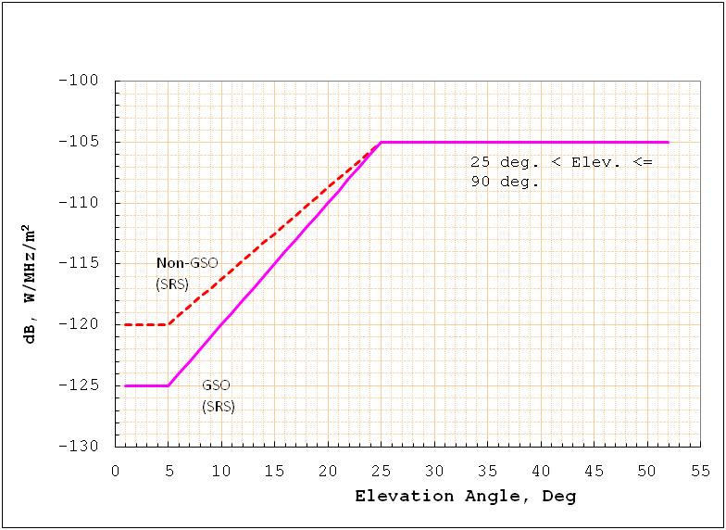
The pfd spectral density limits at the Earth’s surface produced by emissions from FSS satellites at different elevation angles are specified in RR Table 21-4 as given below.
FIGURE 2
pfd spectral density limits for FSS systems (from RR Table 21-4)
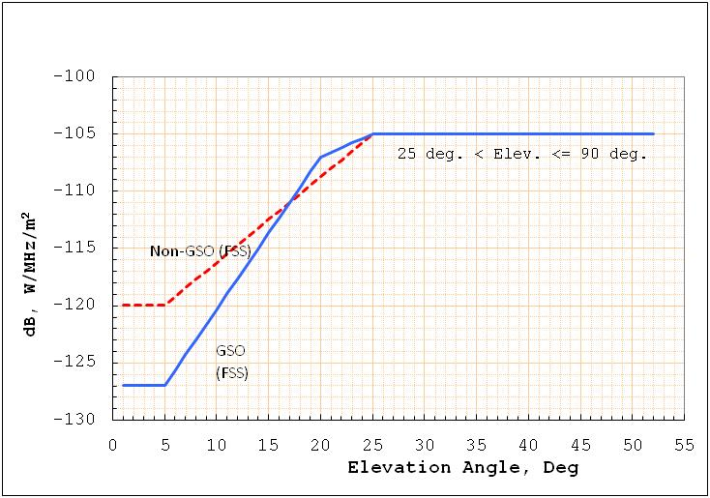
6) When there are multiple satellites in the FSS system, then the FSS satellite with the highest elevation angle from the SRS earth station is assumed to be active and communicating with the FSS earth station. This is reasonable since the FSS satellite with the highest elevation angle will have the shortest slant range to the FSS earth station and the largest link margin. Therefore, the total interference power-spectral density, PSD_{M}, received from the FSS system is assumed to be:
(2)
Note that, in equation (2), the time variable has been omitted for clarity with the understanding that the PSD_{M} has to be re-evaluated for each simulation time point.
7) The probability that the interference is greater than a given threshold, x (dB(W/MHz)), is calculated as the ratio of interference time and tracking time, i.e.:
(3)
where T[] is the duration operator. The numerator is the interference time defined as the duration when the interference received from the FSS satellite is greater than the given threshold, and the denominator is the tracking time defined as the duration when the elevation angle (ε) of the SRS tracking station is greater than minimum elevation angle (ε₀). Here, of course, it is assumed that the SRS earth station is tracking the SRS spacecraft only when the elevation angle is greater than ε₀.
A similar expression is valid for interference from the SRS satellite to the FSS earth station. In this case, however, the denominator has to be modified to give the correct tracking time for the FSS satellite. For example, the tracking condition might be that the range is greater than a specified distance.
8) The simulations are run for three years with 30-second intervals. The simulation duration can be extended to obtain statistics to cover probabilities of the order 10⁻⁵.

5.2 Interference analysis
In this interference analysis, the interference to the FSS systems from the SRS systems are given for two cases:
Case 1) The received pfd spectral density is calculated using the proposed SRS SVLBI and lunar system parameters given in Tables 2 and 5.
Case 2) The received pfd spectral density is assumed to be the pfd spectral density limits for the SRS systems given in Fig. 1. Since the SRS SVLBI and lunar systems are non-GSO systems, the non-GSO curve in Fig. 1 should be used. It gives the maximum pfd spectral density level on the surface of the Earth to be −105 dB(W/(m² · MHz)) for high elevation angles greater than 25 degrees, and −120 dB(W/(m² · MHz)) for low elevation angles less than 5 degrees. For elevation angles in between, linear interpolation is used.
Similarly, the interference to the SRS systems from the FSS systems are calculated for two cases:
Case 1) The received pfd spectral density is calculated using the proposed FSS GSO and HEO system parameters given in Table 7.
Case 2) The received pfd spectral density is assumed to be the pfd spectral density limits for the FSS systems given in Fig. 2 for FSS GSO and non-GSO systems. For the FSS GSO system, the GSO curve, and for the FSS HEO system, the non-GSO curve should be used. For GSO and non-GSO systems, the maximum pfd spectral density level on the surface of the Earth is again −105 dB(W/(m² · MHz)) for high elevation angles greater than 25 degrees.
Simulation results are shown in Annex 1. The probabilities of the interference exceedance as a function of PSD are shown.

5.2.1 Interference results for Case 1
Table 11 shows the expected pfd spectral densities for SRS and FSS systems when the systems transmit using the proposed system parameters (Case 1). The received spectral pfd spectral densities are calculated using the proposed e.i.r.p. densities, transmit antenna gains, operational ranges, and data rates for the systems.
TABLE 11
Expected pfd spectral densities at the SRS and FSS earth stations
when the systems use the proposed e.i.r.p. densities (Case 1)
Service | System | Generated pfd spectral density (dB(W/(m² · MHz)))
SRS | SVLBI | −119
 | Lunar | −128
FSS | GSO | −125
 | HEO | −121

It is clear that the expected operational spectral pfd spectral densities are smaller than the pfd spectral density limits given in Figs 1 and 2 (which are obtained from RR, Table 21-4). The SRS and FSS systems are operating at least 14 dB below the maximum allowed by the RR, Table 21-4.
Table 12 gives the exceedance levels for interferences caused by a system in SRS and FSS to other systems above their protection criteria. These levels are obtained from the results of interference simulations for Case 1 as shown in Annex 1.
TABLE 12
Exceedance of protection criteria for SRS (SVLBI and lunar) and FSS
(GSO and HEO) systems using e.i.r.p. density levels
e.i.r.p.  (Case 1) |  | (Victim systems)  Exceedance of protection criteria  (dB) |  |  |  |  | Max. exceedance level  (dB)
Service/system |  | SRS |  |  | FSS
 |  | SVLBI-20  SVLBI-31  SVLBI-65 | Lunar  (unmanned) | Lunar  (manned) | GSO | HEO
SRS | SVLBI-20  SVLBI-31  SVLBI-65 | >< | −17  −16  −22 |  | −8  −10  −14 | −36  −34  −8 | −8
 | Lunar | −22  −19  −29 | >< |  | −2 | −41 | −2
FSS | GSO | −16  −18  −20 | −5 | 25 | >< | −46 | −5  (lunar unmanned)  25  (lunar manned)
 | HEO | −31  −28  −11 | −29 | −27 | −41 | >< | −11

Note that, except for the GSO FSS to manned lunar SRS case, all the interference levels have negative exceedances, which means that the interference levels are below the protection criteria of the respective systems. The interference from GSO FSS into manned lunar SRS system exceeds the SRS protection by 25 dB. Therefore, if the SRS and FSS systems operate using the proposed system parameters, then the unmanned lunar and SVLBI systems of SRS and GSO and HEO systems of FSS can share the 37.5-38 GHz band without exceeding the protection criteria of any system. For the case of GSO FSS and manned lunar SRS, the 0.001% exceedance required for the protection of the SRS mission would not be met.

5.2.2 Interference results for Case 2
When the SRS and FSS systems use higher e.i.r.p. densities, the received pfd spectral densities at the earth stations need to satisfy the pfd spectral density limits given in RR Table 21-4 as shown in Figs 1 and 2. In order to obtain the exceedance levels, the interferences between the two given systems are simulated assuming that the received pfd spectral density at the Earth’s surface are as given by RR Table 21-4 with a maximum value of −105 dB(W/(m² · MHz)), and the results are compared with the corresponding protection criteria of the systems. Note that these interference results are the worst case, since the FSS and SRS systems are assumed to transmit at any location in their orbits with a high power level that result in having the pfd spectral density limit on the Earth’s surface 100% of the time.
Table 13 shows the levels that the interferences from the SVLBI and lunar systems of SRS and the GSO and HEO systems of FSS exceed the protection criterion of the other systems.
TABLE 13
Exceedance of protection criteria for SRS (SVLBI and lunar) and
FSS (GSO and HEO) systems using pfd spectral density limits
pfd  (Case 2) |  | (Victim systems)  Exceedance of protection criteria  (dB) |  |  |  |  | Max. exceedance level  (dB)
Service/System |  | SRS |  |  | FSS
 |  | SVLBI-20  SVLBI-31  SVLBI-65 | Lunar  (unmanned) | Lunar  (manned) | GSO | HEO
SRS | SVLBI-20  SVLBI-31  SVLBI-65 | >< | 12  13  1 |  | 21  22  9 | −35  −31  11 | 22
 | Lunar | 5  6  2 | >< |  | 23 | −32 | 23
FSS | GSO | 4  2  1 | 16 | 44 | >< | −25 | 16  (lunar unmanned)  44  (lunar manned)
 | HEO | −28  −25  −6 | −27 | –26 | −25 | >< | −6

Note that FSS HEO system operating at the pfd limit causes interference to the SRS systems that are below their protection criteria. The FSS GSO system, however, operating at the pfd limit causes interference to unmanned and manned lunar SRS systems that are 16 dB and 44 dB above their protection criteria, respectively. Therefore, interferences from FSS GSO need to be reduced by reducing the pfd limit for FSS GSO, or by separating the FSS GSO earth stations and SRS earth stations.
If the SRS SVLBI and lunar systems operate at the maximum pfd limits, then the interference levels will exceed the FSS protection criteria by 23 dB in the worst case. However, SRS SVLBI and lunar systems are usually designed to operate much below the maximum allowed pfd limits.

5.3 Other considerations for sharing between SRS and FSS
When SRS and FSS satellites operate using the specified design parameters given in Tables 2, 5 and 7 (Case 1), the received interference pfd spectral densities are well below the maximum allowed. In this case, the interferences received at the SRS and FSS earth stations meet the protection criteria of both services, and SRS and FSS do not degrade each other’s telecom link performance. Thus, the two services can share the 37.5-38 GHz band.
When, however, SRS and FSS satellites operate at the maximum pfd spectral density limits specified in RR Table 21-4 (Case 2), the interference received at the SRS and FSS earth stations may exceed the interference criteria of the services. In this case, one needs to consider how likely that the systems in these two services operate at the maximum pfd spectral density limits, and other methods to reduce the interference to acceptable levels, such as separating the SRS and the FSS earth station locations, making the FSS systems to use frequency bands above 38 GHz, and using FSS spot beams. In addition, other mitigations are possible with the FSS VSAT operations.

5.3.1 SRS and FSS pfd spectral density levels
Note that for Case 1, the proposed SRS and FSS systems generate pfd spectral densities at the surface of the Earth well below the maximum pfd spectral density limits allowed for Case 2 as given in RR Table 21-4 (see Table 11). Due to satellite weight, power, and size constraints, future SRS and FSS systems in the 37.5-38 GHz band would not be able to operate at the maximum allowable pfd spectral density limits, particularly for the clear-sky conditions.
In clear-sky conditions, future FSS systems proposed in the database of Recommendation ITU-R S.1328 using the 37.5-38 GHz band would operate at pfd spectral density levels as in Case 1. During fading, however, these systems may operate near the maximum pfd spectral density levels shown in Case 2 for a small percentage of time. In this case, if the SRS and FSS earth stations are close to each other, they will experience the same atmospheric losses and the interferences will not increase. When the two earth stations are separated considerably such that one experience is fading and the other not, then the interference may be higher.
In simulating Case 2, it is assumed that the systems operate at pfd spectral density limits with a peak of −105 dB(W/(m² · MHz)) for 100% of the time, which is the worst case. As a result, the interference levels at SRS earth stations sometimes exceed the SRS interference criterion.

5.3.2 SRS earth station and FSS earth station locations
The FSS earth stations, called gateways, and the SRS earth stations are not likely to be collocated. Therefore, if the FSS systems use spot beams that point to the FSS earth stations, then the received interference at the SRS earth stations will be less depending on the separation distance and the beamwidth.
For example, if the FSS GSO satellite uses a spot beam with a 3 dB beamwidth of 0.32 degrees, then its footprint will be about 200 km in diameter. This means that if FSS and SRS earth stations are separated by 100 km, the interference from FSS to SRS will be reduced by 3 dB. And further, for the same spot beam the 10 dB beamwidth will be about 0.64 degrees, and a 200-km separation between the two earth stations will provide a 10 dB isolation.

5.3.3 FSS band allocations
The FSS has a 2.5 GHz allocation in the 37.5-40 GHz band. Therefore, in an FSS system supporting few gateways, an FSS gateway station located near an SRS earth station can be supported by a spot beam using a carrier frequency above 38 GHz (in USA).

5.3.4 FSS VSAT operations
The FSS systems, with VSAT type earth station terminals, are likely to have multiple spot beams in the 37.5-40 GHz band. These spot beams are pointed to different geographical areas. For these FSS systems, it is possible to assign a frequency band above 38 GHz to the spot beam that covers the SRS earth stations and assign the 37.5-38 GHz band to the other spot beams.

5.3.5 Apportionment of interference
The sharing results above are obtained using the system parameters of a system in SRS and a system in FSS in pairs. The aggregate interference was not considered.
It is understood that if the systems in FSS, MS, FS, and SRS all contribute the same levels of interference (as specified for the FSS systems) to an application in SRS, then the total interference will be four times higher, i.e. 6 dB higher. This, in principle, is true, but since MS and FS are terrestrial services, the expected interferences from these services to the SRS systems should be small compared to interferences from FSS.
Furthermore, the interference levels from the SRS and FSS systems given in Table 12 vary considerably among themselves. It is clear that not all systems interfere with another at the same level, and usually there is a dominant interferer. In this case, the aggregate interference would be very close to the interference from the dominant source, and limiting the interference from this dominant source would protect the victim system satisfactorily.
If the expected aggregate interference would be higher than the interference calculated individually, then the protection criterion for the victim system needs to have an additional margin. To assess this additional margin, complicated interference scenarios with all the systems need to be run. Recommendation ITU-R SA.1743 allows 89% of the interference from the in-band SRS systems, 10% from the other services sharing the band on a co-equal basis, and 1% from all the other sources. This is not recommended. This would reduce the allowable interference from FSS system by another 10 dB, which may not be acceptable by FSS. Therefore, additional protection margins need to be determined by considering specifics of all the interfering systems without overly restricting the operation of these systems.

5.3.6 System noise temperatures
The system noise temperature of the SRS earth station receivers in the 37-38 GHz band (with 90% weather condition) varies with respect to the pointing elevation angle as shown in Fig. 3.
FIGURE 3
System temperature for SRS earth station receivers
in the 37-38 GHz band (with 90% weather)
This study uses the following receiver noise temperatures for the SRS systems: 60 K for the general SRS protection, 150 K for the SVLBI protection, and 123 K for the lunar mission protection. These receiver noise temperatures are assumed to be the system noise temperatures in telecom link designs for the SRS systems, except for lunar missions, where the total system noise temperature is the sum of the receiver noise temperature and the lunar disk luminescence temperature, i.e. 123 + 250 = 353 K.
The general SRS system protection criterion uses a low system noise temperature of 60 K for telecom link design, since the deep space missions are power limited and would not be able to close the link for higher system noise temperatures some of the time. The SVLBI and lunar missions are not power limited and could be designed to have higher transmit e.i.r.p. densities to close the telecom links with an earth station having higher system noise temperatures. It is clear from Fig. 3 that as the tracking elevation angle increases, the system noise will decrease, and the missions will have a larger telecom link margin. This margin can be used to increase the transmitted data rates. In order to protect the SVLBI, lunar, or any other SRS application from interference from FSS, one could develop a sharing criterion based on the system noise temperature at a higher elevation, i.e. using a lower system noise temperature. But, this would result in a very strict protection criteria, which would be very hard for the interfering FSS systems to satisfy.

5.3.7 Other SRS systems using the 37.5-38 GHz band
Other SRS systems using the 37-38 GHz band, for example L1/L2 missions, could be designed to have telecom parameters similar to lunar missions; that is, they could have high transmit e.i.r.p. densities and be able to close the link for high system noise temperature of 350 K. Since their real system noise temperature would in general be low, around 60 K, they would have an additional link margin of 7 to 8 dB. They could use this additional margin to tolerate interference from FSS systems, with a telecom link performance similar to the lunar missions.

5.3.8 Atmospheric attenuation in sharing studies
The sharing studies use two cases for the received pfd spectral densities at the earth stations as given in § 5.2: 1) pfd spectral densities generated by the proposed transmitter e.i.r.p. densities, and 2) the pfd spectral density limits specified in RR Table 21-4. For Case 1, the received pfd spectral density at the earth station is calculated using the transmit power, transmit antenna gain, space loss, and atmospheric gaseous loss. In the band 37.5-38 GHz, since the atmospheric gaseous loss is small, the pfd spectral densities at the earth station with or without atmospheric losses would not differ much. For Case 2, since the pfd spectral density limits are specified at the earth stations, atmospheric losses as well as the e.i.r.p. densities, antenna gains, and space losses are not used.

5.3.9 Antenna patterns for sharing studies
The sharing studies use the SRS antenna pattern given in RR AP 8-10, which specifies the main-lobe gain and the envelope of the side-lobe gains. This envelope of the side-lobe gains is similar to the envelope given in Recommendation ITU-R SA.509.
Recommendation ITU-R SA.1811 is recommended to be used for compatibility analysis involving a large number of terrestrial interferers and should not be used in SRS-FSS sharing studies. The SRS-FSS sharing studies involve spacecraft and satellites, and the interferences will generally involve main-lobe/side-lobe coupling between the individual transmit and receive antennas.

6 Analysis involving LEO and MEO FSS systems

6.1 Single UE analysis
In this analysis, a single FSS receiving earth station is deployed in the vicinity of the SRS earth station in the North. The distance between both earth stations varies, depending upon the scenarios, between 20 and 80 km.
The FSS earth station is tracking a random satellite in the constellation above 20°, 35° and 10° elevation for respectively the LEO 1 200 km, LEO 600 km and MEO constellations, and this satellite is also tracking its earth station (steerable beam). Hence when the distance between earth stations is set to 0 km (earth stations co-located), there will be no FSS space station antenna discrimination towards the SRS earth station. The only discrimination available would be from the SRS earth station.
The SRS earth station is tracking the Moon above 5 degrees elevation. The antenna pattern considered is based on Recommendation ITU-R SA.1811 with an antenna efficiency of 0.7 and a surface roughness of 0.35 mm.
The simulation is run over a period of 10 days with a 10-seconds time step. Clear sky conditions were used in interference calculations.
The interference generated by single non-GSO FSS space station beam is then computed, and the associated cdf is plotted in Fig. 4.
FIGURE 4
Results of simulations for a single FSS user equipment for Constellation #1
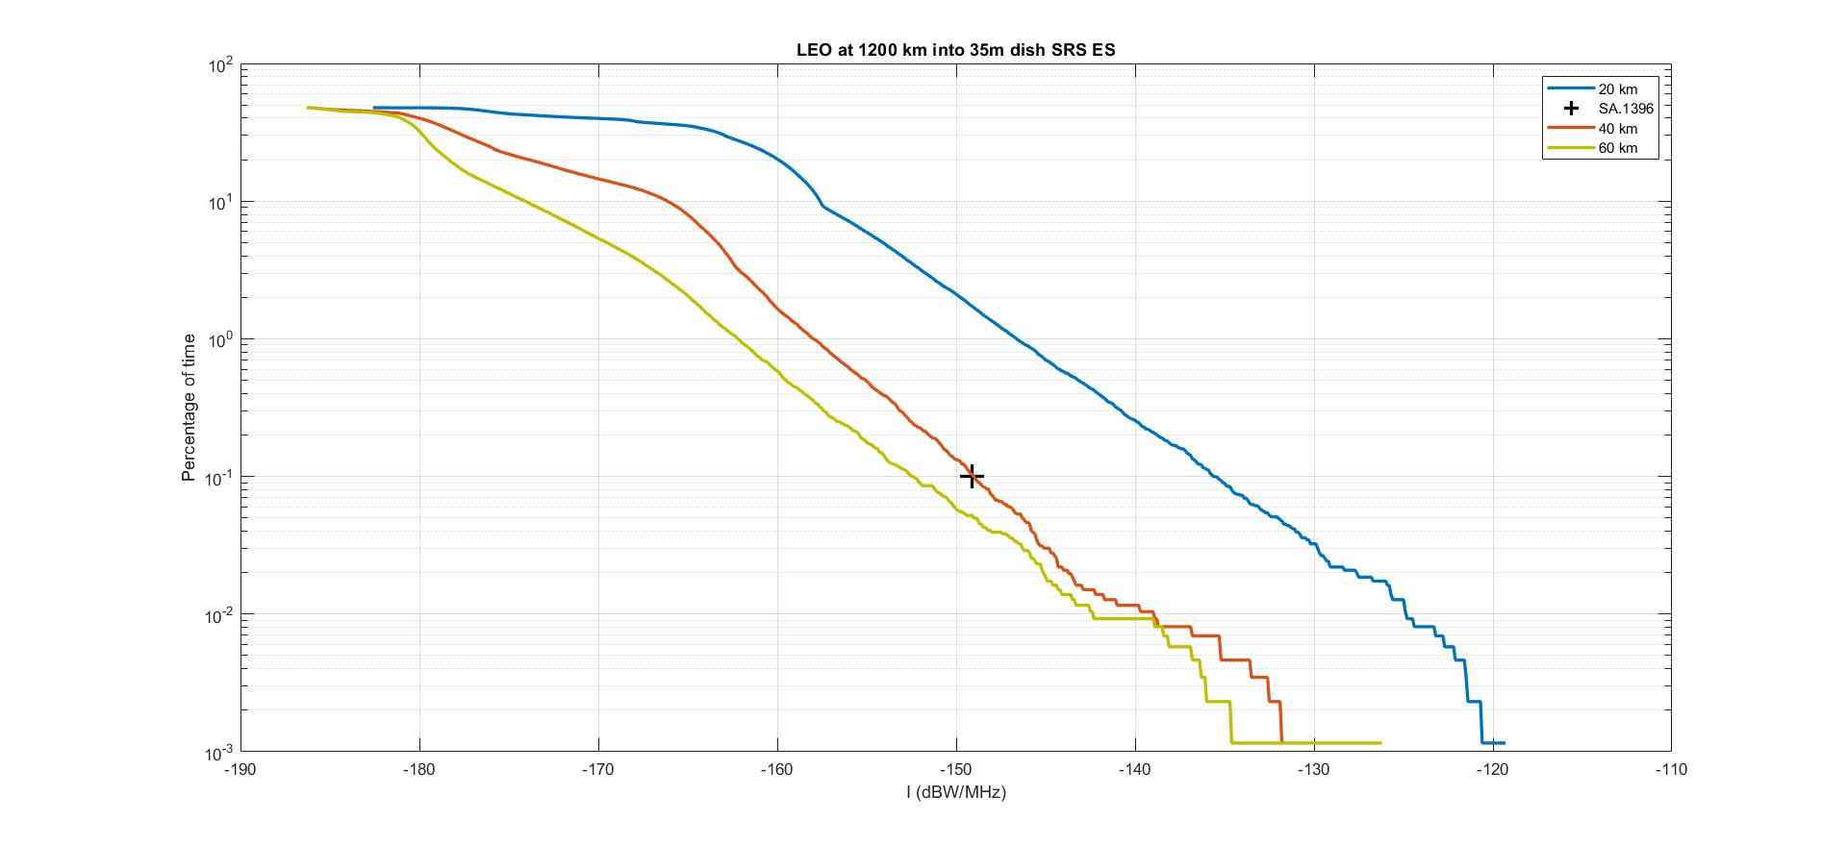
This Figure shows that, with the parameters assumed, as soon as the distance between the non-GSO FSS earth station and the SRS earth station exceeds 40 km, the SRS protection criterion for unmanned missions would be met.
FIGURE 5
Results of simulations for a single FSS user equipment for Constellation #2
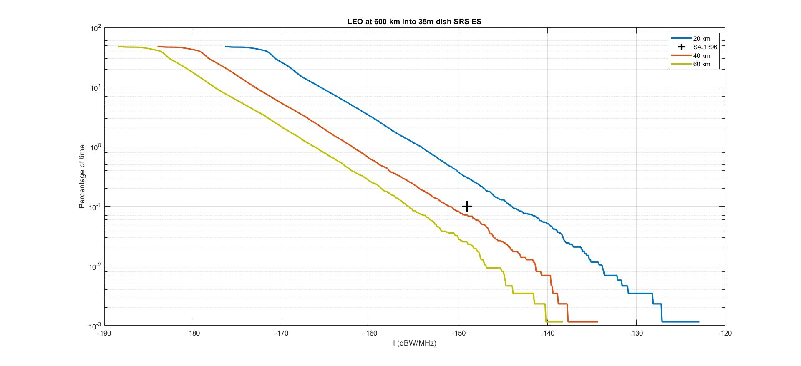
This Figure shows that, with the parameters assumed, as soon as the distance between the non-GSO FSS earth station and the SRS earth station exceeds 40 km, the SRS protection criterion for unmanned missions would be met.
FIGURE 6
Results of simulations for a single FSS user equipment for Constellation #3
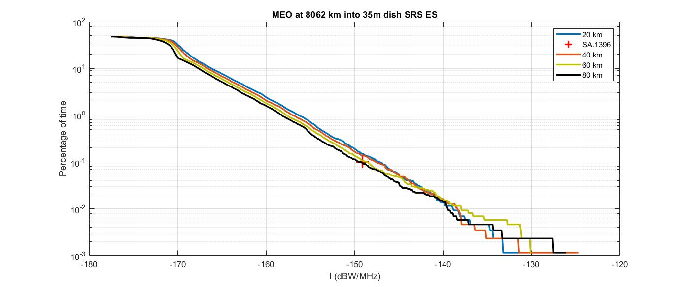
This Figure shows that, with the parameters assumed, as soon as the distance between the MEO FSS earth station and the SRS earth station exceeds 70 km, the SRS protection criterion for unmanned missions would be met.

6.2 Single gateway site analysis
In this analysis, a single FSS gateway site is deployed in the vicinity of the SRS earth station in the North. The distance between both sites is varied between 40 and 80 km.
When considering FSS gateways, the number of such sites would be more limited. However, a non-GSO constellation gateway site could consist of multiple antennas receiving data from all satellite in visibility above a given elevation angle at the same time. If the gateway site is placed in the vicinity of the SRS earth station, this would increase the probability of interference and hence raise the cdf along the Y-axis.
The gateway earth stations are assumed to track the satellites above 20, 35 and 10 degrees elevation for respectively the LEO 1 200 km, the LEO 600 km and the MEO constellations. At the latitude of Cebreros, a minimum of respectively 137, 13 and 29 satellites can be tracked above these elevation angles. However the number of satellites that the earth station can track simultaneously and co-frequency is limited by the so called parameter Nco, which is 10 for LEO 1 200 km, 4 for LEO 600 km and 1 for the MEO constellation.
FIGURE 7
Results of simulations for a single FSS gateway site for Constellation #1
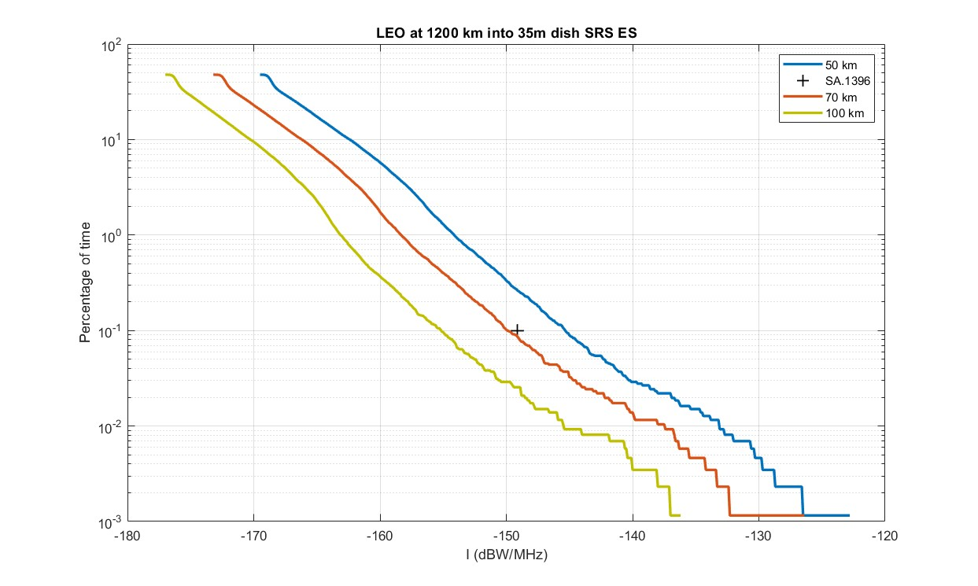
This Figure shows that, with the parameters assumed, as soon as the distance between the non-GSO FSS gateway site and the SRS earth station exceeds 70 km, the SRS protection criterion for unmanned missions would be met.
FIGURE 8
Results of simulations for a single FSS gateway site for Constellation #2
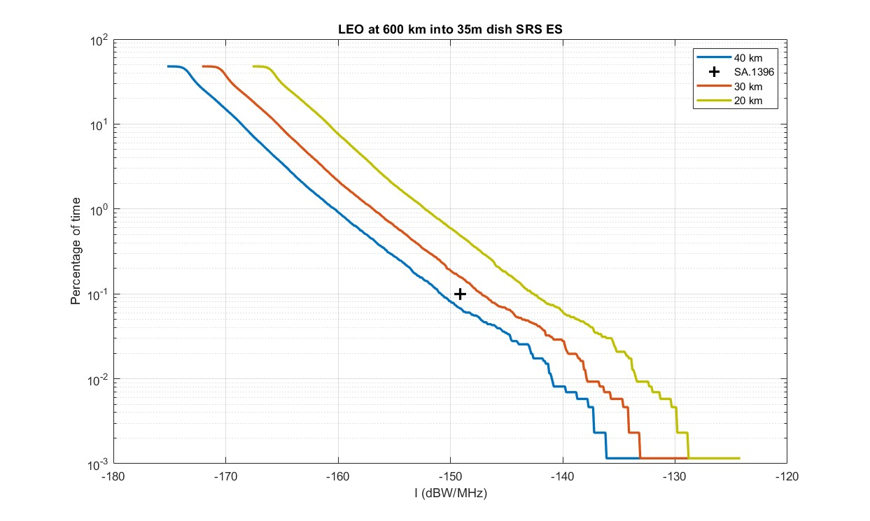
This Figure shows that, with the parameters assumed, as soon as the distance between the non-GSO FSS gateway site and the SRS earth station exceeds 35 km, the SRS protection criterion for unmanned missions would be met.
FIGURE 9
Results of simulations for a single FSS gateway site for Constellation #3
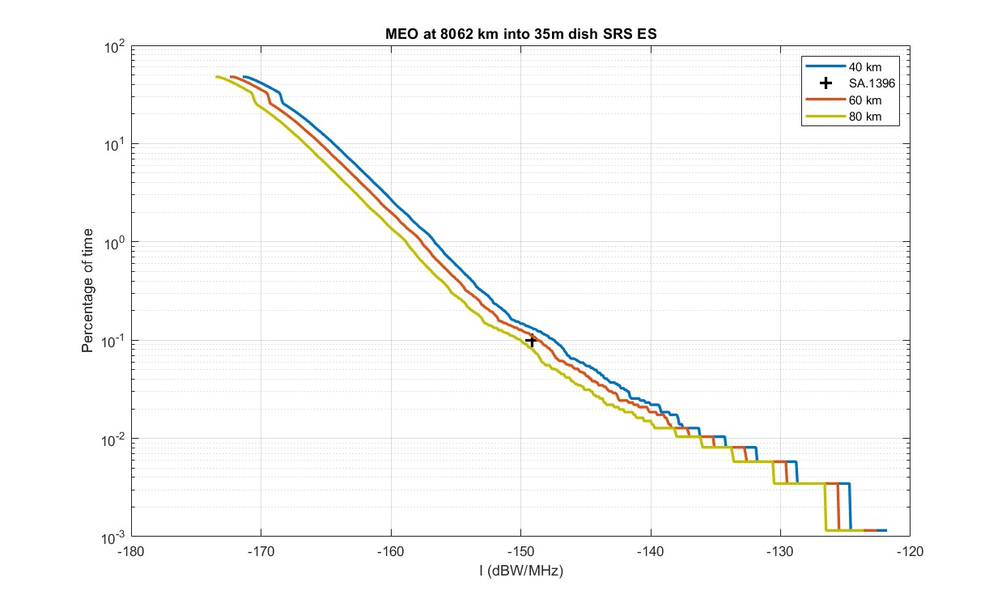
This Figure shows that, with the parameters assumed, as soon as the distance between the non-GSO FSS gateway site and the SRS earth station exceeds 70 km, the SRS protection criterion for unmanned missions would be met.

6.3 Possible additional work
The analysis for user equipment in § 6.1 above has assumed only one single beam of one single satellite at one moment in time. This may be true for a user equipment deployed in the immediate vicinity of the SRS earth station, but each satellite would actually address several user equipment through multiple beams, and this would potentially create aggregate interference into the SRS earth station, that may need to be assessed.
The aggregate interference impact of non-GSO FSS and GSO FSS could be further studied, as well as impact of non-GSO FSS constellation with fixed multi-spot coverage.
In addition, the impact of considering other SRS earth station characteristics (antenna diameters, lower system noise temperature) could also be considered.

7 Conclusions

7.1 GSO and HEO FSS systems
This Report gives the protection criteria for the SVLBI and lunar systems of SRS, and the GSO and HEO systems of FSS. The interference between these systems is simulated for two cases: Case 1 assumed that the systems operate using the parameters and e.i.r.p. density levels as given in Tables 2, 5 and 7. Case 2 assumed that the systems operate with higher transmit powers generating pfd spectral densities on the Earth’s surface as given by RR Table 21-4.
For Case 1, Table 12 in § 5.2.1 summarizes the interference levels generated at the SRS and FSS earth stations. Note that the interference levels generated by the SRS (SVLBI and unmanned lunar) and FSS (GSO and HEO) systems using the proposed system parameters satisfy the sharing protection criteria of the respective systems. The interferences from FSS GSO systems to SRS manned lunar systems exceed the protection of SRS by 25 dB. Therefore, the frequency sharing between SRS (SVLBI and unmanned lunar) systems and FSS (GSO and HEO) in the 37.5-38 GHz band is possible. The frequency sharing is still possible even if the SRS (SVLBI and unmanned lunar) and FSS (GSO and HEO) systems increase their e.i.r.p. densities as given by the maximum exceedance levels. These systems can operate at these e.i.r.p. density levels 100% of the time causing interference to other systems below their protection criteria. For sharing between the FSS GSO systems and SRS manned lunar systems, mitigation methods are needed to reduce the interference to acceptable levels.
For Case 2, when the SRS and FSS systems operate with maximum pfd spectral densities on the Earth’s surface of −105 dB(W/(m² · MHz)), then the interference to the other systems will exceed their protection criteria using the clear weather atmospheric losses. The exceedance levels are shown in Table 13 in § 5.2.2. Note, however, that the SRS and FSS systems do not intend to use these high e.i.r.p. density levels 100% of the time, but only when the weather is bad and atmospheric attenuation is excessive. In this case, if the SRS and FSS earth stations are close to each other so that they have the same weather conditions, the interference will be much smaller than expected due to atmospheric losses and will probably be below the protection criteria. If, however, the SRS and FSS earth stations are separated, then they might experience different weather conditions. If the interference goes through clear sky, the atmospheric attenuation might be small. In this case, however, depending on the separation distance, the transmitting antenna will have a smaller off-boresight gain, and the spectral e.i.r.p. density towards the victim earth station will be reduced. For example, for an FSS GSO system, if the SRS and FSS earth stations are separated by 100 km, the interference e.i.r.p. density would be reduced by 3 dB, and if they are separated by 200 km, the reduction would be 10 dB.
If the FSS systems cannot satisfy the sharing pfd spectral density limits, they might choose to use frequency bands above 38 GHz when operating in the SRS earth station locations and use the 37.5-38 GHz band away from the SRS earth stations. FSS systems with spot beams should be able to satisfy this condition easily. The SRS systems, without spot beams, will have to operate at proper e.i.r.p. density levels to avoid interfering with the FSS.
As noted above, many sharing studies between the SVLBI and lunar systems of SRS and the GSO and HEO systems of FSS have been completed. These studies indicate that the 37.5-38 GHz band sharing between SRS (SVLBI and unmanned lunar) and FSS (GSO and HEO) is feasible using the planned system parameters. If interferences exceed the protection of SRS or FSS systems, then mitigation methods are needed to reduce the interference to acceptable levels.

7.2 MEO and LEO FSS systems
Assuming that LEO and MEO constellations satellites are using spot beams, this report shows that no power limit would be required on FSS satellites emissions, provided that a separation distance is ensured between the FSS earth stations and the SRS earth stations. This separation distance depends on the LEO or MEO constellation characteristics and modes of operation and would be in the range of 35 to 70 km for gateway stations, and 40 to 70 km for user stations.
Given the low number of SRS earth stations operating in the band 37.5-38 GHz worldwide and their location in remote areas, the distance determined for FSS earth stations would be feasible without resulting in huge constraints.
FSS earth stations operating closer than 40 to 70 km to SRS receiving earth stations may still use frequencies above 38 GHz.
It is worth mentioning that a certain assurance needs to be provided to comply with the above-mentioned assumption.

