Report ITU-R S.2515-0
(09/2022)
Uplink interference considerations in the frequency band 7 025-7 075 MHz
for a broadcasting-satellite
service (sound) in Region 2

S Series
Fixed-satellite service

Foreword
The role of the Radiocommunication Sector is to ensure the rational, equitable, efficient and economical use of the radio-frequency spectrum by all radiocommunication services, including satellite services, and carry out studies without limit of frequency range on the basis of which Recommendations are adopted.
The regulatory and policy functions of the Radiocommunication Sector are performed by World and Regional Radiocommunication Conferences and Radiocommunication Assemblies supported by Study Groups.

Policy on Intellectual Property Right (IPR)
ITU-R policy on IPR is described in the Common Patent Policy for ITU-T/ITU-R/ISO/IEC referenced in Resolution ITU-R 1. Forms to be used for the submission of patent statements and licensing declarations by patent holders are available from http://www.itu.int/ITU-R/go/patents/en where the Guidelines for Implementation of the Common Patent Policy for ITU-T/ITU-R/ISO/IEC and the ITU-R patent information database can also be found.

Series of ITU-R Reports
(Also available online at http://www.itu.int/publ/R-REP/en)
Series | Title
BO | Satellite delivery
BR | Recording for production, archival and play-out; film for television
BS | Broadcasting service (sound)
BT | Broadcasting service (television)
F | Fixed service
M | Mobile, radiodetermination, amateur and related satellite services
P | Radiowave propagation
RA | Radio astronomy
RS | Remote sensing systems
S | Fixed-satellite service
SA | Space applications and meteorology
SF | Frequency sharing and coordination between fixed-satellite and fixed service systems
SM | Spectrum management

Note: This ITU-R Report was approved in English by the Study Group under the procedure detailed in Resolution ITU-R 1.

Electronic Publication
Geneva, 2022
© ITU 2022
All rights reserved. No part of this publication may be reproduced, by any means whatsoever, without written permission of ITU.

REPORT ITU-R S.2515-0
Uplink interference considerations in the frequency band 7 025-7 075 MHz
for a broadcasting-satellite service (sound) in Region 2
(2022)

1 Introduction
There has been much analysis of interference into satellite communications and broadcast mobile receiving terminals by the International Telecommunication Union. Most of these analyses have centred on the interference to proper reception at such terminals which is normally termed the ‘downlink’ (the desired radio transmission from the satellite to the mobile receiving terminals). All broadcast and communications satellites also have an ‘uplink’ (the desired radio transmission from central earth stations to the satellite containing the signal(s) that the satellite is to retransmit). There are a wide variety of communications and broadcast satellite systems operating in many different radio frequency bands. The following uses as its technical model the satellite parameters of the Region 2 broadcasting-satellite service (sound) (BSS (sound)) network employing geostationary orbit (GEO) satellites USASAT-28 K, N, O and Q, two located on that orbit near 85° West and two located near 115° West. This BSS (sound) system has operated for two decades [Ref. 1], and currently provides satellite radio broadcast service to nearly 37 million mobile subscribers throughout North America. The satellite uplink radio frequency band for the system is 7 025-7 075 MHz, referred to hereafter as the 7 GHz band. It should be noted that the fixed-satellite service (Earth-to-space) (space-to-Earth) is allocated and operated on a co-primary basis with the fixed and mobile services in the 7 025-7 075 MHz frequency band in accordance with the Radio Regulations. The examples contained in the study are intended to provide guidance to address any potential cross-border interference situations for certain countries in Region 2, and potential domestic interference situations should be considered a national matter and are not addressed in this study.

2 Satellite system configuration
Figure 1 shows the BSS (sound) system that includes the uplink radio transmission from the system’s ground stations to the satellites for retransmission by the satellites to the mobile receiving terminals. There are six uplink carrier frequencies used continuously plus four command carriers at radio frequencies around 7 GHz to the four active satellites in the constellation. Figure 2 shows both the uplink and downlink frequencies. Other uplink frequency configurations than those shown in Figs 1 and 2 can be employed in the 7 025-7 075 MHz frequency band.
Figure 1
BSS (sound) satellite radio transmission system
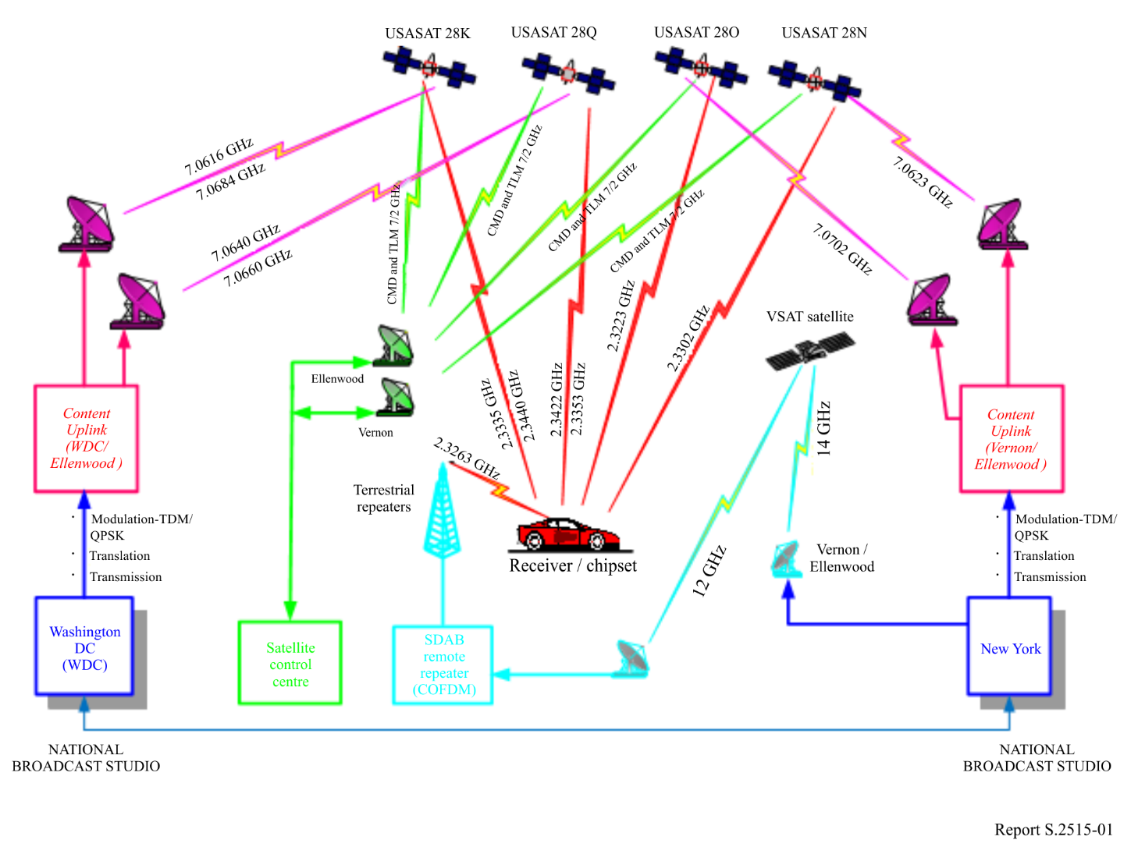
Figure 2
BSS (sound) frequency plan
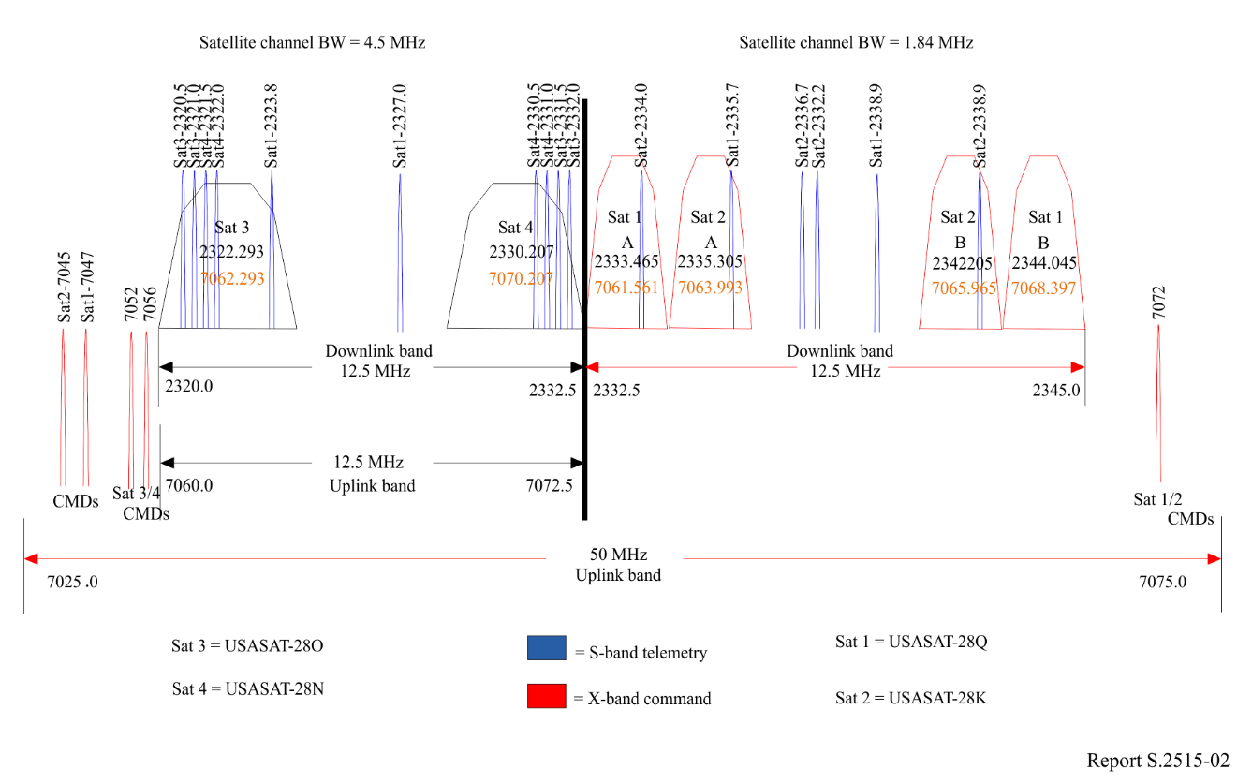
The satellite uplink radio frequency implementation is simple. The uplink transmissions from the central earth stations, which employ 11.3 m diameter antennas, are amplified by the satellite receive antenna and coupled to a 7 GHz receiver. The satellite 7 GHz receiver further amplifies the transmission and sends it to a frequency translator converting it to 2.3 GHz. The 2.3 GHz transmission is then amplified by paralleled traveling-wave tube amplifiers (TWTAs) and transmitted by the satellite transmit antenna to the mobile subscriber receiving terminals on Earth. The satellite receive system noise temperature is typically 900 degrees Kelvin including earth noise seen by the satellite receive antenna. The widest current uplink transmission bandwidth is 4.5 MHz, resulting in a satellite receiving thermal noise floor of −132.5 dBW. The full technical parameters of the network’s transmission system are contained in the satellites’ ITU registrations [2].

3 Examples of sources of potential interference
Examples of potential uplink interference can be categorized as those within the uplink transmission bandwidth (‘in-band’), those adjacent to the band, and intermodulation products. The primary sources are from transmitters on the Earth’s surface but, as described later, there are proposals to share the 7 GHz broadcast uplink band by non-geostationary orbit (non-GSO) satellite constellations.
There are two characteristics which distinguish uplink interference from downlink interference. The first is that most communications/broadcasting satellite systems are located in geostationary orbits. This means that any earth-based transmissions will be attenuated by the path loss to the satellite which, at 7 GHz, is typically 201.2 dB. The second is that the satellite receiving antenna generally has a large field-of-view of the Earth’s surface. Any earth-based transmitters operating at in-band frequencies within the satellite’s field-of-view would be sources of potential uplink interference depending on the deployment and operation circumstances. As such, any aggregate effects from multiple sources of potential interference from adjacent, neighbouring countries could be received and amplified by the satellite’s receive (uplink) antenna gain. Figure 3 shows one example of the typical BSS (sound) satellite receive antenna coverage and directionality. The antenna coverage includes most of the continental United States and adjacent portions of Canada, Mexico and the Caribbean. Any potential interfering flux density from in-band earth-based transmitters from adjacent, neighbouring countries throughout this area of the Earth would be received and amplified by the satellite receive antenna gain of up to a factor of approximately 800 (e.g. up to 29 dBi).
Figure 3
Typical BSS (sound) satellite uplink receive antenna pattern
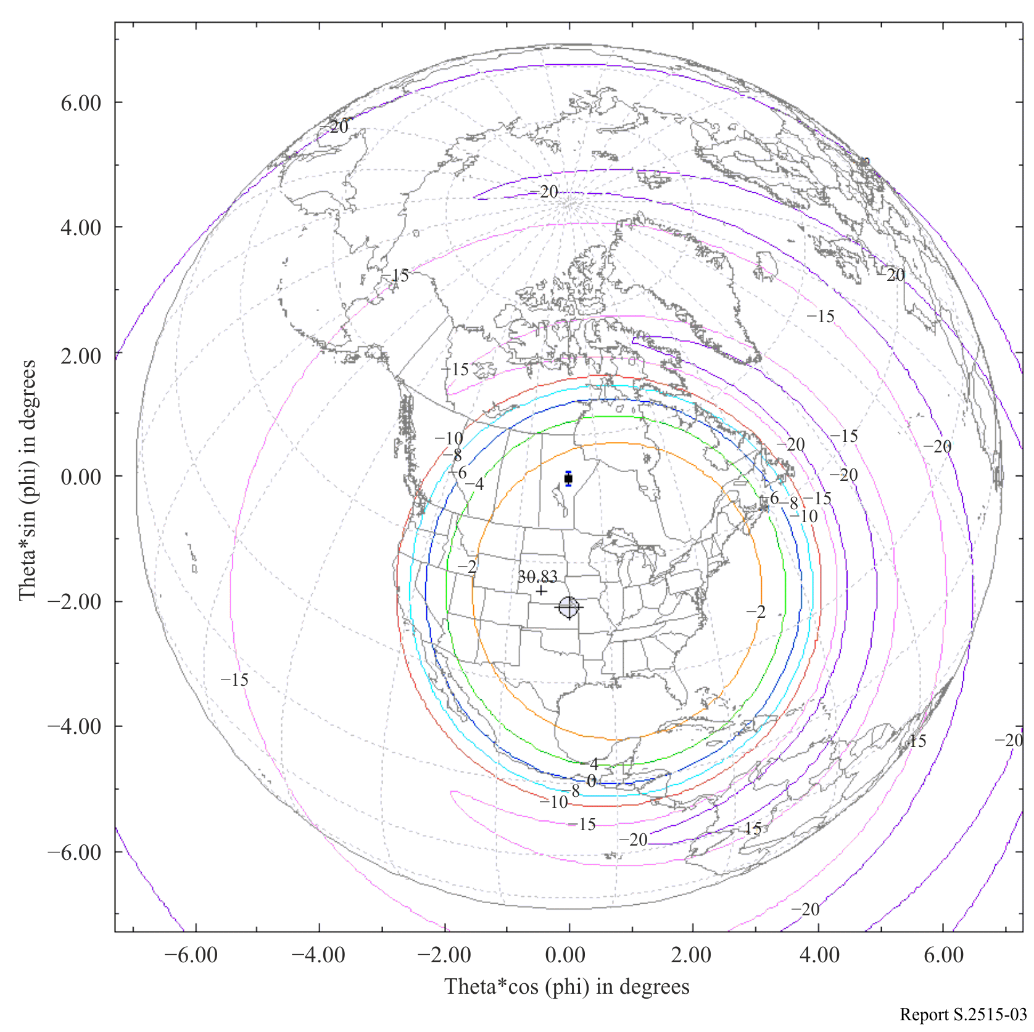

4 Types of potential interference scenarios to uplink

4.1 In-band
The fixed-satellite service (Earth-to-space) (space-to-Earth) is allocated and is operated co-primary with the fixed and mobile services in the 7 025-7 075 MHz frequency band in accordance with the Radio Regulations, such as Article 21. Some examples of Region 2 applications that operate in this band include fixed service (FS) microwave links, television Broadcast Auxiliary Service (BAS), Cable Television Relay Service (CARS), Local Television Transmission Service (LTTS), Radiocommunication Local Area Networks (RLANs) and Ultra-Wideband devices (UWB). Generally, these transmitters are not high powered and some use directive antennas. Aggregate uplink interference from adjacent neighbouring countries from these co-sharing services is currently feasible and further use may be coordinated between concerned administrations, as appropriate, in order to facilitate coexistence.
Besides earth-based transmitter interferers, there are recent ITU filings for non-GSO satellite constellations, including a few that specify use of the 7 GHz frequencies used for the BSS (sound) uplinks. These systems could become a potential source of interference in the future.

4.2 Adjacent-band
The selectivity of the satellite uplink radio frequency filtering in the 7 GHz receiver is not perfect at band edge. Potential interference sources close to the band edge can produce interference levels almost equivalent to in-band interferers. This interference source can be avoided by ensuring the adjacent frequency allocated transmissions at band edge have low interference potential.

4.3 Intermodulation
It is possible that intermodulation products can fall into the 7 GHz band, causing potential interference. Practically, the major contributors would be the 2A-B (or 2B-A) intermodulation products, where A and B are strong radio frequency carriers in the 5-9 GHz range which impinge the geostationary orbit where the satellite is located. This can be mitigated and addressed through proper coordination between concerned administrations.

5 Interference protection criteria
The maximum aggregate interference level is I/N = −12 dB for time invariant sources (Recommendation ITU-R S.1432-1). Study Group 4 has recently provisionally recommended I/Ns for time variant sources of −10.5 dB for 20%, −2.33 dB for 0.001% and −6 dB for 0.03%.
C/N_{up} is automatically combined with the C/N_{down} for satellites using linear translation repeaters of transmissions (reflecting the design of many communications/broadcasting satellites), which results in C/N_{total}. C/N_{up} can be considered an interference contribution to C/N_{total}. However, in the subject BSS (sound) system, C/N_{total} must be sufficient to overcome foliage attenuation [3], which is prevalent over the northern United States and Canada. C/N_{total} must be sufficient after inclusion of all interference contributions to provide mobile subscribers with very high service availability (e.g. a goal of greater than 99.9%), since BSS (sound) programmed music listening will otherwise not be satisfactory.
C/N_{down} is generally interference critical, so a low interference allowance is desirable. For the BSS (sound) system described in this Report, the downlink is to subscriber mobile terminals of high sensitivity (terminal receiver noise temperatures of 80 degree Kelvin) and, as noted above, there is a need to provide very high subscriber digital broadcast audio signal availability. The system link budget design in many communications/broadcasting satellites is done so that the C/N_{up} does not significantly increase C/N_{total}.
It is evident from the above that sharing with the BSS (sound) uplink must consider a variety of potentially interfering sources. Various models and interference criteria are available in the Radio Regulations and relevant ITU-R documents to accomplish such analyses. One is RR Article 21 where the subject radio frequency band is noted in RR Table 21-2. The aggregate interference noise floor increase must account for the previously mentioned existing in-band and adjacent-band services.

6 Summary
This Report provides guidance on the use and operation of uplink transmission satellite parameters for a Region 2 BSS (sound). It is illustrated by an existing network employing geostationary orbit (GEO) satellites USASAT-28 K, N, O and Q, two located on that orbit near 85 degrees. West and two located near 115° West. This Report also notes potential interference scenarios into the satellite radio broadcast service from in-band and adjacent-band transmissions from neighbouring countries and from associated intermodulation products by transmitters sharing the BSS (sound) uplink radio frequency spectrum. Such sharing services should be carefully arranged between concerned administrations in the radio frequencies utilized and limited in flux densities impinging the geostationary orbital arc to conform to the aggregate interference protection criterion in the 7 GHz BSS (sound) uplink radio frequency band so that potential disruptions to the radio broadcast satellite service are mitigated. As earlier noted, this BSS (sound) currently shares the uplink satellite radio frequency band with several other services without significant interference.
Significant interference into uplinks of broadcast and communications satellites should be avoided. Although sharing of the frequency bands used by BSS (sound) GEO satellites with other services is quite feasible, such sharing cases must be limited in the total tolerable amount of interfering power as seen by the satellites’ receiving antennas to keep within the system’s aggregate uplink interference tolerance requirement.

References
[1] R. Akturan, An Overview of the Sirius Satellite Radio System, International Journal of Satellite Communications and Networking. Vol 26 Is. 5 (2008).
[2] ITU IFICs 2679, 2739, 2843 and 2931.
[3] Dr J. Goldhirsh, Dr W. Vogel, Propagation Effects for Land Mobile Satellite Systems: Overview of Experimental Modeling Results, NASA Reference Publication 1274, 1992.

