|  |
| --- |
| **Report ITU-R S.2223-1**  **(10/2016)** |
| **Technical and operational requirements  for GSO FSS earth stations on mobile platforms in bands from 17.3 to 30.0 GHz** |
| **S Series**  **Fixed satellite service** |

Foreword

The role of the Radiocommunication Sector is to ensure the rational, equitable, efficient and economical use of the radio-frequency spectrum by all radiocommunication services, including satellite services, and carry out studies without limit of frequency range on the basis of which Recommendations are adopted.

The regulatory and policy functions of the Radiocommunication Sector are performed by World and Regional Radiocommunication Conferences and Radiocommunication Assemblies supported by Study Groups.

# Policy on Intellectual Property Right (IPR)

ITU-R policy on IPR is described in the Common Patent Policy for ITU-T/ITU-R/ISO/IEC referenced in Annex 1 of Resolution ITU-R 1. Forms to be used for the submission of patent statements and licensing declarations by patent holders are available from <http://www.itu.int/ITU-R/go/patents/en> where the Guidelines for Implementation of the Common Patent Policy for ITU‑T/ITU‑R/ISO/IEC and the ITU-R patent information database can also be found.

|  |  |
| --- | --- |
| Series of ITU-R Reports  (Also available online at <http://www.itu.int/publ/R-REP/en>) | |
| **Series** | Title |
| **BO** | Satellite delivery |
| **BR** | Recording for production, archival and play-out; film for television |
| **BS** | Broadcasting service (sound) |
| **BT** | Broadcasting service (television) |
| **F** | Fixed service |
| **M** | Mobile, radiodetermination, amateur and related satellite services |
| **P** | Radiowave propagation |
| **RA** | Radio astronomy |
| **RS** | Remote sensing systems |
| **S** | **Fixed-satellite service** |
| **SA** | Space applications and meteorology |
| **SF** | Frequency sharing and coordination between fixed-satellite and fixed service systems |
| **SM** | Spectrum management |

|  |
| --- |
|  |

|  |
| --- |
| ***Note****: This ITU-R Report was approved in English by the Study Group under the procedure detailed in Resolution ITU-R 1.* |

*Electronic Publication*

Geneva, 2016

© ITU 2016

All rights reserved. No part of this publication may be reproduced, by any means whatsoever, without written permission of ITU.

REPORT ITU-R S.2223-1

Technical and operational requirements for GSO FSS earth stations   
on mobile platforms in bands from 17.3 to 30.0 GHz

(Question ITU-R 70-1/4)

(2011, 2016)

TABLE OF CONTENTS

**Page**

1 Introduction 1

2 Background 2

3 Sharing requirements 2

3.1 Technical and operational requirements in frequency bands not shared with terrestrial services 2

3.2 Technical and operational requirements in frequency bands shared with terrestrial services 4

3.3 Other issues 4

Attachment – Off-Axis Performance and Mispointing 4

1 Introduction, background and objectives 5

2 Off-axis performance of ESOMP vs VSAT 5

3 Characterization of ESOMP mispointing 9

# 1 Introduction

GSO fixed-satellite service networks may be used within the framework and under the conditions as specified in Resolution **156 (WRC-15)** to provide services to earth stations mounted on mobile platforms. GSO FSS networks are currently providing broadband telecommunications services to aircraft, ships, trains and other vehicles in the 14.0‑14.5 GHz (Earth-to-space) and 10.7-12.7 GHz (space-to-Earth) bands, e.g. Resolution **902 (WRC-03)**. Some service providers use the 17.3‑30.0 GHz FSS band to meet the need for increased broadband speed, capacity, and efficiency.

Advances in satellite antenna technology, particularly the development of 3-axis stabilized antennas which could maintain a high degree of pointing accuracy even on rapidly moving platforms, have allowed the development of mobile earth stations with stable pointing characteristics. Similarly, the application of low power density waveforms could likewise enable the use of smaller antennas and lower performance pointing systems with a view to maintain off-axis e.i.r.p. density within prescribed limits. If properly managed and controlled, the technical characteristics of these mobile earth stations may not be distinguished from fixed earth stations when viewed from an interference perspective to FSS networks.

This Report presents technical and operational requirements for FSS earth stations on mobile platforms (ESOMPs) in bands from 17.3 to 30.0 GHz. It describes how such earth stations operating in FSS allocations between 17.3-30.0 GHz could be designed and operated in compliance with the existing requirements applicable to other types of FSS earth stations. By complying with these existing requirements, earth stations on mobile platforms are expected not to create unacceptable levels of interference to other FSS systems and terminals operating in the same bands or sub-bands. This Report is intended to provide guidance to administrations and FSS network operators wishing to implement earth stations on mobile platforms in FSS allocations in the 17.3‑30.0 GHz band.

The Attachment to this Report is for information only, and provides a study that demonstrates two items: that the off-axis performances of dimensionally similar size antennas[1] are comparable regardless of whether deployed with VSATs or ESOMPs and that ESOMPs, when operating within specified or coordinated limits, are expected to not increase risk of unacceptable interference to other geostationary-satellite orbit (GSO) FSS networks over that of typical fixed VSATs due to mispointing.

This Report was developed based on the understanding that its content, and in particular the Attachment thereto, should not be part of any future ITU-R Recommendation.

# 2 Background

It has been reported within ITU-R that various technically and operationally different networks have been implemented to provide service to earth stations on mobile platforms using FSS networks in bands below 17 GHz in compliance with the objectives of Resolution **156 (WRC-15)** which is equally applicable here and that additional such networks are planned for implementation in bands from 17.3 to 30.0 GHz. It is envisioned that these planned networks may provide access to a variety of broadband communication applications.

The circulation of FSS earth stations on mobile platforms is usually a subject of a number of national and international rules and regulations including satisfactory conformance to mutually agreed technical standards and operational requirements. As such, there is a need for identifying the technical and operational requirements for FSS earth stations on mobile platforms in order to provide a common technical basis for facilitating the implementation of FSS earth stations by various national and international authorities.

The identification of technical and operational requirements for such FSS earth stations operating in this frequency range may assist administrations in preventing unacceptable interference to other GSO FSS networks. Such technical and operational characteristics should be continuously and accurately measurable and controllable.

# 3 Sharing requirements

## 3.1 Technical and operational requirements in frequency bands not shared with terrestrial services

It is clear that implementation of FSS earth stations on mobile platforms would be simplified in bands that are not shared with terrestrial services as this reduces the sharing situation to one of sharing between satellite networks. In such cases, in order to address potential interference with other co-frequency GSO FSS networks, it is essential that FSS earth stations on mobile platforms comply with the off-axis e.i.r.p. limits contained in Recommendation ITU‑R S.524-9, or with any other limits coordinated with neighbouring satellite networks. In addition, any network of such earth stations should be operated such that the aggregate off-axis e.i.r.p. levels produced in the Earth-to-space direction by all co-frequency earth stations within such networks, in the direction of neighbouring satellite networks, are no greater than the off-axis e.i.r.p. levels produced by other specific and/or typical FSS earth station(s) operated in conformance with Recommendation ITU‑R S.524-9, or with any other limits coordinated with neighbouring satellite networks. These requirements will ensure that such earth stations are essentially equivalent to stationary FSS earth stations from the perspective of static uplink interference potential.

Realizing that earth stations on mobile platforms operate in a dynamic environment (i.e. the position and orientation of the platform can change with time), it is important to address this aspect in specifying an essential set of technical and operational requirements. The design, coordination and operation of earth stations on mobile platforms should be such that, in addition to the static requirements discussed above, the interference levels generated by such earth stations account for the following factors:

– Mispointing of the earth station antenna. Where applicable, this includes, at least, motion-induced antenna pointing errors, effects caused by bias and latency of their pointing systems, tracking error of open or closed loop tracking systems, misalignment between transmit and receive apertures for systems that use separate apertures, and misalignment between transmit and receive feeds for systems that use combined apertures.

– Variations in the antenna pattern of the earth station antenna. Where applicable, this includes, at least, effects caused by manufacturing tolerances, ageing of the antenna and environmental effects. Networks using certain types of antennas, such as phased arrays, should account for variation in antenna pattern with scan angles (elevation and azimuth). Networks using phased arrays should also account for element phase error, amplitude error and failure rate.

– Variations in the transmit e.i.r.p. from the earth station. Where applicable, this includes, at least, effects caused by measurement error, control error and latency for closed loop power control systems, and motion-induced antenna pointing errors.

FSS earth stations on mobile platforms that use closed loop tracking of the satellite signal need to employ an algorithm that is resistant to capturing and tracking adjacent satellite signals. Such earth stations must be designed and operated such that they immediately inhibit transmission when they detect that unintended satellite tracking has occurred or is about to occur.

Such earth stations must also immediately inhibit transmission when their mispointing would result in off-axis e.i.r.p. levels in the direction of neighbouring satellite networks above those of other specific and/or typical FSS earth stations operating in compliance with Recommendation ITU‑R S.524-9 or with any other limits coordinated with neighbouring satellite networks. These earth stations also need to be self‑monitoring and, should a fault be detected which can cause harmful interference to FSS networks, must automatically mute any transmissions.

In addition to these autonomous capabilities, FSS earth stations on mobile platforms should be subject to the monitoring and control by a Network Control and Monitoring Center (NCMC) or equivalent facility and these earth stations should be able to receive at least “enable transmission” and “disable transmission” commands from the NCMC. It should be possible for the NCMC to monitor the operation of the earth station to determine if it is malfunctioning.

## 3.2 Technical and operational requirements in frequency bands shared with terrestrial services

Where FSS earth stations on mobile platforms operate in frequency bands and geographical areas that are shared with terrestrial services, in addition to the guidelines in § 3.1, coordination or development of other sharing mechanisms are required.

## 3.3 Other issues

The operation of FSS earth stations on mobile platforms does introduce several important issues, which have not yet been addressed in this Report. These being:

– Three types of FSS earth stations on mobile platforms are envisioned within this Report: ship mobile platform, aircraft mobile platform, land mobile platform. This can be seen as mixing the definition of maritime mobile-satellite, aeronautical mobile-satellite and land mobile-satellite with that of FSS, and of operation of these mobile platforms not in conformance with the current definitions within the Radio Regulations. However, the operation of earth stations on mobile platforms (ESOMP) discussed in this Report follows a similar approach to that taken in the 4/6 GHz and 12/14 GHz bands to permit the operation of similar earth stations on mobile platforms in FSS networks, e.g. Resolution **902 (WRC‑03)**.

– A natural consequence of operating FSS earth stations on mobile platforms is the circulation of these stations within other countries. It should be noted that such circulation requires appropriate administrative and procedural arrangements to ensure that the sovereignty of the country in which these mobile platforms are intended to operate are preserved. In addition, the responsibility for earth stations normally falls on the administration within which the earth station is operated or the administration of the country of registration. It is presumed that this issue would be discussed and agreed between the ESOMP operator and the licensing authority in each administration in which the ESOMPs will operate when the ESOMP operator seeks the necessary authority to operate. However, these issues have not been addressed in detail in this Report.

– As FSS earth stations on mobile platforms cannot be notified as FSS terminals, this will complicate the coordination between these FSS earth stations and the terrestrial services. In such cases, normally the coordination of the earth stations on mobile platforms is conducted on an area wide, or service area, basis, as the position of the earth station is not fixed. This issue has not been addressed in detail in this Report.

Attachment  
  
Off-Axis Performance and Mispointing

The Attachment to this Report is for information only, and provides a study that demonstrates two items: that the off-axis performances of dimensionally similar size antennas[2] are comparable regardless of whether deployed with VSATs or ESOMPs and that ESOMPs, when operating within specified or coordinated limits, are expected to not increase risk of unacceptable interference to other GSO FSS networks over that of typical fixed VSATs due to mispointing.

# 1 Introduction, background and objectives

Studies conducted within ITU-R, during the 2012-2015 study cycle have shown that the pointing accuracy of earth stations on moving platforms (ESOMPs) compares favourably with that of traditional VSATs. This study and its associated analysis characterizes mispointing of a simulated population of ESOMPs in the 17.3-20.2 and 27.5-30 GHz bands. It also compares the off-axis performance of dimensionally similar antennas used by both fixed VSAT and ESOMP earth stations. This study has two parts.

Section 2 demonstrates that the off-axis performances of dimensionally similar size antennas are comparable regardless of whether deployed with VSATs or ESOMPs. It should be noted that, for this analysis, the platform of the ESOMP terminal was stationary during the period that the antenna sidelobe performance was being measured and thus motion effects are not represented in the associated plots in § 2.

It follows then that if the VSAT earth stations are operating in compliance with established limits for off-axis e.i.r.p. density or coordinated interference levels, then a dimensionally similar ESOMP would similarly comply – if motion related effects are excluded.

Section 3 provides a characterization of ESOMP mispointing. The objective is to demonstrate that ESOMPs, when operating within specified or coordinated limits, do not present an increased risk of interference to other GSO FSS networks over that of typical fixed VSATs due to mispointing.

# 2 Off-axis performance of ESOMP vs VSAT

As mentioned in the Introduction above, three different type of terminals[3] are used for the study as follows:

a) a fixed residential, 77 cm VSAT, with a gain of 45.1 dBi at 28.6 GHz;

b) a temporary-fixed / flyaway, 75 cm VSAT, with a gain of 44.7 dBi at 28.6 GHz;

c) an ESOMP, 78.75 cm, with a gain of 41.0 dBi at 28.6 GHz.

For this analysis, the platform of the ESOMP terminal was stationary during the period that the antenna sidelobe performance was being measured and thus motion effects such as mispointing are not represented in the associated plots.

The terminals, used in the study all use the same 2.8 W up-converter / power amplifier electronics. The terminals all operate at the 1 dB gain compression point (P1dB) using a 2.5 MBd symbol rate.

Analysis

Presented on the following pages are two different antenna performance pattern cuts for each of the above 3 terminals. Each antenna pattern is also over-laid with the Recommendation ITU-R S.524-9, *recommends* 4 mask:

– Figures (1) and (2) 77 cm fixed residential VSAT;

– Figures (3) and (4) 75 cm temporary-fixed/flyaway VSAT;

– Figures (5) and (6) 78 cm ESOMPs.

Figure 1

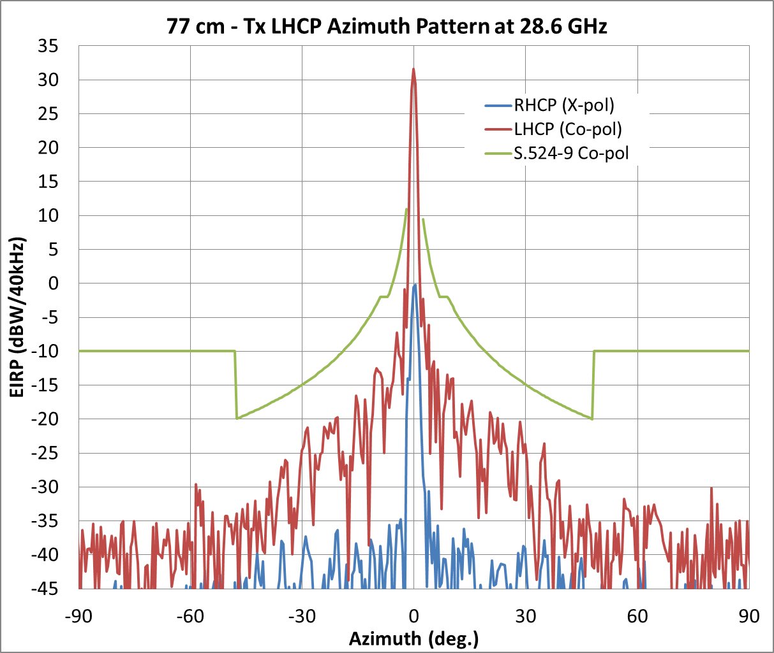

Figure 2

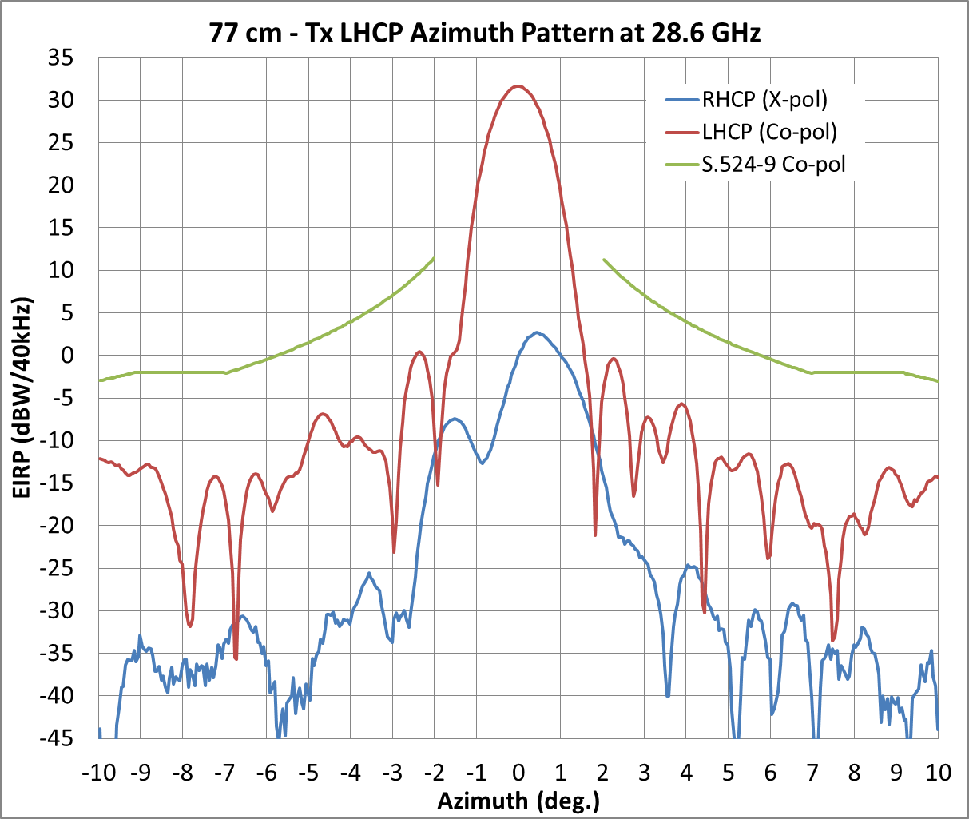

Figure 3

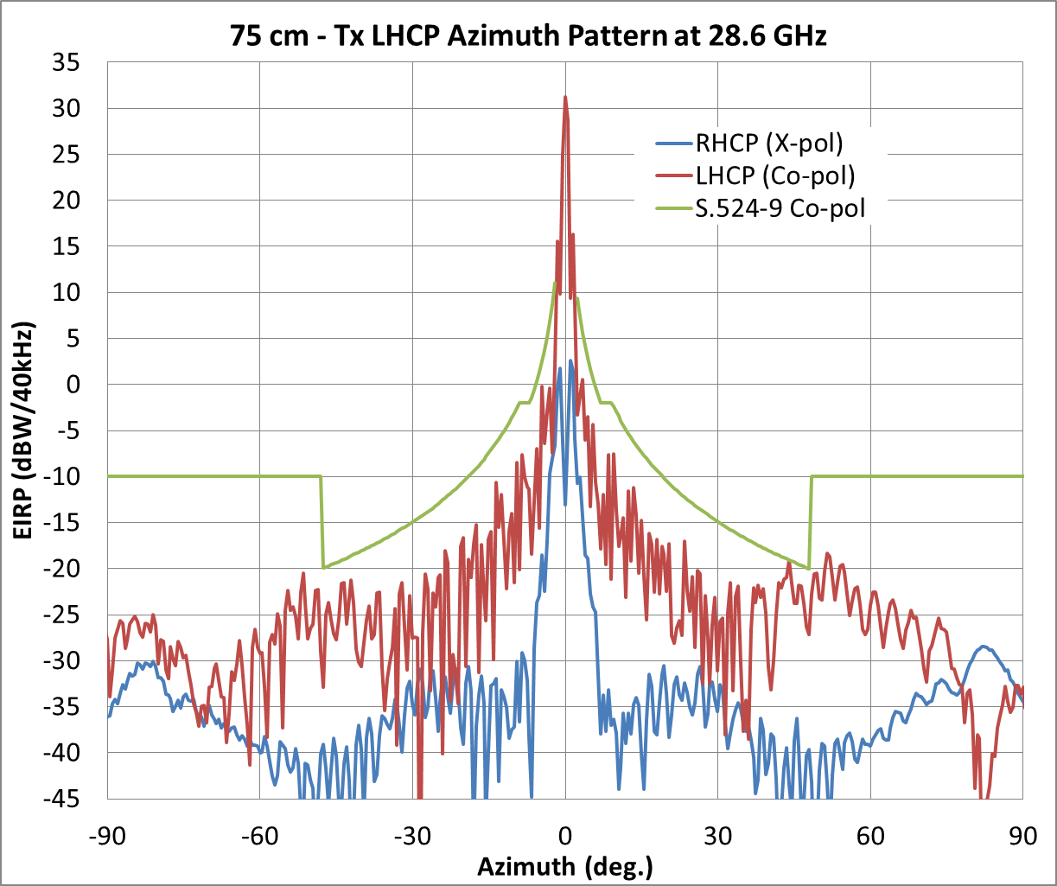

Figure 4

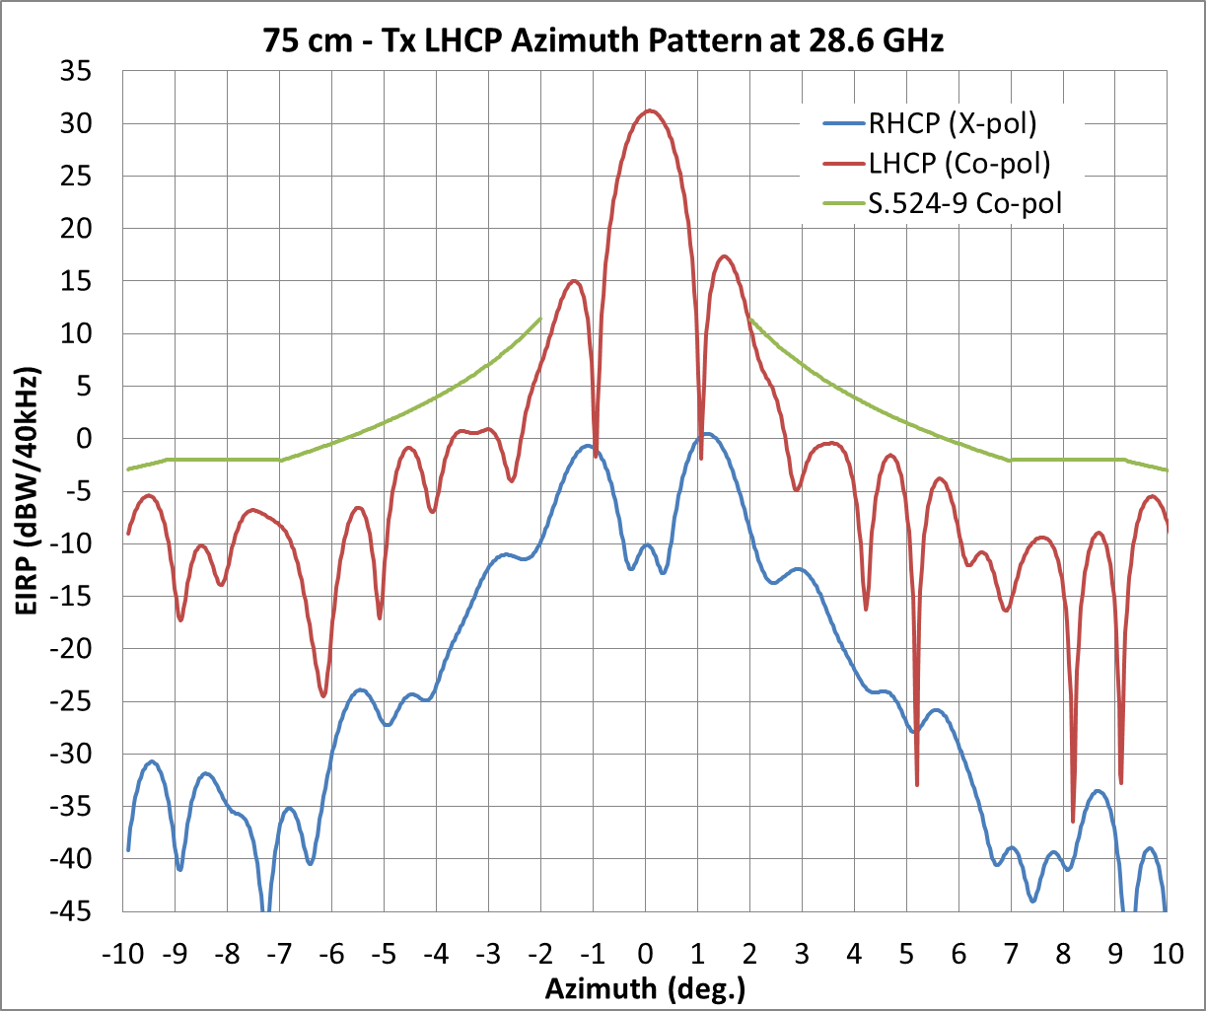

Figure 5

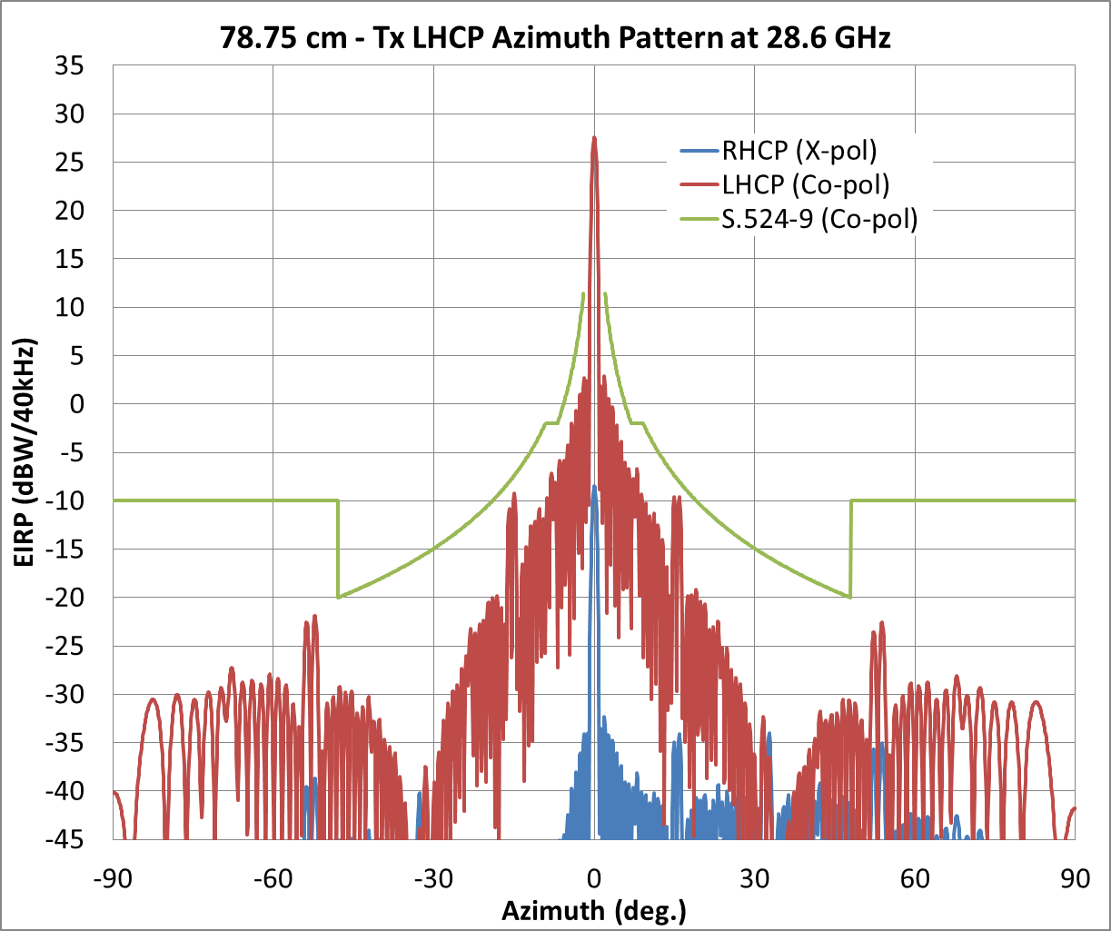

Figure 6

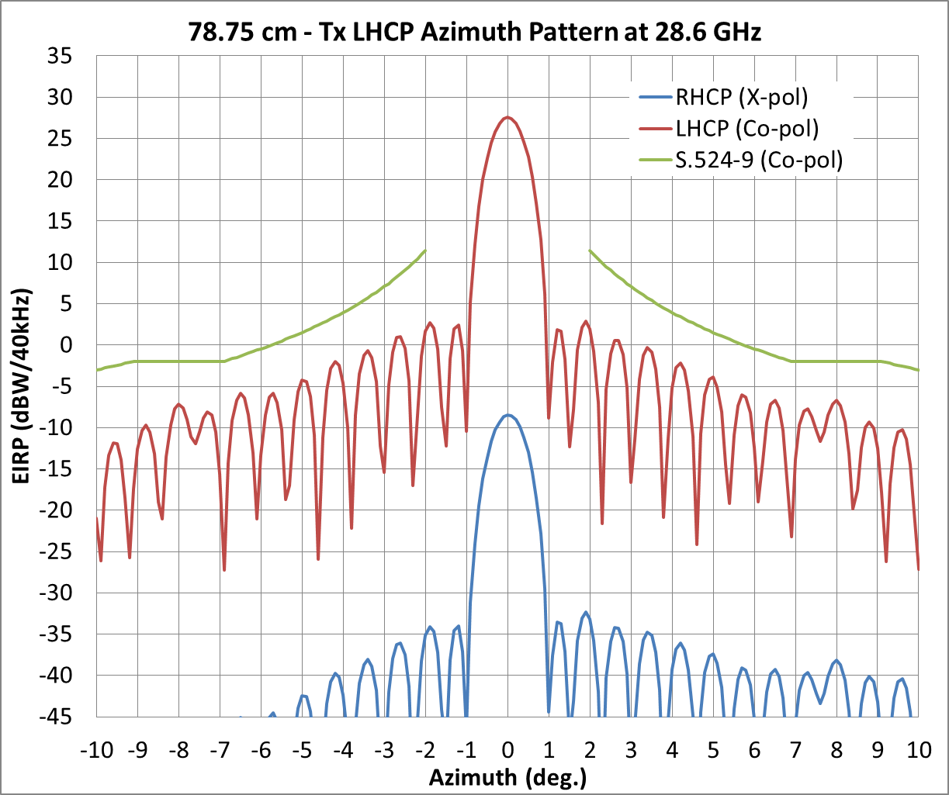

Results

As the above plots demonstrate, within the stated parameters of this study (for the three different types of terminals as stated earlier in this section), the off-axis performances of dimensionally similar size antennas are comparable regardless of whether deployed with VSATs or ESOMPs, when operating within established limits or coordination interference levels.

# 3 Characterization of ESOMP mispointing

Over the past two decades VSATs have been deployed globally with much success for both network operators and service users. VSATs today are meeting the technical and operational requirements as defined by ITU-R Recommendations and at the same time providing inexpensive quality performance to the user.

The accuracy of a VSAT antenna’s pointing over a long period is generally dependent on a number of factors. For example, antenna pointing may degrade dependent on the quality of the foundation or mountings used to support the antenna, as well as the on-going maintenance of both the foundation and mounting. An antenna that is perfectly pointed on the day of its installation may drift off the satellite over time due to settling of the foundation, and/or the combined cumulative effects of wind loading, snow load, etc., over time. Various techniques exist to determine the likely pointing error of a VSAT after installation. The VSAT will continue to operate even when mispointed, but it is general industry practice that when the VSAT’s pointing error estimate approaches an unacceptably large value, a site visit will occur and it will be repointed.

ESOMPs are deployed on a variety of moving platforms, such as aircraft, maritime, or ground based platforms. Accordingly, while ESOMPs may employ antenna sizes and communication subsystems similar to VSATs, they also employ stabilizing techniques in their antenna pointing subsystem which operate continuously to keep the antenna correctly pointed at the desired satellite. These stabilizing techniques can vary by manufacturer, including the use of open or closed loop pointing as system design/performance requirements may dictate.

That said, ESOMP pointing accuracy performance is a function of system design/performance requirements, such as vehicle dynamics and cost. For example, mobile platforms with high dynamics such as a land vehicle moving over rough, possibly off-road terrain will require higher antenna accelerations to maintain the same pointing accuracy as a platform on a cruise ship having dynamic movement that is generally much less affected by its surrounding environment.

To support antenna stability and pointing accuracy, ESOMPs typically have built-in GPS receivers, along with software to calculate initial antenna pointing angles for acquiring the desired satellite. Additionally, the antenna stabilization function and subsystem includes rate gyros and accelerometers that detect movement of the platform and the antenna which provide the feedback necessary for antenna stabilization corrections.

Further, aeronautical ESOMPs also connect to the aircraft’s inertial reference unit (IRU) that is part of the aircraft’s avionics package which provides yet more additional feedback which is also used to stabilize the antenna.

Regardless of the type of platform considered, the potential interference to GSO FSS spacecraft depends upon the resulting pointing accuracy maintained by the ESOMP. The pointing accuracy is controlled or limited by technical and operational requirements independent of platform type[4].Therefore, for the purposes of this study it is not necessary to distinguish between platform types.

Analysis

To further the analysis, it is helpful to understand what angular offset from peak is being achieved by developing a model for offset angle versus dB of gain reduction in the main lobe of the antenna. For this analysis it is also assumed that a typical 75 cm antenna is used.

For example, at 19.7 GHz the antenna 3 dB beamwidth is approximately 1.42°. This may be found by examining a typical 75 cm antenna pattern as shown below, or by using the rule of thumb formula:

$HPBW =\frac{\left(70 × λ\right)}{D}$ (1)

where:

*HPBW*: is half power beamwidth in degrees

λ: is wavelength

*D*: is antenna diameter in same units as λ

A second helpful formula for determining the gain reduction as a function of offset angle from boresight is:

(2)[5]

where:

Δ : change in gain from the max boresight value. To express as a dB value use 10*log(Δ *Gain*)

$Θ$: offset angle from boresight.

For example, as *HPBW* has been given as 1.42°, if the antenna is mispointed by 0.95° the change in gain is found as $10×log⁡(e^{\left[-2.76 × {\left(\frac{0.95}{1.42}\right)}^{2}\right]})$ = –5.4 dB, which corresponds well with Fig. 7.

Figure 7

Typical receive antenna pattern

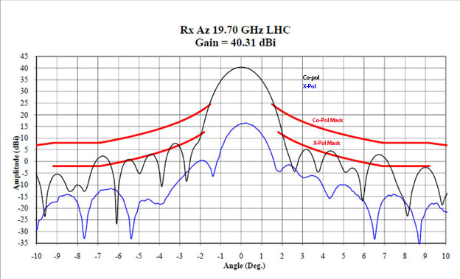

Equation (2) may be restated as follows to yield pointing error in degrees given gain reduction from boresight peak:

$Θ=\sqrt{(\frac{\ln\left(Δ Gain\right) × {HPBW}^{2}}{-2.76})}$ (3)

where:

Δ *Gain* : change in gain from peak boresight value (in linear format).

By using formula (3) above, the effective reduction in gain from the peak boresight value can be used to determine the effective pointing error in degrees:

$0.58=\sqrt{(\frac{\ln\left({10}^{(\frac{-2.0}{10})}\right) × {1.42}^{2}}{-2.76})}$

In this example, a 2 dB signal reduction is equivalent to a pointing error of 0.58°. However, while the magnitude of the mispointing can be determined and a displacement in degrees estimated, the actual direction of the mispointing is unknown.

The antenna could be mispointed in either the direction of azimuth or of elevation or some combination of the two.

In order to calculate the gain in the direction of a victim satellite the simulation will generate a random number between 0 and 360. 0 corresponds to the West azimuth direction, 90 is up in elevation, 180 is East in azimuth, and 270 is down in elevation.

These direction assignments were selected because the analysis assumes that the viewer is looking through the antenna from the rear towards the satellite. See Fig. 8.

Figure 8



Once generated, the random direction component can be used with the magnitude to produce a mispointing vector[6]. For example, if the simulation generates a direction value of 43, this indicates an antenna that is pointing up and to the West of the ideal value.

To find the azimuth and elevation components in degrees for a given mispointing vector the following formulas may be used:

$az =mag ×cos\left(direction\right)$ (4)

$el =mag ×sin\left(direction\right)$ (5)

where:

*mag* : magnitude of the error and direction is the value (0 – 360) as described above.

Using the example pointing error of 0.58° from above and a sample error direction value of 43, the calculated azimuth error value 0.58° × cos(43) = 0.42° (West) and the elevation error   
is 0.58° × sin(43) = 0.40° (up).

It is now possible to both simulate and calculate an associated random pointing error and direction and to then allocate the error in the azimuth and elevation directions.

Also, because the simulation and analysis are concerned with interference to other networks, the VSAT transmit antenna pattern must be considered as well.

Figure 8 shows the matching transmit gain pattern for the representative receive antenna in Fig. 7. Rather than use the actual pattern, a mask is developed as follows:

a) in the region of the main lobe within ±1.1° formula (2) is used with a value of 0.92° for HPBW; and

b) beyond 1.1° from boresight, the familiar 29 – 25 * log(θ) formula is used.

Figure 9

Typical transmit antenna pattern

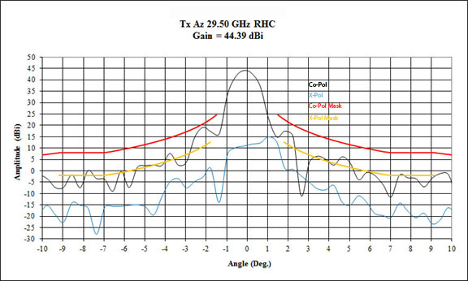

Unlike a fixed FSS VSAT earth station which is peaked only at the time of installation or during follow-up maintenance visits, an ESOMP antenna’s pointing is constantly being adjusted as part of its tracking and pointing function.

ESOMPs may either use open loop pointing based on input from an IRU or may employ some form of closed loop tracking.

Closed loop tracking functions by intentionally mispointing the antenna by a small amount in various directions about the antenna boresight. By doing so, and comparing the signal level measured at each of the pointing positions about the boresight, it is possible to determine if the antenna pointing has drifted off peak and if so, in which direction and by how much. By performing this scanning function periodically as required, the antenna controller ensures that the boresight pointing of the antenna remains on the wanted satellite.

ESOMPs are capable of operating on a variety of mobile platforms. In many cases, regardless of the platform type, the maximum acceleration of the platform in any axis (pitch, yaw, roll) is well defined. For example, modern commercial airliners utilize an IRU as part of their avionics suite.

Analysis of the flight data from these aircrafts’ IRUs have generated mature acceleration profiles which model the expected motion of these aircraft in response to the flight environment. Similar acceleration profiles have been developed for other platforms such as for ESV and vehicle mounted earth station (VMES) platforms.

While ESOMP antenna systems may vary, each is designed with an expected acceleration profile in mind. Antennas that will be used in an environment where greater acceleration is expected in a given direction will employ suitably sized motor drives to keep the antenna pointed within limits. Where expected motion is more modest, smaller and more economical drive motors may be used.

Notwithstanding, the foregoing description of designing an ESOMP antenna for its normally predicted environment, they also have been designed to date, and will be in the future, in conformance with standards to anticipate and expect the unexpected as well. That is, at some point a rogue wave, large pot hole, or severe air turbulence will cause the mobile platform to accelerate at a rate greater than for which the antenna drive motors were designed to accommodate. The control circuitry built into every ESOMP constantly evaluates current and predicted antenna pointing with respect to the desired direction and when the antenna controller determines that the antenna pointing error is going to exceed a predefined maximum limit, the ESOMP’s transmitter is inhibited.

For purposes of this analysis, the design methodology follows provisions of recently adopted ETSI[7] Standard EN 303 978 which requires in section 4.2.6 that “The Applicant shall declare the peak pointing accuracy (δφ) and the associated statistical basis”[8]. The specification also requires that the ESOMP shall be able to detect the pointing error, and further that the ESOMP enter the “Carrier‑off” radio state within a time *T* declared by the applicant – *T* not to exceed 2 seconds[9].

For the purposes of this analysis it is a primary assumption that the ESOMPs will comply with the foregoing technical and operational guidelines. As such, it is assumed that the distribution for ESOMP azimuth and elevation pointing error has a mean error of 0.0° and a standard deviation of 0.2°, which is achieved by many ESOMPs operating today.

In some ESOMP implementations one axis may experience more acceleration than another, for example the elevation axis may see higher acceleration due to pot holes on a VMES. Because a stabilized platform is typically designed to take this acceleration profile into account, for purposes of this simulation it is assumed that the direction of the pointing error is equally likely in any direction.

It should also be noted that in this analysis, a 0° mean pointing error has been assumed because while the closed loop tracking periodically points the antenna slightly away from boresight, the mispointing is small and the frequency of the mispointing is low enough that any error is negligible.

Additionally, some systems may be programmed to execute the closed loop scan only during periods when the transmitter is inactive unless the received signal strength changes by more than some target value since the previous scan.

In the simulation, the distribution for the error represents the magnitude of the error but not the direction. Because the amount of azimuth and elevation error are considered equally likely, for each trial in this simulation a uniform random distribution between 0 and 360 will be generated to represent the direction component. The magnitude and direction values are used with equations (4) and (5) to determine the azimuth and elevation components of the error. The simulation uses 5 000 random locations within the U.S. for the population of ESOMPs. Since the earth station is located in North America, the effect of the elevation error component on adjacent satellites is negligible. The true error that must be studied is in the azimuth direction.

Further, unlike fixed VSATs which continue to transmit regardless of pointing error, the aforementioned ETSI Standard requires that ESOMPs enter a “Carrier off” or transmit inhibit state when pointing error reaches the declared peak limit (δφ). In this simulation, a 0.5° pointing error limit will be applied to the ESOMPs. If the pointing error during a transmit window is equal to or greater than 0.5° the transmission from the ESOMPs will be inhibited[10]. The key assumption made here is that the antenna pointing error reading available at the antenna control unit is the actual pointing error[11].

Figure 10

ESOMP pointing error distribution

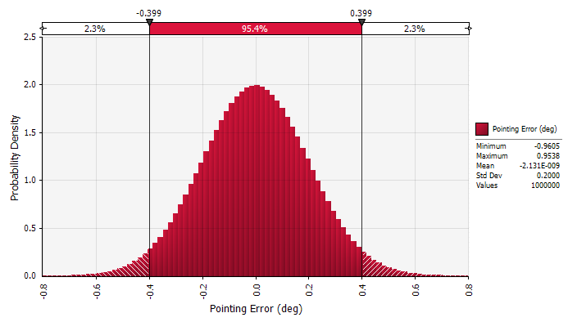

Figure 10 shows the pointing error distribution without limits or truncation at –0.5° and 0.5°.

The simulation combines the pointing error distribution with the random ESOMP site selection for each TDMA burst window, evaluates the actual error in the azimuth direction, and applies the transmit inhibit function at that time.

The resulting azimuth pointing error distribution is shown in Fig. 11. To show the effect of the transmit inhibit function an error value of –1° is logged each time a bursting ESOMP’s pointing error is greater than ±0.5°.

Figure 11

Azimuth pointing error distribution (deg.)

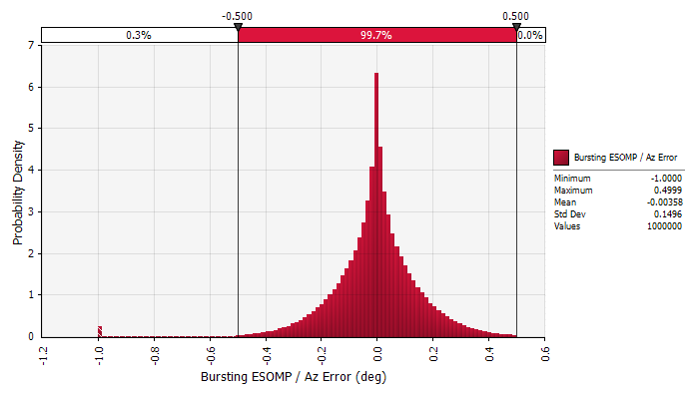

No transmissions occur when the azimuth pointing error is equal to or greater than ±0.5°. The Tx inhibit function is activated 0.3% of the time when the ESOMP is bursting.

Next, using the resulting distribution of azimuth error, the gain in the direction of the adjacent satellite is calculated by adding the antenna error to the topographic separation angle between the desired and adjacent satellites for the ESOMP’s location and then applying the 29-25 × log(θ) formula.

The resulting distribution for delta gain in the direction of the adjacent satellite is shown in Fig. 12. The delta gain values reflect the change in gain toward the adjacent satellite from that of a perfectly pointed reference antenna who’s off-axis gain performance is equal to 29-25 × log(θ) in the region of the adjacent satellite. In this simulation, the maximum increase in gain towards the adjacent satellite is 2.8 dB and increases above 1 dB occur for 6.3% of the time or less.

Figure 12

Delta gain in direction of adjacent satellite (dB)

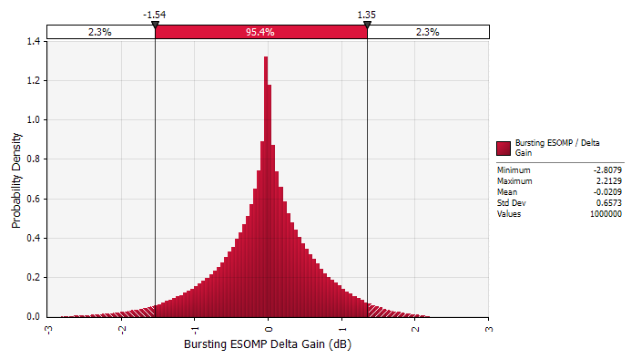

Results[12]

Based on the assumptions stated in this document that ESOMPs comply with the required technical and operational guidelines, the following may be concluded:

Off-axis pointing and gain performance:

1) ESOMPs are no more likely than Fixed VSATs to have increased gain of more than 1 dB toward a victim GSO satellite.

2) ESOMPs do mute Tx when mispointed above permissible limits, whereas Fixed VSATs generally have no Tx inhibit requirement based on mispointing. Accordingly, ESOMPs are no more likely to transmit if mispointed toward a victim GSO satellite than a Fixed VSAT[13].

Based on the above analysis and the assumptions made, it can be observed that ESOMPs create a negligible mispointing interference risk to victim GSO satellites over that of fixed VSATs.

Technical and operational studies towards developing elements to be included in Report ITU-R S.2223 regarding earth stations on mobile platforms in the 17.3-20.2 and 27.5-30.0 GHz bands of the GSO FSS.

1. For the types of antennas considered and assumptions used in the study.
2. For the types of antennas considered and assumptions used in the study.
3. The measured antenna pattern results shown are from similar sized antennas; it should also be noted that similar analyses using antennas of different manufacture or size might result in varying performances when operating under non-laboratory conditions.
4. See Annex 2 to Resolution **902 (WRC-03)** for pointing accuracy of earth stations located on board vessels.
5. Gagliardi, Robert M., *Satellite Communications*, 2nd Ed., New York: Van Nostrand Reinhold (1991), p. 104.
6. The antenna pointing error is a function of the azimuth and elevation pointing error components and the locations of the ESOMP, the wanted satellite, and the victim satellite. Mathematical expressions for these parameters are given in Annex 1 of Recommendation ITU-R S.1857.
7. ETSI (European Telecommunications Standards Institute) is officially recognized by the EU as a European Standards Organization. ETSI has been granted ITU-R Sector Member status and an Agreement for mutual cooperation and exchange of documentation is in place between ETSI and the ITU.
8. ETSI EN 303 978 v1.1.2 (2013-02) – Satellite earth stations and systems (SES); Harmonized EN for earth stations on mobile platforms (ESOMPs) transmitting towards satellites in the geostationary orbit in the 27.5 GHz to 30.0 GHz frequency bands covering the essential requirements of Article 3.2 of the R&TTE Directive.
9. *Ibid.* 
10. *Ibid*.
11. For example, because of installation alignment error the antenna pointing error read by the control unit may not be the same as the actual antenna pointing error, however as part of the installation process on any given platform, installation bias and related errors are typically calibrated out.
12. The statements in this conclusion are with respect to ESOMP terminals with the characteristics described in this analysis. The conclusion’s statements are specific to this analysis and study which pertain to ESOMP terminals designed, manufactured and operated in conformance with technical and operational requirements outlined in this study. Differing results may occur for the operations of ESOMP terminals not designed, manufactured, nor operated in accordance with the technical and operational requirements referenced in this study.
13. It should be also noted that, in the case of having a rogue terminal, location of a VSAT station causing interference into an adjacent satellite network can be identified through geolocation techniques. However, geolocation of stations communicating while in motion, such as an ESOMP terminal, is difficult, and further development of these techniques is ongoing.